1. **Create a Bash script to check if a directory is available or not.**

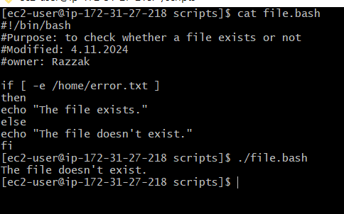

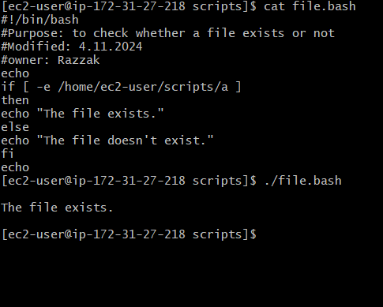

1. **Create a bash script that will create multiple files:**

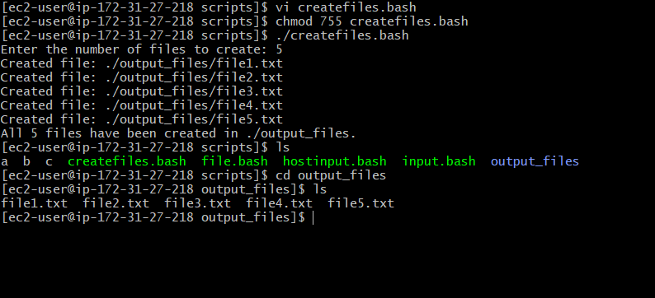

**3) Create a bash script to take backup of a directory.**

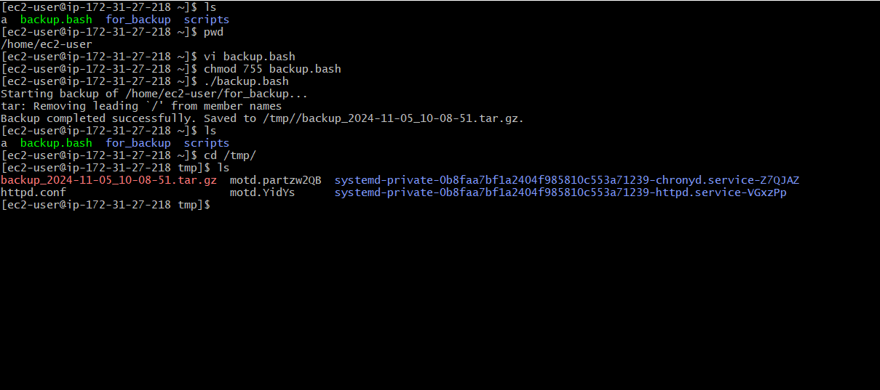

**4) Create a bash script to install nginx in ec2 server.**

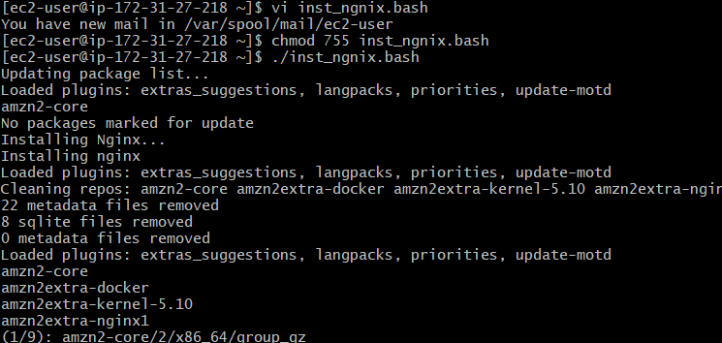

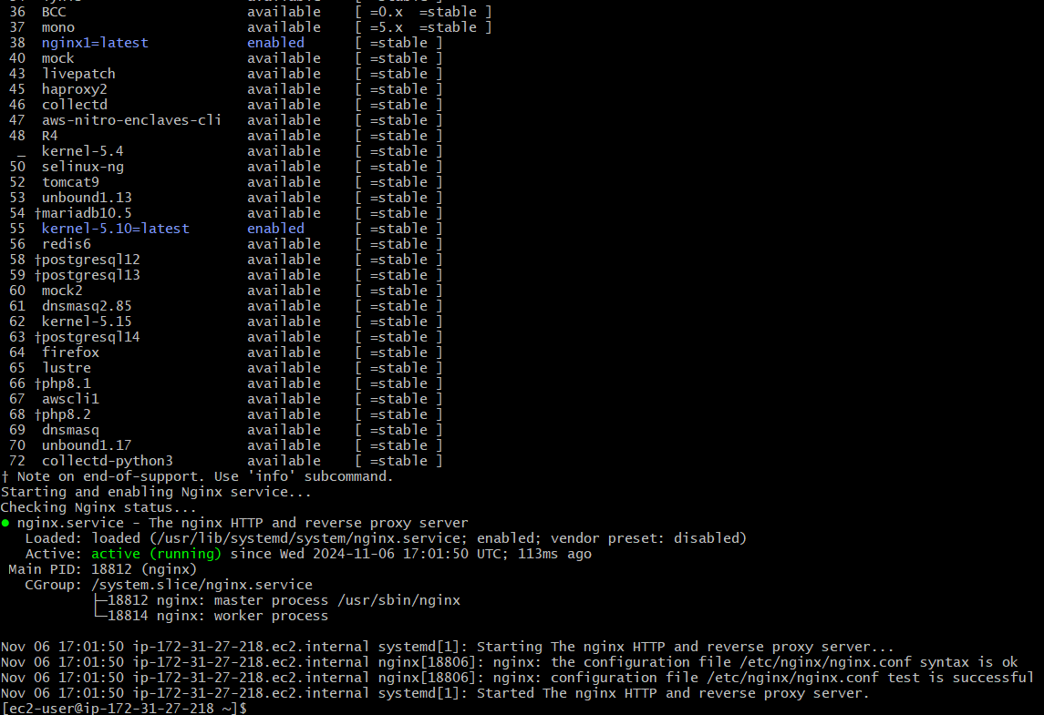

5) Create a bash script to install ApacheTomcat in ec2 server.

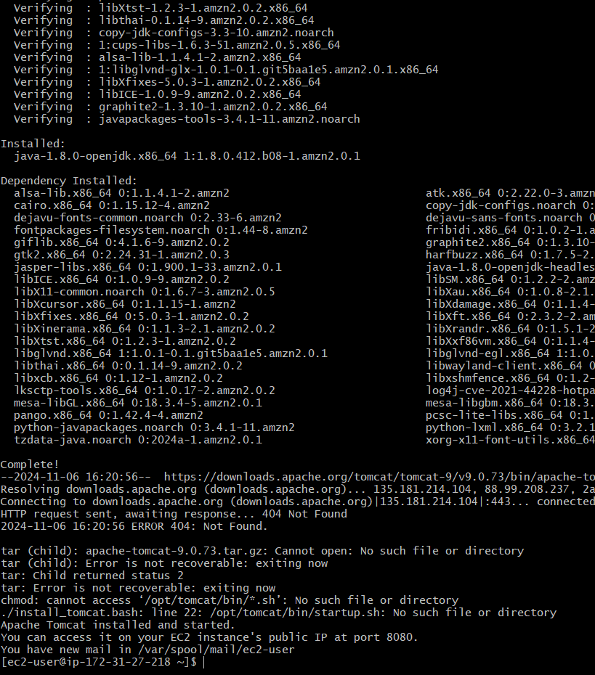

**6) Create a bash script to check list if nginx service is running or not,if not running**

**then script should start the service.**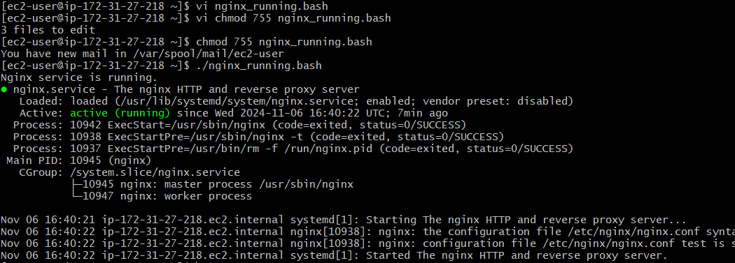

**7) Create a bash script for calculator:**

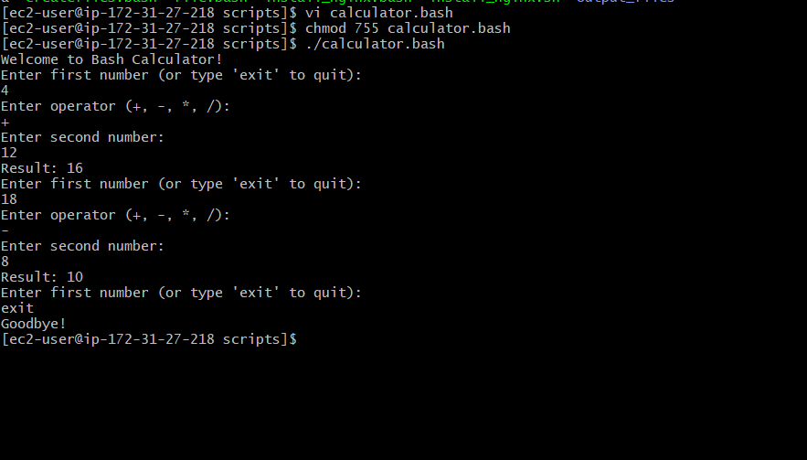

8) Create a bash script to check if directory is avaialble or not,if not then create a directory.

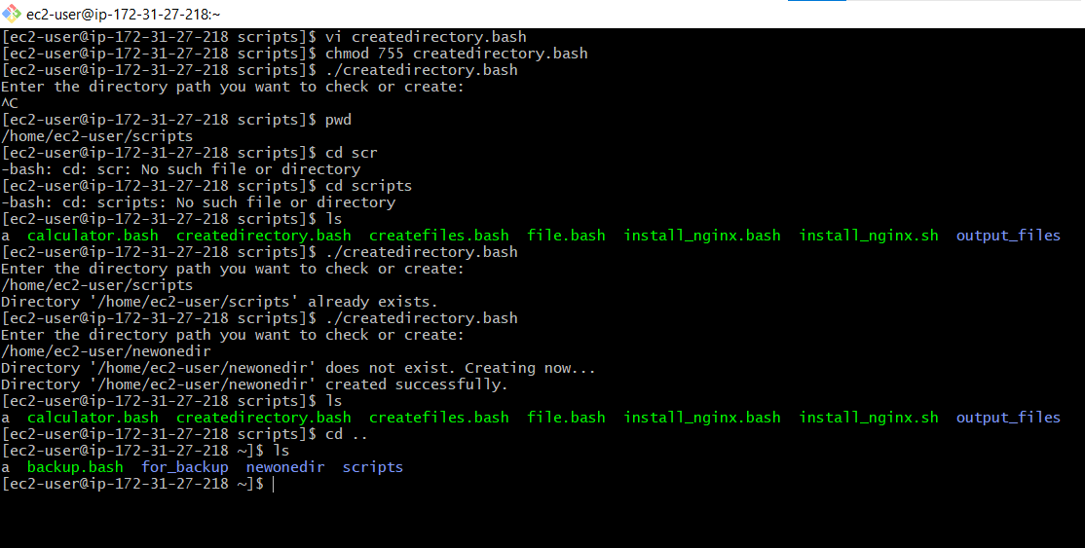

**9) Create bash script to delete last 3 lines for a file.**

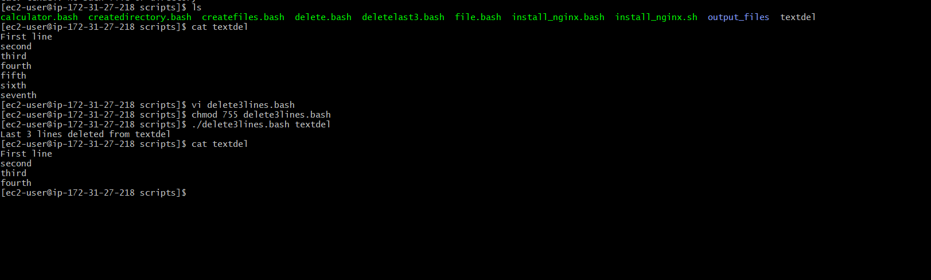

1) April 5th Midnight



2) 5 th of Every November,Jan,June if it is a Thursday.

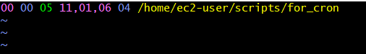

1. At 05 and 27th minutes of 9,10,11 hours everyday

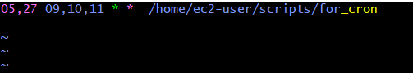

1. 34 min. of 9th hour on 15th Aug



5)Every midnight



6)Every Weekend ( Saturday night 11.59 )



7)After every reboot

