**Terraform Tasks [5th and 6th video]:**

1. Watch terraform-05 video.

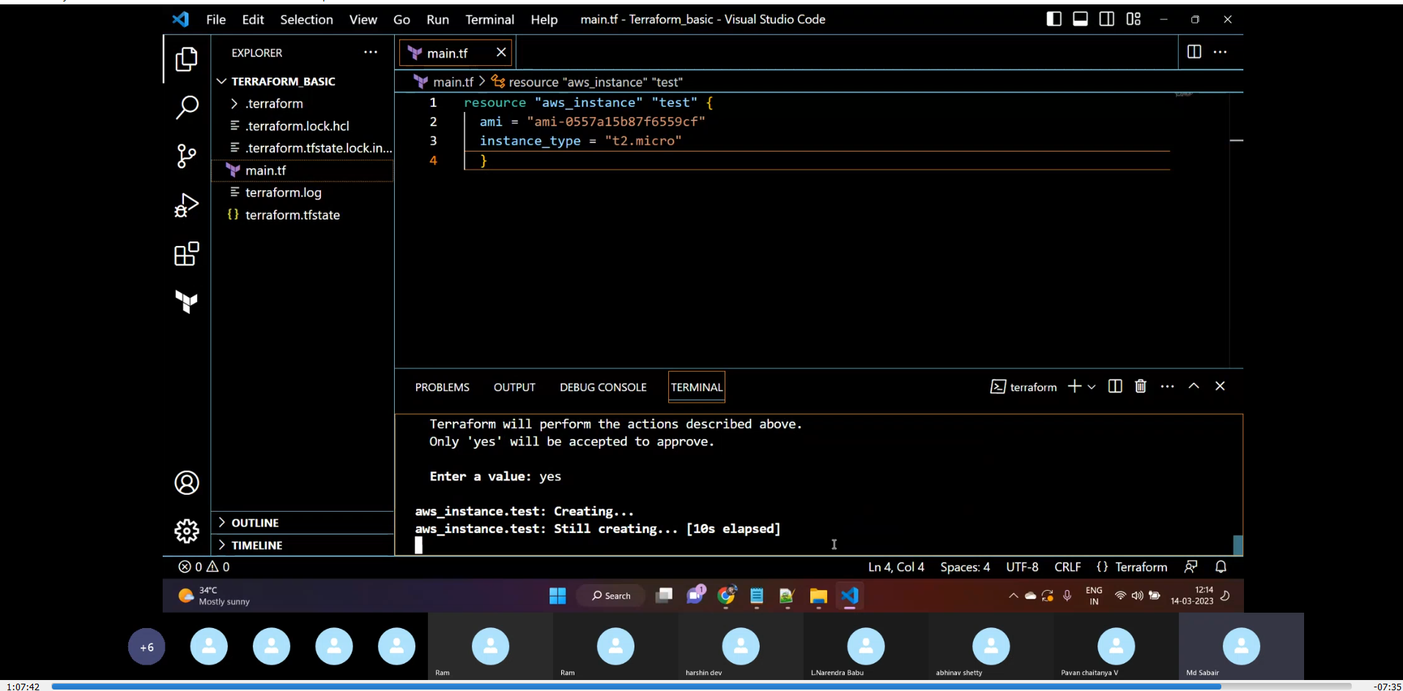

1. **Execute the script shown in video.**

* *Creating s3 bucket*:

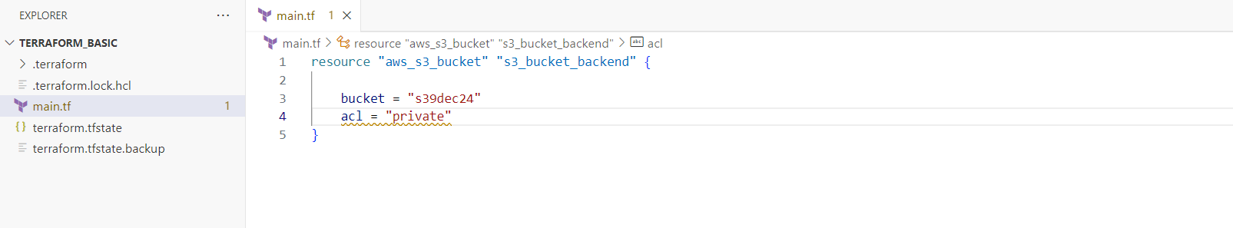

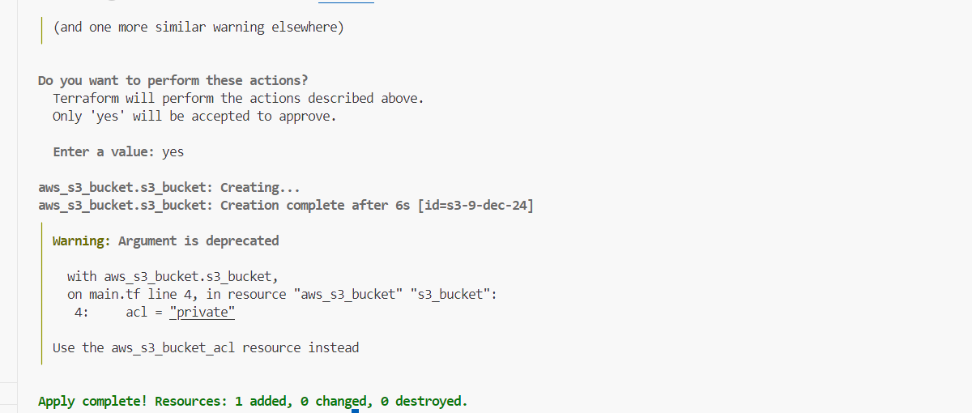

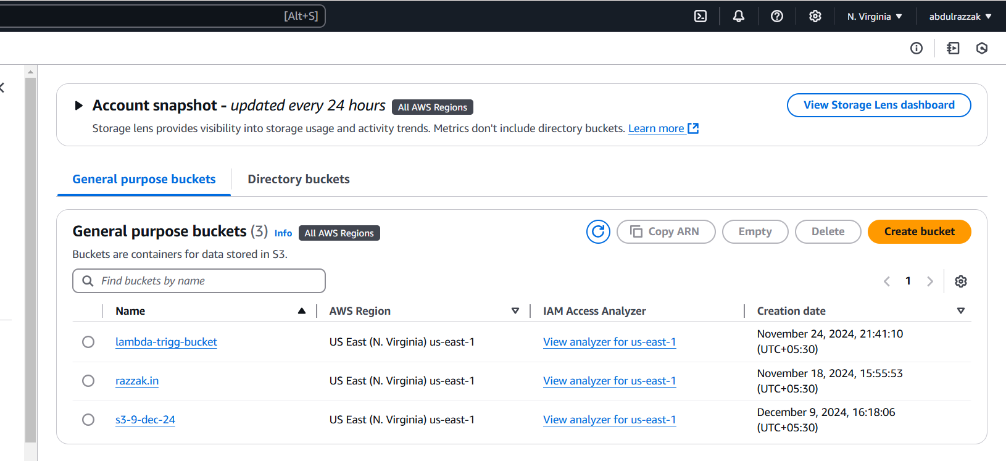

* Creating dynamo db using terraform:

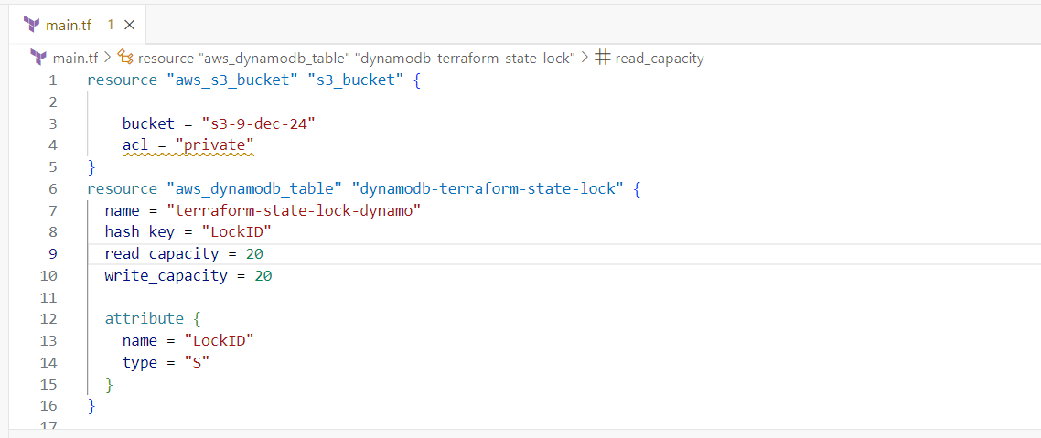

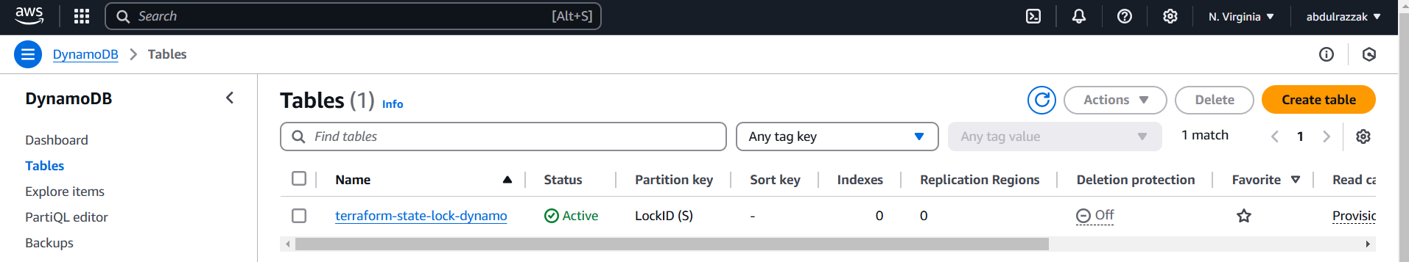

* S3 as backend for terraform.tfstate file:

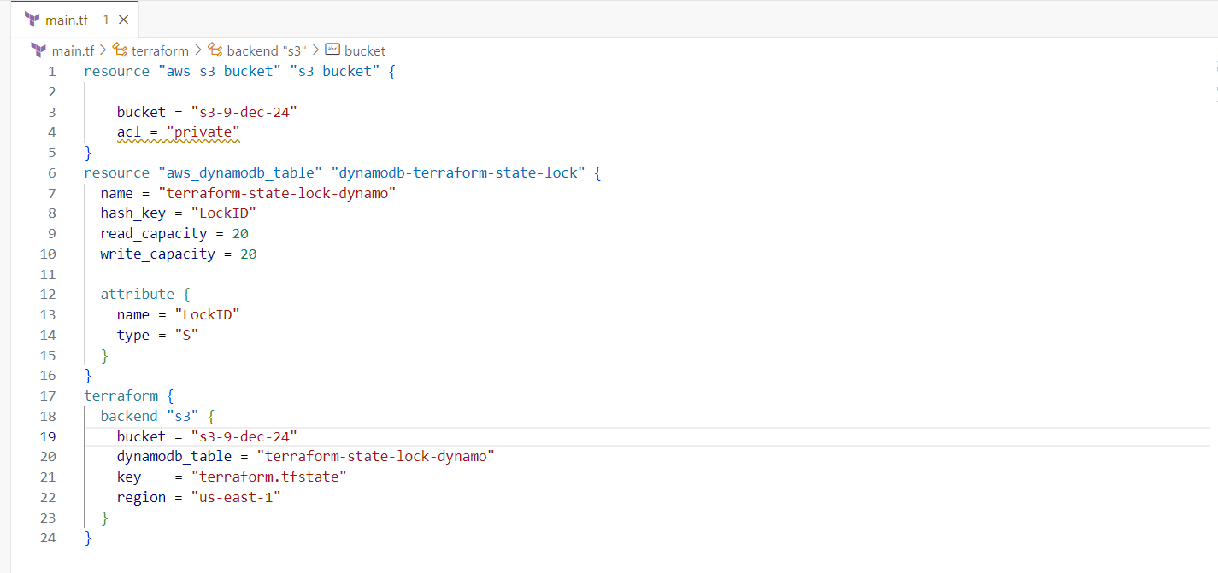

>>State file in s3 bucket:

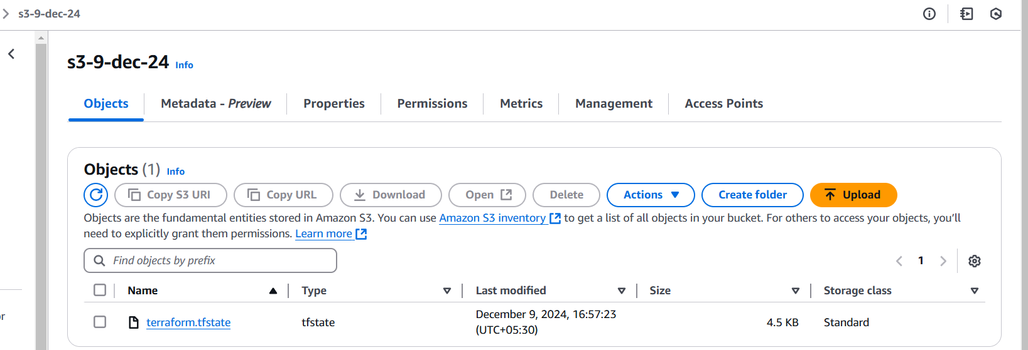

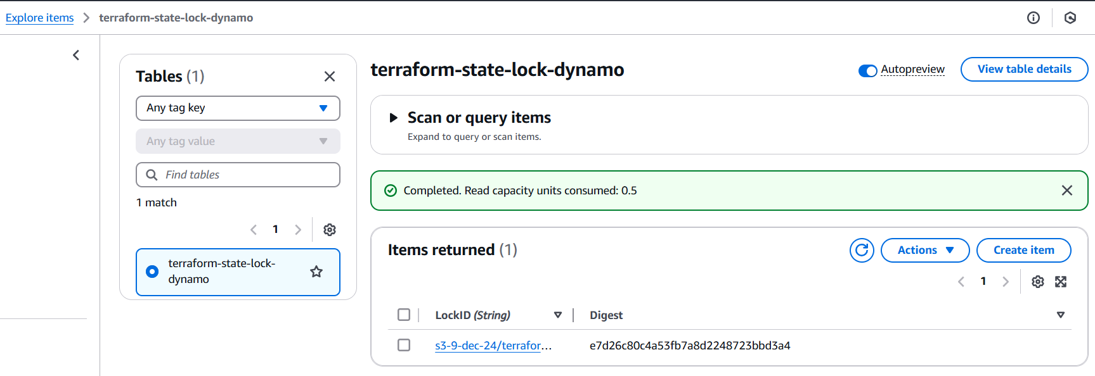

>>Table with the lock ID:

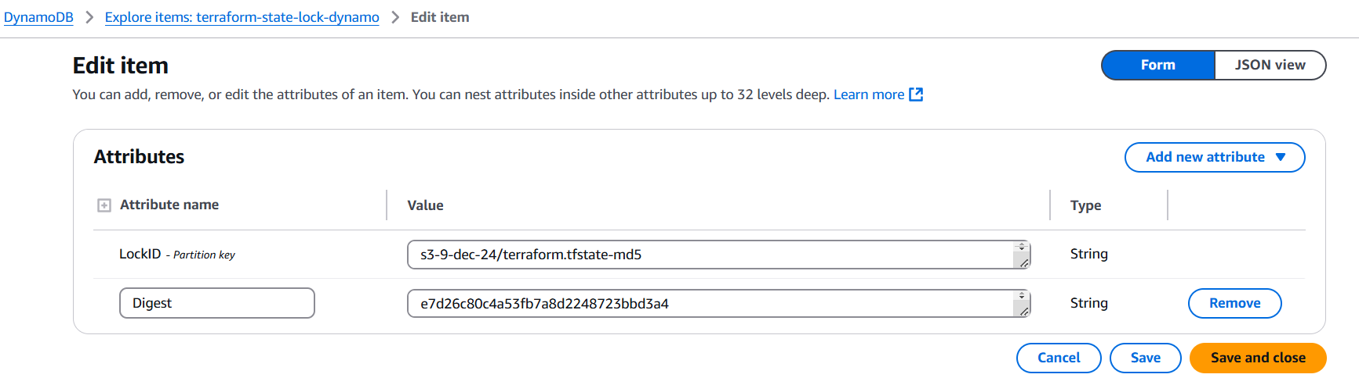

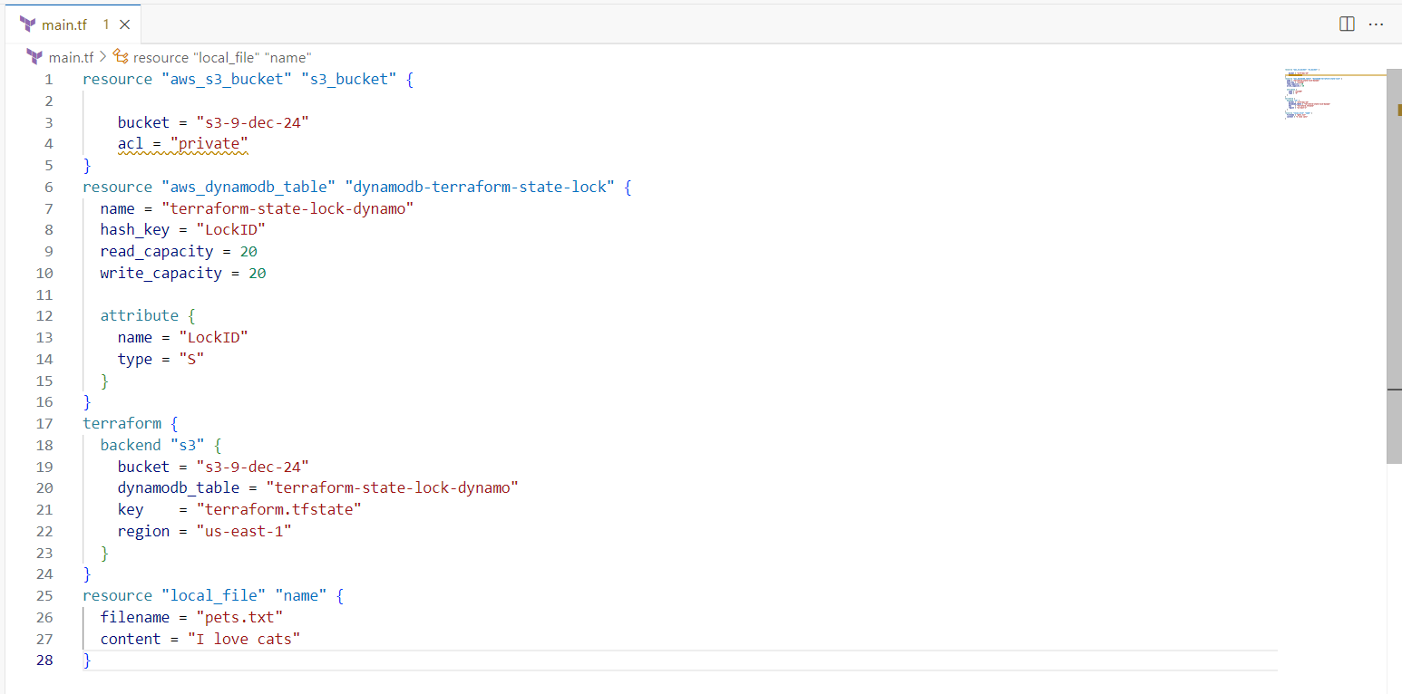

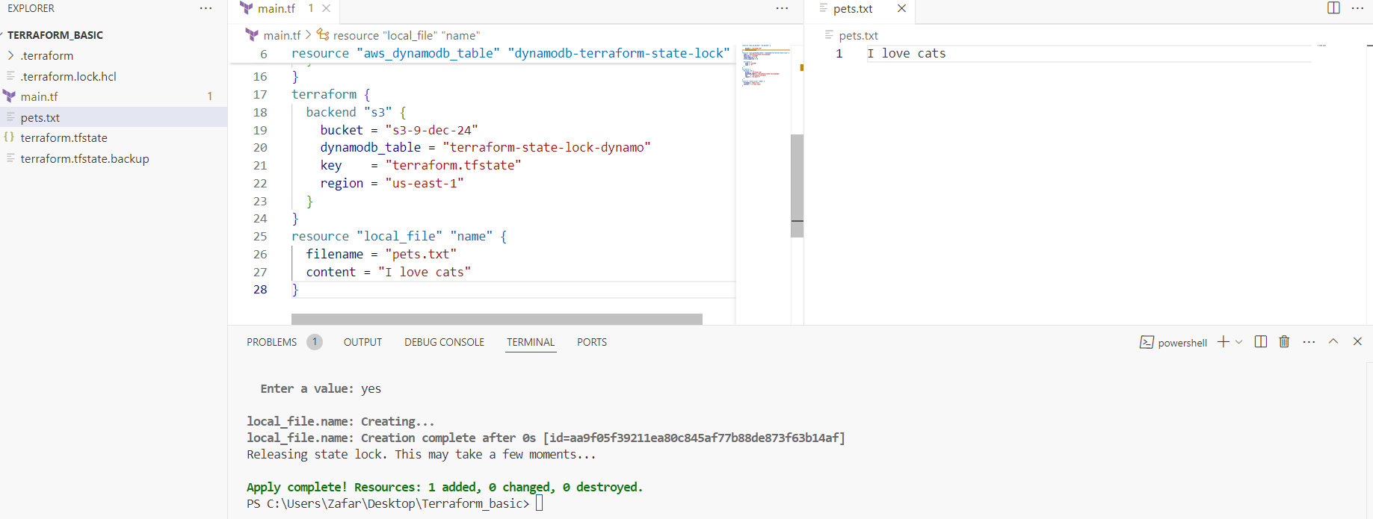

3) Create one ec2 instance with httpd installed using terraform script.

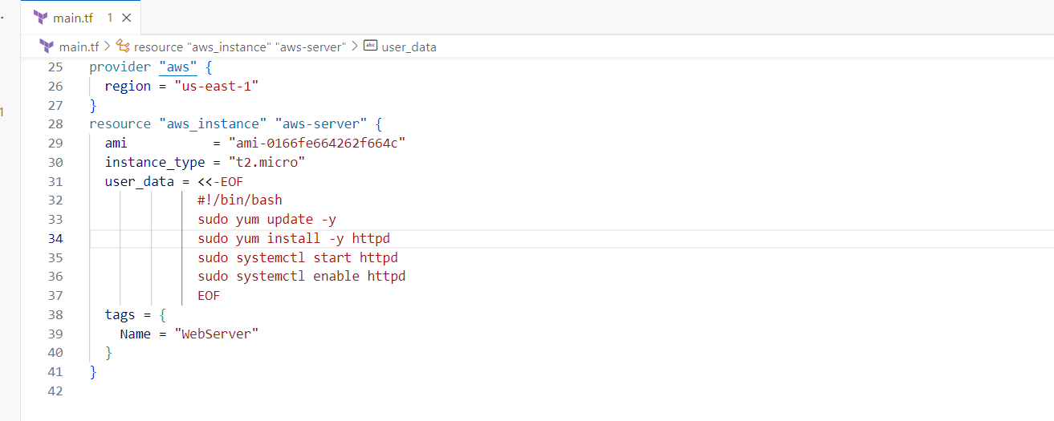

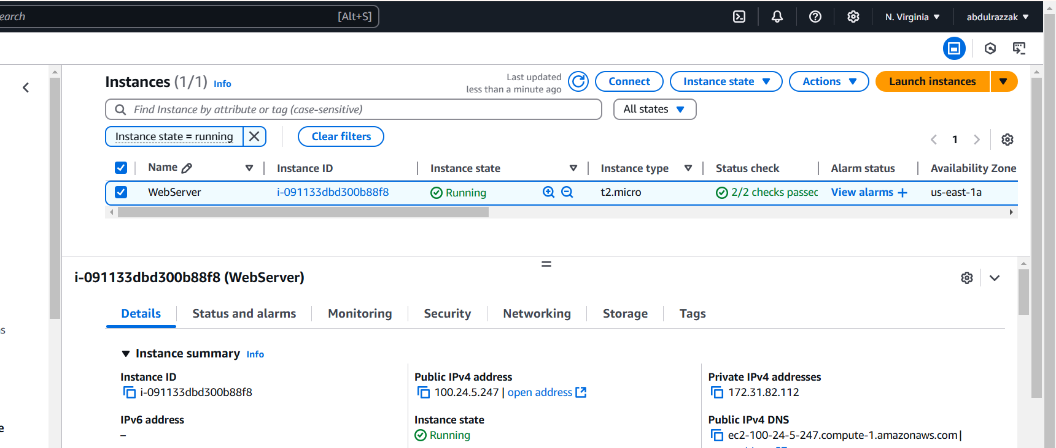

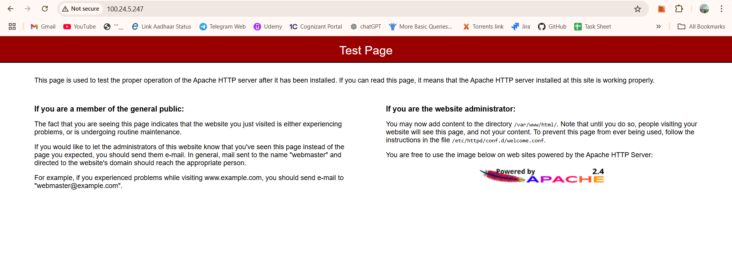

**3)Setup s3 as backend to the task 3.**

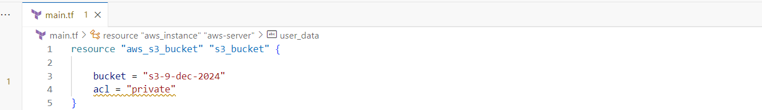

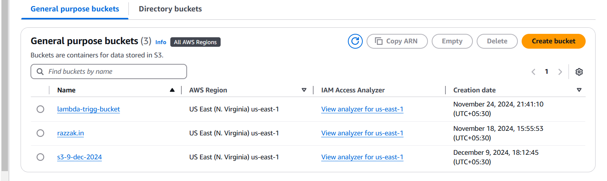

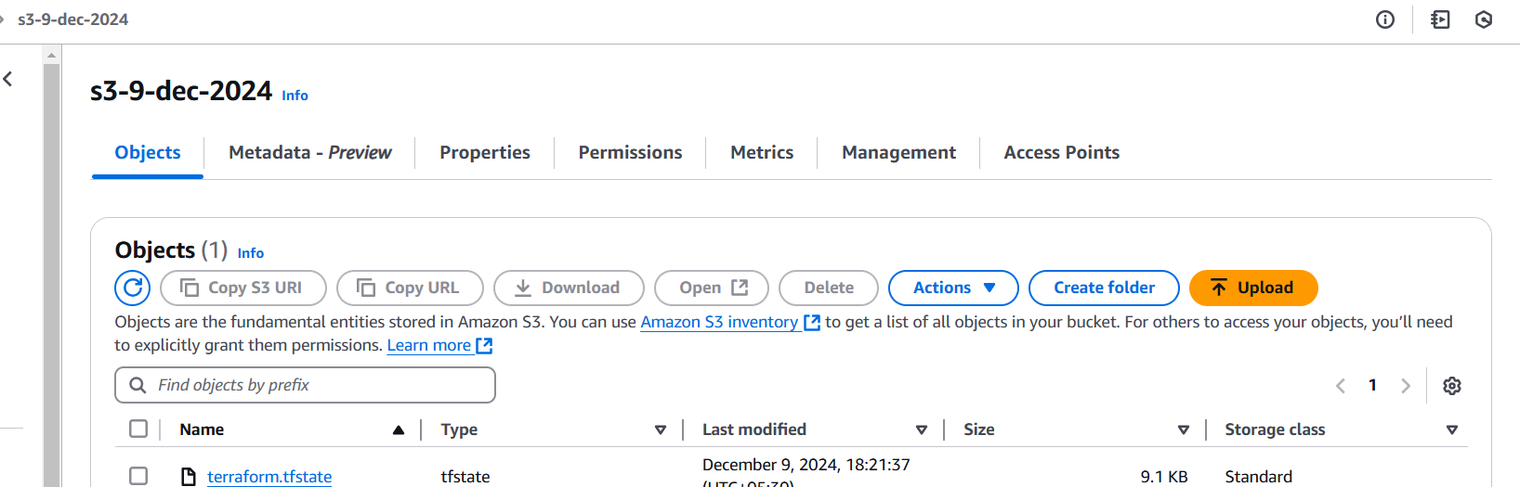

**5) Setup dynamo db locking for task3.**

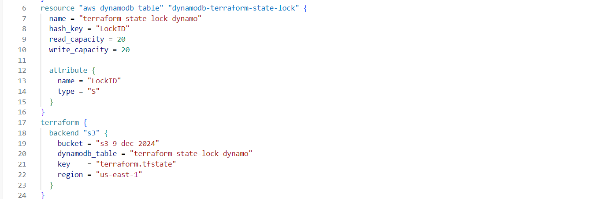

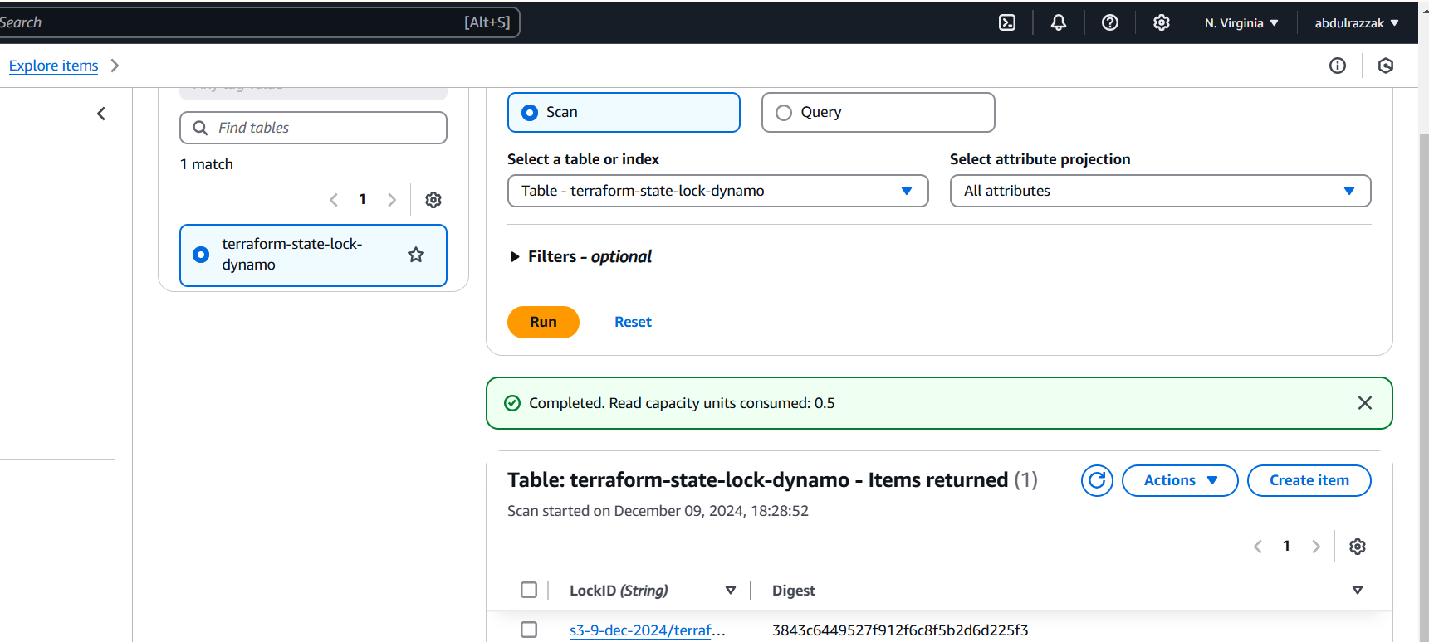

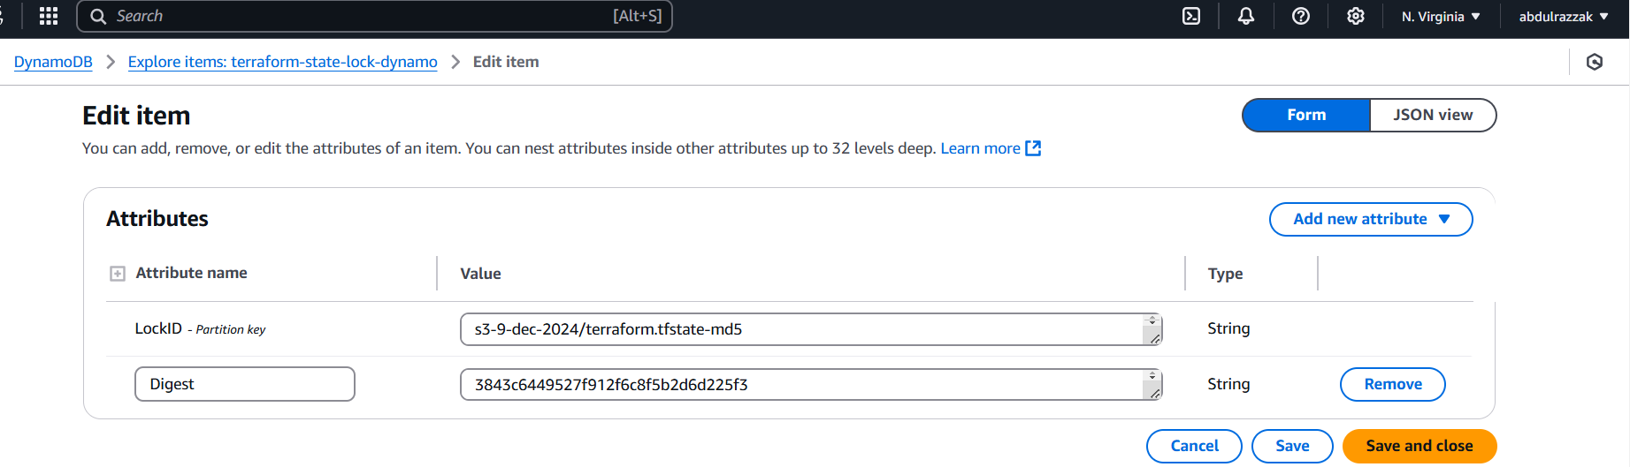

>>>Downloaded the terraform.tfstate file from s3 bucket and opened it:

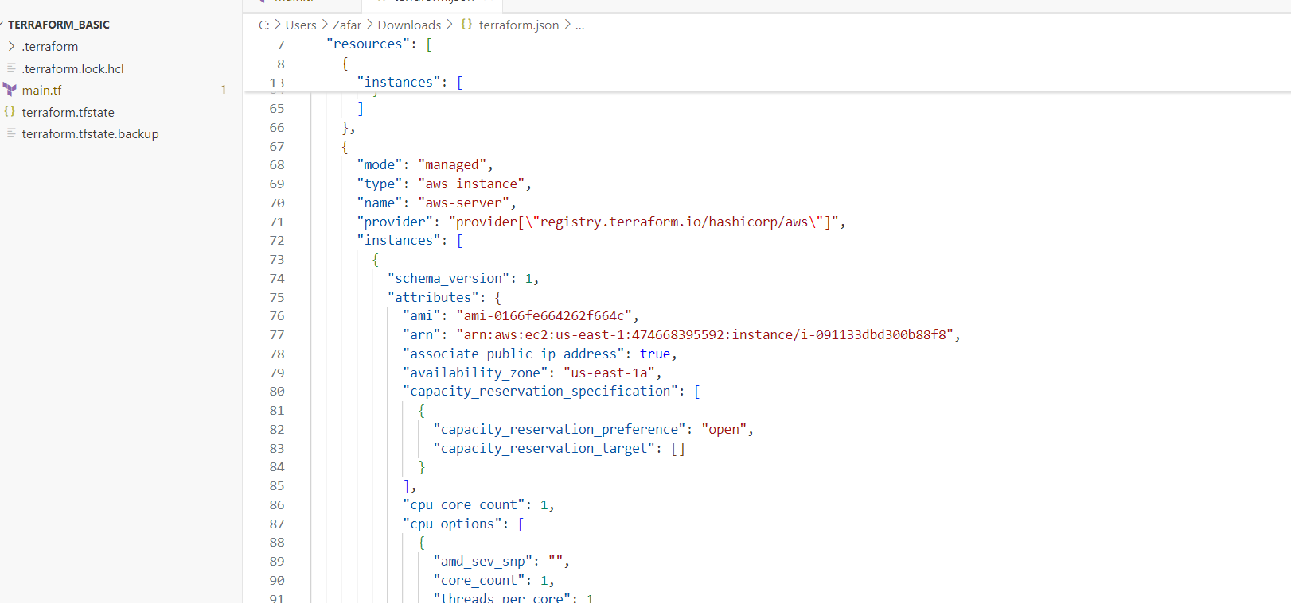

**6) Watch terraform-06 video.**

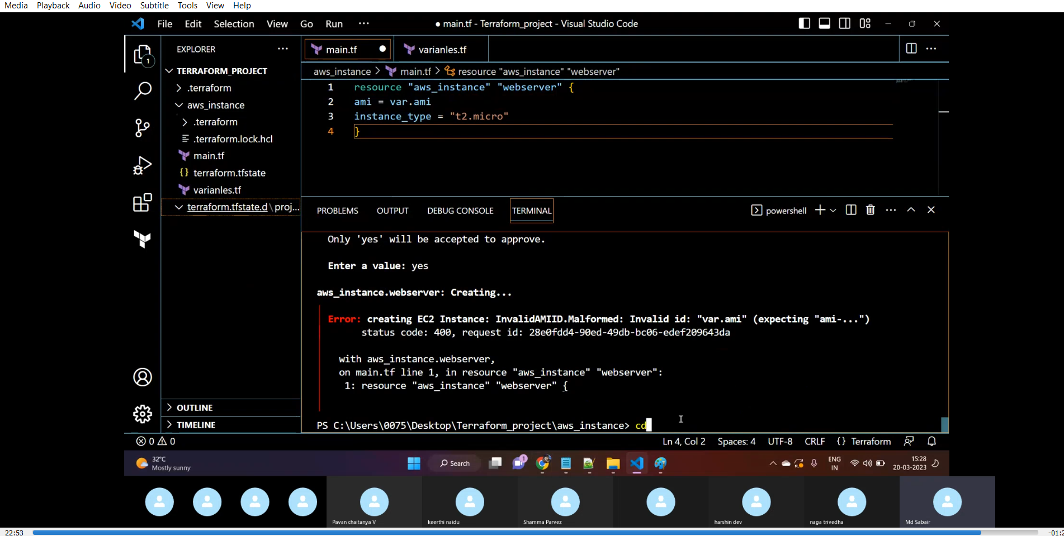

**7) Execute the script shown in video:**

**8) Provision ec2,s3 and vpc using Terraform modules.**

**9) Provision ec2 for 3 different environments (Dev, Staging and Prod) using terraform workspaces.**