**Terraform Tasks:**

**>>> Install Terraform on your PC**

**https://developer.hashicorp.com/terraform/install**

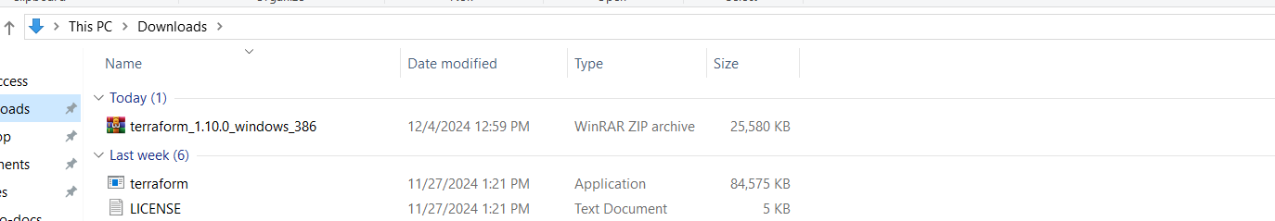

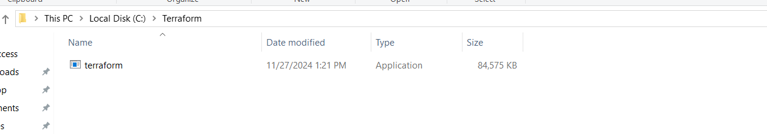

* ***Environmental Variables: -***

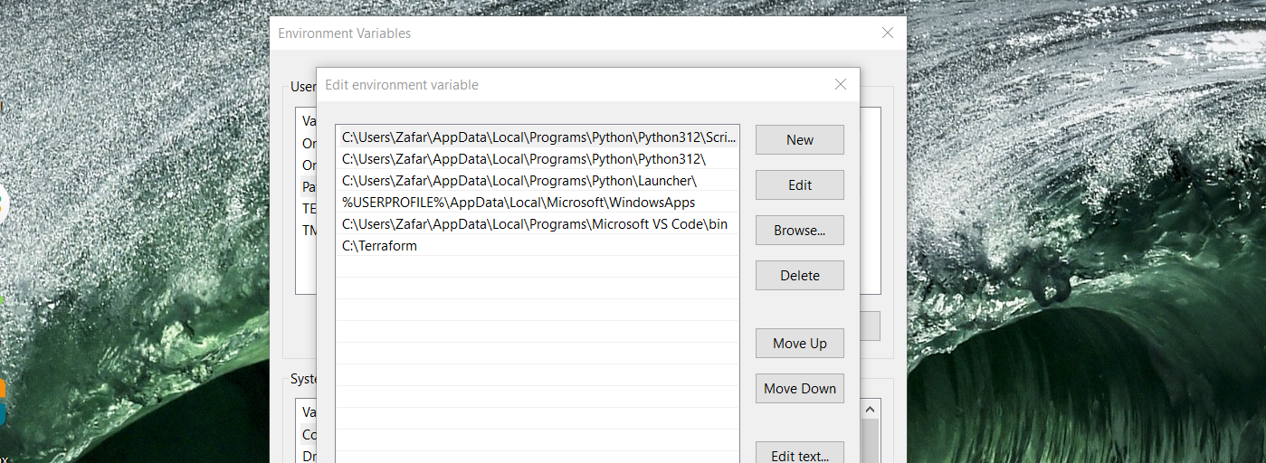

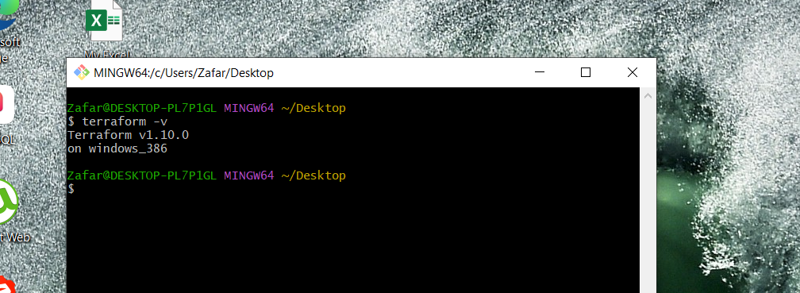

***>> Installed Hashi Corp Terrafrom extension.***

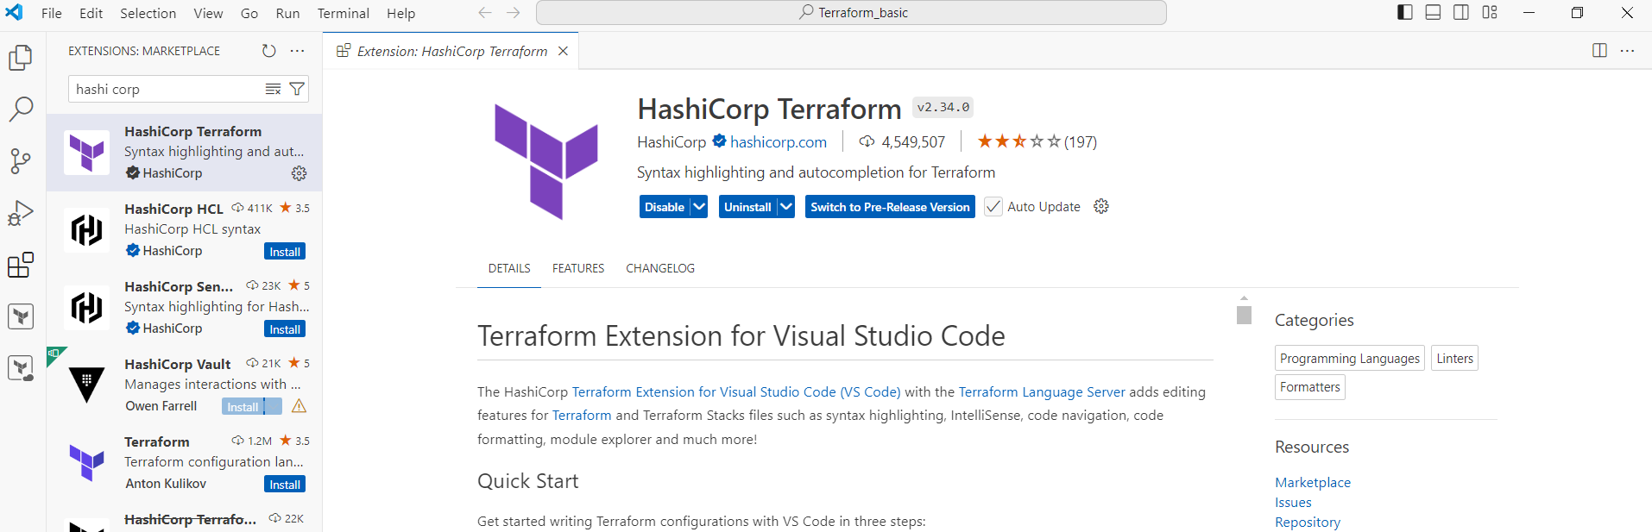

**>>>Execute all the templates shown in video.**

**>>>Terraform Init**

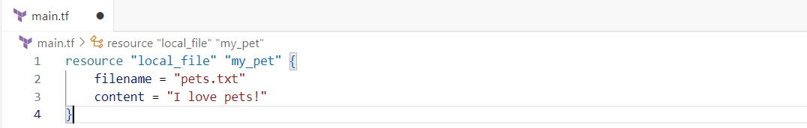

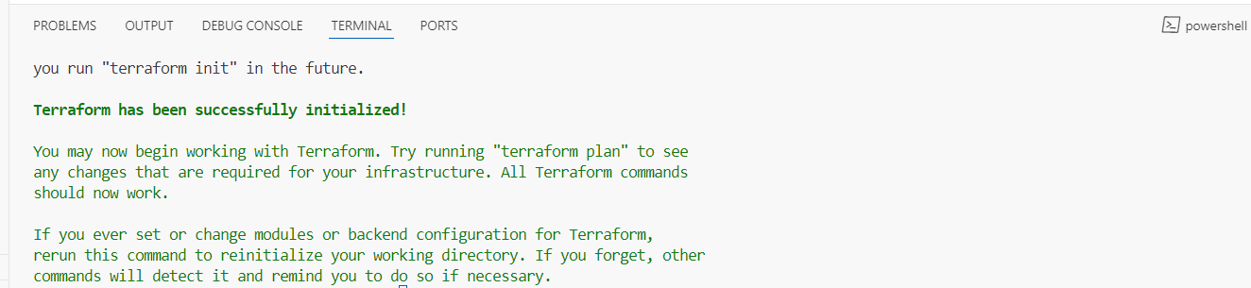

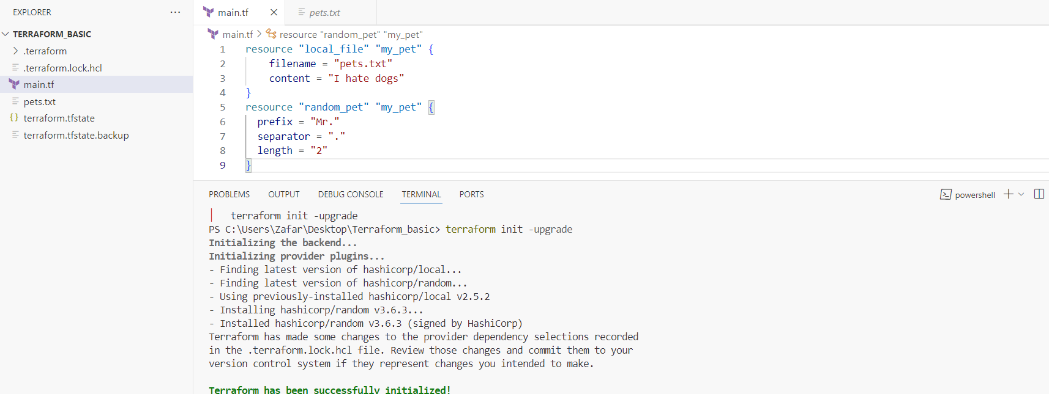

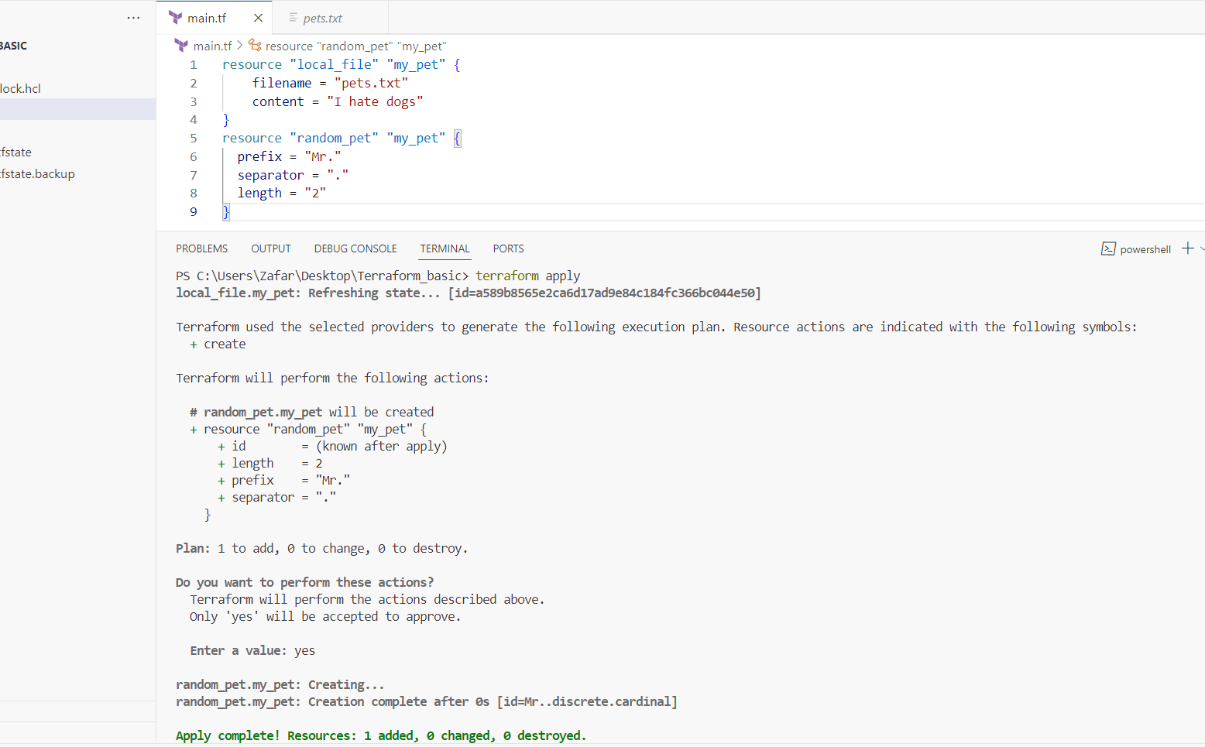

**>>>Terraform Plan**

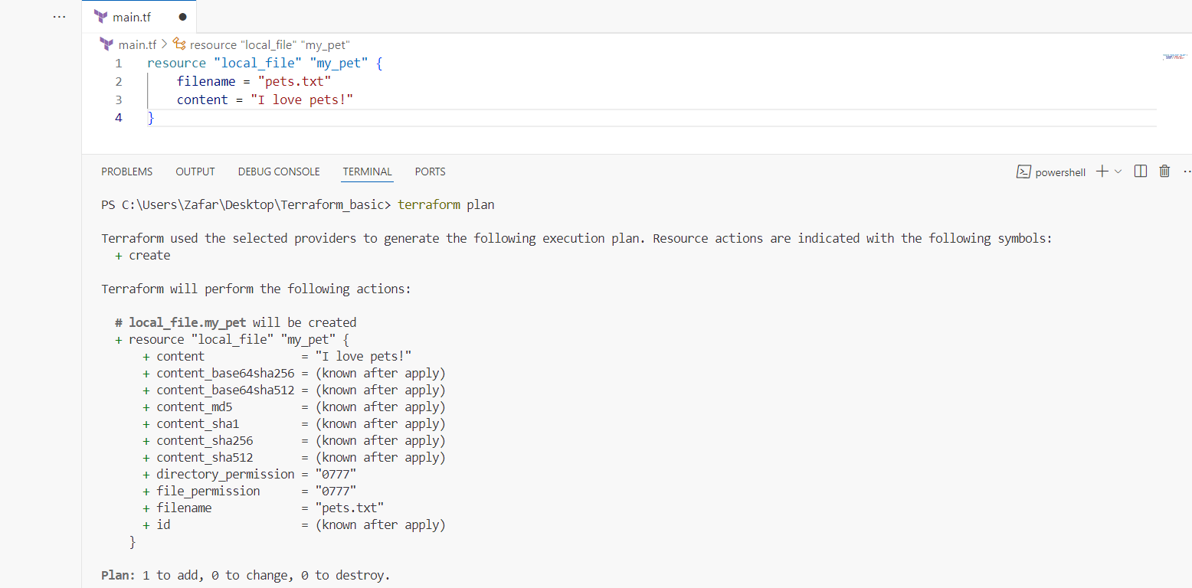

**>>>Terraform Apply**

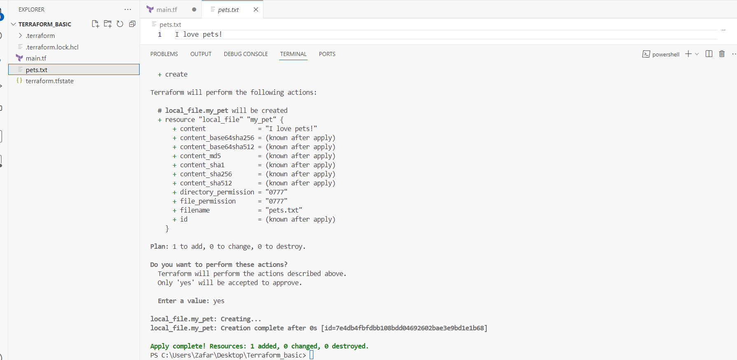

**Changed the content and terraform apply**

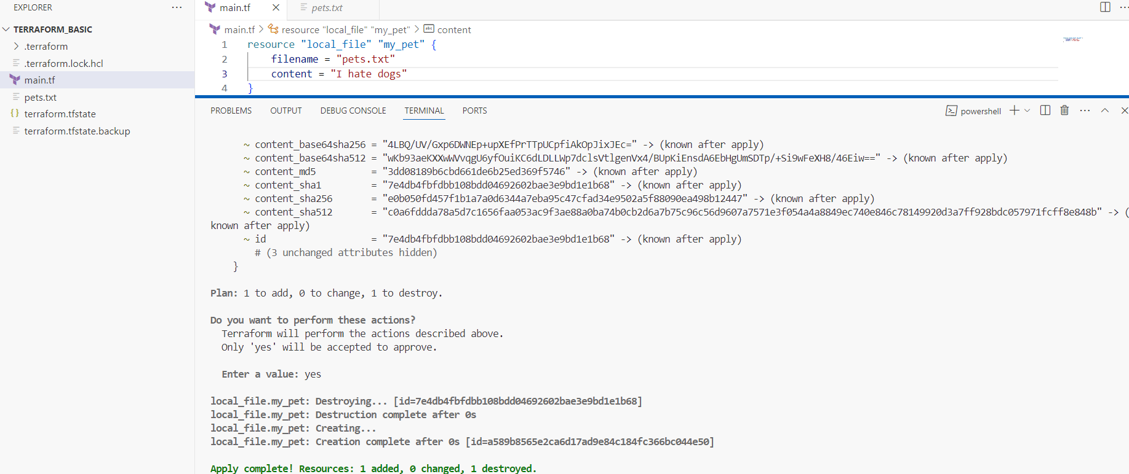



**>>>Terraform destroy**

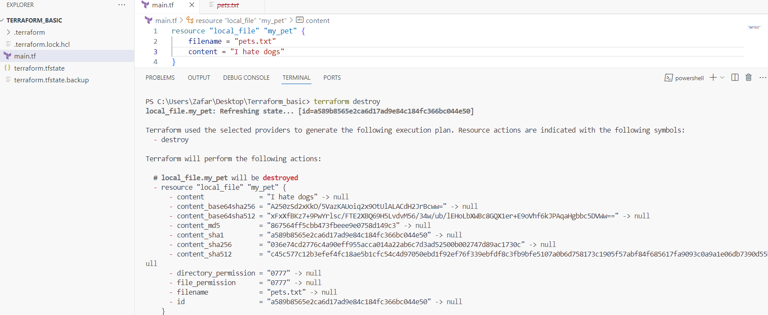

**>>>Terraform fmt**

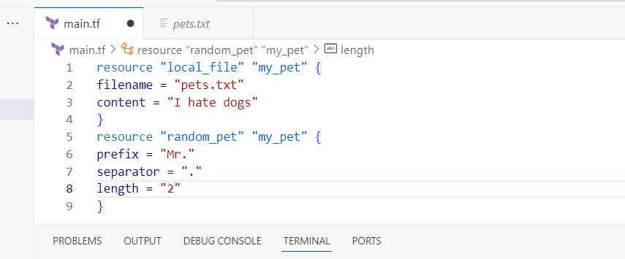

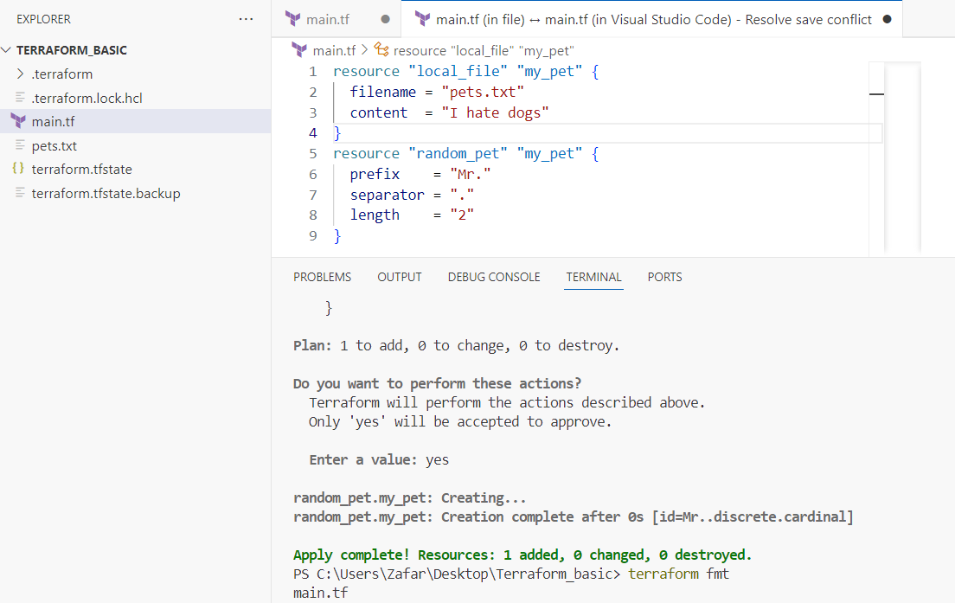

**>>>Integrate terraform in jenkins using Terraform plugin**

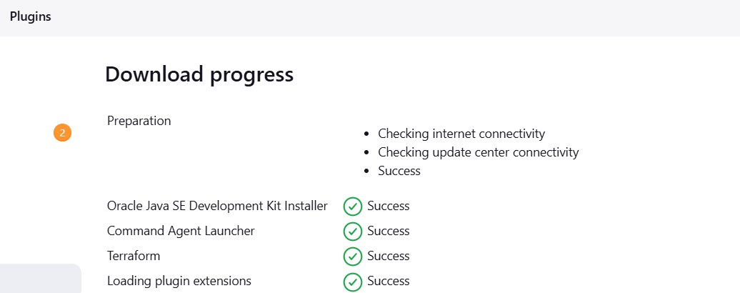

**Created the Jenkins job:**

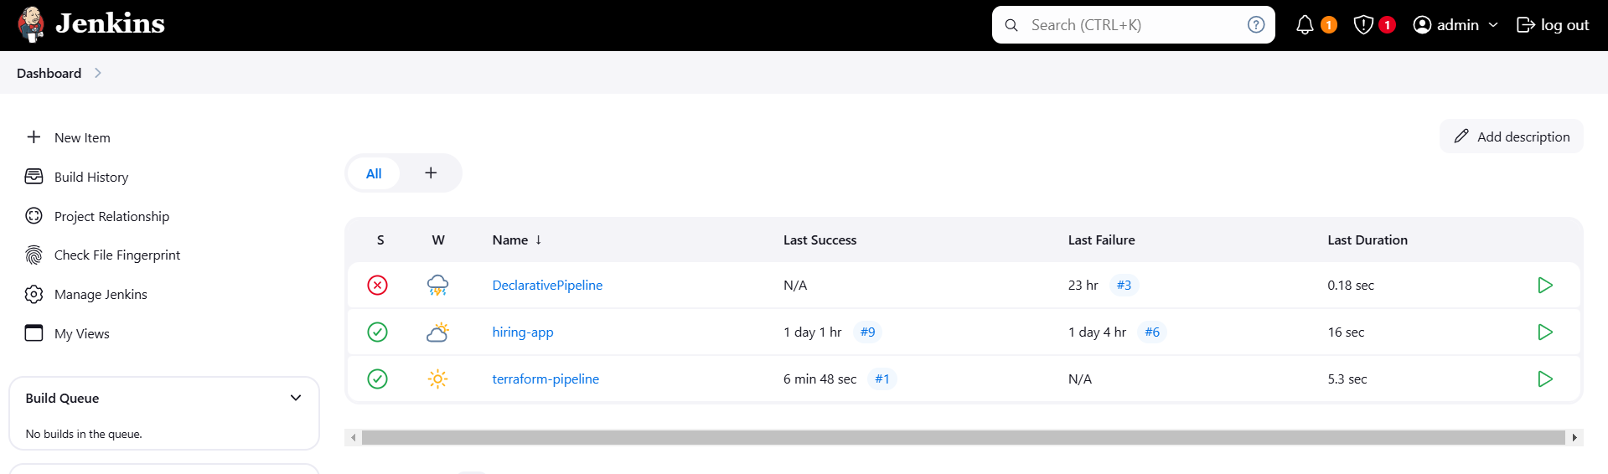

**>>>Creating github repository:**

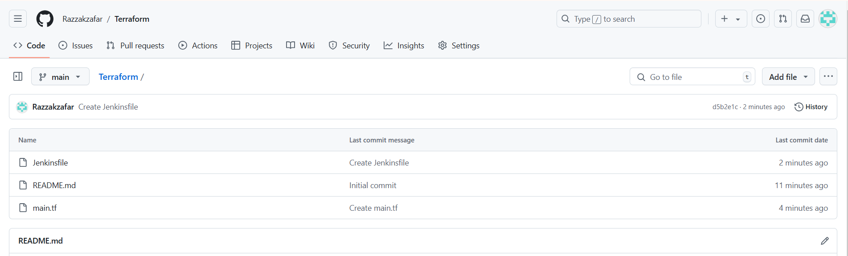

**Terraform Template**

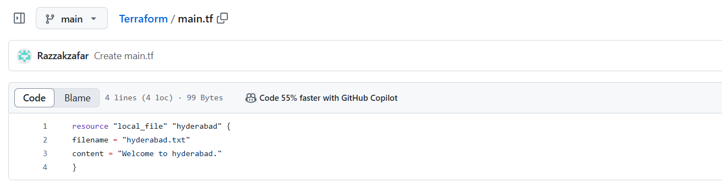

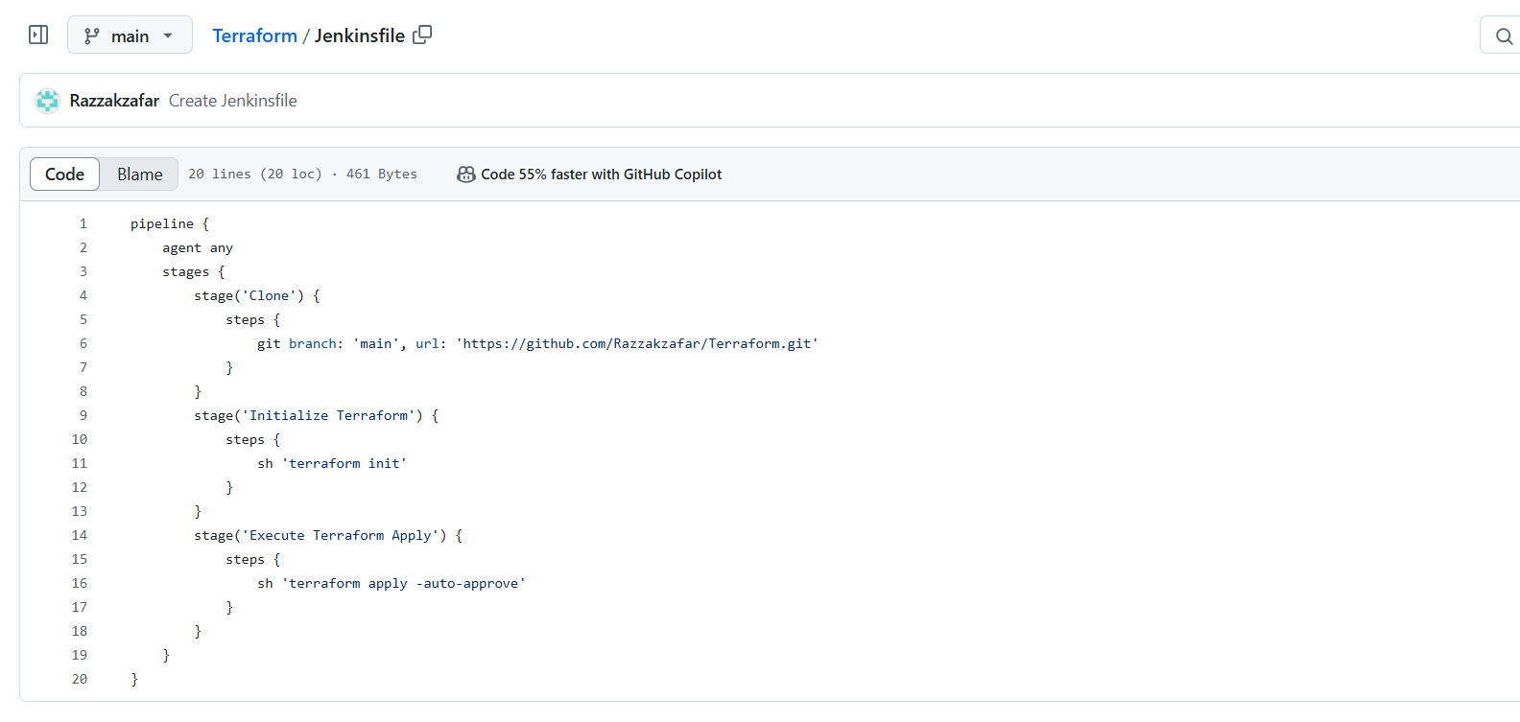

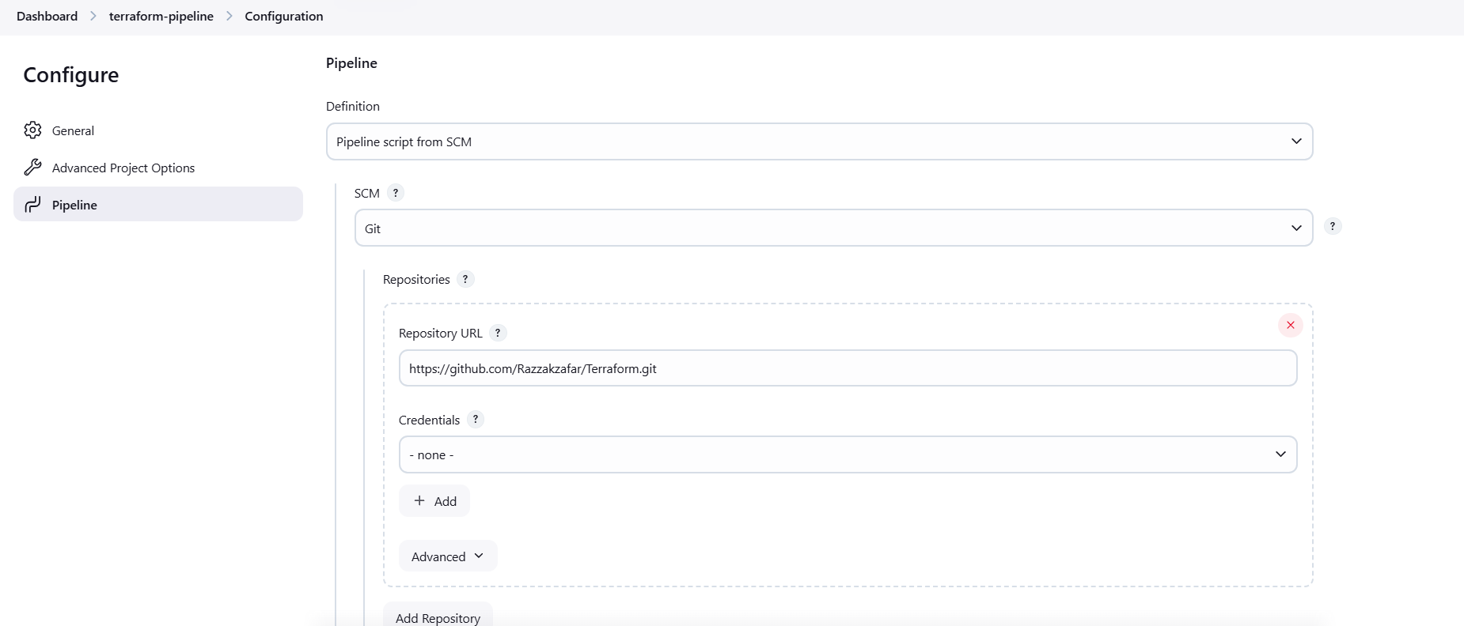

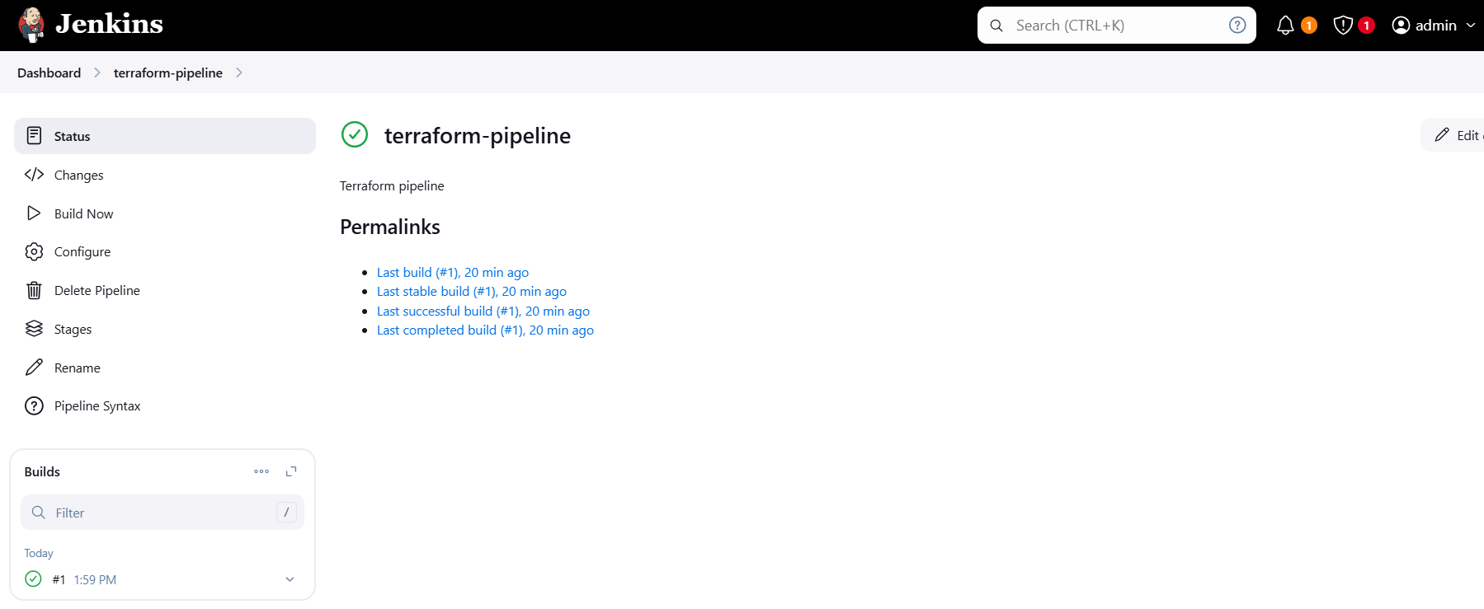

**>>>Console Output:**

