* **Configure VPC endpoints to securely access AWS services:**

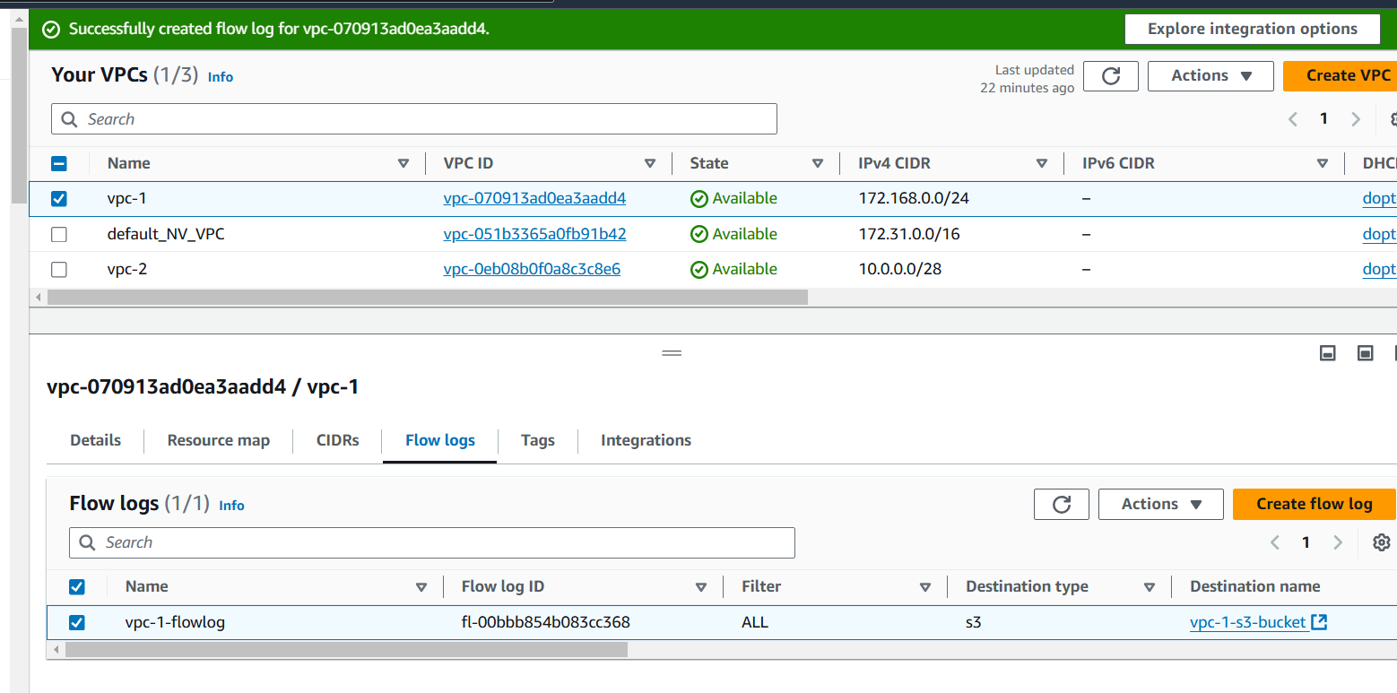

**-Created s3 bucket:**

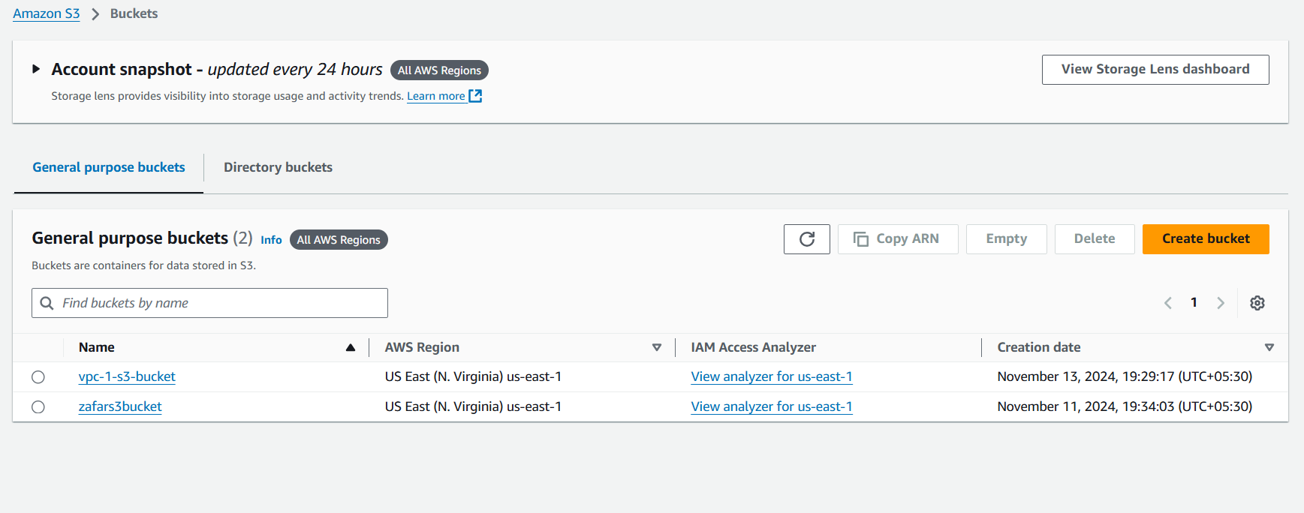

**-Tar file in my s3 bucket:**

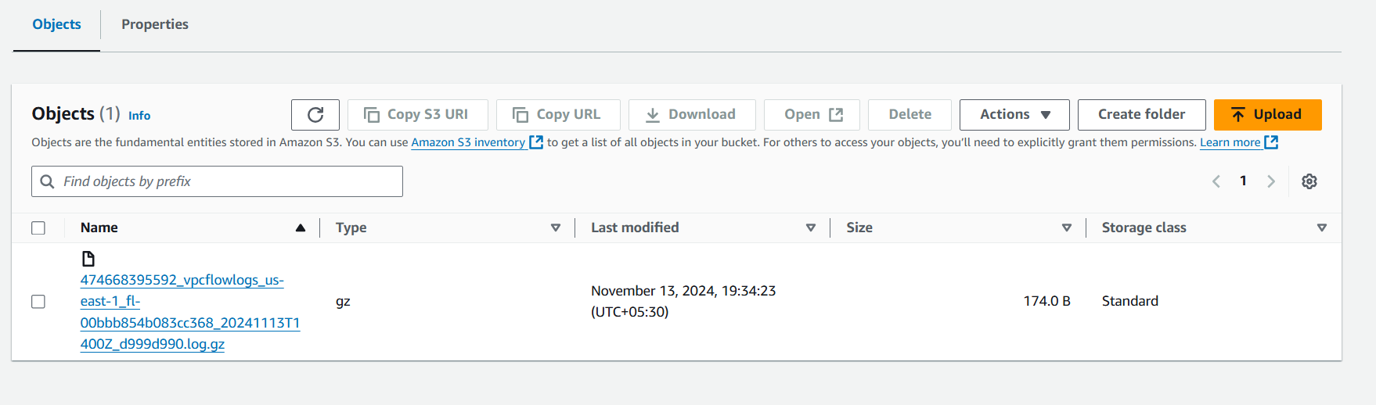

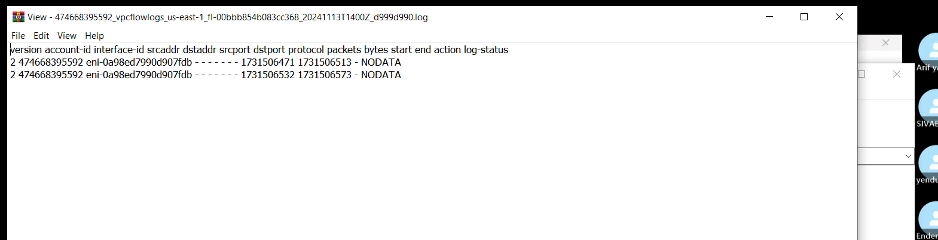

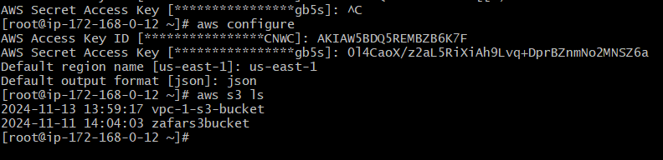

**-Accessing S3 bucket from private ec2 instance:**

