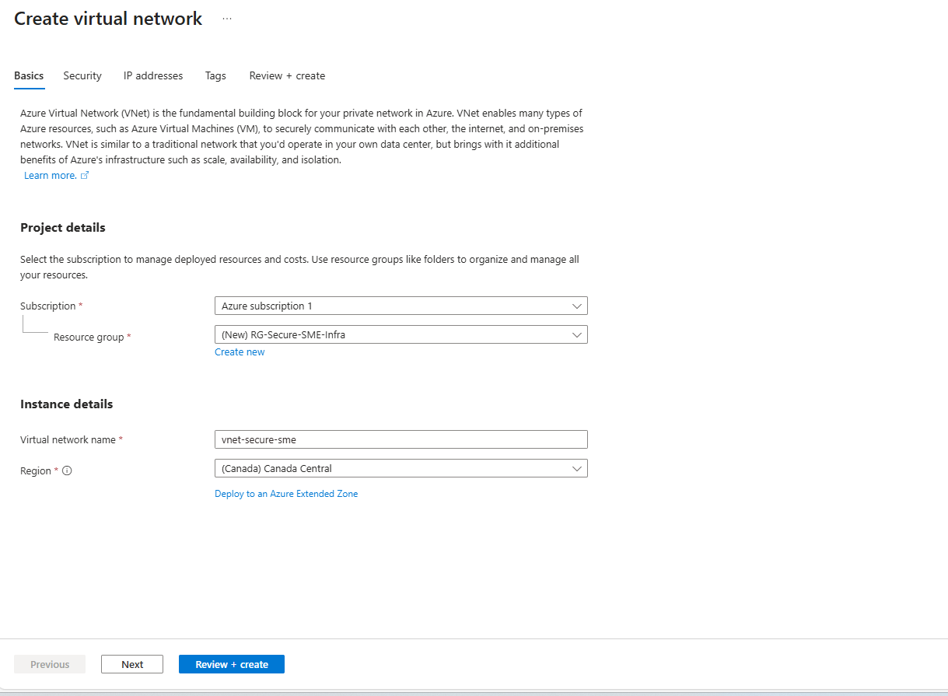
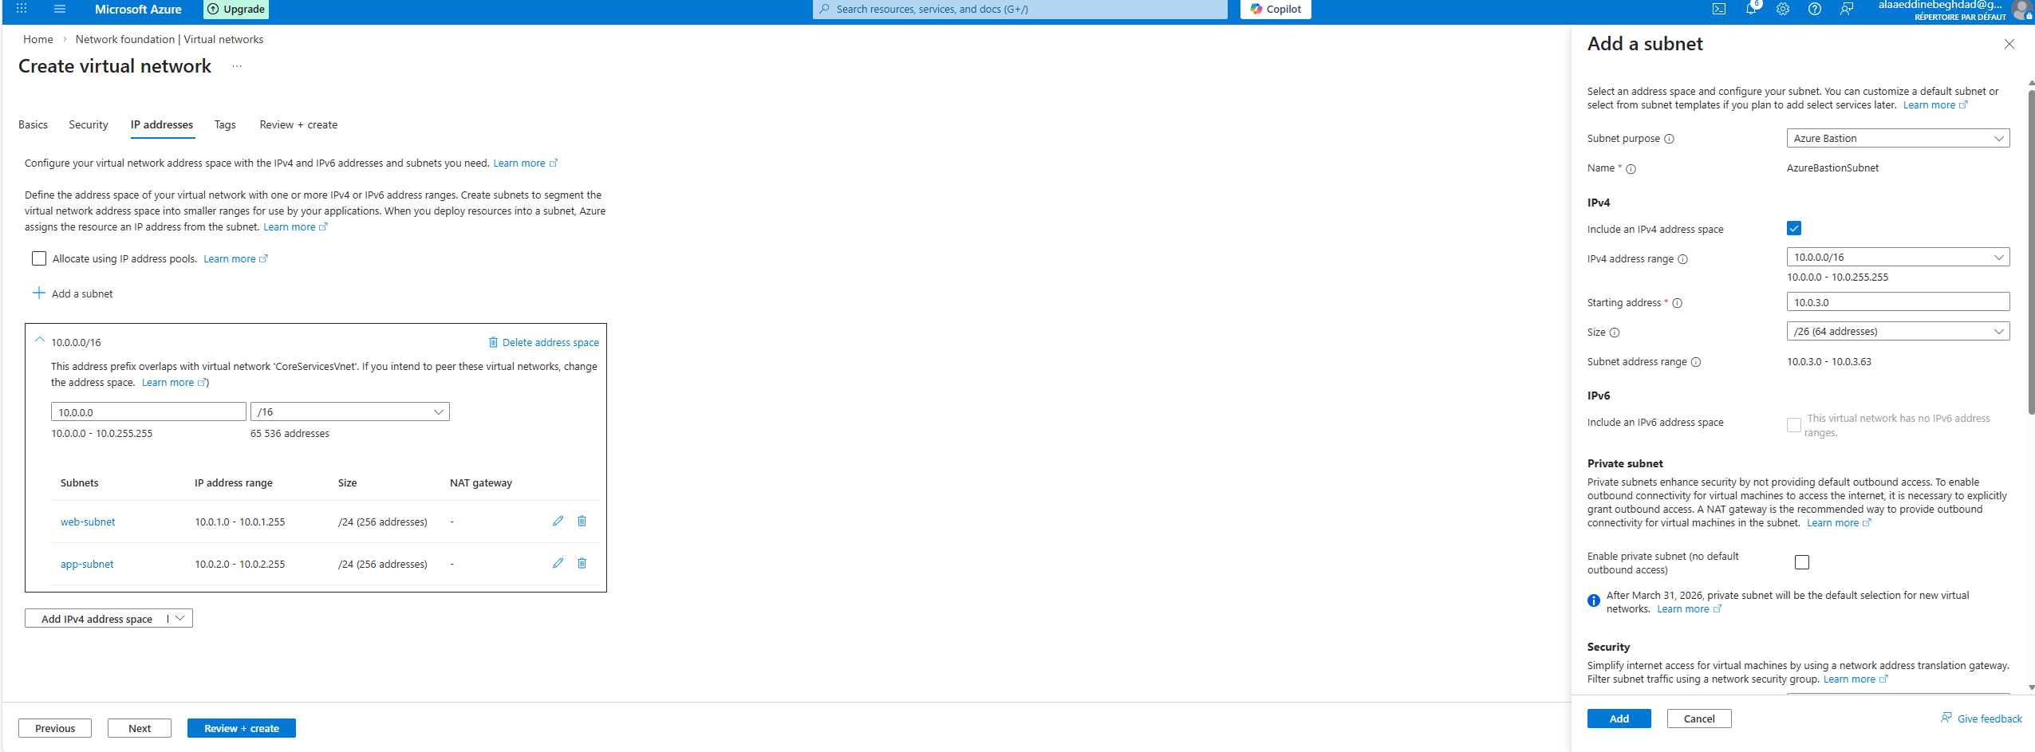
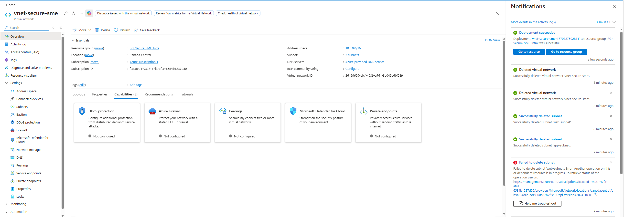
NEXT STEP : Network Security Groups (NSG)

# Step 2— Network Security Groups (NSG)

## Objective
Implement subnet-level security controls to restrict inbound and outbound traffic.

## NSG-Web
- Name: nsg-web
- Associated to: web-subnet
- Purpose: Protect web-tier resources

Rules will be configured in the next step.
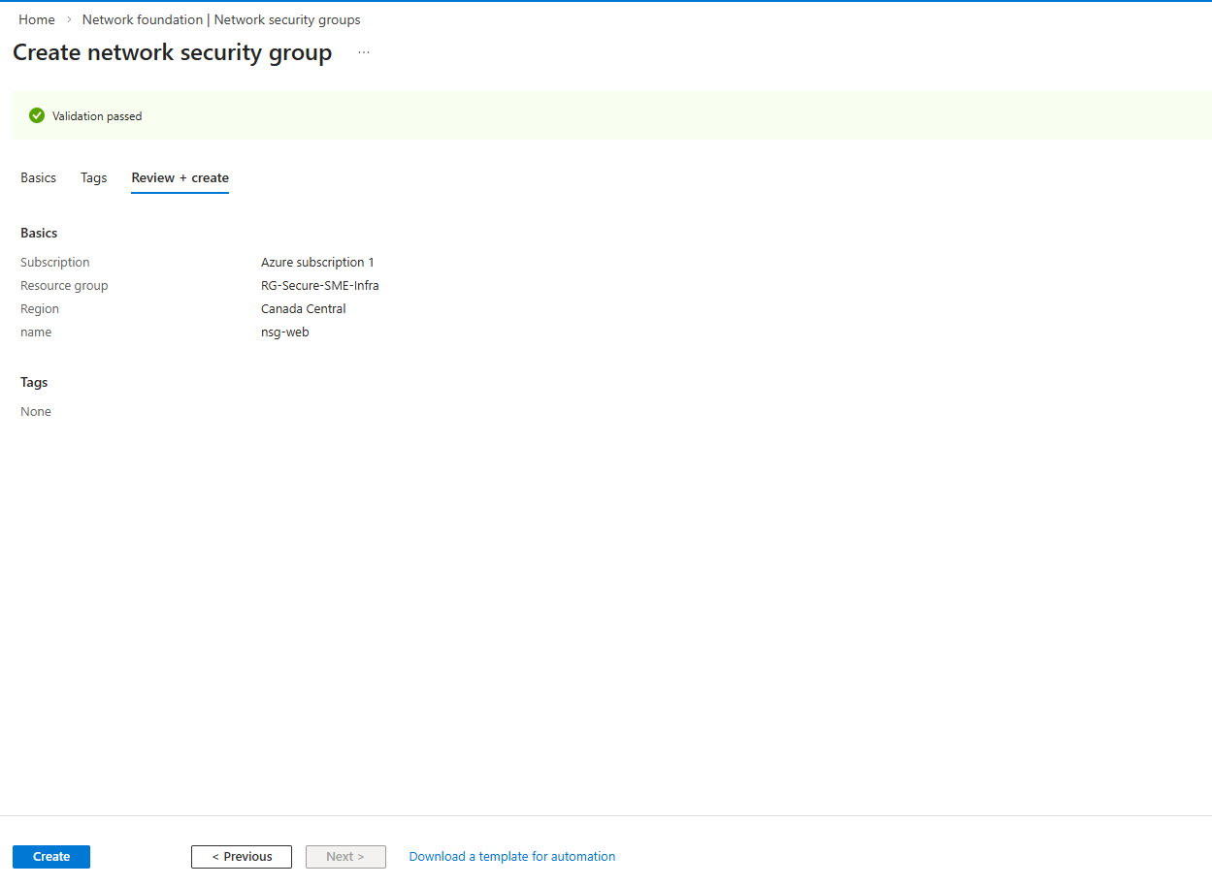
# Step 3 — NSG Association

## Objective
Associate NSGs to subnets to enforce network segmentation.

## Associations
- web-subnet → nsg-web
- app-subnet → nsg-app
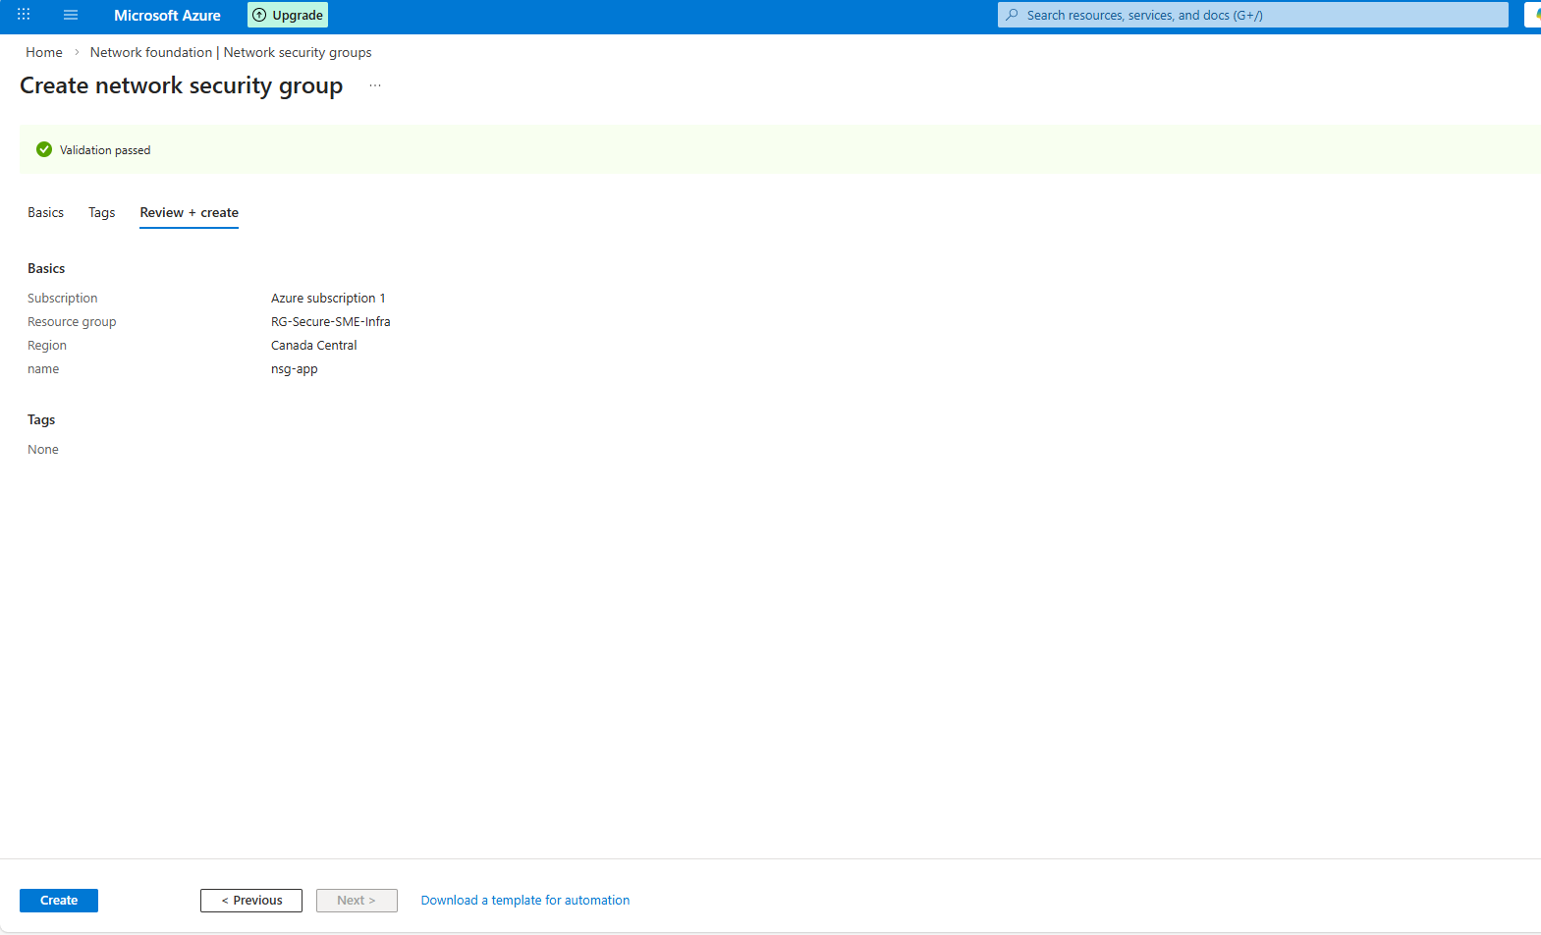

## Notes
Subnet-level NSGs provide centralized traffic filtering for all NICs/VMs in the subnet.
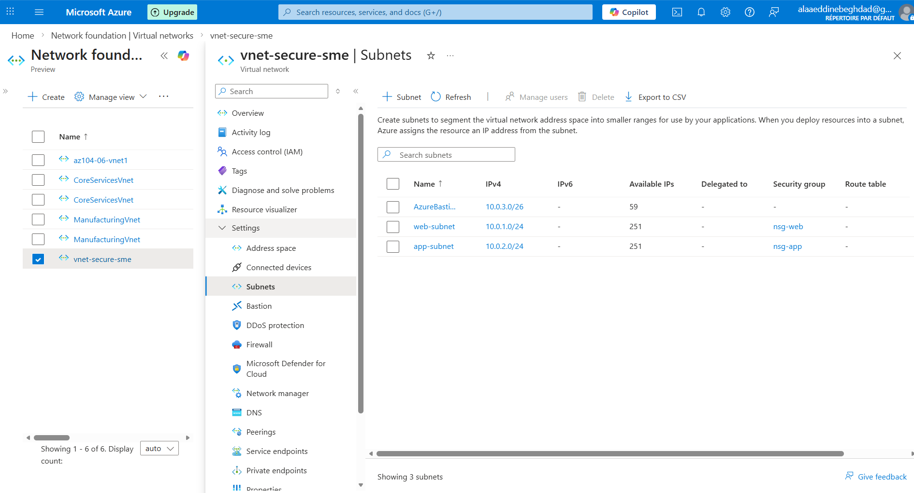

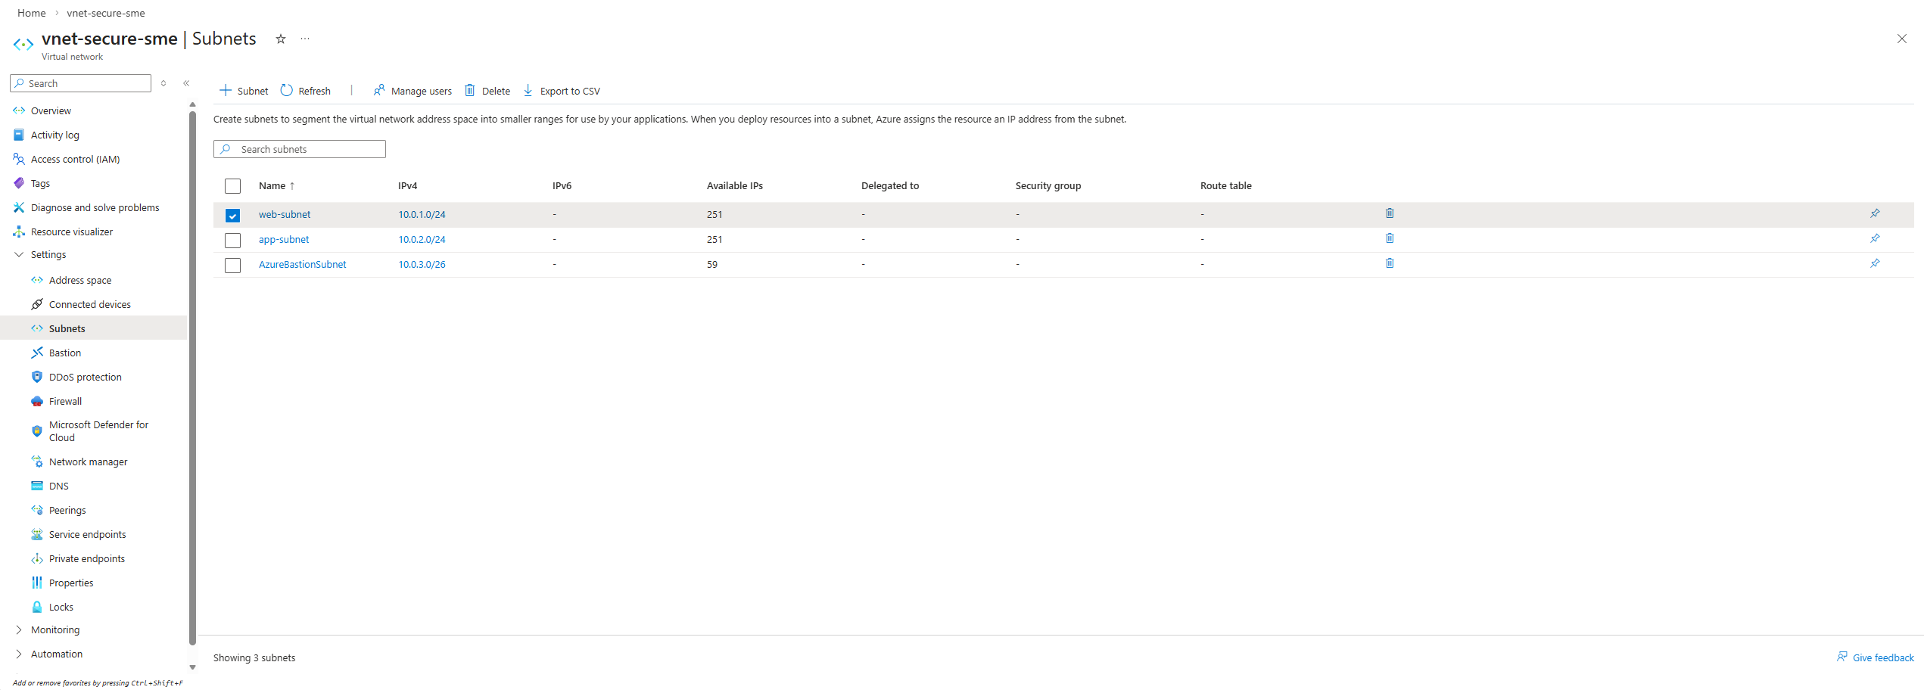
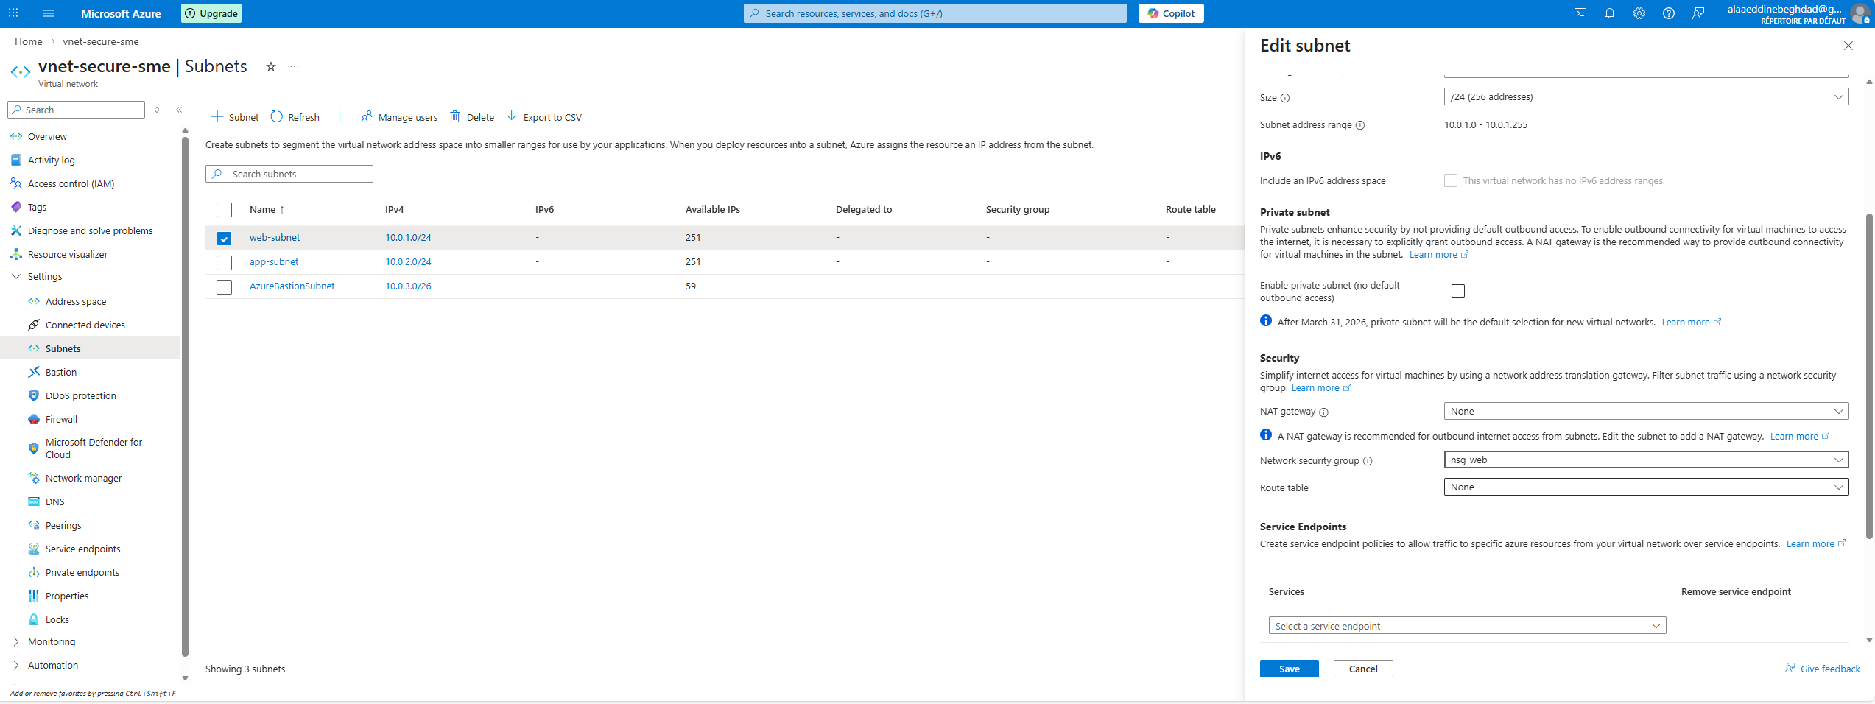
Inbound rules for NSG :
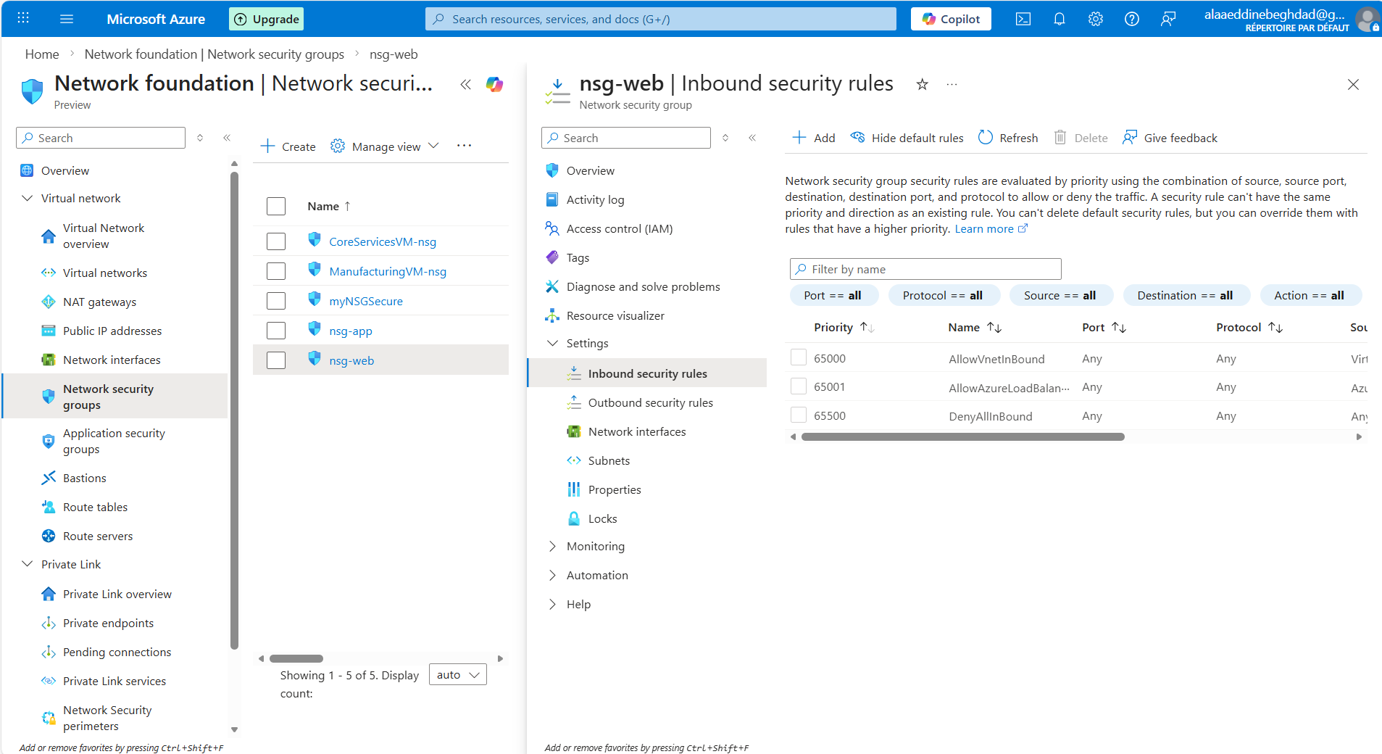

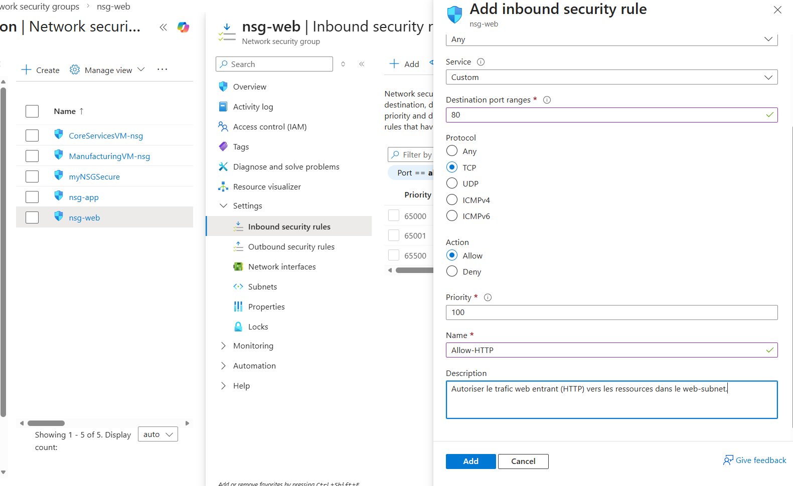

# Step 4 — NSG Rules Configuration

## Objective
Define inbound traffic rules to control access to the web subnet.

## NSG-Web Inbound Rule

Rule Name: Allow-HTTP
Priority: 100
Protocol: TCP
Port: 80
Source: Any
Destination: Any
Action: Allow

## Purpose

This rule allows incoming HTTP traffic (port 80) to resources deployed in the web-subnet.

Without this rule, external users would not be able to access web services hosted inside the subnet.

## Security Consideration

Only required ports are opened.
All other inbound traffic remains blocked by default (DenyAllInBound).
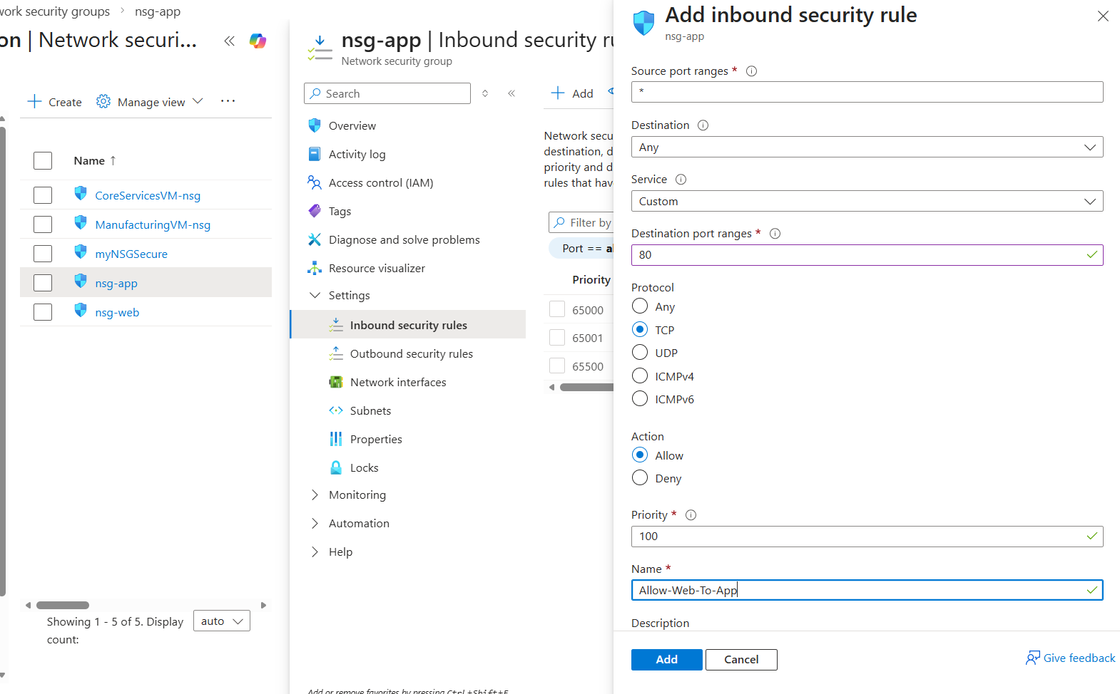

NSG Rule – Allow Web to App Communication
In this step, I created an inbound security rule inside the nsg-app Network Security Group.
The rule allows HTTP traffic (TCP port 80) coming specifically from the web subnet (10.0.1.0/24) to the app subnet.
This ensures controlled communication between the web tier and the application tier while maintaining network segmentation and security best practices.
Configuration:
- Source: 10.0.1.0/24 (web subnet)
- Protocol: TCP
- Destination Port: 80
- Action: Allow
- Priority: 100
- Rule Name: Allow-Web-To-App
This implements a basic 3-tier architecture security model by allowing only required traffic between layers.
Added Explicit Deny Rule for App Subnet
To reinforce security, I created a deny rule in nsg-app blocking inbound HTTP traffic from any source except the web subnet.
This ensures the application layer cannot be accessed directly from the internet.
Configuration:
- Source: Any
- Protocol: TCP
- Destination Port: 80
- Action: Deny
- Priority: 200
- Rule Name: Deny-Internet-To-App
This enforces proper network segmentation and protects the application layer.

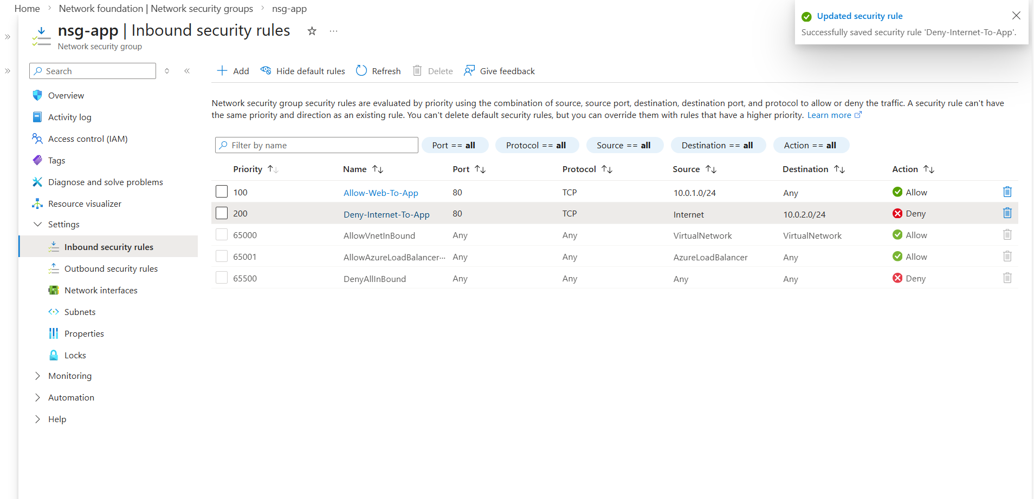
Configured NSG rules for application subnet (nsg-app).

- Allowed HTTP traffic (TCP 80) from Web subnet (10.0.1.0/24) to App subnet.
- Denied direct Internet access to App subnet using Service Tag "Internet".
- Implemented priority-based security model (100 allow internal, 200 deny external).
- Ensured secure 3-tier network segmentation.
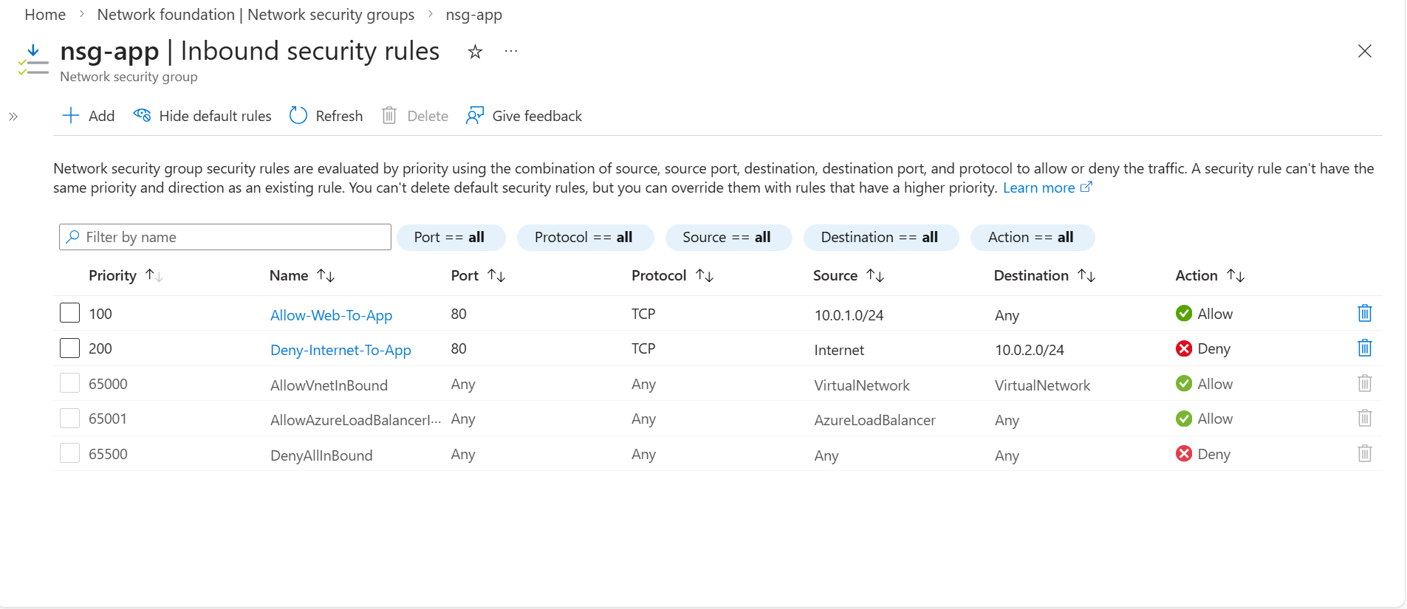
Two-Tier VM Deployment
Objective
Deploy two virtual machines in separate subnets to implement network segmentation and simulate a basic secure two-tier architecture.

VM Roles
Web Tier – vm-web
- Subnet: web-subnet
- Public IP: Enabled
- Purpose: Internet-facing entry point
- Handles external traffic
Application Tier – vm-app
- Subnet: app-subnet
- Public IP: None
- Purpose: Internal backend server
- Accessible only from the web subnet

Design Rationale
The web and application layers are isolated at the network level.
- The web VM is exposed to the internet.
- The application VM is private.
- Direct internet access to the backend is blocked.
- Communication between tiers is controlled using NSG rules.

Traffic Flow
Internet → vm-web → vm-app
Internet ✗→ vm-app (blocked)

This setup demonstrates:
- Subnet-based segmentation
- Controlled inter-tier communication
- Reduced attack surface
- Azure networking best practices

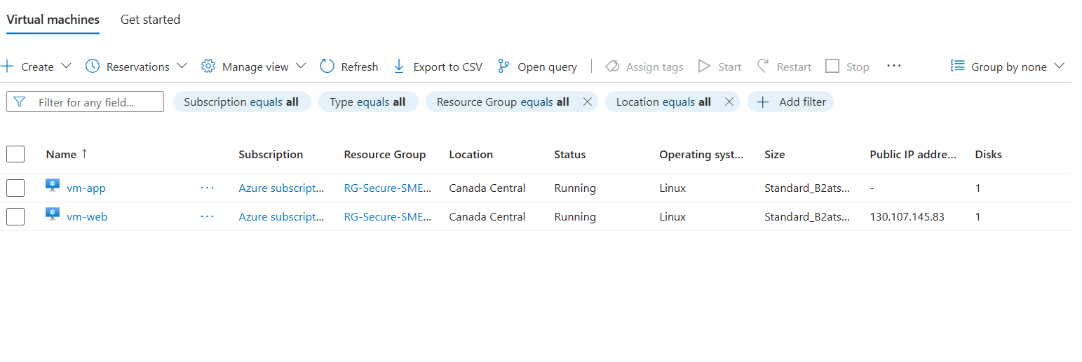## Backend Protection Verification

Direct access to the application server is blocked by NSG rules.

Attempting to access the private IP from the web tier results in a timeout, proving that only authorized traffic is permitted.

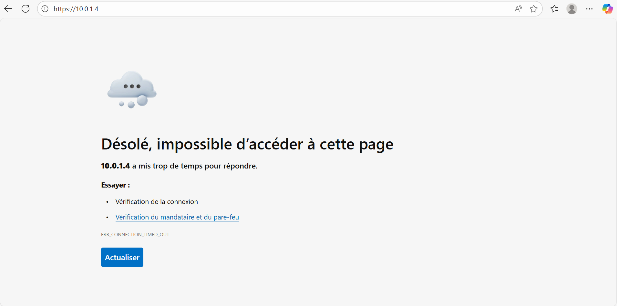

## Lessons Learned

Through this project, I implemented a secure network architecture in Azure using Network Security Groups and subnet segmentation.

Key takeaways:

- Subnet-level NSGs provide centralized security control for multiple resources.
- Security rules are processed by priority (lower number = higher priority).
- Default Azure rules still apply unless explicitly overridden.
- Public-facing services should be isolated from backend resources.
- Backend servers must never be directly exposed to the internet.
- The principle of least privilege improves overall security posture.
- A timeout connection can be a valid security result, proving traffic is blocked.

This lab demonstrates how proper network segmentation reduces attack surface and protects internal workloads in a cloud environment.

Phase 2 — Attack Simulation & Security Validation
An external connectivity test was performed against the backend server public IP.
Result:
- No ICMP response
- TCP connection failed
This confirms the backend server is not reachable from the internet and the NSG segmentation is correctly protecting internal resources.
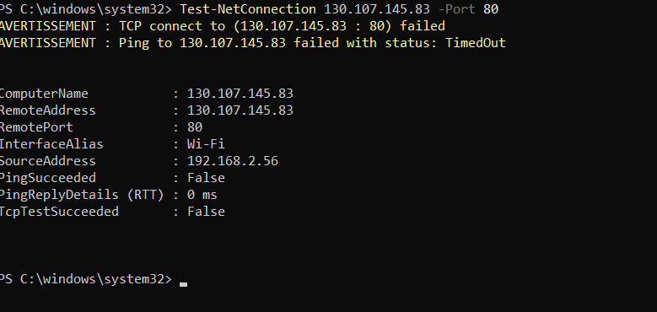

Phase 3 — Secure Access with Azure Bastion

## Phase 3 — Secure Administrative Access (Azure Bastion)

To improve the security posture of the environment, remote administrative access to the virtual machines was migrated to Azure Bastion.

Instead of exposing management ports such as RDP (3389) or SSH (22) to the internet, administrators connect to the machines directly through the Azure portal over HTTPS.

This approach provides:

- No public management ports exposed
- Protection against brute-force and port scanning attacks
- Centralized and controlled remote access
- Reduced attack surface

Azure Bastion acts as a secure jump host managed by the platform, allowing access to both the web and application servers without requiring public IP connectivity.

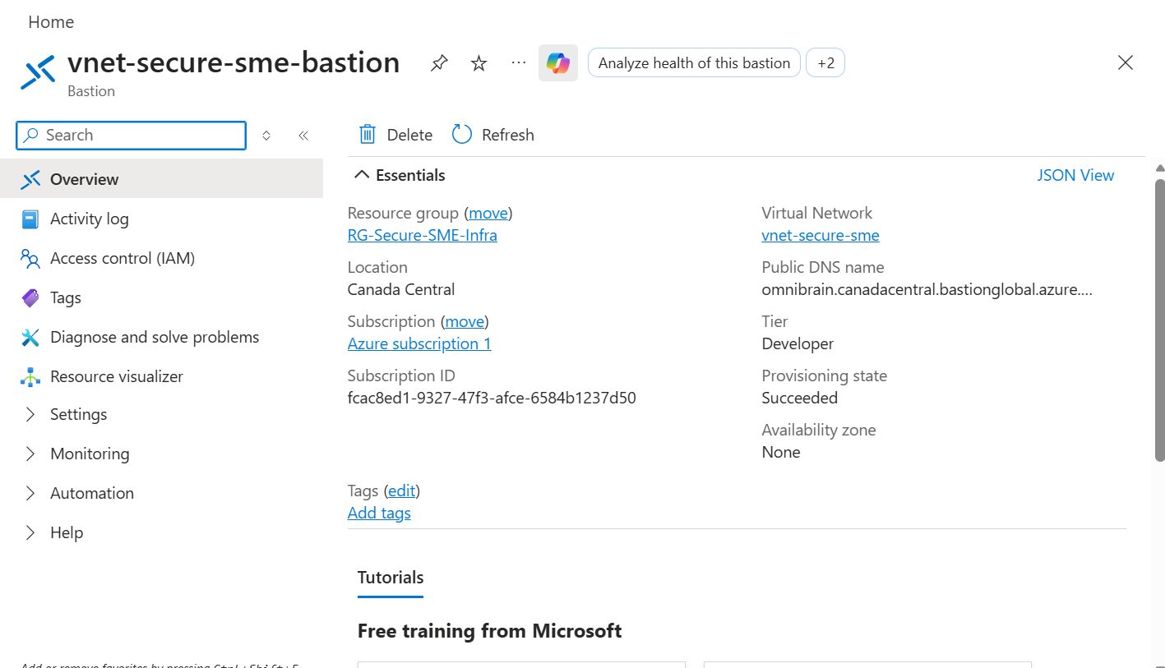
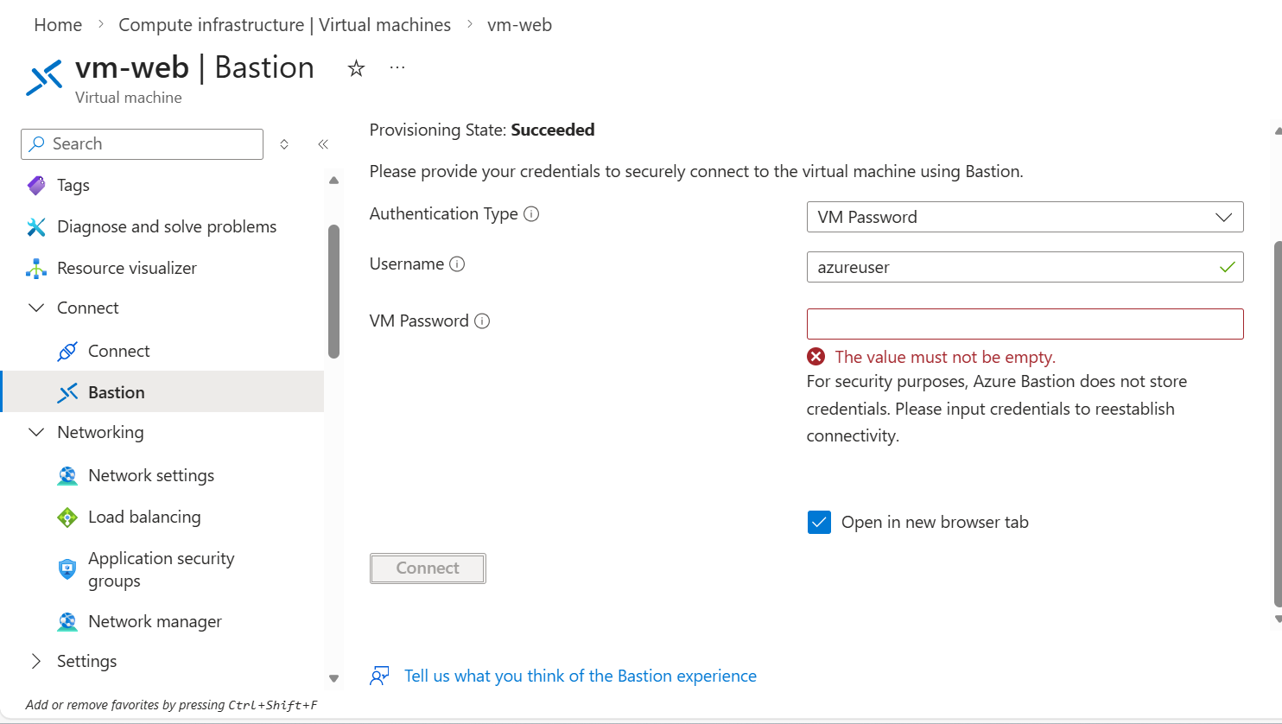
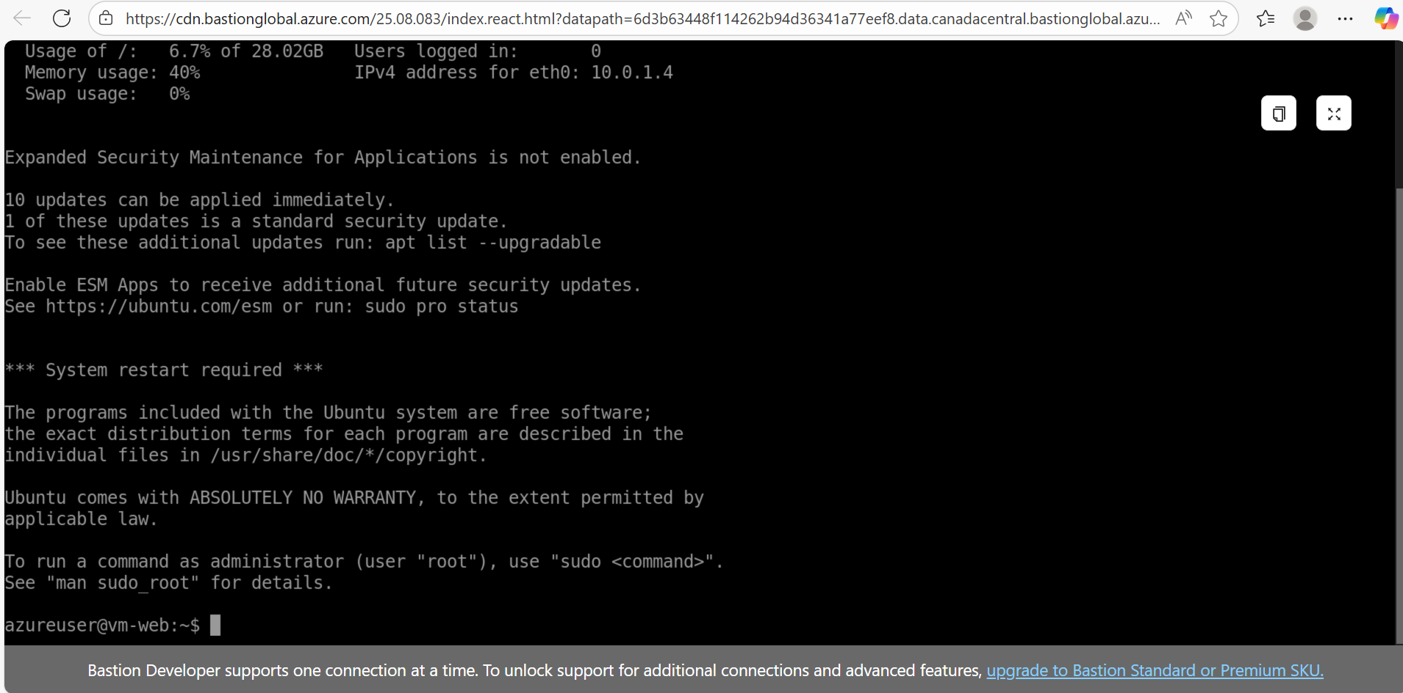
Bastion Summary
Azure Bastion was deployed to securely access virtual machines without exposing RDP/SSH ports to the internet.
Instead of assigning public IP addresses to the VMs, all administrative access is performed through the Azure portal using a private connection inside the virtual network.
This approach significantly reduces the attack surface and prevents common attacks such as port scanning and brute-force attempts.
The Bastion connection successfully allowed remote administration of the web server while keeping the backend infrastructure completely private.

## Phase 4 — Backup & Recovery (Recovery Services Vault)
Objective
The goal of this task is to protect an Azure Virtual Machine against data loss by configuring Azure Backup using a Recovery Services Vault.
This ensures business continuity and allows recovery in case of deletion, corruption, ransomware or infrastructure failure.
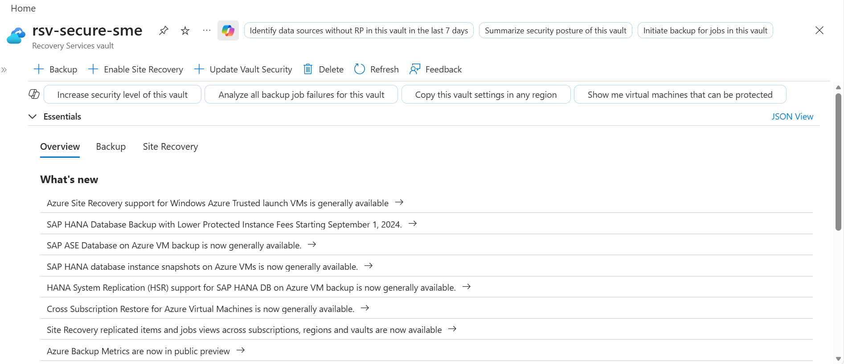
Step 1 — Create Recovery Services Vault
A Recovery Services Vault was deployed in the same region as the virtual machines.
Why?
Azure Backup stores recovery points inside the vault.
A VM cannot be protected without being associated to a vault.
Important:
- Region must match the VM region
- Storage replication defines durability (LRS/GRS)
- Cannot be changed after backups exist

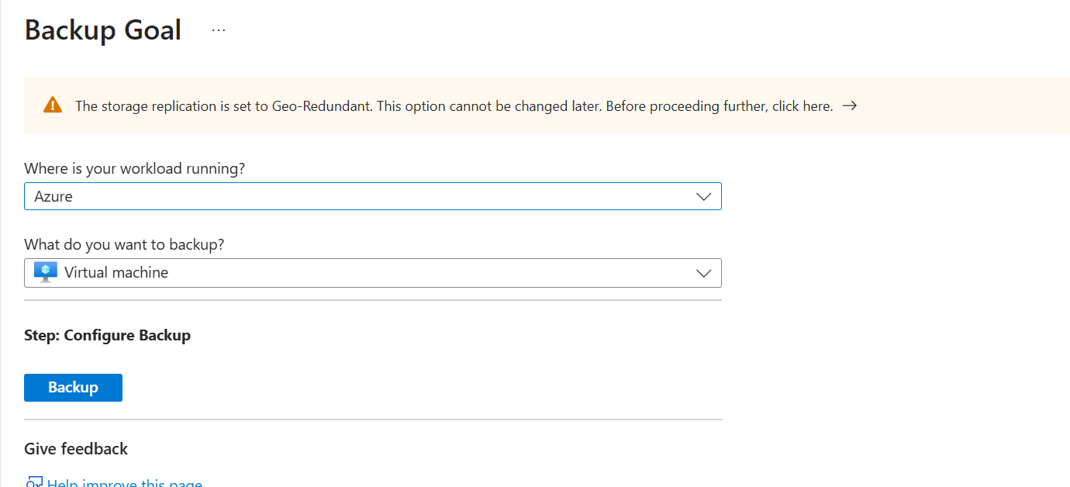
Step 2 — Configure Backup Policy
Backup goal:
- Workload: Azure
- Resource: Virtual Machine
Policy type selected: Standard
Explanation:
- Standard → one backup per day (cheaper)
- Enhanced → multiple backups per day (more expensive)
This decision is important in real environments to control cost.

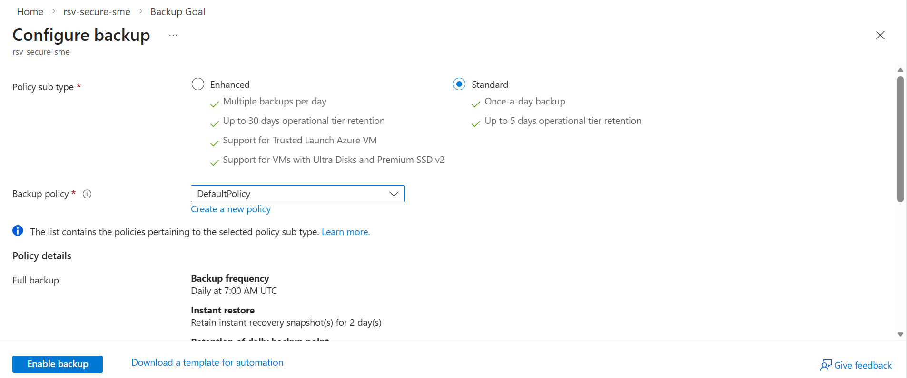
Step 3 —Enable Protection
The VM was attached to the vault and protection was enabled.
Important concept:
At this stage the VM is NOT protected yet.
Azure only configured the backup relationship.
Protection starts only after the first recovery point is created.

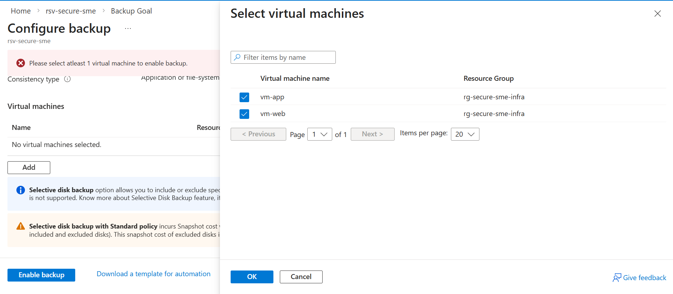
Step 4 — Initial Backup (First Recovery Point)
After enabling backup, Azure automatically triggered the first backup job.
Process:
- Azure creates a disk snapshot
- Snapshot copied into the Recovery Services Vault
- Recovery point created
Once completed → the VM becomes officially protected.
This is a key AZ-104 exam concept.

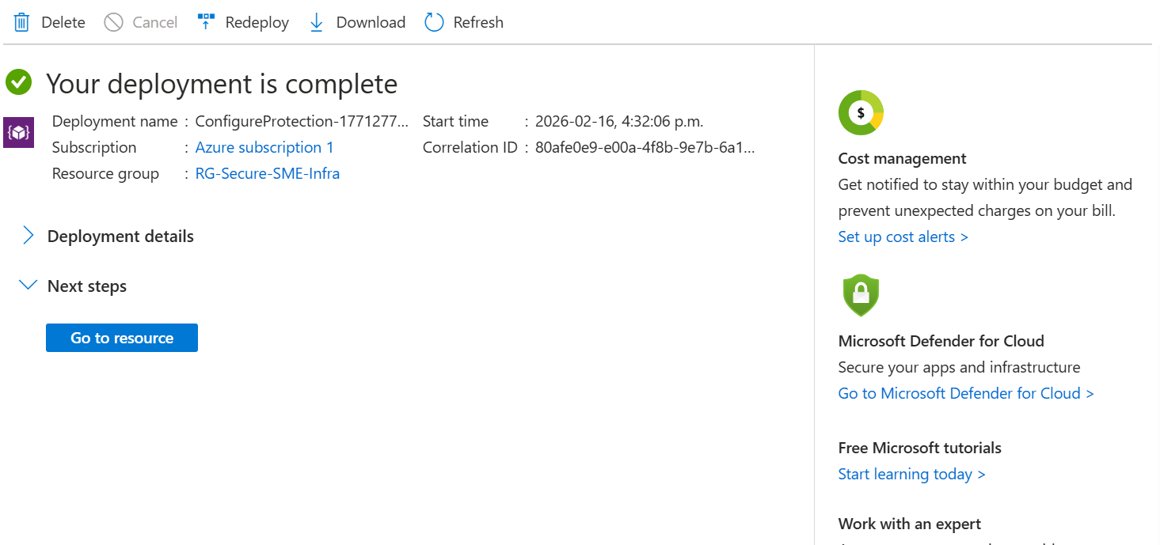
Step 5 — Verify Backup Status
Backup Jobs blade was used to monitor the operation.
Status meanings:
- Configure backup → configuration success
- Backup in progress → snapshot creation
- Completed → VM protected
After completion, recovery points appear in the vault.

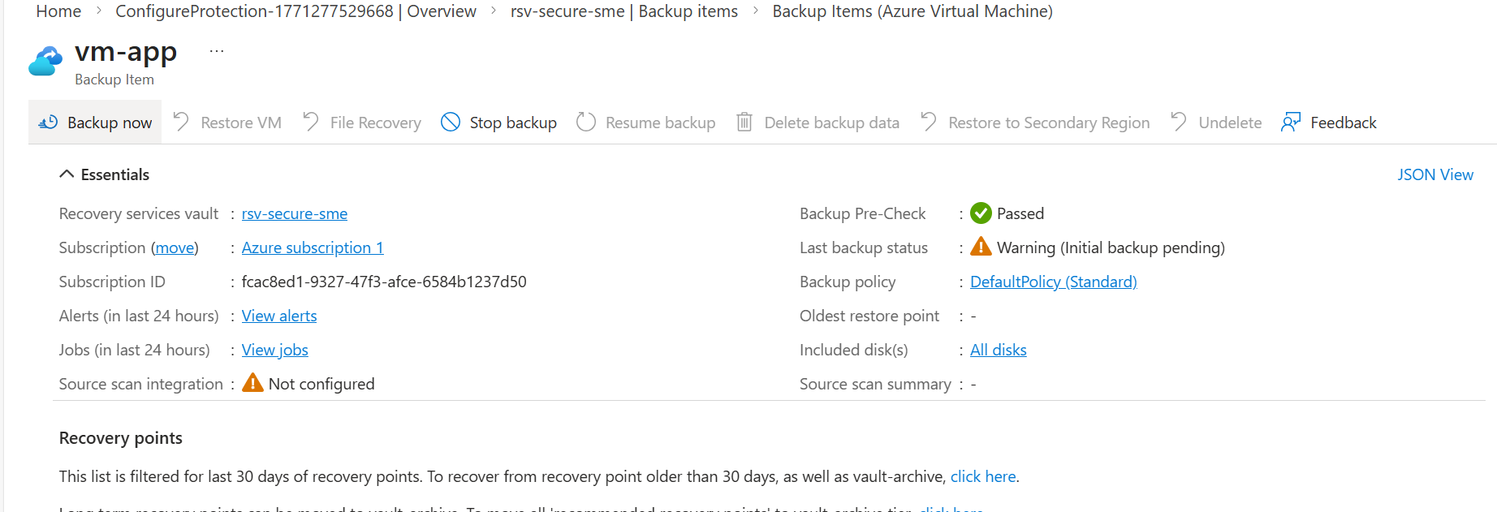
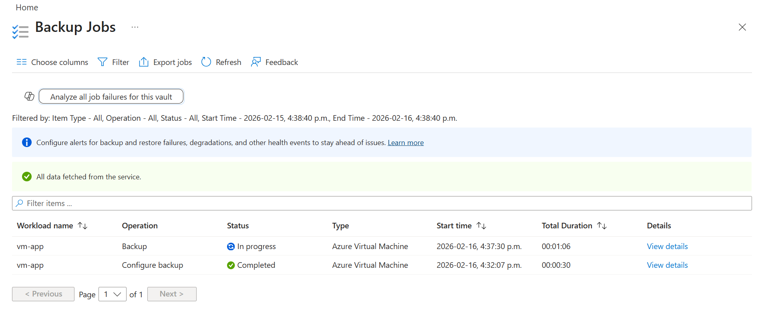
Key Concepts Learned
- Backup != Protected until first recovery point exists
- Recovery Services Vault stores restore points
- Backup policy controls cost and frequency
- Snapshots are used before vault storage
- Standard vs Enhanced policies affect pricing

