**SMOSRE2111**

**MOSES REUBEN**

**MAABARAConN**

- "MAABARAConN transforms lab report management with a digital platform that enhances efficiency, learning, and interaction in educational settings."

**Background Information:**

In many educational institutions, the submission and management of lab reports remain a manual, paper-based process. This traditional approach involves students writing reports in physical notebooks and submitting them to lab technicians or instructors for grading. This method poses several challenges, including physical storage issues, the risk of damage or loss, and time-consuming grading processes. Moreover, it limits the feedback loop and learning enhancement opportunities for students, as comments and grades on physical reports may not be as easily accessible or actionable.

**Problem Statement:**

The manual, paper-based system for lab report submission and management is inefficient and prone to errors. It creates a significant administrative burden for lab technicians and instructors, who must manage, store, and grade a large volume of physical reports. For students, this system limits their ability to receive timely, detailed feedback and hinders their learning experience. Additionally, the physical submission process can be inconvenient and inflexible, failing to leverage the potential of modern technology to enhance educational outcomes.

**Justifications:**

Transitioning to a digital lab report submission system offers myriad benefits that significantly enhance the educational experience and operational efficiency. By leveraging digital platforms, students gain access to immediate, interactive, and comprehensive educational content, fostering a more engaging and effective learning environment. This shift not only streamlines the submission and grading processes, reducing manual errors and saving time, but also facilitates a quicker and more detailed feedback loop, enabling a personalized learning journey. Incorporating innovative learning techniques, such as AI, prepares students for the technological advancements of the future, while also supporting environmental sustainability by reducing paper use. Moreover, digital submissions ensure the security and integrity of students' work, safeguarding against loss or damage. Altogether, moving to a digital submission system represents a forward-thinking approach that enriches student learning, optimizes administrative tasks, and aligns with environmental and technological progress**.**

**Objectives of the System:**

1. **Streamline Submission and Management**: To develop a digital platform that simplifies the submission, storage, and management of lab reports, making the process more efficient for both students and instructors.
2. **Integrated Experiment Data Collection Tools**

**Feature:** Provide tools within the app for data collection during experiments, such as digital forms or interfaces for entering measurements directly from lab equipment (where technologically feasible).

Use QR codes or NFC tags on lab equipment to quickly link the app to the specific experiment setup, making data entry seamless and reducing manual input errors.

1. **Automated Report Formatting and Templates: To** offer a range of customizable templates that automatically format lab reports according to departmental guidelines. This ensures consistency in report presentation and saves students time. Utilize an intelligent template suggestion system that recommends the most suitable template based on the lab's subject matter or the instructor's preferences.
2. **Facilitate Real-time Collaboration**: To offer features that enable real-time communication and collaboration between students and instructors and peer to peer collaboration fostering a more interactive and supportive educational environment.
3. **Improve Feedback Mechanisms**: To enable timely, detailed feedback through the platform, allowing for a dynamic and personalized learning experience.
4. **Enhance Student Learning and Engagement**: To integrate advanced technologies within the platform to provide interactive, immersive learning experiences, helping students better understand complex concepts. Utilize for experiment visualization and simulation, offering students an immersive learning experience.
5. **Implement AI for Personalized Learning**: Leverage AI to analyse student submissions for common errors and provide personalized improvement suggestions, fostering a tailored educational experience.
6. **Ensure Data Security and Integrity**: To implement robust security measures for the storage and management of digital reports, ensuring the authenticity and confidentiality of student work.

**Project Objectives in summery**

1. To create a digital platform that enables efficient submission, storage, and management of lab reports.
2. To streamline the grading and feedback process for instructors and lab technicians.
3. To enhance the educational experience for students through immediate, detailed feedback and innovative learning tools.
4. To reduce the environmental impact associated with paper-based report submission.

**SCOPE**

The scope of the project to digitally transform lab report submission encompasses several key components, aiming to address inefficiencies in the current manual process, improve educational outcomes, and streamline administrative tasks. Below is a detailed outline of the project scope:

**Key Features:**

* **User Management:** Roles for students, instructors, and administrators with respective access controls.
* **Report Submission and Tracking:** Capabilities for submitting, tracking the status, and retrieving past reports.
* **Real-time Collaboration and Communication Tools:** Features supporting interactions among students and between students and instructors.
* **Feedback and Grading System:** Tools for instructors to provide grades and feedback efficiently, including bulk actions where applicable.
* **Analytics and Reporting:** Dashboards for monitoring submission trends, grading efficiency, and user engagement.
* **System Compatibility:** Ensures interoperability with existing hardware and software within the educational ecosystem.

**BENEFICIARIES**

The beneficiaries of the digital lab report submission and management platform, MAABARAConN, include a diverse group of stakeholders, each with distinct roles within the educational ecosystem. The platform aims to enhance the overall efficiency and effectiveness of laboratory-based education by addressing the needs of these stakeholders. Below is a detailed description of the beneficiaries:

**1. Students**

* **Primary Beneficiaries**: Students are at the heart of the educational process and stand to gain significantly from the implementation of MAABARAConN.
* **Benefits**:
  + **Enhanced Learning Experience**: Access to digital tools, simulations, and AI-driven personalized feedback facilitates a deeper understanding of complex concepts.
  + **Efficient Submission Process**: Digital submission eliminates the need for physical presence, allowing for more flexible time management.
  + **Immediate Feedback**: Quick and detailed feedback on submissions aids in rapid learning and improvement.
  + **Accessibility**: Digital reports can be accessed from anywhere, enabling continuous learning and reference.

**2. Instructors and Lab Technicians**

* **Key Stakeholders**: Instructors and lab technicians are crucial for the educational delivery process, guiding and assessing students.
* **Benefits**:
  + **Reduced Administrative Burden**: Automation of report management and grading processes frees up time for more impactful teaching activities.
  + **Enhanced Feedback Mechanism**: Digital tools allow for more detailed and constructive feedback, improving student-instructor interaction.
  + **Streamlined Communication**: Facilitates easier collaboration and communication with students, enhancing the educational experience.

**3. Educational Institutions**

* **Strategic Beneficiaries**: Schools, colleges, and universities that adopt the platform will find strategic value in its capabilities.
* **Benefits**:
  + **Operational Efficiency**: Moving from a paper-based to a digital system reduces costs related to physical storage and materials.
  + **Innovative Image**: Incorporating modern technologies in teaching practices enhances the institution's reputation as a leader in educational innovation.
  + **Sustainability**: Reducing paper usage aligns with environmental sustainability goals.

**SYSTEM REQUIRMENTS**

System requirements for the MAABARAConN project can be broadly categorized into software and hardware requirements. Additionally, these requirements are subdivided into functional and non-functional requirements, ensuring a comprehensive overview of what is needed for the system to operate effectively and meet its objectives.

**Functional Requirements:**

For Users (Students, Instructors, Lab Technicians):

1. **User Authentication and Authorization**: Secure login mechanisms for different user roles (students, instructors, administrators) with appropriate access control.
2. **Report Submission and Management**: Capabilities for students to submit lab reports, instructors to review and grade them, and both to track submission statuses.
3. **Template Management**: Availability of customizable templates for lab reports to ensure consistency in report format according to departmental guidelines.
4. **Real-time Collaboration and Communication**: Tools to facilitate interaction among students and between students and instructors for discussions, clarifications, and feedback.
5. **Feedback and Grading System**: Features enabling instructors to provide grades and detailed feedback on submissions.
6. **Data Collection and Experiment Integration**: Tools within the app for data collection during experiments, including integration with lab equipment where feasible.
7. **Advanced Learning Tools**: Incorporation of AR/VR for immersive experiment simulations and AI for personalized learning suggestions and error detection.

For System Administrators:

1. **User Management**: Capabilities to create, modify, and manage user accounts and roles.
2. **System Monitoring and Analytics**: Tools to monitor system usage, performance, and to generate reports on user engagement and system effectiveness.

**Non-Functional Requirements:**

1. **Scalability**: The system must be scalable to support an increasing number of users and data volume without degradation in performance.
2. **Reliability and Availability**: High availability of the system during peak usage times, with minimal downtime for maintenance.
3. **Security**: Robust security measures, including data encryption, secure data storage, and protection against unauthorized access and data breaches.
4. **Usability**: Intuitive user interface and navigation for all user roles, ensuring ease of use with minimal training.
5. **Interoperability**: Ability to integrate with existing Learning Management Systems (LMS) and other educational tools.
6. **Compliance**: Adherence to data protection and privacy laws relevant to the educational sector.

**Software Development Tools:**

* **Backend Framework**: Django (Python-based framework) for developing the server-side logic and database management.
* **Frontend Technologies**: HTML5, CSS3, and JavaScript frameworks (e.g., React or Angular) for responsive user interface design.
* **Database Management System**: PostgreSQL or MySQL for storing user data, report templates, and submission records.
* **Cloud Services**: AWS or Google Cloud for hosting, storage, and scalable computing resources.
* **Security Tools**: SSL for secure data transmission and OAuth for secure authentication.

**Hardware Development Tools:**

* **Servers**: Adequate server capacity for hosting the application and managing peak loads.
* **Development Machines**: Computers with sufficient specifications for software development and testing.
* **Mobile Devices**: For testing mobile accessibility and responsiveness of the platform.

**Programming Languages:**

* **Primary Language**: Python (Django framework)
* **Frontend Development**: JavaScript, alongside frameworks like React or Angular

**System Review for MAABARAConN**

A system review evaluates existing solutions, identifies their strengths and weaknesses, and determines how the proposed system (MAABARAConN) can innovate or improve upon these aspects. This review focuses on digital platforms for educational institutions, specifically those handling lab report submissions and management, to draw insights for MAABARAConN development.

Existing Solutions Overview:

Existing solutions in the educational technology sector typically offer a range of functionalities, including but not limited to, digital submissions, plagiarism checking, feedback provision, and grade management. Platforms like Turnitin, Blackboard, and Canvas are widely used for these purposes. These systems provide robust frameworks for handling assignments and have been pivotal in transitioning paper-based submissions to digital formats.

**Strengths of Existing Systems:**

1. **Digital Submission**: Facilitates the electronic submission of assignments, making the process more convenient and accessible.
2. **Plagiarism Detection**: Integrated tools help maintain academic integrity by checking submissions against a database of existing work.
3. **Feedback and Grading**: Instructors can provide feedback directly on submissions, which students can access seamlessly.
4. **Integration**: These platforms often integrate with other educational tools and systems, providing a cohesive ecosystem for students and educators.

**Weaknesses of Existing Systems:**

1. **Limited Customization for Lab Reports**: While existing systems are versatile, they may not offer features tailored to the specific needs of lab reports, such as custom templates or experiment integration.
2. **Passive Learning Tools**: There is a lack of immersive, interactive tools like AR/VR that can enhance the understanding of complex scientific concepts.
3. **Delayed Feedback**: In some systems, the process of providing feedback can be time-consuming, delaying students' access to valuable insights.
4. **One-Size-Fits-All Approach**: Not all platforms are equipped to offer personalized learning experiences or suggestions for improvement tailored to individual student needs.

Innovations and Improvements with MAABARAConN:

**Integrated Experiment Data Collection Tools**: By offering direct data collection from lab equipment and customizable digital forms, MAABARAConN addresses the need for seamless integration of experiment data into lab reports.

**Automated Report Formatting and Templates**: Unlike general-purpose systems, MAABARAConN plans to provide templates specifically designed for various types of lab reports, ensuring consistency and saving time for students and instructors.

**Real-time Collaboration and Communication**: Enhancing learning through real-time interactions among students and between students and instructors, fostering a collaborative educational environment.

**Enhanced Feedback Mechanisms**: With the aim of providing timely and detailed feedback, MAABARAConN intends to improve the feedback loop significantly, leveraging AI for instant suggestions and corrections.

**Advanced Learning Tools (AR/VR)**: Incorporating AR and VR to offer immersive learning experiences, MAABARAConN goes beyond traditional digital submission platforms to make learning more engaging and effective.

**AI for Personalized Learning**: By analyzing submissions for common errors and providing personalized tips, MAABARAConN aims to offer a more tailored educational experience, setting it apart from existing solutions.

**Conclusion:**

The review highlights that while existing digital submission and management platforms have laid a strong foundation, there is a significant opportunity for MAABARAConN to innovate, especially in areas specific to science education and lab report management. By addressing the identified weaknesses and incorporating advanced technologies, MAABARAConN is poised to offer a more efficient, engaging, and personalized educational experience.

**PROJECT PLAN**

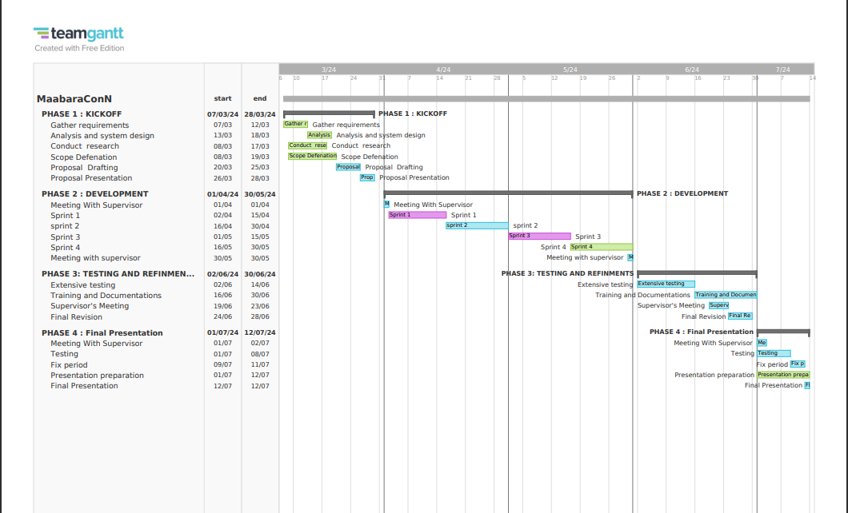

**Phase 1: Preparation and Planning (March 1 - March 31)**

**Objective:** To lay the groundwork for the project, including requirements gathering, initial system design, and project proposal preparation.

* **March 1-7: Project Kick-off and Initial Meetings**
  + Conduct initial meetings with your supervisor to define project scope and objectives.
  + Identify stakeholders for interviews and surveys.
* **March 8-14: Requirements Gathering**
  + Perform stakeholder interviews and surveys with students, instructors, and lab technicians.
  + Conduct benchmarking studies to understand best practices.
* **March 15-21: Analysis and System Design Planning**
  + Analyze gathered requirements to identify key system features and functionalities.
  + Begin drafting the UX design and system architecture.
* **March 22-28: Proposal Drafting**
  + Compile findings and designs into a comprehensive project proposal.
  + Review and refine the proposal with your supervisor.
* **March 29-31: Proposal Finalization and Submission**
  + Finalize the project proposal based on feedback.
  + Submit the completed proposal for approval.

**Phase 2: Development (April 1 - May 31)**

**Objective:** To develop the digital platform, focusing on core functionalities, and to begin initial testing.

* **April 1-15: Development Sprint 1**
  + Focus on developing the platform's core functionalities, such as report submission, template management, and user authentication.
* **April 16-30: Development Sprint 2**
  + Implement advanced features like AR/VR integration, AI-driven feedback, and data collection tools.
* **May 1-15: Development Sprint 3**
  + Continue feature development, focusing on collaborative tools, real-time feedback mechanisms, and security measures.
* **May 16-31: Initial Testing and Revisions**
  + Conduct initial user testing with a small group of stakeholders.
  + Revise the platform based on feedback and perform bug fixes.

**Phase 3: Testing, Training, and Refinement (June 1 - June 30)**

**Objective:** To finalize the platform through extensive testing, stakeholder training, and system refinements.

* **June 1-15: Extensive Testing**
  + Perform extensive user, performance, and security testing.
  + Gather and analyze feedback for further refinements.
* **June 16-23: Training and Documentation**
  + Develop and distribute training materials for users.
  + Conduct training sessions for students, instructors, and technical staff.
* **June 24-30: Final Revisions**
  + Make final adjustments and refinements to the platform.
  + Prepare for the project presentation, including creating a comprehensive presentation and demo.

**Phase 4: Final Presentation and Project Closure (July 1 - July 7)**

**Objective:** To present the completed project to stakeholders and prepare for project closure.

* **July 1-3: Presentation Preparation**
  + Finalize your presentation, focusing on the project's objectives, development process, key functionalities, and benefits.
* **July 4: Final Presentation**
  + Present the completed digital lab report submission and management platform to your supervisors, stakeholders, and other interested parties.
* **July 5-7: Project Closure**
  + Collect feedback from the presentation.
  + Discuss next steps, including any potential future enhancements and the transition to operational status.

**BUDGET**

|  |  |
| --- | --- |
| **SOFTWARE DEVELOPMENT** | **AMOUNT (KSH)** |
| Project Management & planning | 6000 |
| Design (UI/UX) | 3500 |
| Development Frontend and Backend | 5000 |
| Testing and Quality Assurance | 4000 |
|  |  |
| **HARDWARE ACQUISITION COSTS** |  |
| **Server** infrastructure | 6000 |
|  |  |
| **OPERATIONA COSTS** |  |
| Hosting services | 5000 |
| Maintenance and support | 3000 |
|  |  |
| **MARKETING AND OUTREACH** |  |
| Promotional materials | 2500 |
| Stakeholders engagements | 4000 |
|  |  |
| **TOTAL** | **37000** |
|  |  |

**conceptual diagram**

