

I not very fond of apps for my phone, if phone apps are what we are talking about, I usually play, view videos, or search for things using the default search engine. But there is one app that still makes me appreciate it and that is messenger. For me messenger is a helpful application either in your phone or pc because of its versatility and availability.

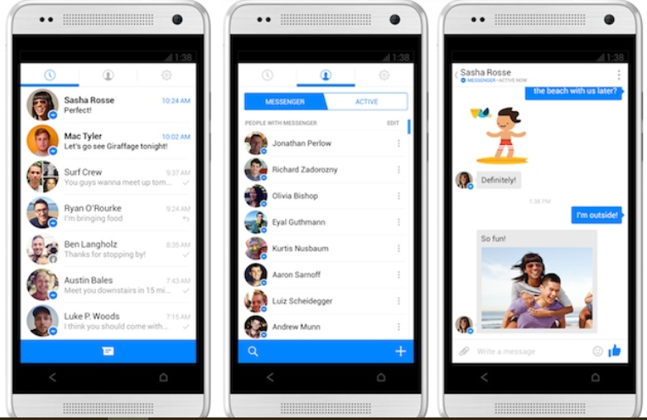

Its compatibility to cross platform be it pc, apple products, or smartphones and that is very convenient. Its easier than most messaging apps to use for me, because it only requires your Facebook account, you can contact all your friends be it messaging, call, or video chat. It also has group chat so it is easier to see who is present in real time.

This allows us to exchange information share images, videos, and document albeit small enough for a document or two. I`ve been using this app ever since I got my first phone, because you only need internet access even without cellular load we can still contact each other. And it is still a very convenient app to have.

Image taken from: <https://www.messenger.com/> , <https://gadgets.ndtv.com/apps/news/facebook-messenger-for-android-with-revamped-user-interface-now-being-tested-439465>