A3: How would you design an interface for a 1000 floor elevator?

If I were to design the interface of a 1000 floor elevator it would depend on how the building that it is designed for. Resources aside the interface would be a simple design that can be used without any confusion. I may use a scroll list touch screen panel which shows what current floor is the elevator now, on the side of the scroll list there you will scroll in which floor you want to go by tapping it. If there are multiple floors that is picked, the program will stop the elevator using the information it gathered until all queued floors are finished. The list is visible on the screen along with the first 5 that is on queue. The user can hold the number that is currently on the queue to remove it if a user made a mistake at the floor. This will allow for smooth transition in the elevator. The scroll list also highlights all floors that it will stop to prevent users to pressing the same floor twice. Emergency stop and other emergency tools in the elevator will be visible and physically present unlike the touch screen for convenience and assurance for the users in case of emergency. 

But that is only for elevators which are used inside the building for floors that only reach 100 and below, like the Burj Khalifa which is about 163 floors with the fastest elevator. To reach 1000 a person must ride a total of 10 separate elevators to reach the top, this will be only used by people with disabilities and employees so that they can interact with all floors when needed.

For people with time and money can choose to go to the express elevator that stops every 300 floors for the stops, there are stops that is required because of the change of altitude which may affect a person`s body if there is a fast pace of movement and altitude like climbing a mountain. Mountaineers climbing mount Everest which is the tallest mountain on earth have multiple camps that is stationed to avoid altitude sickness. Altitude sickness can happen usually develop between 6 and 24 hours after reaching altitudes more than 3,000m (9,842 feet) above sea level. The elevator would be train like in structure that accommodates seats for comfortable travel. To visualize the type of train fast enough is the bullet trains of japan reaching **320 km/h (199 mph). These are used for tourist and a way to generate income.**

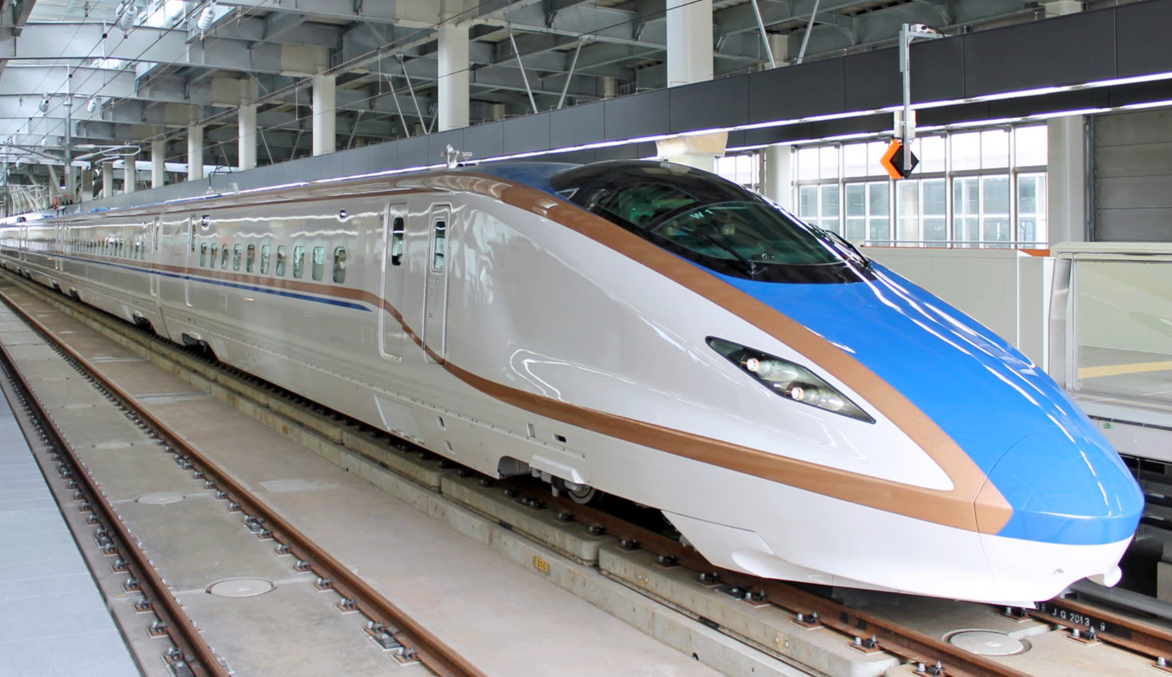

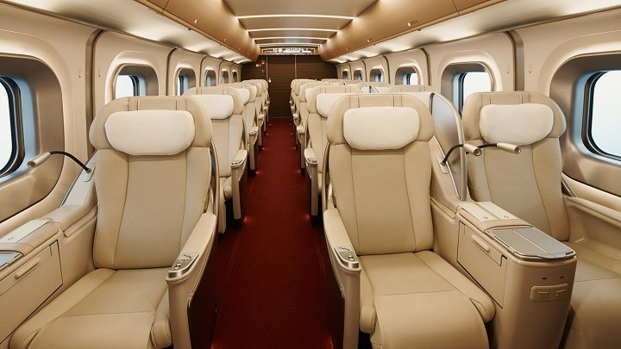

Sources: <https://www.nhs.uk/conditions/altitude-sickness/>, <https://www.jrailpass.com/shinkansen-bullet-trains>,

Images taken from: <https://unsplash.com/search/photos/stacks-of-book>, <https://www.jrailpass.com/blog/shinkansen-gran-class>, <https://asia.nikkei.com/Business/Japan-pushing-bullet-train-for-California-rail-project>