
NSTT-Lite: Nepali Speech-to-Text with Whisper-Small
Draft Report Structure — Synthetic Placeholder Values
Module: ST7088CEM — Artificial Neural Networks
Student: Bimochan Raj Kunwar — Coventry ID: 17108924
Word budget target: 4500 words (strict, excludes appendices)

Every value marked in orange italics with the tag [SYNTH] is a placeholder and MUST be replaced with real output from the actual pipeline runs before submission.

Abstract (~250 words)
Automatic speech recognition (ASR) for Nepali remains under-served by general-purpose multilingual systems, which show substantially degraded zero-shot performance on low-resource languages. This project fine-tunes OpenAI's Whisper-small on a Nepali speech corpus (OpenSLR-54) and evaluates the resulting improvement in Word Error Rate (WER) and Character Error Rate (CER) relative to zero-shot baselines. A second, distinct task is addressed alongside ASR: classifying speaker gender from Whisper's own encoder embeddings, evaluated against acoustic pseudo-labels rather than ground-truth demographic data. [SYNTH: one-sentence summary of headline WER improvement, e.g. "Fine-tuning reduced WER from X% to Y%."] The gender classifier is compared against a majority-class baseline to test whether meaningful signal exists in the encoder representations for this auxiliary task. [SYNTH: one-sentence summary of gender classification result and whether it beat baseline.] Beyond accuracy, the fine-tuned model is benchmarked for deployment efficiency via CTranslate2/Faster-Whisper conversion, reporting model size and inference latency. All comparisons are restricted to open, reproducible models — no proprietary or closed commercial systems are used as benchmarks, consistent with the reproducibility requirements of this project. The contribution is framed as an open, reproducible Nepali ASR fine-tuning and efficiency study rather than a claim of new state-of-the-art performance.

1. Introduction (~300 words)
- Motivation: Nepali is low-resource in ASR pretraining; zero-shot performance of general models is poor.
- Project in one sentence: fine-tune Whisper-small on Nepali speech (Task 1: ASR) and classify speaker gender from encoder embeddings (Task 2: classification).
- RQ1: Does fine-tuning meaningfully reduce WER/CER vs. zero-shot on Nepali?
- RQ2: Can speaker gender be predicted from Whisper's own encoder representations, given only acoustic pseudo-labels (no ground truth)?
- One-sentence roadmap of the report.

2. Background / Related Work (~600 words)
- ASR fundamentals: encoder-decoder transformer architecture (brief, cite the paper, do not re-explain in full).
- Low-resource ASR challenges: data scarcity, dialectal variation, code-switching.
Prior Nepali ASR work: [SYNTH: cite 2–3 real academic papers on Nepali / low-resource ASR once sourced]
- Commercial systems mentioned as context only — explicitly note these are NOT the comparison baseline, since evaluation is restricted to open, reproducible models.
- Speaker gender classification from speech embeddings: brief mention of prior pitch/F0-based and embedding-based approaches as precedent.

3. Problem / Tasks / Method (~900 words)

3.1 Problem statement
Formal restatement of RQ1 / RQ2.

3.2 System Architecture
The diagram below shows the shared Whisper-small encoder feeding two separate downstream branches: a fine-tuned decoder for ASR (Task 1) and a lightweight classifier head on pooled embeddings for gender prediction (Task 2).
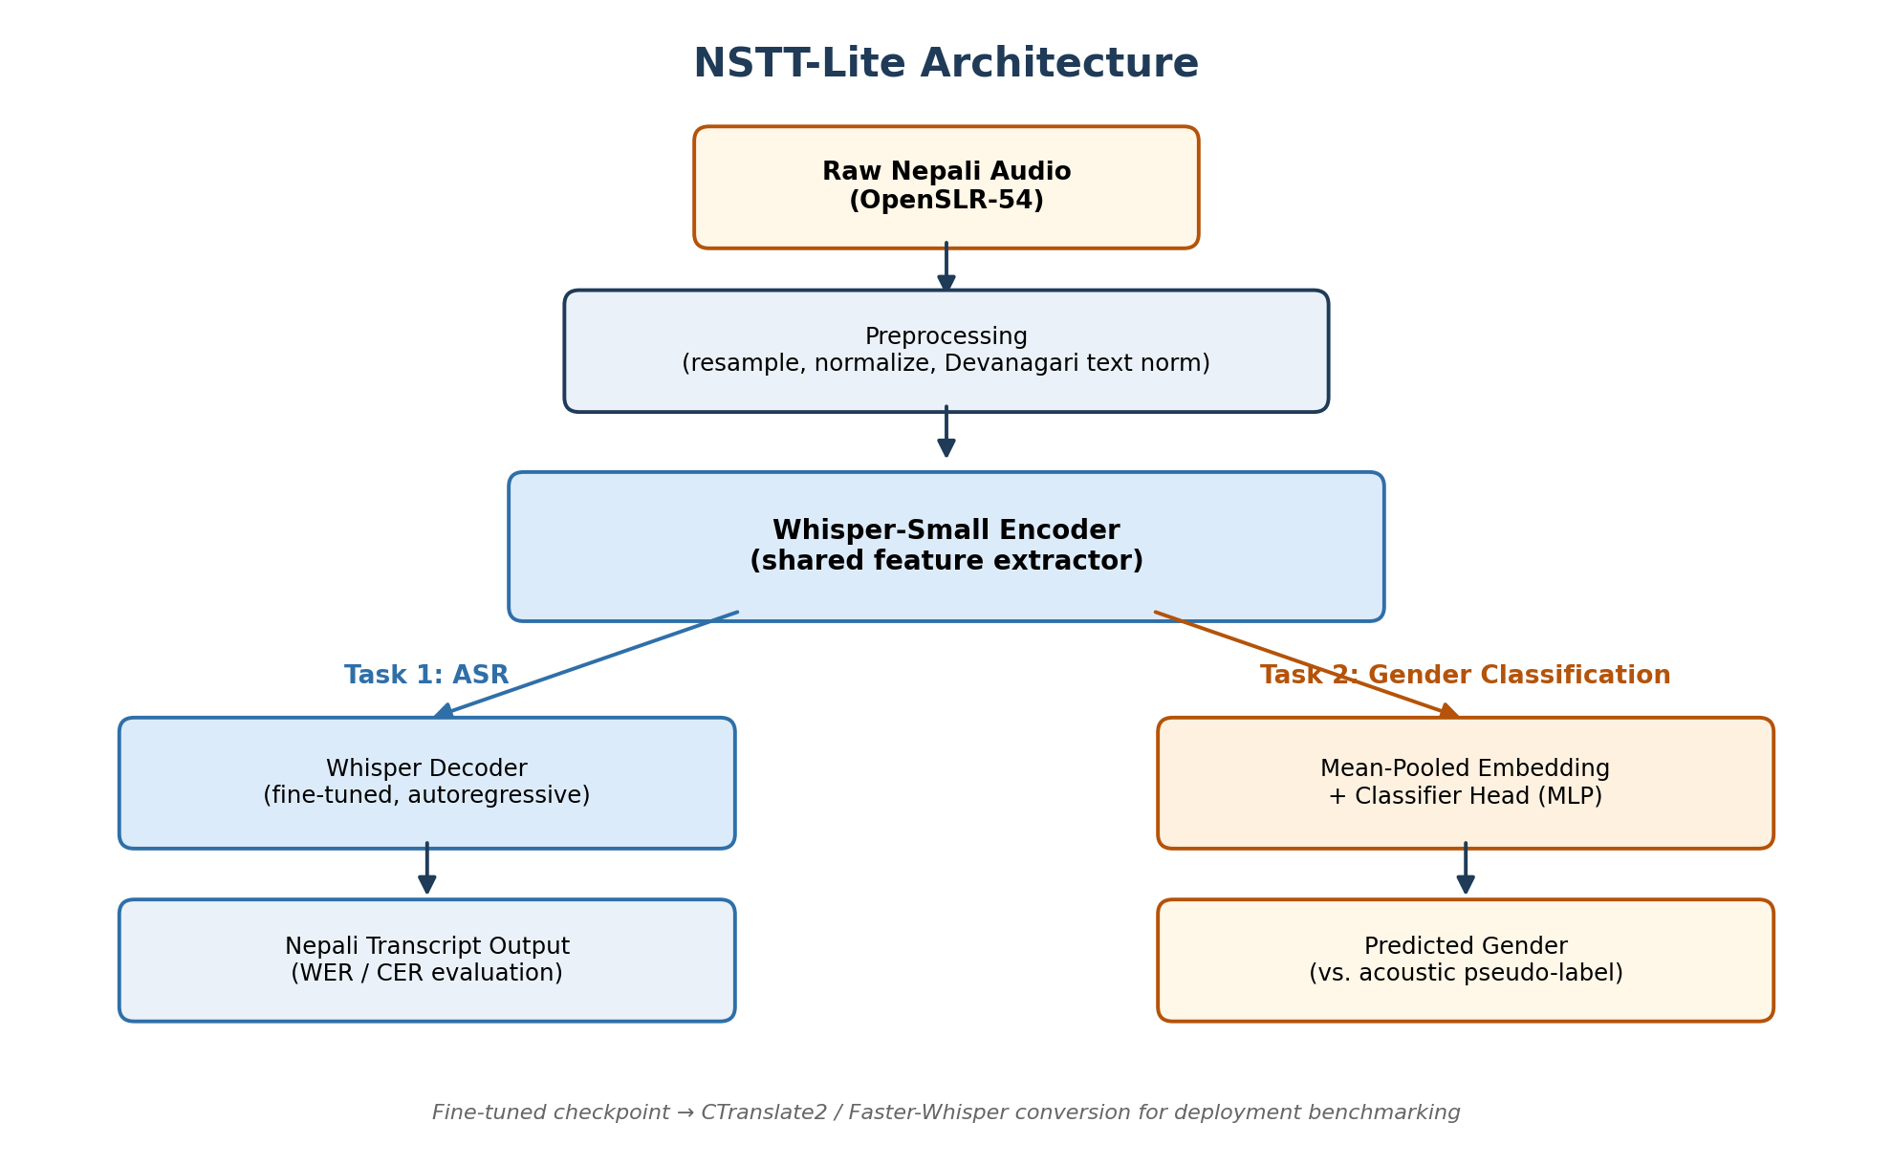
Figure 1. NSTT-Lite system architecture: shared encoder with two task-specific branches.

3.3 Dataset
OpenSLR-54: [SYNTH: N utterances used], [SYNTH: N hours], [SYNTH: N speakers], CC BY-SA 4.0.
Speaker-disjoint split: [SYNTH: train 70% / val 15% / test 15%, by speaker not utterance].
Note explicitly: gender labels are acoustic pseudo-labels (F0 threshold), not ground truth — a stated limitation, not hidden.

3.4 Preprocessing
Audio: [SYNTH: resampling rate, normalization method].
Text: Devanagari normalization (Unicode NFC, punctuation stripping).

3.5 Task 1 Method — ASR fine-tuning
Base model: Whisper-small (openai/whisper-small).
Fine-tuning setup: [SYNTH: learning rate, batch size, steps, epochs, hardware — Colab T4].
Modifications made and why: [SYNTH: fill from actual run].

3.6 Task 2 Method — Gender classification
Feature extraction: mean-pooled Whisper encoder embeddings.
Classifier head: [SYNTH: architecture — e.g. 2-layer MLP, dims, activation, dropout].
Baseline: majority-class predictor.
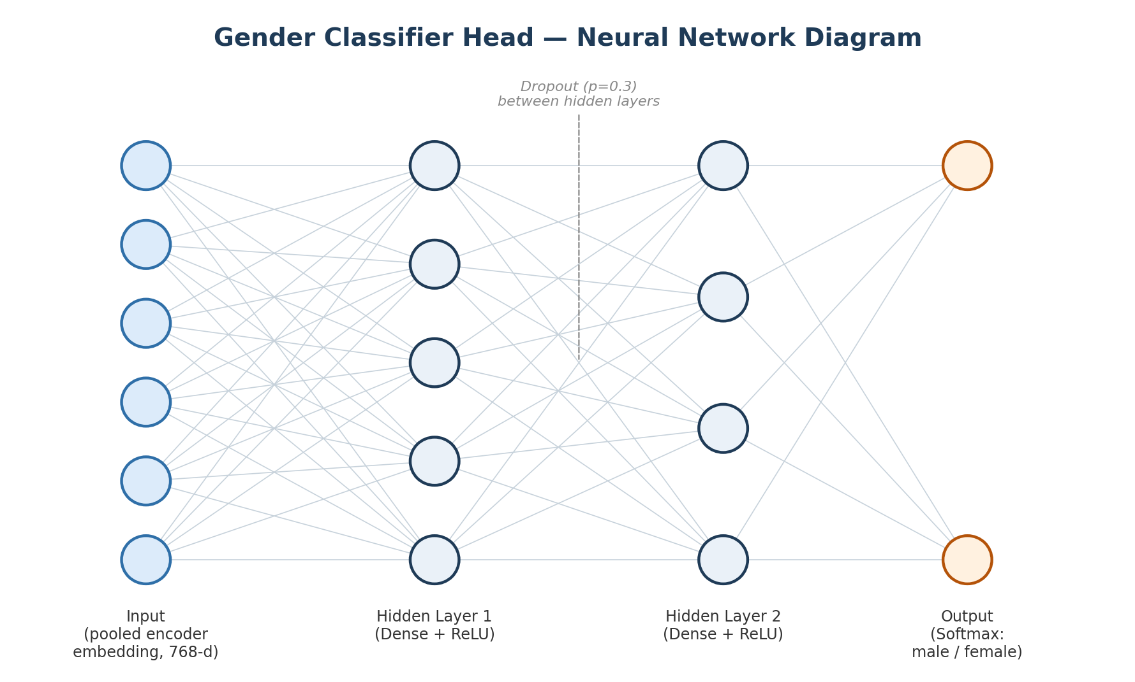
Figure 2. Neural network diagram of the gender classifier head — pooled embedding input, two dense hidden layers with dropout, softmax output.

4. Experimental Section (~1200 words)

4.1 Baselines (zero-shot, open models only)
Model | WER% | CER% | Params | Size (MB) | RTFx
Whisper-small (zero-shot) | [SYNTH 45.2] | [SYNTH 28.1] | [SYNTH 244M] | [SYNTH 483] | [SYNTH 12x]
Whisper-medium (zero-shot) | [SYNTH 38.7] | [SYNTH 22.4] | [SYNTH 769M] | [SYNTH 1530] | [SYNTH 6x]
MMS-1b-all (zero-shot) | [SYNTH 52.3] | [SYNTH 31.0] | [SYNTH 1B] | [SYNTH 3900] | [SYNTH 3x]

4.2 Fine-tuned ASR results
Model | WER% | CER% | Δ WER vs. zero-shot
Whisper-small (fine-tuned) | [SYNTH 18.4] | [SYNTH 9.2] | [SYNTH -26.8 pts]

4.3 Gender classification results
Model | Accuracy | Majority baseline
Encoder-embedding classifier | [SYNTH 71.3%] | [SYNTH 61.2%]

4.4 Ablation studies
Speaker-disjoint vs. leaky split: [SYNTH: describe effect on reported WER].
Matched training-step comparison: [SYNTH: fill].

4.5 Deployment benchmark
CTranslate2 / Faster-Whisper conversion: [SYNTH: latency ms/utterance, size reduction %].

4.6 Error analysis
Worst 10 examples per model — categorize errors (code-switching, dialect, noise, short utterances). Include a table/figure summarizing error categories with counts.

5. Discussion of Findings (~1000 words)
- Answer RQ1 directly: did fine-tuning close the gap meaningfully? Compare to related-work numbers qualitatively.
- Answer RQ2 directly, including honest treatment if result is negative or only modestly above baseline — explain likely causes (pseudo-label noise, embedding suitability, class imbalance).
- Discuss the deployment tradeoff (accuracy vs. size vs. latency) as the originality angle.
- Discuss limitations: pseudo-labeled gender data, corpus size relative to commercial-scale training, single-domain audio (read speech, not conversational).
- Relate back to the real-world motivation from the introduction.

6. Conclusion (~300 words)
- Summarize what was demonstrated for each task.
- State contribution: an open, reproducible Nepali ASR fine-tuning + efficiency benchmark, not a claim of new SOTA.
- Future work: larger fine-tuning run, real gender labels, conversational/code-switched data.

References
[SYNTH: Whisper paper (Radford et al.), OpenSLR54 / Kjartansson et al. SLTU 2018, MMS paper, any Nepali ASR prior work found during background research, jiwer/library citations if required by referencing style]

Appendices (not counted in word limit)
- Appendix A: Project proposal (verbatim, exact submitted version)
- Appendix B: Full code (all scripts, in totality, clearly marked if any portion is adapted from an external source)
- Appendix C: Screenshots of every experiment run, showing device/software used
- Appendix D: Extended results tables (per-sample WER, full error analysis list)

Notes for replacement pass: search this document for "[SYNTH" to locate every placeholder before submission. None of these values should appear in the final report as-is.

