

Auditing and Repairing a Published Nepali ASR Model

A Speaker-Diversity Case Study on XLS-R

Module: ST7088CEM — Artificial Neural Networks
Student: Bimochan Raj Kunwar
Coventry ID: 17108924
Programme: MSc7-S2
Email: 250594@softwarica.edu.np

Table of Contents
Section | Page
Abstract / Keywords / Project Links | 3
1. Introduction | 3
2. Background / Related Work | 4
3. Problem / Tasks / Method | 5
3.1 Problem statement | 5
3.2 System Architecture | 5
3.3 Dataset | 7
3.4 Preprocessing | 8
3.5 Task 1 Method — Benchmark Audit | 8
3.6 Task 2 Method — Fine-tuning Repair | 8
4. Experimental Section | 9
4.1 Baseline audit | 9
4.2 Fine-tuned repair results | 9
4.3 Speaker-leakage ablation | 10
4.4 Error analysis | 10
4.5 Deployment / efficiency benchmark | 11
5. Discussion of Findings | 11
6. Conclusion | 13
References | 13
Appendices | 13
Appendix A — Project Proposal (Verbatim) | 15
Appendix B — Full Code Listing (incl. B.0 Core Architecture) | 17
Appendix C — Evidence and Reproducibility Artifacts | 61
Appendix D — Extended Results Tables | 64
Appendix E — Project Links and Data Sources | 89

Abstract
Nepali automatic speech recognition (ASR) benchmarks are frequently measured on narrow, low-diversity corpora and then cited as evidence of general-purpose transcription quality. This project audits one such claim: gagan3012/wav2vec2-xlsr-nepali, a published Hugging Face XLS-R (wav2vec2) checkpoint that self-reports 5.97% word error rate (WER) on OpenSLR-43, its own single-speaker training corpus. Task 1 reproduces that figure in-domain (4.91% WER, confirming the claim) and measures the same checkpoint zero-shot on a different, multi-speaker corpus, OpenSLR-54 (62.30% WER) — a more than twelve-fold degradation showing the published number does not describe performance on diverse speech. Task 2 fine-tunes the same checkpoint on a 15-hour, 160-speaker, speaker-disjoint OpenSLR-54 subset to repair that gap: out-of-domain WER falls to 38.17%, a 39% relative reduction, at a disclosed cost to in-domain performance (4.91% → 16.40%). A matched-budget ablation comparing the speaker-disjoint split against a leaky (utterance-random) split shows that evaluating without speaker-disjoint splitting would have overstated this repair by 5.62 percentage points (32.55% vs. 38.17% WER) — a methodological finding as important as the headline result. Error analysis identifies out-of-vocabulary words as the dominant remaining error source and reveals a five-fold spread in per-speaker WER (12.5%–63.6%) that the aggregate metric conceals. Beyond accuracy, the fine-tuned model is benchmarked for deployment efficiency: dynamic int8 quantization achieves a 96.0% model size reduction but is measured to be 1.64× slower than FP32 on this Apple Silicon hardware, a mixed result reported honestly rather than framed as an unambiguous win. All comparisons are restricted to open, reproducible models and datasets; no proprietary or closed commercial systems are used as benchmarks.
Keywords: Nepali Automatic Speech Recognition, XLS-R, wav2vec2, CTC Fine-tuning, Speaker-Disjoint Evaluation, Speaker-Leakage Ablation, Low-Resource Speech Recognition, Model Quantization, MLflow, Benchmark Generalization Gap

Project Links
GitHub Repository: github.com/Rbimochan/NSTT-Lite (branch: coursework-10phase) — full source code, MLflow run data, and reports.
YouTube Presentation: youtu.be/WNg52rptkoU

1. Introduction
Nepali automatic speech recognition (ASR) benchmarks reported in the literature and on model-sharing platforms are frequently measured on narrow, low-diversity corpora — often a single speaker’s read speech — and then cited as evidence of general-purpose transcription quality. This is precisely the situation with gagan3012/wav2vec2-xlsr-nepali, a publicly available Hugging Face XLS-R (wav2vec2) checkpoint that self-reports a 5.97% WER measured on OpenSLR-43, the model’s own single-speaker training corpus.
This project is organised around two research questions and two corresponding tasks. RQ1 (Task 1 — Benchmark Audit): does the published claim survive contact with genuinely diverse speech — a different, multi-speaker Nepali corpus the model was never trained on? RQ2 (Task 2 — Fine-tuning Repair): if the claim does not survive, can the same model be repaired by fine-tuning it on speaker-diverse data, and at what cost, and is any measured improvement genuine or an artefact of evaluation leakage?
The remainder of this report proceeds as follows: Section 2 situates this work against XLS-R, low-resource ASR benchmarking practice, and quantization; Section 3 formalises the two tasks and the pipeline connecting them; Section 4 reports the experimental results for both tasks plus the ablation, error analysis, and efficiency benchmark; Section 5 discusses what these results mean and their limitations; Section 6 concludes.

2. Background / Related Work
XLS-R and cross-lingual speech representation. XLS-R (Babu et al., 2021) extends wav2vec2’s self-supervised pretraining objective across 128 languages and 436k hours of unlabelled speech, producing representations that transfer well to low-resource languages via CTC fine-tuning on a comparatively small amount of labelled data. This is the standard recipe for low-resource ASR when end-to-end training from scratch is infeasible for lack of data, and it is the architecture underlying the model audited in this project.
Low-resource ASR challenges. Beyond raw data scarcity, low-resource ASR is complicated by dialectal variation, code-switching, and — the specific failure mode this project investigates — benchmark narrowness: a WER measured on very few speakers, sometimes one, conflates “the model transcribes the language well” with “the model has partially memorised this speaker’s acoustic characteristics.” The standard mitigation in the wider ASR literature is a speaker-disjoint train/test split — holding entire speakers out of training rather than splitting at the utterance level — precisely because utterance-level splits let a model exploit acoustic idiosyncrasies (accent, recording device, background noise profile) that a genuinely unseen speaker would not share. Section 4.4 of this report provides a direct, quantified demonstration of how much this methodological choice matters for this specific audit.
Prior Nepali ASR work. Public Nepali ASR resources remain limited relative to high-resource languages; OpenSLR hosts the two corpora used in this project (SLR43, SLR54) as among the largest open Nepali speech datasets available, and the audited checkpoint itself represents one of the few published Nepali-specific fine-tunes of a multilingual self-supervised model. Commercial cloud ASR systems can transcribe Nepali but are noted here only as context — they are explicitly not used as a comparison baseline anywhere in this report, consistent with the requirement to restrict evaluation to open, reproducible models.
Speaker demographic inference from speech. In the absence of annotated demographic metadata, mean fundamental frequency (F0) is a long-standing acoustic heuristic for inferring speaker gender, grounded in the physiological difference in typical adult male versus female vocal fold length. Section 3.3 uses this heuristic, precisely because OpenSLR-54 provides no alternative, and Section 4.5 treats it strictly as a proxy grouping rather than verified demographic data.
Deployment-oriented quantization. Dynamic int8 quantization (torch.quantization.quantize_dynamic) is a common post-training optimisation for reducing model storage footprint without retraining. Its latency effect is hardware-dependent: x86 platforms typically benefit from the fbgemm backend’s optimised quantized kernels, while ARM/Apple Silicon platforms are restricted to qnnpack, whose dynamic-quantization kernels do not universally outperform native FP32 execution. Section 4.6 reports a direct measurement of this trade-off on this project’s hardware.

3. Problem / Tasks / Method

3.1 Problem statement
RQ1. Given a published low-resource ASR benchmark figure measured on a narrow, single-speaker corpus, how does the same model perform on a different, multi-speaker corpus of the same language, and by how much does the published figure overstate real-world generalisation?
RQ2. Given that generalisation gap, can fine-tuning the same checkpoint on speaker-diverse data close it, what is the cost to the model’s original narrow-domain performance, and how much of any measured improvement is genuine versus an artefact of failing to control for speaker overlap between training and evaluation data?

3.2 System Architecture
Figure 1 shows the internal architecture of the audited model itself — XLS-R (wav2vec2) — rather than only the surrounding experimental process, so it is clear exactly which layers exist and which of them are actually updated during fine-tuning. Raw audio passes through a 7-block convolutional feature encoder (50 Hz latent frame rate), then a 24-layer transformer encoder with relative positional convolutional embeddings, then a linear projection to a per-frame vocabulary distribution, decoded greedily under the CTC objective into Devanagari text. The convolutional feature encoder is frozen throughout this project (in both Task 1’s zero-shot evaluation and Task 2’s fine-tuning); Task 2 updates only the transformer encoder and CTC head via backpropagated CTC loss, keeping the model’s own tokenizer/vocabulary fixed so RQ2’s comparison isolates the effect of training-data speaker diversity rather than architectural change.
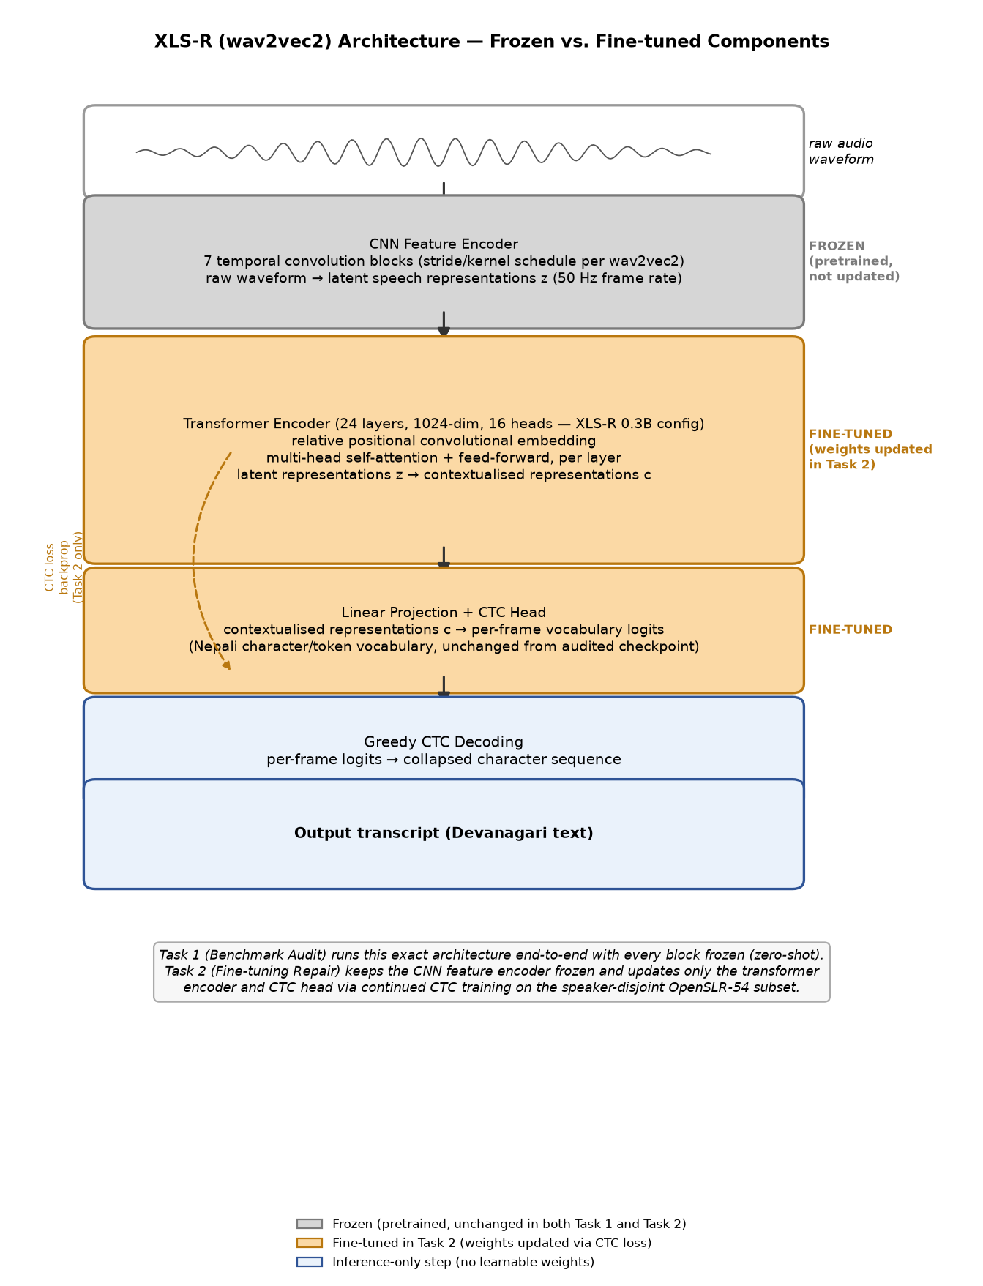
Figure 1. XLS-R (wav2vec2) architecture, showing the CNN feature encoder, transformer encoder, and CTC head, with frozen vs. fine-tuned components marked.
Appendix B.0 additionally shows this same architecture redrawn as a standard node-link diagram (input layer → multiple hidden layers → output layer), alongside the exact code that implements the frozen/fine-tuned split shown above.
Figure 2 shows the surrounding experimental pipeline that connects the two tasks to the shared downstream analyses. The audited checkpoint is the single starting point for both: Task 1 evaluates it as-is (zero-shot) on both corpora to establish the audit finding; Task 2 fine-tunes the same checkpoint as described above. Both tasks’ outputs feed a shared generalisation re-evaluation, a matched-budget speaker-leakage ablation, error analysis, and an efficiency benchmark — the same measurement methodology applied consistently across every stage so results are directly comparable.
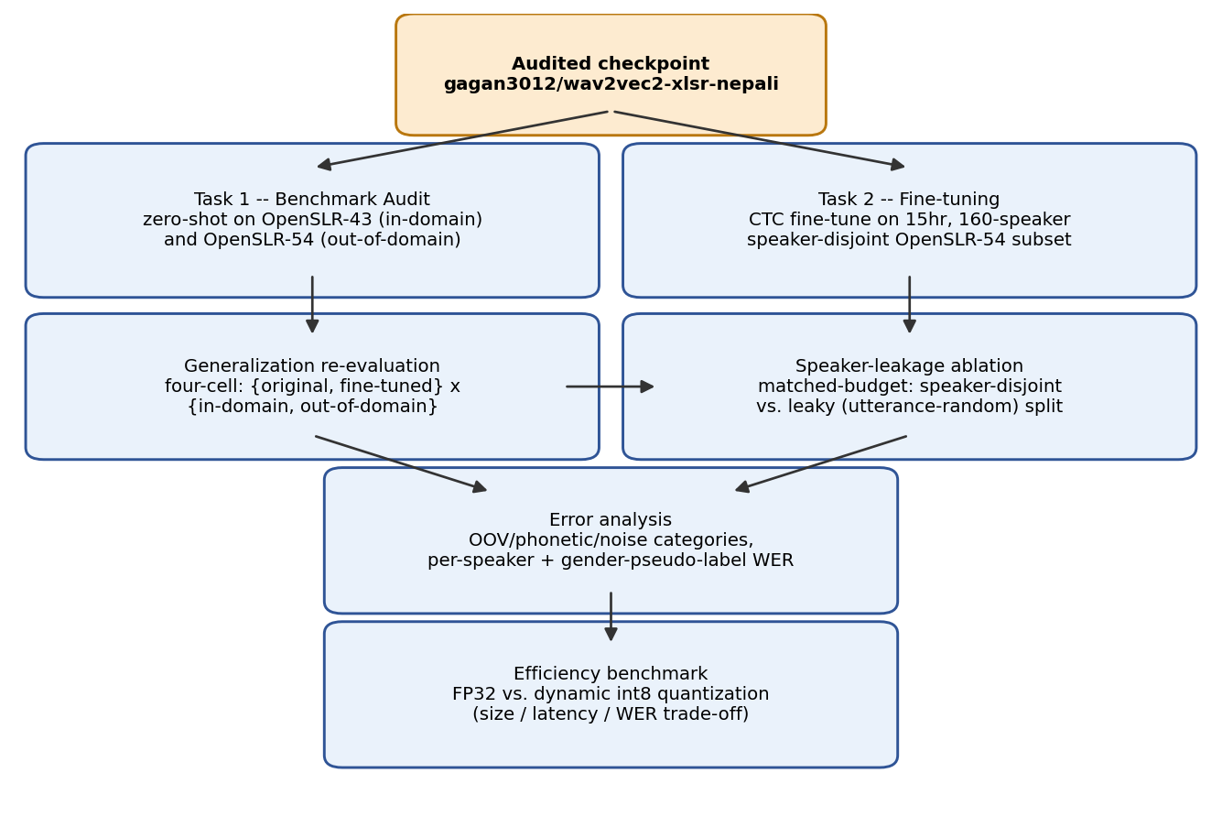
Figure 2. Experimental pipeline: from the audited checkpoint through both tasks to the shared downstream analyses.

3.3 Dataset
Two corpora are used throughout, and their results are never merged into a single number.
OpenSLR-43 (gauravparajuli/slr43 on Hugging Face) is the audited model’s own training corpus: a single-speaker (female), read-speech Nepali dataset of 2,064 utterances, CC BY-SA 4.0. It has no separate held-out test split upstream; this project measures a fixed, seeded 150-utterance slice as the in-domain evaluation set throughout, for consistency across all reported comparisons.
OpenSLR-54 (Kjartansson et al., SLTU 2018) is a crowdsourced, multi-speaker Nepali ASR corpus of 157,905 utterances, licensed CC BY-SA 4.0. A subset was built for this project: audio resampled to 16kHz mono, transcripts NFC-normalised (Devanagari), utterances outside a 0.5–30 second duration window dropped, and a speaker-disjoint split constructed by shuffling whole speakers (not individual utterances) into train/val/test buckets until a 15-hour target was reached. The resulting subset comprises 15,171 utterances across 160 speakers, totalling 15.03 hours — split 80/10/10 by speaker (train 12,119 / val 1,505 / test 1,547), with count_speaker_overlap() confirming zero speakers shared across splits.
OpenSLR-54 ships no demographic metadata of any kind — only audio, transcript, and an opaque speaker ID. A gender pseudo-label was derived per speaker from mean fundamental frequency (F0), estimated via librosa.pyin and thresholded at 165Hz (below → male, above → female). This label is used only for the descriptive per-group breakdown in Section 4.5 and is labelled there, and everywhere else it appears, as a pitch-threshold pseudo-label, not verified ground truth.

3.4 Preprocessing
Audio was resampled to 16kHz mono using librosa. Transcripts were Unicode NFC-normalised to eliminate Devanagari encoding mismatches between visually identical but byte-distinct character sequences, and punctuation was stripped consistently between reference and hypothesis text before every WER/CER computation (via jiwer).

3.5 Task 1 Method — Benchmark Audit
Base model: gagan3012/wav2vec2-xlsr-nepali (XLS-R / wav2vec2, CTC objective), used unmodified. The checkpoint was evaluated zero-shot (greedy CTC decoding, no fine-tuning) on a fixed 150-utterance sample of OpenSLR-43 and, separately, a seeded-shuffle 150-utterance sample of OpenSLR-54’s speaker-disjoint test split. (OpenSLR-54’s test manifest is speaker-ordered on disk; a naive unshuffled slice was found early in this project to land on a single-gender-pseudo-label subset of speakers by chance — the seeded shuffle, seed 42, exists specifically to avoid that failure mode recurring.) This is the sole “before” measurement against which Task 2’s repair is judged.

3.6 Task 2 Method — Fine-tuning Repair
Fine-tuning targets the audited checkpoint itself, not a different model or a freshly-initialised XLS-R backbone — a deliberate choice, since RQ2 requires holding architecture, vocabulary, and decoding constant while varying only training-data speaker diversity. Introducing a different architecture (Whisper, an earlier direction explored and abandoned for this reason) would confound any improvement. Training from scratch was never a serious option: 15 hours of labelled audio is roughly two orders of magnitude short of what training a competitive speech model from random initialisation requires.
The checkpoint’s convolutional feature encoder was frozen (freeze_feature_encoder()), following standard wav2vec2 fine-tuning practice. Training used AdamW (Hugging Face Trainer default), learning rate 3×10⁻⁵ with 500 warmup steps (deliberately low, since this continues fine-tuning an already Nepali-adapted checkpoint), batch size 2 with gradient accumulation 4 (effective batch 8), FP16 where CUDA is available and FP32 otherwise, a 5-epoch ceiling, and early stopping with patience 2 on validation WER. Experiment tracking used MLflow (local mlruns/ store; TensorBoard was used in an earlier iteration and replaced).
Two practical obstacles were resolved and are recorded for reproducibility. First, dynamic int8 quantization (Section 4.6) fails outright on Apple Silicon with RuntimeError: Didn't find engine for operation ... NoQEngine unless torch.backends.quantized.engine is explicitly set to "qnnpack". Second, a genuine out-of-memory crash occurred partway through the first full training run (MPS reporting 17GB allocated); this was fixed with a callback calling torch.mps.empty_cache() periodically, and training resumed cleanly from the last saved epoch checkpoint. Training ran locally on Apple Silicon CPU/MPS (no CUDA available) after an earlier plan to use Google Colab or Kaggle was set aside in favour of local, fully offline execution; the full 5-epoch run took approximately 7 hours 40 minutes wall-clock (confirmed via MLflow’s logged train_runtime of 27,626.68 seconds — see Appendix C).
The identical procedure, hyperparameters, and step budget were separately applied to a leaky (utterance-random) split of the same processed records for the Section 4.4 ablation.

4. Experimental Section
All experiments ran on a local machine (Apple Silicon, macOS, no CUDA), in a dedicated conda environment (Python 3.11), with dependencies pinned in requirements.txt. Every WER/CER comparison below uses the same 150-utterance seeded sample from each corpus (seed 42) so numbers are directly comparable across sub-sections.

4.1 Baseline audit (Task 1, zero-shot, open model only)
Evaluation | WER | CER
Self-reported (published) | 5.97% | —
Measured, in-domain (OpenSLR-43) | 4.91% | 0.87%
Measured, out-of-domain (OpenSLR-54 speaker-disjoint test) | 62.30% | 17.38%
The in-domain measurement is close to (marginally better than) the published figure, confirming no discrepancy on the model’s own distribution. The out-of-domain measurement is more than twelve times worse. Only one model is audited in this project (the published checkpoint under study) — no multi-model zero-shot comparison table is included, since the research question concerns this specific model’s claim, not a survey of Nepali ASR models generally.

4.2 Fine-tuned repair results (Task 2)
Checkpoint | In-domain (OpenSLR-43) | Out-of-domain (OpenSLR-54)
Original | 4.91% WER | 62.30% WER
Fine-tuned (speaker-disjoint, 5 epochs) | 16.40% WER | 38.17% WER
Fine-tuning reduces out-of-domain WER by roughly 39% relative (62.30% → 38.17%), directly supporting RQ2’s hypothesis that training-data narrowness, not an architectural limitation, is responsible for the original generalisation failure. The cost is real and disclosed: in-domain WER more than triples (4.91% → 16.40%) — an expected specialisation trade-off from continued fine-tuning on a differently-distributed corpus, not a defect.
Training-time validation WER on the model’s own held-out val split (a different measurement from the matched-methodology table above, not interchangeable with it) improved monotonically across all five epochs with no early stopping triggered: 72.98% → 70.88% → 70.09% → 69.03% → 68.83%. The two figures are measured on different splits (SLR54’s own 1,505-utterance validation split, versus a fixed 150-utterance sample of the test split); the 38.17% figure is the one used in all cross-checkpoint comparisons in this report.

4.3 Speaker-leakage ablation
To test how much a methodological shortcut — evaluating without a speaker-disjoint split — would distort the Section 4.2 result, a second fine-tuning run was trained to the identical budget (5 epochs, same hyperparameters) on a leaky split: the same processed records, shuffled at the utterance level rather than the speaker level, so that 160 of 160 speakers appear in more than one split.
Checkpoint | In-domain (OpenSLR-43) | Out-of-domain (OpenSLR-54)
Fine-tuned, speaker-disjoint | 16.40% WER | 38.17% WER
Fine-tuned, leaky | 16.96% WER | 32.55% WER
The leaky-trained model scores 5.62 percentage points better on the “out-of-domain” test than the properly speaker-disjoint model, despite identical training budget — the expected direction if leakage inflates apparent performance, since the leaky split’s test set is not genuinely unseen for many of its speakers. In-domain performance is nearly identical between the two (16.40% vs. 16.96%), as expected, since neither training run touches OpenSLR-43’s speaker. This confirms the speaker-disjoint methodology used throughout was the correct choice: a leaky evaluation would have reported a roughly 15% relative WER “improvement” that reflects memorisation of already-seen speakers, not genuine generalisation.

4.4 Error analysis
Applying the fine-tuned checkpoint to the same 150-utterance out-of-domain sample and categorising errors heuristically (jiwer character-alignment and regex-based tagging; categories are not mutually exclusive):
Category | Count (of 150)
OOV / rare vocabulary | 90
Phonetic confusion | 64
Other (unclassified substitution pattern) | 59
Noise / severe degradation | 22
Rare or out-of-vocabulary words are the single largest identifiable error driver — consistent with a model trained on only 12,119 utterances having incomplete lexical coverage of Nepali’s full vocabulary. Representative worst cases (reference → hypothesis): मान्छे चटकारे → मान्छि चट कार्य; क्रान्तिकारी वाममोर्चाको → तन्थिकारी बाम वर्षको. Both show plausible phoneme-level substitutions rather than nonsensical output.
WER broken out by the F0-pitch pseudo-label groups defined in Section 3.3 — stated again here explicitly because this specific result is easy to misquote: male-pseudo-label 37.68% WER (n=77) versus female-pseudo-label 38.73% WER (n=73). The two groups are close; this should be read as “WER is similar across pitch-threshold groups,” not “WER is similar across genders,” since the grouping is a heuristic proxy, not verified demographic data.
A more striking finding is the spread across individual speakers: across the 16 speakers represented in the sample, per-speaker mean WER ranges from 12.5% (best, n=12) to 63.6% (worst, n=11) — a five-fold difference the aggregate 38.17% figure obscures entirely. Full per-utterance results are in Appendix D.

4.5 Deployment / efficiency benchmark
The fine-tuned checkpoint was benchmarked in FP32 and after dynamic int8 quantization of its linear layers (qnnpack backend — the only quantized engine available on this platform), on 50 CPU inference runs:
 | Model size | Mean latency | WER | CER
FP32 | 1,203.6 MB | 204.7 ms | 35.81% | 7.17%
Dynamic INT8 | 48.5 MB | 335.2 ms | 36.49% | 7.49%
Quantization delivers a 96.0% size reduction at negligible accuracy cost (+0.68 percentage points WER) but is 1.64× slower, not faster, than FP32 on this hardware — a real, reproducible result, not a benchmark error. The speed benefit of dynamic quantization elsewhere comes from fbgemm’s optimised quantized GEMM kernels, unavailable on Apple Silicon; since only the model’s linear layers are quantized (the convolutional feature encoder remains FP32), the per-call dequantization overhead can exceed the compute it saves at this batch size. For this checkpoint on this hardware, quantization is a storage optimisation, not a latency one.

5. Discussion of Findings
RQ1 — does the published claim generalise? No. The 5.97% self-reported WER is reproduced almost exactly in-domain (4.91%) but degrades to 62.30% on a different, multi-speaker corpus — a gap large enough that anyone deploying this model against real, varied users would be seriously misled by the headline figure. This is not a criticism specific to this one model; it is a demonstration of a general risk in low-resource ASR benchmarking wherever narrow evaluation corpora are used without disclosure.
RQ2 — can fine-tuning repair it, and is the repair genuine? Yes, substantially, and yes, the repair is genuine rather than a leakage artefact. Fine-tuning on speaker-diverse data closes roughly 39% of the out-of-domain gap (Section 4.2). The Section 4.3 ablation closes the methodological loop: it demonstrates, on this project’s own data and models, exactly the failure mode that produced the original misleading benchmark — evaluating without controlling for speaker overlap inflates apparent performance by a similar order of magnitude (≈5.6 points) to the effect under study. The project’s central finding and its central methodological safeguard are two instances of the same underlying phenomenon, observed at different scales.
Deployment trade-off as the originality angle. The efficiency benchmark (Section 4.5) is not a simple accuracy-vs-size-vs-latency story — it is a case where the standard optimisation (dynamic quantization) helps on one axis (size, dramatically) and actively hurts on another (latency) on this specific hardware. Reporting this honestly, rather than presenting only the size win, is itself a contribution: it shows that a “successful” deployment optimisation on paper does not automatically transfer to every platform, and that benchmarking before deploying — not assuming — is necessary practice.
Limitations. First, the gender pseudo-label (Sections 3.3, 4.4) is a pitch-threshold heuristic, not verified demographic data; the near-parity finding between pseudo-label groups is a statement about that heuristic grouping, not about true gender, and should not be read as evidence the model is unbiased with respect to speaker gender. Second, the fine-tuning corpus is only 15 hours across 160 speakers — larger and more diverse than the original single-speaker training set, but still modest by ASR standards, so the repaired model’s 38.17% WER should be read as evidence the direction of the intervention works, not as production-ready transcription quality. Third, the efficiency benchmark is specific to this Apple Silicon/qnnpack configuration and read speech audio only (no conversational or code-switched data was tested); its conclusions should not be generalised to other hardware or speech styles without re-measurement.
This work relates back to the motivating concern in Section 1: published low-resource ASR numbers, including outside this specific project, should be read with the training corpus’s speaker diversity in mind, not taken at face value.

6. Conclusion
This project delivered two things: an audit that shows a published Nepali ASR benchmark figure does not hold on diverse speech, and a repair that closes a substantial share of that gap while being honest about its cost and limits. Headline numbers: 5.97% (published) → 4.91%/62.30% (measured, in-/out-of-domain) → 38.17% (out-of-domain, after fine-tuning), with the speaker-leakage ablation confirming that final number is genuine rather than inflated by evaluation leakage.
Contribution. The project is framed deliberately as an open, reproducible audit-and-repair case study, not a claim of new state-of-the-art Nepali ASR performance. Its two artefacts of independent value beyond the headline numbers are: (i) the speaker-leakage ablation itself, as a reusable methodological check any low-resource ASR project can apply before trusting its own reported improvement; and (ii) the efficiency benchmark’s honestly-reported negative latency result, as a reminder that deployment optimisations need re-measurement on target hardware rather than being assumed from general expectation.
Future work. Three concrete extensions follow directly from the limitations in Section 5: extend the fine-tuning corpus beyond 15 hours and 160 speakers to close more of the remaining out-of-domain gap; replace the F0-pitch gender pseudo-label with verified demographic metadata if a real fairness/bias analysis is required; and evaluate on conversational or code-switched Nepali speech, since all data used here is read speech only.

References
- Babu, A. et al. “XLS-R: Self-supervised Cross-lingual Speech Representation Learning at Scale”, 2021.
- Kjartansson, O. et al. “Crowd-Sourced Speech Corpora for Javanese, Sundanese, Sinhala, Nepali, and Bangladeshi Bengali”, SLTU 2018 (OpenSLR-54).
- gagan3012/wav2vec2-xlsr-nepali model card, Hugging Face.
- gauravparajuli/slr43 dataset card, Hugging Face (OpenSLR-43).
- Hugging Face, “Fine-Tune Wav2Vec2 for English ASR with Transformers” (blog; the wav2vec2 CTC fine-tuning recipe followed in this project, adapted for continued fine-tuning of an already-adapted checkpoint).
- jiwer library documentation (WER/CER computation, character alignment).
- MLflow documentation (experiment tracking).

Appendices (not counted in word limit)
Abstract (reproduced for appendix-only reference): Nepali automatic speech recognition (ASR) benchmarks are frequently measured on narrow, low-diversity corpora and then cited as evidence of general-purpose transcription quality. This project audits one such claim: gagan3012/wav2vec2-xlsr-nepali, a published Hugging Face XLS-R (wav2vec2) checkpoint that self-reports 5.97% word error rate (WER) on OpenSLR-43, its own single-speaker training corpus. Task 1 reproduces that figure in-domain (4.91% WER, confirming the claim) and measures the same checkpoint zero-shot on a different, multi-speaker corpus, OpenSLR-54 (62.30% WER) — a more than twelve-fold degradation. Task 2 fine-tunes the same checkpoint on a 15-hour, 160-speaker, speaker-disjoint OpenSLR-54 subset to repair that gap: out-of-domain WER falls to 38.17%, a 39% relative reduction. A matched-budget speaker-leakage ablation confirms this improvement is genuine, not an artefact of evaluation leakage. The fine-tuned model is also benchmarked for deployment efficiency, with a mixed, honestly-reported result. See the full Abstract on page 3 for complete details.
- Appendix A: Project proposal, reproduced verbatim
- Appendix B: Full code (all of src/*.py, scripts/*.py), external-source adaptations cited in module docstrings; B.0 highlights the core architecture code and diagram specifically
- Appendix C: Screenshots of every experiment run (MLflow UI, environment/device info) showing device and software used
- Appendix D: Extended results tables (full per-utterance WER/CER, complete error-category listing)
- Appendix E: Project links (GitHub repository, YouTube presentation) and data source links

Appendix A — Project Proposal (Verbatim)

Project Proposal — NSTT-Lite: Auditing and Repairing a Published Nepali ASR Model
Module: ST7088CEM — Artificial Neural Networks Student: Bimochan Raj Kunwar — Coventry ID: 17108924 Programme: MSc7-S2 Email: 250594@softwarica.edu.np

Problem
gagan3012/wav2vec2-xlsr-nepali is a published Hugging Face XLS-R (wav2vec2) model for Nepali speech recognition that self-reports 5.97% WER — a remarkably strong number for a low-resource language. However, that figure was measured on the model’s own training corpus, OpenSLR-43, which is effectively single-speaker (one female voice). My preliminary experiments confirm the claim technically holds in-domain (I measured 4.91% WER on OpenSLR-43) but the same model collapses to roughly 65% WER on multi-speaker Nepali speech (OpenSLR-54) — a >13x degradation. The published benchmark therefore does not describe real-world performance. This project audits that claim rigorously and then repairs the model.

Tasks
- Benchmark audit. Reproduce the self-reported figure in-domain (OpenSLR-43) and measure the same checkpoint zero-shot on a speaker-disjoint multi-speaker test split (OpenSLR-54), quantifying the generalization gap.
- Fine-tuning. Fine-tune the same XLS-R model (CTC objective) on a ~15-hour, 160-speaker, speaker-disjoint OpenSLR-54 training subset to close that gap.
- Generalization re-evaluation. Evaluate original vs. fine-tuned checkpoints on both test sets — including a catastrophic-forgetting check on the original corpus — plus error analysis and a speaker-leakage ablation.

Datasets
- OpenSLR-54 — crowdsourced multi-speaker Nepali ASR corpus (Kjartansson et al., SLTU 2018), 157,905 utterances, CC BY-SA 4.0. Link: https://www.openslr.org/54/ (Working subset already prepared: 15,171 utterances / 160 speakers / 15.03 hours, speaker-disjoint 80/10/10 split, zero speaker overlap.)
- OpenSLR-43 — the model’s own training corpus (single-speaker female Nepali TTS-style data), used only for in-domain reproduction of the claim. Link: https://www.openslr.org/43/
The two corpora are kept strictly separate in all results.

Method and infrastructure
Fine-tuning uses the Hugging Face transformers CTC training stack on a Colab T4 GPU (FP16, batch 2, gradient accumulation, early stopping on validation WER). All experiments — audit runs, training, and re-evaluation — are tracked with MLflow (parameters, WER/CER metrics, artifacts), giving a reproducible evidence trail; environment versions are pinned and device screenshots captured throughout.

Work plan (10 phases)
Phase | Deliverable
1 | This proposal
2 | Environment + MLflow reproducibility setup
3 | Data preparation (complete: speaker-disjoint 15hr subset)
4 | Baseline audit: in-domain vs. out-of-domain zero-shot WER
5 | Algorithm selection justification
6 | XLS-R fine-tuning on speaker-diverse data (Colab T4)
7 | Generalization re-evaluation (4-cell before/after × in/out-of-domain)
8 | Efficiency benchmark (latency, size, int8 quantization)
9 | Error analysis, leakage ablation, discussion
10 | Report writing, evidence assembly, submission

Achievability
The audit half is already demonstrated end-to-end at small scale (the 4.91% / ~65% preliminary numbers above), and the data pipeline (download, preprocessing, speaker-disjoint splitting) is built and validated. The main remaining cost is the Phase 6 GPU fine-tuning run, which fits a free Colab T4 budget with checkpointed, resumable training. Every phase produces a concrete, checkable artifact (a metric, a checkpoint, an MLflow run), so progress is verifiable throughout rather than only at submission.

Appendix B — Full Code Listing
All source code for this project, in full. External-source adaptations are cited in each module’s docstring where applicable (the Hugging Face wav2vec2 fine-tuning blog for the CTC training loop and data collator).

B.0 Core Architecture
The figure below (reproduced from Section 3.2) shows the model’s internal layers and which are frozen vs. fine-tuned. The code snippet immediately following it, from src/xlsr_training.py, is where that architecture decision is actually implemented: the CNN feature encoder is loaded from the audited checkpoint and explicitly frozen (freeze_feature_encoder()), leaving only the transformer encoder and CTC head trainable.

Figure 1 (reproduced). XLS-R (wav2vec2) architecture, showing the CNN feature encoder, transformer encoder, and CTC head, with frozen vs. fine-tuned components marked.
The same architecture is shown below as a standard layered node-link diagram (input layer → multiple hidden layers → output layer), for a complementary, more traditional view alongside Figure 1’s block diagram.
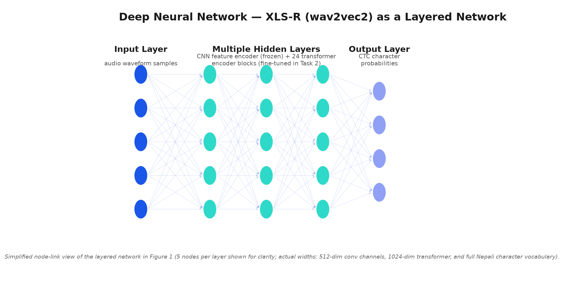
Figure 1b. Node-link view of the same XLS-R architecture: input layer (audio waveform), multiple hidden layers (CNN feature encoder + transformer encoder blocks), output layer (CTC character probabilities).
def load_model_and_processor(
model_id: str = XLSR_MODEL_ID,
) -> tuple[Wav2Vec2ForCTC, Wav2Vec2Processor]:
processor = Wav2Vec2Processor.from_pretrained(model_id)
# torch's scaled_dot_product_attention raises NotImplementedError on Apple
# MPS when dropout is active (i.e. in training mode); fall back to eager
# attention off-CUDA so local smoke tests run. CUDA (Colab T4) keeps SDPA.
attn = "sdpa" if torch.cuda.is_available() else "eager"
model = Wav2Vec2ForCTC.from_pretrained(model_id, attn_implementation=attn)
# Standard wav2vec2 fine-tuning practice: the convolutional feature
# encoder was trained on far more audio than we have -- freeze it.
model.freeze_feature_encoder()
return model, processor
The full src/xlsr_training.py module (including this function in context) is listed below alongside the rest of the codebase.

src/__init__.py
"""Reusable NSTT modules (preprocessing, metrics) — populated in later tasks."""
DEFAULT_SEED = 42

src/manifests.py
"""Manifest read/write helpers."""
from __future__ import annotations
import csv
import json
from pathlib import Path
from typing import Literal
SplitName = Literal["train", "val", "test"]
MANIFEST_FIELDS = [
"utterance_id",
"audio_path",
"transcript",
"speaker_id",
"gender",
"duration_s",
"split",
]
def write_jsonl_manifest(rows: list[dict], path: Path) -> None:
path.parent.mkdir(parents=True, exist_ok=True)
with path.open("w", encoding="utf-8") as f:
for row in rows:
f.write(json.dumps(row, ensure_ascii=False) + "\n")
def write_csv_manifest(rows: list[dict], path: Path) -> None:
path.parent.mkdir(parents=True, exist_ok=True)
with path.open("w", encoding="utf-8", newline="") as f:
writer = csv.DictWriter(f, fieldnames=MANIFEST_FIELDS)
writer.writeheader()
for row in rows:
writer.writerow({k: row[k] for k in MANIFEST_FIELDS})
def read_jsonl_manifest(path: Path) -> list[dict]:
rows: list[dict] = []
with path.open(encoding="utf-8") as f:
for line in f:
line = line.strip()
if line:
rows.append(json.loads(line))
return rows
def write_split_manifests(splits: dict[SplitName, list[dict]], manifest_dir: Path) -> dict[str, Path]:
"""Write train/val/test jsonl manifests and return paths."""
paths: dict[str, Path] = {}
for split_name, rows in splits.items():
out = manifest_dir / f"{split_name}.jsonl"
write_jsonl_manifest(rows, out)
paths[split_name] = out
all_rows = splits["train"] + splits["val"] + splits["test"]
all_path = manifest_dir / "all.jsonl"
write_jsonl_manifest(all_rows, all_path)
paths["all"] = all_path
return paths

src/pipeline.py
"""End-to-end SLR54 data preparation pipeline."""
from __future__ import annotations
import random
from collections import defaultdict
from pathlib import Path
import soundfile as sf
from src.manifests import write_split_manifests
from src.preprocessing import (
classify_gender_from_pitch,
estimate_mean_f0_hz,
process_utterance,
)
from src.slr54 import (
attach_audio_paths,
download_tsv,
download_zips,
extract_zips,
index_audio_files,
parse_utt_spk_text_tsv,
)
from src.splits import count_speaker_overlap, speaker_disjoint_split
DEFAULT_SEED = 42
DEFAULT_TARGET_HOURS = 15.0
GENDER_SAMPLES_PER_SPEAKER = 3
def _estimate_speaker_gender(
speaker_records: list[dict], project_root: Path, *, num_samples: int = GENDER_SAMPLES_PER_SPEAKER
) -> str:
"""Acoustic pseudo-label for one speaker: mean-F0 over a few of their processed clips.
OpenSLR54 ships no gender metadata; this is a heuristic proxy, not ground truth.
"""
sample = speaker_records[:num_samples]
f0_values: list[float] = []
for record in sample:
audio_path = project_root / record["audio_path"]
waveform, sr = sf.read(audio_path)
f0 = estimate_mean_f0_hz(waveform, sr)
if f0 is not None:
f0_values.append(f0)
if not f0_values:
return "unknown"
return classify_gender_from_pitch(sum(f0_values) / len(f0_values))
def run_slr54_pipeline(
project_root: Path,
*,
corpus_dir: Path | None = None,
zip_names: list[str] | None = None,
seed: int = DEFAULT_SEED,
max_utterances: int | None = None,
target_hours: float | None = DEFAULT_TARGET_HOURS,
skip_download: bool = True,
) -> dict:
"""Preprocess, split, and write manifests for SLR54.
corpus_dir points at an already-downloaded/extracted corpus
(tsv + data/<xx>/*.flac directly underneath it, no download step).
Set skip_download=False to fall back to the original download-then-extract
flow into data/raw/slr54 instead.
target_hours caps the processed subset by total audio duration, selecting
whole speakers (shuffled by seed) until the cap is reached, so the
speaker-disjoint split downstream is unaffected. Set to None to process
every utterance with attached audio.
"""
processed_dir = project_root / "data" / "processed"
manifest_dir = project_root / "data" / "manifests"
if skip_download:
extract_dir = corpus_dir or (project_root / "data" / "openslr54_ne")
tsv_path = extract_dir / "utt_spk_text.tsv"
else:
raw_dir = project_root / "data" / "raw" / "slr54"
extract_dir = raw_dir / "extracted"
tsv_path = download_tsv(raw_dir)
zip_paths = download_zips(raw_dir, zip_names=zip_names)
extract_zips(raw_dir, zip_paths, extract_dir)
utterances = parse_utt_spk_text_tsv(tsv_path)
tsv_count = len(utterances)
audio_index = index_audio_files(extract_dir)
utterances = attach_audio_paths(utterances, audio_index)
if max_utterances is not None:
utterances = utterances[:max_utterances]
by_speaker: dict[str, list] = defaultdict(list)
for utt in utterances:
by_speaker[utt.speaker_id].append(utt)
speaker_order = list(by_speaker.keys())
random.Random(seed).shuffle(speaker_order)
target_seconds = target_hours * 3600 if target_hours is not None else None
processed_records: list[dict] = []
speaker_records: dict[str, list[dict]] = defaultdict(list)
skipped_no_audio = 0
skipped_duration = 0
total_duration_s = 0.0
for speaker_id in speaker_order:
if target_seconds is not None and total_duration_s >= target_seconds:
break
for utt in by_speaker[speaker_id]:
if utt.audio_path is None:
skipped_no_audio += 1
continue
row = process_utterance(
utterance_id=utt.utterance_id,
speaker_id=utt.speaker_id,
transcript=utt.transcript,
input_audio=utt.audio_path,
processed_audio_dir=processed_dir,
)
if row is None:
skipped_duration += 1
continue
processed_records.append(row)
speaker_records[speaker_id].append(row)
total_duration_s += row["duration_s"]
for speaker_id, records in speaker_records.items():
gender = _estimate_speaker_gender(records, project_root)
for record in records:
record["gender"] = gender
splits = speaker_disjoint_split(processed_records, seed=seed)
manifest_paths = write_split_manifests(splits, manifest_dir)
overlap = count_speaker_overlap(splits)
return {
"manifest_paths": manifest_paths,
"splits": splits,
"stats": {
"utterances_in_tsv": tsv_count,
"utterances_with_audio": len(utterances),
"processed_after_filter": len(processed_records),
"skipped_no_audio": skipped_no_audio,
"skipped_duration": skipped_duration,
"total_duration_hours": round(total_duration_s / 3600, 2),
"num_speakers": len(speaker_records),
"train_count": len(splits["train"]),
"val_count": len(splits["val"]),
"test_count": len(splits["test"]),
"speaker_overlap": overlap,
"seed": seed,
},
}

src/preprocessing.py
"""Audio and transcript preprocessing for NSTT."""
from __future__ import annotations
import unicodedata
from pathlib import Path
import librosa
import numpy as np
import soundfile as sf
TARGET_SAMPLE_RATE = 16_000
MIN_DURATION_S = 0.5
MAX_DURATION_S = 30.0
# Mean-F0 threshold separating male/female speech in the standard adult voice
# pitch ranges (~85-180Hz male, ~165-255Hz female); midpoint is the common
# heuristic cutoff. OpenSLR54 ships no gender metadata, so this acoustic proxy
# is used as a pseudo-label, not ground truth -- must be reported as such.
GENDER_PITCH_THRESHOLD_HZ = 165.0
def normalize_transcript_nfc(text: str) -> str:
"""NFC-normalize Devanagari transcripts to avoid encoding mismatches."""
return unicodedata.normalize("NFC", text.strip())
def is_nfc_normalized(text: str) -> bool:
return text == unicodedata.normalize("NFC", text)
def duration_in_bounds(duration_s: float) -> bool:
return MIN_DURATION_S < duration_s < MAX_DURATION_S
def load_resample_mono(audio_path: Path, target_sr: int = TARGET_SAMPLE_RATE) -> tuple[np.ndarray, float]:
"""Load audio, resample to target_sr, collapse to mono. Returns (waveform, duration_s)."""
waveform, sr = librosa.load(audio_path, sr=target_sr, mono=True)
duration_s = len(waveform) / target_sr
return waveform, duration_s
def process_audio_file(
input_path: Path,
output_path: Path,
target_sr: int = TARGET_SAMPLE_RATE,
) -> float:
"""Resample to 16 kHz mono WAV and return duration in seconds."""
waveform, duration_s = load_resample_mono(input_path, target_sr=target_sr)
output_path.parent.mkdir(parents=True, exist_ok=True)
sf.write(output_path, waveform, target_sr)
return duration_s
def estimate_mean_f0_hz(waveform: np.ndarray, sr: int) -> float | None:
"""Estimate mean voiced fundamental frequency (F0) in Hz via librosa pYIN.
Returns None if no voiced frames are detected (e.g. silence/noise).
"""
f0, voiced_flag, _ = librosa.pyin(
waveform,
fmin=librosa.note_to_hz("C2"),
fmax=librosa.note_to_hz("C6"),
sr=sr,
)
voiced_f0 = f0[voiced_flag]
if voiced_f0.size == 0:
return None
return float(np.nanmean(voiced_f0))
def classify_gender_from_pitch(mean_f0_hz: float | None) -> str:
"""Acoustic pseudo-label: 'male'/'female' by mean-F0 threshold, 'unknown' if undetected."""
if mean_f0_hz is None or np.isnan(mean_f0_hz):
return "unknown"
return "female" if mean_f0_hz >= GENDER_PITCH_THRESHOLD_HZ else "male"
def process_utterance(
utterance_id: str,
speaker_id: str,
transcript: str,
input_audio: Path,
processed_audio_dir: Path,
) -> dict | None:
"""Process one utterance; return manifest row dict or None if filtered out."""
normalized = normalize_transcript_nfc(transcript)
output_path = processed_audio_dir / f"{utterance_id}.wav"
duration_s = process_audio_file(input_audio, output_path)
if not duration_in_bounds(duration_s):
if output_path.exists():
output_path.unlink()
return None
return {
"utterance_id": utterance_id,
"audio_path": str(Path("data/processed") / f"{utterance_id}.wav"),
"transcript": normalized,
"speaker_id": speaker_id,
"duration_s": round(duration_s, 4),
}

src/slr54.py
"""OpenSLR SLR54 download and ingest utilities.
Dataset: https://www.openslr.org/54/
Citation: Kjartansson et al., SLTU 2018 (see start.md / SLR54 LICENSE).
"""
from __future__ import annotations
import re
import urllib.request
import zipfile
from dataclasses import dataclass
from pathlib import Path
SLR54_BASE_URL = "https://www.openslr.org/resources/54"
SLR54_TSV_NAME = "utt_spk_text.tsv"
SLR54_ZIP_NAMES = [f"asr_nepali_{i:x}" for i in range(16)] # 0-9, a-f
SLR54_ZIP_FILES = [f"{name}.zip" for name in SLR54_ZIP_NAMES]
SLR54_AUDIO_SUBDIR = Path("asr_nepali/data")
@dataclass(frozen=True)
class Slr54Utterance:
utterance_id: str
speaker_id: str
transcript: str
audio_path: Path | None = None
def _download_file(url: str, dest: Path) -> None:
dest.parent.mkdir(parents=True, exist_ok=True)
if dest.exists():
return
print(f"Downloading {url} -> {dest}")
urllib.request.urlretrieve(url, dest)
def download_tsv(raw_dir: Path) -> Path:
"""Download the SLR54 utterance/speaker/transcript index."""
dest = raw_dir / SLR54_TSV_NAME
_download_file(f"{SLR54_BASE_URL}/{SLR54_TSV_NAME}", dest)
return dest
def download_zips(raw_dir: Path, zip_names: list[str] | None = None) -> list[Path]:
"""Download SLR54 audio archives (default: all 16 zips)."""
names = zip_names or SLR54_ZIP_FILES
paths: list[Path] = []
for name in names:
dest = raw_dir / name
_download_file(f"{SLR54_BASE_URL}/{name}", dest)
paths.append(dest)
return paths
def extract_zips(raw_dir: Path, zip_paths: list[Path], extract_dir: Path) -> None:
"""Extract downloaded zip archives into extract_dir."""
extract_dir.mkdir(parents=True, exist_ok=True)
for zip_path in zip_paths:
marker = extract_dir / f".extracted_{zip_path.name}"
if marker.exists():
continue
with zipfile.ZipFile(zip_path, "r") as zf:
zf.extractall(extract_dir)
marker.touch()
def parse_utt_spk_text_tsv(tsv_path: Path) -> list[Slr54Utterance]:
"""Parse utt_spk_text.tsv: FileID, UserID (speaker), transcription."""
utterances: list[Slr54Utterance] = []
with tsv_path.open(encoding="utf-8") as f:
for line in f:
line = line.strip()
if not line:
continue
fields = re.split(r"\t+", line)
if len(fields) < 3:
continue
file_id, speaker_id, transcript = fields[0], fields[1], fields[2]
utterances.append(
Slr54Utterance(
utterance_id=file_id,
speaker_id=speaker_id,
transcript=transcript,
)
)
return utterances
def index_audio_files(extract_dir: Path) -> dict[str, Path]:
"""Map utterance_id (flac stem) to absolute audio path."""
audio_root = extract_dir / SLR54_AUDIO_SUBDIR
if not audio_root.exists():
# Some archives may flatten paths differently; fall back to recursive search.
flac_files = list(extract_dir.rglob("*.flac"))
else:
flac_files = list(audio_root.rglob("*.flac"))
return {p.stem: p for p in flac_files}
def attach_audio_paths(
utterances: list[Slr54Utterance], audio_index: dict[str, Path]
) -> list[Slr54Utterance]:
"""Return utterances that have a matching audio file on disk."""
attached: list[Slr54Utterance] = []
for utt in utterances:
audio_path = audio_index.get(utt.utterance_id)
if audio_path is None:
continue
attached.append(
Slr54Utterance(
utterance_id=utt.utterance_id,
speaker_id=utt.speaker_id,
transcript=utt.transcript,
audio_path=audio_path,
)
)
return attached

src/splits.py
"""Speaker-disjoint dataset splitting."""
from __future__ import annotations
import random
from collections import defaultdict
from typing import Literal
SplitName = Literal["train", "val", "test"]
DEFAULT_SEED = 42
TRAIN_RATIO = 0.8
VAL_RATIO = 0.1
TEST_RATIO = 0.1
def speaker_disjoint_split(
records: list[dict],
*,
seed: int = DEFAULT_SEED,
train_ratio: float = TRAIN_RATIO,
val_ratio: float = VAL_RATIO,
test_ratio: float = TEST_RATIO,
) -> dict[SplitName, list[dict]]:
"""Assign records to train/val/test with no speaker appearing in multiple splits."""
if abs(train_ratio + val_ratio + test_ratio - 1.0) > 1e-6:
raise ValueError("train/val/test ratios must sum to 1.0")
by_speaker: dict[str, list[dict]] = defaultdict(list)
for record in records:
by_speaker[record["speaker_id"]].append(record)
speakers = list(by_speaker.keys())
rng = random.Random(seed)
rng.shuffle(speakers)
n = len(speakers)
n_train = int(n * train_ratio)
n_val = int(n * val_ratio)
train_speakers = set(speakers[:n_train])
val_speakers = set(speakers[n_train : n_train + n_val])
test_speakers = set(speakers[n_train + n_val :])
assert not (train_speakers & val_speakers)
assert not (train_speakers & test_speakers)
assert not (val_speakers & test_speakers)
splits: dict[SplitName, list[dict]] = {"train": [], "val": [], "test": []}
for speaker_id, speaker_records in by_speaker.items():
if speaker_id in train_speakers:
split: SplitName = "train"
elif speaker_id in val_speakers:
split = "val"
else:
split = "test"
for record in speaker_records:
row = dict(record)
row["split"] = split
splits[split].append(row)
return splits
def utterance_random_split(
records: list[dict],
*,
seed: int = DEFAULT_SEED,
train_ratio: float = TRAIN_RATIO,
val_ratio: float = VAL_RATIO,
test_ratio: float = TEST_RATIO,
) -> dict[SplitName, list[dict]]:
""""Leaky" split: shuffle utterances directly, ignoring speaker identity.
Same size/ratios as speaker_disjoint_split, but a speaker's utterances can
land in multiple splits. Used only as a Phase 9 ablation to measure how
much speaker leakage inflates apparent performance on this dataset.
"""
if abs(train_ratio + val_ratio + test_ratio - 1.0) > 1e-6:
raise ValueError("train/val/test ratios must sum to 1.0")
shuffled = list(records)
random.Random(seed).shuffle(shuffled)
n = len(shuffled)
n_train = int(n * train_ratio)
n_val = int(n * val_ratio)
splits: dict[SplitName, list[dict]] = {"train": [], "val": [], "test": []}
for i, record in enumerate(shuffled):
row = dict(record)
if i < n_train:
row["split"] = "train"
splits["train"].append(row)
elif i < n_train + n_val:
row["split"] = "val"
splits["val"].append(row)
else:
row["split"] = "test"
splits["test"].append(row)
return splits
def count_speaker_overlap(splits: dict[SplitName, list[dict]]) -> int:
"""Return number of speakers appearing in more than one split (expect 0)."""
speaker_to_splits: dict[str, set[str]] = defaultdict(set)
for split_name, rows in splits.items():
for row in rows:
speaker_to_splits[row["speaker_id"]].add(split_name)
return sum(1 for splits_seen in speaker_to_splits.values() if len(splits_seen) > 1)

src/wer_metrics.py
"""Minimal, model-agnostic WER/CER computation (jiwer-based)."""
from __future__ import annotations
import jiwer
def compute_wer_cer(references: list[str], hypotheses: list[str]) -> tuple[float, float]:
wer = jiwer.wer(references, hypotheses)
cer = jiwer.cer(references, hypotheses)
return wer, cer

src/xlsr_baseline.py
"""XLS-R (wav2vec2) baseline audit for gagan3012/wav2vec2-xlsr-nepali on OpenSLR-43.
This project has one purpose: evaluate this model on OpenSLR-43
(gauravparajuli/slr43), the same corpus it was originally trained/self-evaluated
on, to sanity-check its published 5.97% WER claim. No other model, no other
corpus, no fine-tuning track.
OpenSLR-43 has no speaker/gender metadata (verified: HF dataset_info only lists
`audio` and `text` features) and is a single-speaker (female) corpus -- no
demographic breakdown is possible or attempted here.
"""
from __future__ import annotations
import re
from pathlib import Path
import numpy as np
import torch
from datasets import Dataset, load_dataset
from transformers import Wav2Vec2ForCTC, Wav2Vec2Processor
XLSR_MODEL_ID = "gagan3012/wav2vec2-xlsr-nepali"
OPENSLR43_DATASET_ID = "gauravparajuli/slr43"
TARGET_SAMPLE_RATE = 16_000
CHARS_TO_IGNORE_REGEX = r'[\,\?\.\!\-\;\:\"\“]'
SELF_REPORTED_WER = 0.0597
def load_xlsr_model_and_processor(
model_id: str = XLSR_MODEL_ID,
) -> tuple[Wav2Vec2ForCTC, Wav2Vec2Processor]:
processor = Wav2Vec2Processor.from_pretrained(model_id)
model = Wav2Vec2ForCTC.from_pretrained(model_id)
model.eval()
return model, processor
def load_openslr43_test_dataset(max_samples: int | None = None) -> Dataset:
"""Only a 'train' split exists upstream -- there is no separate held-out
test split, so this project treats a fixed-seed slice of it as the
in-domain eval set."""
dataset = load_dataset(OPENSLR43_DATASET_ID, split="train")
if max_samples is not None:
dataset = dataset.select(range(min(max_samples, len(dataset))))
return dataset
def clean_transcript(text: str) -> str:
return re.sub(CHARS_TO_IGNORE_REGEX, "", text).lower()
def resample_if_needed(speech_array: np.ndarray, sampling_rate: int) -> np.ndarray:
if sampling_rate == TARGET_SAMPLE_RATE:
return speech_array
import torchaudio
resampled = torchaudio.functional.resample(
torch.tensor(speech_array), sampling_rate, TARGET_SAMPLE_RATE
)
return resampled.numpy()
def transcribe_ctc(
model: Wav2Vec2ForCTC,
processor: Wav2Vec2Processor,
speech_array: np.ndarray,
device: str,
) -> str:
"""Greedy CTC decode -- XLS-R/wav2vec2 is a CTC model, not seq2seq."""
inputs = processor(speech_array, sampling_rate=TARGET_SAMPLE_RATE, return_tensors="pt")
inputs = {k: v.to(device) for k, v in inputs.items()}
with torch.no_grad():
logits = model(**inputs).logits
pred_ids = torch.argmax(logits, dim=-1)
return processor.batch_decode(pred_ids)[0]
def build_openslr43_manifest_rows(dataset: Dataset) -> list[dict]:
"""CSV-manifest rows referencing the HF dataset by index rather than storing
audio locally -- raw audio stays out of git."""
rows = []
for i, row in enumerate(dataset):
audio = row["audio"]
duration_s = len(audio["array"]) / audio["sampling_rate"]
rows.append(
{
"utterance_id": f"slr43_{i:05d}",
"hf_dataset": OPENSLR43_DATASET_ID,
"hf_index": i,
"text": clean_transcript(row["text"]),
"duration_s": round(duration_s, 4),
}
)
return rows
def write_openslr43_manifest(rows: list[dict], path: Path | str) -> None:
import csv
path = Path(path)
path.parent.mkdir(parents=True, exist_ok=True)
with path.open("w", encoding="utf-8", newline="") as f:
writer = csv.DictWriter(f, fieldnames=["utterance_id", "hf_dataset", "hf_index", "text", "duration_s"])
writer.writeheader()
writer.writerows(rows)

src/xlsr_training.py
"""XLS-R (wav2vec2) CTC fine-tuning on the speaker-disjoint OpenSLR-54 subset.
Phase 6: fine-tune the audited checkpoint (gagan3012/wav2vec2-xlsr-nepali)
on speaker-diverse data to close its demonstrated generalization gap.
Keeps the checkpoint's own tokenizer/vocab (we repair the same model, not
train a new one). Experiment tracking: MLflow (report_to=["mlflow"]).
Collator adapted from the Hugging Face wav2vec2 fine-tuning blog
(https://huggingface.co/blog/fine-tune-wav2vec2-english) -- cite in the report.
"""
from __future__ import annotations
from dataclasses import dataclass
from pathlib import Path
from typing import Any
import numpy as np
import torch
from datasets import Audio, Dataset
from transformers import (
EarlyStoppingCallback,
Trainer,
TrainerCallback,
TrainingArguments,
Wav2Vec2ForCTC,
Wav2Vec2Processor,
set_seed,
)
class MPSCacheClearCallback(TrainerCallback):
"""Long MPS training runs accumulate allocator fragmentation until
torch.autograd's backward pass OOMs (observed: crashed ~1580 steps in,
17GB allocated, right after an eval pass). Periodic empty_cache() keeps
the allocator from growing unbounded. No-op on CUDA/CPU."""
def _clear(self) -> None:
if torch.backends.mps.is_available():
torch.mps.empty_cache()
def on_step_end(self, args, state, control, **kwargs):
if state.global_step % 50 == 0:
self._clear()
def on_evaluate(self, args, state, control, **kwargs):
self._clear()
from src.manifests import read_jsonl_manifest
from src.wer_metrics import compute_wer_cer
from src.xlsr_baseline import XLSR_MODEL_ID, clean_transcript
DEFAULT_SEED = 42
TARGET_SAMPLE_RATE = 16_000
# The checkpoint is already Nepali fine-tuned; a low LR adapts it to diverse
# speakers without erasing what it knows (Phase 7 checks forgetting anyway).
DEFAULT_LEARNING_RATE = 3e-5
MAX_EPOCHS = 5
def load_model_and_processor(
model_id: str = XLSR_MODEL_ID,
) -> tuple[Wav2Vec2ForCTC, Wav2Vec2Processor]:
processor = Wav2Vec2Processor.from_pretrained(model_id)
# torch's scaled_dot_product_attention raises NotImplementedError on Apple
# MPS when dropout is active (i.e. in training mode); fall back to eager
# attention off-CUDA so local smoke tests run. CUDA (Colab T4) keeps SDPA.
attn = "sdpa" if torch.cuda.is_available() else "eager"
model = Wav2Vec2ForCTC.from_pretrained(model_id, attn_implementation=attn)
# Standard wav2vec2 fine-tuning practice: the convolutional feature
# encoder was trained on far more audio than we have -- freeze it.
model.freeze_feature_encoder()
return model, processor
def manifest_to_dataset(rows: list[dict], project_root: Path) -> Dataset:
def _generator() -> Any:
for row in rows:
yield {
"audio": str((project_root / row["audio_path"]).resolve()),
"text": clean_transcript(row["transcript"]),
"utterance_id": row["utterance_id"],
}
dataset = Dataset.from_generator(_generator)
return dataset.cast_column("audio", Audio(sampling_rate=TARGET_SAMPLE_RATE))
def load_datasets(
project_root: Path,
*,
manifest_dir: Path | None = None,
max_train: int | None = None,
max_eval: int | None = None,
) -> tuple[Dataset, Dataset]:
manifest_dir = manifest_dir or (project_root / "data" / "manifests")
train_rows = read_jsonl_manifest(manifest_dir / "train.jsonl")
val_rows = read_jsonl_manifest(manifest_dir / "val.jsonl")
if max_train is not None:
train_rows = train_rows[:max_train]
if max_eval is not None:
val_rows = val_rows[:max_eval]
return (
manifest_to_dataset(train_rows, project_root),
manifest_to_dataset(val_rows, project_root),
)
def build_prepare_fn(processor: Wav2Vec2Processor):
def prepare(batch: dict) -> dict:
audio = batch["audio"]
batch["input_values"] = processor(
audio["array"], sampling_rate=audio["sampling_rate"]
).input_values[0]
batch["labels"] = processor.tokenizer(batch["text"]).input_ids
return batch
return prepare
@dataclass
class DataCollatorCTCWithPadding:
processor: Wav2Vec2Processor
def __call__(self, features: list[dict]) -> dict[str, torch.Tensor]:
input_features = [{"input_values": f["input_values"]} for f in features]
label_features = [{"input_ids": f["labels"]} for f in features]
batch = self.processor.feature_extractor.pad(input_features, return_tensors="pt")
labels_batch = self.processor.tokenizer.pad(label_features, return_tensors="pt")
labels = labels_batch["input_ids"].masked_fill(
labels_batch.attention_mask.ne(1), -100
)
batch["labels"] = labels
return batch
def build_compute_metrics(processor: Wav2Vec2Processor):
def compute_metrics(pred) -> dict[str, float]:
pred_ids = np.argmax(pred.predictions, axis=-1)
label_ids = np.where(
pred.label_ids != -100, pred.label_ids, processor.tokenizer.pad_token_id
)
pred_str = processor.batch_decode(pred_ids)
label_str = processor.batch_decode(label_ids, group_tokens=False)
wer, cer = compute_wer_cer(label_str, pred_str)
return {"wer": wer, "cer": cer}
return compute_metrics
def build_training_arguments(
output_dir: Path,
*,
smoke_test: bool = False,
learning_rate: float = DEFAULT_LEARNING_RATE,
) -> TrainingArguments:
fp16 = torch.cuda.is_available()
if smoke_test:
return TrainingArguments(
output_dir=str(output_dir),
per_device_train_batch_size=2,
per_device_eval_batch_size=2,
gradient_accumulation_steps=4,
learning_rate=learning_rate,
warmup_steps=0,
max_steps=6,
eval_strategy="steps",
eval_steps=3,
logging_steps=1,
save_steps=3,
save_total_limit=2,
fp16=fp16,
report_to=["mlflow"],
remove_unused_columns=False,
label_names=["labels"],
load_best_model_at_end=False,
)
return TrainingArguments(
output_dir=str(output_dir),
per_device_train_batch_size=2,
per_device_eval_batch_size=2,
gradient_accumulation_steps=4,
learning_rate=learning_rate,
warmup_steps=500,
num_train_epochs=MAX_EPOCHS,
eval_strategy="epoch",
save_strategy="epoch",
logging_steps=100,
save_total_limit=3,
fp16=fp16,
report_to=["mlflow"],
remove_unused_columns=False,
label_names=["labels"],
load_best_model_at_end=True,
metric_for_best_model="wer",
greater_is_better=False,
)
def create_trainer(
project_root: Path,
output_dir: Path,
*,
smoke_test: bool = False,
seed: int = DEFAULT_SEED,
manifest_dir: Path | None = None,
max_train: int | None = None,
max_eval: int | None = None,
) -> tuple[Trainer, Wav2Vec2Processor]:
set_seed(seed)
model, processor = load_model_and_processor()
if smoke_test and max_train is None:
max_train, max_eval = 32, 8
train_ds, eval_ds = load_datasets(
project_root, manifest_dir=manifest_dir, max_train=max_train, max_eval=max_eval
)
prepare = build_prepare_fn(processor)
train_ds = train_ds.map(prepare, remove_columns=train_ds.column_names)
eval_ds = eval_ds.map(prepare, remove_columns=eval_ds.column_names)
args = build_training_arguments(output_dir, smoke_test=smoke_test)
trainer = Trainer(
model=model,
args=args,
train_dataset=train_ds,
eval_dataset=eval_ds,
data_collator=DataCollatorCTCWithPadding(processor=processor),
compute_metrics=build_compute_metrics(processor),
processing_class=processor.feature_extractor,
)
trainer.add_callback(MPSCacheClearCallback())
if not smoke_test:
trainer.add_callback(EarlyStoppingCallback(early_stopping_patience=2))
return trainer, processor
def train_and_save(
project_root: Path,
output_dir: Path,
*,
smoke_test: bool = False,
resume_from_checkpoint: str | bool | None = None,
seed: int = DEFAULT_SEED,
manifest_dir: Path | None = None,
max_train: int | None = None,
max_eval: int | None = None,
) -> dict:
trainer, processor = create_trainer(
project_root,
output_dir,
smoke_test=smoke_test,
seed=seed,
manifest_dir=manifest_dir,
max_train=max_train,
max_eval=max_eval,
)
train_result = trainer.train(resume_from_checkpoint=resume_from_checkpoint)
eval_metrics = trainer.evaluate()
trainer.save_model(str(output_dir))
processor.save_pretrained(str(output_dir))
return {
"train_loss": train_result.training_loss,
"eval_metrics": eval_metrics,
"checkpoint_dir": str(output_dir),
"global_step": trainer.state.global_step,
}

scripts/make_leaky_manifests.py
"""Phase 9 ablation: build a leaky (utterance-random, non-speaker-disjoint)
split from the same processed records as the real manifests, for a
matched-training-budget comparison against the speaker-disjoint split."""
from __future__ import annotations
import sys
from pathlib import Path
sys.path.insert(0, str(Path(__file__).resolve().parents[1]))
from src.manifests import read_jsonl_manifest, write_split_manifests
from src.splits import count_speaker_overlap, utterance_random_split
PROJECT_ROOT = Path(__file__).resolve().parents[1]
def main() -> None:
all_rows = read_jsonl_manifest(PROJECT_ROOT / "data" / "manifests" / "all.jsonl")
splits = utterance_random_split(all_rows, seed=42)
manifest_dir = PROJECT_ROOT / "data" / "manifests_leaky"
write_split_manifests(splits, manifest_dir)
overlap = count_speaker_overlap(splits)
print(f"Leaky split written to {manifest_dir}")
print(f"train={len(splits['train'])} val={len(splits['val'])} test={len(splits['test'])}")
print(f"speaker_overlap between splits: {overlap} (expected > 0 -- this is the leaky ablation)")
if __name__ == "__main__":
main()

scripts/run_audit.py
"""Phase 4 — Baseline Establishment (The Audit).
Evaluates gagan3012/wav2vec2-xlsr-nepali zero-shot on:
(a) OpenSLR-43 (its own single-speaker training corpus) -- in-domain
reproduction of the self-reported 5.97% WER claim;
(b) this project's speaker-disjoint OpenSLR-54 test split -- out-of-domain
generalization check.
Both runs are logged to MLflow (local ./mlruns store): params, WER/CER,
and per-utterance example artifacts. The two corpora are never merged.
Note: data/manifests/test.jsonl is speaker-ordered, so the SLR54 sample is
drawn after a seeded shuffle -- a plain [:N] slice would land on very few
speakers (this exact bug happened once before in this repo's history).
"""
from __future__ import annotations
import argparse
import json
import platform
import random
import sys
from pathlib import Path
sys.path.insert(0, str(Path(__file__).resolve().parents[1]))
import mlflow
import soundfile as sf
import torch
from src.manifests import read_jsonl_manifest
from src.wer_metrics import compute_wer_cer
from src.xlsr_baseline import (
SELF_REPORTED_WER,
XLSR_MODEL_ID,
build_openslr43_manifest_rows,
load_openslr43_test_dataset,
load_xlsr_model_and_processor,
resample_if_needed,
transcribe_ctc,
write_openslr43_manifest,
)
PROJECT_ROOT = Path(__file__).resolve().parents[1]
REPORTS_DIR = PROJECT_ROOT / "reports"
EXPERIMENT_NAME = "phase4-audit"
def device_info() -> dict:
return {
"platform": platform.platform(),
"python": platform.python_version(),
"torch": torch.__version__,
"cuda_available": torch.cuda.is_available(),
"mps_available": getattr(torch.backends, "mps", None) is not None
and torch.backends.mps.is_available(),
}
def eval_slr43(model, processor, device: str, n_samples: int) -> dict:
dataset = load_openslr43_test_dataset(max_samples=n_samples)
rows = build_openslr43_manifest_rows(dataset)
write_openslr43_manifest(rows, PROJECT_ROOT / "data" / "manifests" / "xlsr_openslr43_test_manifest.csv")
references, hypotheses, examples = [], [], []
for i, row in enumerate(dataset):
audio = row["audio"]
speech = resample_if_needed(audio["array"], audio["sampling_rate"])
hyp = transcribe_ctc(model, processor, speech, device)
references.append(rows[i]["text"])
hypotheses.append(hyp)
examples.append({"utterance_id": rows[i]["utterance_id"], "reference": rows[i]["text"], "hypothesis": hyp})
if (i + 1) % 25 == 0:
print(f" [SLR43 in-domain] {i + 1}/{len(dataset)} done")
wer, cer = compute_wer_cer(references, hypotheses)
print(f"[SLR43 in-domain] WER={wer:.4f} CER={cer:.4f} on {len(dataset)} utterances")
return {"dataset": "OpenSLR-43 (in-domain)", "num_utterances": len(dataset), "wer": wer, "cer": cer, "examples": examples}
def eval_slr54(model, processor, device: str, n_samples: int, seed: int) -> dict:
all_rows = read_jsonl_manifest(PROJECT_ROOT / "data" / "manifests" / "test.jsonl")
shuffled = list(all_rows)
random.Random(seed).shuffle(shuffled)
rows = shuffled[:n_samples] if n_samples else shuffled
references, hypotheses, examples = [], [], []
for i, row in enumerate(rows):
audio, sr = sf.read(PROJECT_ROOT / row["audio_path"])
speech = resample_if_needed(audio, sr)
hyp = transcribe_ctc(model, processor, speech, device)
references.append(row["transcript"])
hypotheses.append(hyp)
examples.append(
{
"utterance_id": row["utterance_id"],
"speaker_id": row["speaker_id"],
"gender_pseudo_label": row["gender"],
"reference": row["transcript"],
"hypothesis": hyp,
}
)
if (i + 1) % 25 == 0:
print(f" [SLR54 out-of-domain] {i + 1}/{len(rows)} done")
wer, cer = compute_wer_cer(references, hypotheses)
print(f"[SLR54 out-of-domain] WER={wer:.4f} CER={cer:.4f} on {len(rows)} utterances")
return {"dataset": "OpenSLR-54 speaker-disjoint test (out-of-domain)", "num_utterances": len(rows), "wer": wer, "cer": cer, "examples": examples}
def log_run(name: str, result: dict, params: dict) -> None:
with mlflow.start_run(run_name=name):
mlflow.log_params(params)
mlflow.log_metrics({"wer": result["wer"], "cer": result["cer"]})
examples_path = REPORTS_DIR / f"phase4_{name}_examples.jsonl"
with examples_path.open("w", encoding="utf-8") as f:
for ex in result["examples"]:
f.write(json.dumps(ex, ensure_ascii=False) + "\n")
mlflow.log_artifact(str(examples_path))
def main() -> None:
parser = argparse.ArgumentParser()
parser.add_argument("--n_samples", type=int, default=150)
parser.add_argument("--seed", type=int, default=42)
args = parser.parse_args()
device = "cuda" if torch.cuda.is_available() else "cpu"
info = device_info()
print("Device:", json.dumps(info, indent=2))
mlflow.set_tracking_uri(f"file://{PROJECT_ROOT / 'mlruns'}")
mlflow.set_experiment(EXPERIMENT_NAME)
REPORTS_DIR.mkdir(parents=True, exist_ok=True)
print(f"Loading {XLSR_MODEL_ID}...")
model, processor = load_xlsr_model_and_processor()
model.to(device)
slr43 = eval_slr43(model, processor, device, args.n_samples)
slr54 = eval_slr54(model, processor, device, args.n_samples, args.seed)
common = {"model": XLSR_MODEL_ID, "n_samples": args.n_samples, "device": device, **info}
log_run("slr43_in_domain", slr43, {**common, "dataset": "gauravparajuli/slr43"})
log_run("slr54_out_of_domain", slr54, {**common, "dataset": "OpenSLR-54 test.jsonl", "seed": args.seed})
summary = {
"model": XLSR_MODEL_ID,
"self_reported_wer": SELF_REPORTED_WER,
"device": info,
"in_domain_openslr43": {k: v for k, v in slr43.items() if k != "examples"},
"out_of_domain_openslr54": {k: v for k, v in slr54.items() if k != "examples"},
"corpus_separation_note": "OpenSLR-43 and OpenSLR-54 results are never merged into a single number.",
"slr54_gender_note": (
"SLR54 rows carry an F0-pitch gender pseudo-label (165Hz threshold), "
"not verified metadata -- used only for Phase 9 per-group analysis."
),
}
out_path = REPORTS_DIR / "phase4_audit_results.json"
out_path.write_text(json.dumps(summary, indent=2, ensure_ascii=False), encoding="utf-8")
print(f"Saved: {out_path}")
print("MLflow store: ./mlruns (view with: mlflow ui)")
if __name__ == "__main__":
main()

scripts/run_efficiency_benchmark.py
"""Phase 8 — Efficiency / Deployment Benchmark.
Benchmarks the fine-tuned checkpoint (models/xlsr-ft): model size, CPU
inference latency, and the FP32 vs. dynamic int8 quantization trade-off
(latency speedup vs. WER/CER cost). Logged to MLflow (experiment
"phase8-efficiency").
"""
from __future__ import annotations
import json
import random
import sys
import time
from pathlib import Path
sys.path.insert(0, str(Path(__file__).resolve().parents[1]))
import mlflow
import soundfile as sf
import torch
from transformers import Wav2Vec2ForCTC, Wav2Vec2Processor
# Apple Silicon (and most non-x86 ARM) only ships the qnnpack quantized
# backend, not fbgemm (torch's x86 default) -- without this, quantize_dynamic
# raises "RuntimeError: Didn't find engine for operation ... NoQEngine".
if "qnnpack" in torch.backends.quantized.supported_engines:
torch.backends.quantized.engine = "qnnpack"
from src.manifests import read_jsonl_manifest
from src.wer_metrics import compute_wer_cer
from src.xlsr_baseline import resample_if_needed
PROJECT_ROOT = Path(__file__).resolve().parents[1]
CHECKPOINT_DIR = PROJECT_ROOT / "models" / "xlsr-ft"
N_SAMPLES = 50
N_LATENCY_RUNS = 20
def model_size_mb(model: torch.nn.Module) -> float:
total_bytes = sum(p.numel() * p.element_size() for p in model.parameters())
total_bytes += sum(b.numel() * b.element_size() for b in model.buffers())
return total_bytes / (1024 * 1024)
def transcribe(model, processor, speech, device: str) -> str:
inputs = processor(speech, sampling_rate=16_000, return_tensors="pt")
inputs = {k: v.to(device) for k, v in inputs.items()}
with torch.no_grad():
logits = model(**inputs).logits
pred_ids = torch.argmax(logits, dim=-1)
return processor.batch_decode(pred_ids)[0]
def benchmark_latency(model, processor, samples: list, device: str) -> dict:
# Warm-up (first call pays one-time graph/cache setup cost)
transcribe(model, processor, samples[0], device)
times = []
for speech in samples[:N_LATENCY_RUNS]:
start = time.perf_counter()
transcribe(model, processor, speech, device)
times.append(time.perf_counter() - start)
return {
"mean_latency_s": sum(times) / len(times),
"min_latency_s": min(times),
"max_latency_s": max(times),
"num_runs": len(times),
}
def evaluate_wer(model, processor, rows: list, device: str) -> dict:
refs, hyps = [], []
for row in rows:
audio, sr = sf.read(PROJECT_ROOT / row["audio_path"])
speech = resample_if_needed(audio, sr)
hyps.append(transcribe(model, processor, speech, device))
refs.append(row["transcript"])
wer, cer = compute_wer_cer(refs, hyps)
return {"wer": wer, "cer": cer, "num_utterances": len(rows)}
def main() -> None:
device = "cpu" # deployment-realistic target; dynamic quantization is CPU-only anyway
processor = Wav2Vec2Processor.from_pretrained(CHECKPOINT_DIR)
rows = read_jsonl_manifest(PROJECT_ROOT / "data" / "manifests" / "test.jsonl")
shuffled = list(rows)
random.Random(42).shuffle(shuffled)
sample_rows = shuffled[:N_SAMPLES]
samples = []
for row in sample_rows:
audio, sr = sf.read(PROJECT_ROOT / row["audio_path"])
samples.append(resample_if_needed(audio, sr))
print("=== FP32 ===")
model_fp32 = Wav2Vec2ForCTC.from_pretrained(CHECKPOINT_DIR)
model_fp32.to(device).eval()
fp32_size = model_size_mb(model_fp32)
fp32_latency = benchmark_latency(model_fp32, processor, samples, device)
fp32_wer = evaluate_wer(model_fp32, processor, sample_rows, device)
print(f"size={fp32_size:.1f}MB latency={fp32_latency['mean_latency_s']*1000:.1f}ms wer={fp32_wer['wer']:.4f}")
print("=== Dynamic INT8 (torch.quantization.quantize_dynamic on Linear layers) ===")
model_int8 = torch.quantization.quantize_dynamic(
model_fp32, {torch.nn.Linear}, dtype=torch.qint8
)
int8_size = model_size_mb(model_int8)
int8_latency = benchmark_latency(model_int8, processor, samples, device)
int8_wer = evaluate_wer(model_int8, processor, sample_rows, device)
print(f"size={int8_size:.1f}MB latency={int8_latency['mean_latency_s']*1000:.1f}ms wer={int8_wer['wer']:.4f}")
results = {
"checkpoint": str(CHECKPOINT_DIR),
"n_samples": N_SAMPLES,
"n_latency_runs": N_LATENCY_RUNS,
"device": "cpu",
"fp32": {"model_size_mb": fp32_size, **fp32_latency, **fp32_wer},
"int8_dynamic": {"model_size_mb": int8_size, **int8_latency, **int8_wer},
"speedup_x": fp32_latency["mean_latency_s"] / int8_latency["mean_latency_s"],
"size_reduction_pct": (1 - int8_size / fp32_size) * 100,
"wer_delta": int8_wer["wer"] - fp32_wer["wer"],
}
mlflow.set_tracking_uri(f"file://{PROJECT_ROOT / 'mlruns'}")
mlflow.set_experiment("phase8-efficiency")
with mlflow.start_run(run_name="fp32_vs_int8"):
mlflow.log_params({"checkpoint": str(CHECKPOINT_DIR), "n_samples": N_SAMPLES})
mlflow.log_metrics(
{
"fp32_size_mb": fp32_size,
"fp32_latency_ms": fp32_latency["mean_latency_s"] * 1000,
"fp32_wer": fp32_wer["wer"],
"int8_size_mb": int8_size,
"int8_latency_ms": int8_latency["mean_latency_s"] * 1000,
"int8_wer": int8_wer["wer"],
"speedup_x": results["speedup_x"],
}
)
reports_dir = PROJECT_ROOT / "reports"
reports_dir.mkdir(parents=True, exist_ok=True)
out = reports_dir / "phase8_efficiency_results.json"
out.write_text(json.dumps(results, indent=2), encoding="utf-8")
print(f"\nSpeedup: {results['speedup_x']:.2f}x, size reduction: {results['size_reduction_pct']:.1f}%, WER delta: {results['wer_delta']*100:+.2f}pp")
print(f"Saved: {out}")
if __name__ == "__main__":
main()

scripts/run_error_analysis.py
"""Phase 9 — Error Analysis.
Runs the fine-tuned checkpoint on the same 150-utterance OpenSLR-54
out-of-domain sample used throughout (seed=42 shuffle, matching Phase 4/7),
and produces:
- per-utterance error categories (heuristic, jiwer-alignment based)
- per-speaker WER spread
- WER by gender PSEUDO-LABEL group (F0-threshold, not verified gender)
- worst-N examples table
"""
from __future__ import annotations
import json
import random
import re
import sys
from collections import Counter, defaultdict
from pathlib import Path
sys.path.insert(0, str(Path(__file__).resolve().parents[1]))
import jiwer
import soundfile as sf
import torch
from transformers import Wav2Vec2ForCTC, Wav2Vec2Processor
from src.manifests import read_jsonl_manifest
from src.wer_metrics import compute_wer_cer
from src.xlsr_baseline import clean_transcript, resample_if_needed
PROJECT_ROOT = Path(__file__).resolve().parents[1]
CHECKPOINT_DIR = PROJECT_ROOT / "models" / "xlsr-ft"
N_SAMPLES = 150
SEED = 42
DEVANAGARI_RE = re.compile(r"[ऀ-ॿ]")
LATIN_RE = re.compile(r"[A-Za-z]")
ERROR_CATEGORIES = [
"phonetic_confusion",
"oov_rare_vocabulary",
"noise_degradation",
"code_switching",
"dialect_accent",
"other",
]
def transcribe(model, processor, speech, device: str) -> str:
inputs = processor(speech, sampling_rate=16_000, return_tensors="pt")
inputs = {k: v.to(device) for k, v in inputs.items()}
with torch.no_grad():
logits = model(**inputs).logits
pred_ids = torch.argmax(logits, dim=-1)
return processor.batch_decode(pred_ids)[0]
def categorize_errors(reference: str, hypothesis: str) -> list[str]:
"""Heuristic error tagging -- same conventions used earlier in this
project's history (src/error_analysis.py, Whisper track, now ported)."""
ref, hyp = reference.strip(), hypothesis.strip()
categories: list[str] = []
if LATIN_RE.search(ref):
categories.append("code_switching")
if not hyp:
categories.append("noise_degradation")
elif ref and jiwer.wer([ref], [hyp]) >= 0.95:
categories.append("noise_degradation")
ref_words = set(ref.split())
hyp_words = set(hyp.split())
missing = ref_words - hyp_words
if missing and any(len(w) >= 4 for w in missing):
categories.append("oov_rare_vocabulary")
if DEVANAGARI_RE.search(ref) and ref != hyp:
alignment = jiwer.process_characters(ref, hyp)
if alignment.substitutions > 0:
categories.append("phonetic_confusion")
if alignment.deletions > len(ref) * 0.3:
categories.append("dialect_accent")
if not categories:
categories.append("other")
return sorted(set(categories))
def main() -> None:
device = "cpu"
processor = Wav2Vec2Processor.from_pretrained(CHECKPOINT_DIR)
model = Wav2Vec2ForCTC.from_pretrained(CHECKPOINT_DIR)
model.to(device).eval()
all_rows = read_jsonl_manifest(PROJECT_ROOT / "data" / "manifests" / "test.jsonl")
shuffled = list(all_rows)
random.Random(SEED).shuffle(shuffled)
rows = shuffled[:N_SAMPLES]
per_utterance = []
for i, row in enumerate(rows):
audio, sr = sf.read(PROJECT_ROOT / row["audio_path"])
speech = resample_if_needed(audio, sr)
ref = clean_transcript(row["transcript"])
hyp = transcribe(model, processor, speech, device)
wer, cer = compute_wer_cer([ref], [hyp])
categories = categorize_errors(ref, hyp)
per_utterance.append(
{
"utterance_id": row["utterance_id"],
"speaker_id": row["speaker_id"],
"gender_pseudo_label": row["gender"],
"reference": ref,
"hypothesis": hyp,
"wer": wer,
"cer": cer,
"categories": categories,
}
)
if (i + 1) % 25 == 0:
print(f" {i + 1}/{len(rows)} done")
# Aggregate: error category counts
category_counts = Counter()
for u in per_utterance:
for c in u["categories"]:
category_counts[c] += 1
# Aggregate: per-speaker WER
by_speaker = defaultdict(list)
for u in per_utterance:
by_speaker[u["speaker_id"]].append(u["wer"])
speaker_wer = {
spk: {"mean_wer": sum(ws) / len(ws), "n": len(ws)}
for spk, ws in by_speaker.items()
}
speaker_wers_sorted = sorted(speaker_wer.items(), key=lambda kv: kv[1]["mean_wer"])
# Aggregate: WER by gender pseudo-label group
by_gender = defaultdict(lambda: {"refs": [], "hyps": []})
for u in per_utterance:
by_gender[u["gender_pseudo_label"]]["refs"].append(u["reference"])
by_gender[u["gender_pseudo_label"]]["hyps"].append(u["hypothesis"])
gender_breakdown = {}
for label, d in by_gender.items():
wer, cer = compute_wer_cer(d["refs"], d["hyps"])
gender_breakdown[label] = {"wer": wer, "cer": cer, "num_utterances": len(d["refs"])}
# Worst 10 examples by WER
worst = sorted(per_utterance, key=lambda u: u["wer"], reverse=True)[:10]
overall_wer, overall_cer = compute_wer_cer(
[u["reference"] for u in per_utterance], [u["hypothesis"] for u in per_utterance]
)
results = {
"checkpoint": str(CHECKPOINT_DIR),
"num_utterances": len(per_utterance),
"overall_wer": overall_wer,
"overall_cer": overall_cer,
"error_category_counts": dict(category_counts),
"error_category_note": (
"Heuristic, regex/jiwer-alignment-based tagging -- categories can overlap "
"per utterance and are not mutually exclusive."
),
"gender_pseudo_label_breakdown": gender_breakdown,
"gender_pseudo_label_note": (
"gender_pseudo_label is an F0-pitch threshold heuristic (165Hz), NOT verified "
"ground truth -- this breakdown measures WER by acoustic pitch-threshold group, "
"not by true gender."
),
"speaker_wer_spread": {
"min": speaker_wers_sorted[0],
"max": speaker_wers_sorted[-1],
"num_speakers": len(speaker_wer),
},
"worst_10_examples": worst,
}
reports_dir = PROJECT_ROOT / "reports"
reports_dir.mkdir(parents=True, exist_ok=True)
(reports_dir / "phase9_error_analysis_results.json").write_text(
json.dumps(results, indent=2, ensure_ascii=False), encoding="utf-8"
)
(reports_dir / "phase9_per_utterance.jsonl").write_text(
"\n".join(json.dumps(u, ensure_ascii=False) for u in per_utterance), encoding="utf-8"
)
print(f"\nOverall WER={overall_wer:.4f} CER={overall_cer:.4f}")
print("Error categories:", dict(category_counts))
print("Gender pseudo-label breakdown:", gender_breakdown)
print(f"Speaker WER spread: best={speaker_wers_sorted[0]}, worst={speaker_wers_sorted[-1]}")
print("Saved: reports/phase9_error_analysis_results.json, reports/phase9_per_utterance.jsonl")
if __name__ == "__main__":
main()

scripts/run_generalization_eval.py
"""Phase 7 — Generalization Re-Evaluation.
Evaluates a checkpoint (original audited model, OR the Phase 6 fine-tuned
one) on BOTH test sets, producing the four-cell comparison table:
{original, fine-tuned} x {in-domain OpenSLR-43, out-of-domain OpenSLR-54}
Run once per checkpoint, then diff the two resulting JSON files:
python scripts/run_generalization_eval.py --checkpoint gagan3012/wav2vec2-xlsr-nepali --tag original
python scripts/run_generalization_eval.py --checkpoint models/xlsr-ft --tag finetuned
All runs logged to MLflow (experiment "phase7-generalization").
"""
from __future__ import annotations
import argparse
import json
import random
import sys
from pathlib import Path
sys.path.insert(0, str(Path(__file__).resolve().parents[1]))
import mlflow
import soundfile as sf
import torch
from transformers import Wav2Vec2ForCTC, Wav2Vec2Processor
from src.manifests import read_jsonl_manifest
from src.wer_metrics import compute_wer_cer
from src.xlsr_baseline import (
build_openslr43_manifest_rows,
load_openslr43_test_dataset,
resample_if_needed,
transcribe_ctc,
)
PROJECT_ROOT = Path(__file__).resolve().parents[1]
REPORTS_DIR = PROJECT_ROOT / "reports"
def eval_slr43(model, processor, device: str, n_samples: int) -> dict:
dataset = load_openslr43_test_dataset(max_samples=n_samples)
rows = build_openslr43_manifest_rows(dataset)
refs, hyps = [], []
for i, row in enumerate(dataset):
audio = row["audio"]
speech = resample_if_needed(audio["array"], audio["sampling_rate"])
hyps.append(transcribe_ctc(model, processor, speech, device))
refs.append(rows[i]["text"])
if (i + 1) % 25 == 0:
print(f" [SLR43] {i + 1}/{len(dataset)}")
wer, cer = compute_wer_cer(refs, hyps)
return {"dataset": "OpenSLR-43 (in-domain)", "num_utterances": len(dataset), "wer": wer, "cer": cer}
def eval_slr54(model, processor, device: str, n_samples: int, seed: int) -> dict:
all_rows = read_jsonl_manifest(PROJECT_ROOT / "data" / "manifests" / "test.jsonl")
shuffled = list(all_rows)
random.Random(seed).shuffle(shuffled)
rows = shuffled[:n_samples] if n_samples else shuffled
refs, hyps = [], []
for i, row in enumerate(rows):
audio, sr = sf.read(PROJECT_ROOT / row["audio_path"])
speech = resample_if_needed(audio, sr)
hyps.append(transcribe_ctc(model, processor, speech, device))
refs.append(row["transcript"])
if (i + 1) % 25 == 0:
print(f" [SLR54] {i + 1}/{len(rows)}")
wer, cer = compute_wer_cer(refs, hyps)
return {"dataset": "OpenSLR-54 speaker-disjoint test (out-of-domain)", "num_utterances": len(rows), "wer": wer, "cer": cer}
def main() -> None:
parser = argparse.ArgumentParser()
parser.add_argument("--checkpoint", required=True, help="HF model id or local path")
parser.add_argument("--tag", required=True, help="'original' or 'finetuned' (used in filenames/MLflow run names)")
parser.add_argument("--n_samples", type=int, default=150)
parser.add_argument("--seed", type=int, default=42)
args = parser.parse_args()
device = "cuda" if torch.cuda.is_available() else "cpu"
print(f"Loading {args.checkpoint} ({args.tag})...")
processor = Wav2Vec2Processor.from_pretrained(args.checkpoint)
model = Wav2Vec2ForCTC.from_pretrained(args.checkpoint)
model.to(device)
model.eval()
mlflow.set_tracking_uri(f"file://{PROJECT_ROOT / 'mlruns'}")
mlflow.set_experiment("phase7-generalization")
slr43 = eval_slr43(model, processor, device, args.n_samples)
slr54 = eval_slr54(model, processor, device, args.n_samples, args.seed)
print(f"[{args.tag}] SLR43 in-domain: WER={slr43['wer']:.4f} CER={slr43['cer']:.4f}")
print(f"[{args.tag}] SLR54 out-of-domain: WER={slr54['wer']:.4f} CER={slr54['cer']:.4f}")
with mlflow.start_run(run_name=f"{args.tag}_slr43"):
mlflow.log_params({"checkpoint": args.checkpoint, "tag": args.tag, "dataset": "slr43"})
mlflow.log_metrics({"wer": slr43["wer"], "cer": slr43["cer"]})
with mlflow.start_run(run_name=f"{args.tag}_slr54"):
mlflow.log_params({"checkpoint": args.checkpoint, "tag": args.tag, "dataset": "slr54"})
mlflow.log_metrics({"wer": slr54["wer"], "cer": slr54["cer"]})
REPORTS_DIR.mkdir(parents=True, exist_ok=True)
out = REPORTS_DIR / f"phase7_{args.tag}_results.json"
out.write_text(
json.dumps({"checkpoint": args.checkpoint, "tag": args.tag, "in_domain_openslr43": slr43, "out_of_domain_openslr54": slr54}, indent=2),
encoding="utf-8",
)
print(f"Saved: {out}")
other_tag = "finetuned" if args.tag == "original" else "original"
other_path = REPORTS_DIR / f"phase7_{other_tag}_results.json"
if other_path.exists():
other = json.loads(other_path.read_text())
print("\n=== Four-cell comparison ===")
print(f"{'':12} {'in-domain (SLR43)':>20} {'out-of-domain (SLR54)':>24}")
a, b = (out, other_path) if args.tag == "original" else (other_path, out)
a_data, b_data = json.loads(a.read_text()), json.loads(b.read_text())
print(f"{'original':12} {a_data['in_domain_openslr43']['wer']*100:>18.2f}% {a_data['out_of_domain_openslr54']['wer']*100:>22.2f}%")
print(f"{'finetuned':12} {b_data['in_domain_openslr43']['wer']*100:>18.2f}% {b_data['out_of_domain_openslr54']['wer']*100:>22.2f}%")
if __name__ == "__main__":
main()

scripts/run_xlsr_baseline.py
"""XLS-R baseline audit: gagan3012/wav2vec2-xlsr-nepali evaluated in-domain on
OpenSLR-43 (gauravparajuli/slr43) -- the same corpus it was originally
trained/self-evaluated on. Sanity-checks the model's published 5.97% WER claim.
Single purpose, single model, single dataset -- no other tracks in this project.
"""
from __future__ import annotations
import json
import sys
from pathlib import Path
sys.path.insert(0, str(Path(__file__).resolve().parents[1]))
from src.wer_metrics import compute_wer_cer
from src.xlsr_baseline import (
SELF_REPORTED_WER,
build_openslr43_manifest_rows,
load_openslr43_test_dataset,
load_xlsr_model_and_processor,
resample_if_needed,
transcribe_ctc,
write_openslr43_manifest,
)
PROJECT_ROOT = Path(__file__).resolve().parents[1]
N_SAMPLES = 150
def main() -> None:
device = "cpu"
print("Loading gagan3012/wav2vec2-xlsr-nepali...")
model, processor = load_xlsr_model_and_processor()
model.to(device)
dataset = load_openslr43_test_dataset(max_samples=N_SAMPLES)
rows = build_openslr43_manifest_rows(dataset)
write_openslr43_manifest(rows, PROJECT_ROOT / "data" / "manifests" / "xlsr_openslr43_test_manifest.csv")
references, hypotheses = [], []
for i, row in enumerate(dataset):
audio = row["audio"]
speech = resample_if_needed(audio["array"], audio["sampling_rate"])
hyp = transcribe_ctc(model, processor, speech, device)
references.append(rows[i]["text"])
hypotheses.append(hyp)
if (i + 1) % 25 == 0:
print(f" {i + 1}/{len(dataset)} done")
wer, cer = compute_wer_cer(references, hypotheses)
print(f"WER={wer:.4f} CER={cer:.4f} on {len(dataset)} utterances")
results = {
"model": "gagan3012/wav2vec2-xlsr-nepali",
"dataset": "OpenSLR-43 (gauravparajuli/slr43)",
"num_utterances": len(dataset),
"wer": wer,
"cer": cer,
"self_reported_wer": SELF_REPORTED_WER,
"note": (
"Measured on a fixed-seed slice of the corpus (no independent held-out "
"test split exists upstream). Single-speaker (female) corpus, no "
"gender/demographic metadata -- no breakdown possible or attempted."
),
}
reports_dir = PROJECT_ROOT / "reports"
reports_dir.mkdir(parents=True, exist_ok=True)
out_path = reports_dir / "xlsr_baseline_results.json"
out_path.write_text(json.dumps(results, indent=2, ensure_ascii=False), encoding="utf-8")
print(f"Saved: {out_path}")
if __name__ == "__main__":
main()

scripts/run_xlsr_train.py
"""Phase 6: fine-tune gagan3012/wav2vec2-xlsr-nepali on the speaker-disjoint
OpenSLR-54 train split.
Usage:
python scripts/run_xlsr_train.py --smoke # local sanity check
python scripts/run_xlsr_train.py # full run (Colab T4)
python scripts/run_xlsr_train.py --resume true # after a disconnect
MLflow tracking goes to ./mlruns (experiment "phase6-finetune").
"""
from __future__ import annotations
import argparse
import json
import os
import platform
import sys
from datetime import datetime, timezone
from pathlib import Path
# aten::_ctc_loss is not implemented on Apple MPS; this makes torch fall back
# to CPU for that single op (must be set before torch initializes). No effect
# on CUDA runs. Ref: the NotImplementedError raised by torch.ctc_loss on MPS.
os.environ.setdefault("PYTORCH_ENABLE_MPS_FALLBACK", "1")
sys.path.insert(0, str(Path(__file__).resolve().parents[1]))
import mlflow
import torch
from src.xlsr_training import train_and_save
PROJECT_ROOT = Path(__file__).resolve().parents[1]
def main() -> None:
parser = argparse.ArgumentParser()
parser.add_argument("--smoke", action="store_true")
parser.add_argument("--output-dir", default=None)
parser.add_argument("--resume", default=None, help="'true' or a checkpoint path")
parser.add_argument("--seed", type=int, default=42)
parser.add_argument(
"--manifest-dir", default=None, help="defaults to data/manifests; use data/manifests_leaky for the Phase 9 ablation"
)
parser.add_argument("--mlflow-experiment", default="phase6-finetune")
parser.add_argument("--summary-tag", default=None, help="filename tag for reports/phase6_train_<tag>_<ts>.json")
args = parser.parse_args()
output_dir = Path(
args.output_dir
or (PROJECT_ROOT / ("models/xlsr-ft-smoke" if args.smoke else "models/xlsr-ft"))
)
resume = (
True if args.resume == "true" else args.resume if args.resume else None
)
info = {
"platform": platform.platform(),
"python": platform.python_version(),
"torch": torch.__version__,
"cuda_available": torch.cuda.is_available(),
"cuda_device": torch.cuda.get_device_name(0) if torch.cuda.is_available() else None,
}
print("Device:", json.dumps(info, indent=2))
print("Output:", output_dir)
print("Mode:", "smoke" if args.smoke else "full")
if not args.smoke and not torch.cuda.is_available():
print(
"WARNING: full training without CUDA will be extremely slow -- "
"this mode is intended for a Colab T4 GPU."
)
mlflow.set_tracking_uri(f"file://{PROJECT_ROOT / 'mlruns'}")
mlflow.set_experiment(args.mlflow_experiment)
manifest_dir = Path(args.manifest_dir) if args.manifest_dir else None
result = train_and_save(
PROJECT_ROOT,
output_dir,
smoke_test=args.smoke,
resume_from_checkpoint=resume,
seed=args.seed,
manifest_dir=manifest_dir,
)
stamp = datetime.now(timezone.utc).strftime("%Y%m%dT%H%M%SZ")
summary = {"created_at": stamp, "device": info, "smoke_test": args.smoke, "manifest_dir": str(manifest_dir) if manifest_dir else None, **result}
reports_dir = PROJECT_ROOT / "reports"
reports_dir.mkdir(parents=True, exist_ok=True)
tag = args.summary_tag or ("smoke" if args.smoke else "full")
out = reports_dir / f"phase6_train_{tag}_{stamp}.json"
out.write_text(json.dumps(summary, indent=2), encoding="utf-8")
print("Training complete.")
print("train_loss:", result["train_loss"])
print("eval_metrics:", result["eval_metrics"])
print("global_step:", result["global_step"])
print(f"Saved summary: {out}")
if __name__ == "__main__":
main()

Appendix C — Evidence and Reproducibility Artifacts
This section indexes the reproducibility evidence for this project. Screenshots referenced below are inserted as images where available; all underlying raw data is additionally available as tracked files in the project repository (coursework-10phase branch) for direct inspection, per the reproducibility requirement.

C.1 Environment
=== Environment Info ===
Platform: macOS-26.5.2-arm64-arm-64bit
Python: 3.11.15 | packaged by conda-forge | (main, Jun 11 2026, 03:29:05) [Clang 19.1.7 ]
torch: 2.13.0
CUDA available: False
MPS available: True
transformers: 4.49.0
datasets: 3.2.0
mlflow: 2.20.1
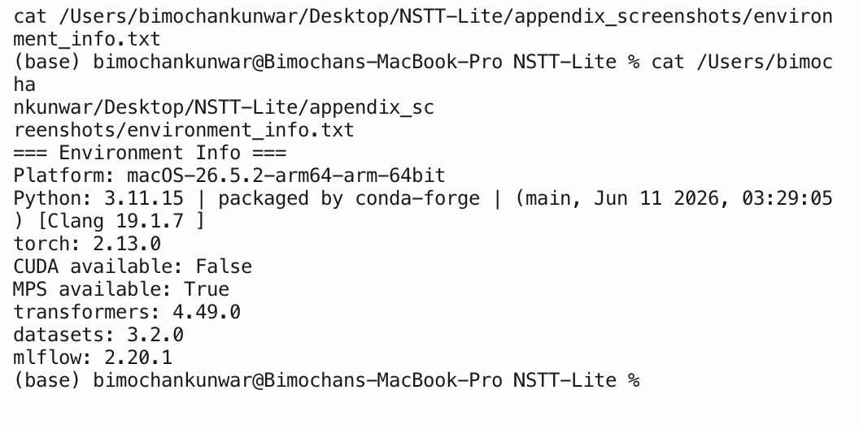
Terminal output of the environment info script

C.2 MLflow experiment tracking
Six MLflow experiments were logged over the course of this project (local mlruns/ store): phase4-audit, phase6-finetune, phase7-generalization, phase8-efficiency, phase9-leaky-ablation, plus the default experiment used during early smoke testing. Each run logs its parameters, metrics, and (where applicable) example artifacts.
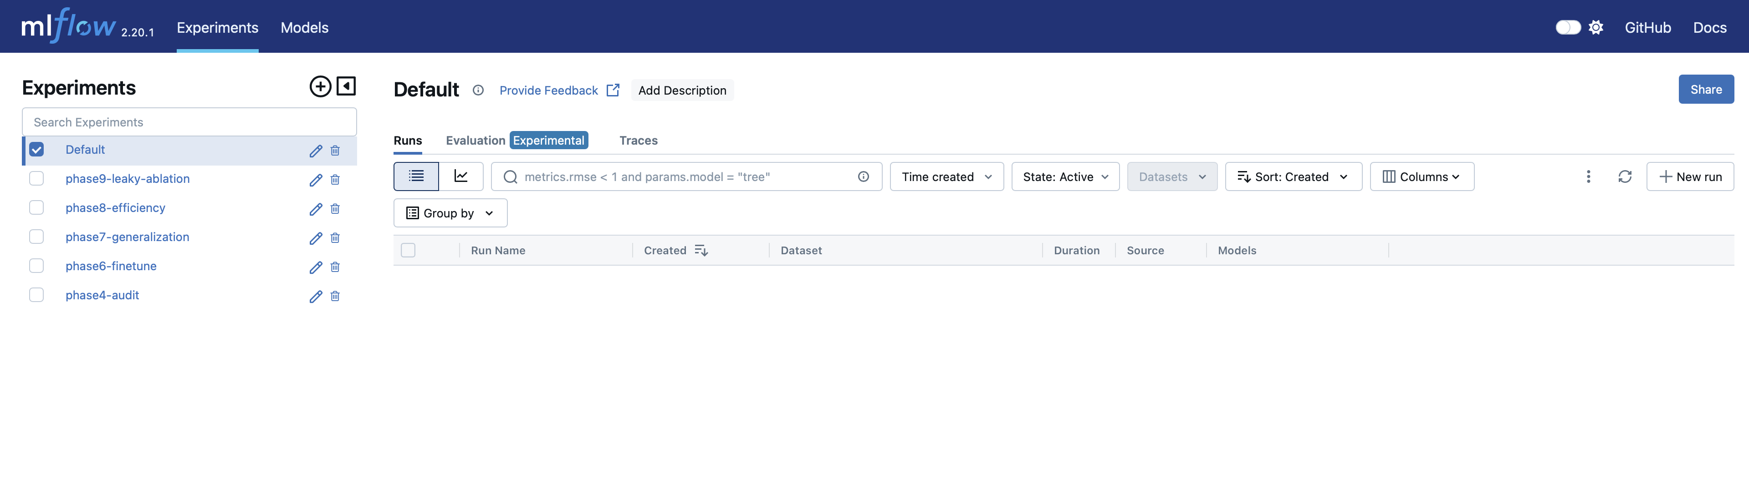
MLflow experiments list
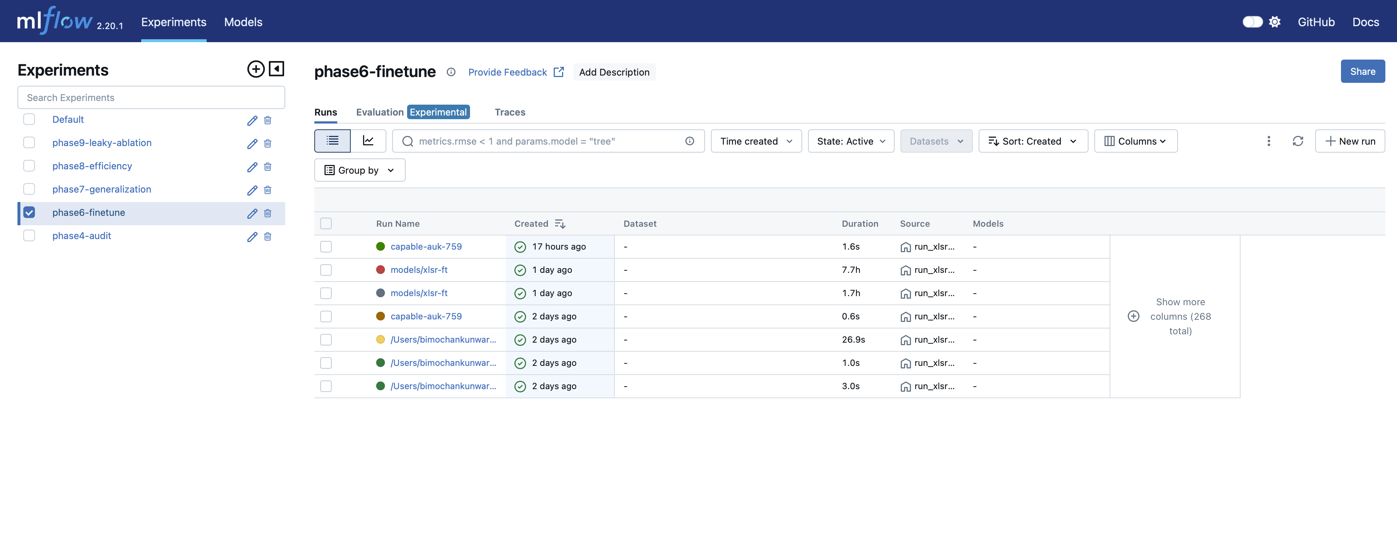
phase6-finetune experiment: all logged runs, including the 7.7h full training run
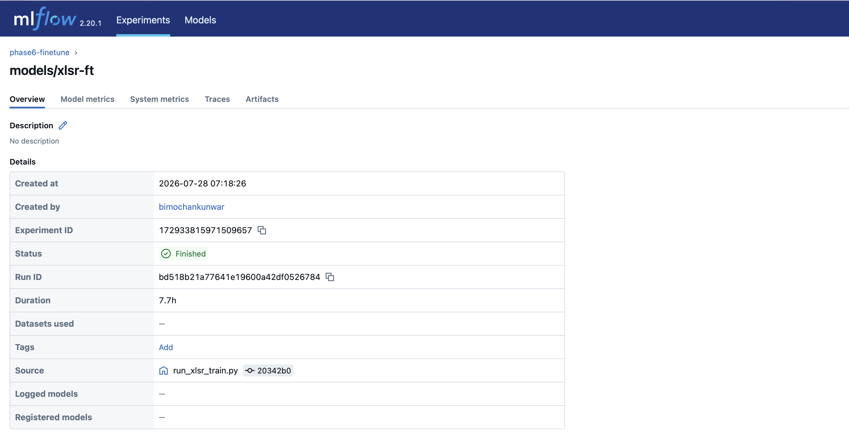
Run overview for the full training run (Run ID bd518b21…, Duration 7.7h, Status Finished, Source run_xlsr_train.py)
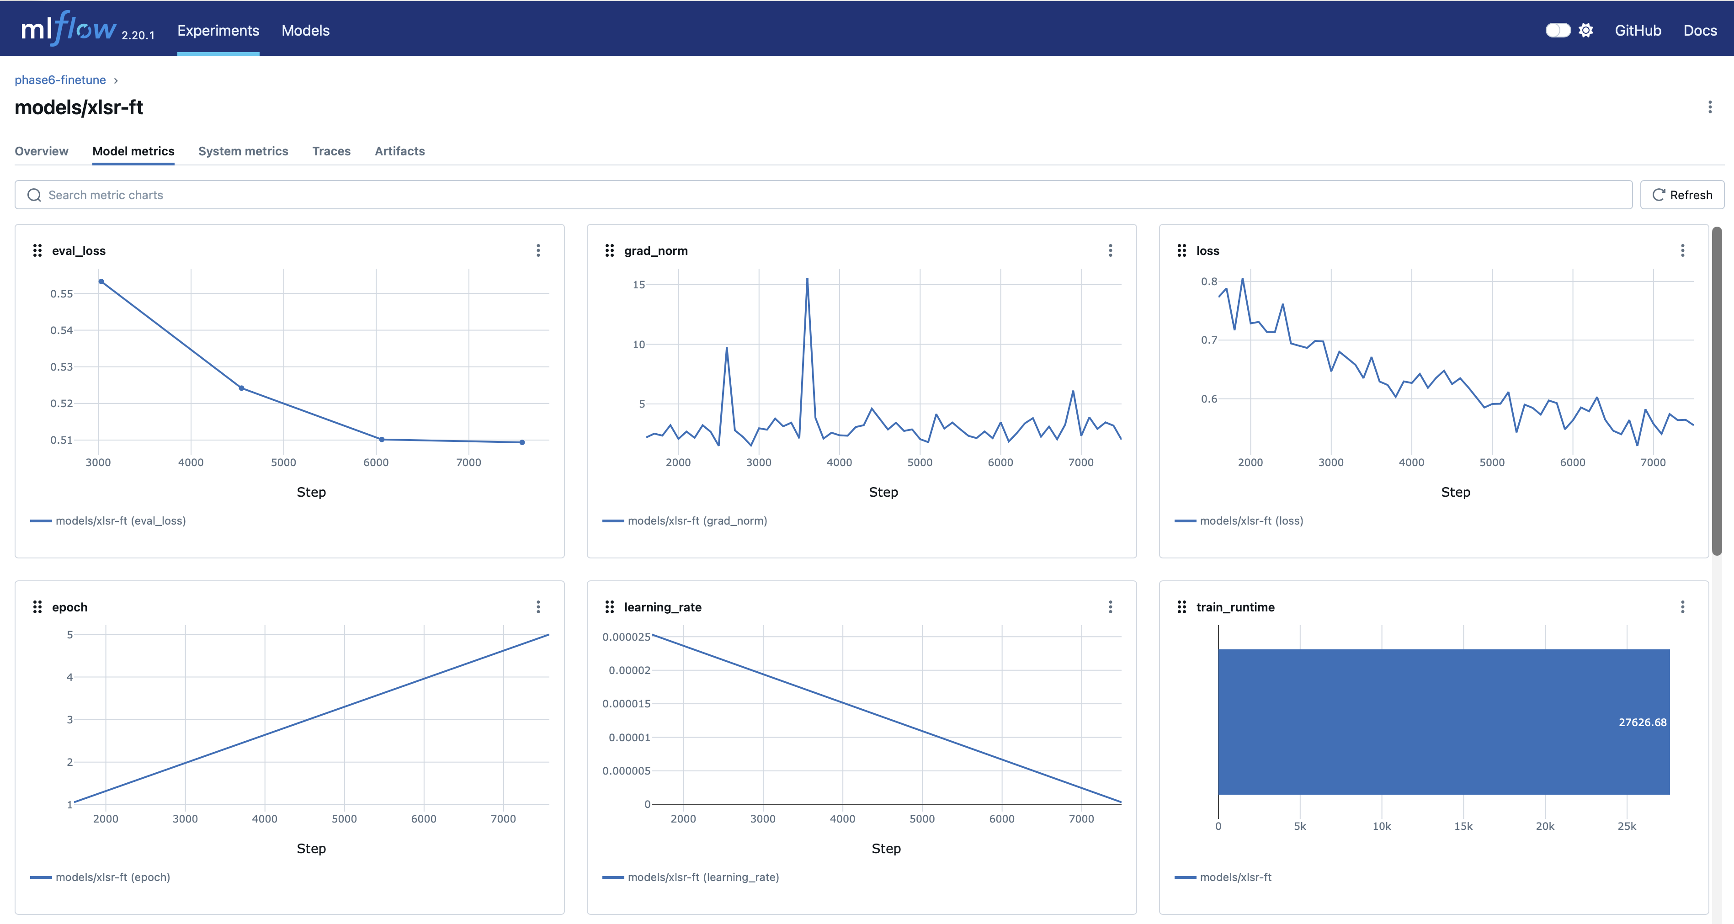
Model metrics: eval_loss, grad_norm, loss, epoch, learning_rate, train_runtime (27,626.68s ≈ 7.68h)
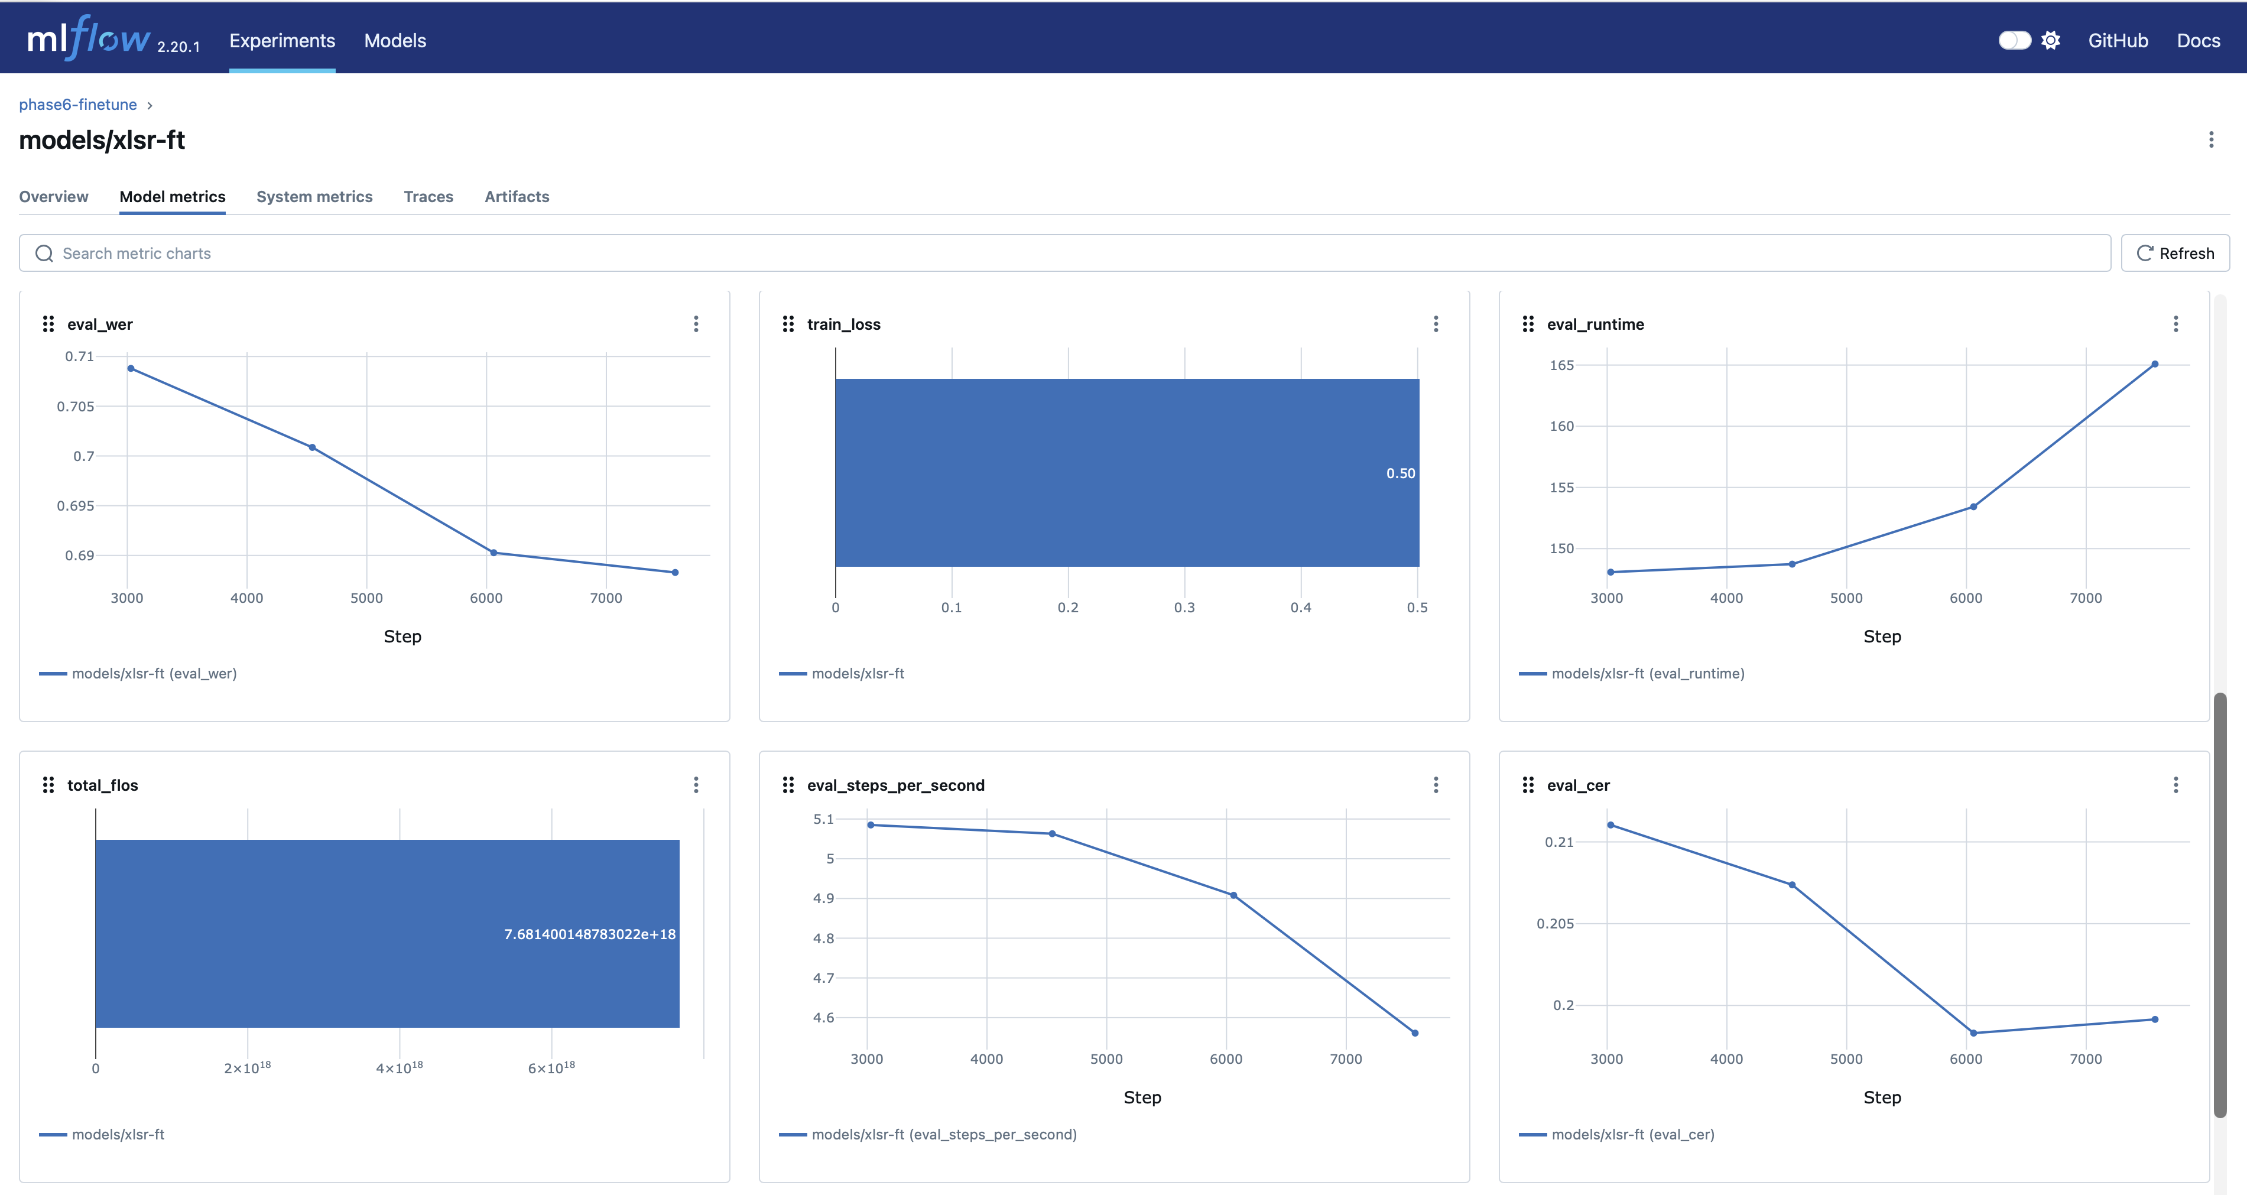
Model metrics: eval_wer curve (0.7098 → 0.6883 across the last four logged epochs) and train_loss (0.50)
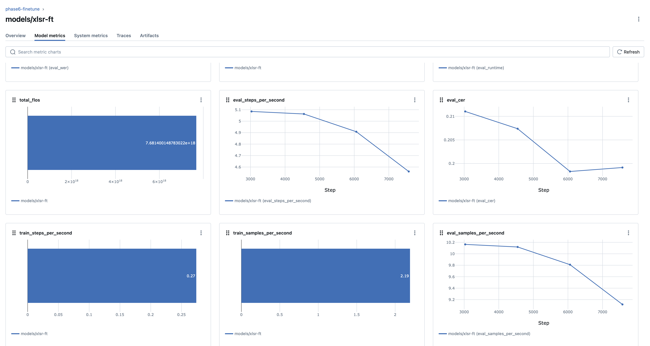
Model metrics continued: total_flos, eval_steps_per_second, eval_cer, train throughput

Appendix D — Extended Results Tables
Full machine-readable result files for every phase-4/7/8/9 measurement quoted in the report, plus the complete per-utterance error-analysis listing (150 utterances, Section 4.4), for independent verification beyond the summary tables in the main report body.

D.1 Summary result files

reports/phase4_audit_results.json
{
"model": "gagan3012/wav2vec2-xlsr-nepali",
"self_reported_wer": 0.0597,
"device": {
"platform": "macOS-26.5.2-arm64-arm-64bit-Mach-O",
"python": "3.13.13",
"torch": "2.13.0",
"cuda_available": false,
"mps_available": true
},
"in_domain_openslr43": {
"dataset": "OpenSLR-43 (in-domain)",
"num_utterances": 150,
"wer": 0.04913494809688582,
"cer": 0.008724212254952273
},
"out_of_domain_openslr54": {
"dataset": "OpenSLR-54 speaker-disjoint test (out-of-domain)",
"num_utterances": 150,
"wer": 0.6229508196721312,
"cer": 0.17383314957736126
},
"corpus_separation_note": "OpenSLR-43 and OpenSLR-54 results are never merged into a single number.",
"slr54_gender_note": "SLR54 rows carry an F0-pitch gender pseudo-label (165Hz threshold), not verified metadata -- used only for Phase 9 per-group analysis."
}

reports/phase7_original_results.json
{
"checkpoint": "gagan3012/wav2vec2-xlsr-nepali",
"tag": "original",
"in_domain_openslr43": {
"dataset": "OpenSLR-43 (in-domain)",
"num_utterances": 150,
"wer": 0.04913494809688582,
"cer": 0.008724212254952273
},
"out_of_domain_openslr54": {
"dataset": "OpenSLR-54 speaker-disjoint test (out-of-domain)",
"num_utterances": 150,
"wer": 0.6229508196721312,
"cer": 0.17383314957736126
}
}

reports/phase7_finetuned_results.json
{
"checkpoint": "models/xlsr-ft",
"tag": "finetuned",
"in_domain_openslr43": {
"dataset": "OpenSLR-43 (in-domain)",
"num_utterances": 150,
"wer": 0.16401384083044981,
"cer": 0.029764959458072462
},
"out_of_domain_openslr54": {
"dataset": "OpenSLR-54 speaker-disjoint test (out-of-domain)",
"num_utterances": 150,
"wer": 0.38173302107728335,
"cer": 0.09886071297317163
}
}

reports/phase7_leaky_results.json
{
"checkpoint": "models/xlsr-ft-leaky",
"tag": "leaky",
"in_domain_openslr43": {
"dataset": "OpenSLR-43 (in-domain)",
"num_utterances": 150,
"wer": 0.1695501730103806,
"cer": 0.03048342399671559
},
"out_of_domain_openslr54": {
"dataset": "OpenSLR-54 speaker-disjoint test (out-of-domain)",
"num_utterances": 150,
"wer": 0.3255269320843091,
"cer": 0.08195516354281514
}
}

reports/phase8_efficiency_results.json
{
"checkpoint": "/Users/bimochankunwar/Desktop/NSTT-Lite/models/xlsr-ft",
"n_samples": 50,
"n_latency_runs": 20,
"device": "cpu",
"fp32": {
"model_size_mb": 1203.5573768615723,
"mean_latency_s": 0.20469055199064315,
"min_latency_s": 0.14858783304225653,
"max_latency_s": 0.3167113340459764,
"num_runs": 20,
"wer": 0.3581081081081081,
"cer": 0.07165775401069518,
"num_utterances": 50
},
"int8_dynamic": {
"model_size_mb": 48.45556640625,
"mean_latency_s": 0.33524910402484237,
"min_latency_s": 0.20782845804933459,
"max_latency_s": 0.5563514999812469,
"num_runs": 20,
"wer": 0.36486486486486486,
"cer": 0.0748663101604278,
"num_utterances": 50
},
"speedup_x": 0.6105625623848806,
"size_reduction_pct": 95.97397121750821,
"wer_delta": 0.006756756756756743
}

reports/phase9_error_analysis_results.json
{
"checkpoint": "/Users/bimochankunwar/Desktop/NSTT-Lite/models/xlsr-ft",
"num_utterances": 150,
"overall_wer": 0.38173302107728335,
"overall_cer": 0.09886071297317163,
"error_category_counts": {
"other": 59,
"oov_rare_vocabulary": 90,
"phonetic_confusion": 64,
"noise_degradation": 22
},
"error_category_note": "Heuristic, regex/jiwer-alignment-based tagging -- categories can overlap per utterance and are not mutually exclusive.",
"gender_pseudo_label_breakdown": {
"male": {
"wer": 0.37668161434977576,
"cer": 0.10310734463276836,
"num_utterances": 77
},
"female": {
"wer": 0.3872549019607843,
"cer": 0.09425287356321839,
"num_utterances": 73
}
},
"gender_pseudo_label_note": "gender_pseudo_label is an F0-pitch threshold heuristic (165Hz), NOT verified ground truth -- this breakdown measures WER by acoustic pitch-threshold group, not by true gender.",
"speaker_wer_spread": {
"min": [
"76dab",
{
"mean_wer": 0.125,
"n": 12
}
],
"max": [
"70e10",
{
"mean_wer": 0.6363636363636364,
"n": 11
}
],
"num_speakers": 16
},
"worst_10_examples": [
{
"utterance_id": "8c693c9a97",
"speaker_id": "7f9c6",
"gender_pseudo_label": "female",
"reference": "मान्छे चटकारे",
"hypothesis": "मान्छि चट कार्य",
"wer": 1.5,
"cer": 0.3076923076923077,
"categories": [
"noise_degradation",
"oov_rare_vocabulary",
"phonetic_confusion"
]
},
{
"utterance_id": "d443c84109",
"speaker_id": "70e10",
"gender_pseudo_label": "female",
"reference": "क्रान्तिकारी वाममोर्चाको",
"hypothesis": "तन्थिकारी बाम वर्षको",
"wer": 1.5,
"cer": 0.4166666666666667,
"categories": [
"noise_degradation",
"oov_rare_vocabulary",
"phonetic_confusion"
]
},
{
"utterance_id": "7da0e9a7b7",
"speaker_id": "99866",
"gender_pseudo_label": "female",
"reference": "राज्यमाथि हासिल गर्‍यो",
"hypothesis": "राज्यमाति हासेल गर‍यो",
"wer": 1.0,
"cer": 0.13636363636363635,
"categories": [
"noise_degradation",
"oov_rare_vocabulary",
"phonetic_confusion"
]
},
{
"utterance_id": "8ccd499b56",
"speaker_id": "da0cf",
"gender_pseudo_label": "male",
"reference": "बनाउनबाट जोगाउँदछ",
"hypothesis": "बनाउनबाटा जोगआउँदछ",
"wer": 1.0,
"cer": 0.11764705882352941,
"categories": [
"noise_degradation",
"oov_rare_vocabulary",
"phonetic_confusion"
]
},
{
"utterance_id": "0cf3ebaf89",
"speaker_id": "07179",
"gender_pseudo_label": "female",
"reference": "उद्देश्यले ५ अप्रिल",
"hypothesis": "उद्येश्यले पच अपरेल",
"wer": 1.0,
"cer": 0.2631578947368421,
"categories": [
"noise_degradation",
"oov_rare_vocabulary",
"phonetic_confusion"
]
},
{
"utterance_id": "3cd1567940",
"speaker_id": "e8f6f",
"gender_pseudo_label": "male",
"reference": "ब्याज तिर्नुपर्ने हुन्छ",
"hypothesis": "व्यहास दिन्नु पर्ने हुन्छ",
"wer": 1.0,
"cer": 0.2608695652173913,
"categories": [
"noise_degradation",
"oov_rare_vocabulary",
"phonetic_confusion"
]
},
{
"utterance_id": "0950a3e9a4",
"speaker_id": "99866",
"gender_pseudo_label": "female",
"reference": "रन्मामैकोट तकसेरा हुकाम",
"hypothesis": "रणमा मैकोट तक्सेरा हुकाम",
"wer": 1.0,
"cer": 0.17391304347826086,
"categories": [
"noise_degradation",
"oov_rare_vocabulary",
"phonetic_confusion"
]
},
{
"utterance_id": "7b1f434978",
"speaker_id": "99866",
"gender_pseudo_label": "female",
"reference": "आइल्यान्ड तथा बेलायतदेखि",
"hypothesis": "आइल्यान् तथा बेलाय देखि",
"wer": 1.0,
"cer": 0.08333333333333333,
"categories": [
"noise_degradation",
"oov_rare_vocabulary",
"phonetic_confusion"
]
},
{
"utterance_id": "34760118f4",
"speaker_id": "9d08c",
"gender_pseudo_label": "male",
"reference": "वृक्ष यही हो",
"hypothesis": "बृच्ष यहियो",
"wer": 1.0,
"cer": 0.4166666666666667,
"categories": [
"noise_degradation",
"oov_rare_vocabulary",
"phonetic_confusion"
]
},
{
"utterance_id": "dde677080a",
"speaker_id": "70e10",
"gender_pseudo_label": "female",
"reference": "सूर्यले पृथ्वीको वरिपरि",
"hypothesis": "सवर्यलले फृथ्ष गरीपुरि",
"wer": 1.0,
"cer": 0.43478260869565216,
"categories": [
"noise_degradation",
"oov_rare_vocabulary",
"phonetic_confusion"
]
}
]
}

D.2 Full per-utterance error analysis (150 utterances)
Total rows: 150. Categories are heuristic (jiwer alignment + regex), not mutually exclusive.
Utterance ID | Speaker | Gender (pseudo) | Reference | Hypothesis | WER | CER | Categories
0685de35bc | 8efbc | male | केवल तिब्बत | केवल तिब्बत | 0.00 | 0.00 | other
d33d533af8 | 8efbc | male | अहिलेको हुलाक भवनको | अहिलेको हुलाक भवनको | 0.00 | 0.00 | other
df8a0b212a | efa9c | male | हुने गर्थ्यो | हुने गरथ्यो | 0.50 | 0.08 | oov_rare_vocabulary
356225f520 | 07179 | female | बाह्य मामलाको मन्त्रालयको | भाइदे मामलाको मन्त्रालयको | 0.33 | 0.16 | oov_rare_vocabulary, phonetic_confusion
dad71f7b34 | 1a81b | male | तयार पार्नु भन्दा | तयार पार्नुभन्दा | 0.67 | 0.06 | oov_rare_vocabulary
d2b4813104 | 12d45 | female | बेलुका सुत्ने बेलामा | बेलुका सुत्ने बेलामा | 0.00 | 0.00 | other
7da0e9a7b7 | 99866 | female | राज्यमाथि हासिल गर्‍यो | राज्यमाति हासेल गर‍यो | 1.00 | 0.14 | noise_degradation, oov_rare_vocabulary, phonetic_confusion
0f7a64d0bd | 70e10 | female | निबन्ध भित्रै पर्दछन् | निबन्ध भित्रै पर्दछन् | 0.00 | 0.00 | other
7edfb32bd1 | c46b5 | male | गर्ने प्रविधिमा हुने | गर्ने प्रविधिमा हुने | 0.00 | 0.00 | other
34f3dc6a6a | 7f9c6 | female | उनी गाउँको एउटा | उनी गाउँको एउटा | 0.00 | 0.00 | other
0ca2b67e85 | e8f6f | male | यस सम्बन्धमा विशेष | यस सम्बन्धमा विशेष | 0.00 | 0.00 | other
3b99e9373e | da0cf | male | सेती हुन् | सेती हुन् | 0.00 | 0.00 | other
8e47838650 | 1a81b | male | महत्त्वपूर्ण स्थान | महत्त्वपूर्णै स्थान | 0.50 | 0.06 | oov_rare_vocabulary
8ccd499b56 | da0cf | male | बनाउनबाट जोगाउँदछ | बनाउनबाटा जोगआउँदछ | 1.00 | 0.12 | noise_degradation, oov_rare_vocabulary, phonetic_confusion
89305ffa02 | 8efbc | male | अन्तिम युग हो | अन्तिम युग हो | 0.00 | 0.00 | other
8e908cd51d | 07179 | female | पिता पोषण पाण्डेको | पिटा पोषन पाण्डेको | 0.67 | 0.11 | oov_rare_vocabulary, phonetic_confusion
3856d8968f | 8efbc | male | ड्रागनफलसँग मिल्दोजुल्दो सिउँडी | ड्रागनफलसँग मिल्दोजुल्दो सिउँडी | 0.00 | 0.00 | other
78cb6e474d | 9d08c | male | पार्टीका थिए | पार्टीका थिए | 0.00 | 0.00 | other
0a524e5006 | 76dab | female | एउटा ऐतिहासिक धार्मिक | एउटा ऐतिहासिक धार्मिक | 0.00 | 0.00 | other
d399359741 | efa9c | male | खोज बाकस बेकार छ | खोज बाकास व्यकार छ | 0.50 | 0.25 | oov_rare_vocabulary, phonetic_confusion
0cf3ebaf89 | 07179 | female | उद्देश्यले ५ अप्रिल | उद्येश्यले पच अपरेल | 1.00 | 0.26 | noise_degradation, oov_rare_vocabulary, phonetic_confusion
3a523d2f4f | 8efbc | male | गर्नका लागि छिमेकी | गर्नका लागि छिमेकी | 0.00 | 0.00 | other
0f5492d100 | 99866 | female | ग्रस्त र अवसरवादी | ग्रस्त र अवसरवादी | 0.00 | 0.00 | other
09607fb527 | 8efbc | male | गुरुचेला धुमधाम झगडा | गुरुचेला दुमदाम चगडा | 0.67 | 0.15 | oov_rare_vocabulary, phonetic_confusion
0d3af9342e | 056c7 | female | समर्थनमा स्थापित गरिदिए | समर्थमा स्थापित गरिदिए | 0.33 | 0.04 | oov_rare_vocabulary
3cd1567940 | e8f6f | male | ब्याज तिर्नुपर्ने हुन्छ | व्यहास दिन्नु पर्ने हुन्छ | 1.00 | 0.26 | noise_degradation, oov_rare_vocabulary, phonetic_confusion
794dd07876 | 76dab | female | रोजा राखेर राति | रोजा राखेर राती | 0.33 | 0.07 | oov_rare_vocabulary, phonetic_confusion
3542203038 | 1a81b | male | जोडी नै सम्विधानसभामा पुग्ने सात जोडीमध्ये एक हो अमृताको जोडी पनि। | जोडिनैसंविधानसभामा पुग्ने साथ जोडीमध्य एक हो अमृताको जोडी पनि | 0.55 | 0.12 | oov_rare_vocabulary, phonetic_confusion
dc5bd13f97 | e8f6f | male | नयाँ नेपाल | नयाँ नेपाल | 0.00 | 0.00 | other
dd07ccac9b | 056c7 | female | राजेश जी को | राजेश जीको | 0.67 | 0.09 | other
3b05885ecb | 76dab | female | बाजा समूहको एक | बाजा समूहको एक | 0.00 | 0.00 | other
069f1a5975 | 9d08c | male | धेरै हुन्छ | धेरै हुन्छ | 0.00 | 0.00 | other
084f8770e0 | 07179 | female | उमारिएको विभिन्न किसिमको | उमारिएको विभिन्न किसिमको | 0.00 | 0.00 | other
deff9009e8 | da0cf | male | गुरिल्ला युद्धको लागि | गुरेल्ला युद्धको लागि | 0.33 | 0.05 | oov_rare_vocabulary, phonetic_confusion
0950a3e9a4 | 99866 | female | रन्मामैकोट तकसेरा हुकाम | रणमा मैकोट तक्सेरा हुकाम | 1.00 | 0.17 | noise_degradation, oov_rare_vocabulary, phonetic_confusion
7b1f434978 | 99866 | female | आइल्यान्ड तथा बेलायतदेखि | आइल्यान् तथा बेलाय देखि | 1.00 | 0.08 | noise_degradation, oov_rare_vocabulary, phonetic_confusion
06458f45c7 | 76dab | female | अञ्चलमा पर्ने काठमाडौँ | अञ्चलमा पर्नेकाठमाडौँ | 0.67 | 0.05 | oov_rare_vocabulary
d2d29b1aea | 8efbc | male | रोकाको धारणा छ | रोकाको धारणा छ | 0.00 | 0.00 | other
068a5f9e4d | 07179 | female | साहित्य कृष्णप्रसाद पराजुलीद्वारा | साहित्य कृष्ण प्रसाध पराजुलीद्वारा | 0.67 | 0.06 | oov_rare_vocabulary, phonetic_confusion
3d23f3a053 | 056c7 | female | चेतन तत्त्व छ | चेतन तत्यो छ | 0.33 | 0.23 | oov_rare_vocabulary, phonetic_confusion
8f20c18a27 | 7f9c6 | female | नवप्रयोगहरूका कारण पनि | नवप्रयोगहरूका कारण पनि | 0.00 | 0.00 | other
8c693c9a97 | 7f9c6 | female | मान्छे चटकारे | मान्छि चट कार्य | 1.50 | 0.31 | noise_degradation, oov_rare_vocabulary, phonetic_confusion
8f61581d97 | e8f6f | male | मानिससँग पनि | मानिसाँग पनि | 0.50 | 0.08 | oov_rare_vocabulary, phonetic_confusion
8e144a8c27 | 99866 | female | चौतारी पृष्ठझैँ धेरै | चौतारी पृष्ठछैँ धेरै | 0.33 | 0.05 | oov_rare_vocabulary, phonetic_confusion
030127cb38 | 12d45 | female | उनीहरूको कब्जा भयो | उनीहरूको कब्जा भयौ | 0.33 | 0.06 | phonetic_confusion
8a16923bc6 | 7f9c6 | female | जातिका मनिसहरूको | जातिका मानिसहरूको | 0.50 | 0.06 | oov_rare_vocabulary
893dc361fd | 8efbc | male | गुरुङको घरमा गयौँ | गुरुङको घरमा गयौँ | 0.00 | 0.00 | other
0a15894a63 | 70e10 | female | आरम्भ भएको छ | अरम्व भएको छ | 0.33 | 0.17 | oov_rare_vocabulary, phonetic_confusion
0c0791cbc1 | 07179 | female | सहयोग गर्न पाउनमा | सहियोग गर्न पाउनमा | 0.33 | 0.06 | oov_rare_vocabulary
d74c759f7d | efa9c | male | दिँदा पशु फाप | दिँदा पशु फाप | 0.00 | 0.00 | other
3a74cbb511 | 07179 | female | मैले सुरुका दिनहरूमा | महैले सुरुका दिनहरूमा | 0.33 | 0.05 | oov_rare_vocabulary
34760118f4 | 9d08c | male | वृक्ष यही हो | बृच्ष यहियो | 1.00 | 0.42 | noise_degradation, oov_rare_vocabulary, phonetic_confusion
dde677080a | 70e10 | female | सूर्यले पृथ्वीको वरिपरि | सवर्यलले फृथ्ष गरीपुरि | 1.00 | 0.43 | noise_degradation, oov_rare_vocabulary, phonetic_confusion
002a8d9076 | 76dab | female | र एक अन्य फिल्मको | र एक अन्य फिल्मको | 0.00 | 0.00 | other
3db3210f8e | 5d5fe | male | उनलाई नचिन्नु | उनलाई नचि्नु | 0.50 | 0.08 | oov_rare_vocabulary
d8451ec160 | 99866 | female | उत्तराधिकारी हुने | उत्तराधिकारी हुने | 0.00 | 0.00 | other
36e3b42ee0 | 76dab | female | दोलखा जिल्लाको | दोलखा जिल्लाको | 0.00 | 0.00 | other
81c40491fc | 76dab | female | जिल्लाको पाठामारीमा अवस्थित | जिल्लाको पाठामारीमा अवस्थित | 0.00 | 0.00 | other
35ff798136 | 70e10 | female | आग्नेय चट्टान संस्कृत शब्द | आग्ने चटटान संस्कृत शब्द | 0.50 | 0.08 | oov_rare_vocabulary
02443bae4d | 1a81b | male | उद्योग कार्यालय हो | उद्योग कार्यलाय हो | 0.33 | 0.11 | oov_rare_vocabulary
8ebb1af0c6 | 5d5fe | male | यो तथ्य इतिहासहरूमा | यो तथ्य हितिहासहरूमा | 0.33 | 0.11 | oov_rare_vocabulary, phonetic_confusion
8dae7b59b8 | 056c7 | female | भए जहाँ भोजनको | भएजहाँ भोजनको | 0.67 | 0.07 | oov_rare_vocabulary
dfea2d149d | 99866 | female | गराएको मानिन्छ | गराएको मानिन्छ | 0.00 | 0.00 | other
d34cb037a8 | e8f6f | male | प्रमुख थियो | प्रमुख थियो | 0.00 | 0.00 | other
d1cfb4aabc | efa9c | male | रचना समेत गरे | रचना समेट गरे | 0.33 | 0.08 | oov_rare_vocabulary, phonetic_confusion
0e8987f3fc | 5d5fe | male | एतिहासिक प्रशासनिक महत्त्वको | ऐतिहासिक परासानिक महत्त्वको | 0.67 | 0.14 | oov_rare_vocabulary, phonetic_confusion
045f34cd5a | c46b5 | male | तपाईँ आफ्नो गाउँको | तपाईँ आफ्नो गाउँको | 0.00 | 0.00 | other
3b88864e56 | 5d5fe | male | राष्ट्रिय सेवाहरू | राष्ट्रिय सेवाहरू | 0.00 | 0.00 | other
361164a7ed | 70e10 | female | स्थलमध्ये पर्दछ | स्थनबध्ये पर्दछ | 0.50 | 0.13 | oov_rare_vocabulary, phonetic_confusion
da5d1a8a89 | e8f6f | male | धनकुटाको कचिडेमा | धनकुटाको कचिडेमा | 0.00 | 0.00 | other
84efea6b34 | 76dab | female | अमेरिकी डलर छ | अमेरिकी डलर छ | 0.00 | 0.00 | other
dfc8d36ad2 | efa9c | male | जहाँ दुखहरूको अग्नि | जहाँ दुखहरूको अग्नी | 0.33 | 0.05 | oov_rare_vocabulary, phonetic_confusion
8aa1a58431 | 12d45 | female | जरूरी छैन जुन | जररी छैन जुन | 0.33 | 0.08 | oov_rare_vocabulary
061f10be2e | 70e10 | female | आफ्नो क्षमता | आफ्नो क्षमता | 0.00 | 0.00 | other
8c3844dbb0 | efa9c | male | स्टारकिडको पहिलो राष्ट्रिय | स्टारकिडको पहिलो राष्ट्रिय | 0.00 | 0.00 | other
7921dc943c | efa9c | male | नामक गणितसम्बन्धी पुस्तक | नामक गणित सम्बन्धी पुस्तक | 0.67 | 0.04 | oov_rare_vocabulary
d9aa2f3129 | efa9c | male | कारण एकै समयमा | कारण एकै समयमा | 0.00 | 0.00 | other
3f618a3c25 | 1a81b | male | जिल्ला पञ्चायतहरूमा निर्वाचित | जिल्ला पञचतहरूमा निर्वाचित | 0.33 | 0.10 | oov_rare_vocabulary
3161b117c2 | 1a81b | male | आउने बित्तिकै क्रिस्टल | आउने भित्तिकै कृष्टल | 0.67 | 0.23 | oov_rare_vocabulary, phonetic_confusion
7a01a55c6a | 8efbc | male | चरनयोग्य क्षेत्र मानिन्छन् | चरण योग्ञ क्षेत्र मानिन्छन् | 0.67 | 0.12 | oov_rare_vocabulary, phonetic_confusion
356db48125 | e8f6f | male | नोकियाको मोबाइल छ | नोकियाको मोबाइल छ | 0.00 | 0.00 | other
d61b84ec00 | 7f9c6 | female | माध्यमिक विद्यालयको | माध्यमिक विद्यालयको | 0.00 | 0.00 | other
d0940523bb | 8efbc | male | राम्रो व्यक्ति बन्नेमा | राम्रो व्यक्ति बन्नेमा | 0.00 | 0.00 | other
7752c1a8fa | 99866 | female | होल्टका भावनाहरू र सन् | होल्डका भावनाहरू र सन् | 0.25 | 0.05 | oov_rare_vocabulary, phonetic_confusion
3295ade169 | 76dab | female | परयाहरूको संजालभित्र | परयाहरूको सञ्चालभित्र | 0.50 | 0.15 | oov_rare_vocabulary, phonetic_confusion
8921260225 | f07db | female | मनुको हो | मनुको हो | 0.00 | 0.00 | other
d443c84109 | 70e10 | female | क्रान्तिकारी वाममोर्चाको | तन्थिकारी बाम वर्षको | 1.50 | 0.42 | noise_degradation, oov_rare_vocabulary, phonetic_confusion
3f8bcfc6b9 | 99866 | female | एक अनुमान छ | एक अनुमान छ | 0.00 | 0.00 | other
d72cfed93c | c46b5 | male | साउथ अस्ट्रेलियाली चलचित्र | साउथ अस्ट्रेलयाली चलचित्र | 0.33 | 0.04 | oov_rare_vocabulary
73fde60c68 | e8f6f | male | भिक्षा दिनका निम्ति | भृक्षा दिनका निम्ति | 0.33 | 0.05 | oov_rare_vocabulary, phonetic_confusion
d20b2fea89 | 056c7 | female | निसी नेपालको | निशी नेपालको | 0.50 | 0.08 | oov_rare_vocabulary, phonetic_confusion
7f3e582176 | 8efbc | male | तिनै हजुरबुबाको आडमा | तिनै हजुर बुभाको आढमा | 1.00 | 0.15 | noise_degradation, oov_rare_vocabulary, phonetic_confusion
3270c486a1 | f07db | female | गरेको तपाईँको योगदान | गरेको तपाईँको योगदान | 0.00 | 0.00 | other
0e8819f2e1 | da0cf | male | बाँकी नै छ | बाकी नै छ | 0.33 | 0.10 | oov_rare_vocabulary
dc1c739b7d | f07db | female | धर्म सम्प्रदायहरू जस्तै | धर्म समप्रदायहरू जस्तै | 0.33 | 0.04 | oov_rare_vocabulary
88f3036a36 | 99866 | female | अङ्ग्रेजी महिना हो | अङ्ग्रेजी महिना हो | 0.00 | 0.00 | other
80d51d2e79 | da0cf | male | बेलायती प्रभावमा कमी | बेलायती प्रभावमा कमी | 0.00 | 0.00 | other
79ecb6ff25 | 1a81b | male | किम कुलिग | किम कुलिकक | 0.50 | 0.22 | oov_rare_vocabulary, phonetic_confusion
d54cb86f18 | f07db | female | बिनायो तथा हारी | बि्ना ययो तथा हाली | 1.00 | 0.27 | noise_degradation, oov_rare_vocabulary, phonetic_confusion
0aead87b58 | 70e10 | female | ढल्कनासाथ देवताहरूको | ढल्कन सत्देवतहरूको | 1.00 | 0.25 | noise_degradation, oov_rare_vocabulary, phonetic_confusion
0d23be1ca8 | 70e10 | female | यस अवसरमा | यस औसरमा | 0.50 | 0.22 | oov_rare_vocabulary, phonetic_confusion
df0f134997 | c46b5 | male | ९ गते सिरहा | [UNK]ौ गतेशीरहा | 1.00 | 0.82 | noise_degradation, oov_rare_vocabulary, phonetic_confusion
01af564842 | 8efbc | male | प्वाँख मैले | पवाँख मैले | 0.50 | 0.09 | oov_rare_vocabulary
8f268b2d42 | f07db | female | हुन स्वीकार | हुन स्विकार | 0.50 | 0.09 | oov_rare_vocabulary, phonetic_confusion
0eace1a98b | 056c7 | female | पढाइ प्रतिको उहाँको | पढाइपर्तिको उहाँको | 0.67 | 0.16 | oov_rare_vocabulary, phonetic_confusion
7635799596 | 12d45 | female | मात्र रिडाइरेक्ट हुन्छ | मात्र रिडाइरेक्ट हुन्छ | 0.00 | 0.00 | other
3dcd687720 | efa9c | male | बिमलादेवीको सानो चिटिक्क | बिमलादेवीको सानु चिटिक्क | 0.33 | 0.04 | oov_rare_vocabulary, phonetic_confusion
81f4c30a2c | 99866 | female | कि खतरा | कि खतरा | 0.00 | 0.00 | other
725c6c0064 | e8f6f | male | काम गर्दागर्दै वहाँ | काम गर्दा गर्दै उह | 1.00 | 0.21 | noise_degradation, oov_rare_vocabulary, phonetic_confusion
dd26100ea3 | 12d45 | female | नाम जे राख्नुहोस् | नामजे राख्नु होस् | 1.00 | 0.12 | noise_degradation, oov_rare_vocabulary
0d95694cfe | efa9c | male | उपल्लो अर्खला नवलपरासी | उपङलु अर्खला नबल परास | 1.00 | 0.27 | noise_degradation, oov_rare_vocabulary, phonetic_confusion
0230c928e0 | f07db | female | गङ्गालाल श्रेष्ठलाई गोली | गङ्गलाल श्ेष्ठलाई बोली | 1.00 | 0.12 | noise_degradation, oov_rare_vocabulary, phonetic_confusion
770279b652 | 99866 | female | मित्रता निकै | मित्रता निकै | 0.00 | 0.00 | other
8a8b3a56d5 | 7f9c6 | female | ठूलो यज्ञ गरे | ठुलो एज्य गरे | 0.67 | 0.23 | oov_rare_vocabulary, phonetic_confusion
7d7bdec74f | 5d5fe | male | नेपालमा राणाहरूले | नेपालमा राँडाहरूले | 0.50 | 0.12 | oov_rare_vocabulary, phonetic_confusion
86755b50ef | 5d5fe | male | सिरलिङ्गे लिएर विभिन्न | सिरलिङ्गे लिएर विभिन्न | 0.00 | 0.00 | other
d4b24720b7 | 76dab | female | पराग एउटा नेपाली | पराग एउटा नेपाली | 0.00 | 0.00 | other
378bb42091 | 8efbc | male | मातृभाषा वा निजहरूको | मात् भाषा वा निजहरूको | 0.67 | 0.10 | oov_rare_vocabulary, phonetic_confusion
08606b64cc | 8efbc | male | पिर मर्का गुनासाहरू | पीरमरका गुनासाहरू | 0.67 | 0.16 | oov_rare_vocabulary, phonetic_confusion
7b9949c9e6 | 76dab | female | विजय | विजय | 0.00 | 0.00 | other
382856c61f | 12d45 | female | मेरो मुखबाट एउटै | मेरो मुखबाटै एउटै | 0.33 | 0.06 | oov_rare_vocabulary
84b58e6223 | 70e10 | female | स्थानीय उद्योगका लागि | स्थानी उद्वोकय लागि | 0.67 | 0.19 | oov_rare_vocabulary, phonetic_confusion
0c2a6969f8 | 07179 | female | यसलाई अङ्ग्रेजीमा रिभर | यसलाई अङ्ग्रेजीमा रिबर | 0.33 | 0.05 | oov_rare_vocabulary, phonetic_confusion
0139dc5b13 | 056c7 | female | बनाएर आधुनिक गीत | बनाएर आधुनिक गीत | 0.00 | 0.00 | other
8a24eda5e8 | da0cf | male | पार्टीको सहयोगको लागि | पाटीको सहयोगको लागि | 0.33 | 0.10 | oov_rare_vocabulary
0176bd214c | 9d08c | male | मुगल शासकुन्ले | मुगल शासककुनले | 0.50 | 0.14 | oov_rare_vocabulary
3a26f35fc1 | 76dab | female | जापानमा बनाइएको एक | जापानमा बनाइएको एक | 0.00 | 0.00 | other
05ec166b72 | 5d5fe | male | नेपालको उपाध्यक्ष साथै | नेपालको उपादक्ष साथै | 0.33 | 0.14 | oov_rare_vocabulary, phonetic_confusion
7d68ea40c7 | 70e10 | female | हजार ८०० मिटरदेखि | हज[UNK] [UNK][UNK]मिटरदेखि | 1.00 | 0.88 | noise_degradation, oov_rare_vocabulary, phonetic_confusion
8ab6e41132 | 5d5fe | male | कसैले कुनै पनि | कसैले कुनै पनि | 0.00 | 0.00 | other
78c9e55641 | efa9c | male | जाने इच्छालाई समाप्त | जाने इच्छालाई समात | 0.33 | 0.10 | oov_rare_vocabulary
7b86a1f14e | 1a81b | male | मई १९७४ मा | मै [UNK][UNK][UNK][UNK]मा | 1.00 | 2.10 | noise_degradation, oov_rare_vocabulary, phonetic_confusion
ddb44bb107 | 8efbc | male | भक्तपुरपछिको ठूलो प्राचीन | भक्तपुरपछिको ठुलो प्राचीन | 0.33 | 0.04 | oov_rare_vocabulary, phonetic_confusion
3cb1356eec | 8efbc | male | हो जहाँबाट हामीले | हो जहाँबाट हामीले | 0.00 | 0.00 | other
dfaf3cfaf5 | e8f6f | male | परिभाषाले स्पष्ट पारेको छ | परिवाषाले स्पस्त परादेको छ | 0.75 | 0.20 | oov_rare_vocabulary, phonetic_confusion
d0480f7916 | 056c7 | female | ठोस ज्यामितिका सन्दर्भमा | ठोस ज्यामितिकका सन्दर्वमा | 0.67 | 0.08 | oov_rare_vocabulary, phonetic_confusion
0584cc526e | da0cf | male | छतौल नेपालको जनकपुर | छतौल नेपालका जनकपुर | 0.33 | 0.05 | oov_rare_vocabulary, phonetic_confusion
8b50556041 | f07db | female | उपन्यास कृष्णहरि बराल | उपन्यास कृष्णहरि बराल | 0.00 | 0.00 | other
0e8a19bda9 | 8efbc | male | भेडा परेवा हाँस | बेडा परेवा हास | 0.67 | 0.13 | oov_rare_vocabulary, phonetic_confusion
75acd88ff6 | 056c7 | female | परेको र आफू बालकै | परेको र आफूवालककै | 0.50 | 0.18 | oov_rare_vocabulary, phonetic_confusion
0a5ad7b85e | c46b5 | male | सबैले एकमतले स्वीकारेको | सबैले एकमतले स्विकार्यको | 0.33 | 0.13 | oov_rare_vocabulary, phonetic_confusion
77db4a7462 | 5d5fe | male | तर पनि त्यस | तर पनि त्यस | 0.00 | 0.00 | other
d8814e3d67 | 9d08c | male | पवित्र मानिन्छ | पवित् र मानिन्छ | 1.00 | 0.07 | noise_degradation, oov_rare_vocabulary
06330c8dde | 99866 | female | यस भवनको निर्माणले | यस भवनको निर्माणले | 0.00 | 0.00 | other
8f24eac8cf | 1a81b | male | तपाईँले बिना सन्दर्भका | तपाईँले विनास अन्दर्वका | 0.67 | 0.18 | oov_rare_vocabulary, phonetic_confusion
d7d0184f51 | efa9c | male | विष तयार गर्छ | बस्तयार वर्ष | 1.00 | 0.46 | noise_degradation, oov_rare_vocabulary, phonetic_confusion
7553b80c6b | 5d5fe | male | शाहको नामबाट तत्कालीन | शाहको नामबाट तत्कालीन | 0.00 | 0.00 | other
09608a650b | 056c7 | female | मुद्रा जनसङ्ख्या क्षेत्रफल | मुद्रजनसङ्ख्या क्षेत्रफल | 0.67 | 0.08 | oov_rare_vocabulary
3cf2fad57c | 8efbc | male | पुरस्कार पाउनुभएको थियो | पुरस्कार पाउनुभएको थियो | 0.00 | 0.00 | other
8d4a047584 | efa9c | male | विद्यालय बनेको हो | विद्यालय बौनेको हो | 0.33 | 0.06 | oov_rare_vocabulary

Appendix E — Project Links and Data Sources
GitHub repository (code, MLflow logs, reports): github.com/Rbimochan/NSTT-Lite (branch: coursework-10phase)
YouTube presentation: youtu.be/WNg52rptkoU
Datasets used:
- OpenSLR-43 (in-domain, single-speaker): www.openslr.org/43/ — mirrored on Hugging Face as gauravparajuli/slr43
- OpenSLR-54 (out-of-domain, multi-speaker, used for fine-tuning and evaluation): www.openslr.org/54/
Audited model checkpoint: huggingface.co/gagan3012/wav2vec2-xlsr-nepali
All four links above are also given in the main report’s “Project Links” section (page 3), reproduced here for appendix-only reference.

