Escribir en una tabla de Access desde Visual Basic

Primero se deben crear las tablas en una Base de Datos, como se muestra a continuación.

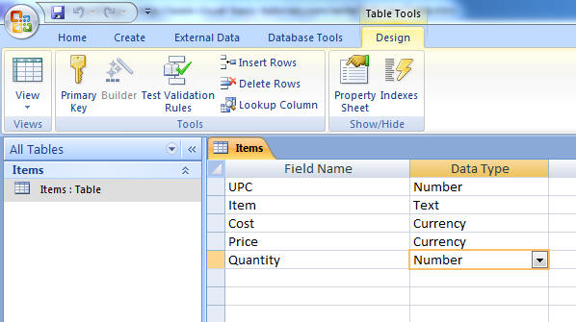

Se tiene el siguiente Formulario

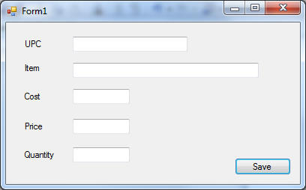

**Code:**

**Nota: Se tiene que agregar la siguiente referencia en el proyecto: Microsoft Access 12.0 Object Library)**

**Ir al Proyecto – Agregar Referencia – Click on COM tab, scroll to Microsoft Access 12.0 Object Library**

|  |
| --- |
| Imports Access = Microsoft.Office.Interop.Access  Imports System.Data  Imports System.Data.OleDb  Public Class Form1      Dim provider As String      Dim dataFile As String      Dim connString As String      Dim myConnection As OleDbConnection = New OleDbConnection        Private Sub SaveButton_Click(ByVal sender As System.Object, ByVal e As System.EventArgs) Handles SaveButton.Click          provider = "Provider=Microsoft.ACE.OLEDB.12.0;Data Source ="          dataFile = "C:\Users\Jimmy\Documents\Test Database.accdb"          connString = provider & dataFile          myConnection.ConnectionString = connString            myConnection.Open()          Dim str As String          str = "insert into Items ([UPC], [Item], [Cost], [Price], [Quantity]) values (?, ?, ?, ?, ?)"          Dim cmd As OleDbCommand = New OleDbCommand(str, myConnection)          cmd.Parameters.Add(New OleDbParameter("UPC", CType(TextBox1.Text, String)))          cmd.Parameters.Add(New OleDbParameter("Item", CType(TextBox2.Text, String)))          cmd.Parameters.Add(New OleDbParameter("Cost", CType(TextBox3.Text, String)))          cmd.Parameters.Add(New OleDbParameter("Price", CType(TextBox4.Text, String)))          cmd.Parameters.Add(New OleDbParameter("Quantity", CType(TextBox5.Text, String)))          Try              cmd.ExecuteNonQuery()          Catch ex As Exception              MsgBox(ex.Message)          End Try          TextBox1.Clear()          TextBox2.Clear()          TextBox3.Clear()          TextBox4.Clear()          TextBox5.Clear()        End Sub  End Class |