SummarySphere
Documentation

Developed By:
Benoni Circiu & Robert Nistor

Contents
1. Project Overview 3
2. System Architecture 5
3. Directory Structures 6
4. Frontend Developer Guide 9
5. Backend Developer Guide 10
6. Unified API Reference 12

1. Project Overview
SummarySphere is an AI-powered course summarization system designed to help students study efficiently. It provides a complete full-stack solution allowing users to upload long documents (PDF, Word, or Text), extract their text content, store them securely, generate customized summaries, and interact with documents using semantic-search capabilities. It bridges modern AI capabilities with student study workflows.
Key System Capabilities
- File Text Extraction: Extracts raw text from PDF, DOCX, and TXT files automatically on upload.
- Dual-Storage Strategy: Persists original files and summaries in Microsoft Azure Blob Storage, while vectorizing the document contents into a PostgreSQL database with pgvector.
- Multi-Format AI Summaries: Provides structured AI-generated summaries in different formats (brief, detailed, bullet points, academic) using LLM models via Spring AI.
- Document Chat (RAG): Enables students to ask questions directly about an uploaded document (Retrieval-Augmented Generation / RAG), querying the document's text using pgvector.
- General AI Assistant: An interactive, helpful study assistant equipped with tools to list, search, and quiz the student on their materials.
- Notification & Clean-up: Asynchronous password recovery (Resend API) and clean user profile deletion.
Application Screen Walkthrough
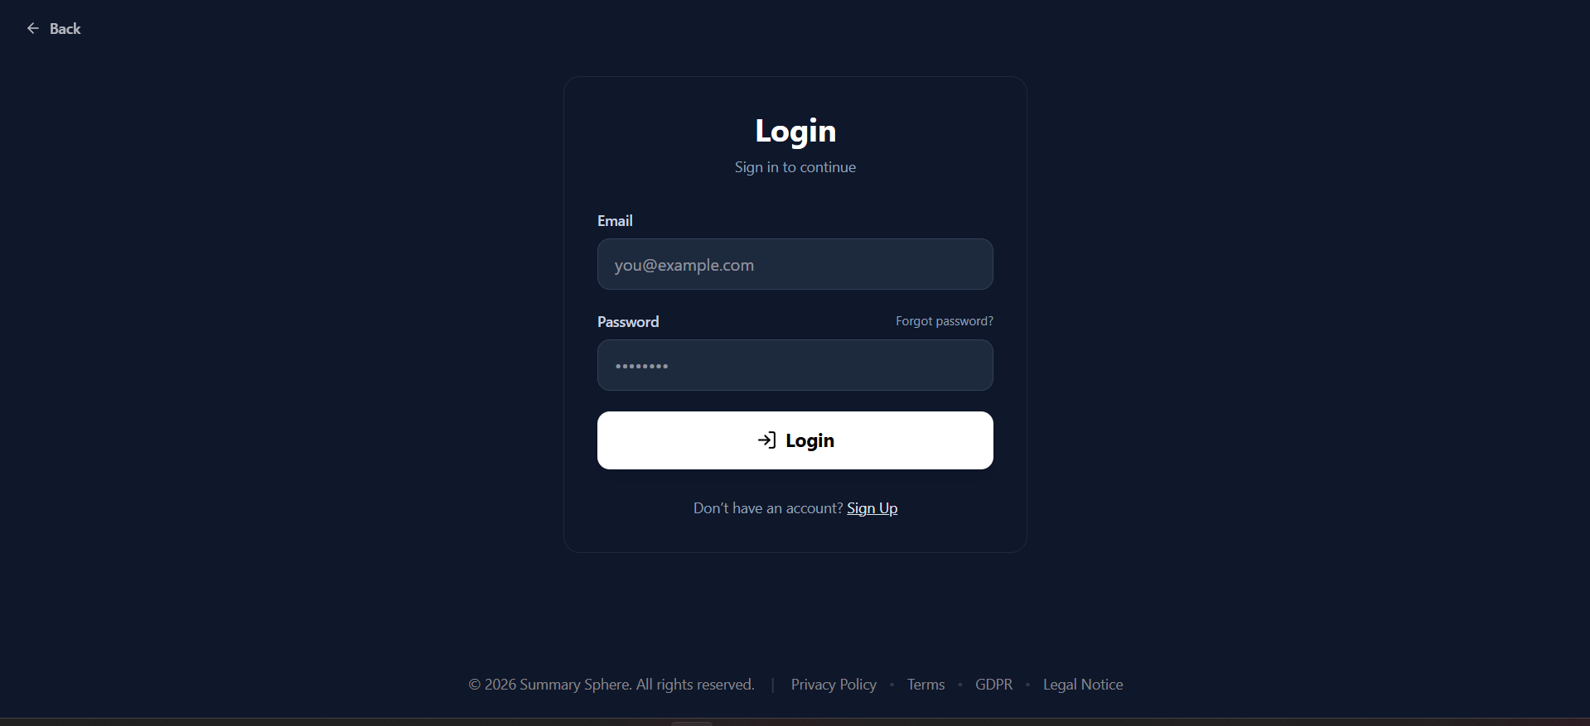
Login Page
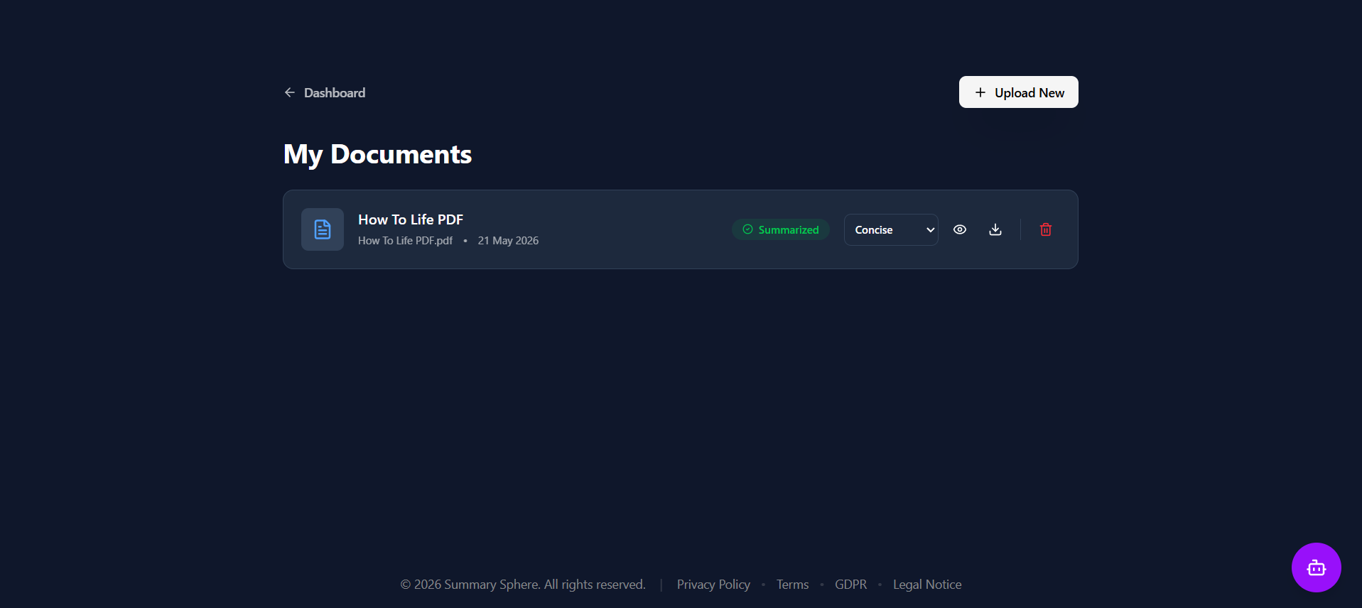
Document list Dashboard

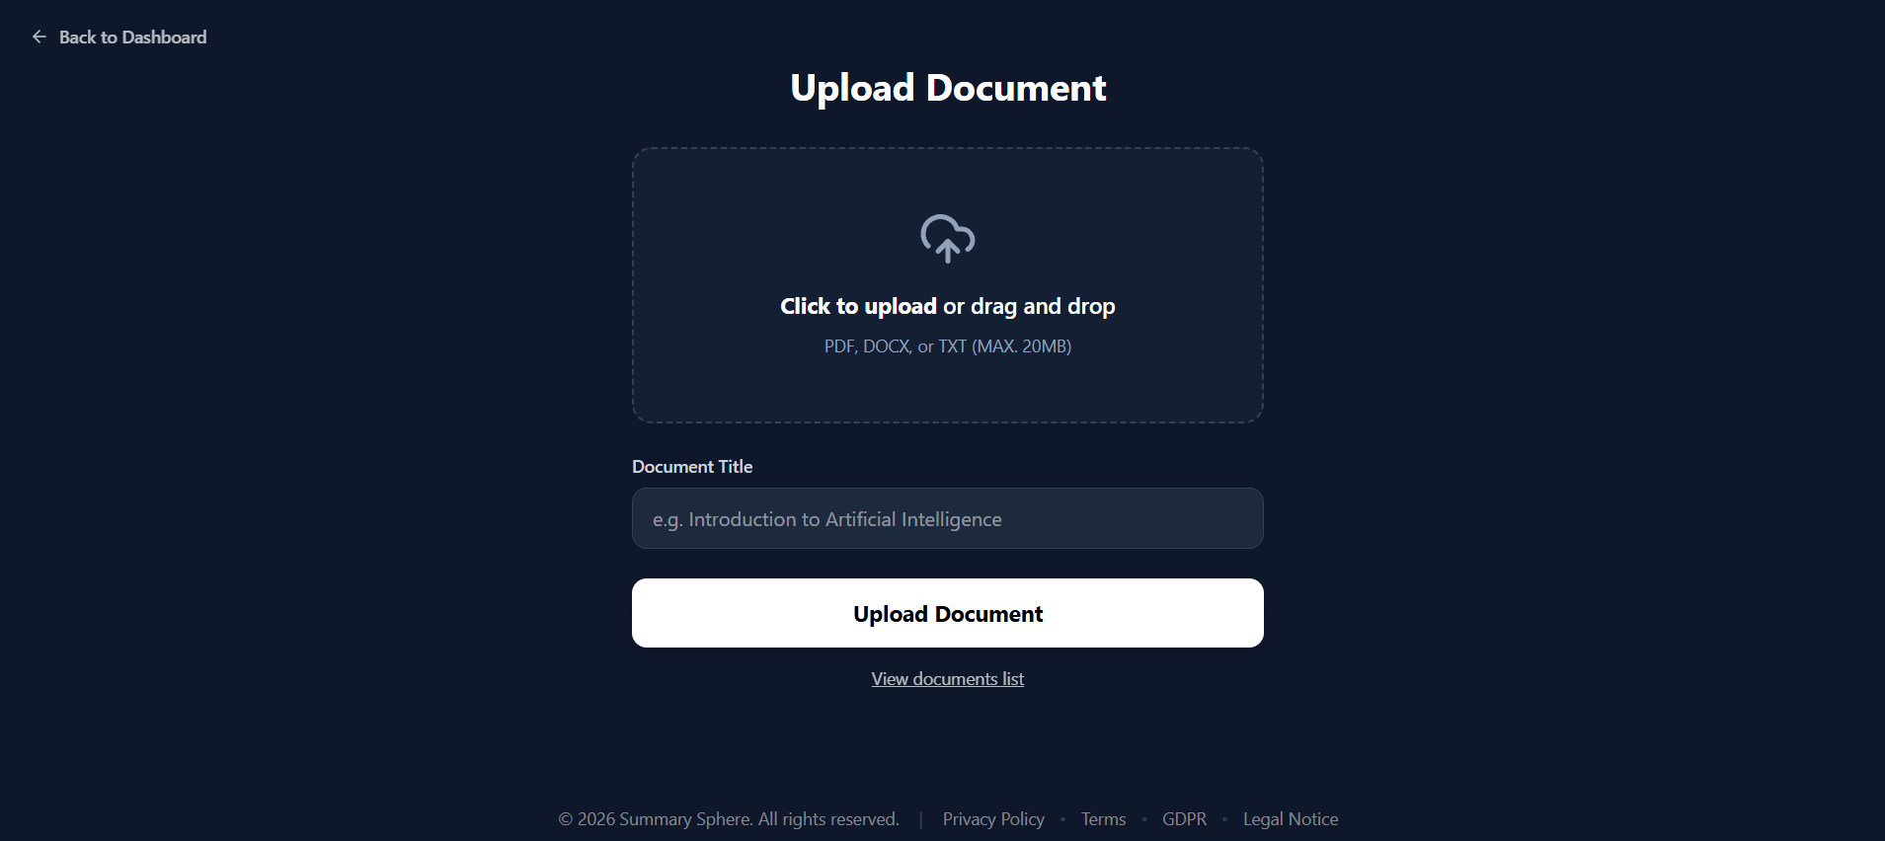
Document upload page
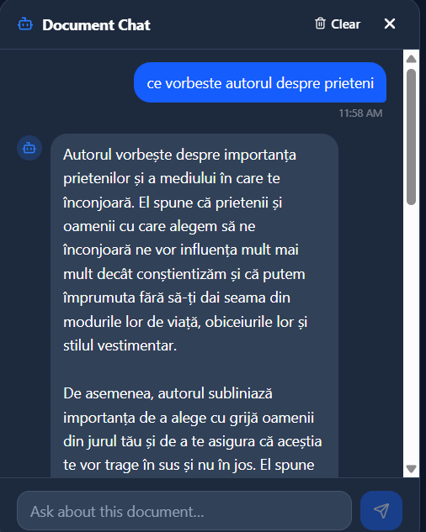
Information gathering using RAG
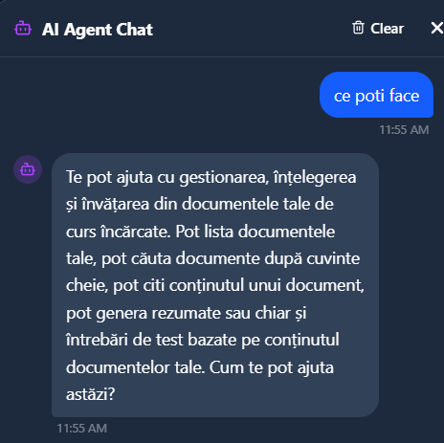
Agent chat with tools use

2. System Architecture
SummarySphere is designed around a decoupled client-server architecture. The React single-page frontend communicates with the Spring Boot backend via REST APIs. Data persistence is split to support fast semantic search alongside durable unstructured storage.
1. React Frontend: Interactive SPA serving views, dashboard controls, and chat dialogs. Built on React 19, Vite, and TailwindCSS v4. Communicates with backend using Fetch API with auth headers.
2. Spring Boot Backend: A Spring Boot 4.0 Java application implementing business logic, Spring Security filter chains, file extractions, and Spring AI pipelines.
3. PostgreSQL with pgvector: Stores relational structures (Users, Documents, Chat Messages, summaries) and utilizes the pgvector extension to store document vector embeddings for semantic search.
4. Azure Blob Storage (or Azurite Emulator): Object storage hosting the physical PDF, Word, and Text documents uploaded by users, as well as generated summary text caches.
5. Large Language Model Engines: Google Gemini API handles text embeddings (gemini-embedding-001) and Groq (LLAMA4) generates the summaries and chat responses.

3. Directory Structures
Here are the core structures of the frontend and backend workspaces.
Frontend Repository Tree (SummarySphere-Frontend)
SummarySphere-Frontend/
├── public/ # Static public assets (Favicon, assets)
├── src/
│ ├── assets/ # Logo and default SVGs
│ ├── components/ # Reusable presentation components
│ │ ├── CTAbutton.tsx # Framer Motion animated buttons
│ │ ├── Footer.tsx # Standard layout footer
│ │ ├── LegalLayout.tsx # Layout for terms and conditions
│ │ ├── RequireAuth.tsx # Route guard wrapping protected routes
│ │ └── Toast.tsx # Alert popup wrapper (react-hot-toast)
│ ├── pages/ # Lazy-loaded views
│ │ ├── Dashboard.tsx # Document management dashboard
│ │ ├── Documents.tsx # File overview, filtering, and summaries
│ │ ├── DocumentDetails.tsx # Detailed view, PDF viewer & RAG document chat
│ │ ├── Upload.tsx # Drag-and-drop document upload page
│ │ ├── Login.tsx # Auth login page
│ │ ├── SignUp.tsx # User registration page
│ │ ├── ForgotPassword.tsx # Trigger reset email
│ │ ├── ResetPassword.tsx # Enter new password
│ │ ├── Loading.tsx # Full page loading spinner
│ │ └── GDPR.tsx / TermsOfService.tsx etc. # Legal/policy pages
│ ├── services/ # Authentication state managers
│ │ ├── authApi.ts # Authentication HTTP client with variant retry paths
│ │ ├── authContext.tsx # Context provider for global user authentication state
│ │ └── authStorage.ts # Handles localStorage JWT storage and event listeners
│ ├── types/ # TS interface definitions
│ │ └── auth.ts # User session & credentials models
│ ├── App.tsx # Root component, router routes & dark mode toggle
│ ├── api.ts # Primary client API containing CRUD, chat, & agent requests
│ ├── index.css # Global stylesheet importing TailwindCSS v4
│ └── main.tsx # Main application entry point
├── package.json # Client dependencies (React 19, Tailwind v4, Lucide, Framer Motion)
├── tsconfig.json # TS base configurations
└── vite.config.ts # Vite build tool and API proxy definitions

Backend Repository Tree (SummarySphere-Backend)
SummarySphere-Backend/
├── compose.yaml # Docker Compose defining pgvector and local Azurite
├── Dockerfile # Production Docker packaging blueprint
├── pom.xml # Maven build dependencies (Spring Boot 4, Spring AI, Tika)
├── src/
│ └── main/
│ ├── java/com/beno/summaryspherebackend/
│ │ ├── config/ # Config layer (Security, CORS, Swagger, Azure Storage)
│ │ │ ├── AzureBlobConfig.java
│ │ │ ├── Config.java
│ │ │ ├── JwtAuthenticationFilter.java
│ │ │ ├── MethodSecurityConfig.java
│ │ │ ├── SecurityConfig.java
│ │ │ └── SwaggerConfig.java
│ │ ├── controllers/ # REST Controllers (Mapping API routes to services)
│ │ │ ├── AgentController.java # General AI agent chat helper
│ │ │ ├── AuthController.java # Auth signup, login, password recovery
│ │ │ ├── ChatController.java # Document-specific RAG chat sessions
│ │ │ ├── DocumentController.java # File upload, metadata, delete, summaries
│ │ │ └── UserController.java # Scoped files list and account deletion
│ │ ├── dtos/ # Data Transfer Objects / Request-Response Schemas
│ │ │ ├── AgentSchema.java
│ │ │ ├── AuthSchema.java
│ │ │ ├── ChatSchema.java
│ │ │ ├── DocumentDTO.java
│ │ │ ├── DocumentListDTO.java
│ │ │ └── SummarizationSchema.java
│ │ ├── entities/ # JPA Database Models (Hibernate)
│ │ │ ├── AgentConversation.java / AgentMessage.java
│ │ │ ├── ChatMessage.java # Document chat histories
│ │ │ ├── Document.java # Metadata, parsed content, owner reference
│ │ │ ├── DocumentSummary.java # Persisted AI summary text
│ │ │ └── User.java # Authentication schema and roles
│ │ ├── enums/ # Enum types (MessageRole, Role, SummaryStatus)
│ │ ├── exceptions/ # Central exception handling classes
│ │ ├── repositories/ # Spring Data JPA repositories (Database interfaces)
│ │ ├── services/ # Service interfaces / layers
│ │ │ ├── agent/ # General AI Agent helper
│ │ │ │ ├── AgentService.java
│ │ │ │ └── AgentTools.java # Spring AI tool definitions
│ │ │ ├── impl/ # Service implementations
│ │ │ │ ├── AIServiceImpl.java # Gemini API interface
│ │ │ │ ├── ChatServiceImpl.java # Document chat logics
│ │ │ │ ├── DocumentServiceImpl.java # File storage & metadata handling
│ │ │ │ ├── DocumentSummaryServiceImpl.java # Summary retrieval & persistence
│ │ │ │ ├── EmailServiceImpl.java # Resend & SMTP email notifications
│ │ │ │ ├── FileExtractionServiceImpl.java # Apache Tika text parser
│ │ │ │ └── UserServiceImpl.java # User management operations
│ │ │ └── ... (service interfaces)
│ │ ├── ModelMappers/ # Converters (ConvertToDto.java)
│ │ └── SummarySphereBackendApplication.java # Spring Boot Application Entry
│ └── resources/
│ ├── application.properties # App configurations (AI API keys, DB urls, secrets)

4. Frontend Developer Guide
Technical Stack
- Core Framework: React 19 with TypeScript for type-safety.
- Build Engine: Vite 7 as the rapid build and development tool.
- Styling Framework: TailwindCSS v4 using `@tailwindcss/vite` plugin for styling.
- Animation: Framer Motion for beautiful page transitions and animations.
- Navigation: React Router DOM v7 for client-side nested routing.
- Toast Provider: react-hot-toast for responsive notifications.
- PDF Export: jsPDF for converting generated summaries to downloadable files.
Setup & Run Locally
Follow these steps to run the frontend application locally:
- Navigate to the frontend directory: `cd SummarySphere-Frontend`
- Install required dependencies: `npm install`
- Run the local Vite development server: `npm run dev` (Runs on port `5173`)
- To compile a production bundle: `npm run build` followed by `npm run preview`
Core Architectural Mechanics
Authentication State Flow
User sessions are managed via JWT. The token is fetched on login/signup and stored in localStorage under the key 'authSession'. The authStorage module decodes the JWT client-side to verify expiration date. It dispatches a custom event 'authSessionChanged' and a native 'storage' event. The AuthContext acts as the single source of truth for the app, offering hooks (useAuth) to access the user state. Safe page routing is accomplished using a RequireAuth layout component that intercepts unauthenticated route access and redirects users back to /login while tracking their intended location.
API Integration & Proxy
Vite handles API routing under the hood by proxying any requests prefixed with '/api' to 'http://localhost:8080' (configured in vite.config.ts). This handles CORS issues locally. For external deployment, base URLs can be overridden via environment variables (e.g. VITE_DOCUMENTS_BASE_URL). Network calls are wrapped inside clean helper functions in api.ts which automatically injects Authorization Bearer tokens in headers.

5. Backend Developer Guide
Technical Stack
- Programming Language: Java 21 for modern syntax and security features.
- Application Framework: Spring Boot 4.0.0 with WebMVC, Security, and JPA.
- AI Orchestration: Spring AI 2.0.0-M6 (Google GenAI embedding starters & OpenAI chat starters mapped to OpenRouter).
- Vector & Data Store: PostgreSQL with pgvector for storing document text vector embeddings.
- Unstructured Storage: Azure Blob Storage SDK for persisting actual file data.
- Document Parser: Apache Tika 2.9.2 (core and standard-parsers) for PDF/DOCX parsing.
- Communications: Spring Starter Mail + Resend SDK for secure transaction emails.
- Api Documentation: SpringDoc OpenAPI 2.8.5 for interactive Swagger Swagger-UI pages.
Setup & Run Locally
Follow these steps to run the backend locally:
- Navigate to the backend directory: `cd SummarySphere-Backend`
- Create a '.env' file in the root directory and supply required API keys (Gemini, OpenRouter, Azure Storage, and Mail configurations).
- Run Docker Compose to launch PostgreSQL (with pgvector) and the Azurite storage emulator: `docker compose up -d`
- Compile the project using Maven: `mvn clean install`
- Run the application: `mvn spring-boot:run` (Runs on port `8080`)
Core Architectural Features
File Text Extraction (Apache Tika)
When a document is uploaded, DocumentService invokes FileExtractionService which delegates text parsing to Apache Tika. Apache Tika detects metadata and extracts the raw content from PDFs, Word documents (docx), and text files (txt) automatically, returning a clean string of text. This raw content is saved in the Database and Azure Storage.
Dual-Storage Strategy
Documents require two modes of access. To retrieve the original files or read them raw, they are uploaded to Azure Blob Storage (container: summaries). To support semantic query searching, the text content extracted from the document is broken down into chunks, vectorized into 3072-dimension vectors using the Google GenAI embedding model (gemini-embedding-001), and saved to the PostgreSQL database in the vector store schema created automatically on startup.
Retrieval-Augmented Generation (RAG) Chat
When a user starts a chat session focusing on a specific document, the chat endpoint vectors their query and performs a similarity search (cosine distance) inside pgvector against only the text chunks matching the document's UUID. The closest matching contexts are extracted and fed to the LLM context prompt, enabling the AI to answer specifically and accurately based on the document's content.
AI Agent with Spring AI Tools
The AgentService exposes a conversational assistant that leverages Spring AI tool calling. The AgentTools class registers functions with the @Tool annotation. The AI agent can automatically decide to invoke these tools during conversation to: list the current user's documents, search their documents by keywords, extract document content, retrieve summaries, trigger new summaries, or generate custom multiple-choice quizzes.

6. Unified API Reference
The backend application serves rest endpoints under the '/api' prefix. The list below represents the primary REST routes, their required user roles, and their actions. For interactive testing, run the server and open the Swagger page at http://localhost:8080/swagger-ui/index.html.
Method | Endpoint Path | Required Role | Description
POST | /api/auth/register | Public | Register a new user account.
POST | /api/auth/login | Public | Authenticates user; returns a session JWT token.
POST | /api/auth/forgot-password | Public | Sends an email link asynchronously to reset password.
POST | /api/auth/reset-password | Public | Verifies token and resets user password.
POST | /api/documents | USER, ADMIN | Upload a document (PDF, Word, or TXT) via multipart-form.
GET | /api/documents | ADMIN | List all documents across all users in the system.
GET | /api/documents/{id} | USER, ADMIN | Fetch document metadata for the file owner.
DELETE | /api/documents/{id} | USER, ADMIN | Delete document, database entries, and Azure storage files.
GET | /api/documents/{id}/download-link | USER, ADMIN | Generates secure temporary SAS download url for the file.
POST | /api/documents/{id}/summarize | USER, ADMIN | Generates and returns an AI summary of a specific type.
GET | /api/documents/{id}/summary | USER, ADMIN | Retrieve latest generated summary for the document.
GET | /api/documents/{id}/summary/{type} | USER, ADMIN | Retrieve specific summary type (brief, detailed, etc.).
GET | /api/documents/{id}/summaries | USER, ADMIN | List all summaries generated for a document.
POST | /api/documents/{id}/chat | USER, ADMIN | Submit a message to chat with a document (RAG).
GET | /api/documents/{id}/chat | USER, ADMIN | Retrieve entire chat history of a document session.
DELETE | /api/documents/{id}/chat | USER, ADMIN | Clear all chat history for a document session.
GET | /api/agent/chat | USER, ADMIN | Fetch or initialize the general AI agent study chat session.
POST | /api/agent/chat | USER, ADMIN | Send query to AI agent (supports Tool annotations).
DELETE | /api/agent/chat | USER, ADMIN | Resets and clears general agent chat conversation.
GET | /api/users/me/documents | USER, ADMIN | List all documents belonging to the authenticated user.
DELETE | /api/users/me | USER, ADMIN | Permanently deletes user, clear files in storage, and DB records.

