

1. On this page I intend to keep the user engaged with fun elements. It will have a dark aesthetic that is easy to read, but not too wordy. I would like have some black and white photos and add a pop of color.
2. Here’s a sample layout of my basic design:

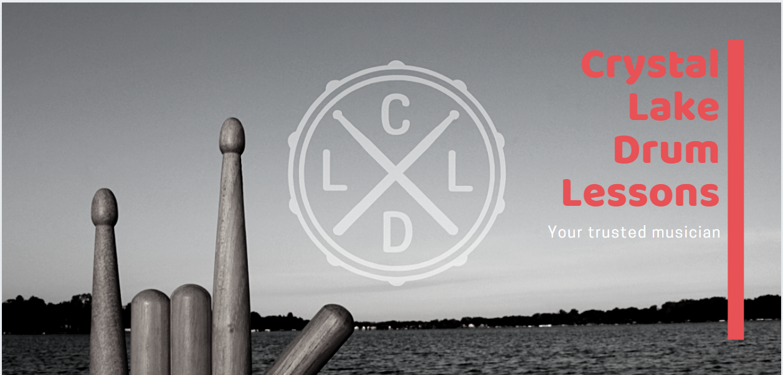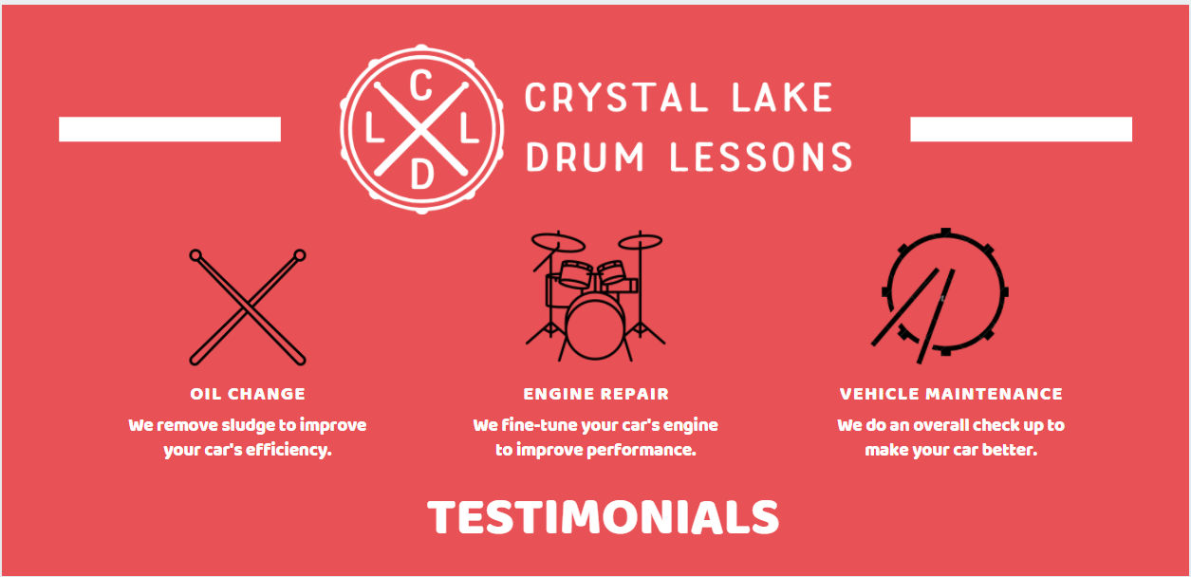  
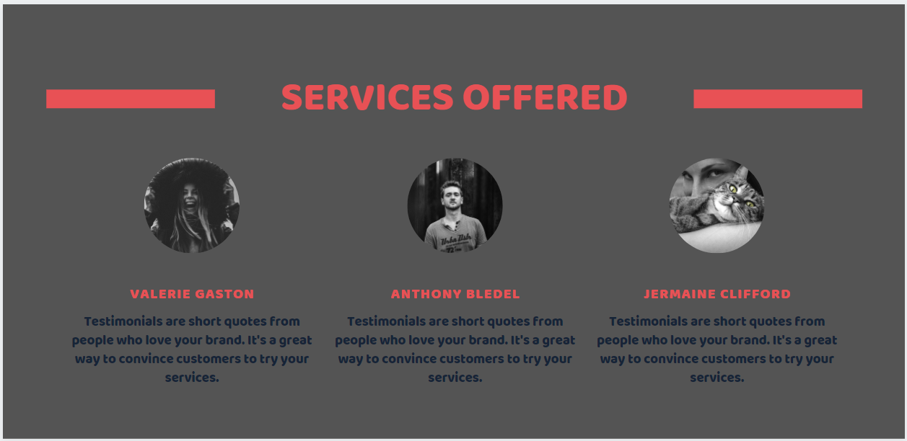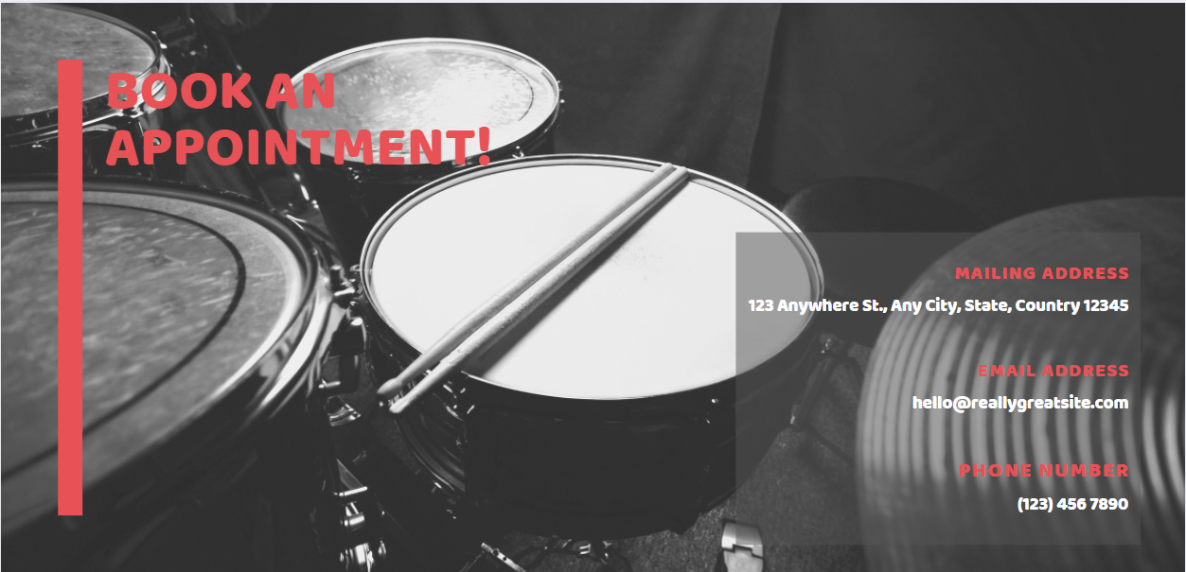

1. For my navbar, I will have Home -> About Me -> Rates & Policies ->Repairs & Restorations -> FAQ  
     
   Instead of having the contact in a separate tab, I intend to add a modal with contact information so that it can be accessed on any page, as well as in the footer.

The Repairs & Restorations page will include a carousel of photos and descriptions of some work that Tony has done on drumsets.

1. References:

* Crystallakedrumlessons.com
* Canva.com - design prototype
* Schoolofrock.com/music-lessons/drum-lessons
* Musicmakers4life.com