Project Report

Visitor Management System

A Winter Internship Project

Author

Rounak Basu

Student of CSE, 3rd year at



Institute of Engineering & Management, Kolkata

**ACKNOWLEDGEMENT**

It was my privilege to get the opportunity of doing my Winter Internship Programme in Powergrid Corporation of India Limited, a government of India enterprise under ministry of power, a central transmission utility and a Maharatna company. This company make one nation, one grid, one frequency, one price throughout the country.

I would like to convey my sincere thanks to the management of the company for giving me this opportunity as it was a great chance for learning and professional development. I have been associated for the last one month w.e.f 8.01.2019 to 15.02.2019 in the IT department of Eastern Region II headquarters at Kolkata. I am grateful to Mr. Sudip Goswami, Manager(IT) and Mr. Debangshu Chatterjee, Assistant Manager (IT) who have allowed me to encroach upon their precious time freely right from the very beginning of this research work till the completion of my internship. Their guidance, encouragement and suggestions provided me necessary insight into the research problem and paved the way for the meaningful ending the work in a short duration. I have no hesitation to say that, without their constant support and valuable advice from time-to-time, I would probably fail to complete the work in an appropriate manner.

0

**ABSTRACT**

The Visitor Management System (VMS) is an integrated system for handling visitors which automates the workflow involving the employees, departments, security and visitors. The VMS has been designed after studying the current workflow concerning visitors in the organization. It is designed to simplify the administration and thereby provide a minimally intrusive experience to the visitor and the host. VMS is a Web application, which has all the information about visitors to the organization. Every visitor has a mandatory host. Each visitor has a unique visitor ID and a visit ID associated with him / her. System logs and tracks each visitor and visit and also facilitates the processing of Visit. Also it is the authentic record for Security staff on visitors to the organization.

This software is being build with help of NODE.JS The data of the new visitors visiting the organization will be stored in the database. With this system the visitor’s information can be stored in the database, so that in the future it shall be used for the reference. The data will be stored in the MONGODB as the backend. This software will help an organization to do the job effectively and give an all round development of the project.

**CONTENTS**

Sl. No. Topic

1. Introduction
2. System Specification-
   1. Software Specification
3. Software Features
   1. Server Side - Node.js
   2. Frontend - Embedded JavaScript
   3. Backend - Mongodb
4. System Study:
   1. Proposed System
   2. Technical Research
   3. System Design
   4. Testing
5. Features of the system
6. Conclusion
7. **INTRODUCTION**

From the management point of view it is difficult to deal with visitors during rush hours with the manual system of working making the visitors to wait in long queues. Management for tracking visitors unit wise need to check the records manually which consumes a lot of time and might also led to inaccuracy in information collected for such purpose. Some of the problems faced are the difficulty in managing visitors across multiple locations/sites, therefore accommodation needs to be made all over one specific website in order to manage the visitors visiting the organization, therefore it will also help in maintaining a record and have over control over visitors.

Visitor management system is the system that manages the visitor’s data, employee’s data, administration process and helps in maintaining visitor's messages. Visitor management using a desktop application system is an onerous and time consuming process involving heavy workload. In the proposed system, one can easily manage the various functions of an office in an efficient manner. The key feature of this project is to easily allocate visitors to the employees. The system additionally includes a number of special options like making distinctive identities for every visitors thus visitor details will be accessed simply.

**2.SYSTEM SPECIFICATION**

**2.1. SOFTWARE SPECIFICATIONS:**

Operating System : Windows 10

Server : Node.js

Frontend : Embedded JavaScript

Backend : Mongodb

Reports : Data Reports

**3.SOFTWARE FEATURES**

**3.1 SERVER SIDE - Node.js**

Node.js is an [open-source](https://en.wikipedia.org/wiki/Open-source_software), [cross-platform](https://en.wikipedia.org/wiki/Cross-platform) [JavaScript](https://en.wikipedia.org/wiki/JavaScript) [run-time environment](https://en.wikipedia.org/wiki/Runtime_system) that executes JavaScript code outside of a browser. JavaScript is used primarily for [client-side scripting](https://en.wikipedia.org/wiki/Client-side_scripting), in which scripts written in JavaScript are embedded in a webpage's HTML and run client-side by a JavaScript engine in the user's web browser. Node.js lets developers use JavaScript to write command line tools and for [server-side scripting](https://en.wikipedia.org/wiki/Server-side_scripting)—running scripts server-side to produce [dynamic web page](https://en.wikipedia.org/wiki/Dynamic_web_page) content before the page is sent to the user's web browser. Consequently, Node.js represents a "JavaScript everywhere" paradigm, unifying [web application](https://en.wikipedia.org/wiki/Web_application) development around a single programming language, rather than different languages for server side and client side scripts.

Node.js allows the creation of [Web servers](https://en.wikipedia.org/wiki/Web_server) and networking tools using [JavaScript](https://en.wikipedia.org/wiki/JavaScript) and a collection of "modules" that handle various core functionality.Modules are provided for [file system](https://en.wikipedia.org/wiki/File_system) I/O, networking ([DNS](https://en.wikipedia.org/wiki/Domain_Name_System), [HTTP](https://en.wikipedia.org/wiki/HTTP), [TCP](https://en.wikipedia.org/wiki/Transmission_Control_Protocol), [TLS/SSL](https://en.wikipedia.org/wiki/Transport_Layer_Security), or [UDP](https://en.wikipedia.org/wiki/User_Datagram_Protocol)), [binary](https://en.wikipedia.org/wiki/Binary_file) data (buffers), [cryptography](https://en.wikipedia.org/wiki/Cryptography) functions, [data streams](https://en.wikipedia.org/wiki/Stream_(computing)), and other core functions. Node.js's modules use an API designed to reduce the complexity of writing server applications.

Node.js is officially supported on [Linux](https://en.wikipedia.org/wiki/Linux), macOS, Microsoft, SmartOS, FreeBSD and IBM AIX.

**3.2 FRONTEND - Embedded JavaScript**

EJS is a simple templating language that lets you generate HTML markup with plain JavaScript. Embedded JavaScript (EJS) is used to return this code to a straightforward, maintainable HTML structure. EJS is a JavaScript templating library. It is commonly used for building HTML strings from JSON data.

**3.3 BACKEND - MongoDB**

MongoDB is a [cross-platform](https://en.wikipedia.org/wiki/Cross-platform) [document-oriented database](https://en.wikipedia.org/wiki/Document-oriented_database) program. It is issued under the [Server Side Public License (SSPL)](https://www.mongodb.com/licensing/server-side-public-license) version 1, which was submitted for certification to the [Open Source Initiative](https://en.wikipedia.org/wiki/Open_Source_Initiative) but later withdrawn in lieu of SSPL version . Classified as a [NoSQL](https://en.wikipedia.org/wiki/NoSQL) database program, MongoDB uses [JSON](https://en.wikipedia.org/wiki/JSON)-like documents with [schemata](https://en.wikipedia.org/wiki/Database_schema). MongoDB is developed by [MongoDB Inc.](https://en.wikipedia.org/wiki/MongoDB_Inc.) MongoDB supports field, [range query](https://en.wikipedia.org/wiki/Range_query_(database)), and [regular expression](https://en.wikipedia.org/wiki/Regular_expression) searches. Queries can return specific fields of documents and also include user-defined [JavaScript](https://en.wikipedia.org/wiki/JavaScript)functions. Queries can also be configured to return a random sample of results of a given size. MongoDB is an

object-oriented, simple, dynamic, and scalable NoSQL database. It is based on the NoSQL document store model. The motivation of the MongoDBlanguage is to implement a data store that provides high performance, high availability, and automatic scaling. MongoDB is extremely simple to install and implement.

**4.SYSTEM STUDY**

**4.1 Proposed System**

The new system will have the facility to sort data according to any specific type on the basis of what the user wants in any order. Also with the help of computerized system if the user wants to access any single user's data from many users data he can automatically get the desired data of the desired visitor or visit details, etc. in a fraction of second which is again time saving and very quick. Some of the features of the proposed system are given below :

* Maintaining the database
* Removal of data redundancy
* Data consistency
* Leaves messages
* Menu driven interface
* Ensure data security

**4.2 Technical Research**

Technical research involves study on similar system to know the functionality features of the existing system, this is to find the flaws in the existing systems and to take note and suggest good features. Visitor management system (VMS) is developed using the trends in information technology which provides a feature to capture visitor information by using identification proof of the visitor and save them to a database that is centralized

**4.3 System Design**

System architecture gives a detailed specification of the requirements that provides developers with a detailed picture of the objectives of the system development. Software System architecture comprises of components and the interactions that takes place between these components.

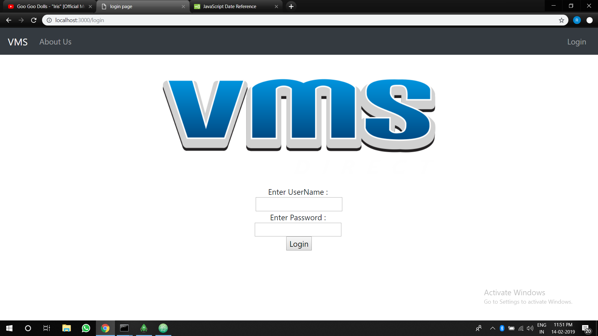

Fig.2 : Login Page

This is the first page; when users of this system type in the URL for the system. This page is responsible to filter out users and non-users of this system by validating the login credentials that the users type in as shown above in Fig.2. When the right credentials are typed in, the user is granted access into the system and when the wrong credentials are type in, the users are prompted to correct their credentials. Only the admins are given access to the system.

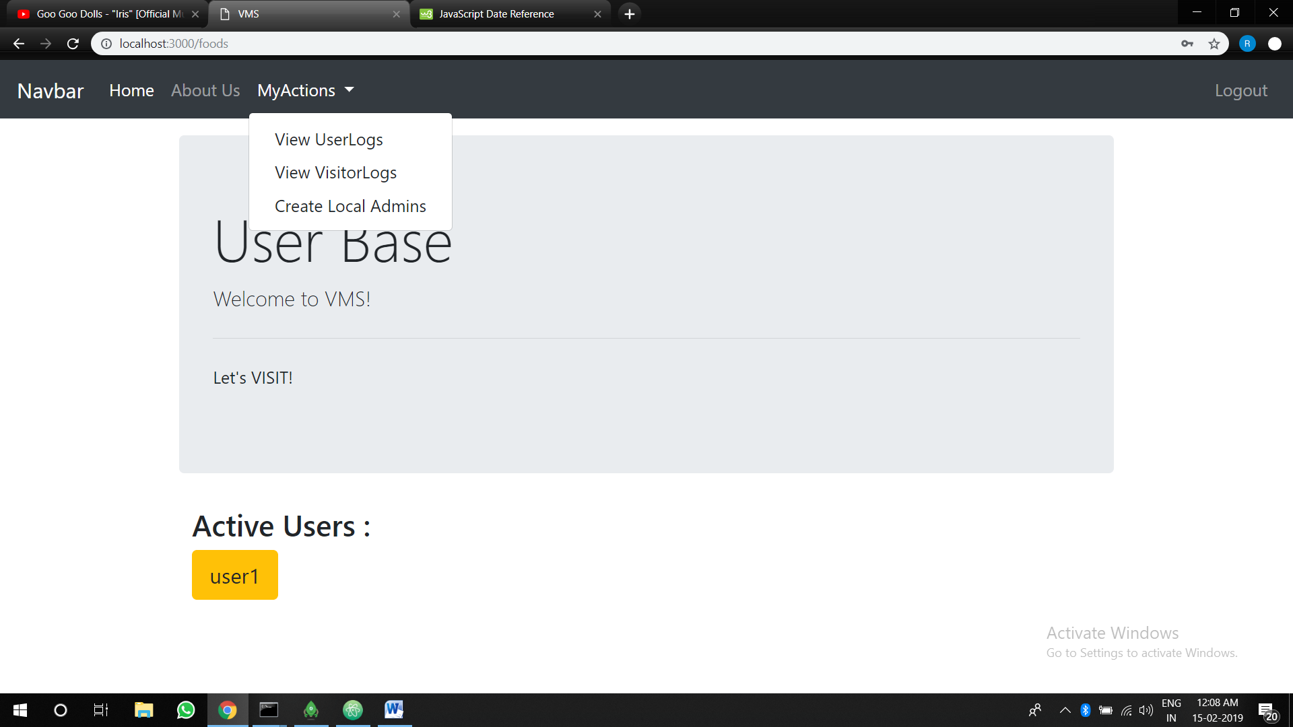

Fig. 3 : Admins access on this page only

This page is shown only if the “SUPER ADMINS” or the “LOCAL ADMINS” created by the super-admins are logged in. Super-Admin has the sole authority of adding local admins (fig.4). Once logged in, the admins can add visitors and associate their visits with the employees.

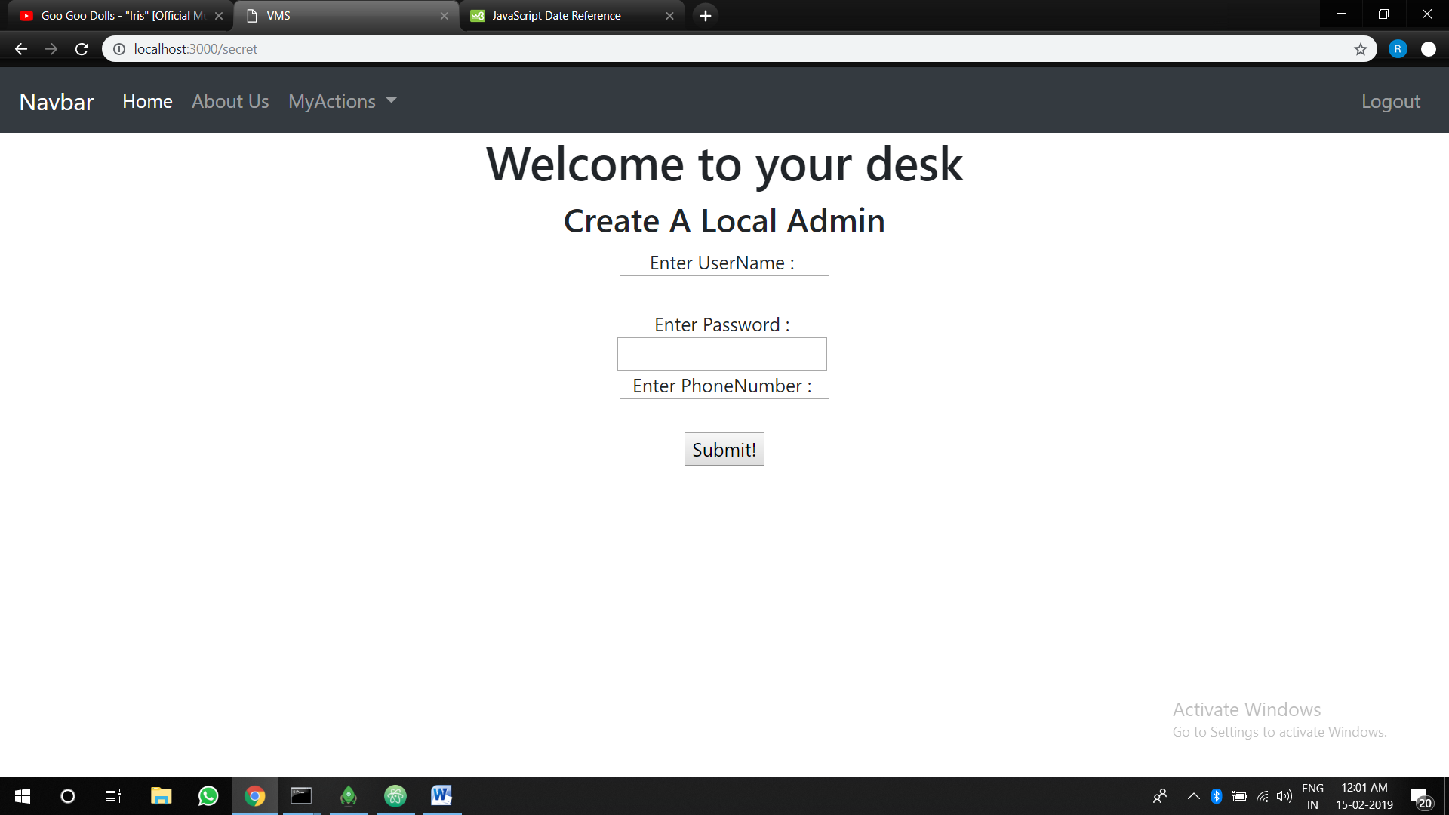

Fig 4 : Super-Admins have the sole right to add local admins.

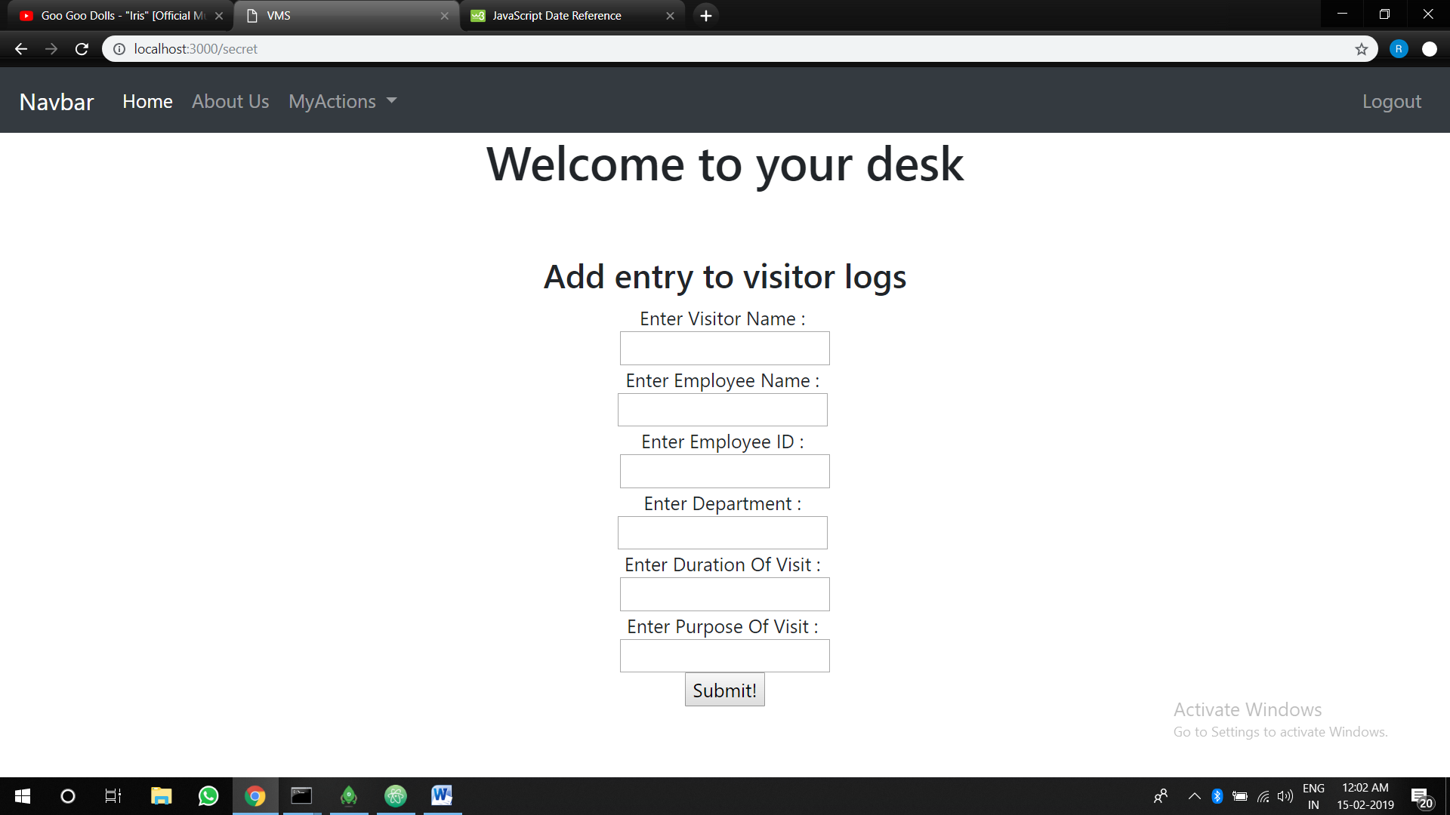

Fig. 5 : Visitor’s Form

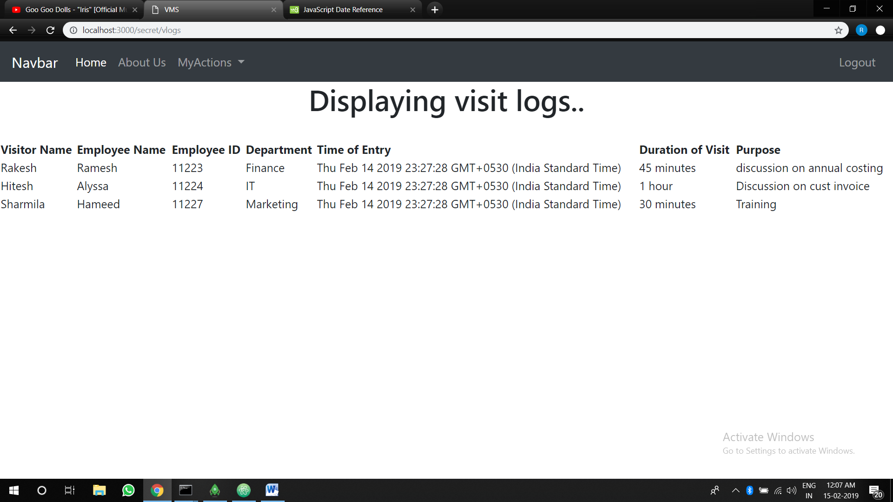

Fig. 6 : Associating visitors to the employees during their visits

**4.4 TESTING**

Unit testing is called the first level of testing that used in software testing. This testing is to test the different modules during the design of modules and it is combination of set of test that is used in integrating the units into a huge system. This unit testing first mainly focus on the modules of the system to locate errors. In this errors are verified and corrected to that unit perfectly fits to the project. Unit testing is done for the visitor information, once it is found that this unit of code provides the functionality of uploading visitor information is working successfully then they test the other code to edit the visitor details to test the edit function.

Module testing is done once the units of codes are tested separately for their successful functioning. During module testing two units of codes are testing to find whether the code in one unit is working in conjunction with the other unit of code successfully (Target, 2015). For the visitor management system when the code for uploading visitor information is working, then the code for search function to search for the uploaded visitor information is tested, this way module testing is done by testing units of code with each other.

User Acceptance Test This test takes during the transition phase of the RUP methodology where the system that is testing by the developers will be deployed at user-domain and the users are exposed to testing. User acceptance testing is the most crucial testing of all the testing in the software development. Only when the user testing is successful that is if the system meets the requirements as expected the system is deployed finally for actual use in the real world scenario. Here for the proposed visitor management system the users are security guard, student and the administrators who will test the system for its working based on the requirement specifications.

**FEATURES OF THE SYSTEM**

Proposed system for Visitors Management System will be an online system that can run on the internet using a browser. The system has three main users administrator of the management, admins and the employees. All the three users will be able to access the system using login credentials provided and perform actions that are implemented.

Below given are the main functionalities that will be delivered to the user based on the module :

* • Allow administrator to login to the system and add local admins.
* • Allow local admins to add visitors.
* • Allow admin to view the overall process of having visitor.
* • Allow super admins to delete local admin accounts.

**CONCLUSION**

At the beginning of the project a lot had to be learned. Hence it was quite challenging. I was lucky enough to not only try my hand at MEAN stack development at a beginner’s level but also learn about version-control using git and getting familiarized with CSS/Bootstrap.

I was thrilled to be able to learn how to use and handle MongoDB databases and link them to my web server. I also enjoyed learning about password encryption using passport.

All in all, this was an outstanding learning experience and I am confident that whatever I have learnt, will help me in my career in the future.