**Draft Design - Wireframes**

Our solution presents a collection of information about refugee services in multiple ways: through a web interface, and by SMS messaging. These options are available to accommodate refugees who do not have consistent internet access. Instructions to access the information by SMS are distributed by paper flyers printed in multiple languages.

**Multilingual Informational Paper Flyer:**

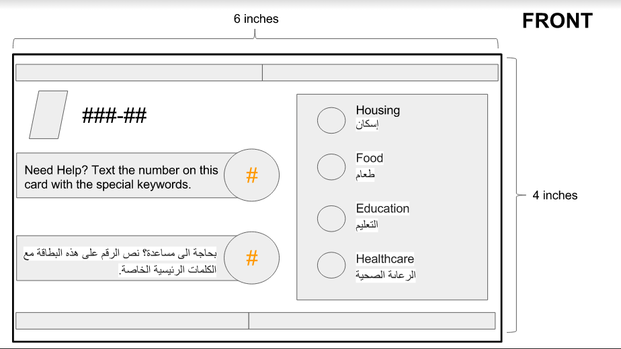

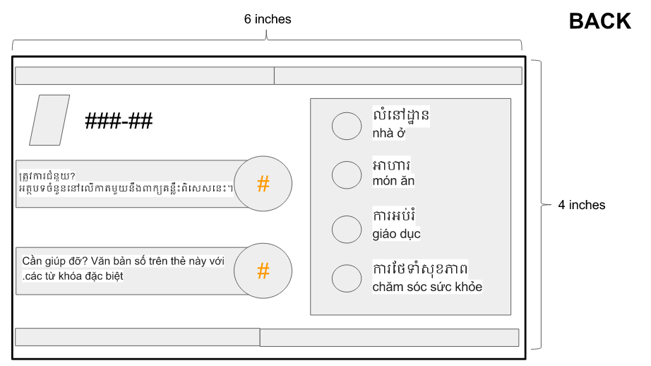

**Web Wireframes:**

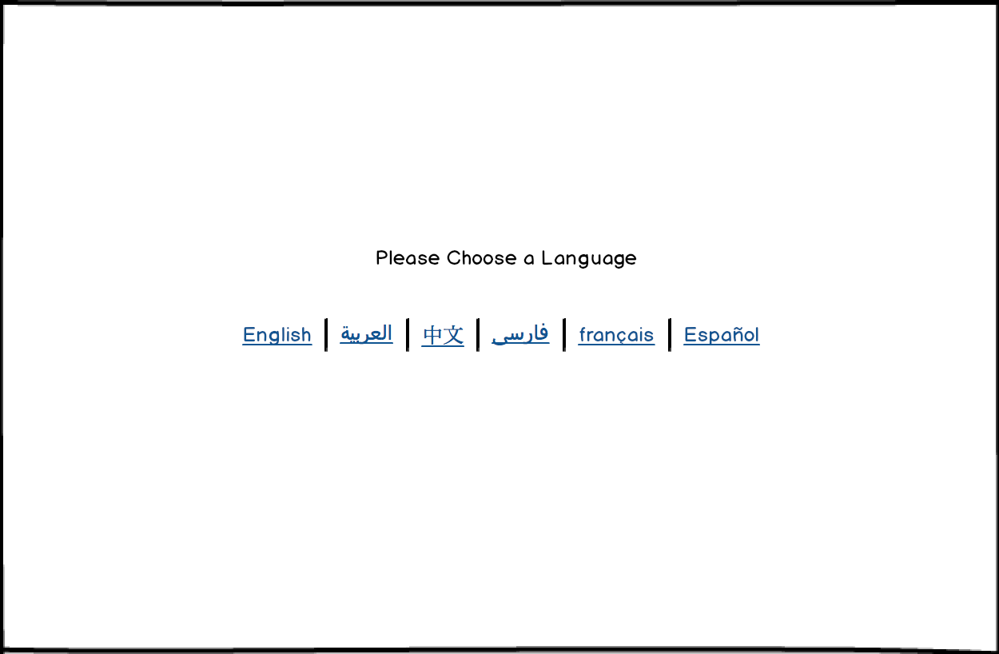

Web landing page with language selection. (Index page)

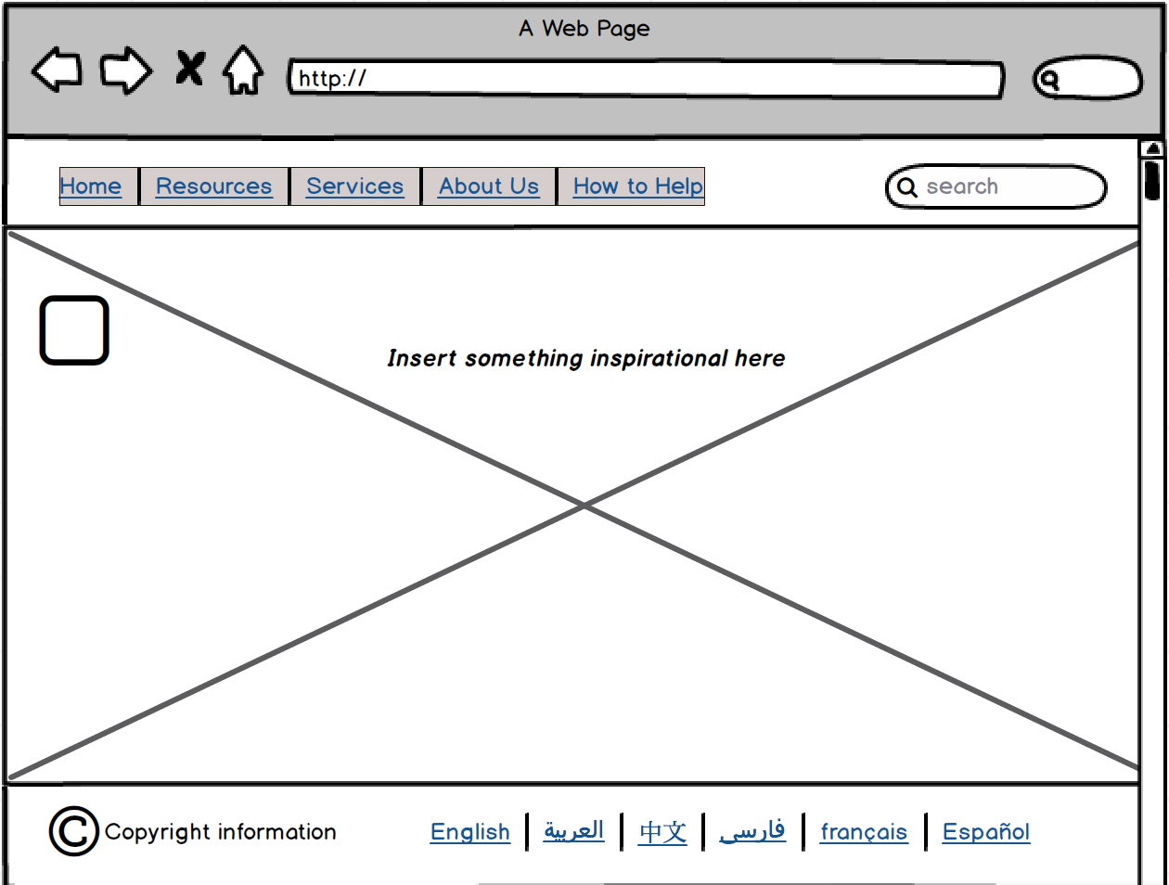

Homepage with different menu options, search option, picture with inspirational quote, language selection and logo in the top left. (homepage)

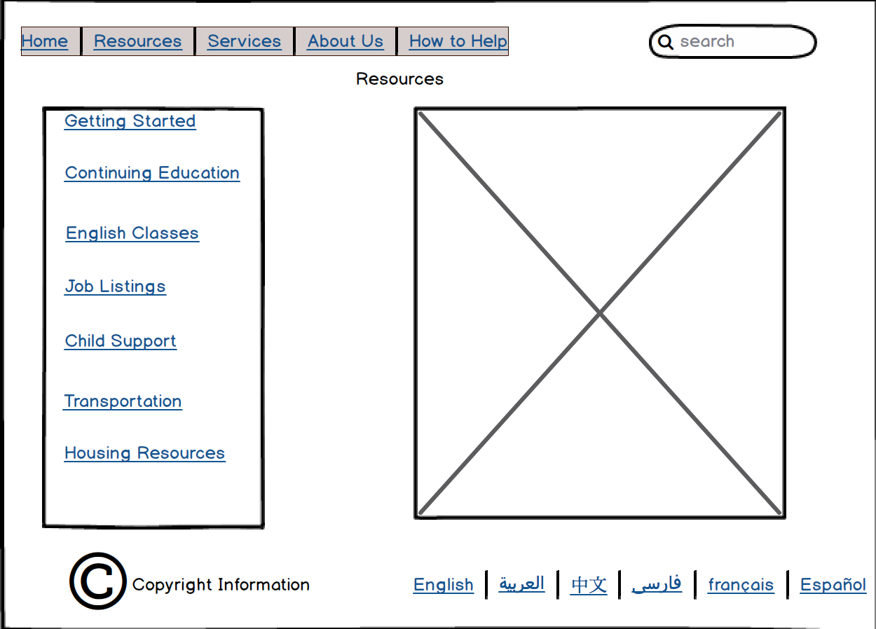

Resources page, has list of resources on left, stock photo of helping people on the right. (Resources page)

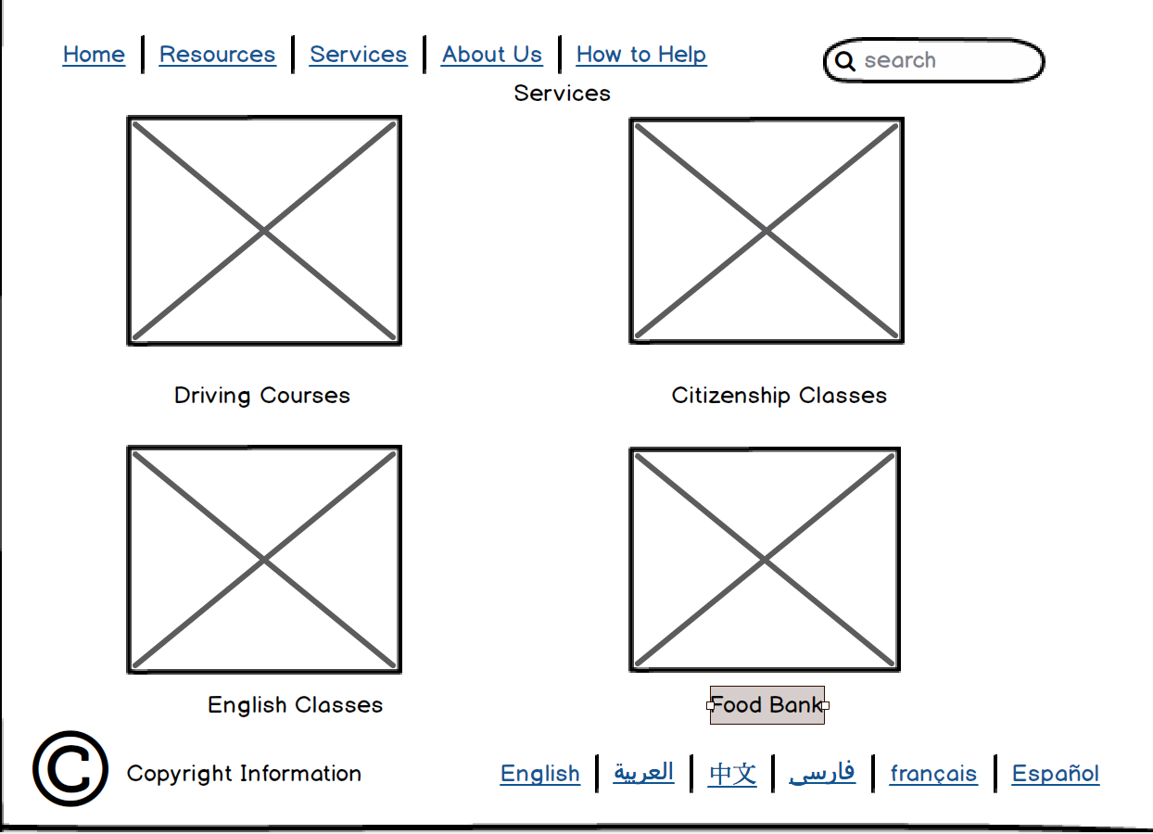

Services page, Stock photos connected to links with services provided.

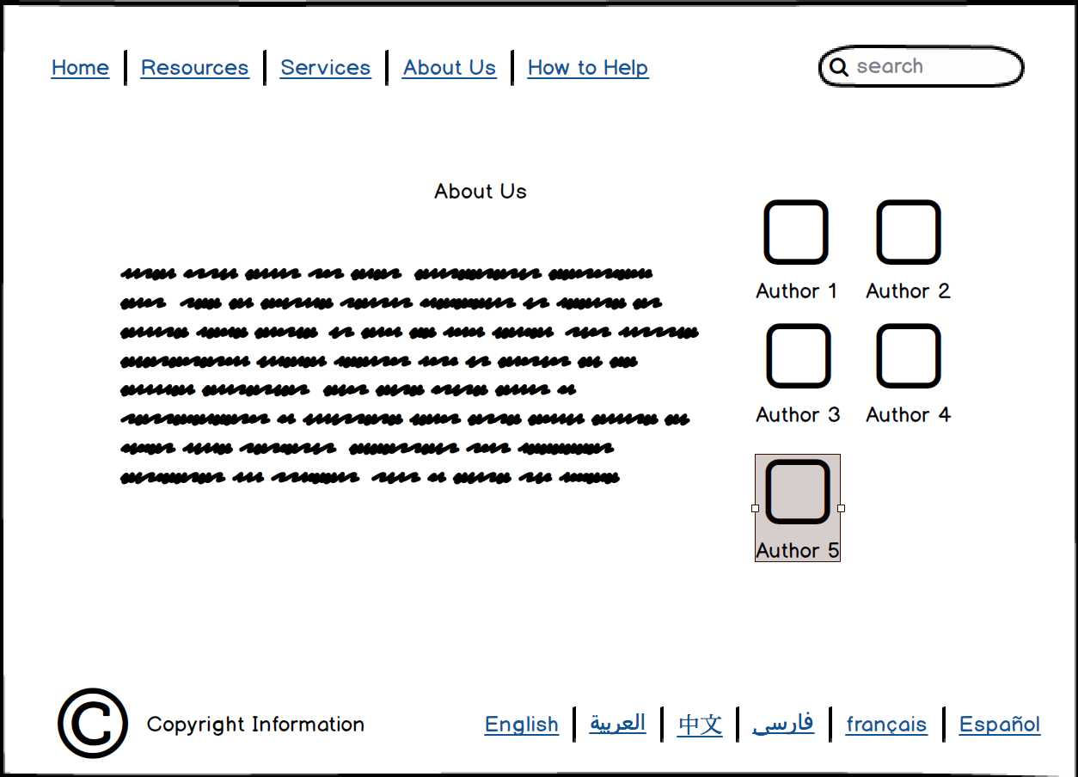

About us page with generic mission goals etc. Author photos on the right

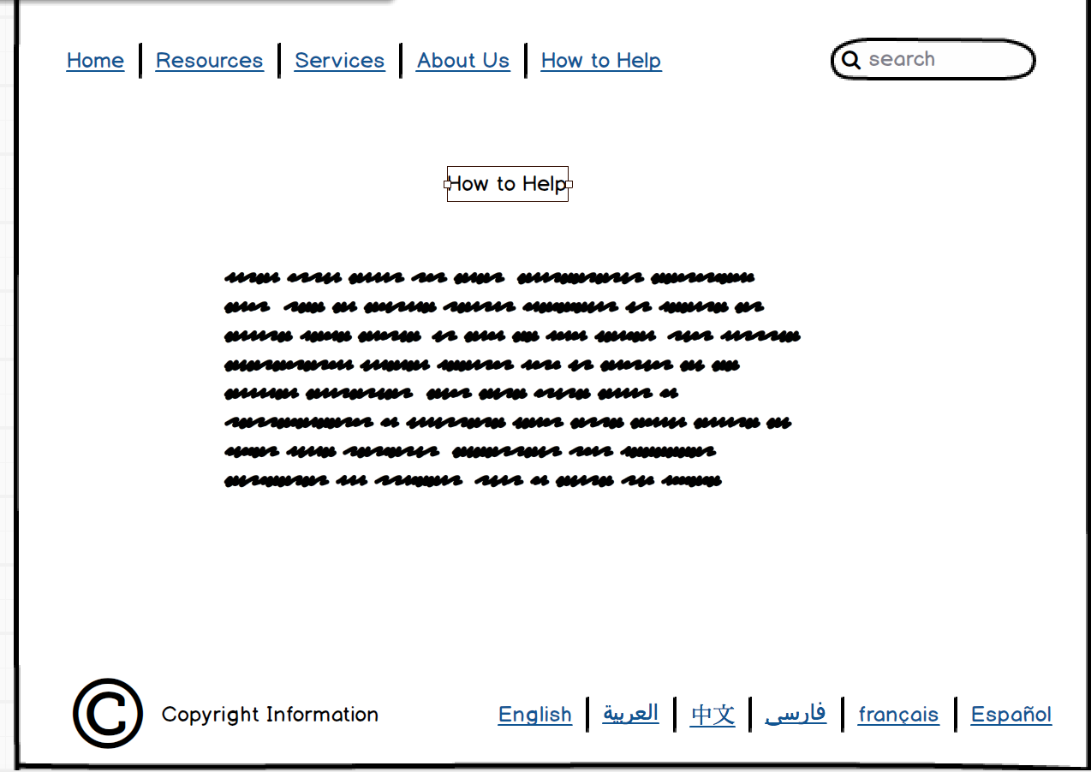

How to help information on this page

**Draft Design - Usage Scenarios**

**Scenario 1**

Zainab Al-Faraj is a Syrian refugee in Seattle who’s not familiar with technology and the English language. Because of this, online resources have been difficult for her to navigate through. One of the most important thing to Zainab is the well-being of her three children, so naturally, Zainab’s main priority is to learn more about healthcare programs available to her. Zainab tried to go to the library to search up healthcare programs for refugees, but the vast information on the web made it difficult for her to locate resources. This is when our flyer would prove to be useful for individuals that are not familiar with technology and/or the English language. With our flyer, Zainab can get fast and reliable information about healthcare programs with just her phone. Looking at the flyer, Zainab would see four popular languages among refugees: English, Arabic, Khmer, and Vietnamese. With Arabic being her first language, Zainab would be able to read the flyer easily. She would then text the number on the top of the flyer with the word “Healthcare” to get a list of information and resources about healthcare programs. This would save Zainab a significant amount of time, and would ensure that the information she has is valid and reliable. Our flyer also includes other keywords besides “Healthcare”, such as “Housing”, “Food”, and “Education”. These topics tend to be refugees’ top priorities, so by including them on the flyer, we are accommodating to their most important needs.

**Scenario 2**

Bhavni Thompson works full-time with the IRC to assist incoming refugees as they transition to life in the United States. This period can be extremely difficult, and immigration and integration with U.S. society are only possible when refugees have access to the proper resources relevant to their needs. While she is experienced with assisting the people she works with, it is challenging to take all of the information about each person’s individual case and use that to find the most pressing needs and the services which address those requirements. As a person who works with refugees, she can talk with them and ask questions and plug the response directly into our online system. This will allow her to efficiently filter out the many resources which are out there and find only those which will be most helpful for the person’s situation. She can also give refugees information about our system so that they will be able to access it and find resources on their own time. With this saved time and efficiency, refugees have a better experience during their transition, and refugee organizations and their volunteers and employees like Bhavni have spared time and resources to help more individuals.

Upon arriving at the website, Bhavni will see a page that asks her to choose a language to proceed. These languages are some of the most common among refugees, and it includes English, Arabic, Chinese, Farsi, French, and Spanish. Since Bhavni is familiar with English, she would choose “English” to continue. Bhavni would be directed to a Home page that will serve as a welcome page. A navigations tab is shown at the top of the page with links to “Resources”, “Services”, “About Us”, and “How to Help”. On the right hand side of the navigations bar is the search bar. On the bottom right hand corner, the six languages will still be present for users to switch between languages if necessary. On the resources page, the user will see links on the left hand side. They are, in order, “Getting Started”, “Continuing Education”, “English Classes”, “Job Listings”, “Child Support”, “Transportation”, and “Housing Resources”. Clicking on a tab will allow the website to present the topic to the user, and it will include a list of local offices that can provide resources. Address, phone numbers, and hours of operation of local officers are all details that will be shown to the user. On the “Services” page, there will be a list of services shown in a block layout, where there will be a photo representing the service. Users will click on the photo to navigate to the specific service they are looking for. On the “About Us” page, users can find a brief paragraph discussing our main mission goals, followed by the creators/designers of the website on the right hand side. Lastly, the “How to Help” page will present users with simple ways they can help refugees.

In an example where Bhavni Thompson needs to help a refugee with finding a job, Bhavni can use our website to easily locate resources. After choosing English as her language, Bhavni can navigate to the “Resources” page and click on “Job Listings”. The website would then present Bhavni with a list of different job listings. Going through the listing with the refugee, Bhavni can locate a job suitable for the refugee. Let’s say that to attend an interview for the job, the refugee would need to find some sort of transportation to get to the office. Bhavni can then click on the Transportation tab to find local resources that could help the refugee get to his destination. Then, let’s say that the refugee does not want to rely on public transportation in the long term. Instead, the client wants to learn how to drive and eventually purchase his/her own car. Bhavni can navigate to the “Services” page and from there, click on “Driving Courses”, where Bhavni would be presented with a list of organizations that holds driving courses for the client. From looking for a job, to locating temporary transportation, to planning for long term transportation, Bhavni can help her client with finding reliable resources and services with just one website. Instead of having to open up multiple tabs and having to go through dozens of searches for just one task, Bhavni has a place where information is consolidated.