## **APPENDIX B: COLORMAP .XML FILES**

**BLUE/GREEN DIVERGENT**



<ColorMaps>

<ColorMap space="CIELAB" indexedLookup="false" name="62c">

<Point x="0.000000" o="1" r="0.082353" g="0.133333" b="0.278431"/>

<Point x="0.050000" o="1" r="0.105882" g="0.196078" b="0.321569"/>

<Point x="0.100000" o="1" r="0.156863" g="0.286275" b="0.419608"/>

<Point x="0.150000" o="1" r="0.211765" g="0.396078" b="0.521569"/>

<Point x="0.200000" o="1" r="0.282353" g="0.505882" b="0.600000"/>

<Point x="0.250000" o="1" r="0.349020" g="0.631373" b="0.701961"/>

<Point x="0.300000" o="1" r="0.439216" g="0.768627" b="0.800000"/>

<Point x="0.350000" o="1" r="0.517647" g="0.858824" b="0.847059"/>

<Point x="0.400000" o="1" r="0.596078" g="0.921569" b="0.878431"/>

<Point x="0.450000" o="1" r="0.709804" g="0.968627" b="0.905882"/>

<Point x="0.490000" o="1" r="0.803922" g="0.980392" b="0.929412"/>

<Point x="0.500000" o="1" r="0.831373" g="0.988235" b="0.886275"/>

<Point x="0.510000" o="1" r="0.803922" g="0.980392" b="0.823529"/>

<Point x="0.550000" o="1" r="0.709804" g="0.968627" b="0.729412"/>

<Point x="0.600000" o="1" r="0.584314" g="0.901961" b="0.584314"/>

<Point x="0.650000" o="1" r="0.505882" g="0.800000" b="0.478431"/>

<Point x="0.700000" o="1" r="0.439216" g="0.701961" b="0.384314"/>

<Point x="0.750000" o="1" r="0.376471" g="0.600000" b="0.301961"/>

<Point x="0.800000" o="1" r="0.321569" g="0.501961" b="0.235294"/>

<Point x="0.850000" o="1" r="0.250980" g="0.419608" b="0.129412"/>

<Point x="0.900000" o="1" r="0.223529" g="0.349020" b="0.094118"/>

<Point x="0.950000" o="1" r="0.231373" g="0.321569" b="0.105882"/>

<Point x="1.000000" o="1" r="0.215686" g="0.278431" b="0.082353"/>

<NaN r="0.25" g="0" b="0"/>

</ColorMap>

</ColorMaps>

**ASYMMETRIC BLUE/GREEN DIVERGENT**

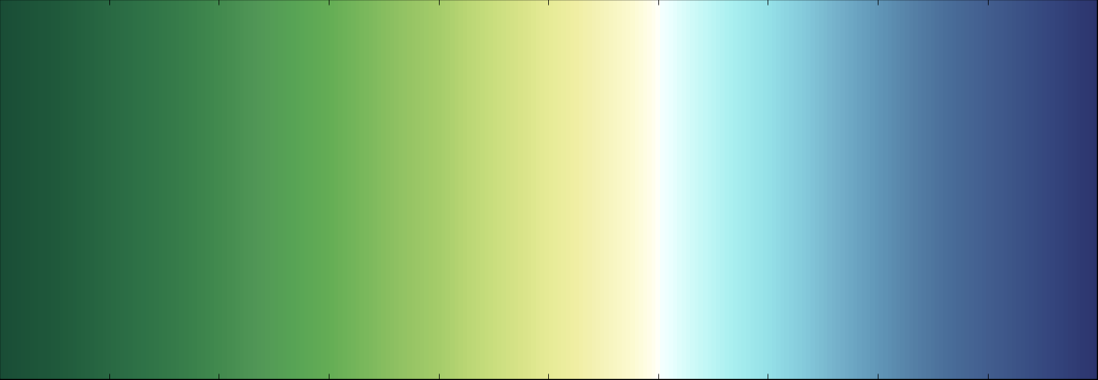

<ColorMaps>

<ColorMap space="CIELAB" indexedLookup="false" name="Fav6">

<Point x="0.000000" o="1" r="0.098039" g="0.301961" b="0.211765"/>

<Point x="0.020000" o="1" r="0.109804" g="0.321569" b="0.219608"/>

<Point x="0.050000" o="1" r="0.121569" g="0.349020" b="0.231373"/>

<Point x="0.075000" o="1" r="0.141176" g="0.380392" b="0.247059"/>

<Point x="0.100000" o="1" r="0.160784" g="0.411765" b="0.262745"/>

<Point x="0.133000" o="1" r="0.184314" g="0.450980" b="0.278431"/>

<Point x="0.166000" o="1" r="0.215686" g="0.490196" b="0.290196"/>

<Point x="0.200000" o="1" r="0.258824" g="0.541176" b="0.305882"/>

<Point x="0.233000" o="1" r="0.317647" g="0.588235" b="0.337255"/>

<Point x="0.266000" o="1" r="0.341176" g="0.639216" b="0.333333"/>

<Point x="0.300000" o="1" r="0.392157" g="0.678431" b="0.333333"/>

<Point x="0.333000" o="1" r="0.478431" g="0.721569" b="0.360784"/>

<Point x="0.366000" o="1" r="0.572549" g="0.760784" b="0.388235"/>

<Point x="0.400000" o="1" r="0.647059" g="0.800000" b="0.415686"/>

<Point x="0.425000" o="1" r="0.725490" g="0.839216" b="0.454902"/>

<Point x="0.450000" o="1" r="0.788235" g="0.870588" b="0.494118"/>

<Point x="0.475000" o="1" r="0.847059" g="0.890196" b="0.533333"/>

<Point x="0.500000" o="1" r="0.901961" g="0.921569" b="0.588235"/>

<Point x="0.525000" o="1" r="0.941176" g="0.933333" b="0.639216"/>

<Point x="0.550000" o="1" r="0.960784" g="0.952941" b="0.729412"/>

<Point x="0.575000" o="1" r="0.988235" g="0.980392" b="0.811765"/>

<Point x="0.595000" o="1" r="1.000000" g="0.996078" b="0.921569"/>

<Point x="0.600000" o="1" r="1.000000" g="1.000000" b="0.968627"/>

<Point x="0.600000" o="1" r="0.968627" g="1.000000" b="0.996078"/>

<Point x="0.610000" o="1" r="0.921569" g="1.000000" b="0.996078"/>

<Point x="0.633000" o="1" r="0.803922" g="0.980392" b="0.972549"/>

<Point x="0.666000" o="1" r="0.666667" g="0.941176" b="0.941176"/>

<Point x="0.700000" o="1" r="0.584314" g="0.882353" b="0.909804"/>

<Point x="0.733000" o="1" r="0.517647" g="0.792157" b="0.858824"/>

<Point x="0.766000" o="1" r="0.450980" g="0.686275" b="0.788235"/>

<Point x="0.800000" o="1" r="0.380392" g="0.592157" b="0.721569"/>

<Point x="0.833000" o="1" r="0.333333" g="0.501961" b="0.650980"/>

<Point x="0.866000" o="1" r="0.286275" g="0.427451" b="0.600000"/>

<Point x="0.900000" o="1" r="0.258824" g="0.368627" b="0.560784"/>

<Point x="0.933000" o="1" r="0.227451" g="0.317647" b="0.521569"/>

<Point x="0.960000" o="1" r="0.203922" g="0.270588" b="0.490196"/>

<Point x="0.980000" o="1" r="0.188235" g="0.239216" b="0.458824"/>

<Point x="1.000000" o="1" r="0.172549" g="0.203922" b="0.431373"/>

<NaN r="0.25" g="0" b="0"/>

</ColorMap>

</ColorMaps>

**GREEN/GOLD**

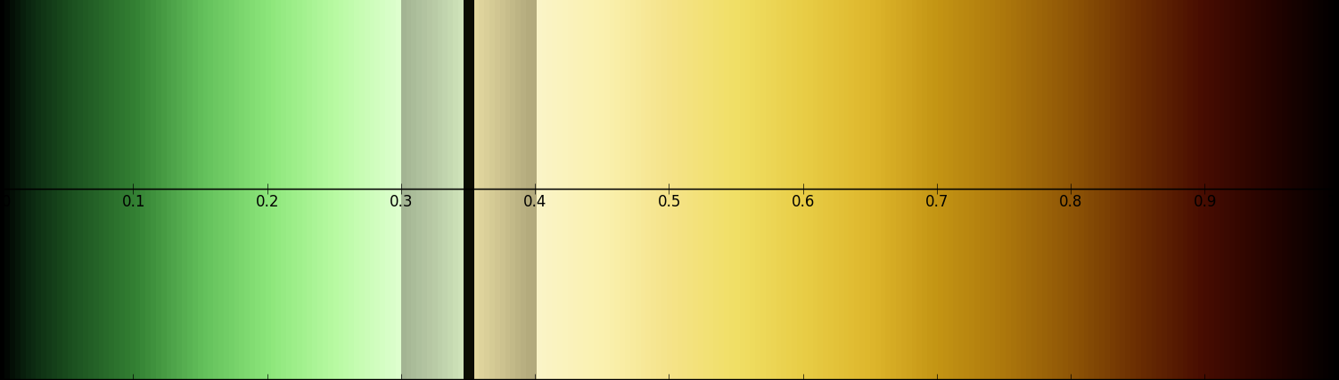

<ColorMaps>

<ColorMap space="CIELAB" indexedLookup="false" name="GrGold">

<Point x="0.000000" o="1" r="0.000000" g="0.000000" b="0.000000"/>

<Point x="0.020000" o="1" r="0.039216" g="0.149020" b="0.058824"/>

<Point x="0.050000" o="1" r="0.101961" g="0.301961" b="0.117647"/>

<Point x="0.100000" o="1" r="0.200000" g="0.501961" b="0.200000"/>

<Point x="0.150000" o="1" r="0.384314" g="0.749020" b="0.352941"/>

<Point x="0.200000" o="1" r="0.549020" g="0.901961" b="0.478431"/>

<Point x="0.250000" o="1" r="0.721569" g="0.980392" b="0.635294"/>

<Point x="0.300000" o="1" r="0.878431" g="1.000000" b="0.819608"/>

<Point x="0.300000" o="1" r="0.635294" g="0.701961" b="0.572549"/>

<Point x="0.325000" o="1" r="0.729412" g="0.800000" b="0.654902"/>

<Point x="0.347000" o="1" r="0.819608" g="0.901961" b="0.737255"/>

<Point x="0.347000" o="1" r="0.039216" g="0.050980" b="0.011765"/>

<Point x="0.350000" o="1" r="0.039216" g="0.050980" b="0.011765"/>

<Point x="0.353000" o="1" r="0.050980" g="0.043137" b="0.011765"/>

<Point x="0.353000" o="1" r="0.901961" g="0.854902" b="0.631373"/>

<Point x="0.375000" o="1" r="0.800000" g="0.760784" b="0.560784"/>

<Point x="0.395000" o="1" r="0.701961" g="0.666667" b="0.490196"/>

<Point x="0.395000" o="1" r="0.701961" g="0.666667" b="0.490196"/>

<Point x="0.400000" o="1" r="0.701961" g="0.666667" b="0.490196"/>

<Point x="0.400000" o="1" r="0.980392" g="0.956863" b="0.784314"/>

<Point x="0.450000" o="1" r="0.980392" g="0.945098" b="0.686275"/>

<Point x="0.500000" o="1" r="0.960784" g="0.890196" b="0.537255"/>

<Point x="0.550000" o="1" r="0.941176" g="0.874510" b="0.396078"/>

<Point x="0.600000" o="1" r="0.909804" g="0.803922" b="0.274510"/>

<Point x="0.650000" o="1" r="0.870588" g="0.717647" b="0.172549"/>

<Point x="0.700000" o="1" r="0.768627" g="0.584314" b="0.078431"/>

<Point x="0.750000" o="1" r="0.678431" g="0.470588" b="0.047059"/>

<Point x="0.800000" o="1" r="0.560784" g="0.337255" b="0.023529"/>

<Point x="0.850000" o="1" r="0.419608" g="0.180392" b="0.007843"/>

<Point x="0.900000" o="1" r="0.278431" g="0.047059" b="0.003922"/>

<Point x="0.950000" o="1" r="0.141176" g="0.011765" b="0.000000"/>

<Point x="1.000000" o="1" r="0.000000" g="0.000000" b="0.000000"/>

<NaN r="0.25" g="0" b="0"/>

</ColorMap>

</ColorMaps>

**LINEAR GREEN – 9_17y**

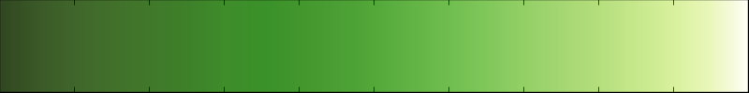

<ColorMaps>

<ColorMap space="CIELAB" indexedLookup="false" name="9_17e">

<Point x="0.000000" o="1" r="0.180392" g="0.200000" b="0.164706"/>

<Point x="0.050000" o="1" r="0.219608" g="0.290196" b="0.152941"/>

<Point x="0.100000" o="1" r="0.254902" g="0.349020" b="0.121569"/>

<Point x="0.150000" o="1" r="0.305882" g="0.400000" b="0.121569"/>

<Point x="0.200000" o="1" r="0.349020" g="0.450980" b="0.125490"/>

<Point x="0.250000" o="1" r="0.329412" g="0.501961" b="0.133333"/>

<Point x="0.300000" o="1" r="0.313725" g="0.549020" b="0.141176"/>

<Point x="0.350000" o="1" r="0.294118" g="0.600000" b="0.149020"/>

<Point x="0.400000" o="1" r="0.317647" g="0.650980" b="0.176471"/>

<Point x="0.450000" o="1" r="0.341176" g="0.701961" b="0.211765"/>

<Point x="0.500000" o="1" r="0.360784" g="0.749020" b="0.239216"/>

<Point x="0.550000" o="1" r="0.380392" g="0.788235" b="0.278431"/>

<Point x="0.600000" o="1" r="0.474510" g="0.831373" b="0.333333"/>

<Point x="0.650000" o="1" r="0.560784" g="0.870588" b="0.392157"/>

<Point x="0.700000" o="1" r="0.650980" g="0.909804" b="0.454902"/>

<Point x="0.750000" o="1" r="0.733333" g="0.929412" b="0.509804"/>

<Point x="0.800000" o="1" r="0.811765" g="0.949020" b="0.568627"/>

<Point x="0.850000" o="1" r="0.878431" g="0.968627" b="0.631373"/>

<Point x="0.900000" o="1" r="0.949020" g="0.988235" b="0.694118"/>

<Point x="0.950000" o="1" r="0.992157" g="1.000000" b="0.800000"/>

<Point x="1.000000" o="1" r="1.000000" g="0.992157" b="0.901961"/>

<NaN r="0.25" g="0" b="0"/>

</ColorMap>

</ColorMaps>

0 148 4 100

0.05 160 15 96

0.1 166 28 93

0.15 170 38 90

0.2 173 45 87

0.25 176 47 83

0.3 178 50 80

0.35 180 51 77

0.4 183 52 73

0.45 186 53 69

0.5 189 54 66

0.55 192 60 62

0.6 195 59 58

0.65 199 58 54

0.7 204 56 52

0.75 209 54 50

0.8 216 52 47

0.85 223 50 44

0.9 227 52 40

0.95 232 54 35

1 242 58 30

**MUTED BLUE/GREEN – upu3**

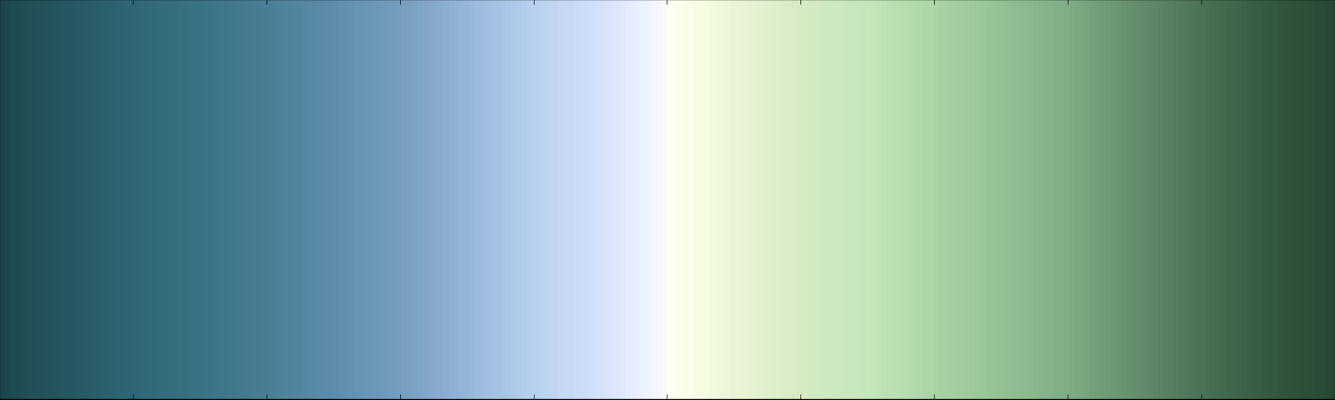

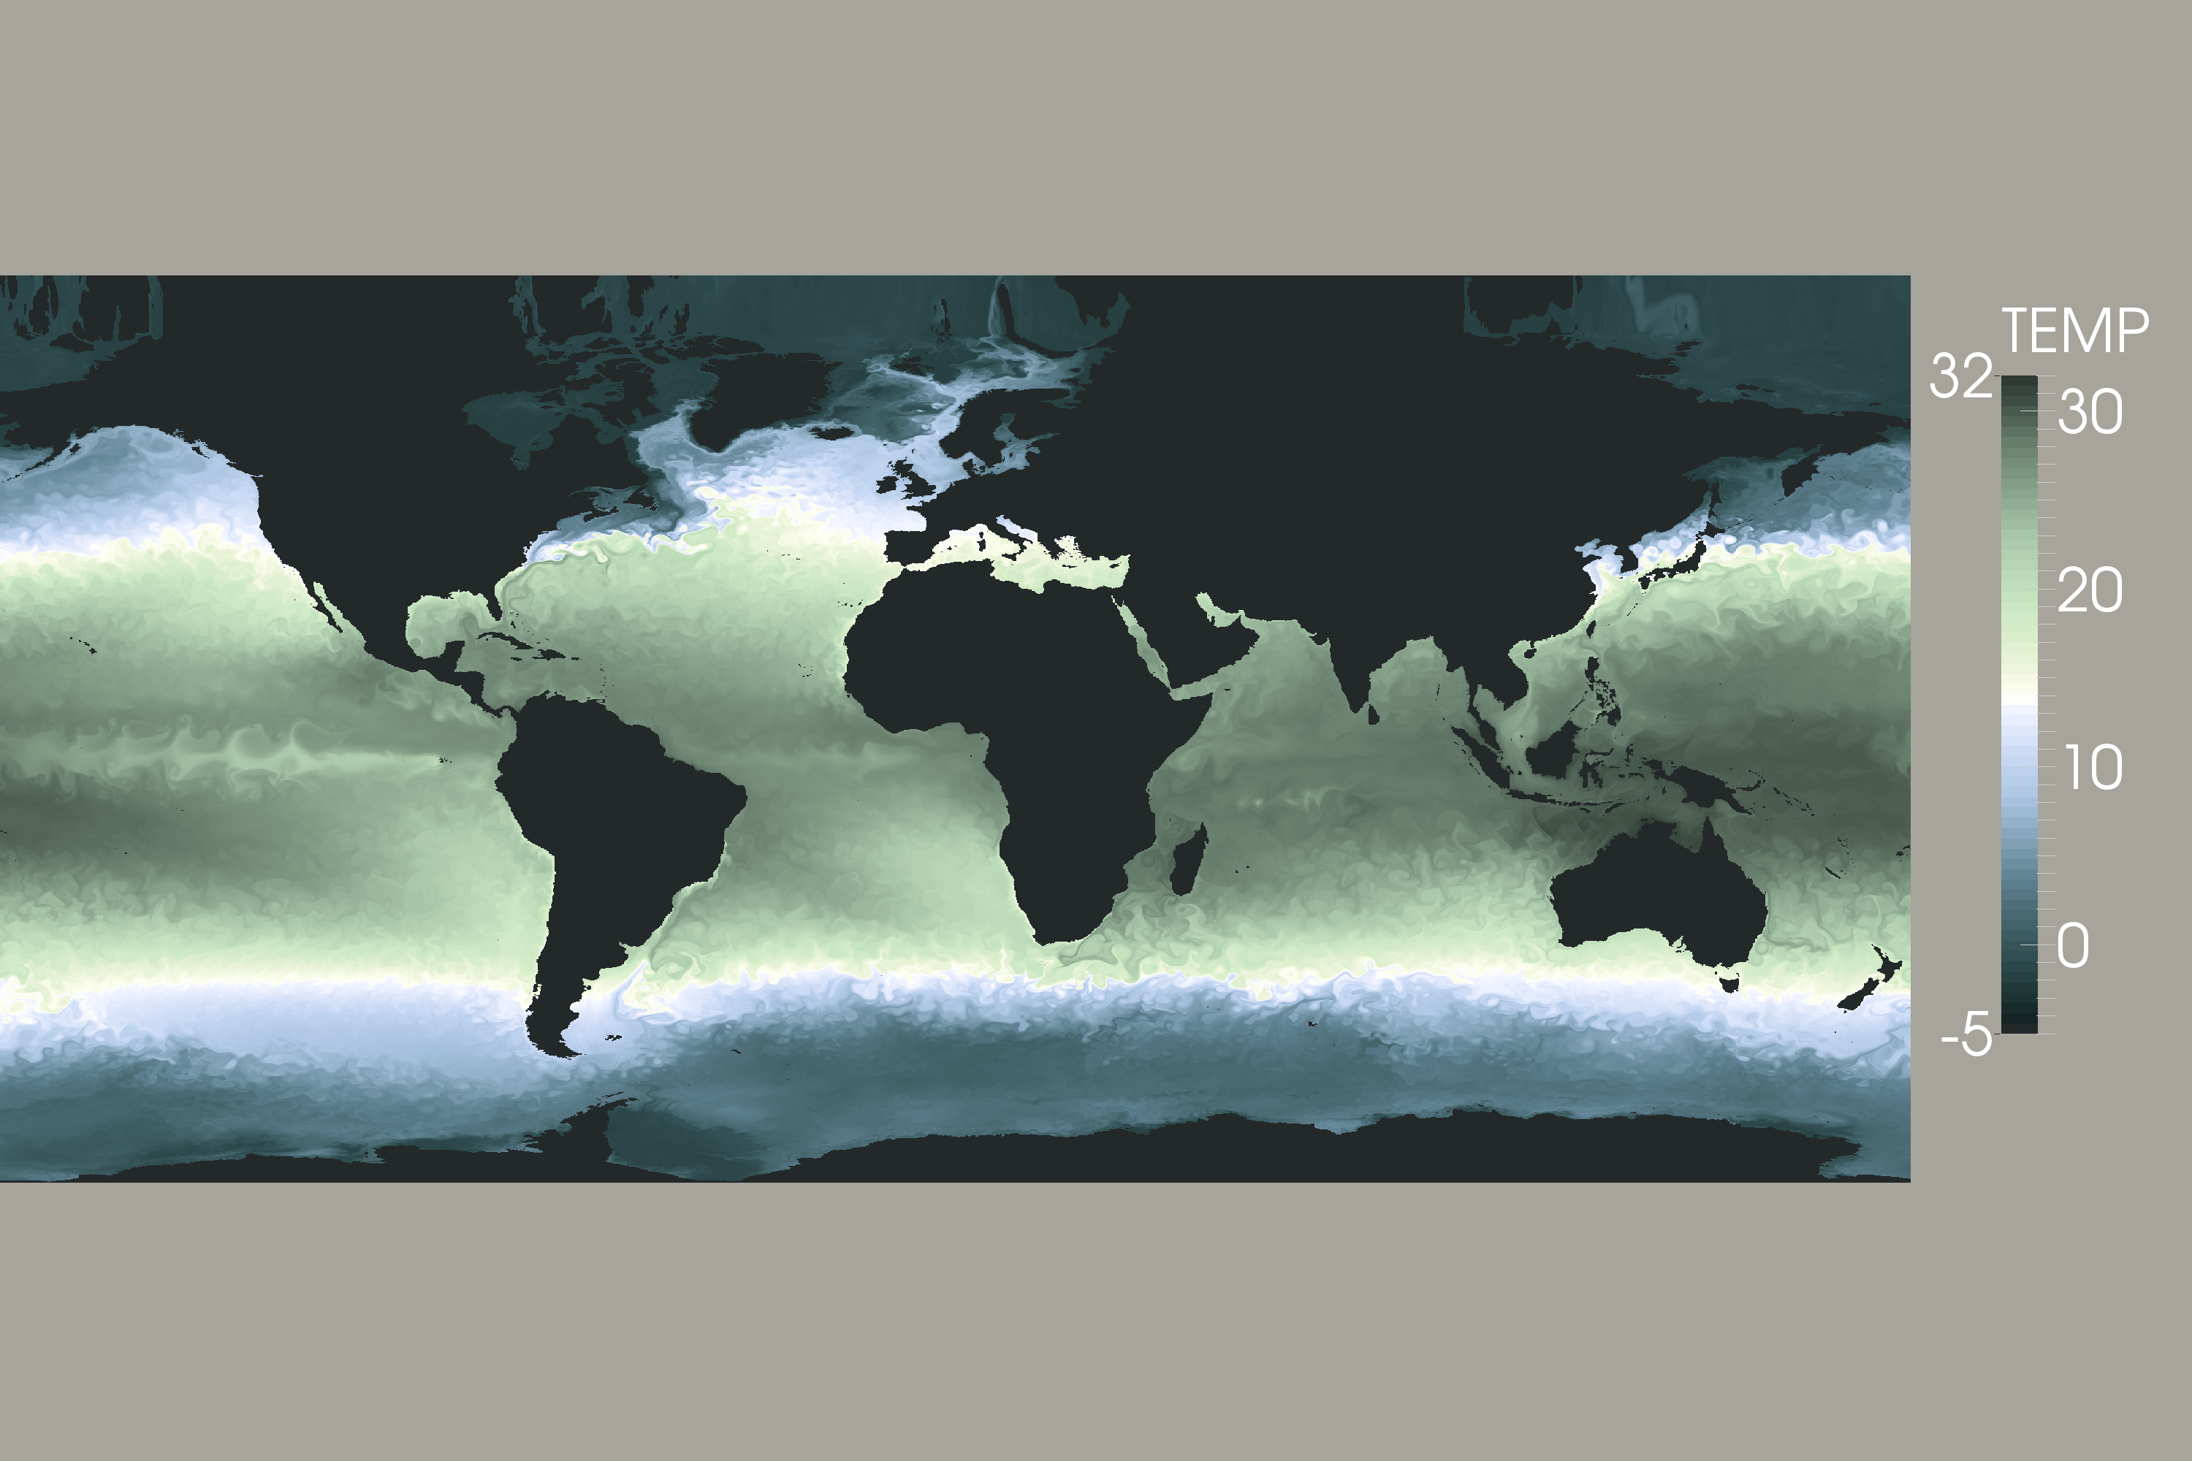

<ColorMaps>

<ColorMap space="CIELAB" indexedLookup="false" name="upuFinal">

<Point x="0.000000" o="1" r="0.109804" g="0.274510" b="0.301961"/>

<Point x="0.020000" o="1" r="0.129412" g="0.309804" b="0.341176"/>

<Point x="0.050000" o="1" r="0.149020" g="0.341176" b="0.380392"/>

<Point x="0.100000" o="1" r="0.188235" g="0.403922" b="0.458824"/>

<Point x="0.150000" o="1" r="0.227451" g="0.447059" b="0.521569"/>

<Point x="0.200000" o="1" r="0.290196" g="0.494118" b="0.588235"/>

<Point x="0.250000" o="1" r="0.368627" g="0.552941" b="0.670588"/>

<Point x="0.300000" o="1" r="0.458824" g="0.619608" b="0.749020"/>

<Point x="0.350000" o="1" r="0.588235" g="0.713725" b="0.850980"/>

<Point x="0.400000" o="1" r="0.725490" g="0.815686" b="0.941176"/>

<Point x="0.450000" o="1" r="0.831373" g="0.882353" b="0.980392"/>

<Point x="0.475000" o="1" r="0.909804" g="0.933333" b="1.000000"/>

<Point x="0.500000" o="1" r="0.980392" g="0.984314" b="1.000000"/>

<Point x="0.500000" o="1" r="0.980392" g="0.984314" b="1.000000"/>

<Point x="0.500000" o="1" r="1.000000" g="1.000000" b="0.980392"/>

<Point x="0.500000" o="1" r="0.996078" g="1.000000" b="0.949020"/>

<Point x="0.525000" o="1" r="0.972549" g="0.988235" b="0.890196"/>

<Point x="0.550000" o="1" r="0.917647" g="0.960784" b="0.835294"/>

<Point x="0.600000" o="1" r="0.835294" g="0.921569" b="0.772549"/>

<Point x="0.650000" o="1" r="0.768627" g="0.901961" b="0.737255"/>

<Point x="0.700000" o="1" r="0.670588" g="0.831373" b="0.654902"/>

<Point x="0.750000" o="1" r="0.576471" g="0.760784" b="0.584314"/>

<Point x="0.800000" o="1" r="0.498039" g="0.678431" b="0.521569"/>

<Point x="0.850000" o="1" r="0.392157" g="0.560784" b="0.427451"/>

<Point x="0.900000" o="1" r="0.294118" g="0.450980" b="0.333333"/>

<Point x="0.950000" o="1" r="0.211765" g="0.349020" b="0.254902"/>

<Point x="1.000000" o="1" r="0.152941" g="0.278431" b="0.196078"/>

<NaN r="0.25" g="0" b="0"/>

</ColorMap>

</ColorMaps>

**EXTENDED COOL/WARM**

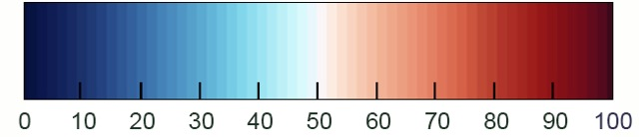

  </ColorMap>  
  <ColorMap space="Lab" indexedLookup="false" name="CIELAB">  
    <Point x="0" o="1" r="0.0196078" g="0.188235" b="0.380392"/>  
    <Point x="23.1374" o="1" r="0.0885023" g="0.321111" b="0.564935"/>  
    <Point x="39.0628" o="1" r="0.163394" g="0.444984" b="0.697505"/>  
    <Point x="51.2196" o="1" r="0.247059" g="0.555703" b="0.754101"/>  
    <Point x="61.0543" o="1" r="0.420691" g="0.676432" b="0.818692"/>  
    <Point x="69.3133" o="1" r="0.606455" g="0.789776" b="0.880278"/>  
    <Point x="76.4325" o="1" r="0.761471" g="0.868513" b="0.924559"/>  
    <Point x="82.6887" o="1" r="0.87805" g="0.925719" b="0.951949"/>  
    <Point x="88.2688" o="1" r="0.969085" g="0.966476" b="0.964935"/>  
    <Point x="93.3046" o="1" r="0.983856" g="0.897581" b="0.84683"/>  
    <Point x="97.893" o="1" r="0.982467" g="0.800687" b="0.706111"/>  
    <Point x="102.107" o="1" r="0.960327" g="0.667826" b="0.536339"/>  
    <Point x="106.003" o="1" r="0.894575" g="0.503807" b="0.399771"/>  
    <Point x="109.626" o="1" r="0.817075" g="0.332174" b="0.281041"/>  
    <Point x="113.012" o="1" r="0.728496" g="0.155016" b="0.197391"/>  
    <Point x="116.189" o="1" r="0.576928" g="0.0553597" b="0.149248"/>  
    <Point x="119" o="1" r="0.403922" g="0" b="0.121569"/>  
    <NaN r="0.498039" g="0" b="0"/>  
  </ColorMap>  
</ColorMaps>

**ASYMMETRIC BLUE/ORANGE DIVERGENT**

**W5 Blue Orange**

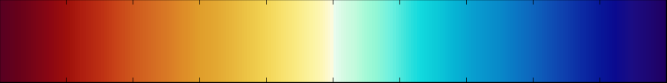

<ColorMaps>

<ColorMap space="Lab" indexedLookup="false" name="W5">

<Point x="0.25" o="1" r="0.34902" g="0" b="0.129412"/>

<Point x="0.54" o="1" r="0.4" g="0.00392157" b="0.101961"/>

<Point x="0.83" o="1" r="0.470588" g="0.0156863" b="0.0901961"/>

<Point x="1.12" o="1" r="0.54902" g="0.027451" b="0.0705882"/>

<Point x="1.41" o="1" r="0.619608" g="0.0627451" b="0.0431373"/>

<Point x="1.7" o="1" r="0.690196" g="0.12549" b="0.0627451"/>

<Point x="1.99" o="1" r="0.741176" g="0.184314" b="0.0745098"/>

<Point x="2.28" o="1" r="0.788235" g="0.266667" b="0.0941176"/>

<Point x="2.57" o="1" r="0.811765" g="0.345098" b="0.113725"/>

<Point x="2.86" o="1" r="0.831373" g="0.411765" b="0.133333"/>

<Point x="3.15" o="1" r="0.85098" g="0.47451" b="0.145098"/>

<Point x="3.44" o="1" r="0.870588" g="0.54902" b="0.156863"/>

<Point x="3.73" o="1" r="0.878431" g="0.619608" b="0.168627"/>

<Point x="4.02" o="1" r="0.890196" g="0.658824" b="0.196078"/>

<Point x="4.31" o="1" r="0.909804" g="0.717647" b="0.235294"/>

<Point x="4.6" o="1" r="0.929412" g="0.776471" b="0.278431"/>

<Point x="4.83806" o="1" r="0.94902" g="0.823529" b="0.321569"/>

<Point x="5.1093" o="1" r="0.968627" g="0.87451" b="0.407843"/>

<Point x="5.40363" o="1" r="0.980392" g="0.917647" b="0.509804"/>

<Point x="5.70373" o="1" r="0.988235" g="0.956863" b="0.643137"/>

<Point x="5.85955" o="1" r="0.992157" g="0.964706" b="0.713725"/>

<Point x="6.0384" o="1" r="0.988235" g="0.980392" b="0.870588"/>

<Point x="6.05" o="1" r="1" g="1" b="1"/>

<Point x="6.0616" o="1" r="0.913725" g="0.988235" b="0.937255"/>

<Point x="6.24045" o="1" r="0.827451" g="0.980392" b="0.886275"/>

<Point x="6.41358" o="1" r="0.764706" g="0.980392" b="0.866667"/>

<Point x="6.59249" o="1" r="0.658824" g="0.980392" b="0.843137"/>

<Point x="6.79448" o="1" r="0.572549" g="0.964706" b="0.835294"/>

<Point x="7.06572" o="1" r="0.423529" g="0.941176" b="0.87451"/>

<Point x="7.27925" o="1" r="0.262745" g="0.901961" b="0.862745"/>

<Point x="7.55627" o="1" r="0.0705882" g="0.854902" b="0.870588"/>

<Point x="7.8102" o="1" r="0.0509804" g="0.8" b="0.85098"/>

<Point x="8.15647" o="1" r="0.0235294" g="0.709804" b="0.831373"/>

<Point x="8.52005" o="1" r="0.0313725" g="0.615686" b="0.811765"/>

<Point x="8.95" o="1" r="0.0313725" g="0.537255" b="0.788235"/>

<Point x="9.24" o="1" r="0.0392157" g="0.466667" b="0.768627"/>

<Point x="9.53" o="1" r="0.0509804" g="0.396078" b="0.741176"/>

<Point x="9.82" o="1" r="0.054902" g="0.317647" b="0.709804"/>

<Point x="10.11" o="1" r="0.054902" g="0.243137" b="0.678431"/>

<Point x="10.4" o="1" r="0.0431373" g="0.164706" b="0.639216"/>

<Point x="10.69" o="1" r="0.0313725" g="0.0980392" b="0.6"/>

<Point x="10.98" o="1" r="0.0392157" g="0.0392157" b="0.560784"/>

<Point x="11.27" o="1" r="0.105882" g="0.0509804" b="0.509804"/>

<Point x="11.56" o="1" r="0.113725" g="0.0235294" b="0.45098"/>

<Point x="11.85" o="1" r="0.12549" g="0" b="0.380392"/>

<NaN r="0.250004" g="0" b="0"/>

</ColorMap>

</ColorMaps>

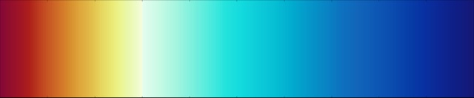

<ColorMaps>

<ColorMap space="CIELAB" indexedLookup="false" name="15b2Asy">

<Point x="0.000000" o="1" r="0.521569" g="0.035294" b="0.211765"/>

<Point x="0.014980" o="1" r="0.560784" g="0.054902" b="0.180392"/>

<Point x="0.029960" o="1" r="0.600000" g="0.070588" b="0.160784"/>

<Point x="0.044940" o="1" r="0.639216" g="0.090196" b="0.137255"/>

<Point x="0.059920" o="1" r="0.678431" g="0.121569" b="0.101961"/>

<Point x="0.074900" o="1" r="0.721569" g="0.207843" b="0.113725"/>

<Point x="0.089880" o="1" r="0.760784" g="0.286275" b="0.129412"/>

<Point x="0.104860" o="1" r="0.788235" g="0.356863" b="0.141176"/>

<Point x="0.119840" o="1" r="0.811765" g="0.427451" b="0.152941"/>

<Point x="0.134820" o="1" r="0.831373" g="0.498039" b="0.164706"/>

<Point x="0.149800" o="1" r="0.850980" g="0.572549" b="0.188235"/>

<Point x="0.164780" o="1" r="0.870588" g="0.643137" b="0.227451"/>

<Point x="0.179760" o="1" r="0.878431" g="0.694118" b="0.262745"/>

<Point x="0.194740" o="1" r="0.890196" g="0.760784" b="0.301961"/>

<Point x="0.209720" o="1" r="0.901961" g="0.827451" b="0.360784"/>

<Point x="0.224700" o="1" r="0.909804" g="0.878431" b="0.419608"/>

<Point x="0.239680" o="1" r="0.921569" g="0.929412" b="0.482353"/>

<Point x="0.254660" o="1" r="0.921569" g="0.960784" b="0.576471"/>

<Point x="0.269640" o="1" r="0.917647" g="0.968627" b="0.678431"/>

<Point x="0.284620" o="1" r="0.929412" g="0.980392" b="0.764706"/>

<Point x="0.299000" o="1" r="0.960784" g="0.988235" b="0.870588"/>

<Point x="0.300000" o="1" r="1.000000" g="1.000000" b="1.000000"/>

<Point x="0.301000" o="1" r="0.890196" g="0.988235" b="0.941176"/>

<Point x="0.334620" o="1" r="0.784314" g="0.980392" b="0.898039"/>

<Point x="0.369640" o="1" r="0.650980" g="0.960784" b="0.874510"/>

<Point x="0.404660" o="1" r="0.490196" g="0.941176" b="0.866667"/>

<Point x="0.439680" o="1" r="0.321569" g="0.921569" b="0.870588"/>

<Point x="0.474700" o="1" r="0.141176" g="0.890196" b="0.866667"/>

<Point x="0.509720" o="1" r="0.070588" g="0.854902" b="0.870588"/>

<Point x="0.544740" o="1" r="0.050980" g="0.796078" b="0.850980"/>

<Point x="0.579760" o="1" r="0.023529" g="0.749020" b="0.831373"/>

<Point x="0.614780" o="1" r="0.007843" g="0.674510" b="0.811765"/>

<Point x="0.649800" o="1" r="0.015686" g="0.596078" b="0.788235"/>

<Point x="0.684820" o="1" r="0.031373" g="0.525490" b="0.768627"/>

<Point x="0.719840" o="1" r="0.050980" g="0.447059" b="0.749020"/>

<Point x="0.754860" o="1" r="0.066667" g="0.396078" b="0.729412"/>

<Point x="0.789880" o="1" r="0.054902" g="0.349020" b="0.709804"/>

<Point x="0.824900" o="1" r="0.043137" g="0.301961" b="0.690196"/>

<Point x="0.859920" o="1" r="0.027451" g="0.247059" b="0.658824"/>

<Point x="0.894940" o="1" r="0.031373" g="0.192157" b="0.631373"/>

<Point x="0.929960" o="1" r="0.047059" g="0.152941" b="0.580392"/>

<Point x="0.964980" o="1" r="0.058824" g="0.117647" b="0.521569"/>

<Point x="1.000000" o="1" r="0.082353" g="0.094118" b="0.458824"/>

<NaN r="0.25" g="0" b="0"/>

</ColorMap>

</ColorMaps>

**LINEAR YELLOW**

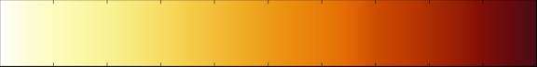

<ColorMaps>

<ColorMap space="CIELAB" indexedLookup="false" name="yel15">

<Point x="0.000000" o="1" r="1.000000" g="1.000000" b="0.988235"/>

<Point x="0.002000" o="1" r="1.000000" g="1.000000" b="0.988235"/>

<Point x="0.050000" o="1" r="0.984314" g="0.988235" b="0.843137"/>

<Point x="0.100000" o="1" r="0.988235" g="0.988235" b="0.741176"/>

<Point x="0.150000" o="1" r="0.980392" g="0.968627" b="0.654902"/>

<Point x="0.200000" o="1" r="0.980392" g="0.945098" b="0.576471"/>

<Point x="0.250000" o="1" r="0.968627" g="0.905882" b="0.486275"/>

<Point x="0.300000" o="1" r="0.968627" g="0.862745" b="0.388235"/>

<Point x="0.350000" o="1" r="0.960784" g="0.803922" b="0.286275"/>

<Point x="0.400000" o="1" r="0.949020" g="0.741176" b="0.219608"/>

<Point x="0.450000" o="1" r="0.941176" g="0.678431" b="0.149020"/>

<Point x="0.500000" o="1" r="0.929412" g="0.607843" b="0.094118"/>

<Point x="0.550000" o="1" r="0.921569" g="0.545098" b="0.054902"/>

<Point x="0.600000" o="1" r="0.909804" g="0.486275" b="0.035294"/>

<Point x="0.650000" o="1" r="0.890196" g="0.411765" b="0.019608"/>

<Point x="0.700000" o="1" r="0.800000" g="0.305882" b="0.000000"/>

<Point x="0.750000" o="1" r="0.760784" g="0.239216" b="0.000000"/>

<Point x="0.800000" o="1" r="0.678431" g="0.180392" b="0.011765"/>

<Point x="0.850000" o="1" r="0.600000" g="0.121569" b="0.023529"/>

<Point x="0.900000" o="1" r="0.501961" g="0.054902" b="0.031373"/>

<Point x="0.950000" o="1" r="0.400000" g="0.039216" b="0.058824"/>

<Point x="1.000000" o="1" r="0.301961" g="0.047059" b="0.090196"/>

<NaN r="0.25" g="0" b="0"/>

</ColorMap>

</ColorMaps>

**LINEAR GRAY5**

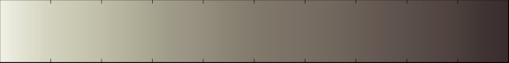

<ColorMaps>

<ColorMap space="CIELAB" indexedLookup="false" name="gray5">

<Point x="0.000000" o="1" r="0.941176" g="0.941176" b="0.894118"/>

<Point x="0.050000" o="1" r="0.878431" g="0.878431" b="0.807843"/>

<Point x="0.100000" o="1" r="0.819608" g="0.819608" b="0.737255"/>

<Point x="0.150000" o="1" r="0.788235" g="0.784314" b="0.701961"/>

<Point x="0.200000" o="1" r="0.749020" g="0.741176" b="0.658824"/>

<Point x="0.250000" o="1" r="0.701961" g="0.690196" b="0.607843"/>

<Point x="0.300000" o="1" r="0.650980" g="0.639216" b="0.564706"/>

<Point x="0.350000" o="1" r="0.611765" g="0.592157" b="0.525490"/>

<Point x="0.400000" o="1" r="0.580392" g="0.556863" b="0.494118"/>

<Point x="0.450000" o="1" r="0.541176" g="0.513725" b="0.454902"/>

<Point x="0.500000" o="1" r="0.509804" g="0.478431" b="0.427451"/>

<Point x="0.550000" o="1" r="0.490196" g="0.454902" b="0.407843"/>

<Point x="0.600000" o="1" r="0.470588" g="0.431373" b="0.388235"/>

<Point x="0.650000" o="1" r="0.450980" g="0.407843" b="0.368627"/>

<Point x="0.700000" o="1" r="0.419608" g="0.376471" b="0.345098"/>

<Point x="0.750000" o="1" r="0.388235" g="0.341176" b="0.317647"/>

<Point x="0.800000" o="1" r="0.360784" g="0.313725" b="0.290196"/>

<Point x="0.850000" o="1" r="0.329412" g="0.282353" b="0.266667"/>

<Point x="0.900000" o="1" r="0.301961" g="0.250980" b="0.239216"/>

<Point x="0.950000" o="1" r="0.250980" g="0.203922" b="0.200000"/>

<Point x="1.000000" o="1" r="0.219608" g="0.180392" b="0.176471"/>

<NaN r="0.25" g="0" b="0"/>

</ColorMap>

</ColorMaps>

**LINEAR GRAY4 – Blue/Green**

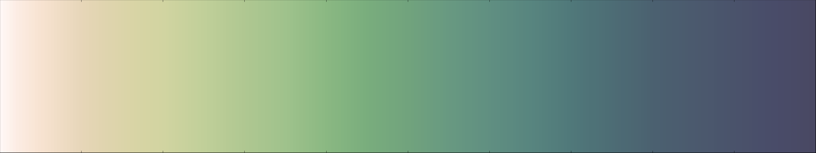

<ColorMaps>

<ColorMap space="CIELAB" indexedLookup="false" name="grays4_25">

<Point x="0.000000" o="1" r="1.000000" g="0.968627" b="0.960784"/>

<Point x="0.020000" o="1" r="0.988235" g="0.925490" b="0.890196"/>

<Point x="0.050000" o="1" r="0.968627" g="0.886275" b="0.815686"/>

<Point x="0.100000" o="1" r="0.901961" g="0.839216" b="0.721569"/>

<Point x="0.125000" o="1" r="0.878431" g="0.831373" b="0.686275"/>

<Point x="0.150000" o="1" r="0.858824" g="0.831373" b="0.662745"/>

<Point x="0.175000" o="1" r="0.839216" g="0.831373" b="0.639216"/>

<Point x="0.200000" o="1" r="0.819608" g="0.831373" b="0.631373"/>

<Point x="0.250000" o="1" r="0.752941" g="0.811765" b="0.600000"/>

<Point x="0.300000" o="1" r="0.686275" g="0.780392" b="0.568627"/>

<Point x="0.350000" o="1" r="0.623529" g="0.760784" b="0.549020"/>

<Point x="0.400000" o="1" r="0.541176" g="0.721569" b="0.509804"/>

<Point x="0.450000" o="1" r="0.474510" g="0.678431" b="0.490196"/>

<Point x="0.500000" o="1" r="0.443137" g="0.639216" b="0.490196"/>

<Point x="0.550000" o="1" r="0.407843" g="0.600000" b="0.505882"/>

<Point x="0.600000" o="1" r="0.376471" g="0.560784" b="0.505882"/>

<Point x="0.650000" o="1" r="0.345098" g="0.521569" b="0.498039"/>

<Point x="0.700000" o="1" r="0.313725" g="0.470588" b="0.478431"/>

<Point x="0.750000" o="1" r="0.301961" g="0.427451" b="0.458824"/>

<Point x="0.800000" o="1" r="0.294118" g="0.380392" b="0.439216"/>

<Point x="0.850000" o="1" r="0.294118" g="0.352941" b="0.431373"/>

<Point x="0.900000" o="1" r="0.290196" g="0.325490" b="0.419608"/>

<Point x="0.950000" o="1" r="0.286275" g="0.298039" b="0.411765"/>

<Point x="1.000000" o="1" r="0.286275" g="0.282353" b="0.388235"/>

<NaN r="0.25" g="0" b="0"/>

</ColorMap>

</ColorMaps>

Blue Turquoise 8_31f

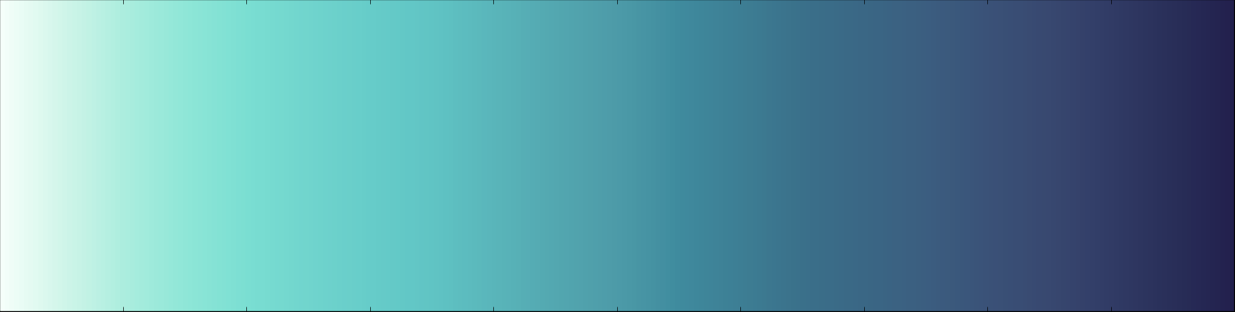

<ColorMaps>

<ColorMap space="CIELAB" indexedLookup="false" name="8_31f">

<Point x="0.000000" o="1" r="0.960784" g="1.000000" b="0.980392"/>

<Point x="0.050000" o="1" r="0.815686" g="0.960784" b="0.913725"/>

<Point x="0.100000" o="1" r="0.670588" g="0.929412" b="0.870588"/>

<Point x="0.150000" o="1" r="0.556863" g="0.901961" b="0.843137"/>

<Point x="0.200000" o="1" r="0.478431" g="0.870588" b="0.823529"/>

<Point x="0.250000" o="1" r="0.439216" g="0.831373" b="0.803922"/>

<Point x="0.300000" o="1" r="0.400000" g="0.800000" b="0.788235"/>

<Point x="0.350000" o="1" r="0.376471" g="0.768627" b="0.768627"/>

<Point x="0.400000" o="1" r="0.349020" g="0.709804" b="0.729412"/>

<Point x="0.450000" o="1" r="0.325490" g="0.654902" b="0.690196"/>

<Point x="0.500000" o="1" r="0.301961" g="0.607843" b="0.658824"/>

<Point x="0.550000" o="1" r="0.247059" g="0.545098" b="0.619608"/>

<Point x="0.600000" o="1" r="0.239216" g="0.494118" b="0.580392"/>

<Point x="0.650000" o="1" r="0.227451" g="0.439216" b="0.541176"/>

<Point x="0.700000" o="1" r="0.227451" g="0.403922" b="0.521569"/>

<Point x="0.750000" o="1" r="0.231373" g="0.368627" b="0.501961"/>

<Point x="0.800000" o="1" r="0.227451" g="0.321569" b="0.470588"/>

<Point x="0.850000" o="1" r="0.219608" g="0.282353" b="0.439216"/>

<Point x="0.900000" o="1" r="0.192157" g="0.235294" b="0.400000"/>

<Point x="0.950000" o="1" r="0.160784" g="0.184314" b="0.349020"/>

<Point x="1.000000" o="1" r="0.133333" g="0.125490" b="0.301961"/>

<NaN r="0.25" g="0" b="0"/>

</ColorMap>

</ColorMaps>

8_31f HSV

0 148 4 100

0.05 160 15 96

0.1 166 28 93

0.15 170 38 90

0.2 173 45 87

0.25 176 47 83

0.3 178 50 80

0.35 180 51 77

0.4 183 52 73

0.45 186 53 69

0.5 189 54 66

0.55 192 60 62

0.6 195 59 58

0.65 199 58 54

0.7 204 56 52

0.75 209 54 50

0.8 216 52 47

0.85 223 50 44

0.9 227 52 40

0.95 232 54 35

1 242 58 30

**Blue 8_31T1**

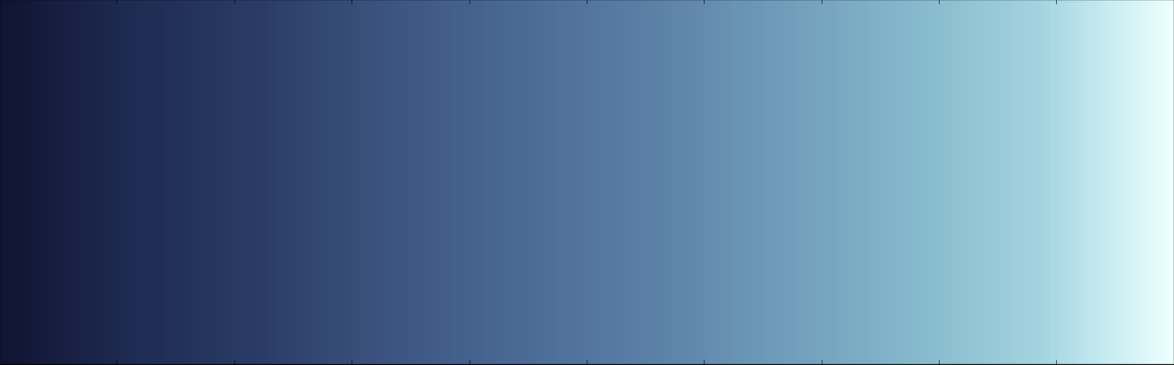

<ColorMaps>

<ColorMap space="CIELAB" indexedLookup="false" name="8_30T1">

<Point x="0.100000" o="1" r="0.066667" g="0.078431" b="0.200000"/>

<Point x="0.200000" o="1" r="0.117647" g="0.168627" b="0.321569"/>

<Point x="0.300000" o="1" r="0.164706" g="0.235294" b="0.400000"/>

<Point x="0.400000" o="1" r="0.235294" g="0.333333" b="0.501961"/>

<Point x="0.500000" o="1" r="0.290196" g="0.415686" b="0.580392"/>

<Point x="0.600000" o="1" r="0.356863" g="0.501961" b="0.650980"/>

<Point x="0.700000" o="1" r="0.439216" g="0.611765" b="0.729412"/>

<Point x="0.800000" o="1" r="0.521569" g="0.717647" b="0.800000"/>

<Point x="0.900000" o="1" r="0.643137" g="0.831373" b="0.878431"/>

<Point x="0.950000" o="1" r="0.780392" g="0.925490" b="0.949020"/>

<Point x="1.000000" o="1" r="0.929412" g="1.000000" b="1.000000"/>

<NaN r="0.25" g="0" b="0"/>

</ColorMap>

</ColorMaps>

HSV

0 235 90` 10

0.1 235 67 20

0.2 225 63 32

0.3 222 59 40

0.4 218 53 50

0.5 214 50 58

0.6 210 45 65

0.7 204 40 73

0.8 198 35 80

0.9 192 27 88

0.95 188 18 95

1 180 7 100

**Muted Blue 17b**

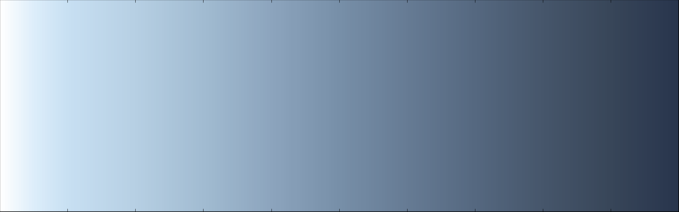

<ColorMaps>

<ColorMap space="CIELAB" indexedLookup="false" name="17b">

<Point x="0.000000" o="1" r="1.000000" g="1.000000" b="1.000000"/>

<Point x="0.050000" o="1" r="0.862745" g="0.929412" b="0.980392"/>

<Point x="0.100000" o="1" r="0.780392" g="0.874510" b="0.949020"/>

<Point x="0.200000" o="1" r="0.713725" g="0.811765" b="0.890196"/>

<Point x="0.300000" o="1" r="0.631373" g="0.733333" b="0.819608"/>

<Point x="0.400000" o="1" r="0.549020" g="0.643137" b="0.741176"/>

<Point x="0.500000" o="1" r="0.466667" g="0.560784" b="0.658824"/>

<Point x="0.600000" o="1" r="0.400000" g="0.482353" b="0.580392"/>

<Point x="0.700000" o="1" r="0.333333" g="0.407843" b="0.501961"/>

<Point x="0.800000" o="1" r="0.274510" g="0.337255" b="0.419608"/>

<Point x="0.900000" o="1" r="0.219608" g="0.274510" b="0.349020"/>

<Point x="1.000000" o="1" r="0.156863" g="0.207843" b="0.301961"/>

<NaN r="0.25" g="0" b="0"/>

</ColorMap>

</ColorMaps>

5

HSV

0 0 0 100

0.05 205 12 98

0.1 206 18 95

0.2 206 20 89

0.3 208 23 82

0.4 210 26 74

0.5 211 29 66

0.6 212 31 58

0.7 213 33 50

0.8 214 35 42

0.9 215 37 35

1 218 48 30

Olive Green to Blue



<ColorMaps>

<ColorMap space="CIELAB" indexedLookup="false" name="OliveGr_Bl">

<Point x="0.000000" o="1" r="1.000000" g="0.980392" b="0.941176"/>

<Point x="0.050000" o="1" r="0.949020" g="0.921569" b="0.835294"/>

<Point x="0.100000" o="1" r="0.901961" g="0.886275" b="0.721569"/>

<Point x="0.200000" o="1" r="0.733333" g="0.780392" b="0.545098"/>

<Point x="0.300000" o="1" r="0.572549" g="0.701961" b="0.447059"/>

<Point x="0.400000" o="1" r="0.396078" g="0.600000" b="0.352941"/>

<Point x="0.500000" o="1" r="0.270588" g="0.501961" b="0.309804"/>

<Point x="0.600000" o="1" r="0.207843" g="0.431373" b="0.317647"/>

<Point x="0.650000" o="1" r="0.176471" g="0.400000" b="0.325490"/>

<Point x="0.700000" o="1" r="0.137255" g="0.380392" b="0.341176"/>

<Point x="0.800000" o="1" r="0.101961" g="0.317647" b="0.360784"/>

<Point x="0.900000" o="1" r="0.094118" g="0.243137" b="0.341176"/>

<Point x="0.950000" o="1" r="0.090196" g="0.188235" b="0.321569"/>

<Point x="1.000000" o="1" r="0.078431" g="0.137255" b="0.278431"/>

<NaN r="0.25" g="0" b="0"/>

</ColorMap>

</ColorMaps>

HSV

0 40 6 100

0.05 45 15 95

0.1 55 22hsv2mp MutedGreen.txt

90

0.2 72 30 78

0.3 90 36 70

0.4 110 41 60

0.5 120 46 50

0.6 130 54 44

0.65 136 60 41

0.7 142 60 39

0.8 150 64 36

0.9 160 70 34

0.95 170 72 32

1 180 72 28