MainActivity.java

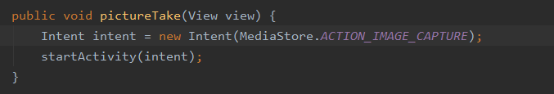

activity_main.xml

