Hostel Management System
DataBase management and warehousing
Dr. Ryan LaBrie
Charmy raj | SPU ID:900420893
2025
Table of Contents
Business Justification for Hostel Management System 1
Application Section 2
ER-Diagram 2
Relational Schema 3
User Interface 5
Forms 6
Reports 10
Conclusion 12
What went well? 12
What did not go well? 13
What would you do differently next time? 13

Business Justification for Hostel Management System
Managing a hostel efficiently is important for providing a smooth and comfortable living experience for students and staff. As the number of hostel residents increases, using paper records or outdated systems makes managing rooms, payments, complaints, and daily activities difficult. To solve these issues, we need a Hostel Management Database System that will simplify operations and improve management efficiency.
The new system will help with the following challenges:
- Better Data Management: Right now, student details, room assignments, fees, complaints, and mess records are stored separately, making it hard to find and manage information. This database will store all data in one place, making access easier and improving decision-making.
- Room Allocation System: Assigning rooms manually can lead to mistakes, such as double booking or incorrect records. The system will automate room assignments, show available rooms in real-time, and keep accurate records, making the process easier for administrators.
- Fee Payment Tracking: Keeping track of student fee payments and overdue balances can be challenging. The system will automatically update payment records, send reminders for due payments, and ensure that financial records are always up to date.
- Handling Complaints Efficiently: Students often face issues related to hostel facilities. The system will allow students to file complaints online, track their status, and help administrators resolve them quickly.
- Mess Monitoring: Tracking mess usage manually can lead to errors. This system will help manage meal planning and reduce food wastage.
- Status Management for Better Organization: The database will have different status tables to manage room availability, fee payments, complaint progress, and mess participation, ensuring everything is well-organized.
- Improved Decision-Making: The system will generate reports on hostel occupancy, payment collections, complaint resolutions, and other important areas. These insights will help management make better plans and decisions.
Benefits:
- Smoother Operations – Automates and simplifies data management.
- Better Student Experience – Ensures efficient room allotments, quick complaint handling, and easy meal planning.
- Transparent Fee Management – Keeps accurate records of payments and dues.
- Improved Resource Management – Tracks occupancy and mess attendance in real-time.
- Scalability – Can easily handle future hostel expansions and changing requirements.
The database system will be built using Microsoft Access, which is easy to use and offers strong data management features. It will consist of several interconnected tables, such as Students, Rooms, Fees, Complaints, Mess, and Status Tables, to store and manage data effectively. This digital system will help hostel management run smoothly, ensure transparency, and improve the living experience for students.

Application Section

ER-Diagram
I have provided a detailed description of the Entity-Relationship (ER) diagram, outlining the entities (tables) I have modeled, their attributes, and the relationships between them. The entities I have identified, such as Student, Rooms, RoomAllotments, Complaints, Mess, Fees, and MealTypes, accurately reflect the core components of a hostel management system.
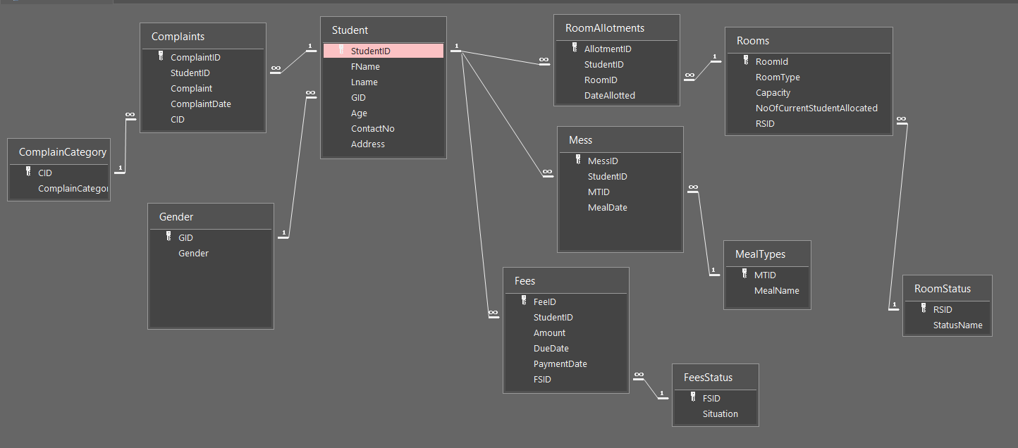
Fig 1 ER-Diagram of Hostel Management System

- Student is the central entity, connected to complaints, fees, room allotments, and mess.
- Rooms are allocated through RoomAllotments and have statuses.
- Meals are recorded in the Mess entity, with types stored in MealTypes.
- Fees management is handled through the Fees entity, linked to FeeStatus.
This ERD represents a hostel management system that tracks students, their accommodations, complaints, meals, and payments efficiently.

Relational Schema
1. Student Table
Schema: Student(StudentID, FName, LName, GID, Age, ContactNo, Address)
• Primary Key (PK): StudentID
• Foreign Key (FK): GID → Gender(GID)
2. Gender Table
Schema: Gender(GID, Gender)
• Primary Key (PK): GID
3. RoomAllotments Table
Schema: RoomAllotments(AllotmentID, StudentID, RoomID, DateAllotted)
• Primary Key (PK): AllotmentID
• Foreign Keys (FK):
o StudentID → Student(StudentID)
o RoomID → Rooms(RoomID)
4. Rooms Table
Schema: Rooms(RoomID, RoomType, Capacity, NoOfCurrentStudentAllocated, RSID)
• Primary Key (PK): RoomID
• Foreign Key (FK): RSID → RoomStatus(RSID)
5. RoomStatus Table
Schema: RoomStatus(RSID, StatusName)
• Primary Key (PK): RSID
6. Mess Table
Schema: Mess(MessID, StudentID, MTID, MealDate)
• Primary Key (PK): MessID
• Foreign Keys (FK):
o StudentID → Student(StudentID)
o MTID → MealTypes(MTID)
7. MealTypes Table
Schema: MealTypes(MTID, MealName)
• Primary Key (PK): MTID
8. Fees Table
Schema: Fees(FeeID, StudentID, Amount, DueDate, PaymentDate, FSID)
• Primary Key (PK): FeeID
• Foreign Keys (FK):
o StudentID → Student(StudentID)
o FSID → FeesStatus(FSID)
9. FeesStatus Table
Schema: FeesStatus(FSID, Situation)
• Primary Key (PK): FSID
10. Complaints Table
Schema: Complaints(ComplaintID, StudentID, Complaint, ComplaintDate, CID)
• Primary Key (PK): ComplaintID
• Foreign Keys (FK):
o StudentID → Student(StudentID)
o CID → ComplainCategory(CID)
11. ComplainCategory Table
Schema: ComplainCategory(CID, ComplainCategory)
• Primary Key (PK): CID

User Interface
User Interface: I have developed a comprehensive user interface consisting of multiple forms and reports to meet the business needs of hostel management. The forms I have created, such as the Student Registration Form, Room Allocation Form, and Fee Payment Form, allow for efficient data entry, retrieval, and management of student, room, and fee details. Validation rules have been implemented for fields like contact numbers and email addresses to ensure data integrity and improve user experience. Additionally, I have incorporated subforms and calculation fields to enhance system functionality and usability. For instance, the Room Allocation Form includes a subform displaying current room availability and assigned students, while the Fee Payment Form calculates total due amounts and tracks pending payments. The reports I have developed, such as the Pending Complaints Report and Fee Due Report, provide valuable insights into hostel operations and facilitate data-driven decision-making.
Populated & Functioning Database: I have successfully populated the database, enforcing domain, entity, and referential integrity constraints to maintain data consistency and accuracy. The inclusion of features like a main management dashboard, with buttons and macros to navigate between different forms and reports, enhances the overall user experience and operational efficiency. Furthermore, I have incorporated unique and engaging features, such as alerts for overdue fees, automatic status updates for complaints, and a digital room allocation system, making the hostel management process more efficient and seamless. This system ensures transparency, automation, and ease of access, creating a well-organized and user-friendly hostel management experience.
Overall, the hostel management database system I have developed demonstrates a comprehensive understanding of database design principles, effective implementation of functional requirements, and a commitment to delivering a polished and integrated product. The system's capabilities in streamlining operations, improving student and staff interactions, and enabling data-driven decision-making position the hostel for better efficiency, transparency, and organization.

Forms
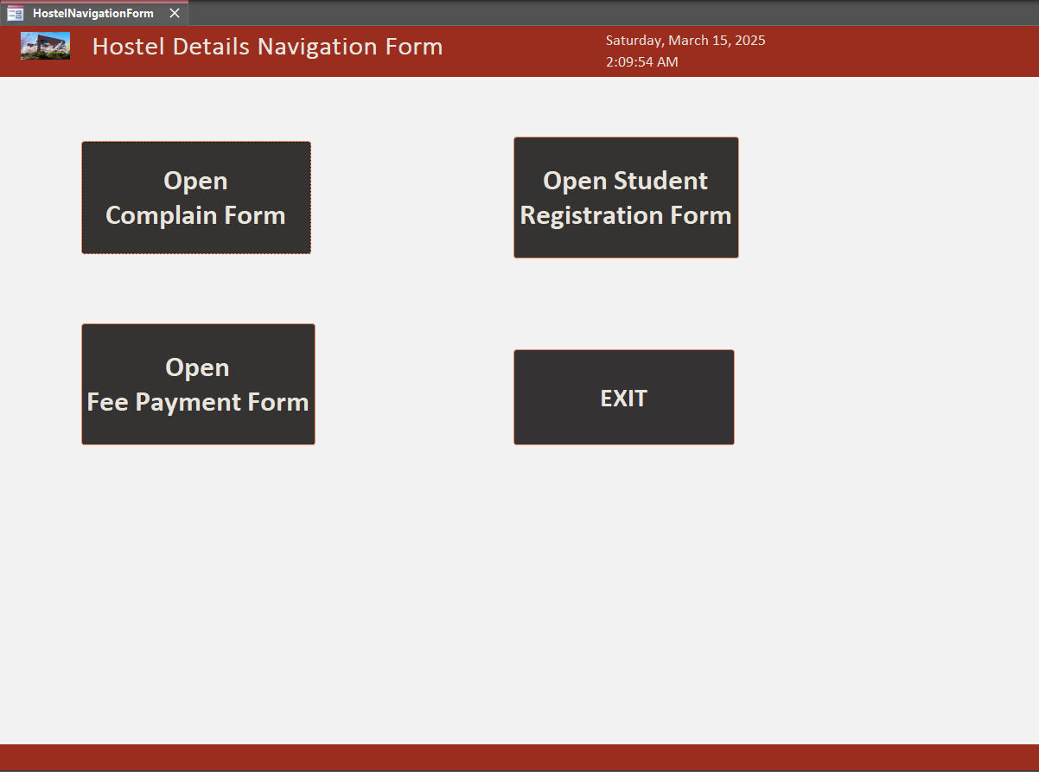
Fig 2 Navigation Form [Form-1]
This form is set as the default form, meaning it will automatically open whenever the database is launched. It serves as a navigation hub for the hostel management system, providing access to all essential forms.
Users can open specific forms by clicking the respective buttons:
- Complaint Form – To register complaints.
- Student Registration Form – For new student enrollment.
- Fee Payment Form – To manage fee transactions.
Additionally, clicking the Exit button will close the application. This streamlined interface ensures easy access to key hostel management functions.

Complain Form
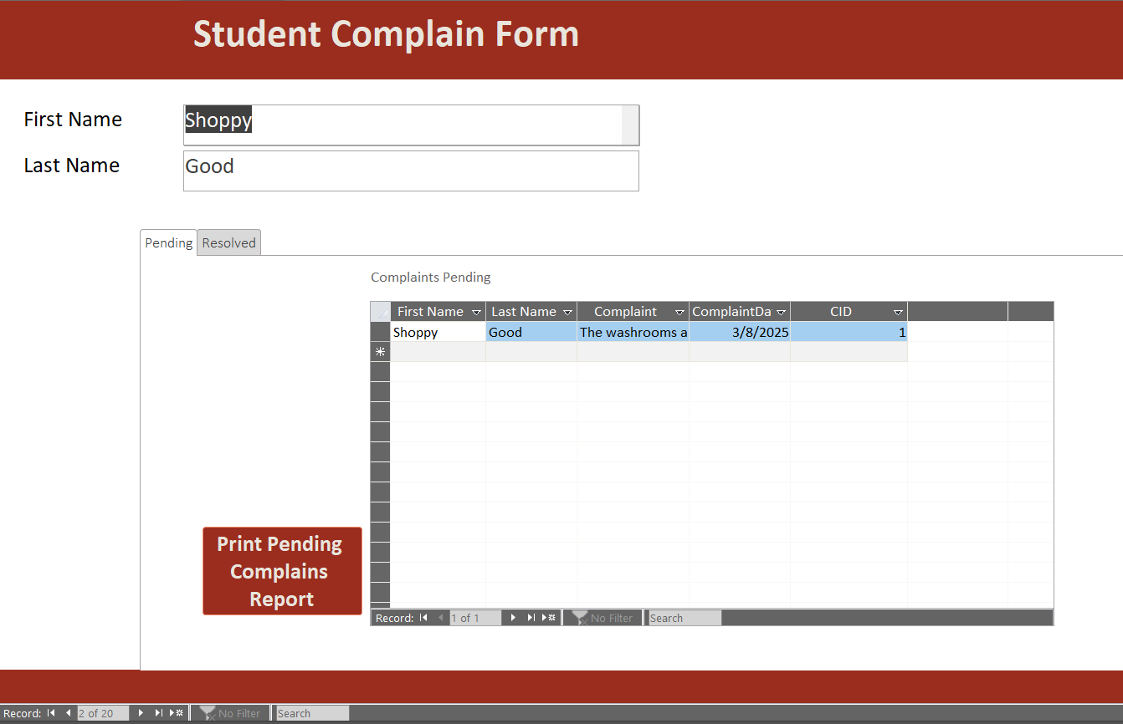
Fig 3 Student Complain Form [Form-2]
This form consists of two subforms:
- Pending Complaints – Displays complaints that have not yet been resolved.
- Resolved Complaints – Lists complaints that have been addressed.
Each subform includes a button that allows users to print a report for the respective complaints, ensuring easy record-keeping and tracking of complaint statuses.

Fee Payment Form
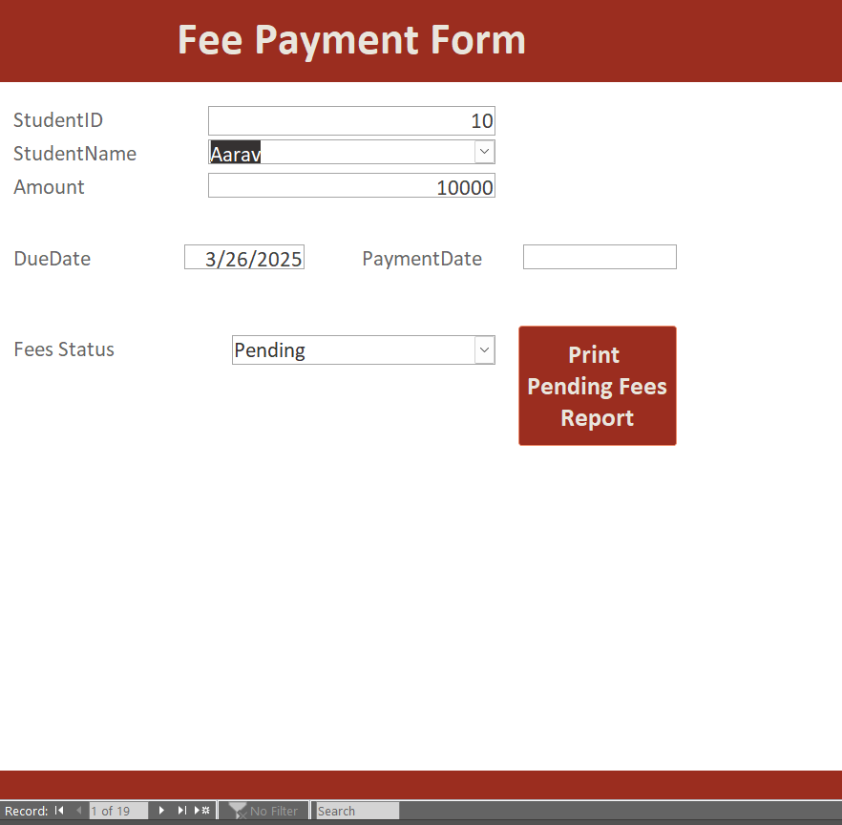
Fig 4 Fee Payment Form [Form-3]
- This form allows users to identify students with overdue and pending hostel fees.
- The fee status is managed using a drop-down (combo box), enabling easy selection and updating of payment statuses.
- This setup ensures efficient tracking and management of student fee records.

Student Registration Form
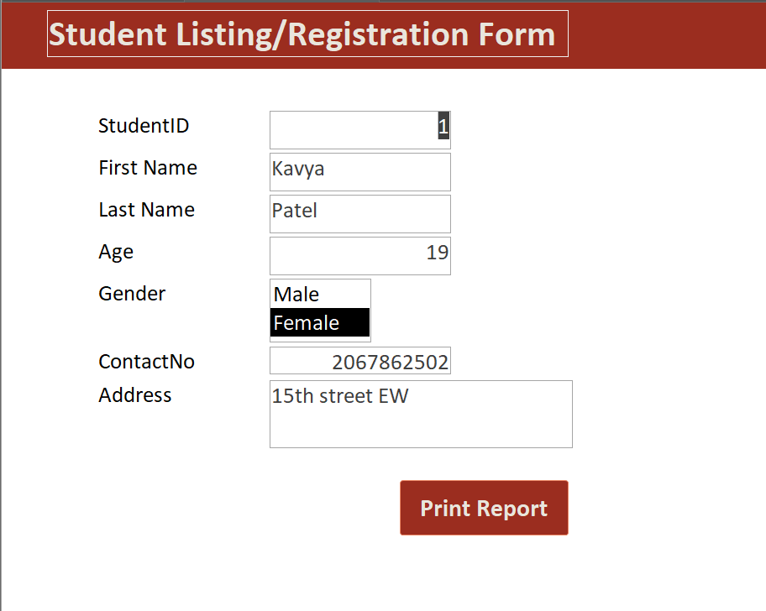
Fig 5 Student Registration Form [Form-4]
- In this form, a list box is used for selecting the gender attribute.
- Additionally, when clicking the "Print Report" button, the system generates a report specifically for the selected student, rather than displaying a report for all students.
- This functionality ensures a more personalized and efficient report generation process.

Reports
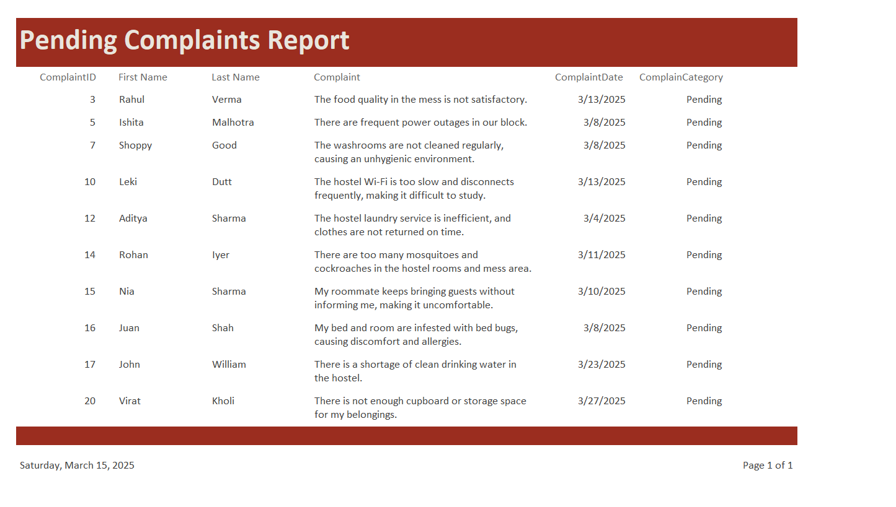
Fig 6 Pending Complaints Report [Report- 1]
- This report provides a list of students with unresolved complaints.
- It is also linked to the complaint form under the "Pending Complaints" section.
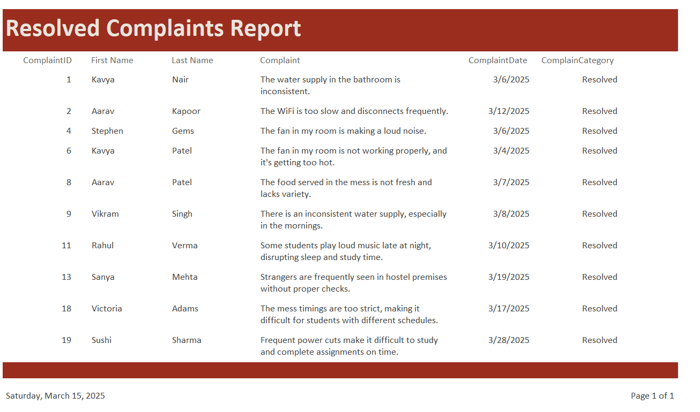
Fig 7 Resolved Complaints Report [Report- 2]
- This report provides a list of students with resolved complaints.
- It is also linked to the complaint form under the "Resolved Complaints" section.

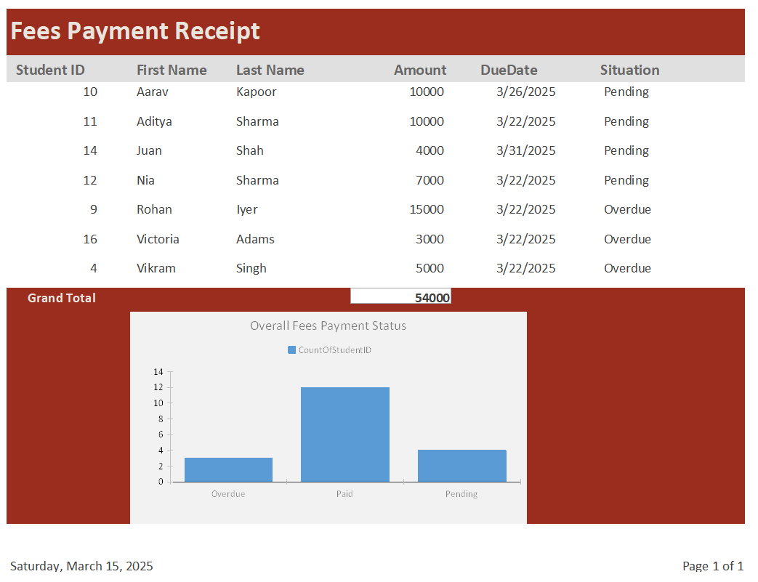
Fig 8 Fees Payment Report [Report- 3]
- This report lists all students with overdue or pending hostel fees, along with the corresponding outstanding amounts.
- It also includes a grand total of the outstanding balance, along with the overall fees that have not been paid.
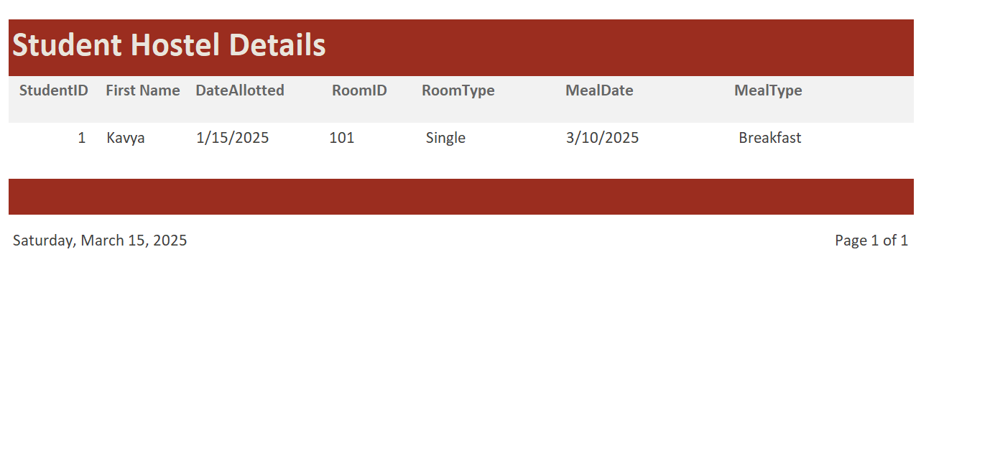
Fig 9 Student Hostel Detail Report [Report- 4]
- This report is linked to the student registration form and provides data for the selected student.
- To link to the student registration form, I was referential integrity formula.

Conclusion

What went well?
- Clear understanding of project requirements and objectives: From the beginning, I had a strong grasp of the project's goals and the essential features needed for the hostel management database system. This allowed me to plan and execute the project effectively, ensuring all necessary components were addressed and implemented successfully. Effective requirement gathering and thorough analysis helped streamline the development process and ensured that all key functionalities were incorporated.
- Successful implementation of key database features: I was able to implement the core functionalities of the system, including user-friendly forms for data entry, insightful reports for analysis, and validation rules to maintain data integrity. The addition of automation features, such as automatic complaint status updates and fee tracking, contributed to a more efficient and functional system. The use of lookup tables for standardizing data, ensuring referential integrity, and reducing redundancy significantly improved performance and data management.
- Integration of unique and engaging elements: To enhance the user experience, I included features like an intuitive navigation dashboard, real-time message alerts, and interactive reports. These features improved the overall usability and professionalism of the system. The use of macros and buttons for easier navigation made the system more user-friendly, ensuring that both administrators and students could efficiently interact with the interface.
- Strong validation and error handling mechanisms: To maintain data accuracy, I implemented input validation rules for fields. This significantly reduced errors and improved system reliability. The use of error messages and alerts helped users quickly identify and correct mistakes.
- Scalability and flexibility: The database system was designed in a way that allows future expansion, such as adding new reports, integrating additional automation, or extending functionalities like mess management and attendance tracking.

What did not go well?
- Underestimation of project complexity: Initially, I underestimated the complexity of integrating multiple automation features, which led to delays in troubleshooting and refining certain functionalities. Debugging macros and setting up correct relationships took longer than expected, impacting the timeline.
- Challenges in handling large data volumes: While the database performed well with small datasets, performance issues arose when working with larger datasets, requiring additional optimizations. Queries and reports took longer to load, highlighting the need for better indexing and query structuring.
- Limited experience with advanced database concepts: My limited knowledge of advanced queries and database optimization techniques restricted the implementation of more complex functionalities that could have further improved system performance. Stored procedures and triggers could have been used to automate certain tasks, but due to time constraints, these were not fully explored.
- Graphical User Interface (GUI) design limitations: While the forms were functional, the overall aesthetic design of the user interface could have been more polished. A more visually appealing design with better UI/UX elements would have enhanced the user experience.

What would you do differently next time?
- Focus on database optimization techniques: To prevent performance issues with large datasets, I would prioritize learning and implementing optimization techniques such as indexing, query optimization, and efficient data structuring. Using partitioning and caching strategies could further improve system responsiveness.
- Enhance automation and advanced database functionalities: I would dedicate more time to learning advanced database concepts such as stored procedures, triggers, and database indexing to improve automation within the system. This would allow for more dynamic data processing and reduce manual interventions.
- Improve database design skills: In future projects, I would work on refining my database design skills to ensure better scalability, maintainability, and efficiency. Studying normalization techniques and implementing best practices in database architecture would help create a more robust system.
- Allocate more time for GUI improvements: A visually appealing interface improves usability and engagement. Next time, I would focus on enhancing the layout, colors, fonts, and user experience design to make the system more intuitive and appealing to users.
- Comprehensive testing and debugging: While I tested the system thoroughly, I would allocate more time for extensive testing with larger datasets and real-world scenarios to uncover potential performance bottlenecks and usability issues before deployment.

