**1: Mocking and Stubbing**

**pom.xml**

<project xmlns="http://maven.apache.org/POM/4.0.0"   
         xmlns:xsi="http://www.w3.org/2001/XMLSchema-instance"   
         xsi:schemaLocation="http://maven.apache.org/POM/4.0.0   
         http://maven.apache.org/xsd/maven-4.0.0.xsd">   
   
    <modelVersion>4.0.0</modelVersion>   
   
    <groupId>org.example</groupId>   
    <artifactId>MockitoProject</artifactId>   
    <version>1.0-SNAPSHOT</version>   
   
    <properties>   
        <maven.compiler.source>17</maven.compiler.source>   
        <maven.compiler.target>17</maven.compiler.target>   
    </properties>   
   
    <dependencies>   
        <dependency>   
            <groupId>org.junit.jupiter</groupId>   
            <artifactId>junit-jupiter</artifactId>   
            <version>5.10.2</version>   
            <scope>test</scope>   
        </dependency>   
   
        <dependency>   
            <groupId>org.mockito</groupId>   
            <artifactId>mockito-core</artifactId>   
            <version>5.12.0</version>   
            <scope>test</scope>   
        </dependency>   
    </dependencies>   
   
    <build>   
        <plugins>   
            <plugin>   
                <groupId>org.apache.maven.plugins</groupId>   
                <artifactId>maven-surefire-plugin</artifactId>   
                <version>3.1.2</version>   
            </plugin>   
        </plugins>   
    </build>   
</project>

**ExternalApi.java**

package org.example;   
   
public interface ExternalApi {   
    String getData();   
}

**MyService.java**

package org.example;   
public class MyService {   
   
    private final ExternalApi externalApi;   
   
    public MyService(ExternalApi externalApi) {   
        this.externalApi = externalApi;   
    }   
   
    public String fetchData() {   
        return externalApi.getData();   
    }   
}

**MyServiceTest.java**

package org.example;   
import org.junit.jupiter.api.Test;   
import static org.junit.jupiter.api.Assertions.*assertEquals*;   
import static org.mockito.Mockito.*;   
   
public class MyServiceTest {   
   
    @Test   
    public void testFetchData() {   
        ExternalApi mockApi = *mock*(ExternalApi.class);   
        *when*(mockApi.getData()).thenReturn("Mock Data");   
        MyService service = new MyService(mockApi);   
        String result = service.fetchData();   
        *assertEquals*("Mock Data", result);   
    }   
}

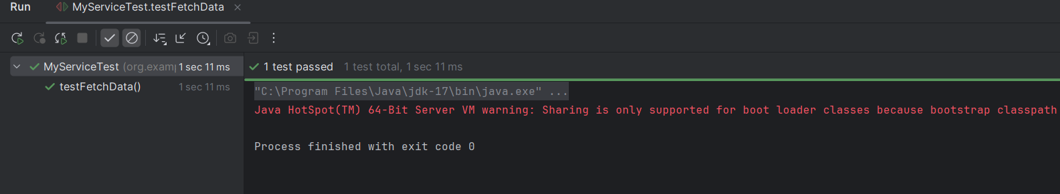

**2: Verifying Interactions**

**pom.xml**

<project xmlns="http://maven.apache.org/POM/4.0.0"   
         xmlns:xsi="http://www.w3.org/2001/XMLSchema-instance"   
         xsi:schemaLocation="http://maven.apache.org/POM/4.0.0   
         http://maven.apache.org/xsd/maven-4.0.0.xsd">   
   
    <modelVersion>4.0.0</modelVersion>   
   
    <groupId>org.example</groupId>   
    <artifactId>MockitoProject</artifactId>   
    <version>1.0-SNAPSHOT</version>   
   
    <properties>   
        <maven.compiler.source>17</maven.compiler.source>   
        <maven.compiler.target>17</maven.compiler.target>   
    </properties>   
   
    <dependencies>   
        <dependency>   
            <groupId>org.junit.jupiter</groupId>   
            <artifactId>junit-jupiter</artifactId>   
            <version>5.10.2</version>   
            <scope>test</scope>   
        </dependency>   
   
        <dependency>   
            <groupId>org.mockito</groupId>   
            <artifactId>mockito-core</artifactId>   
            <version>5.12.0</version>   
            <scope>test</scope>   
        </dependency>   
    </dependencies>   
   
    <build>   
        <plugins>   
            <plugin>   
                <groupId>org.apache.maven.plugins</groupId>   
                <artifactId>maven-surefire-plugin</artifactId>   
                <version>3.1.2</version>   
            </plugin>   
        </plugins>   
    </build>   
</project>

**ExternalApi.java**

package org.example;   
   
public interface ExternalApi {   
    String getData();   
}

**MyService.java**

package org.example;   
   
public class MyService {   
   
    private final ExternalApi externalApi;   
   
    public MyService(ExternalApi externalApi) {   
        this.externalApi = externalApi;   
    }   
   
    public String fetchData() {   
        return externalApi.getData();   
    }   
}

**MyServiceTest.java**

package org.example;   
   
import org.junit.jupiter.api.Test;   
import static org.mockito.Mockito.*;   
   
public class MyServiceTest {   
   
    @Test   
    public void testVerifyInteraction() {   
        ExternalApi mockApi = *mock*(ExternalApi.class);    
        MyService service = new MyService(mockApi);    
        service.fetchData();   
        *verify*(mockApi).getData();   
        System.*out*.println("Verified: getData() was called once");   
    }   
}

