Exercise 1: Control Structures

Scenario 1: The bank wants to apply a discount to loan interest rates for customers above 60 years old.

o Question: Write a PL/SQL block that loops through all customers, checks their age, and if they are above 60, apply a 1% discount to their current loan interest rates.

BEGIN

FOR cust_rec IN (

SELECT CustomerID, DOB

FROM Customers

) LOOP

-- Calculate age

IF MONTHS_BETWEEN(SYSDATE, cust_rec.DOB) / 12 > 60 THEN

-- Update all loans for this customer

UPDATE Loans

SET InterestRate = InterestRate - 1

WHERE CustomerID = cust_rec.CustomerID;

END IF;

END LOOP;

COMMIT;

END;

/

SELECT * FROM Loans;

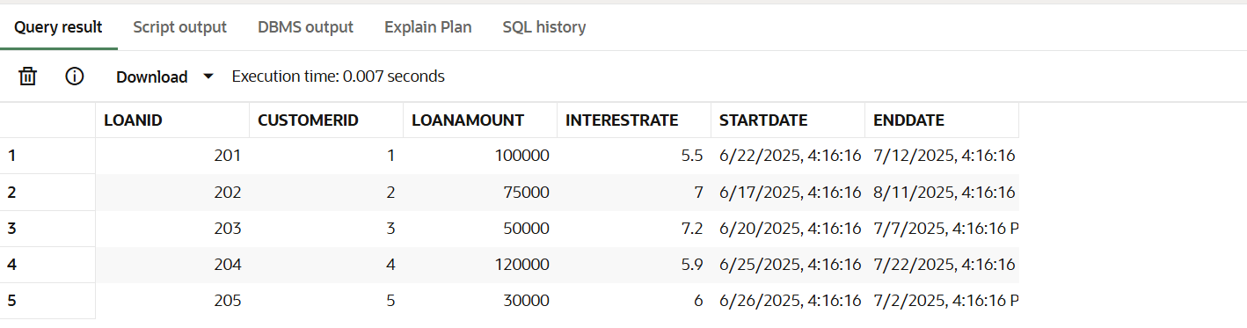

Scenario 2: A customer can be promoted to VIP status based on their balance.

o Question: Write a PL/SQL block that iterates through all customers and sets a flag IsVIP to TRUE for those with a balance over $10,000.

ALTER TABLE Customers ADD (IsVIP CHAR(1));

BEGIN

FOR cust_rec IN (

SELECT CustomerID, Balance

FROM Customers

) LOOP

IF cust_rec.Balance > 10000 THEN

UPDATE Customers

SET IsVIP = 'Y'

WHERE CustomerID = cust_rec.CustomerID;

ELSE

UPDATE Customers

SET IsVIP = 'N'

WHERE CustomerID = cust_rec.CustomerID;

END IF;

END LOOP;

COMMIT;

END;

/

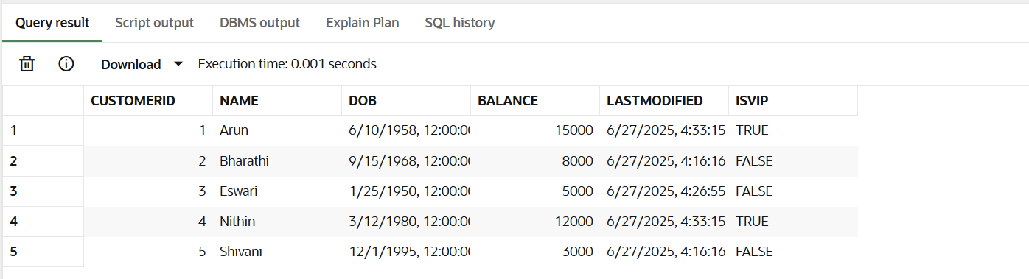

Scenario 3: The bank wants to send reminders to customers whose loans are due within the next 30 days.

o Question: Write a PL/SQL block that fetches all loans due in the next 30 days and prints a reminder message for each customer.

DECLARE

CURSOR loan_cur IS

SELECT l.LoanID, l.CustomerID, l.EndDate, c.Name

FROM Loans l

JOIN Customers c ON l.CustomerID = c.CustomerID

WHERE l.EndDate BETWEEN SYSDATE AND SYSDATE + 30;

BEGIN

FOR rec IN loan_cur LOOP

DBMS_OUTPUT.PUT_LINE('Reminder: Dear ' || rec.Name ||

', your loan (LoanID: ' || rec.LoanID ||

') is due on ' || TO_CHAR(rec.EndDate, 'YYYY-MM-DD') || '.');

END LOOP;

END;

/

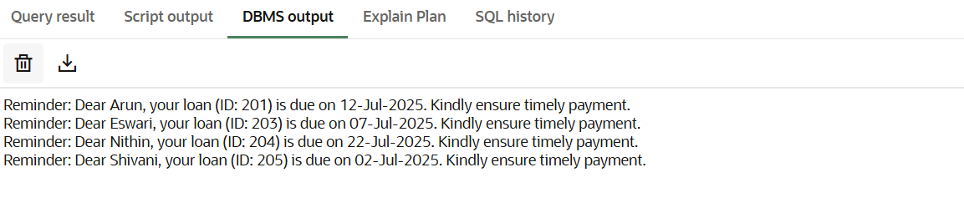

Exercise 3: Stored Procedures

Scenario 1: The bank needs to process monthly interest for all savings accounts.

o Question: Write a stored procedure ProcessMonthlyInterest that calculates and updates the balance of all savings accounts by applying an interest rate of 1% to the current balance.

CREATE OR REPLACE PROCEDURE ProcessMonthlyInterest AS

BEGIN

UPDATE Accounts

SET Balance = Balance * 1.01,

LastModified = SYSDATE

WHERE AccountType = 'Savings';

COMMIT;

END;

/

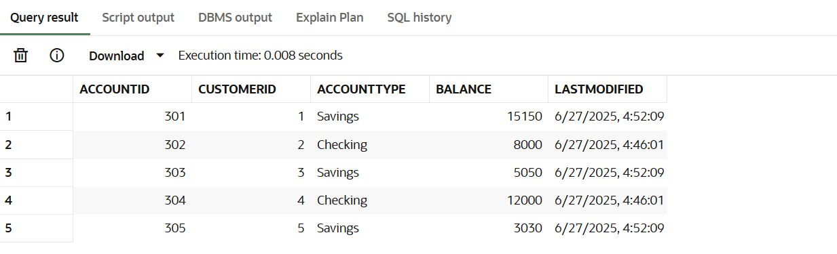

Scenario 2: The bank wants to implement a bonus scheme for employees based on their performance.

o Question: Write a stored procedure UpdateEmployeeBonus that updates the salary of employees in a given department by adding a bonus percentage passed as a parameter.

CREATE OR REPLACE PROCEDURE UpdateEmployeeBonus(

p_Department IN VARCHAR2,

p_BonusPercent IN NUMBER

) AS

BEGIN

UPDATE Employees

SET Salary = Salary + (Salary * p_BonusPercent / 100)

WHERE Department = p_Department;

COMMIT;

END;

/

-- Give a 10% bonus to HR department

BEGIN

UpdateEmployeeBonus('Tech', 10);

END;

/

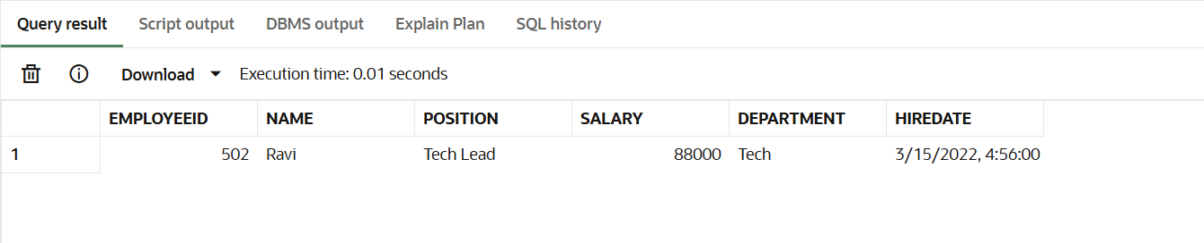

Scenario 3: Customers should be able to transfer funds between their accounts.

o Question: Write a stored procedure TransferFunds that transfers a specified amount from one account to another, checking that the source account has sufficient balance before making the transfer.

CREATE OR REPLACE PROCEDURE TransferFunds(

p_SourceAccountID IN NUMBER,

p_TargetAccountID IN NUMBER,

p_Amount IN NUMBER

) AS

v_SourceBalance NUMBER;

BEGIN

-- Check source account balance

SELECT Balance INTO v_SourceBalance

FROM Accounts

WHERE AccountID = p_SourceAccountID

FOR UPDATE;

IF v_SourceBalance < p_Amount THEN

RAISE_APPLICATION_ERROR(-20001, 'Insufficient funds in source account.');

END IF;

-- Deduct from source

UPDATE Accounts

SET Balance = Balance - p_Amount,

LastModified = SYSDATE

WHERE AccountID = p_SourceAccountID;

-- Add to target

UPDATE Accounts

SET Balance = Balance + p_Amount,

LastModified = SYSDATE

WHERE AccountID = p_TargetAccountID;

COMMIT;

END;

/

BEGIN

  TransferFunds(301, 303, 2000);

END;

/

