DefCry Game Design

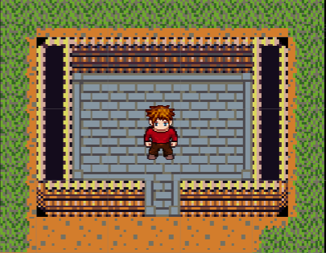

***‘Try to Survive’*** – Ryan Clode

This page: Table of Contents and Team Member Listing

|  |  |  |
| --- | --- | --- |
| Table of Contents  [1 Game Overview](https://n-xovwktmtjsnaxyc2mwes2xu7pohqedmdm6zjw5q-2lu-script.googleusercontent.com/userCodeAppPanel)  [2 High Concept](https://n-xovwktmtjsnaxyc2mwes2xu7pohqedmdm6zjw5q-2lu-script.googleusercontent.com/userCodeAppPanel)  [3 Unique Selling Points](https://n-xovwktmtjsnaxyc2mwes2xu7pohqedmdm6zjw5q-2lu-script.googleusercontent.com/userCodeAppPanel)  [4 Platform Minimum Requirements](https://n-xovwktmtjsnaxyc2mwes2xu7pohqedmdm6zjw5q-2lu-script.googleusercontent.com/userCodeAppPanel)  [5 Competitors / Similar Titles](https://n-xovwktmtjsnaxyc2mwes2xu7pohqedmdm6zjw5q-2lu-script.googleusercontent.com/userCodeAppPanel)  [6 Synopsis](https://n-xovwktmtjsnaxyc2mwes2xu7pohqedmdm6zjw5q-2lu-script.googleusercontent.com/userCodeAppPanel)  [7 Game Objectives](https://n-xovwktmtjsnaxyc2mwes2xu7pohqedmdm6zjw5q-2lu-script.googleusercontent.com/userCodeAppPanel)  [8 Game Rules](https://n-xovwktmtjsnaxyc2mwes2xu7pohqedmdm6zjw5q-2lu-script.googleusercontent.com/userCodeAppPanel)  [9 Game Structure](https://n-xovwktmtjsnaxyc2mwes2xu7pohqedmdm6zjw5q-2lu-script.googleusercontent.com/userCodeAppPanel)  [10 Game Play](https://n-xovwktmtjsnaxyc2mwes2xu7pohqedmdm6zjw5q-2lu-script.googleusercontent.com/userCodeAppPanel)  [10.1 Game Controls](https://n-xovwktmtjsnaxyc2mwes2xu7pohqedmdm6zjw5q-2lu-script.googleusercontent.com/userCodeAppPanel)  [10.2 Game Camera](https://n-xovwktmtjsnaxyc2mwes2xu7pohqedmdm6zjw5q-2lu-script.googleusercontent.com/userCodeAppPanel)  [10.2.1 HUD](https://n-xovwktmtjsnaxyc2mwes2xu7pohqedmdm6zjw5q-2lu-script.googleusercontent.com/userCodeAppPanel)  [10.2.2 Maps](https://n-xovwktmtjsnaxyc2mwes2xu7pohqedmdm6zjw5q-2lu-script.googleusercontent.com/userCodeAppPanel)  [11 Players](https://n-xovwktmtjsnaxyc2mwes2xu7pohqedmdm6zjw5q-2lu-script.googleusercontent.com/userCodeAppPanel)  [11.1 Characters](https://n-xovwktmtjsnaxyc2mwes2xu7pohqedmdm6zjw5q-2lu-script.googleusercontent.com/userCodeAppPanel)  [11.2 Metrics](https://n-xovwktmtjsnaxyc2mwes2xu7pohqedmdm6zjw5q-2lu-script.googleusercontent.com/userCodeAppPanel)  [11.3 States](https://n-xovwktmtjsnaxyc2mwes2xu7pohqedmdm6zjw5q-2lu-script.googleusercontent.com/userCodeAppPanel)  [11.4 Weapons](https://n-xovwktmtjsnaxyc2mwes2xu7pohqedmdm6zjw5q-2lu-script.googleusercontent.com/userCodeAppPanel)  [12 Player Line-up](https://n-xovwktmtjsnaxyc2mwes2xu7pohqedmdm6zjw5q-2lu-script.googleusercontent.com/userCodeAppPanel)  [13 NPC](https://n-xovwktmtjsnaxyc2mwes2xu7pohqedmdm6zjw5q-2lu-script.googleusercontent.com/userCodeAppPanel)  [13.1 Enemies](https://n-xovwktmtjsnaxyc2mwes2xu7pohqedmdm6zjw5q-2lu-script.googleusercontent.com/userCodeAppPanel)  [13.1.1 Enemy States](https://n-xovwktmtjsnaxyc2mwes2xu7pohqedmdm6zjw5q-2lu-script.googleusercontent.com/userCodeAppPanel)  [13.1.2 Enemy Spawn Points](https://n-xovwktmtjsnaxyc2mwes2xu7pohqedmdm6zjw5q-2lu-script.googleusercontent.com/userCodeAppPanel)  [13.2 Allies / Companions](https://n-xovwktmtjsnaxyc2mwes2xu7pohqedmdm6zjw5q-2lu-script.googleusercontent.com/userCodeAppPanel)  [13.2.1 Ally States](https://n-xovwktmtjsnaxyc2mwes2xu7pohqedmdm6zjw5q-2lu-script.googleusercontent.com/userCodeAppPanel)  [13.2.2 Ally Spawn Points](https://n-xovwktmtjsnaxyc2mwes2xu7pohqedmdm6zjw5q-2lu-script.googleusercontent.com/userCodeAppPanel)  [14 Art](https://n-xovwktmtjsnaxyc2mwes2xu7pohqedmdm6zjw5q-2lu-script.googleusercontent.com/userCodeAppPanel)  [14.1 Setting](https://n-xovwktmtjsnaxyc2mwes2xu7pohqedmdm6zjw5q-2lu-script.googleusercontent.com/userCodeAppPanel)  [14.2 Level Design](https://n-xovwktmtjsnaxyc2mwes2xu7pohqedmdm6zjw5q-2lu-script.googleusercontent.com/userCodeAppPanel)  [14.3 Audio](https://n-xovwktmtjsnaxyc2mwes2xu7pohqedmdm6zjw5q-2lu-script.googleusercontent.com/userCodeAppPanel)  [15 Procedurally Generated Content](https://n-xovwktmtjsnaxyc2mwes2xu7pohqedmdm6zjw5q-2lu-script.googleusercontent.com/userCodeAppPanel)  [15.1 Environment](https://n-xovwktmtjsnaxyc2mwes2xu7pohqedmdm6zjw5q-2lu-script.googleusercontent.com/userCodeAppPanel)  [15.2 Levels](https://n-xovwktmtjsnaxyc2mwes2xu7pohqedmdm6zjw5q-2lu-script.googleusercontent.com/userCodeAppPanel)  [15.3 Artificial Intelligence NPC](https://n-xovwktmtjsnaxyc2mwes2xu7pohqedmdm6zjw5q-2lu-script.googleusercontent.com/userCodeAppPanel)  [15.4 Visual Arts](https://n-xovwktmtjsnaxyc2mwes2xu7pohqedmdm6zjw5q-2lu-script.googleusercontent.com/userCodeAppPanel)  [15.5 Audio](https://n-xovwktmtjsnaxyc2mwes2xu7pohqedmdm6zjw5q-2lu-script.googleusercontent.com/userCodeAppPanel)  [15.6 Minimum Viable Product (MPV)](https://n-xovwktmtjsnaxyc2mwes2xu7pohqedmdm6zjw5q-2lu-script.googleusercontent.com/userCodeAppPanel)  [16 Wish List](https://n-xovwktmtjsnaxyc2mwes2xu7pohqedmdm6zjw5q-2lu-script.googleusercontent.com/userCodeAppPanel)   |  | | --- | |  | | Game Development Team Members    PRODUCER  You    PRODUCTION MANAGER  You    PRODUCTION COORDINATOR  You  GAME DESIGNERS  You  SYSTEMS/IT COORDINATOR  You  PROGRAMMERS  You  TECHNICAL ARTISTS  You  AUDIO ENGINEERS  You  UX TESTERS  You |

|  |
| --- |
|  |

# 1 Game Overview

Title: DefCry

Platform: PC Standalone

Genre: Medieval Shooter

Rating: (10+) ESRB

Target: Casual gamer (aging from 12 - 30)

Release date: November, 2019

Publisher: Ryan’s Games

Description: Survive multiple waves of Orks across 3 challenging levels with nothing but your trusty hand bow and a few magic power ups. Each level gets increasingly more challenging, but to compensate, the later levels will provide more power ups, as well as some barriers to use as cover and as outplay potential. You have 3 lives.

# 2 High Concept

The concept of the game is a 2D waves shooter. Don’t let enemies touch you, or you lose a life. You can run around and shoot in any direction, as well as pick up power ups that let you shoot in multiple directions.

# 3 Unique Selling Points

* Extremely fast paced
* Challenging gameplay
* Tight maneuvers, close calls, and a high skill cap.
* Classic 2D medieval art style is familiar to games like Legends of Zelda

# 4 Platform Minimum Requirements

PC Standalone, Windows 10, intel i3 or greater

# 5 Competitors / Similar Titles

Smash TV

# 6 Synopsis

You find yourself surrounded by Orks, with nothing but your trusty bow and some magical power ups to fend them off.

# 7 Game Objectives

The object of the game is to kill every enemy in each of the 3 levels, while not losing all 3 lives.

# 8 Game Rules

The game is set in a closed environment, in which orks spawn around the edges of the screen. The player can move around and fire arrows in any direction, which instantly kill any ork it hits. If the player is touched by an ork, he loses one life. There is a set number of orks that spawn each level, and the player must kill them all to move on to the next level. The player must survive to the end of the third level with at least one life left to win.

# 9 Game Structure

Start game 🡪 level 1 🡪 level 2 🡪 level 3 🡪 end

# 10 Game Play

## 10.1 Game Controls

W – Up

A – Left

S – Down

D – Right

LMB – Hold down to fire arrows

Mouse – move around to aim

## 10.2 Game Camera

The camera is locked in one position and can view the entire map at once.

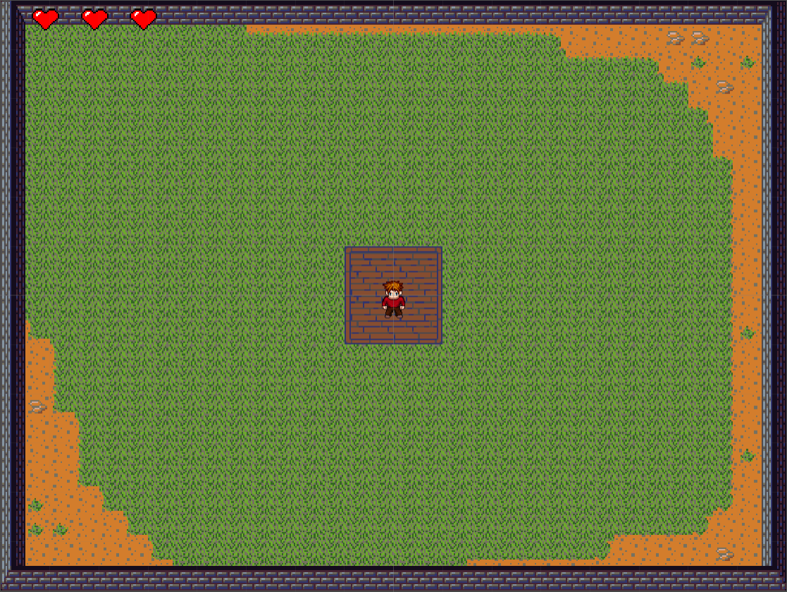

### 10.2.1 HUD

The players lives is represented as 3 hearts in the top Left.



### 10.2.2 Maps

There are 3 different levels:

Level 1:



Level 2:

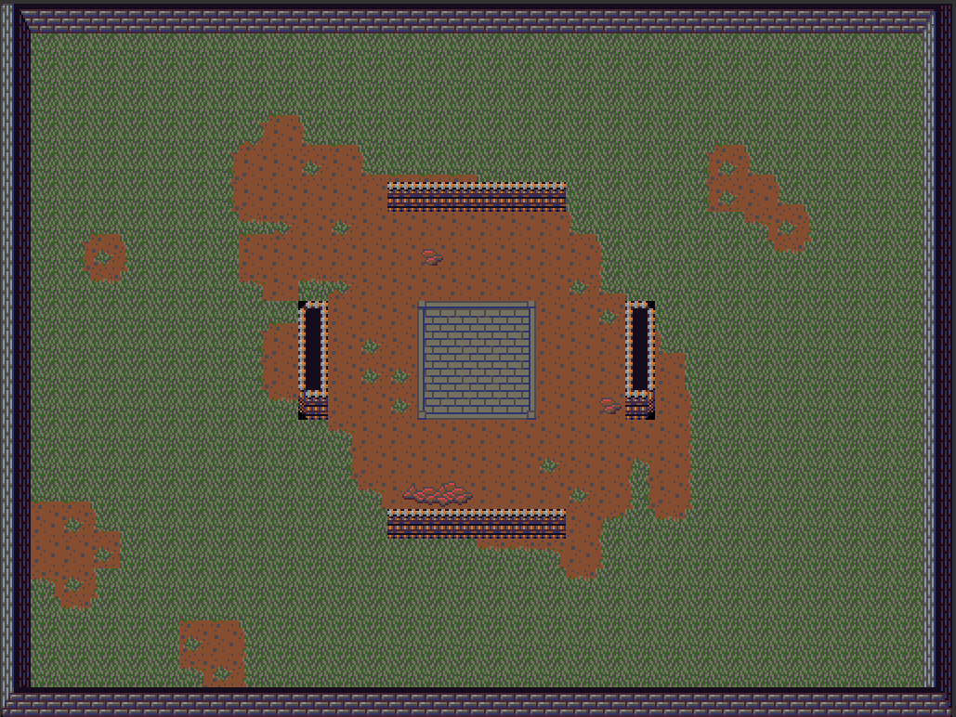

Level 3:

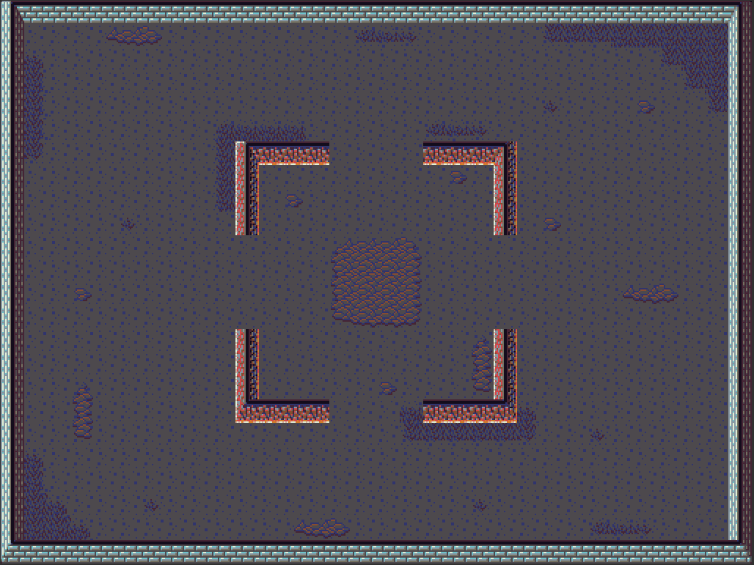

# 11 Players

## 11.1 Characters

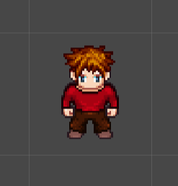

There is one Character.

## 11.2 Metrics

Lives: 3

Speed: 10

## 11.3 States

Idle: The player stands still

Move: the player walks in the direction of movement with left, right, up and down animations

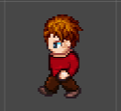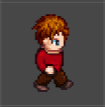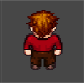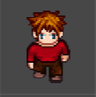

Death: The player falls down

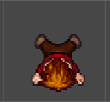

Attacking:

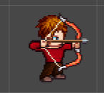

## 11.4 Weapons

The player has one weapon: The bow

The bow fires at a rate of 3 arrows per second, and fires one arrow at a time, unless a power up is active.

## 11.5 Power Ups

Power ups spawn in the middle of the screen in each level.

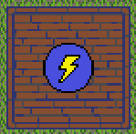

Shotgun: players shoots 3 arrows in the direction of aiming instead of 1. Lasts 12 seconds.

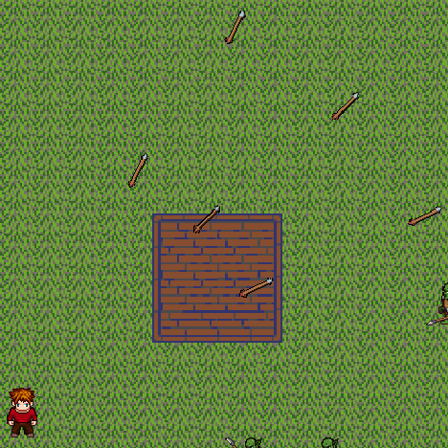

Wheel: Shoots arrows in every direction regardless of aim. Lasts 7 seconds.

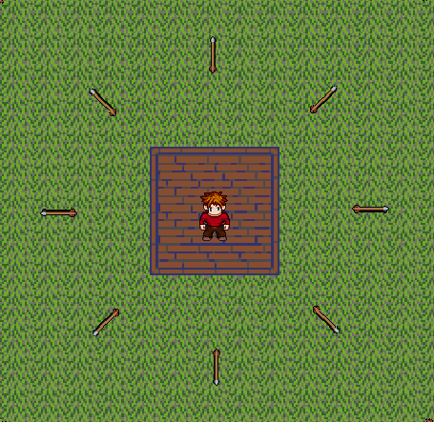

# 12 Player Line-up

N/A

# 13 NPC

## 13.1 Enemies

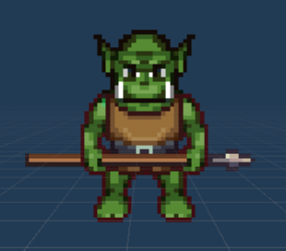

There is only one enemy: The ork

This enemy will die to a single arrow, but each arrow can only kill one enemy. Enemies spawn at increasingly faster rates each level, then resets to a slow pace at the beginning of the next level. Spawn rates cap at the fastest at the end of the third level.

Health: 1

Speed: 5 (unless super speed)

**SuperSpeed:**

There is a 25% chance for each enemy that is spawned to have super speed on levels 2 and 3 only.

Level 2 SuperSpeed: 10

Level 3 SuperSpeed: 15

### 13.1.1 Enemy States

Idle: Ork stands still

Move: animation for each move direction

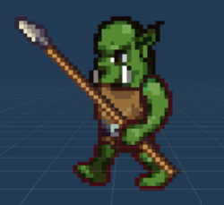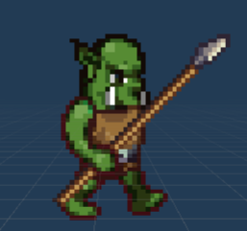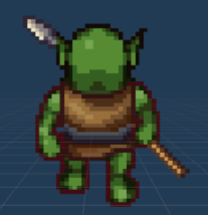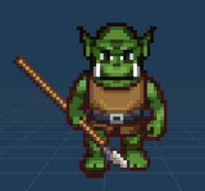

Die: The Ork falls down

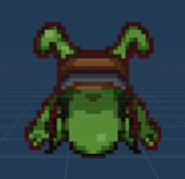

### 13.1.2 Enemy Spawn Points

Enemies spawn randomly at any place on the edge of the map.

# 14 Art

## 14.1 Setting



The setting changes between each level. The first level starts off with a peaceful green scenery. The second level shows some darker green grass, and a dirt patch in the middle, indicating that the player has been there for a while, as well as showing some darker and less cheery tones compared to the first level. The third level takes a twist to an all dirt landscape with nightmarish looking walls and colors to indicate danger and the higher difficulty of that level.

## 14.2 Level Design

First level is meant to be a warm up, with minimal enemies, going at slow pace. Second Level and third level has some cover from barriers.





## 14.3 Audio

Audio sound is made for firing an arrow. Audio sound is made for picking up a power up. Sound of arrow firing is slightly different and louder when power up is activated.

# 15 Bibliography

Arrow sound: <https://www.freesoundeffects.com/free-sounds/arrow-10072/>

Tile Set: <https://opengameart.org/content/dawnlike-16x16-universal-rogue-like-tileset-v181>

Character and enemy: <http://gaurav.munjal.us/Universal-LPC-Spritesheet-Character-Generator/>

All other assets were made by Ryan Clode