

DHARMSINH DESAI UNIVERSITY

Department of MCA

Artificial Intelligence
Term work Documentation

Topic Name: Smart Waste Classification

Name: Mehul Patel Name: Raghav Vithlani
Roll No: MA039 Roll No: MA043
Academic Year: 2026-27

Checked by: Date:
Dr. Narayan A. Joshi
MCA Department.

Table of Contents
We have arranged this report in the same order as our working Jupyter Notebook: input video, detection and tracking, counting output, and evaluation. Project: Vehicle Detection and Counting | Batch: B1 | Submission: 21-10-2026.
1. Project Title and Objectives 2
2. Datasets and Input Specifications 3
3. System Methodology and Configuration 5
4. Source Code and Explanations 6
5. Output Screenshots and Visual Results 12
6. Performance Evaluation and Comparative Analysis 15
7. Conclusion and Limitations 16
8. References 17

The explanations and results below follow the notebook's workflow.

Files and Results Used
Item | Details
Notebook | Smart_Waste_Classification.ipynb
Dataset folder | Garbage_dataset/original — local folder path used by the notebook
Dataset images | 12,259 images across 10 waste categories
Model | MobileNetV2 transfer learning with a final 10-class output layer
Saved model | smart_waste_classifier.keras
Test set | 1,839 images
Example prediction | battery, confidence 69.46%

1. Project Title and Objectives

1.1 Project Title
Smart Waste Classification System Using Deep Learning

1.2 Introduction
Waste should be sorted correctly so that useful materials can be reused or recycled. Sorting waste by hand can take time, and some items may be placed in the wrong bin. This project uses a trained image model to look at a waste image and predict its category. After predicting the category, the program displays a simple disposal or recycling suggestion.
The notebook uses Python, OpenCV, TensorFlow/Keras, NumPy, Pandas, Matplotlib and scikit-learn. It uses MobileNetV2, a model already trained on a large image dataset, and adapts it to the ten waste categories in this project.

1.3 Objectives
- Load and check the waste image dataset and count images in each category.
- Resize images to 160 × 160 pixels and scale pixel values between 0 and 1.
- Split the images into training, validation and testing sets.
- Build and train an image classification model using MobileNetV2.
- Measure model performance using accuracy, precision, recall, F1-score and a confusion matrix.
- Predict the category of a new waste image and show its confidence score.
- Give a simple disposal or recycling recommendation for the predicted category.
- Save the trained model so it can be loaded and used again.

1.4 Scope of the Project
The system classifies one image at a time into one of ten categories. It does not control a physical waste bin or verify local recycling rules. The recommendation is a general suggestion; users should follow local waste collection guidance.

2. Dataset and Input Specifications

2.1 Dataset Overview
The notebook reads images from a local dataset folder. Each waste category has its own folder. The notebook found all ten expected folders and counted 12,259 images in total.
Waste category | Number of images
battery | 756
biological | 699
cardboard | 1411
clothes | 1892
glass | 1736
metal | 930
paper | 1336
plastic | 1597
shoes | 1449
trash | 453
TOTAL | 12,259

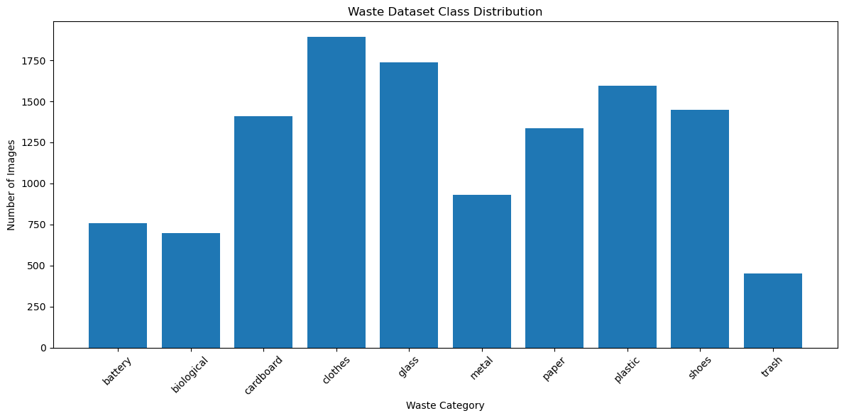
Figure 2.1: Image count in each waste category.

2.2 Waste Categories
The ten categories used by the model are battery, biological, cardboard, clothes, glass, metal, paper, plastic, shoes and trash.

2.3 Dataset Split
Dataset part | Images | Purpose
Training | 8,581 | Used to teach the model
Validation | 1,839 | Used to check performance while training
Testing | 1,839 | Used for final evaluation
Total | 12,259 | All images

It uses a stratified split so that the categories are represented in the training, validation and test sets. The split is 70% training, 15% validation and 15% testing.

2.4 Image Pre-processing
OpenCV reads each image, changes it from BGR to RGB colour order, resizes it to 160 × 160 pixels and converts pixel values to the range 0 to 1. This gives the model images in a consistent format.
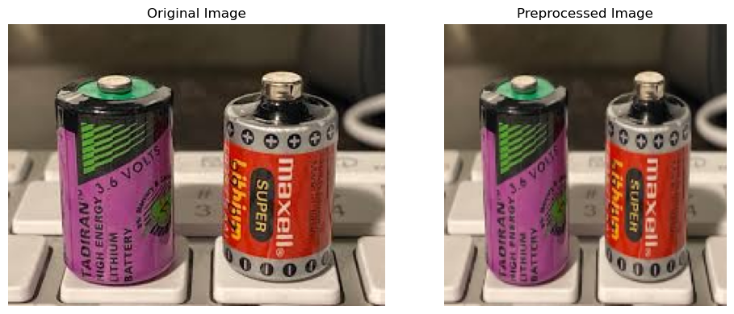
Figure 2.2: Example of an original image and its pre-processed version.

3. System Methodology and Configuration

3.1 Processing Sequence
- Read the dataset folders and collect image paths with their category labels.
- Count the images in each category and display sample images.
- Pre-process images by changing colour order, resizing and normalizing pixel values.
- Split the dataset into training, validation and testing groups.
- Create batches of 32 images for model training.
- Load MobileNetV2 with ImageNet weights and add the classification layers.
- Train the model, then fine-tune the last 30 layers of the base model.
- Evaluate the model on the test dataset and create performance graphs.
- Save the trained model as smart_waste_classifier.keras.
- Predict the class of a new image and show the suggested disposal action.

3.2 Tools and Model Settings
Setting | Value / purpose
Programming language | Python
Image processing | OpenCV
Deep learning library | TensorFlow / Keras
Base model | MobileNetV2, ImageNet pre-trained weights
Input image size | 160 × 160 × 3
Batch size | 32
Output classes | 10 waste categories
Optimizer | Adam
Initial learning rate | 0.001
Fine-tuning learning rate | 0.00001
Training | Up to 25 epochs, followed by up to 10 fine-tuning epochs
Callbacks | Early stopping and learning-rate reduction
Saved model | smart_waste_classifier.keras

3.3 How the Model Works
MobileNetV2 extracts visual patterns from the image. The added layers reduce these features to a smaller set, apply dropout to help reduce overfitting, and use a softmax output to give a score for each of the ten categories. The category with the highest score becomes the prediction.
During the first training stage, the pre-trained MobileNetV2 layers are frozen. During fine-tuning, only the last 30 base-model layers are allowed to train, while batch-normalization layers remain frozen.

4. Source Code and Explanations
This section presents the main code blocks from the project workflow, followed by a short explanation of each block. The code excerpts are arranged in the same order as the notebook: library setup, dataset preparation, image preprocessing, model creation, training, evaluation, saving and prediction.

4.1 Install and Import Libraries
The required libraries support image processing, data handling, model training, visualization and evaluation.
%pip install tensorflow opencv-python numpy pandas matplotlib seaborn scikit-learn
import os
import cv2
import numpy as np
import pandas as pd
import matplotlib.pyplot as plt
import seaborn as sns
import tensorflow as tf
from sklearn.model_selection import train_test_split
from sklearn.metrics import (
classification_report, confusion_matrix,
accuracy_score, precision_score, recall_score, f1_score
)
from tensorflow.keras import layers, models

4.2 Define the Dataset Path and Classes
The dataset is stored in folders, with one folder for each waste category. The class list fixes the output order used by the classifier. Change the dataset path if the folder is stored in another location.
dataset_path = r"D:\Smart_Waste_Classification\Garbage_dataset\original"
class_names = [
"battery", "biological", "cardboard", "clothes", "glass",
"metal", "paper", "plastic", "shoes", "trash"
]

4.3 Collect Image Paths and Labels
This block scans the class folders, finds supported image files, and stores each image path with its numeric class label. A DataFrame makes the image records easier to inspect and split.
image_extensions = (".jpg", ".jpeg", ".png", ".bmp", ".webp")
image_paths, image_labels = [], []
for label, class_name in enumerate(class_names):
folder_path = os.path.join(dataset_path, class_name)
for file_name in os.listdir(folder_path):
if file_name.lower().endswith(image_extensions):
image_paths.append(os.path.join(folder_path, file_name))
image_labels.append(label)
data = pd.DataFrame({
"image_path": image_paths,
"label": image_labels
})
data["class_name"] = data["label"].apply(lambda x: class_names[x])
print("Total images found:", len(data))
print(data["class_name"].value_counts())

4.4 Pre-process Images
OpenCV reads each image in BGR format. The function converts it to RGB, resizes it to 160 × 160 pixels and normalizes pixel values to the range 0–1. This provides consistent input to the model.
IMAGE_SIZE = 160
def preprocess_image(image_path):
image = cv2.imread(image_path)
if image is None:
raise ValueError(f"Could not read image: {image_path}")
image = cv2.cvtColor(image, cv2.COLOR_BGR2RGB)
image = cv2.resize(image, (IMAGE_SIZE, IMAGE_SIZE))
image = image.astype(np.float32) / 255.0
return image

4.5 Split the Dataset and Create Batches
The dataset is divided into training, validation and testing groups using stratification so that each category remains represented. Batches of 32 images are used to process data efficiently.
train_data, temp_data = train_test_split(
data, test_size=0.30, random_state=42,
stratify=data["label"]
)
validation_data, test_data = train_test_split(
temp_data, test_size=0.50, random_state=42,
stratify=temp_data["label"]
)
BATCH_SIZE = 32

4.6 Build the Classification Model
The report describes a MobileNetV2 model initialized with ImageNet pre-trained weights. The original classification head is removed, and new layers are added for the ten waste categories. Data augmentation can help the model generalize to variations in image position and size.
base_model = tf.keras.applications.MobileNetV2(
input_shape=(160, 160, 3),
include_top=False,
weights="imagenet"
)
base_model.trainable = False
inputs = tf.keras.Input(shape=(160, 160, 3))
x = tf.keras.layers.RandomFlip("horizontal")(inputs)
x = tf.keras.layers.RandomRotation(0.08)(x)
x = tf.keras.layers.RandomZoom(0.10)(x)
x = base_model(x, training=False)
x = tf.keras.layers.GlobalAveragePooling2D()(x)
x = tf.keras.layers.Dropout(0.3)(x)
outputs = tf.keras.layers.Dense(
10, activation="softmax"
)(x)
model = tf.keras.Model(inputs, outputs)

4.7 Compile, Train and Fine-tune
In the first stage, the pre-trained base model is frozen and the new classification layers are trained. Fine-tuning then unfreezes the last 30 eligible base-model layers and uses a smaller learning rate to adapt the model carefully to waste images. Batch-normalization layers remain frozen.
model.compile(
optimizer=tf.keras.optimizers.Adam(learning_rate=0.001),
loss="sparse_categorical_crossentropy",
metrics=["accuracy"]
)
callbacks = [
tf.keras.callbacks.EarlyStopping(
monitor="val_loss", patience=5,
restore_best_weights=True
),
tf.keras.callbacks.ReduceLROnPlateau(
monitor="val_loss", factor=0.5,
patience=2, min_lr=1e-6
)
]
# First training stage
history = model.fit(
train_dataset,
validation_data=validation_dataset,
epochs=25,
callbacks=callbacks
)
# Fine-tuning stage
base_model.trainable = True
for layer in base_model.layers[:-30]:
layer.trainable = False
for layer in base_model.layers:
if isinstance(layer, tf.keras.layers.BatchNormalization):
layer.trainable = False
model.compile(
optimizer=tf.keras.optimizers.Adam(learning_rate=0.00001),
loss="sparse_categorical_crossentropy",
metrics=["accuracy"]
)
fine_tune_history = model.fit(
train_dataset,
validation_data=validation_dataset,
epochs=10,
callbacks=callbacks
)

4.8 Evaluate the Model
The test set is used only for final evaluation. Accuracy, weighted precision, weighted recall and weighted F1-score summarize performance. The classification report gives per-category results, while the confusion matrix shows which classes are most often confused.
test_loss, test_accuracy = model.evaluate(test_dataset, verbose=1)
y_true, y_pred = [], []
for images, labels in test_dataset:
probabilities = model.predict(images, verbose=0)
y_true.extend(labels.numpy())
y_pred.extend(np.argmax(probabilities, axis=1))
print("Accuracy:", accuracy_score(y_true, y_pred))
print("Weighted precision:",
precision_score(y_true, y_pred, average="weighted", zero_division=0))
print("Weighted recall:",
recall_score(y_true, y_pred, average="weighted", zero_division=0))
print("Weighted F1-score:",
f1_score(y_true, y_pred, average="weighted", zero_division=0))
print(classification_report(
y_true, y_pred, target_names=class_names, zero_division=0
))
cm = confusion_matrix(y_true, y_pred)
sns.heatmap(cm, annot=True, fmt="d",
xticklabels=class_names, yticklabels=class_names)
plt.xlabel("Predicted Class")
plt.ylabel("Actual Class")
plt.tight_layout()
plt.show()

4.9 Save and Reload the Model
Saving the model allows it to be reused later without training it again. The saved file contains the trained model architecture and weights.
model.save("smart_waste_classifier.keras")
from tensorflow.keras.models import load_model
loaded_model = load_model("smart_waste_classifier.keras")
print("Saved model loaded successfully.")

4.10 Predict a New Image and Show a Recommendation
For a new image, the program applies the same preprocessing, predicts the probability for each category, selects the category with the highest score and displays a general disposal recommendation.
recommendations = {
"battery": "Use a battery or e-waste collection center.",
"biological": "Send for composting or suitable biological treatment.",
"cardboard": "Send for recycling; keep it clean and dry.",
"clothes": "Reuse, donate or use textile recycling.",
"glass": "Send to a glass recycling facility.",
"metal": "Send to a metal recycling facility.",
"paper": "Send for paper recycling.",
"plastic": "Send to a suitable plastic recycling facility.",
"shoes": "Reuse, donate or use an appropriate recycling facility.",
"trash": "Use the appropriate general waste disposal system."
}
def predict_waste(image_path):
image = preprocess_image(image_path)
image_batch = np.expand_dims(image, axis=0)
probabilities = model.predict(image_batch, verbose=0)[0]
predicted_index = int(np.argmax(probabilities))
predicted_class = class_names[predicted_index]
confidence = probabilities[predicted_index] * 100
print("Predicted category:", predicted_class)
print(f"Confidence: {confidence:.2f}%")
print("Recommendation:", recommendations[predicted_class])
return probabilities

5. Output Screenshots and Visual Results
The following figures are taken from the saved outputs of the submitted Jupyter Notebook.
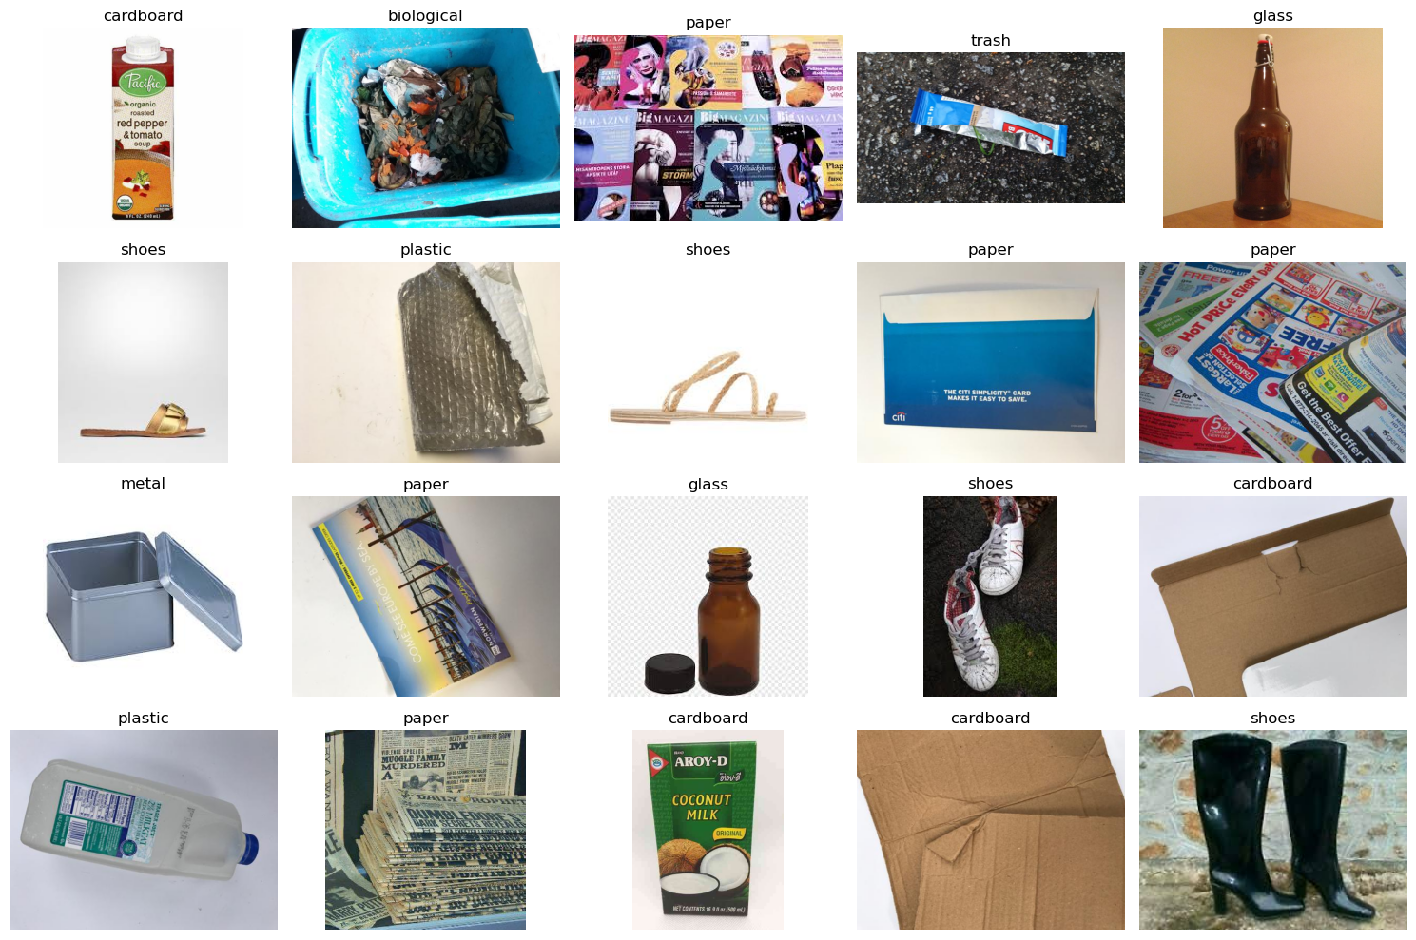
Figure 5.1: Sample images from the waste dataset.
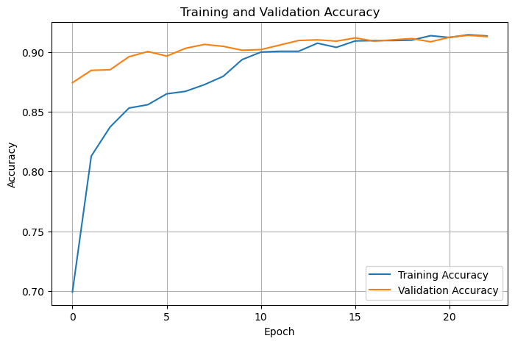
Figure 5.2: Training and validation accuracy during training.
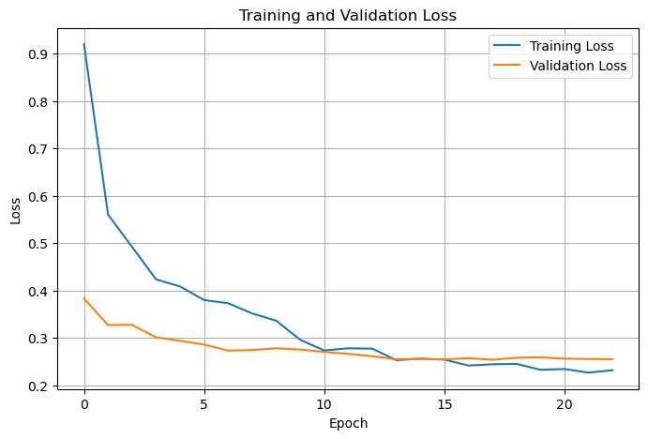
Figure 5.3: Training and validation loss during training.
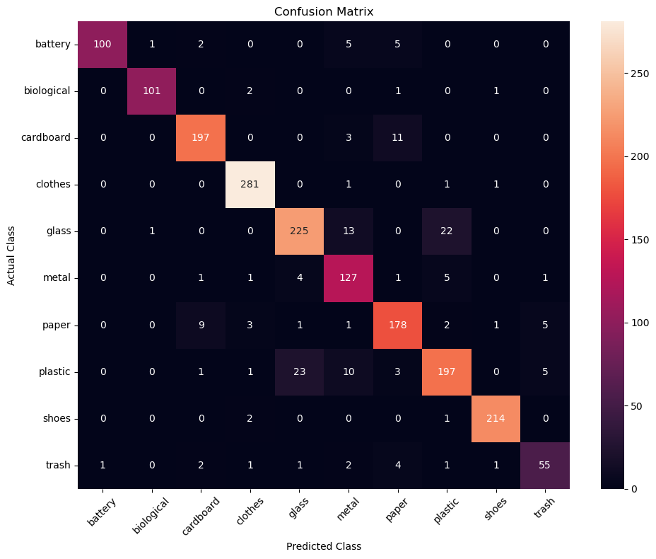
Figure 5.4: Confusion matrix showing actual and predicted classes.
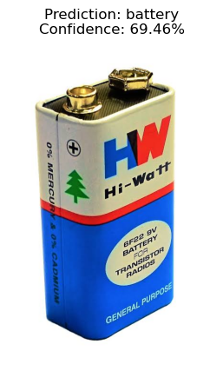
Figure 5.5: Example prediction for a battery image.
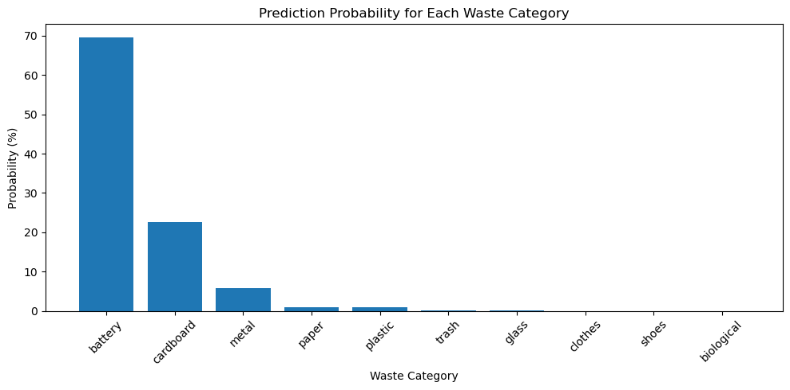
Figure 5.6: Probability scores for the ten categories.

6. Performance Evaluation and Analysis

6.1 Overall Test Results
The saved notebook output reports the following results on the test set of 1,839 images.
Metric | Result
Accuracy | 91.08%
Precision (weighted) | 91.22%
Recall (weighted) | 91.08%
F1-score (weighted) | 91.09%
Test loss | 0.2645

Accuracy is the share of test images classified correctly. Precision describes how often predictions for a class are correct. Recall describes how many actual examples of a class were found. The F1-score combines precision and recall into one measure. The notebook reports weighted precision, recall and F1-score, which take the number of examples in each class into account.

6.2 Results by Category
Category | Precision | Recall | F1-score | Test images
battery | 0.99 | 0.88 | 0.93 | 113
biological | 0.98 | 0.96 | 0.97 | 105
cardboard | 0.93 | 0.93 | 0.93 | 211
clothes | 0.97 | 0.99 | 0.98 | 284
glass | 0.89 | 0.86 | 0.87 | 261
metal | 0.78 | 0.91 | 0.84 | 140
paper | 0.88 | 0.89 | 0.88 | 200
plastic | 0.86 | 0.82 | 0.84 | 240
shoes | 0.98 | 0.99 | 0.98 | 217
trash | 0.83 | 0.81 | 0.82 | 68

In the saved report, clothes and shoes have F1-scores of 0.98, while trash has an F1-score of 0.82. Metal has a lower precision of 0.78, which means some images predicted as metal belong to other categories. The results show that performance is not exactly the same for every category.

6.3 Example Prediction
Item | Saved output
Input image | battery.jpg
Predicted category | battery
Confidence | 69.46%
Recommendation | Dispose of batteries at a battery or e-waste collection center.

This is one example from the notebook, not a guarantee that every battery image will receive the same result. The confidence score is the model's score for its chosen category.

6.4 Notes on the Evaluation
The values in this report are copied from the saved notebook outputs. Results can change if the dataset, random split, software version or training run changes. A high overall score does not mean every prediction will be correct, so uncertain or important waste items should be checked by a person.
7. Conclusion and Limitations

7.1 Conclusion
The Smart Waste Classification System uses deep learning to predict one of ten waste categories from an image. The notebook prepares the dataset, trains a MobileNetV2-based model, evaluates its results, saves the model and tests it on a new image. In the saved run, the model achieved 91.08% test accuracy. It also gives a simple disposal or recycling suggestion based on the predicted category.

7.2 Limitations
- The model predicts only the ten categories included in its dataset.
- Results may be less reliable for blurry images, unusual lighting, cluttered backgrounds or items not represented well in training data.
- The recommendation is general and may not match the rules of every local waste collection service.
- The example battery prediction had 69.46% confidence, so the output should not be treated as certain.
- The notebook uses a local Windows dataset path. That path must be changed if the project is run on another computer.

7.3 Future Improvements
- Test the model on more images collected from real waste bins and different lighting conditions.
- Add more waste categories if a suitable labelled dataset is available.
- Create a simple user interface to upload an image and show the prediction.
- Connect recommendations to local recycling guidance.

8. References
- Smart_Waste_Classification.ipynb — submitted project notebook and saved outputs.
- TensorFlow/Keras documentation: https://www.tensorflow.org/
- OpenCV documentation: https://docs.opencv.org/
- MobileNetV2 documentation: https://www.tensorflow.org/api_docs/python/tf/keras/applications/MobileNetV2
- Scikit-learn documentation: https://scikit-learn.org/stable/
- Kaggle Garbage Classification Dataset: https://www.kaggle.com/datasets/sumn2u/garbage-classification-v2

