Data from the 330 competitors across the U.S. suggests that Big Mountain’s current ticket price is underpriced. Out of the various features for Big Mountain resort provided for study, the most important ones are - fast quads, runs, snow-making area, and vertical drop.

As we can see from the below graphs, Big Mountain is already fairly high on some of the league charts of facilities offered, but its modeled price is even higher than its current price because it offers great facilities in comparison to its competitors.

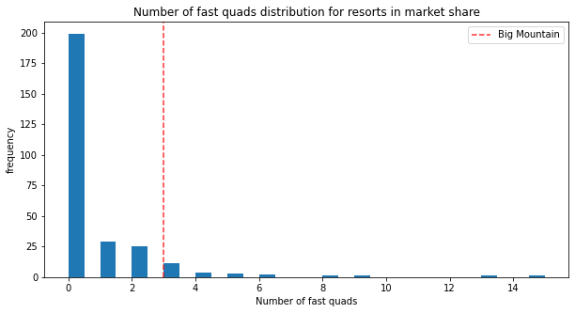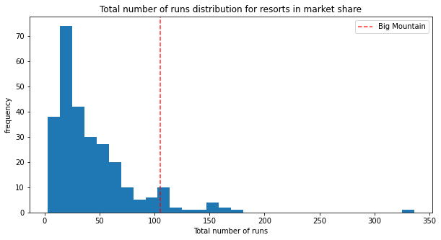

Investors’ suspicion that Big Mountain is not capitalizing on its facilities as much as it could seem to be correct.

**Key Recommendations:**

1. Big Mountain currently charges $81.00. Resort The modeling suggests for a ticket price to be $95.87. According to our model, given the existing facilities and considering the ticket prices of Big Mountain's competitors, Big Mountain should have a ticket price between $85.48 to $106.26. This means the ticket price should be increased to $85.48 from the current price of $81.

Every year about 350,000 people visit Big Mountain. The additional cost of $1,540,000 can be easily covered with the increased ticket price of $85.48. The additional cost comes out to be 88 cents per ticket considering each visitor on average buys 5-day tickets. Investors would still be able to maintain a minimum profit margin of 9.2%.

1. The business should not spend money on modeling scenarios where adding resources don't lead to an increase in revenue. As Big Mountain's ticket price is already quite high in Montana, they should focus on reducing those operating costs which add no value to the revenue.

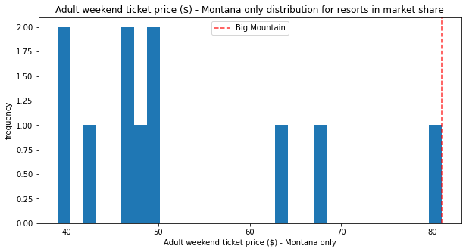

1. We would recommend closing at least 1 run because it is not adding any value to the revenue but might bring down operating costs. For the decision of closing more runs, we would like to have information on the operating cost of the runs to compare the decrease in revenue vs decrease in operating costs.

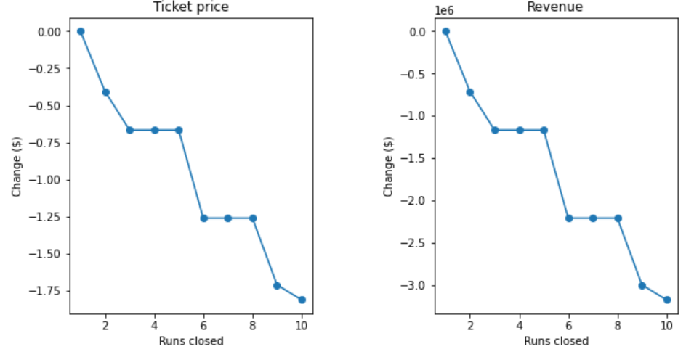

1. If the cost of adding a run, increasing the vertical drop by 150 feet, and installing an additional chair lift is less than $3,474,638 + minimum profit margin of 9.2% for investors, then we would like to recommend this addition. We can increase the ticket price by $1.99 by making these changes.
2. We would not recommend increasing the snow-making area by 2 acres along with the above changes as it doesn’t add value to the ticket price.
3. We would also not recommend increasing the longest run by .2 miles, as it doesn’t add value to the ticket price but might add additional operating or installing costs.