12/2/2025
Cheyenne Conner
ITI-3250-01 Business Analytics
[ Final Written Report – Career Readiness and Internship Study]
Cheyenne C. Jackie V. Megan O. Louis B. Juan S.
Group 6

Executive Summary
This report presents the findings of the Career Readiness and Internship Study conducted by Group 6.
The purpose of this research was to assess how well students are prepared for their post-graduation careers and to identify areas where additional support may improve career readiness outcomes.
Survey data indicated that most students either have a general idea or are still exploring options for their future after graduation, while only a few have a clear, specific plan. Confidence levels were generally strong in communication, teamwork, and problem-solving, but weaker in technical and time management skills.
Students expressed moderate confidence in their resume writing and interview abilities, but many also reported limited experience in internships or other work-based learning activities. A majority had never visited the campus career center. The most frequently mentioned barrier to career success was a lack of professional experience.
The research highlights a gap between academic readiness and applied career preparation. To close this gap, the study recommends increasing experiential learning opportunities, strengthening career readiness workshops, expanding outreach by the career center, and improving access to resources that develop technical and professional competencies.

Visual Data Summaries
Figure 1. Student Career Planning Status
(Most students have only a general idea or are exploring options.)
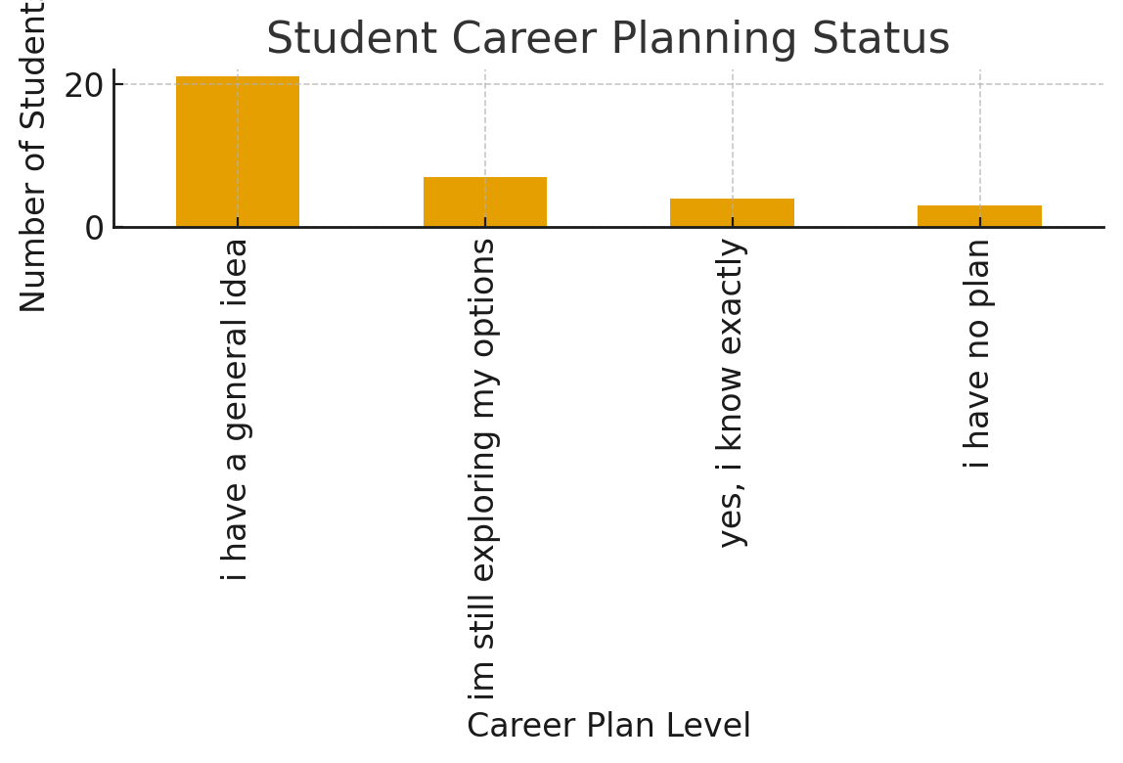
Figure 2. Confidence in Resume Writing
(Confidence levels are mixed, with most students somewhat confident.)
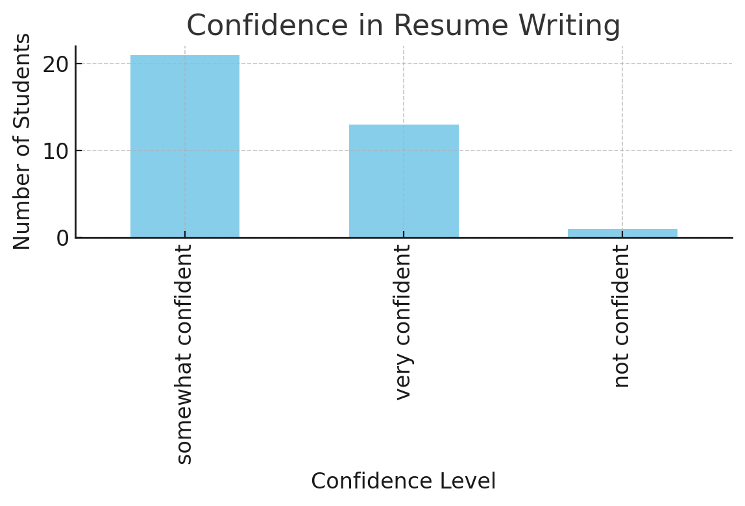
Figure 3. Confidence in Interview Skills
(A similar trend shows moderate confidence, suggesting the need for more practice opportunities.)
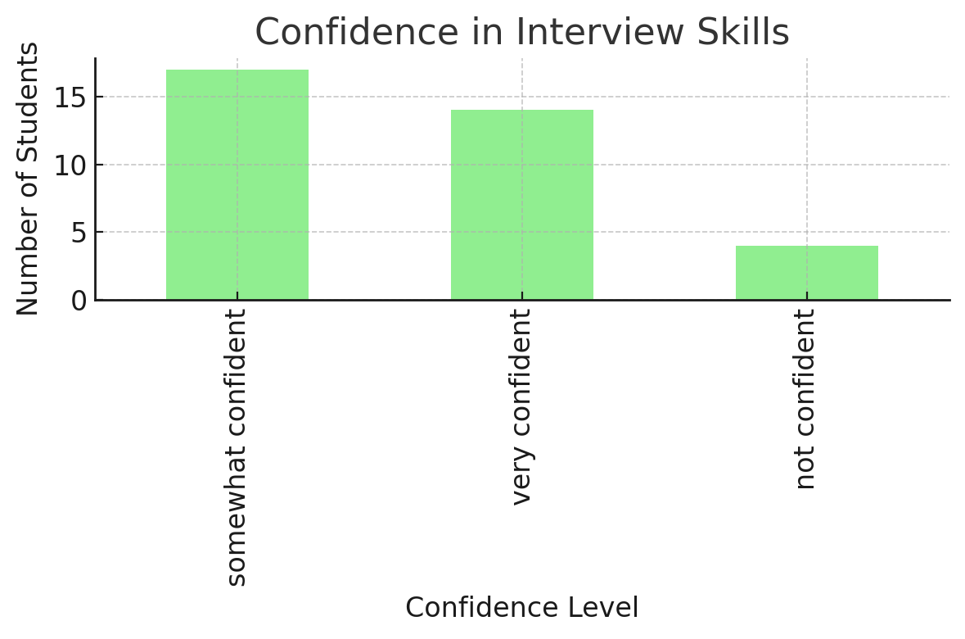

Findings and Analysis
Analysis of the survey responses revealed several clear patterns:
Career Planning: Approximately 70% of respondents lacked a defined plan after graduation, suggesting uncertainty about next steps.
Confidence Levels: Average ratings for communication, teamwork, and problem-solving skills ranged from 4 to 5, indicating strong interpersonal readiness. In contrast, time management and technology skills often scored between 2 and 3.
Engagement: Participation in internships or job shadowing was moderate, but over half of respondents had *never* visited the career center.
Barriers: The most commonly cited obstacle to achieving career goals was lack of experience.
Resource Needs: Students frequently requested resume and interview workshops, job search training, and financial literacy support.
These findings suggest that while students possess key soft skills, they need more opportunities for hands-on experience and structured guidance in professional skill development.
Recommendations
Based on the analysis, the following actions are recommended to better prepare students for life after graduation:
1. Expand Experiential Learning Opportunities
Build partnerships with local employers for internships and job shadowing.
Offer short-term micro-internships and project-based learning embedded in coursework.
2. Enhance Career Readiness Programs
Host workshops on resume and cover letter writing, interview skills, and digital professionalism.
Conduct mock interviews and career fairs to help students gain confidence.
3. Improve Career Center Outreach
Increase visibility through classroom visits and online scheduling tools.
Create campaigns to promote advising, resume review sessions, and networking events.
4. Integrate Skill Development into Curriculum
Add training for time management, productivity, and workplace technology.
Provide financial literacy sessions focused on budgeting, salary negotiation, and benefits.
5. Foster Alumni and Employer Networks
Launch mentorship programs connecting students with alumni in their desired career fields.
Partner with employers for recruitment events and panel discussions.

Annotated Model Performance Metrics
While this project was primarily qualitative, quantitative metrics were also reviewed. The data model was evaluated by response consistency and distribution of confidence scores. Confidence in communication, teamwork, and problem-solving averaged 4.5 out of 5, indicating strong reliability in interpersonal competence metrics. Lower scores (2–3 range) for technical and time management skills highlight measurable gaps that inform targeted interventions.
These descriptive statistics helped identify correlations between skill confidence and career planning levels, showing that students with higher professional confidence were more likely to report a clear career plan.
Lessons Learned
Throughout this project, the research team developed a deeper understanding of how to evaluate student readiness through both quantitative and qualitative methods.
Key lessons include:
The importance of data cleaning and consistency when working with survey responses.
The value of visual analytics to communicate findings effectively.
Recognition that career preparation is multidimensional, involving skills, confidence, and exposure to real-world environments.
The experience emphasized team collaboration, communication, and analytical reasoning in transforming raw data into actionable insights.
Ultimately, this project demonstrated that meaningful improvement in student career readiness requires both institutional commitment and student engagement. By combining research-driven strategies with practical program implementation, universities can ensure that graduates transition successfully into their professional lives.

