APPLICATION ARCHITECTURE

Our project will be based on the Java Swing framework. The application will run a JFrame named “DrawGUI” containing all graphical elements of the GUI. In order to achieve all requirements, we designed the raw architecture shown in the following picture (to be further detailed).

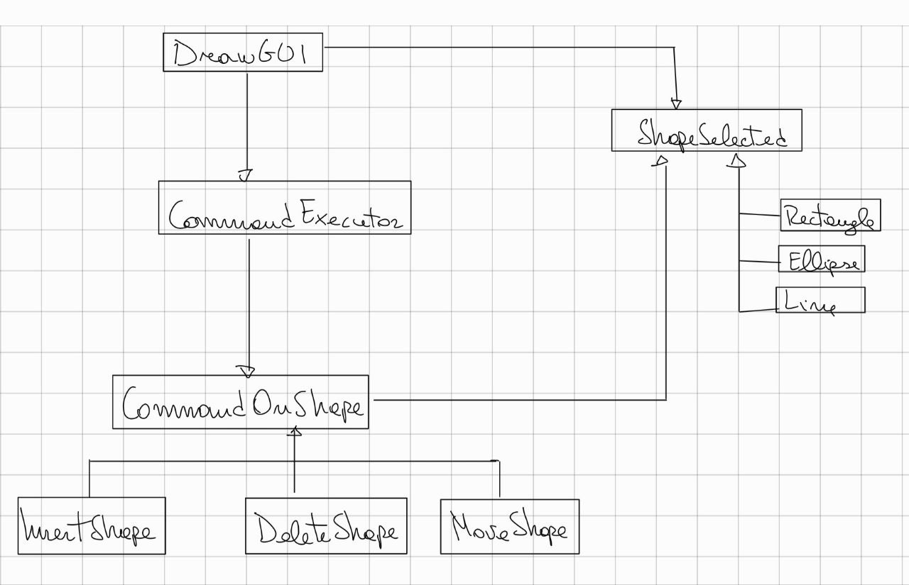



All the elements shown in the picture represents a class/interface that we intend to create. This schema will almost certainly be updated during the development.

About conventions:

* The language and the IDE used for the development will be Java and NetBeans
* We will use English language for naming variables, classes, and for comments.
* For classes and methods, we will use camelCase as expressed by the java conventions (e.g. ClassName, methodName).
* Every variable/attribute will follow the methods naming rule (e.g. attributeName).