Open BLT Bootloader Configuration for Infineon XMC 4200

Table of Contents
Introduction: 3
OpenBLT Bootloader: 4
Getting started: 4
Steps to flash the initial Bootloader: 5
Program initialization: 5
.1) Create the new simple project in the DAVE for the OpenBLT CAN bootloader 5
Resource initialization: 5
Include the following files to the directory of the created new program 5
OpenBLT configuration: 7
CAN peripheral configuration: 7
We have a source file that included in the workspace, to configure the CAN open the can.c present in the source file configure the following values. 7

Introduction:
Bootloader is the first piece of firmware which gets executed once the Embedded System is turned-on/reset. The primary objective of the Bootloader is to initialise the Embedded System and provide control to the Application/RTOS.
A bootloader is an application whose primary objective is to upgrade/modify system software without the intervention of specialized firmware upgrade tools. Bootloaders can have many functionalities, but it's mainly used to manage the application. They can also utilize different protocols such as UART, CAN, I2C, I2S, Ethernet, or USB to establish communication and initialize a firmware upgrade.
In general, the operation of a bootloader is relatively standard. There are three crucial parts in any bootloader: branching code, on startup, it decides whether to execute the bootloader code or the application code. This is done by checking a GPIO pin at start-up.
In a more complex system, the bootloader loads itself to the memory along with the application code, then it checks for initial parameters and system integrity. Once that's done, it goes back to executing the application code. This is why many bootloaders contain the branching code.
Even when the application is running, it's so designed that it can request a firmware upgrade, after which it takes care of the necessary system clean-ups once that is done, it soft-resets the chip by putting known values to the watchdog register. Additionally, the application puts out all the necessary instructions for the branching code to put the device on bootloader mode.
Now when the bootloader loads into the memory, it starts initializing basic instruction and peripherals to prepare for a firmware upgrade. The peripherals typically are system clocks, interrupts and communication channels, and schedulers. These allow the bootloader to accept instruction from outside, and it starts the upgrade process; once done, it soft-resets the chip, and when it boots up again, it goes to the normal operation mode.

OpenBLT Bootloader:
OpenBLT is an open source bootloader that can run on any microcontroller and use any type of communication interface to perform software updates, without the need of specialized debugger hardware.
After the one-time integration of the bootloader into your microcontroller based product, the user or technician can work with the bootloader to conveniently perform a firmware update.
OpenBLT is mostly used as an STM32 bootloader, due to the popularity of STM32 microcontrollers. However, the bootloader’s architecture is such that it can work with any microcontroller. It currently supports ST STM32, Infineon XMC, NXP S12, and TI TM4C and LM3S microcontrollers. The source code organization creates a separation between microcontroller dependent and independent functionality, making it easy to port the bootloader to microcontroller targets that are not yet supported.

Getting started:
The first step is to download OpenBLT. The latest version is available in the official feaser.com . The download package contains numerous preconfigured demonstration programs for popular microcontroller evaluation boards. You can either obtain one of these low-cost boards to first get familiar with operating the OpenBLT bootloader, or dive right in and port a demonstration program to your own hardware.

Steps to flash the initial Bootloader:

Program initialization:

Create the new simple project in the DAVE for the OpenBLT CAN bootloader
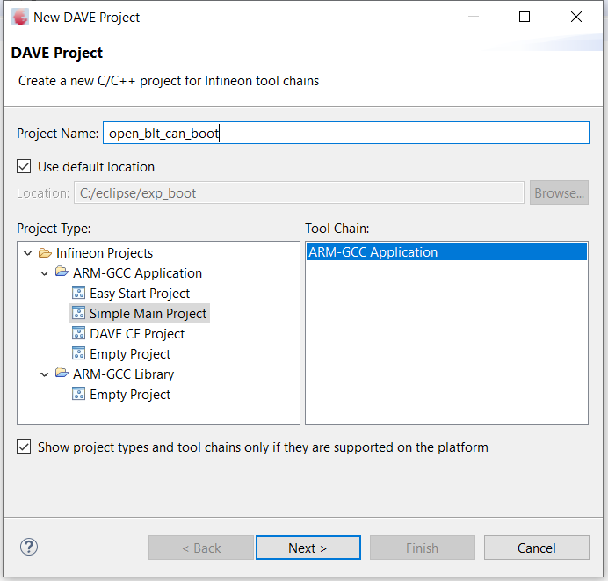

Fig 1.1.a

Resource initialization:

Include the following files to the directory of the created new program
Sl no. | Required files
1. | blt_conf.h
2. | hooks.c
3. | led.c
4. | led.h
5. | shared_params.c
6. | shared_params.h
7. | main.c
8. | Source file

- Open the properties of the new program file, go to the paths and symbols mention under the c/c++ general and add the path of the following files.
Sl no. | Files | Path of the files
1. | Source | ${project name}/final_boot_main/Source
2. | ARMCM4_XMC4 | ${project name}/final_boot_main/Source/ARMCM4_XMC4
3. | GCC | ${project name}/final_boot_main/Source/ARMCM4_XMC4/GCC

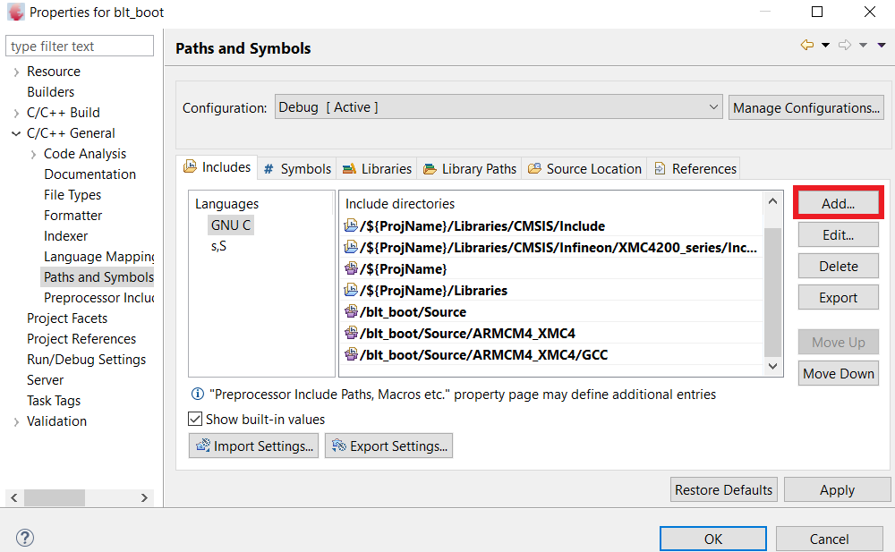
Fig 1.2.a
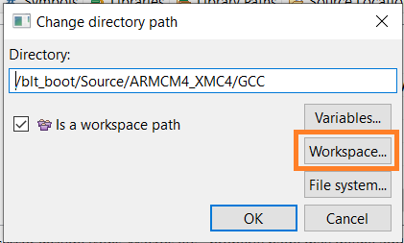

Fig 1.2.b

OpenBLT configuration:
- Configure the values of the following macros in the file blt_conf.h , with the new mentioned value for the XMC 4200.
Sl no. | macros | values
1. | BOOT_CPU_XTAL_SPEED_KHZ | 12MHz
2. | BOOT_CPU_SYSTEM_SPEED_KHZ | 80MHz
3. | BOOT_COM_CAN_ENABLE | 1

- Open the file led.c , this file is to validate the working of the bootloader , it has some function to initialize led to blink according to the time delay provided.
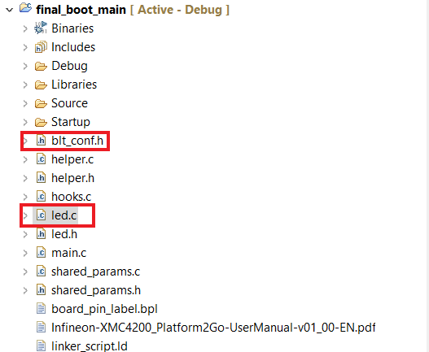

Fig 1.3.a

CAN peripheral configuration:

We have a source file that included in the workspace, to configure the CAN open the can.c present in the source file configure the following values.
Sl no. | ports | pins
1. | Rx pin | 14.3
2. | Tx pin | 2.0

