

# Art Museum Database Management System

CCCS-215

# -CS-

|  |  |
| --- | --- |
| Student name | Student ID |
| Riham Mohammed Al-Nashri | 2110278 |
| Rawan Fawaz Alsufyani | 2112024 |
| Enas Abdulaziz Alharbi | 2110329 |
| Fatma Saleh Asiri | 2007704 |
| Lama talal Al-Jedani | 2116713 |



## Problem definition:

Nowadays a lot of museums don't have a database to record the clients information or the paintings that is being sold to clients,and the increasing number of reserving tickets, and register the data in the required museum, so when the curator decides to sell/buy a painting we must register it first in the database so we can have an efficient system to handle the data. Also, it can be accessible by the employees to add or remove the requested data quickly and securely.

## Initial list of entities :

-Employee entity

-Museum entity

-Painting entity

-Ticket entity

-Curator entity

## Duties of the project:

each member will handle one entity

|  |  |
| --- | --- |
| Member | Role |
| Riham | Curator |
| Lama | Ticket |
| Enas | Employee |
| Fatma | Museum |
| Rawan | Painting |

Phase 1:



Business Rules:

1. <Employee> <one> <work-in> <one> <museum>
2. <Museum> <one> <has> <any number> <Employee> 3- <Ticket> <one> <reserve> <one> <Museum>

4- <Museum> <one> <bought> <any number> <Ticket> 5- <Curator> <may> <buys> <any number> <Painting> 6- <Painting> <may> <ordered> <one> <Curator>

7- <Curator> <one> <buys> <any number> <Ticket> 8- <Ticket> <one> <has> <one> <Curator>

1. <Painting> <one> <include> <one> <Museum>
2. <Museum> <one> <has> <any number> <Painting>

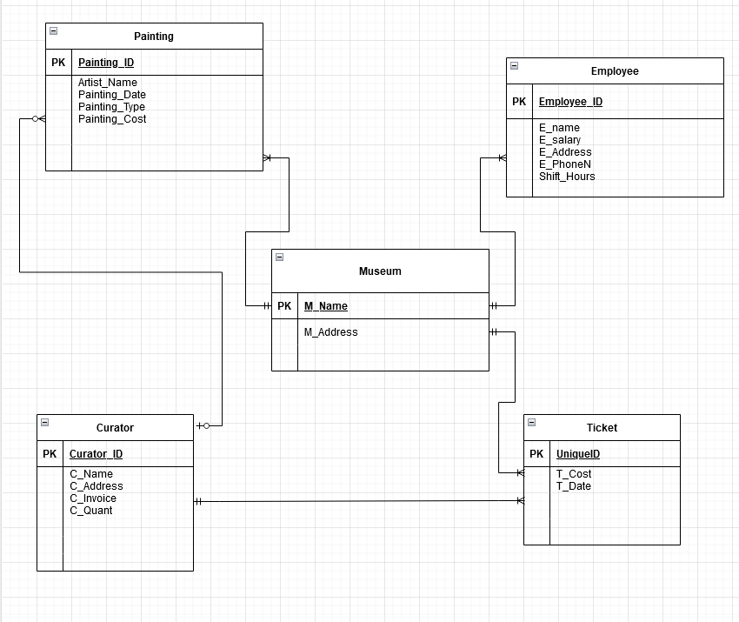

Phase 2

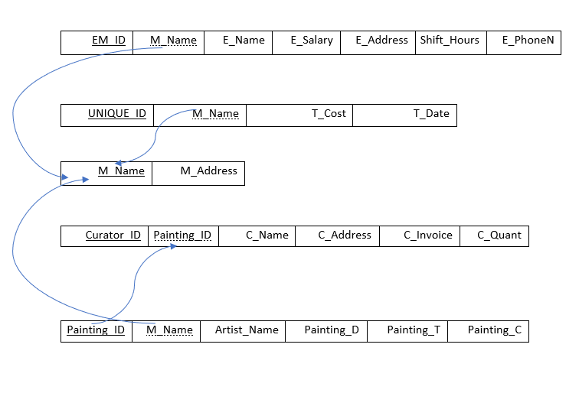

Employee

Ticket

Museum

Curator

C_Name

UNIQUE_ID

Painting

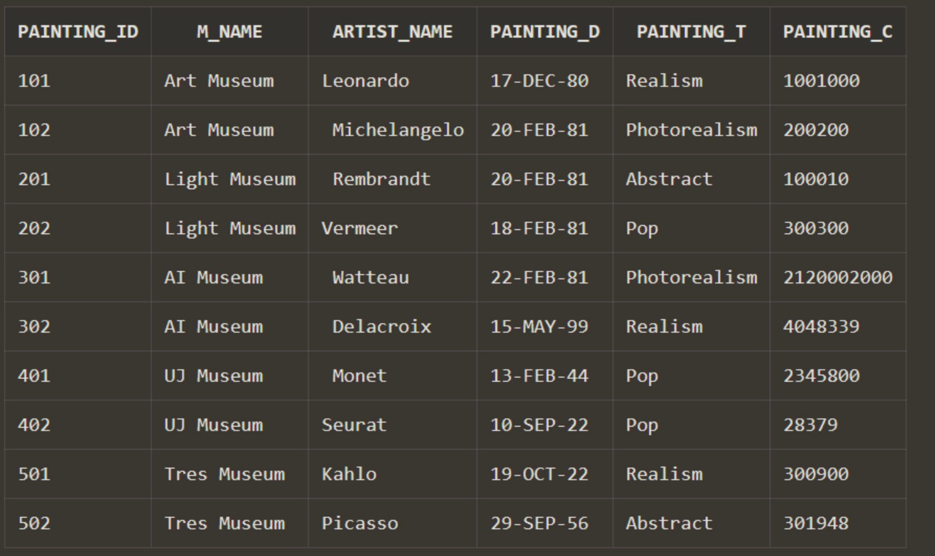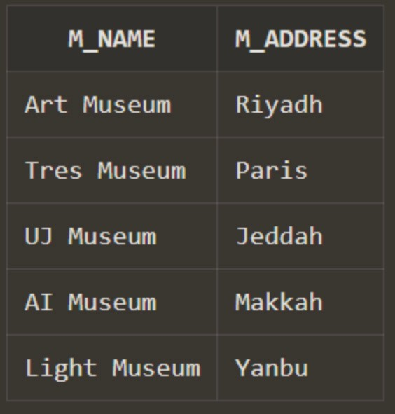 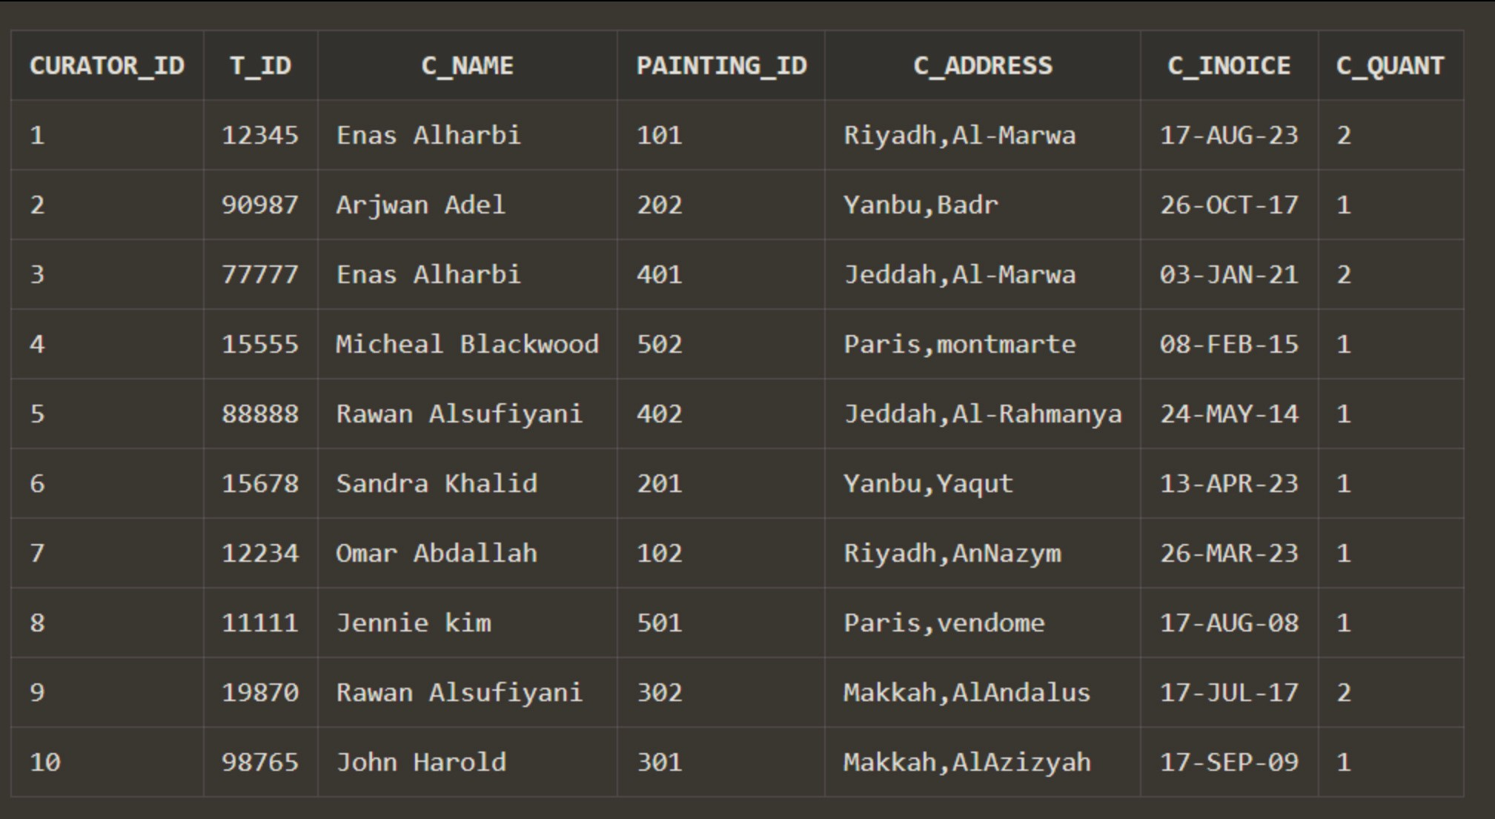



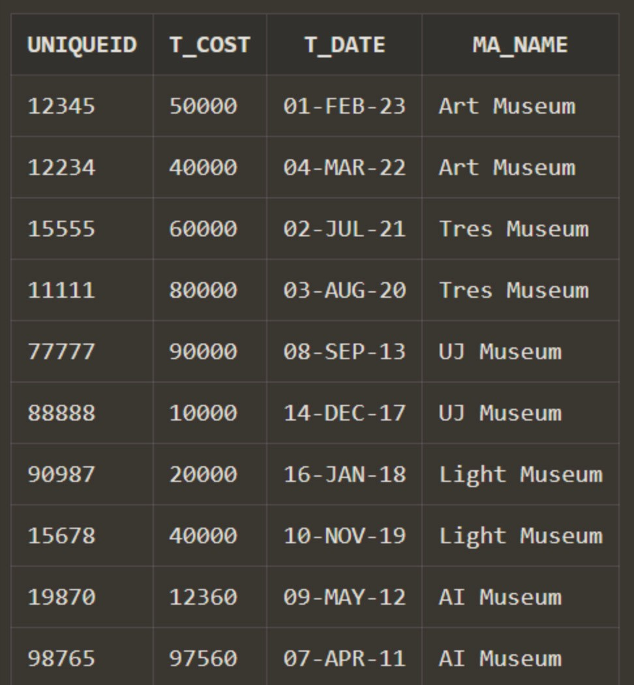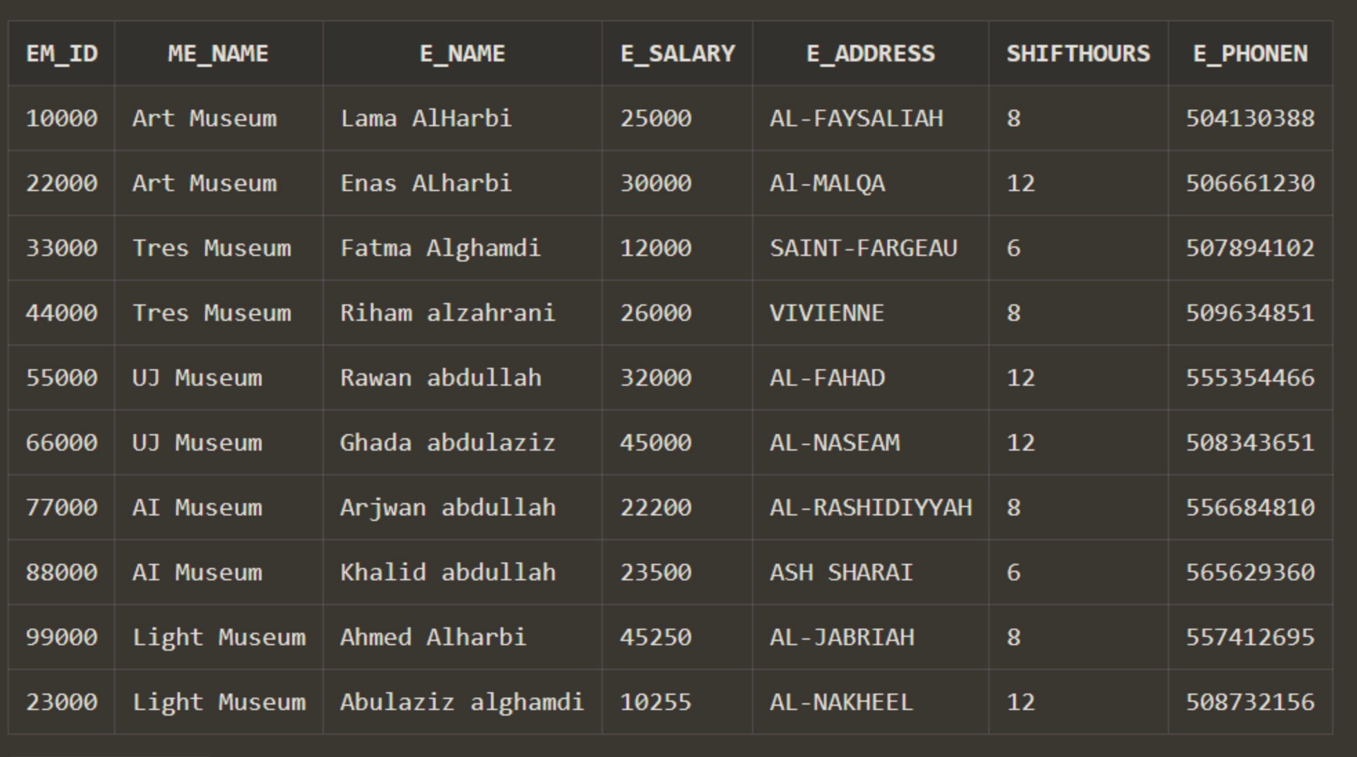



Query

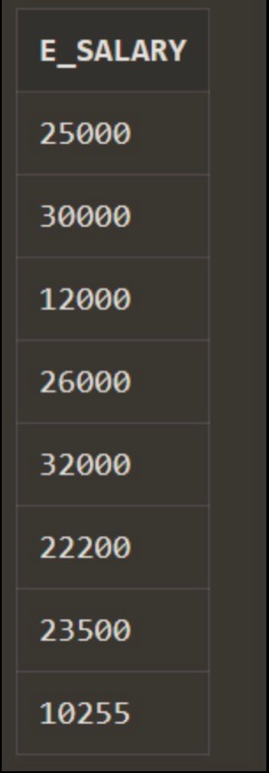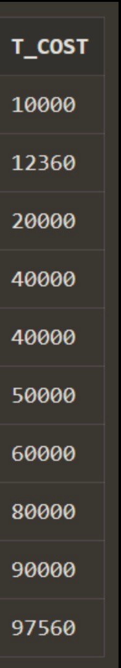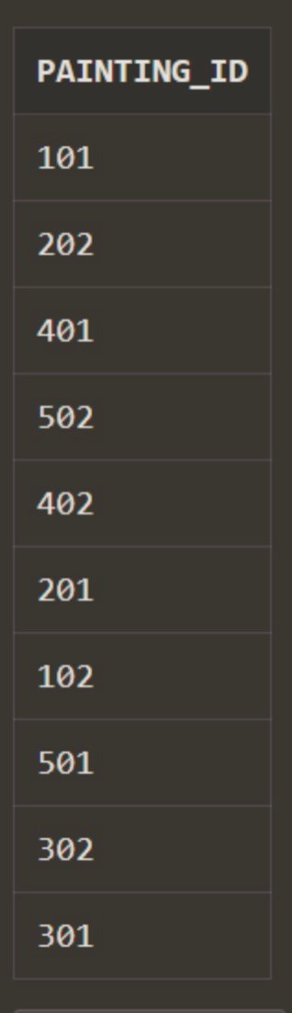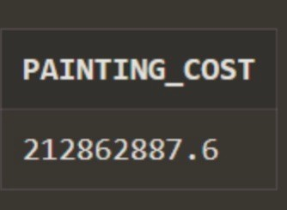

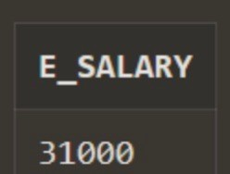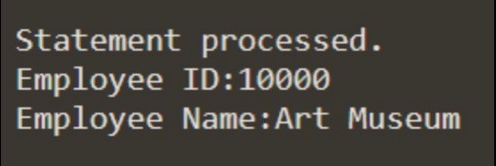Procedure

Phase3:

create table Curator(

Curator_ID Number(5) primary key,

T_ID number(5),

C_Name Varchar2(20),

Painting_ID number(3),

C_Address Varchar2(20),

C_Inoice date,

C_Quant number(2)

);

create table Museum(

M_Name Varchar2(25) primary key,

M_Address varchar2(25));

create table Employee(

EM_ID Number(5) primary key,

Me_Name varchar2(25),

E_Name Varchar2(20),

E_Salary Number (6),

E_Address Varchar2(15),

ShiftHours Number(2),

E_PhoneN Number(10)

);

create table Ticket(

UniqueID Number(5) primary key,

T_Cost Number(7),

T_Date Date,

Ma_Name varchar(25)

);

create table Painting(

Painting_ID Number(3) primary key,

M_Name varchar2(25),

Artist_Name Varchar2(20),

Painting_D Date,

Painting_T Varchar(15),

Painting_C Number(10)

);

alter table Employee

add foreign Key (Me_Name) references Museum(M_Name);

alter table Curator

add foreign key (T_ID) references Ticket(UniqueID);

alter table Curator

add foreign key (Painting_ID) references Painting(Painting_ID);

alter table Painting

add foreign key (M_name) references Museum(M_Name);

alter table Ticket

add foreign key (Ma_Name) references Museum(M_Name);

insert into museum values ('Art Museum','Riyadh');

insert into museum values ('Tres Museum','Paris');

insert into museum values ('UJ Museum','Jeddah');

insert into museum values ('AI Museum','Makkah');

insert into museum values ('Light Museum','Yanbu');

insert into ticket values (12345,50000,to_date('01-2-2023','dd-mm-yyyy'),'Art Museum');

insert into ticket values (12234,40000,to_date('04-3-2022','dd-mm-yyyy'),'Art Museum');

insert into ticket values (15555,60000,to_date('02-7-2021','dd-mm-yyyy'),'Tres Museum');

insert into ticket values (11111,80000,to_date('03-8-2020','dd-mm-yyyy'),'Tres Museum');

insert into ticket values (77777,90000,to_date('08-9-2013','dd-mm-yyyy'),'UJ Museum');

insert into ticket values (88888,10000,to_date('14-12-2017','dd-mm-yyyy'),'UJ Museum');

insert into ticket values (90987,20000,to_date('16-1-2018','dd-mm-yyyy'),'Light Museum');

insert into ticket values (15678,40000,to_date('10-11-2019','dd-mm-yyyy'),'Light Museum');

insert into ticket values (19870,12360,to_date('09-5-2012','dd-mm-yyyy'),'AI Museum');

insert into ticket values (98765,97560,to_date('07-4-2011','dd-mm-yyyy'),'AI Museum');

insert into curator values (1,12345,'Enas Alharbi',101,'Riyadh,Al-Marwa',to_date('17-08-2023','dd-mm-yyyy'),02);

insert into curator values (2,90987,'Arjwan Adel',202,'Yanbu,Badr',to_date('26-10-2017','dd-mm-yyyy'),01);

insert into curator values (3,77777,'Enas Alharbi',401,'Jeddah,Al-Marwa',to_date('03-01-2021','dd-mm-yyyy'),02);

insert into curator values (4,15555,'Micheal Blackwood',502,'Paris,montmarte',to_date('08-02-2015','dd-mm-yyyy'),01);

insert into curator values (5,88888,'Rawan Alsufiyani',402,'Jeddah,Al-Rahmanya',to_date('24-05-2014','dd-mm-yyyy'),01);

insert into curator values (6,15678,'Sandra Khalid',201,'Yanbu,Yaqut',to_date('13-04-2023','dd-mm-yyyy'),01);

insert into curator values (7,12234,'Omar Abdallah',102,'Riyadh,AnNazym',to_date('26-03-2023','dd-mm-yyyy'),01);

insert into curator values (8,11111,'Jennie kim',501,'Paris,vendome',to_date('17-08-2008','dd-mm-yyyy'),01);

insert into curator values (9,19870,'Rawan Alsufiyani',302,'Makkah,AlAndalus',to_date('17-07-2017','dd-mm-yyyy'),02);

insert into curator values (10,98765,'John Harold',301,'Makkah,AlAzizyah',to_date('17-09-2009','dd-mm-yyyy'),01);

insert into employee values (10000,'Art Museum','Lama AlHarbi',25000,'AL-FAYSALIAH',8,0504130388);

insert into employee values (22000,'Art Museum','Enas ALharbi',30000,'Al-MALQA',12,0506661230);

insert into employee values (33000,'Tres Museum','Fatma Alghamdi',12000,'SAINT-FARGEAU',6,0507894102);

insert into employee values (44000,'Tres Museum','Riham alzahrani',26000,'VIVIENNE',8,0509634851);

insert into employee values (55000,'UJ Museum','Rawan abdullah',32000,'AL-FAHAD',12,0555354466);

insert into employee values (66000,'UJ Museum','Ghada abdulaziz',45000,'AL-NASEAM',12,0508343651);

insert into employee values (77000,'AI Museum','Arjwan abdullah',22200,'AL-RASHIDIYYAH',8,0556684810);

insert into employee values (88000,'AI Museum','Khalid abdullah',23500,'ASH SHARAI',6,0565629360);

insert into employee values (99000,'Light Museum','Ahmed Alharbi',45250,'AL-JABRIAH',8,0557412695);

insert into employee values (23000,'Light Museum','Abulaziz alghamdi',10255,'AL-NAKHEEL',12,0508732156);

INSERT INTO painting VALUES (101,'Art Museum','Leonardo',to_date('17-12-1980','dd-mm-yyyy'), 'Realism',1001000);

INSERT INTO painting VALUES (102,'Art Museum',' Michelangelo',to_date('20-2-1981','dd-mm-yyyy'),'Photorealism',200200);

INSERT INTO painting VALUES (201,'Light Museum',' Rembrandt',to_date('20-2-1981','dd-mm-yyyy'),'Abstract',100010);

INSERT INTO painting VALUES (202,'Light Museum','Vermeer', to_date('18-2-1981','dd-mm-yyyy'),'Pop',300300);

INSERT INTO painting VALUES (301,'AI Museum',' Watteau', to_date('22-2-1981','dd-mm-yyyy'),'Photorealism',2120002000);

INSERT INTO painting VALUES (302,'AI Museum',' Delacroix',to_date('15-5-1999','dd-mm-yyyy'), 'Realism',4048339);

INSERT INTO painting VALUES (401,'UJ Museum',' Monet',to_date('13-2-1844','dd-mm-yyyy'),'Pop',2345800);

INSERT INTO painting VALUES (402,'UJ Museum','Seurat',to_date('10-9-1922','dd-mm-yyyy'),'Pop',28379);

INSERT INTO painting VALUES (501,'Tres Museum','Kahlo',to_date('19-10-1922','dd-mm-yyyy'), 'Realism',300900);

INSERT INTO painting VALUES (502,'Tres Museum' ,'Picasso',to_date('1756-9-29','yyyy-mm-dd'), 'Abstract',301948);

select e_salary from employee

where e_salary < 40000;

select T_cost from ticket

order by T_cost;

select avg(painting_c) as Painting_Cost from painting;

select painting.painting_ID from curator,painting where painting.painting_ID = curator.painting_id;

create or replace procedure display (r_empno number)

as

r_name employee.me_name%type;

begin

select me_name into r_name from employee

where em_id = r_empno;

dbms_output.put_line('Employee ID:' || r_empno);

dbms_output.put_line('Employee Name:' || r_name);

end display;

exec display(10000);

create or replace procedure shiftC (s_id number,credit number)

as

s_newSalary number(6);

s_oldsalary number(6);

s_shift number(2);

begin

select e_salary, shifthours into s_oldsalary,s_shift

from employee where em_id=s_id;

s_newsalary := s_oldsalary + credit;

update employee

set e_salary = s_newsalary

where em_id=s_id;

end shiftC;

exec shiftc(10000,6000);

select e_salary

from employee;

select *

from museum;

select *

from ticket;

select *

from employee;

select *

from curator;

select *

from painting;