Political Donor Polarization: Observing Consumptive Behavior using a Network Approach

October 05, 2020

American politics has recently been defined by unprecedented levels of partisan polarization. Given the concurrent rise of the amount of money in politics, many have suggested a connection between money in politics and polarization. This paper uses the occurence of a specific polarizing event, former Wisconsin Governor Scott Walker’s introduction and passage of Act 10, to analyze the relationship between donor polarization and mass polarization. Using political donation data from the Wisconsin Campaign Finance Information System (CFIS) and using the network science measure of modularity, this paper shows that political donor networks polarized during the 2012 election cycle at the same time as the electorate. This result suggests that political donors were likely not the main contributors to the polarization in the state and provides evidence for the ‘consumption’ model of political donations.

Political campaign finance plays an important role in the American political system. This significance is evidenced by the attention that academic researchers pay to the topic as well as the many different contexts in which campaign finance is studied. For example, research has been conducted on the impact of political donations on roll-call voting in the U.S. Congress (Roscoe and Jenkins 2005; Stratmann 1991), gender representation in political parties (Crowder-Meyer and Cooperman 2018; Barber, Butler, and Preece 2016; Kitchens and Swers 2016; Thomsen and Swers 2017), ability to win political campaigns (Bonica 2017; Bonneau 2007), the connection between money raised and public attention (Ellis, Ripberger, and Swearingen 2017), judicial function (Palmer and Levendis 2008), perceptions of corruption (Bowler and Donovan 2015), political economy and stock returns (Akey 2015; Fowler, Garro, and Spenkuch 2020; Cooper, Gulen, and Ovtchinnikov 2010), and the significant amount of time that candidates and legislators devote to fundraising (Torres-Spelliscy 2017).

Even though political donors are believed to play an out-sized role in democracy, the psychological processes of donors is thought to be similar to ordinary voters. Political donations can be thought of an extension of voting. In other words, both actions are political consumption that seek to improve a preferred candidate’s chances of winning. Ansolabehere, de Figueiredo and Snyder summarized this idea by stating, “In our view, campaign contributing should not be viewed as an investment, but rather as a form of consumption–or, in the language of politics, participation” (2003). Donations can be seen as an outlet for motivated citizens to increase their participation beyond just turning out to vote when they perceive the stakes of elections to be high (Hill and Huber 2017).

The folk-theory of political donors is of smokey backrooms and access-oriented donors who seek to have a direct influence on policy making. However, even when donors contribute to legislators that maximize their economic interests, donations are not found to be motivated by existing policy agreements and not an expectation of access (Barber, Canes-Wrone, and Thrower 2016). Even donations from business executives have been found to be “best understood as purchases of ‘good will’ whose returns, while positive in expectation, are contingent and rare” (Gordon, Hafer, and Landa 2007).

Although the psychological process of making a political campaign contribution can be thought of as similar to voting, there are significant demographic and ideological differences between donors and voters. People with lower incomes, less education, and do not work in professional and managerial jobs are less likely to be politically engaged, including making political donations (Laurison 2016). Donors to the Democratic and Republican parties were summarized as being “Limousine Liberals” and “Corporate Conservatives” (Francia et al. 2005). In addition, while Democrats and Republicans draw their bases of electoral support from different geographic bases, major campaign donors are highly concentrated geographically. These “big-donor neighborhoods” are unrepresentative of the country as a whole and point to these communities having a distinct political culture (Bramlett, Gimpel, and Lee 2011). In both parties, donors are more ideologically extreme than non-donating voters (Hill and Huber 2017; Francia et al. 2003) and wealthy donors who make up the “big money” in politics are especially partisan (McCarty, Poole, and Rosenthal 2006).

This ideological extremity shown by political donors has led some scholars to suggest that political donors are contributors to the partisan polarization of the politics of the United States (Francia et al. 2005). This idea is supported by the observation that both political polarization and campaign spending have risen in conjunction (McCarty, Poole, and Rosenthal 2006). However, there little evidence for the causal relationship of donors causing political polarization. Many have found that political donations don’t influence polarization (Harden and Kirkland 2016; Raja and Wiltse 2012; Keena and Knight-Finley 2019). Furthermore, it is likely the case that the causal arrow flows the other direction, and it is a more polarized electorate and candidates that have led to more polarized donors (Harden and Kirkland 2016; Raja and Wiltse 2012; Keena and Knight-Finley 2019).

[Add in section about consequences of polarized donors / why is it inmportant that we understand what is causing greater donor polarization]

Studying polarization, particularly among political donors can be difficult because of the myriad of potential confounding factors that can contribute to polarization (Harden and Kirkland 2016). In addition, polarization is generally a phenomenon that gradually increases or decreases over time (Pew Research Center 2017). However, this paper leverages a singular event, former Wisconsin Governor Scott Walker’s proposition and passage of Act 10, a “budget repair bill” that ended collective bargaining for teachers unions, to examine political donor polarization in the state of Wisconsin. Given the recent research which has pointed to the polarization of political donors as being *reactive* instead of *causal* to broader polarization, we could expect political donors to follow the trend of voters and polarize after introduction of Act 10 and subsequent events.

**: Political donors in the State of Wisconsin polarized during the 2011-2012 election cycle compared to the 2009-2010 election cycle and maintained their level of polarization in the 2013-2014 election cycle.**

If this hypothesis is supported, these results would strengthen the evidence for politics donors being *reactive* to their political environment as we would expect under Ansolabehere, de Figueiredo and Snyder’s consumption model of political giving.

Alternatively, if political donors are instead *contributors* to mass and legislative polarization, as is suggested by some scholars, we would expect to see hypothesis 2.

**: Polarization levels stays the same from 2009-2010 compared to 2011-2012.**

If hypothesis two is supported, the result would suggest that political donors helped to create the polarized political environment that we see today.

In addition, this paper makes a methodological contribution to campaign finance research by taking a network approach to measuring donor polarization by using modularity as a measure of polarization. This method has been used elsewhere in the social sciences to study congressional polarization (Waugh et al., n.d.; Zhang et al. 2008) and polarization in social media networks (Guerra et al. 2013; Garcia et al. 2015; Conover et al. 2011). This paper conceives of the political donor landscape of donors and candidates acting as nodes who are connected by donations that act as edges. This method is important in studying political donor networks because it takes into consideration real-world actions, such as in network studies of polarization among member of congress where voting records (Guerra et al. 2013) and co-sponsorships (Zhang et al. 2008) are used to study polarization opposed to surveys administered to donors that rely on self-reported ideology and partisanship.

# Wisconsin Context

Both Wisconsin’s legislators and mass public are among the most polarized in the nation (Cramer 2016), and the state been used by academics to examine how political actions unfold in contentious and highly divisive environment (Bode et al. 2018). Although many state legislatures are also experiencing polarization (Shor 2015), Wisconsin is unique in that there is a single event that many point to in creating “the most politically divisive place in America” (Kaufman 2012).

In 2011, newly-elected Republican Governor Scott Walker introduced Act 10, a “budget reconciliation bill” that stripped public school teachers of collective bargaining via their union. Up to 100,000 protested this “anti-union bill” at the State Capitol and even occupied the capitol building for a period of time (Sewell 2011). Democratic lawmakers fled to Illinois in an effort to delay or stop the bill from passing into law (Layton 2011). In 2012 there was an unsuccessful election to recall Governor Walker.

Wisconsin Governor Scott Walker’s self-anointed “divide and conquer” politics (Blake 2012) has left a political divide in Wisconsin that persists to today. The result is that “divisive politics ruled Wisconsin over the last decade” (Marley and Beck 2019). The Marquette Law School poll headed by Charles Franklin has called public opinion in Wisconsin a “lesson in the two worlds of Wisconsin” where “it seems often as if people have not only differing opinions but differing views of facts and realities” (Borsuk 2017).

[Why Wisconsin is especially good for studying your question]

# Methodology

All data on political contributions came from the Wisconsin Campaign Finance Information System (“Wisconsin Campaign Information System,” n.d.). I exported all contributions to State Assembly, State Senate, and Gubernatorial races from the 2010, 2012, and 2014 elections. This dataset does not include donations to party committees, although it does include disbursements from these committees. I manually created a table of the parties of each of all the campaigns receiving contributions in this timeframe and added the party of the campaign receiving the donation to this dataset.

To clean and analyze my data I used the statistical programming language R (R Core Team 2013; Wickham et al. 2019). I started with 1,499,603 donations. I then filtered out 3,503 unitemized/ anonymous donations, removed punctuation from the names of the donors, and used Open Refine (Kelli 2013) via the refinr R package (Muir 2018) to standardize names (for example, Jim versus James). Next, I created a unique identifier for donors by combining their standardized name with their zip code. This identifier was created to be able to link donors who contributed across multiple campaigns in multiple years without considering two different people, with the same name, from different locations to be the same person.

Next, I estimated the partisanship of each donor in each election cycle by taking the percent of donations that each donor gave to Republicans divided by their donations to Republicans and Democrats. I took that “percent donated to Republicans” and rescaled it from -1 to 1, where -1 represents the most Democratic donors, and 1 the most Republican donors. I also calculated each individual’s party bin: if more than 75% of donations were to Democrats, they were labeled as a Democrat; if more than 75% of donations were to Republicans, they were labeled as a Republican; if their donations were somewhere inbetween, they were labeled as being a bipartisan donor.

To quantify the levels of polarization in each election cycle, I calculated two statistics: network modularity and average absolute partisanship of donors.

First, political donations can be thought of as a network where donors and candidates are nodes and donations connecting donors and candidates are edges. This conceptualization of the political donor landscape as network allows us to examine the network structure and calculate network statistics on the graph of donors and candidates. One of the most useful network statistics for measuring polarization in a network is modularity (Newman 2006).

The modularity of a graph measures the strength of the division of groups (such as political parties) by calculating “the number of edges falling within groups minus the expected number in an equivalent network with edges placed at random” (Newman 2006). The modularity of a network falls in range [-1/2, 1]. If the modularity is positive, the number of edges that remain within each group is greater than the expected number to remain in-group based on chance. The higher the modularity, the greater the concentration of edges within each groups. In other words, the higher the modularity of a network, the higher the polarization among the groups. Formally, the equation to calculate modularity Q is:

In this equation is equal to the strength of all the ties in the network, is the strength/ weighted degree of the th node, is the group (in this case, party/ party bin) to which the belong, and if and belong to the same group (party/ party bin) and 0 if they do not belong to the same party/ party bin.

I calculated the modularity of the network graphs of each election cycle (2010, 2012, 2014) using the igraph R package (Csardi and Nepusz 2006). I used candidates’ declared parties and donors’ party bin as the groups for the modularity calculation. The modularity of the network graph of each election is in Table 1.

In addition to calculating the change in modularity of each of the election cycles, I also analyzed the change in mean absolute partisanship of the donors in each election cycle.

I defined a donor’s absolute partisanship as the absolute value of their partisanship score (which is on a scale from -1 to 1). Therefore, the larger a donor’s absolute the partisanship, the higher percentage of their money that they contributed to a single party. To calculate the significance in the difference of the mean absolute partisanship, I use a bootstrap methodology with 1,000 replications using the infer R package (Bray et al. 2020). This paper uses a non-parametric permutation method because of the non-Normal distribution of partisanship of the donors (98% of donors across all election cycles only contribute to a single party).

To conduct a hypothesis test with a permutation, you first compute the mean for each group of the measure that you’re interested in–in this case we are calculating the mean partisanship of donors in two given election cycles. This is difference . Next, you pool the data and randomly draw new groups of data of equal sizes of the original groups. You then calculate the difference in sample means from these random draws and compare them to your original sample mean (Wilcox 2003). This paper uses 1,000 replications, primarily to be able to calculate a p-value to the thousandths place. A p-value for a permutation test is done by calculating the proportion of randomly drawn that are greater than the original (Butar and Park 2008). In essence, you figure out what proportion of your randomized draws have a sample mean that is greater or less than your observed data–how many randomized groupings having a result that is as or more extreme than your observed groups. If your p-value is below your pre-specified level (this paper uses the standard .05) you can reject the null hypothesis.

The results of the bootstrap are found in Table 2.

# Results

The results of this analysis show that political donors in Wisconsin polarized during the 2012 election cycle, the same time that mass polarization occurred in the state. This phenomenon is best visualized in Figure 1. This figure uses the Yifan Hu layout algorithm (Hu 2005) in the Gephi software (Bastian, Heymann, and Jacomy 2009), a force-directed graphical layout of networks that seeks to repulse clusters of nodes from one another. The Yifan Hu layout algorithm is a standard among social scientists studying networks such as online networks (Rehman et al. 2020; Adalat, Niazi, and Vasilakos 2018; Khonsari et al. 2010; Hemsley et al. 2015). This visual representation shows two distinct clusters of donors (Democrats and Republicans) that are reasonably close to one another in the 2010 election cycle and then polarize significantly in the 2012 election cycle and remain polarized in 2014.

This graphical representation reflects statistical measures of polarization within the networks. Table 1 show the modularity of the networks in the 2010, 2012, and 2014 election cycles. In 2010, the modularity of the donor network is 0.4. The modularity for the 2012 cycle climbs to 0.49 and settles in at 0.48 during the 2014 cycle. The interpretation of modularity is the higher the number, the more observed polarization within the network. As such, the rise in modularity in the 2012 cycle depicts polarization within the donor network in 2012 compared to 2010. And then the steady modularity in the 2014 cycle reveals a stabilization of the level of polarization observed in the 2012 election cycle.

One limitation of a modularity calculation is that it does not quantify uncertainty. To validate the results of the modularity calculation, I conducted a hypothesis test. Table 2 compares the average absolute donor partisanship in 2012 compared to 2010 and 2014 compared to 2012. As the table shows, donors in the 2012 election cycle became much more partisan with an average change of absolute of partisanship of 0.04214 (CI = 0.04019-0.044, p-value = <.001). However, there was not a statistically signiciant change in mean absolute partisanship in the 2014 election cycle compared to the 2012 election cycle (0.04214, CI = 0.04019-0.044, p-value = <.001).

Taken together, the results of the modularity calculations and the hypothesis tests support the rejection of the null of and fail to reject the null of the alternative . In other words, political donors in Wisconsin had a statistically significant increase in polarization in the 2012 election cycle–the same time as when other scholars and experts point towards the mass polarization of the state. [Find mass polarization data, hopefully MU law poll]

Additional data and graphs are provided to contextualize the polarization that is observed among political donors in Wisconsin. Figure 2 shows the partisan flow of political donors across the election cycles, including the massive influx of new donors in both the 2012 and 2014 election cycles. Figure 3 shows the partisan shift of donors who contributed in both the 2010 and 2012 election cycles. Figure 4 shows the geographical shifts of donor partisanship.

# Discussion

The failure to reject the null of suggests that political donors were likely not the main contributors to the extreme levels of polarization first seen in the state in 2012. Other factors such as Governor Scott Walker’s Act 10 and a more polarized primary electorate in the wake of the Tea Party in 2010 (Jacobson 2012), and electing election Governor Walker in the first place, appear to be the contributors to mass polarization and political donors in Wisconsin.

These results also provide evidence for the ‘consumption’ model of political donations. Ansolabehere, de Figueiredo and Syder’s (2003) conclusion that political donations are similar to voting in that they are both acts of political consumption are borne out in the results of this paper. Polarization of political donors happened in unison with the polarization of the electorate. The conclusion that we can draw is that the polarization of these two groups of people were a behavioral, participatory response to a changing political environment. Both the electorate and donors have specific acts of political consumption (voting and donating, respectively) that were both impacted in the same way at the same time.

Further evidence for this consumption model is the idea that political donations are an extension of voting in the broader realm of political participation. The inflow of new donors show in Figure 2 suggests that the same mechanism that triggered mass polarization also spurred members of the mass electorate to go beyond voting and make political contributions. Previous research by Oklobzija (2016) reached a similar conclusion that “politically polarizing events bear dividends for extremist lawmakers” in California who raised more money as a result of polarizing political events. Even though new donors are the likely explanation for most of the polarization observed in the networks, donors that contributed in both the 2010 and 2012 election cycles also showed significant movement. The shift among donors whose contributions are not purely partisan shift to be more Republican. Figure 3 shows how donors who were not pure partisan donors in 2010 much more often became purely Republican donors compared to Democartic donors. [Add split-ticket voting discussion]

[Add paragraph on geographic sorting]

In short, it appears that political donations are an extension of voting, an outlet for political participation when individuals perceive the stakes of the election to be high (Hill and Huber 2017). And so it would be reasonable to find that political donors are not the cause of political polarization. But in fact, more polarized donors are a reflection of polariztion seen elsewhere in American politics.

# Tables

Modularity calculation for the donor networks in each election cycle. Higher modularity means more polarization.

|  |  |
| --- | --- |
| Election Cycle | Modularity |
| 2010 | 0.3987139 |
| 2012 | 0.4912348 |
| 2014 | 0.4797870 |

Bootstrapped difference-in-means test with 1,000 replications comparing mean partisanship of donors.

|  |  |  |  |
| --- | --- | --- | --- |
| Election Cycle | T | CI | p |
| 2012 compared to 2010 | 0.04214 | 0.04019-0.044 | <.001 |
| 2014 compared to 2012 | -0.00027 | -0.00087-0.00035 | 0.358 |

# Figures

### Figure 1

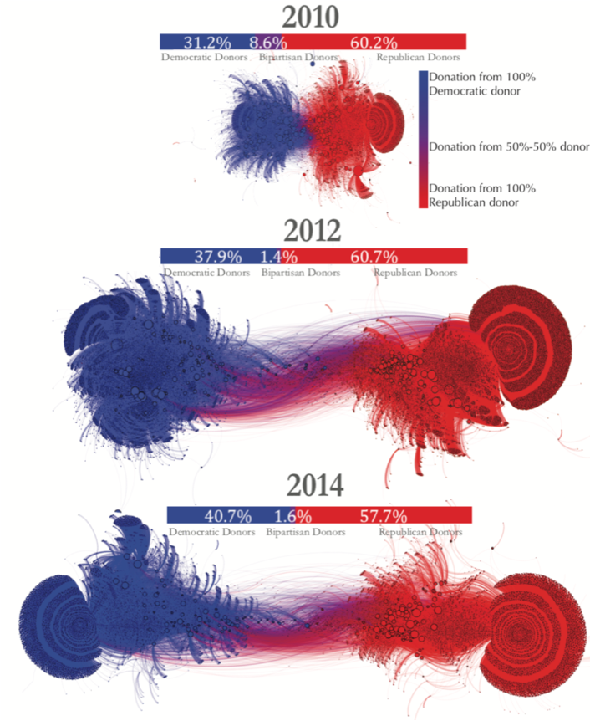

Visual representation of Wisconsin donor networks in the 2010, 2012 and 2014 election cycle using the Yifan Hu layout algorithm. Each dot/ node is a donor or campaign and lines/ edges connecting them are donations. Nodes sized by in-degree (incoming donations. Nodes and edges are colored by the partisanship of the donor. Percentages on the bars reprsent the percent of donors in each party bin.

### Figure 2

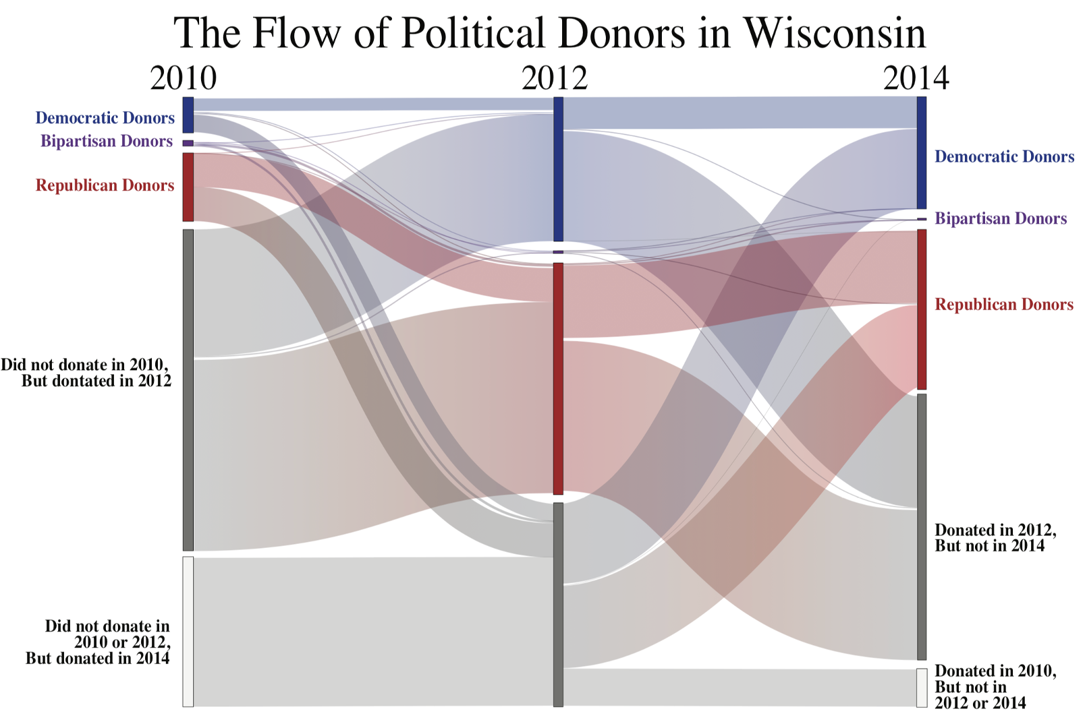

Sankey diagram of the flow of political donors in 2010, 2012, and 2014 election cycles in Wisconsin. The vertical bars are proportional to the number of donors in each bin.

# References

Adalat, Mohsin, Muaz A. Niazi, and Athanasios V. Vasilakos. 2018. “Variations in Power of Opinion Leaders in Online Communication Networks.” *Royal Society Open Science* 5 (10).

Akey, Pat. 2015. “Valuing Changes in Political Networks: Evidence from Campaign Contributions to Close Congressional Elections.” *The Review of Financial Studies* 28 (11): 3188–3223.

Ansolabehere, Stephen, John M. de Figueiredo, and James M. Snyder Jr. 2003. “Why Is There so Little Money in U.s. Politics.” *Journal of Economic Perspectives* 17 (1): 105–30.

Barber, Michael J., Daniel M. Butler, and Jessica Preece. 2016. “Gender Inequalities in Campaign Finance.” *Quarterly Journal of Political Science* 1 (2): 219–48.

Barber, Michael J., Brandice Canes-Wrone, and Sharece Thrower. 2016. “Ideologically Sophisticated Donors: Which Candidates Do Individual Contributors Finance.” *American Journal of Political Science* 61 (2): 1057–72.

Bastian, Mathieu, Sebastien Heymann, and Mathieu Jacomy. 2009. “Gephi: An Open Source Software for Exploring and Manipulating Networks.” <http://www.aaai.org/ocs/index.php/ICWSM/09/paper/view/154>.

Blake, Aaron. 2012. “Scott Walker Said Budget Strategy in Wisconsin Was ’Divide and Conquer’.” *The Washington Post*, May.

Bode, Leticia, Stephanie Edgerly, Chris Wells, Itay Gabay, Charles Franklin, Lew Friedland, and Dhavan V. Shah. 2018. “Participation in Contentious Politics: Rethinking the Roles of News, Social Media, and Conversation Amid Divisiveness.” *Journal of Information Technology & Politics* 15 (3): 215–29.

Bonica, Adam. 2017. “Professional Networks, Early Fundraising, and Electoral Success.” *Election Law Journal: Rules, Politics, and Policy* 16 (1): 153–71.

Bonneau, Chris W. 2007. “Campaign Fundraising in State Supreme Court Elections.” *Social Science Quartlery* 88 (1): 68–85.

Borsuk, Alan. 2017. “New Poll Gives Vivid Look into Polarized Political Perceptions.” June 29, 2017. <https://law.marquette.edu/poll/2017/06/29/new-poll-gives-vivid-look-into-polarized-political-perceptions/>.

Bowler, Shaun, and Todd Donovan. 2015. “Campaign Money, Congress, and Perceptions of Corruption.” *American Politics Research* 44 (2): 272–95.

Bramlett, Brittany H., James G. Gimpel, and Frances E. Lee. 2011. “The Political Ecology of Opinion in Big-Donor Neighborhoods.” *Political Behavior* 33: 565–600.

Bray, Andrew, Chester Ismay, Evgeni Chasnovski, Ben Baumer, Mine Cetinkaya-Rundel, Simon Couch, Ted Laderas, et al. 2020. *Infer: Tidy Statistical Inference*. <https://cran.r-project.org/web/packages/infer/index.html>.

Butar, Ferry, and Jae-Wan Park. 2008. “Permutation Tests for Comparing Two Populations.” *MSME* 3 (September): 19–30.

Conover, Michael D., Jacob Ratkiewicz, M. Francisco, B. Gonçalves, F. Menczer, and A. Flammini. 2011. “Political Polarization on Twitter.” In *ICWSM*.

Cooper, Michael J., Huseyin Gulen, and Alexei V. Ovtchinnikov. 2010. “Corporate Political Contributions and Stock Returns.” *The Journal of Finance* 65 (2): 687–724.

Cramer, K. J. 2016. *The Politics of Resentment: Rural Consciousness in Wisconsin and the Rise of Scott Walker*. Chicago Studies in American Politics. University of Chicago Press. <https://books.google.com/books?id=Rg2ZCwAAQBAJ>.

Crowder-Meyer, Melody, and Rosalyn Cooperman. 2018. “Can’t Buy Them Love: How Party Culture Among Donors Contributes to the Party Gap in Women’s Representation.” *The Journal of Politics* 80 (4): 1211–24.

Csardi, Gabor, and Tamas Nepusz. 2006. “The Igraph Software Package for Complex Network Research.” *InterJournal* Complex Systems: 1695. <http://igraph.org>.

Ellis, William Curtis, Joseph T. Ripberger, and Colin Swearingen. 2017. “Public Attention and Head-to-Head Campaign Fundraising: An Examination of U.s. Senate Elections.” *American Review of Politics* 36 (1): 30–53.

Fowler, Anthony, Haritz Garro, and Jörg L. Spenkuch. 2020. “Quid Pro Quo? Corporate Returns to Campaign Contributions.” *The Journal of Politics* 82 (3): 844–58.

Francia, Peter L., John C. Green, Paul S. Herrnson, Lynda W. Powell, and and Clyde Wilcox. 2003. *The Financiers of Congressional Elections*. New York, NY: Columbia University Press.

Francia, Peter L., John C. Green, Paul S. Herrnson, Lynda W. Powell, and Clyde Wilcox. 2005. “Limousine Liberals and Corporate Conservatives: The Financial Constituencies of the Democratic and Republican Parties.” *Social Science Quarterly* 86 (4): 761–78.

Garcia, David, Adiya Abisheva, Simon Schweighofer, Uwe Serdült, and Frank Schweitzer. 2015. “Ideological and Temporal Components of Network Polarization in Online Political Participatory Media.” *Policy & Internet* 7 (1): 46–79.

Gordon, Sanford C., Catherine Hafer, and Dimitri Landa. 2007. “Consumption or Investment? On Motivations for Political Giving.” *The Journal of Politics* 69 (4).

Guerra, P. H. Calais, Wagner Meira Jr., Clair Cardie, and R. Kleinberg. 2013. “Party Polarization in Congress: A Network Science Approach.” *Proceedings of the 7th International Conference on Weblogs and Social Media, ICWSM 2013*, January, 215–24.

Harden, Jeffrey J., and Justin H. Kirkland. 2016. “Do Campaign Donors Influence Polarization? Evidence from Public Financing in the American States.” *Legislative Studies Quarterly* 41 (1): 119–1542.

Hemsley, Bronwyn, Stephen Dann, Stuart Palmer, Meredith Allan, and Susan Balandin. 2015. “‘We Definitely Need an Audience’: Experiences of Twitter, Twitter Networks and Tweet Content in Adults with Severe Communication Disabilities Who Use Augmentative and Alternative Communication (Aac).” *Disability and Rehabilitation* 37 (17): 1531–42. <https://doi.org/10.3109/09638288.2015.1045990>.

Hill, Seth J., and Gregory A. Huber. 2017. “Representativeness and Motivations of the Contemporary Donorate: Results from Merged Survey and Administrative Records.” *Political Behavior* 39 (March): 3–29.

Hu, Yifan. 2005. “Efficient, High-Quality Force-Directed Graph Drawing.” *Mathematica Journal* 10 (1): 37–71.

Jacobson, Gary C. 2012. “The Electoral Origins of Polarized Politics: Evidence from the 2010 Cooperative Congressional Election Study.” *American Behavioral Scientist* 56 (12): 1612–30.

Kaufman, Dan. 2012. “How Did Wisconsin Become the Most Politically Divisive Place in America?” *The New York Times Magazine*, May.

Keena, Alex, and Misty Knight-Finley. 2019. “Are Small Donors Polarizing? A Longitudinal Study of the Senate.” *Election Law Journal: Rules, Politics, and Policy* 18 (2): 132–44.

Kelli, Ham. 2013. “OpenReinfe (Version 2.5).” *Journal of the Medical Library Association* 101 (3): 233–34.

Khonsari, K. K., Z. A. Nayeri, A. Fathalian, and L. Fathalian. 2010. “Social Network Analysis of Iran’s Green Movement Opposition Groups Using Twitter.” In *2010 International Conference on Advances in Social Networks Analysis and Mining*, 414–15.

Kitchens, Karin E., and Michele L. Swers. 2016. “Why Aren’t There More Republican Women in Congress? Gender, Partisanship, and Fundraising Support in the 2010 and 2012 Elections.” *Politics & Gender* 12 (4): 648–76.

Laurison, Daniel. 2016. “Social Class and Political Engagement in the United States.” *Sociology Compass* 10 (9): 684–97.

Layton, Lyndsey. 2011. “’Wisconsin 14’ Group of Democratic Senators Returns, Greeted by Thousands at Capitol.” *The Washington Post*, March.

Marley, Patrick, and Molly Beck. 2019. “Divisive Politics Ruled Wisconsin over the Last Decade.” *Milwaukee Journal Sentinel*, December.

McCarty, Nolan, Keith T. Poole, and Howard Rosenthal. 2006. *Polarizaed America: The Dancedance of Ideology and Unequal Riches*. Cambridge, Mass: MIT Press.

Muir, Chris. 2018. *Refinr: Cluster and Merge Similar Values Within a Character Vector*. <https://cran.r-project.org/web/packages/refinr/index.html>.

Newman, M. E. J. 2006. “Modularity and Community Structure in Networks.” *Proceedings of the National Academy of Sciences* 103 (23): 8577–82. <https://doi.org/10.1073/pnas.0601602103>.

Oklobdzija, Stan. 2016. “Closing down and Cashing in: Extremism and Political Fundraising.” *State Politics & Policy Quarterly* 17 (2): 201–24.

Palmer, Vernon Valentine, and John Levendis. 2008. “The Louisiana Supreme Court in Question: An Empirical and Statistical Study of the Effects of Money on the Judicial Function.” *Tulane Law Review* 82 (4): 1291–1314.

Pew Research Center. 2017. “The Partisan Divide on Political Values Grows Even Wider.” online.

Raja, Raymond J. La, and David L. Wiltse. 2012. “Don’t Blame Donors for Ideological Polarization of Political Parties: Ideological Change and Stability Among Political Contributors, 1972-2008.” *American Politics Research* 40 (3): 501–30.

R Core Team. 2013. *R: A Language and Environment for Statistical Computing*. Vienna, Austria: R Foundation for Statistical Computing. <http://www.R-project.org/>.

Rehman, Ateeq Ur, Aimin Jiang, Abdul Rehman, Anand Paul, Sadia din, and Muhammad Tariq Sadiq. 2020. “Identification and Role of Opinion Leaders in Information Diffusion for Online Discussion Network.” *Journal of Ambient Intelligence and Humanized Computing*, January.

Roscoe, Douglas D., and Shannon Jenkins. 2005. “A Meta-Analysis of Campaign Contributions’ Impact on Roll Call Voting.” *Social Science Quartlery* 86 (1): 52–68.

Sewell, Abby. 2011. “Protesters Out in Force Nationwide to Oppose Wisconsin’s Anti-Union Bill.” *Los Angeles Times*, February.

Shor, Boris. 2015. “Polarization in American State Legislatures.” In *American Gridlock: The Sources, Character, and Impact of Political Polarization*, edited by James A. Thurber and AntoineEditors Yoshinaka, 203–21. Cambridge University Press. <https://doi.org/10.1017/CBO9781316287002.011>.

Stratmann, Thomas. 1991. “What Do Campaign Contributions Buy? Deciphering Causal Effects of Money and Votes.” *Southern Economic Journal* 57 (3): 606–20.

Thomsen, Danielle M., and Michele L. Swers. 2017. “Which Women Can Run? Gender, Partisanship, and Candidate Donor Networks.” *Political Research Quarterly* 70 (2): 449–63.

Torres-Spelliscy, Ciara. 2017. “Time Suck: How the Fundraising Treadmill Diminishes Effetive Governance.” *Seton Hall Legislative Journal* 42 (December).

Waugh, Andrew Scott, Liuyi Pei, James H. Fowler, Peter J. Mucha, and Mason Alexander Porter. n.d. “Party Polarization in Congress: A Network Science Approach.”

Wickham, Hadley, Mara Averick, Jennifer Bryan, Winston Chang, Lucy D’Agostino McGowan, Romain François, Garrett Grolemund, et al. 2019. “Welcome to the tidyverse.” *Journal of Open Source Software* 4 (43): 1686. <https://doi.org/10.21105/joss.01686>.

Wilcox, Rand R. 2003. “8 - Comparing Two Independent Groups.” In *Applying Contemporary Statistical Techniques*, edited by Rand R. Wilcox, 237–84. Burlington: Academic Press. <https://doi.org/https://doi.org/10.1016/B978-012751541-0/50029-8>.

“Wisconsin Campaign Information System.” n.d. <https://cfis.wi.gov/#>.

Zhang, Yan, A. J. Friend, Amanda L. Traud, Mason A. Porter, James H. Fowler, and Peter J. Mucha. 2008. “Community Sructure in Congressional Cosponsorship Networks.” *Physica A: Statistical MEchanics and Its Applications* 387 (1): 1705–12.