Political Donor Motivations and Social Media: A Time-Series Analysis

Ross Dahlke

December 03, 2020

The two predominant theories of political donor motivations are the access-oriented model (Fouirnaies and Hall 2015) and the consumption model (Ansolabehere, Figueiredo, and Snyder 2003). This paper combines political donation records and social media posts from politicians to test whether either behavior is observed. In the access-oriented model, individual political donors and political action committees (PACs) are assumed to contribute to campaigns in an effort to acquire access and influence politicians into supporting specific policy issues (Fouirnaies and Hall 2015). In this study, the access-oriented model of donors predicts that donations from specific groups of donors will precede public support of certain policies. The consumption model of donors views political contributions as being an extension of voting along a participatory spectrum, and that donors support candidates who they already know support policy issues that the donors care about or are ideologically motivated (Barber 2016; Johnson 2010). In this research, the consumption model predicts that donations from various groups of donors will lag in response to public support of certain policy issues. Previous studies have also posited these two models of political donor motivations against each other (Heerwig 2016).

# Data

Data for this research comes from two primary sources: politicians’ social media posts and political donation data. For social media posts, this paper used the Facebook (Barbera, Geisler, and Atteveldt 2017) and Twitter (Kearney 2019) APIs to collect social media posts from all candidates for the Wisconsin State Senate and Wisconsin State Assembly during the 2016 election cycle (*n* = 82,851). A subset of these posts were hand-coded into 27 topical categories. This subset was used to train a BERT deep learning transfer model that was used to predict the topic of the remainder of the posts (training dataset = 8,242, 10% of total posts; testing dataset = 4,122, 5% of total posts). Political donation data for all candidates to the Wisconsin State Legislature during the 2016 election cycle were collected from the Wisconsin Campaign Information System (CFIS) (*n* = 12,962). These donations were used to create a network of political donations with candidates and donors serving as nodes and donations between them as edges. This network was clustered into distinct communities so that donors in each community are most similar to one another based on which campaigns they contributed to. I theorize that these clusters of donors represent *latent coalitions* of donors who, whether they operate in an organized fashion or not, are working toward the goal of electing the same candidates. Studying political fundraisers as members of political coalitions has been studied in the past (Adams 2007; Heerwig 2016). This paper’s statistically-driven definition of latent coalitions seeks to add to the coalition literature.

# Methodology

These two datasets were analyzed against each other using the Granger causality time-series methodology. This methodology has been used by other researchers to study social media (Freelon, McIlwain, and Clark 2018; Lukito 2020). Similar to political donations, this methodology has been used to study the relationship between social media and non-social media events such as offline protests (Bastos, Mercea, and Charpentier 2015) and stock prices (Park, Leung, and Ma 2017). Granger causality detects whether movements in one time series precedes, lags, has a confounding variable, or is not related to another time series. Specifically, this paper compares time series of donations from clusters of political donors and times series of the number of social media posts by each topic that were made by campaigns that each donor cluster contributed to. For example, a time series of donations from a donor coalition was compared to the aggregate count of posts about a given topic made by candidates that the donor cluster contributed to.

# Preliminary Results

Initial results suggest that it is more common to observe behavior consistent with the consumption model (31% of coalitions, 4/13) than the access-oriented model. However, the access-oriented model is still observed in 15% of coalition (2/13). Under a strict interpretation of either model, we would expect to find behavior that fits only with that model. These results that find both the models present in the data is in line with some other research in suggesting that there are a “diversity of roles individual contributors play in the campaign finance system” (Heerwig 2016). Specific results of the Granger causality model are in Figure 1 below.

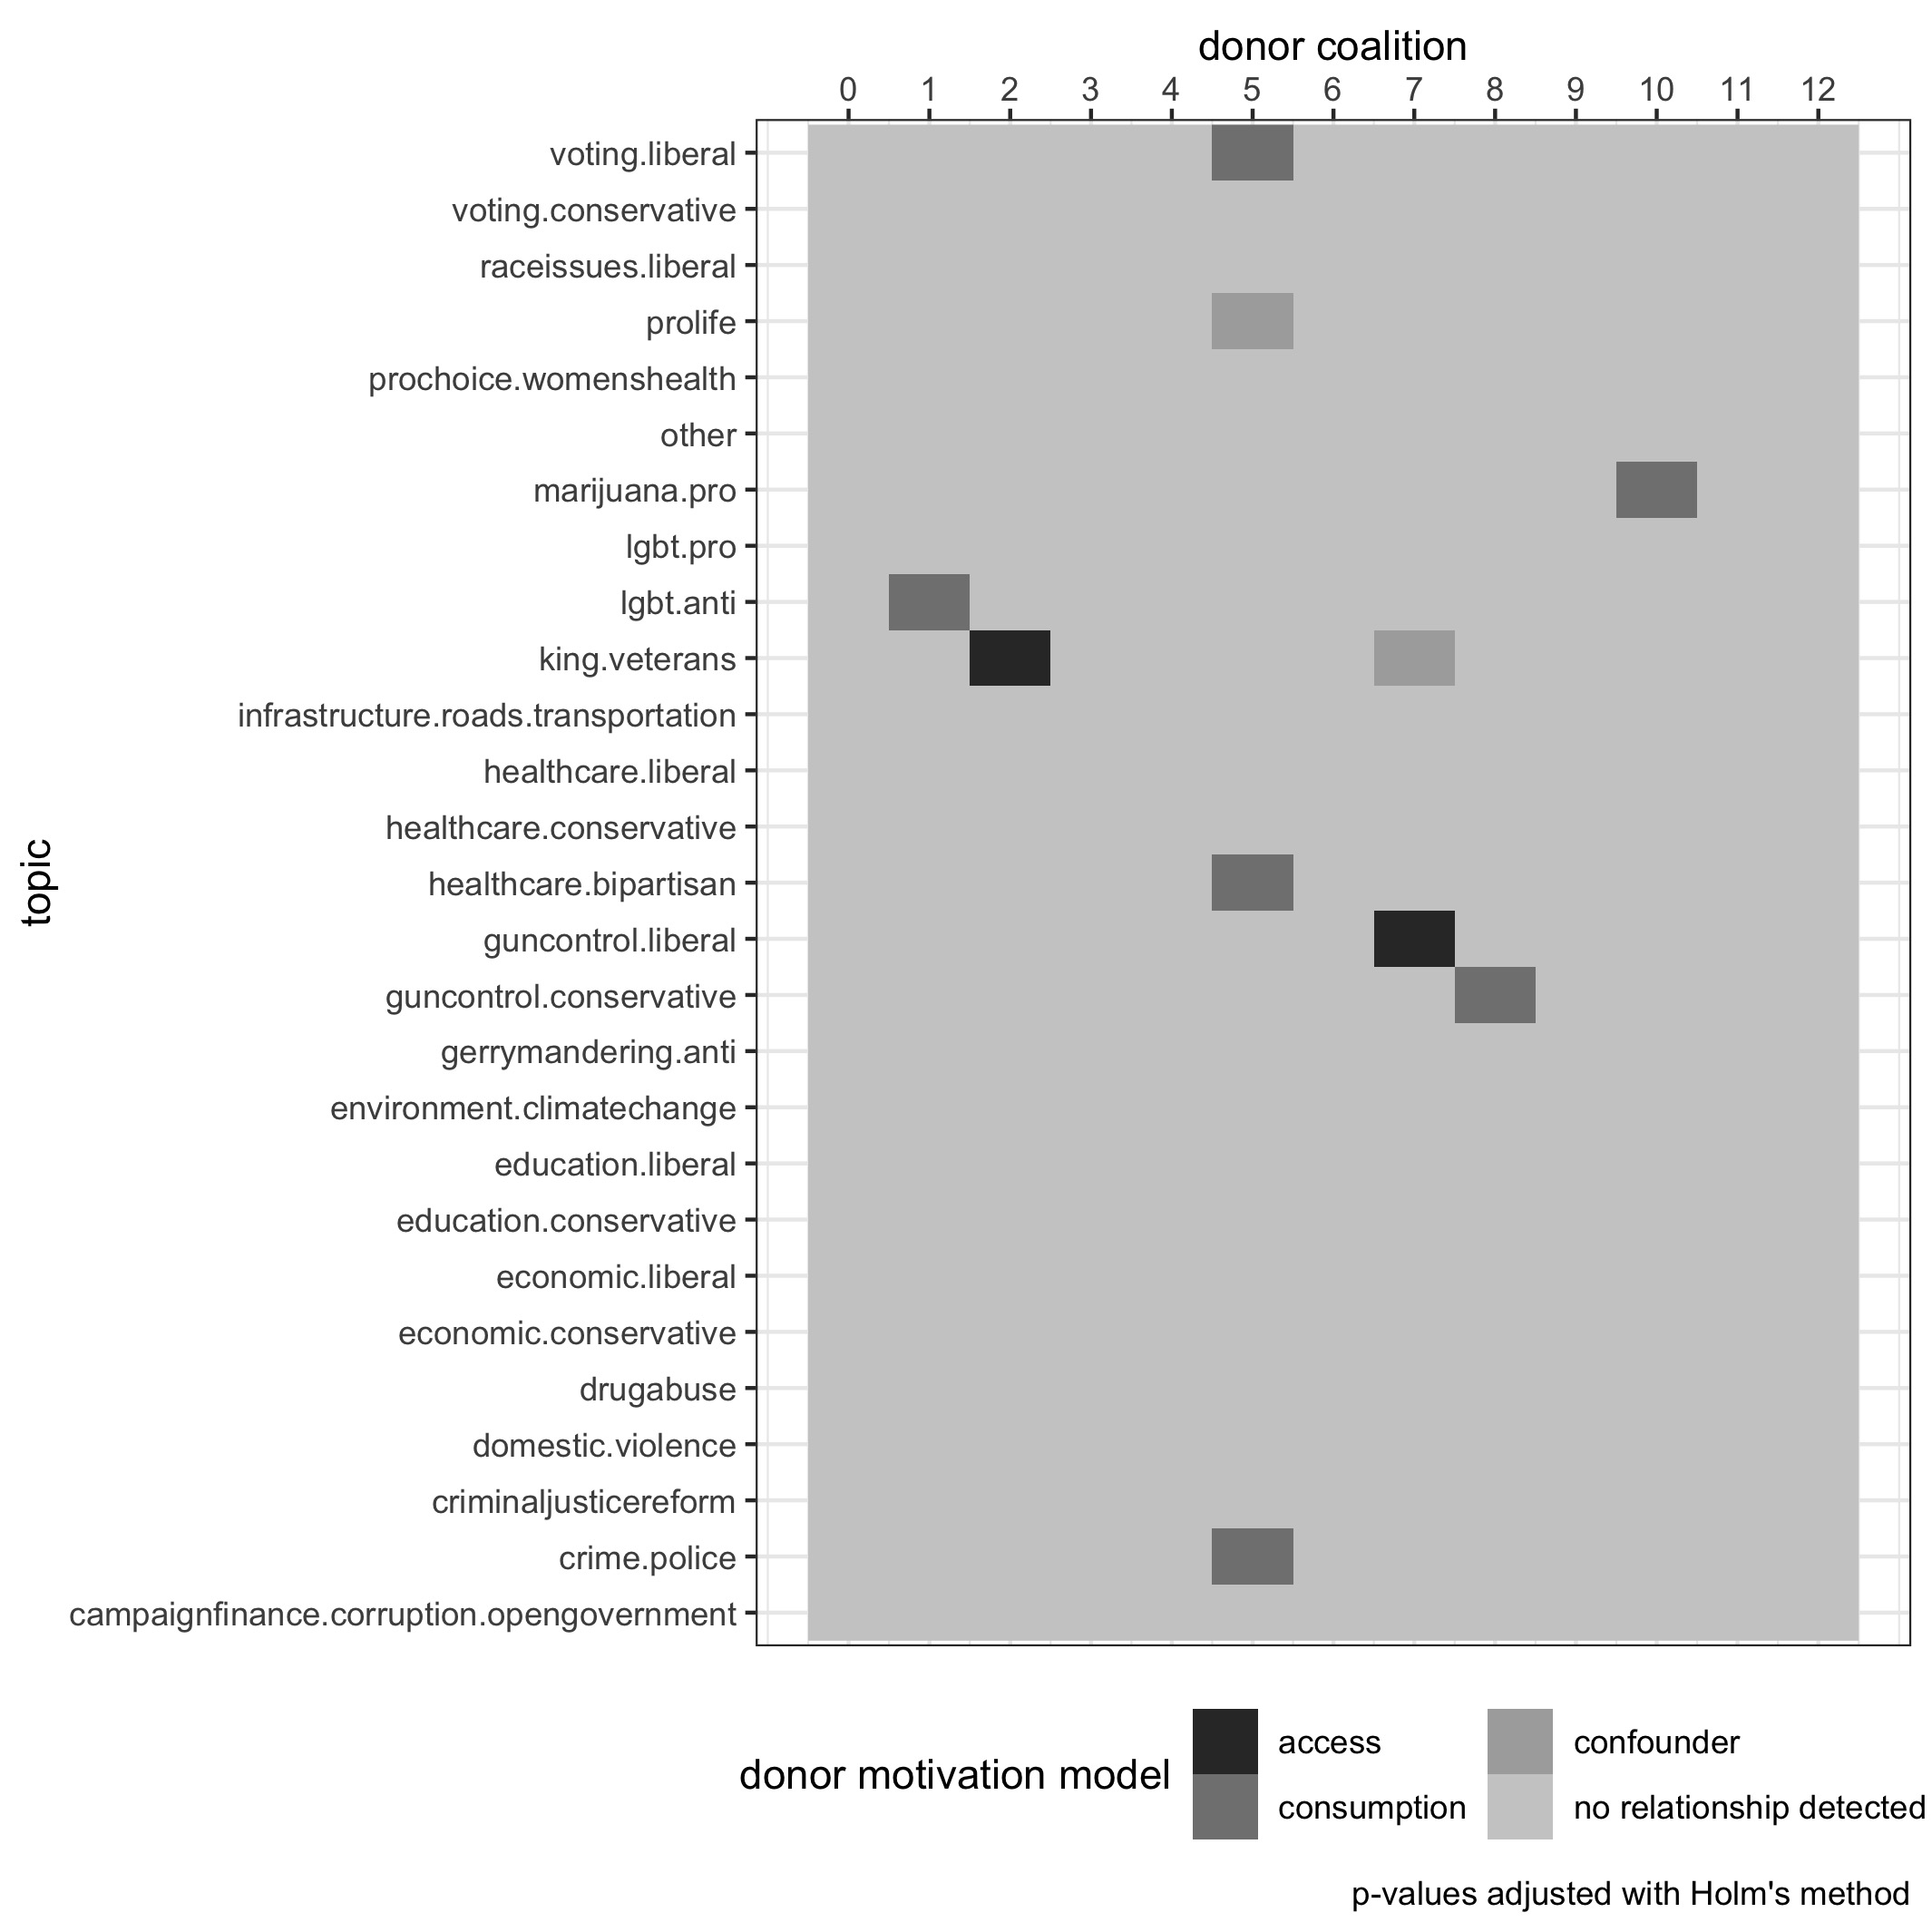

Donor Motivation Models

One theoretical next step for this paper is to flesh out the implications of observing behavior that fits under both the consumption and access-oriented model of political donors. Most often, the literature assumes that political donors have monolithic a monolithic psychological process that motivate them. However, the clear breakdown of different coalitions exhibiting behavior that falls into different models, and distinct behavior in relation to unique policy issues, suggests that latent coalitions of political donors are strategic actors with unique motivations. One empirical next step is to quantify potential confounders for donor clusters that don’t fit under either model, such as geographic proximity or competitiveness of the races contributed to.

# References

Adams, Brian E. 2007. “Fundraising Coalitions in Open Seat Mayoral Elections.” *Journal of Urban Affairs* 29 (5): 481–99. <https://doi.org/10.1111/j.1467-9906.2007.00361.x>.

Ansolabehere, Stephen, John M. de Figueiredo, and James M. Snyder. 2003. “Why Is There so Little Money in U.s. Politics.” *Journal of Economic Perspectives* 17 (1): 105–30.

Barber, Michael. 2016. “Donation Motivations: Testing Theories of Access and Ideology.” *Political Research Quarterly* 69 (1): 148–59.

Barbera, Pablo, Andrew Geisler, and Wouter van Atteveldt. 2017. *Rfacebook*. <https://cran.r-project.org/web/packages/Rfacebook/Rfacebook.pdf>.

Bastos, Marco T., Dan Mercea, and Arthur Charpentier. 2015. “Tents, Tweets, and Events: The Interplay Between Ongoing Protests and Social Media.” *Journal of Communication* 65 (2): 320–50. <https://doi.org/10.1111/jcom.12145>.

Fouirnaies, Alexander, and Andrew Hall. 2015. “The Exposure Theory of Access: Why Some Firms Seek More Access to Incumbents Than Others.” *SSRN Electronic Journal*, January. <https://doi.org/10.2139/ssrn.2652361>.

Freelon, D, C McIlwain, and M Clark. 2018. “Quantifying the Power and Consequences of Social Media Protest.” *New Media & Society* 20 (3): 990–1011. <https://doi.org/10.1177/1461444816676646>.

Heerwig, Jennifer A. 2016. “Donations and Dependence: Individual Contributor Strategies in House Elections.” *Social Science Research* 60: 181–98. <https://doi.org/https://doi.org/10.1016/j.ssresearch.2016.06.001>.

Johnson, Bertram. 2010. “Individual Contributions: A Fundraising Advantage for the Ideologically Extreme?” *American Politics Research*, June, 890–908. <https://doi.org/10.1177/1532673X09357500>.

Kearney, Michael W. 2019. “Rtweet: Collecting and Analyzing Twitter Data.” *Journal of Open Source Software* 4 (42): 1829. <https://doi.org/10.21105/joss.01829>.

Lukito, Josephine. 2020. “Coordinating a Multi-Platform Disinformation Campaign: Internet Research Agency Activity on Three U.s. Social Media Platforms, 2015 to 2017.” *Political Communication* 37 (2): 238–55. <https://doi.org/10.1080/10584609.2019.1661889>.

Park, J., H. Leung, and K. Ma. 2017. “Information Fusion of Stock Prices and Sentiment in Social Media Using Granger Causality.” In *2017 Ieee International Conference on Multisensor Fusion and Integration for Intelligent Systems (Mfi)*, 614–19. <https://doi.org/10.1109/MFI.2017.8170390>.