Political Donor Motivations and Public Support of Policies: A Time Series Analysis

Ross Dahlke

February 22, 2021

The two predominant theories of political donor motivations are the access-oriented model and the consumption model. This paper combines political donation records and social media posts from politicians to examine behaviors predicted by these two theories. In the access-oriented model, individual political donors and political action committees (PACs) are assumed to contribute to campaigns in an effort to acquire access and influence politicians into supporting specific policy issues. The access-oriented model of donors predicts that donations from specific groups of donors will precede public support of certain policies. The consumption model of donors views political contributions as being an extension of voting along a participatory spectrum, and that donors support candidates who they already know support policy issues that the donors care about or are ideologically motivated. The consumption model predicts that donations from various groups of donors will lag in response to public support of certain policy issues. Historically, these two models have treated political donors as all having the same motivations. More recent studies in campaign finance have found that both motivational models can exist in different groups of donors. This paper statistically derives coalitions of similar donors and tests the competing models of political donor motivations on these more granular groups of donors who support similar candidates. We find that both models are observed in real-life data.

# Introduction

The amount of money raised and spent by political campaigns in the United States continues to rise with each election cycle (Goldmacher 2020). However, the explanations of the motivations of political donors, the psychological reasons why political donors decide to make a contribution, remain unsettled. The predominant theories of political donor motivation fall into two broad categories, the access-oriented model or the consumption model. In the access-oriented model, contributions are given in exchange for access and political favors that presumably materialize in altered government policy (Francia et al. 2003). The consumption model of donations sees donors as participants in the political process who seek to alter election probabilities in a way that helps one’s preferred campaign, similar to how voting seeks to help a campaign achieve election (Ansolabehere, Figueiredo, and Snyder 2003).

The prevalence of the two theories in political science literature has varied across time. In the twentieth century, the bulk of academic inquiry into the motivations of political donors focused on the access-oriented model, particularly around Political Action Committees (PACs) and interest group politics (e.g., Herndon 1982). In the early- to mid-2000s, political scientists shifted their focus to and found evidence of the consumption model of donor motivations (e.g., Ansolabehere, Figueiredo, and Snyder 2003). In response to the *Citizens United* U.S. Supreme Court case in 2010, research focus again shifted back to the effects of the increased amount of money being donated to political campaigns and causes (e.g., Fouirnaies 2018).

The present work eschews a zero-sum view of the motivations of political donors. Instead, the two predominant models are both investigated with assumptions that allow them to exist together by looking for both motivational models among different communities of donors. While much of the research history of political donor motivations has either pitted the two models of motivation against one another (Welch 1980) or operated exclusively in the domain of one and not the other (Fellowes and Wolf 2004), recent scholarship has developed a more nuanced view of the motivations of political donors in that they are not a monolith and that different donors can have different motivations.

This emerging, more nuanced view on the motivations of political donors is that donors are unique actors. Different donors may have different motivations, intents, and goals in making a political contribution. This recent scholarship has divided political donors into different groups and studied the two models, access-oriented and consumption, within these different groups. One way to divide political donors is into PACs versus individuals, with PACs’ behavior being inline with the access-oriented model and individuals broadly being found to exhibit behavior consistent with the consumption model (Barber 2016). Another way to group individual donors is into frequent or infrequent donors, with frequent donors having been found to be access-oriented where infrequent donors are consumption-oriented (Heerwig 2016). Even more granularly, individual donors can be characterized into further specific descriptive categories with different categorizations showing different types of motivation for making a contribution (Rhodes, Schaffner, and Raja 2018).

This paper employs a novel clustering approach to find statistically similar political donors and layers in politicians’ social media data to advance our understanding of the distinct motivations of political donors, including the policy issues that may motivate them to make a contribution. Instead of making a descriptive distinction between donors, such as PACs versus individuals (Barber 2016), frequent versus infrequent donors (Heerwig 2016), or other heuristics (Rhodes, Schaffner, and Raja 2018), donors are clustered together based on their network connections. This type network-based approach has started to emerge among computer science and machine learning researchers (Wahl and Sheppard 2018) who then make descriptive summaries of the statistical communities. We add a political psychological component to this approach by layering in an additional unique dataset, social media data from politicians, to identify behaviors and potentially the underlying reasons why donors are in the same statistical community. This paper combines these two datasets to test theories of motivations in clusters of political donors.

In a network-based approach, donor clusters act as a *latent coalition* where different coalitions can have a distinct motivation. Previous network studies have concluded that this type of network clustering has been highly predictive for other types of political analysis, including voting behavior in the U.S. House of Representatives and Senate (Wahl, Sheppard, and Shanahan 2019). Instead of focusing on the clusters in the campaign finance networks that legislators belong to, this study examines the donors themselves and their statistically-derived clusters. This paper’s approach in using latent coalitions of donors continues the recent line of work of studying ever-granular groups of donors.

In addition, the use of social media data, and not just administrative donation records, allows us to consider specific policy topics that may motivate political donors. Are there certain policy issues that have donors who exhibit behavior inline with the access-oriented model or consumption model? Hypothesizing different issues are related to different groups of donors, this paper also considers policy-specific motivations. Most research into the motivations of political donors focus on ideological proximity instead of specific policy issues (Ensley 2009), or specific policy motivations are briefly discussed but not the focus of the paper (Bonica 2014). But when they are the focus of the paper, individual-policy preferences are an integral component of the campaign finance system (Bonica 2019). For example, perhaps pro-environmental donors are driven by the access-oriented model and anti-abortion groups are driven by the consumption model of politics. This paper combines donation records with social media data collected in Wisconsin during the 2016 election cycle to measure whether campaigns’ support of certain policy issues respond to donations from clusters or whether donations from coalitions respond to public support of policy issues. Previous studies have used social media posts as a proxy for public appeals and the connection these appeals have to fundraising (Fu and Howell 2020). Particularly with the rise of politics online, adding in social media data provides a valuable variable in understanding the information ecology that political donors experience and how the information ecology relates to their donation motivations. The results of this paper suggest that public support of policy issues on social media is both a valuable predictor of, and can be predicted by, political donations from coalitions of donors.

# Access-Oriented Model

Access-oriented political donors are those that attempt to use their contributions to gain access to politicians. Most often, access-oriented motivations are thought to be the reason behind contributions from Political Action Committees (PACs) and donors with business interests. The theory goes that this access can then influence legislative behavior (Francia et al. 2003). The process of influencing legislation is fundamentally a communicative process where those seeking to influence legislators must be able to have direct access to legislators to whom they can take their arguments (Milbrath 1958).

Congress is an information ecology where competing facts and perspectives are everywhere and changing at all times. Political contributions can gain direct access that allows one to cut through all the noise of competing information that the legislator might be encountering (Milbrath 1958). Interest groups and individuals have the goal of gaining access to politicians through their financial contributions in order to influence government policies (Baker 2020a; Fouirnaies and Hall 2015; Herndon 1982; Powell and Grimmer 2016). These attempts to buy access are successful in gaining meetings with congressional offices for both special interest groups (Langbein 1986) and individual donors (Kalla and Broockman 2016).

Measuring the direct access that political financiers gain from political contributions can be a challenging endeavor due to all of the noise in the political ecology. Instead, researchers have treated the “access” component of contributor influence as an implicit assumption and instead look for evidence of “influence” of political contributors on politicians. Many political science papers do not use the explicit term “access-oriented donor” and instead refer to their work as examining the potential “influence” of political donors on politicians. This line of influence research inherently implies a gain of access by political contributors. In order to have influence over public policy, one must first have access to politicians in order to communicate with them because the contribution itself does not carry any intrinsic message (Langbein 1986). In other words, studies that examine the influence of political donors make the assumption of the access-oriented model because influence requires access.

Even though research has suggested there is a connection between political contributions and access, it is unclear if that access actually converts to *influence* in the political process. PAC contributions have a limited effect on roll-call voting (Wright 1985) with about one-third of roll-call votes being impacted by campaign contributions (Roscoe and Jenkins 2005). In these instances, there is an apparent connection between PAC contributions and roll-call votes, but that correlation is potentially due to broader support from larger interest groups (Grenzke 1989). These correlations could be a manifestation of legislators responding to changes in the opinions of the national individual donor class (Canes-Wrone and Gibson 2019). One article went so far as to conclude that “evidence in the article undermines belief in the military-industrial complex model” (Wayman 1985) when studying the effect of defense-related PACs on roll-call voting.

Other lobbying efforts, beside political contributions, can also impact politicians’ behaviors. Donations are just a piece of the broader lobbying effort when trying to influence legislation. Ideologically extreme groups, particularly very liberal groups, are more reliant on PAC contributions than other lobbying methods compared to other interest groups (McKay 2010). These other interest groups can alter the legislators’ perceptions of the power of the interest group, for example, union membership rates (Finger 2019) which can factor into whether contributions can acquire influence.

Contributions from financial (Hayes 2017), telecommunications (Edwards and Figueiredo 2016), education (Constant 2006), environmental (Hogan 2020) and healthcare interest groups (McKay 2018) have all influenced legislation. Any connection that does exist between campaign contributors and public policy has a stronger impact if the contributions are from organized business interests within a member’s district (Hall and Wayman 1990), potentially similar to how members of congress prioritize public opinion of their district over national public opinion (Butler and Nickerson 2011). Further, there is a stronger influence as a result of contributions from individuals with business interests, opposed to PACs, which many other studies focus on (Fellowes and Wolf 2004). While it is “nearly universal” (Bonica 2016) that corporate executives of Fortune 500 firms make political contributions, and there is a significant increase in contributions once the business people are promoted to executive status (Fremeth, Richter, and Schaufele 2013), there is heterogeneity in their political leanings (Bonica 2016). Individual executives all have unique reasons and motivations for contributing to political campaigns.

Potentially, the influence exerted by contributors when making a political contribution is so indirect that it doesn’t always materialize in statistical patterns of legislative voting or public policy, but there is evidence of the influence towards the benefit of the financial contributor. Interest groups seek both direct and indirect access to the policy making process (Fouirnaies 2018). Firms that contribute to winning political campaigns have abnormal financial returns after the election (Akey 2015; Cooper, Gulen, and Ovtchinnikov 2010). In addition to immediately-felt financial returns, donors may systematically contribute money to legislative agenda setters, such as chairs of financial committees, in an effort to set future legislative agendas (Fouirnaies 2018). Even business executives understand that political contributions are purchases of “good will” which are positive in return but are not frequent nor universal (Gordon, Hafer, and Landa 2007). For example, political contributions reduce the punishment for business executives who are sanctioned for committing fraud (Fulmer, Knill, and Yu 2017); increase the number of “sweatheart” contracts awarded from the government (Ferris, Houston, and Javakhadze 2019); and increase the premium and survivability of Initial Public Offerings (IPOs) (Gounopoulos, Mazouz, and Wood 2021).

There is still only a weak relationship between public policy outcomes and political contributions (Hadani, Bonardi, and Dahan 2017). This weak connection may be more of a signalling of policy preference than anything else (Austen-Smith 1995), in which case the assumption that a contribution itself does not carry a message (Langbein 1986) may have to be reassessed. In addition, this signalling is likely only effective if the contribution is large enough to influence the likelihood of the candidate being elected (Schnakenberg and Turner 2021).

Instead of focusing on direct access or financial outcomes, this research article examines politicians’ public support of policy issues. Under the access-oriented model of political donor motivations, we would expect to find politicians to be more supportive of certain policy issues after receiving campaign contributions from access-oriented donors. This hypothesis will be tested using a Granger causality model (Granger 1969), which is an econometric methodology to test whether changes in one time series predict future changes in another time series.

**: Donations from coalitions of political donors will precede, or Granger cause, increased public support of certain political issues from the politicians to whom they donate.**

Since access-oriented donors are thought to be wealthier contributors, sometimes seeking access for financial gain, this paper will also examine the amount contributed by members of donor coalitions that are accepted by .

**: Donors from access-oriented coalitions will on average be *larger* contributors to political campaigns than donors not in access-oriented coalitions.**

# Consumption Model

While the access-oriented model is centered on donors *influencing* the political process, the consumption model is about donors *participating* in the political process. The consumption model of political donors concludes that political contributions are not vehicles by which donors seek access to politicians but instead are acts of consumption, or in other words, participation (Ansolabehere, Figueiredo, and Snyder 2003). Under this model, individual donors are intrinsically motivated by ideology (Ansolabehere, Figueiredo, and Snyder 2003). People don’t receive a direct benefit from making a political donation, but they do experience the indirect benefits of participating in a political campaign that matches their ideology and excites them. Said another way, for consumption-motivated donors, making a contribution is just an extension of voting on a participatory spectrum. Under this approach, donations are a way for individuals to participate and be responsive to their “perception of the stakes in the election” (Hill and Huber 2017).

Ideological proximity, or the spatial distance between the ideology of candidates and donors, is an important component to the consumption model of political donors, (Ensley 2009), potentially even more so than agreement between the donor and the candidate on specific policy issue positions (Barber, Canes-Wrone, and Thrower 2019), such as taxes, global warming, and gay rights. The similarity between a donor’s policy preferences and a senator’s roll-call votes is a predictor of whether a donor makes a contribution (Barber, Canes-Wrone, and Thrower 2017). It is unclear if this connection between contributors’ policy preferences and legislators’ votes holds historically or only recently (Canes-Wrone and Gibson 2019). Divergence of ideology among the candidates for an office, such as a more extreme political opponent, does not impact donors’ decisions to make a contribution (Ensley 2009). Out-of-state donors display policy-specific motivations in an effort to acquire surrogate representations (Baker 2020b). The theoretical implications for this paper are that consumption-oriented donors will contribute to politicians who already show support for the policy issues, or are ideologically proximate, to themselves. In other words, donors reward for policy proximity between themselves and candidates.

In addition to individual donors, PACs also sometimes display behavior that can be defined as consumptive. For example, PACs for organized labor unions reduce contributions to members of the U.S. House of Representatives when they supported the North American Free Trade Agreement (NAFTA) (Engel and Jackson 1998), showing that labor PACs responded to perceived changes in ideological proximity of the policy issues they are about opposed to doubling-down on their efforts to potentially influence legislators who have become estranged from the PAC’s priorities. While labor unions sometimes “punish” legislators for their votes (Jansa and Hoyman 2018), this punishment is to coax incumbents into changing their position back to being pro-labor (Jansa 2019), suggesting that there might actually be some influence-buying. Other PACs also show behavior that is inline with the consumption model of political donor motivations where PACs contribute to politicians who already agree with their policy preferences (Goldberg et al. 2020) as opposed to coercing a future vote on relevant policy topics (Callahan 2019). Contributions from PACs and individuals that exhibit consumption-oriented behavior are a lagging indicator of politicians’ ideology and support of policy issues. Individuals and PACs make contributions between the politicians they are donating to are ideologically proximate to them or support similar policies. These donors reward ideologically proximate politicians, respond to changing ideological spatial location of the politicians, and do not try to necessarily influence policy stances into the future.

All together, under the consumption model of donor motivations we would expect public support of policy issues to attract political donors who care about that policy, which leads to .

**: Public support from politicians on certain political issues will precede, or Granger cause, donations from coalitions of political donors.**

Individual donors, as opposed to PACs, continue to make up a clear majority of donations to political candidates (Heerwig 2016). These individual donors most often exhibit behavior consistent with the consumption model of donations (Barber 2016; Heerwig 2016). Further, individual donors arguably play an even more central role in politics more recently with the growth in small-dollar individual donors.

With the rise of small-dollar donors on the internet and the assumption that these small-dollar donors are motivated by the consumption model of donor motivations, this paper will examine the amount of money contributed by members of donor coalitions that are accepted by .

**: Donors from consumption coalitions will on average be *smaller* contributors to political campaigns than donors not in consumption coalitions.**

# Rise of Small-Dollar Donors

The growing number of small-dollar donors in the political process suggests that there will be more consumption-oriented donors in the future. The anecdotal examples of the Bernie Sanders and Donald Trump presidential campaigns, both of which received a large number of small-dollar donors (Choma and Voght 2020), illustrate the consumption-oriented model’s connection to small-dollar donors. Small-dollar donors likely did not directly access or influence the politics of the Sanders or Trump campaigns. Instead, donors reacted to their messages and decided to move further down the participatory spectrum in those campaigns. Individual contributors are mostly all participants in politics without an ulterior motive besides wanting to support the campaign they are contributing to. Individual donors are “fickle financiers of elections” whose donation habits can be disrupted by little changes to their worlds such as moving to an area that is more or less Democratic or Republican (Kettler and Lyons 2019).

The Democratic Party as a whole has recently grown its proportion of money that is coming from small-dollar donors (Albert and Raja 2020). Incumbents have been able to sustain their small-dollar fundraising programs (Heberlig and Larson 2020)–suggesting that this trend is not going to go away. This growth in small-dollar donors has created a donorate that is more demographically representative of America but is more ideologically extreme (Albert and Raja 2020) and give indiscriminately to incumbents, challengers, and open seat candidates (Culberson, McDonald, and Robbins 2019). It is conceivable that campaigns that rely on small donors will adopt rhetoric and tout their “outsider” status in an effort to activate these small, more ideologically extreme donors (Arbour 2020). Extremist politicians can leverage polarizing events to raise more money for their campaigns (Oklobdzija 2017). As a result, some have predicted that small-dollar donors will polarize the nation’s politics even further (Oklobdzija 2017). Although legislators who receive a large number of small-dollar donors aren’t more polarized in their voting in the next legislative session, legislators taking up a more polarized agenda does increase the number of small-dollar donors they attract in the subsequent election (Keena and Knight-Finley 2019), providing further evidence for the consumption model of political donor motivations. Other studies have agreed that mass donors are the cause of partisan polarization (Raja and Wiltse 2012), but this conclusion is not definitive (Harden and Kirkland 2016). And so, even though small-dollar donors themselves may not be polarizing, they may provide incentive for politicians to take more polarized positions.

This research paper will also examine the polarization of political donor coalitions and whether consumption-oriented donors and access-oriented donors are in polarized positions in the donor network graph.

**: Consumption-motivated donors will be more polarized in the political donor network than non-consumption donors.**

**: Access-oriented donors will be less polarized in the political donor network than non-consumption donors.**

# Online Fundraising

The field of non-profit organizational studies (Hazard 2003; DSW 2000; Miller 2009; Raihani and Smith 2015), and not political science, has historically done the most research into online fundraising. The few studies that have researched the connection between social media posts and political fundraising have found a connection between the two (Wang et al. 2020). Before political scientists studied the digital world and donations to campaigns, the internet was seen more broadly as an agora public discussion (Anduiza, Gallego, and Cantijoch 2010; Gennaro and Dutton 2006; Zúñiga, Puig-I-Abril, and Rojas 2009; Valenzuela, Kim, and Gil de Zúñiga 2011; Vesnic-Alujevic 2012), a hub of political organizing (Cogburn and Espinoza-Vasquez 2011; Jost et al. 2018; Levenshus 2010), and a useful predictor of offline political capital (Gil de Zúñiga, Jung, and Valenzuela 2012; Hardina 2005).

Digital communication methods are similar to traditional political communication and can be extrapolated to offline characteristics. The differences that are seen in online political communication, like lowered costs and eased barriers to entry, represent a “difference-of-degree” and not a paradigm shifting “difference-in-kind” (Karpf 2010). There is a strong connection between online channels of communication in the form of social networks and offline connections and building and maintaining social capital from those offline connections (Cranshaw et al. 2010; Ellison and Steinfield 2006; Liben-Nowell et al. 2005; Scellato et al. 2010). Online social networks have also been used to study offline-based actions and beliefs like opinion polarization (Lee et al. 2014), political polarization (Hanna et al. 2013), political participation (Lawrence, Sides, and Farrell 2010) and political discourse (Kushin and Kitchener 2009).

The bottom line is that online actions and behaviors reflect the offline world, and the online world is frequently extrapolated to explain offline actions and behaviors by prior researchers. This study builds upon these previous uses of online indicators of offline actions and beliefs by combining political administrative records of political donations and politicians’ social media accounts to discern the relationship between political donations and public support of policy issues.

# Data

Data for this research come from two primary sources: politicians’ social media posts and political donation data.

For social media posts, this paper used the Facebook (Barbera, Geisler, and Atteveldt 2017) and Twitter (Kearney 2019) APIs to collect social media posts from all candidates for the Wisconsin State Senate and Wisconsin State Assembly during the 2016 election cycle (*n* = 82,851). A subset, 12,364 posts, or about 15% of the total posts collected, were hand-coded into 27 topical categories. These topical categories included if the post was made in support or opposition to a policy. For example, there is a “voting liberal” category that contains posts that are supportive of repealing voting ID laws and expanding early voting. The category “voting conservative” are posts that are in support of voter ID laws and other conservative voting reforms. Another example is that posts about healthcare were categorized into three different topics: liberal, conservative, and bipartisan.

These 12,364 posts were used to train and test a BERT deep learning transfer model. Of these 12,364 posts that were hand-coded, about 90%, 11,128 were used in the training set and about 10%, 1,236, were used in the test set. This trained model achieved 82.9% accuracy in categorizing the topic of posts in the test set. This model was applied to the rest of the uncoded corpus that were later used for aggregations and calculations of the topics that politicians were posting about.

BERT, which stands for Bidirectional Encoder Representations from Transformers, is a pre-trained deep learning model that allows researchers to add just an additional output layer, in this case the hand-coded topical categories of the social media posts, onto a large pre-trained neural network (Devlin et al. 2019). BERT is currently the state-of-the-art model and performs at the cutting-edge of Natural Language Processing (Devlin et al. 2019). BERT and other transfer learning models have yet to be widely adopted by political scientists, but are an ideal choice for political science text classification, especially when compared to traditional text-as-data methods in the discipline (Terechshenko et al. 2020). BERT has been applied to other social media research such as the detection of propaganda (Vlad et al. 2019), misinformation (Jiang et al. 2020), hate speech (Mozafari, Farahbakhsh, and Crespi 2020), stance (Tian et al. 2020), and aggression (Ramiandrisoa and Mothe 2020).

Individual political donation data for all candidates to the Wisconsin State Legislature during the 2016 election cycle were collected from the Wisconsin Campaign Information System (CFIS). Anonymous contributions were removed, names were made uniform (removed punctuation, made all names lowercase, etc.), and OpenRefine (Ham 2013) was used to stem names to identify people who might be the same person (e.g., Jim Smith and James Smith). To ensure that people who have the same name, but are different people, were not counted as the same individual, their zip code was added to the end of their name to create a unique identifier. Finally, only contributions from donors who contributed to more than one campaign were used. This filtering was done for computational efficiency and also because there were many donors who only made a single contribution which resulted in unequal, and computationally unusable, clusters. These steps left 28,858 from donations from 7,567 donors.

These donations were used to create a network of political donations with candidates and donors serving as nodes and donations between them as edges. This network was clustered into 13 distinct communities so that donors in each community are most similar to one another based on which campaigns they contributed to. The Louvain method as implemented by Gephi (Bastian, Heymann, and Jacomy 2009) did the clustering, or community detection. The rest of the analysis used these clusters assigned to the donors and are referred to as coalitions, communities, or clusters that donors belong to.

This network is visualized in Figure 1 using the Yifan Hu layout algorithm (Hu 2005) with the two political parties clearly divided with Democratic donors in the left large group of donors and Republicans on the right. The graph is shaded by the statistical community the donor and candidates are in.

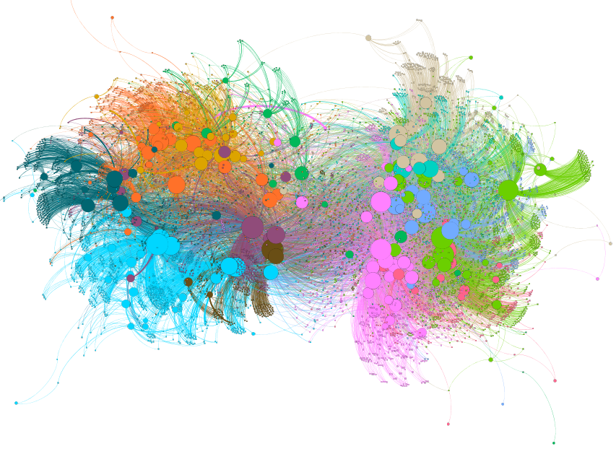

Political Donors in Wisconsin in 2016

# Methodology & Results

## Access-Oriented and Consumption Models

and test the relationships between the social media dataset and the political donation dataset. A Granger causality time-series model was used to test the two models of political donor motivations. Other social media studies have used this methodology (Freelon, McIlwain, and Clark 2018; Lukito 2020). Similar to political donations, this methodology has been used to study the relationship between social media and non-social media events such as offline protests (Bastos, Mercea, and Charpentier 2015) and stock prices (Park, Leung, and Ma 2017). Granger causality detects whether movements in one time series precedes, lags, has a confounding variable, or is not related to another time series (Granger 1969). An abbreviated version of how this methodology works is that one takes two time series variables X and Y. First, a vector autoregression (VAR) model is built to predict the outcome variable Y with Y being the sole predictor of the model. In other words, one only uses Y to predict Y. Then, a second model is built where both variables X and Y are used to build the VAR to predict Y. Effectively, if the second model, with the inclusion of X, does a better job of predicting Y than the first model alone, as measured by an *F*-statistic, X is said to Granger cause Y. The two variables, X and Y, are also flipped and the same process is done. If the null is rejected in both instances, then there is likely a confounding variable Z. This analysis was conducted in R (R Core Team 2013) with the lmtest package (Zeileis and Hothorn 2002). P-values were adjusted with the Bonferroni method (Haynes 2013). The optimal lag for each model was calculated using a Bayesian Information Criteria (Ahelegbey, Billio, and Casarin 2016) implemented by the tsDyn package (Stigler 2010).

We compare time series of donations from clusters of political donors and time series of the number of social media posts by each topic that were made by campaigns that each donor cluster contributed to. In other words, a time series of donations from a donor coalition was compared to the aggregate count of posts about a given topic made by candidates that the donor cluster contributed to. For example, donations from donor coalition 6 Granger caused politicians that received donations from the coalition to publicly support women’s issue and pro-choice policies. Stated another way, donations from coalition 6 predict whether candidates will publicly support pro-women policies. The theoretical connection to political donor psychology is that this behavior is expected under the access-oriented model of political donor motivations. Coalitions and policy topics that are accepted by either or are in Table 1. The full results of the Granger causality tests are visualized in Figure 2.

H1 and H3 acceptances

|  |  |  |  |  |  |
| --- | --- | --- | --- | --- | --- |
| coalition | policy topic | model | BIC | F-statistic | p-value |
| 0 | veterans issues: bipartisan | consumption | 5 | 7.6 | <.001 |
| 1 | veterans issues: bipartisan | access | 7 | 7.1 | <.001 |
| 1 | drug abuse: bipartisan | consumption | 7 | 4.5 | <.001 |
| 3 | race issues: liberal | access | 4 | 6.7 | <.001 |
| 4 | guns: conservative | consumption | 4 | 6.5 | <.001 |
| 6 | abortion and women’s issues: conservative | access | 2 | 14.2 | <.001 |
| 7 | drug abuse: bipartisan | consumption | 7 | 5.7 | <.001 |
| 11 | infrastructure: liberal | consumption | 7 | 5.8 | <.001 |

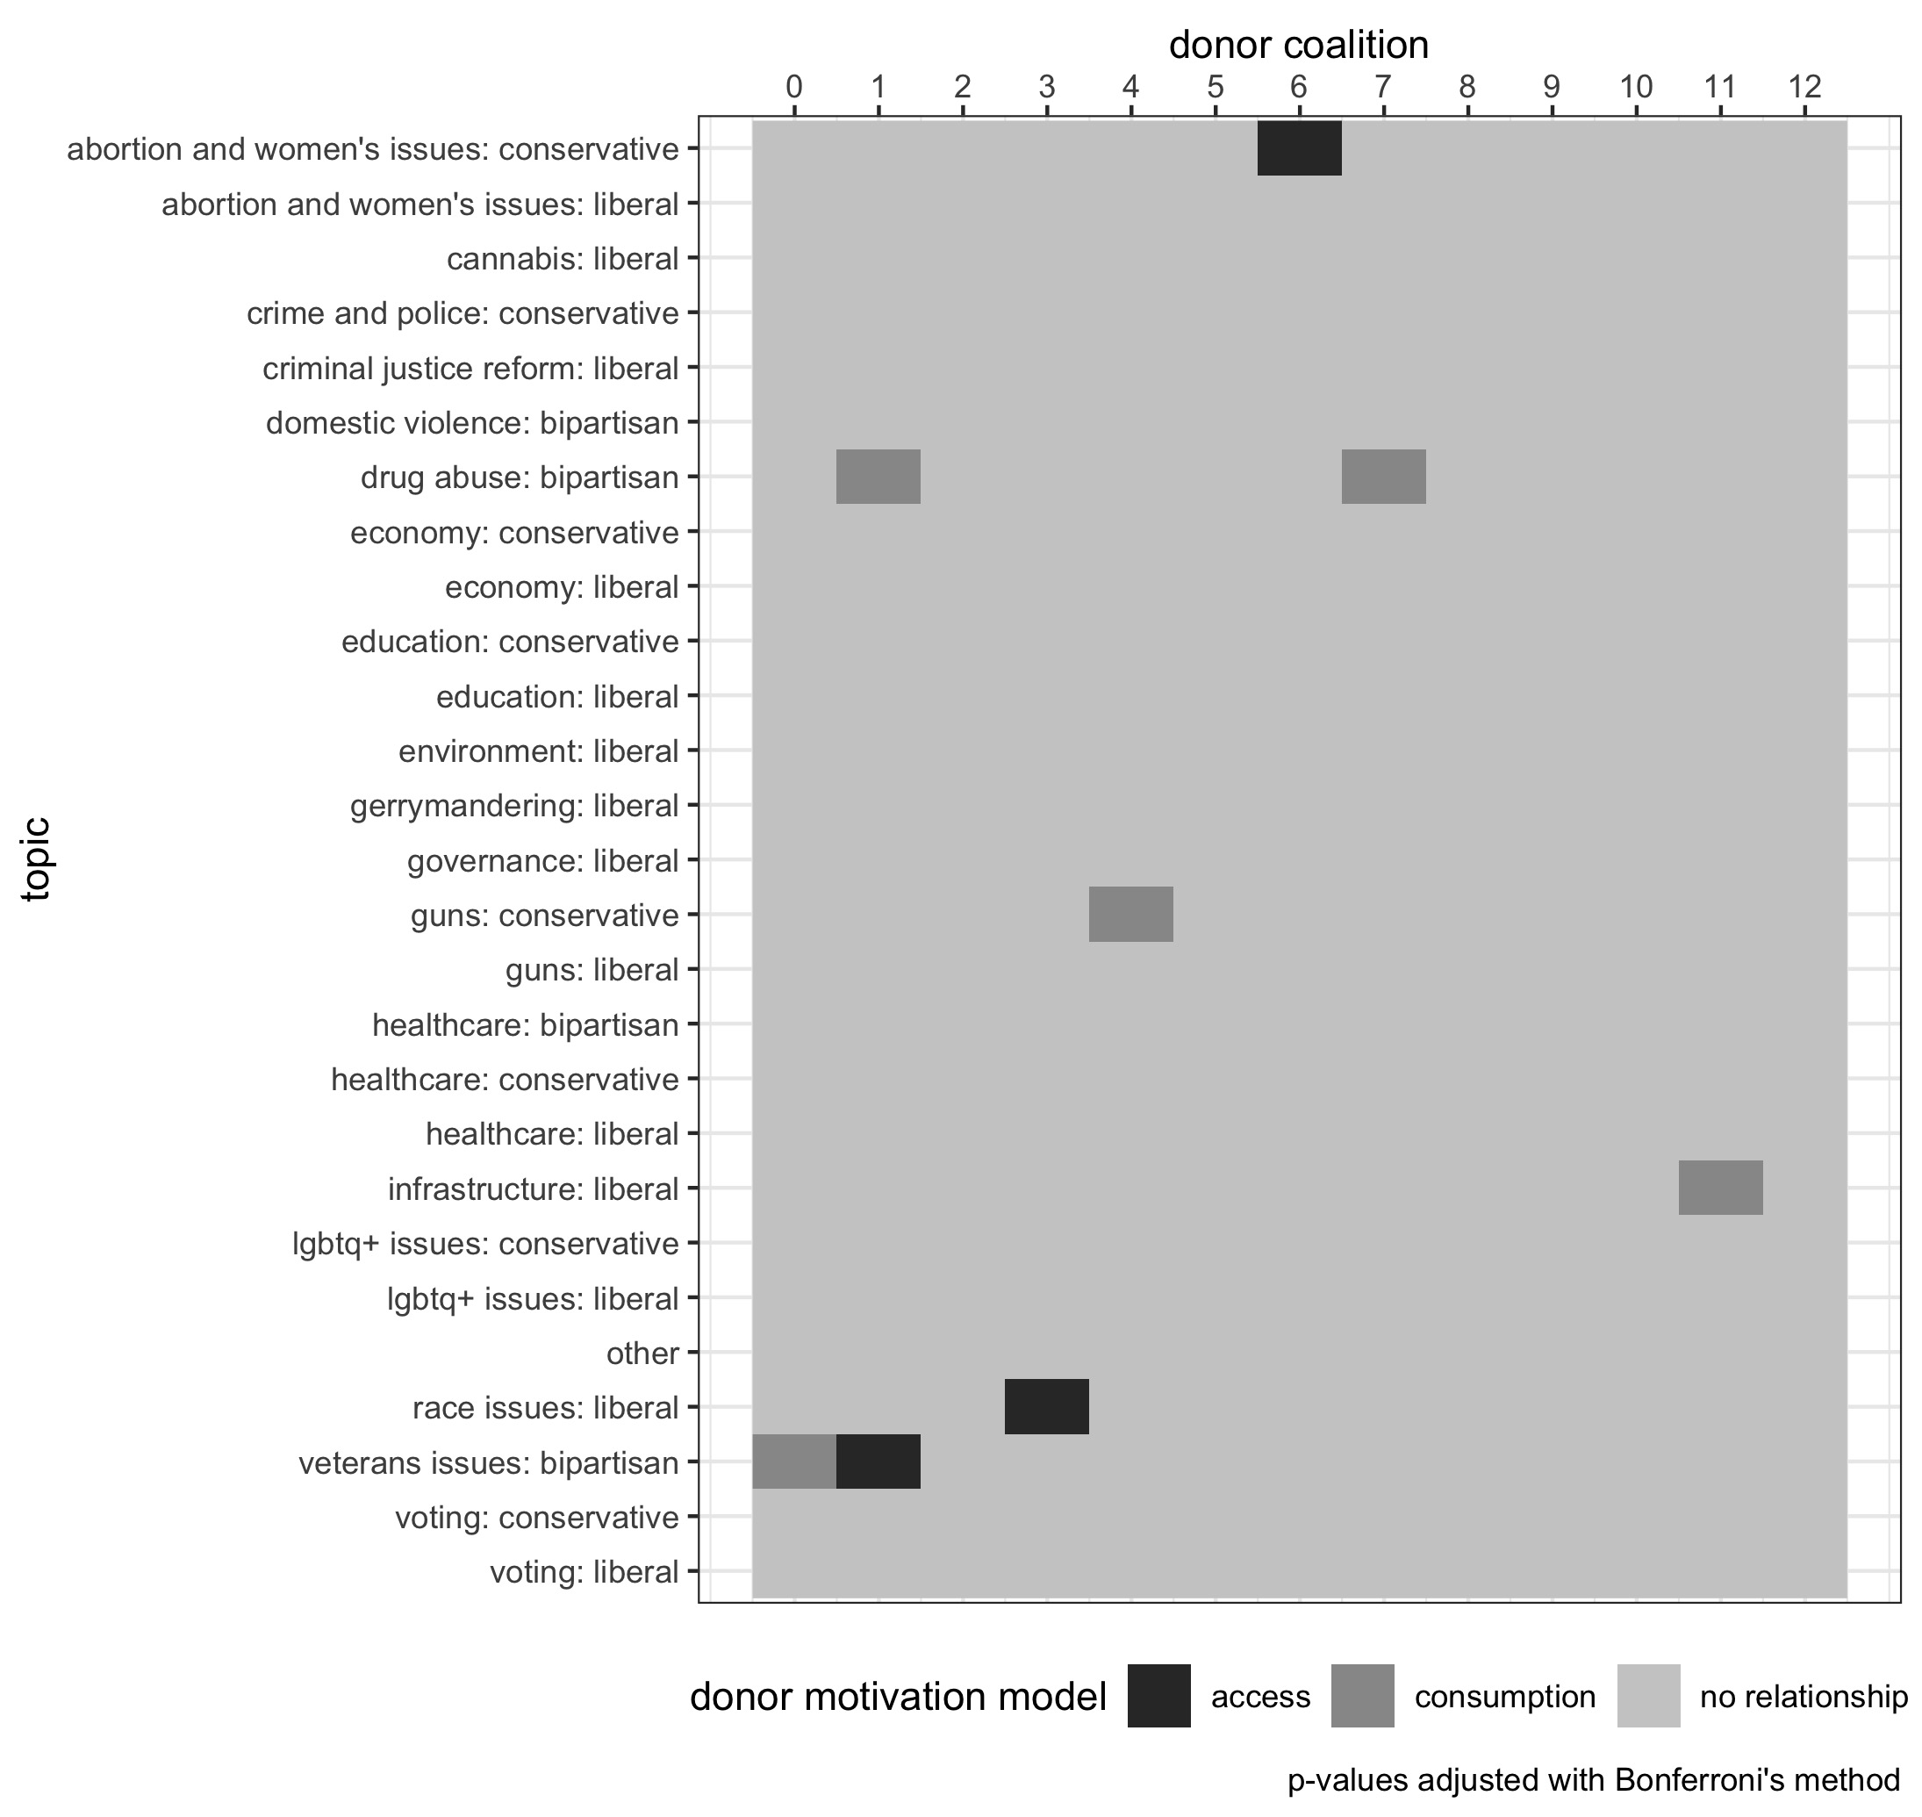

Donor Motivation Models

For three donor coalitions show behavior consistent with the access-oriented model where we can predict politicians’ public support of policy issues after they receive contributions from these donor groups. For these three groups and policy issues is accepted. These access-oriented coalitions represent 1,572 individual donors or 21.3% of all donors in the dataset; 6,489 individual donations or 22.4% of donations; and $654,577.60 or 16.5% of dollars contributed. Each of these three coalitions appear to have unique policy and even ideological positions that they support.

In addition to these three access-oriented clusters of donors, five coalitions of donors exhibit behavior that one would expect under the consumption model of donor motivations and are accepted by . In other words, public support of various policy issues from campaigns predicts donations from these coalitions. The five consumption-motivated clusters of donors contain: 2,702, 36.7% of donors; 11,080, 38.4% of donations; and donated a collective $1,341,129.70 or 33.8% of money contributed. Similar to access-oriented clusters, consumption-oriented coalitions show significant relationships to policy issues across the ideological spectrum.

These results were used to test and . Donor coalitions and the topic of social media posts that were accepted by and are listed in Table 1.

## Donor Sizes

Coalitions of donors that were accepted by only or were used to test , that access-oriented donors are on-average larger donors, and , that consumption-oriented donors are on-average smaller donors, with a difference-in-means permutation test since the statistical assumptions were not met for an OLS regression. Results to and are in Table 2. Neither the access-oriented donors nor the consumption-oriented donors contributed statistically significantly different amounts of money than donors that were donors that were not only access-oriented and not only consumption-oriented.

Difference in Average Donor Size

|  |  |  |  |  |
| --- | --- | --- | --- | --- |
| Hypothesis | Model | T | 95% CI | p-value |
| H2 | access | -48.62 | -115.4, 21.47 | 0.144 |
| H4 | consumption | 34.60 | -29.21, 118.39 | 0.310 |

A histogram showing the total contributions of donors by motivational model are in Figure 3.

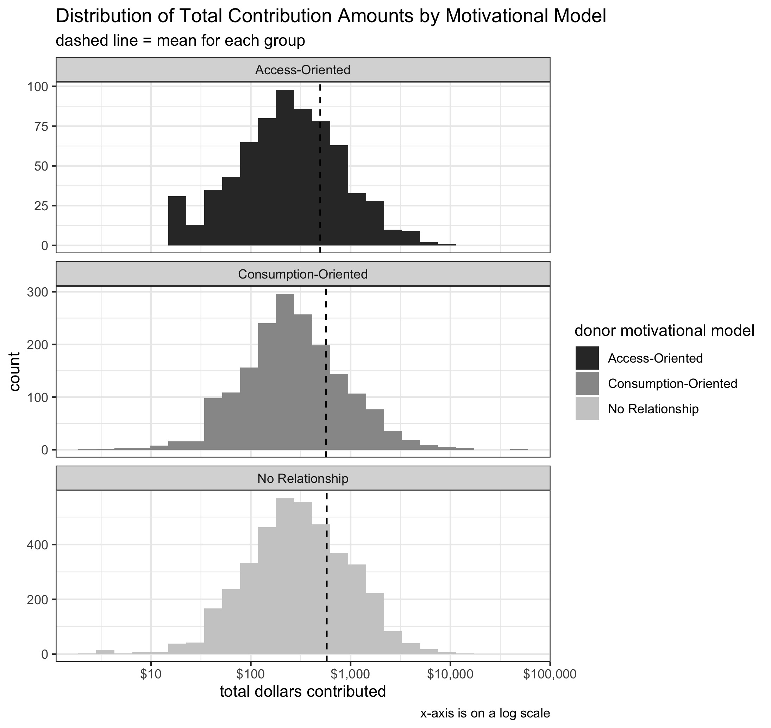

## Donor Spatial Positions

To study the polarization of consumption-motivated donors, we extract the x-coordinate position from the donor network (Figure 1). The positions of all the donors grouped by motivational model is shown in Figure 4.

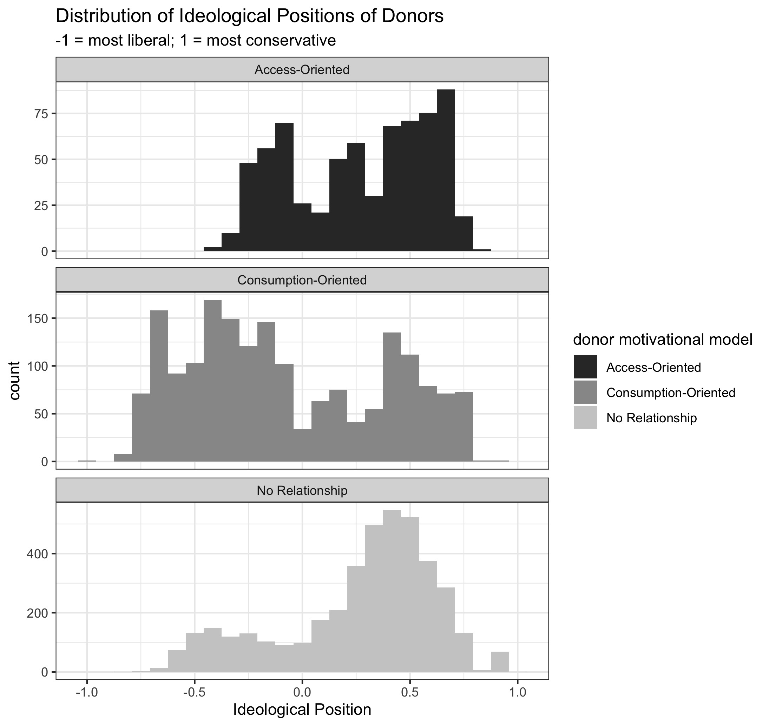

We then rescale the coordinate position to be -1 to 1 with -1 representing the left-most, or most Democratic, node and 1 representing the right-most, or most Republican, node. To test , that consumption-oriented donors are more polarized in the network graph, and , that access-oriented donors are less polarized in the network graph, a difference-in-means permutation test on the absolute value of the rescaled x-coordinate with the coalition category as a variable. A non-parametric permutation test was used since the statistical assumptions for an OLS regression were not met. This absolute value effectively is the level of polarization in the graph, with the nodes that are on the extremes of the graph being closer to 1 and the central-most nodes, representing bipartisan donors, being closer to 0. Results for and are in Table 3. Consumption-motivated donors are on average in more polarized positions (further to the left and right of the graph) than non-consumption-oriented donors, and access-oriented donors are on average in less polarized positions (closer to the middle of the graph) than non-access-oriented donors.

Difference in Average Donor Position Polarization

|  |  |  |  |  |
| --- | --- | --- | --- | --- |
| Hypothesis | Model | T | 95% CI | p-value |
| H5 | consumption | 0.01 | 0, 0.02 | 0.014 |
| H6 | access | -0.05 | -0.06, -0.03 | <.001 |

The polarized positions of all the donors are shown by group in Figure 5.

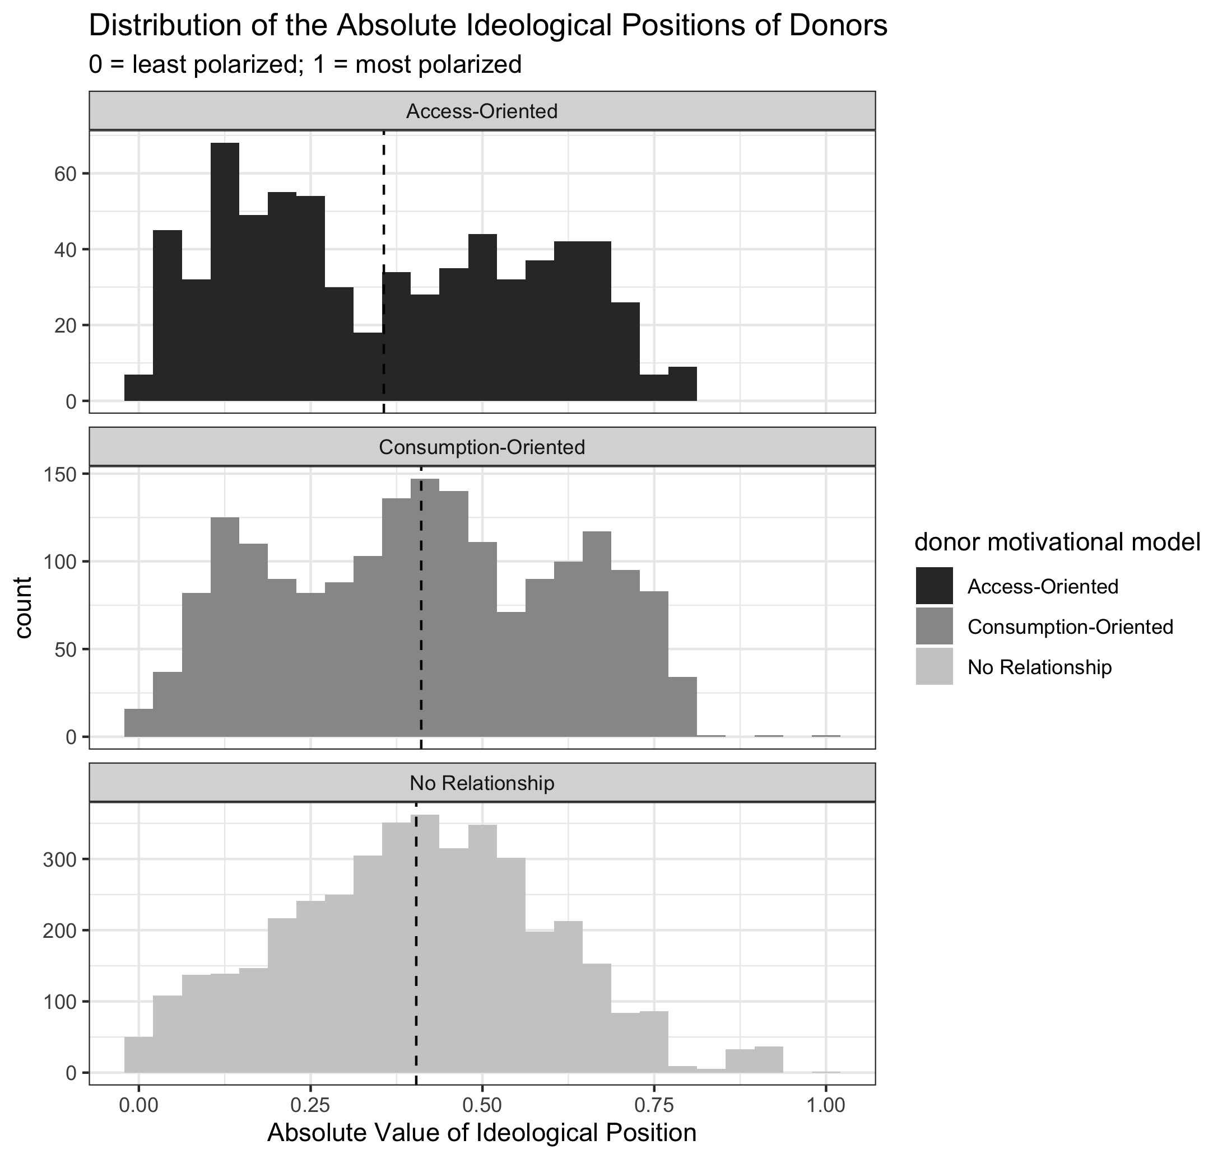

# Discussion

We find evidence that supports the recent scholarship into the motivations of political donors that maintains a nuanced view into the psychology of political contributors: different donors hold different motivations. Different donor coalitions exhibited behavior that is inline with both the access-oriented and consumption model of political donations with policy issues across the ideological spectrum of liberal, conservative, and bipartisan. Example social media posts of the various topics can be found in the appendix.

The analyses conducted in this paper show that multiple models of political donor motivations can exist within different coalitions of political donors. Historical studies on the motivations of political donors have explicitly reasoned or implicitly assumed that donors hold monolithic motivations–all donors are motivated by the same psychological processes. The results of this paper contrast this historical principle and instead is in agreement with the recent line of donor studies which take a more nuanced approach to political donors.

While much of the popular concern over money in politics is around access-oriented donors manipulating the political system, we find that there are more consumption-oriented donors than access-oriented donors. There are more consumption-motivated groups of donors than access-oriented donors, five groups compared to three, respectively. These consumptive groups also represent more people (2,702 versus 1,572), donations (11,080 versus 6,489), and total amount contributed ($1,341,129.70 versus $654,577.60). While any number of access-oriented donors may remain concerning to some in the public, these results suggest that more people use political donations as a vehicle for increased participation in, not manipulation of, the political process.

The folk theory of political donors is that of access-oriented donors with financial interests donating large sums of money to politicians, but the results of reject this idea. Donors in access-oriented coalitions do not contribute statistically significantly more money on average than other donors. Just because a donor is not contributing a large sum of money themselves does not mean that they are not seeking to coax a politician into supporting specific policies. This effect can be amplified when coalitions of donors operate in conjunction with one another. For example, members of an interest group could each contribute a relatively small amount of money, but in aggregate, the unified donations could potentially gain that interest group access to a politician. If anything, donors that are labeled in this study as being in an access-oriented cluster potentially donate less money than other donors, but this non-statistically significant result with a relatively large confidence interval is not conclusive. A future study could replicate this analysis with multiple election cycles or study multiple states or federal elections to achieve higher statistical power. The converse is found for consumption-oriented donors.

The folk theory of consumption-motivated donors is of small-dollar donors whose contributions can be harnessed online. Similar to access-oriented donors, is rejected and consumption-motivated donors are not on average smaller donors than other contributors. Again, these results suggest a disaggregation between the notion that the amount of money one contributes is indicative of one’s motivations. If someone is able to contribute a large sum of money and they care about a certain issue, it stands to reason that they may just support campaigns who already care about that issue. If contributions to campaigns are similar to financial investments, the equivalent is someone investing in a company because they believe the company will do well in the future, not because every time someone invests in a company they expect to be able to tangibly alter the direction of the company. While there are certainly activist investors, they are well outnumbered by the amount of people who are not activist investors, even among wealthy individuals. This paper challenges conventional beliefs on the size of access-oriented versus consumptive donors, but it does concur with the literature on the levels of polarization among donors.

Consumption-motivated donors are in more polarized spatial positions within the donor graph than non-consumptive donors, and access-oriented donors are more centrally located. The acceptances of and are in agreement with past literature. These results provide descriptive context and are not meant to imply any level of causality. Past studies have either suggested or found a connection between donor motivations and political polarization, and this study also finds these descriptive relationships. Future studies should examine the causal mechanisms of these relationships. Do candidates take more polarizing stances in an effort to court consumptive donors? Has an increased number of consumptive donors helped more polarized candidates to win office? Do access-oriented donors seek out campaigns that are more moderate? Or can access-oriented donors influence the ideological extremity of candidates?

In addition to the finding that both the access-oriented and consumption motivational models can exist in different donor coalitions, one of the thirteen donor clusters, coalition 1, revealed a duality where they were access-oriented in relation to one policy issue and consumption-oriented to another. While it is possible that this finding is spurious, there is additional face validity in this finding because the two issues the donor coalition had a relationship with were both bipartisan issues–veterans issues and drug abuse. Not many studies have come to the conclusion that donors can operate with both motivational models. While this study finds this behavior to be relatively rare, in only one donor cluster, it does open up the possibilities to an even more complex view as to why donors make a political contribution. Further, public support of one policy issue, veteran’s issues, is both Granger caused by donations from a coalition and Granger causes another coalition to make a contribution. This result suggests that issues can play different roles to different groups of political donors. One group of donors can seek access in order to influence that policy, and another group can display consumptive behavior and reward politicians who already publicly support policy issues.

Finally, there has been a debate among campaign-finance scholars whether donation motivations are driven by only ideological proximity or specific policy issues. We find that policy issues are a factor in contribution motivations, at least for the specific groups that exhibit access-oriented or consumptive behavior. The policy issues that are connected to donor clusters in this study range the political spectrum, including liberal policies (race issues, public infrastructure), conservative policies (pro-life, pro-gun), and bipartisan issues (drug abuse, veteran’s issues). Further, some of the topics are perennial focuses of campaigns, such as pro-life politics. Other issues were particularly salient during this election cycle, such as veterans issues with the Tomah Veteran’s Affair hospital scandal (Honl 2016) and King Veteran’s Home scandal. These two scandals created an electoral environment in which veteran’s issues were in the public focus, and results from this paper suggest that some political donors both sought to influence campaigns to address these issues as well as reward politicians for their focus on the topic.

Six of the thirteen coalitions of donors did not display access-oriented or consumptive behavior with the policy topics tested. The motivations behind these clusters of donors remain unclear. It is possible that they are motivated by ideological proximity in a way that is not adequately tested using the methods in this paper. Future studies should test other potential reasons that people make political contributions, such as individuals contributing to ideologically proximate campaign, geographically local campaigns, competitive campaigns, or other potential motivations.

# Limitations

Like all observational studies, this research cannot claim true causality. While the main methodology employed is formally called “Granger causality,” this causality is in an econometric sense and is more akin to predictive value. So while the findings of this paper do have predictive power–for example, donations from certain groups of individuals successfully receiving candidates to publicly support policy issues–true causal claims cannot be made. Future studies should use the findings from this research to conduct lab experiments where causal claims can be made.

We found discrete examples of donor coalitions demonstrating access-oriented or consumptive behavior on specific issues. However, these results do not suggest that these donors only care about those issues or that other donors don’t care about these issues. Instead, these donors have a unique statistical relationship where when they contribute money to a political campaign, it either predicts or is predicted by campaigns public support of policy issues. Future studies can employ surveys to identify if the statistical relationships found in an analysis like this paper concur with people’s self conceptions. Do donor coalitions who donate in a consumptive fashion where they contribute to a campaign after they publicly support an issue actually report that they prioritize that issue? Possibly, these behaviors are subconscious reactions. Donors may not be able to exactly identify *why* they like a candidate or may report some other reason, when it is actually a reinforcement of a concurrence between their policies and the information environment that they consume.

Finally, this study was not meant to find nor did it find exhaustive evidence as to what motivates ever single donor in the dataset. Even within the information ecology, this study does not consider things like news stories or personal friend circles. There are other potential reasons that donors make contributions, such as geographic proximity where people donate to their local candidates or allocating money to competitive races.

# Conclusion

Campaign finance scholars are divided on the motivations of political donors. Do political donors seek to buy access, to participate more in politics, or some combination of both? This study finds that different coalitions of donors, and in one instance, a singular coalition, exhibit behavior that is consistent with different motivational models. Overall, there are more consumptive donors compared to access-oriented donors. In addition, there is no statistical difference in the average contributor size of access-oriented and consumption-oriented donors compared to other donors. However, access-oriented donors are found to be more spatially central within donor networks, and consumptive donors are more polarized.

# Appendix

Social Media Examples

example #

topic

campaign

social media site

post

1

race issues: liberal

Bowen 4 Action

Twitter

@ JoyAnnReid: #OscarsSoWhite black people can’t even get nominated for the movies about black people…

2

race issues: liberal

Citizens of the 81st for Dave Considine

Twitter

1 in every 9 African-Americans are disenfranchised because of felony convictions in Wisconsin

3

abortion and women’s issues: conservative

Ken Skowronski for Assembly

Facebook

Last night I had a great time at the Wisconsin Right to Life Dinner with my fellow colleagues. I am proud to have supported the bold Pro-Life reforms we have put in place and I will continue to defend the rights of those who cannot defend themselves.

4

abortion and women’s issues: conservative

Friends & Neighbors of Robin Vos

Twitter

An Assembly committee will vote on a bill to ban the sale of aborted children’s body parts on Wednesday.

5

abortion and women’s issues: conservative

Friends of Chuck Wichgers

Facebook

’I’m glad to know Chuck, who is a solid conservative. He’s shown that he understands the principles that secure our freedom and that he will work for them in office. But more than that, I’ve seen that he is passionate about the God-given dignity of every human life. He knows that every person’s right to live and to live freely comes from a much higher source than government.’PATRICK MCILHERAN, FORMER EDITORIAL WRITER, MILWAUKEE JOURNAL SENTINEL

6

veterans issues: bipartisan

Sanfelippo for Assembly

Twitter

Welcome Home Veterans Initiative seeks to solve veteran homelessness in state:

7

veterans issues: bipartisan

Citizens for Peter Barca

Twitter

Regionalizing Wisconsin’s county veterans service offices remains a concern in vet community

8

guns: conservative

Scott Fitzgerald for Senate

Twitter

Thanks to the Wisconsin Game Preserve Association for the honor of their 2015 Legislator of the Year award!

9

guns: conservative

Kremer for Wisconsin

Facebook

This is a fair interview with Frederica Freyberg discussing the ‘Campus Carry Act’ in Wisconsin. This aired on public television yesterday morning.

10

infrastructure: liberal

Friends of Jonathan Brostoff

Facebook

Dr. Mark Stout has written a compelling alternative to the $1.1 billion highway proposal. This option that would save money and provide a brighter, more progressive, more responsible future for our state. If you haven’t yet, please take a look and share widely.

11

infrastructure: liberal

Wachs for Assembly

Twitter

WI roads rank 3rd worst in US. Yet Scott Walker isnt ready to put politics aside to solve our infrastructure woes.

12

drug abuse: bipartisan

Michael Schraa for Assembly

Facebook

A great story about the HOPE Agenda and my colleague on Joint Finance, WI State Rep John Nygren’s efforts to fight against heroin and opiate addiction.

Method

koRpus

stringi

Word count

6888

6865

Character count

46691

46680

Sentence count

323

Not available

Reading time

34.4 minutes

34.3 minutes

# References

Ahelegbey, Daniel Felix, Monica Billio, and Roberto Casarin. 2016. “Bayesian Graphical Models for Structural Vector Autoregressive Processes.” *Journal of Applied Econometrics* 31 (2): 357–86. <https://doi.org/https://doi.org/10.1002/jae.2443>.

Akey, Pat. 2015. “Valuing Changes in Political Networks: Evidence from Campaign Contributions to Close Congressional Elections.” *The Review of Financial Studies* 28 (11): 3188–3223. <https://doi.org/10.1093/rfs/hhv035>.

Albert, Zachary, and Raymond La Raja. 2020. “Small Dollar Donors and the Evolving Democratic Party.” *APSA Preprints*.

Anduiza, Eva, Aina Gallego, and Marta Cantijoch. 2010. “Online Political Participation in Spain: The Impact of Traditional and Internet Resources.” *Journal of Information Technology & Politics* 7 (4): 356–68. <https://doi.org/10.1080/19331681003791891>.

Ansolabehere, Stephen, John M. de Figueiredo, and James M. Snyder. 2003. “Why Is There so Little Money in U.s. Politics.” *Journal of Economic Perspectives* 17 (1): 105–30.

Arbour, Brian. 2020. “Tiny Donations, Big Impact: How Small-Dollar Donors Are Eroding the Power of Party Insiders.” *Society* 57: 496–506.

Austen-Smith, David. 1995. “Campaign Contributions and Access.” *The American Political Science Review* 89 (3): 566–81. <http://www.jstor.org/stable/2082974>.

Baker, Anne. 2020a. “Policies, Profits, Networks, or Duty?: Donors’ Motivations for Contributing to Parties and Interest Groups.” *The Social Science Journal* 0 (0): 1–16. <https://doi.org/10.1080/03623319.2020.1727224>.

———. 2020b. “The Partisan and Policy Motivations of Political Donors Seeking Surrogate Representation in House Elections.” *Political Behavior* 42 (4): 1035–54. <https://doi.org/10.1007/s11109-019-09531-2>.

Barber, Michael. 2016. “Donation Motivations: Testing Theories of Access and Ideology.” *Political Research Quarterly* 69 (1): 148–59.

Barber, Michael, Brandice Canes-Wrone, and Sharece Thrower. 2019. “Campaign Contributions and Donors’ Policy Agreement with Presidential Candidates.” *Presidential Studies Quarterly* 49 (4): 770–97. <https://doi.org/https://doi.org/10.1111/psq.12609>.

Barber, Michael J., Brandice Canes-Wrone, and Sharece Thrower. 2017. “Ideologically Sophisticated Donors: Which Candidates Do Individual Contributors Finance?” *American Journal of Political Science* 61 (2): 271–88. <https://doi.org/https://doi.org/10.1111/ajps.12275>.

Barbera, Pablo, Andrew Geisler, and Wouter van Atteveldt. 2017. *Rfacebook*. <https://cran.r-project.org/web/packages/Rfacebook/Rfacebook.pdf>.

Bastian, Mathieu, Sebastien Heymann, and Mathieu Jacomy. 2009. “Gephi: An Open Source Software for Exploring and Manipulating Networks.” <http://www.aaai.org/ocs/index.php/ICWSM/09/paper/view/154>.

Bastos, Marco T., Dan Mercea, and Arthur Charpentier. 2015. “Tents, Tweets, and Events: The Interplay Between Ongoing Protests and Social Media.” *Journal of Communication* 65 (2): 320–50. <https://doi.org/10.1111/jcom.12145>.

Bonica, Adam. 2014. “Mapping the Ideological Marketplace.” *American Journal of Political Science* 58 (2): 367–86. <http://www.jstor.org/stable/24363491>.

———. 2016. “Avenues of Influence: On the Political Expenditures of Corporations and Their Directors and Executives.” *Business and Politics* 18 (4): 367–94. <https://doi.org/10.1515/bap-2016-0004>.

———. 2019. “Are Donation-Based Measures of Ideology Valid Predictors of Individual-Level Policy Preferences?” *The Journal of Politics* 81 (1): 327–33. <https://doi.org/10.1086/700722>.

Butler, Daniel M., and David W. Nickerson. 2011. “Can Learning Constituency Opinion Affect How Legislators Vote? Results from a Field Experiment.” *Quarterly Journal of Political Science* 6: 55–83.

Callahan, Scott. 2019. “Do Campaign Contributions from Farmers Influence Agricultural Policy? Evidence from a 2008 Farm Bill Amendment Vote to Curtail Cotton Subsidies.” *Journal of Agricultural and Applied Economics* 51 (3): 417–33. <https://doi.org/10.1017/aae.2019.9>.

Canes-Wrone, Brandice, and Nathan Gibson. 2019. “Does Money Buy Congressional Love? Individual Donors and Legislative Voting.” *Congress & the Presidency* 46 (1): 1–27. <https://doi.org/10.1080/07343469.2018.1518965>.

Choma, Russ, and Kara Voght. 2020. “Small-Dollar Donors Powered the 2020 Race. Then the Pandemic Happened.” *Mother Jones*, April.

Cogburn, Derrick L., and Fatima K. Espinoza-Vasquez. 2011. “From Networked Nominee to Networked Nation: Examining the Impact of Web 2.0 and Social Media on Political Participation and Civic Engagement in the 2008 Obama Campaign.” *Journal of Political Marketing* 10 (1-2): 189–213. <https://doi.org/10.1080/15377857.2011.540224>.

Constant, Louay M. 2006. “When Money Matters: Campaign Contributions, Roll Call Votes, and School Choice in Florida.” *State Politics & Policy Quarterly* 6 (2): 195–219. <https://doi.org/10.1177/153244000600600204>.

Cooper, Michael J., Huseyin Gulen, and Alexei V. Ovtchinnikov. 2010. “Corporate Political Contributions and Stock Returns.” *The Journal of Finance* 65 (2): 687–724. <https://doi.org/https://doi.org/10.1111/j.1540-6261.2009.01548.x>.

Cranshaw, Justin, Eran Toch, J. Hong, A. Kittur, and N. Sadeh. 2010. “Bridging the Gap Between Physical Location and Online Social Networks.” *Proceedings of the 12th ACM International Conference on Ubiquitous Computing*.

Culberson, Tyler, Michael P. McDonald, and Suzanne M. Robbins. 2019. “Small Donors in Congressional Elections.” *American Politics Research* 47 (5): 970–99. <https://doi.org/10.1177/1532673X18763918>.

Devlin, Jacob, Ming-Wei Chang, Kenton Lee, and Kristina Toutanova. 2019. “BERT: Pre-Training of Deep Bidirectional Transformers for Language Understanding.” <http://arxiv.org/abs/1810.04805>.

DSW, Jerry D. Marx. 2000. “Online Fundraising in the Human Services.” *Journal of Technology in Human Services* 17 (2-3): 137–52. <https://doi.org/10.1300/J017v17n02_03>.

Edwards, Geoff, and Rui de Figueiredo. 2016. “The Market for Legislative Influence over Regulatory Policy” 34 (May). <https://doi.org/10.1108/S0742-332220160000034007>.

Ellison, Nicole, and Charles Steinfield. 2006. “Spatially Bounded Online Social Networks and Social Capital: The Role of Facebook.” *Annual Conference of the International Communication Association*, January.

Engel, Steven T., and David J. Jackson. 1998. “Wielding the Stick Instead of the Carrot: Labor Pac Punishment of Pro-Nafta Democrats.” *Political Research Quarterly* 51 (3): 813–28. <https://doi.org/10.1177/106591299805100312>.

Ensley, Michael J. 2009. “Individual Campaign Contributions and Candidate Ideology.” *Public Choice* 138 (1/2): 221–38. <http://www.jstor.org/stable/40270840>.

Fellowes, Matthew C., and Patrick J. Wolf. 2004. “Funding Mechanisms and Policy Instruments: How Business Campaign Contributions Influence Congressional Votes.” *Political Research Quarterly* 57 (2): 315–24.

Ferris, Stephen P., Reza Houston, and David Javakhadze. 2019. “It Is a Sweetheart of a Deal: Political Connections and Corporate-Federal Contracting.” *Financial Review* 54 (1): 57–84. <https://doi.org/https://doi.org/10.1111/fire.12181>.

Finger, Leslie K. 2019. “Interest Group Influence and the Two Faces of Power.” *American Politics Research* 47 (4): 852–86. <https://doi.org/10.1177/1532673X18786723>.

Fouirnaies, Alexander. 2018. “When Are Agenda Setters Valuable?” *American Journal of Political Science* 62 (1): 176–91. <https://doi.org/https://doi.org/10.1111/ajps.12316>.

Fouirnaies, Alexander, and Andrew Hall. 2015. “The Exposure Theory of Access: Why Some Firms Seek More Access to Incumbents Than Others.” *SSRN Electronic Journal*, January. <https://doi.org/10.2139/ssrn.2652361>.

Francia, Peter L., John C. Green, Paul S. Herrnson, Lynda W. Powell, and and Clyde Wilcox. 2003. *The Financiers of Congressional Elections*. New York, NY: Columbia University Press.

Freelon, D, C McIlwain, and M Clark. 2018. “Quantifying the Power and Consequences of Social Media Protest.” *New Media & Society* 20 (3): 990–1011. <https://doi.org/10.1177/1461444816676646>.

Fremeth, Adam, Brian Kelleher Richter, and Brandon Schaufele. 2013. “Campaign Contributions over Ceos’ Careers.” *American Economic Journal: Applied Economics* 5 (3): 170–88. <https://doi.org/10.1257/app.5.3.170>.

Fu, Shu, and William G. Howell. 2020. “The Behavioral Consequences of Public Appeals: Evidence on Campaign Fundraising from the 2018 Congressional Elections.” *Presidential Studies Quarterly* 50 (2): 325–47. <https://doi.org/https://doi.org/10.1111/psq.12645>.

Fulmer, Sarah, A. Knill, and X. Yu. 2017. “Negation of Sanctions: The Personal Effect of Political Contributions.” *Business History eJournal*.

Gennaro, Corinna di, and William Dutton. 2006. “The Internet and the Public: Online and Offline Political Participation in the United Kingdom.” *Parliamentary Affairs* 59 (2): 299–313. <https://doi.org/10.1093/pa/gsl004>.

Gil de Zúñiga, Homero, Nakwon Jung, and Sebastián Valenzuela. 2012. “Social Media Use for News and Individuals’ Social Capital, Civic Engagement and Political Participation.” *Journal of Computer-Mediated Communication* 17 (3): 319–36. <https://doi.org/10.1111/j.1083-6101.2012.01574.x>.

Goldberg, Matthew H., Jennifer R. Marlon, Xinran Wang, Sander van der Linden, and Anthony Leiserowitz. 2020. “Oil and Gas Companies Invest in Legislators That Vote Against the Environment.” *Proceedings of the National Academy of Sciences* 117 (10): 5111–2. <https://doi.org/10.1073/pnas.1922175117>.

Goldmacher, Shane. 2020. “The 2020 Campaign Is the Most Expensive Ever (by a Lot).” *The New York Times Magazine*, October.

Gordon, Sanford C., Catherine Hafer, and Dimitri Landa. 2007. “Consumption or Investment? On Motivations for Political Giving.” *The Journal of Politics* 69 (4): 1057–72.

Gounopoulos, Dimitrios, Khelifa Mazouz, and Geoffrey Wood. 2021. “The Consequences of Political Donations for Ipo Premium and Performance.” *Journal of Corporate Finance* 67: 101888. <https://doi.org/https://doi.org/10.1016/j.jcorpfin.2021.101888>.

Granger, C. W. J. 1969. “Investigating Causal Relations by Econometric Models and Cross-Spectral Methods.” *Econometrica* 37 (3): 424–38. <http://www.jstor.org/stable/1912791>.

Grenzke, Janet M. 1989. “PACs and the Congressional Supermarket: The Currency Is Complex.” *American Journal of Political Science* 33 (1): 1–24. <http://www.jstor.org/stable/2111251>.

Hadani, Michael, Jean-Philippe Bonardi, and Nicolas M Dahan. 2017. “Corporate Political Activity, Public Policy Uncertainty, and Firm Outcomes: A Meta-Analysis.” *Strategic Organization* 15 (3): 338–66. <https://doi.org/10.1177/1476127016651001>.

Hall, Richard L., and Frank W. Wayman. 1990. “Buying Time: Moneyed Interests and the Mobilization of Bias in Congressional Committees.” *American Political Science Review* 84 (3): 797–820. <https://doi.org/10.2307/1962767>.

Ham, Kelli. 2013. “OpenRefine (Version 2.5). Http://Openrefine.org. Free, Open-Source Tool for Cleaning and Transforming Data.” *Journal of the Medical Library* 101 (3): 233–34.

Hanna, Alex, Chris Wells, Peter Maurer, Lew Friedland, Dhavan Shah, and Jörg Matthes. 2013. “Partisan Alignments and Political Polarization Online: A Computational Approach to Understanding the French and Us Presidential Elections.” In *Proceedings of the 2nd Workshop on Politics, Elections and Data*, 15–22. PLEAD ’13. New York, NY, USA: Association for Computing Machinery. <https://doi.org/10.1145/2508436.2508438>.

Harden, Jeffrey J., and Justin H. Kirkland. 2016. “Do Campaign Donors Influence Polarization? Evidence from Public Financing in the American States.” *Legislative Studies Quarterly* 41 (1): 119–52. <https://doi.org/https://doi.org/10.1111/lsq.12108>.

Hardina, Donna. 2005. “Using the Web to Teach Power Analysis.” *The Social Policy Journal* 4 (2): 51–68. <https://doi.org/10.1300/J185v04n02_05>.

Hayes, Thomas J. 2017. “Bankruptcy Reform and Congressional Action: The Role of Organized Interests in Shaping Policy.” *Social Science Research* 64: 67–78. <https://doi.org/https://doi.org/10.1016/j.ssresearch.2016.09.026>.

Haynes, Winston. 2013. “Bonferroni Correction.” In *Encyclopedia of Systems Biology*, edited by Werner Dubitzky, Olaf Wolkenhauer, Kwang-Hyun Cho, and Hiroki Yokota, 154–54. New York, NY: Springer New York. <https://doi.org/10.1007/978-1-4419-9863-7_1213>.

Hazard, Brenda L. 2003. “Online Fundraising at Arl Libraries.” *The Journal of Academic Librarianship* 29 (1): 8–15. <https://doi.org/https://doi.org/10.1016/S0099-1333(02)00399-3>.

Heberlig, Eric, and Bruce Larson. 2020. “Gender and Small Contributions: Fundraising by the Democratic Freshman Class of 2018 in the 2020 Election.” *Society* 57: 534–39. <https://doi.org/https://doi.org/10.1007/s12115-020-00528-w>.

Heerwig, Jennifer A. 2016. “Donations and Dependence: Individual Contributor Strategies in House Elections.” *Social Science Research* 60: 181–98. <https://doi.org/https://doi.org/10.1016/j.ssresearch.2016.06.001>.

Herndon, James F. 1982. “Access, Record, and Competition as Influences on Interest Group Contributions to Congressional Campaigns.” *The Journal of Politics* 44 (4): 996–1019.

Hill, Seth J., and Gregory A. Huber. 2017. “Representativeness and Motivations of the Contemporary Donorate: Results from Merged Survey and Administrative Records.” *Political Behavior* 39 (1): 3–29. <https://doi.org/10.1007/s11109-016-9343-y>.

Hogan, Robert E. 2020. “Legislative Voting and Environmental Policymaking in the American States.” *Environmental Politics* 0 (0): 1–20. <https://doi.org/10.1080/09644016.2020.1788897>.

Honl, Ryan. 2016. “Here Are the Facts About the Tomah Va Scandal.” *The Cap Times*, May.

Hu, Yifan. 2005. “Efficient, High-Quality Force-Directed Graph Drawing.” *Mathematica Journal* 10 (1): 37–71.

Jansa, Joshua M. 2019. “You Catch More Flies with Honey: An Analysis of Pac Punishment and Congressional Vote Switching.” *Interest Groups & Advocacy* 8 (2).

Jansa, Joshua M., and Michele M. Hoyman. 2018. “Do Unions Punish Democrats? Free-Trade Votes and Labor Pac Contributions, 1999–2012.” *Political Research Quarterly* 71 (2): 424–39. <https://doi.org/10.1177/1065912917738575>.

Jiang, Shan, Miriam Metzger, Andrew Flanagin, and Christo Wilson. 2020. “Modeling and Measuring Expressed (Dis)belief in (Mis)information.” *Proceedings of the International AAAI Conference on Web and Social Media* 14 (1): 315–26. <https://ojs.aaai.org/index.php/ICWSM/article/view/7302>.

Jost, John, Pablo Barberá, Richard Bonneau, Melanie Langer, Megan Metzger, Jonathan Nagler, Joanna Sterling, and Joshua Tucker. 2018. “How Social Media Facilitates Political Protest: Information, Motivation, and Social Networks: Social Media and Political Protest.” *Political Psychology* 39 (February): 85–118. <https://doi.org/10.1111/pops.12478>.

Kalla, Joshua L., and David E. Broockman. 2016. “Campaign Contributions Facilitate Access to Congressional Officials: A Randomized Field Experiment.” *American Journal of Political Science* 60 (3): 545–58. <https://doi.org/https://doi.org/10.1111/ajps.12180>.

Karpf, David. 2010. “Online Political Mobilization from the Advocacy Group’s Perspective: Looking Beyond Clicktivism.” *Policy & Internet* 2 (4): 7–41. <https://doi.org/https://doi.org/10.2202/1944-2866.1098>.

Kearney, Michael W. 2019. “Rtweet: Collecting and Analyzing Twitter Data.” *Journal of Open Source Software* 4 (42): 1829. <https://doi.org/10.21105/joss.01829>.

Keena, Alex, and Misty Knight-Finley. 2019. “Are Small Donors Polarizing? A Longitudinal Study of the Senate.” *Election Law Journal: Rules, Politics, and Policy* 18 (2): 132–44. <https://doi.org/10.1089/elj.2018.0498>.

Kettler, Jaclyn J., and Jeffrey Lyons. 2019. “The Fickle Financiers of Elections? The Impact of Moving on Individual Contributions.” *Journal of Elections, Public Opinion and Parties* 0 (0): 1–19. <https://doi.org/10.1080/17457289.2019.1652620>.

Kushin, Matthew J., and Kelin Kitchener. 2009. “Getting Political on Social Network Sites: Exploring Online Political Discourse on Facebook.” *First Monday* 14 (11). <https://doi.org/10.5210/fm.v14i11.2645>.

Langbein, Laura I. 1986. “Money and Access: Some Empirical Evidence.” *The Journal of Politics* 40 (4): 1052–62.

Lawrence, Eric, John Sides, and Henry Farrell. 2010. “Self-Segregation or Deliberation? Blog Readership, Participation, and Polarization in American Politics.” *Perspectives on Politics* 8 (1): 141–57. <http://www.jstor.org/stable/25698520>.

Lee, Jae Kook, Jihyang Choi, Cheonsoo Kim, and Yonghwan Kim. 2014. “Social Media, Network Heterogeneity, and Opinion Polarization.” *Journal of Communication* 64 (4): 702–22. <https://doi.org/10.1111/jcom.12077>.

Levenshus, Abbey. 2010. “Online Relationship Management in a Presidential Campaign: A Case Study of the Obama Campaign’s Management of Its Internet-Integrated Grassroots Effort.” *Journal of Public Relations Research* 22 (3): 313–35. <https://doi.org/10.1080/10627261003614419>.

Liben-Nowell, David, Jasmine Novak, Ravi Kumar, Prabhakar Raghavan, and Andrew Tomkins. 2005. “Geographic Routing in Social Networks.” *Proceedings of the National Academy of Sciences* 102 (33): 11623–8. <https://doi.org/10.1073/pnas.0503018102>.

Lukito, Josephine. 2020. “Coordinating a Multi-Platform Disinformation Campaign: Internet Research Agency Activity on Three U.s. Social Media Platforms, 2015 to 2017.” *Political Communication* 37 (2): 238–55. <https://doi.org/10.1080/10584609.2019.1661889>.

McKay, Amy. 2010. “The Effects of Interest Groups’ Ideology on Their Pac and Lobbying Expenditures.” *Business and Politics* 12 (2): 1–21. <https://doi.org/10.2202/1469-3569.1306>.

———. 2018. “What Do Campaign Contributions Buy? Lobbyists’ Strategic Giving.” *Interest Groups & Advocacy* 7 (1).

Milbrath, Lester W. 1958. “The Political Party Activity of Washington Lobbyists.” *The Journal of Politics* 20 (2): 339–52.

Miller, Bryan. 2009. “Community Fundraising 2.0—the Future of Fundraising in a Networked Society?” *International Journal of Nonprofit and Voluntary Sector Marketing* 14 (4): 365–70. <https://doi.org/https://doi.org/10.1002/nvsm.373>.

Mozafari, Marzieh, Reza Farahbakhsh, and Noël Crespi. 2020. “A Bert-Based Transfer Learning Approach for Hate Speech Detection in Online Social Media.” *Complex Networks and Their Applications VIII. COMPLEX NETWORKS 2019. Studies in Computational Intelligence* 881. <https://doi.org/10.1007/978-3-030-36687-2_77>.

Oklobdzija, Stan. 2017. “Closing down and Cashing in: Extremism and Political Fundraising.” *State Politics & Policy Quarterly* 17 (2): 201–24. <https://doi.org/10.1177/1532440016679373>.

Park, J., H. Leung, and K. Ma. 2017. “Information Fusion of Stock Prices and Sentiment in Social Media Using Granger Causality.” In *2017 Ieee International Conference on Multisensor Fusion and Integration for Intelligent Systems (Mfi)*, 614–19. <https://doi.org/10.1109/MFI.2017.8170390>.

Powell, Eleanor Neff, and Justin Grimmer. 2016. “Money in Exile: Campaign Contributions and Committee Access.” *The Journal of Politics* 78 (4): 974–88. <https://doi.org/10.1086/686615>.

Raihani, Nichola J., and Sarah Smith. 2015. “Competitive Helping in Online Giving.” *Current Biology* 25 (9): 1183–6. <https://doi.org/https://doi.org/10.1016/j.cub.2015.02.042>.

Raja, Raymond J. La, and David L. Wiltse. 2012. “Don’t Blame Donors for Ideological Polarization of Political Parties: Ideological Change and Stability Among Political Dontributors, 1972-2008.” *American Politics Research* 40 (3): 501–30. <https://doi.org/https://doi.org/10.1177/1532673X11429845>.

Ramiandrisoa, Faneva, and Josiane Mothe. 2020. “Aggression Identification in Social Media: A Transfer Learning Based Approach.” In *Proceedings of the Second Workshop on Trolling, Aggression and Cyberbullying*, 26–31. Marseille, France: European Language Resources Association (ELRA). <https://www.aclweb.org/anthology/2020.trac-1.5>.

R Core Team. 2013. *R: A Language and Environment for Statistical Computing*. Vienna, Austria: R Foundation for Statistical Computing. <http://www.R-project.org/>.

Rhodes, Jesse H., Brian F. Schaffner, and Raymond J. La Raja. 2018. “Detecting and Understanding Donor Strategies in Midterm Elections.” *Political Research Quarterly* 71 (3): 503–16. <https://doi.org/10.1177/1065912917749323>.

Roscoe, Douglas D., and Shannon Jenkins. 2005. “A Meta-Analysis of Campaign Contributions’ Impact on Roll Call Voting*.” *Social Science Quarterly* 86 (1): 52–68. <https://doi.org/https://doi.org/10.1111/j.0038-4941.2005.00290.x>.

Scellato, Salvatore, Cecilia Mascolo, Mirco Musolesi, and Vito Latora. 2010. “Distance Matters: Geo-Social Metrics for Online Social Networks.” In, 8. WOSN’10. USA: USENIX Association.

Schnakenberg, Keith E., and Ian R. Turner. 2021. “Helping Friends or Influencing Foes: Electoral and Policy Effects of Campaign Finance Contributions.” *American Journal of Political Science* 65 (1): 88–100. <https://doi.org/https://doi.org/10.1111/ajps.12534>.

Stigler, Matthieu. 2010. *Threshold Cointegration: Overview and Implementation in R*. <https://cran.r-project.org/web/packages/tsDyn/vignettes/ThCointOverview.pdf>.

Terechshenko, Zhanna, Fridolin Linder, Vishakh Padmakumar, Fengyuan Liu, Jonathan Nagler, Joshua A. Tucker, and Richard Bonneau. 2020. “A Comparison of Methods in Political Science Test Classification: Transfer Learning Models for Politics.” *resentedattheXXXVIIPolMethAnnualMeeting*.

Tian, Lin, Xiuzhen Zhang, Yan Wang, and Huan Liu. 2020. “Early Detection of Rumours on Twitter via Stance Transfer Learning.” In *Advances in Information Retrieval*, edited by Joemon M. Jose, Emine Yilmaz, João Magalhães, Pablo Castells, Nicola Ferro, Mário J. Silva, and Flávio Martins, 575–88. Cham: Springer International Publishing.

Valenzuela, Sebastián, Yonghwan Kim, and Homero Gil de Zúñiga. 2011. “Social Networks that Matter: Exploring the Role of Political Discussion for Online Political Participation.” *International Journal of Public Opinion Research* 24 (2): 163–84. <https://doi.org/10.1093/ijpor/edr037>.

Vesnic-Alujevic, Lucia. 2012. “Political Participation and Web 2.0 in Europe: A Case Study of Facebook.” *Public Relations Review* 38 (3): 466–70. <https://doi.org/https://doi.org/10.1016/j.pubrev.2012.01.010>.

Vlad, George-Alexandru, Mircea-Adrian Tanase, Cristian Onose, and Dumitru-Clementin Cercel. 2019. “Sentence-Level Propaganda Detection in News Articles with Transfer Learning and BERT-BiLSTM-Capsule Model.” In *Proceedings of the Second Workshop on Natural Language Processing for Internet Freedom: Censorship, Disinformation, and Propaganda*, 148–54. Hong Kong, China: Association for Computational Linguistics. <https://doi.org/10.18653/v1/D19-5022>.

Wahl, S., and J. Sheppard. 2018. “Association Rule Mining in Fuzzy Political Donor Communities.” In *MLDM 2018: Machine Learning and Data Mining in Pattern Recognition*. Vol. 10935. <https://doi.org/https://doi.org/10.1007/978-3-319-96133-0_18>.

Wahl, S., J. Sheppard, and E. Shanahan. 2019. “Legislative Vote Prediction Using Campaign Donations and Fuzzy Hierarchical Communities.” In *2019 18th Ieee International Conference on Machine Learning and Applications (Icmla)*, 718–25. <https://doi.org/10.1109/ICMLA.2019.00129>.

Wang, Austin Horng-En, Fei-Pei Lai, Fushun Hsu, and Peter Shaojui Wang. 2020. “Mobilizing Sophisticated Donors: What Candidate Facebook Posts Do Attract Intra- and Inter-District Donations?” *Issues & Studies* 56 (04): 2050005. <https://doi.org/10.1142/S1013251120500058>.

Wayman, Frank Whelon. 1985. “Arms Control and Strategic Arms Voting in the U.s. Senate: Patterns of Change, 1967-1983.” *The Journal of Conflict Resolution* 29 (2): 225–51. <http://www.jstor.org/stable/174100>.

Welch, W. P. 1980. “The Allocation of Political Monies: Economic Interest Groups.” *Public Choice* 35 (1): 97–120. <https://doi.org/10.1007/BF00154752>.

Wright, John R. 1985. “PACs, Contributions, and Roll Calls: An Organizational Perspective.” *American Political Science Review* 79 (2): 400–414. <https://doi.org/10.2307/1956656>.

Zeileis, Achim, and Torsten Hothorn. 2002. “Diagnostic Checking in Regression Relationships.” *R News* 2 (3): 7–10. <https://CRAN.R-project.org/doc/Rnews/>.

Zúñiga, Homero Gil De, Eulàlia Puig-I-Abril, and Hernando Rojas. 2009. “Weblogs, Traditional Sources Online and Political Participation: An Assessment of How the Internet Is Changing the Political Environment.” *New Media & Society* 11 (4): 553–74. <https://doi.org/10.1177/1461444809102960>.