

Data Analysis Project

By:
Rdan Tufail (SP24-BAI-044)

Course: Programming for AI
Task: Breast Cancer Diagnosis Classification
Submitted on: December 12, 2025

Table of Contents
Introduction 3
Project Objectives: 3
Dataset Reference 3
Exploratory Data Analysis (EDA) 4
Data Quality 4
Feature Characteristics 4
Feature Separability 4
Data Preprocessing 5
Separation and Splitting 5
Feature Scaling (Standardization) 5
Preprocessing Steps 5
Modelling and Evaluation 6
Manual Logistic Regression 6
Manual Single-Neuron Neural Network 7
Conclusion and Recommendation 7
Model Comparison 7
Recommendation 8
References 9

Introduction
This project aims to develop and evaluate two classification models—Logistic Regression and Single Neuron Neural Network—to predict whether a breast mass is Malignant (cancerous, Class 0) or Benign (non-cancerous, Class 1). The goal is to identify the most effective model for accurately diagnosing the disease based on clinical measurements.

Project Objectives:
- Perform comprehensive Exploratory Data Analysis (EDA) on the dataset.
- Apply necessary data preprocessing techniques, including feature scaling.
- Train and evaluate Manual Logistic Regression and Single Neuron Network models.
- Determine the optimal model based on accuracy, precision, and recall metrics

Dataset Reference
Dataset Name: load_breast_cancer from sklearn.datasets
Source: Scikit-learn (built-in)
Dataset Description:
- 569 student records
- 31 features including radius, texture, perimeter, area, etc.
- Scores available for math, reading, and writing
Target Variable:
Outcome:
- 0 = Malignant if average score ≥ 50
- 1 = Benign otherwise
Target Class Balance:
The class distribution is slightly imbalanced, which is common in medical datasets:
Outcome | Proportion
Benign (Class 1) | 62.74%
Malignant (Class 0) | 37.26%

Exploratory Data Analysis (EDA)
The EDA was performed to diagnose data quality, understand feature distributions, and identify relationships relevant for modelling.

Data Quality
- The dataset is perfectly clean, containing zero missing values across all 31 columns. This eliminated the need for complex imputation methods, simplifying the preprocessing pipeline.

Feature Characteristics
- Scale Disparity: A significant difference in feature scales was observed. For example, mean area values range up to 2,501, while mean smoothness values are around 0.09. This confirmed the necessity of feature scaling for both models.
- Feature Correlation (Multicollinearity): A high degree of correlation was found among geometrically related features (e.g., radius, perimeter, and area are all near-perfectly correlated). This is a known structural property of the data.

Feature Separability
- Key features, such as mean radius, demonstrated a highly effective ability to separate the two classes visually. The histogram for Malignant tumours was clearly shifted to larger values compared to the Benign tumours, indicating strong predictive power.

Data Preprocessing
Based on the EDA findings (cleanliness and scale disparity), the following steps were executed:

Separation and Splitting
- The feature matrix (X) and target vector (y) were separated.
- The data was split into 80% Training and 20% Testing sets.
- Stratified Sampling (stratify=y) was used to ensure that the 62.7% : 37.3% class ratio was maintained in both the training and testing sets, preventing bias in model evaluation.

Feature Scaling (Standardization)
- Method: StandardScaler was used to transform the data, ensuring all features have a mean of 0 and a standard deviation of 1.
- Rationale: Scaling prevents features with naturally large values (like area) from disproportionately influencing coefficient-based models.
- Data Leakage Prevention: The scaler was fitted only on the training data (x_train) and then applied (transformed) to both the training and test sets (x_test).

Preprocessing Steps
Step | Description
Missing Values | No missing values; validated using df.info(), could also be checked through df.isnull().sum()
Duplicates | No duplicate features/ attributes, could be handled through df.drop_duplicates()
Outlier detection/ treatment | IQR method
Feature Transformations | Log/ sqrt for skewed positive features
Scaling | Features standardized using StandardScaler
Train/Test Split | 80% training, 20% testing, stratified on target

Modelling and Evaluation
Two distinct classification algorithms were trained on the scaled data and evaluated using the testing set. We evaluated all models on the test set using:
- Accuracy
- Precision
- Recall
- F1-score

Manual Logistic Regression
- One linear layer with sigmoid activation
- Binary cross-entropy loss
- Parameters trained using gradient descent

Performance Metrics:
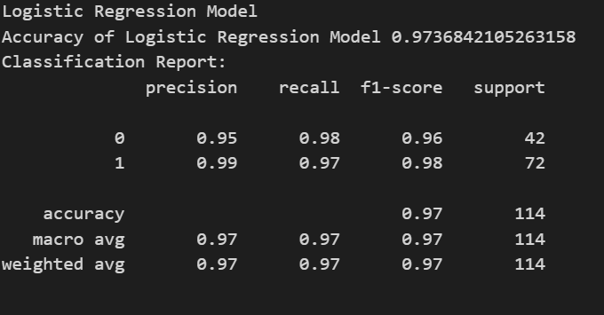
Overall Accuracy=97%

Manual Single-Neuron Neural Network
- One neuron with 30 inputs (same as number of features)
- Sigmoid activation function → outputs probability
- Binary cross-entropy loss
- Trained via backpropagation (gradient descent)
- Gradient descent used to update weights and bias
- Can later be extended to multiple neurons/layers

Performance Metrics:
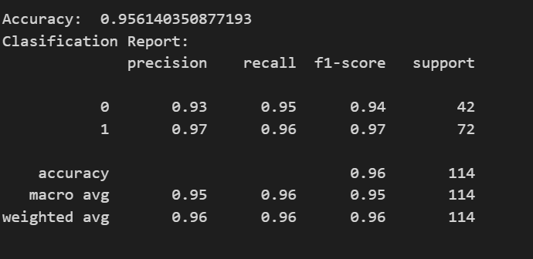
Overall Accuracy: 96%

Conclusion and Recommendation

Model Comparison
Model | Overall Accuracy | Malignant (0) Recall
Logistic Regression | 97.37% | 98%
Single Neuron NN | 95.61% | 95%

The manually implemented Logistic Regression model achieved the strongest overall performance, with both the highest accuracy and the highest recall for the Malignant class. Although the Single-Neuron Neural Network (one-layer perceptron) uses the same underlying mathematical formulation, the Logistic Regression model converged more effectively and produced more stable results during training.
Two major factors contribute to this performance difference:
- Linear Separability: The Breast Cancer dataset exhibits a strong linear decision boundary. Logistic Regression is a direct linear classifier and is therefore well-suited to this structure. As a result, it was able to learn an almost optimal separating hyperplane in the feature space.
- Optimization Stability: The Single-Neuron Neural Network required manual gradient descent and weight updates. Although theoretically equivalent, neural networks are more sensitive to learning rate selection and initialization. Minor instability during training caused slightly lower accuracy and recall compared to the manual Logistic Regression model.

Recommendation
The Manual Logistic Regression model is recommended for deployment.
It achieved:
- Highest accuracy: 97.37%
- Highest Malignant Recall: 98%
In medical diagnostic applications, recall for the Malignant (positive) class is critically important. A false negative — predicting a malignant tumour as benign — carries severe medical risk. The Manual Logistic Regression model demonstrated the best ability to minimize such false negatives.
Therefore, based on quantitative performance and the safety-critical nature of the problem, Manual Logistic Regression is the most reliable and clinically suitable model for this dataset.

References
- Scikit-learn Documentation: https://scikit-learn.org/stable/modules/neighbors.html

