PART-TIME FACULTY/EXTRA TEACHING LOAD(S)
DAILY TIME RECORD (DTR)

Name of Faculty: RONALD D. BESINGA For the Month of: NOVEMBER
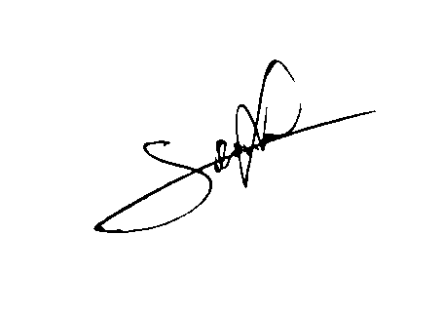
Date | Subject(s)/Subject Code(s) |  |  |  |  |  |  |  | Date | Subject(s)/Subject Code(s)
Date | ICT 3 – ICT Fundamentals w/ Office Productivity |  |  |  |  |  |  |  | Date | ICT 3 – ICT Fundamentals w/ Office Productivity
Date | In | Out | In | Out | In | Out | In | Out | Date | In | Out | In | Out | In | Out | In | Out
1 |  |  |  |  |  |  |  |  | 16
2 |  |  |  |  |  |  |  |  | 18
3 |  |  |  |  |  |  |  |  | 19
4 |  |  |  |  |  |  |  |  | 20
5 |  |  |  |  |  |  |  |  | 21
6 |  |  |  |  |  |  |  |  | 22
7 |  |  |  |  |  |  |  |  | 23
8 |  |  |  |  |  |  |  |  | 24 | 10:30 AM | 1:30 PM
9 |  |  |  |  |  |  |  |  | 25 | 7:30 AM | 10:30 AM
10 |  |  |  |  |  |  |  |  | 26
11 |  |  |  |  |  |  |  |  | 27
12 |  |  |  |  |  |  |  |  | 28
13 |  |  |  |  |  |  |  |  | 29
14 |  |  |  |  |  |  |  |  | 30
15 |  |  |  |  |  |  |  |  | 31
Total |  |  |  |  |  |  |  |  | Total | 6 HOURS

Accomplished by: Checked/Approved by: Reviewed/Received by:
Umy-sec121123
RONALD D. BESINGA IRENE MAY C. ESCAUSO
Signature over Printed Name of Faculty Signature over Printed Name of Dean/Program Head Signature over Printed Name of HR

Date: 12/11/2023 Date Date:

PART-TIME FACULTY/EXTRA TEACHING LOAD(S)
DAILY TIME RECORD (DTR)

Name of Faculty: RONALD D. BESINGA For the Month of: DECEMBER
Date | Subject(s)/Subject Code(s) |  |  |  |  |  |  |  | Date | Subject(s)/Subject Code(s)
Date | ICT 3 – ICT Fundamentals w/ Office Productivity |  |  |  |  |  |  |  | Date | ICT 3 – ICT Fundamentals w/ Office Productivity
Date | In | Out | In | Out | In | Out | In | Out | Date | In | Out | In | Out | In | Out | In | Out
1 |  |  |  |  |  |  |  |  | 17
2 |  |  |  |  |  |  |  |  | 18
3 |  |  |  |  |  |  |  |  | 19
4 |  |  |  |  |  |  |  |  | 20
5 |  |  |  |  |  |  |  |  | 21
6 |  |  |  |  |  |  |  |  | 22
7 |  |  |  |  |  |  |  |  | 23
8 | 10:30 AM | 1:30 PM |  |  |  |  |  |  | 24
9 | 7:30 AM | 10:30 AM |  |  |  |  |  |  | 25
10 |  |  |  |  |  |  |  |  | 26
11 |  |  |  |  |  |  |  |  | 27
12 |  |  |  |  |  |  |  |  | 28
13 |  |  |  |  |  |  |  |  | 29
14 |  |  |  |  |  |  |  |  | 30
15 |  |  |  |  |  |  |  |  | 31
Total | 6 HOURS |  |  |  |  |  |  |  | Total

Accomplished by: Checked/Approved by: Reviewed/Received by:
Umy-sec121123
RONALD D. BESINGA IRENE MAY C. ESCAUSO
Signature over Printed Name of Faculty Signature over Printed Name of Dean/Program Head Signature over Printed Name of HR

Date: 12/11/2023 Date Date:

