

**AGUSAN DEL SUR STATE COLLEGE OF AGRICULTURE AND TECHNOLOGY**

**BACHELOR OF SCIENCE INFORMATION TECHNOLOGY**

**DENVER LOGROÑO TERADO**

**CHE CHE LLOREN**

***BARANGAY INDIGENT BENEFICIARIES INFORMATION SYSTEM***

**SEPTERMBER 2023**

**INTRODUCTION**

The industrial workplace uses computerization as a control system to manage processes. It decreases human error and processing time, increasing productivity and producing goods of excellent quality. This can lead to a process that is effectively integrated into the system and can work considerably faster and more precisely than the manual system.

To manage paper papers, find information, and keep information secure, it takes more time and space. A manual transaction frequently needs to be totally redone rather than just updated when mistakes are made or adjustments or repairs are required. With manual or semi-automated systems, information must frequently be written down, copied, and entered multiple times. Reducing the number of duplicate data entering through systemization.

The creation of an indigent beneficiary’s information system for Barangay is the main subject of this project. Considering the benefits raises knowledge of the capabilities of information systems. In order to automate the barangay notification of people who will receive their financial benefits by SMS, the researchers designed an Indigent Beneficiary Information System, a web-based system that is automatically generated. Would instantly save time for the barangay's employees and enable a basic degree of statistical analysis of the data collected there.

**STATEMENT OF THE PROBLEM**

* As of now the Barangay is currently using the manual/ paper based information system for their Indigent Beneficiaries which may cost a lot of human errors. Like the following:
* Inconsistency in data entry, room for errors, miskeying information.
* Large ongoing staff training cost.
* System is dependent on good individuals.
* Reduction in sharing information and customer services.
* Time consuming and costly to produce reports.
* Lack of security.
* Duplication of data entry.

**OBJECTIVES OF THE STUDY**

* **General Objective**

The study aims to develop a web-based Barangay Indigent Beneficiaries

Information System for barangay Bunawan.

* **Specific Objectives**

1. To lessen the possible error in searching the particular indigent beneficiaries.

2. To generate automatic pdf file copy of the beneficiaries according to category.

3. To automatically send the SMS to the beneficiaries if there will be a distribution of assistance aid.

4. To Evaluate the develop System

4.1 Functional Suitability;

4.2 Performance Efficiency;

4.3 Compatibility;

4.4 Usability;

4.5 Reliability;

4.6 Security;

4.7. Maintainability; and

4.8 Portability.

**SIGNIFICANCE OF THE STUDY**

* **Barangay Captain**. Can easily identify the family base on their category and can easily identify the possible needs and services in their range.
* **DSWD Secretary**. Can help to provide more accurate data in barangay and provide more services to all resident.
* **Presidents.** It will be easy for them to access their records if there are some changes to be done on their part.
* **Indigent.** Can easily provide their information in which program they are capable of.
* **The Researcher.** It will increase their knowledge and help them to develop their skills in web development. It will be a good learning experience for them in developing a useful and efficient system.
* **The Future Researcher.** The study will serve as their reference material for future research. This will be their concrete basis in formulating their system.

**SCOPE AND DELIMITATION**

This study will focus on the development of the proposed Indigent Beneficiaries Information System of Barangay. To automate the current manual process and transaction in it. This system contains modules such as account settings, record management, SMS messages, announcements, and generate reports. Account settings hold the access inside the system in which the admin will add and modify the user. The admin also will only have the access to delete information regarding to all the beneficiaries. The user can manage all the information regarding to all the beneficiaries to be added or to remove. And it has the authority to distribute the announcements to be disseminate.

Record management holds the information of the members that will be gathered in the data to be collected in the first step. SMS is the service that will use to disseminate the announcements to be done. Announcements holds all the program in every category. And last is to generate reports under generate reports, the list of all the beneficiaries, the summary of all the distribution by category who received benefits or financial assistance.

However, the limitations of the system include that the software does not support operation to do reply any kind of messages. The SMS is an automatic message to be send directly to the beneficiary in each category. The system is a web-based that support operation over the internet with local area network (LAN).

**LOCATION AND TIME OF STUDY**

**Location**

This research will be conducted to Barangay Bunawan. The reasons of the researcher assigns the school as a research location because of some considerations as follows:

* + - * The issue was discovered by the researcher and was connected to the study's title.
      * The barangay's readiness to grant approval for research.

**Time of Study**

This study was conducted in even semester of Academic Year 2023/2024.

**Conceptual Framework of the Study**

**INPUT PROCESS OUTPUT**

Data Gathering

* Interview
* Survey
* Brainstorming
* Indigenous demographic information

Software Process model:

* Modified Waterfall Model

Data analysis

* Use Case Diagram
* Sequence diagram
* Development diagram
* Work breakdown

Hardware tools

* Computer
* Laptop
* Intel core i5 or higher 4GB RAM, 500GB (at least 250 SSD)
* Mobile android device
* Modem

Software tools

* Windows 8 or Higher OS
* Programming

Language: Nodejs

Development Tools

* Visual studio code, Nodejs, Npm
* Mongo Database

***BARANGAY INDIGENT BENEFICIARIES INFORMATION SYSTEM***

Figure 1. The Conceptual Framework

.

This conceptual framework shows the stages of the project development. This figure shows a basis to achieve user requirements. Software and hardware requirements of the system as shown in the figure.

        The researcher interviewed the staff of the Department of  Social Welfare and Development to identify the problem. The process box includes a modified waterfall model and used a use diagram and sequence diagram to develop the system.

In addition, the figure above also includes the hardware and software requirements as well as the development tools to be used in the study. The hardware requirements include Intel Core i5 or higher processor, 4GB RAM, 500GB HD (at least 250 SSD), a Computer, a Mobile Device, and a Modem. In terms of software requirements, the system will use Windows 8 or higher OS. For the development of the system the researcher will be using the following: Nodejs along with Mongo Database to create Web base that allows to input all the data and information.

The researcher used these methods, concept and ideas in order to develop the project as an output entitled: “BARANGAY INDIGENT BENEFICIARIES INFORMATION SYSTEM ”.

**Review of Related Literature**

**Social inclusion of senior citizens**

The article by Dahl (2018), titled "Social inclusion of senior citizens in Japan: “Community-Based Integrated Care System”—Social Inclusion of Senior Citizens in Japan. In this regard, the article underscores the current international move to incorporate social inclusion, which is supported widely by international organizations and implemented even by national policies.

Specifically, the article highlights how the notion of social inclusion is fairly versatile and as such, can be applicable and valid in a variety of social settings. Nevertheless, it acknowledges that there exists some problems in turning these ideas into reality. In relation to Japan, the ‘Community-based Integrated Care System’ was one of the changes done by the revised Long-term Care Insurance Law which was implemented in 2006.

The feasibility study that informs this paper derives, inter alia, from field work done in one major commuter city within the greater Tokyo Area. This highlights inconsistencies between theory and practice concerning the adoption of policies for social inclusion. It is argued that the planned ‘Community-based Integrated Care System’ model could foster an efficient local care system in place but would not necessarily equip local people, especially elderly.

The study by Boustani looks at ways of improving the community integration of children below eighteen years with special emphasis on a developing country’s communal life. It pushes for child centred initiatives which involve children participating in the decision making process and preserving local services. The three pilot municipalities had successfully put into place essential resources like a call center, software solutions, library, digital network center, and child participation on the municipal boards. The program addresses weaknesses and safeguards minors against different kinds of abuse.  
  
This article emphasizes that it is necessary to understand needs and interests of young people with a goal to involve them into social and political communities’ life. Furthermore, it casts doubts on the prospects of realizing these goals with help from artificial intelligence (AI).  
  
It can be argued that the paper’s relevance came out during the Covid-19 pandemic when the technologies were used to help the young population in affected areas get integrated and understand the danger from the pandemic. The article supports these various theoretical frameworks of Gender Inequalities and Children’s Inclusion; Municipal Governance & Reform; Organizational Innovation (Public Sector); and Social Inclusion. This presents the importance of innovation in the public sector and how AI protects and assists vulnerable groups. (Boustani, N. M. (n.d.). )

Livingstone and Helsper's (2007) study on "Gradations in digital inclusion: “Children, young people and the digital divide” is concerned with one of the crucial aspects that is usually disregarded in debates about so called ‘digital divide’ amongst children and youth. The authors present evidence from a national survey of UK 9 to 19-year-old school students which reveals inequalities in e-access as well as use as per age groupings, sex, and social class.  
  
The article proposes the idea of the ‘continuum of digital inclusion’ as an alternative to the dichotomy of digital connection and non-digital connection. This acknowledges that differences between infrequent users of the internet such as non-users to regular users like daily browsers, reflect variations on how youth utilise online opportunities from basic to comprehensive levels.    
The research focuses on the multiplicity of digital inclusion; it pin points the role played by demographic variables as well as utilization trends and digital competence in determining broad and deep access to internet. Such investigation gives a precious understanding concerning numerous aspects of digital experiences of youth and can be helpful for policy-makers, as well as researchers, in relation to addressing the problem connected with the digital gap within younger generations.

The study by Celia Capadocia Yangco, the significance of the Philippines’ pledge towards protecting the right and welfare of the country’s sizable percentage of children is captured in detail. This is pointed out by an article on a certain page of its volume that numerous provisions in the Constitution and laws of the Philippines pertain to enforcing the rights of the Filipino children underlining a great dedication to Filipino child welfare.  
  
Yangco shows how Filipino families, including their children, experience difficulties amidst of global transformations and social changes. Urbanisation, technological advancement, and greater involvement of women in employment has brought new stress upon families, affecting the condition of children. The changes which are geared towards progress may result in child neglect or even children’s rights abuses thus, calls on the government and other stakeholders to react more positively on the matter.  
  
This is evident in an article that highlights that through DSWD and CWC, the government has rolled out initiatives to effectively confront and handle every challenge associated with child labour. Survival, Protection, Development, and Participation of Children. these initiatives are aligned with the Filipino strategy for developing strategic plans for children, Child 21, that compliance to the UN Convention on the Rights of the Child (CRC). The rights based approach is directed towards creating a child-sensitive and child-friendly society in the Philippines.

In their study, Blanquisa and Berdin (2022) examined the effects of 4Ps or Pantawid Pamilyang Pilipino Program on households with beneficiaries in Malilipot, Philippines. This research paper’s main aim is describing the social characteristics of 4Ps beneficiaries such as age, gender, education level, health, family setting and other sociodemographic indicators.  
  
Fifty-six household beneficiaries aged between 30 and 80 are in the study, with almost all being lifelong residents of San Isidro Iraya. Generally, this household comprises of two parents and five children. Mothers’ educational attainments vary where some of them have gone up to College level while others are Grade and high school leavers. Men in these households are usually working on construction sites. Firstly, in all of the households, it is noteworthy that there are 7 cases of single parent mothers and early widows while 49 households have married parents.  
  
The household has a monthly income of less than P12,000 and receives a quarterly 4Ps allowance of P5,200 which is subject to deductions on children’s school attendance. High School pupils get P1, 000 quarterly while Elementary grade children get P500 per term. This research describes the regulation imposed by the DSWD. Benefits comprise boosting incomes, promoting better health and education among youngsters, as well as fostering positive attitudes in homes. But weaknesses are mainly limited by failure of budgets intended for different Household needs.

A research study carried out on the implementation of Solo Parent Welfare Act of 2000 in Tabuk City, Kalinga Province provides insights into the awareness, extet of implementation and factors influencing the application of an important law. This study uses a questionnaire that applies a three-point likert scale for responses. The study utilizes the weighted mean and ANOVA analysis to provide an objective evaluation of the collected data.  
The results show that respondents have “moderate awareness” concerning the Solo Parents’ Welfare Act of 2000, leaving ample opportunity to improve the spread of information on critical legislations. The same is said about the level of implementation that is “moderately implemented”, which opens possible prospects for improvement with respect to implementing other provision of the Act.  
This study’s primary achievement is in highlighting that the “moderately serious” level of factors influencing the Act’s application in Tabuk City. If resolved, they would enhance the implementation of the Solo Parent Welfare Act.  
In essence, this study presents important findings about the state of implementation of the Solo Parent Welfare Act in Tabul City, Kalinga Province which can serve as the basis for policy makers and other stakeholders to enhance the current statutes and policies favoring parent

**METHODOLOGY**

**Software process model**

The waterfall planning method, which was selected as the software process, was used to create the framework. A theoretically grounded strategy will determine the path of the entire research. The model describes the steps or order of a process.

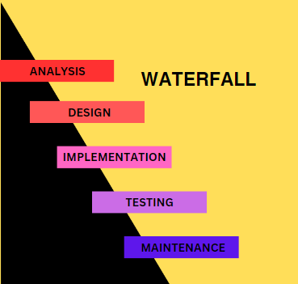

Figure 2: Waterfall significance

The method was developed by the researcher using a modified waterfall paradigm. It is believed that the researcher will collaborate with the business and technical groups to identify both functional and non-functional requirements.

The subsequent phases the researcher must adhere to a modified waterfall model and a software process model to complete the investigation;

1. **Analysis**

During this stage, the researchers will collect data by conducting in-person observations and speaking with the Barangay officers of Banawan. The researchers learned that the said barangay is still using a manual process of distributing the financial assistance. The researchers will acquire data during this process, which inspires them to create an application that would assist them in solving the problem. The researchers will next provide a detailed definition of the requirements and place the application specifications.

1. **Design**

In this phase, the researcher will use Visual Studio 2019 to design the system. Since this application includes various designing features and the most in demand tool for art editing, the proponents have an idea of utilizing it.

1. **Implementation**

The system will be installed in the main computer unit used in Barangay Bahawan in order to test the Barangay Indigent Beneficiaries Information System. If proven functional, there is a possibility that the DSWD will adapt the system.

1. **Testing**

In this phase, the proponent must install the Barangay Indigent Beneficiaries Information System on an desktop to verify its functionality and find any potential problems or missing features. As a result, they are able to quickly find flaws and rectify them so that the program complies with all software requirements.

1. **Operation and Maintenance**

The program will be installed on desktop and used in practice during the final phase. The researchers will fix any system issues that were found during earlier stages. The system must be fully improved, implemented, and the system services must be improved.

**Requirement specification**

**User Requirement**

The system for Barangay Indigent Beneficiaries Information System will be developed through the following features;

* Web-based Database
* User-friendly interactive feature.
* Safety and security of data

**Functional Requirements**

**Admin**

* Accessibility to the main system
* Monitor the records of the indigent families.
* Give tasks to the DSWD staffs/

**Barangay Staff**

* Accessibility to the system
* Can use data visualization to track the data reports.

**Indigent**

* Accessibility to the system
* Monitor the activities in Barangay
* Receive notifications to their mobile phones towards the activities of Barangay

**Non-functional requirements**

* 1. **Operational requirements**
* The system is web-based.
* The system requires an Internet connectivity.
* The system must be installed in Desktop computer.
* The system must be accessible to mobile phone.
  1. **Performance Requirements**
* The system must be easy to navigate.
* The system must be user-friendly.

**Software & Hardware Requirements**

**Software requirements**

Software must be taken into consideration for the development and production of the system in order for the researcher to design and build it. For this Barangay Indigent Beneficiaries Information System, the proponents will use the following application:

* Operating system (Windows 8 or higher)
* Visual studio 2019 (Xamarin. Forms)
* XAMPP

**Hardware requirements**

The researchers designed a system for Barangay Bunawan with the following hardware.

* Computer/Laptop

Specifications:

Processor: Intel Core i3-1215U (10MB Smart Cache, 1.2 Ghz Performance Core with Intel Turbo Boost Technology 2.0 up to 4.4 Ghz)

Graphics: Intel UHD Graphics

Memory: 20GB 3200Mhz DDR4 system memory (upgradeable)

Storage: 1TB NVMe 250GB SSD

Display: 15.6″ HD 1366×768 resolution

Operating System: Windows 10

**Feasibility Issues**

The proposed system was put to the test via the feasibility study that is presented below. The following are the analysis's key findings:

**Technical** **Feasibility**

The technical feasibility is determined by the researchers due to the emergence of online site. Since majority of the business transactions have already extended their processes thru a website, the required equipments will be a Desktop, stable Internet connection, and cellular phones.

**Economic Feasibility**

The system is economically feasible since it is free of charge. The researcher decided to make the application free for all the stakeholder.

**Operational Feasibility**

This study is operationally feasible because it is user-friendly, accessible, easy to navigate and easy to maintain.

**Schedule Feasibility**

The system is schedule feasibility because the proponents guarantee that it every necessary process will be finished within the given timeframe.

**Project Cost**

In this capstone project, the Barangay Indigent Beneficiaries Information System will be integrating both the software and hardware. For now, the proposed total development cost of this project is---. Depending on how the application is developed, the estimated cost may differ.

**Work breakdown structure**

The researcher is having a structural work breakdown that is shown in Figure 2 and also shows five stages with a description of every stage. The work breakdown structures serve as a guide for the researcher to follow in order to make an application.

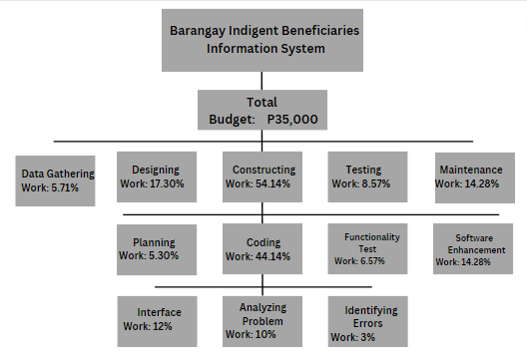

Figure 3. Work Breakdown structures

This figure displays the costs associated with the system's development and upkeep at each stage. It comprises system and software design, implementation, system testing, and maintenance. It also involves requirements analysis. The illustration will serve as a guide for dividing the costs.

**Cost- Benefit Analysis**

The expenses of the labor, software, and hardware needed to complete the project are estimated in this section. It will weigh the benefits the project will bring to the company against the expense of putting it into action. Additionally, it will demonstrate the benefits that Barangay Indigent Beneficiaries Information System has reaped from the project's execution.The table below shows the cost estimated for implementation and system development.

**A. Hardware Cost**

|  |  |  |  |
| --- | --- | --- | --- |
| Recommended Requirements | Specifications | Quantity | Unit Price |
| Processor | Intel Core i3-1215U (10MB Smart Cache, 1.2 Ghz Performance Core with Intel Turbo Boost Technology 2.0 up to 4.4 Ghz) | 1 | 5,297 |
| Motherboard | KBL Metapod_kl v1.22 | 1 | 2,500 |
| Ram | 20GB 3200Mhz DDR4 system memory (upgradeable) | 1 | 1,000 |
| Hard drive | 1TB NVMe 250GB SSD | 1 | 1,500 |
| Keyboard | Integrated | 1 | Free |
| Monitor | Integrated | 1 | Free |
| Mouse | Pro max Model: M3 | 1 | 250 |

**Total: ₱10,547**

***Table 3.1 Hardware Cost***

Source: <https://shopee.ph/>

**B. Utility Expenses**

| **Particulars** | **Cost** |
| --- | --- |
| Electricity | 129.60 |

**Total: ₱129.60**

***Table 3.4 Utility Expenses***

*Computer Usage 4.32/day for 10 hours in 30 days

**C. Summary Cost**

|  |  |
| --- | --- |
| **Costs** | **Amount** |
| Hardware Cost | 10,547 |
| Utility Expense | 129.60 |

**Total Costs: ₱10,676.60**

***Table 3.6 Summary Cost***

**Estimated Benefits:**

Accuracy and efficiency of the software at approximately 85% Total estimated Benefits = ₱10,676.60* 85%

**Total = ₱9075.11**

**Payback Period**

Payback Period = (Total Cost / Total Estimated Benefits) * 12

= (10,676.60/ 9075.11) *12

**Total = 14 months or 1 year and 2 months**

**Return of Investment**

Return of Investment = (Total Estimated Benefits / Total Cost) * 100

= (9075.11/ 10,676.60) * 100

**Total = 85%**

**Risk Management**

The risk management that the researchers have developed is an essential tool when working on a project. It can help the researchers identify and understand the risks related to the work they are doing for the study. It also gives the researchers access to detailed information about project schedules, team member withdrawals because of financial difficulties, and other relevant information.

**Risk management**

The table 3 shows the possible encounter of the following during the operation of the application.

Table 1. Risk Management

|  |  |  |  |  |  |  |
| --- | --- | --- | --- | --- | --- | --- |
| **Risk** | **Level** | **Description** | **Potential** | **Effects** | **Strategy** | **Status** |
| Possible withdrawal or dropping from class of a team member. | High | A team member has the possibility of withdrawing or dropping from class. It can cause a major fallback especially if the assigned task to them is crucial. | Frequent absences or leave from class is a sign of potential withdrawal or dropping from class. | The project's position will be in jeopardy. | The group must conduct regular meeting to have an open discussion towards the issues that arises within each member to avoid experiencing such team member loss due to withdrawal or dropping. | So far, all the team members are cooperative. |
| System failure | High | A system failure happens when there is a power interruption or unexpected system bug. | It may erased the recent changes in the system. | It can cause a major disaster in the system. | It will take time for the team to identify the problems, formulate the appropriate inquiries, and ascertain the cause of the system failure. | The system is in the process if making. |

**Implementation of the System**

**Team building activities**

The team will conduct a regular meeting so that each member know how the process of making a system happens in every detailed manner. It is important to keep everyone in touch and at the same time, be open for the suggestions of every member to create harmony.

**Programming, compilation, and linking**

The researchers will program, compile and link codes in order to create every function of the Barangay Indigent Beneficiaries Information System.

**Structure walk-through and quality control**

The researchers planned to conduct or acquire data in order to achieve their goal, meet the study's objectives, and establish the study's structure in order to have quality control.

**Testing and debugging**

The researchers will consult with an expert IT professional when testing and troubleshooting the system. To start the debugging process, they must identify the exact place in the design or code.

**System Documentation**

Documentation plays a crucial role in a research system, providing the investigators with evidence that the study has been completed. Documentation demonstrates the study's methodology, cost, cost flow, and many other aspects.

**System installation**

The system will be available online through web hosting. Web hosting is an online service that enables the content of a website to be accessed online. It involves renting the ability to store all website files and data on a server. Web hosts provide tools and technology to ensure website safety, maintain server uptime, implement security measures, and ensure successful data delivery (Hostinger.ph).

**Periodic Maintenance**

In order to help the Barangay officers make the most out of the project's output, the researchers planned to write a user manual.

**Deployment Diagram**

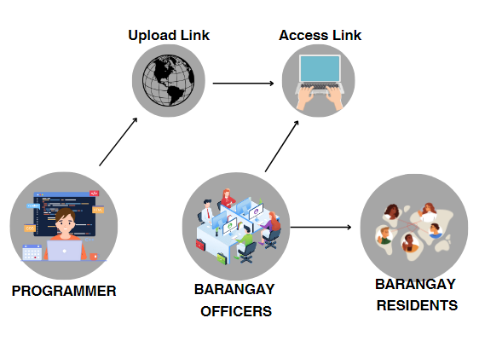

Figure 5.Deployment Diagram

Shows the systematic flow of the system and how the researchers ought to deploy the output of the study. The interaction between the users and devices to be used are also reflected in the figure.

**System Design**

**Use Case Diagram**

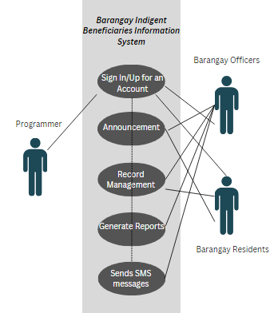

Figure 6: Use Case Diagram

**Programmer/s** – In this study, they are the proponents of the Barangay Indigent Beneficiaries Information System. They will be in charge of coding, debugging and testing the entire system.

**Barangay Officers** - In this study, they are one of the stakeholders that will benefit from the Barangay Indigent Beneficiaries Information System. They will input all the barangay records into the database which is embedded into the system.

**Barangay Residents** - In this study, they are the primary beneficiaries from the Barangay Indigent Beneficiaries Information System. They will receive notifications from their cellphones once their barangay has important community announcements.

**Use Case Description**

The table makes use of a case diagram to display the system's allocated person.

Table 2. Use case description for the page.

|  |  |
| --- | --- |
| **Use case name** | **Home page** |
| Barangay Bunawan | The home page will be visible to the user. |
| User | Programmer/Barangay Officers/ Barangay Residents |
| The main flow of the events | 1. Open and modify accounts 2. Can post important announcements. 3. Can generate monthly reports 4. Can send updated notification in mobile phone |
| Post condition | The users can successfully view the home page. |

The sequence diagram derived from the generated use case diagram is depicted in this picture. This demonstrates how the user interacts with the application as a whole.

**Sequence Diagram**

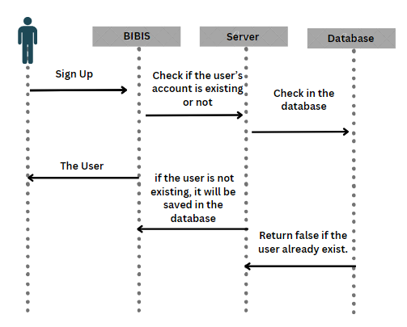

Figure 7. Barangay Indigents Sign up Sequence Diagram

The process by which the residents for the application is depicted in this picture. Following the residents' first registration, the username and password are added to the database, the server verifies that the user doesn't already exist, and the login process is initiated.

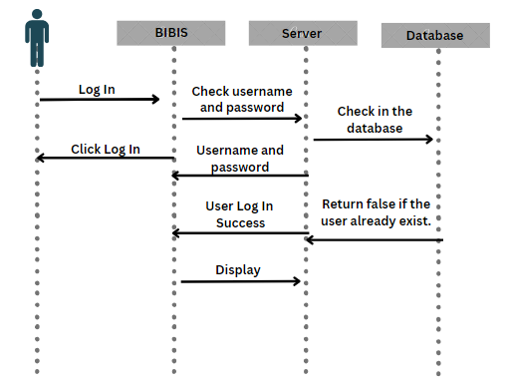

Figure 8. Staff Sign up Sequence Diagram

The procedure for Barangay officers to log into the sysem is depicted in the picture. The officers will first log in with their username and password. The server will then verify that the username and password match, and the user will be able to access the program.



Figure 9. Programmers Sign up Sequence Diagram

This figure shows the process of how the programmer will navigate through the system. First the programmer will sign up, then he will check if all the features are functioning according to its use.

**ENTITY RELATIONSHIP DIAGRAM**

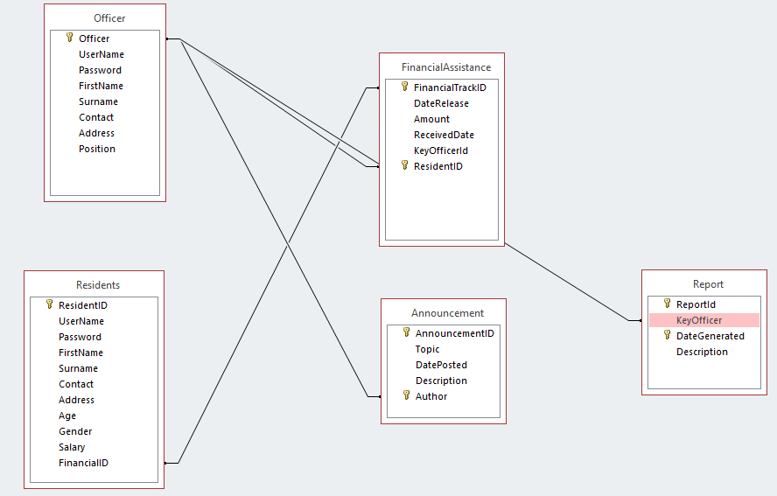

Figure 10. Entity Relationship Diagram

Figure 10. The Barangay Indigent Beneficiary Information System's entity-relationship diagram displays every visual tool for database tables. In order to specify the connections between structured data groupings of information system functionalities, it employed structure data.

**Result and discussion**

The researchers used a modified waterfall model technique for the development and design of a system, ensuring accurate implementation of intended requirements through system testing. Any bugs or mistakes were addressed by the development team. Fifty respondents (half will be the Barangay officers while half will be the residents) will be selected as respondents to evaluate the system's functional and non-functional requirements using a five-point Likert scale, ensuring the system met the stated objectives.

Table 4. Likert Scale Rating

**Rating Description**

5 Strongly Acceptable (SA)

4 Acceptable (A)

3 Moderately Acceptable (MA)

2 Not Acceptable (NA)

1 Strongly Not Acceptable (SNA)

To determine the acceptability of the system the mean score was categorized as follows.

Table 5. Category Rating

Category Rating Description

4.50 – 5: 00 Strongly Acceptable (SA)

3.50 – 4.49 Acceptable (A)

2.50 – 3.49 Moderately Acceptable (MA)

1.50 -2.49 Not Acceptable

1.00 -1.49 Strongly Not Acceptable

**References:**

Hostinger.ph.What is Web Hosting – Web Hosting Explained for Beginners. https://www.hostinger.ph/tutorials/what-is-web-hosting/