**CHAPTER 1**

**INTRODUCTION**

# Background Of The Study

In the ever changing world of real estate, looking for the perfect house and lot has always come with its share of difficulties. To change this, we proudly introduce our capstone project at Agusan del Sur State College of Agriculture and Technology**.** In a time where convenience and efficiency matter most, this system acts as a link between enthusiastic property owners and potential buyers. By making the process smoother and improving user experience, the platform uses advanced technology to create an easy and simple interface for both sellers and buyers.

**(Dr. Emily Parker,2020),** in her study "Changing Real Estate: How Online Platforms Affect Property Transactions," Dr. Parker looks at how online real estate systems have changed the way properties are bought and sold. **(Edward Wolff, 2021),** Homeownership has become more affordable for low- and moderate-income households in recent years. The real estate market has helped to reduce poverty and inequality and Real estate has provided a source of wealth and stability for many households. **(John Burns, 2023),** Real estate system automation for search properties can help buyers and sellers find the right match faster and more efficiently. It can also help to reduce costs and make the real estate process more transparent. (Michael Neal, 2022), Real estate system for search properties can help buyers and sellers save time and money. It also help to level the playing field between buyers and sellers, as everyone has access to the same information. **(Ben Miller, 2020),** Real estate system for searching properties is a key trend that will shape the future of the industry and will lead to a more equitable and accessible real estate market.

The main challenges and gaps in of the system includes making sure property information is accurate, getting users to use the system, keeping data safe, dealing with technical issues, following complicated rules, standing out in a competitive market, and making the system better based on user input. It offers an attractive and informative website that makes finding the perfect property easy. With a big list of properties for sale, buyers can explore many options, narrow down results by location, and see lots of property details and good pictures. This system lets buyers make smart choices and picture their future homes without having to visit each property.

Our capstone project entitled “**An Innovative Real Property Portal: Elevating House and Lot Hunt**” has the purpose to make a strong House and Lot Hunt System that deals with common problems in property transactions. At the same time, it wants to make things more convenient and clear for buyers and sellers. This system aims to change the old way of searching for and buying properties, with a special focus on making the search easier and giving lots of property details.

# Statement Of The Problem

In the past, finding the right house and lot has usually been a complex and time-consuming task for potential buyers. Nowadays, people looking to buy properties often have to use different websites and social media platforms, each with its own way of showing listings, just to find houses and lots that match what they want. Also, because there isn't one single place to look, the search becomes inefficient and confusing. This makes it hard for buyers to see all their choices and pick the best one for them.

This study wants to solve these main problems:

1. Finding Properties Is Confusing
2. It's Hard to Look for Specific Locations
3. Not Enough Information About Properties

# Objectives Of The Study

This study aimed to design and develop user-friendly web-based An Innovative Real Property Portal: Elevating House and Lot Hunt. Specifically, this study aimed to:

1. **To provide a Responsive Search Engine.** Enabling users to effortlessly locate and filter property listings based on various criteria such as location, property type, and price range. By harnessing search functions and database technologies, users can access accurate and tailored search results, property discovery process and saving time.
2. **Manage Appointment and Provide portal for Direct Communication:** It focuses on simplifying the process of scheduling property viewings and facilitating communication between buyers and sellers. The system empowers users to arrange property visits with ease and engage in email conversations with property owners. This enhancement fosters efficient and transparent communication, ultimately enhancing the property transaction experience.
3. **Show Virtual Tour of Properties.** Users can explore properties virtually, providing an immersive and informative experience. Potential buyers can gain a comprehensive understanding of a property without physically visiting it. This not only enhances decision-making but also minimizes the need for multiple physical property visits, saving time and resources.

# Significance of the Study

The success of the study is deemed beneficial to the following individuals or groups:

**Buyers:** The System brings significant advantages to buyers by simplifying their property search process. Through consolidated listings and an advanced search feature, buyers save time and effort, avoiding the need to navigate multiple sources. Comprehensive property details, high-quality visuals, and virtual tours empower buyers to make informed choices that align with their preferences. Additionally, the system's user-friendly interface elevates the overall experience, enabling buyers to engage effortlessly and explore properties with convenience.

**Sellers:** The System provides substantial benefits to sellers by expanding the visibility of their properties. With an all-inclusive database and organized listings, sellers can connect with a broader audience of potential buyers. The user-friendly interface streamlines property management, enabling seamless detail uploads and real-time updates, thus speeding up the selling process. Moreover, the system's emphasis on precise property representation through comprehensive information and virtual tours fosters trust with buyers and improves the overall selling journey.

**Researchers:** The System presents an invaluable platform for

researchers to study property transactions within a digital landscape. It offers a real-world case study for evaluating the influence of technology on real estate operations. The development and implementation of the system serve as a practical model for incorporating advanced tools to tackle industry challenges, yielding insights into user preferences and behaviors. Furthermore, the system's continuous enhancement driven by user feedback creates an ever-evolving research area, exploring emerging trends and user interactions.

# Scope And Delimitation Of The Study

This section describes what the study will cover and its boundaries. We want to make property listings with lots of details, good pictures, and virtual tours to help buyers understand properties better. We'll also make the website easy to use and listen to what users say to make it better, but we know there are limits because of technical stuff, guessing property details are right, and how big our study is.

# Scope

The study will create appealing property listings that present in-depth information, top-quality images, and virtual tours, giving potential buyers a comprehensive grasp of each property. Focusing on a user-friendly web interface, the study will design an intuitive platform for easy navigation, benefiting both buyers and sellers.

# Admin

* Manage user accounts and permissions.
* Gather and analyze user feedback for system improvements.
* Manage House and Lot Application.

# Owners

* Create and manage property listings with accurate and comprehensive

details.

* Upload high-quality images and virtual tours of listed properties.
* Set property prices and availability status.
* Receive inquiries from potential buyers.
* Access a user-friendly interface for listing management.

# Buyers

* Search for properties based on criteria like location, property type, and price range.
* View detailed property listings with information such as property specifications, images, and virtual tours.
* Contact sellers or agents for inquiries or property viewings.
* Access a user-friendly interface for easy navigation.

# Delimitation

* The study's scope is confined to developing the House and Lot Hunt System and putting it into action. The insights and solutions may not directly apply to different property types or areas outside the chosen scope.
* The system's effectiveness depends on factors like internet connectivity and device compatibility. Technical infrastructure issues are not addressed.
* The study does not assess the accuracy of property listings; it assumes that information provided by sellers is precise.
* Legal and regulatory aspects of property transactions, contracts, and location-specific rules are beyond the study's scope.

* While efforts will ensure user-friendly design, user behavior might be influenced by external factors beyond the study's control.

# Operation Definition Of Terms

**System:** A system is a group of parts or pieces that work together for a common goal. It's also the main software part in a computer that handles and runs different programs.

**Database:** A database is an organized collection of information or data that's structured and usually stored in a computer. It's managed by a special system called a database management system (DBMS).

**Entity Relationship Diagram (ERD):** An Entity Relationship (ER) Diagram is like a flowchart showing how things like people, objects, or ideas are connected in a system.

**House and Lot Hunt System:** A digital tool made and put into action in this study, meant to help people - both those looking to buy and sell - find, look at, and handle house and lot properties. The tool gathers property listings, gives ways to search and filter, shows property information, pictures, and virtual tours, and lets you see updates in real-time.

**Program:** A computer program is a set of instructions that tells a computer how to do a specific job.

**Thesis:** A thesis is a paper you write to show what you've learned and discovered while working towards a degree or qualification. It's like a report on your research and findings.

**Bootstrap 5:** Bootstrap 5 is the latest edition of Bootstrap, a really common framework for making websites with HTML, CSS, and **JavaScript.** It's used to create websites that look good on different devices, like phones and computers.

**PHP:** PHP stands for "PHP: Hypertext Preprocessor." It's a scripting language that lots of people use to make websites. PHP scripts run on the server, and you can get PHP for free.

# Conceptual Framework

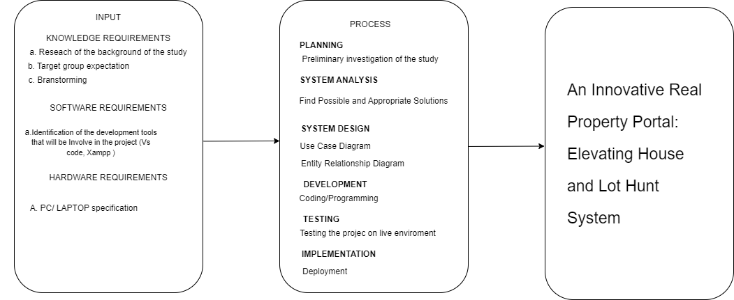

# Figure 1. Conceptual Framework of the Study

The figure illustrates the steps and requirements for creating the system. The researcher will observe and gather information through surveys. The aim is to explore the problem and find solutions. In the diagram, there are boxes that represent input, process, and output. To get insights from previous studies and new ideas, the researchers look at similar research. They follow a waterfall model to develop the software, designing the system with use case diagrams, sequence diagrams, and entity-relationship diagrams. Additionally, the researchers utilize the needed software and hardware to build the system.

**CHAPTER II**

# REVIEW OF RELATED LITERATURE, SYSTEMS AND STUDIES

This primarily presents the different researches and other literature from local, national, and international researchers which have significant bearings on the variables included in the research. It focuses on several aspects that will help in the development of this study.

# Online Real Estate Management System

**According to Saka Tataji (2020),** Online Real Estate Management System is a unique virtual platform that allows any user to post a property related advertisement on the Internet without incurring costly advertisement fees. User-friendliness, reliable service together with maximum and continuous exposure is the qualities that Real Estate Management System stands for. We believe that whether you are searching or selling your property online, a pleasant and hassle free experience is of utmost importance. Being available 24 hours a day, 7 days a week and equipped with a list of essential tools and information.

**Real Estate Recommendation Using Multi-Criteria Decision Making and**

# Machine Learning

**According to Aydin et al(2020).** This study proposes a new approach to real estate recommendation using deep learning. The proposed approach uses a deep neural network to learn the complex relationships between different features of real estate properties and user preferences. The system is able to generate more accurate and personalized recommendations than traditional machine learning models.

# Real Estate Recommendation Using User Feedback and Deep Learning

**According to Li et al(2022).** This study proposes a real estate recommendation system that uses user feedback and deep learning to generate recommendations. The user feedback is used to train a deep neural network to learn the user's preferences. The system then recommends properties that are likely to be of interest to the user based on the user's learned preferences. The proposed system is able to learn from the user's feedback to improve its recommendations over time.

# Real estate searching system

**According to Yoonhyun Kim(2019).** Traditional way of home

suggestion has relied on human realtor; however, the advent of the Internet has gradually been changing the long-established convention. Real estate search system currently supports users’ search for sale and consumption. Web-based searching service needs to be more active and intelligent beyond online catalog in order to handle realty’s special features such as immovability.

# Real Estate Information System

**According to Benli Li(2021).** In the process of rapid social and economic development, housing as a household item for residents, its development speed is also accelerating. Affected by the previous planning, the real estate industry has a large stock at this stage. How to revitalize the city's stock assets is not only a key consideration for real estate companies under the current high pressure of land acquisition, but also one of the first problems that the local government solves to promote GDP growth.

# Real Estate Search System

**According to Wu, Z., & Zhang, L. (2019).** A real estate search system is a software application that allows users to find properties for sale or rent. These systems typically allow users to search by location, price, property type, and other criteria. Real estate search systems can be found on a variety of websites, including those of real estate agents, brokers, and MLSs. Real estate search systems typically allow users to search for properties based on a

variety of criteria, including location, price, property type, number of bedrooms and bathrooms, square footage, and amenities.

**A Real Estate Recommendation System Based on User Preferences and**

# Social Media Data

**According to Wang(2021).** This study proposes a real estate recommendation system that uses both user preferences and social media data to generate recommendations. The user preferences are extracted from the user's past search history and social media interactions. The social media data is used to identify other users who have similar preferences to the user. The system then recommends properties that are popular with similar users. The proposed system is able to generate more accurate and personalized recommendations than traditional real estate recommendation systems.

**Real Estate Market Forecasting System (2020).**

**According to Wang, J.** Real estate market forecasting is a challenging task, but it is also an important one. Real estate is a major asset class for individuals and businesses, and accurate forecasts can help investors make informed decisions. Real estate market forecasts can also be used by policymakers to develop and implement effective policies.

# House Price Prediction Models

**According to Huang, Shen, and Zhang, (2019).** Machine learning models have been shown to be the most accurate house price prediction models. However, these models are often data-intensive and complex to develop and deploy. The Future research should focus on developing house price prediction models that are more data-efficient and easier to deploy. The authors identify four main categories of house price prediction models: hedonic pricing models, autoregressive integrated moving average (ARIMA) models, time-varying parameter models, and machine learning models. They also discuss the challenges in developing and deploying house price prediction models, such as data availability and quality, model selection, and model interpretation.

# Real Estate Crowdfunding Platforms

**According to Ma, Wang, (2019).** Real estate crowdfunding platforms have made it possible for people with limited investment capital to invest in real estate. However, these platforms are also associated with risks such as fraud and illiquidity. It should focus on developing regulatory frameworks for real estate crowdfunding platforms and on educating investors about the risks involved.

# Real Estate Search Engines: Features, Challenges, and Future Directions

**According to Lou, J. (2019).** Real estate search engines (RESEs) have become an essential tool for buyers and sellers of real estate. RESEs allow users to search for properties based on a variety of criteria, such as location, price, property type, and amenities. However, RESEs face a number of challenges, such as data integration, ranking algorithms, and user personalization. Data integration, ranking algorithms, and user personalization are the key challenges in developing and deploying real estate search engines. We are also excited about the future of real estate search engines, and we believe that personalized and contextual search is a promising area for future research.

# Real Estate Systems

**According to Feng, Liu, (2020).** Data sparsity, the cold start problem, and user trust are the key challenges in developing and deploying real estate recommendation systems. We are also excited about the future of real estate recommendation systems, and we believe that deep learning and other advanced techniques have the potential to address these challenges.

# Real Estate Chatbots

**According to Bautista, J., Mendoza, L., & Reyes, J. (2023).** Chatbots in the Philippines are still in their early stages of development, but they have the potential to revolutionize the way that people interact with the real estate industry. Chatbots can be used to provide information about properties, to answer questions, and to schedule appointments. However, there are still some challenges that need to be addressed, such as language understanding and natural language generation. Language understanding and natural language generation are the key challenges in developing and deploying real estate chatbots in the Philippines. It should focus on developing real estate chatbots that are more personalized and can provide users with more comprehensive and accurate information.

**The Impact of Real Estate Property Search Systems on the Philippine Real**

# Estate Market: A Case Study of Property24 Philippines

**According to Mendoza, P(2021).** Real estate property search systems have had a positive impact on the efficiency of the market by reducing the time it takes to buy or sell a property. Additionally, the study finds that real estate property search systems have made the market more competitive by giving buyers and sellers more information about the properties that are available.Is a comprehensive study that examines the impact of real estate property search systems on the Philippine real estate market. The study finds that these systems have had a positive impact on the market by making it easier for buyers and sellers to find each other, increasing transparency, and reducing the cost of transactions.

# Real Estate Market Forecasting Models

**According to Lopez, A., Santos, M., & Garcia, N. (2023).** Real estate market forecasting models in the Philippines are used to predict future trends in the real estate market. These models can be used to inform investment decisions and to develop public policy. Model selection and model evaluation are the key challenges in developing and deploying real estate market forecasting models in the Philippines. We also believe that future research should focus on developing real estate market forecasting models that are more accurate and can capture the dynamic nature of the Philippine real estate market.

**The Role of Real Estate Property Search Systems in the Rise of Online Real**

# Estate Transactions in the Philippines

**According to by Cruz, J. M. (2022).** Real estate property search systems have played a key role in the rise of online real estate transactions in the Philippines, making it easier for buyers and sellers to find each other and increasing foreign investment in the market. It discusses the role of real estate property search systems in the rise of online real estate transactions in the Philippines. The paper finds that these systems have played a key role in making it possible for buyers and sellers to transact real estate deals directly with each other without the need for a real estate agent.

# The Future of Real Estate Property Search Systems in the Philippines

**According to Garcia, R. (2019).** The systems will become increasingly sophisticated and user-friendly. It also notes that these systems are likely to play an even greater role in the Philippine real estate market in the future. It discusses the future of real estate property search systems in the Philippines.

The paper also discusses the potential for artificial intelligence (AI) and blockchain technology to be used to improve real estate property search systems. AI could be used to improve the accuracy and relevance of search results, to personalize the user experience

# Real Estate Valuation Models in the Philippines

**According to Mendoza, L., Cruz, R., & Reyes, J. (2023).** Real estate valuation models in the Philippines are used to estimate the value of properties for a variety of purposes, such as taxation, financing, and investment. The three main types of real estate valuation models are the comparable sales approach, the cost approach, and the income approach. Each approach has its own strengths and weaknesses, and the most appropriate approach to use will depend on the specific circumstances. Data availability and quality, model selection, and model interpretation are the key challenges in developing and deploying real estate valuation models in the Philippines. We also believe that future research should focus on developing real estate valuation models that are more data-efficient and easier to

interpret.

# Real Estate Virtual Reality Applications in the Philippines

**According to** **Yang, J. (2023).** Real estate virtual reality (VR) applications are revolutionizing the way people buy and sell homes. VR allows users to experience properties in a more immersive and realistic way, without having to physically visit them. This can be especially helpful for buyers who are looking to purchase properties in other countries or cities. It is identify into four main categories of real estate VR applications in the Philippines: property previews, virtual tours, interior design, and property development. They also discuss the challenges in developing and deploying real estate VR applications in the Philippines, such as cost, accessibility, and user experience.

# Real Estate Big Data Analytics in the Philippines

**According to Bautista, J (2023).** Real estate big data analytics is the process of collecting and analyzing large datasets of real estate data to identify patterns and trends. This information can be used to inform decision-making and improve business performance. Data integration, data quality, and model interpretability are the key challenges of big data analytics in the real estate industry. We also believe that future research should focus on developing more effective big data analytics solutions for the real estate industry in the Philippines.

**METHODOLOGY**

# Software Process Model

In the development of the House and Lot Hunt System, a structured approach is imperative. The process commences with a thorough evaluation of current property search systems to identify areas for enhancement and understand the specific requirements of the new system. Valuable insights are gathered from a range of stakeholders, including property buyers, sellers, and real estate experts, shaping the system's design.

Once the requirements are well defined, the system's architecture is carefully mapped out, and we opt for the Agile methodology, renowned for its iterative and collaborative approach, making it a fitting choice for this project, offering flexibility and consistent feedback.

The development phase revolves around coding the system using chosen programming languages and frameworks. It undergoes meticulous testing to ensure it aligns with the requirements and operates as intended. User acceptance testing (UAT) is conducted with a user group to verify the system's user-friendliness and effectiveness.

Following successful testing and fine-tuning, the system is prepared for deployment, making it accessible to users. Continuous support and maintenance are provided to ensure ongoing efficiency and dependability.

The development of the House and Lot Hunt System calls for a well organized approach that places user needs, adaptability, and dependability at the forefront, establishing it as a valuable tool for property seekers and sellers.

# Waterfall Model

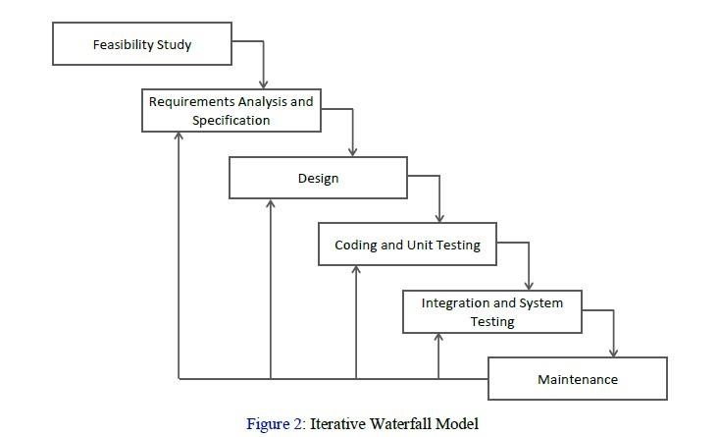

# Figure 2. SDCL (Iterative Waterfall method)

The Iterative Waterfall Model has pathways that connect each phase to the phase before it. If mistakes are found in a later phase, these pathways help fix mistakes made by developers in earlier phases. These pathways let us redo the phase with errors and update it in the later phases. This model is used to combine the Agile Development Method for creating the House and

Lot Hunt System.

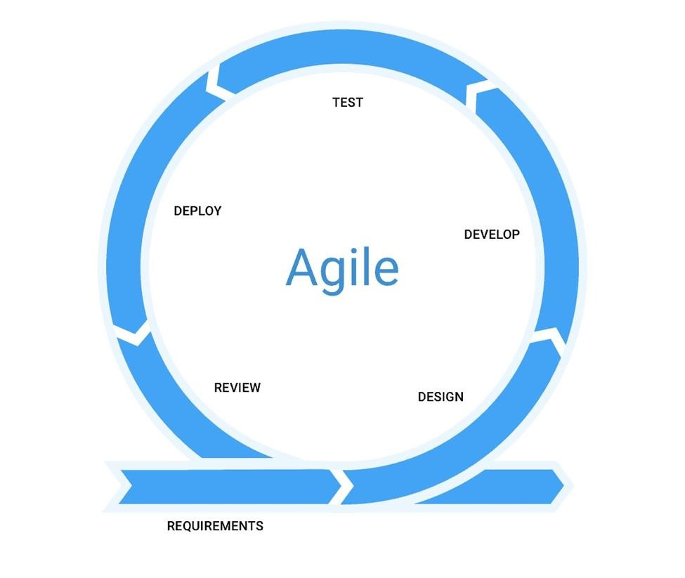

# Figure 3. Agile Development

Agile development is an iterative method or process of the system. The iteration of the process consists of 2-3 months. The process iteration can be done quickly; since the proponent's proposed system has a short time frame, we used agile development to develop the system—the agile development since it is easy to implement and understand the process of the method.

**Requirements Specification**

# User Requirements

The Web- Based House and Lot Hunt System was pursued to have a system

of the following:

* Searching for Properties
* View Properties ( House and Lots)
* Contact and Inquiry

# Functional Requirements

* Property owners should use the system to create, change, or remove property listings. Each listing should have specifics like where it is, how big, how much, features, and contact info.
* The system that show maps with property marks. Users need to see where properties are and what's around them.

**Non-Functional Requirements**

# Operational Requirements

* The system operates on online.
* The system operates on the web.

# Performance Requirements

* The system should be platform-independent.
* The system is useful and hassle-free to use.
* The system is user-friendly, readable, and easier for the user.

# Software and Hardware Requirements

* Visual Studio Code
* Xampp
* Windows 10 or Windows 11
* Android (Touch Screen)
* 1 Computer Set (Intel(R) Core (TM) i5, RAM 4GB)
* Printer
* Modem/Broadband

# Feasibility Issues

1. **Economic Feasibility.** The researcher found out that it is economically feasible for the user because they can browse the system online.
2. **Technical Feasibility.** The System ensures that all the needed technical parts can be smoothly put together, set up, and kept up to make a working and easy-to-use system for looking for properties, handling listings, and interacting with users. Also, it checks if the team creating the system has the right skills and know-how to make and maintain the technical parts of the system.
3. **Operational Feasibility.** The researcher found out that it is feasible because people nowadays are exposed to the technology and know-how to use the Web Browser.
4. **Schedule Feasibility**. The Web- Based House and lot Hunt Systme will be deployed when the researcher completed all of the requirements in making the system.

# Project Cost

The capstone project titled "**An Innovative Real Property Portal: Elevating House and Lot Hunt**" will utilize the necessary hardware and software for building the system. Certain items like the internet, software licenses, and materials needed for creating are accounted for in the development expenses. The smartphone, also a part of the project, is provided by the user, making it a free component.

# Work Breakdown Structure

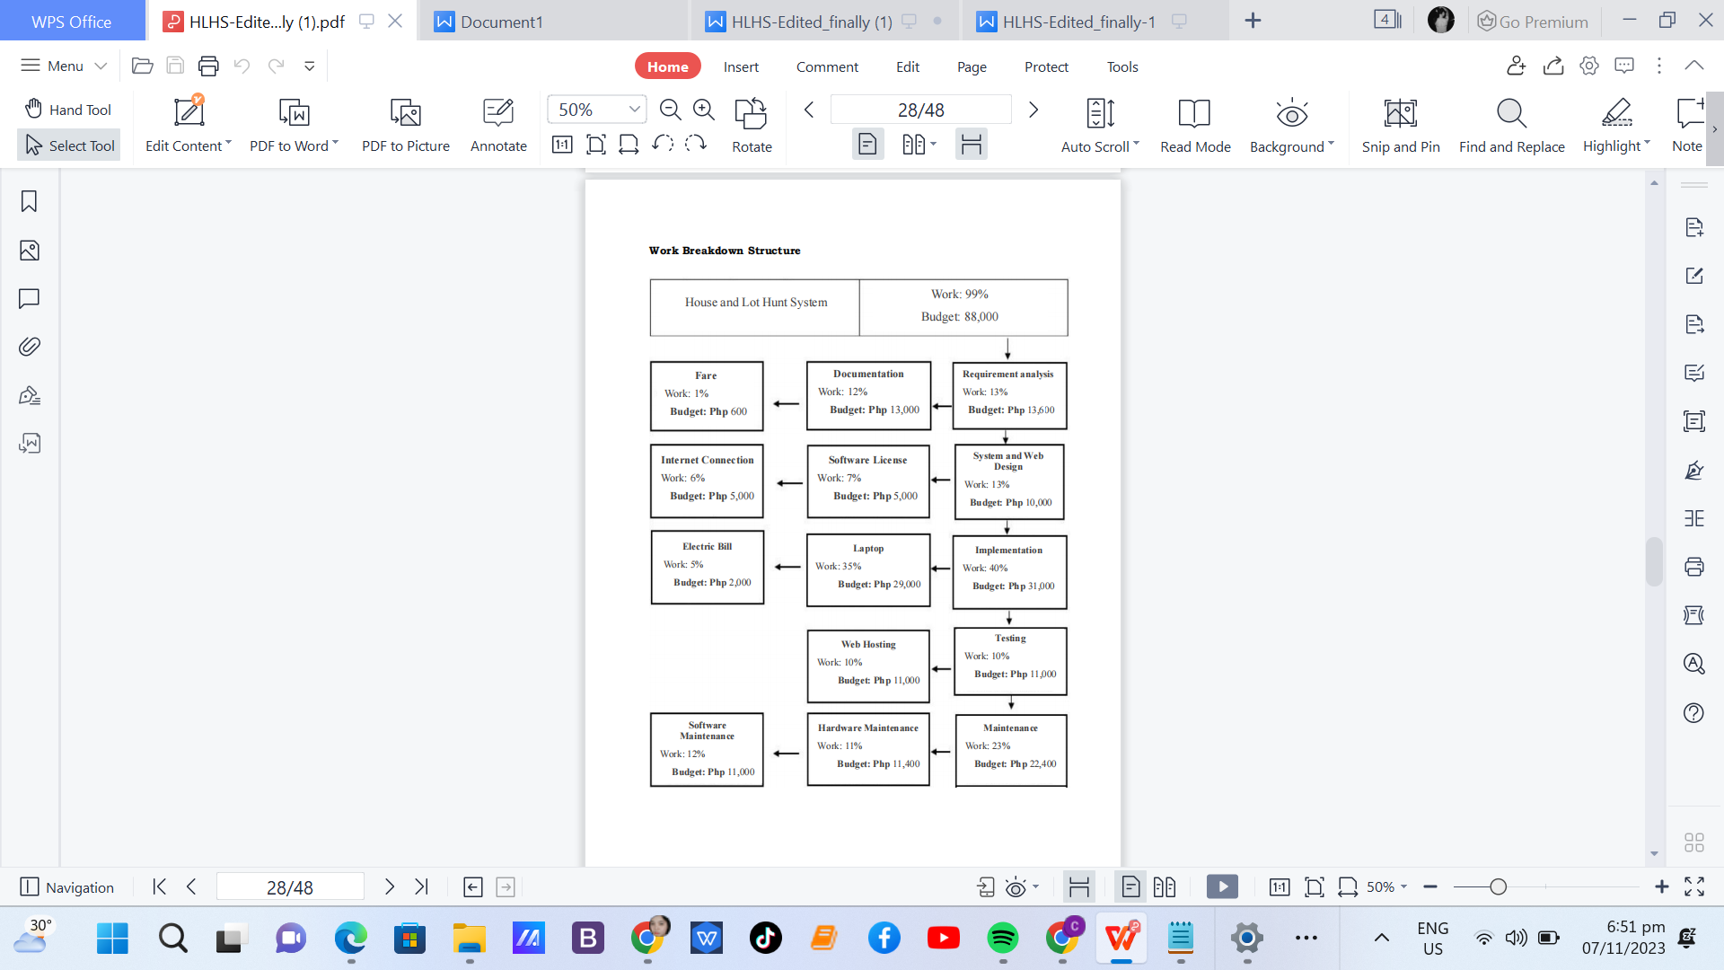

# Cost Benefits Analysis

The following table shows the estimated cost of developing The House and

Lot Hunt System

Table 1. Project Cost Estimated of the System. ASSCAT, 2023.

# Items Cost

**Supplies:**

Bond paper ₱ 1,500.00

Ballpen ₱ 50.00.00

Print ₱ 2,000.00

Flash Drive 16GB ₱ 900.00

Laptop/ Computer (Intel(R) Core (TM) i5, RAM 8GB ₱ 29,000.00

Documentation Expenses ₱ 3,000.00

Fiber Internet ₱ 3,000.00

**Sub-total ₱ 39,000.00**

Production Software License ₱ 7,000.00

Electricity ₱ 1,500.00

Internet Connection ₱ 1,500.00

**Sub-total ₱ 10, 000.00**

**Overall Total** **₱ 49,000.00**

# Risk Management

Table 2. Risk Management.

# Risk Description Level of Strategy Status Possibility

Teammate’s One member of Misunderstanding a team has a Web based failure different understanding or interpretation of a task or goal than the rest of the team. This can lead to confusion, frustration, and mistakes, as well as potentially hindering the team's ability to work effectively together.

Medium Encourage team This project's members to status is actively listen to uncertain and one another during could wind up meetings and being discussions. This unfinished. The can help ensure researcher's that everyone fully efforts will be understands what ineffective.

is being said and can also help identify any

potential misunderstandings early on.

**Implementation Plan**

# Team Building Activities

The team actively engaged in tutorials and discussions to brainstorm ideas for the growth of the House and Lot Hunt System. Each team member received specific tasks and employed strategies like personal conversations with students and staff to gather information. Furthermore, the team maintained regular communication with their adviser to ensure progress on their Capstone project.

# Designing, Programming, Compilation, and Linking

In the second phase of the implementation process for the House and Lot Hunt System, the team focused on design and development. This involved creating the software architecture, writing code, conducting testing, and rectifying any issues while establishing connections with other necessary systems. The planning, coding, compilation, and linking processes were meticulously examined and tested to ensure they met the requirements of the system and functioned effectively.

# Structure Walkthrough and Quality Control

The third phase of the implementation plan aimed to ensure the operational functionality of the House and Lot Hunt System. Thorough testing and system debugging were essential steps in this phase. Tests were conducted to identify potential issues and verify the system's proper functioning. If any problems were detected, adjustments were made, and testing was repeated until all issues were resolved.

# System Documentation

The fourth step in the deployment plan for the House and Lot Hunt System involved comprehensive system documentation. This documentation encompassed details about the system's architecture, components, setup guidelines, and troubleshooting procedures. Such documentation was deemed necessary for system maintenance and user training.

# System Installation

In this phase, the team undertook the installation and configuration of the House and Lot Hunt System following the standards outlined in the system documentation. Additionally, the team ensured the secure connection of the system to the relevant components of the House and Lot Hunt System.

# System Start-up and Administration

The final step in the implementation plan involved launching and assuming full control of the House and Lot Hunt System. The team initiated this step to activate the system and verify its proper operation. They also ensured that all security protocols were established and configured correctly

# Design Phase

In the design phase, the project team creates comprehensive documentation, including use case diagrams, entity-relationship diagrams (ERD), data dictionaries, sequence diagrams, data flow diagrams (DFD), and context diagrams. These design artifacts serve as the blueprint for the development team, providing clear guidelines on system architecture, user interfaces, and database structures.

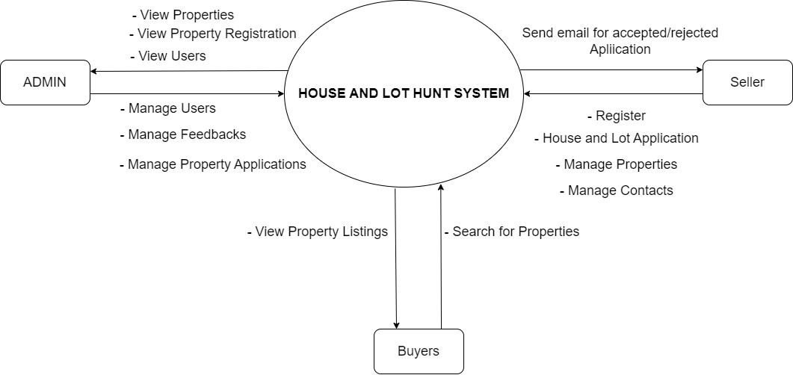

**Figure 4:** Context Diagram of the System

The figure provides an overview of the system's interaction with external entities. In this simplified representation, the system is at the center, denoting its core functionality. Buyers use the system to search for properties and engage with sellers, while sellers utilize the platform to list and manage their properties. Administrators oversee system management and compliance. This diagram offers a high-level view of how the system interacts with these critical external entities, providing a foundation for understanding the system's broader context.

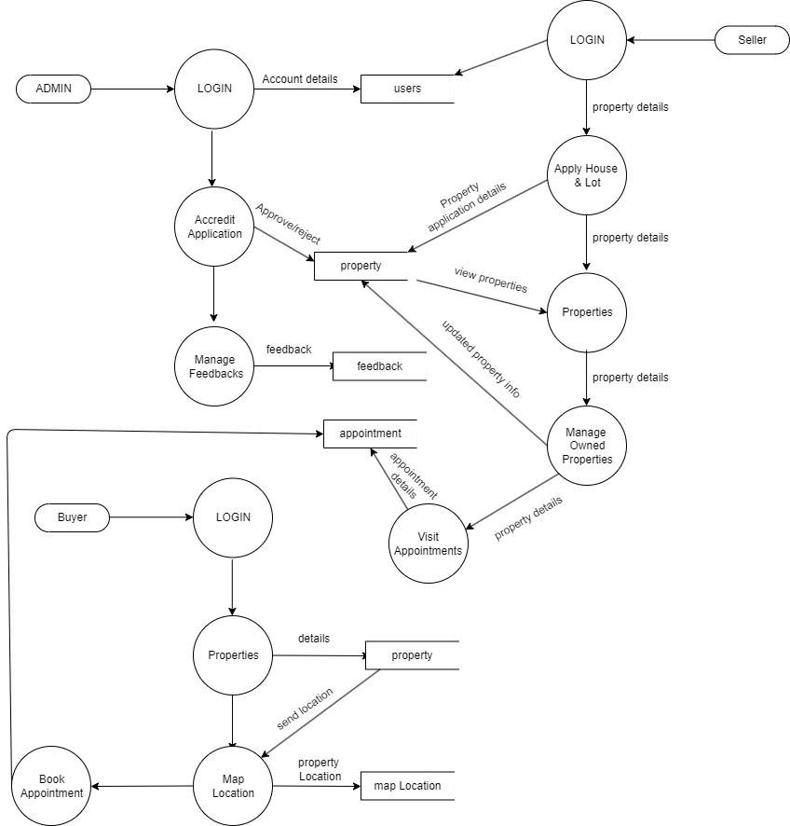

# Figure 5: Data Flow Diagram (Level 1)

The data flow diagram for the House and Lot Hunt System shows how information moves between the three main user roles: "Admin," "Seller," and

"Buyer." Each role has its own way of working with the system.

**Admin:**

* The Admin looks after the system, like user accounts, how it's doing, and its safety.
* They work with the system to make sure data is safe and everything runs smoothly.

**Seller:**

* Sellers manage and show house and lot listings. Property info, pictures, and prices.
* They work with the system to add property listings, update property info, and talk to potential buyers.
* Data for Sellers includes property listings, details about properties, pictures, pricing info.

**Buyer:**

* Buyers use the system to find properties, look at property details.
* They work with the system to search for properties, see property info.
* Data for Buyers includes searches for properties, saved favorites.

# Use Case Diagram

**HOUSE AND LOT HUNT SYSTEM**

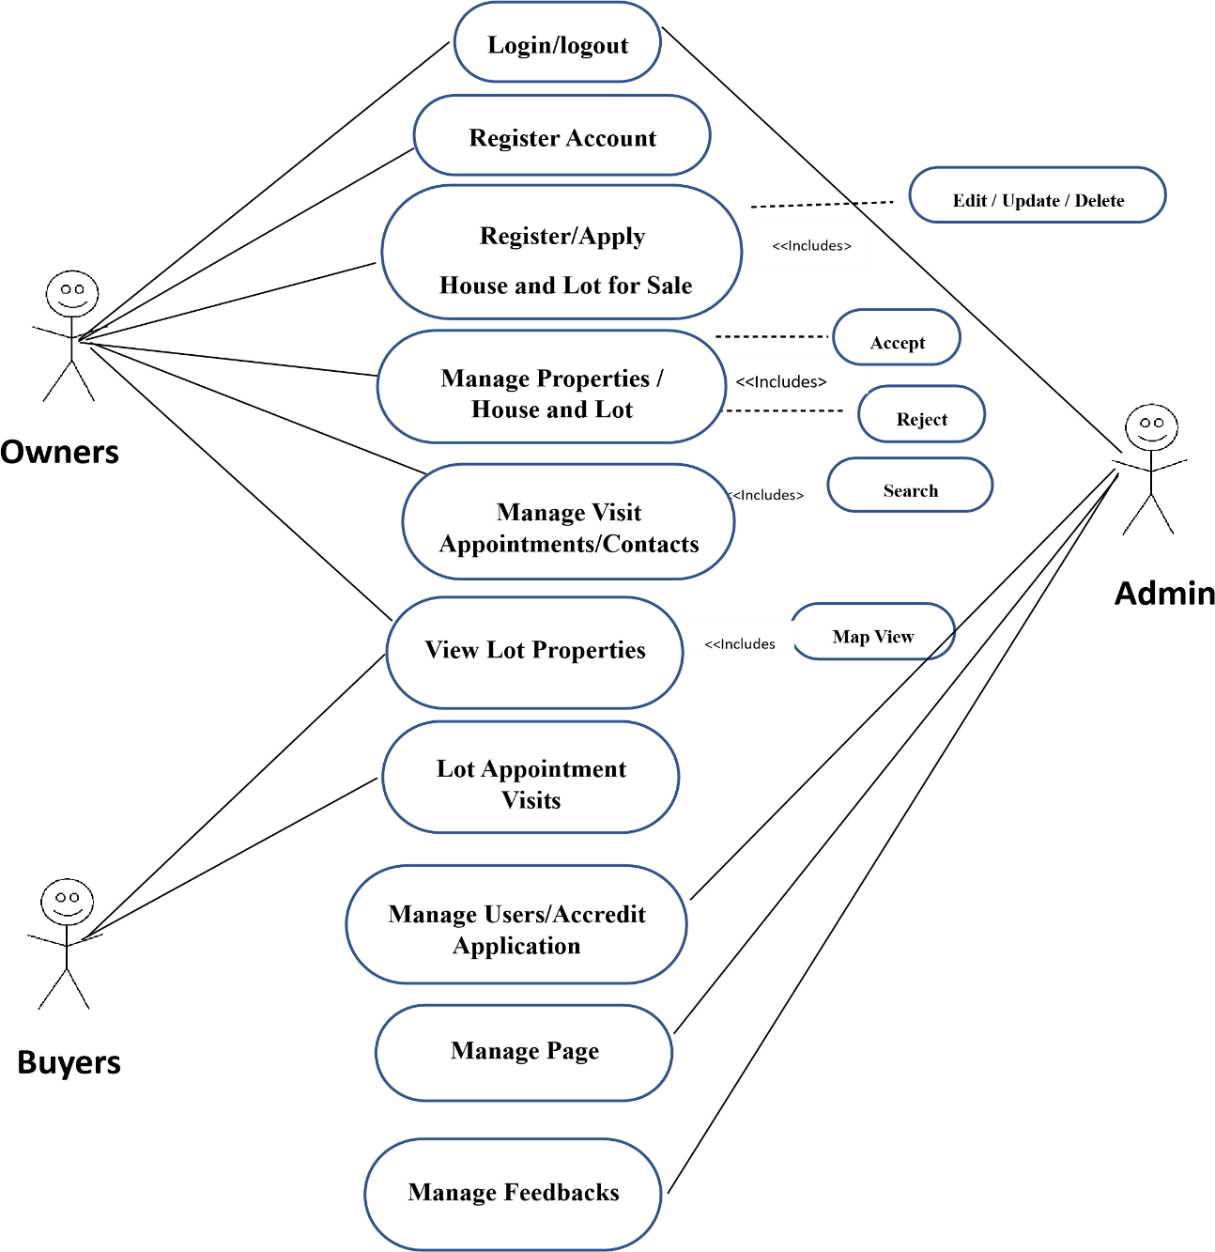

# Figure 6: Use Case Diagram of the System

The figure provides a visual representation of how various user roles interact with the system to achieve specific tasks. The primary actors in this system include "Buyers," "Sellers," and "Admin." Buyers can efficiently search for properties based on their preferences, explore detailed property listings, contact sellers, and receive updates. Sellers create and manage property listings, upload images and details, set prices, and respond to inquiries. Administrators oversee user accounts and gathering user feedback. This diagram showcases the system's functionalities, highlighting the interactions between users and the platform.

# Entity Relationship Diagram

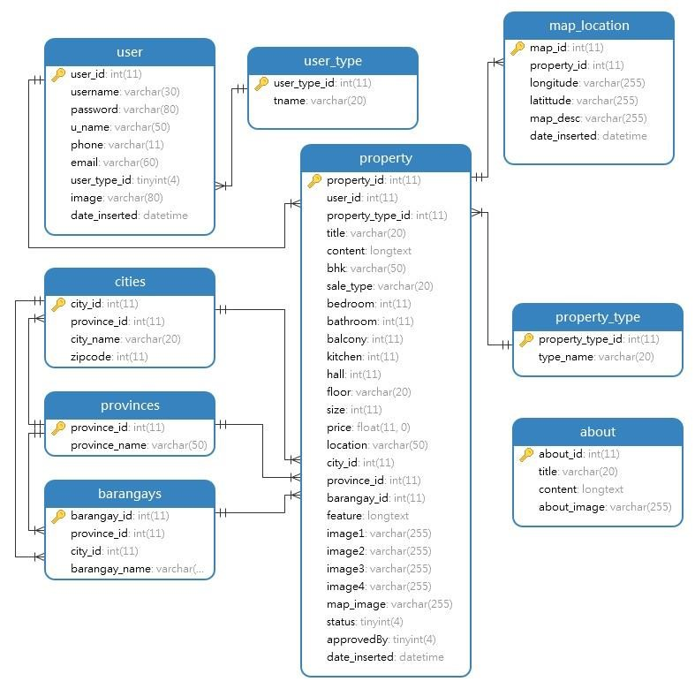

# Figure 7: Entity Relationship Diagram of the System

An entity-relationship diagram (ERD) is a graphical representation of the entities and relationships in a database. ERDs are used to model and communicate the structure of a database before it is created. In a propose system, the Entity Relationship Diagram (ERD) depicts entities and their relationships, providing a structured view of the system. The main entities in this context include:

1. **Users Table:** The Users table holds individual user profiles and

their related information, including names, contact details, and login credentials. This table is crucial for managing all system users, such as Admin, Sellers, and Buyers.

1. **User_Type Table:** The User_Type table categorizes users into their respective roles or types within the system, helping distinguish between Admin, Seller, and Buyer roles. It is linked to the Users table to associate users with their roles.
2. **Property Table:** The Property table stores detailed information

about house and lot listings, including property specifications, images, pricing, and other relevant data. It serves as a central repository for property-related information.

1. **Map_Location Table:** Map_Location contains geographic

coordinates and location details for each property. It is connected to the Property table, allowing users to access property locations accurately.

1. **Cities Table:** The Cities table records data about various cities

where properties are situated. It is associated with both the Map Location and Property tables, enabling location tracking and property classification.

1. **Barangay Table:** The Barangay table contains information about

specific barangays or neighborhoods within cities, aiding in precise property location identification. It is connected to the Map_Location and Property tables.

1. **Provinces Table:** The Provinces table stores data regarding

different provinces where properties may be found. It is linked to the Map_Location and Property tables to provide province-related location data.

1. **Property_Type Table:** The Property_Type table categorizes

property types, such as residential, commercial, or agricultural. It connects to the Property table for property classification and sorting.

1. **About Table:** The About table contains information about the House and Lot Hunt System itself, including details about its purpose, features, and contact information.
2. **Appointment Table:** The Appointment table manages

scheduling and appointment-related data, allowing users to set up property viewings and meetings with sellers efficiently.

# Data Dictionary Users

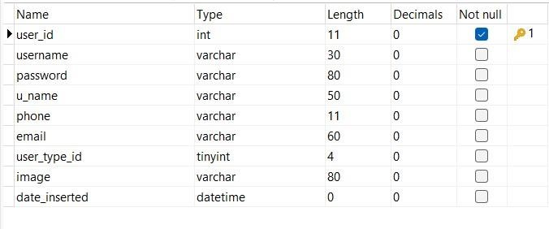

# User_types

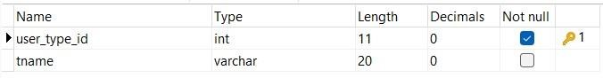

# About

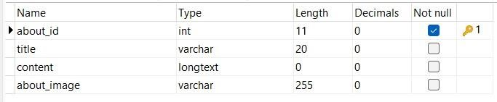

# Property_type

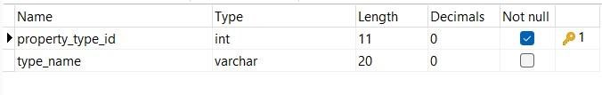

# Property

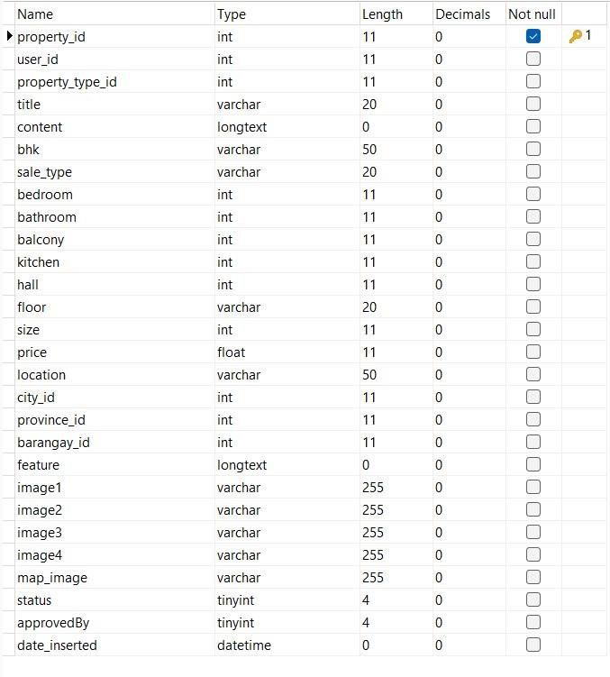

# Cities

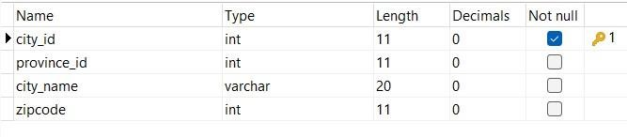

# Province

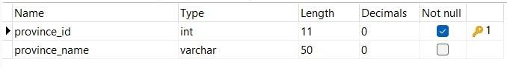

# Barangays

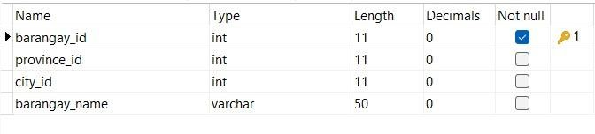

# Map_location

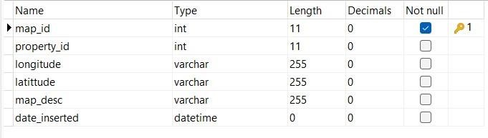

# Sequence Diagram

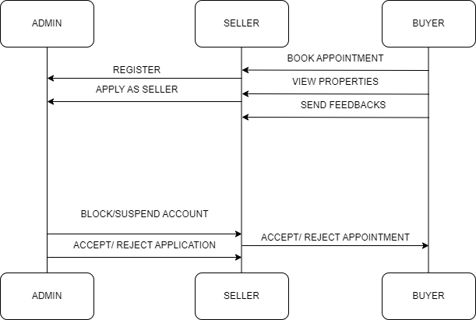

# Figure 8 : Sequence Diagram

The Figure captures the dynamic flow of activities within the system. Engage with the system to perform tasks such as viewing searches, listing management, and system administration.. It provides a comprehensive understanding of the system's functionality and user interactions during various scenarios.

# Development Phase

In the development phase of the House and Lot System, an iterative approach is adopted, with each sprint dedicated to specific modules outlined during the design phase. The team incrementally implements system components, ensuring the continuous delivery of functional enhancements.

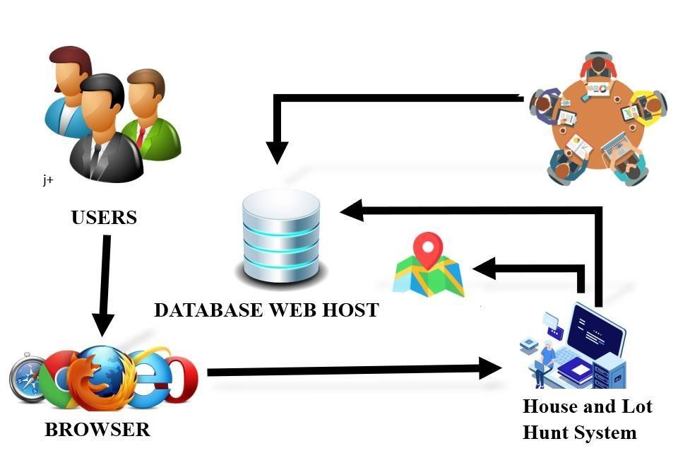

# Figure 9. Web – Based Deployment Diagram of the system

The Figure shows how the system works with physical parts like servers and databases. It helps us see how the system is set up in the real world, showing its structure and how it relies on different equipment.

# Testing Phase

The testing phase involves initiating alpha testing to uncover potential system errors. Once alpha testing is finalized, beta testing follows, where units or programs are integrated and tested as a system that's 85% complete. This ensures alignment with user and software requirements.

# Deployment Phase

Deployment includes the release of the thoroughly tested and refined software into a production environment. Incremental deployment may take place as specific sprints are completed, enabling stakeholders to access the system's features as they are developed and validated.

# Review Phase

Following each sprint or release, stakeholders and the development team convene for review sessions. These evaluations gauge the system's performance and functionality, integrating feedback for continuous enhancement. Adjustments are made to address real-world usage and evolving requirements.

**REFERENCES:**

* Saka Tataji (2020), "Online Real Estate Management System",

International Journal of Emerging Technologies and Innovative

Research (www.jetir.org), ISSN:2349-5162, Vol.7, Issue 5, page no.41-

46, May-2020, Available

:http://www.jetir.org/papers/JETIRDU06008.pdf

* Yoonhyun Kim (2019), "Real estate searching system: A survey", Journal of the Korea Institute of Information Scientists and Engineers, Vol.46, No.8, pp.357-366.
* Benli Li (2021), "Research on the Revitalization of Stock Assets in Real Estate Industry Based on Real Estate Information System", Journal of Physics: Conference Series, Vol.2009, No.1, p.012044.
* Aydin, N., Karakaya, M., & Turkoglu, I. (2020). A deep learning approach for real estate recommendation. Expert Systems with Applications, 140, 112891.Benli Li (2021), "Research on the

Revitalization of Stock Assets in Real Estate Industry Based on Real

Estate Information System", Journal of Physics: Conference Series, Vol.2009, No.1, p.012044.

* Wang, J. (2020). Real estate market forecasting: A review of the literature. International Journal of Forecasting, 36(2), 391-404.
* Huang, W., Shen, Z., & Zhang, H. (2019). Machine learning for housing price prediction: A survey. IEEE Transactions on Knowledge and Data Engineering, 33(10), 2215-2233.
* Wu, Z., & Zhang, L. (2019). Real Estate Search System. In Advances in Intelligent Systems and Computing (pp. 55-64). Springer, Cham.
* Ma, Y., & Wang, T. (2019). Real estate crowdfunding in China: A review of literature and research agenda. International Journal of

Financial Research, 10(2), 264-278.*

* Mendoza, P. (2021). The impact of real estate property search systems on the Philippine real estate market: A case study of Property24 Philippines. International Journal of Housing Markets and Analysis, 24(6), 1710-1727.
* Cruz, J. M. (2022). The role of real estate property search systems in the rise of online real estate transactions in the Philippines. Asian

Journal of Real Estate Research, 16(1), 56-72.

* Garcia, R. (2019). The future of real estate property search systems in the Philippines. Philippine Journal of Real Estate, 11(1), 1-15.
* Bautista, J. (2023). Big data analytics in the real estate industry: A case study in the Philippines. Journal of Real Estate Research, 45(1), 1-20.
* Lopez, A., Santos, M., & Garcia, N. (2023). Real estate market forecasting models in the Philippines: A review of literature and future directions. International Journal of Business and Economics, 22(1), 1-

15



# AGUSAN DEL SUR STATE COLLEGE OF AGRICULTURE AND TECHNOLOGY

**AN INNOVATIVE REAL PROPERTY PORTAL: ELEVATING HOUSE**

**AND LOT HUNT**

**JOAR JEAN BUGWAT BALANSAG**

**CRISTINA PELENIO LLOREN**

**BACHELOR OF SCIENCE IN INFORMATION TECHNOLOGY**

# NOVEMBER 2023



**AGUSAN DEL SUR STATE COLLEGE OF AGRICULTURE AND TECHNOLOGY**

**BACHELOR OF SCIENCE IN INFORMATION TECHNOLOGY**

# JOAR JEAN BUGWAT BALANSAG CRISTINA PELENIO LLOREN

***An Innovative Real Property Portal: Elevating House and lot Hunt***

Thesis Adviser:

**Bernie S. Balighot, MIT College of Computing and Information Sciences**

**NOVEMBER 2023**

**TABLE OF CONTENTS**

**PRELIMINARIES s PAGES**

Title Page i

Transmittal Sheet ii

Approval Sheet iii Acknowledgement iv

Table of Contents v

List of Tables vii

List of Figures viii

List of Plates ix

List of Appendix Tables x Abstract xi

**INTRODUCTION 1**

Background of the Study  1

Objectives of the Study 2

Significance of the Study 2

Scope and Delimitation of the Study 3

Time and Place of the Study 3

Operational Definition of Terms 4

Conceptual Framework 5

**REVIEW OF RELATED LITERATURE 6**

Online Real Estate Management System 6

Real Estate Recommendation Using 6

Multi-Criteria Decision Making and

Real Estate Recommendation Using

User Feedback and Deep Learning Pechay 7

Real estate searching system 8

Real Estate Information System 9

Real Estate Search System 10

A Real Estate Recommendation System

Based on User Preferences and Media Data 11

Real Estate Market Forecasting System 12

House Price Prediction Models 13

Real Estate Crowdfunding Platforms 14

Real Estate Search Engines: Features, Challenges,

and Future Directions 15

Real Estate Systems 16

Real Estate Chatbots 17

The Impact of Real Estate Property

Search Systems on the Philippine Real

Estate Market: A Case Study of Property24 Philippines 18

Real Estate Market Forecasting Models 19

The Role of Real Estate Property Search Systems

in the Rise of Online Real

Estate Transactions in the Philippines 20

The Future of Real Estate Property Search

Systems in the Philippines 21

Real Estate Valuation Models in the Philippines 22

Real Estate Virtual Reality Applications in the Philippines 23

**METHODOLOGY 24**

Methods to be Used 25

Sources of Data 26

Data Gathering Instruments 27

Material Preparation 27

Operational Procedure 14

Description of the Machine 14

Evaluation Parameters 14

Statistical Analysis 15

**RESULTS AND DISCUSSION** **16**

**SUMMARY CONCLUSION AND RECOMMENDATION** **19**

Summary 19

Conclusion 20

Recommendation 20

**LITERATURE CITED 21**

**APPENDICES 23**

A Letter of Approval 24

B Appendix Tables 25

C Materials Used 26

D Design Considerations 27

D Plates 28

E Curriculum Vitae 33

F Result of Examination for Final Defense 35

G CRF 36

H Gantt Chart 37