**UTILIZATION OF ELECTRONIC LEARNING MATERIALS AS**

**CLINICAL GUIDES IN THE CLINICAL EXPOSURE AMONG**

**THE BACHELOR OF SCIENCE IN NURSING STUDENTS**

**AT BUTUAN DOCTORS’ COLLEGE**

**SCHOOL YEAR 2023 - 2024**

**_________________________**

A Research Proposal

Presented to the

Faculty Department of Nursing

Butuan Doctors’ College, Butuan City, Philippines

__________________________

In Partial Fulfillment

of the Requirements for the Degree

Bachelor Science of Nursing

__________________________

by

Jayvi Mae M. Bangga

April Ann T. Casinao

Chrestine M. Delapeña

James Bryan B. Tabanao

John Angelo P. Victorino

**November 2023**

**APPROVAL SHEET**

This Research Paper entitled **“UTILIZATION OF ELECTRONIC LEARNING MATERIALS AS CLINICAL GUIDES IN THE CLINICAL EXPOSURE AMONG THE BACHELOR OF SCIENCE IN NURSING STUDENTS AT BUTUAN DOCTORS’ COLLEGE S.Y. 2023 - 2024”** prepared and submitted by **Jayvi Mae M. Bangga, April Ann T. Casinao, Chrestine M. Delapeña, James Bryan B. Tabanao, and John Angelo P. Victorino** in partial fulfillment of the requirements for the degree of **BACHELOR OF SCIENCE IN NURSING,** has been examined and recommended for the acceptance and approval for **FINAL ORAL DEFENSE.**

**JESUS L. PICARDAL, RN, MATMRS**

Research Adviser

**PANEL OF EXAMINERS**

Approved by the **Panel of Examiners** with a Grade of                   

**JENNIFER H. ARANA, RN, MN**

**Chairperson**

**TITO G. RAFIL, Ed.D. MARY ANN M. GOZON**  Member   Member  

Accepted and approved in partial fulfillment of the requirements for the degree o**f BACHELOR OF SCIENCE IN NURSING**

**______________________**

**Date of Final Oral Defense**

**JENNIFER H. ARANA, RN, MN**

Dean, Department of Nursing

**CONTENTS**

**Page**

**TITLE PAGE** i

**APPROVAL SHEET**  ii

**CONTENTS** iii

**TABLES** v

**FIGURES** vi

**CHAPTER**

**1 THE PROBLEM AND RESEARCH DESIGN** **1**

Introduction

Theoretical Framework 2

Conceptual Framework 4

Statement of the Problem 5

Hypothesis 6

Significance of the Study 6

Scope and Limitations of the Study 7

Content

Respondents and Place

Period

Definition of Terms 8

Research Design 9

Research Locale 9

Respondents and Sampling Procedure 10

Research Instrument 11

Data Gathering Procedure 11

Statistical Techniques 12

**2 REVIEW OF RELATED LITERATURE AND STUDIES**

Related Literature – Foreign 15

Related Literature – Local 16

Related Studies – Foreign 17

Related Studies – Local 19

**REFERENCES**

Bibliography 21

Webliography 22

**APPENDICES**

1. Letter of Request to Conduct the Study 23
2. Letter of Request to the Office of the Registrar of 24  
   Butuan Doctors’ College, Butuan City
3. Certification of the Number of Enrollees 25
4. Request for Research Proposal Hearing 26

**TABLES**

**Table Page**

1 Likert’s Scale with the Corresponding Numerical Rating 15

and Verbal Description

**FIGURES**

**Figure Page**

1. Schematic Diagram Showing the Independent and Dependent 5

Variables of the Study

**CHAPTER 1**

**THE PROBLEM AND RESEARCH DESIGN**

**Introduction**

The increasing prevalence of technology devices and portable digital assistants is fundamentally reshaping the field of technology-enhanced learning in education. These tools have become deeply ingrained in the teaching and learning process. (Gause et al., 2022) Notably, students demonstrate a higher acceptance and utilization of high-quality electronic resources compared to clinicians. Mobile gadgets use among students is linked to positive educational impacts (Maudsley et al., 2019), and there is evidence of a connection between mobile gadgets use and academic performance among health-related students. (Sheiktaheri and Kermani, 2018)

In the past, electronic resources are available but not fully utilized, particularly in developing countries. However, the COVID-19 pandemic has compelled the entire globe to depend on these resources for educational purposes as the shift from traditional to electronic surged. (Zalat et al., 2021)

Electronic books have proven to enhance students' academic performance, satisfaction, and learning outcomes, offering benefits such as accessibility, interactivity, cost-effectiveness, and environmental sustainability. (Nueva, 2019) Mobile applications have emerged as valuable assets in health-related education, characterized by their affordability, versatility, boundary-

free accessibility, online and offline functionality, simulation features, and flexible learning options. (Chandran et al., 2022) While, utilization of credible health-related websites improves the Electronic Health (eHealth) literacy among nursing students, thereby allowing people to seek, find, understand, and appraise health information from electronic sources and apply this knowledge in addressing or solving health problems. (Sharma, Oli, & Thapa, 2019)

The purpose of this study is to assess the impact of utilization of electronic learning materials as the clinical guides among the Butuan Doctors’ College Bachelor of Science in Nursing students that are exposed to the different assigned clinical areas.

This study is important among the nursing students of Butuan Doctors’ College in selecting cost-efficient yet reliable study and clinical guides that can be used during their clinical exposures. The study may also serve as a guide for students in selecting reliable electronic learning materials to hone their knowledge and skills not just clinically but in academic setting as well.

**Theoretical Framework**

This study will be anchored in Benjamin Bloom’s “Bloom’s Taxonomy”. Bloom's Taxonomy, originating from a 1948 meeting of university educators led by Benjamin Bloom, was conceived as a theoretical model of learning to identify educational objectives and facilitate the development of testing items. The committee expanded its initial framework to encompass three learning domains: cognitive, affective, and psychomotor. (Corcoran, 2023)

The cognitive domain, focusing on knowledge and thinking, has become synonymous with Bloom's Taxonomy. It comprises six hierarchical levels of objectives, ranging from foundational skills to higher-order thinking. In 2001, Anderson and Krathwohl revised Bloom's levels from nouns to verbs, shaping the contemporary version of the taxonomy. The cognitive domain's levels include Remember, understand, apply, analyze, evaluate, and create, representing various cognitive skills and thought processes. (Corcoran, 2023)

The affective domain, introduced in 1964, outlines skills and behaviors related to attitudes and values. As learners progress through its five levels – receiving, responding, valuing, organizing, and characterizing – they become self-reliant and internally motivated. Despite being challenging to articulate and assess initially, affective outcomes are closely tied to deeper thinking and lifelong learning. (Corcoran, 2023)

Bloom and his colleagues didn't create subcategories for the psychomotor domain, which involves physical movement and motor skills. Educators later developed subcategories. The psychomotor domain includes seven levels: perception, set, guided response, mechanism, complex overt response, adaptation, and origination. These levels represent the development of physical skills, measured in terms of speed, precision, distance, procedures, and technical execution. The psychomotor domain underscores the importance of practice in skill development, leading to confidence, proficiency, and adaptability in various situations. (Corcoran, 2023)

The researchers incorporate the Bloom's Taxonomy to their study “Utilization of Electric Learning Materials as Clinical Guides in the Clinical Exposure among the Bachelor of Science in Nursing Students at Butuan Doctors’ College School Year 2023 – 2024” as it provides a structured framework for designing, implementing, and evaluating educational interventions. The cognitive domain aids in shaping learning objectives that improves thinking skills, ensuring a comprehensive understanding of clinical concepts. The affective domain, on the other hand, addresses attitudes and values, promoting the development of qualities such as professionalism which is crucial in the nursing practice. Meanwhile, the psychomotor domain facilitates the acquisition of physical skills and coordination needed in clinical settings. Integrating Bloom's Taxonomy ensures a holistic approach to learning, enhancing the effectiveness of the performance of the nursing students with the utilization of electronic learning materials in guiding nursing students through their clinical exposure by addressing cognitive, affective, and psychomotor dimensions.

**Conceptual Framework**

This section presents the schematic diagram of the study showing the relationship between the independent and dependent variables. The independent variables are the Reciprocal Determinism, Behavioral Capability, Observational Learning, Reinforcements, Expectations, and Self-efficacy. The dependent variable is the utilization of electronic learning materials as clinical guides in the clinical exposure among Bachelor of science in Nursing students at Butuan Doctors’ College.

**Independent Variable**

* 1. Cognitive Domain
  2. Affective Domain

1.3 Psychomotor Domain

**Dependent Variable**

Utilization of electronic learning materials as clinical guides in the clinical exposure among Bachelor of science in Nursing students at Butuan Doctors’ College for the school year 2023 - 2024.

**Figure 1. The Schematic Diagram Showing the Relationship Between the  
 Independent and Dependent Variables of the Study**

**Statement of the Problem**

This study aims to evaluate the effects of the utilization of electronic learning materials as clinical guides in the clinical exposure among Bachelor of science in Nursing students at Butuan Doctors’ College. Specifically, it addresses the following questions:

1. To what extent is the level of do the Bachelor of Science in Nursing students at Butuan Doctors’ College currently technology in terms of:

1.1 Cognitive Domain;

1.2 Affective Domain; and

1.3 Psychomotor Domain?

2. Is there a significant relationship between cognitive domain, affective domain, and psychomotor domain and the utilization of electronic learning materials as clinical guides in the clinical exposure among Bachelor of science in Nursing students at Butuan Doctors’ College.

**Hypothesis**

The study will be guided by the null hypothesis to be tested at 5% level of significance, formulated related to the stated problem:

HO1: There is no significant relationship between the cognitive domain, affective domain, and psychomotor domain and the utilization of electronic learning materials as clinical guides in the clinical exposure among Bachelor of science in Nursing students at Butuan Doctors’ College.

**Significance of the Study**

The findings of the study are beneficial to the following:

**Bachelor of Science in Nursing students at Butuan Doctors’ College, Butuan City**. The study's outcomes offer the students valuable insights into the effectiveness of electronic learning materials when employed as clinical aids. It equips them with a deeper comprehension of how these digital tools influence their knowledge and skills acquisition on their performance in clinical settings. Additionally, the study endeavors to enhance the students' technological literacy, focusing on their ability to adeptly use technology and access trustworthy resources for knowledge enhancement.

**Future researchers.** This study may serve as a reference for future studies centered on the effects of the utilization of electric learning materials such as electronic books, mobile applications, and nursing websites in the cognitive, affective, and psychomotor domains of the nursing students. It can serve as a foundational resource, aiding in the exploration of related topics and supporting the advancement of knowledge.

**Scope and Limitations of the Study**

This section presents the limits and boundaries of this research paper.

**Content.** The study will focus on the utilization of electronic learning materials, such as electronic books, mobile applications, and nursing websites as clinical guides in the clinical exposure among the Bachelor of Science in Nursing students of Butuan Doctors’ College. The independent variables are cognitive domain, affective domain, and psychomotor domain. The dependent variable is the utilization of electronic learning materials as clinical guides in the clinical exposure among Bachelor of science in Nursing students at Butuan Doctors’ College.

**Respondents and Place.** The respondents of the study will be 120 out of 171 Bachelor of Science in Nursing students officially enrolled for the First Semester, Collegiate Year 2023-2024 at Butuan Doctors’ College, Butuan City.

**Period.** This study will be conceptualized on the First Semester, Collegiate Year 2023-2023. The information and relevant documents will be gathered on the Second Semester, Collegiate Year 2023-2024.

**Definition of Terms**

The researchers operationally defined the following terms to facilitate an effective understanding of the study.

**Affective Domain.** The affective domain refers to monitoring the development of attitudes throughout the learning process, addressing how of the Bachelor of Science in Nursing students of Butuan Doctors’ College, Butuan City, while on clinical duty emotionally respond to both external and internal factors, including values, passions, and motivations. To optimize effectiveness, learning objectives associated with this domain should have a distinct instructional focus on fostering emotional growth, explicitly outlined in the learning objective.

**Cognitive Domain.** The cognitive domain encompasses the acquisition of knowledge and the cultivation of intellectual abilities. This involves recalling or recognizing specific facts, procedural patterns, and concepts that contribute to the development of intellectual skills. The cognitive learning domain is specifically tailored to equip Bachelor of Science in Nursing students with mental skills that facilitate knowledge acquisition with the use of electrical learning materials.

**Electronic Learning Materials.** It consists of the technological tools such as electronic books, mobile applications, and nursing websites.

**Psychomotor Domain.** The psychomotor domain encompasses physical actions, coordination, and the utilization of motor skills. Proficiency in these skills is acquired through regular practice and can be evaluated based on factors such as speed, precision, distance, procedures, or execution techniques. During their clinical duties, students pursuing a Bachelor of Science in Nursing at Butuan Doctors’ College in Butuan City have the opportunity to enhance their physical abilities through utilizing electronic learning materials as clinical guides for their clinical exposure.

**Research Design**

The study will use the descriptive research design. It will involve the collection, analysis, presentation, and interpretation of the data gathered. This method will be used to assess the effects of the utilization of electronic learning materials such as electronic books, mobile applications, and nursing websites on the education and performance among the nursing students at Butuan Doctors' College during clinical exposure.

**Research Locale**

This study will be conducted at Butuan Doctors’ College, Butuan Doctors’ College is a private, non-sectarian educational institution located in Butuan City, Agusan del Norte that was founded in 1971. It is recognized by the Commission on Higher Education (CHED). The current Dean of the Department of Bachelor of Science in Nursing is Jennifer H. Arana RN, MN.

This study will primarily focus on chosen nursing students from Butuan Doctors’ College affiliated at the different healthcare facilities. These students are chosen because of their engagement with modern resources and technology such as electronic books, mobile applications, and nursing websites as clinical guides during their practical training. These healthcare facilities work closely with Butuan Doctors’ College and are crucial for training these future nurses. Under the guidance of the dedicated nursing department, students can put their classroom knowledge into practice in real healthcare settings. This real-world experience, combined with the use of digital tools, is a vital part of the educational journey for BSN students.

**Respondents and Sampling Procedure**

The respondents of the study will be the Bachelor of Science in Nursing students of Butuan Doctors’ College, Butuan City officially enrolled for the First Semester, Collegiate Year 2023-2024. A sample size of 120 students was taken out of 171 students using the Slovin's formula, with a 5% margin of error. The researchers will utilize the stratified random sampling in choosing the respondents from Bachelor of Science in Nursing level II with 50 respondents, level III with 50 respondents, and level IV with 20 respondents.

**Research Instrument**

The researchers will utilize a self-made questionnaire as the instrument in gathering data. The formulated questionnaire will be checked by the Research Adviser, Jesus L. Picardal, RN, MATMRS. The questions will be written in the English language. The questionnaire will be sent through Google forms, and it will be based on the independent variables which are the cognitive domain, affective domain, and psychomotor domain, consisting of 15 questions with 5 questions for each individual variable. The respondents will rate their responses according to the Likert’s scale categorized as 5- Always, 4- Often, 3- Sometimes, 2- Rarely, and 1- Never by selecting their desired answer on the choices provided.

**Data Gathering Procedure**

The researchers will observe the following step-by-step procedure in gathering data:

**Request for Approval to Conduct the Study.** A letter of request to conduct the study will be signed by the researchers and the Research Adviser, Jesus L. Picardal, RN, MATMRS, the Dean of the Nursing Department of Butuan Doctors’ College, Butuan City, Jennifer H. Arana, RN, MN. A letter of request to conduct the study will also be sent to the Executive Administrative Officer, Maria Katrina M. Estacio, M.D., through the Dean of the Nursing Department of Butuan Doctors’ College, Butuan City, Jennifer H. Arana, RN, MN.

**Distribution of Questionnaires.** The researchers will send a website link of the self-made questionnaires prepared in the Google Forms to the 120 respondents through Gmail or Facebook messenger.

**Retrieval of Questionnaires.** The researchers will retrieve the answered self-made questionnaires through Google Forms as the respondents clicked “Submit”. The respondents will receive a notification that they have accomplished the questionnaire.

**Consolidation of Data.** The data will be gathered and will be checked, tallied, tabulated, analyzed, and interpreted with the application of the appropriate statistical tools.

**Statistical Techniques**

To have a higher quality of analysis and interpretation of the data gathered, the following statistical tools will be used:

**Weighted Mean.** This refers to a calculation that considers the varying degrees of importance of the numbers in a data set. (Ganti and Westfall, 2021) This will be used to determine perception on the effects of the utilization of electronic learning materials as clinical guides in the clinical exposure among the Bachelor of Science in Nursing students of Butuan Doctors’ College using the Likert’s scale with the corresponding numerical rating and verbal description indicated in Table 1.

**Formula:**

WM = $\frac{\sum{fx}}{N}$

Where:

WM = Weighted Mean

x = numerical rating

Σ = Summation

N = total number of respondents

F = Frequency

**Table 1**

**Likert’s Scale with the Corresponding Numerical Rating**

**and Verbal Description**

|  |  |  |
| --- | --- | --- |
| Numerical Rating | Ranging of Means | Verbal Description |
| 5 | 4.21 – 5.00 | Always |
| 4 | 3.41 – 4.20 | Often |
| 3 | 2.61 – 3.40 | Sometimes |
| 2 | 1.81 – 2.60 | Rarely |
| 1 | 1.00 – 1.80 | Never |

**Chi-Square.** This refers to a test that determines whether two variables are related or independent from one another. (Hayes, 2020) This will be used to determine the significant relationship of the observational learning, outcomes expectations, self-efficacy, and self-regulation to the level of utilization of electronic learning materials as clinical guides in the clinical exposure among the Bachelor of Science in Nursing students of Butuan Doctors’ College, Butuan City.

**Formula:**

$x^{2}=\sum{\frac{{(fo-fe)}^{2}}{fe}}$

Where:

$x^{2}$ = Chi-square

fo = Observed frequency

fe = Expected frequency

Σ = Summation

**CHAPTER 2**

**REVIEW OF RELATED LITERATURE AND STUDIES**

This chapter presents information collected for the research, gathered from books, articles, journals, and the internet. The gathered literature and studies offer valuable insights into the research topic, categorized into two sections: Related Literature and Related Studies.

**Related Literature – Foreign**

Most nursing students enrolled in a four-year Bachelor of Nursing program indicated ownership of a smartphone, yet slightly less than half actively utilized mobile applications for their learning during clinical practice. Various educational apps, including calculators, drug reference guides, and medical dictionaries, were employed to differing extents. Students highlighted several advantages of mobile technology, including enhanced access to educational resources, increased knowledge and confidence, and diminished anxiety associated with practical learning experiences. (O’Connor & Andrews,2018)

Utilizing a mobile application to facilitate the acquisition of clinical nursing skills represents an innovative educational approach. Embracing mobile technology as a teaching tool offers a favorable educational advantage, granting nursing students enhanced accessibility to diverse educational resources, fostering interactive learning environments at any time and place. The introduction of a mobile app for simulated learning demonstrated positive outcomes, benefiting nursing students by improving their knowledge, skill performances, and reducing cognitive loading associated with the learning process. (Chang et al., 2023)

Nursing informatics is characterized as the integration of fundamental computer skills, information literacy, and information management, which are crucial components of contemporary nursing practice. The ever-evolving healthcare landscape, aligned with modern technological advancements, necessitates the nursing profession's proactive response and integration of suitable technologies, particularly electronic learning materials, especially in educational settings (Nwozichi et al., 2019).

Information and communication technology (ICT), having witnessed significant advancements in recent years, stands as a powerful and invaluable tool in the healthcare setting. Given the dynamic nature of healthcare, nurse educators encounter numerous challenges in preparing students for the progressively sophisticated practice environment. The intricate nature of adopting ICT in the healthcare environment underscores the need for nursing students to be equipped with critical thinking skills to effectively adopt these technologies while ensuring the delivery of safe and high-quality care (Nwozichi et al., 2019).

ICT has demonstrated its effectiveness as a valuable tool in enhancing nursing education, with both faculty and nursing students exhibiting a positive attitude toward its implementation (Nwozichi et al., 2019).

The influence of modern technologies has brought about significant changes in various aspects of education, and nursing education is no exception. In the realm of learning, improved nursing education with technology aims to address three main aspects: thinking and understanding (cognitive), emotions and attitudes (affective), and physical skills and coordination (psychomotor). These days learners are familiar with and prefer educational environments that incorporate multimedia elements. They anticipate a certain degree of technological integration in their educational experiences. This suggests a need for instructional methods that resonate with the expectations and preferences of contemporary learners, ensuring a more effective educational experience in nursing and beyond. (Yilmaz et al., 2021)

**Related Literature – Local**

Student nurses frequently use cellphones, particularly nursing students, which suggests that there is widespread availability of mobile technology for education. (Alimin V., Bello C. M., Sinlian F.A., 2022)

With the rapid expansion of technology, these changing conditions can affect the learning of students. Therefore, mobile technology access and usage are crucial to study to understand how the technology is successfully incorporated into nursing school. The aim of this study is to obtain a clearer picture of nursing students as digital learners with their usage and access to mobile technology. (Alimin V., Bello C. M., Sinlian F.A., 2022)

With the integration of technology, new aspects of learning and improvement are rapidly developed, decreasing the old learning style, mobile technology overpowered the lives of the human race as the tool for communication evolved into learning and socializing tools. Advanced technology has further improved the extent of our learning abilities through technology. (Khadim, 2018)

**Related Studies – Foreign**

Mobile applications serve as valuable tools for improving cognitive skills in healthcare professionals. (Chandran et al., 2022) The affective domain, covering professional behaviors, holds significant importance in the field of nursing education. (Whittaker, 2023) Empathy, a crucial human attribute applicable to all aspects of life, holds particular significance in the realm of healthcare. The delivery of patient-centered care hinges on healthcare practitioners possessing empathy. Scholarly evidence affirms positive associations between empathy and affective domains, emphasizing that soft skills are rooted in empathy. Students with empathic qualities exhibit stronger affective skills and demonstrate the capacity to acquire, develop, reinforce, and display robust affective behaviors, abilities, and attitudes. Despite being an inherent trait, empathy is adaptable. Educational interventions throughout the curriculum, encompassing both didactic and experiential training, can influence and shape the level of empathy in students. Activities aimed at enhancing empathy can strengthen the effectiveness of educational methods, aiding students in acquiring necessary affective skills. The teaching, modeling, and assessment of empathy and empathy-based affective skills essential for patient-centered care should be systematically incorporated throughout the entire healthcare curriculum. (Ratka, 2018)

Nursing education research involving the use of technology for teaching psychomotor skills is prevalent. Most studies examining the integration of educational technology for teaching and assessing clinical psychomotor skills report favorable educational outcomes. Furthermore, a majority of these studies indicate that students view technology positively and express satisfaction with its incorporation into their education. Subsequent research efforts could explore the effectiveness of these technologies in both undergraduate and postgraduate settings. Moreover, there is potential to broaden the assessment of student learning and skills, using educational technologies not only in the classroom but also in clinical environments.

(Hernon et al., 2023)

With advancements in information technology (IT), IT-assisted instruction has been gradually introduced into nursing education courses, and IT has become a key component of health care. The spread of Internet-connection technologies such as smartphones and tablets and the increasing popularity of social media platforms have led to the development of new educational strategies for disseminating information. Effectively integrating digital technology into education is crucial to promoting student success, and the creation of digital teaching and learning materials that effectively attract the attention of the target audience has become a major goal of education and learning. E-book systems can attract the attention and interest of nursing students. Science and technology are reshaping educational patterns. Since late 2019, the COVID-19 pandemic has transformed human behavior, particularly in aspects related to global public health. (Wu T.T et al., 2023)

According to Kam Cheong Li et al., students actively used mobile apps for studying supplementary materials as well as participating in in-class activities and clinical assessments. The students had a relatively high level of motivation for performing and learning well, but relatively low perceived satisfaction and self-efficacy with mobile learning. They showed better study performance after practicing mobile learning. The study also suggests that students perceived intrinsic value with mobile learning has to be enhanced for improving study performance. (Cheong K. Li et al, 2019)

Simulation technology use may meet the expectations of undergraduate nursing students and prepare them for clinical practice, representing an opportunity to fill gaps between theory and clinical practice while simultaneously developing new teaching scenarios. (Mulyadi et al., 2021).

In clinical nursing education, mobile learning can improve the skills, knowledge, and confidence of nursing students. Nursing students show positive attitudes to mobile learning. Facilitating factors to use mobile learning include its usefulness, convenience, and ease of use, whereas barriers include limitations of hardware facility, updated content, and software stability. Mobile learning may be a dominant or supplementary teaching method in clinical nursing education. It plays an active role in promoting the learning of nursing students. Compared with traditional learning methods, this new learning approach meets the requirements of nursing education in new areas by virtue of its advantages and learning outcomes (Bin Chen et al, 2021).

**Related Studies – Local**

The recognition of eHealth literacy skills among students has seen a growing importance in nursing education. EHealth literacy refers to the ability to search for, retrieve, comprehend, evaluate, and apply online health information, thereby enhancing both knowledge and practice. The Internet has emerged as a pivotal resource, providing access to new health-related knowledge through reliable websites and various electronic learning materials (Oducado & Moralista, 2020).

While Filipino nursing students generally exhibit eHealth literacy, there exists a spectrum, with some demonstrating only a moderate level of proficiency. Furthermore, the perceived usefulness and significance of the Internet, coupled with the frequency of its utilization for accessing health information, significantly impact the eHealth literacy levels of nursing students. As students engage more with the Internet for health-related information and perceive it as both useful and important, their eHealth literacy levels correspondingly rise (Oducado & Moralista, 2020).

To ensure a consistently high level of eHealth literacy among nursing students, it is imperative to provide ongoing instruction, education, and training in this domain. The recommendation is to integrate eHealth literacy into the undergraduate nursing program, catering to the literacy needs of students within the digital environment. This proactive approach aims to maximize the benefits derived from online health information, fostering health literacy in the electronic realm (Oducado & Moralista, 2020).

**REFERENCES**

**Bibliography**

**a. Book**

Yilmaz, D. U., Tuncalı, S. H., & Yilmaz, Y. (2020): Nursing Education in the Era of Virtual Reality. In G. Guazzaroni & A. Pillad (Eds.), Virtual and Augmented Reality in Education, Art, and Museums (pp. 47-70). IGI Global. https://doi.org/10.4018/978-1-7998-1796-3.ch003

Basak, T., Cant, R. P., Cobbett, S., D’Souza, M. S., Fawaz, M. A., Forber, J., Gu, Y., Handeland, J. A., Herron, E. K., Hudder, K., Kim, J., Kunst, E. L., Lee, B. O., Merriman, C. D., Shin, S., Tan, A. J. Q., Torralba, K. D., Alinier, G., … Gemuhay, H. M. (2021, September 1). *Effects of simulation technology-based learning on nursing students’ learning outcomes: A systematic review and meta-analysis of experimental studies*. Nurse Education Today. https://www.sciencedirect.com/science/article/abs/pii/S0260691721003841

**b. Journal**

Alimin , V. H., Bello , C. M., & Singlian, F. A. S. (n.d.). International. https://uz.edu.ph/wp-content/uploads/2023/03/PJBR-VOL03-2022.pdf

Anna Ratka PharmD, a, b, & Empathy. (2023, July 24). *Empathy and the development of Affective Skills*. American Journal of Pharmaceutical Education. https://www.sciencedirect.com/science/article/pii/S0002945923021897

Andersen, B. L., Jørnø, R. L., & Nortvig, A.-M. (2021, November 26). *Blending adaptive learning technology into nursing education: A scoping review*. Contemporary Educational Technology. https://www.cedtech.net/article/blending-adaptive-learning-technology-into-nursing-education-a-scoping-review-11370

Associação Brasileira de Enfermagem. (2020, October 26). *Nursing education: Challenges and perspectives in times of the COVID-19 pandemic*. Revista Brasileira de Enfermagem. https://www.scielo.br/j/reben/a/5k48Mq64Qp5vnCthC3GGMMq/?lang=en

Chandran, V. P., Balakrishnan, A., Rashid, M., Kulyadi, G. P., Khan, S., Devi, E. S., Nair, S., & Thunga, G. (n.d.). *Mobile applications in Medical Education: A systematic review and meta-analysis*. PLOS ONE. https://journals.plos.org/plosone/article?id=10.1371%2Fjournal.pone.0265927

Chen, B., Yang, T., Wang, Y., Xiao, L., Xu, C., Shen, Y., Qin, Q., Wang, Y., Li, C., Chen, F., Leng, Y., Pu, Y., & Sun, Z. (2021, August 21). Nursing students’ attitudes toward Mobile Learning: An Integrative Review. International journal of nursing sciences. https://www.ncbi.nlm.nih.gov/pmc/articles/PMC8488805/

Singh, K., Sarkar, S., Gaur, U., Gupta, S., Adams, O. P., Sa, B., & Majumder, M. A. A. (2021, October 4). *Smartphones and educational apps use among medical students of a Smart University campus*. Frontiers. https://www.frontiersin.org/articles/10.3389/fcomm.2021.649102/full

Strategies for developing the affective domain of novice nurses. (n.d.). https://journals.healio.com/doi/10.3928/00220124-20230113-03

Technology usage for teaching and learning in nursing ... - curationis. (n.d.-b). https://journals.co.za/doi/full/10.4102/curationis.v45i1.2261

Wu, T.-T., Lu, Y.-C., & Huang, Y.-M. (2023, April 29). *Effect of multimedia e-book use on the information literacy of nursing students and health communication in student-led large- and small-group Community Health Education sessions*. MDPI. https://www.mdpi.com/2071-1050/15/9/7408

**Webliography**

Effects of mobile apps for nursing students: Learning motivation ... (n.d.-a). https://www.tandfonline.com/doi/full/10.1080/02680513.2018.1454832

Hernon, O., McSharry, E., Simpkin, A., MacLaren, I., & Carr, P. J. (2023, March 11). *Effectiveness of structured self-evaluation of video recorded performance on peripheral intravenous catheter insertion: A randomised control trial study protocol - trials*. BioMed Central. https://trialsjournal.biomedcentral.com/articles/10.1186/s13063-023-07200-8

Stapleton-Corcoran, E. (n.d.). *Bloom’s Taxonomy of Educational Objectives*. Center for the Advancement of Teaching Excellence| Center for the Advancement of Teaching Excellence | University of Illinois Chicago. https://teaching.uic.edu/blooms-taxonomy-of-educational-objectives/#what

Zalat, M. M., Hamed, M. S., & Bolbol, S. A. (n.d.). *The experiences, challenges, and acceptance of e-learning as a tool for teaching during the COVID-19 pandemic among University Medical Staff*. PLOS ONE. https://journals.plos.org/plosone/article?id=10.1371%2Fjournal.pone.0248758

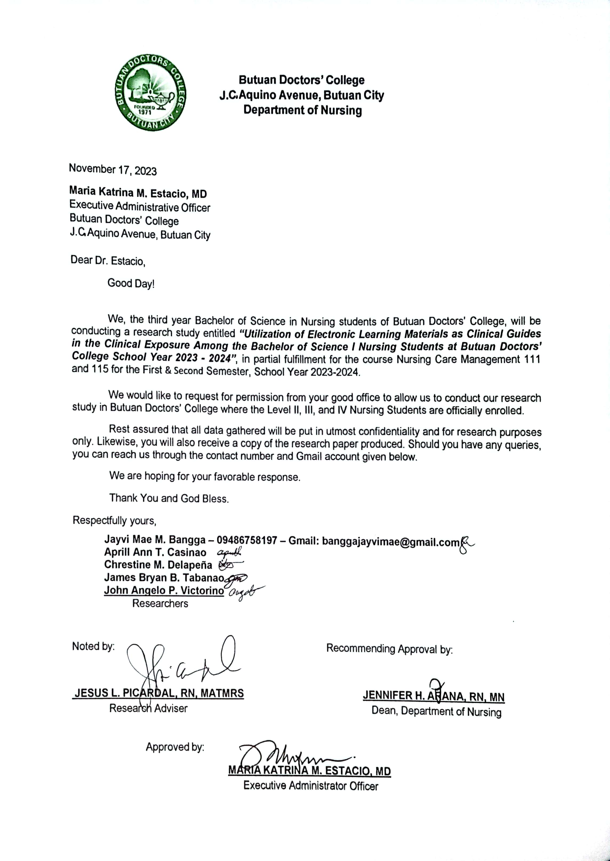**APPENDIX A**

**APPENDIX B**

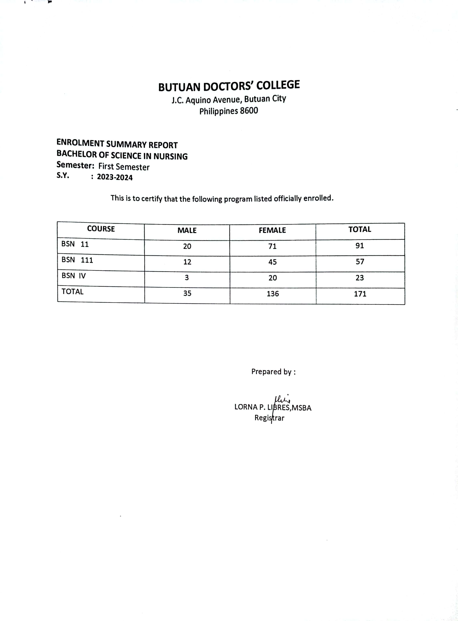**APPENDIX C**