

**Discrete Mathematics**

Name: Course:

Instructor: Subj./Schedule:

**General Direction:**

* ***Answer responsibly:*** *“To be a student is, precisely, to be responsible.”*
* ***Any kind of erasure is considered as wrong:*** *“With pencil you can always erase not in pens.”*
* ***No Cheating:*** *“All good is hard. All evil is easy. Dying, Losing, Cheating, and mediocrity is easy. Stay away from easy.”*

**Test I**. Write your answer in a separate clean sheet of paper.

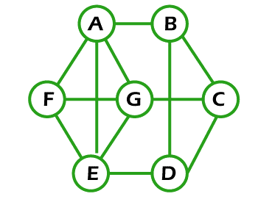

1.

G:

G = (V , E) :

Size:

Order:

The Handshaking Lemma:

Degree of a Graph:

Graph :

Adjacency Matrix :

Ajacency List:

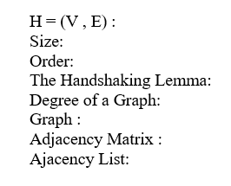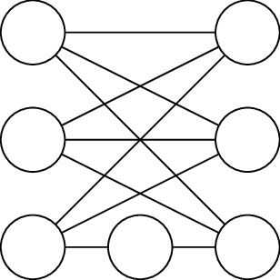

2. H :