

**Discrete Mathematics**

Name: Course:

Instructor: Subj./Schedule:

**General Direction:**

* ***Answer responsibly:*** *“To be a student is, precisely, to be responsible.”*
* ***Any kind of erasure is considered as wrong:*** *“With pencil you can always erase not in pens.”*
* ***No Cheating:*** *“All good is hard. All evil is easy. Dying, Losing, Cheating, and mediocrity is easy. Stay away from easy.”*

**Test I**. Write your answer in a separate clean sheet of paper.

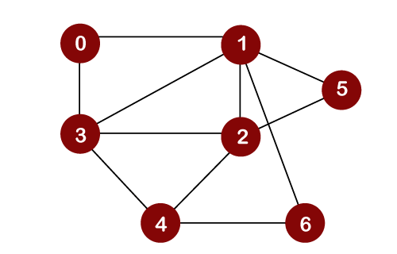

1.

Obtain the Breadth-First Search (BFS) and Depth-First Search (DFS) traversal sequences starting from vertex 0. Please provide the **queue** for BFS and the **stack** for DFS.

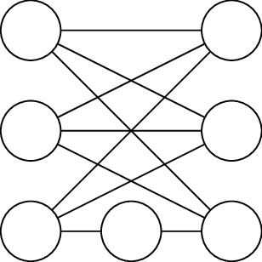

Obtain the Breadth-First Search (BFS) and Depth-First Search (DFS) traversal sequences starting from vertex A. Please provide the **queue** for BFS and the **stack** for DFS.

2.