 ***BUTUAN DOCTORS’ COLLEGE***

***J.C. Aquino Avenue, Butuan City***

***Department of Nursing***

**Hydatidiform Mole**

*An Individual Case Presentation*

*April Ann T. Casinao*

***STUDENT***

*Kenneth R. Falle, RN*

***CLINICAL INSTRUCTOR***

*Jennifer H. Arana, RN, MN*

***DEAN OF NURSING***

***TABLE OF CONTENTS***

**I.INTRODUCTION**

· Description

· Definition

· Signs/ Symptoms

· Causes of Diseases

· Statistical occurrences of Disease (Global, National, Local)

· Reason why you choose this topic

**II. ANATOMY & PHYSIOLOGY**

· Head to Toe Assessment: Pertinent findings; focus assessment

**III. PATHOPHYSIOLOGY**

**IV. LABORATORY**

**V. MEDICAL INTERVENTIONS**

**VI. SURGICAL INTERVENTIONS**

**VII. DRUG STUDY**

**VIII. NURSING CARE PLANS**

**IX. DISCHARGE PLAN**

**CHAPTER I**

**INTRODUCTION**

A hydatidiform mole, also known as a molar pregnancy, is a rare gestational condition resulting from abnormal fertilization of the egg, leading to the growth of abnormal tissue in the uterus instead of a normal fetus. There are two main types: complete and partial moles, both with symptoms like vaginal bleeding, severe nausea, an enlarged uterus, and sometimes high blood pressure. Diagnosis involves ultrasound and tissue biopsy, with timely medical management being crucial. The condition's signs and symptoms include bleeding, severe nausea, rapid uterine growth, high blood pressure, low hCG levels, and various other symptoms like abdominal pain and fatigue. The primary cause is genetic, related to abnormal fertilization, chromosomal abnormalities, maternal age, or a history of molar pregnancy. Lifestyle and environmental factors do not contribute to its occurrence.

Hydatidiform mole (HM) exhibits varying global, national, and local incidence rates. Globally, it ranges from 0.6 to 8 cases per 1,000 to 1,500 pregnancies, with significant disparities by region, such as rates as high as 1 in 200 pregnancies in parts of Africa. Nationally, the Philippines reports an estimated incidence of 1 in 1,200 pregnancies. At the local level, a study in Cagayan de Oro, published in "The Philippine Journal of Obstetrics and Gynecology" in 2019, found a prevalence of 6.1% (11/181) for HM in their population. Notably, the risk of HM increases with age, particularly in women over 40, and those with a history of previous HM or fertility drug use. Additionally, the risk of invasive disease, where molar tissue grows outside the uterus, is approximately 15% to 20% in complete HMs and 1% to 5% in partial HMs, often necessitating surgical intervention.

I chose to research hydatidiform mole because it's an important topic in nursing, especially for women's health. As a nursing student, I'm passionate about women's health and want to make a positive impact. Hydatidiform mole is a condition that doesn't happen often, but when it does, it can have serious effects on pregnant women. I wanted to study it to understand why it happens, what the symptoms are, and how to manage it. I'm also interested in the emotional and psychological aspects that patients and their families go through when dealing with this condition. Researching hydatidiform mole aligns with my academic and career goals in nursing. I believe that by studying this condition, I can improve my knowledge and clinical skills, which will help me provide better care to women who experience it. This research also emphasizes the importance of early detection and proper treatment to prevent complications like gestational trophoblastic neoplasia. By focusing on the hydatidiform mole, I hope to contribute to the field of women's health nursing and make a meaningful difference in the lives of patients and their families who face this challenging situation.

**ANATOMY AND PHYSIOLOGY**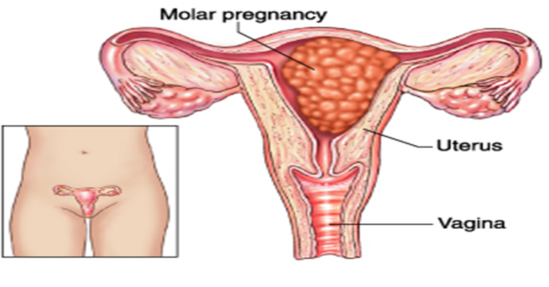

**AFFECTED ORGANS IN HYDATIDIFORM MOLE:**

● **Uterus:** The uterus is a muscular organ in the female pelvis that is responsible for holding the fetus during pregnancy. In hydatidiform mole, the molar tissue can grow and fill the uterus, causing it to enlarge.

Layers of the uterus and their functions:

* **Perimetrium:** The outermost layer of the uterus, made up of connective tissue and a serous membrane. It helps to protect the uterus and keep it in place.
* **Myometrium:** The middle layer of the uterus, made up of smooth muscle. It is responsible for expanding during pregnancy and contracting during labor.
* **Endometrium:** The innermost layer of the uterus, made up of mucous membrane. It is where the embryo implants and grows during pregnancy. The endometrium also sheds each month during menstruation.
* **Fundus**: Is the upper part of the uterus. It is where the fetus grows and develops during pregnancy. The fundus function is to provide a space for the fetus to grow and to protect it from harm. It also helps to push the baby down the birth canal during labor..

● **Fallopian tubes:** The fallopian tubes are the tubes that carry the egg from the ovary to the uterus. In hydatidiform mole, the molar tissue can spread to the fallopian tubes, which can cause pain and bleeding.

● **Ovaries:** The ovaries are the organs that produce eggs and hormones. In hydatidiform mole, the molar tissue can spread to the ovaries, which can cause pain and swelling.

**FUNCTION SYSTEMS OF THE AFFECTED ORGANS:**

● **Uterus:** The uterus is a muscular organ that helps to maintain pregnancy and childbirth. It also plays a role in menstruation.

● **Fallopian tubes:** The fallopian tubes help to transport the egg from the ovary to the uterus. They also play a role in fertilization.

● **Ovaries:** The ovaries produce eggs and hormones. The eggs are released from the ovaries during ovulation. The hormones produced by the ovaries help to regulate the menstrual cycle and pregnancy.

The specific organ that is most affected by hydatidiform mole is the uterus. The molar tissue can grow and fill the uterus, causing it to enlarge. This can lead to symptoms such as bleeding, pain, and nausea. In some cases, the molar tissue can spread to other organs, such as the fallopian tubes or ovaries.

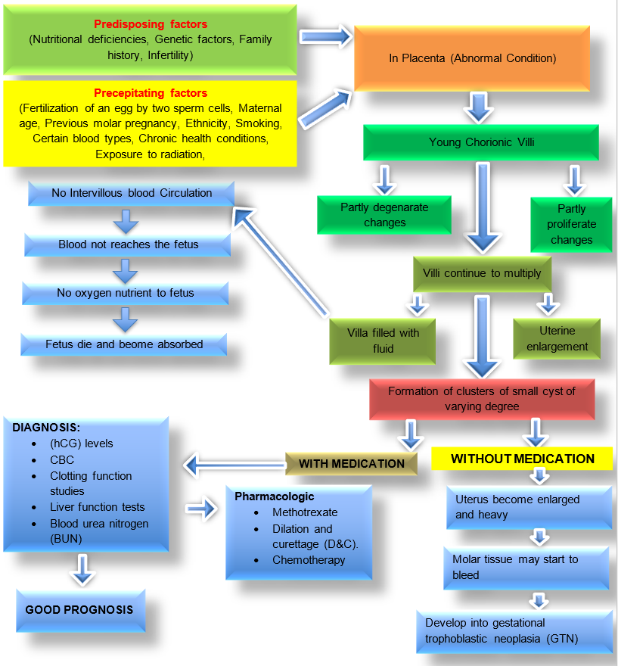 **PATHOPHYSIOLOGY**

**LABORATORY**

* **Quantitative beta-human chorionic gonadotropin (hCG) levels:** hCG is a hormone produced by the placenta. Elevated hCG levels, especially in the first trimester of pregnancy, can be a sign of a hydatidiform mole. However, it is important to note that hCG levels can also be elevated in other conditions, such as twins or multiples, and miscarriage.

**Nursing Interventions:**

* Regularly check vital signs and assess for abnormal uterine bleeding or pain.
* Initiate serial hCG level monitoring per physician orders to track trends.
* Inform the patient about hCG significance and the possibility of further tests for diagnosis.
* Offer compassionate emotional support to help the patient cope with anxiety.
* Coordinate imaging (e.g., ultrasound) to confirm or rule out a hydatidiform mole.
* If necessary, prepare the patient for procedures like dilation and curettage (D&C).
* **Complete blood cell count with platelets:** A complete blood cell count can be used to detect anemia, which can be a sign of a hydatidiform mole. Platelet levels may also be decreased, which can increase the risk of bleeding.

**Nursing Responsibilities:**

* Regularly monitor the patient's complete blood cell count (CBC) to detect signs of anemia and platelet levels.
* Assess for anemia-related symptoms such as fatigue and weakness.
* Evaluate the patient's risk of bleeding and closely observe for signs of bleeding, including easy bruising and unusual bleeding.
* Prepare for blood transfusion if severe anemia or significant platelet depletion is detected and ordered by the healthcare provider.
* Educate the patient about the importance of CBC results and potential implications.
* Work closely with the healthcare team to develop a comprehensive care plan.
* **Clotting function studies:** Clotting function studies may be ordered to assess the risk of bleeding.

**Nursing Responsibilities:**

* Regularly check and monitor the results of clotting function studies.
* Evaluate the patient's bleeding risk based on clotting function results.
* Implement fall precautions and ensure the patient's environment is safe to prevent injuries that may lead to bleeding.
* Educate the patient about the significance of clotting function studies and any necessary precautions or medications.
* Administer prescribed clotting factor replacement therapies or medications as ordered by the healthcare provider to manage clotting disorders.
* **Liver function tests:** Liver function tests may be ordered to assess the risk of liver damage, which can occur in some cases of hydatidiform mole.

**Nursing Responsibilities:**

* Regularly monitor the patient's liver function test results.
* Evaluate the patient's liver health based on test outcomes.
* Educate the patient about the purpose and significance of liver function tests and any potential implications for their care.
* Implement safety measures to prevent complications associated with liver damage, such as bleeding precautions and medication management.
* Administer prescribed medications or treatments as ordered by the healthcare provider to address liver issues, if necessary.
* **Blood type and Rh factor:** This information is needed for blood transfusions, if necessary.

**Nursing Responsibilities:**

* Ensure accurate blood typing and Rh factor determination for the patient.
* Verify the patient's identity using two unique identifiers to prevent errors.
* Properly label blood samples to prevent mix-ups and ensure accuracy.
* Educate the patient about the importance of knowing their blood type and Rh factor for potential transfusions.
* Document blood type and Rh factor in the patient's medical record.
* **Serum inhibin A and activin A levels:** These hormones are produced by the placenta and can be elevated in hydatidiform mole.

Nursing Responsibilities:

* Ensure the proper collection of blood samples for inhibin A and activin A level testing.
* Educate the patient about the significance of these hormones in monitoring hydatidiform mole and any potential implications.
* Accurately label blood samples, and thoroughly document the collection process.
* Keep a vigilant eye for signs or symptoms associated with hydatidiform mole, such as abnormal uterine bleeding or abdominal pain.

**MEDICAL INTERVENTIONS**

* **Dilation and Curettage (D&C):** The most common treatment for hydatidiform mole involves the removal of the abnormal tissue through a procedure called dilation and curettage. During this procedure, the uterine lining is scraped to remove the molar tissue.
* **Monitoring Beta-hCG Levels:** Regular monitoring of beta-human chorionic gonadotropin (beta-hCG) levels is essential to track the progress of treatment. A significant decrease in beta-hCG levels over time indicates successful removal of the mole.
* **Follow-Up Ultrasound:** Periodic ultrasound examinations are performed to ensure complete removal of the molar tissue and to monitor for any potential complications or recurrence.
* **Chemotherapy:** In cases where the mole has developed into gestational trophoblastic neoplasia (GTN), chemotherapy may be necessary to treat and prevent the spread of cancerous cells.
* **Blood Transfusions:** If severe vaginal bleeding has led to anemia, blood transfusions may be required to stabilize the patient's hemoglobin levels.
* **Emotional Support:** Patients with hydatidiform mole often require emotional support and counseling, as the diagnosis can be emotionally distressing. Supportive care is an essential component of treatment.
* **Contraception:** Following the removal of the mole, patients are usually advised to avoid pregnancy for a certain period, as the risk of recurrence is higher during this time.
* **Long-Term Follow-Up:** Long-term follow-up is necessary to monitor for any potential complications or recurrence of the condition, as well as to assess fertility and future pregnancy planning.

**CHAPTER V**

**SURGICAL INTERVENTIONS**

**Preoperative nursing interventions for a hydatidiform mole:**

* Assess the patient's vital signs, blood pressure, and oxygen saturation.
* Perform a physical examination, including a pelvic exam.
* Obtain a complete blood count and other lab tests as ordered by the physician.
* Educate the patient about the procedure and what to expect.
* Provide emotional support to the patient and her family.
* Prepare the patient for surgery by obtaining informed consent and providing preoperative medications as ordered by the physician.
* Advise the patient not to eat or drink in the preoperative period.

**Intraoperative nursing interventions for a hydatidiform mole:**

* Monitor the patient's vital signs, blood pressure, and oxygen saturation.
* Position the patient into a lithotomy position.
* Administer anesthesia and pain medication as ordered by the physician.
* Assist the physician with the surgical procedure.
* Monitor the patient for any complications.

**Postoperative nursing interventions for a hydatidiform mole:**

* Monitor the patient's vital signs, blood pressure, and oxygen saturation.
* Assess the patient for pain and administer pain medication as ordered by the physician.
* Monitor the patient for bleeding and other complications.
* Educate the patient about her postoperative care, including wound care, diet, and activity restrictions.
* Provide emotional support to the patient and her family.
* Follow up with the patient after her discharge to monitor her recovery.

**DRUG STUDY**

|  |  |  |  |  |  |  |  |
| --- | --- | --- | --- | --- | --- | --- | --- |
| **BRAND NAME** | **GENERIC NAME** | **DOSE/FREQUENCY** | **Mechanism of Action** | **CLASSIFICATION** | **INDICATION** | **CONTRAINDICATION** | **NURSING RESPONSIBILITIES** |
| **Trexall, Rheumatrex** | Methotrexate | 2.5 milligrams (mg)  Route: Oral | Interferes with the metabolism of folic acid, which is essential for cell growth and division. | Antimetabolite | To treat persistent or recurrent hydatidiform mole. | Contraindicated in patients who are pregnant or breastfeeding, who have severe bone marrow suppression, or who have a known allergy to the drug. | **Preoperative**  - Assess the patient's medical history  - Educate the patient about methotrexate.  **Intraoperative**  - Monitor the patient's vital signs and hydration status.  - Monitor the patient's renal function.  **Postoperative**  -  Assess the patient for signs of infection. |

|  |  |  |  |  |  |  |  |
| --- | --- | --- | --- | --- | --- | --- | --- |
| **BRAND NAME** | **GENERIC NAME** | **DOSE/FREQUENCY** | **Action** | **CLASSIFICATION** | **INDICATION** | **CONTRAINDICATION** | **NURSING RESPONSIBILITIES** |
| **Platinol** | Cisplatin | 100mg/m2 and 20 mg/m2  Route: Intravenous | Cisplatin binds to DNA and cross-links it, preventing cell division and leading to cell death. | Alkylating agent | Cisplatin is used to treat a variety of cancers, including hydatidiform mole. | Cisplatin is contraindicated in patients who are pregnant or breastfeeding, who have severe bone marrow suppression, or who have a known allergy to the drug. | **Preoperative:**  - Administer antiemetics and other supportive medications as needed,  - Assess the patient's nutritional status.  **Intraoperative:**  - Monitor the patient's fluid balance and electrolyte levels.  - Monitor the patient for signs of an allergic reaction.  **Postoperative**  - Monitor the patient for signs of infection. |

|  |  |  |  |  |  |  |  |
| --- | --- | --- | --- | --- | --- | --- | --- |
| **BRAND NAME** | **GENERIC NAME** | **DOSE/FREQUENCY** | **Action** | **CLASSIFICATION** | **INDICATION** | **CONTRAINDICATION** | **NURSING RESPONSIBILITIES** |
| **VePesid, Injection** | Etoposide | 50-100 mg/m²/day IV  Route:Intravenous | Etoposide inhibits topoisomerase II, an enzyme that plays a role in DNA replication and repair. This can lead to cell death. | Topoisomerase inhibitor | Etoposide is used to treat a variety of cancers, including hydatidiform mole. | Etoposide is contraindicated in patients who are pregnant or breastfeeding, who have severe bone marrow suppression, or who have a known allergy to the drug. | **Preoperative**  - Educate the patient about etoposide.  - Assess the patient's medical history.    **Intraoperative**  - Monitor the patient's blood pressure.  - Administer antiemetics and other supportive medications as needed.  **Postoperative**  - Assess the patient for signs of infection |

|  |  |  |  |  |  |  |  |
| --- | --- | --- | --- | --- | --- | --- | --- |
| **BRAND NAME** | **GENERIC NAME** | **DOSE/FREQUENCY** | **Action** | **CLASSIFICATION** | **INDICATION** | **CONTRAINDICATION** | **NURSING RESPONSIBILITIES** |
| **Dactinomycin, Injection** | Actinomycin D | 45 mcg/kg intravenously once every 3 to 6 weeks  Route: Intravenous | Actinomycin D intercalates into DNA and inhibits RNA transcription. This can lead to cell death. | Cytotoxic antibiotic | Actinomycin D is used to treat a variety of cancers, including hydatidiform mole. | Actinomycin D is contraindicated in patients who are pregnant or breastfeeding, who have severe bone marrow suppression, or who have a known allergy to the drug. | **Preoperative**  - Educate the patient about actinomycin D.  - Assess the patient's nutritional status.  **Intraoperative**  - Monitor the patient's blood pressure.  - Administer antiemetics and other supportive medications as needed.  **Postoperative**  - Teach the patient about potential long-term side effects of actinomycin D. |

**IDENTIFICATION OF NURSING PROBLEM**

* **Risk for hemorrhage:** Hydatid mole can cause uterine bleeding due to the rapid growth of the molar tissue. The bleeding can be heavy and prolonged, leading to hemorrhage.
* **Risk for infection:** Hydatid mole is a dead pregnancy, and the dead tissue can be a breeding ground for bacteria. Infection can spread to the uterus, ovaries, and fallopian tubes. In severe cases, it can lead to sepsis.
* **Pain:** Hydatid mole can cause pain in the lower abdomen and pelvis due to the rapid growth of the molar tissue and the stretching of the uterus. The pain can be sharp and intermittent or dull and constant.
* **Anxiety:** Hydatid mole is a frightening experience for women, and it can cause a great deal of anxiety. Women may worry about their health, their ability to have a healthy pregnancy in the future, and the emotional impact of the loss.

· **Electrolyte imbalance:** Hydatid mole can cause electrolyte imbalance due to heavy bleeding, vomiting, and diarrhea. Electrolyte imbalance can lead to a variety of complications, such as heart problems, muscle weakness, and seizures.

* **Fluid overload:** Hydatid mole can cause fluid overload due to the rapid growth of the molar tissue and the increased blood flow to the uterus. Fluid overload can lead to a variety of complications, such as swelling, shortness of breath, and pulmonary edema.

***CHAPTER VII***

***NURSING CARE PLANS***

**NCP I: Acute Pain related to postoperative incision**

|  |  |  |  |  |  |
| --- | --- | --- | --- | --- | --- |
| **ASSESSMENT** | **NURSING DIAGNOSIS** | **PLANNING** | **INTERVENTION** | **RATIONALE** | **EVALUATION** |
| **Subjective Data:**  “Sakit kaayo akong tiyan”as verbalized by the client  Pain Scale of 7/10  **Objective Data:**  -Abdominal pain and cramping  -Uterine size and firmness | Acute Pain related to postoperative incision | Within 2 hours of nursing interventions, the patient will report a pain level of 3/10. | **INDEPENDENT**  1. Assess the patient's pain level using a reliable pain assessment tool, such as the Visual Analogue Scale (VAS).  2. Monitor the patient's response to pain management and adjust interventions as needed.  3. Keep the incision site clean and dry    4. Encourage the patient to express her pain and concerns.  5. Teach the patient relaxation techniques.  6.Offer the patient complementary therapies.  **DEPENDENT**  7. Administer analgesics as prescribed by the physician. | 1. For evaluating effective pain management interventions.    2. To ensure that they are effective and that the patient is not experiencing any side effects.  3. To prevent infection and promote healing.  4. To better understand the patient's pain experience and to develop more effective pain management interventions.  5. To reduce pain.    6. To reduce stress and anxiety, which can contribute to pain.  7. For reducing pain. | After 2 hours of nursing interventions, the patient will be able to report a pain level of 3/10 and be able to relax and rest comfortably. |

**NCP II: Risk for fluid volume deficit related to excessive vascular loss**

|  |  |  |  |  |  |
| --- | --- | --- | --- | --- | --- |
| **ASSESSMENT** | **NURSING DIAGNOSIS** | **PLANNING** | **INTERVENTION** | **RATIONALE** | **EVALUATION** |
| **Subjective Data:**  “Malipong ko pag mutindog unya uga kaayo akong baba.”as verbalized by the client.  **Objective Data:**  - Elevated heart rate (tachycardia)  - Tachypnea (rapid breathing)  - Reduced urine output  - Nausea  - Dizziness | Risk for fluid volume deficit related to excessive vascular loss | Within 5 hours of nursing intervention, the patient will be able to maintain fluid and electrolyte balance. | **INDEPENDENT**  1. Assess the patient's vital signs, including blood pressure, heart rate, and respiratory rate.  2. Monitor the patient's intake and output.    3. Assess the patient's mucous membranes for signs of dehydration, such as dryness and tackiness.    4. Monitor the patient for signs and symptoms of complications from fluid volume deficit, such as shock and renal failure.    5. Weigh the patient.    6. Encourage the patient to drink plenty of fluids.  **DEPENDENT**  7. Administer intravenous fluids as prescribed by the physician. | 1. To have important clues about the patient's overall health and fluid status    2. To assess the patient's fluid balance.    3. For early detection and management of potential fluid volume deficit.      4. To prevent life-threatening conditions, ensuring the patient's safety      5. A sudden increase in weight may be a sign of fluid overload.  6. To treat fluid volume deficit.    7. To replace the fluids that they have lost. | After 5 hours of nursing intervention, the patient's vital signs will remain within normal limits and the patient's intake and output will be balanced. |

**NCP III:** [**Anxiety**](http://nandanursingdiagnosis.blogspot.com/search/label/Nursing%20Diagnosis%20for%20Anxiety) **related to changes in health status**

|  |  |  |  |  |  |
| --- | --- | --- | --- | --- | --- |
| **ASSESSMENT** | **NURSING DIAGNOSIS** | **PLANNING** | **INTERVENTION** | **RATIONALE** | **EVALUATION** |
| **Subjective Data:**  “Wala koy tarong tulog permi tungod ani” as verbalized by the client.  **Objective Data:**  -restlessness  -increased respiratory rate (RR: 27 bpm)  -increased heart rate (108 bpm)  -changes in appetite  -sweating | [Anxiety](http://nandanursingdiagnosis.blogspot.com/search/label/Nursing%20Diagnosis%20for%20Anxiety) related to changes in health status | Within 2 hours of nursing interventions, the patient will be able to use coping skills to reduce anxiety. | **INDEPENDENT:**  1. Assess the patient's level of anxiety and identify the sources of their anxiety.  2. Educate the patient about hydatidiform mole and its treatment.  3. Help the patient to develop and use coping mechanisms to manage their anxiety.  4. Provide emotional support to the patient and their family.  5. Encourage the patient to talk about their feelings and concerns.  6. Teach the patient to develop a plan for coping with the emotional and practical challenges of hydatidiform mole.  7. Help patient relaxation techniques and coping skills to manage anxiety.  **DEPENDENT:**  8. Coordinate care with other healthcare professionals, | 1.To tailor interventions to the individual patient's needs.    2. To help the patient understand their condition and make informed decisions about their care.  3. To reduce anxiety symptoms and improve overall well-being.  4. To help the patient feel less alone and more supported.  5. To help the patient feel better and cope more effectively with their anxiety.  6. To help the patient feel more in control and less overwhelmed.  7. To reduce anxiety symptoms and improve overall well-being.    8. To ensure that the patient receives the best possible care. | After 2 hours of nursing interventions, the patient will decrease in anxiety. |

*CHAPTER VIII*

***DISCHARGE PLAN***

|  |  |
| --- | --- |
| **Medication** | * Administer prescribed methotrexate and folic acid as directed, emphasizing the importance of adherence. * Educate on potential medication side effects and the need to report any adverse reactions. * Discuss the importance of birth control to prevent pregnancy during recovery. |
| **Exercise** | * Avoids strenuous exercise for at least 6 weeks after surgery. These are activities such as running, jumping, and lifting heavy objects. * Focus on light to moderate exercises such as walking, and yoga, and aim for at least 30 minutes of exercise mass days of the week. * Listen to your body and rest when you need to. Don't push the patient too hard, as this can delay the recovery. * High-intensity should generally be avoided during treatment and recovery. |
| **Treatment** | * Ensure the patient understands the importance of attending all follow-up appointments. * Instruct the patient to report any abnormal symptoms such as vaginal bleeding or pelvic pain immediately. * Discuss contraception options to prevent pregnancy during the follow-up period, as pregnancy can complicate the monitoring of hCG levels. * Provide the patient with a prescription for antiemetic medication. |
| **Health Teaching** | * Advise the patient to avoid strenuous activities and heavy lifting for a specified period, as recommended by the healthcare provider. * Encourage a healthy diet and regular exercise to support overall well-being. * Prescribe medications as needed for pain management or to address complications. * Provide clear instructions on medication usage and potential side effects. * Educate the patient about the nature of a hydatidiform mole, its potential risks, and the importance of adherence to the treatment plan. * Ensure the patient understands the signs and symptoms that require immediate medical attention. * Provide information on potential complications and instruct the patient to report any unusual symptoms immediately. * Offer emotional support resources, including counseling or support groups. * Discuss future pregnancy planning, including genetic counseling if necessary. |
| **Follow-up (OPD check-up)** | * Encourage the patient to contact their doctor if they experience any signs or symptoms again. * Schedule and remind the patient about upcoming follow-up appointments. * Explain the ongoing importance of hCG monitoring to ensure complete recovery. * Review contraception choices at each follow-up visit as needed. |
| **Diet** | * Emphasize the importance of a balanced diet rich in nutrients to support overall health and recovery. * Encourage the consumption of folate-rich foods like leafy greens (broccoli, pechay, malunggay, water spinach (kangkong) and citrus fruit (oranges, grapefruits, lemons). Folate, also known as vitamin B9, is particularly important for both general health and future pregnancy prospects. * Reinforce the avoidance of alcohol and smoking for both general health and future pregnancy prospects. |
| **SPIRITUAL CARE** | * Encourage patient to read inspirational and spiritual books. * Encourage patient to continue hearing/attending mass. * Stress the significance of having deep faith in God. * Encourage the patient to have faith and pray to God. * Encourage the patient to strengthen the faith and communicate with God. |