# Indian Institute of Technology-Guwahati

Department of Civil Engineering



**Course No. CE-607**

**Random Vibrations Assignment-1**

ROHAN DHARMADHIKARI

154104002

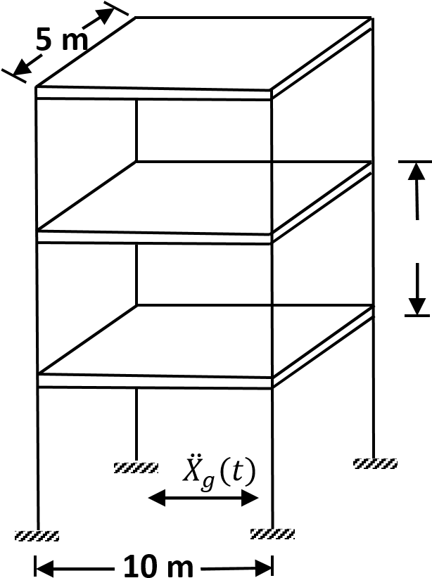**QUESTION 1**

**Inter-Storey Drift:**

The given system was analysed in the frequency domain. The standard deviation for the displacements at each floor level and the inter-storey drift were found. Taking the maximum of the two inter-storey s.d., the probability of failure was found.

The Moment of inertia of the columns was adjusted in iterations till the probability of failure was just below 0.001. That M.I. was considered as design M.I. So a column with M.I. greater than or equal to the design M.I. can be used.

Design M.I. = 0.001148 m4

The standard deviation of the defection at each floor level: (Mean = 0)

σ1 = 1.4837 mm; σ2 = 2.6638 mm; σ3 = 3.3162 mm;

The standard deviation for the inter-storey drift: (Mean = 0)

σ12 = 3.0491 mm; σ23 = 4.2536 mm

The probability of failure:

pf = 0.00099705

Now, let’s provide a column of dimensions 350mm x 350mm,

M.I. provided = 0.00125

The standard deviation of the defection at each floor level: (Mean = 0)

σ1 = 1.2388 mm; σ2 = 2.2219 mm; σ3 = 3.3162 mm;

The standard deviation for the inter-storey drift: (Mean = 0)

σ12 = 2.5439 mm; σ23 = 3.5469 mm

The probability of failure:

pf = 7.908 x 10-5 … safe.

**Base Shear:**

Input ground acceleration is a zero-mean gaussian with Kanai-Tajimi spectrum. The forces at each level can be determined by the expressions:

F = M*I*xag

Therefore, the PSDF of the forces are:

Sff = M*I*xag*xag**I**M*

The base shear force is equal to sum of all forces at all levels. The standard deviation of base shear, σF = 92.8914 N.  
Allowable Shear Force at the base, Fall = 46.4 kN.

Hence, probability of failure, pf = 0.

**QUESTION 2**

For the given functions, the plots of auto-correlation:

1. y(t) = cos(5t)
2. y(t) = e-0.5t(sin(10t) + cos(15t))
3. y(t) = Band Limited White Noise
4. y(t) = e-0.5t

Autocorrelation using in-built function:

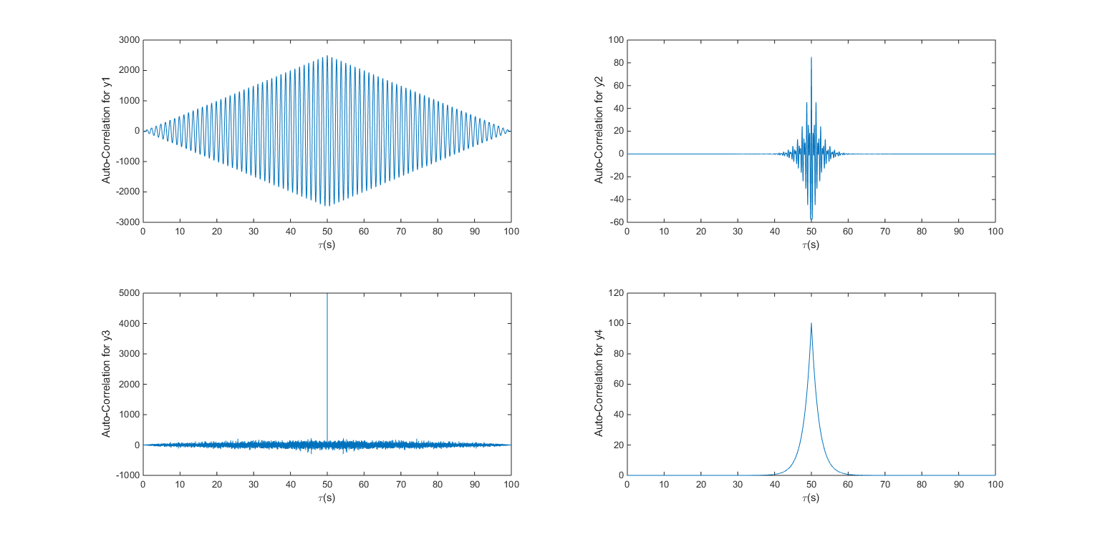

Autocorrelation using own function:

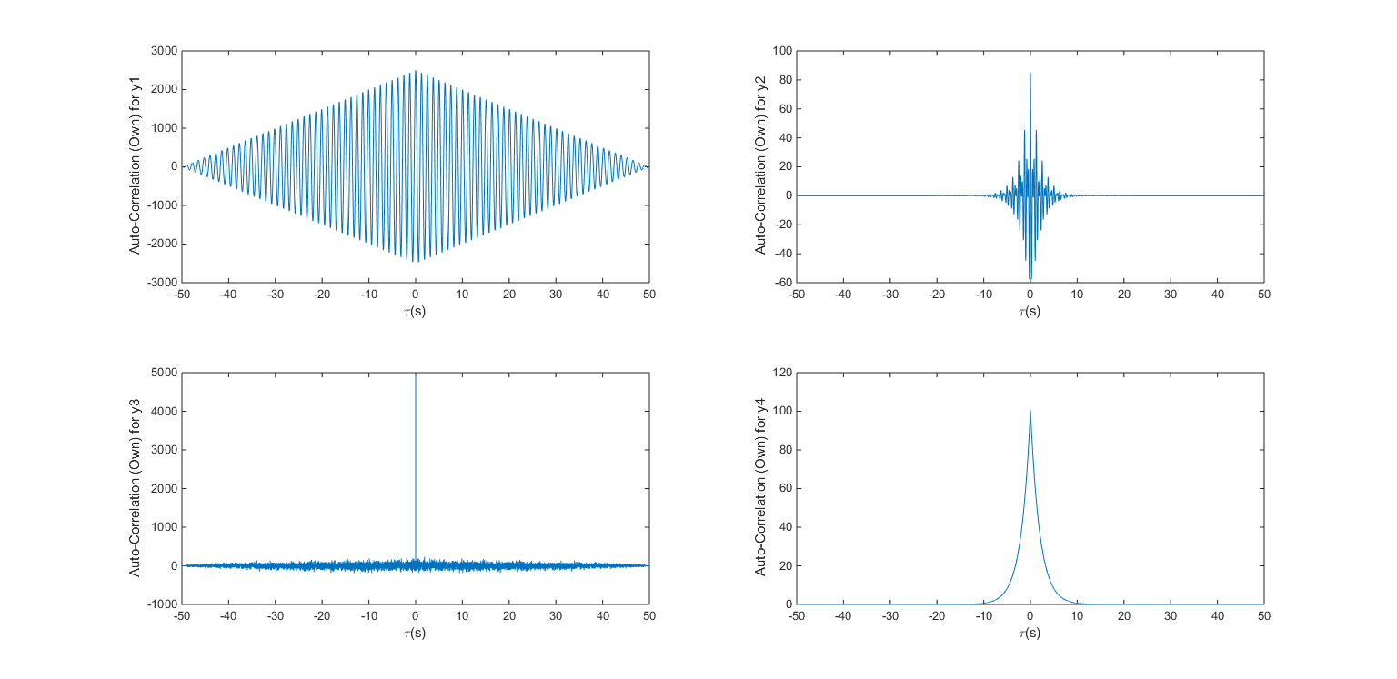

**QUESTION 3**

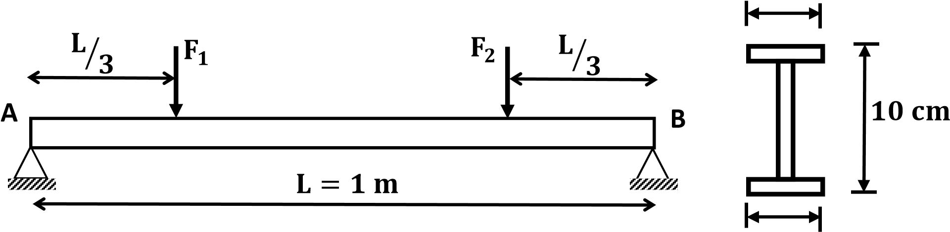

Using Finite-Element Method, the beam was divided in 3 parts. Then, the Mass and Stiffness matrices were generated for the whole beam. Using these matrices, the natural frequencies and the mode shapes were determined.

Using the influence factor as 1 at node 3 in direction of F1 and 0.75 at node 5 in same direction. and takin the intensity of PSDF of both forces as 1, we get the PSDF of the displacement. The value of Sxx is actually the coefficient of I0 if the intensity was I0.

Thus, using the pf given, we find the σx required and dividing that by the Sxx calculated, we get the value of intensity as:

I0 = 0.0158

**QUESTION 4**

F

3

F

2

F

1



3.5

m

10

m

5

m

The system is modelled in SAP2000. The slabs are assigned dead weight and not the columns. Using Modal Analysis, the Mass and Stiffness matrices are obtained. Then using the same technique as in question 1, the Sxx is obtained. And the technique used in question 3 is used to find the required intensity.

I0 = 15.2644 N