# Indian Institute of Technology-Guwahati

Department of Civil Engineering



**Course No. CE-607**

**Random Vibrations Assignment-2**

**Q3**

ROHAN DHARMADHIKARI

154104002

DIPTOJIT DATTA

154104007

**Question**

Consider 5DOF system given below. The support motion is modeled by Kanai-Tajimi spectrum (assume ${S_{0},ω}_{n},η_{g}$). Evaluate RMS value of top response and check the results with modal combination rules (i.e. SRSS & CQC)

System Propeties:





**SOLUTION:**

Exact Solution:

For the given system, the values of S0, wg and ηg are assumed. Using these values over a range of 0 to 150 rad/s frequencies, the input Power Spectral Density is generated.

Input PSDF:

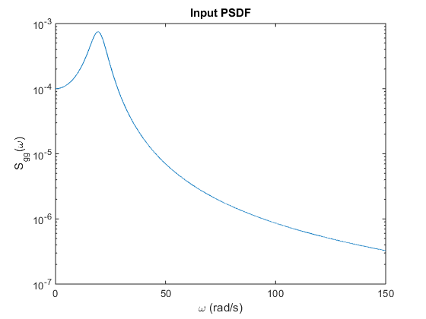

Using this input PSDF and the Impulse Response Function, H(w) = [K – w2M + iwC]-1, the response psdf of the MDOF system is determined

Response PSDF:

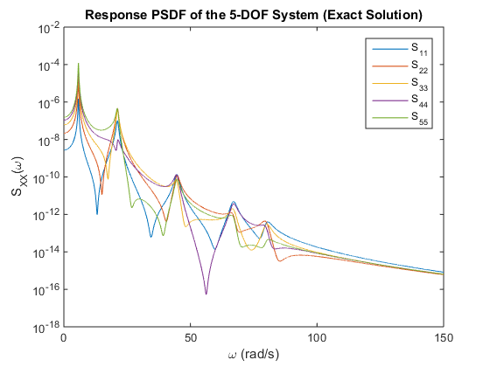

Taking the area under curve for all the response psdfs, we get the covariance matrix and correspondingly the variance of the response of each floor. The rms value of the displacement of a particular floor is the square root of the variance. (Zero Mean Processs)

Exact Solution: Y5_rms = 6.6614E+03 units

Modal Solution:

For the modal solution, we determine the natural frequencies of the MDOF system and its mode shapes. This done by using the Eigen values and the Eigen vectors obtained from the Stiffness and Mass matrices.

Natural Frequencies:

wn = 5.7466, 21.1805, 44.6521, 66.9590, 79.9752

Mode Shapes:

Φ = -0.0173 0.0615 0.1171 0.1458 -0.1097

-0.0521 0.1307 0.1072 -0.0479 0.1324

-0.0910 0.1165 -0.0754 -0.0919 -0.1230

-0.1261 0.0112 -0.1125 0.1285 0.0768

-0.1546 -0.1286 0.0869 -0.0509 -0.0227

Using the mode shapes, diagonal Mass, Stiffness and Damping matrices are obtained. The Impulse Response Function is obtained using these diagonal matrices. Using this IRF the response psdf is obtained

Modal Response PSDF:

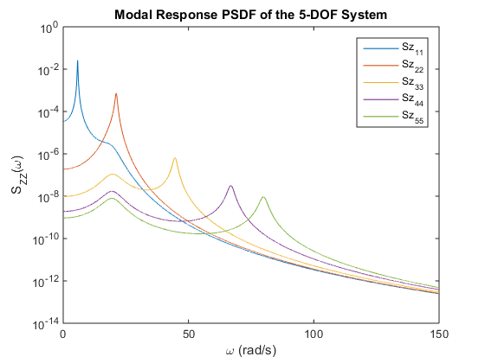

Now the modal covariance matrix is found from the modal response psdf and then is converted to the global covariance by using the mode shapes.

But, this converting gives an overestimate of the response.

Modal Solution (Simple addition): Y5_rms = 1.1970E+04 units

Using SRSS:

Modal Solution (SRSS): Y5_rms = 4.9779E+03 units

Using CQC:

Modal Solution (CQC): Y5_rms = 4.9706E+03 units