Calculate Pool Gauge Level Visuals and Statistics Tool Manual

By: Ryan Wortmann former MDC employee

leelandsteamer@gmail.com

**READ THROUGLY BEFORE ATTEMPTING TO RUN TOOLS. CONTAINS A GREAT DEAL OF IMPORTANT INFO.**

This is a 2 part workflow. Part one (Calculate Pool Gauge Level Visuals and Statistics) will use an Arcmap Script tool to take an input pool and export a folder of jpegs and a json file. Part two (Push Data to Cloud) will take all the data outputted by the first step and push it to the database in the cloud so that it can be accessed by Wetland Waterfowl Decision Support Tool. This workflow will be repeated once for every individual pool.

**Before Getting Started**

Download the toolbox here: https://github.com/Rdubya54/Calculate-Pool-Gauge-Level-Visuals-and-Statistics

Open ArcMap and navigate to where you placed the downloaded folder. Open the toolbox so that you see the two tools inside. Right click on Calculate Pool Gauge Level Visuals and Statistics and select Properties. Click the Source tab and point the tool to the Calculate_Pool_Gauge Level_Visuals_and_Statistics.py file in the scripts folder.

Open the Basemap.mxd included in the downloaded folder. Add the Food Plots.lpk , the Reclassed Surface.lpk, and the Water Control Strutures.lpk files to the basemap, all of which are included in the downloaded folder. **KEEP THESE LAYERS TOGGLED OFF.**

The Basemap.mxd also contains an ESRI Basemap Imagery Layer and multiple NAIP imagery layers. These stay **TOGGLED ON.** The Basemap.mxd should be able to display these layers by default, but if for some reason it cannot you may have to add them in as well. The NAIP imagery layers are on the O drive (O:\Image_Layer_Files\NAIP_2018.lyr) so just drag them in from there if they aren’t working.

Symbology on Basemap.mxd should look like this:

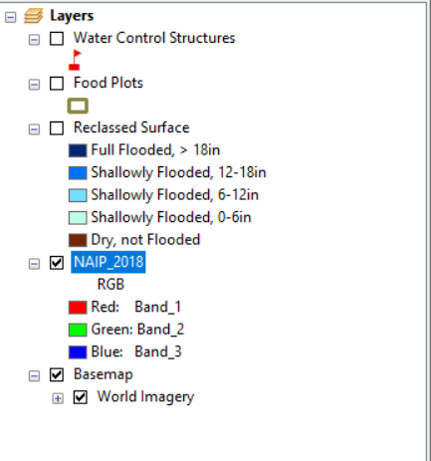

Now save and close the Basemap.mxd. **DO NOT RUN THE TOOLS WHILE INSIDE OF YOUR BASEMAP.MXD OR WHILE IT ITS OPEN. MAKE A NEW MXD FOR RUNNING THESE TOOLS IN.**

**Only Calculating for Valid Water Control Structures:**

At the time of writing this, every conservation area has slightly different schemas for its Water Control Structures geodatabases. You will likely get WCS feature classes that contain gates that actually pump water and with gates that only serve to drain the pool. You will want the tool to skip these drain-only WCS’s because they aren’t used to add water to the pool.

1. Find out which gates pump water into the pool and are not just drains. You will have to have Andy or the Conservation Area Manager identify these for you.
2. Add a field to the WCS feature class called “valid”. Make it a text field.
3. For each WCS that pump water into the pool and are not just drains, enter “yes”.

Tool will now skip WCS’s that are only drains. The tool will run on all WCS’s with “yes” in their “valid” field.

**Proximity:**

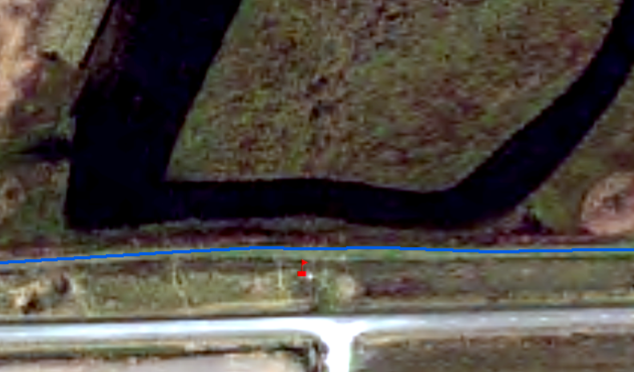

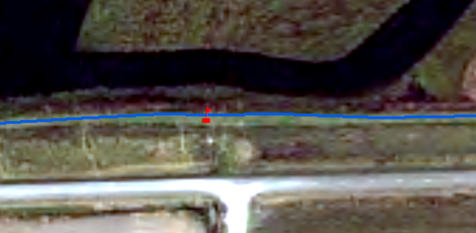

**Calculate Pool Gauge Level Visuals and Statistics (Step 1 of 2):**

**Tool Overview:**

**Tool must be run one pool at a time. Do not try to enter a unit of pools.**

This tool takes a given input pool and creates a visualization of how much water at a given depth classification will be in the pool at a given gauge level. It will do this once for each water control structure in the pool. For example, if the tool is creating a visualization for a pool at a gauge for 134.5 meters and the pool has 3 different water control structures/basins, it will do a separate calculation/visualization for each structure. This is because the results will be different depending on which water control structure is being manipulated.

The tool starts doing calculations at the minimum elevation within the pool, keeps doing them as the input gauge level increment increases, and then stops at the maximum elevation.

The tool’s final outputs are a json file named data.json containing all of the statistics calculated for the pool and a folder containing one jpeg for each visualization the tool made.

**Tool Inputs Explained**:

*Conservation Area Name*: Enter the name of the Conservation Area that this pool is located. This input text will be saved to the cloud and used to point the data to the proper place in the Wetland Waterfowl Decision Support Tool so be careful not to make any spelling mistakes. Variations in capitalization are fine, just keep spelling consistent as you run the tool on each pool.

*Pool Unit Name*: Enter the name of the Pool Unit that this pool is part of. You may have to get all the unit names from Andy or the Area Manager. This input text will be saved to the cloud and used to point the data to the proper place in the Wetland Waterfowl Decision Support Tool so be careful not to make any spelling mistakes. Variations in capitalization are fine, just keep spelling consistent as you run the tool on each pool.

*Input Pool Feature Class*: Input a feature class that contains **ONLY** one pool. This is the pool for which the Visuals and Statistics will be calculated. If you have one feature class containing all of your pools, you have to export each pool to its own feature class.

*DEM Containing Input Pool*: Input a DEM that contains the input pool. Don’t worry about clipping it to the pool. The tool does it for you.

*Water Control Structures for Pool*: Input a feature class that contains **ONLY** the water control structures that are used to manipulate the water levels for the input pool. If you have one feature class containing all of your water control structures, you have to make a new feature class containing only the water control structures for the input pool.

*Structure Name Identifier Field*: This input field will have a drop down menu containing all of the fields in your input water control structure feature class attribute table. Select the field that contains the name or label for each water control structure. These names will be written to the database and will be the identifier for each water control structure in the Wetland Waterfowl Decision Support Tool.

*Gauge Level Increment*: Input a number. This will be how frequent you want the tool to perform its calculations. For example, inputting 0.1 will make tool perform calculations every 0.1 meters until it reaches the maximum elevation. The smaller the value, the more calculations and output images the tool will make.

*Basemap*: Input the Basemap.mxd that came in the download folder with your copy of the toolbox. See *Important Info About the Basemap.mxd* for a run-down of what this is.

*Output GDB*: Input any geodatabase. This gdb is going to act as a dump for all of the data generated that will **NOT** be needed for anything in the end. All of the data outputted to this gdb is used by the tool to reach it’s final outputs but in the end is not needed. You can delete this data/gdb after the tool is done running.

*Output Folder*: Input a file folder. This folder is where all of the final outputs, the output jpegs and the output json file will be saved to.

*Food Plots (optional):* Only needed if you want food plot statistics calculated for the pool. Like the pool and water control structure feature class, input a feature class that contains **ONLY** the food plots contained in the input pool.

*Crop Type Identifier Field (required if Food Plots are entered):* This input field will have a drop down menu containing all of the fields in your food plots feature class attribute table. Select the field that contains the name of each crop type in the feature class, i.e “Corn”, “Millet”.

**Tool Outputs Explained:**

Both of these outputs are written to the input Output Folder. **DO NOT CHANGE THE NAME OF ANY OF THESE FILES.** They are named in a very specific way so they can automatically be pushed to the cloud and referenced by the decision support tool.

data.json: This JSON file contains the following statistics for each water control structure at each calculated gauge level:

* Total Acres of each type of Flooded Habitat
* Total Acres of each type of Flooded Crop (if food plots were inputted)
* Total Acreage of Pool
* Total Acreage of Crop (if food plots were inputted)

(Conservation Area Name)_(Pool Name)_images: This is the folder containing a jpeg of each water control structure at each calculated gauge level. They are named as such (Pool Name)_(Structure Name)_(Gauge Level)_Reclassed_Surface.jpeg.

**Errors:**

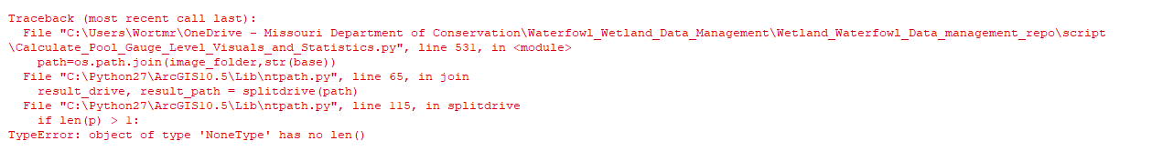

If you get this error just run the tool again and then it will work.

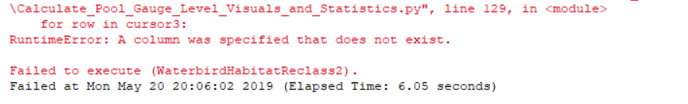

You might have forgot to add the “valid” field to your WCS feature class.

**Important Info about the Basemap.mxd:**

The Basemap.mxd included in the folder and used as an input in the Calculate Pool Gauge Level Visuals and Statistics tool plays a very important part of this workflow and tampering with it can potentially mess up the output jpegs. This is because as the tool completes calculations for a given gauge level, the tool adds the water control structure layer, the food plots (if entered) layer, and the raster layer representing the water level at to the Basemap.mxd. It then automatically zooms to the raster layer, takes a screenshot, exports it as a jpeg, and saves it to the input Output Folder.

Three layer package files (.lpk) have also been included in the download folder. These layer package files are a dummy raster layer representing various water levels (Reclassed Surface.lpk), a dummy water control structure layer (Water Control Structures.lpk), and a dummy food plot layer (Food Plots.lpk). These layers should be in your Basemap.mxd at all times and always turned off. These layers exist for the sole purpose of providing a consistent symbology formatfor the new layers that tool is importing into the Basemap. Without these layers to reference, the symbology is totally inconsistent. If you want to change the symbology used in the output images, just change the symbology of the corresponding dummy .lpk and then save the Basemap.mxd.

**REMEMBER TO KEEP THESE LAYER PACKAGES TOGGLED OFF AND THE BASEMAP AND NAIP IMAGERY LAYERS TOGGLE ON.**

**Push Data to Cloud (Step 2 of 3):**

Push Data to Cloud pushes the data.json file and all of the output jpegs created by a run of the Calculate Pool Gauge Level Visuals and Statistics Tool to our Google Firebase database (the cloud). There is no Arcmap tool for this step, you will just be running the push_data_to_cloud.py file from IDLE to finish this step. The file is inside of the “script” folder from the downloaded folder from Github.

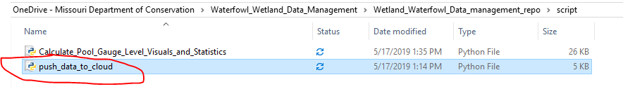

This script requires two python libraries that do not come standard with Python and will require you to download them from the command line before being able to run the script without getting importing module errors.

IT’s configuration of the MDCLocal network firewall will properly prevent you from being able to do this. You will need to be able to connect to the MDCGuest network to get around this. If you are using a Desktop computer, get the Wifi USB Adapter from Joel or Dyan and connect to MDCGuest using that. As long as you can connect to MDCGuest you should be able to install these python packages without any problems.

Open command prompt.

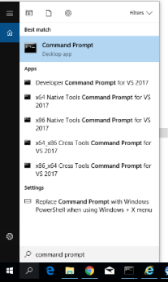

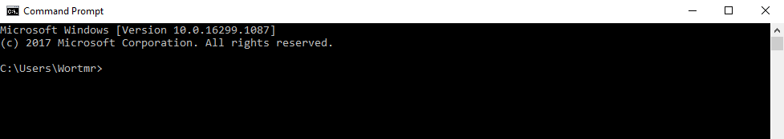

Enter the following commands:

cd ..

cd ..

You should now be at the root of your C: drive

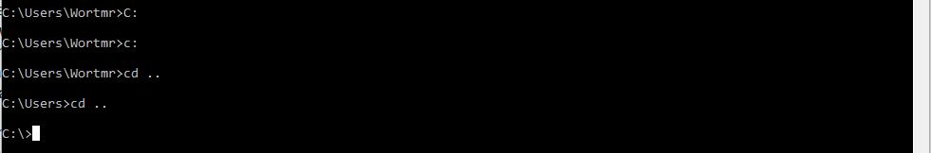

cd Python27

cd ArcGIS10.5

cd Scripts

The exact filenames/filepaths may be slightly different for you, but the main idea is for you to navigate to wherever your Python27 folder is on your machine and “cd”ing into the Scripts folder where the pip.py folder is located.

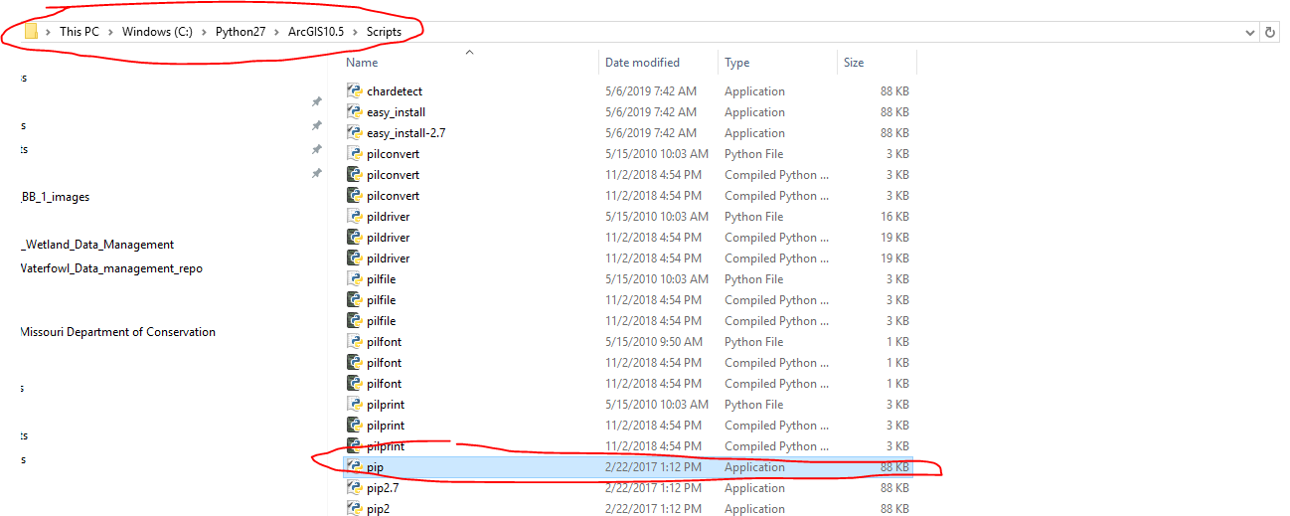

Once you are in this folder with the command line, run:

pip install google-cloud-firestore

pip install firebase-admin



The google-cloud-firestore and the firebase-admin libraries should now be successfully installed.

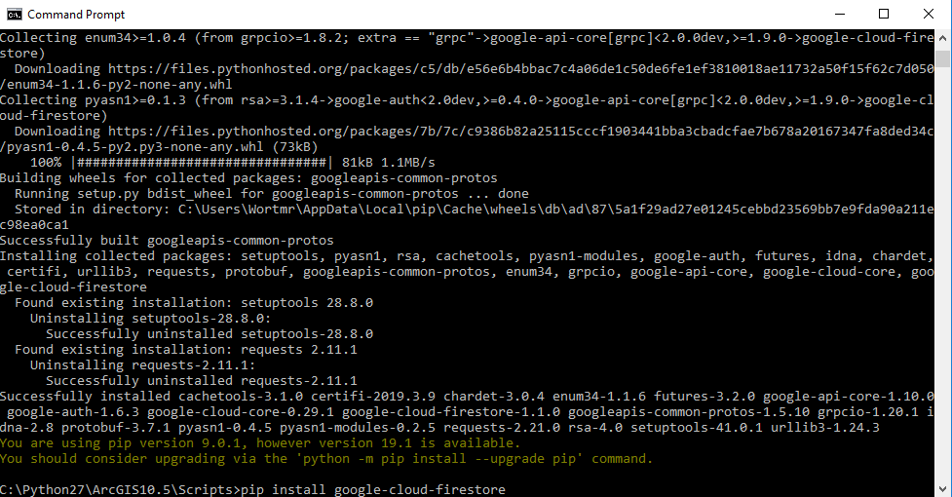

Close the command line.

You should now be able to run the push_data_to_cloud.py script without getting any importing library errors.

Navigate to the script in the folder downloaded from github. Right click it and select “Edit with IDLE”.

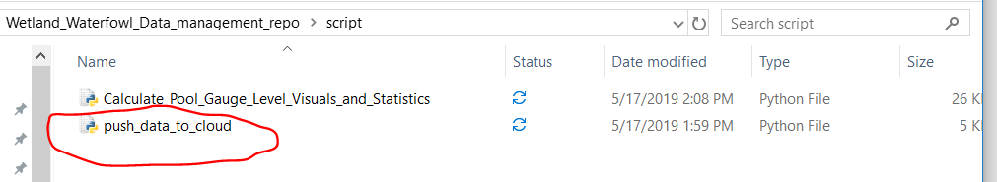

There are only 3 lines in the script you will ever need to edit (unless you decide to make changes to the whole firestore database structure, this will mean the javascript for the Waterfowl Decision Support Tool will also have to be changed to continue working however).

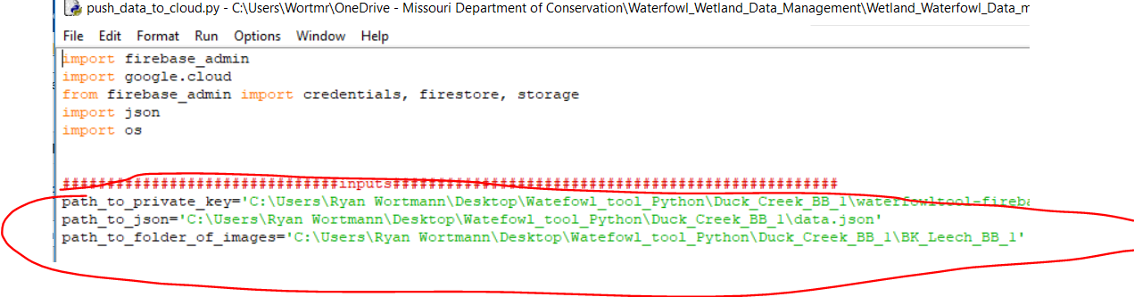

**Tool Inputs:**

*path_to_private_key*: This is a json file that gives you permission to write to the cloud. Get a copy of it from Joel or Dyan. If this file is lost a new one can be generated in the Decision Support Tool firebase project console. Be sure to keep this file in a safe place.

*path_to_json*: Give the path to the data.json file that your run of the Calculate Gauge Level Visuals and Statistics created.

*path_to_folder_of_images*: Give the path to the folder of images that your run of the Calculate Gauge Level Visuals and Statistics created.

Once you have edited your copy of the script accordingly, press Run -> Run Module.

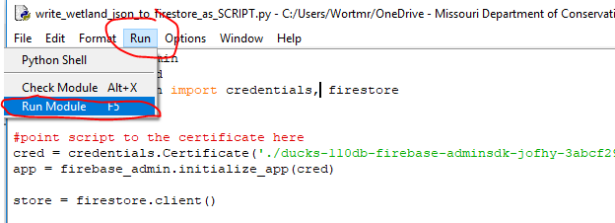

The JSON data and the JPEGS will now be in the cloud for use by the Decision Support Tool. If you have access to our firebase console, you can find the JSON data in the firestore database called “Conservation Areas”. The jpegs images are pushed to a folder in the Storage tab in a storage bucket.