GIS WORKSTREAM · PEATLAND REWETTING PROJECT
2026 Fire: National Breakdown
Burned area, hotspots and repeated burns by concession, forest area and DMPG village; the KLH priority area and roles. Indonesia, 2015 to 2026

Prepared for the World Bank and the Ministry of Environment / Environmental Control Agency (KLH/BPLH), Republic of Indonesia
Departemen Teknik Geodesi, Universitas Gadjah Mada
November 2026
Contents
1 Summary 3
2 The 2026 fire season 5
3 Data 8
4 Method 10
5 Completeness of the burned-area maps 12
6 Concessions and forest area 13
7 Concession types 14
8 Forest area function 16
9 DMPG villages 17
10 Repeatedly burned land 18
11 Islands and provinces 19
12 Peat 21
13 The KLH priority area 22
14 Who covers the priority area 24
15 Roles 26
16 Limitations 27
Annex A Tables 28
Concessions and forest area 28
Peat 28
Concession types 29
Forest area function 29
DMPG villages 30
Islands and provinces 30
Repeatedly burned land 33
KLH priority area 33

1 Summary
This report sets out where Indonesia's burned area of 2015 to 2025 and its hotspots of 2026 fall with respect to business licences (concessions), the forest area (kawasan hutan), the villages of the Desa Mandiri Peduli Gambut programme (DMPG) and peat. It covers all land inside the 2023 village boundaries, 189.1 million ha. The figures say where fires were observed. They do not show the cause of a fire or who is responsible for it. The last chapters set out KLH's priority area for peat restoration, who covers which part of it and the roles of the ministries.
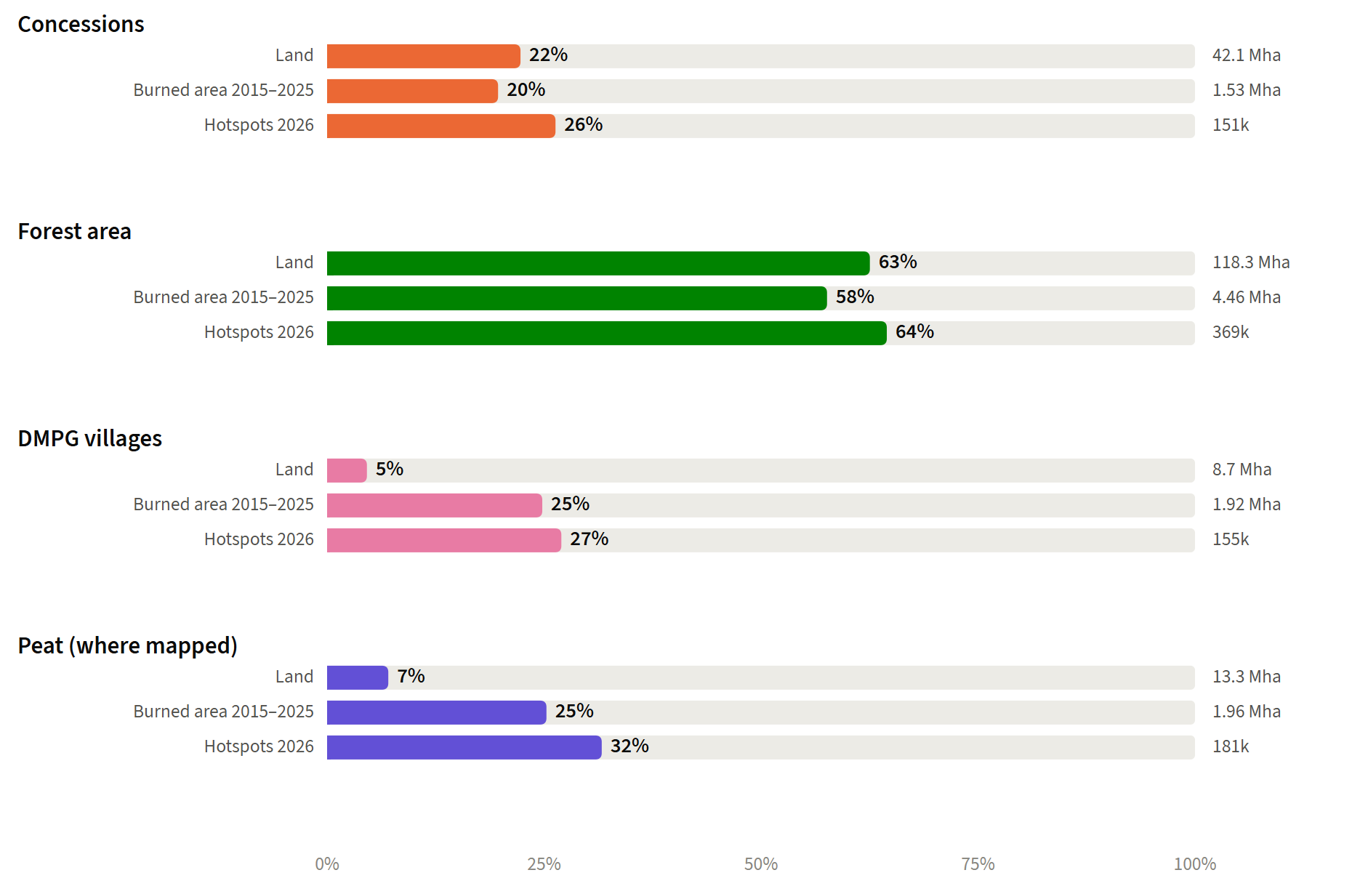
Figure 1.1. Share of the land, of the burned area 2015 to 2025 and of the 2026 VIIRS hotspots inside concessions, forest area, DMPG villages and peat; absolute values on the right. Source: KLHK burned area, NASA FIRMS VIIRS, licences 2025, forest area 2023, SiTMAT DMPG villages, KLH peat (PPEG 2026)
- VIIRS recorded 572,701 hotspots on land from 1 January to 31 October 2026, 3.2 times the mean of 2015 to 2025 over the same months and the second highest since 2012, after 2015 (765,124). MODIS, the series KLH reports, recorded 199,069 to 29 October 2026.
- Concessions hold 22% of the land, 20% of the area burned in 2015 to 2025 (1.53 of 7.75 million ha) and 26% of the 2026 hotspots (150,715). They had 36 hotspots per 100 km² in 2026, against 29 outside them.
- The forest area holds 63% of the land, 58% of the burned area and 64% of the 2026 hotspots.
- Peat covers 7% of the land and holds 25% of the burned area and 32% of the 2026 hotspots.
- DMPG villages cover 5% of the land and hold 27% of the 2026 hotspots. The programme works on fire-prone peat; within their provinces, DMPG village peat had 221.8 hotspots per 100 km² in 2026 against 81.7 on other peat, and hotspots rose about as much in both (3.7 and 3.4 times the 2015 to 2025 mean).
- 1.5 million ha burned in two or more different years of 2015 to 2026. Concessions hold 15% of this repeatedly burned land and DMPG villages 26% (chapter 10).
- Five provinces hold 69% of the 2026 hotspots.
- KLH's priority area is 3.3 million ha of peat with damaged ecosystem status (SKEG 2024) in 362 priority KHG (chapter 13). KLH assigns 78% of it to licence holders, inside their licences or in the 5 km buffer around them, 13% to the Ministry of Forestry and 9% to KLH/BPLH (chapters 14 and 15).
- The burned-area maps of 2024 and 2026 are incomplete as delivered (0.6 and 0.2 ha per VIIRS hotspot against 2.1 to 6.4 ha in the other years), so 2026 is described through its hotspots.

2 The 2026 fire season
VIIRS gives the 2026 figures in this report. It sees fires at 375 m against 1 km for MODIS, and one sensor (S-NPP) has recorded Indonesia since 2012, so 2026 can be set against earlier years over the same months. MODIS is the series KLH reports; its 2026 total is given beside each VIIRS figure where it matters. The 2026 VIIRS record runs to 31 October 2026: January to July from the standard product, August to October from the near-real-time product. November and December are not yet in it.
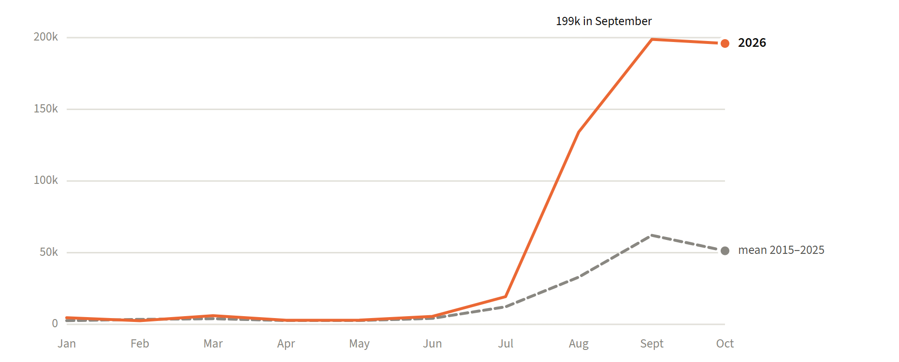
Figure 2.1. VIIRS hotspots per month in 2026 against the mean of 2015 to 2025. Medium and high confidence, likely gas flares and volcanoes left out. Source: NASA FIRMS VIIRS S-NPP
Hotspots stayed near the usual level until June. From July they rose far above it: 198,786 in September, against a mean of 62,092 for that month in 2015 to 2025. Over 1 January to 31 October 2026, VIIRS counts 572,701 hotspots, 3.2 times the mean of 2015 to 2025; only 2015 had more over the same months.
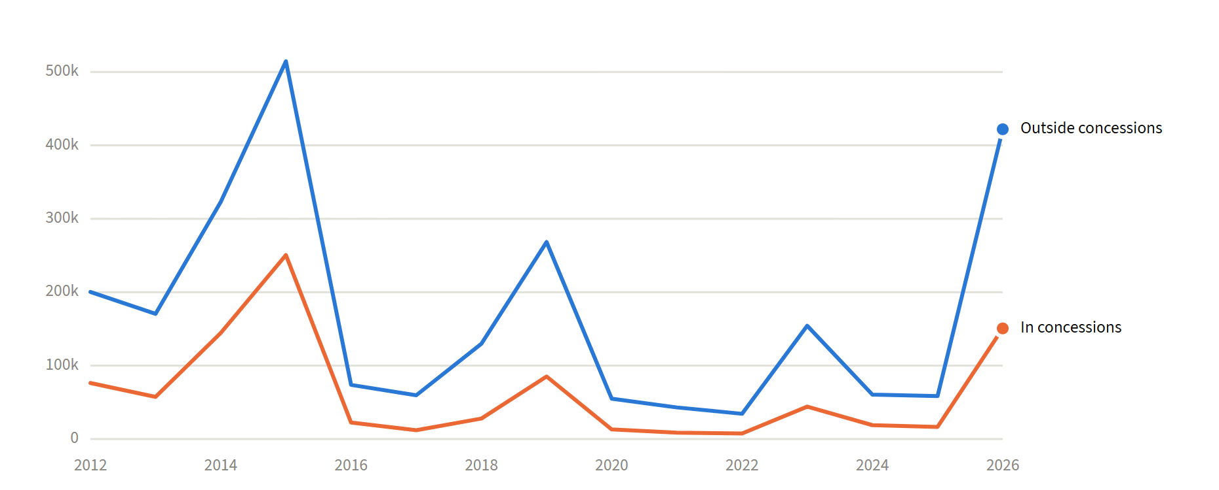
Figure 2.2. VIIRS hotspots per year from 1 January to 31 October, inside and outside concessions. Source: NASA FIRMS VIIRS S-NPP, licences 2025
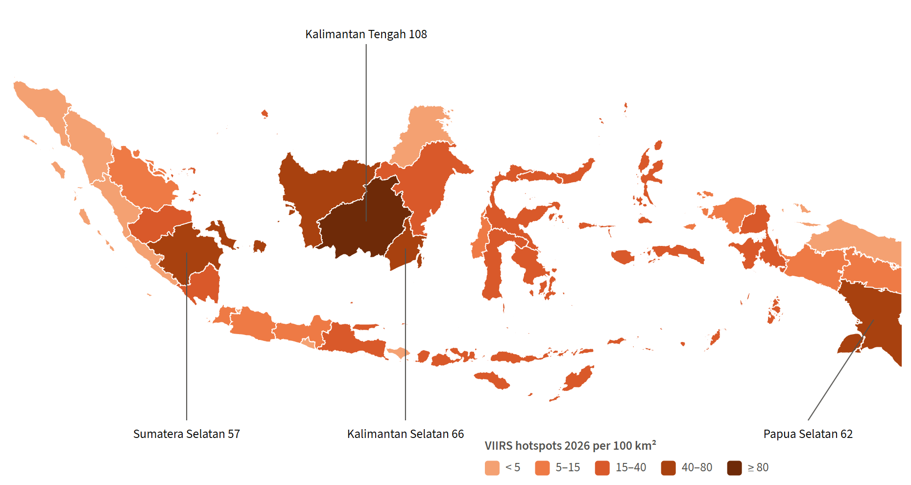
Figure 2.3. VIIRS hotspots of 2026 per 100 km² of land, by province. Source: NASA FIRMS VIIRS S-NPP, village boundaries 2023
Five provinces hold 69% of the 2026 hotspots: Kalimantan Tengah (164,968), Kalimantan Barat (79,375), Papua Selatan (72,322), Sumatera Selatan (49,779), Kalimantan Timur (30,175). The share inside concessions differs widely between them, from 16% to 64%.
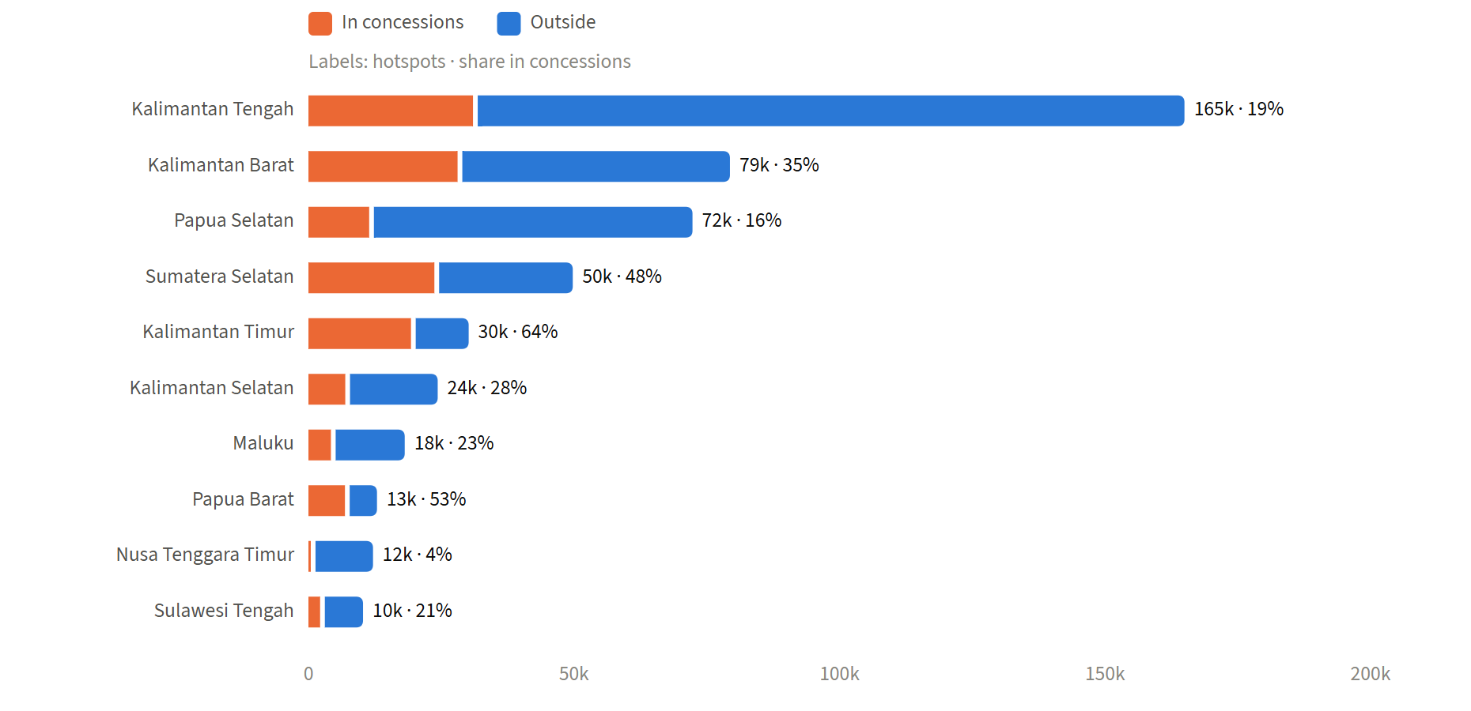
Figure 2.4. The ten provinces with the most VIIRS hotspots in 2026, inside and outside concessions. Source: NASA FIRMS VIIRS S-NPP, licences 2025
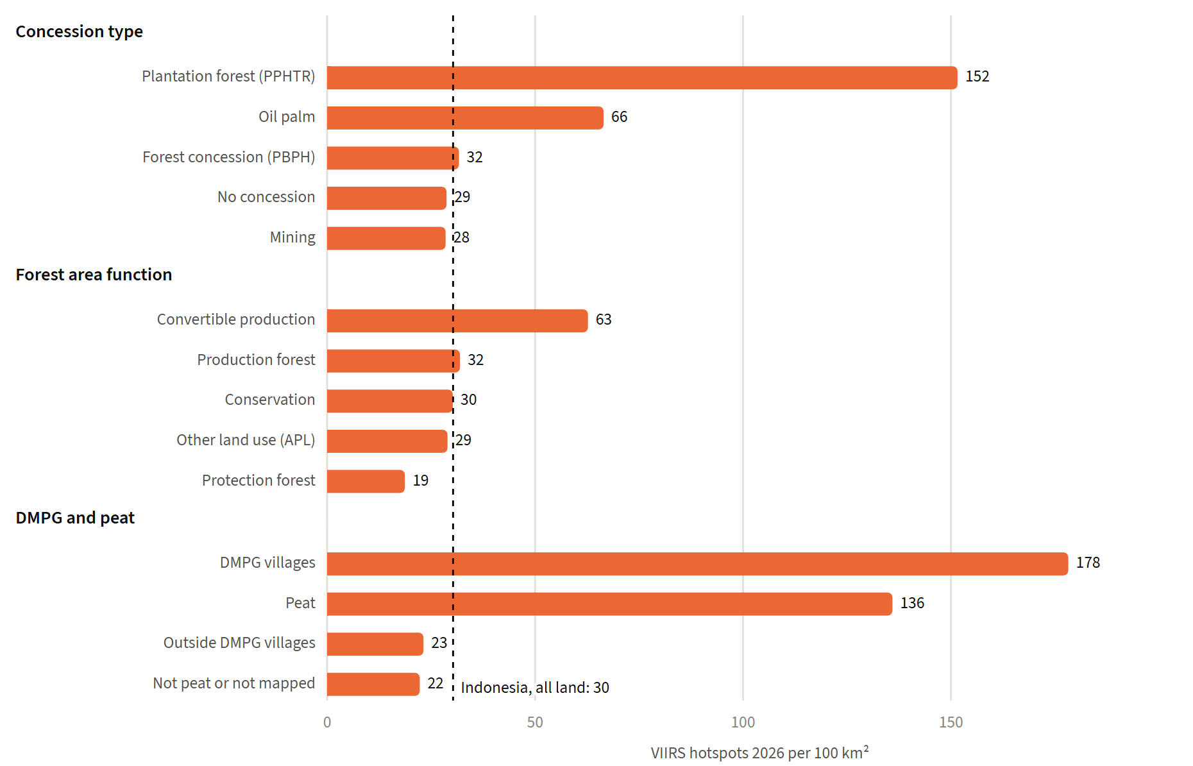
Figure 2.5. VIIRS hotspots of 2026 per 100 km² by land status; dashed line: all land. Source: this analysis
Near known static heat sources such as gas flares, 11,449 further VIIRS detections are set apart. With them the 2026 total is 584,150, and the shares by land status change by at most 0.6 percentage points. With them, MODIS counts 220,060.

3 Data
All layers were used as delivered. Table 3.1 lists them.
Table 3.1. Input layers. Source: data catalogue of the project
Layer | Content | Source | Date | Scale or resolution
Village boundaries | 83,519 villages, 38 provinces, 517 districts and cities; the land mask and the province of every cell | KLH | 2023 | Polygons
KHG boundaries | 865 peat hydrological units | KLHK | 2017 | Polygons
Business licences | 1,610 oil palm, 5,776 mining, 2,416 forest concession (PBPH), 353 plantation forest (PPHTR) and 3,160 community forest (PPHKM) polygons | Project team; issuing agency not stated | 2025 | Polygons
Forest area function | 4,265 polygons in 21 function codes | Project team, inferred KLHK | 2023 | 1:250,000
DMPG villages | 838 villages in 10 provinces | SiTMAT portal, KLH | 2017 to 2024 | Polygons
Burned area | One polygon per burned patch, with a flag for each burn year 2015 to 2026 | KLHK; production method not stated | 2015 to 2026 | Polygons
Peat extent | Peat land (lahan gambut) of KLH's integrated thematic analysis for peat ecosystem restoration, 13.3 million ha | KLH | April 2026 | Polygons, counted on the 30 m grid
MODIS hotspots 2026 | KLH file to 15 September, NASA FIRMS MODIS near real time after it; low, medium and high confidence | KLH, NASA FIRMS | 1 January to 29 October 2026 | 1 km
VIIRS hotspots | S-NPP country archive 2012 to 2025 and 2026 standard and near-real-time files | NASA FIRMS | 2012 to 31 October 2026 | 375 m
PPEG integrated thematic analysis | Overlay of KHG, peat, SKEG 2024 damage status, canal-affected zone, licences, forest area, landform and peat thickness, with an intervention class and an actor for every polygon | KLH | April 2026 | Polygons
Target villages | 2,004 villages for peat ecosystem restoration | Bluebook 2026 | April 2026 | Polygons

A cell is in a concession when it lies in an oil palm, mining, PBPH or PPHTR licence. Community forest permits (PPHKM, perhutanan sosial) are social forestry permits and are not counted as concessions: their land keeps its forest area class. Where licences overlap, the land counts once in the concession totals and, in the table by type, under the first type in the order oil palm, mining, plantation forest, forest concession. The licence layer covers only the licences it holds. Land with unlicensed plantations counts as "no concession": at one KHG studied by the project, Mendahara-Batanghari, a forest-type map shows 43.7% of the land as tree crops outside any licence.
The 21 forest area function codes are grouped into conservation (nature reserves, wildlife reserves, national parks, recreation parks, grand forest parks, hunting parks and their marine counterparts), protection forest (HL), production forest (HP, HPT), convertible production forest (HPK), other land use (APL), and water or undefined. "Forest area" means the first four groups.
A hotspot is a satellite detection of heat. One fire can give many detections, and a short or small fire may give none. VIIRS (375 m pixels, one sensor since 2012) gives the 2026 figures and the comparison with earlier years. MODIS (1 km pixels) is the series KLH reports and is given beside it. The two are never added. Low-confidence detections are left out.

4 Method
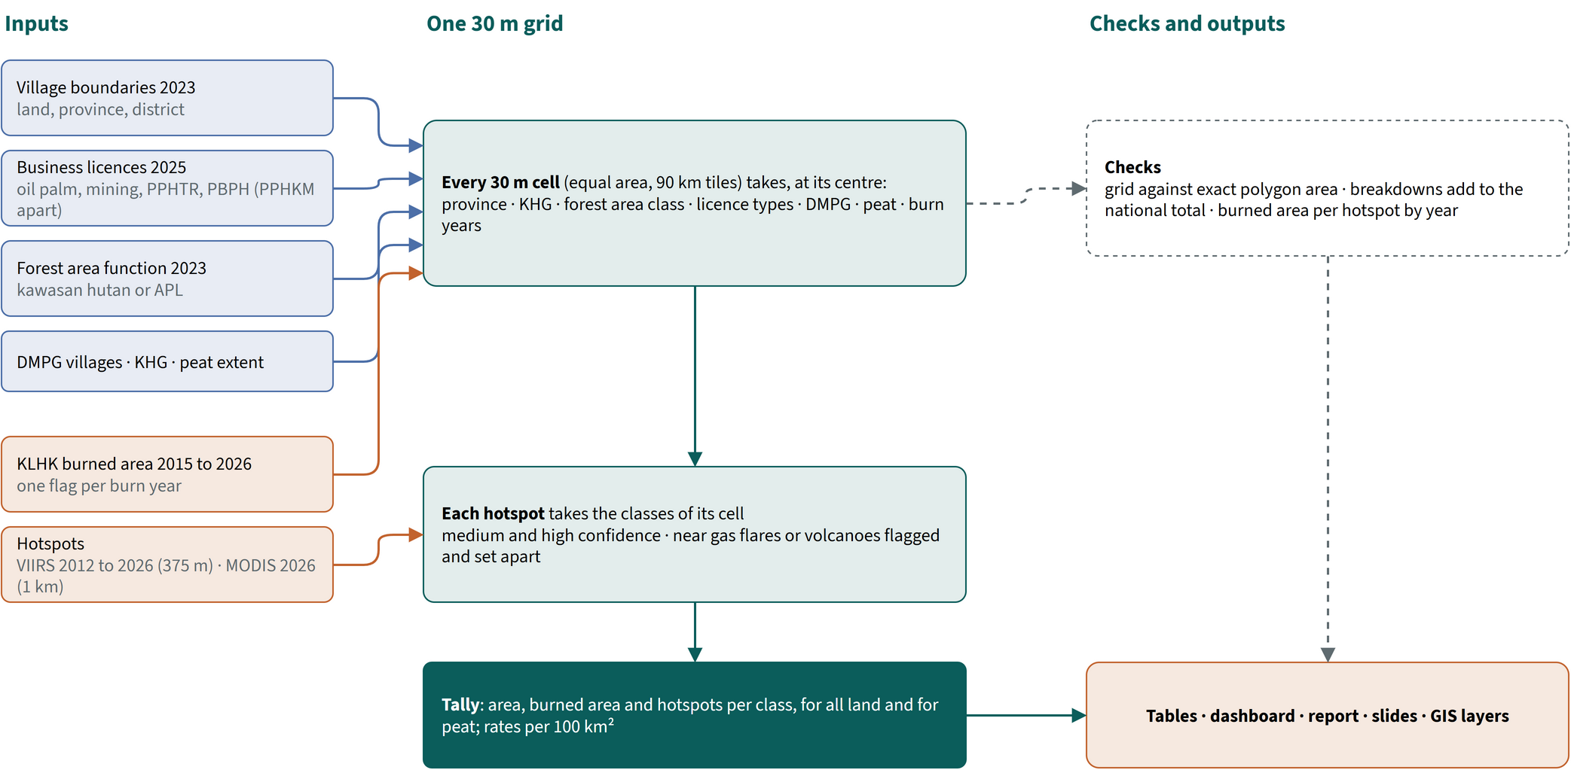
Figure 4.1. The analysis: every layer on one 30 m grid; cells and hotspots take the classes where they lie. Source: this analysis
All layers are laid on one equal-area grid of 30 m cells covering Indonesia, processed in tiles of 90 km. Every cell takes the value of each layer at its centre: its district and province, KHG, forest area class, the licence types it lies in, whether it lies in a DMPG village, whether it is peat, and the years it burned. Cells outside the village boundaries (sea, neighbouring countries and small gaps in the village layer) are left out. Areas are cell counts times the cell area, so overlapping polygons are never counted twice.
Hotspots take the classes of the cell they fall in. The VIIRS archive records a type for each detection (vegetation fire, volcano, static land source such as a gas flare, offshore), and only vegetation fires are kept. The MODIS file and the recent VIIRS file carry no type. A detection of these within 1 km (MODIS) or 375 m (VIIRS) of a VIIRS detection typed as volcano, static land source or offshore in any year is flagged as a likely static source and reported apart. Applied to the typed VIIRS file of 2026, with static locations taken from 2012 to 2025 only, the rule flags static sources with a precision of 0.88 and a recall of 0.67. KLH's own hotspot counts include these sources: with them, MODIS 2026 counts 220,060 medium and high confidence hotspots on land.
Rates are hotspots per 100 km² of the class, so that classes of different size can be compared. VIIRS years are compared over the same calendar window, 1 January to 31 October. Burned area is summed per year; "ever burned" counts a cell once however often it burned.
Every result is checked against an independent total:
- the burned area on the grid differs from the exact polygon area by 0.09% over all years and by at most 0.7% in any year;
- every breakdown (by concession, forest area, DMPG, island, province) adds up to the national total exactly;
- the area of each KHG agrees with an earlier count on a 100 m grid to a median of 0.09%, and the forest area classes inside KHG to within 1.87%;
- 53,236 ha of the 2015 burned area lies east of the border at 141° E, in Papua New Guinea, and 4,517 MODIS and 41,322 VIIRS hotspots lie outside the village boundaries; both are left out.
The licences of 2025 and the forest area of 2023 are matched to every year, so earlier burns may have occurred when the land had another status.

5 Completeness of the burned-area maps
Burned area and hotspots measure the same fires in different ways. Between 2015 and 2025 the burned area per VIIRS hotspot lies between 2.1 and 6.4 ha in every year except 2024 (0.57). In 2026 it is 0.20: VIIRS recorded 572,701 hotspots on land to 31 October, the second highest since 2012, after 2015 (765,124), while the burned-area map holds 111,781 ha. In the provinces with the most hotspots in 2026 the ratio is Kalimantan Tengah 0.02, Kalimantan Barat 0.36, Papua Selatan 0.09. The 2026 map, and that of 2024, are therefore incomplete as delivered.
Table 5.1. Burned area and VIIRS hotspots per year, all land. Source: KLHK burned area, NASA FIRMS VIIRS S-NPP (medium and high confidence, vegetation fires)
Year | Burned area (ha) | VIIRS hotspots | ha per hotspot | Note
2015 | 2,579,074 | 811,971 | 3.18
2016 | 432,945 | 101,781 | 4.25
2017 | 161,761 | 76,861 | 2.10
2018 | 523,969 | 166,583 | 3.15
2019 | 1,638,461 | 394,718 | 4.15
2020 | 291,772 | 74,660 | 3.91
2021 | 352,268 | 54,938 | 6.41
2022 | 201,925 | 44,726 | 4.51
2023 | 1,161,205 | 217,339 | 5.34
2024 | 47,290 | 83,154 | 0.57 | incomplete
2025 | 359,579 | 79,286 | 4.54
2026 | 111,781 | 572,701 | 0.20 | incomplete

Burned-area shares in this report are taken over 2015 to 2025, which includes the incomplete 2024 at its small weight. The 2026 season is described through the MODIS and VIIRS hotspots.

6 Concessions and forest area
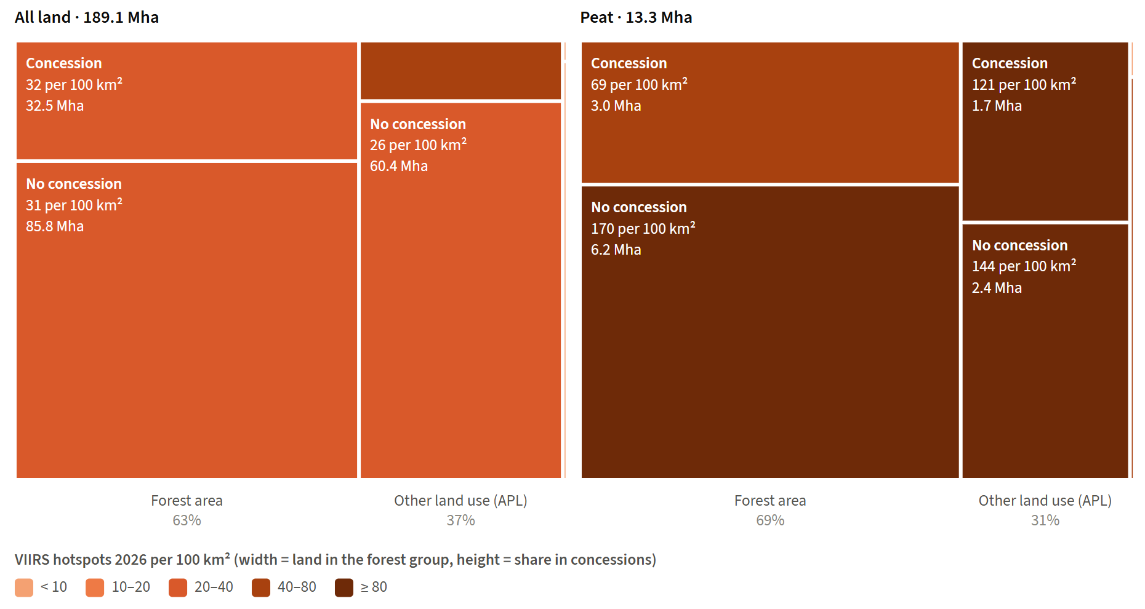
Figure 6.1. Land by forest area (column width) and concession (height), coloured by VIIRS hotspots of 2026 per 100 km², for all land and for peat. Source: this analysis
On all land, 2026 hotspots per 100 km² range from 26 (outside concessions, APL) to 47 (in concessions, APL). On peat it is higher in every combination than in any combination on all land: from 69 (in concessions, forest area) to 170 (outside concessions, forest area).
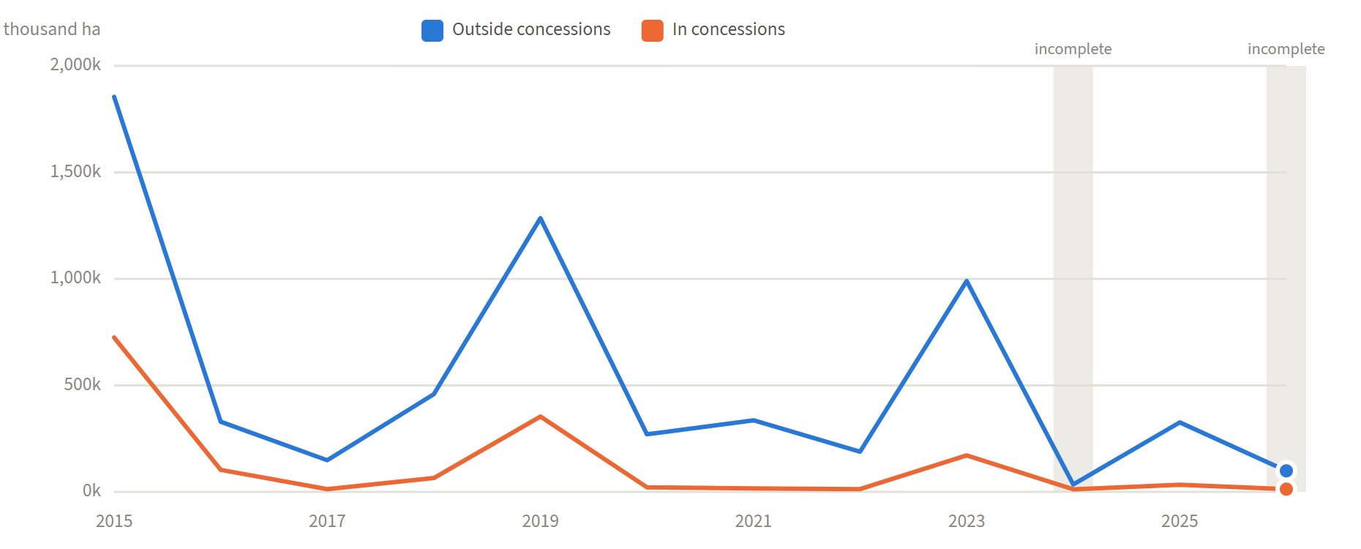
Figure 6.2. Burned area per year inside and outside concessions. Grey bands: years whose burned-area map is incomplete. Source: KLHK burned area, licences 2025
Table A.1 in the annex gives the values, and Table A.2 those for peat.

7 Concession types
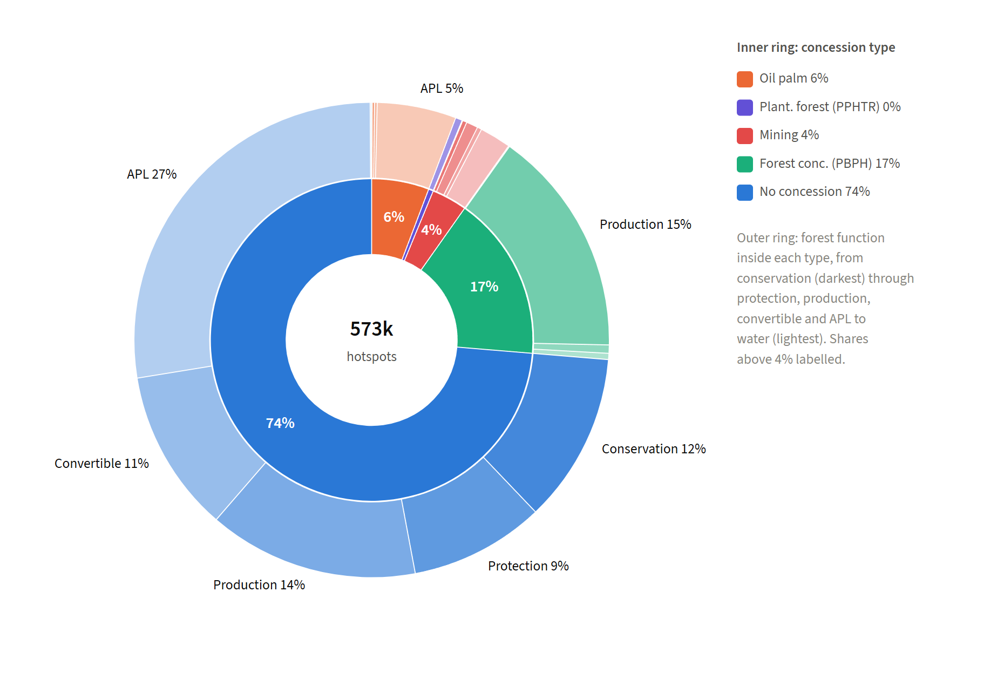
Figure 7.1. VIIRS hotspots of 2026 by concession type (inner ring) and the forest area function inside each type (outer ring). Source: this analysis
Most 2026 hotspots lie outside any concession (74%). Of those inside one, most are in forest concessions (PBPH, 17% of all hotspots) and oil palm (6%).
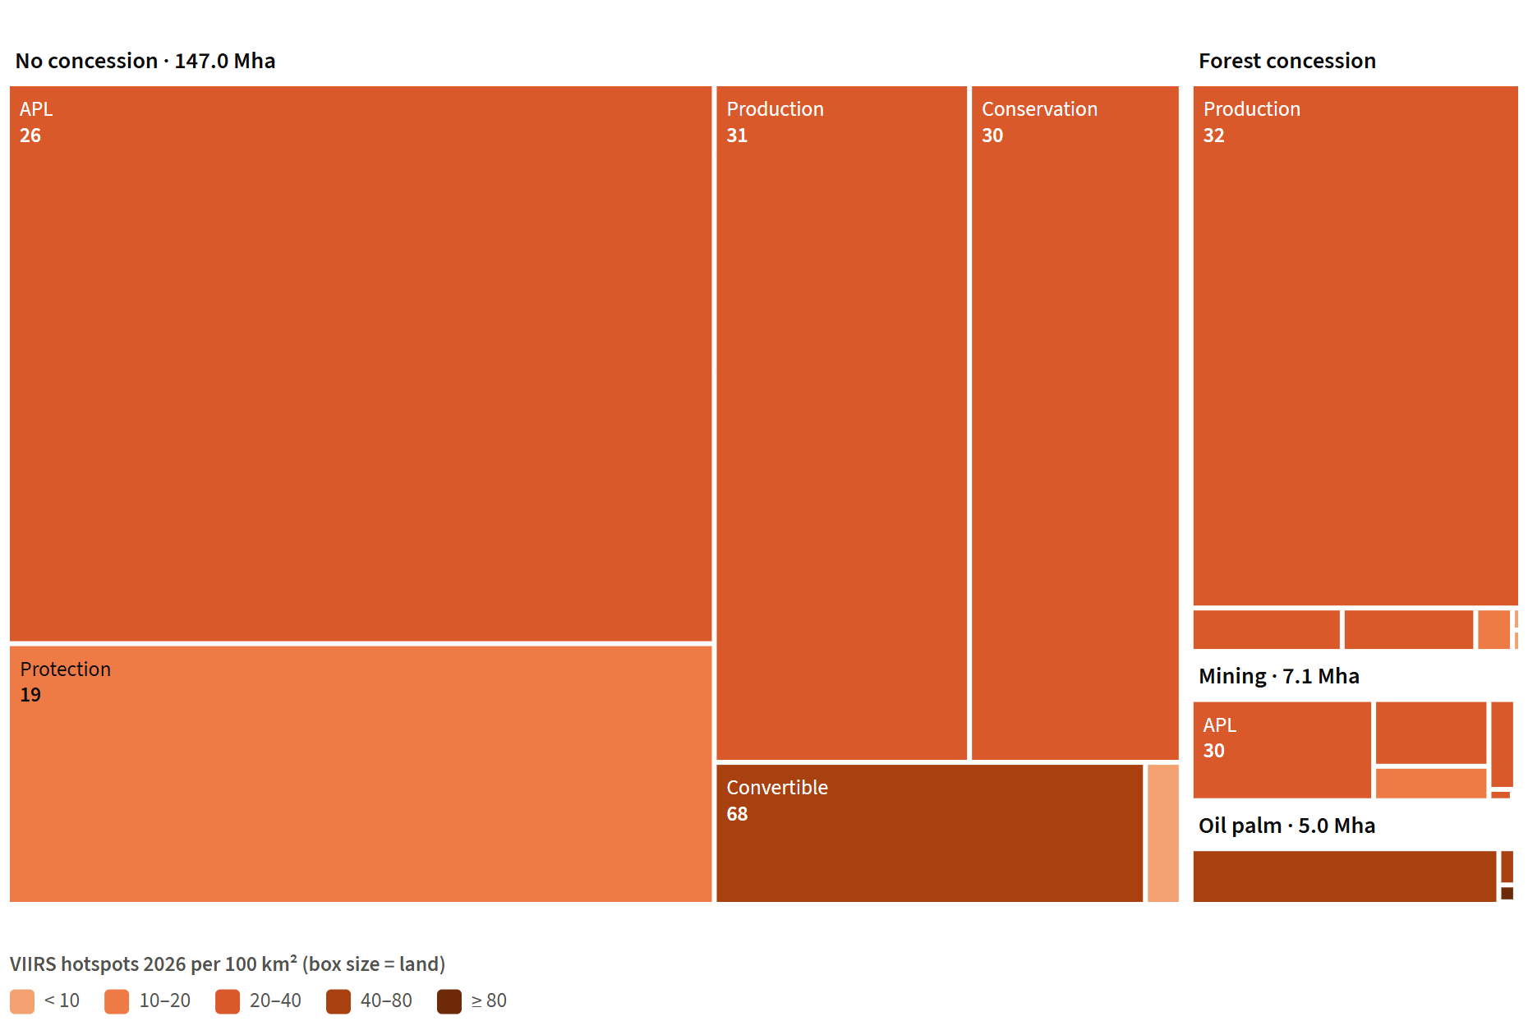
Figure 7.2. Land by concession type and forest area function (box size), coloured by VIIRS hotspots of 2026 per 100 km². Source: this analysis
By density the order changes: plantation forest licences (PPHTR) had 152 hotspots per 100 km² and oil palm 66, against 32 in forest concessions, 28 in mining licences and 29 outside concessions. Tables A.3 and B.4 give the values.

8 Forest area function
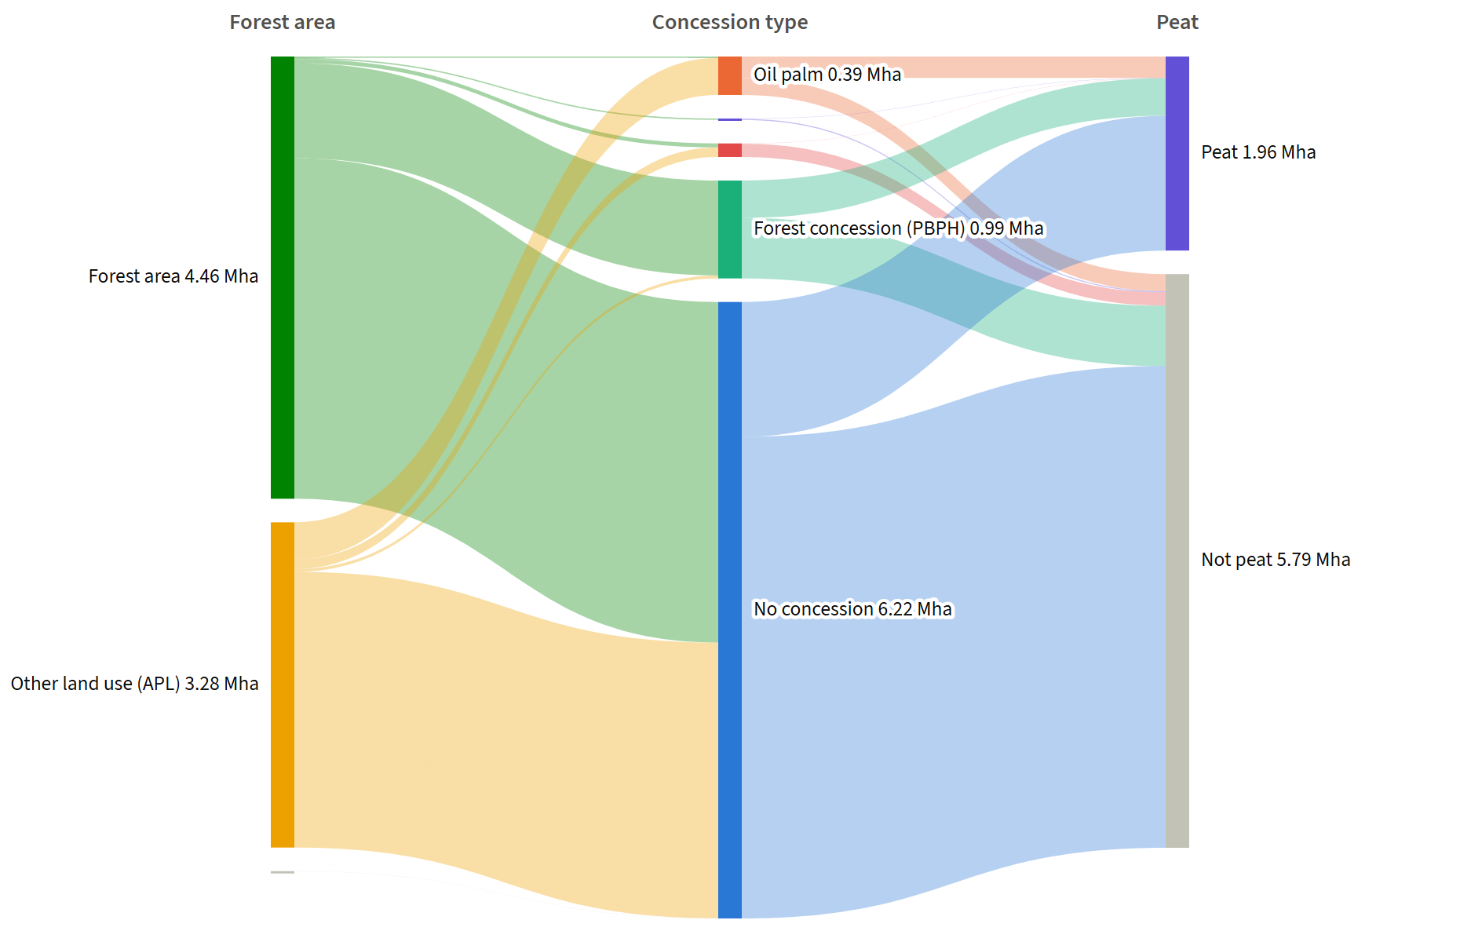
Figure 8.1. Burned area 2015 to 2025 (sum of the yearly areas, so land that burned twice counts twice) flowing from forest area function to concession type to peat. Source: KLHK burned area, licences 2025, forest area 2023, KLH peat (PPEG 2026)
Of the area burned in 2015 to 2025, 44% lay in the forest area outside any concession and 36% in other land use (APL) outside any concession. Among forest functions, convertible production forest (HPK) had the densest 2026 hotspots (63 per 100 km²) and protection forest the sparsest (19). Tables A.5 and B.6 give the values.

9 DMPG villages
DMPG villages cover 8.7 million ha, 5% of the land, and hold 25% of the burned area of 2015 to 2025 and 27% of the 2026 VIIRS hotspots. The programme chose villages on fire-prone peat, so the comparison below keeps to peat in the 10 provinces that hold DMPG villages.
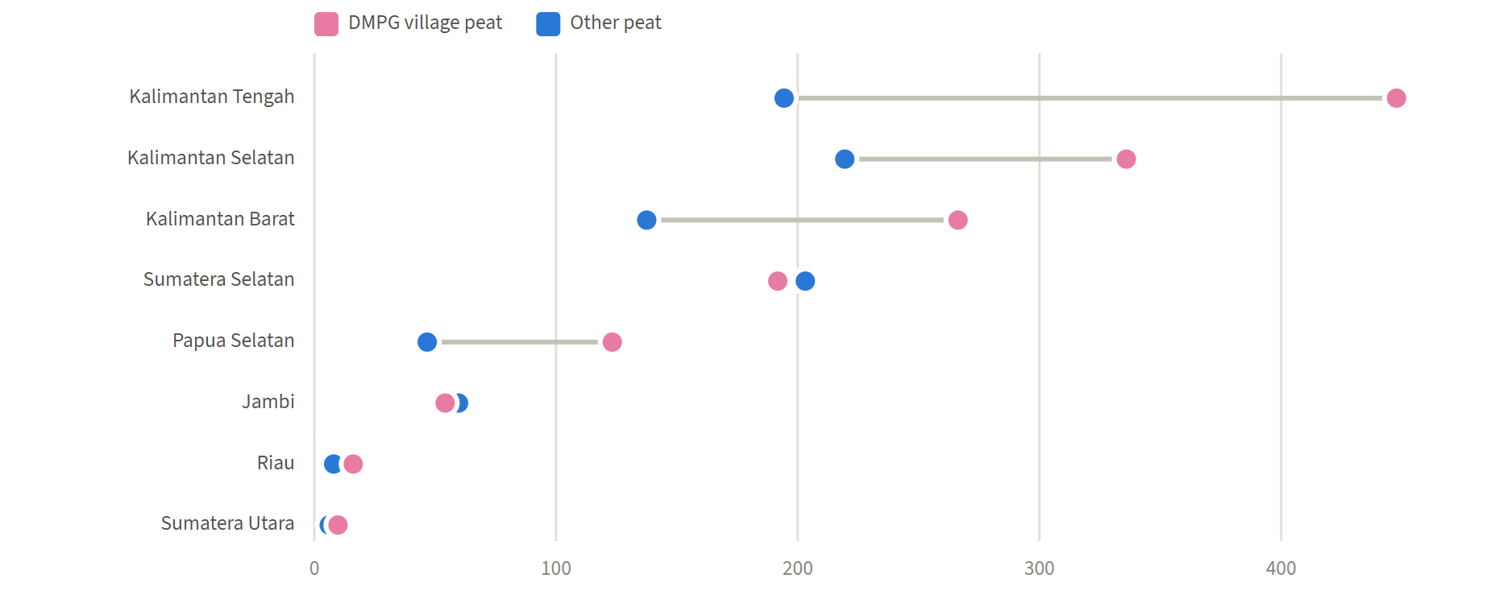
Figure 9.1. VIIRS hotspots of 2026 per 100 km² of peat in DMPG villages and on other peat, by province (provinces with at least 100 km² of peat on each side). Source: NASA FIRMS VIIRS S-NPP, SiTMAT DMPG villages, KLH peat (PPEG 2026)
On this comparable land, 18% of the DMPG village peat burned at least once in 2015 to 2026, against 7% of other peat. VIIRS hotspots of 2026 were 3.7 times the 2015 to 2025 mean in DMPG villages and 3.4 times elsewhere. The project's investigation of the 2026 season compared the rise in hotspots on DMPG village land with the rise on land outside it within the same KHG and land tenure class. The ratio of the two rises was 0.87 (95% interval 0.60 to 1.14, 28 KHG), so that test was inconclusive: it neither shows nor rules out a smaller rise in DMPG villages. Table A.7 gives the values.

10 Repeatedly burned land
Of the 189.1 million ha of land, 5.6 million ha burned at least once in 2015 to 2026 and 1.5 million ha burned in two or more different years: 997 thousand ha twice, 315 thousand ha three times and 177 thousand ha four times or more. A cell counts as burned twice when the burned-area maps of two different years cover it. The maps of 2024 and 2026 are incomplete (chapter 5), so these counts are lower bounds.
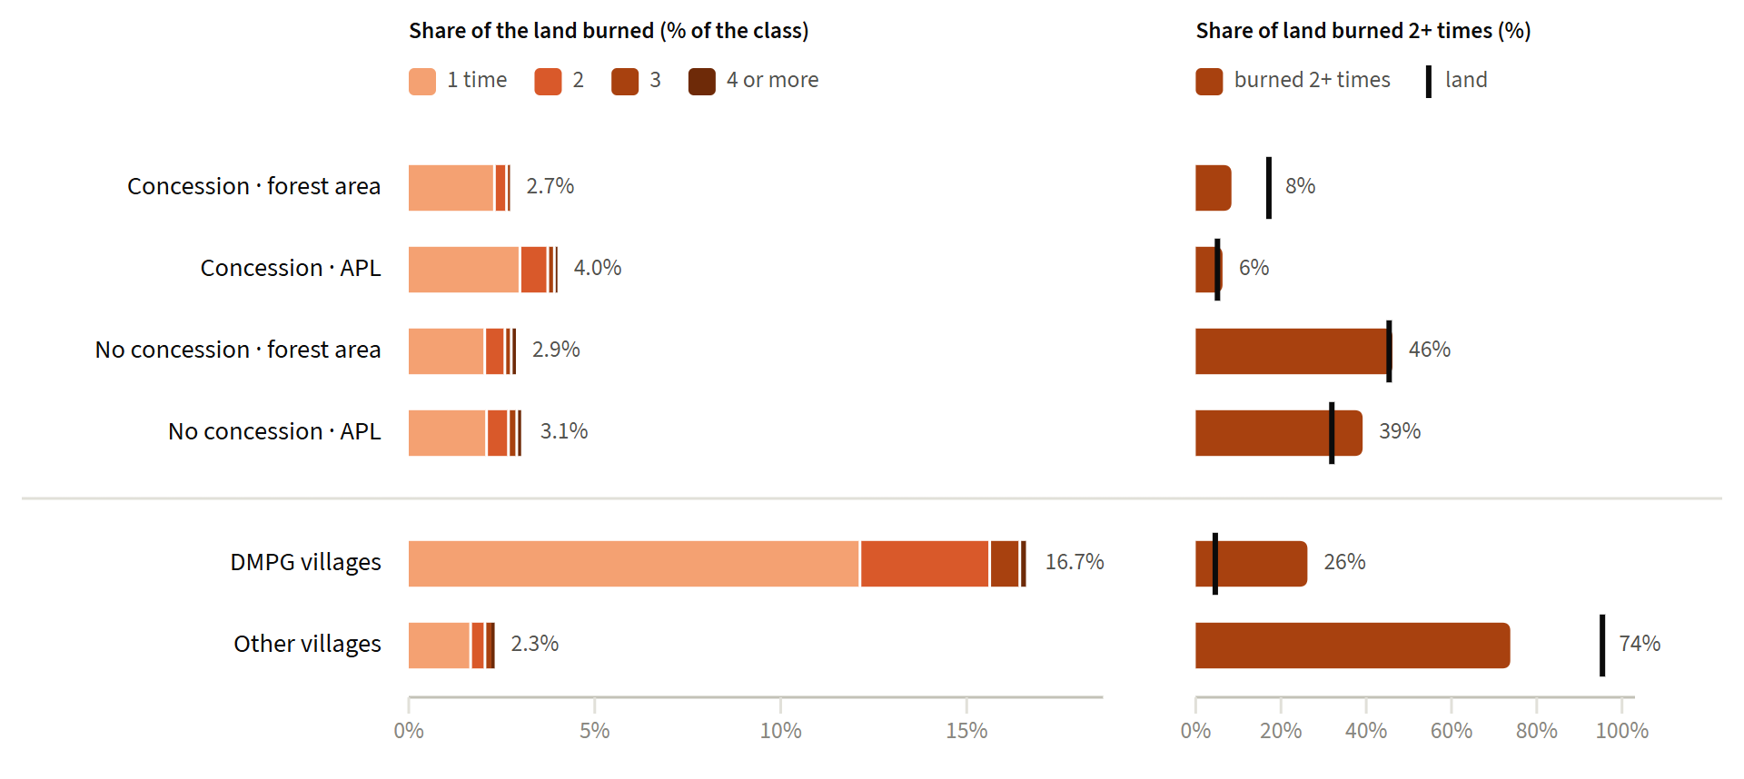
Figure 10.1. Left: share of each class burned once, twice, three times and four or more times in 2015 to 2026. Right: each class's share of all land burned twice or more (bar) against its share of the land (tick). Source: KLHK burned area, licences 2025, forest area 2023, SiTMAT DMPG villages
Most repeatedly burned land lies outside concessions: 46% in the forest area and 39% in other land use (APL) without a licence. Concessions hold 22% of the land, 23% of the land ever burned and 15% of the land burned twice or more. Inside concessions, burned land burned again less often: 14% of the ever-burned land in the forest area and 24% in APL, against 28% and 31% outside them.
DMPG villages cover 5% of the land and hold 26% of the land ever burned and 26% of the land burned twice or more. 16.7% of their land burned at least once, against 2.3% elsewhere; the programme chose villages on fire-prone peat (chapter 9). Within burned land the share that burned again is about the same in and outside DMPG villages (27% and 26%). Table A.11 gives the values.

11 Islands and provinces
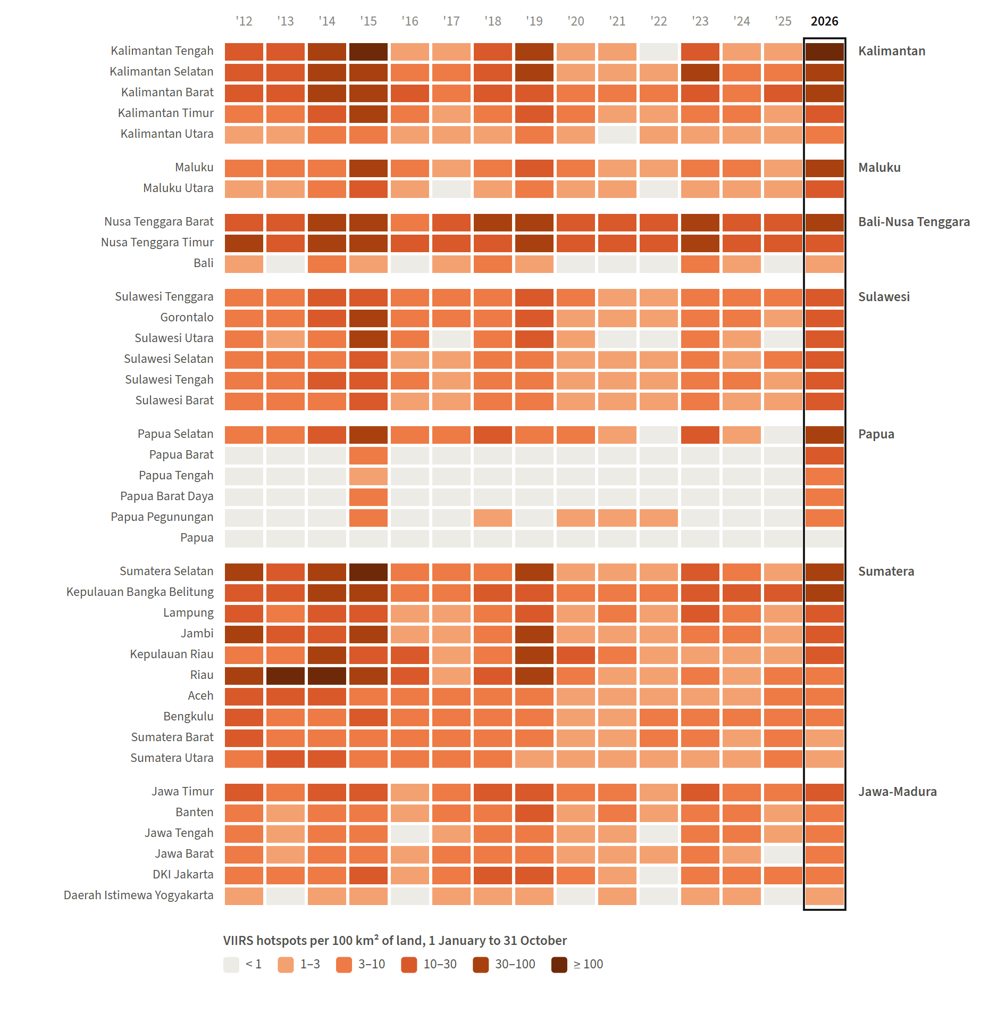
Figure 11.1. VIIRS hotspots per 100 km² of land by province and year, 1 January to 31 October in every year; provinces grouped by island, 2026 outlined. Source: NASA FIRMS VIIRS S-NPP, village boundaries 2023
The years with the most hotspots over these months were 2015, 2026, 2014. In 2026 the highest rates, in hotspots per 100 km², were in Kalimantan Tengah (108), Kalimantan Selatan (66), Papua Selatan (62), Sumatera Selatan (57).
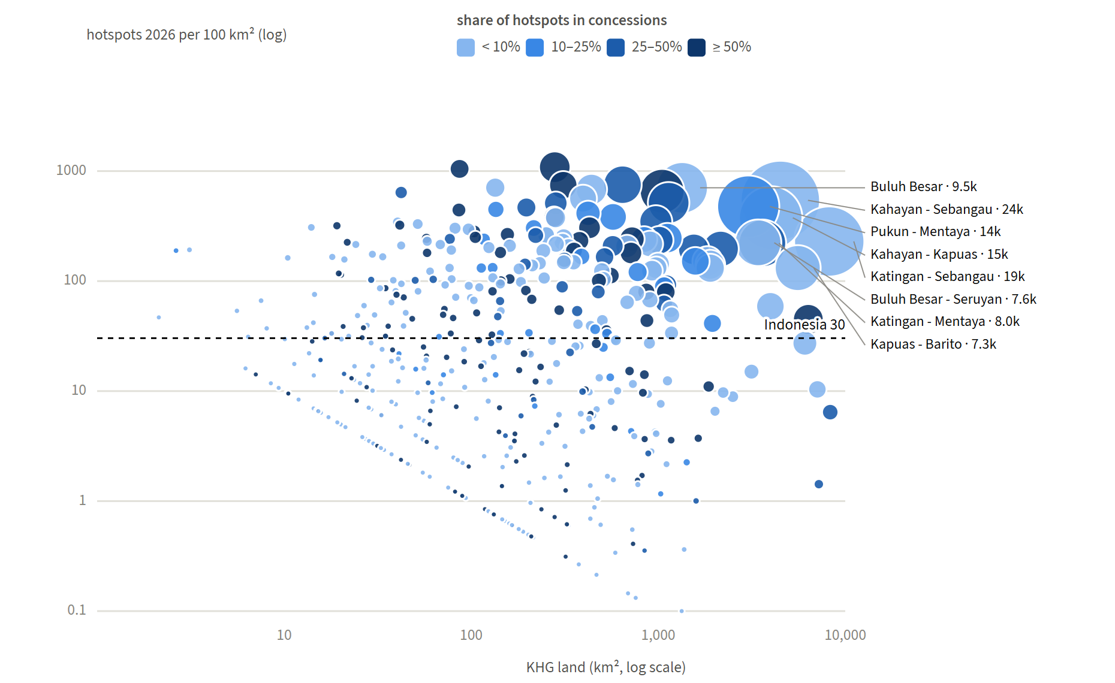
Figure 11.2. KHG by land area and VIIRS hotspots of 2026 per 100 km² (both on log scales); bubble size: number of hotspots; colour: share of them inside concessions; dashed line: all land. Source: this analysis
Tables A.8 to B.10 give the values by island, province and KHG.

12 Peat
Peat is KLH's peat land map of the integrated thematic analysis for peat ecosystem restoration (April 2026), the map KLH's restoration targets are set on. A cell counts as peat when its centre lies in a peat polygon. The right panel of Figure 6.1 shows peat by concession and forest area, and Table A.2 gives the values.

13 The KLH priority area
KLH has set a restoration target of about 3.3 million ha in 337 priority KHG, chosen on the peat ecosystem damage status (SKEG), in particular burned and canal-affected land. In KLH's integrated thematic analysis for peat ecosystem restoration (PPEG, April 2026), peat with SKEG 2024 damage of any class covers 3.3 million ha. This report takes that peat as the priority area. A KHG is a priority KHG when it lies in one of the 2,004 target villages of the Bluebook 2026 (345 KHG) or holds damaged peat (17 more): 362 KHG. The 337 KHG of the target are not listed in the sources, so this list is a reconstruction.
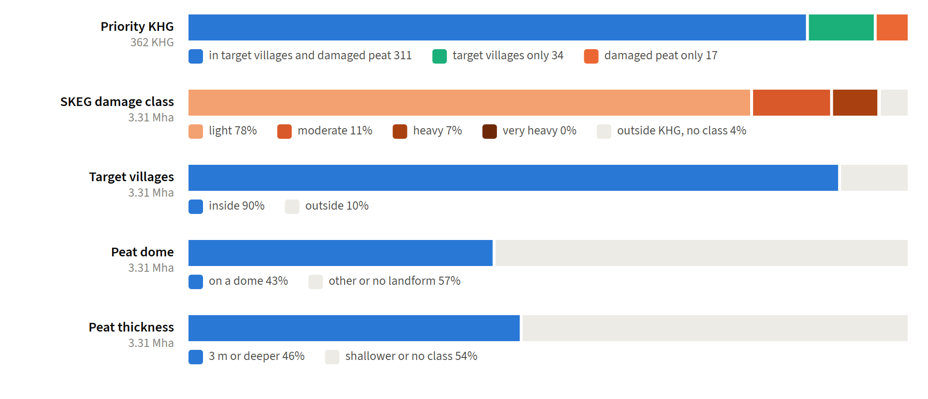
Figure 13.1. The priority KHG and the damaged peat by attribute: the reason each KHG is listed, the SKEG damage class, whether the peat lies in a target village, on a peat dome and on peat 3 m or deeper. Source: KLH PPEG integrated analysis, Bluebook 2026 target villages
311 KHG meet both conditions; 34 lie in target villages without damaged peat, and 17 hold damaged peat outside the target villages. Most damage is light (78%); 11% is moderate and 7% heavy. The other 4% lies outside any KHG, where KLH's file codes the peat as damaged but gives no damage class. 90% of the priority area lies in the target villages. 1.4 million ha (43%) lies on peat domes, the ombrogenous part, and 1.5 million ha (46%) on peat 3 m or deeper. Both come from KLH's landform and thickness classes, which are blank in places; Pulau Bengkalis, for one, has no dome in the landform field.
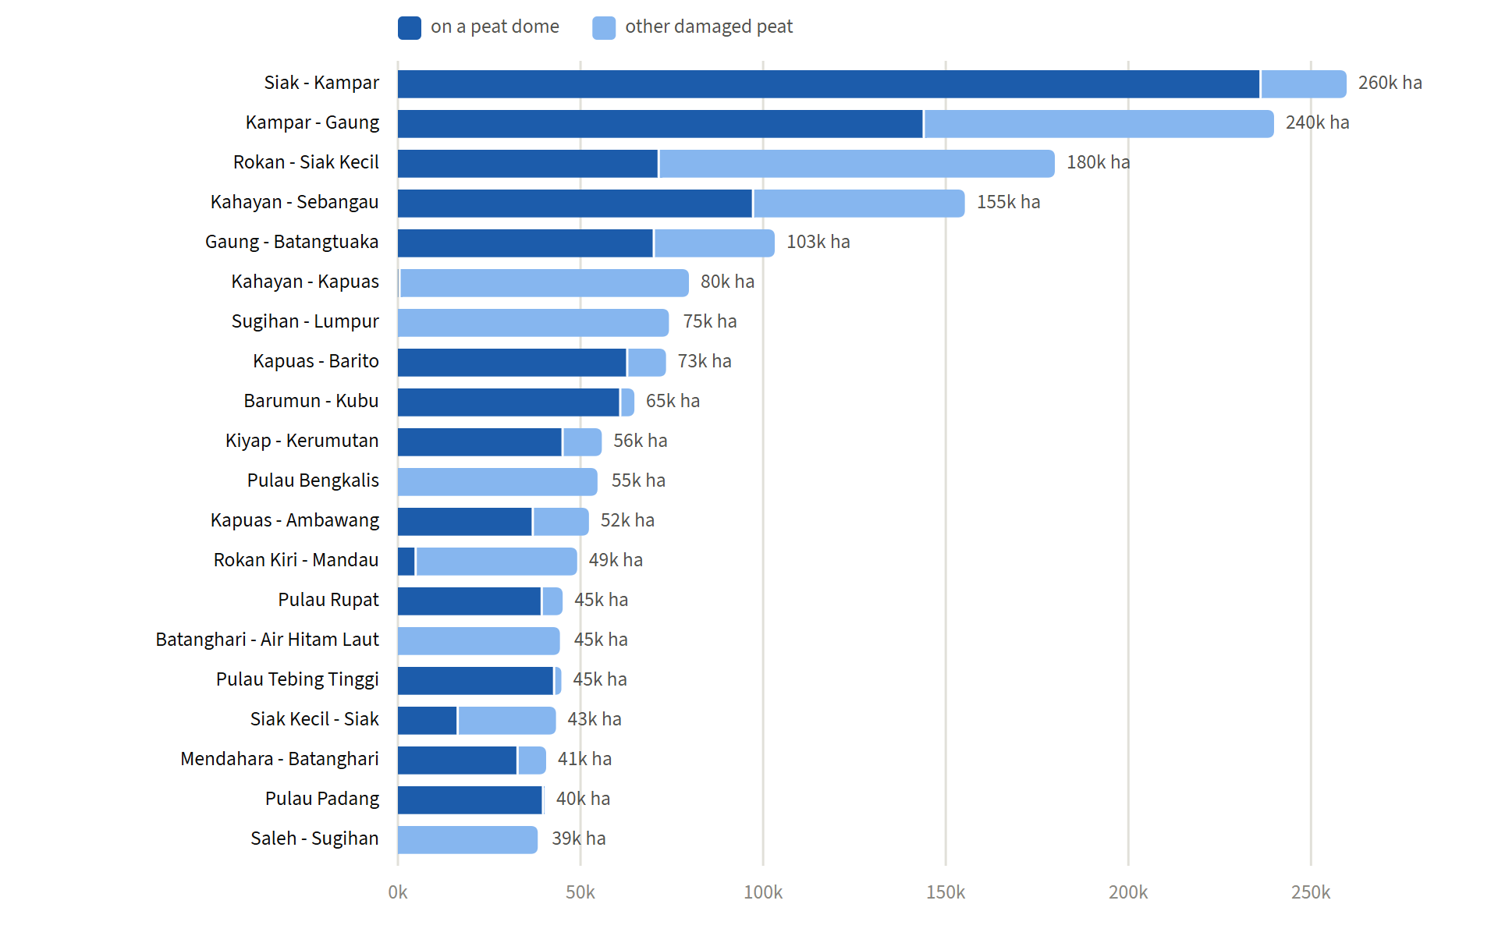
Figure 13.2. The 20 KHG with the most damaged peat, on a peat dome and elsewhere. Source: KLH PPEG integrated analysis
The priority area is concentrated: 17 KHG hold half of it. The largest are Siak - Kampar (260 thousand ha), Kampar - Gaung (240 thousand ha), Rokan - Siak Kecil (180 thousand ha). Table A.12 lists the 30 KHG with the most damaged peat.

14 Who covers the priority area
The PPEG analysis assigns every part of the priority area to one actor: licence holders inside their licences, licence holders together with communities in the 5 km buffer around licences, the Ministry of Forestry in the forest area outside licences, and KLH/BPLH in other land use (APL) outside licences. It also codes what the land needs: rewetting (R1) where it is canal-affected, revegetation (R2) where it burned, and livelihood revitalisation (R3) everywhere. The assignment says who acts. It does not say who caused the damage.
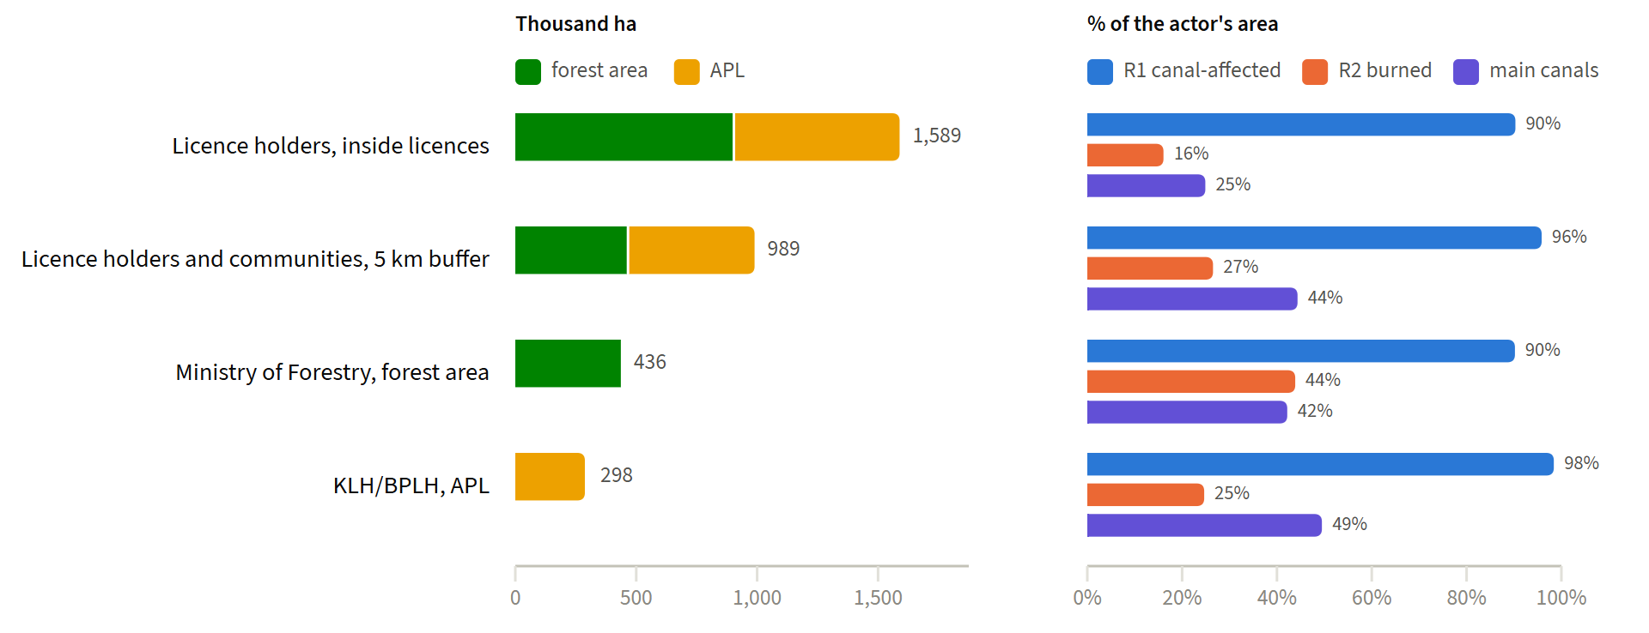
Figure 14.1. Damaged peat by actor, split into forest area and APL (left), and the share of each actor's area that is canal-affected, burned and near primary or secondary canals (right). Source: KLH PPEG integrated analysis
Licence holders cover 78% of the priority area: 1.6 million ha inside licences and 989 thousand ha in the buffer. The Ministry of Forestry covers 436 thousand ha and KLH/BPLH 298 thousand ha. Nearly all of the priority area is canal-affected (3.1 million ha), so rewetting is needed almost everywhere; 783 thousand ha burned. Land assigned to the Ministry of Forestry burned most often (44% of it, against 16% inside licences).
Riau holds 45% of the priority area, 84% of it assigned to licence holders. In Kalimantan Tengah the Ministry of Forestry has the largest part. Table A.13 gives the values by province.
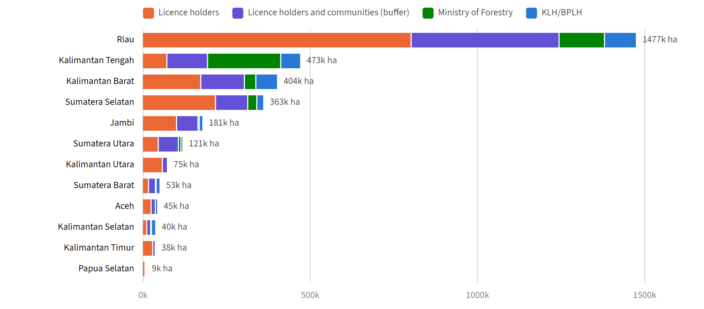
Figure 14.2. Damaged peat by province and actor, the twelve provinces with the most. Source: KLH PPEG integrated analysis

15 Roles
The terms of reference of the focus group discussion of 2 November 2026 set out what KLH asks of each ministry; the discussion notes add the roles of BPGM and Bappenas. Table 15.1 sets these roles beside the part of the priority area each covers.
Table 15.1. Roles as stated for the focus group discussion and the part of the priority area each covers. Source: FGD terms of reference (KLH/BPLH, letter B.70/E/PKL.4.5/10/2026, agenda item 9), FGD notes of 2 November 2026, KLH PPEG integrated analysis
Institution | Role | Part of the priority area
Ministry of Public Works | Technical support, field implementation and coordination of canal blocks on primary and secondary canals | 1.2 million ha in the zone affected by primary or secondary canals; 25,391 km of primary and 73,150 km of secondary canals in the priority KHG
Ministry of Forestry | Technical support, water management and rewetting infrastructure in the forest area, with and without licences | 436 thousand ha outside licences; 1.8 million ha in the forest area in all, 898 thousand ha of it inside licences
KLH/BPLH | Sets the priority area and the PPEG analysis; rewetting in APL outside licences | 298 thousand ha
Licence holders | Water management inside their licences; water sharing with the communities around them | 1.6 million ha inside licences, 989 thousand ha in the buffer
BPGM | Aligns peat targets and priorities; coordinates the ministries without replacing them | 362 priority KHG
Bappenas | Direction of support and budget for peat restoration; planning and financing | 3.1 million ha to rewet, 783 thousand ha to revegetate
Ministry of Finance | No role stated in the FGD documents

The canal lengths come from the national canal layer, which is drawn from OpenStreetMap; 44 priority KHG have no canal in it, so the lengths are lower bounds. An indicative investment envelope needs the number of canal blocks and wells per KHG. It follows from the prioritisation of the KHG within the priority area.

16 Limitations
- The burned-area maps of 2024 and 2026 are incomplete as delivered (chapter 5), and the method used to make the maps is not documented with them.
- The licence layer of 2025 and the forest area map of 2023 are matched to burns since 2015. Land may have been licensed or reclassified after it burned.
- The licence layer holds the licences it was given. Unlicensed plantations and other managed land count as "no concession".
- Hotspots and burned area inside a licence or a forest area class are a spatial overlap. They do not show the cause of a fire or who is responsible.
- MODIS and VIIRS count fires differently and are never added or compared in absolute numbers. The MODIS file joins two sources at 15 September 2026; over the 15 days where both exist the NASA source has 4.3% more detections.
- The static-source flag misses about a third of the static detections and wrongly flags about one in eight of those it flags (chapter 4).
- The priority KHG are reconstructed from KLH's PPEG analysis and the Bluebook target villages; the 337 KHG of KLH's target are not listed in the sources. In Papua, 2.5 million ha inside KHG carry no peat, damage or thickness class in the PPEG analysis. Outside the KHG, 137 thousand ha of peat is coded damaged without a damage class; it is counted in the priority area.
- The actor of each part of the priority area is KLH's assignment in the PPEG analysis, not a finding of this report.
- A cell or hotspot takes the class at its centre or position. A MODIS pixel is about 1 km across, so a hotspot near a boundary may come from the neighbouring class.

Annex A Tables
The values behind the charts. Areas are on the 30 m grid; hotspots are VIIRS of 2026 (1 January to 31 October), medium and high confidence, likely static sources left out; burned area is the sum of the yearly areas 2015 to 2025.

Concessions and forest area
Table A.1. Land, burned area and hotspots by concession and forest area, all land. The last column compares VIIRS hotspots of 2026 with the mean of 2015 to 2025 over the same months. Source: this analysis
Class | Area (thousand ha) | Area (%) | Burned 2015 to 2025 (thousand ha) | Burned (%) | Ever burned (% of class) | VIIRS hotspots 2026 | Hotspots (%) | Hotspots per 100 km² | 2026 / mean 2015 to 2025
Concession, forest area | 32,455 | 17% | 1,026 | 13% | 2.7 | 105,262 | 18% | 32.4 | 3.5
Concession, APL | 9,644 | 5% | 501 | 6% | 4.0 | 45,421 | 8% | 47.1 | 2.8
Concession, water or undefined | 38.6 | 0% | 0.4 | 0% | 0.9 | 32 | 0% | 8.3 | 2.8
No concession, forest area | 85,800 | 45% | 3,439 | 44% | 2.9 | 264,075 | 46% | 30.8 | 3.8
No concession, APL | 60,378 | 32% | 2,783 | 36% | 3.1 | 157,330 | 27% | 26.1 | 2.5
No concession, water or undefined | 776 | 0% | 2.0 | 0% | 0.2 | 581 | 0% | 7.5 | 6.5

Peat
Table A.2. Peat, burned peat and hotspots on peat by concession and forest area; shares are of the peat. Source: this analysis
Class | Area (thousand ha) | Area (%) | Burned 2015 to 2025 (thousand ha) | Burned (%) | Ever burned (% of class) | VIIRS hotspots 2026 | Hotspots (%) | Hotspots per 100 km² | 2026 / mean 2015 to 2025
Concession, forest area | 3,025 | 23% | 384 | 20% | 11.2 | 20,770 | 11% | 68.7 | 1.9
Concession, APL | 1,697 | 13% | 214 | 11% | 9.6 | 20,559 | 11% | 121.1 | 3.8
Concession, water or undefined | 0.6 | 0% | 0.0 | 0% | 4.3 | 0 | 0% | 0.0 | 0.0
No concession, forest area | 6,202 | 47% | 937 | 48% | 11.7 | 105,194 | 58% | 169.6 | 4.4
No concession, APL | 2,402 | 18% | 423 | 22% | 12.6 | 34,680 | 19% | 144.4 | 3.2
No concession, water or undefined | 6.2 | 0% | 0.5 | 0% | 5.2 | 26 | 0% | 42.1 | 2.9

Concession types
Table A.3. Land, burned area and hotspots by concession type, each cell counted once (overlaps go to the first type in the order of the table), all land. Source: this analysis
Class | Area (thousand ha) | Area (%) | Burned 2015 to 2025 (thousand ha) | Burned (%) | Ever burned (% of class) | VIIRS hotspots 2026 | Hotspots (%) | Hotspots per 100 km² | 2026 / mean 2015 to 2025
Oil palm | 4,958 | 3% | 388 | 5% | 6.0 | 32,963 | 6% | 66.5 | 3.4
Mining | 7,130 | 4% | 137 | 2% | 1.5 | 20,315 | 4% | 28.5 | 2.5
Plantation forest (PPHTR) | 181 | 0% | 13.7 | 0% | 5.8 | 2,749 | 0% | 151.6 | 6.2
Forest concession (PBPH) | 29,868 | 16% | 988 | 13% | 2.9 | 94,688 | 17% | 31.7 | 3.4
No concession | 146,953 | 78% | 6,223 | 80% | 3.0 | 421,986 | 74% | 28.7 | 3.2

Table A.4. The same by licence type, overlapping licences counted under each type; community forest permits (PPHKM), which are not concessions, for comparison. Shares are of all land. Source: this analysis
Class | Area (thousand ha) | Area (%) | Burned 2015 to 2025 (thousand ha) | Burned (%) | Ever burned (% of class) | VIIRS hotspots 2026 | Hotspots (%) | Hotspots per 100 km² | 2026 / mean 2015 to 2025
Oil palm | 4,958 | 3% | 388 | 5% | 6.0 | 32,963 | 6% | 66.5 | 3.4
Mining | 7,130 | 4% | 137 | 2% | 1.5 | 20,315 | 4% | 28.5 | 2.5
Plantation forest (PPHTR) | 181 | 0% | 13.7 | 0% | 5.8 | 2,749 | 0% | 151.6 | 6.2
Forest concession (PBPH) | 29,868 | 16% | 988 | 13% | 2.9 | 94,688 | 17% | 31.7 | 3.4
Community forest (PPHKM) | 1,116 | 1% | 58.2 | 1% | 4.2 | 5,696 | 1% | 51.0 | 2.7

Forest area function
Table A.5. Land, burned area and hotspots by forest area function, all land. Source: this analysis
Class | Area (thousand ha) | Area (%) | Burned 2015 to 2025 (thousand ha) | Burned (%) | Ever burned (% of class) | VIIRS hotspots 2026 | Hotspots (%) | Hotspots per 100 km² | 2026 / mean 2015 to 2025
Conservation | 22,000 | 12% | 1,137 | 15% | 3.5 | 66,502 | 12% | 30.2 | 4.4
Protection forest | 29,242 | 15% | 574 | 7% | 1.5 | 54,662 | 10% | 18.7 | 3.6
Production forest (HP, HPT) | 55,928 | 30% | 2,034 | 26% | 2.9 | 178,661 | 31% | 31.9 | 3.3
Convertible production (HPK) | 11,083 | 6% | 719 | 9% | 4.7 | 69,512 | 12% | 62.7 | 5.3
Other land use (APL) | 70,022 | 37% | 3,284 | 42% | 3.2 | 202,751 | 35% | 29.0 | 2.6
Water, undefined | 805 | 0% | 2.3 | 0% | 0.3 | 613 | 0% | 7.6 | 6.1
Not mapped | 8.9 | 0% | 0.0 | 0% | 0.0 | 0 | 0% | 0.0 | 0.0

Table A.6. Forest area function of the land inside concessions; shares are of the concession land. Source: this analysis
Class | Area (thousand ha) | Area (%) | Burned 2015 to 2025 (thousand ha) | Burned (%) | Ever burned (% of class) | VIIRS hotspots 2026 | Hotspots (%) | Hotspots per 100 km² | 2026 / mean 2015 to 2025
Conservation | 89.2 | 0% | 2.9 | 0% | 2.7 | 263 | 0% | 29.5 | 2.8
Protection forest | 1,123 | 3% | 5.2 | 0% | 0.4 | 2,125 | 1% | 18.9 | 5.5
Production forest (HP, HPT) | 29,504 | 70% | 989 | 65% | 2.9 | 96,817 | 64% | 32.8 | 3.4
Convertible production (HPK) | 1,739 | 4% | 28.7 | 2% | 1.4 | 6,057 | 4% | 34.8 | 5.1
Other land use (APL) | 9,644 | 23% | 501 | 33% | 4.0 | 45,421 | 30% | 47.1 | 2.8
Water, undefined | 38.4 | 0% | 0.4 | 0% | 0.9 | 32 | 0% | 8.3 | 2.8

DMPG villages
Table A.7. Peat in DMPG villages and other peat, provinces with DMPG villages; shares are of that peat. Source: this analysis
Class | Area (thousand ha) | Area (%) | Burned 2015 to 2025 (thousand ha) | Burned (%) | Ever burned (% of class) | VIIRS hotspots 2026 | Hotspots (%) | Hotspots per 100 km² | 2026 / mean 2015 to 2025
DMPG village, no concession | 3,562 | 29% | 938 | 50% | 19.7 | 100,196 | 57% | 281.3 | 4.2
DMPG village, concession | 1,962 | 16% | 385 | 21% | 16.1 | 22,320 | 13% | 113.8 | 2.4
Other peat, no concession | 4,069 | 34% | 361 | 19% | 6.8 | 36,738 | 21% | 90.3 | 3.9
Other peat, concession | 2,536 | 21% | 191 | 10% | 6.8 | 17,205 | 10% | 67.8 | 2.6

Islands and provinces
Table A.8. Land, burned area and hotspots by island. Source: this analysis
Class | Area (thousand ha) | Area (%) | Burned 2015 to 2025 (thousand ha) | Burned (%) | Ever burned (% of class) | VIIRS hotspots 2026 | Hotspots (%) | Hotspots per 100 km² | 2026 / mean 2015 to 2025
Bali-Nusa Tenggara | 7,171 | 4% | 1,231 | 16% | 9.1 | 18,452 | 3% | 25.7 | 1.1
Jawa-Madura | 13,260 | 7% | 211 | 3% | 1.3 | 13,301 | 2% | 10.0 | 1.8
Kalimantan | 53,470 | 28% | 2,620 | 34% | 3.6 | 301,962 | 53% | 56.5 | 4.2
Maluku | 7,763 | 4% | 229 | 3% | 2.1 | 26,222 | 5% | 33.8 | 5.9
Papua | 41,221 | 22% | 990 | 13% | 1.7 | 96,031 | 17% | 23.3 | 8.0
Sulawesi | 18,623 | 10% | 267 | 3% | 1.1 | 32,506 | 6% | 17.5 | 3.1
Sumatera | 47,581 | 25% | 2,202 | 28% | 3.7 | 84,227 | 15% | 17.7 | 1.6

Table A.9. Land, burned area and hotspots by province, ordered by VIIRS hotspots of 2026. Source: this analysis
Province | Island | Land (thousand ha) | Burned 2015 to 2025 (thousand ha) | Burned in concessions (%) | Burned in forest area (%) | VIIRS hotspots 2026 | Hotspots in concessions (%) | Hotspots in forest area (%) | Hotspots per 100 km²
Kalimantan Tengah | Kalimantan | 15,345 | 1,135 | 13% | 67% | 164,968 | 19% | 80% | 107.5
Kalimantan Barat | Kalimantan | 14,704 | 519 | 26% | 47% | 79,375 | 35% | 47% | 54.0
Papua Selatan | Papua | 11,705 | 946 | 6% | 94% | 72,322 | 16% | 82% | 61.8
Sumatera Selatan | Sumatera | 8,677 | 1,159 | 49% | 58% | 49,779 | 48% | 46% | 57.4
Kalimantan Timur | Kalimantan | 12,698 | 279 | 54% | 39% | 30,175 | 64% | 50% | 23.8
Kalimantan Selatan | Kalimantan | 3,713 | 653 | 12% | 13% | 24,343 | 28% | 39% | 65.6
Maluku | Maluku | 4,616 | 212 | 9% | 78% | 18,132 | 23% | 83% | 39.3
Papua Barat | Papua | 5,952 | 13.0 | 54% | 59% | 12,909 | 53% | 82% | 21.7
Nusa Tenggara Timur | Bali-Nusa Tenggara | 4,645 | 862 | 1% | 30% | 12,161 | 4% | 36% | 26.2
Sulawesi Tengah | Sulawesi | 6,161 | 86.3 | 13% | 40% | 10,281 | 21% | 61% | 16.7
Jawa Timur | Jawa-Madura | 4,804 | 142 | 1% | 74% | 8,349 | 1% | 65% | 17.4
Maluku Utara | Maluku | 3,147 | 17.0 | 51% | 76% | 8,090 | 44% | 76% | 25.7
Kepulauan Bangka Belitung | Sumatera | 1,669 | 34.1 | 39% | 62% | 8,030 | 37% | 62% | 48.1
Sulawesi Selatan | Sulawesi | 4,533 | 42.6 | 6% | 24% | 8,004 | 14% | 48% | 17.7
Jambi | Sumatera | 4,903 | 184 | 51% | 68% | 7,619 | 23% | 75% | 15.5
Sulawesi Tenggara | Sulawesi | 3,617 | 94.4 | 10% | 67% | 7,208 | 15% | 51% | 19.9
Nusa Tenggara Barat | Bali-Nusa Tenggara | 1,968 | 365 | 5% | 56% | 6,209 | 7% | 55% | 31.6
Riau | Sumatera | 8,994 | 462 | 30% | 81% | 5,858 | 11% | 71% | 6.5
Lampung | Sumatera | 3,357 | 156 | 6% | 54% | 5,506 | 19% | 29% | 16.4
Papua Tengah | Papua | 6,120 | 5.0 | 0% | 89% | 4,320 | 8% | 81% | 7.1
Papua Pegunungan | Papua | 5,429 | 12.8 | 0% | 40% | 3,261 | 0% | 65% | 6.0
Kalimantan Utara | Kalimantan | 7,010 | 33.5 | 37% | 36% | 3,101 | 44% | 42% | 4.4
Sulawesi Utara | Sulawesi | 1,451 | 15.9 | 4% | 44% | 2,748 | 8% | 48% | 18.9
Aceh | Sumatera | 5,683 | 35.8 | 24% | 45% | 2,652 | 18% | 22% | 4.7
Papua Barat Daya | Papua | 3,912 | 8.4 | 26% | 45% | 2,564 | 18% | 62% | 6.6
Gorontalo | Sulawesi | 1,203 | 9.7 | 8% | 36% | 2,358 | 23% | 56% | 19.6
Jawa Tengah | Jawa-Madura | 3,434 | 32.9 | 0% | 36% | 2,152 | 1% | 46% | 6.3
Jawa Barat | Jawa-Madura | 3,704 | 35.7 | 0% | 67% | 2,031 | 1% | 33% | 5.5
Sulawesi Barat | Sulawesi | 1,659 | 18.4 | 3% | 52% | 1,907 | 4% | 49% | 11.5
Sumatera Utara | Sumatera | 7,246 | 105 | 24% | 70% | 1,426 | 12% | 56% | 2.0
Kepulauan Riau | Sumatera | 827 | 19.5 | 0% | 65% | 1,242 | 1% | 49% | 15.0
Sumatera Barat | Sumatera | 4,212 | 40.0 | 1% | 69% | 1,222 | 4% | 69% | 2.9
Bengkulu | Sumatera | 2,013 | 6.6 | 36% | 56% | 893 | 6% | 30% | 4.4
Banten | Jawa-Madura | 935 | 0.3 | 4% | 24% | 681 | 2% | 21% | 7.3
Papua | Papua | 8,103 | 4.1 | 8% | 34% | 655 | 6% | 38% | 0.8
Bali | Bali-Nusa Tenggara | 559 | 4.2 | 1% | 94% | 82 | 0% | 35% | 1.5
Daerah Istimewa Yogyakarta | Jawa-Madura | 317 | 0.3 | 0% | 24% | 57 | 0% | 37% | 1.8
DKI Jakarta | Jawa-Madura | 66.1 | 0.0 | - | - | 31 | 0% | 0% | 4.7

Table A.10. The 30 KHG with the most VIIRS hotspots in 2026. Source: this analysis
KHG | Land (thousand ha) | Burned 2015 to 2025 (thousand ha) | VIIRS hotspots 2026 | In concessions (%) | Hotspots per 100 km²
Sungai Kahayan - Sungai Sebangau | 450 | 290 | 24,410 | 6% | 542.5
Sungai Katingan - Sungai Sebangau | 821 | 122 | 18,827 | 5% | 229.2
Sungai Kahayan - Sungai Kapuas | 400 | 91.8 | 15,038 | 1% | 376.4
Sungai Pukun - Sungai Mentaya | 303 | 46.2 | 14,442 | 21% | 476.4
Sungai Buluh Besar | 134 | 32.1 | 9,471 | 0% | 705.2
Sungai Katingan - Sungai Mentaya | 360 | 47.0 | 7,957 | 37% | 220.8
Sungai Buluh Besar - Sungai Seruyan | 342 | 26.5 | 7,625 | 5% | 223.1
Sungai Kapuas - Sungai Barito | 557 | 83.8 | 7,328 | 9% | 131.5
Sungai Sibumbung - Sungai Talangrimba | 105 | 85.5 | 6,888 | 65% | 656.4
Sungai Pawan - Sungai Tolak | 114 | 22.5 | 5,855 | 41% | 515.1
Sungai Pawan - Sungai Kepulu | 64.5 | 16.1 | 4,848 | 29% | 752.2
Sungai Lamandau - Sungai Jelai | 216 | 54.7 | 4,234 | 28% | 196.3
Sungai Pukun - Sungai Seruyan | 97.1 | 12.5 | 3,374 | 45% | 347.3
Sungai Tolak - Sungai Siduk | 28.0 | 5.9 | 3,041 | 55% | 1,086.7
Sungai Durian - Sungai Kualan | 155 | 18.1 | 3,014 | 35% | 194.4
Sungai Lamandau - Sungai Arut | 44.0 | 3.6 | 2,993 | 0% | 680.9
Sungai Sugihan - Sungai Lumpur | 635 | 277 | 2,850 | 94% | 44.9
Sungai Air Hitam Laut - Sungai Buntu Kecil | 184 | 34.1 | 2,780 | 0% | 151.4
Sungai Barito - Sungai Taping | 112 | 106 | 2,759 | 19% | 246.4
Sungai Saleh - Sungai Sugihan | 190 | 152 | 2,676 | 6% | 141.0
Sungai Batanghari - Sungai Air Hitam Laut | 190 | 47.4 | 2,486 | 0% | 131.0
Sungai Kapuas - Sungai Ambawang | 158 | 11.2 | 2,392 | 25% | 151.4
Sungai Pungurbesar - Sungai Kapuas | 101 | 38.9 | 2,383 | 44% | 235.3
Sungai Buru Mappi - Sungai Buru Obaa | 398 | 15.7 | 2,349 | 0% | 59.0
Sungai Musi - Sungai Blidah | 31.1 | 4.3 | 2,318 | 71% | 745.8
Sungai Tengar - Sungai Tapah | 39.7 | 9.1 | 2,233 | 3% | 563.1
Sungai Seruyan - Sungai Kelua Besar | 57.3 | 7.6 | 2,197 | 25% | 383.3
Sungai Lalan - Sungai Merang | 84.0 | 17.5 | 2,007 | 16% | 238.9
Sungai Lamandau - Sungai Kumai | 90.3 | 23.3 | 1,967 | 6% | 217.9
Sungai Pukun - Sungai Kelua Besar | 72.4 | 17.8 | 1,747 | 66% | 241.1

Repeatedly burned land
Table A.11. Land burned once, twice, three and four or more times in the burn years 2015 to 2026, by concession and forest area and by DMPG village, all land; areas in thousand ha. A cell that burned in two different years counts as burned twice. Water and undefined land (0.8 million ha) is left out of the rows and kept in the total. Source: this analysis
Class | Land | Ever burned (%) | Once | Twice | 3 times | 4 or more | Burned again (% of burned) | Share of land burned 2+ times
Concession, forest area | 32,455 | 2.7 | 759 | 106 | 16.1 | 3.0 | 14 | 8%
Concession, APL | 9,644 | 4.0 | 292 | 72.1 | 17.1 | 4.5 | 24 | 6%
No concession, forest area | 85,800 | 2.9 | 1,785 | 464 | 147 | 76.0 | 28 | 46%
No concession, APL | 60,378 | 3.1 | 1,285 | 355 | 135 | 93.2 | 31 | 39%
DMPG villages | 8,674 | 16.7 | 1,055 | 303 | 70.2 | 17.5 | 27 | 26%
Other villages | 180,417 | 2.3 | 3,068 | 694 | 245 | 159 | 26 | 74%
All land | 189,091 | 3.0 | 4,123 | 997 | 315 | 177 | 27 | 100%

KLH priority area
Table A.12. The 30 KHG with the most SKEG 2024 damaged peat; damaged peat in thousand ha. Source: KLH PPEG integrated analysis, Bluebook 2026 target villages
KHG | Province | Damaged peat | On a peat dome | On peat 3 m or deeper | Licence holders and buffer | In target villages
Sungai Siak - Sungai Kampar | Riau | 260 | 91% | 83% | 99% | yes
Sungai Kampar - Sungai Gaung | Riau | 240 | 60% | 70% | 96% | yes
Sungai Rokan - Sungai Siak Kecil | Riau | 180 | 40% | 71% | 94% | yes
Sungai Kahayan - Sungai Sebangau | Kalimantan Tengah | 155 | 62% | 57% | 29% | yes
Sungai Gaung - Sungai Batangtuaka | Riau | 103 | 68% | 45% | 78% | yes
Sungai Kahayan - Sungai Kapuas | Kalimantan Tengah | 79.7 | 0% | 39% | 26% | yes
Sungai Sugihan - Sungai Lumpur | Sumatera Selatan | 74.9 | 0% | 52% | 100% | yes
Sungai Kapuas - Sungai Barito | Kalimantan Tengah | 73.4 | 85% | 3% | 29% | yes
Sungai Barumun - Sungai Kubu | Riau... | 64.7 | 94% | 41% | 60% | yes
Sungai Kiyap - Sungai Kerumutan | Riau | 55.8 | 80% | 79% | 100% | yes
Pulau Bengkalis | Riau | 55.3 | 0% | 81% | 23% | yes
Sungai Kapuas - Sungai Ambawang | Kalimantan Barat | 52.3 | 70% | 64% | 99% | yes
Sungai Rokan Kiri - Sungai Mandau | Riau | 49.1 | 9% | 81% | 57% | yes
Pulau Rupat | Riau | 45.1 | 87% | 63% | 89% | yes
Sungai Batanghari - Sungai Air Hitam Laut | Jambi | 45.0 | 0% | 75% | 89% | yes
Pulau Tebing Tinggi | Riau | 44.8 | 95% | 65% | 84% | yes
Sungai Siak Kecil - Sungai Siak | Riau | 43.3 | 37% | 72% | 100% | yes
Sungai Mendahara - Sungai Batanghari | Jambi | 40.6 | 80% | 46% | 97% | yes
Pulau Padang | Riau | 40.2 | 98% | 83% | 97% | yes
Sungai Saleh - Sungai Sugihan | Sumatera Selatan | 38.9 | 0% | 0% | 44% | yes
Pulau Rangsang | Riau | 38.8 | 92% | 75% | 73% | yes
Sungai Burnai - Sungai Sibumbung | Sumatera Selatan | 38.1 | 0% | 73% | 98% | yes
Sungai Kapuas - Sungai Mandor | Kalimantan Barat | 34.5 | 0% | 65% | 61% | yes
Sungai Mentarang- Sungai Sembakung | Kalimantan Utara | 34.4 | 0% | 89% | 98% | yes
Sungai Enok - Sungai Batang | Riau | 33.2 | 0% | 0% | 68% | yes
Sungai Rokan - Sungai Kubu | Riau | 32.3 | 95% | 71% | 58% | yes
Sungai Katingan - Sungai Sebangau | Kalimantan Tengah | 28.0 | 51% | 34% | 9% | yes
Sungai Pungurbesar - Sungai Kapuas | Kalimantan Barat | 27.9 | 29% | 0% | 82% | yes
Sungai Mempawah - Sungai Peniti | Kalimantan Barat | 27.0 | 0% | 84% | 2% | yes
Sungai Kualuh Bilah - Sungai Barumun | Sumatera Utara | 26.8 | 95% | 0% | 100% | yes

Table A.13. SKEG 2024 damaged peat by province and actor, thousand ha; provinces with at least 1,000 ha. Source: KLH PPEG integrated analysis
Province | Licence holders | Licence holders and communities, buffer | Ministry of Forestry | KLH/BPLH | Total
Riau | 804 | 442 | 136 | 95.5 | 1,477
Kalimantan Tengah | 73.0 | 122 | 219 | 59.6 | 473
Kalimantan Barat | 174 | 130 | 34.2 | 64.9 | 404
Sumatera Selatan | 218 | 96.4 | 27.2 | 20.7 | 363
Jambi | 102 | 64.1 | 3.8 | 10.8 | 181
Sumatera Utara | 47.2 | 60.3 | 7.5 | 5.8 | 121
Kalimantan Utara | 59.6 | 15.0 | 0.0 | 0.6 | 75.2
Sumatera Barat | 18.1 | 20.7 | 2.1 | 11.7 | 52.6
Aceh | 25.9 | 12.5 | 0.0 | 7.0 | 45.4
Kalimantan Selatan | 12.9 | 11.4 | 2.5 | 12.8 | 39.6
Kalimantan Timur | 30.9 | 7.3 | 0.1 | 0.1 | 38.4
Papua Selatan | 7.6 | 0.7 | 0.8 | 0.5 | 9.5
Lampung | 3.0 | 4.8 | 0.0 | 0.2 | 8.0
Papua Tengah | 3.3 | 0.0 | 1.6 | 2.4 | 7.3
Bengkulu | 0.0 | 0.1 | 0.0 | 4.3 | 4.4
Papua Barat Daya | 0.3 | 0.4 | 1.9 | 1.4 | 4.1
Sulawesi Tengah | 3.0 | 0.5 | 0.0 | 0.0 | 3.6
Sulawesi Barat | 2.5 | 0.4 | 0.0 | 0.0 | 2.9
Kepulauan Bangka Belitung | 1.5 | 0.6 | 0.1 | 0.0 | 2.2
Papua Barat | 1.9 | 0.0 | 0.0 | 0.0 | 1.9

