GIS WORKSTREAM · PEATLAND REWETTING PROJECT
RE-PEAT: peatland rewetting toolkit
Findings and proposed methodology

Prepared for the World Bank and the Ministry of Environment / Environmental Control Agency (KLH/BPLH), Republic of Indonesia
Departemen Teknik Geodesi, Universitas Gadjah Mada
October 2026
Contents

1 Executive summary
The 2026 dry season made peat fire a national priority again. KLH/BPLH puts the burned area from January to October 2026 at about 1.64 million ha, about 673,279 ha of it on peat, and has set a restoration target of about 3.3 million ha in 337 priority KHG (KLH/BPLH 2026). The regulatory target is a water table no more than 0.4 m below the peat surface (PP 57/2016).
RE-PEAT is the peatland rewetting toolkit developed for the World Bank and KLH peatland rewetting project by its GIS workstream at the Department of Geodetic Engineering, Universitas Gadjah Mada. It works on the KHG (Kesatuan Hidrologis Gambut, peat hydrological unit), the official planning unit, and takes a KHG through five steps: terrain, sub-KHG units, water balance (neraca air), prioritisation, and the design of canal blocks and pumping (RE-PEAT Interventions). The same method applies to any of the 865 KHG. This report sets out the data, the methods and the evidence behind them, and the results to October 2026.

Main findings
- Terrain data limit how precisely blocks can be planned. At two KHG with airborne LiDAR, five elevation models were benchmarked against the LiDAR, and the best of them, DeltaDTM after correction, errs by 0.47 to 0.64 m in height differences over 1 km, which is more than the real relief of the domes (0.38 to 0.46 m). DEMNAS, FABDEM and GLO-30 err by 1.7 to 2.5 m after correction. Because no model met the accuracy criterion set in advance, the whole chain runs once per elevation model and the spread between the runs is reported with the results.
- The mapped canal network, more than the terrain, sets the sub-KHG units. With primary and secondary canals and rivers as outlets, the 14 analysed KHG split into 22 to 30 units per analysis, and the layout agrees across terrain sources about as well as across noisy copies of the LiDAR.
- The national ranking picks out the KHG that burn later. All 865 KHG were profiled and 476 ranked on fire on peat, this year's hotspots and canals by class. With indicators from 2015 to 2022, the ranking separates the KHG that had hotspots in 2023 to 2025 with an AUC of 0.956, and ten of the 11 resolved main KHG fall in its top third. The ranking uses default weights proposed by the project for agreement with KLH and the World Bank, and the weights can be adjusted in the dashboard.
- In concessions, water management holds the water table up. At Sugihan-Lumpur the climate removed 307 mm in the 2026 dry season while the station water table fell only 11 cm, so about 290 mm, or 1.8 billion m³, came from outside the rain balance. The deficit was 211 mm at Air Hitam Laut-Buntu Kecil, 119 mm at Mendahara-Batanghari and 7 mm at Kampar-Gaung. It was 348 mm at Kahayan-Sebangau (one station only, so low confidence), 299 mm at Kapuas-Barito and 132 mm at Pungurbesar-Kapuas, and 0 mm at three Riau KHG where rain exceeded evapotranspiration; four KHG have no station inside them.
- Open climate data give each KHG a reliable calendar of dry months, but they separate sub-KHG reliably in only 2 of 12 runs at the four KHG where this was tested.
- Canal blocks raise the water table only near the blocked canal. A groundwater model for rewetting scenarios, which is in development, reproduces the water supply of managed land when that land is held at 0.4 m. At Mendahara-Batanghari, blocks cut the number of days with the water table deeper than 40 cm by 26 days on average within 150 m of a blocked reach, and by almost nothing beyond 350 m.
- Land outside licences can so far be tested against 6 community stations in one KHG. Once logger outliers are screened out, the model on a 100 m grid matches their level and fall when canals are set at the levels measured in LiDAR, and does not match them with canals at 1.2 m.
- The number of blocks depends on the terrain model. The blocks needed by the slope rule differ by a factor of 2.6 to 7.0 between elevation models at the five KHG with LiDAR, and DEMNAS gives 1.6 to 4.2 times the DeltaDTM count at the nine KHG without it. RE-PEAT Interventions keeps the blocks that give 90 % of the canal rewetting and applies the 500 m minimum spacing of the KLH guide, which gives 5 to 117 blocks per run. Budgets range from 1 to 620 billion Rp per run, driven by revegetation of burned land and, where the ranking counts many blocks, by the KLH estimate of missing blocks, and use proposed unit prices that are still to be verified; a KLH cost standard for rewetting works, once available, would replace them.
Table 1.1. Key figures of the 14 analysed KHG on the DeltaDTM variant, the only elevation model that exists for all 14; the range column spans every model the KHG was analysed on (LiDAR, DeltaDTM, DEMNAS). Deficit in mm of the 2026 dry season with the number of stations behind it. Default weights. Source: chapter 10
KHG | Elevation models (n) | Sub-KHG | Deficit 2026 (mm; stations) | High-need units (n, km²) | Blocks needed (ranking) | Blocks needed, range across models | Blocks proposed, kept | Budget, central (billion Rp)
Kampar - Gaung | 3 | 27 | 7; 78 | 9, 2,384 | 3,394 | 1,675 to 9,518 | 117, 57 | 7
Pulau Bengkalis | 2 | 27 | 0; 2 | 9, 260 | 2,291 | 2,291 to 3,732 | 97, 52 | 21
Pulau Padang | 2 | 30 | 0; 3 | 10, 287 | 992 | 992 to 2,355 | 49, 24 | 3
Pulau Tebing Tinggi | 2 | 29 | 0; 5 | 10, 488 | 1,088 | 1,088 to 2,845 | 114, 52 | 4
Air Hitam Laut - Buntu Kecil | 3 | 29 | 211; 8 | 10, 645 | 1,012 | 1,012 to 2,616 | 26, 18 | 18
Mendahara - Batanghari | 3 | 29 | 119; 12 | 10, 754 | 3,908 | 1,995 to 8,763 | 114, 54 | 77
Saleh - Sugihan | 3 | 26 | no stations | 9, 638 | 1,165 | 1,165 to 7,752 | 21, 11 | 25
Sugihan - Lumpur | 3 | 29 | 290; 51 | 10, 2,379 | 6,237 | 3,634 to 25,580 | 117, 39 | 407
Mempawah - Peniti | 2 | 28 | no stations | 10, 229 | 4,586 | 4,586 to 18,544 | 217, 117 | 44
Pungurbesar - Kapuas | 2 | 30 | 132; 3 | 10, 379 | 4,896 | 4,896 to 17,432 | 143, 36 | 34
Kapuas - Barito | 2 | 28 | 299; 6 | 10, 1,632 | 3,810 | 3,810 to 12,184 | 128, 44 | 24
Kahayan - Sebangau | 2 | 29 | 348; 1 | 10, 1,843 | 3,276 | 3,276 to 7,466 | 30, 13 | 95
Balangan - Batangalai | 2 | 22 | no stations | 8, 116 | 723 | 723 to 2,277 | 18, 11 | 8
Buru Mappi - Buru Obaa | 2 | 30 | no stations | 10, 2,124 | 73 | 73 to 303 | 18, 13 | 75

Status
The full chain has been applied to 14 KHG: eleven of the 12 main KHG, two reserve KHG and the earlier test site Kampar-Gaung. Five of them (Air Hitam Laut-Buntu Kecil, Kampar-Gaung, Mendahara-Batanghari, Saleh-Sugihan and Sugihan-Lumpur) have three elevation models each, and nine have corrected DeltaDTM and DEMNAS only, which makes 33 analyses. The twelfth main KHG, Cawang-Lalang, is to be confirmed with KLH. Chapter 10 reports the results KHG by KHG. The national dashboard, the interventions report and print layouts for each KHG, and a QGIS plugin that guides KLH staff through the design stage by stage are in working order.

Decisions and data requested
KLH and the World Bank are asked to agree the ranking weights, confirm the twelfth KHG, decide whether data under non-commercial licences may be used, and choose how the groundwater model represents water management in concessions (chapter 11). The results would gain most from water-table stations in land outside licences, measured canal water levels by season, LiDAR for the KHG where blocks will be designed, and a documented source for the burned-area layer.

2 Background, scope and approach

2.1 The problem
Rewetting decisions depend on knowing where and when the water table falls, because drained peat dries out and burns. Tropical peat forms a dome of partly decomposed plant material. It is highest in the middle and slopes by a few metres over several kilometres towards the rivers that bound it, and when intact it stays waterlogged all year. Drainage canals dug for plantations, farming, transport or logging lower the water table, most strongly near the canals. In the dry season the rain stops but evapotranspiration continues at about 4 mm per day, the water table falls further, and the dry upper peat can burn, sometimes for weeks below the surface. Drained peat also subsides: about 2.2 cm per year on average over 2.7 million ha of Southeast Asian peat surveyed by satellite radar in 2007-2011 (Hoyt et al. 2020) and about 4.3 cm per year under plantation drainage (Evans et al. 2019).
Rewetting aims to keep the water table high enough through the dry season that the peat does not dry out and burn. Its tools are canal blocks (sekat kanal), adjustable water gates (pintu air) and, where water has to be moved, pumps.

2.2 Policy context in 2026
Indonesia has the largest area of tropical peat in the world, about 13.36 million ha holding an estimated 57 gigatonnes of carbon. Since 2016 the government has restored peat through the 3R strategy: rewetting, revegetation and revitalisation of livelihoods, delivered through programmes such as the peat-care villages (Desa Mandiri Peduli Gambut, DMPG), restoration by concession holders, communities and development partners. In October 2025 the government reported about 4.16 million ha of peat rewetted through 45,000 canal blocks (KLH/BPLH 2026).
The 2026 dry season raised the urgency. The national fire monitoring system (Sipongi, Ministry of Forestry) recorded 202,004.30 ha burned from January to July 2026. KLH/BPLH's own burn-scar analysis gives about 1.64 million ha burned from January to October 2026, more than in the same period of 2019, 2023 and 2025, of which about 673,279 ha (40.9%) was on peat. KLH has set a peat restoration target of about 3.3 million ha in 337 priority KHG, selected with the peat ecosystem damage status (Status Kerusakan Ekosistem Gambut, SKEG), especially on burned land and land affected by canals. The interventions it lists are water management and rewetting infrastructure, revegetation where suitable, monitoring of the peat water table (TMAT), early fire warning and community empowerment (KLH/BPLH 2026).
KLH/BPLH frames the response as water governance at KHG level, including water sharing between licence holders and the communities around them within one KHG. Its focus group discussion of 2 November 2026 on fire prevention through KHG water governance asks for the current condition and fire risk of priority KHG, the factors that make peat vulnerable (hydrology, land use, rewetting infrastructure, governance), the roles of each ministry and agency, and a KHG-based action plan with locations, intervention types, responsibilities, timing and funding needs, including through the proposed Re-Peat project (KLH/BPLH 2026). The toolkit described in this report provides evidence for several of these: where water is short and when (chapter 8), which KHG and sub-KHG to treat first (chapters 6 and 7), and which blocks and pumps are needed and at what cost (chapter 9). Chapter 11 maps the outputs to the discussion's questions.

2.3 Regulatory target
Indonesian regulation (PP 71/2014 as amended by PP 57/2016) treats cultivation-function peat as damaged when the water table (tinggi muka air, TMA) is more than 0.4 m below the surface at a compliance point. Permen LHK P.15/2017 sets how the TMA is measured. The fire literature agrees with this threshold: fire danger rises mostly when the water table falls below 0.4 m, burning is found below about 0.6 m (Taufik et al. 2022), and at a South Sumatra site fire hazard became high once the water table fell below a critical depth of about 0.85 m, where capillary rise no longer kept the topsoil moist (Taufik et al. 2019). Throughout this report, "deeper than 40 cm" means the water table is below the regulatory line.
The planning unit is the KHG (Kesatuan Hidrologis Gambut, peat hydrological unit): a peat area bounded by rivers or the sea that behaves as one water system. The official list (SK.129/MENLHK/2017) has 865 KHG. Inside a KHG this study works with sub-KHG: parts of the KHG that drain to their own outlet, a river or a large canal.

2.4 Scope of the GIS workstream
The GIS workstream of the World Bank and KLH peatland rewetting project builds a toolkit, RE-PEAT, that answers four questions in order:
1. Which KHG should rewetting focus on, nationally?
2. Which ground surface can the analysis rely on inside a KHG, given that good terrain data exist for few KHG?
3. Where inside a KHG is water short, by how much, and in which season (neraca air, the water balance)?
4. Where should canal blocks, gates and pumps go, how much water must be moved, and at what cost?
The project selected 12 main KHG for detailed work, with reserves (Table 2.1). The twelfth, Cawang-Lalang, is to be confirmed with KLH: its name does not match the official boundary file, and the nearest KHG is Air Banyuasin - Air Lalang. Kampar-Gaung, the earlier test site, is analysed as well.
Table 2.1. The selected KHG. Source: project selection of 22 October 2026; areas from the KHG boundary file, Kampar-Gaung from the SK.129/MENLHK/2017 list
Province | Role | KHG | Code | Area (ha) | Full chain run
Riau | main | KHG Pulau Padang | 14.10.01 | 111,286
Riau | main | KHG Pulau Bengkalis | 14.03.02 | 90,686
Riau | reserve | KHG Pulau Tebing Tinggi | 14.10.03 | 138,061
Sumatera Selatan | main | KHG Sungai Saleh - Sungai Sugihan | 16.02-07.01 | 190,230 | yes
Sumatera Selatan | main | cawang-lalang (unresolved)
Sumatera Selatan | reserve | KHG Sungai Sugihan - Sungai Lumpur | 16.02.01 | 636,828 | yes
Jambi | main | KHG Sungai Mendahara - Sungai Batanghari | 15.05-07-10.01 | 201,383 | yes
Jambi | main | KHG Sungai Air Hitam Laut - Sungai Buntu Kecil | 15-16.01 | 183,856
Kalimantan Barat | main | KHG Sungai Mempawah - Sungai Peniti | 61.02-08.01 | 51,045
Kalimantan Barat | main | KHG Sungai Pungurbesar - Sungai Kapuas | 61.12-71.01 | 101,269
Kalimantan Tengah | main | KHG Sungai Kahayan - Sungai Sebangau | 62.11-14.02 | 451,507
Kalimantan Tengah | main | KHG Sungai Kapuas - Sungai Barito | 62.03-04.01 | 558,168
Kalimantan Selatan | main | KHG Sungai Balangan - Sungai Batangalai | 63.07-08-11.01 | 30,859
Papua Selatan | main | KHG Sungai Buru Mappi - Sungai Buru Obaa | 91.18-17.01 | 402,643
Riau | earlier test site | KHG Sungai Kampar - Sungai Gaung | 14.02-04-05.01 | 710,823 | yes

2.5 How the toolkit is built
RE-PEAT is a chain of modules, each building on the outputs of the one before (Figure 2.1). Every result can be regenerated from the source data when those data are updated, and the same method runs for any of the 865 KHG.
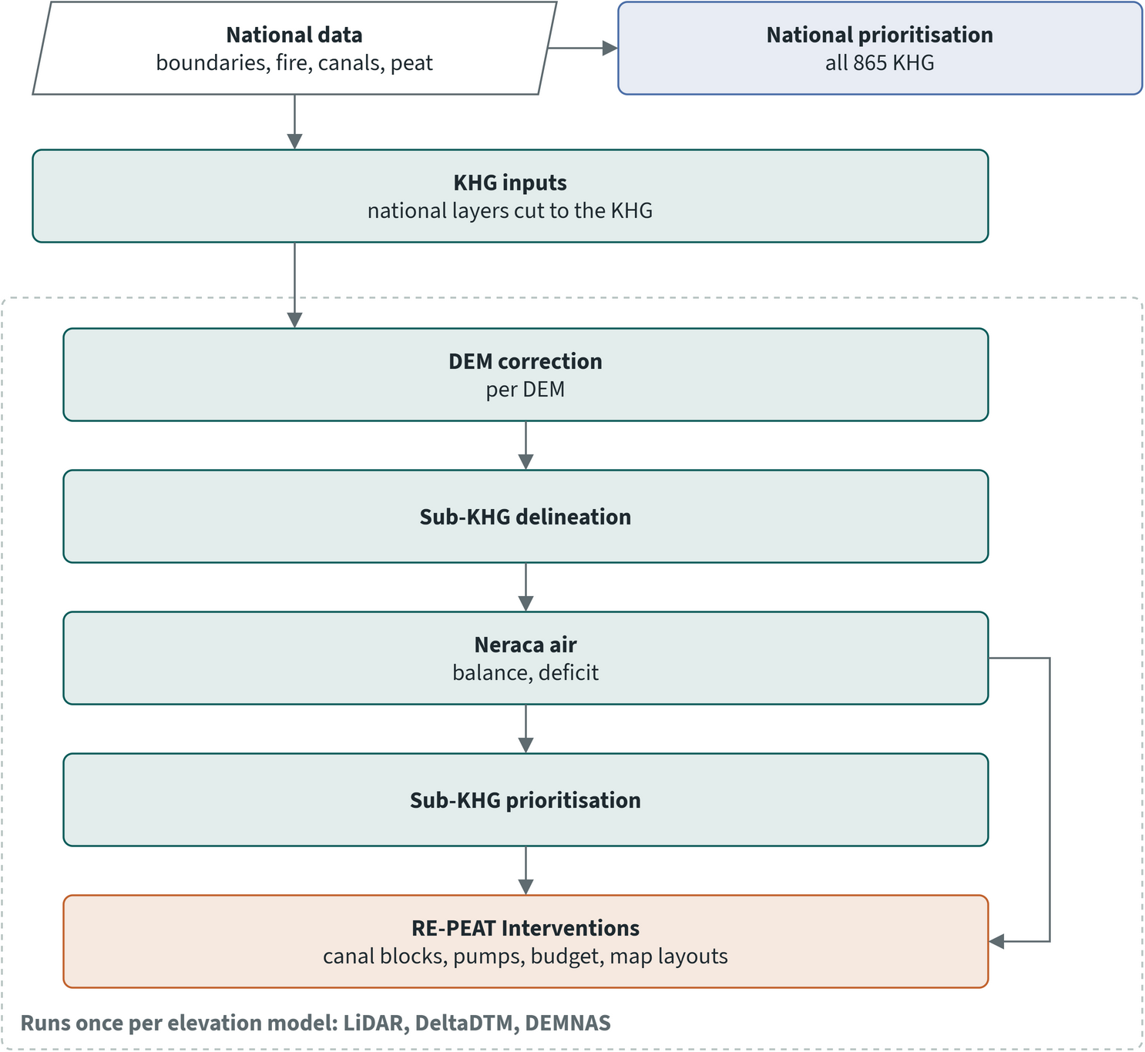
Figure 2.1. The RE-PEAT chain for one KHG. Each step runs once per elevation model (LiDAR where it covers the KHG, corrected DeltaDTM and corrected DEMNAS). The national ranking runs separately over all 865 KHG
The modules are:
- DEM correction: clips each elevation model to the KHG and corrects DeltaDTM and DEMNAS towards bare ground (chapter 4).
- Sub-KHG delineation: divides the KHG into drainage units from the terrain, canals and rivers (chapter 5).
- National and sub-KHG prioritisation: ranks all 865 KHG, and ranks the sub-KHG inside one KHG (chapters 6 and 7).
- Neraca air: the water balance per sub-KHG and the water-table deficit from station records, and a groundwater model in development for rewetting scenarios (chapter 8).
- RE-PEAT Interventions: places canal blocks and pumps, sizes the water need and the budget, and produces the map layouts, also as a QGIS plugin for KLH staff (chapter 9).
Few KHG have airborne LiDAR, and the open elevation models differ in quality from one KHG to the next (chapter 4). The whole chain therefore runs once per elevation model, and the differences between the three runs show how much a result depends on the terrain.

2.6 Lessons from the 2021 Kahayan-Sebangau study
The 2021 final report of the UGM team on KHG Sungai Kahayan - Sungai Sebangau is the direct predecessor of this toolkit. Several of its methods were kept and automated: sub-KHG delineation from flow direction and stream order with large channels as outlets (16 sub-KHG there), a water balance with interception by land cover, block spacing from the 0.4 m design limit divided by land slope, and the closing of blocks from June to August. It also showed that the worst sub-KHG by mean water balance were not the worst by number of deficit months, so both measures are kept.
Two of its steps are not carried forward. The study multiplied the mean daily water-table decline by the KHG area as if each centimetre of decline were a centimetre of water lost, which ignores that peat releases only part of its volume when it drains (its specific yield, about 0.3 near the surface). It also estimated a canal emptying time of 730 to 770 days by assuming canals lose water only by open-water evaporation, which the authors themselves called unrealistic, since canals lose most of their water by seepage into the peat. Chapter 8 returns to how the study's water balance was reproduced.

2.7 Structure of this report
Chapter 3 describes the data and how they were curated. Chapters 4 to 9 follow the chain: terrain, delineation, national and sub-KHG prioritisation, neraca air and interventions. Chapter 10 compares the KHG, chapter 11 lists the limitations and the decisions needed from KLH and the World Bank, and the annexes hold the references, the glossary and the parameter register. The national and sub-KHG rankings use default weights proposed by the project for agreement with KLH and the World Bank; the weights can be adjusted in the dashboard. The groundwater model in chapter 8 is in development.

3 Data curation and inputs

3.1 Data inventory
The study combines three kinds of data. National layers cover all 865 KHG (Kesatuan Hidrologis Gambut, peat hydrological units): boundaries, canals, burned area, hotspots, peat extent and land status. Other datasets exist for some KHG only, such as LiDAR terrain models, modelled peat depth and water-table stations. Global satellite products for rain, evapotranspiration, land cover, surface water and elevation come from Google Earth Engine, Microsoft Planetary Computer and other public archives.
For every dataset the inventory records units, resolution, source, date and licence. Where a source is incomplete, it states how far the data can be trusted. Peat depth, for example, covers only part of most KHG, so it is reported and does not drive a ranking.
For the analysis of a single KHG, every national input is clipped to the KHG plus a 5 km buffer: the boundary, canals, rivers, lakes and existing canal blocks; burned area, hotspots, peat extent and the other national layers; the KHG's peat-depth raster; the SiTMAT stations within the area; and the ICESat-2 ground points. Each clip is listed with its source, so the inputs of one KHG can be handed over and the analysis repeated without the national data. At Mendahara-Batanghari the fire, hotspot, canal and peat-share indicators computed from the clipped inputs equal those computed from the national layers, with a largest difference of 4e-16.
The satellite sources (Earth Engine, Planetary Computer, SlideRule, and the land-cover and canopy-height tiles on public cloud storage) are read from the provider at the time of analysis. A later repeat of the analysis can therefore differ slightly where a provider has updated its archive.

3.2 Datasets used in the analysis
Table 3.1 lists the datasets by theme. "Not recorded" means the source documentation gives no value for that property. Two datasets carry non-commercial licences, FABDEM and the Global Peatland Map, and both are used only as checks.
Table 3.1. Datasets used in the RE-PEAT analysis. Source: RE-PEAT data inventory, the neraca air (water balance) method report, the sub-KHG prioritisation method and the national profile method
Dataset | Provider | Type and resolution | Period | Licence | Used for | Confidence and limits
KHG boundaries and registry | KLHK, SK.129/MENLHK/2017 | Polygons, 865 KHG; registry of codes, names, provinces and areas | 2017 | Not recorded | Unit of every analysis; clipping of all inputs | Boundary file has names only; codes are joined from the registry. Some names have irregular spacing
Canal network | OSM-derived (inferred) | Lines, classed primary, secondary and tertiary | 2025 | Not recorded | Canal density by class; outlet canals in delineation; canal reach and blocks needed; block placement; canal boundary of the groundwater model | Provider inferred from the delivered data; no flow direction
Rivers and lakes (RBI) | BIG, Rupa Bumi Indonesia | Lines and polygons | Not recorded | Not recorded | Fixed boundaries in delineation; distance to water; water sources | Scale and year to be confirmed; no field for perennial flow or dry-season level
Existing canal blocks | BRGM/PPEG, Bluebook 2026 | Points of hydrological infrastructure; canal blocks marked as realised are used | Not recorded | Not recorded | Existing blocks in the block-gap indicator and the interventions module; counts in the national profile | Completeness per KHG to be checked; at Pulau Tebing Tinggi none of the 168 blocks has a build year
Proposed canal blocks, Bluebook 2026-2030 | KLH/BRGM | Points by province, placed on LiDAR, BRGM or DEMNAS contours | 2026 | Not recorded | Data readiness review only | Targets, not built. The Riau file placed on BRGM contours has no attributes
Peat extent, GFW composite | Global Forest Watch | Raster, about 76 m | Layer version 2023-03-15 | CC BY 4.0 | Peat area per KHG; fire counted on peat | Mapped extent, not a survey. Union of two published peat maps, so it can exceed either; Papua rests on the modelled map
Global Peatland Map 2.0 | Greifswald Mire Centre, UNEP | Raster, about 1 km | 2022 | CC BY-NC-SA 4.0, non-commercial | Cross-check of the GFW extent only | Coarse; licence to be checked before use in a deliverable
Peat depth classes | BBSDLP (inferred) | Polygons, 1:50,000; classes from 50-100 cm to over 700 cm | 2011-2019 | Not recorded | Reported in the national profile with weight 0; fallback depth in the groundwater model | Covers 89 of 865 KHG; must not drive a ranking
Modelled peat depth per KHG | KLHK Direktorat Gambut archive; modeller not stated | Raster per KHG, about 10 m, about 70 KHG in Sumatra and Kalimantan | Not recorded | Not recorded | Peat depth per sub-KHG (reported), the interventions module and the groundwater model | Partial: 53 % to 96 % of each selected KHG where present; none for Kahayan-Sebangau, Kapuas-Barito and Buru Mappi-Buru Obaa. Unit not stated (values suggest cm). Correlation 0.10 with the 2015 Tebing Tinggi cores
DEMNAS | BIG | Surface model, about 8.3 m, float metres above EGM2008; 143 map sheets | Not recorded (sheets obtained 25 and 26 October 2026) | Not recorded | DEMNAS variant of the chain, after correction | Includes canopy. No-data value differs by sheet. Older Sumatra copy is resampled and lossy, the Kalimantan mosaic is in whole metres
KLHK LiDAR DTMs | KLHK Direktorat Gambut LiDAR archive; Berbak-Muba DTM by Deltares | Bare-earth DTMs, 25 m (Riau, Jambi, Musi Banyuasin, OKI, Kalimantan Barat) and 20 m (Sugihan-Saleh) | Archive 2015-2024; Sugihan-Saleh 2020; Berbak-Muba 2018 | Not recorded | LiDAR variant of the chain; reference for the DEM benchmark | Used as delivered. Two Sugihan-Saleh copies carry a wrong coordinate-system label
Pulau Padang LiDAR | UGM study of 2018; acquisition provider not stated | Bare-earth DTM, 2 m | Flown November 2016 | Not recorded | Reference in DEM comparisons; not used in the analysis chain | Stated RMSE 0.35 m against GPS; no vertical datum in the file, about 2.0 m below EGM2008 ICESat-2 heights
Copernicus DEM GLO-30 | ESA | Surface model, 1 arcsec (about 30 m) | TanDEM-X 2011-2015 | Not recorded | DEM benchmark only | Includes canopy
FABDEM v1.2 | Hawker et al. 2022 | GLO-30 with forests and buildings removed, 1 arcsec | 2023 | CC BY-NC-SA 4.0, non-commercial | DEM benchmark only | Non-commercial licence
DeltaDTM v1.1 | Deltares (Pronk et al. 2024), through Earth Engine | Coastal bare-earth DTM, 1 arcsec | 2024; inputs to 2023 | CC BY 4.0 | DeltaDTM variant of the chain, after correction | Defined for land below 10 m; the Earth Engine copy stops at 30.00 m
Canopy height | Meta and WRI | Raster, 1.19 m | 2024 | CC BY 4.0 | Canopy term of the DEMNAS correction | No no-data value declared
ICESat-2 ATL08 | NASA/NSIDC, through SlideRule | Ground heights on 100 m segments, ellipsoidal | 2019-2025 | Not recorded | Calibration and validation of the DEM correction | Never used as truth; some granules could not be retrieved, so coverage can be slightly incomplete
GEDI L2A | NASA, through Earth Engine | Ground elevation in 25 m cells | 2019-2025 | Open data | Tested; not used by the chain | Noisy under peat forest: NMAD 4.06 m and 5.02 m against LiDAR at two KHG
Hotspots, FIRMS VIIRS | NASA FIRMS | Points, 375 m | 2012-2025 | Not recorded | Hotspot density in both rankings; held-out validation | One satellite (S-NPP), one overpass pair a day; vegetation fires of nominal and high confidence kept
KLH hotspots 2026 | KLH (curated), MODIS | Points, 1 km | 1 January to 15 September 2026 | Not recorded | This year's hotspot indicator, with its own weight | Medium and high confidence kept. Not comparable in counts with VIIRS; radiative power in 4 of 9 months; left out of held-out validation
Burned area | Not recorded | Polygons with yearly flags and burn frequency | 2015-2026 | Not recorded | Fire frequency and repeat burns in both rankings; burned area in the interventions module | Provenance not recorded; 584,000 polygons
Business licences | Project team; issuing agency not stated | Polygons by licence type | 2025 | Not recorded | Overlays (context, not scored); managed land in the groundwater model | Licence types overlap; areas are not summed
Peat ecosystem function (FEG) | KLHK (inferred) | Polygons, protected or cultivation function | 2017 | Not recorded | Protected-peat share per sub-KHG, which sets the canal-closing class in the interventions module; overlays | Indicative function
Forest area function | KLHK (inferred) | Polygons, 1:250,000 | 2023 | Not recorded | Overlays (context) | 173 polygons undefined
Target villages for peat ecosystem restoration | BRGM, Bluebook 2026 | 2,004 village polygons | 2026 | Not recorded | Counts in the national profile; overlays (context) | None noted
DPG atlas villages | BRG atlas; boundaries from KLH village boundaries 2023 | 244 villages, 243 with a polygon | Mapping June 2018 to July 2019 | Not stated | Overlays (context, not scored) | Not an official DPG or DMPG layer (section 3.5)
SiTMAT water-table stations | SiTMAT portal (concession and community stations) | Daily water level per station, cm | 1 April to 22 October 2026 | Not recorded | KHG deficit; water-table indicators per sub-KHG; groundwater model checks; national profile (shown) | One season; community coverage 27 %; see section 3.4
CHIRPS daily rain | UCSB Climate Hazards Center, through Earth Engine | 0.05° (5.6 km), mm/day | 1981 to 30 September 2026 | Public domain | Rain of the climatic balance and the groundwater model | Rain taken as the KHG mean
MOD16A2GF evapotranspiration | NASA LP DAAC, through Earth Engine | 500 m, 8-day | 2000 to December 2025 | No restrictions | Central ET of the climatic balance | Ends in December 2025
MOD16A2 evapotranspiration, not gap-filled | NASA LP DAAC, through Earth Engine | 500 m, 8-day | 2021 to 8 October 2026 | No restrictions | ET of groundwater model runs in 2026 | Gaps not filled
WaPOR v3 actual ET | FAO, through Earth Engine | 326 m, dekadal | 1 January 2018 to 11 October 2026 | Free use | Second ET source of the climatic balance | Includes interception; annual totals below measured ET on peat
TerraClimate | Through Earth Engine and Planetary Computer | About 4 km, monthly | Earth Engine copy to December 2024; Planetary Computer copy to December 2021 | CC0 | Climate shown on the national profiles (not scored); reproduction of the 2021 Kahayan-Sebangau water balance | Coarse: separates regions, not neighbouring KHG
ERA5 | Copernicus | 0.25°, hourly, summed to days | Period of each analysis (2026 for the deficit) | Copernicus | Rain and evaporation of the KHG deficit | Dropped from the national dry-spell indicators and off in the sub-KHG ranking (section 3.3)
ESA WorldCover | ESA WorldCover consortium | 10 m land-cover classes | 2020 and 2021 releases | CC BY 4.0 | Interception in the balance; forest share in the sub-KHG ranking; masks and class offsets in the DEM correction; national profiles | Sampled at 250 m for the national profiles
JRC Global Surface Water | European Commission Joint Research Centre | 30 m, months with water per year | Version 1.3 (2020 release) | Not recorded | Distance to permanent water in the sub-KHG ranking; permanent water share on national profiles (shown) | None noted
Sentinel-2 L2A | ESA, through Planetary Computer | 20 m bands read onto a 30 m grid | Dry season (August to October) of each baseline year | Not recorded | NDMI and NDVI per sub-KHG (reported); moisture layer of the interventions module | Not used for the national profiles, where processing all KHG would be too costly
Pulau Tebing Tinggi field survey | KLHK coring team | 1,385 points with peat thickness, water table and chemistry | Late 2015 | Not recorded | Field check of the groundwater model | Exact survey date not recorded; water-table depths differ more by field team than by place

What the sources mean for confidence
The national ranking rests on the layers that cover all 865 KHG: boundaries, canals, burned area, hotspots, peat extent, land status and climate. Layers that cover only part of the country, peat depth and LiDAR above all, are used inside a KHG where they exist and are reported without a score at national level. The rankings use default weights proposed by the project for agreement with KLH and the World Bank, and the weights can be adjusted in the dashboard.
Two inputs need particular care. The modelled peat depth has no stated unit or modeller, and at Pulau Tebing Tinggi it agrees poorly with the 2015 field cores: across 881 peat points inside the raster the correlation is 0.10 and the mean absolute difference is 302 cm, and at the 207 mineral-soil points the raster gives a median of 630 cm of peat. The burned-area polygons, which drive the fire indicators, have no recorded provider or method.

3.3 Which input each step uses
Table 3.2 shows which inputs each step of the analysis uses, and whether an input enters the result or is only reported.
Table 3.2. Inputs used by each step of the analysis (x = used in the result; c = reported, or shown as context, but not in the ranking score or the physics; b = benchmark or check only). Source: RE-PEAT analysis settings for the selected KHG and the methods of each module
Input | DEM correction | Delineation | Neraca air balance | KHG deficit | Groundwater model | National prioritisation | Sub-KHG prioritisation | Interventions
KHG boundary | x | x | x | x | x | x | x | x
DEM (corrected DeltaDTM or DEMNAS, or LiDAR) | x | x |  |  | x |  | c | x
ICESat-2 ground points | x
Canopy height | x (DEMNAS only)
ESA WorldCover | x |  | x |  |  | c | x
GLO-30, FABDEM, GEDI | b
Sub-KHG units |  |  | x |  | x |  | x | x
Canals by class |  | x |  |  | x | x | x | x
Rivers and lakes |  | x |  |  |  |  | x | x
Existing canal blocks |  |  |  |  |  | c | c | x
CHIRPS rain |  |  | x |  | x
MOD16 evapotranspiration |  |  | x |  | x |  |  | x (optional stage)
WaPOR evapotranspiration |  |  | x
ERA5 rain and evaporation |  |  |  | x
SiTMAT stations |  |  |  | x | x (checks) | c | c | c
Peat depth (modelled; BBSDLP fallback) |  |  |  |  | x | c | c | x
GFW peat extent |  |  |  |  |  | x | x
Global Peatland Map |  |  |  |  |  | b
Burned area |  |  |  |  |  | x | x | x
VIIRS hotspots |  |  |  |  |  | x | c
KLH hotspots 2026 |  |  |  |  |  | x | x
Peat ecosystem function |  |  |  |  | c | c | c | x
Business licences |  |  |  |  | x | c
Forest area function |  |  |  |  | c | c
Target and DPG villages |  |  |  |  |  | c
Sentinel-2 |  |  |  |  |  |  | c | x
JRC surface water |  |  |  |  |  | c | x
TerraClimate |  |  |  |  |  | c
Neraca air outputs |  |  |  |  |  |  | c | x
Tebing Tinggi field survey |  |  |  |  | x (checks)

Notes on the matrix:
- The DEM correction calibrates against ICESat-2 only; GEDI is not used. For DeltaDTM every canopy factor is zero, so canopy height affects only the DEMNAS correction. LiDAR is used as delivered.
- The climatic balance uses the gap-filled MOD16, which ends in December 2025, and WaPOR. Only the groundwater model uses the MOD16 series without gap filling, for 2026.
- The KHG deficit is a mass balance on ERA5 rain and evaporation and the observed change in station water levels. The DEM, peat depth and canals appear in its diagnostic reports but do not enter the deficit.
- The groundwater model is in development and is not yet part of the analysis chain. It holds managed land (plantation licences) at a target water table.
- The sub-KHG need score uses canal reach, distance to permanent water, forest share, repeat burns, this year's KLH hotspots and canal density by class. NDMI, NDVI, peat depth, VIIRS hotspots and the neraca air P minus ET enter only the rank-sum score of the earlier method, which is computed alongside for comparison. The water-table indicators, protected share, DEM-based lift and block gap are reported per sub-KHG. Fire and canal indicators come from the national layers clipped to the KHG; the online burned-area product, online hotspot data and the TerraClimate deficit are not used. No settlement or road layer is used, so exposure and access are not assessed.
- The interventions module requires a DEM, a moisture layer (the Sentinel-2 NDMI of the prioritisation), the sub-KHG units and the canals. Pumping can be designed only where the river layer shows which rivers flow in the dry season. The RBI river layer has no such field, so the module designs canal blocks without pumping. The neraca air map appears only in its report.
- In the national profile, peat depth, SiTMAT, BRGM structures, villages and the land-status layers are reported or shown as context and carry no weight.
ERA5 is used in one step only. It was dropped from the national dry-spell indicators because its 25 km cells cannot separate neighbouring KHG and its hourly archive was too slow to read for all 865 KHG. It is not used in the sub-KHG ranking, where the rain indicators carry weight 0. For the KHG deficit it remains the adopted forcing, because its evaporation total matches MOD16 and its rain is as close to the IMERG reference as CHIRPS. The groundwater model uses CHIRPS and MOD16 instead, the same products as the climatic balance.

3.4 Water table from SiTMAT stations
The SiTMAT stations show that in 2026 the water table in concessions stayed close to the -40 cm limit and fell slowly through the dry season, while the community stations, outside the concessions, sat far deeper from mid-August, when their record starts. In 14 of the 18 KHG that have both kinds of station the community stations are deeper, by a median of 86 cm in those 14. Rewetting outside managed land therefore starts from a much lower water table than inside it, and the drawdown in managed land is concentrated in Kalimantan Tengah and Sumatera Selatan.
SiTMAT is an Indonesian online portal of peatland water-table readings. Its data were extracted into daily tables per station for 1 April to 22 October 2026 (205 days). It is the only water-table record available to the project, and it covers one dry season. The project built an explorer page on these records. The figures in this section use the explorer's methods and default settings.

Data and quality
Table 3.3. SiTMAT stations and data quality, 1 April to 22 October 2026
 | Community stations | Concession stations
Stations in the extract | 124 | 1,160
Period over which coverage is measured | 91 days from 01 August | 213 days from 01 April
Mean coverage of days | 30 % | 55 %
Stations under 50 % coverage | 78 | 465
Readings flagged out of range (below -500 or above +100 cm) / as spikes (jump over 60 cm) | 141 / 60 | 21 / 109
Stations kept in the cleaned baseline (to 14 October) / with valid data | 36 of 73 | 307 of 1,157
Median of station medians, cleaned baseline | -80.0 cm | -37.0 cm
Station-days 80 cm or more below the surface, cleaned baseline | 50 % | 1 %
Panel stations / stations with a weekly median, this chapter's analysis | 45 of 48 | 521 of 1,132
Panel: stations with a weekly median in at least 60 % of the weeks and a start level; concession weeks 1 April to 22 October, community weeks from 19 August.
The station counts in this table follow three definitions. "Stations in the extract" are all stations with rows in the extract, with or without a valid reading. The cleaned baseline keeps stations with enough valid days up to 14 October. The analysis below uses stations that have at least one weekly median: 1,132 concession and 48 community stations.
The data have four known weaknesses:
- The record is short. Six months cover one dry-season drawdown and the start of the wet season, so trends cannot be separated from the season.
- Concession stations reporting per day fall from about 740 in April to about 400 in October.
- Rain and soil moisture are zero in every concession row, so the portal gives no rainfall.
- Community stations have low coverage, many flags, and status classes that do not follow the -40 cm and -80 cm breaks. Some stations have bad coordinates and are left out of spatial work.
The chain therefore uses concession stations only, and drops readings flagged out of range or as spikes, unless a run asks for community stations.
The community record has a further problem. Its first readings, from 21 July, come from a few stations. Eight of the nine stations that report through July read 0 to +3 cm, and after a gap in early August the same stations read between -82 and -200 cm. The July values are placeholders. The community series in this section therefore start on 19 August, the first week from which at least half of the community stations report in every following week. Stations whose weekly level never changes look like stuck loggers: 11 concession panel stations over the season and one community panel station from 19 August; leaving them out moves the shares below -40 cm and -80 cm by 3 percentage points or less, so they are kept.

How the record is read
Stations start and stop reporting through the season, so a plain median of whoever reports on a day would mix a change in the water table with a change in which stations report. The analysis avoids this in four steps:
1. Each station's daily readings are reduced to a weekly median, for weeks with at least 3 valid readings. Flagged readings are dropped.
2. A fixed panel is kept: stations with a weekly median in at least 60 % of the weeks and a start level, the median of their first 4 weeks (at least 2 of them valid).
3. Each panel station is compared with its own start level. The median of these changes across the panel, with the middle 50 % of stations, gives the change since the start. Stations that join or leave cannot move this line.
4. Trends are Theil-Sen slopes of the weekly series, tested with the Mann-Kendall test at 95 %. A station is "clearly falling" when its own trend is negative and significant.
The share of stations below -40 cm and below -80 cm is counted each week on the same panel. Duration curves pool all daily readings of the panel in the first and the last third of the window and show how often each level is reached. The longest dry spell is the longest run of days below -40 cm at a station; gaps of up to 2 days without a reading do not break a run.

The water table through the 2026 dry season
In the 525 concession panel stations, the median water table in the last 4 weeks was 2.7 cm lower than in the first 4 weeks of April. The fall is small but steady: the trend is -0.22 cm per week and significant. It is uneven across stations. By October the middle half of the stations ranged from 11.5 cm lower to 12.3 cm higher than their own start, and 49 % of the stations fell significantly while 12 % rose.
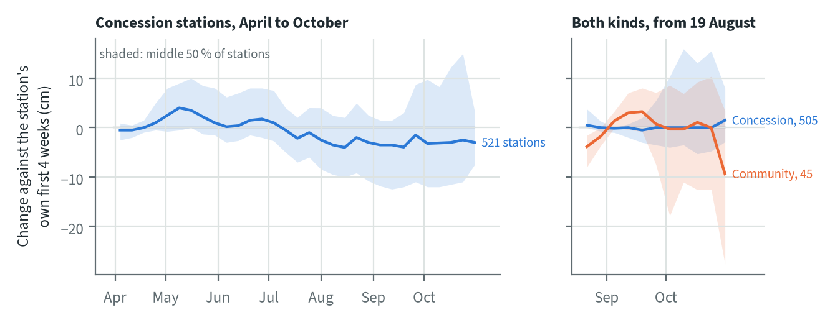
Figure 3.1. Change in water level since the start, median of the panel stations against each station's own first 4 weeks, with the middle 50 % of stations shaded. Left: concession stations, 1 April to 22 October 2026. Right: concession and community stations from 19 August. Source: SiTMAT, April to October 2026
The share of concession panel stations below -40 cm moved with the season more than the median did. It was 33 % in the first two weeks of April, fell to 5 % in the week from 20 May, rose to 48 % in the week from 29 July, and was 35 % in the last two weeks. Very few concession stations went below -80 cm: 2 % at the start and 3 % at the end. Among community stations, 83 % were below -40 cm and 56 % below -80 cm in the first two weeks from 19 August, and 72 % and 47 % in the last two weeks.
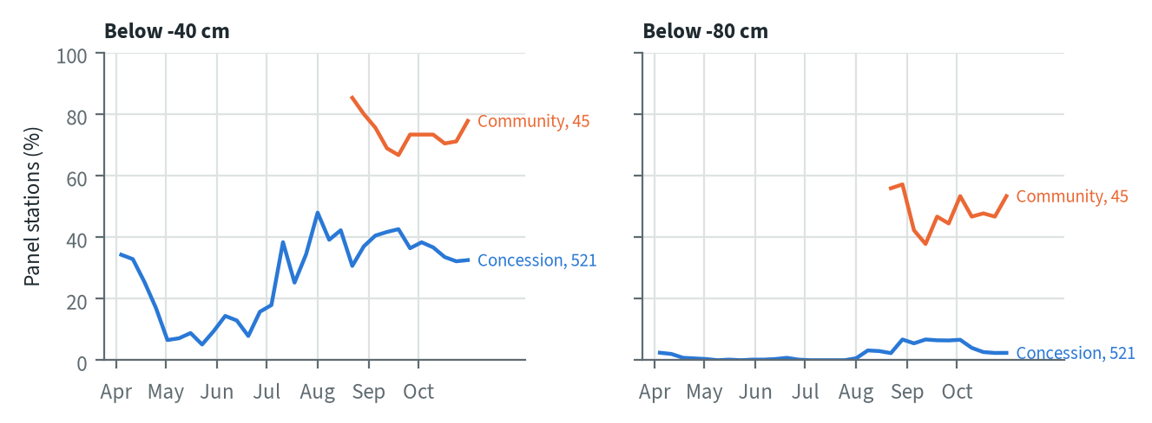
Figure 3.2. Share of panel stations with a weekly median below -40 cm and below -80 cm, concession stations from 1 April and community stations from 19 August 2026; end labels give the number of panel stations. Source: SiTMAT, April to October 2026
The duration curves show where the change happened. In concessions, 16 % of the daily readings were below -40 cm from 1 April to 7 June, against 41 % from 16 August to 22 October; below -80 cm the shares were 1 % and 5 %. The curves hardly differ above -40 cm: water management keeps most of the concession readings in a narrow band near the limit, and the dry season pushes the deepest third of the readings below it. The community curves for 19 August to 8 September and for 2 to 22 October lie on top of each other, with three quarters of the readings below -40 cm in both.
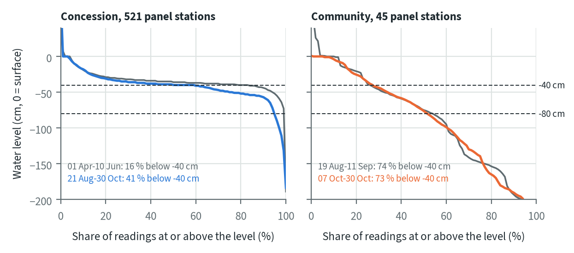
Figure 3.3. Duration curves of the daily water level of the panel stations, first third against last third of the window (share of readings at or above each level), with the -40 cm and -80 cm lines. Left: concession, 1 April to 22 October 2026. Right: community, 19 August to 22 October. Source: SiTMAT, April to October 2026
A weekly median does not show how long a station stays below the limit. Of the 525 concession panel stations, 112 never went below -40 cm. For the others the median longest run below -40 cm was 23 days; 76 stations stayed below for more than 60 days in a row and 61 for more than 90 days.
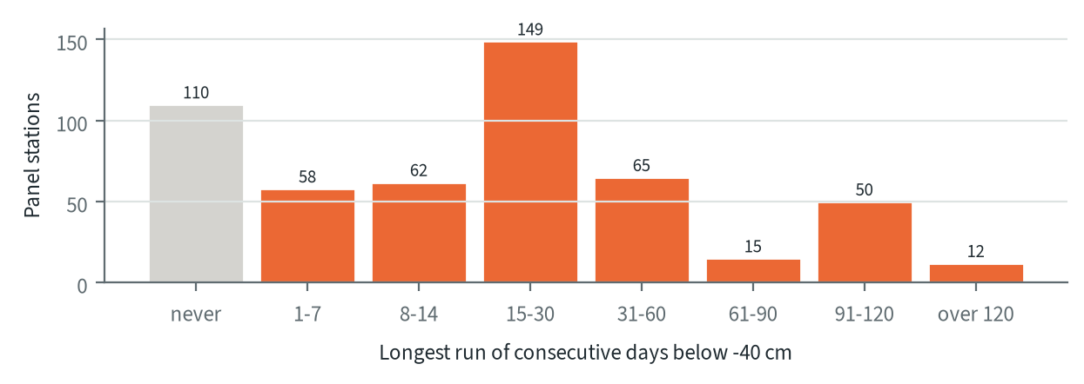
Figure 3.4. Longest run of consecutive days below -40 cm per concession panel station, 1 April to 22 October 2026 (gaps of up to 2 days do not break a run). Source: SiTMAT, April to October 2026

Where the water table fell
Four provinces carry the drawdown in concessions. In Kalimantan Tengah the provincial median fell by 1.14 cm per week (28.5 cm since the start), and the share of stations below -40 cm rose from 15 % to 56 %. In Sumatera Selatan the median fell by 0.59 cm per week (12.0 cm), and the share below -40 cm rose from 19 % to 85 %. Jambi and Kalimantan Barat fell by about 0.25 cm per week. In Jambi 98 % of the panel stations fell significantly, yet the median level ended at -40 cm. Riau, with 221 of the 525 panel stations, shows no trend.
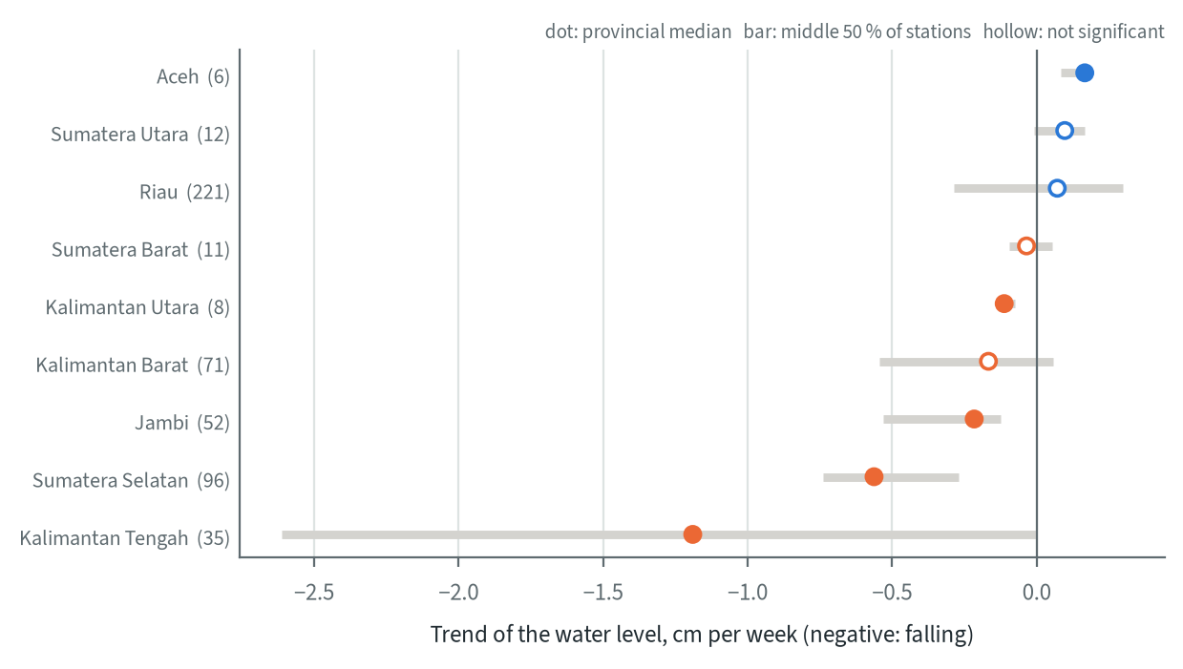
Figure 3.5. Trend of the water level per province, concession panel stations, 1 April to 22 October 2026: Theil-Sen slope of the provincial median change (filled: significant at 95 %) and the middle 50 % of the station trends; provinces with at least 5 panel stations, panel stations in brackets. Source: SiTMAT, April to October 2026
Table 3.4. Water table per province, concession stations, 1 April to 22 October 2026
Province | Concession stations (panel) | Level now (cm) | Change since start (cm) | Trend (cm per week) | Below -40 cm, start / now (% of stations) | Stations clearly falling (%) | Community stations
Kalimantan Tengah | 129 (35) | -81 | -26.5 | -1.19* | 15 / 78 | 69 | 2
Sumatera Selatan | 144 (96) | -50 | -11.2 | -0.56* | 19 / 82 | 76 | 4
Jambi | 86 (52) | -40 | -5.3 | -0.22* | 1 / 28 | 98 | 14
Kalimantan Barat | 186 (71) | -38 | +5.9 | -0.17 | 43 / 27 | 54 | 1
Kalimantan Utara | 21 (8) | -35 | -2.9 | -0.11* | 0 / 0 | 38 | 4
Sumatera Barat | 22 (11) | -23 | +8.0 | -0.03 | 0 / 0 | 27 | 2
Riau | 398 (221) | -31 | +18.2 | +0.07 | 36 / 19 | 24 | 7
Sumatera Utara | 82 (12) | -30 | +1.4 | +0.10 | 10 / 0 | 0 | 4
Aceh | 21 (6) | -27 | +9.2 | +0.17* | 12 / 0 | 0 | 7
Level now: median of the last 4 weekly medians of all reporting stations. Change: median of the panel, last 4 weeks against each station's first 4 weeks. Trend: Theil-Sen slope of that median; * = Mann-Kendall significant at 95 %. Start / now: first 2 and last 2 weeks. Clearly falling: station trend significant and negative.
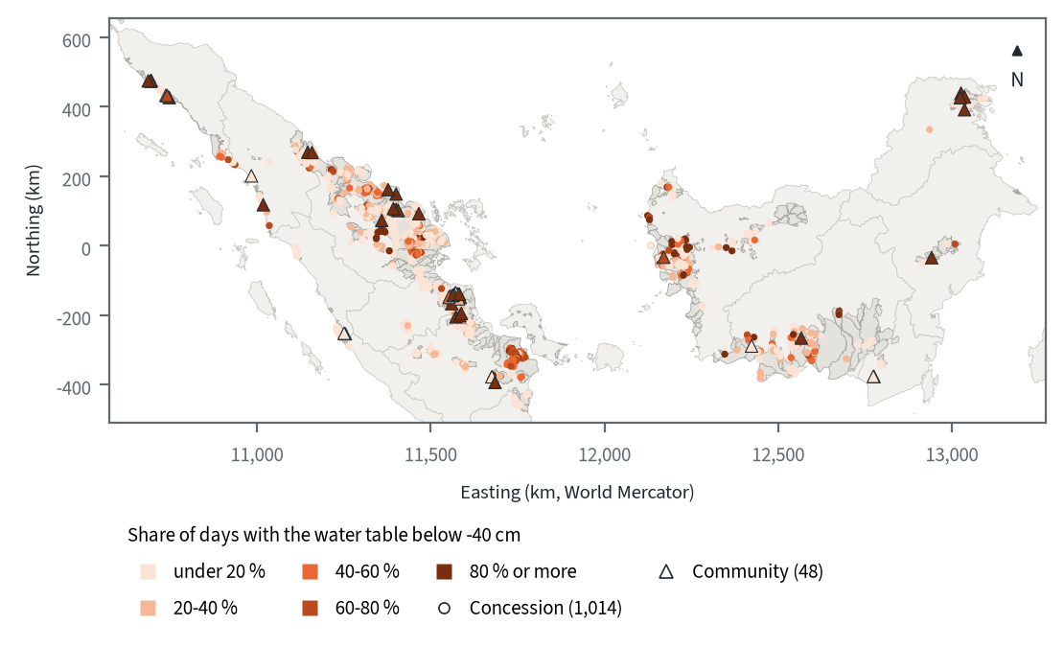
Figure 3.6. SiTMAT stations in Sumatra and Kalimantan by share of days with the water table below -40 cm: concession stations (circles), 1 April to 22 October 2026, and community stations (triangles), 19 August to 22 October; stations with at least 20 valid days. KHG boundaries in grey. Source: SiTMAT, April to October 2026; KHG map 2017

Managed land and community land
Concession stations and community stations describe two different situations. Over the common window from 19 August, the median concession station did not change (0.0 cm) and neither did the median community station (+0.3 cm, not significant). The difference is one of level. In the first and the last two weeks of that window, 38 % and 43 % of the concession stations were below -40 cm, against 83 % and 72 % of the community stations.
The 18 KHG that hold both kinds of station make the comparison inside one hydrological unit. Mean concession levels range from -61.9 cm to -28.8 cm. In 14 of the 18 KHG the community stations are deeper, by a median of 86 cm in those 14, and in 11 KHG the community mean is below -100 cm. Many of these points rest on one or two community stations (36 community against 184 concession stations in all), so a single KHG point shows the direction of the difference more reliably than its size.
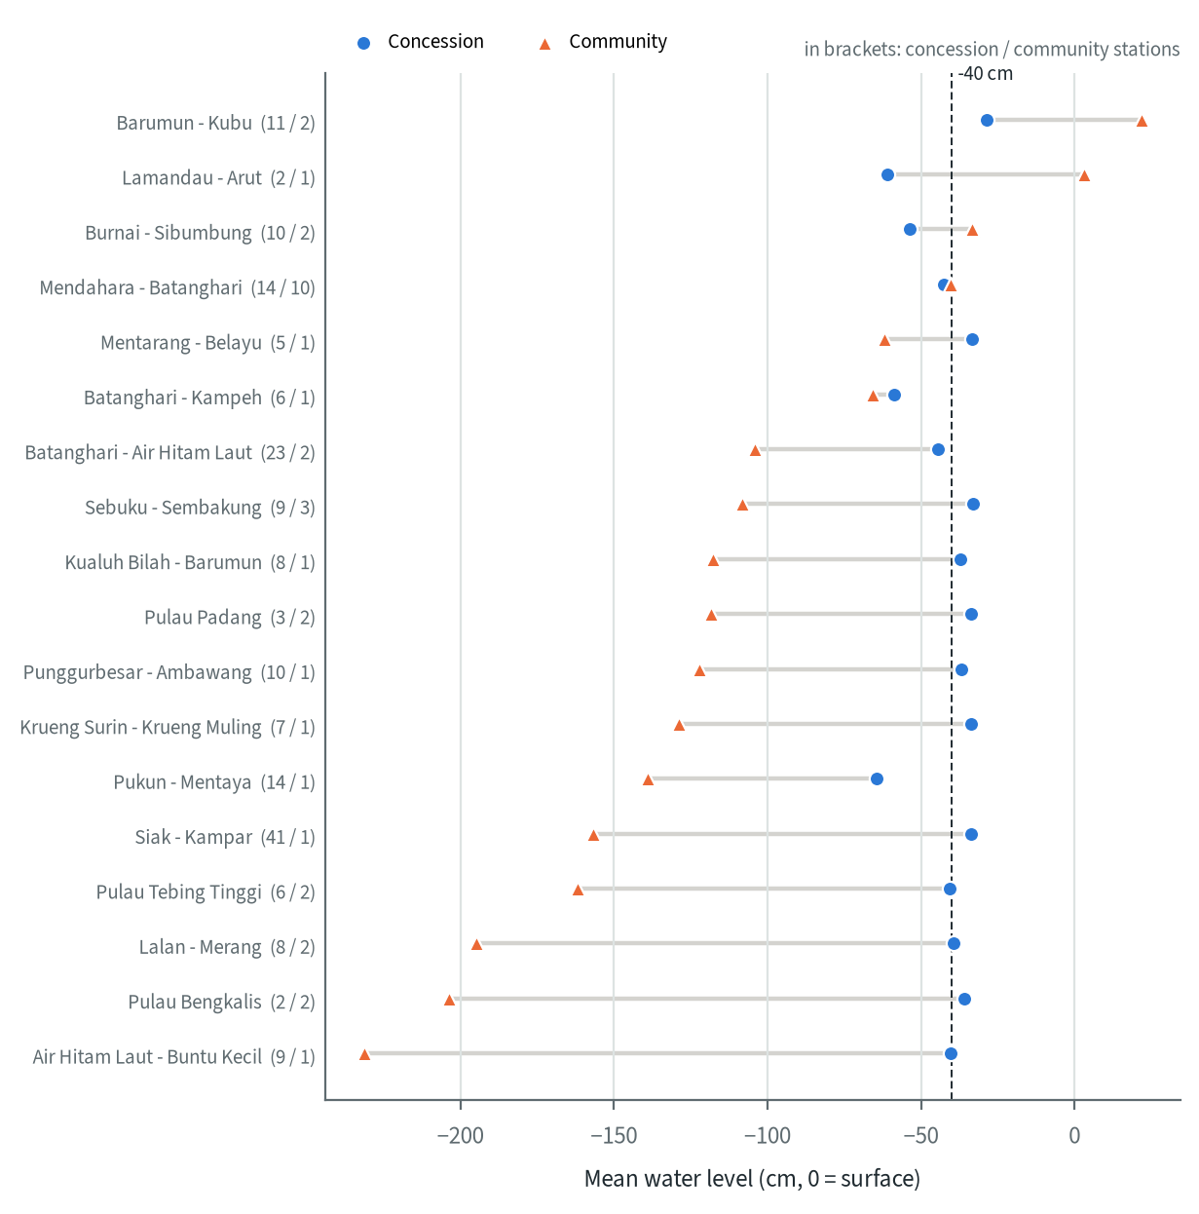
Figure 3.7. Mean water level of concession and community stations in the same KHG, 19 August to 22 October 2026, KHG with both kinds of station; numbers of concession and community stations in brackets. Source: SiTMAT, August to October 2026
Concessions also differ among themselves. Of the 122 concessions with at least three stations, the median concession had its water table below -40 cm on 11 % of the days, 27 never went below, 15 were below on half the days or more, and 6 on 80 % or more. The provincial medians run from 0 % in Kalimantan Utara and Sumatera Barat to 21 % in Sumatera Selatan and 27 % in Kalimantan Tengah. Concessions are shown here as a distribution; the report does not name them.
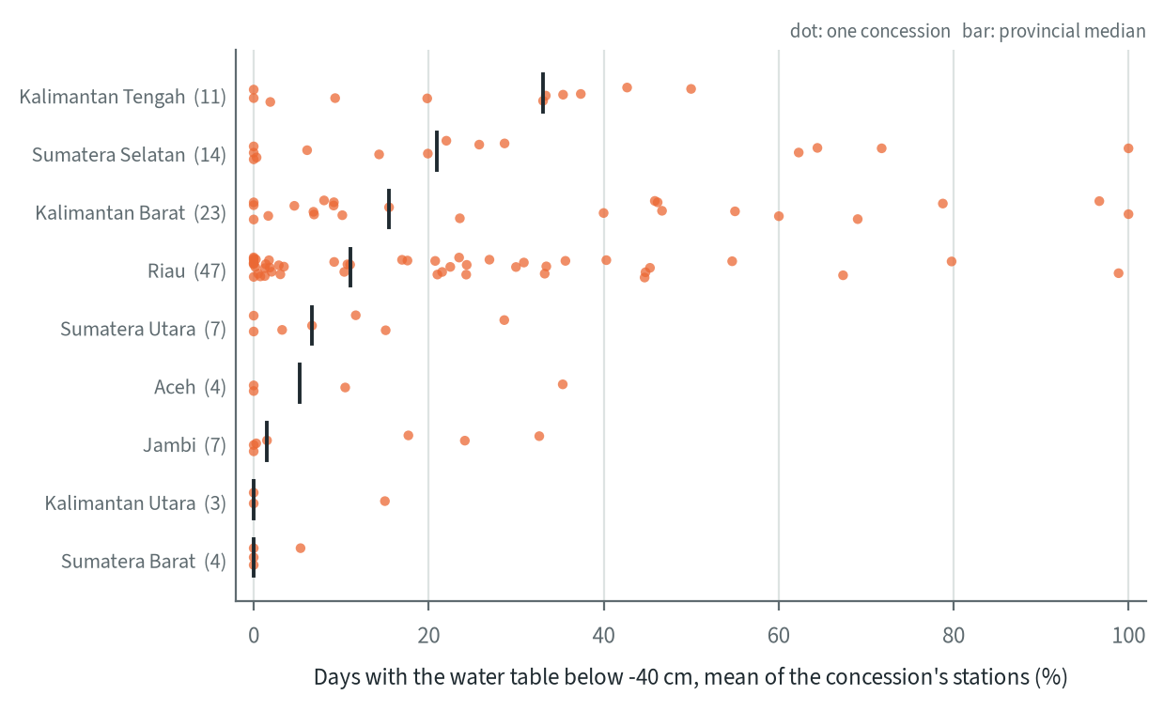
Figure 3.8. Share of days with the water table below -40 cm per concession (mean of its stations with at least 20 valid days; concessions with at least 3 stations), by province, 1 April to 22 October 2026; number of concessions in brackets. Concessions are not named. Source: SiTMAT, April to October 2026

Coverage of the selected KHG
Station coverage of the selected KHG is uneven. Sugihan-Lumpur has 54 concession stations and no community station; its panel of 51 stations fell by a median of 14.6 cm from April to October (the station mean over the dry-season deficit window of chapter 8 fell about 11 cm), and its stations spent 60 % of the days below -40 cm. Mendahara-Batanghari has 15 concession and 10 community stations with data. Its concession panel fell by 4.8 cm and its community panel by 4.7 cm from 19 August (on the screened record of the 6 community stations off canal cells used in chapter 8, the fall from 19 August to 30 September is 11 cm), but the community stations spent 49 % of the days below -40 cm against 13 % for the concession stations. Saleh-Sugihan, Mempawah-Peniti, Balangan-Batangalai and Buru Mappi-Buru Obaa have no station inside the KHG, so no station-based deficit can be computed for them.
Station counts in this report differ by date and filter: the deficit at Sugihan-Lumpur uses 51 stations, and the groundwater model scores 33 that are not on canal or edge cells.
Table 3.5. SiTMAT stations in the selected KHG: concession stations and panel, change since the start, share of days below -40 cm (concession 1 April to 22 October 2026, community from 19 August)
KHG | Concession stations (panel) | Change since start, concession (cm) | Days below -40 cm, concession (%) | Community stations | Days below -40 cm, community (%)
Sugihan - Lumpur | 54 (51) | -13.4 | 61 | - | -
Mendahara - Batanghari | 15 (11) | -4.6 | 13 | 10 | 50
Air Hitam Laut - Buntu Kecil | 9 (5) | -9.1 | 25 | 1 | 100
Pulau Tebing Tinggi | 6 (5) | -9.0 | 24 | 2 | 99
Kapuas - Barito | 6 (0) | - | 0 | - | -
Pungurbesar - Kapuas | 5 (3) | -78.6 | 49 | - | -
Pulau Padang | 3 (0) | - | 1 | 2 | 98
Pulau Bengkalis | 2 (2) | +9.9 | 25 | 2 | 99
Kahayan - Sebangau | 1 (0) | - | 37 | - | -
Saleh - Sugihan | - | - | - | - | -
Mempawah - Peniti | - | - | - | - | -
Balangan - Batangalai | - | - | - | - | -
Buru Mappi - Buru Obaa | - | - | - | - | -
Stations with at least one weekly median. Change: median of the panel stations, last 4 weeks against each station's first 4 weeks. '-' = no station.
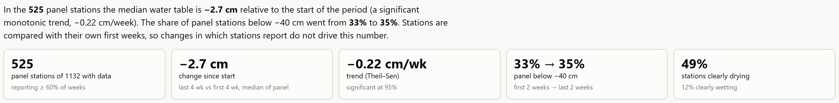
Figure 3.9. The SiTMAT explorer, a page built for this project from the SiTMAT records: headline figures of the concession panel at the default settings, which match the analysis above. Filters set the station kind, province, regency, KHG, dates and panel rules. Source: SiTMAT, April to October 2026

3.5 DPG and DMPG villages
The World Bank asked whether villages of the peat-care village programme (Desa Peduli Gambut, DPG; renamed Desa Mandiri Peduli Gambut, DMPG, in 2020) are safe from fire and should count in the prioritisation. Three sources were available for the analysis:
- The Badan Restorasi Gambut atlas of DPG villages: one volume per province (Riau, Jambi, Sumatera Selatan, Kalimantan Barat, Kalimantan Tengah, Kalimantan Selatan) with participatory village boundary and land-tenure maps, and village index maps with a coordinate grid. The maps are images, without vector data.
- A list of the 244 villages in the atlas, extracted from the atlas volumes: Riau 40, Jambi 26, Sumatera Selatan 40, Kalimantan Barat 41, Kalimantan Tengah 74, Kalimantan Selatan 23. Mapping took place from June 2018 to July 2019. 177 of the 244 match a Bluebook 2026 target village by village and district name.
- A village boundary file for the atlas villages, built by the project. Each atlas village was matched by name to the KLH village boundaries of 2023, which are the closest in time to the atlas. Village boundaries from BIG (June 2026 edition) were the fallback for villages without a match. Names were compared ignoring case, spaces and punctuation, from exact matches down to close spellings within the same sub-district or district. 243 villages matched in the 2023 boundaries: 224 exactly, 8 with a different sub-district spelling, 1 in another district, 2 as the leading words of a longer name and 8 by close spelling. The one unmatched village, Ampaian Rotan Makmur, is absent from the BIG 2026 boundaries too. The 177 villages that are also target villages have identical polygons.
The atlas holds none of the villages added to the programme later, and its boundaries are approximate: they come from 2023 administrative boundaries, not from the participatory maps.
A national DMPG layer, published on the SiTMAT portal of KLH, was obtained on 28 October 2026. It holds 838 village boundaries in ten provinces, with the programme of each village (DMPG, or DMPG and DMPM for 77 villages) and its support history: the year and source of each round, for example 2018 Kemitraan followed by 2022 APBN. By the first round, 75 villages entered in 2017, 187 in 2018, 132 in 2019, 245 in 2020 and 183 from 2021 to 2024, and 16 have no year; 483 were first funded from the state budget (APBN), 143 through partnerships and 212 by other partners or programmes. Of the 244 atlas villages, 224 are in this layer by village and district name, and for matched villages the two boundaries coincide (median overlap 1.00). The analyses in this report still use the 244 atlas villages; the national layer supersedes them for later work. DPG and DMPG villages are context on the national overlays and are not scored.
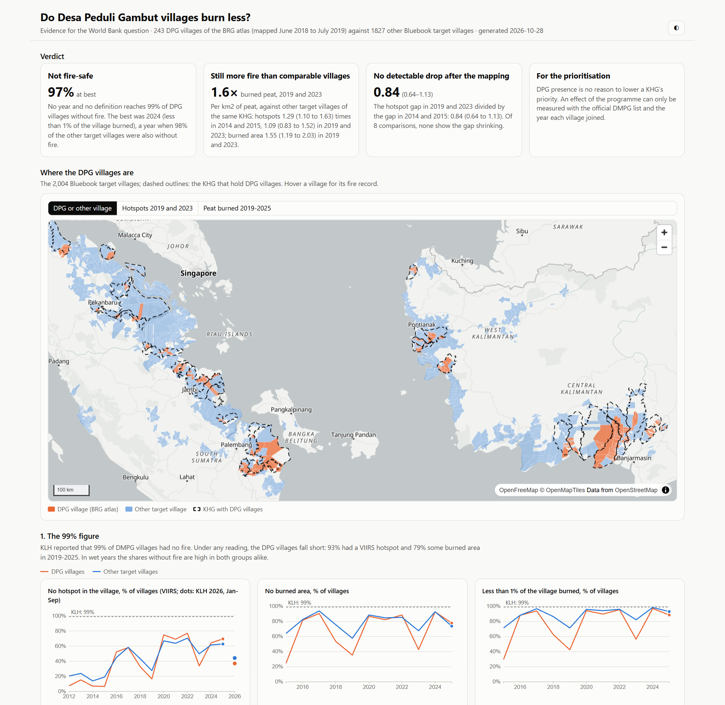
Figure 3.10. The DPG village page prepared for the World Bank question on peat-care villages: atlas villages with their boundaries, hotspots and burned area. Source: BRG atlas, KLH 2023 village boundaries, VIIRS hotspots, burned area 2015-2025

3.6 The selected KHG
The detailed work covers 12 main KHG, with two reserves, Pulau Tebing Tinggi and Sugihan-Lumpur (Table 2.1). Each name was matched to the official KHG boundaries. Three needed interpretation: "Menpanwah" was read as Mempawah (KHG Sungai Mempawah - Sungai Peniti, 51,045 ha), "Kahayan-Barito" was corrected to Kapuas-Barito (558,168 ha), and Buru Mappi - Buru Obaa (402,643 ha) was chosen over the reversed pair Buru Obaa - Buru Mappi (98,805 ha). No KHG is named Cawang-Lalang. The nearest is KHG Air Banyuasin - Air Lalang (60,758 ha); it is left out until the choice is confirmed. Kampar-Gaung, the earlier test site, is analysed with the selected KHG, which gives 14 KHG in all.

3.7 Data readiness per selected KHG
Table 3.6. Data available per selected KHG: LiDAR DTM and its coverage, modelled DTM, DEMNAS, contours, modelled peat depth and its coverage, canals, rivers, existing infrastructure, proposed canal blocks (Bluebook 2026, targets, not built) and SiTMAT stations. Source: per-KHG data recap of 25 October 2026
KHG | LiDAR DTM | Modelled DTM | DEMNAS | Contours | Peat depth (model) | Canals (OSM/BRGM) | Rivers (RBI) | Existing structures (BRGM), points | Proposed blocks, points | SiTMAT stations, n
Pulau Padang | 2 m, 100% | 12.4 m, 100% | 8.3 m, 100% | BRGM 2,942 km | 10 m, 81.1% | 1,169 km | - | 292 | BRGM 1556 | 6
Pulau Bengkalis | - | 12.4 m, 100% | 8.3 m, 100% | BRGM 5,282 km | 10 m, 72.6% | 1,867 km | 22 km | 205 | BRGM 5189 | 4
Pulau Tebing Tinggi | - | 12.4 m, 100% | 8.3 m, 100% | BRGM 3,148 km | 10 m, 79.3% | 1,341 km | 83 km | 382 | BRGM 1688 | 9
Saleh - Sugihan | 20 m, 61.9% | 12.4 m, 100% | jp2 8.3 m, 100% | LiDAR 25 cm 70,540 km | 10 m, 69.4% | 3,645 km | 32 km | 192 | BRGM 1285 | -
Sugihan - Lumpur | 25 m, 100% | 12.4 m, 100% | jp2 8.3 m, 100% | LiDAR 25 cm 23,861 km | 10 m, 74.7% | 14,229 km | 10 km | 2972 | LiDAR 11105 | 54
Mendahara - Batanghari | 25 m, 100% | 12.4 m, 100% | 8.3 m, 100% | LiDAR 25 cm 4,593 km | 10 m, 62.6% | 4,589 km | 101 km | 700 | LiDAR 3319 | 27
Air Hitam Laut - Buntu Kecil | 25 m, 100% | 12.4 m, 100% | jp2 8.3 m, 100% | LiDAR 25 cm 12,235 km | 10.1 m, 95.7% | 873 km | - | 238 | LiDAR 2400 | 10
Mempawah - Peniti | - | 12.4 m, 100% | 8.3 m, 100% | BRGM 12,672 km | 10 m, 54.3% | 4,919 km | 50 km | 264 | BRGM 22335 | -
Pungurbesar - Kapuas | - | 10 m, 100% | 8.3 m, 100% | BRGM 819 km | 10 m, 54.1% | 4,786 km | 96 km | 521 | BRGM 2611 | 5
Kahayan - Sebangau | - | - | 8.3 m, 100% | BRGM 5,580 km | - | 9,589 km | 169 km | 1333 | DEMNAS 32167 | 2
Kapuas - Barito | - | - | 8.3 m, 100% | BRGM 12,527 km | - | 5,825 km | 288 km | 254 | BRGM 3568 | 12
Balangan - Batangalai | - | 10 m, 100% | 8.3 m, 100% | BRGM 701 km | 10 m, 53.4% | 1,381 km | - | 112 | BRGM 1450 | -
Buru Mappi - Buru Obaa | - | - | - | BRGM 3,428 km | - | 31 km | 153 km | - | - | -
Air Banyuasin - Air Lalang | - | 12.4 m, 100% | jp2 8.3 m, 100% | BRGM 511 km | 10.1 m, 86.4% | 1,977 km | 29 km | 60 | BRGM 1434 | -
Rasters: finest product covering at least half the KHG, its resolution and the share of the KHG polygon it covers. jp2: DEMNAS Sumatra re-hosted as lossy JPEG2000. Proposed blocks: Bluebook 2026 targets, not built. Kampar-Gaung (test site) is not in the recap.
Table 3.7. Elevation models available for each KHG: product, resolution and share of the KHG covered. Source: DEM input preparation, October 2026
KHG | LiDAR (resolution, cover) | DeltaDTM (resolution, cover) | DEMNAS (resolution, cover)
Kampar - Gaung | 25 m, 99.8% | 30.92 m, 99% | 8.35 m, 100%
Pulau Bengkalis | - | 30.92 m, 99.3% | 8.35 m, 100%
Pulau Padang | not clipped | 30.92 m, 99.3% | 8.35 m, 100%
Pulau Tebing Tinggi | - | 30.92 m, 98.5% | 8.35 m, 100%
Air Hitam Laut - Buntu Kecil | 25 m, 100%; 25 m, 97% | 30.92 m, 99.9% | 8.35 m, 100%
Mendahara - Batanghari | 25 m, 100% | 30.92 m, 99.5% | 8.35 m, 100%
Saleh - Sugihan | 20 m, 98.3% | 30.92 m, 98.8% | 8.35 m, 100%
Sugihan - Lumpur | 20 m, 1.6%; 25 m, 100% | 30.92 m, 98.4% | 8.35 m, 100%
Mempawah - Peniti | - | 30.92 m, 99.7% | 8.35 m, 100%
Pungurbesar - Kapuas | - | 30.92 m, 99.8% | 8.35 m, 100%
Kapuas - Barito | - | 30.92 m, 99.5% | 8.35 m, 100%
Kahayan - Sebangau | - | 30.92 m, 99.8% | 8.35 m, 100%
Balangan - Batangalai | - | 30.92 m, 97.9% | 8.35 m, 100%
Buru Mappi - Buru Obaa | - | 30.92 m, 99.4% | 8.35 m, 99.4%
Cover: valid cells over KHG cells inside the clipped raster window. Chapter 4 gives the cover of the whole KHG polygon.
The recap shows four main gaps.
- LiDAR covers few KHG. Of the selected KHG, only Mendahara-Batanghari, Air Hitam Laut-Buntu Kecil, Saleh-Sugihan, Sugihan-Lumpur and Pulau Padang have a LiDAR DTM, all in Sumatra. No KHG in Kalimantan or Papua has one. Pulau Padang's 2 m LiDAR covers the whole KHG but is not used in the analysis chain, so Pulau Padang is analysed on DeltaDTM and DEMNAS. Every other KHG relies on the two corrected open DEMs.
- Modelled peat depth covers between 53 % (Balangan-Batangalai) and 96 % (Air Hitam Laut-Buntu Kecil) of the KHG where it exists, and is absent for Kahayan-Sebangau, Kapuas-Barito and Buru Mappi-Buru Obaa. There the peat-depth indicators carry weight 0.
- Water-table stations are missing at Saleh-Sugihan, Mempawah-Peniti, Balangan-Batangalai and Buru Mappi-Buru Obaa, and sparse at Kahayan-Sebangau (2 stations). A KHG deficit from stations cannot be computed where there are none.
- Buru Mappi-Buru Obaa in Papua Selatan has the least data of all: 31 km of mapped canals, no existing or proposed canal blocks, no peat depth, no stations and no LiDAR.
The recap is dated 25 October 2026, before DEMNAS sheets for every KHG were obtained (25 and 26 October), the remaining DeltaDTM areas (26 October) and the ICESat-2 points (27 and 28 October). For elevation the DEM input table supersedes the recap. It shows DEMNAS and DeltaDTM covering at least 97.9 % of every selected KHG, Buru Mappi-Buru Obaa included, where the recap lists no DEMNAS.
For the Saleh-Sugihan LiDAR the recap gives 61.9 % coverage and the DEM input table 98.3 %. The recap figure is correct: the DEM input table measures coverage only within the rectangular extent of the clipped LiDAR, not over the whole KHG. As a result the Saleh-Sugihan LiDAR passed the 90 % coverage threshold of the LiDAR variant although it covers about 62 % of the KHG (chapter 4), and the LiDAR results for Saleh-Sugihan describe only that part of the KHG.
Rivers from the RBI layer are missing at Pulau Padang, Air Hitam Laut-Buntu Kecil and Balangan-Batangalai. This affects delineation, where mapped rivers are fixed boundaries.

4 Terrain: DEM investigation

4.1 Why terrain matters
Each later step of the toolkit depends on a ground surface. The boundaries of the sub-KHG units within a KHG (Kesatuan Hidrologis Gambut, peat hydrological unit) follow the divides of the terrain, the neraca air (water balance) needs the slope towards the canals, and canal-block design needs the height drop along each canal. The design quantities are small. The water-table limit for peat is 0.4 m below the surface, and the head drop between two canal blocks is about 0.3 m. The relief of a peat dome is of the same order. In Block C of the former Mega Rice Project the dome slope is 1 to 2 m per km near the rivers and under 0.5 m per km in the centre (Ritzema et al. 2014). In the airborne LiDAR of the two benchmark KHG, the height difference between two points 1 km apart is only 0.46 m (Mendahara-Batanghari) and 0.38 m (Sugihan-Lumpur), as a root mean square.
A usable terrain model therefore has to get height differences right to a few decimetres over a kilometre. Absolute height matters much less, since a constant offset does not change slopes, divides or head drops. This chapter tests which available elevation source comes closest to that requirement, and what follows for KHG that have no LiDAR.

4.2 Candidate elevation sources
Table 4.1. Elevation sources tested. Source: DEM benchmark report (data table) and the metadata of each product
Source | Type | Grid used (m) | Origin and licence
Airborne LiDAR (KLHK) | Bare-earth terrain model | 20 to 25 | KLHK Direktorat Gambut archive, 2015-2024; flight dates and vertical datum not recorded
DEMNAS | Radar surface model blended with stereo mass points | 8 | Badan Informasi Geospasial (BIG), national sheets
KLHK modelled DTM | Terrain model, method not documented | 12 | KLHK Direktorat Gambut archive
Copernicus GLO-30 | Radar surface model (TanDEM-X, 2011 to 2015) | 30 | ESA Copernicus DEM, open data
FABDEM v1.2 | GLO-30 with forests and buildings removed by machine learning | 30 | Hawker et al. 2022; non-commercial licence
DeltaDTM v1.1 | GLO-30 corrected with ICESat-2 and GEDI, non-terrain cells removed; defined for land below 10 m above mean sea level | 30 | Pronk et al. 2024; CC BY 4.0

What DEMNAS is
DEMNAS is Indonesia's national elevation model on a 0.27 arc-second grid (about 8 m), with heights on the EGM2008 geoid. It is built from radar surface models (IFSAR and TerraSAR-X at 5 m, ALOS PALSAR at 11.25 m; Julzarika and Harintaka 2019), into which stereo-plotted mass points are merged (Susetyo et al. 2018; Susetyo 2023). The 2018 prototype used IFSAR and TerraSAR-X only, with mass points 20 to 50 m apart, denser on steep terrain and sparser on flat ground (Susetyo et al. 2018). On flat, forested peat domes the product therefore leans most on the radar surface, and so on the canopy that radar sees. From a profile comparison, Julzarika and Harintaka (2019) found DEMNAS "dominated by DSM" in a South Kalimantan sample, and in a Central Java sample in the form of neither a DSM nor a DTM.
All published accuracies are measured at control points on open, accessible ground, so they are a best case for peat forest.
Table 4.2. Published vertical accuracy of DEMNAS. Source: DEMNAS literature review of the project
Study | Area | Reference points | RMSE (m) | LE90 (m)
Susetyo et al. 2018 | Aceh to North Sumatra, prototype | 142 control points | 2.237 | 3.679
BIG portal, as quoted by Susetyo 2023 | Sumatra | control points | 2.79 | not given
Susetyo 2023 | Bogor, 30 to 2,000 m relief | 60 GPS pre-marks | 4.968 | 8.172

The figure of 8.17 m often quoted for DEMNAS is the LE90 of Susetyo (2023), which is 1.645 times the RMSE; the matching RMSE is 4.97 m. No published value shows sub-metre accuracy for DEMNAS anywhere.

4.3 Earlier tests against satellite ground heights
The satellite tests showed that the DEMNAS error differs from site to site and stays far above the head drop between canal blocks even after correction. Before LiDAR was available, DEMNAS was tested at three sites (a 15 km window in Sebangau, Mendahara and Bengkalis) against ground heights from the ICESat-2 laser altimeter (ATL08 product, 2019 to 2025), held out in 2 km spatial blocks. These tests set the method that the benchmark later used.
- The DEMNAS offset to the ground differs by site: the median DEM minus ground was -3.4 m at Sebangau, -0.03 m at Mendahara and +2.16 m at Bengkalis. At Sebangau, open land sat about 4 m below the satellite ground heights, which none of the published papers explains.
- The fitted share of canopy height left in DEMNAS under tree cover was 0.10 (Mendahara), 0.21 (Bengkalis) and about 0.05 (Sebangau), far below the 0.8 assumed at the start. Using 0.8 would have made Mendahara worse than the raw DEM (RMSE 5.9 m against 2.6 m).
- After calibration and smoothing, RMSE at held-out ICESat-2 points was 1.24 m (Sebangau window), 2.32 m (Mendahara) and 2.78 m (Bengkalis), in the range of the published accuracy. No site met the 0.25 m target of the original methodology.
- The error of height differences over 1 to 2 km was 1.16, 1.88 and 2.55 m root mean square at the three sites, and it kept growing out to 8 km. The error behaves as a regional tilt, which more smoothing does not remove.
- GEDI ground heights were also tried as a second calibration source. Against the LiDAR they scatter by 4.06 m (Mendahara) and 5.02 m (Sugihan-Lumpur) as NMAD, against 0.67 and 0.63 m for ICESat-2, so GEDI is not used for calibration under peat forest.
- On the 2 m LiDAR of Pulau Padang (flown November 2016), smoothed DEMNAS had a height-difference error of 1.67 m over 1 km and 2.08 m over 2 km, too coarse to resolve a 0.3 m head drop between blocks. These figures include a sub-cell misregistration of the surfaces that was corrected afterwards; in a later check it accounted for 0.25 m NMAD.
Over the whole Kahayan-Sebangau KHG (22,422 usable ICESat-2 points), calibrated DEMNAS and FABDEM came out level: 2.14 and 2.19 m root mean square over 1 to 2 km. FABDEM did slightly better on open and degraded peat (0.91 against 1.02 m) and in mangrove (2.39 against 3.79 m). FABDEM and GLO-30 cover the KHG wall to wall, while the DEMNAS tile supplied for that test covered only a diagonal strip.

4.4 Correction method
The DEM correction turns a surface model into a ground estimate and smooths it to the scale of a peat dome. It works on the native grid of each product.
1. The DEM is mosaicked, clipped to the KHG plus 500 m, and projected to the local UTM zone.
2. Land cover (ESA WorldCover 2021, 10 m) and canopy height (Meta/WRI global canopy height) are taken for the same area. Canopy below 2 m counts as zero and canopy above 60 m is clipped.
3. ICESat-2 ATL08 ground segments of 100 m (2019 to 2025, at least 10 ground photons) are converted from ellipsoidal heights to EGM2008. Points in water or built-up land, within 50 m of a land-cover change, or more than 30 m from the DEM are dropped.
4. The points are split into calibration and validation sets by 2 km blocks, with 30% held out, because neighbouring points along one track are nearly identical.
5. For each land-cover class with at least 30 points under canopy of 2 m or more, a robust line is fitted: DEM minus ground = offset + k × canopy height. Both the offset and the canopy factor k (bounded 0 to 1) are fitted per class. Classes with fewer points keep the prior k and a single offset fitted on all low-canopy points.
6. The corrected surface is DEM minus k × canopy height minus offset. Water and built-up cells are masked, and cells more than 2.5 m from a 400 m local median are removed as spikes.
7. The surface is smoothed with a 300 m median and then a 150 m gaussian, and gaps are filled. Errors are reported at the held-out points.
Two parameter sets are used, the same as in the benchmark.
- DeltaDTM is processed at 30 m. Its prior canopy factor is 0 for every class, because it is already a terrain model. The fit still runs, and the fitted k came out between 0 and 0.007 at Mendahara-Batanghari and Kampar-Gaung, so in practice only the per-class offsets act.
- DEMNAS is processed at 8 m with prior canopy factors of 0.8 for tree cover and mangrove, 0.5 for shrubland, 0.4 for herbaceous wetland and 0.2 for grassland and cropland. The fit replaces them where a class has enough points. At Mendahara-Batanghari it fitted k = 0.087 for tree cover and 0.30 for mangrove. Shrubland, grassland, cropland and wetland had too few points under canopy and kept their priors, which the earlier tests do not support.

4.5 LiDAR benchmark design
The KLHK LiDAR made a direct test possible. Five sources were benchmarked at the two KHG that it covers fully, each scored as delivered and again after the correction above. The LiDAR served only as the reference and never entered a fit; the calibration used ICESat-2 alone.
Table 4.3. Benchmark sites. Source: DEM benchmark report
KHG | Area (km²) | LiDAR reference | LiDAR cells inside the KHG | Real 1 km height difference (m RMS) | ICESat-2 ATL08 points
Sungai Mendahara - Sungai Batanghari | 2,012 | KLHK, 25 m (Jambi) | 3,219,296 | 0.46 | 68,979
Sungai Sugihan - Sungai Lumpur | 6,347 | KLHK, 25 m (OKI) | 10,151,210 | 0.38 | 266,462

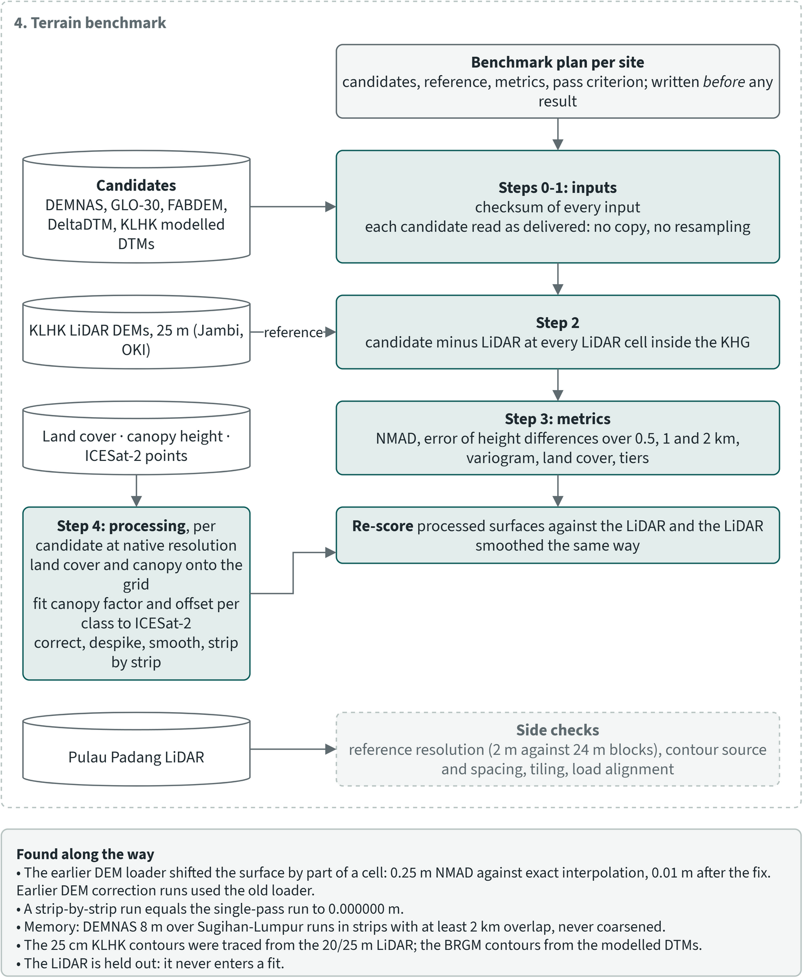
Figure 4.1. DEM benchmark workflow, part 1: the terrain benchmark against LiDAR, steps 0 to 4
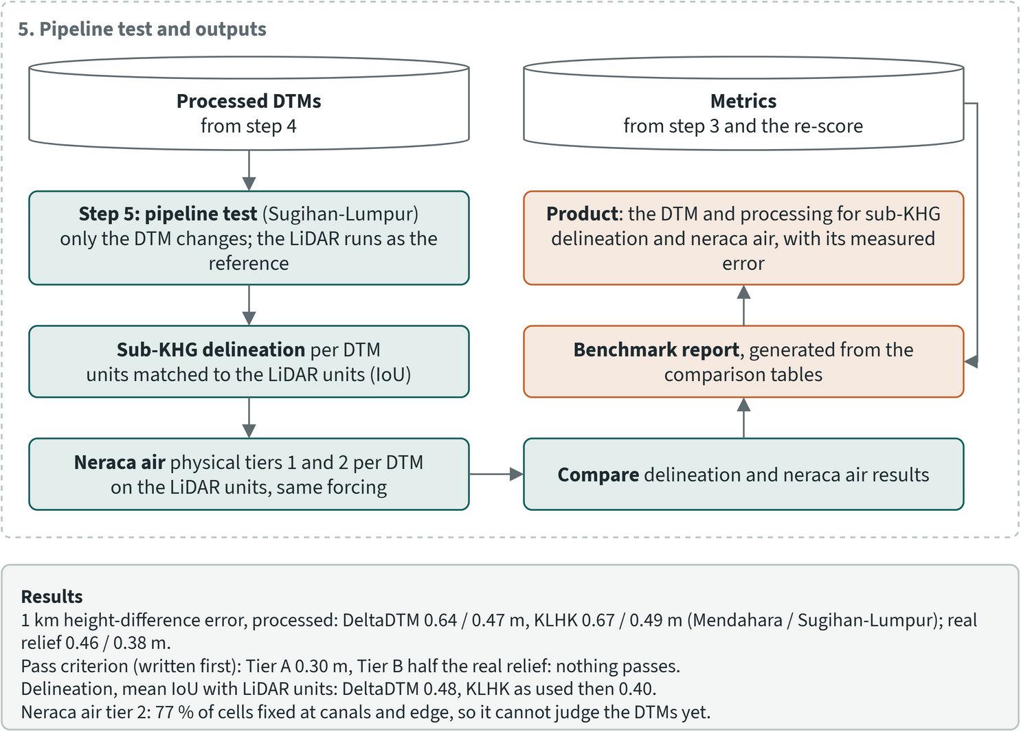
Figure 4.2. DEM benchmark workflow, part 2: test on the sub-KHG delineation and results
Each candidate was compared with the LiDAR at every LiDAR cell inside the KHG, without resampling the candidate. The main metric is the error of height differences: for all pairs of cells 0.5, 1 and 2 km apart, the difference in height in the candidate is compared with the difference in the LiDAR, and the root mean square of that error is reported. A constant offset does not affect it. The NMAD of candidate minus LiDAR is reported alongside.
The pass criterion was fixed before any result was computed. Tier A requires an error of height differences over 1 km of at most 0.30 m, one canal-block head drop. Tier B requires at most half the real 1 km height difference of that site's LiDAR.
All processed candidates sit +0.6 to +1.0 m above the LiDAR. The flight dates and vertical datum of the LiDAR were never recorded, so this offset cannot be assigned to either side. It does not affect the metrics.

Is a 25 m reference fine enough?
A 25 m reference keeps the dome-scale relief that the water balance needs and loses detail at the scale of canals. This was tested by averaging the 2 m LiDAR of Pulau Padang into 24 m blocks. Inside a block the heights vary by a median standard deviation of 0.05 m, and 5% of the blocks hold more than 1 m of relief (canals, ditches and embankments). Between blocks 1 km apart, the real height difference is 1.35 m root mean square.

4.6 Benchmark results
Processed DeltaDTM came closest to the LiDAR at both sites, with an error of 0.64 m (Mendahara) and 0.47 m (Sugihan-Lumpur) over 1 km. The KLHK modelled DTM was second, at 0.67 and 0.49 m. DEMNAS, FABDEM and GLO-30 stayed between 1.66 and 2.49 m after processing. No source passed Tier A or Tier B at either site: the best errors are still larger than the real 1 km relief of the LiDAR (0.46 and 0.38 m).
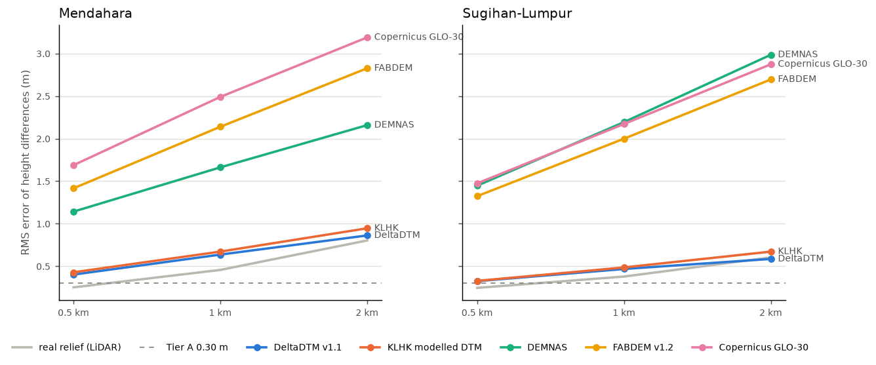
Figure 4.3. Error of height differences between LiDAR cells 0.5, 1 and 2 km apart, after processing (lower is better); grey is the real height difference in the LiDAR, dashed is Tier A. Source: DEM benchmark, Mendahara-Batanghari and Sugihan-Lumpur
Table 4.4. Error of each source against the LiDAR, as delivered and after processing. Source: DEM benchmark report (metrics against 25 m KLHK LiDAR)
Site | Source | State | NMAD (m) | Δh error 0.5 km (m) | Δh error 1 km (m) | Δh error 2 km (m)
Mendahara | DeltaDTM v1.1 | as delivered | 0.68 | 0.54 | 0.74 | 0.94
Mendahara | DeltaDTM v1.1 | processed | 0.64 | 0.40 | 0.64 | 0.86
Mendahara | KLHK modelled DTM | as delivered | 1.10 | 0.61 | 0.80 | 1.05
Mendahara | KLHK modelled DTM | processed | 1.07 | 0.43 | 0.67 | 0.95
Mendahara | DEMNAS | as delivered | 2.12 | 2.70 | 2.94 | 3.25
Mendahara | DEMNAS | processed | 1.60 | 1.14 | 1.66 | 2.16
Mendahara | FABDEM v1.2 | as delivered | 1.58 | 2.31 | 2.84 | 3.40
Mendahara | FABDEM v1.2 | processed | 1.43 | 1.42 | 2.14 | 2.83
Mendahara | Copernicus GLO-30 | as delivered | 3.10 | 3.54 | 4.08 | 4.69
Mendahara | Copernicus GLO-30 | processed | 2.09 | 1.69 | 2.49 | 3.19
Sugihan-Lumpur | DeltaDTM v1.1 | as delivered | 0.49 | 0.45 | 0.56 | 0.66
Sugihan-Lumpur | DeltaDTM v1.1 | processed | 0.46 | 0.33 | 0.47 | 0.59
Sugihan-Lumpur | KLHK modelled DTM | as delivered | 0.71 | 0.35 | 0.49 | 0.66
Sugihan-Lumpur | KLHK modelled DTM | processed | 0.70 | 0.33 | 0.49 | 0.67
Sugihan-Lumpur | DEMNAS | as delivered | 3.21 | 2.89 | 3.46 | 4.15
Sugihan-Lumpur | DEMNAS | processed | 2.28 | 1.45 | 2.19 | 2.98
Sugihan-Lumpur | FABDEM v1.2 | as delivered | 2.44 | 2.10 | 2.65 | 3.29
Sugihan-Lumpur | FABDEM v1.2 | processed | 2.10 | 1.32 | 2.00 | 2.69
Sugihan-Lumpur | Copernicus GLO-30 | as delivered | 3.21 | 2.92 | 3.47 | 4.12
Sugihan-Lumpur | Copernicus GLO-30 | processed | 2.20 | 1.47 | 2.17 | 2.87

The correction helps the surface models most, because it removes part of the canopy. DEMNAS improved from 2.94 to 1.66 m at Mendahara and from 3.46 to 2.19 m at Sugihan-Lumpur. DeltaDTM and the KLHK modelled DTM are already terrain models and gained little. For every source the error grows with distance, so what remains is a regional tilt or bow in the surface.
Heavier smoothing does not change this conclusion. With a 1,200 m median and 600 m gaussian, DeltaDTM scored 0.450 m at Mendahara and 0.319 m at Sugihan-Lumpur over 1 km. A perfectly flat surface scores the LiDAR's own relief there, 0.457 and 0.379 m, so at that smoothing DeltaDTM is barely better than assuming the land is flat.
Table 4.5. NMAD of processed source minus LiDAR by land-cover class (classes with at least 2% of the LiDAR cells). Source: DEM benchmark report; land cover from ESA WorldCover
Site | Land cover | Share of LiDAR cells | DeltaDTM (m) | KLHK modelled (m) | DEMNAS (m)
Mendahara | tree cover | 82% | 0.62 | 1.15 | 1.70
Mendahara | shrubland | 6% | 0.66 | 0.46 | 0.91
Mendahara | grassland | 8% | 0.69 | 0.90 | 1.18
Mendahara | cropland | 2% | 0.71 | 1.01 | 1.68
Sugihan-Lumpur | tree cover | 49% | 0.45 | 0.72 | 2.65
Sugihan-Lumpur | shrubland | 8% | 0.45 | 0.52 | 1.36
Sugihan-Lumpur | grassland | 18% | 0.48 | 0.68 | 1.65
Sugihan-Lumpur | cropland | 19% | 0.40 | 0.71 | 3.05
Sugihan-Lumpur | mangroves | 4% | 0.40 | 0.41 | 2.85

DeltaDTM holds an NMAD of 0.40 to 0.71 m in every class. DEMNAS is worst under tree cover and cropland at Sugihan-Lumpur (2.65 and 3.05 m).
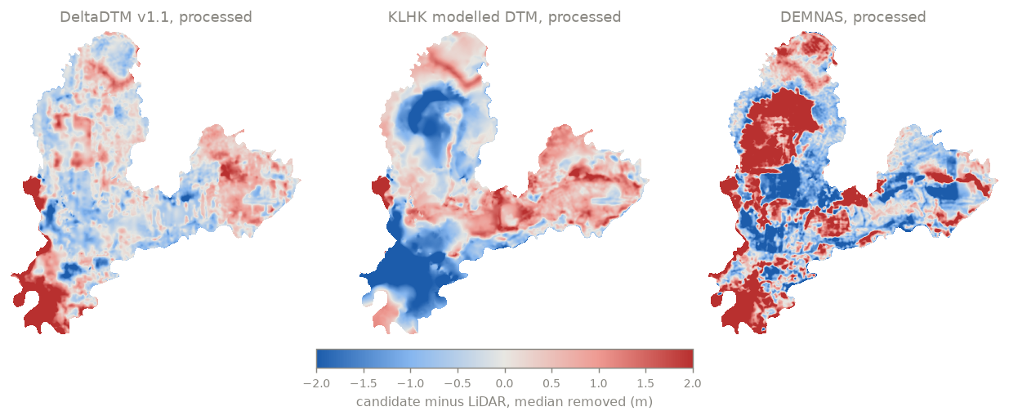
Figure 4.4. Mendahara-Batanghari: processed source minus LiDAR, median removed; blue is too low, red too high. Source: DEM benchmark
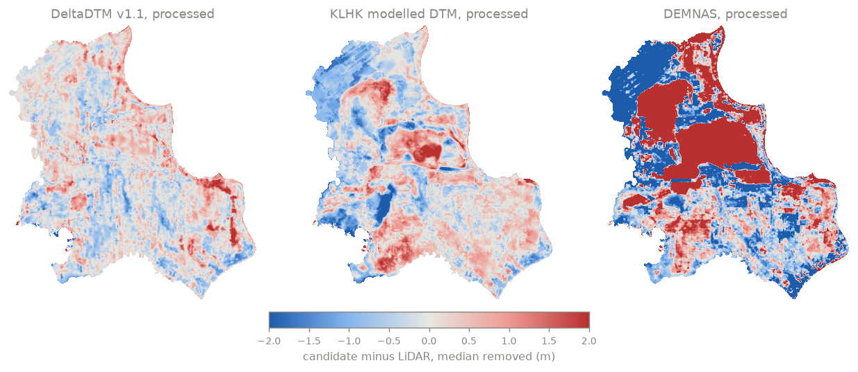
Figure 4.5. Sugihan-Lumpur: processed source minus LiDAR, median removed; blue is too low, red too high. Source: DEM benchmark

4.7 Effect on sub-KHG units
The choice of terrain changes the sub-KHG units, and no open source reproduces the LiDAR units well. At Sugihan-Lumpur the sub-KHG delineation (chapter 5) was repeated with only the terrain changed, and each set of units was compared with the units delineated from the LiDAR. For each LiDAR unit, the best-matching unit of the candidate is found and their intersection over union (IoU) computed. This test used primary canals and rivers as unit outlets, the setting in use at the time.
Table 4.6. Sub-KHG units at Sugihan-Lumpur by terrain source, primary canals and rivers as outlets. Source: DEM benchmark report, test on the sub-KHG delineation
Terrain | Sub-KHG units | Mean best-match IoU with LiDAR units | Median IoU | KHG area in matched overlap
LiDAR (reference) | 30 | 1.00 | 1.00 | 100%
KLHK modelled DTM, as first used in the delineation | 28 | 0.40 | 0.36 | 66%
KLHK modelled DTM, processed | 29 | 0.45 | 0.41 | 66%
DeltaDTM, processed | 30 | 0.48 | 0.47 | 70%
DEMNAS, processed | 30 | 0.38 | 0.34 | 58%
Flat surface (control) | 30 | 0.40 | 0.37 | 58%

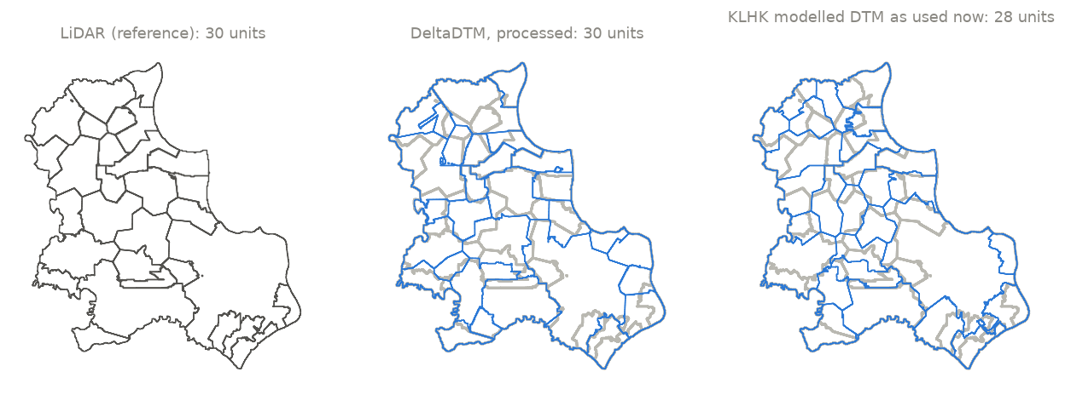
Figure 4.6. Sub-KHG units at Sugihan-Lumpur from the LiDAR, processed DeltaDTM and the KLHK modelled DTM, primary canals as outlets; grey lines are the LiDAR units. Source: DEM benchmark, test on the sub-KHG delineation
Processed DeltaDTM matched the LiDAR units best, but a mean IoU of 0.48 is a weak match, and a flat surface (0.40) did better than processed DEMNAS (0.38). The mapped rivers and canals are unit boundaries for every terrain, so part of the boundary network is the same in every case; the terrain decides how the pieces between those channels form and merge. With secondary canals added as outlets, as now adopted, all terrain sources agree more closely with the LiDAR (chapter 5).
The same test ran the groundwater model on each terrain. That model is in development. In its set-up at the time, 19,433 of its 25,391 cells (77%) were canal or edge cells with fixed heads, and it showed no skill at the water-table stations even on the LiDAR, so it could not tell the terrains apart.

4.8 Limits of the evidence
- There are two benchmark sites, both in the eastern Sumatra lowland, and one kind of reference: 25 m LiDAR of unknown date and datum.
- ICESat-2 (2019 to 2025) is newer than the LiDAR and the global models (GLO-30 is from TanDEM-X data of 2011 to 2015), so peat subsidence since then is part of the errors.
- Nothing records how the KLHK modelled DTM was made. If it was calibrated on the same LiDAR, its scores at these two sites are better than it would get elsewhere. This has not been tested.
- Part of the ICESat-2 data could not be read, so the calibration used slightly fewer points than exist.

4.9 Decision: one chain per DEM
No source passed the criterion, and the best one still has errors larger than the relief it must describe. The project therefore did not pick a single terrain. The whole analysis chain (sub-KHG delineation, neraca air, prioritisation and RE-PEAT Interventions) runs once per DEM:
- LiDAR as delivered, where it covers at least 90% of the KHG;
- DeltaDTM after the correction;
- DEMNAS after the correction.
The differences between the three results show how far a result depends on terrain. The Pulau Padang LiDAR is a 2 m DTM and is left out of the chain.
Table 4.7. DEM coverage of the selected KHG: share of the KHG with valid data per product. Source: DEM coverage assessment of the project
KHG | DEM | Resolution (m) | Cover of clip window (%) | Cover of KHG polygon (%) | Source
Kampar - Gaung | LiDAR | 25 | 99.8 | 99.8 | airborne LiDAR
Kampar - Gaung | DeltaDTM | 30.92 | 99.0 | 99.0 | DeltaDTM v1.1 via Earth Engine
Kampar - Gaung | DEMNAS | 8.35 | 100.0 | 100.0 | BIG DEMNAS
Pulau Bengkalis | DeltaDTM | 30.92 | 99.3 | 99.3 | DeltaDTM v1.1 via Earth Engine
Pulau Bengkalis | DEMNAS | 8.35 | 100.0 | 100.0 | BIG DEMNAS
Pulau Padang | LiDAR | 2 | - | 100.0 | airborne LiDAR
Pulau Padang | DeltaDTM | 30.92 | 99.3 | 99.3 | DeltaDTM v1.1 via Earth Engine
Pulau Padang | DEMNAS | 8.35 | 100.0 | 100.0 | BIG DEMNAS
Pulau Tebing Tinggi | DeltaDTM | 30.92 | 98.5 | 98.5 | DeltaDTM v1.1 via Earth Engine
Pulau Tebing Tinggi | DEMNAS | 8.35 | 100.0 | 100.0 | BIG DEMNAS
Air Hitam Laut - Buntu Kecil | LiDAR | 25 | 100.0 | 100.0 | airborne LiDAR
Air Hitam Laut - Buntu Kecil | DeltaDTM | 30.92 | 99.9 | 99.9 | DeltaDTM v1.1 via Earth Engine
Air Hitam Laut - Buntu Kecil | DEMNAS | 8.35 | 100.0 | 100.0 | BIG DEMNAS
Mendahara - Batanghari | LiDAR | 25 | 100.0 | 100.0 | airborne LiDAR
Mendahara - Batanghari | DeltaDTM | 30.92 | 99.5 | 99.5 | DeltaDTM v1.1 via Earth Engine
Mendahara - Batanghari | DEMNAS | 8.35 | 100.0 | 100.0 | BIG DEMNAS
Saleh - Sugihan | LiDAR | 20 | 98.3 | 61.9 | airborne LiDAR
Saleh - Sugihan | DeltaDTM | 30.92 | 98.8 | 98.8 | DeltaDTM v1.1 via Earth Engine
Saleh - Sugihan | DEMNAS | 8.35 | 100.0 | 100.0 | BIG DEMNAS
Sugihan - Lumpur | LiDAR | 25 | 100.0 | 100.0 | airborne LiDAR
Sugihan - Lumpur | DeltaDTM | 30.92 | 98.4 | 98.4 | DeltaDTM v1.1 via Earth Engine
Sugihan - Lumpur | DEMNAS | 8.35 | 100.0 | 100.0 | BIG DEMNAS
Mempawah - Peniti | DeltaDTM | 30.92 | 99.7 | 99.7 | DeltaDTM v1.1 via Earth Engine
Mempawah - Peniti | DEMNAS | 8.35 | 100.0 | 100.0 | BIG DEMNAS
Pungurbesar - Kapuas | DeltaDTM | 30.92 | 99.8 | 99.8 | DeltaDTM v1.1 via Earth Engine
Pungurbesar - Kapuas | DEMNAS | 8.35 | 100.0 | 100.0 | BIG DEMNAS
Kapuas - Barito | DeltaDTM | 30.92 | 99.5 | 99.5 | DeltaDTM v1.1 via Earth Engine
Kapuas - Barito | DEMNAS | 8.35 | 100.0 | 100.0 | BIG DEMNAS
Kahayan - Sebangau | DeltaDTM | 30.92 | 99.8 | 99.8 | DeltaDTM v1.1 via Earth Engine
Kahayan - Sebangau | DEMNAS | 8.35 | 100.0 | 100.0 | BIG DEMNAS
Balangan - Batangalai | DeltaDTM | 30.92 | 97.9 | 97.9 | DeltaDTM v1.1 via Earth Engine
Balangan - Batangalai | DEMNAS | 8.35 | 100.0 | 100.0 | BIG DEMNAS
Buru Mappi - Buru Obaa | DeltaDTM | 30.92 | 99.4 | 99.4 | DeltaDTM v1.1 via Earth Engine
Buru Mappi - Buru Obaa | DEMNAS | 8.35 | 99.4 | 99.4 | BIG DEMNAS
Clip window: valid cells over KHG cells inside the clipped raster window, the measure the chain's coverage gate reads. KHG polygon: valid cells over the whole KHG polygon, counted at native resolution. A LiDAR without a clip is measured on its source file.
Of the 14 KHG assessed for terrain coverage, the available LiDAR covers Kampar-Gaung, Air Hitam Laut-Buntu Kecil, Mendahara-Batanghari and Sugihan-Lumpur, part of Saleh-Sugihan, and Pulau Padang, which the chain leaves out. DeltaDTM covers 97.9 to 99.9% and DEMNAS 99.4 to 100% of each of them.
For a KHG without LiDAR, the chain gives two terrain variants and no reference. The benchmark points to processed DeltaDTM as the closer one, with a measured error of 0.47 to 0.64 m over 1 km at the two test sites. That error should be carried into the uncertainty of the neraca air, and unit boundaries should rest on the mapped rivers and canals. Heights that need decimetre accuracy, such as canal water levels, block crests and logger heads, have to come from GNSS or levelling. DeltaDTM is defined only for land below 10 m above mean sea level, so higher ground in a KHG falls outside its scope; its data licence is CC BY 4.0. FABDEM was not taken into the chain. Its licence is non-commercial (CC BY-NC-SA 4.0 at the University of Bristol, Non-Commercial Government Licence v2.0 on the mirror used), and it is not clear whether a KLH deliverable counts as non-commercial use.
The benchmark proposes three next steps: a trend correction from ICESat-2 (regression-kriging, aimed at the long-range part of the error), a test of the KLHK modelled DTM away from the LiDAR footprints, and a review of the fixed-head canal cells in the groundwater model before it is used to judge terrain.

5 Sub-KHG delineation

5.1 What a sub-KHG is and why it is needed
A KHG (Kesatuan Hidrologis Gambut, peat hydrological unit) is too large to plan rewetting as one block. The KHG treated in this chapter range from 1,897 km² (Saleh-Sugihan) to 7,111 km² (Kampar-Gaung). The national KHG map (SK.129/MENLHK/2017) defines no level below the KHG, and no regulation found sets one based on drainage.
The toolkit therefore splits each KHG into sub-KHG units. A sub-KHG is the land that drains to one stretch of outlet channel, bounded by water divides and by the outlet channels themselves. It is the spatial unit of the neraca air (water balance), of the sub-KHG prioritisation, and of the canal-block planning in RE-PEAT Interventions.
The approach follows the UGM team's 2021 study of the Kahayan-Sebangau KHG (Laporan Akhir KHG Kahayan-Sebangau 2021). That study fixed the sub-KHG boundaries first, to set the analysis unit of the water balance, because the KHG was too large for detailed simulation everywhere. It defined a sub-KHG outlet as a natural or artificial channel, usually a small river or a canal, that carries part of the water to the KHG outlet. It derived flow direction (D8) and Strahler stream order from a LiDAR DTM, filled with WorldDEM elsewhere, took channels of order 7 as outlets, and obtained 16 sub-KHG of 35.0 to 1,491.2 km² in a KHG of 4,508 km². A field check found that the modelled flow directions matched the field and that sub-KHG boundaries are wide outlet canals collecting the flow of neighbouring units. The published version (Cahyono et al. 2022) describes the sub-units as determined from streamlines, outlet channels, peat depth, slopes and network connectivity. The same team's Pulau Padang study of 2018 used the same approach and produced 11 units.
The nearest published precedent is Jaenicke et al. (2010), who delineated two sub-catchments of the Sebangau dome, named after their outlet rivers, from a 30 m DTM. Cobb et al. (2017) describe tropical peat domes as taking their shape "within a network of rivers or canals", which supports using the mapped channels as unit boundaries.

5.2 Method
The delineation applies the 2021 approach in the same way to any KHG. It takes a ground DTM, the mapped rivers and lakes, the canal network with its class, and the KHG polygon. The mapped channels set most of the unit layout, and the terrain places the divides between them.
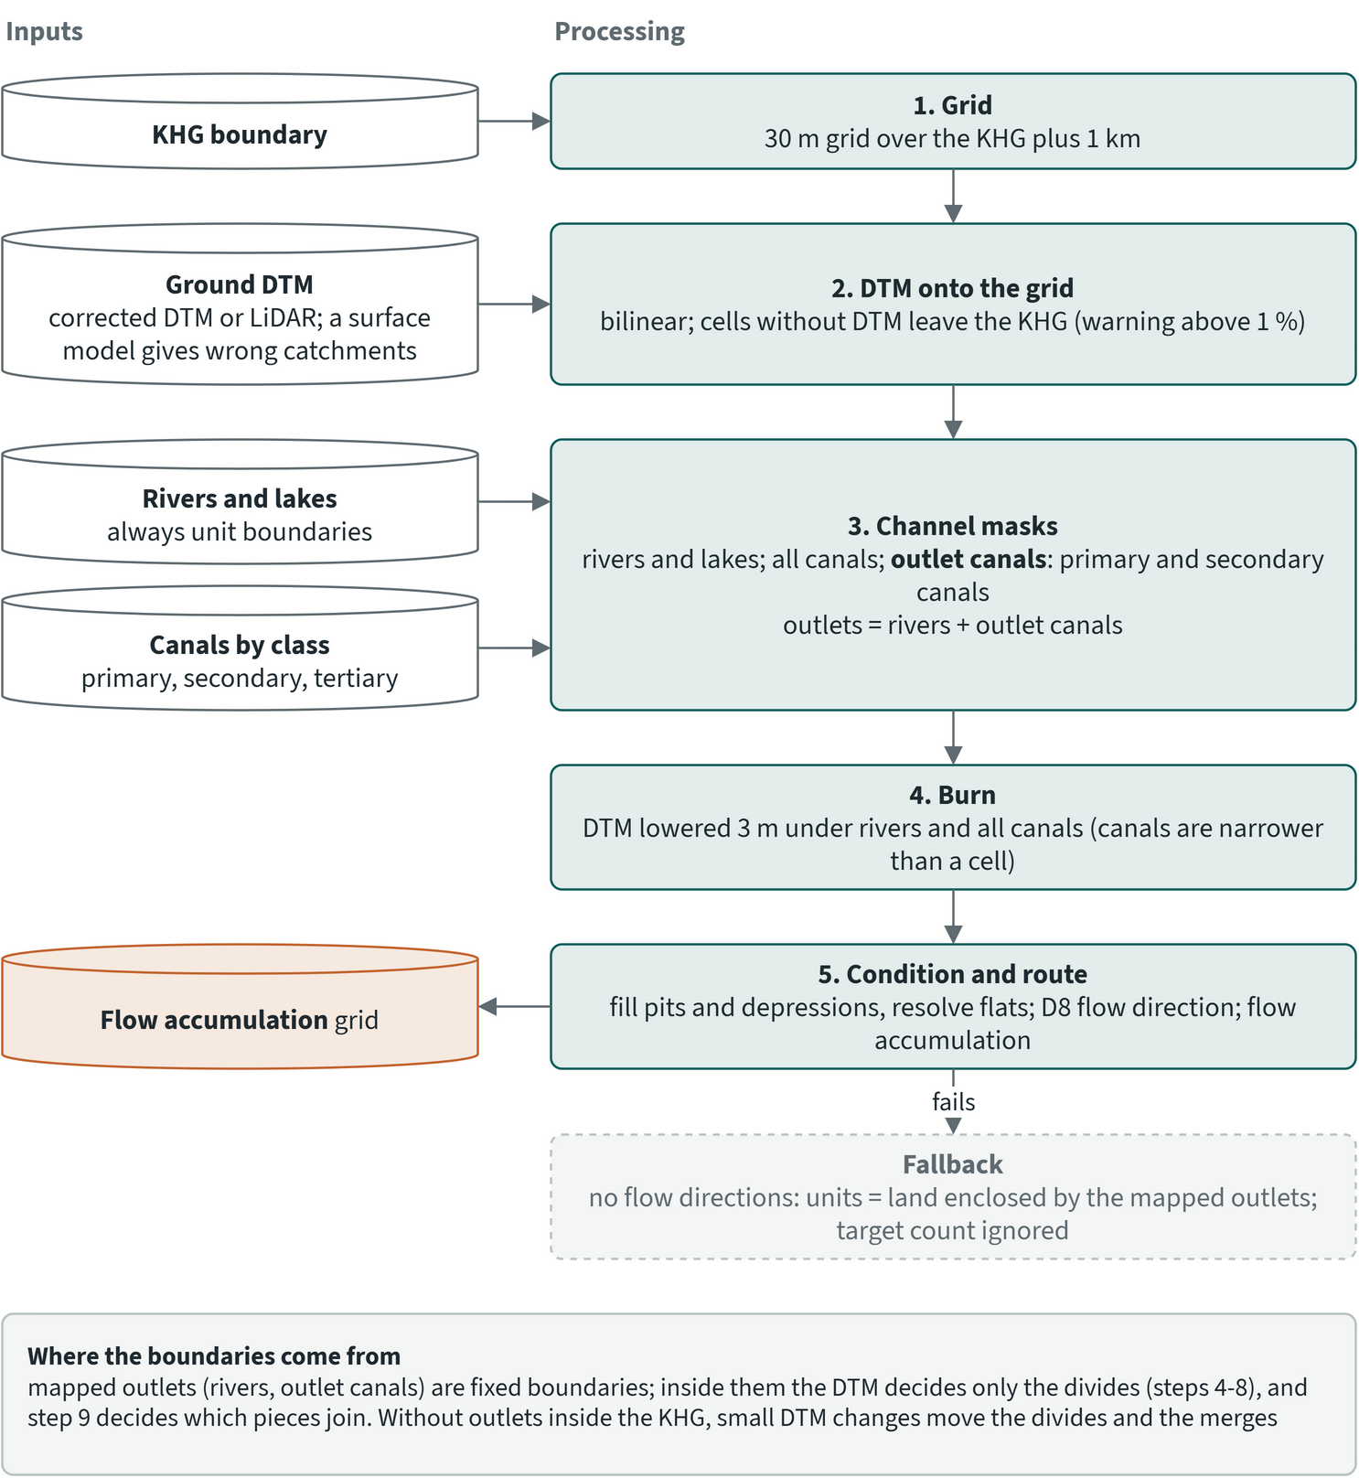
Figure 5.1. Sub-KHG delineation, part 1: inputs and steps 1 to 5 (surface preparation and flow)
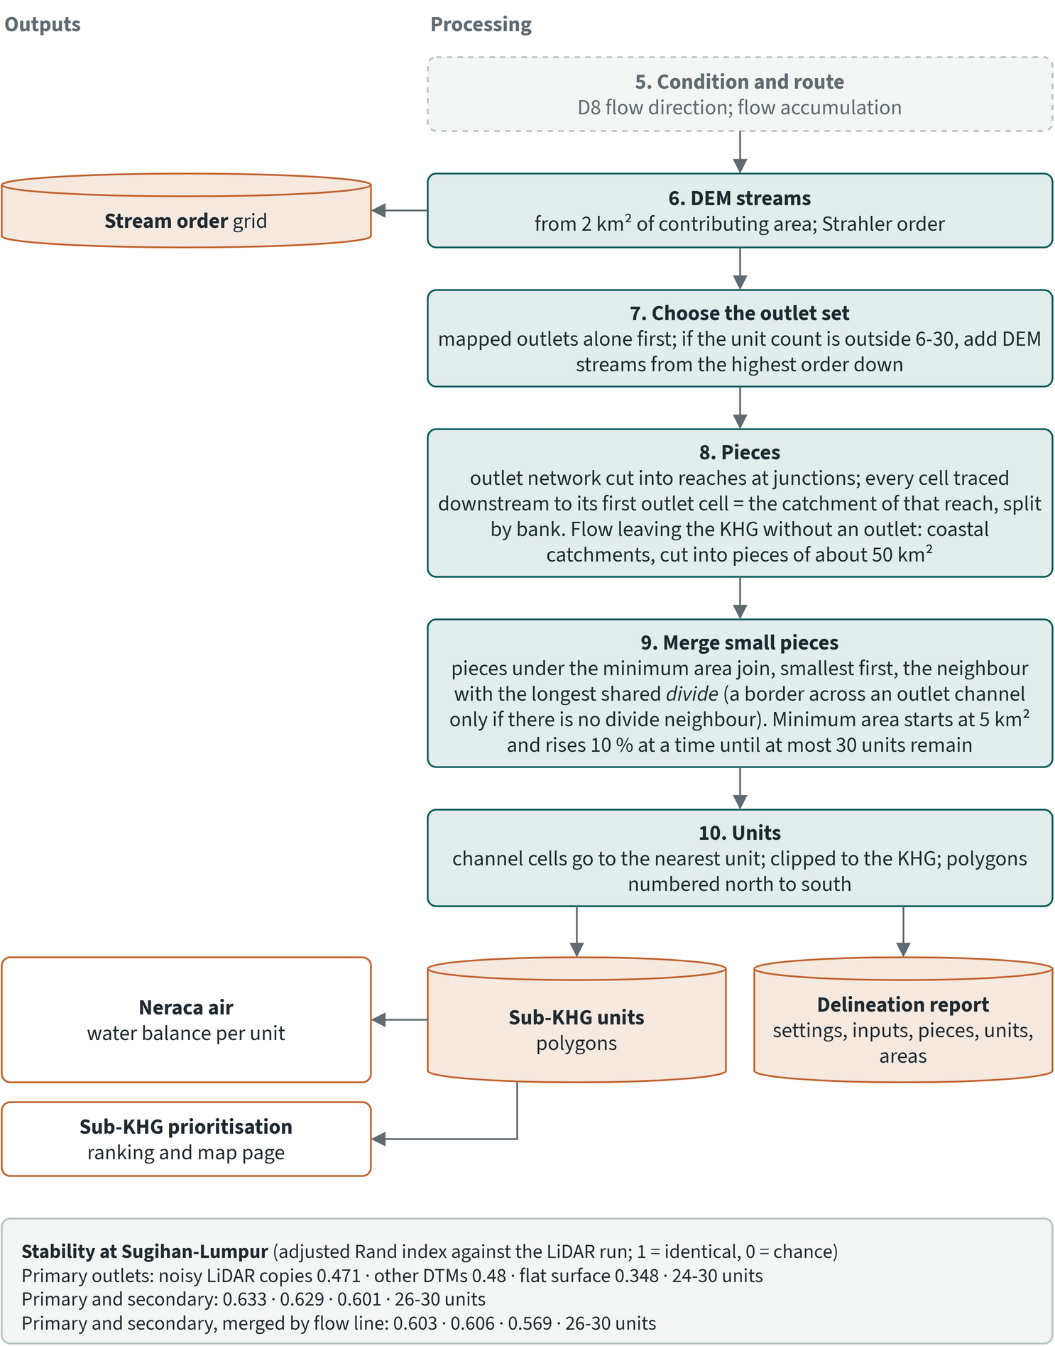
Figure 5.2. Sub-KHG delineation, part 2: steps 6 to 10, outputs and the analyses that use them
1. The DTM is projected onto a 30 m UTM grid over the KHG plus 1 km, with bilinear interpolation. The 20 m and 25 m LiDAR, 8 m DEMNAS and 30 m DeltaDTM are all resampled to this grid for this step only; the native surfaces are kept.
2. Rivers and all canals are cut 3 m into the DTM, since canals are narrower than a 30 m cell.
3. Pits, depressions and flats are resolved. D8 flow direction, flow accumulation and Strahler order follow. DEM-derived streams start at 2 km² of contributing area.
4. The outlet set is the mapped rivers and lakes plus the outlet canals, which are the primary and secondary canals (Kanal Primer, Kanal Sekunder) of the BRGM canal layer. Tertiary canals, the plantation drainage grid, are cut into the DTM but are not outlets.
5. Every cell is traced downstream to the first outlet cell it reaches. Each piece is the catchment of one reach of outlet channel on one bank, so divides and outlet channels are its boundaries. Flow that leaves the KHG without meeting an outlet forms coastal catchments, which are cut into compact pieces of about 50 km².
6. Pieces below a minimum area are merged, smallest first, into the neighbour they share the longest divide with; a border across an outlet channel is used only when there is no divide neighbour. With the automatic setting, the minimum area starts at 5 km² and rises by 10% at a time until at most 30 units remain.
7. Channel cells go to the nearest unit, the result is clipped to the KHG, and units are numbered north to south.
The method tries the mapped outlets alone first. Only if they give fewer than 6 or more than 30 units does it add DEM-derived streams, from the highest Strahler order down. In all 12 delineations reported below the mapped outlets alone gave a count in range, so no DEM stream was added.
Table 5.1. Delineation settings. Source: delineation method of the toolkit
Setting | Value
Analysis grid | 30 m, UTM
Channel burn depth | 3 m
Stream start (DEM streams) | 2 km² contributing area
Outlets | rivers, lakes, primary and secondary canals
Target unit count | 6 to 30
Minimum area | automatic: from 5 km², +10% per step, until at most 30 units
Merge | into the neighbour with the longest shared divide
Coastal catchments | cut into pieces of about 50 km²

The target count and the minimum area are set by the project. No regulation or study found gives an external basis for them.

Why secondary canals are outlets
With secondary canals as outlets, the units agree much better across terrain sources and terrain noise (section 5.4). The first test delineations at Kampar-Gaung and Sugihan-Lumpur used only primary canals and rivers as outlets; secondary canals were added after the stability test showed this. The 2021 study also counted primary and secondary canals, and ignored tertiary canals, when it assessed canal blocks.

5.3 Results for the first four KHG
Every delineation gave a unit count close to the upper limit, and unit size follows the density of the outlet canal network. The delineation has been made for these four KHG, the ones on which the method was developed, each with three terrain variants (chapter 4): LiDAR as delivered, DeltaDTM after correction and DEMNAS after correction. At Mendahara-Batanghari and Sugihan-Lumpur the corrected DeltaDTM and DEMNAS are the surfaces made for the benchmark; at Kampar-Gaung and Saleh-Sugihan they were made with the same correction and the same parameters.
Table 5.2. Sub-KHG units per KHG and terrain source: number of units, pieces before merging, automatic minimum area and unit areas. Source: sub-KHG delineation results per KHG
KHG | Terrain | Sub-KHG (n) | Pieces before merging (n) | Minimum area (km²) | Unit area min / median / max (km²) | Units total (km²)
Kampar-Gaung | LiDAR | 28 | 18,534 | 105.6 | 109 / 216 / 621 | 7,096
Kampar-Gaung | DeltaDTM | 27 | 17,504 | 116.1 | 128 / 225 / 539 | 7,110
Kampar-Gaung | DEMNAS | 29 | 15,435 | 116.1 | 128 / 215 / 511 | 7,110
Mendahara-Batanghari | LiDAR | 29 | 16,881 | 30.6 | 36 / 64 / 140 | 2,011
Mendahara-Batanghari | DeltaDTM | 29 | 15,500 | 33.6 | 39 / 55 / 203 | 2,012
Mendahara-Batanghari | DEMNAS | 29 | 14,877 | 30.6 | 36 / 56 / 151 | 2,012
Saleh-Sugihan | LiDAR (62% of KHG) | 29 | 5,885 | 17.3 | 20 / 39 / 76 | 1,173
Saleh-Sugihan | DeltaDTM | 26 | 13,911 | 27.8 | 32 / 74 / 137 | 1,897
Saleh-Sugihan | DEMNAS | 27 | 13,868 | 30.6 | 37 / 67 / 138 | 1,897
Sugihan-Lumpur | LiDAR | 29 | 21,137 | 116.1 | 126 / 221 / 373 | 6,346
Sugihan-Lumpur | DeltaDTM | 29 | 19,140 | 105.6 | 118 / 189 / 413 | 6,347
Sugihan-Lumpur | DEMNAS | 27 | 18,920 | 105.6 | 121 / 223 / 481 | 6,347
Where a LiDAR covers only part of the KHG, its units cover only that part; the cover is given after the terrain name.
All 12 delineations gave 26 to 29 units. The count is close to the cap of 30 in every case because the automatic minimum area rises only until the count falls to 30 or below. What differs by KHG and terrain is the minimum area chosen and the spread of unit sizes.
- Kampar-Gaung (7,111 km²): 27 to 29 units. The minimum area was 105.6 km² on LiDAR and 116.1 km² on DeltaDTM and DEMNAS. Units ran from 109.2 to 621.0 km² on LiDAR, 128.4 to 538.8 km² on DeltaDTM and 127.5 to 510.6 km² on DEMNAS, with medians of 215 to 225 km².
- Mendahara-Batanghari (2,012 km²): 29 units on each terrain. The minimum area was 30.6 km² (LiDAR, DEMNAS) and 33.6 km² (DeltaDTM). Median unit area was 63.5 km² on LiDAR, 54.8 km² on DeltaDTM and 56.5 km² on DEMNAS; the largest unit was 139.8, 202.9 and 151.0 km².
- Saleh-Sugihan (1,897 km²): 26 units on DeltaDTM (31.7 to 137.3 km²) and 27 on DEMNAS (37.3 to 137.8 km²). The LiDAR delineation gave 29 units of 20.3 to 76.5 km², but the LiDAR covers only about 1,174 km² (62%) of the KHG, so these units cover only that part and cannot be compared with the other two.
- Sugihan-Lumpur (6,347 km²): 29 units on LiDAR (126.2 to 373.0 km², median 220.8 km², minimum area 116.1 km²), 29 on DeltaDTM (117.6 to 413.0 km²) and 27 on DEMNAS (121.1 to 481.0 km²), both with a minimum area of 105.6 km².
Mendahara-Batanghari has 2,190 primary and secondary canal segments in 2,012 km², and Saleh-Sugihan 3,080 in 1,897 km², so their catchment pieces are small and the 30-unit cap is reached at a minimum area of about 30 km². Kampar-Gaung has 977 outlet canal segments in 7,111 km², so its units are larger. Sugihan-Lumpur has only 2 river segments, so its 4,387 primary and secondary canal segments make up nearly all of its outlet network.
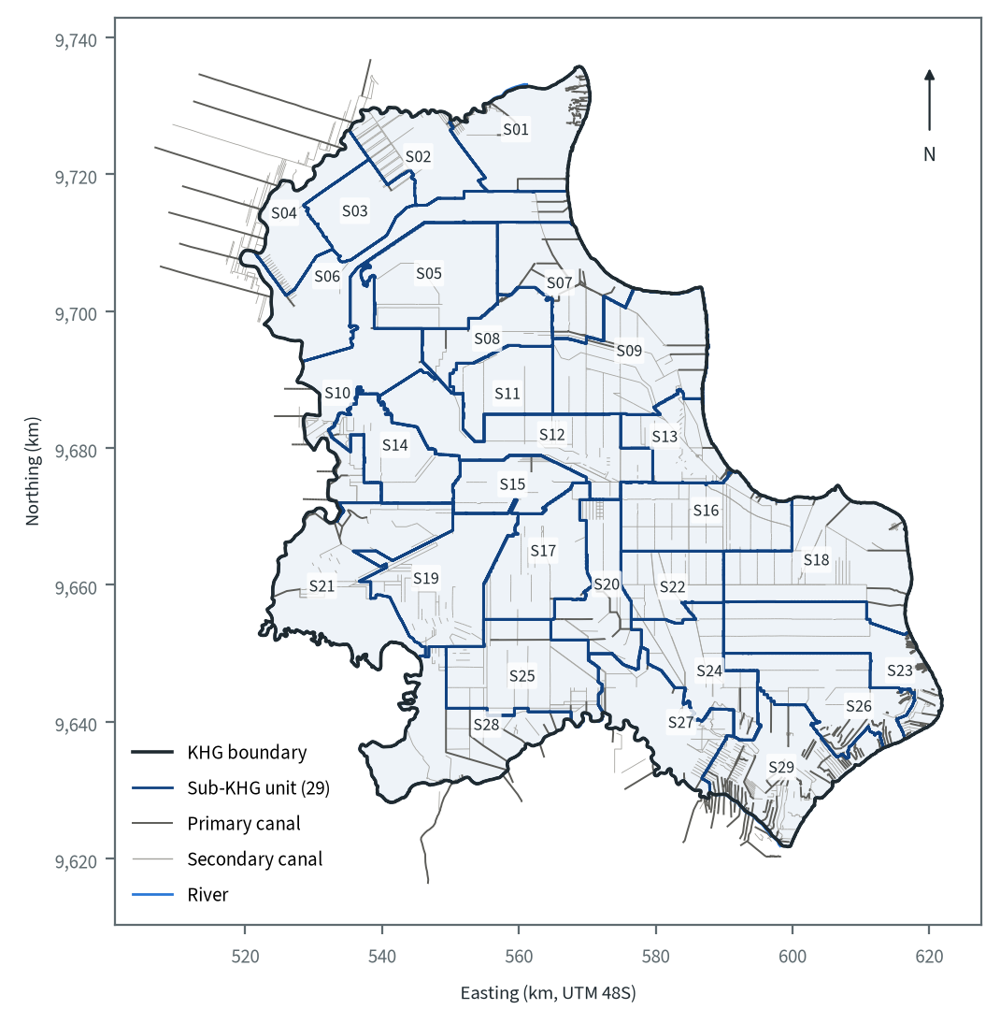
Figure 5.3. Sub-KHG units of Sugihan-Lumpur delineated on the LiDAR, with primary and secondary canals and rivers as outlets

5.4 Sensitivity to terrain and settings
The unit layout is set mainly by the mapped canal network, and the terrain moves the internal divides. At Sugihan-Lumpur a stability test delineated the KHG with seven terrain surfaces, with five copies of the LiDAR to which spatially correlated noise was added (0.25 m standard deviation, 500 m correlation length), and with a flat surface on which only the mapped channels shape the units. Each result was compared with the LiDAR delineation by the adjusted Rand index (ARI, 1 for an identical partition) and the mean best-match intersection over union (IoU). The test design was fixed before any delineation was made.
Table 5.3. Agreement of sub-KHG units with the LiDAR units at Sugihan-Lumpur, by outlet setting. Source: delineation stability test, Sugihan-Lumpur
Outlets | ARI, noisy LiDAR copies (mean) | ARI, other terrain sources (mean) | ARI, flat surface | Unit count range
Primary canals and rivers | 0.471 | 0.48 | 0.348 | 24 to 30
Primary and secondary canals and rivers | 0.633 | 0.629 | 0.601 | 26 to 30
Primary and secondary, merge by flow line | 0.603 | 0.606 | 0.569 | 26 to 30

With primary canals only, the units are unstable: 0.25 m of noise on the LiDAR changes them about as much as switching to another terrain source, and the largest LiDAR unit reaches 1,353 km². With secondary canals added, agreement rises to about 0.63 for both noise and terrain, and the largest LiDAR unit falls to 373 km². The flat surface then scores 0.601, close to the real terrain sources. A merge rule that prefers the neighbour draining to the same channel line agreed slightly less (0.603 and 0.606), so the longest-divide merge is kept.
Table 5.4. Mean best-match IoU of each terrain source with the LiDAR units at Sugihan-Lumpur, primary and secondary canals as outlets. Source: delineation stability test, Sugihan-Lumpur
Terrain | Units | Best-match IoU | ARI
LiDAR smoothed (300 m median, 150 m gaussian) | 27 | 0.628 | 0.691
KLHK modelled DTM, as delivered | 27 | 0.609 | 0.651
DeltaDTM with ICESat-2 offsets, smoothed (300 m median, 150 m gaussian) | 28 | 0.598 | 0.613
KLHK modelled DTM, processed | 30 | 0.574 | 0.640
Flat surface | 28 | 0.568 | 0.601
DeltaDTM with ICESat-2 offsets, smoothed (1,200 m median, 600 m gaussian) | 29 | 0.556 | 0.609
DEMNAS, processed | 27 | 0.552 | 0.598

DeltaDTM with ICESat-2 offsets and the standard smoothing agrees with the LiDAR units better than the flat surface does, and processed DEMNAS slightly worse. The gaps are small, which fits the terrain benchmark of chapter 4: over 1 km the terrain errors of the open DEMs are larger than the relief itself.
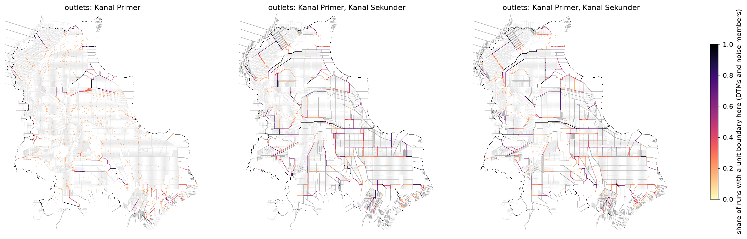
Figure 5.4. Share of delineations in which each cell is a unit boundary, Sugihan-Lumpur, over all terrain sources and noisy LiDAR copies; left primary canals as outlets, middle primary and secondary, right primary and secondary with the flow-line merge. Source: delineation stability test
The minimum area is the other main setting. In the earlier primary-only delineations, raising the minimum area from 5 to 300 km² reduced the count smoothly with the longest-divide merge: 247 to 9 units at Kampar-Gaung (from 5,581 pieces) and 182 to 6 at Sugihan-Lumpur (from 6,219 pieces). An earlier rule that dropped small pieces and gave their cells to the nearest unit collapsed both KHG to 1 or 2 units at a minimum area of 100 km² or more.
Small changes in input also move the result. The same LiDAR gave 30 units with a minimum area of 105.6 km² from the original delivery, and 29 units with 116.1 km² from the copy clipped to the KHG.

5.5 Limits
- No official sub-KHG layout exists for the four KHG, so the units cannot be checked against one. The only reference layout is the 16 units of the 2021 Kahayan-Sebangau study; the delineation has not yet been applied to that KHG, so that comparison is still to be made.
- Unit count and minimum area have no external basis; they are set by the project.
- The outlets depend on the canal classes in the BRGM canal layer. The layer has no flow direction or canal dimensions, and the units carry no outlet reach or record of which unit drains into which.
- There is no explicit dome-crest layer. The divides between units come from D8 flow on a surface whose error over 1 km exceeds the relief where no LiDAR exists.
- Licence areas are not used in the delineation. The 2021 study noted that plantations may change sub-KHG boundaries by turning rivers into canals.
- The unit size sets what the water balance can resolve. The smallest units at Sugihan-Lumpur (about 118 to 126 km²) span only about four cells of the CHIRPS rain grid (0.05°, about 31 km² per cell), and the smallest Kahayan-Sebangau unit of 2021 (35 km²) about one cell. Rain cannot differ much between neighbouring units.

6 National prioritisation of 865 KHG
The national profile shows which KHG (Kesatuan Hidrologis Gambut, peat hydrological unit) should get rewetting attention first. It describes every KHG in the 2017 national KHG map and ranks those large enough to compare, using fire history, this year's hotspots and canal density, with fire counted on peat. For a shortlist, further layers on climate, land cover, surface water and land status are shown beside the score as context; they do not enter it.
The rankings in this chapter use default weights proposed by the project for agreement with KLH and the World Bank. The weights can be changed in the dashboard, which re-ranks the KHG at once.
KLH has a peat restoration target of about 3.3 million ha in 337 priority KHG, selected using the peat ecosystem damage status (SKEG), in particular burned land and land affected by canals (KLH/BPLH 2026). The ranking in this chapter is a separate exercise. It covers all 865 KHG and states its method and weights openly, so it can be compared with the list of 337 KHG or used alongside it. The list itself was not available to the project, so no comparison is made here.
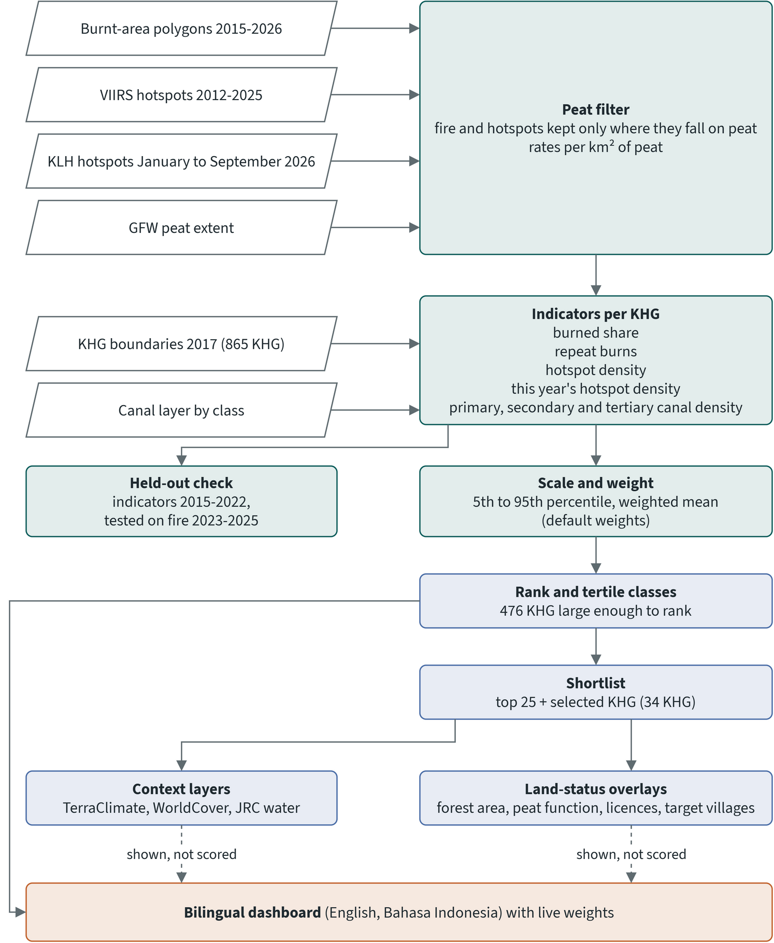
Figure 6.1. National profile: from national layers to the ranking, the shortlist layers and the dashboard

6.1 Units and peat basis
The ranking covers almost all peat inside KHG, although only about half of the KHG are ranked. A KHG is ranked when it is at least 50 km² in area and has at least 25 km² of peat. Of the 865 KHG in the national map, 476 pass both tests; the other 389 are profiled but not ranked. The ranked KHG hold 180,004 km² of the 185,920 km² of peat that the peat extent places inside KHG.
Each KHG gets its area in an equal-area projection and its peat area from the Global Forest Watch (GFW) peat extent. For Indonesia that layer is the union of two published peat maps (Miettinen et al. 2016; Gumbricht et al. 2017), at about 76 m. All fire rates are per km² of peat, and fire is counted only on peat: a burned patch counts when its representative point falls on a peat cell, a hotspot when the cell under it is peat.
The Global Peatland Map (1 km, non-commercial licence) serves only as a cross-check. Its median peat share per KHG is higher than the GFW share on every island.
Table 6.1. Median peat share per KHG, GFW extent against the 1 km Global Peatland Map. Source: national profile dashboard data
Island | KHG (n) | GFW extent (share) | Global Peatland Map (share)
Kalimantan | 190 | 0.66 | 0.93
Papua | 465 | 0.82 | 0.93
Sulawesi | 3 | 0.06 | 0.64
Sumatera | 207 | 0.74 | 0.97

6.2 Indicators
The score rests mainly on where peat has burned and where hotspots fall, with canal density as a measure of drainage. Seven indicators enter it, and fire history covers 2015 to 2025.
Table 6.2. Scored indicators of the national ranking and their default weights. Source: national profile report and its default settings
Indicator | Data | Unit | Weight
Burned share | burnt-area polygons with a burn flag per year, on peat | % of peat burned per year, mean 2015-2025 | 2
Repeat burns | same | % of peat burned two or more times, 2015-2025 | 1
Hotspot density | VIIRS S-NPP 375 m active fires (NASA FIRMS), vegetation fires, nominal and high confidence, on peat | hotspots per km² of peat per year | 1
Hotspots this year | KLH hotspots (MODIS) 1 January to 15 September 2026, medium and high confidence, on peat | hotspots per km² of peat, year to date | 1
Primary canals | canal layer, class from the canal code (Kanal Primer) | km per km² of KHG | 0.5
Secondary canals | same (Kanal Sekunder) | km per km² of KHG | 0.3
Tertiary canals | same (Kanal Tersier) | km per km² of KHG | 0.2

Hotspots are filtered by confidence. In the VIIRS archive, low-confidence detections and non-vegetation types (volcanoes, static sources, offshore) are dropped. The KLH hotspot data mix two confidence schemes across its nine monthly layers; both are mapped to low, medium and high, and low is dropped. Of 167,718 KLH points, 160,207 are medium or high, and 37,657 of these fall on peat inside a KHG. The dashboard can switch this year's indicator to high confidence only.
This year's hotspots are a separate indicator with their own weight. MODIS at 1 km and VIIRS at 375 m give counts that cannot be compared, so the 2026 record is kept apart from the history. It also has two ranks of its own, by density and by count, because density favours KHG with little peat and the count favours large ones. By density the top KHG is Sungai Tolak - Sungai Siduk (3.93 hotspots per km² of peat, 604 hotspots). By count it is Sungai Kahayan - Sungai Sebangau (2,538 hotspots on peat).
The three canal weights add up to 1, with more weight on the larger canals. The canal layer is derived from OpenStreetMap and is patchy: 517 of the 865 KHG have no canal segment in it, 213 of them among the 476 ranked KHG. Where no canals are mapped, the canal indicators are treated as missing rather than as zero, and the KHG is scored on its fire indicators alone.
Several further indicators are reported with weight 0: this year's burned share, fire radiative power (Spearman 0.99 with hotspot density), peat depth (the 1:50,000 depth map covers 100 of 865 KHG), existing hydrological structures, target villages, and the water table from SiTMAT, the online portal of daily peat water-table readings. SiTMAT concession stations lie in 164 KHG. For each, the profile reports the share of days with the water table deeper than 0.4 m, using stations with at least 30 days of valid readings in the 2026 season.

6.3 Scaling, score and classes
Fire dominates the score, and the classes of most KHG hold when the weights change. Each indicator is scaled from 0 to 1 between its 5th and 95th percentile over the ranked KHG, and values beyond those limits are clipped. The score is the weighted mean of the scaled indicators a KHG has. A KHG without mapped canals is therefore scored on the four fire indicators, with the weights renormalised. No impact indicator is scored at national level, so the score is the urgency score.
Classes are tertiles by rank: the top third of the 476 ranked KHG is "national focus: high" (158 KHG), the next third "medium" (159) and the rest "low" (159). A KHG with a score of zero is always "low".
Three pairs of scaled indicators correlate above 0.8 (Spearman), the level at which overlap is flagged: burned share and hotspot density 0.89, burned share and repeat burns 0.87, hotspot density and this year's hotspots 0.83. Fire therefore counts for more than the nominal weight of burned share (2 out of a total weight of 6).
Weight sensitivity was tested with 300 random weight sets drawn around the defaults (Dirichlet, concentration 20). In 89.3% of ranked KHG the class "high" either held in at least 80% of the draws or in at most 20%. The median standard deviation of rank across the draws is 13.1 places.

6.4 Held-out validation
The ranking picks out the KHG where peat burns later far better than chance, which supports its use for targeting fire-prone peat. The validation builds the indicators from 2015 to 2022, without this year's hotspots, and tests the ranking on fire in 2023 to 2025. It reports two measures for each target: the AUC, which is how well the score separates KHG with later fire from those without, and the share of later fire that falls in the top 20% of KHG (capture, weighted by KHG area; random choice gives 20%). Each measure is computed for the full score and for burned share alone ("fire history alone").
Table 6.3. Held-out validation of the national score, indicators 2015-2022, test years 2023-2025, 476 KHG. Source: validation report of the national profile
Target | KHG with the target | Score | AUC | Capture, top 20% | Spearman
Burned share of peat 5% per year or more | 10 | full score | 0.973 | 0.846 | 0.735
 |  | fire history alone | 0.970 | 0.886 | 0.771
Hotspots on peat (any) | 282 | full score | 0.956 | 0.771 | 0.829
 |  | fire history alone | 0.882 | 0.815 | 0.784

Both scores point at later fire far better than chance. The full score separates KHG with and without later hotspots better than fire history alone (AUC 0.956 against 0.882). Fire history alone captures more of the later fire in its top 20% for both targets (88.6% against 84.6% of burned area, 81.5% against 77.1% of hotspots). The burned-share test rests on only 10 KHG that burned 5% or more of their peat per year in 2023 to 2025. The validation therefore shows that the ranking follows fire. It cannot settle the canal weights, because no held-out outcome measures drainage.

6.5 National ranking
The highest-priority KHG lie mostly in Kalimantan and Sumatera. Of the top 20 KHG, 11 are in Kalimantan, 8 in Sumatera and 1 in Papua. By province, Kalimantan Barat and Sumatera Selatan have 6 each. Ranking on KHG area instead of peat area keeps 14 of the top 20.
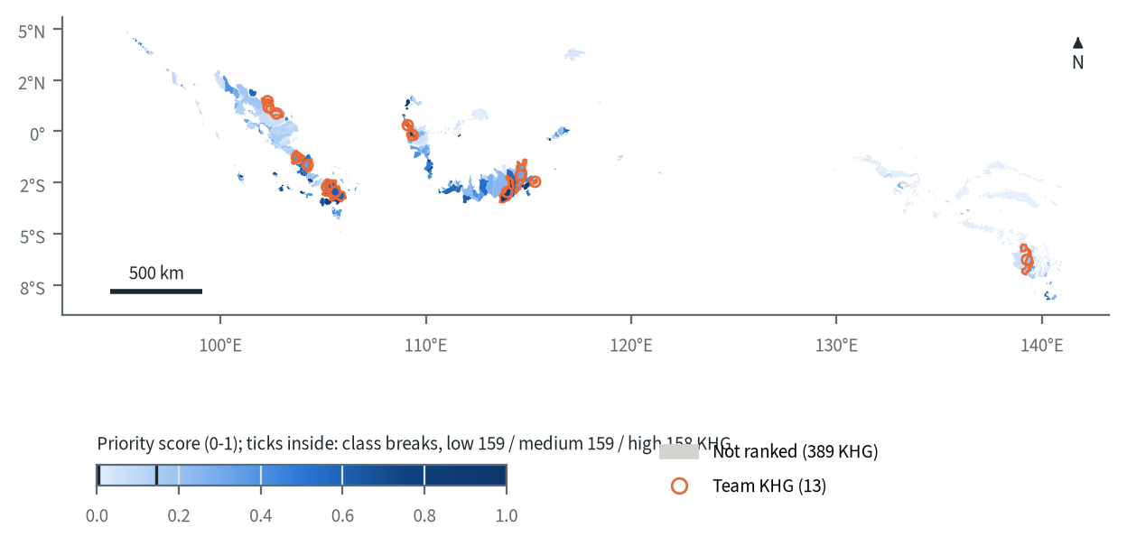
Figure 6.2. National rewetting priority score per KHG (default weights)
Table 6.4. Top 20 KHG of the national ranking (default weights)
Rank | KHG | Province | Peat (km²) | Burned / repeat burns (% of peat) | Hotspots (per km² peat per year) | Hotspots 2026 (per km² peat; high conf. %) | Canals P / S / T (km per km²) | Score | Rank SD
1 | Pungurbesar - Kapuas | Kalimantan Barat | 744 | 4.6 / 15.0 | 1.04 | 2.45 (9) | 0.37 / 1.52 / 2.83 | 0.96 | 1.2
2 | Ifileki Bian - Lekiage Sentuf | Papua | 48 | 7.4 / 18.1 | 0.59 | 1.10 (2) | - / - / - | 0.90 | 5.3
3 | Kahayan - Sebangau | Kalimantan Tengah | 3,955 | 6.4 / 18.5 | 1.48 | 1.27 (48) | 0.30 / 0.06 / 1.77 | 0.89 | 4.2
4 | Barito - Taping | Kalimantan Selatan | 729 | 7.2 / 24.2 | 0.75 | 0.59 (40) | 0.87 / 3.52 / 6.45 | 0.88 | 5.4
5 | Balangan - Batangalai | Kalimantan Selatan | 137 | 4.6 / 14.6 | 1.04 | 0.58 (11) | 0.51 / 1.28 / 2.69 | 0.88 | 4.4
6 | Selakau - Sebangkau | Kalimantan Barat | 52 | 4.1 / 13.2 | 1.09 | 1.09 (7) | 0.38 / 0.25 / 1.15 | 0.87 | 3.5
7 | Sibumbung - Talangrimba | Sumatera Selatan | 856 | 8.4 / 24.5 | 1.32 | 1.94 (55) | 0.05 / 0.21 / 0.89 | 0.86 | 5.9
8 | Melawi - Batunanta | Kalimantan Barat | 62 | 3.2 / 14.6 | 1.09 | 1.89 (43) | 0.00 / 0.40 / 1.00 | 0.85 | 5.8
9 | Musi - Penu | Sumatera Selatan | 193 | 4.8 / 15.8 | 1.42 | 1.01 (61) | 0.02 / 0.65 / 1.91 | 0.84 | 4.0
10 | Aek Ubar - Aek Lunang | Sumatera Barat | 184 | 6.2 / 16.1 | 2.05 | 2.53 (7) | 0.00 / 0.00 / 0.00 | 0.83 | 8.3
11 | Mangkatip - Barito 1 | Kalimantan Tengah | 176 | 11.8 / 40.7 | 0.74 | 0.44 (28) | 0.71 / 0.36 / 2.96 | 0.82 | 7.4
12 | Jempang - Kedangpahu | Kalimantan Timur | 45 | 4.7 / 12.6 | 0.75 | 0.91 (29) | 0.05 / 0.94 / 2.38 | 0.79 | 4.7
13 | Sambas Besar - Seiyung | Kalimantan Barat | 491 | 3.9 / 13.7 | 0.83 | 0.24 (17) | 0.60 / 0.64 / 1.23 | 0.79 | 9.2
14 | Bentayan - Penimpahan | Sumatera Selatan | 353 | 3.3 / 8.3 | 0.75 | 0.73 (48) | 0.42 / 1.29 / 1.90 | 0.77 | 5.2
15 | Ulakkedondong - Lumpur | Sumatera Selatan | 554 | 7.0 / 18.4 | 1.81 | 0.50 (48) | 0.09 / 0.23 / 1.02 | 0.76 | 7.8
16 | Musi - Rawas | Sumatera Selatan | 81 | 6.4 / 26.3 | 1.55 | 0.33 (19) | 0.09 / 0.67 / 1.14 | 0.75 | 8.6
17 | Raya - Pangnilang | Kalimantan Barat | 69 | 2.0 / 6.9 | 0.91 | 1.17 (17) | 0.50 / 2.09 / 4.26 | 0.75 | 9.6
18 | Talang - Ulakkedondong | Sumatera Selatan | 87 | 6.1 / 25.6 | 1.49 | 0.60 (48) | 0.00 / 0.02 / 0.03 | 0.74 | 10.4
19 | Tolak - Siduk | Kalimantan Barat | 154 | 2.6 / 4.1 | 1.29 | 4.19 (48) | 0.18 / 1.52 / 3.14 | 0.74 | 8.5
20 | Kalumpang | Sumatera Selatan | 48 | 8.8 / 30.0 | 2.15 | 0.21 (10) | 0.09 / 0.56 / 1.68 | 0.74 | 11.0
Burned: share of peat burned per year; repeat burns: share of peat burned more than once. P / S / T: primary, secondary, tertiary canals; '-' = not mapped. Rank SD: standard deviation of the rank over the sensitivity runs. Default weights, proposed for agreement with KLH and the World Bank.
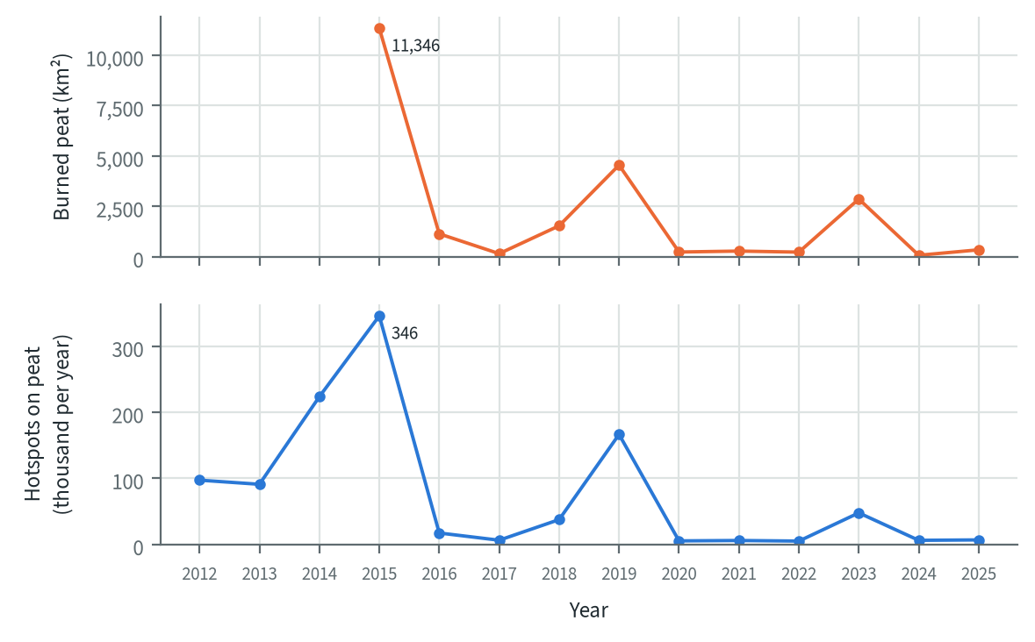
Figure 6.3. Burned peat and hotspots on peat per year, all 865 KHG
Summed over all KHG, 11,346 km² of peat burned in 2015, 4,547 km² in 2019 and 2,861 km² in 2023, against 68 to 1,532 km² in the other years from 2016 to 2025. VIIRS hotspots on peat follow the same pattern, with 345,772 in 2015 and 166,389 in 2019.

6.6 Where the selected KHG rank
Most of the KHG selected for detailed work fall in the national high class. The project selected 12 main KHG and some reserves. Cawang-Lalang could not be matched to a KHG in the national boundary map and is left out. Of the other 11 main KHG, 10 are in the top third ("high") and Pulau Padang is in the middle third. Four main KHG are in the national top 25: Sungai Pungurbesar - Sungai Kapuas (rank 1), Sungai Balangan - Sungai Batangalai (4), Sungai Kahayan - Sungai Sebangau (7) and Sungai Mempawah - Sungai Peniti (21).
Table 6.5. Rank of the selected main and reserve KHG (default weights). Source: national profile
KHG | Role | Rank (of 476) | Class | Share of draws in class "high"
Sungai Pungurbesar - Sungai Kapuas | main | 1 | high | 1.00
Sungai Balangan - Sungai Batangalai | main | 4 | high | 1.00
Sungai Kahayan - Sungai Sebangau | main | 7 | high | 1.00
Sungai Mempawah - Sungai Peniti | main | 21 | high | 1.00
Sungai Saleh - Sungai Sugihan | main | 30 | high | 1.00
Sungai Sugihan - Sungai Lumpur | reserve | 31 | high | 1.00
Pulau Bengkalis | main | 69 | high | 1.00
Sungai Mendahara - Sungai Batanghari | main | 71 | high | 1.00
Sungai Air Hitam Laut - Sungai Buntu Kecil | main | 90 | high | 0.98
Sungai Kapuas - Sungai Barito | main | 96 | high | 0.99
Sungai Buru Mappi - Sungai Buru Obaa | main | 138 | high | 0.74
Pulau Padang | main | 194 | medium | 0.08
Pulau Tebing Tinggi | reserve | 204 | medium | 0.01

The low ranks of Pulau Padang and Pulau Tebing Tinggi come from little fire on their peat: their burned share is below 0.4% of peat per year. Sungai Buru Mappi - Sungai Buru Obaa has a low burned share (0.7% of peat per year), but its 920 hotspots on peat this year place it 12th of the ranked KHG by this year's count.
Table 6.6. Indicators of the selected KHG (default weights)
KHG | Rank (class) | Peat (km²) | Burned / repeat burns (% of peat) | Hotspots (per km² peat per year) | Hotspots on peat 2026 (n; high conf. %) | Rank by 2026 hotspots / by area | Canals P / S / T (km per km²) | SiTMAT stations (days deeper than 0.4 m, %)
Pungurbesar - Kapuas | 1 (high) | 744 | 4.6 / 15.0 | 1.04 | 1,825 (9) | 5 / 1 | 0.37 / 1.52 / 2.83 | 5 (49)
Kahayan - Sebangau | 3 (high) | 3,955 | 6.4 / 18.5 | 1.48 | 5,004 (48) | 1 / 4 | 0.30 / 0.06 / 1.77 | 1 (37)
Balangan - Batangalai | 5 (high) | 137 | 4.6 / 14.6 | 1.04 | 79 (11) | 100 / 7 | 0.51 / 1.28 / 2.69 | -
Mempawah - Peniti | 22 (high) | 376 | 2.0 / 5.5 | 0.69 | 693 (7) | 22 / 27 | 0.41 / 2.51 / 6.70 | -
Saleh - Sugihan | 27 (high) | 1,607 | 7.6 / 26.8 | 0.38 | 587 (34) | 29 / 32 | 0.17 / 0.61 / 1.14 | -
Sugihan - Lumpur (reserve) | 32 (high) | 5,424 | 4.0 / 4.7 | 0.94 | 710 (53) | 21 / 28 | 0.12 / 0.47 / 1.64 | 54 (61)
Mendahara - Batanghari | 71 (high) | 1,731 | 1.5 / 0.7 | 0.68 | 56 (52) | 111 / 82 | 0.43 / 0.66 / 1.19 | 14 (13)
Pulau Bengkalis | 78 (high) | 893 | 1.2 / 2.4 | 0.29 | 674 (13) | 23 / 75 | 0.27 / 0.38 / 1.41 | 2 (25)
Air Hitam Laut - Buntu Kecil | 84 (high) | 1,432 | 1.0 / 3.4 | 0.79 | 362 (47) | 45 / 59 | 0.03 / 0.19 / 0.26 | 9 (25)
Kapuas - Barito | 92 (high) | 4,407 | 1.2 / 2.2 | 0.42 | 1,171 (41) | 11 / 89 | 0.27 / 0.03 / 0.74 | 6 (0)
Buru Mappi - Buru Obaa | 143 (high) | 1,699 | 0.7 / 0.1 | 0.14 | 1,018 (9) | 14 / 179 | 0.00 / 0.00 / 0.00 | -
Pulau Padang | 192 (medium) | 1,102 | 0.4 / 0.8 | 0.11 | 17 (12) | 164 / 178 | 0.11 / 0.17 / 0.77 | 3 (1)
Pulau Tebing Tinggi (reserve) | 205 (medium) | 1,364 | 0.3 / 0.6 | 0.13 | 1 (0) | 256 / 192 | 0.07 / 0.30 / 0.61 | 6 (24)
Rank among the ranked KHG; P / S / T: primary, secondary, tertiary canals, '-' = not mapped. Default weights, proposed for agreement with KLH and the World Bank.

6.7 Context layers for the shortlist
Climate, land cover and surface water give context for the shortlisted KHG. These layers are coarse, so they are shown on the profile pages and not scored. The shortlist is the top 25 KHG and the selected KHG, 34 KHG in all. The layers are:
- TerraClimate dry-season water deficit (June to October) and monthly rain, 2015 to 2021, about 4 km; the dataset ends in 2021.
- ESA WorldCover land-cover shares, sampled at 250 m.
- JRC Global Surface Water: the share of cells with any water and with water in 10 or more months a year (permanent water).
- The GFW and 1 km peat shares, as a check.
Across the 34 KHG, the mean dry-season deficit runs from 5 mm (Krueng Pneunom - Krueng Lambalik) to 120 mm (Sungai Kahayan - Sungai Sebangau), and tree cover from 25% to 95% of the KHG. Dry-spell indicators from the ERA5 reanalysis are not used, because its 25 km grid cannot tell neighbouring KHG apart.
Table 6.7. Context layers of the selected KHG (shown, not scored)
KHG | Rank | Dry-season deficit 2015-2021 (mm) | Rain, year / Jun-Oct (mm) | Tree / crop / grass / wetland (% of KHG) | Permanent water (% of KHG) | Peat, GFW / GPM 1 km (% of KHG)
Pungurbesar - Kapuas | 1 | 30 | 3,108 / 1,097 | 56 / 2 / 34 / 0 | 0.5 | 73 / 99
Kahayan - Sebangau | 3 | 120 | 2,578 / 588 | 53 / 1 / 24 / 1 | 0.1 | 88 / 99
Balangan - Batangalai | 5 | 86 | 2,808 / 825 | 54 / 6 / 27 / 7 | 0.0 | 45 / 100
Mempawah - Peniti | 22 | 30 | 2,813 / 1,108 | 83 / 2 / 10 / 0 | 0.0 | 74 / 93
Saleh - Sugihan | 27 | 109 | 2,584 / 669 | 41 / 15 / 28 / 0 | 0.5 | 85 / 99
Sugihan - Lumpur | 32 | 108 | 2,535 / 702 | 51 / 18 / 17 / 0 | 0.4 | 85 / 100
Mendahara - Batanghari | 71 | 72 | 2,406 / 713 | 84 / 2 / 7 / 0 | 0.3 | 86 / 100
Pulau Bengkalis | 78 | 11 | 2,376 / 917 | 69 / 1 / 17 / 0 | 0.8 | 99 / 99
Air Hitam Laut - Buntu Kecil | 84 | 89 | 2,469 / 706 | 87 / 0 / 10 / 0 | 0.0 | 78 / 100
Kapuas - Barito | 92 | 99 | 2,553 / 621 | 82 / 1 / 8 / 1 | 0.4 | 79 / 99
Buru Mappi - Buru Obaa | 143 | 46 | 3,669 / 1,284 | 79 / 0 / 2 / 18 | 0.1 | 43 / 77
Pulau Padang | 192 | 15 | 2,370 / 839 | 86 / 3 / 5 / 0 | 0.9 | 99 / 99
Pulau Tebing Tinggi | 205 | 18 | 2,284 / 788 | 83 / 0 / 4 / 0 | 1.4 | 99 / 97

6.8 Land-status overlays
The land-status overlays show how much of the burned peat and of this year's hotspots lie inside licence areas or on peat with a protected function. For the same 34 KHG, the profile is crossed with four layers: forest area function (2023), peat ecosystem function (2017), business licences (2025) and the target villages for peat restoration. These overlays are context and do not enter the score. A regular grid of points is laid inside each KHG. The cell size grows with KHG area from 100 m, in 50 m steps, so that each KHG gets about 60,000 points. Each point carries its peat flag, its class in each layer, whether it burned between 2015 and 2025, and the licences it lies in. Areas are point counts times the cell area. Licences overlap, so licence areas are never summed; "any licence" counts each point once.
The figures say where burned peat and hotspots fall, and nothing about who caused a fire. The licence layer of 2025 is also matched with burns from 2015 onwards, when the holder may have been different. No holder names are given in this report.
The share of peat inside licence areas differs widely among the selected KHG. In Sungai Sugihan - Sungai Lumpur, 4,313 km² of peat (80% of its peat) lies in licence areas; 1,748 km² of that peat burned between 2015 and 2025, and 193 of the 213 hotspots on peat in 2026 fell inside licence areas. In Sungai Kahayan - Sungai Sebangau, licence areas hold 3.5% of the peat and 98 of the 2,538 hotspots on peat this year. Sungai Mempawah - Sungai Peniti had none of its 691 hotspots on peat inside a licence area. Sungai Buru Mappi - Sungai Buru Obaa (920 hotspots on peat) has no licence area in the 2025 layer.
Peat with a protected function holds most of this year's hotspots in several of the selected KHG: 128 of 146 in Sungai Saleh - Sungai Sugihan, where 92% of the peat has that function, and 1,636 of 1,825 in Sungai Pungurbesar - Sungai Kapuas.
Table 6.8. Burned peat 2015-2025 and hotspots on peat 2026 inside licence areas and on protected peat function, selected KHG (context, not scored)
KHG | Peat in licence areas, km² (% of peat) | Burned peat in licence areas, km² (% of that peat) | Hotspots 2026 on peat in licence areas (n) | Protected peat function (% of peat) | Hotspots 2026 on protected peat (n) | Hotspots 2026 on peat, all (n)
Pungurbesar - Kapuas | 178 (24) | 64 (36) | 372 | 52 | 1,636 | 1,825
Kahayan - Sebangau | 140 (4) | 122 (87) | 251 | 62 | 3,415 | 5,004
Balangan - Batangalai | 0 (0) | 0 (-) | 0 | 65 | 56 | 79
Mempawah - Peniti | 0 (0) | 0 (0) | 0 | 45 | 503 | 693
Saleh - Sugihan | 46 (3) | 28 (62) | 35 | 92 | 535 | 587
Sugihan - Lumpur | 4,313 (80) | 1,748 (41) | 665 | 67 | 258 | 710
Mendahara - Batanghari | 555 (32) | 131 (24) | 12 | 64 | 48 | 56
Pulau Bengkalis | 45 (5) | 3 (8) | 84 | 47 | 565 | 674
Air Hitam Laut - Buntu Kecil | 431 (30) | 87 (20) | 0 | 84 | 335 | 362
Kapuas - Barito | 444 (10) | 61 (14) | 108 | 77 | 975 | 1,171
Buru Mappi - Buru Obaa | 0 (0) | 0 (-) | 0 | 82 | 724 | 1,018
Pulau Padang | 574 (52) | 18 (3) | 2 | 48 | 15 | 17
Pulau Tebing Tinggi | 365 (27) | 13 (4) | 0 | 50 | 0 | 1
Burned peat 2015-2025. Licence areas: any business licence of 2025. Context only, not scored.
The overlay also draws a 5 km ring around licence areas, following the "Buffer 5 Kilometer" zone of the BlueBook 2026 canal-block data. No regulation setting a 5 km duty was found, so the ring is shown as a zone and implies no obligation.

6.9 Reading the ranking
Fire history decides the top of the national ranking. Canals and this year's hotspots mostly reorder KHG that already have a fire record. Seven of the 11 main selected KHG stay within the top 158 places, the size of the "high" class, under every weight preset in the dashboard. Pulau Padang and Pulau Tebing Tinggi stay below rank 170 under every preset. The figures in this section use the dashboard's own scoring at the default weights proposed by the project for agreement with KLH and the World Bank. These weights can be changed in the dashboard.

What drives the top ranks
Each bar in the next figure splits a KHG's score into what its fire history, this year's hotspots and its canals add. Across the top 25, fire history gives 79 % of the summed score, this year's hotspots 12 % and canals 9 %. Fire history can add at most 0.67 to the score (its weights are 4 of the total of 6). Eleven KHG reach that maximum, all of them in the top 25: they rank at or above the 95th percentile on burned share, repeat burns and hotspot density. Among these KHG the order is set by this year's hotspots and by canals. Within the top 25, canals add the most at Barito-Taping (0.17), and two KHG have no mapped canal.
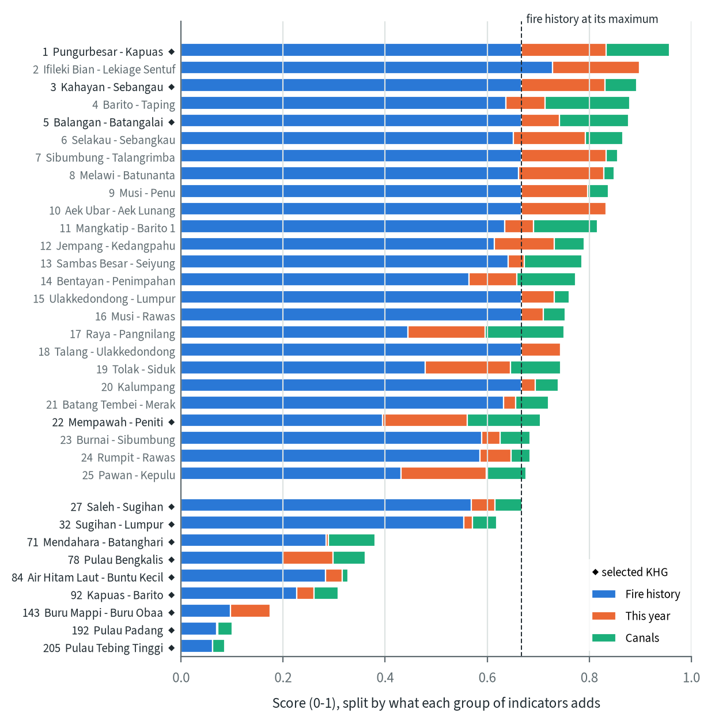
Figure 6.4. What each group of indicators adds to the national score, top 25 KHG and the selected KHG below them, default weights proposed for agreement with KLH and the World Bank (adjustable in the dashboard); rank before the name, selected KHG marked. Source: national profile, hotspots to 15 September 2026

How robust the ranks are to the weights
The dashboard offers four presets besides the default. History drops this year's hotspots. This year keeps only this year's hotspots. Canals keeps only the three canal densities, so only the 263 KHG with mapped canals can be scored. Equal gives every parameter, including this year's burned area, a weight of 1.
Table 6.9. The dashboard's weight presets: weights, KHG that can be ranked, how many of the default top 25 stay in the top 25, selected KHG in the top 25, and the top 3
Preset | Weights | KHG ranked | Default top 25 still in top 25 | Selected KHG in top 25 | Top 3
Default | burned share 2, repeat burns 1, hotspots 2015 to 2025 1, hotspots this year 1, primary canals 0.5, secondary canals 0.3, tertiary canals 0.2 | 476 | 25 | 4 | Pungurbesar - Kapuas; Ifileki Bian - Lekiage Sentuf; Kahayan - Sebangau
History | burned share 2, repeat burns 1, hotspots 2015 to 2025 1, primary canals 0.5, secondary canals 0.3, tertiary canals 0.2 | 476 | 22 | 5 | Barito - Taping; Balangan - Batangalai; Pungurbesar - Kapuas
This year | hotspots this year 1 | 476 | 7 | 2 | Tolak - Siduk; Pawan - Kepulu; Tandatuan - Beberi
Canals | primary canals 0.5, secondary canals 0.3, tertiary canals 0.2 | 263 | 7 | 3 | Barito - Taping; Kapuas - Mandor; Raya - Pangnilang
Equal | burned share 1, repeat burns 1, hotspots 2015 to 2025 1, hotspots this year 1, burned area this year 1, primary canals 1, secondary canals 1, tertiary canals 1 | 476 | 18 | 4 | Pungurbesar - Kapuas; Raya - Pangnilang; Mempawah - Peniti
Presets as in the dashboard. History: this year's indicators set to 0. This year: hotspots this year only. Canals: canal indicators only, so KHG without mapped canals drop out.
The top of the list holds as long as fire history keeps its weight. Without this year's hotspots, 21 of the default top 25 stay in the top 25, and with equal weights 18. Scored on this year's hotspots alone, only 9 stay, and on canals alone 7. The validation in section 6.4 tested the fire indicators; nothing yet tests the canal weights, so the canal-only ranking is a view of drainage and carries no validated weight of its own.
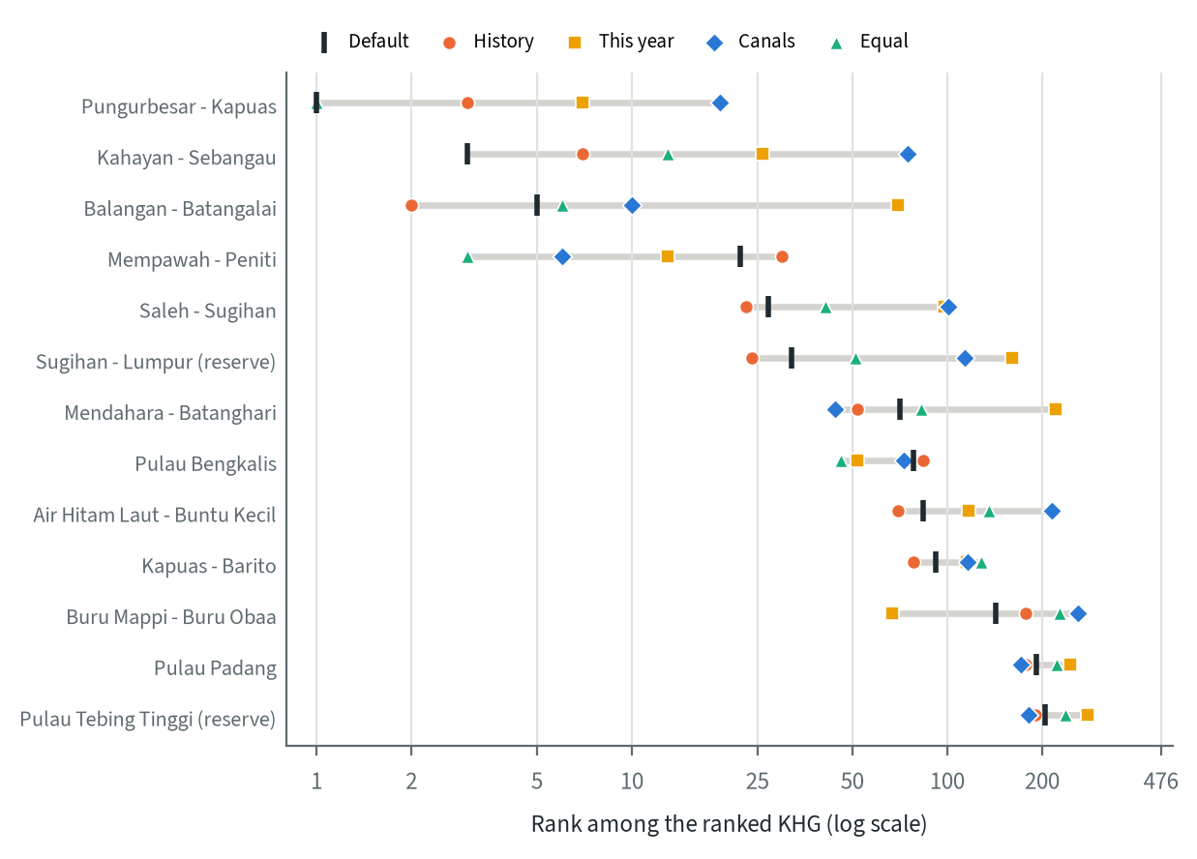
Figure 6.5. Rank of the selected KHG under the dashboard's weight presets: Default, History (no indicators of this year), This year (hotspots this year only), Canals (canal indicators only) and Equal (all weights 1); grey bar: range across presets. Source: national profile, hotspots to 15 September 2026
For the selected KHG the presets separate three groups:
- Pungurbesar-Kapuas, Balangan-Batangalai and Kahayan-Sebangau rank in the top 7 at default weights and under History. Each drops under one preset: Balangan-Batangalai to 54 on this year's hotspots, Kahayan-Sebangau to 75 on canals.
- Mempawah-Peniti (21 at default weights) rises under every preset that weighs this year or canals more: 10 on this year's hotspots, 6 on canals, 3 with equal weights. Saleh-Sugihan and Sugihan-Lumpur (30 and 31) rise to 23 and 24 on fire history alone and fall to 151 and 193 on this year's hotspots.
- Buru Mappi-Buru Obaa ranks 138 at default weights and 49 on this year's hotspots. Pulau Padang and Pulau Tebing Tinggi stay between 171 and 269 under every preset.

How the selected KHG compare
The next figure places each team KHG among the ranked KHG on every parameter of the dashboard, as the strip plots of its profile page do. Most indicators compare with all 476 ranked KHG (repeat burns with the 287 that have a value), canal densities with the 263 that have mapped canals. Saleh-Sugihan is at the 99th percentile for burned share and repeat burns, and Sugihan-Lumpur at the 96th for burned share. Both are low on this year's hotspots (68th and 59th). Mempawah-Peniti is at the 98th percentile for this year's hotspots and, among KHG with mapped canals, for secondary and tertiary canal density. Pulau Padang and Pulau Tebing Tinggi are at the 70th and 68th percentiles for burned share: 217 of the 476 ranked KHG have no burned peat at all, so a small burned share still places them in the upper half.
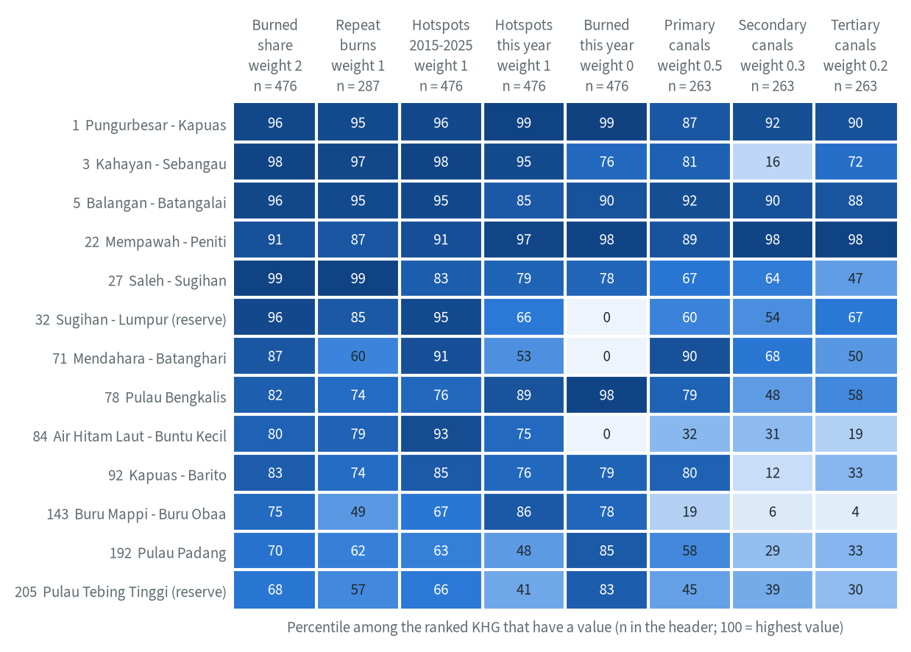
Figure 6.6. Position of the selected KHG among the ranked KHG on each dashboard parameter (percentile: share of the ranked KHG with a value that have a lower one; n in the header), with the default weight of each parameter; rows by rank. Source: national profile, hotspots to 15 September 2026
The yearly lines of the profile pages show what lies behind these positions. The 2015 fires burned 42.6 % of the peat in Saleh-Sugihan, 38.9 % in Kahayan-Sebangau and 37.0 % in Sugihan-Lumpur. Saleh-Sugihan burned again in 2019 (28.3 %) and 2023 (11.9 %), and Kahayan-Sebangau in 2019 (17.6 %), while Sugihan-Lumpur has burned at most 5.5 % a year since 2015. Pungurbesar-Kapuas burns in most years, with 16.6 % in 2018, 11.0 % in 2023 and 8.0 % in the part of 2026 covered so far. In Mempawah-Peniti and Pulau Bengkalis, 6.0 % of the peat has burned in that part of 2026, more than in any full year since 2015. This year's burned area enters the score only through the Equal preset.
This year's hotspots come in different months. Pungurbesar-Kapuas had 710 of its 1,825 hotspots on peat in March, Pulau Bengkalis 389 of 674 in February, Buru Mappi-Buru Obaa 703 of 920 in July, and Kahayan-Sebangau 1,333 of 2,538 in the first half of September (the record ends on 15 September). TerraClimate puts the largest dry-season water deficit of 2015 to 2021 in 2015 for 9 of the 13 KHG, up to 403 mm in Sugihan-Lumpur.
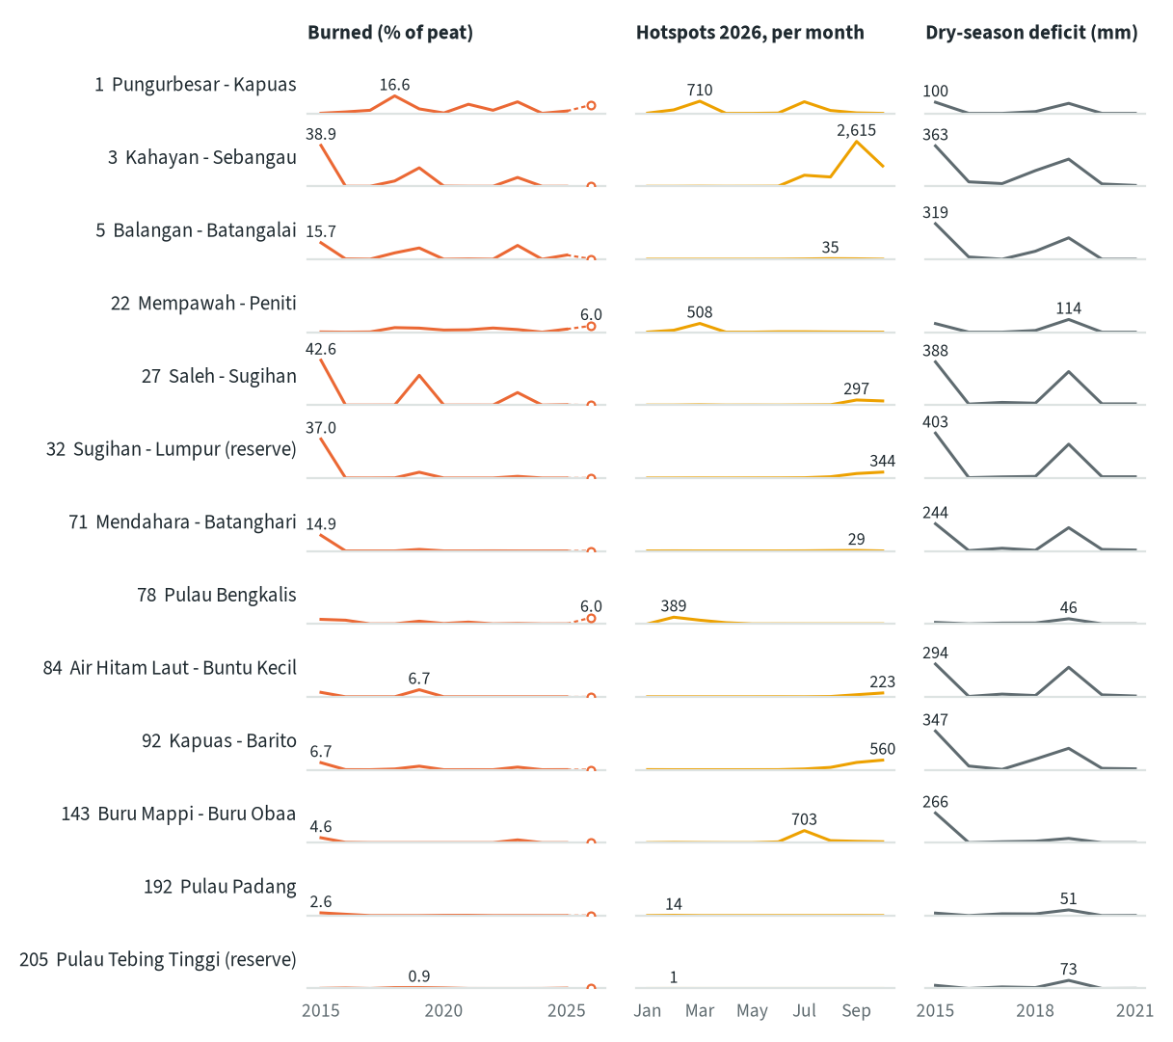
Figure 6.7. Profile lines of the selected KHG, rows by rank: burned share of peat per year 2015-2025 with 2026 as a partial year (hollow point), KLH hotspots on peat per month from January to 15 September 2026, and TerraClimate dry-season water deficit 2015-2021. Each column has one scale for all rows; the label gives the peak. Source: national profile, hotspots to 15 September 2026; TerraClimate

The dashboard
The ranking is published as one self-contained page in English and Bahasa Indonesia, so that KLH can test its own weights. Sliders set the weight of each of the eight parameters, or a preset sets them all at once. The page re-ranks all KHG at once with the same scaling as the national ranking and shows the rank shift against the default weights. Filters set the minimum peat area, the island, the hotspot confidence and how a KHG without mapped canals is treated. A profile page for each of the 34 shortlisted KHG holds the strip plots, the yearly lines, a map of burns, canals, this year's hotspots and land status, and a sortable table with a CSV download. The page address stores the weights, filters, language and selected KHG, so any view can be shared as a link.
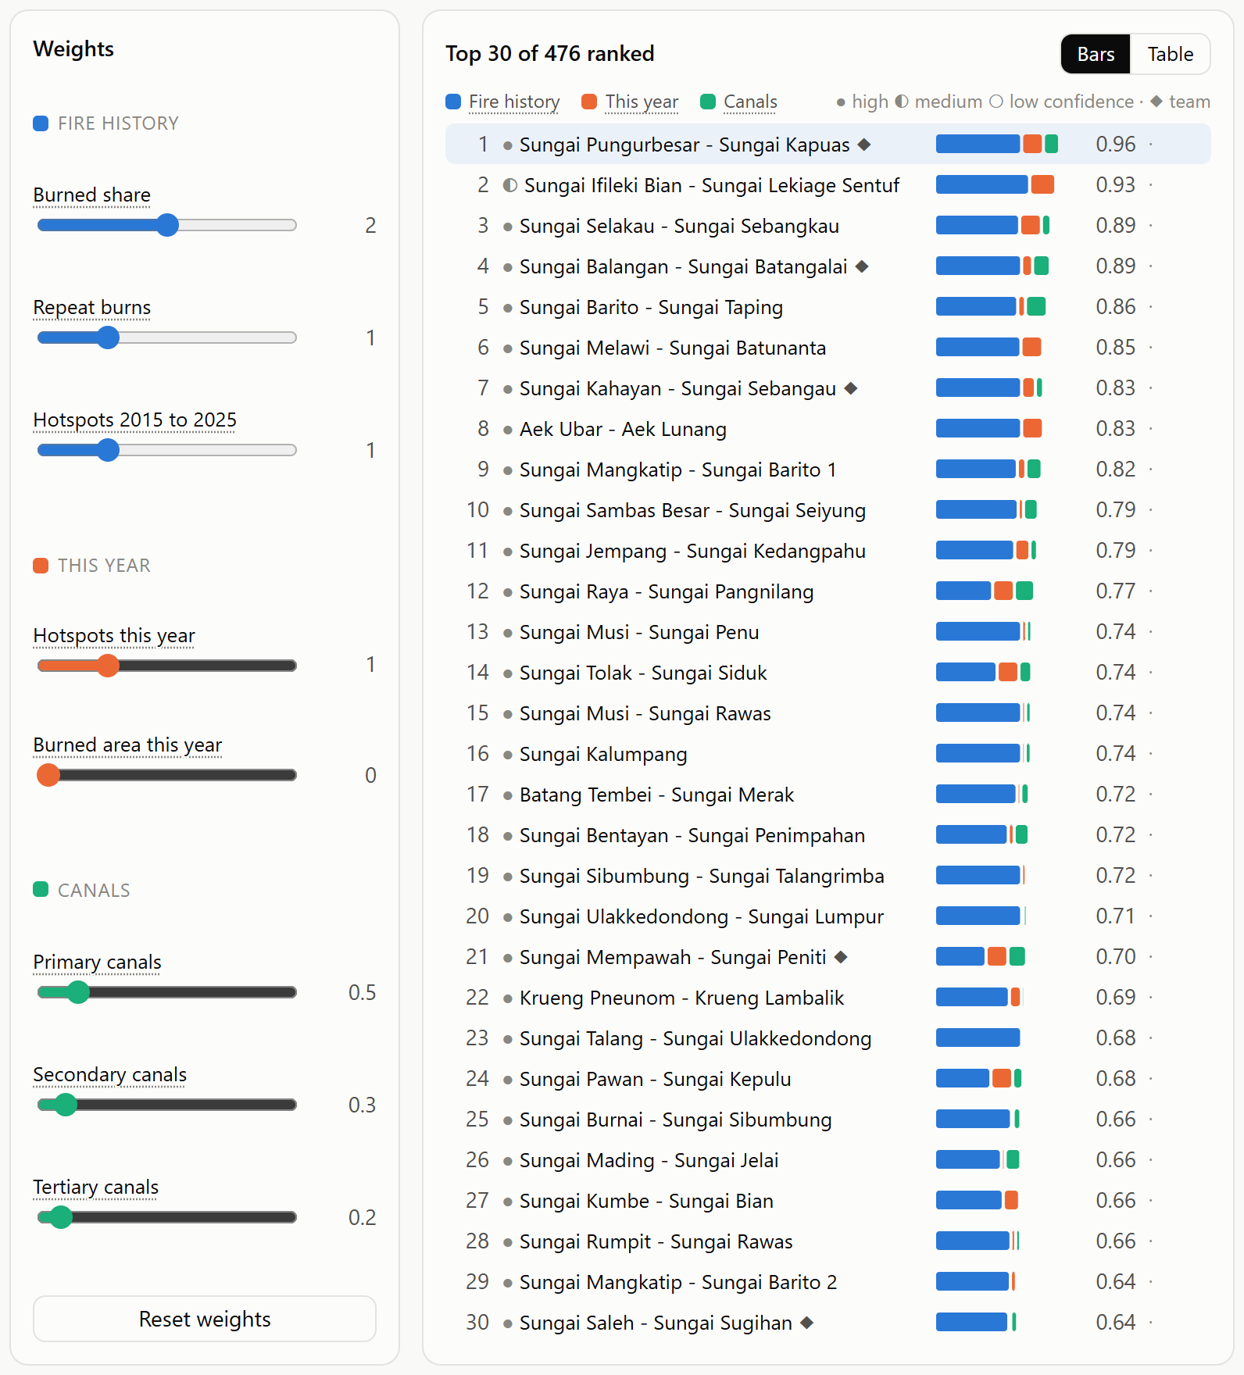
Figure 6.8. The national dashboard: weight sliders by group and the ranking with the contribution of each group, at default weights proposed for agreement with KLH and the World Bank. Source: national profile, hotspots to 15 September 2026

6.10 Limits
- The weights are defaults proposed for agreement with KLH and the World Bank; a different weighting changes the order, although most classes hold (section 6.3).
- The canal layer is missing for 517 KHG, so drainage plays no part in their score.
- Peat depth, concessions, tidal influence, fire severity and feasibility are not scored.
- The context layers and land-status overlays cover only the 34 shortlisted KHG.
- The burnt-area polygons carry the largest weight and are also the validation target, but their source is not documented, so their accuracy cannot be judged.
- The validation tests prediction of fire only. No held-out data can yet test the drainage part of the score.

7 Sub-KHG prioritisation
Within one KHG (Kesatuan Hidrologis Gambut, peat hydrological unit), the sub-KHG prioritisation sets the order in which parts of the KHG should receive rewetting work. It ranks the sub-KHG units by their need for intervention: sekat kanal (canal blocks), bored wells and pumping. Each unit gets a need score, a rank (1 = most need) and a class (high, medium or low need, the tertiles within the KHG). The ordered list and the KHG water deficit go to RE-PEAT Interventions, which designs blocks and pumping for the units in that order. Which measure suits a unit is decided afterwards, from the feasibility indicators and the interventions module.
The rankings in this chapter use default weights proposed by the project for agreement with KLH and the World Bank. The weights can be adjusted, and the rankings shown follow from these defaults and the data now available.
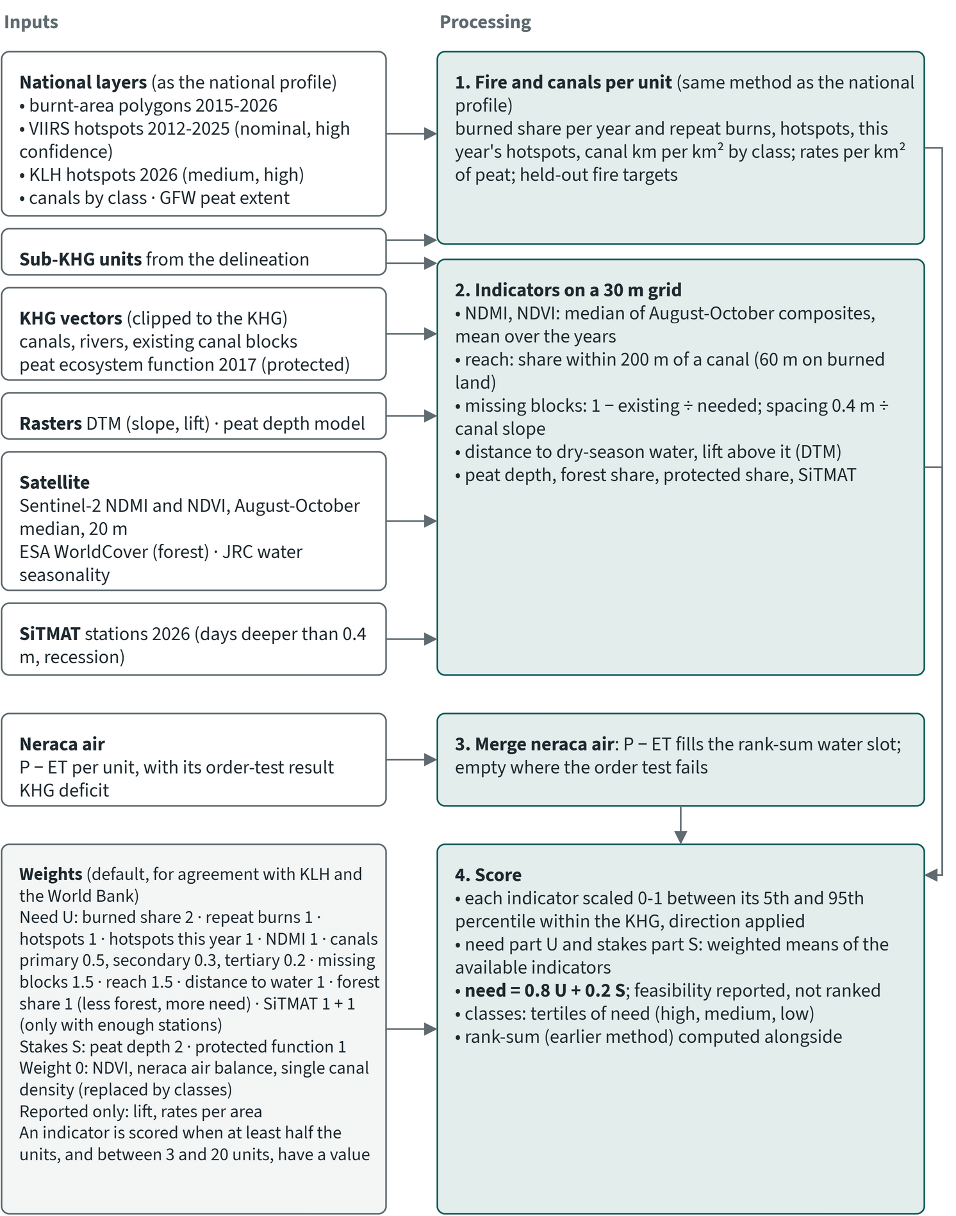
Figure 7.1. Sub-KHG prioritisation, part 1: inputs, steps 1 to 4 and the weights
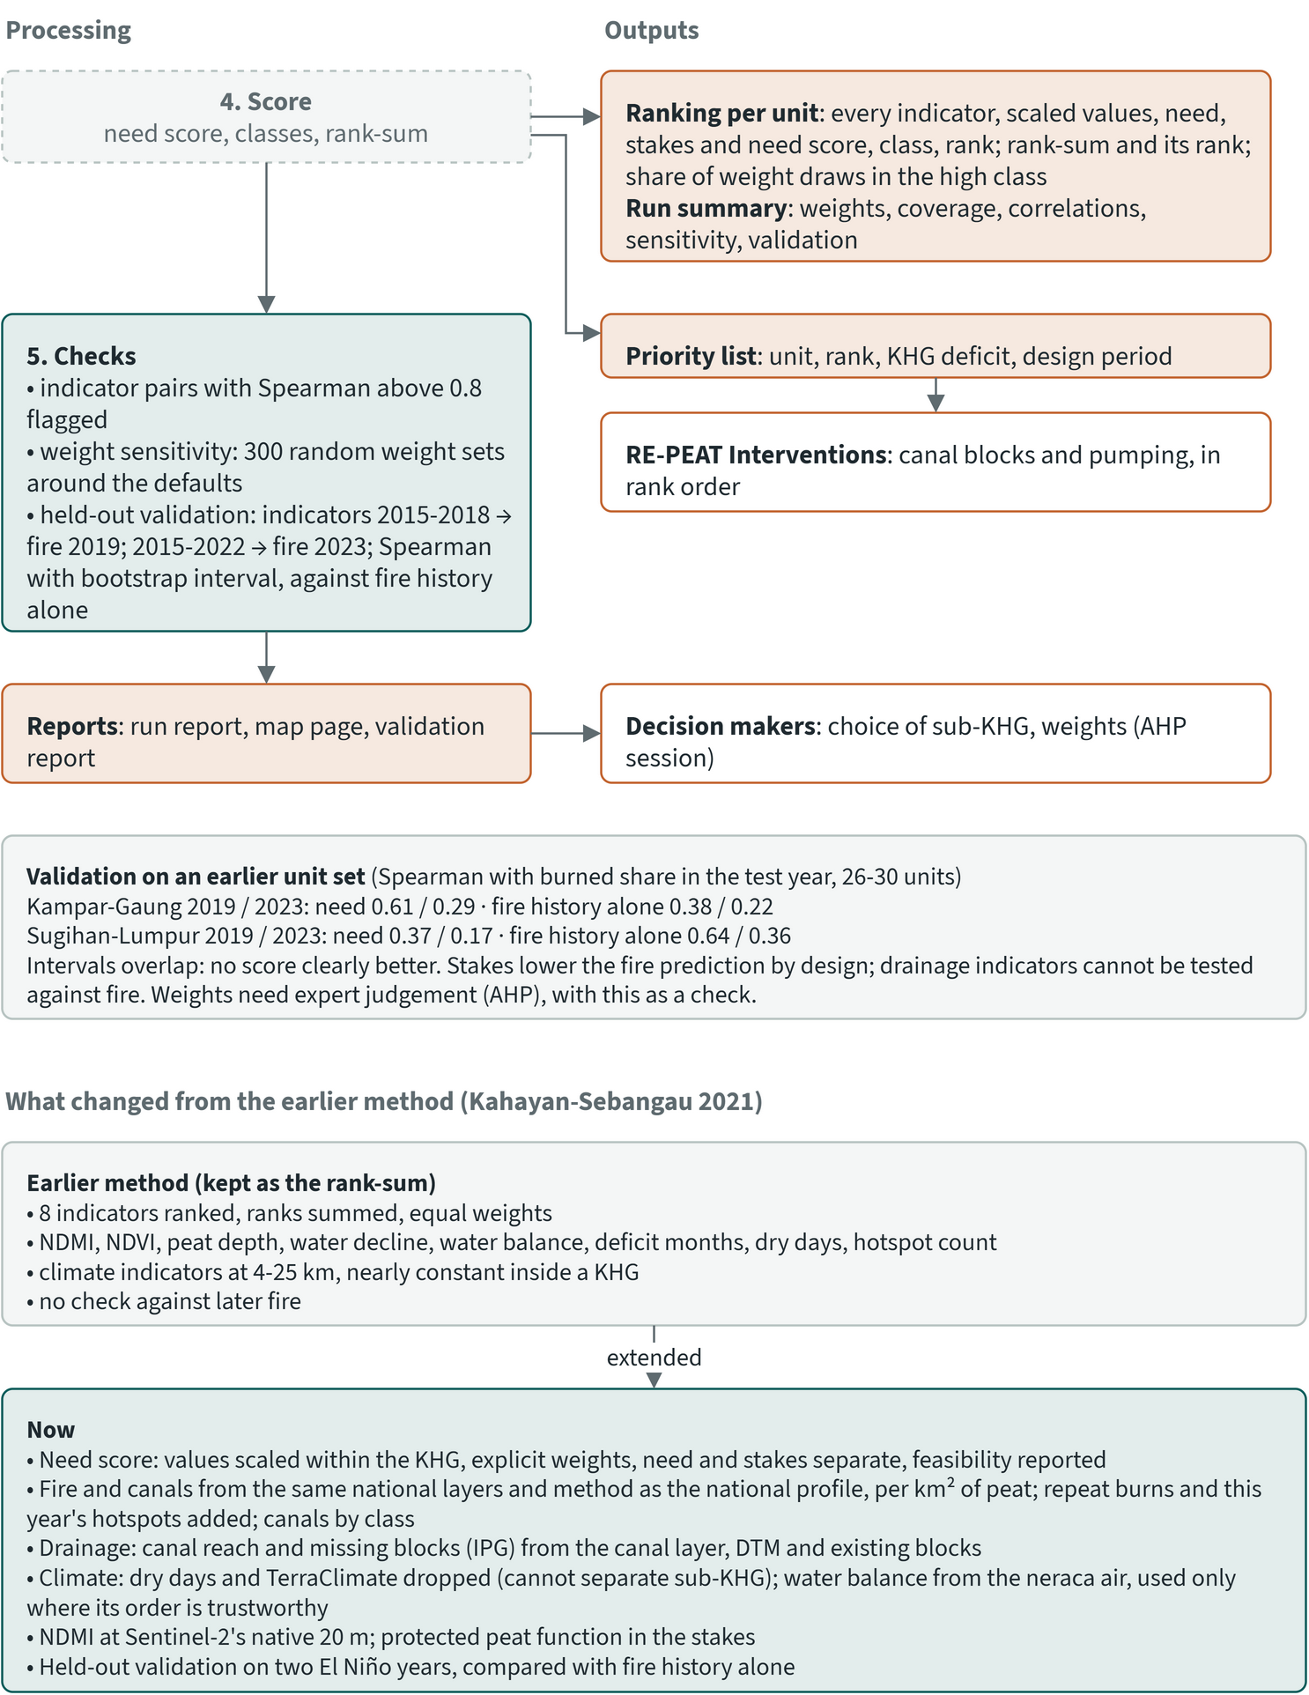
Figure 7.2. Sub-KHG prioritisation, part 2: checks, outputs, users and validation

7.1 Units and inputs
The choice of DEM changes the units themselves, so a ranking holds only for the DEM it was made on. The units come from the sub-KHG delineation (chapter 5), which is carried out once per DEM: the KLHK LiDAR-derived DEM where it covers the KHG, and the corrected DeltaDTM and DEMNAS. Each DEM variant has its own delineation, its own neraca air (water balance) and its own ranking. The units of two variants therefore differ in shape and number, and a unit name such as S03 in one variant does not refer to the same area in another.
Fire and canals per unit are counted with the same method as the national profile (chapter 6). The sub-KHG units take the place of the national KHG, so rates are per km² of peat on the GFW extent and fire is counted only on peat. The other indicators are computed on a 30 m grid and averaged over each unit.
Table 7.1. Inputs of the sub-KHG ranking. Source: sub-KHG method of the prioritisation module and its settings for Sugihan-Lumpur
Input | Form and resolution | Period | Used for
Sub-KHG units | polygons, one set per DEM |  | the units
Burnt-area polygons | per-year burn flags | 2015-2026 | burned share, repeat burns, validation target
VIIRS S-NPP hotspots (NASA FIRMS) | points, vegetation fires, nominal and high confidence | 2012-2025 | hotspot density, validation target
KLH hotspots | points (MODIS), medium and high confidence | 1 Jan to 15 Sep 2026 | this year's hotspot density
GFW peat extent | about 76 m raster |  | denominator of the fire rates
Canal layer | lines, class from the canal code | 2025 | canal density by class, reach, blocks needed
Existing canal blocks | BRGM hydrological structures, realised canal blocks |  | blocks existing
Rivers | RBI lines |  | distance to water
Peat ecosystem function | 2017 polygons, protected function |  | protected share
DTM | the DEM of the variant |  | canal slope, lift above water
Peat depth model | raster, per KHG |  | peat depth
Sentinel-2 L2A | 20 m bands, cloud-masked | August-October of each baseline year | NDMI, NDVI
ESA WorldCover | 10 m | 2020/2021 | forest share
JRC Global Surface Water | 30 m, months with water |  | permanent water for distance to water
SiTMAT stations | daily water-table readings | 1 April to 15 October 2026 | days deeper than 0.4 m, recession rate
Neraca air per unit | table per unit with a stability flag | 2018-2025 | P minus ET (rank-sum only)
KHG deficit | one value per KHG | June to October 2026 | passed to the interventions module

The indicators use the baseline years 2015 to 2022. The year 2023, an El Niño year, is held out for validation.

7.2 Indicators
The need score combines fire, drainage by canals, missing canal blocks, distance to water and dryness, with a smaller part for what is at risk. Indicators fall into three groups. Need indicators say how urgently a unit needs intervention. Stakes indicators say what is at risk. Feasibility indicators help choose the measure and leave the rank unchanged.
Table 7.2. Indicators and default weights of the sub-KHG need score. Source: ranking reports of Sugihan-Lumpur and the method of the prioritisation module
Group | Indicator | More need when | Weight
Need | Burned share of peat per year | higher | 2
Need | Repeat burns (peat burned two or more times) | higher | 1
Need | VIIRS hotspots per km² of peat per year | higher | 1
Need | KLH hotspots this year per km² of peat | higher | 1
Need | Dry-season NDMI (Sentinel-2) | lower (drier) | 1
Need | Primary, secondary, tertiary canal density (km per km²) | denser | 0.5, 0.3, 0.2
Need | Missing canal blocks (1 minus the block metric) | more missing | 1.5
Need | Canal reach: share within 200 m of a canal (60 m on burned land) | larger | 1.5
Need | Mean distance to permanent water or a river | farther (wells needed) | 1
Need | Forest share (WorldCover tree cover and mangrove) | smaller | 1
Need | SiTMAT: share of days deeper than 0.4 m; recession rate | deeper; faster | 1; 1
Stakes | Mean peat depth | thicker | 2
Stakes | Share with protected peat function | larger | 1
Feasibility (reported, not ranked) | Median height of the land above the nearest water (DTM) |  | 1 within feasibility
Reported | NDVI, neraca air balance, this year's burned share, single canal density |  | 0

Missing canal blocks follow the block metric of the 2021 Kahayan-Sebangau study. Keeping the water table within 0.4 m of the surface on a canal with slope s needs a block every 0.4 ÷ s metres. The spacing is kept between 50 and 2,000 m. For each unit:
1. The canal slope is the median DTM slope along the primary and secondary canals in the unit.
2. Blocks needed is the length of those canals divided by the spacing, rounded up.
3. Blocks existing is the number of realised canal blocks inside the unit.
4. Additional blocks is blocks needed minus blocks existing, and zero where the unit already has enough.
5. The indicator is 1 minus the ratio of existing to needed blocks, capped between 0 and 1.
The 0.4 m target is the PP 57/2016 water-table criterion.
Rain-based indicators (TerraClimate deficit, dry spells) have weight 0. Their 4 to 25 km cells are nearly constant inside a KHG.
The neraca air balance per unit (rain minus evapotranspiration) is used only when its order of units is stable across evapotranspiration products and years. Even then it fills only the water-balance slot of the rank-sum and never enters the need score. SiTMAT is scored only when enough units contain a station: at least half the units must have a value, with never fewer than 3 and never more than 20 required.

7.3 Scoring and classes
Need weighs four times as much as stakes in the final score, and the result is checked against a simpler rank-sum and against changes in the weights.
1. Each indicator is scaled from 0 to 1 between its 5th and 95th percentile within the KHG, oriented so that 1 means most need.
2. The need part (U) and the stakes part (S) are weighted means of the scaled indicators a unit has.
3. The need score is 0.8 U + 0.2 S.
4. Classes are the tertiles of the need score.
5. The rank-sum method used in earlier project work is computed beside it. It ranks the units by each of its eight indicators with equal weights and sums the ranks. The agreement of the two rankings is reported.
The earlier rank-sum used NDMI, NDVI, peat depth, water decline, the water balance, deficit months, dry days and hotspots. At present only four or five of these have data: NDMI, NDVI, peat depth, VIIRS hotspots, and the water balance where it is stable. Deficit months are left out at Sugihan-Lumpur, because their order between units follows land cover.
Two checks follow the scoring. Indicator pairs with a Spearman correlation above 0.8 are flagged. Weight sensitivity uses 300 random weight sets drawn around the defaults (Dirichlet, concentration 20). The share of draws in which a unit lands in the high class is reported; a unit is called stable when that share is at least 0.8 or at most 0.2.

7.4 Worked example: Sungai Sugihan - Sungai Lumpur
At Sungai Sugihan - Sungai Lumpur the three DEM variants give a similar split of units and area between the need classes, the need score broadly agrees with the earlier rank-sum, and most units keep their class under changed weights. The KHG (South Sumatra, reserve KHG) covers about 6,347 km² and ranks 31st of 476 KHG nationally (chapter 6).
Table 7.3. Sub-KHG units and classes per DEM variant, Sungai Sugihan - Sungai Lumpur (default weights). Source: ranking results per DEM variant
 | LiDAR | DeltaDTM | DEMNAS
Units (n) | 29 | 29 | 27
Unit area, min to max (km²) | 126 to 373 | 118 to 413 | 121 to 481
Unit area, median (km²) | 221 | 189 | 223
High need: units, area (km²) | 10, 2,175 | 10, 2,379 | 9, 2,057
Medium need: units, area (km²) | 9, 1,823 | 9, 1,808 | 9, 1,922
Low need: units, area (km²) | 10, 2,348 | 10, 2,160 | 9, 2,368
Units with a SiTMAT station | 11 | 10 | 12
Neraca air balance stable | 0 of 29 units | 0 of 29 units | 27 of 27 units
Need score against rank-sum: Spearman | 0.76 | 0.68 | 0.69
Top 20% shared with rank-sum | 4 of 6 | 5 of 6 | 3 of 5
Units consistently in or out of the high class in 300 weight draws (share in high at least 0.8 or at most 0.2) | 62% | 62% | 74%
Median rank spread across draws (SD, places) | 4.2 | 4.2 | 4.0

In all three variants the scored indicators are the same 14: the fire, NDMI, canal, missing-block, reach, distance-to-water and forest indicators, and peat depth and protected function. SiTMAT is not scored in any variant, because too few units contain a station (10 to 12, below the minimum of 13 or 14). The neraca air balance passed its stability check only in the DEMNAS variant. There it entered the rank-sum; in the LiDAR and DeltaDTM variants the rank-sum uses four indicators.
Two pairs of indicators are flagged as correlated. Tertiary canal density and canal reach correlate at 0.85 (LiDAR), 0.88 (DeltaDTM) and 0.87 (DEMNAS). Peat depth and lift correlate at -0.80 in the LiDAR variant. Canals are thus counted partly twice in the need score.
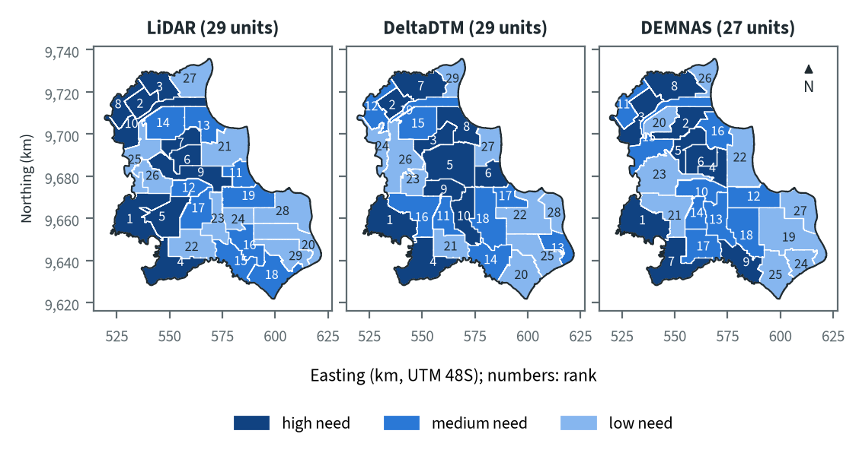
Figure 7.3. Need class per sub-KHG of Sungai Sugihan - Sungai Lumpur for the three DEM variants (default weights)
Table 7.4. The ten highest-need sub-KHG of Sungai Sugihan - Sungai Lumpur, LiDAR variant (default weights)
Rank | Unit | Area (km²) | Need score (U / S) | Burned (% of peat per year) | Hotspots (per km² peat per year) | Within canal reach (%) | Missing blocks (0-1) | Blocks needed / existing / additional | Peat depth (m) | High class in weight draws (%)
1 | S21 | 373 | 0.62 (0.58 / 0.77) | 8.8 | 1.57 | 35 | 0.60 | 265 / 106 / 159 | 3.2 | 98
2 | S03 | 135 | 0.58 (0.59 / 0.51) | 5.6 | 0.83 | 82 | 0.88 | 16 / 2 / 14 | 1.3 | 99
3 | S02 | 170 | 0.51 (0.57 / 0.27) | 3.5 | 0.57 | 69 | 1.00 | 85 / 0 / 85 | 1.0 | 89
4 | S28 | 275 | 0.51 (0.57 / 0.29) | 7.8 | 1.38 | 16 | 0.68 | 76 / 24 / 52 | 1.3 | 88
5 | S19 | 256 | 0.46 (0.32 / 1.00) | 0.3 | 0.26 | 72 | 0.32 | 377 / 258 / 119 | 3.4 | 73
6 | S11 | 138 | 0.45 (0.32 / 1.00) | 0.0 | 3.14 | 82 | 0.00 | 72 / 84 / 0 | 4.3 | 71
7 | S08 | 134 | 0.45 (0.43 / 0.55) | 5.9 | 4.06 | 53 | 0.13 | 93 / 81 / 12 | 1.9 | 71
8 | S04 | 139 | 0.44 (0.45 / 0.40) | 0.5 | 0.09 | 85 | 1.00 | 32 / 0 / 32 | - | 57
9 | S12 | 293 | 0.44 (0.31 / 0.96) | 0.1 | 2.03 | 81 | 0.18 | 296 / 243 / 53 | 3.3 | 61
10 | S06 | 261 | 0.43 (0.44 / 0.38) | 5.9 | 1.32 | 81 | 0.00 | 60 / 102 / 0 | 1.3 | 48
U: need part (urgency); S: stakes part. Default weights, proposed for agreement with KLH and the World Bank.

7.5 Blocks needed and how the DEM changes them
The number of canal blocks a KHG appears to need depends strongly on the DTM, through the canal slope, and the count on one DEM can be several times the count on another.
Table 7.5. Canal blocks needed, existing and additional per DEM variant, Sungai Sugihan - Sungai Lumpur, primary and secondary canals. Source: block summaries and unit tables of the ranking per DEM variant
 | LiDAR | DeltaDTM | DEMNAS
Median canal slope of the units (m/m) | 0.00028 | 0.00060 | 0.0023
Spacing at that slope, 0.4 m ÷ slope (m) | 1,446 | 671 | 175
Units at the 2,000 m spacing cap | 4 | 0 | 0
Blocks needed | 3,634 | 6,237 | 25,580
Blocks existing | 2,847 | 2,847 | 2,847
Additional blocks | 1,335 | 3,631 | 22,733
Additional blocks in high-need units | 526 | 1,514 | 4,988

The LiDAR variant at this KHG uses the 25 m DEM that KLHK derived from LiDAR. The same canal network gives 3,634 blocks needed on that DEM and 25,580 on DEMNAS, seven times as many, because the median canal slope on DEMNAS is eight times the LiDAR slope. The vertical error of each DEM is assessed in the DEM benchmark (chapter 4).
Blocks needed count only primary and secondary canals, while blocks existing count every realised canal block in the unit, on any canal class. The two totals are therefore not a like-for-like comparison. Until a DEM with small slope error covers a KHG, the block count from the ranking is a first, rough figure; the block design in RE-PEAT Interventions sets its own spacing.
Additional blocks are counted per unit and are zero where a unit already has more blocks than needed. On the LiDAR DEM several units have more existing blocks than the rule asks for. The additional total (1,335) is therefore larger than blocks needed minus blocks existing (787).
The KHG deficit passed to the interventions module is 290 mm. It covers 1 June to 9 October 2026 and is built from 51 SiTMAT stations with ERA5 rain and evaporation and a specific yield of 0.15, with a range of 285 to 296 mm for specific yields of 0.10 to 0.20. The deficit is computed once per KHG and is the same for all three DEM variants.

7.6 Agreement between DEM variants and across KHG
Whether a place is high need should not depend on which DEM was used, so the variants are compared on the ground. Because each DEM variant draws its own units, the rankings of two variants cannot be compared unit by unit. Instead, the unit layers of two variants are intersected, and each piece carries the class and score of both. Agreement is the share of the KHG area that falls in the same class under both DEMs, plus the rank correlation of the two need scores over the pieces, weighted by area.
Rankings on all three DEM variants are available for four KHG, the ones on which the method was developed: Sungai Sugihan - Sungai Lumpur, Sungai Saleh - Sungai Sugihan, Sungai Mendahara - Sungai Batanghari and the earlier test site Sungai Kampar - Sungai Gaung. The tables below give the classes, block counts and agreement between DEM variants for these four. Chapter 10 gives the results for all 14 analysed KHG.
Table 7.6. Sub-KHG units and need classes per KHG and DEM variant (default weights)
KHG | DEM | Units (n) | High / medium / low need (units) | High / medium / low need (km²) | Spearman, need score vs rank-sum | Units with a stable class (%) | Blocks needed / existing / additional
Sugihan-Lumpur | LiDAR | 29 | 10 / 9 / 10 | 2,175 / 1,823 / 2,348 | 0.76 | 62 | 3,634 / 2,847 / 1,335
Sugihan-Lumpur | DeltaDTM | 29 | 10 / 9 / 10 | 2,379 / 1,808 / 2,160 | 0.68 | 62 | 6,237 / 2,847 / 3,631
Sugihan-Lumpur | DEMNAS | 27 | 9 / 9 / 9 | 2,057 / 1,922 / 2,368 | 0.69 | 74 | 25,580 / 2,847 / 22,733
Saleh-Sugihan | LiDAR (62% of KHG) | 29 | 10 / 9 / 10 | 460 / 333 / 380 | 0.64 | 62 | 7,752 / 0 / 7,752
Saleh-Sugihan | DeltaDTM | 26 | 9 / 8 / 9 | 638 / 629 / 629 | 0.67 | 85 | 1,165 / 25 / 1,141
Saleh-Sugihan | DEMNAS | 27 | 9 / 9 / 9 | 618 / 629 / 649 | 0.64 | 74 | 6,768 / 25 / 6,744
Mendahara-Batanghari | LiDAR | 29 | 10 / 9 / 10 | 695 / 573 / 743 | 0.51 | 62 | 1,995 / 417 / 1,596
Mendahara-Batanghari | DeltaDTM | 29 | 10 / 9 / 10 | 754 / 558 / 700 | 0.38 | 69 | 3,908 / 417 / 3,509
Mendahara-Batanghari | DEMNAS | 29 | 10 / 9 / 10 | 616 / 670 / 726 | 0.56 | 72 | 8,763 / 417 / 8,346
Kampar-Gaung (test site) | LiDAR | 28 | 10 / 9 / 9 | 2,398 / 2,250 / 2,449 | 0.59 | 68 | 1,675 / 2,754 / 505
Kampar-Gaung (test site) | DeltaDTM | 27 | 9 / 9 / 9 | 2,384 / 2,273 / 2,453 | 0.57 | 63 | 3,394 / 2,754 / 1,605
Kampar-Gaung (test site) | DEMNAS | 29 | 10 / 9 / 10 | 3,003 / 1,831 / 2,277 | 0.64 | 69 | 9,518 / 2,754 / 6,764
Kampar-Gaung is a test site, not one of the 12 selected KHG. Stable class: share of units keeping their class over the weight draws. Default weights, proposed for agreement with KLH and the World Bank.
Table 7.7. Agreement of the sub-KHG need ranking between DEM variants (default weights)
KHG | DEM pair | Overlap (km²) | Same need class (% of overlap) | High need in first also high in second (%) | Spearman of scores, area-weighted
Sugihan-Lumpur | LiDAR - DeltaDTM | 6,350 | 62 | 63 | 0.68
Sugihan-Lumpur | LiDAR - DEMNAS | 6,350 | 57 | 64 | 0.55
Sugihan-Lumpur | DeltaDTM - DEMNAS | 6,351 | 65 | 66 | 0.72
Saleh-Sugihan | LiDAR (62% of KHG) - DeltaDTM | 1,174 | 79 | 88 | 0.85
Saleh-Sugihan | LiDAR (62% of KHG) - DEMNAS | 1,174 | 71 | 82 | 0.86
Saleh-Sugihan | DeltaDTM - DEMNAS | 1,898 | 74 | 79 | 0.86
Mendahara-Batanghari | LiDAR - DeltaDTM | 2,012 | 67 | 73 | 0.87
Mendahara-Batanghari | LiDAR - DEMNAS | 2,012 | 84 | 80 | 0.91
Mendahara-Batanghari | DeltaDTM - DEMNAS | 2,013 | 69 | 62 | 0.88
Kampar-Gaung | LiDAR - DeltaDTM | 7,094 | 77 | 76 | 0.81
Kampar-Gaung | LiDAR - DEMNAS | 7,094 | 63 | 74 | 0.75
Kampar-Gaung | DeltaDTM - DEMNAS | 7,108 | 75 | 87 | 0.83
Units are matched by location, not by name: the unit sets differ per DEM. Shares are of the area both variants cover. Default weights, proposed for agreement with KLH and the World Bank.

7.7 Held-out validation
Within a KHG the need score points at later fire better than chance, but fire history alone does as well or better in most comparisons, so the validation cannot by itself justify the weights. The validation builds the indicators from 2015 to 2022, leaves this year's hotspots out, and tests the ranking on 2023. It uses the same measures as the national validation (chapter 6): the AUC and the share of later fire captured by the top 20% of units.
Table 7.8. Validation on 2023 of the sub-KHG ranking per DEM variant, Sungai Sugihan - Sungai Lumpur. AUC of the full need score, of the need part only, and of burned share alone. Source: ranking reports per DEM
Target | Score | LiDAR | DeltaDTM | DEMNAS
Units with 5% or more of peat burned in 2023 |  | 3 of 29 | 3 of 29 | 3 of 27
Burned share: AUC | need score | 0.72 | 0.88 | 0.79
 | need part only | 0.81 | 0.94 | 0.86
 | fire history alone | 0.82 | 0.87 | 0.88
Units with hotspots in 2023 |  | 17 of 29 | 17 of 29 | 15 of 27
Hotspots: AUC | need score | 0.56 | 0.59 | 0.60
 | need part only | 0.67 | 0.70 | 0.71
 | fire history alone | 0.69 | 0.72 | 0.77

The AUC of the need score is above 0.5 in every variant, but only modestly for hotspots (0.56 to 0.60). Fire history alone scores the same or higher in five of the six comparisons; the exception is burned share on DeltaDTM (0.88 against 0.87). The burned-share test rests on three units, so one unit more or less changes the AUC by a large step. For hotspots the need part does better than the full score. The stakes part (peat depth, protected function) describes what is at risk and says nothing about where fire will occur, so it lowers fire prediction by design.
An earlier unit set of the same KHG (30 units, delineated before the per-DEM variants) was tested with bootstrap intervals on two folds, 2019 and 2023. For burned share in 2019, the Spearman correlation with the need score was 0.37 (90% interval 0.06 to 0.62), against 0.64 (0.39 to 0.82) for fire history alone. At Sungai Kampar - Sungai Gaung the order was reversed: 0.61 (0.35 to 0.80) for the need score against 0.38 (0.02 to 0.68) for fire history. With 26 to 30 units the intervals overlap, and no score is clearly better than another.
Fire is the only outcome that can be tested. Canals, missing blocks and canal reach describe the need for rewetting itself, and no held-out data can test them yet. The weights therefore cannot be set from the validation alone. They should be set by expert judgement, for example in a pairwise-comparison (AHP) session with KLH and the World Bank, with the validation as a check.

7.8 Limits
- The weights are defaults proposed for agreement with KLH and the World Bank. Under other weightings some units move in or out of the high-need class (section 7.4).
- Peat depth carries weight 2 in the stakes part, which makes up 0.2 of the need score. At Sugihan-Lumpur the peat depth model covers 74.7% of the KHG, and it correlates with lift at -0.80 in the LiDAR variant. A depth layer that covers only part of a KHG should not drive the ranking, so this weight needs a decision before the rankings are used.
- The units are large (118 to 481 km² at Sugihan-Lumpur). Their size follows from a cap of 30 units per KHG in the delineation (at Sugihan-Lumpur on the LiDAR DEM, a minimum unit area of 116 km² chosen automatically to stay within the cap) and has no hydrological basis. Block effects reach a few hundred metres: about 600 m in model results (Urzainki et al. 2023). An indicator averaged over 200 km² cannot locate where blocks act.
- Burned share is the heaviest need indicator and comes from burnt-area polygons whose source is not documented, so their accuracy cannot be judged.
- The block count depends strongly on the DTM (section 7.5).
- SiTMAT covers one season (2026), mostly in concessions, and too few units to be scored at Sugihan-Lumpur.
- The canal layer is derived from OpenStreetMap and has no flow direction. Existing blocks come from the BRGM structures and may be incomplete.
- Forest share counts plantations as tree cover.
- Classes are tertiles within one KHG, so a high-need unit in one KHG is not directly comparable with a high-need unit in another.
- With 26 to 30 units per KHG and few burned units in a test year, the validation intervals are wide.

8 Neraca air (water balance)
Neraca air is the water balance of a peat hydrological unit (KHG) and of its sub-units (sub-KHG). For rewetting planning it tells when a KHG runs short of water and how much water the managed system has to supply to hold the water table. This chapter has two parts. Sections 8.1 to 8.5 cover the method the project has adopted: a climatic balance per sub-KHG from open satellite products, and a supply deficit per KHG from observed water tables. From section 8.6 the chapter covers the groundwater model for simulating rewetting scenarios, which is in development and is described separately.

8.1 Purpose and the regulatory target
Government Regulation PP 71/2014, as amended by PP 57/2016, treats cultivation-function peat (gambut) as damaged when the water table (TMA, tinggi muka air) is more than 0.4 m below the surface at a compliance point. Rewetting means holding or bringing back enough water to keep the water table above that line, with canal blocks (sekat kanal), water gates and, in emergencies, pumps. RE-PEAT uses the 0.4 m depth as its target throughout.
For rewetting, neraca air has to answer three questions:
1. In which months of the year does a KHG, or a sub-KHG, lose more water to evapotranspiration than rain supplies?
2. Do some sub-KHG lose more water than others, so that the balance can help rank them for intervention?
3. How much water, in millimetres and in cubic metres, must the managed system supply over a dry season to hold the water table where it was observed?
The adopted method answers the first and third questions with numbers for every selected KHG that has the data. Its answer to the second is weaker, because the open data separate sub-KHG reliably at only some sites (section 8.4).

8.2 Earlier work
The adopted method starts from the 2021 Kahayan-Sebangau study and the Pulau Padang work of Amal et al. (2021). Reproducing the 2021 balance showed that its published figures depend on runoff coefficients that vary between units without a stated reason, so the project fixed a single coefficient and a single form of the equation.

The 2021 Kahayan-Sebangau study
The starting point is the neraca air of the 2021 study of KHG Kahayan-Sebangau by the UGM team. Its Earth Engine scripts compute a monthly balance from TerraClimate (about 4.6 km, monthly, 2010-2020):
WB = P - ET - C × P
where P is rain, ET is actual evapotranspiration and C is a runoff coefficient. The scripts use C = 0.25 for every unit. One script assigns 0.35 to ten of the 16 sub-KHG and 0.25 to the other six, with no reason given. The TerraClimate runoff band is loaded but not used, and the scripts have no interception term. The study's final report adds interception by land cover, from 0 % on open land to 16.4 % under forest, and cites C = 0.07-0.18 from two months of measurements on Pulau Padang; the measurements behind that range could not be traced. The report's Table 5.10 gives a sub-KHG balance for 2010-2020 of 41 to 65 mm/month and 3.9 to 5.3 deficit months per year.

Reproduction of the 2021 scripts
The project rebuilt the 2021 balance on the same 16 sub-KHG polygons and TerraClimate data. Monthly values match the 2021 Earth Engine expression within 0.1 mm at six test points (two months, three sub-KHG). The remaining difference comes from the 2021 charts being computed at 2,500 m against TerraClimate's 4,638 m grid.
The reproduction does not match the published Table 5.10. With C = 0.25 everywhere, the 16 units range from 49.3 to 54.0 mm/month with 3.6 to 5.0 deficit months per year. With the 0.25/0.35 split, the ten units at 0.35 drop by about 21 mm/month, and the range becomes 28.7 to 50.9 mm/month with 4.1 to 5.4 deficit months. The KHG-mean calendar shows deficits in July (-39 mm), August (-39 mm), September (-5 mm) and October (-4 mm), with 90 % and 91 % of sub-KHG-months in deficit in July and August.
The scripts also carry material from other sites: their headers name KHG Pulau Padang and Tebing Tinggi, one map layer named "January 2019" shows August 2020, and one boundary layer is labelled Mempawah. The 16 polygons are Kahayan-Sebangau (4,523 km2 in total, against 451,507 ha in the KHG registry).

The earlier design
An early design for the water balance followed the Pulau Padang water balance of Amal et al. (2021): storage change equals rain minus evapotranspiration minus runoff to canals, extended with pump inflow and inflow from upstream units. It proposed a dekadal time step, a runoff coefficient conditioned on canal-block status and antecedent water table, calibration against water-table stations, and a deficit for prioritisation of Sy × (TMA - 0.4 m) × area. Most of it could not be built, because it depended on canal discharge, block status and station networks that are not available to the project.

The runoff coefficient
The project uses C = 0.12, the value from Pulau Padang, with a range of 0.07-0.18, and does not use separate values by land class. The full text of Amal et al. (2021), a two-month field campaign in November and December 2017, gives no runoff coefficient. It reports that on community land without canal blocks the water table sat between -0.6 and -1.9 m and rain "directly flows as runoff", while on company land with blocks it stayed between -0.4 and -0.6 m. The dissertation abstract (Amal 2022) states that runoff enters the balance through a coefficient, splits Pulau Padang into 11 sub-KHG, and finds deficit months in January, February, March, June and July, worst in February in the north. A MIKE SHE study of Pulau Padang (Kurnianto et al. 2026) found that converting forest to managed land raised runoff by about 6 %, while differences in rain between years changed runoff up to eightfold.

8.3 Why climate data alone cannot predict water tables
In managed peat, water management sets the water table more than the weather does. Open rain and evaporation data could not predict water tables per sub-KHG, so the adopted method uses the climate only for timing and measures the management term from water-table stations. The tests used the SiTMAT water-table stations in managed concessions, the only daily water-table series at the test KHG, which cover one season (2026).

A rain-driven bucket fitted to stations
The first model was a daily bucket per sub-KHG: the water table falls when ERA5 rain minus evaporation is negative, scaled by an effective storage coefficient, with an optional drainage loss near canals. Storage, drainage and the starting depth were fitted to 86 stations at Kampar-Gaung (1 April to 9 October 2026) and scored on spatial blocks left out of the fit.
- Timing was moderate: the median correlation per station was 0.63.
- Spatial skill was nil. The Spearman correlation across held-out stations was -0.03 for peak depth and -0.02 for days deeper than 40 cm. The out-of-fold error (16.5 cm) was worse than a no-skill baseline in which every station follows the KHG-mean curve (15.3 cm).
- Every fitted parameter ran to the edge of its allowed range: specific yield 3.0, drainage 4.0 mm/day, starting depth 40 cm. A specific yield of 3.0 is not physical; measured values on drained Sumatran peat are 0.3 near the surface and 0.1 at 1.5 m depth (Ismail et al. 2021). The fit absorbed a missing drainage term and returned a nearly flat water table at 40 cm.
- The observed mean water table sat at about 40 cm from April to August and fell to 60-70 cm in September, a pattern consistent with managed water levels.
- No site property explained which stations were deepest (Spearman 0.34 or less for peat depth, elevation, canal distance and density, river distance, distance to the KHG edge, NDMI and NDVI).
The concession a station belongs to explains 64 % of the variance in peak depth (10 concessions with 3 or more stations, 85 stations). Sentinel-1 radar backscatter ranked peak depth across stations with a Spearman of 0.53, but inside concessions this fell to 0.21. The radar mostly reflects how a concession is managed.
Replacing ERA5 evaporation with WaPOR made the fit worse at both test KHG: out-of-fold error 24.0 against 20.4 cm at Kampar-Gaung and 14.2 against 11.3 cm at Sugihan-Lumpur, without the drainage term.
A further test fitted one canal level per concession and season, after Taufik et al. (2019). Leaving one station out, the error at Kampar-Gaung was 12.4 cm, against 14.6 cm for the all-station mean curve and 10.9 cm for copying the other stations of the same concession. With a whole concession left out, the model had no skill (17.2 against 17.0 cm). The fitted dry-season canal levels ranged from 28 to 88 cm between concessions at Kampar-Gaung; at Sugihan-Lumpur they sat at 32-36 cm from June after 52-56 cm in April and May. The project did not develop the bucket approach further.

Physical tiers 1 and 2
The project then tested a physical model with no fitted parameters. Tier 1 is one water table for the whole KHG draining to canals; tier 2 is a 2D groundwater model on a 500 m grid with canals and the KHG edge as fixed heads. Both use ERA5 forcing and peat tables after Urzainki et al. (2020).
Table 8.1. Tier 1 physical model against the station-mean water table, 1 April to 15 October 2026, base transmissivity. Source: tier 1 model results of the neraca air analysis
KHG | Stations | Simulated mean depth (cm) | Observed mean depth (cm) | Bias (cm) | RMSE (cm) | Correlation
Sugihan-Lumpur | 51 | 65.7 | 43.0 | +22.7 | 56.6 | 0.96
Kampar-Gaung | 86 | 25.1 | 42.0 | -16.9 | 27.5 | 0.68

At Sugihan-Lumpur the model gets the timing right and the level wrong. Raising transmissivity a thousandfold made it worse (100.2 cm simulated at a canal drawdown of 1.2 m), because the canals then pull the water table towards their level. Letting evaporation fall as the water table deepens, with the natural-peat thresholds of Apers et al. (2022), cut the error from 56.6 to 46.2 cm and left most of the gap. In the 2D model, 30 % of cells were fixed as canal or edge, and every free cell followed the same curve: all 28 sub-KHG had the same mean depth, 65 cm. These tiers were an early diagnostic version of the groundwater model. The rewetting model of section 8.6 builds on it, holds managed land at 0.4 m and uses a 100 m grid; it will replace the adopted outputs only after it passes a check against field water tables.

What the failures show
At Sugihan-Lumpur, rain minus evaporation from June to October summed to about -306 mm. With a specific yield of 0.14-0.2 the water table should have fallen 1.5 to 2 m. The station mean fell about 11 cm. Water came in from outside the rain balance, through tidal and river inflow in canals, gates and pumping, and held the level. Stations in managed concessions stay almost flat through the dry season, so water management sets their level.
The literature agrees. Every model reviewed that works in drained tropical peat treats drainage as an explicit input. SWAP in South Sumatra sets the canal water level by season, no deeper than 130 cm below the surface in the dry season and 50 cm in the wet (Taufik et al. 2019). The ecosys model across Riau prescribes a lateral boundary water table (Mezbahuddin et al. 2023). PEATCLSM-Trop uses ditch depth, interval and conductivity, and notes that its drainage map does not take local canal management into account, which it names among its main remaining errors (Apers et al. 2022). None of these models predicts the water table from rain minus evaporation alone, which is what the bucket attempted.
The adopted method therefore keeps the climatic balance for what it can show (when a KHG is short of water, and how sub-KHG compare where the data agree) and measures the management term directly from the stations as a supply deficit.

8.4 The adopted method
The method gives planners two results at two levels, kept apart:
- Per sub-KHG, a climatic water balance: how much water the climate leaves each unit, in how many months a year it falls short, and whether the order of units is reliable enough to use in ranking.
- Per KHG, a supply deficit: how much water the managed system supplied to hold the observed water table through the 2026 dry season.
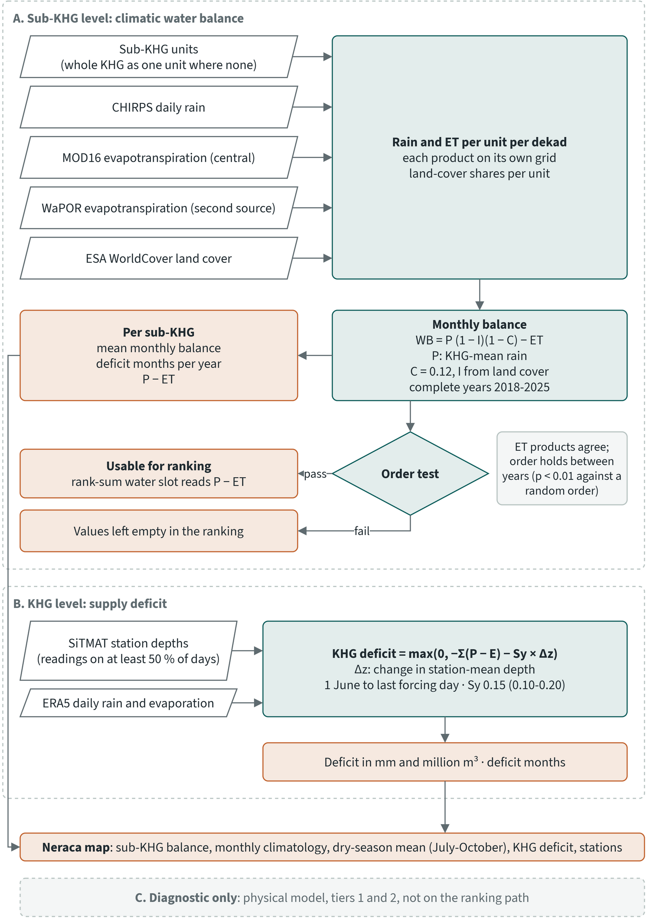
Figure 8.1. Adopted neraca air method: climatic balance per sub-KHG and supply deficit per KHG

Inputs
Table 8.2. Inputs of the adopted neraca air method. Source: neraca air method report and the Earth Engine product definitions
Input | Product | Grid | Period available | Used for
Sub-KHG units | sub-KHG delineation; the whole KHG as one unit where none exist | polygons |  | balance
Rain | CHIRPS daily | 0.05° (about 5.6 km) | 1981 to 30 September 2026 | balance
Evapotranspiration, central | MODIS MOD16A2GF v061, gap-filled 8-day | 500 m | 2000 to December 2025 | balance
Evapotranspiration, near real time | MODIS MOD16A2 v061, not gap-filled | 500 m | 2021 to October 2026 | 2026 balance
Evapotranspiration, second source | FAO WaPOR v3 L1 AETI, dekadal | 326 m | 2018 to 11 October 2026 | balance (agreement test)
Land cover | ESA WorldCover v200 | 10 m | 2021 | interception
Rain reference | IMERG Final monthly V07 | 0.1° | 1998 to September 2025 | checks
Water table | SiTMAT concession stations, daily depth | points | 1 April to 22 October 2026 | deficit
Rain and evaporation, KHG mean | ERA5 daily | 0.25° | deficit window of each KHG | deficit

SiTMAT is the only daily water-table series used by the adopted method. Its stations do not report rain, and no rain-gauge record was available to the project.

Where the rain and evapotranspiration data come from
Rain and evapotranspiration (ET) are not measured at each peat unit, so the balance uses satellite-based estimates. A satellite sees cloud, vegetation and surface temperature, and a model turns those into millimetres of water. The errors of these products enter every balance value, so the table and notes below say what each product is.
Table 8.3. Rain and evapotranspiration products behind the balance. Source: Funk et al. (2015); Mu et al. (2011); NASA LP DAAC (2021); FAO; UN FAO; Klaasse et al. (2023)
Product | Producer | Quantity | How it is made | Grid and time step | Use in the balance
CHIRPS | Climate Hazards Group | Rain | Rainfall climatology and infrared cold-cloud estimates, blended with station records | 0.05° (about 5.6 km), daily | Rain for every unit
MOD16A2GF v061 | NASA, from the MODIS sensor on the Terra satellite | Evapotranspiration | Penman-Monteith for soil evaporation, wet canopy evaporation and transpiration, with daily weather reanalysis and MODIS leaf area, FPAR, albedo and land cover; gap filled after the end of the year | 500 m, 8-day totals | Central ET to December 2025
MOD16A2 v061 | NASA, as above | Evapotranspiration | The same, without gap filling | 500 m, 8-day totals | ET for 2026
WaPOR v3 AETI | FAO; model by eLEAF | Evapotranspiration and interception | ETLook model: two Penman-Monteith equations (soil, canopy) plus an interception term; thermal imagery from the VIIRS sensor sharpened to a finer grid; soil moisture stress | 326 m (global level, nominally 300 m), dekadal | Second source for the agreement test

CHIRPS was developed for the USAID Famine Early Warning Systems Network (Funk et al. 2015). It starts from a 0.05° rainfall climatology, adds rain estimates from how long clouds stay cold in infrared satellite images, and blends in station records. It covers 50°S to 50°N, which includes Indonesia, and its final version appears about three weeks after the period. Against IMERG, a merged satellite and gauge product, CHIRPS totals were 16 % higher at Sugihan-Lumpur and 8 % higher at Kampar-Gaung over 2018 to September 2025, with a monthly correlation of 0.89 at both.
MOD16 comes from NASA and the MODIS sensors; Mu et al. (2011) describe the algorithm. For each 500 m pixel it adds three parts: evaporation from the soil, evaporation of rain held on the wet canopy, and transpiration by plants through the dry canopy (NASA LP DAAC 2021). Each part follows the Penman-Monteith equation, which estimates evaporation from the energy available at the surface, the dryness of the air and the resistance of vegetation and soil to water loss. The inputs are land cover, leaf area index, the fraction of absorbed light (FPAR), albedo, and air pressure, temperature, humidity and radiation from a daily meteorological reanalysis (NASA LP DAAC 2021). Leaf area and FPAR come as 8-day composites, so the ET value in a pixel is the sum over the eight days.
The gap-filled version replaces leaf area and FPAR values that failed the quality screening by linear interpolation between the previous and the next period, and is produced after the end of each year. The user guide states that gap filling generally raises 8-day ET. Over 2021 to 2025 at Sugihan-Lumpur, the version without gap filling, which the 2026 balance uses, was 2.2 % above the gap-filled version (1,472 against 1,440 mm/yr, correlation 0.93 over 180 dekads). Against 46 eddy-covariance towers worldwide, the algorithm had a mean absolute error of 0.31 mm/day with reanalysis weather, 24 % of the tower ET and within the 10 to 30 % uncertainty of tower measurements (Mu et al. 2011). Each pixel also carries a quality flag that records cloud and whether a back-up algorithm was used.
WaPOR is the FAO portal for water productivity from open remote sensing data. It was built to monitor agricultural water productivity, and its global level covers the whole globe at 300 m (FAO n.d.). Its AETI layer is the sum of soil evaporation, canopy transpiration and interception, delivered as the average daily rate of each dekad in mm/day, with monthly and annual sums. The method is ETLook (Bastiaanssen et al. 2012), which solves two Penman-Monteith equations in parallel, one for soil evaporation and one for canopy transpiration. Transpiration is coupled to the moisture of the root zone and evaporation to the moisture of the topsoil. The canopy resistance depends on leaf area, a minimum stomatal resistance, and reduction factors for soil moisture, solar radiation, temperature and humidity. Interception is computed from vegetation cover, leaf area and rain: the share intercepted is large for small rain and falls quickly as rain increases, and the energy it uses is not available for transpiration (UN FAO n.d.). Version 3 takes land surface temperature from the VIIRS sensor and sharpens it to a finer grid, builds smoother vegetation and albedo series, and uses a relative soil moisture estimated from surface temperature to reduce ET in dry soil (Klaasse et al. 2023). Dekadal values appear a few days after each dekad in a near-real-time version, and a final version replaces them later (FAO n.d.).
The two ET products share four properties that matter for the balance.
- Both are model estimates. Over 2018 to September 2025, WaPOR totals were 19 % below MOD16 at Sugihan-Lumpur and 21 % below at Kampar-Gaung, with monthly correlations of 0.61 and 0.44. The balance takes MOD16 as the central product because its annual level lies within eddy-covariance measurements on peat (see the balance step below), and keeps WaPOR as a second source.
- Both include evaporation of rain that the canopy intercepted: MOD16 as wet canopy evaporation, WaPOR as its interception term (NASA LP DAAC 2021; UN FAO n.d.). The interception term of the balance removes that share of the rain a second time, so the results also give P - ET, rain minus ET without the runoff and interception terms.
- Both depend on optical or thermal images, which cloud interrupts. MOD16 interpolates leaf area and FPAR across failed periods. WaPOR smooths and gap-fills its vegetation and albedo series, and its developers note that persistent cloud makes good data hard to produce in some areas (Klaasse et al. 2023).
- Neither was built for peat swamp forest. MOD16 is a global product and WaPOR was designed for agricultural water productivity. The comparison with eddy-covariance sites on peat is the check on the level of ET.

What the peat literature uses
None of the three products is validated over Indonesian peat in the sources reviewed for this report. For rain, the peat studies found use IMERG or GPM. Hooijer and Vernimmen (2026) built a 25-year daily water table record for forested peatlands in Southeast Asia from IMERG, and Apers et al. (2025) used IMERG for peat hydraulic parameters in Brunei, noting that gridded satellite rain is coarse and misses cloud-scale rain. Yondriadi and Sutikno (2026) compared GPM with three BMKG stations in Riau over 2015 to 2024: monthly R² was 0.86 to 0.94, GPM was too high in the wet season and too low in the dry season, and the authors recommend a local correction. IMERG is the cross-check on CHIRPS in this report.
For evapotranspiration, the studies found test MOD16 outside peat. In East Java, MOD16A2 overestimated against climate-station estimates, with a mean absolute error of 0.92 mm/day and a correlation of 0.25 (Faisol et al. 2020). At 16 forest sites in East Asia, MOD16 bias exceeded 30 % under some cloud conditions, largest at tropical coastal forests, and was linked to overestimated MODIS leaf area (Wang et al. 2021). In the Lancang-Mekong basin, MOD16 had a higher error against eddy covariance than three other products (Chen et al. 2022). These sites are not peat, so they show the risk and do not measure the error here. At Sugihan-Lumpur and Kampar-Gaung the two ET products differ by 19 to 21 % in total, so the choice of product moves every balance value.
The 2021 Kahayan-Sebangau study used TerraClimate (section 8.2), a model product with 4.6 km pixels and a monthly step that ends in December 2024. MOD16 and WaPOR have finer pixels and steps of eight or ten days, which suits sub-KHG units and a dekadal balance.

The climatic balance per sub-KHG
The balance is computed per dekad and summarised per month and per year. A dekad is days 1-10, 11-20, or 21 to the end of the month.
Step 1 retrieves rain and evapotranspiration per unit and per dekad from Earth Engine. The total for a dekad is the sum, over the source images that overlap it, of the image's daily rate times the days of overlap. The daily rate is the image value times its scale factor, divided by the image length when the value is a total (one CHIRPS day, one MOD16 8-day composite), and used as is when it is a mean daily rate (WaPOR). MOD16 fill values are excluded. Each value is an area-weighted mean over the unit, computed on the product's own grid with no resampling, and carries its count of valid pixels and the share of the dekad covered by images. WorldCover class shares are counted per unit. Since each period must start and end on a dekad boundary, the series used here end on 1 October 2026.
Step 2 forms the monthly balance:
WB(u, month) = P_KHG × (1 - I_u) × (1 - C) - ET_u
The two reductions act in sequence: interception removes its share of the rain first, and the runoff coefficient applies to the rain that reaches the ground.
- P_KHG is the area-weighted KHG mean of the month's rain, the same for every unit. CHIRPS and IMERG order the sub-KHG differently by mean rain (Spearman -0.34 over 30 units at Sugihan-Lumpur, -0.06 over 26 at Kampar-Gaung), so rain cannot separate units.
- ET_u is MOD16 for the unit. Its annual level, 1,385 to 1,441 mm/yr at the two test KHG over 2018-2025, lies within eddy-covariance measurements over Central Kalimantan peat of 1,636, 1,553 and 1,374 mm/yr at undrained, drained and drained-burnt sites (Hirano et al. 2015). WaPOR (1,101 to 1,180 mm/yr) lies below the lowest site, so it serves as a second source only.
- C = 0.12.
- I_u is the unit's interception share: the sum over WorldCover classes of class share times interception (tree cover and mangroves 0.164, shrubland 0.08, herbaceous wetland 0.05, grassland and cropland 0.03, other classes 0).
A month counts only when all its dekads are fully covered for both rain and evapotranspiration, and a year only when all 12 months count. Over the complete years the method gives, per unit:
- the mean monthly balance (mm/month);
- deficit months, the number of months a year with a negative balance;
- P - ET, rain minus evapotranspiration without the runoff and interception terms (mm/month);
- the spread of the yearly mean between years.

Can the order of sub-KHG be trusted?
A ranking of sub-KHG by water balance is only useful where the order of units reflects water, and this holds at few sites. With the same rain for every unit, the mean balance follows forest share: the interception term is 6-16 % of about 240 mm/month of rain and is fixed by land cover, which is larger than the differences in evapotranspiration between units (standard deviation 3-7 mm/month). Across units the mean balance correlated with forest share at -0.44 at Sugihan-Lumpur and -0.82 on the 2021 Kahayan-Sebangau units, while P - ET correlated at 0.07 and 0.11. P - ET therefore carries the water signal between units. Satellite evapotranspiration already includes evaporation of intercepted rain, so the interception term counts it a second time; the formula is kept because it is the established form of the 2021 study.
The method tests, for each KHG and DEM variant, whether the order of units can be used. The order passes when both of these hold:
1. MOD16 and WaPOR order the units' mean evapotranspiration alike, and
2. the yearly balance keeps its order between years (median Spearman over all pairs of complete years),
each at or above the 99th percentile of the same statistic for a random order of the same number of units, found by simulation (10,000 draws). A fixed threshold such as 0.5 would not be equally strict for every number of units: the 99th percentile for one Spearman is 0.43 for 30 units, 0.46 for 26, 0.58 for 16 and 0.72 for 10. The year test is weak, because a land-cover term fixed in time keeps the order between years whatever the water does, so the evapotranspiration test carries the decision. With fewer than 5 units no order is tested.
Where the test fails, the balance values of those units are left out of the sub-KHG ranking. The water indicator of the sub-KHG ranking uses P - ET, and deficit months carry a weight of 0. The ranking uses default weights proposed by the project for agreement with KLH and the World Bank, and adjustable in the dashboard.

The KHG supply deficit
The supply deficit gives the volume of water that had to reach a KHG from outside the rain balance to hold the observed water table, which is the quantity that water supply and pumping plans have to cover. It is a mass balance on the observed water table, with nothing fitted:
deficit (mm) = max(0, -Σ(P - E) - Sy × Δz × 10)
deficit (m3) = deficit (mm) / 1,000 × KHG area
- P - E is the daily ERA5 rain minus evaporation, KHG mean, summed over the window.
- Δz is the change in the station-mean depth (cm, positive deeper) between the mean of the first 7 and the last 7 days of the window. A water table that fell supplied part of the loss itself. One that rose against a negative balance adds to what had to come from outside.
- Sy = 0.15, with a band from 0.10 to 0.20. The peat tables after Urzainki et al. (2020) are not used here, because they rest on boreal retention curves.
- The window runs from 1 June to the last day with forcing, at most 31 October. Only stations with readings on at least half the window's days are used.
- Deficit months are the calendar months in the window with negative P - E; a partial last month counts.
ERA5 remains the deficit's forcing. Against IMERG over 21 dry-season months of 2019-2021, ERA5 rain was biased +18 % at Sugihan-Lumpur and +7 % at Kampar-Gaung, against +27 % and +7 % for CHIRPS. ERA5 evaporation totals were within -6 % and +2 % of MOD16 over the same months, and 17 % and 28 % above WaPOR. Using CHIRPS and WaPOR for the deficit would lower evapotranspiration by about a quarter, and the deficit with it. WaPOR is also revised by its provider: six dekads of 2026 (11 June to 10 August) changed after the project first retrieved them. For June to September 2026 at Sugihan-Lumpur, CHIRPS gave 208 mm of rain against 140 mm from ERA5, and the Earth Engine pair (CHIRPS minus WaPOR) gave -211 mm against -281 mm from ERA5.

Checks
The checks confirm the arithmetic and the KHG calendar of dry months. They do not confirm the order of sub-KHG.
Table 8.4. Checks of the adopted method. Source: neraca air method report and the check reports it names
Check | Result
Reproduction of the 2021 scripts | within 0.1 mm
Dekad arithmetic: one period equal to one source image | maximum difference 5e-14 mm (WaPOR), 1e-6 mm (TerraClimate)
Deficit months at Pulau Padang, 2018-2025, against Amal (2022) | February in deficit in 75 % of years, July 62 %, January 38 %, March 25 %, June 12-25 % (MOD16 or WaPOR); August 25-38 %, not named by Amal
Station deficit per sub-KHG against the long-term balance, Sugihan-Lumpur, 9 units with 3 or more stations | deficit 123 to 277 mm (median 181); Spearman with mean balance 0.32 and with deficit months 0.49, where a negative and a positive value were expected
Same, Kampar-Gaung, 6 units | deficit 0 in every unit

Over 2018-2025 the deficit months at Pulau Padang match the months Amal (2022) names, with February the most frequent, as in that study. The station deficit per sub-KHG runs against the order of units from the long-term balance at Sugihan-Lumpur and is zero in every unit at Kampar-Gaung.

Outputs
For each KHG and DEM variant the method produces:
- the balance per sub-KHG: mean monthly balance, deficit months per year, P - ET, spread between years, interception share, the WaPOR values for comparison, and the result of the order test;
- the monthly balance per sub-KHG and evapotranspiration source;
- a summary with the KHG calendar of monthly balance, evapotranspiration agreement, year stability and the forest-share check, and the parameters used;
- the KHG deficit with its band, volume, deficit months and the evidence behind it (stations, valid days);
- the neraca map, with sub-KHG polygons carrying the balance, the monthly climatology, the dry-season mean (July to October) and the KHG deficit, and the stations with their start, end and deepest depth in the window and their share of days deeper than 40 cm. Units that fail the order test are shown grey and not ranked. The map has no water-table surface, because the gridded model failed the station check.
The method applies to any list of KHG, up to the full registry of 865, and gives one summary per KHG and DEM variant. A KHG without delineated sub-KHG is treated as one unit.

8.5 Results at the first four KHG with completed chains
At KHG level the balance gives a consistent calendar of dry months, and the 2026 supply deficit gives the volume of water the managed system supplied at three of the four KHG. The order of sub-KHG is reliable in only two of twelve combinations of KHG and DEM. Chapter 10 gives the water balance and deficit of all 14 analysed KHG.
The full analysis chain is complete at Kampar-Gaung (KHG 14.02-04-05.01), Mendahara-Batanghari (15.05-07-10.01), Saleh-Sugihan (16.02-07.01) and Sugihan-Lumpur (16.02.01), once for each DEM variant: LiDAR, DeltaDTM and DEMNAS. The climatic balance uses CHIRPS rain, MOD16 evapotranspiration and the complete years 2018-2025 throughout.

Rain and evapotranspiration
Table 8.5. Annual rain and evapotranspiration, KHG mean, 2018-2025. Source: dekadal rain and evapotranspiration per sub-KHG from Earth Engine, DeltaDTM variant, area-weighted over sub-KHG
KHG | CHIRPS rain, mean (min-max) (mm/yr) | MOD16 ET (mm/yr) | WaPOR ET (mm/yr)
Kampar-Gaung | 2,785 (2,051-3,286) | 1,385 | 1,101
Mendahara-Batanghari | 2,855 (2,202-3,435) | 1,408 | 1,071
Saleh-Sugihan | 2,971 (2,325-3,504) | 1,350 | 1,139
Sugihan-Lumpur | 2,885 (2,212-3,483) | 1,441 | 1,180

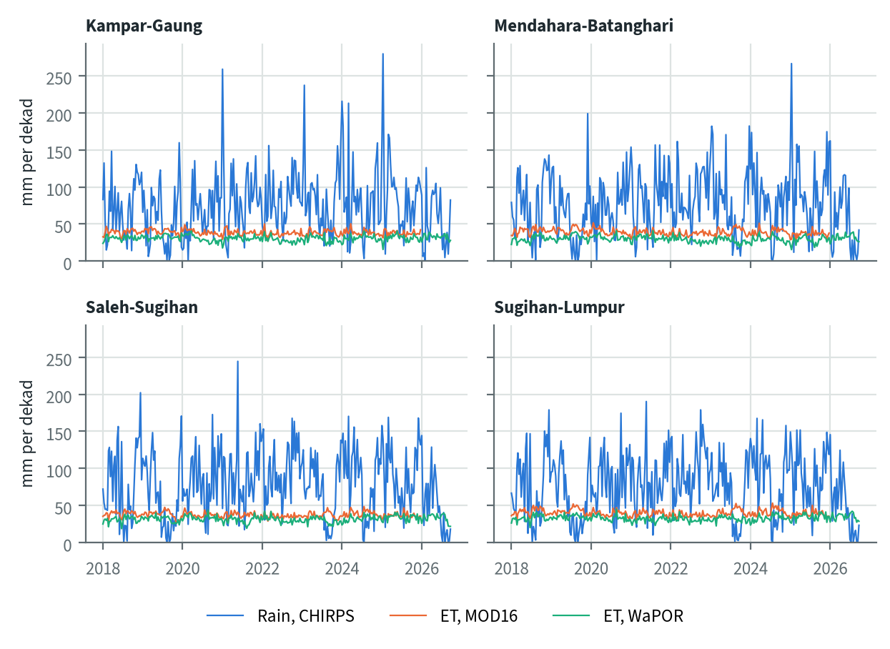
Figure 8.2. Dekadal rain and evapotranspiration per KHG, 2018 to September 2026

The KHG supply deficit, dry season 2026
Sugihan-Lumpur needed about 290 mm of water from outside the rain balance in one dry season, about 1.8 billion m3 over the KHG. Its water table fell 11 cm while the climate removed 307 mm. Mendahara-Batanghari needed 119 mm (240 million m3); its 12 stations fell 22 cm, which supplied 33 mm of the 152 mm loss. At Mendahara-Batanghari the window has 133 days of forcing out of 135, and 7 of the 12 stations belong to one concession.
Table 8.6. KHG supply deficit, dry season 2026. Source: KHG deficit results of the neraca air analysis (SiTMAT stations, ERA5)
KHG | Window | Stations | Area (km2) | ERA5 P - E (mm) | Station-mean depth, start to end (cm) | Deficit (mm), Sy 0.15 | Band, Sy 0.10-0.20 (mm) | Volume (million m3) | Months with P - E < 0
Sugihan-Lumpur | 1 Jun to 9 Oct | 51 | 6,348 | -306.7 | 40.2 to 51.2 | 290.2 | 284.7-295.7 | 1,842 | 5
Mendahara-Batanghari | 1 Jun to 13 Oct | 12 | 2,012 | -152.3 | 33.4 to 55.6 | 119.1 | 108.0-130.2 | 240 | 4
Kampar-Gaung | 1 Jun to 9 Oct | 78 | 7,115 | +9.3 | 43.2 to 32.3 | 7.1 | 1.6-12.5 | 50 | 2
Saleh-Sugihan |  | 0 | 1,907 |  |  | no station

At Kampar-Gaung the climate was close to neutral (+9 mm), but the station mean rose 10.9 cm. At Sy 0.15 that rise stored 16 mm, more than the rain balance supplied, so 7 mm had to come from outside. The stations there are held at about 40 cm through the season (section 8.3).
No SiTMAT station lies inside Saleh-Sugihan, so no station-based deficit can be computed for this KHG.
The deficit covers 2026 only, the one season the stations record. Its deficit months count ERA5 rain minus evaporation in that season, while the calendar below uses the CHIRPS and MOD16 balance with runoff and interception over 2018-2025, so the two need not agree.
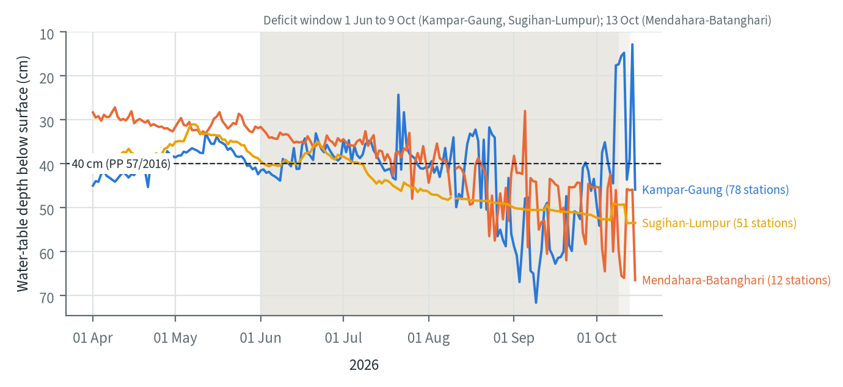
Figure 8.3. Station-mean water-table depth, 1 April to 15 October 2026

The climatic balance per sub-KHG
Every KHG has a positive mean balance over the year, from 58 to 84 mm/month, and 2.2 to 2.7 deficit months a year on average. Within a KHG the sub-KHG means span 13 to 45 mm/month. The year-to-year order test passed in every case (median Spearman 0.64 to 0.94, against thresholds of 0.11 to 0.12), so the evapotranspiration test decided the outcome each time.
Table 8.7. Climatic balance per sub-KHG by KHG and DEM variant, 2018-2025 (CHIRPS rain as KHG mean, MOD16). Mean balance is the unweighted mean over sub-KHG. Source: neraca air summary and the sub-KHG balance of each variant
KHG | DEM | Sub-KHG | Area (km2) | Mean balance (mm/month) | Sub-KHG range (mm/month) | P - ET range (mm/month) | Deficit months per year, mean (range) | ET order agreement (needed) | Order usable
Kampar-Gaung | LiDAR | 28 | 7,126 | 58.4 | 50.9-64.5 | 109.1-122.1 | 2.66 (2.38-3.25) | -0.48 (0.45) | no
Kampar-Gaung | DeltaDTM | 27 | 7,140 | 58.8 | 50.9-67.2 | 109.1-122.3 | 2.66 (2.38-3.25) | -0.48 (0.44) | no
Kampar-Gaung | DEMNAS | 29 | 7,140 | 58.8 | 50.5-63.8 | 109.1-122.7 | 2.66 (2.38-3.25) | -0.59 (0.43) | no
Mendahara-Batanghari | LiDAR | 29 | 2,021 | 62.2 | 53.4-74.8 | 114.8-128.4 | 2.48 (2.12-3.12) | 0.06 (0.43) | no
Mendahara-Batanghari | DeltaDTM | 29 | 2,022 | 63.0 | 51.5-78.9 | 112.3-132.3 | 2.44 (2.00-2.88) | -0.10 (0.43) | no
Mendahara-Batanghari | DEMNAS | 29 | 2,022 | 62.7 | 48.3-73.6 | 108.9-126.9 | 2.49 (2.12-3.25) | 0.08 (0.43) | no
Saleh-Sugihan | LiDAR | 29 | 1,180 | 75.0 | 65.9-105.3 | 111.7-149.1 | 2.47 (1.62-2.75) | 0.56 (0.43) | yes
Saleh-Sugihan | DeltaDTM | 26 | 1,907 | 83.5 | 68.0-113.1 | 117.7-152.1 | 2.19 (1.38-2.75) | 0.38 (0.46) | no
Saleh-Sugihan | DEMNAS | 27 | 1,907 | 83.9 | 68.0-113.0 | 117.7-152.7 | 2.18 (1.50-2.75) | 0.30 (0.44) | no
Sugihan-Lumpur | LiDAR | 29 | 6,378 | 69.7 | 56.5-94.1 | 104.4-135.4 | 2.44 (2.12-2.75) | 0.41 (0.43) | no
Sugihan-Lumpur | DeltaDTM | 29 | 6,380 | 69.7 | 57.6-88.0 | 110.5-132.1 | 2.45 (2.12-2.75) | 0.41 (0.43) | no
Sugihan-Lumpur | DEMNAS | 27 | 6,380 | 69.6 | 60.5-88.0 | 108.5-130.7 | 2.43 (2.12-2.62) | 0.53 (0.44) | yes

The order between sub-KHG can be used in only two of the twelve cases:
- At Kampar-Gaung, MOD16 and WaPOR order the units in opposite directions in all three variants (Spearman -0.48 to -0.59).
- At Mendahara-Batanghari the two products are unrelated (Spearman -0.10 to 0.08), and the mean balance follows forest share almost entirely (Spearman -0.77 to -0.87), so the interception term sets the order.
- At Sugihan-Lumpur the agreement sits on the threshold. It passes with DEMNAS units (0.53) and fails with LiDAR and DeltaDTM units (0.41 against 0.43). An earlier delineation with 30 units passed at 0.46.
- At Saleh-Sugihan it passes only with the LiDAR units (0.56). The LiDAR covers 1,180 of the 1,907 km2 of this KHG, so that case describes a different and drier area: 75.0 against 83.5-83.9 mm/month.
The DEM changes the sub-KHG boundaries and their number (26 to 29 per KHG), and through them the units' evapotranspiration. It barely changes the KHG-level result: where the variants cover the same area, mean balance differs by at most 0.8 mm/month and mean deficit months by at most 0.05. The usable order of units does change with the DEM at the two KHG where agreement is near the threshold.

Dry-season months
The timing of the dry season differs by region, which sets when interventions need to be in place. The two Riau and Jambi KHG have a short, sharp dry season centred on July, and Kampar-Gaung has a second one in February (mean -13 mm). The two South Sumatra KHG have a longer dry season from July to October; at Sugihan-Lumpur the mean is negative in July, August and September. The worst year was 2019, with 4 to 6 deficit months across the four KHG; in 2022 Saleh-Sugihan and Sugihan-Lumpur had none.
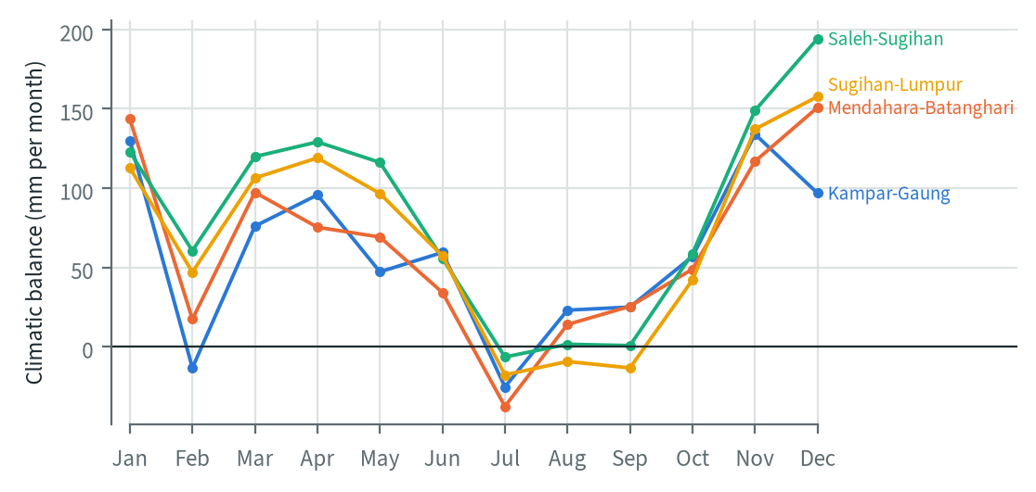
Figure 8.4. Mean monthly climatic balance by calendar month, 2018-2025
Table 8.8. Calendar months with a negative KHG-mean balance, share of years 2018-2025. Months where no KHG reaches 30 % are left out. Source: monthly sub-KHG balance of the DeltaDTM variant (MOD16), mean over sub-KHG
KHG | Feb | Jul | Aug | Sep | Oct | Lowest mean month (mm)
Kampar-Gaung | 50 % | 75 % | 38 % | 25 % | 12 % | July, -25
Mendahara-Batanghari | 25 % | 88 % | 62 % | 25 % | 25 % | July, -38
Saleh-Sugihan | 12 % | 50 % | 62 % | 50 % | 38 % | July, -6
Sugihan-Lumpur | 12 % | 50 % | 62 % | 50 % | 38 % | July, -18

The tables below give the values per sub-KHG for each KHG. They use the DeltaDTM variant, the one that covers the full area at all four KHG.
Table 8.9. Climatic balance per sub-KHG, Kampar-Gaung, 2018-2025 (DeltaDTM units)
Sub-KHG | Area (km²) | Balance, MOD16 (mm/month) | P - ET (mm/month) | Deficit months per year | Interception (share) | Balance, WaPOR (mm/month)
S01 | 184 | 55.4 | 110.7 | 3.00 | 0.13 | 86.9
S02 | 485 | 60.3 | 115.3 | 2.88 | 0.13 | 97.9
S03 | 159 | 62.3 | 120.5 | 2.50 | 0.15 | 80.9
S04 | 148 | 67.2 | 118.8 | 2.50 | 0.12 | 97.5
S05 | 226 | 55.4 | 109.1 | 3.12 | 0.13 | 85.5
S06 | 226 | 60.8 | 112.9 | 2.75 | 0.12 | 94.4
S07 | 172 | 50.9 | 109.7 | 3.25 | 0.15 | 90.3
S08 | 274 | 60.2 | 117.9 | 2.50 | 0.15 | 83.5
S09 | 299 | 57.5 | 116.2 | 2.75 | 0.15 | 78.5
S10 | 207 | 56.3 | 115.2 | 2.75 | 0.15 | 82.1
S11 | 206 | 55.7 | 113.5 | 3.00 | 0.15 | 90.1
S12 | 439 | 52.8 | 112.0 | 3.12 | 0.15 | 87.9
S13 | 157 | 65.1 | 122.3 | 2.38 | 0.14 | 84.4
S14 | 437 | 57.5 | 116.8 | 2.62 | 0.15 | 71.4
S15 | 144 | 61.0 | 118.0 | 2.62 | 0.14 | 88.2
S16 | 211 | 59.5 | 120.1 | 2.62 | 0.16 | 73.5
S17 | 151 | 59.4 | 119.1 | 2.62 | 0.16 | 78.2
S18 | 463 | 59.9 | 117.8 | 2.38 | 0.15 | 77.8
S19 | 163 | 56.8 | 118.0 | 2.50 | 0.16 | 73.9
S20 | 317 | 60.0 | 119.7 | 2.50 | 0.16 | 72.0
S21 | 230 | 55.6 | 114.2 | 2.88 | 0.15 | 92.7
S22 | 541 | 58.1 | 116.3 | 2.62 | 0.15 | 79.3
S23 | 341 | 61.8 | 120.5 | 2.38 | 0.15 | 80.8
S24 | 129 | 58.8 | 119.0 | 2.38 | 0.16 | 68.6
S25 | 316 | 60.9 | 121.4 | 2.38 | 0.16 | 75.0
S26 | 211 | 59.9 | 120.1 | 2.38 | 0.16 | 78.4
S27 | 303 | 58.8 | 116.7 | 2.50 | 0.15 | 79.0
Order of units not usable with DeltaDTM units (ET products disagree on the order). Period 2018-2025.
Table 8.10. Climatic balance per sub-KHG, Mendahara-Batanghari, 2018-2025 (DeltaDTM units)
Sub-KHG | Area (km²) | Balance, MOD16 (mm/month) | P - ET (mm/month) | Deficit months per year | Interception (share) | Balance, WaPOR (mm/month)
S01 | 52 | 64.3 | 124.7 | 2.38 | 0.15 | 83.6
S02 | 61 | 58.7 | 120.7 | 2.50 | 0.16 | 81.0
S03 | 40 | 60.3 | 122.5 | 2.38 | 0.16 | 83.0
S04 | 41 | 58.1 | 120.1 | 2.50 | 0.16 | 89.3
S05 | 80 | 52.8 | 114.0 | 2.75 | 0.16 | 84.3
S06 | 63 | 57.8 | 120.0 | 2.62 | 0.16 | 86.8
S07 | 39 | 61.9 | 121.2 | 2.50 | 0.15 | 94.1
S08 | 204 | 57.7 | 120.1 | 2.50 | 0.16 | 79.1
S09 | 60 | 60.1 | 119.7 | 2.50 | 0.15 | 91.7
S10 | 96 | 66.0 | 124.1 | 2.38 | 0.14 | 92.3
S11 | 97 | 63.5 | 116.9 | 2.38 | 0.12 | 103.9
S12 | 62 | 75.6 | 125.2 | 2.25 | 0.10 | 99.6
S13 | 40 | 63.9 | 115.6 | 2.62 | 0.11 | 98.9
S14 | 49 | 51.5 | 112.3 | 2.88 | 0.15 | 88.6
S15 | 120 | 65.9 | 120.6 | 2.25 | 0.12 | 96.9
S16 | 94 | 58.6 | 120.0 | 2.62 | 0.16 | 88.5
S17 | 59 | 61.2 | 122.6 | 2.50 | 0.16 | 92.2
S18 | 188 | 58.3 | 119.0 | 2.50 | 0.15 | 86.1
S19 | 41 | 68.8 | 122.3 | 2.25 | 0.12 | 92.8
S20 | 50 | 71.7 | 123.9 | 2.25 | 0.11 | 99.8
S21 | 52 | 72.3 | 126.1 | 2.25 | 0.12 | 96.8
S22 | 49 | 69.0 | 126.6 | 2.12 | 0.14 | 92.2
S23 | 52 | 61.6 | 120.5 | 2.38 | 0.14 | 87.1
S24 | 55 | 67.1 | 124.6 | 2.38 | 0.14 | 90.8
S25 | 77 | 57.1 | 116.6 | 2.75 | 0.15 | 92.1
S26 | 42 | 64.0 | 123.3 | 2.38 | 0.15 | 91.6
S27 | 41 | 61.9 | 120.2 | 2.50 | 0.14 | 87.2
S28 | 77 | 58.2 | 117.5 | 2.62 | 0.15 | 92.0
S29 | 43 | 78.9 | 132.3 | 2.00 | 0.12 | 95.2
Order of units not usable with DeltaDTM units (ET products disagree on the order). Period 2018-2025.
Table 8.11. Climatic balance per sub-KHG, Saleh-Sugihan, 2018-2025 (DeltaDTM units)
Sub-KHG | Area (km²) | Balance, MOD16 (mm/month) | P - ET (mm/month) | Deficit months per year | Interception (share) | Balance, WaPOR (mm/month)
S01 | 64 | 85.6 | 139.1 | 2.25 | 0.11 | 81.6
S02 | 101 | 99.4 | 146.1 | 1.75 | 0.08 | 89.3
S03 | 66 | 94.5 | 146.1 | 1.88 | 0.10 | 95.0
S04 | 38 | 68.0 | 132.2 | 2.62 | 0.16 | 63.4
S05 | 138 | 93.0 | 142.4 | 1.88 | 0.09 | 106.8
S06 | 47 | 78.1 | 136.1 | 2.25 | 0.13 | 84.3
S07 | 42 | 99.9 | 148.4 | 1.75 | 0.09 | 114.1
S08 | 39 | 113.1 | 152.1 | 1.38 | 0.04 | 121.7
S09 | 95 | 105.5 | 149.6 | 1.62 | 0.07 | 115.8
S10 | 86 | 108.9 | 151.6 | 1.62 | 0.06 | 119.3
S11 | 69 | 98.4 | 149.5 | 1.75 | 0.10 | 106.8
S12 | 99 | 85.1 | 138.7 | 2.25 | 0.11 | 103.8
S13 | 87 | 84.5 | 135.2 | 2.00 | 0.10 | 107.5
S14 | 100 | 70.3 | 128.9 | 2.62 | 0.13 | 96.4
S15 | 55 | 72.1 | 127.4 | 2.62 | 0.12 | 97.7
S16 | 67 | 70.0 | 121.1 | 2.50 | 0.10 | 101.4
S17 | 77 | 71.7 | 122.9 | 2.38 | 0.10 | 104.1
S18 | 101 | 72.8 | 117.7 | 2.38 | 0.07 | 106.4
S19 | 82 | 77.9 | 127.6 | 2.38 | 0.09 | 103.4
S20 | 50 | 69.9 | 120.3 | 2.38 | 0.10 | 98.4
S21 | 84 | 80.6 | 131.7 | 2.25 | 0.10 | 106.0
S22 | 79 | 83.9 | 132.1 | 2.25 | 0.09 | 104.6
S23 | 72 | 71.4 | 128.7 | 2.38 | 0.13 | 95.4
S24 | 57 | 75.9 | 129.2 | 2.38 | 0.11 | 98.6
S25 | 32 | 72.0 | 126.4 | 2.62 | 0.11 | 103.1
S26 | 80 | 68.7 | 123.4 | 2.75 | 0.12 | 97.4
Order of units not usable with DeltaDTM units (ET products disagree on the order). Usable with the LiDAR units, which cover 1,180 of 1,907 km². Period 2018-2025.
Table 8.12. Climatic balance per sub-KHG, Sugihan-Lumpur, 2018-2025 (DeltaDTM units)
Sub-KHG | Area (km²) | Balance, MOD16 (mm/month) | P - ET (mm/month) | Deficit months per year | Interception (share) | Balance, WaPOR (mm/month)
S01 | 144 | 64.8 | 122.9 | 2.50 | 0.14 | 75.3
S02 | 271 | 88.0 | 130.7 | 2.12 | 0.07 | 105.7
S03 | 131 | 83.4 | 132.1 | 2.25 | 0.09 | 103.9
S04 | 172 | 80.1 | 128.5 | 2.25 | 0.09 | 100.7
S05 | 118 | 71.0 | 124.5 | 2.38 | 0.12 | 93.0
S06 | 253 | 73.7 | 125.3 | 2.38 | 0.11 | 93.2
S07 | 220 | 69.7 | 124.2 | 2.38 | 0.12 | 87.0
S08 | 149 | 72.1 | 122.2 | 2.38 | 0.10 | 95.1
S09 | 148 | 60.3 | 114.8 | 2.75 | 0.12 | 96.1
S10 | 190 | 65.3 | 123.1 | 2.38 | 0.14 | 86.5
S11 | 347 | 66.9 | 119.5 | 2.38 | 0.11 | 94.4
S12 | 415 | 65.5 | 119.6 | 2.50 | 0.12 | 89.9
S13 | 156 | 63.5 | 117.3 | 2.62 | 0.12 | 88.3
S14 | 127 | 69.6 | 120.8 | 2.50 | 0.11 | 94.1
S15 | 155 | 76.2 | 122.2 | 2.38 | 0.08 | 93.7
S16 | 125 | 57.6 | 111.8 | 2.75 | 0.12 | 88.2
S17 | 148 | 76.3 | 124.0 | 2.38 | 0.09 | 95.7
S18 | 353 | 61.2 | 115.1 | 2.75 | 0.12 | 88.6
S19 | 148 | 63.7 | 111.5 | 2.62 | 0.09 | 93.6
S20 | 232 | 65.0 | 110.9 | 2.50 | 0.08 | 94.1
S21 | 295 | 66.9 | 120.9 | 2.50 | 0.12 | 90.2
S22 | 328 | 63.1 | 110.5 | 2.62 | 0.09 | 90.1
S23 | 329 | 64.4 | 121.5 | 2.62 | 0.13 | 92.2
S24 | 184 | 71.2 | 120.9 | 2.38 | 0.10 | 91.1
S25 | 139 | 73.9 | 121.0 | 2.38 | 0.09 | 78.8
S26 | 266 | 73.7 | 118.7 | 2.38 | 0.08 | 80.3
S27 | 239 | 67.8 | 119.3 | 2.38 | 0.11 | 92.7
S28 | 333 | 74.1 | 123.6 | 2.25 | 0.10 | 97.5
S29 | 266 | 71.1 | 120.9 | 2.38 | 0.10 | 72.5
Order of units not usable with DeltaDTM units (ET products disagree on the order). Usable with the DEMNAS units. Period 2018-2025.

What the results support
The balance is most useful at KHG level and for comparing KHG. It is consistent across DEM variants and gives a calendar of dry-season months for every selected KHG, which can guide when canal blocks and water supply need to be in place. The 2026 deficit gives the volume of water the managed system supplied at three KHG, from 50 million m3 at Kampar-Gaung to 1.8 billion m3 at Sugihan-Lumpur. Between sub-KHG, the open climate data separate units in two of twelve cases, and the station deficit per sub-KHG does not confirm that order, so the balance should carry little weight in a ranking inside a KHG. The deficit covers one season, and the balance cannot be checked against water tables for 2018-2025.

8.6 Why a groundwater model
The rewetting programme needs to know which peat stays deeper than 40 cm through the dry season if sekat kanal (canal blocks) are built on given reaches, or if water is pumped onto given units, and how much water that takes. The adopted neraca air cannot answer either question. It has two outputs: a monthly climatic balance per sub-KHG and a station-based supply deficit for the whole KHG.
The climatic balance has no stored water, no canal level and no blocks, so an intervention has nothing to act on. The deficit is a mass balance on observed water tables (TMA) and has no spatial form. A what-if question needs three things the adopted method lacks: a water table in every place, a way for canals to drain or supply the peat, and a way for a block or a pump to change that exchange. The two-dimensional groundwater-flow equation, with canals as boundary conditions, provides all three. Every model in the review below that simulated canal blocking on tropical peat has this structure.
The groundwater model described in this chapter is in development. It can be applied to any KHG from its code, takes its climate forcing from satellite products and scores itself against field data. It has passed the supply check where that check can be made. It has not passed the checks on water-table level and dynamics outside managed land, and its scenario results are first results for one KHG.

Background: how water moves in peat
The groundwater model rests on three ideas: how much water the peat stores, how fast water moves through it, and a daily balance that links the two.
The water table is the level below which the pores of the peat are full. When it falls by one metre, only part of the peat volume drains. That share is the specific yield (Sy). A small Sy means a small loss of water lowers the water table a long way: a net loss of 10 mm of water lowers it by about 17 mm where Sy is 0.6, and by 100 mm where Sy is 0.1. Section 8.8 gives the values used.
Water moves sideways from where the water table is high to where it is low. The flow grows with the slope of the water table and with the transmissivity (T) of the peat, the amount of water the saturated peat carries sideways, in m²/day. T falls with depth, so a water table that sinks into deeper peat conducts much less.
Over one day, the water table in a cell changes by rain, minus evapotranspiration, plus the net inflow from neighbouring cells, divided by Sy. Written for a grid of cells, these three ideas make the Boussinesq equation, given in full in section 8.8. It follows the water table across the landscape and has no flow up and down inside the peat. Cobb et al. (2017) use it as Boussinesq's equation for essentially horizontal groundwater flow, which needs only that sideways flow is proportional to the slope of the water table, and call it standard for domains much wider than thick. Urzainki et al. (2020) add that it is much cheaper to solve than the full three-dimensional problem. A KHG is wide compared with the depth of its peat: Balangan-Batangalai has 137 km² of peat, and the deepest depth class used here is taken as 8 m.
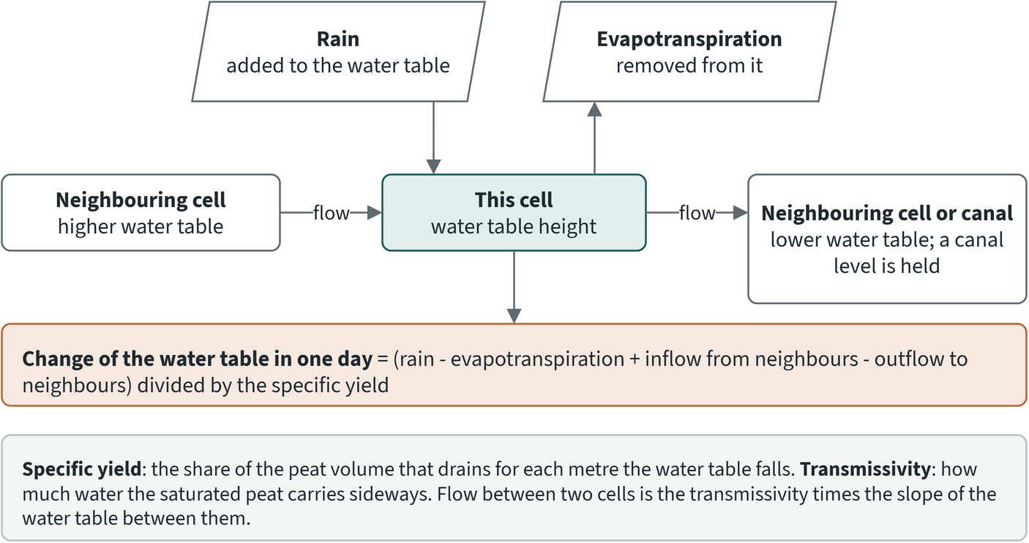
Figure 8.5. The terms of the Boussinesq equation for one model cell
Peat forms domes because water drains slowly through it. Ingram (1982) argued that waterlogging in raised mires is better explained by impeded drainage than by the water-holding force of the peat itself (matric forces), and found that the elliptical profile of the surface of one mire agreed with his model. Cobb et al. (2017) put numbers on this for a pristine peat dome in Brunei: once a dome has reached a stable shape, the curvature of its surface equals minus the mean net rainfall divided by the mean transmissivity, so more water arriving, or peat that carries less of it away, gives a more strongly curved dome. The result assumes the same transmissivity everywhere and negligible flow through deep peat, which the authors say would flatten the dome centre and steepen its margin. The same slow drainage explains why a canal matters. A canal gives the water an outlet below the water table. The water table next to it falls until the slope towards the canal can carry the water that arrives, and the effect fades with distance. In the Mendahara-Batanghari scenario, cells within 150 m of a block reach were deeper than 40 cm on 26 fewer days of the 122-day dry season, and beyond 1 km nothing changed (section 8.14).
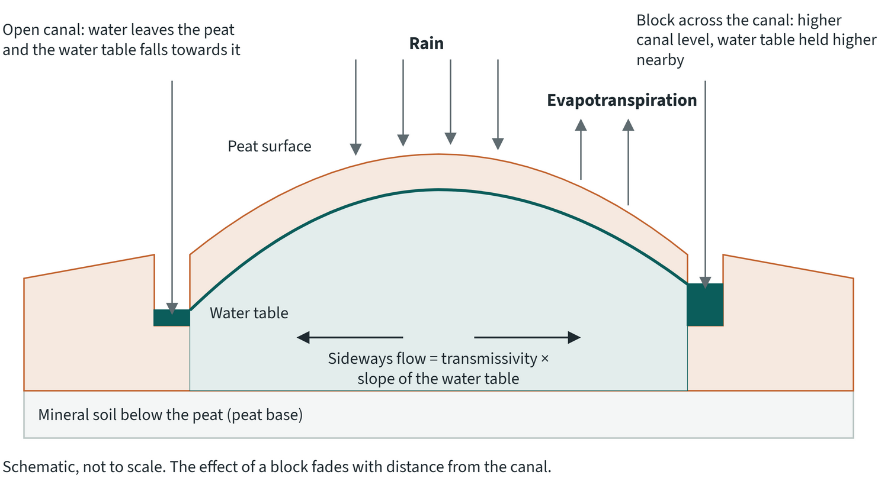
Figure 8.6. Cross-section of a peat dome between two canals: an open canal on the left and a canal held higher by a block on the right (schematic)
The equation has been used to place canal blocks in drained tropical peat. Urzainki et al. (2020) used it to compare block positions over a 931 km² drained peatland in Sumatra. Section 8.7 lists the models that solve it.
The equation has limits. It describes the water table only, with no flow over the surface; the model removes ponded water each day, since runoff in tropical peat is saturation-excess (section 8.8). It needs the water level at its boundaries. In RE-PEAT these are canals, the KHG edge and managed land held at the 0.4 m target (section 8.8). Canals narrower than a cell and the scenario inputs are covered in sections 8.11 and 8.12.

8.7 Review of existing models
The review looked for models that have simulated canal blocks or water-table management on tropical gambut (peat), and asked what each would need to run on an Indonesian KHG. Its main result for the project is that the choice of equation matters less than two inputs: the transmissivity of tropical peat and a canal level that responds to blocks. The table summarises the review. "Not stated" means the review did not record the item.
Table 8.13. Groundwater and peat-hydrology models considered for rewetting scenarios. Source: RE-PEAT review of groundwater models (October 2026), with the literature notes on tropical peat parameters
Model | Dimension and form | Canals, blocks, pumps | Data needs | Use on tropical peat | Licence, availability | Decision
Urzainki et al. 2020 | 2D Boussinesq, 100 m grid | canal fixed 1.2 m below the land; a block lifts upstream canal cells to a set level; no pump | DTM, canal map, peat depth, peat hydraulic table | no quantitative validation, as the authors state | open source (MIT) | form adopted; its fixed canal rule failed in our earlier runs
Urzainki et al. 2023, Merang-Kepayang, 22,000 ha, 168 blocks | 2D peat (triangular mesh) coupled to a 1D canal network | canal stage is a state; a weir equation per block; no pump | canal network with bed and width | qualitative only: microtopography prevented a one-to-one comparison with 141 dipwells | open source (MIT) | its tropical peat parameters adopted; canal network deferred
MIKE SHE with MIKE Hydro River (Kurnianto et al. 2026), Pulau Padang | 3D/2D, 100 m, about 113,000 cells, 3 peat layers, tide boundary | 123 dams as broad-crested weirs; dynamic canal stage; no pump in the text | layered peat conductivity, tide, canal network | 15 wells, 2018: RMSE 0.05-0.09 m, NSE 0.36-0.87 | commercial (DHI) | not chosen: commercial, closed source
SIMGRO (Jaenicke et al. 2010), Sebangau | quasi-3D finite element with channels | dams along canals; no pump | not stated | one dipwell: R² 0.74 | legacy | not chosen
MODFLOW via FREEWAT (Suryadi et al. 2021), Kahayan-Sebangau | 2D grid | block heights 0.2-0.6 m at canal spacing 200-400 m; a well term exists, not used | not stated | NSE 0.73-0.95 near one canal, 30-day calibration | open | deferred (see below)
DigiBog_Hydro (Putra et al. 2022) | 2.5D Boussinesq, 1 m grid, synthetic 0.2 km² | a dam as two fixed ditch levels; no pump | not stated | scenario study, no validation | open source (GPL-3.0) | not chosen: 1 m grid only
PEATCLSM-Trop (Apers et al. 2022) | 1D per 9 km cell | static ditch depth 0.68 m, spacing 31.4 m; no network, no blocks | not stated | water-level anomaly R 0.68, drained peat in Southeast Asia | part of a NASA land surface model | not chosen: 1D, no maps
SWAP (Taufik et al. 2019), South Sumatra | per site, canals as a lateral drainage flux | canal level set by season (not deeper than 1.3 m below the surface dry, 0.5 m wet) | canal level, drainage resistance | water table deeper than 85 cm 34% of the time with canal drainage, 1.9% without | not stated | not chosen; it confirms that the canal level decides the water table
DRAINMOD (Imanudin et al. 2018), oil palm on peat | 1D field between parallel drains | outlet level; no pump | not stated | on peat under oil palm, water table down to 90 cm, and 30-40 cm with tertiary channels held at 70 cm | licence not confirmed | not chosen: 1D, no maps
MONALAGA, Universitas Riau | not documented online | the product page lists canal-blocking scenarios | not stated | not published | not public | not available
MPeat2D (Mahdiyasa et al. 2024) | 2D bog development over about 5,000 years | none | not stated | none | not stated | not relevant

MONALAGA ("Model Neraca Air Lahan Gambut") was applied to KHG Pulau Tebing Tinggi in 2020, according to the university's product page. The same group's published peat balances are monthly balances per sub-KHG with no water table or canal level. Whether MONALAGA is that balance could not be confirmed, and its report was not available to the project.
The review led to four conclusions for the RE-PEAT model:
- The equation did not cause the failure of the project's earlier runs. Urzainki et al. (2023) and DigiBog solve the same 2D Boussinesq equation, and MIKE SHE, SIMGRO and MODFLOW solve the same Darcy flow. Two inputs separated those models from the earlier runs: transmissivity, and a canal level that responds to blocks.
- Tropical transmissivity is 100 to 1,000 times the boreal table the earlier runs used. The boreal table gave 0.59 m²/day at the surface. Urzainki et al. (2023) use 50 or 500 m²/day; Jaenicke et al. (2010) used 30 m²/day in the top metre.
- Urzainki et al. (2020) and Kurnianto et al. (2026) used a 100 m grid. Block effects fade within a few hundred metres, so the 500 m grid of the earlier runs was too coarse.
- None of the tropical studies reviewed models a pump. A pump needs a new term in the model.
The review also gave the expected size of a block effect, against which any run can be checked. Kurnianto et al. (2026) found the drainage effect on the adjacent forest averaged 9 cm at 100 m from a dammed canal and fell below 5 cm by about 300 m. Urzainki et al. (2023) found a mean rise of 1.44 cm in a dry year and 1.57 cm in a wet year over their 22,000 ha study area, part of a 140,000 ha dome. Field reports from Tebing Tinggi give rewetting up to about 400 m upstream of a block (Sutikno et al. 2023).
MODFLOW 6 was considered as the computing engine and deferred. It would bring a standard, peer-recognised code with a water budget per boundary, canal packages, a pump term and a Newton solver. Its costs are layering thin unconfined peat into about 8 to 10 layers to follow transmissivity falling with depth, and a separate compiled program that users of the RE-PEAT Interventions desktop tool would have to install. The deciding reason was that MODFLOW faces the same open questions as the RE-PEAT solver: the canal level in managed land, the specific yield of the peat, and the data the model is tested against. A different engine answers none of them. MODFLOW remains the fallback if a full canal network is needed.

8.8 The model

Equation and grid
The model solves the two-dimensional nonlinear Boussinesq equation for the water table in the peat:
Sy(z) dh/dt = div( T(z) grad h ) + R
Here h is the water-table elevation, z its depth below the land surface (negative downwards), Sy the specific yield (the water released per metre of fall), T the transmissivity of the saturated peat below the water table, and R the net recharge, rain minus evapotranspiration, in metres per day. In words: each day the water table in a cell rises with rain, falls with evapotranspiration, and exchanges water with its neighbours in proportion to the slope of the water table and the ease with which water moves through the peat. Ponded water is removed each day; runoff in tropical peat is saturation-excess (Katimon et al. 2013).
The KHG is divided into square cells of 100 m or 200 m on a metric grid. The model advances one day at a time with an implicit scheme and iterates within each day for the nonlinearity. RE-PEAT Interventions uses the same solver for its block optimisation, so both tools share one water model. A simulation starts with the peat saturated at the start of a wet season (1 November 2025 for the 2026 simulations) and spins up for several months before the dry season it reports.

Peat hydraulic properties
Specific yield and transmissivity both fall with depth. The working parameter sets are the tropical sets of Urzainki et al. (2023), calibrated at the Merang-Kepayang dome in South Sumatra:
- specific yield 0.6 at the surface, falling exponentially with depth;
- transmissivity 50 m²/day ("small") or 500 m²/day ("large") at the surface, falling by a factor e for every 0.4 m of depth, down to the peat base.
These values were calibrated at one site and were not measured. The surface specific yield of 0.6 fits intact forest with the water table near the surface. Measurements in drained peat point to 0.1 to 0.3: Ismail et al. (2021) report up to 0.3 near the surface and 0.1 at 1.5 m depth at Pulau Padang, and Kurnianto et al. (2026) calibrated 0.10 to 0.15. Cobb and Harvey (2019) give about 0.29 near the surface in Brunei, a value on a curve fitted to their data. A third set, labelled "drained", takes its specific yield from Ismail et al. (2021): an exponential through their two values (0.3 at the surface, 0.1 at 1.5 m), fitted by the RE-PEAT team because the paper gives no coefficients. Its transmissivity is the large tropical set. The boreal table of the earlier runs is kept only as a reference for the known failure. No parameter is fitted to the stations.
Peat depth comes from the KHG's modelled peat-depth map. Where that map is empty, the BBSDLP 1:50,000 peat-depth classes fill the gap (class midpoints, 8 m for the deepest class), and then the KHG median. With the tropical sets, transmissivity below 2 m is small whatever the depth, so a weak depth map matters less for flow than it would for storage.

Boundaries
The model treats the following as fixed or held water levels:
- The KHG edge, held 0.3 m below the local surface (a river rule).
- Canals by class (primary, secondary, tertiary), each held at a set depth below the local surface: 1.2 m in the base simulations, with 0.6 m and 0.4 m as alternatives, and the levels measured in the Pulau Padang LiDAR (primary 0.8 m, secondary and tertiary 0.3 m). A class can also be left free. Two variants change how canals act. In the first, canals narrower than a cell exchange water with the cell instead of holding the whole cell at the canal level. In the second, a canal water balance per sub-KHG lets the canal level fall in the dry season, with the class levels as the outlet sill.
- Managed land. Plantation licences (forest plantation and oil palm, from the 2025 licence layer) are held at a target water table. Their canals are fixed at the target, and each day any managed cell that fell below the target is brought back to it. The water this takes is the model's water-management supply. Holding managed land is optional; results that use it say so, and hold the land at 0.4 m, the compliance level of PP 57/2016. An alternative gives each licence the median level of the concession stations outside it.
- Canal blocks. RE-PEAT Interventions places blocks and gives each block's reach, the canal stretch it holds water in, with the water depth below the land. A block scenario fixes the canal cells of each reach at that depth. Where a reach falls on a canal cell that is already fixed, by its class or by managed land, the higher water level is kept, so a block never lowers a canal.
- Pumped land. The sub-KHG units that RE-PEAT Interventions marks for water supply are held at 0.4 m, like managed land, and the water this takes is the pumping need. Where managed and pumped land overlap, the shallower target applies.
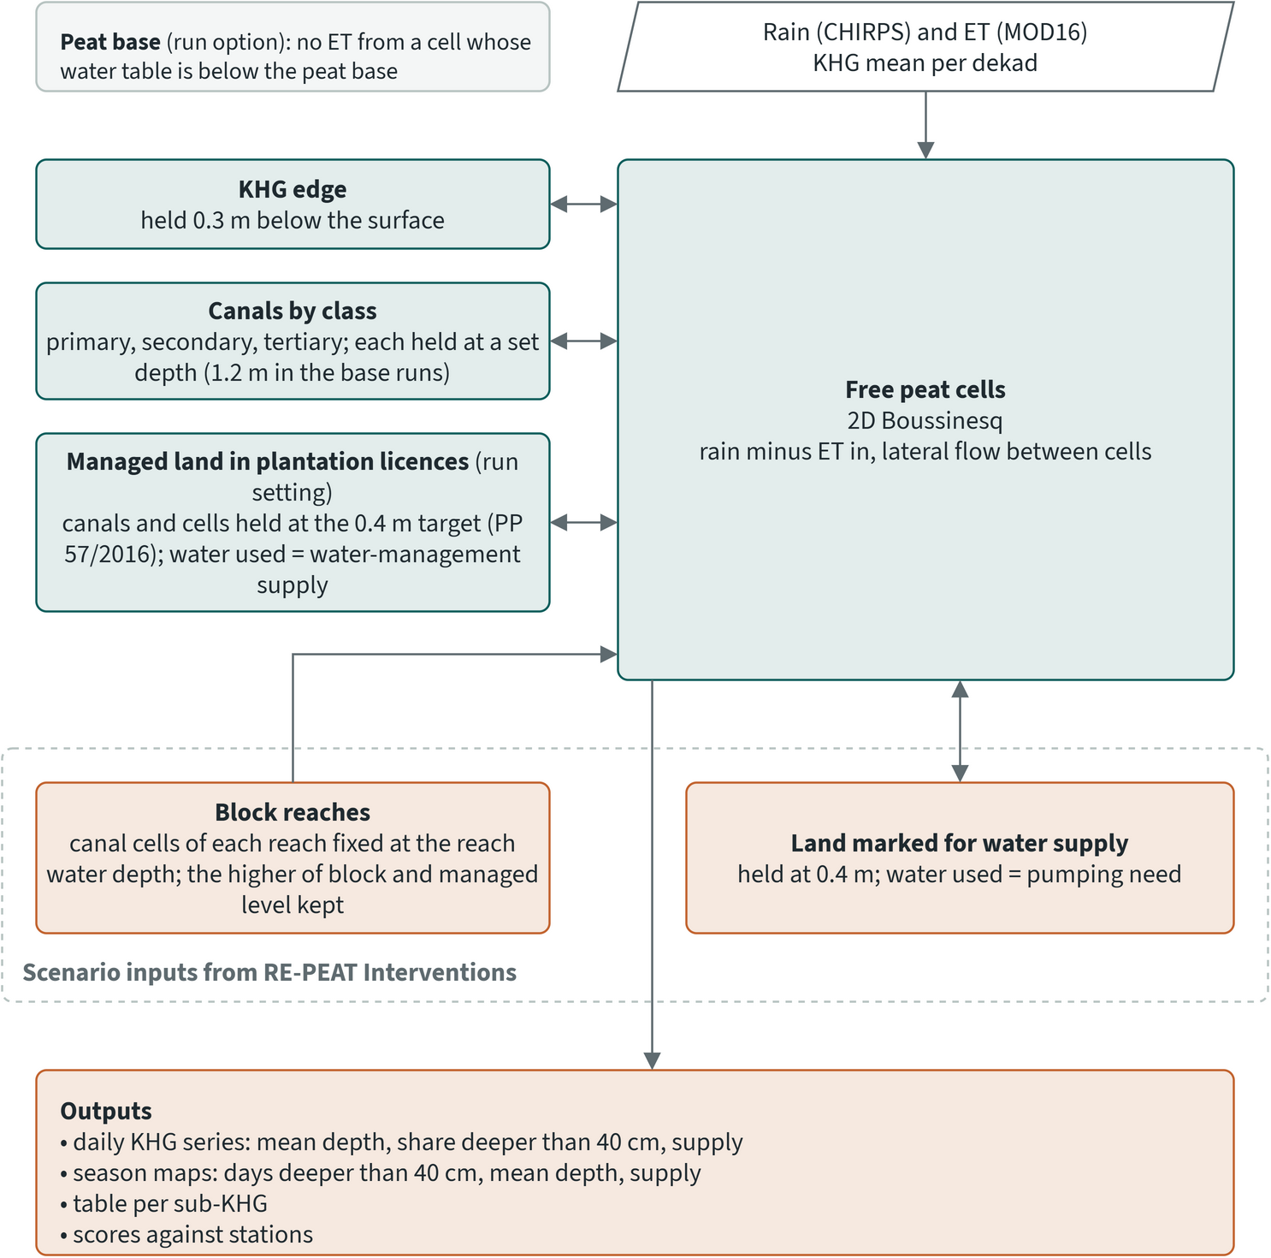
Figure 8.7. Boundaries of the groundwater model and how a scenario changes them (model in development)
In simulations that hold managed land, the model also stops evapotranspiration from a cell whose water table has fallen below the peat base. The model has no infiltration limit for burned land: the review of burned-peat hydrology found no established drop in infiltration after fire on tropical peat (Setiawan et al. 2020). The effects that are supported, a lower surface after fire (Konecny et al. 2016) and lower evapotranspiration on burned land (Hirano et al. 2015), are already captured by a post-fire LiDAR DTM or would need evapotranspiration per cell.

Forcing and inputs
Rain is CHIRPS and evapotranspiration is MOD16, both as KHG means per dekad, spread evenly over the days of the dekad and extracted with Google Earth Engine. For 2026, MOD16 without gap filling is used, because the gap-filled product ends in December 2025. The DTM is the LiDAR DTM where it exists, otherwise the corrected DeltaDTM or DEMNAS. Each simulation records every input, its source and the share of the KHG it covers.

Outputs
The model computes the water-table depth of every cell every day. Each simulation produces:
- a daily KHG series: mean depth, share of the area deeper than 40 cm, rain, evapotranspiration, the water exchanged between the peat and the canals and edge, and the water supplied to managed land;
- season maps for June to September (122 days): the days each cell of open land was deeper than 40 cm, the mean depth, and the water supplied to each managed cell;
- a table per sub-KHG: open and managed area, the open land's mean depth and days deeper than 40 cm, the share of open land deeper than 40 cm for more than half the season, and the water supplied to managed land;
- scores against stations or field points.
Open land is land not held by water management or pumping. A sub-KHG "still needs rewetting" when more than half of its open land is deeper than 40 cm for more than half the season.

8.9 Design choices
The table lists the main design choices of the model, with the reason for each and the evidence behind it.
Table 8.14. Design choices of the groundwater model. Source: RE-PEAT groundwater model report, October 2026
Design choice | Reason | Evidence
The scenario model is part of the water-balance tool, as a separate component | one water model for the project; the tool already holds the solver and peat tables | project decision
The groundwater model becomes the neraca air once it passes a field check; the climatic balance stays as the fallback | scenarios need a water table and a canal mechanism; LiDAR covers few KHG, and open DEM errors are of the order of a dome's relief | review; project decision
One solver, shared with RE-PEAT Interventions | the solver existed twice, identical; users of the desktop tool need a simple installation | installation tested
Groundwater components consolidated without changing existing results | three methods were mixed together | 74 of 74 established outputs identical after the change
2D nonlinear Boussinesq on a regular grid, implicit with iteration | open, tested and shared between tools; the models that simulated blocks solve the same flow | review (section 8.7)
Peat: the tropical sets of Urzainki et al. (2023); boreal table kept as the known failure; nothing fitted | tropical transmissivity is 100-1,000 times the boreal table | measured surface Sy (0.29-0.3) is about half the 0.6 used, recorded as an open question
Canals: a fixed level per class first; a canal network later | tests transmissivity before the canal mechanism changes, so the two effects are not confused | earlier failed runs
Forcing: CHIRPS and MOD16, KHG mean, per dekad | the same products as the climatic balance | adopted balance
DTM: corrected surface where it exists; raw DeltaDTM where not, stated with the result | DeltaDTM is a bare-earth product; Tebing Tinggi has no LiDAR | DEMNAS 1.86 m above the survey elevations at Tebing Tinggi
Domain: the whole KHG; gaps in peat depth filled | neither peat mask separated peat from mineral survey points | field-input check at Tebing Tinggi
Acceptance criteria fixed before any simulation; two simple predictions scored the same way; no parameter fitted | the criteria must not drift towards whatever a simulation gives; a model that cannot beat distance to canal adds nothing | design principle
Every step can be repeated for any KHG from its code, and every reported number is produced by the method | results can be updated with new data and extended to all 865 KHG | design principle
Managed land held at a target water table (0.4 m); the water this takes is the water-management supply | in three KHG the stations in managed land stay almost flat through the dry season while the model drained them | section 8.11
For managed-land simulations, stations in managed land are left out; the supply must be within a factor of 2 of the station deficit, or (amended after the Kampar-Gaung results) within 50 mm | holding a target makes managed stations agree by construction; a ratio of two small numbers fails on small differences | Kampar-Gaung deficit 7 mm
Inputs from national layers with fallbacks, cell by cell; each simulation lists its inputs and their share | not every KHG has every input | input tables per simulation
No ET below the peat base; existing blocks left for the block scenario | with a low Sy at depth, the water table fell below the peat | 642 cm drawdown at Sugihan-Lumpur where peat is about 1.3 m thick
Blocks and pumped land come from RE-PEAT Interventions | one canal network and one set of block positions for both tools; reach depths are relative to the land, so they apply on any DTM | project decision
Canals narrower than a cell exchange water with it; canal cells outside managed land are no longer fixed | fixed cells covered up to 40% of the grid at 200 m and made the land up to 19 cm too wet against a 5 m grid; the exchange term is within 0.7 cm | numerical check against a 5 m grid
Optional canal water balance per sub-KHG: canal water rises with seepage and rain and leaves by evaporation and through the outlet | no canal level series exists for these KHG | canal widths and beds taken in advance from published plantation surveys
Station records screened for restarts after gaps, settling days and stuck loggers | SiTMAT quality control passes these; one community result rested on them | 17% of concession and 23% of community readings left out nationally
Recommended set-up: canals inside cells at the LiDAR levels, no canal water balance, scores on the screened record | best match to the screened community record; the canal water balance overshoots and rests on an unmeasured outlet constant | comparison of canal settings (section 8.11)

8.10 How the model is judged
The acceptance criteria were fixed before the simulations they judge, so they cannot drift towards a result. A model is compared with two simple predictions scored the same way:
- the constant prediction: the median observed depth everywhere;
- the distance prediction: observed depth regressed on the logarithm of distance to the nearest canal, fitted to the same points. It is fitted in-sample, so it is favoured.
The field check on water-table levels passes when the model's Spearman rank correlation across points is at least 0.3 and above that of the distance prediction, and its RMSE is below that of the constant prediction. Simulations scored against stations add a check on timing: the median correlation of each station's daily series with the model must be at least 0.5. A station counts only with at least 30 days of record, and the level checks need at least 8 stations.
Simulations with managed land held at a target add a supply check: the water the model supplies to managed land from June to early October must be within a factor of 2 of the station-based deficit. This criterion was fixed before the first managed-land simulation. After the Kampar-Gaung results it was amended to also pass when the two are within 50 mm, about two weeks of dry-season evapotranspiration. Kampar-Gaung had a near-neutral dry season and a deficit of 7 mm, and a ratio of two small numbers fails on small absolute differences. The amendment turned the Kampar-Gaung result with the large tropical set from fail to pass; the change and its reason are documented in the model report.
Three rules decide which data a check uses:
- A check with too few data is "not testable", which is different from "fail". A simulation passes when every check that could be made passed.
- A station on a canal or edge cell shows only the imposed canal level and is left out of the level and dynamics scores.
- A station inside land held at a target shows only the target, and is left out too. With managed land held, the independent tests are therefore the stations outside managed land, and the supply.

8.11 Test sites and evidence
The evidence so far shows that water management controls the dry-season water table in plantation land, and that the canal level outside licences controls it in open land. Holding plantations at a target reproduces the observed supply deficit where the dry season was dry. Outside licences the model matches the few community stations only with shallow canal levels and on the screened record.

Pulau Tebing Tinggi: a field survey that cannot test the pattern
The first test used the 2015 field survey of Pulau Tebing Tinggi: 1,385 points, 1,132 on peat. Of the peat points, 329 have a water table of 0. The zeros cluster by field team (up to 91% of one team's points) and in mangrove (91%), and the ponding column is 0 everywhere, so they were treated as missing. After flagging implausible depths, 528 points were scored on the 200 m grid. The KHG has no LiDAR, so the simulation used DeltaDTM, which agrees with the survey elevations at r 0.91 and sits a median 0.37 m lower.
All six configurations (three peat sets, canals at 0.6 m and 1.2 m) fail the check. The Spearman correlation is 0.01 to 0.05 and the model is 48 to 71 cm shallower than the readings. The constant prediction has an RMSE of 40 cm; the model's is 67 to 81 cm. A 100 m simulation gives the same result (Spearman -0.01, 584 points).
The survey itself cannot test a spatial pattern. Its depths follow neither distance to canal (Spearman 0.00) nor recorded peat thickness (0.02). Between field teams that worked the same 2 km block, the team accounts for 76% of the variance (258 points), and this does not follow visit timing: across 25 teams the Spearman of a team's median depth with its median last-rain date is 0.13. A model that matched the true water table would still score near zero against these readings, so the failure says nothing about the model's spatial skill, in either direction.

Choosing sites with stations
The SiTMAT stations were ranked by KHG. Of 1,181 stations in 178 KHG, a station counted as good with at least 120 unflagged days (concession) or 45 days (community, whose records start later). Three KHG with LiDAR and sub-KHG units were chosen.
Table 8.15. KHG used to test the groundwater model against SiTMAT stations, 2026. Source: SiTMAT station ranking for the groundwater model
KHG | Good concession stations | Good community stations | Station level spread (cm) | Median drawdown of good stations, June to September 2026 (cm) | Why chosen
Kampar-Gaung | 78 | 0 | 11.0 | 7.0 | most stations; more spread of levels than Sugihan-Lumpur
Sugihan-Lumpur | 51 | 0 | 3.1 | 11.0 | selected KHG; earlier work
Mendahara-Batanghari | 12 | 9 | 12.7 | 1.0 | the only KHG with at least 5 concession and 3 community stations

All simulations use the LiDAR DTM, CHIRPS and MOD16 without gap filling, from 1 November 2025 (saturated) to 30 September 2026.

Sugihan-Lumpur: right timing, wrong amplitude
With canals fixed 1.2 m below the surface, the model gets the timing of the stations right and the size of the dry-season fall wrong. Of the 51 stations, 18 sit on canal or edge cells and 33 are scored. The median per-station correlation is 0.87 and the mean curve of the 33 stations correlates at 0.94 with the model. The stations fall a median 12 cm over the record; the model falls 126 cm. The KHG-mean depth at the end of September is 122 cm, while the stations hold about 42 cm. From June to September rain minus evapotranspiration was -376 mm.
Holding the canals at 0.4 m instead brings the mean level to the stations (36.5 cm simulated, 42.3 cm observed) but still leaves a 72 cm fall. Canals at a fixed level supply water only once the peat beside them falls below that level: 14 mm in August and 25 mm in September.
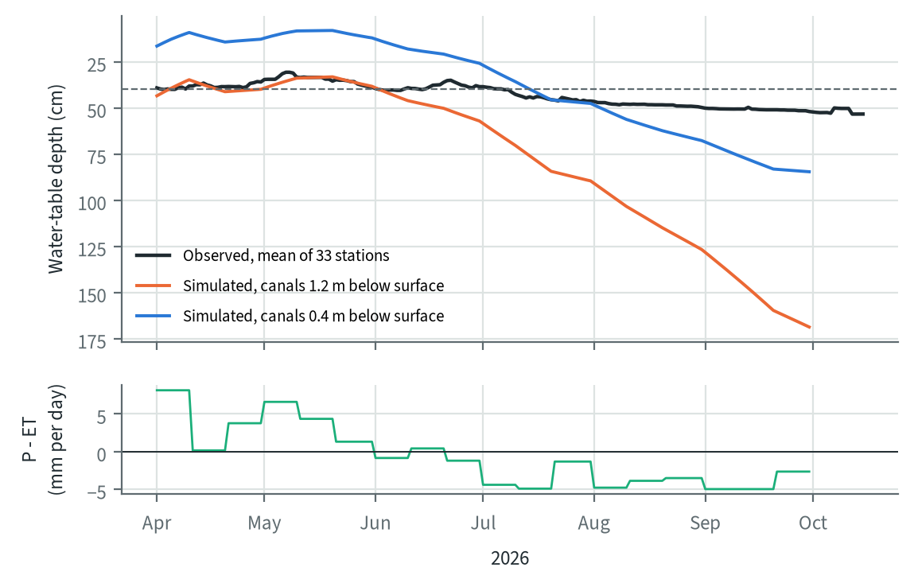
Figure 8.8. Observed and simulated water-table depth at the SiTMAT stations of Sugihan-Lumpur, November 2025 to September 2026 (model in development)

Three KHG: the stations in managed land stay flat
Across the three KHG the stations in managed land barely move through the dry season, and the model drains in every configuration with fixed canals.
Table 8.16. Model results against SiTMAT stations, 2026, canals fixed per simulation (no managed target). Source: summary of groundwater model simulations scored against SiTMAT stations
KHG | Peat set | Canal level (m) | Stations scored | Spearman, model / distance | Bias (cm) | RMSE, model / constant (cm) | Median station r | Drawdown observed / simulated (cm)
Sugihan-Lumpur | tropical large | 1.2 | 33 | -0.21 / 0.15 | +34 | 37 / 4 | 0.87 | 12 / 126
Sugihan-Lumpur | tropical large | 0.4 | 33 | -0.24 / 0.15 | -6 | 11 / 4 | 0.90 | 12 / 72
Sugihan-Lumpur | drained (Ismail Sy) | 1.2 | 33 | -0.25 / 0.15 | +144 | 145 / 4 | 0.77 | 12 / 642
Sugihan-Lumpur | drained (Ismail Sy) | 0.4 | 33 | -0.33 / 0.15 | +12 | 15 / 4 | 0.90 | 12 / 108
Kampar-Gaung | tropical large | 1.2 | 55 | 0.05 / 0.34 | +3 | 19 / 12 | 0.65 | 1 / 31
Kampar-Gaung | tropical large | 0.4 | 55 | 0.03 / 0.34 | -23 | 27 / 12 | 0.65 | 1 / 19
Kampar-Gaung | drained (Ismail Sy) | 1.2 | 55 | 0.10 / 0.34 | +17 | 28 / 12 | 0.67 | 1 / 82
Kampar-Gaung | drained (Ismail Sy) | 0.4 | 55 | 0.21 / 0.34 | -17 | 21 / 12 | 0.63 | 1 / 33
Mendahara-Batanghari (100 m) | tropical large | 1.2 | 15 | -0.32 / 0.17 | +45 | 60 / 11 | 0.38 | 21 / 64
Mendahara-Batanghari (100 m) | tropical large | 1.2, plantations 0.4 | 15 | -0.09 / 0.17 | +23 | 48 / 11 | 0.38 | 21 / 40

Every simulation in the table fails the check, and three findings come out of it:
- Station levels in managed land differ little. At Sugihan-Lumpur the constant prediction is within 4 cm RMSE, so a Spearman across stations measures almost nothing. Kampar-Gaung has more spread, and there distance to canal (0.34) beats every model configuration.
- The measured lower specific yield of drained peat (Ismail et al. 2021) makes every fall larger. With canals at 1.2 m the water table at the Sugihan-Lumpur stations fell a median 642 cm, far below the peat itself (about 1.3 m thick). That led to the rule that no evapotranspiration is taken below the peat base.
- Evapotranspiration that falls as the water table deepens, with the natural-peat thresholds of Apers et al. (2022), changed nothing at Sugihan-Lumpur with canals at 0.4 m: the model reached the first threshold only at the end of September.
At Mendahara-Batanghari the stations split by kind. The 9 concession stations (8 inside plantation licences) sit at 37 cm and fall 6 cm through the dry season; the model with plantation canals at 0.4 m puts them at 28 cm and lets them fall 52 cm. The 6 community stations off canal cells sit at 29 cm and fall 63 cm; the model puts them at 95 cm with a 38 cm fall. The flatness belongs to managed land. What the model lacks is the water supplied to managed land by canal operation, gates or pumping, which exceeds what seepage from a fixed canal level gives.

Managed land held at a target
Holding plantation licences at 0.4 m gives a supply of the right size where the dry season was dry.
Table 8.17. Water supplied to managed land, June to early October 2026, against the station-based deficit. Source: summary of groundwater model simulations scored against SiTMAT stations
KHG | Managed share of the KHG | Peat set | Target | Model supply (mm) | Station deficit (mm) | Stations outside managed land | Result
Sugihan-Lumpur | 77% | tropical large | 0.4 m | 244 | 290 | 0 | pass (supply only)
Sugihan-Lumpur | 77% | tropical large | station median per licence | 233 | 290 | 0 | pass (supply only)
Sugihan-Lumpur | 77% | drained (Ismail Sy) | 0.4 m | 324 | 290 | 0 | pass (supply only)
Kampar-Gaung | 44% | tropical large | 0.4 m | 42 | 7 | 0 | pass (supply only, within 50 mm)
Kampar-Gaung | 44% | tropical large | station median per licence | 41 | 7 | 0 | pass (supply only, within 50 mm)
Kampar-Gaung | 44% | drained (Ismail Sy) | 0.4 m | 104 | 7 | 0 | fail (supply)
Mendahara-Batanghari | 22% | tropical large | 0.4 m | 194 | 119 | 7 | fail (dynamics)
Mendahara-Batanghari | 22% | tropical large | station median per licence | 209 | 119 | 7 | fail (dynamics)
Mendahara-Batanghari | 22% | drained (Ismail Sy) | 0.4 m | 250 | 119 | 7 | fail
Mendahara-Batanghari, canals outside licences 0.6 m | 22% | tropical large | 0.4 m | 181 | 119 | 7 | fail (dynamics)

At Sugihan-Lumpur the supply that holding the plantations takes (233 to 324 mm) is close to the 290 mm the stations imply. At Mendahara-Batanghari it is within a factor of 2. The targets taken from other concessions' stations at Sugihan-Lumpur (0.43 to 0.44 m) are close to the regulatory 0.4 m. At Sugihan-Lumpur and Kampar-Gaung every station off a canal cell lies inside a licence, so these two sites test only the supply.
Land outside licences is the weak part. Mendahara-Batanghari's 6 community stations, off canal cells, are the only independent test of levels there. They sit at 29 cm and fall 63 cm. The model gives 95 cm and a 38 cm fall with the large tropical set, and 165 cm and 99 cm with the Ismail specific yield. The median station correlation is 0.38, below the 0.5 criterion. With canals outside licences at 0.6 m instead of 1.2 m, the community stations come out at 66 cm with a 23 cm fall, and the mean of the 7 stations outside licences matches (37 cm simulated, 36 cm observed). A shallower canal corrects the level of unmanaged land; its swing stays too small. The 6 stations start in late July 2026 and cover only the falling limb, which limits what they can test.

The managed-land target
The concession stations follow the 40 cm rule, so they show compliance with the regulation more than the water table that management actually holds. Across 1,157 SiTMAT concession stations, readings at -40 cm outnumber readings at -41 cm by 2.5 to 1; community stations show no such step. Published plantation water tables are deeper: about 70 cm under Acacia (Evans et al. 2019; Hooijer et al. 2012), and canal water about 0.6 m below oil palm and 0.85 m below Acacia above 5 m elevation (Vernimmen and Hooijer 2026). The 0.4 m target is therefore treated as a scenario setting with a band of 0.4, 0.6 and 0.8 m.
Table 8.18. Effect of the managed-land target and of the canal level outside licences, June to September 2026 (model in development). Source: groundwater model simulations, managed-target band
KHG | Canals outside licences | Target | Open land: days deeper than 40 cm (of 122) | Supply to managed land (mm)
Sugihan-Lumpur | 1.2 m | 0.4 m | 68 | 244
Sugihan-Lumpur | LiDAR levels | 0.4 / 0.6 / 0.8 m | 56 / 56 / 56 | 243 / 149 / 103
Kampar-Gaung | 1.2 m | 0.4 m | 24 | 42
Kampar-Gaung | LiDAR levels | 0.4 / 0.6 / 0.8 m | 5 / 5 / 5 | 40 / 16 / 8
Mendahara-Batanghari | 1.2 m | 0.4 m | 61 | 194
Mendahara-Batanghari | LiDAR levels | 0.4 / 0.6 / 0.8 m | 41 / 41 / 41 | 172 / 124 / 92

The target changes the water supplied to managed land and leaves the open land unchanged. The canal level outside licences sets the open land. The LiDAR levels were measured at Pulau Padang only, on one flight date, and the narrow drains are below the LiDAR pixel size, so their 0.3 m is a shallow bound.

Canals narrower than a cell, and a canal water balance
Letting canals narrower than a cell exchange water with it, instead of fixing the whole cell, changes the days deeper than 40 cm on the same cells by 0 to 2. The canal water balance lets the canals fall to a season median of 0.41 to 0.55 m below the land at Mendahara-Batanghari and Sugihan-Lumpur, inside the published range, with an outlet time constant of 1 or 0.1 day; neither value has been measured.

Outliers in the station record
SiTMAT's quality control flags single spikes and passes loggers that restart after a gap at a shifted level and loggers stuck at one value. A screening rule for these cases, with thresholds set after inspecting the records, leaves out 17% of concession and 23% of community readings nationally. At Mendahara-Batanghari the community stations report 3 days in July, stop for three weeks, and restart about 50 cm above the ground before dropping within a week. Their earlier "fall of 63 cm" comes from these days. On the screened record they sit at 44 cm and fall 11 cm from 19 August to 30 September.
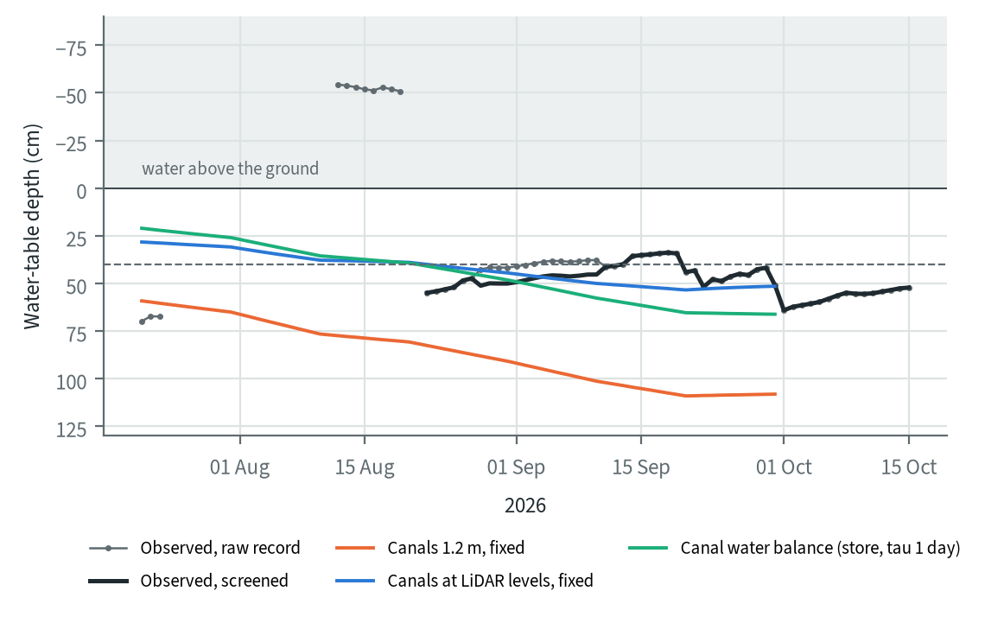
Figure 8.9. Community stations at Mendahara-Batanghari, raw and screened record, against three canal settings, 2026 (model in development)
Table 8.19. Community stations at Mendahara-Batanghari, screened record, 19 August to 30 September 2026 (model in development). Source: groundwater model simulations, canal settings
Canals outside licences | Level, observed / model (cm) | Fall, observed / model (cm)
1.2 m, fixed | 44 / 101 | 11 / 25
LiDAR levels, fixed | 44 / 47 | 11 / 6
LiDAR levels, canals exchanging water with their cells | 44 / 48 | 11 / 9
LiDAR levels, canal water balance | 44 / 56 to 63 | 11 / 24

On the screened record and the 100 m grid, canals at the LiDAR levels match the stations' level and fall, and the canal water balance makes them too dry. On the 200 m grid the 4 comparable stations fall 2 cm against about 21 cm in the model, and the station correlation on the screened record is not yet available. These are 6 stations over six weeks in one KHG. The recommended set-up scores the screened record, lets canals exchange water with their cells at the LiDAR levels and leaves the canal water balance off. The station-based deficit of the adopted neraca air reads the same records and does not yet apply this screening.
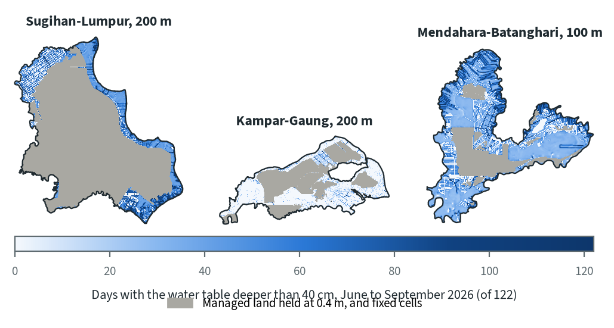
Figure 8.10. Days with the water table deeper than 40 cm, June to September 2026, recommended set-up (model in development)
With this set-up the open land outside licences is deeper than 40 cm on 49 days on average at Sugihan-Lumpur, 6 at Kampar-Gaung and 40 at Mendahara-Batanghari. At Mendahara-Batanghari the check now passes on levels, on the community stations and on supply, and fails on daily dynamics (median station correlation 0.30 against 0.5).

Season outputs, and a dry and a wet year
The season outputs per sub-KHG show how much the dry-season water table and the managed-land supply vary inside each KHG, with managed land held at 0.4 m.
Table 8.20. Range over sub-KHG units of the June to September 2026 season outputs, managed land held at 0.4 m, large tropical set (model in development). Source: per sub-KHG season tables of the groundwater model simulations
KHG | Units | Open land: mean depth (cm) | Open land: days deeper than 40 cm (of 122) | Managed supply (mm)
Sugihan-Lumpur (canals outside licences 1.2 m) | 30 | 35 to 97 | 50 to 120 | 181 to 319
Kampar-Gaung (canals 1.2 m) | 28 | 12 to 45 | 1 to 68 | 13 to 152
Mendahara-Batanghari (canals 0.6 m) | 29 | 23 to 62 | 30 to 105 | 101 to 316

Two further simulations at Sugihan-Lumpur used a dry and a wet year chosen from the climatic-balance calendar (6 and 0 deficit months), with gap-filled MOD16.
Table 8.21. Sugihan-Lumpur in a dry and a wet year, June to September, managed land held at 0.4 m. Source: groundwater model simulations for 2019 and 2022
Year | Rain minus ET (mm) | Water supplied to managed land | Open land at the end of September
2019 (El Niño) | -285 | 163 mm (480 million m³) | mean depth 79 cm; all deeper than 40 cm
2022 | +602 | 1 mm | mean depth 9 cm; 7% deeper than 40 cm

The supply follows the dryness of the season and is close to zero in a wet year. No stations cover 2019 or 2022, so these simulations show how the model behaves without testing its skill. Some units stay dry even in the wet year: unit S02 had open land deeper than 40 cm on 96 of 122 days in 2019 and 48 in 2022.

8.12 Scenarios at Mendahara-Batanghari
Canal blocks rewet the peat close to the blocked reaches and change little beyond about 350 m, so their effect should be judged by distance from a reach and per sub-KHG. Pumping onto the units marked for water supply adds about 50 million m³ to the water needed in the dry season. These first scenarios show how the interventions act; they do not test the current block plan.
The scenarios ran at Mendahara-Batanghari on the 100 m grid with the LiDAR DTM. They take 160 block reaches and the land marked for water supply from the RE-PEAT Interventions plan of this KHG made on 27 October 2026, before the KLH block spacing was adopted. The current plan, with that spacing, has 150 reaches. The baseline holds plantation licences at 0.4 m. Three scenarios are compared: baseline, blocks, and blocks with pumping. RE-PEAT Interventions marks 8 sub-KHG units for water supply, 29% of the KHG, and pumping holds them at 0.4 m.
The baseline canal level outside licences matters. RE-PEAT Interventions computes the water each block holds from an unblocked canal level 1.0 m below the land, and its reaches hold water at a median 0.59 m below the land. On a baseline with canals already at 0.6 m, most reaches raise nothing, because a block never lowers a canal. The scenarios below use a 1.2 m baseline, which is closer to the 1.0 m of RE-PEAT Interventions without being equal to it; a scenario on a matching baseline has not yet been simulated.
Table 8.22. Rewetting scenarios at Mendahara-Batanghari, June to September 2026, canals outside licences 1.2 m below the land (model in development). Source: scenario comparison of the groundwater model, Mendahara-Batanghari
Scenario | Open land (km²) | Open land: days deeper than 40 cm (area-weighted, of 122) | Water supplied in the season, all held land (million m³) | Sub-KHG still needing rewetting
Baseline | 1,207 | 60.9 | 58.5 | 12 of 29
Blocks | 1,207 | 60.2 | 58.3 | 12 of 29
Blocks and pumping | 823 | 58.0 | 108.7 | 9 of 29

The blocks change no unit's status. Averaged over the open land they cut the days deeper than 40 cm by 0.7 days, because their effect is local.
Table 8.23. Change in days deeper than 40 cm by distance from a block reach, blocks scenario against baseline, Mendahara-Batanghari, June to September 2026. Source: scenario comparisons of the groundwater model, baselines with canals outside licences at 1.2 m and 0.6 m
Distance from a block reach | Cells | Mean change, 1.2 m baseline (days) | Cells at least 10 days better, 1.2 m baseline | Mean change, 0.6 m baseline (days) | Cells at least 10 days better, 0.6 m baseline
0-150 m | 2,009 | -26.2 | 62% | -13.6 | 26%
150-350 m | 2,693 | -8.9 | 35% | -4.1 | 17%
350-1,000 m | 7,064 | -0.8 | 1% | -0.4 | 0%
beyond 1,000 m | 108,945 | 0.0 | 0% | 0.0 | 0%

Within 150 m of a reach, 62% of cells have at least 10 fewer days deeper than 40 cm; beyond 350 m almost none do. This matches the literature: a lateral effect under 5 cm by about 300 m (Kurnianto et al. 2026) and rewetting up to about 400 m upstream of blocks in Tebing Tinggi (Sutikno et al. 2023). The 160 reaches touch a small share of this densely canalled KHG, so the KHG-wide figure barely moves, and the KHG average is the wrong measure for judging blocks.
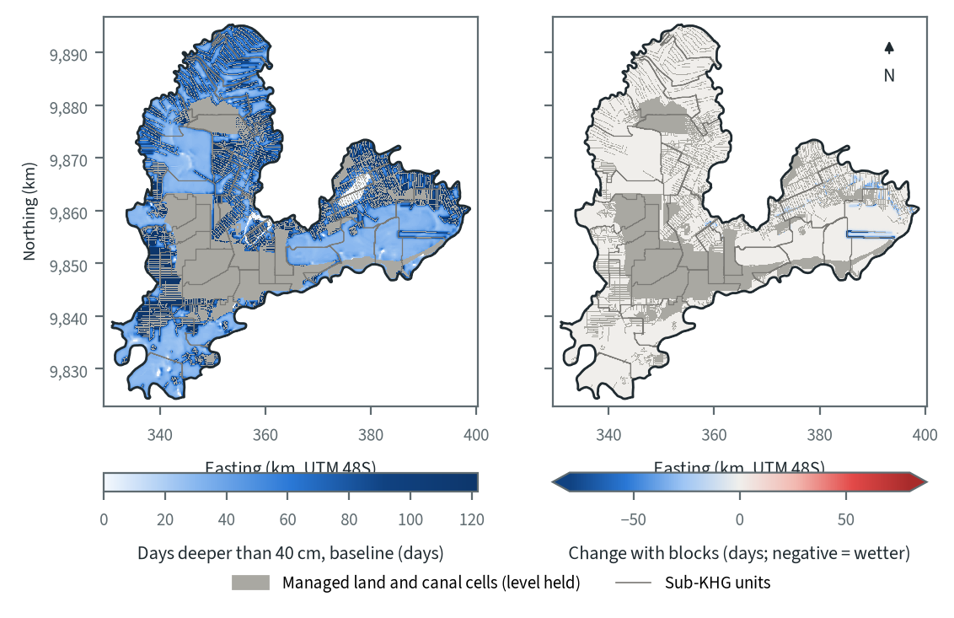
Figure 8.11. Days deeper than 40 cm in June to September 2026 at Mendahara-Batanghari: baseline, and change under the blocks scenario of the 27 October 2026 plan (model in development)
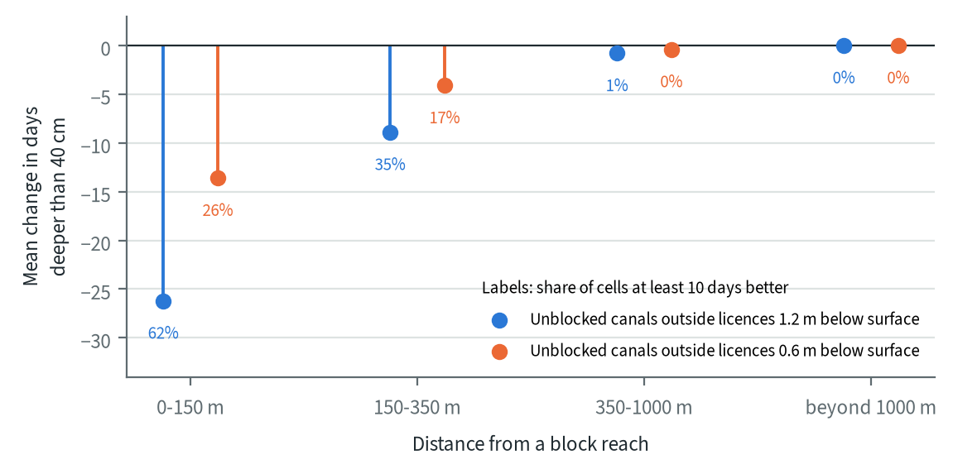
Figure 8.12. Mean change in days deeper than 40 cm by distance from a block reach, Mendahara-Batanghari, June to September 2026 (model in development)
Pumping takes about 50 million m³ more water in June to September (108.7 against 58.5 million m³). The number of units still needing rewetting falls from 12 to 9 only because pumping takes three of the dry units (S01, S02 and S09) out of open land: they are now held at the target. No unit left open changes status. The scenario therefore shows how much water pumping needs and where blocks act; the three units count as rewetted because they are held by assumption. On the 0.6 m baseline the pattern is the same, with smaller effects: blocks cut 13.6 days within 150 m, pumping takes 105.1 against 54.6 million m³, and the count falls from 8 to 7 because S09 is held. Given the limitations below, the ranking of the scenarios can be used; the absolute water table cannot yet.

8.13 Limitations and what is needed
The model can be applied to any KHG, but its results can be trusted only where they can be checked against field data. Its present limits, by their effect on the results:
- Water management in managed land is imposed and not simulated. Holding plantations at 0.4 m reproduces the supply at Sugihan-Lumpur, but the target is a regulatory assumption. Real canal levels in concessions are unknown, and they control the result.
- Results on land outside licences rest on 6 community stations in one KHG with six weeks of usable record. With canals at 1.2 m the model is far too deep there (101 cm against 44 cm on the screened record); with the LiDAR canal levels it matches on the 100 m grid (47 cm), less well at 200 m. The raw record, with its restarts and stuck loggers, gave a different picture (29 cm and a 63 cm fall).
- The surface specific yield of 0.6 in the tropical sets is about twice the measured values for drained peat. The measured lower value makes the drawdown worse where stations show the water table held up, so it is kept as a sensitivity case.
- Canal levels are set per class, or move with one canal water balance per sub-KHG whose outlet constant has not been measured. With no canal network, a block holds a reach at one level and water does not flow along canals. Canals in managed land stay fixed at the target. Tides are not represented, and the KHG edge is held by a river rule even on a coast.
- Forcing is a KHG mean per dekad, so evapotranspiration does not vary by land cover or fire history.
- Inputs are uneven. At Mendahara-Batanghari 36% of the KHG takes its peat depth from the KHG median of 3.9 m. At Tebing Tinggi the peat-depth map agrees with field thickness at r 0.10. LiDAR covers few KHG, and open DEMs can be wrong by as much as a dome's relief.
- No measurement before and after blocking is available to the project, so the simulated block response is untested in the field. It agrees with the published range.
To make the model operational, the project needs:
- water-table stations in land outside licences, with records through a full dry season, in several KHG;
- measured canal water levels in concessions and community land, by season;
- LiDAR or an equally good DTM for the KHG where scenarios are wanted;
- a baseline canal level that matches the one RE-PEAT Interventions assumes.
Decisions needed from KLH and the World Bank:
1. How the canal boundary in managed land is represented: a target water table as now (0.4 m, PP 57/2016), or a supply term sized from the deficit. Either is an assumption, and it sets the result in managed land.
2. What the field check rests on. The Tebing Tinggi survey cannot test spatial pattern, and managed station levels carry little spatial signal. Options are the 2026 Tebing Tinggi stations (5 concession stations at about 20 cm, 3 community stations at about 150 cm, one season), a site with stations and LiDAR, and the supply deficit as a second check.
3. Whether to adopt a measured specific yield (about 0.3 at the surface to 0.1 at 1.5 m) and evapotranspiration that falls with depth. Both come after the canal boundary, because neither replaces the missing supply.
4. Whether to build the canal network with a weir per block (Urzainki et al. 2023) or move to MODFLOW 6 with a stage per reach.
Until the model passes its checks outside managed land, the climatic balance and the station deficit remain the adopted neraca air, and the groundwater model's scenario maps are indicative.

8.14 Questions and answers

What does the model produce?
Maps. The KHG is divided into cells of 100 m or 200 m, and the model computes the water-table depth of every cell every day. A simulation gives maps for a season (days deeper than 40 cm, mean depth, water supplied to managed land), a daily KHG series, a table per sub-KHG, and scores against stations.

Does a result hold for one date only?
No. The result is a daily series for every cell. A map is a summary over a period, by default June to September, or a snapshot of one day. Any other season can be chosen.

Why not model every KHG now, with blocks and pumps?
The model can already be applied to any KHG. What is missing is confidence in the answer. In managed land the model drains far more than the stations show unless water management is imposed, and on land outside licences it is still too deep. Canal water levels are unknown, and blocks and pumps work by changing them. Many KHG lack a good DTM and peat-depth map, and only KHG with enough stations can show whether the model works.

Why does the model need to "hold" managed land at 0.4 m?
The stations there stay almost flat through the dry season (a median fall of 1 to 12 cm) while rain minus evapotranspiration is strongly negative. Companies hold canal water up with blocks, gates and pumps. The model cannot represent how, so it imposes the result and reports the water this takes. That water matched the station-based deficit at Sugihan-Lumpur (233 to 324 mm against 290 mm). The stations, though, cluster at the 40 cm compliance limit, so they do not measure the managed water table. A target of 0.6 or 0.8 m leaves the open land unchanged and cuts the water by a factor of 2 to 5.

How far does a canal block reach?
In the Mendahara-Batanghari scenario, cells within 150 m of a block reach were deeper than 40 cm on average on 26 fewer days of the 122-day dry season; at 150 to 350 m, 9 fewer; beyond 1 km, no change. Published studies give a similar reach.

How much water would pumping need?
At Mendahara-Batanghari, holding the 8 units that RE-PEAT Interventions marks for water supply at 0.4 m takes about 50 million m³ in June to September 2026, on top of the 58.5 million m³ the model gives for managed land.

Does burned peat need different parameters?
Not for infiltration. On tropical peat, permeability did not fall significantly after fire across four Indonesian sites (Setiawan et al. 2020). Burned land sits lower and evaporates less; a post-fire LiDAR DTM already captures the lower surface.

Is the model ready to replace the adopted neraca air?
No. It is in development. It replaces the climatic balance only after it passes the field checks, and then only on KHG with adequate inputs.

9 RE-PEAT Interventions: canal blocks and pumping
RE-PEAT Interventions turns the results of the earlier chapters into a costed rewetting plan for one KHG (Kesatuan Hidrologis Gambut, peat hydrological unit). In the highest-ranked sub-KHG units it proposes where to build sekat kanal (canal blocks) on the primary and secondary canals and shows the canal stretch each block holds back. For every sub-KHG in the KHG it assigns a treatment and prices the quantities. Where a river can supply water in the dry season, it also routes pumped water to the driest pools and sizes the pump stations. KLH staff use it through a QGIS plugin; the same method also runs in batch over many KHG.
The module is the last step of the toolkit. It draws on the canal network, rivers and existing blocks of the KHG, the DTM from the DEM correction (chapter 4), the sub-KHG units from the delineation, the KHG water deficit from the neraca air (water balance), and the order and indicators of the sub-KHG from the sub-KHG prioritisation.

9.1 Inputs
Table 9.1. Inputs of RE-PEAT Interventions. Source: interventions module method report and README
Input | Source in the toolkit | Used for
Bare-earth DTM | DEM correction: LiDAR where it exists, then DeltaDTM, then DEMNAS | land profile along each canal, flow accumulation; a surface model (DSM) is refused
Canals with class | KHG inputs (primary, secondary, tertiary) | the network; primary and secondary by default
Existing canal blocks | KHG inputs | blocks already built, counted as in place
Rivers | KHG inputs | flow direction of canals; pump intakes when a river is marked perennial or has a dry-season level
Sub-KHG units and ranking | delineation and sub-KHG prioritisation | which sub-KHG are analysed (top n by rank), deficit per unit
Moisture (NDMI) | latest annual NDMI of the KHG | dryness of each canal segment
Burnt area, peat depth | national layers clipped to the KHG (optional) | criteria of the segment need score
Sub-KHG indicators | sub-KHG prioritisation | protected peat share, NDMI, burnt share, canal reach, distance to water, canal density
Water balance map | neraca air | KHG deficit, monthly balance and SiTMAT stations for the report
Unit prices | proposed defaults, with a register of sources | the budget

The data inputs are assembled automatically for each KHG. Every parameter that is a policy choice (weights, spacing, pump specifications, prices) starts empty, and no stage runs until its required values are set, either by the user or from a set of proposed defaults. Each value taken from the proposed defaults is listed in the plan's report, so a reviewer can see which choices still need agreement.

9.2 The twelve stages
The method has twelve stages, with three points where a reviewer checks the results before the plan goes further: after the canal network is cleaned (stage 2), after canal segments are scored for need (stage 6) and after water routes are drawn (stage 9). Changing a setting or an input recomputes that stage and every later one.
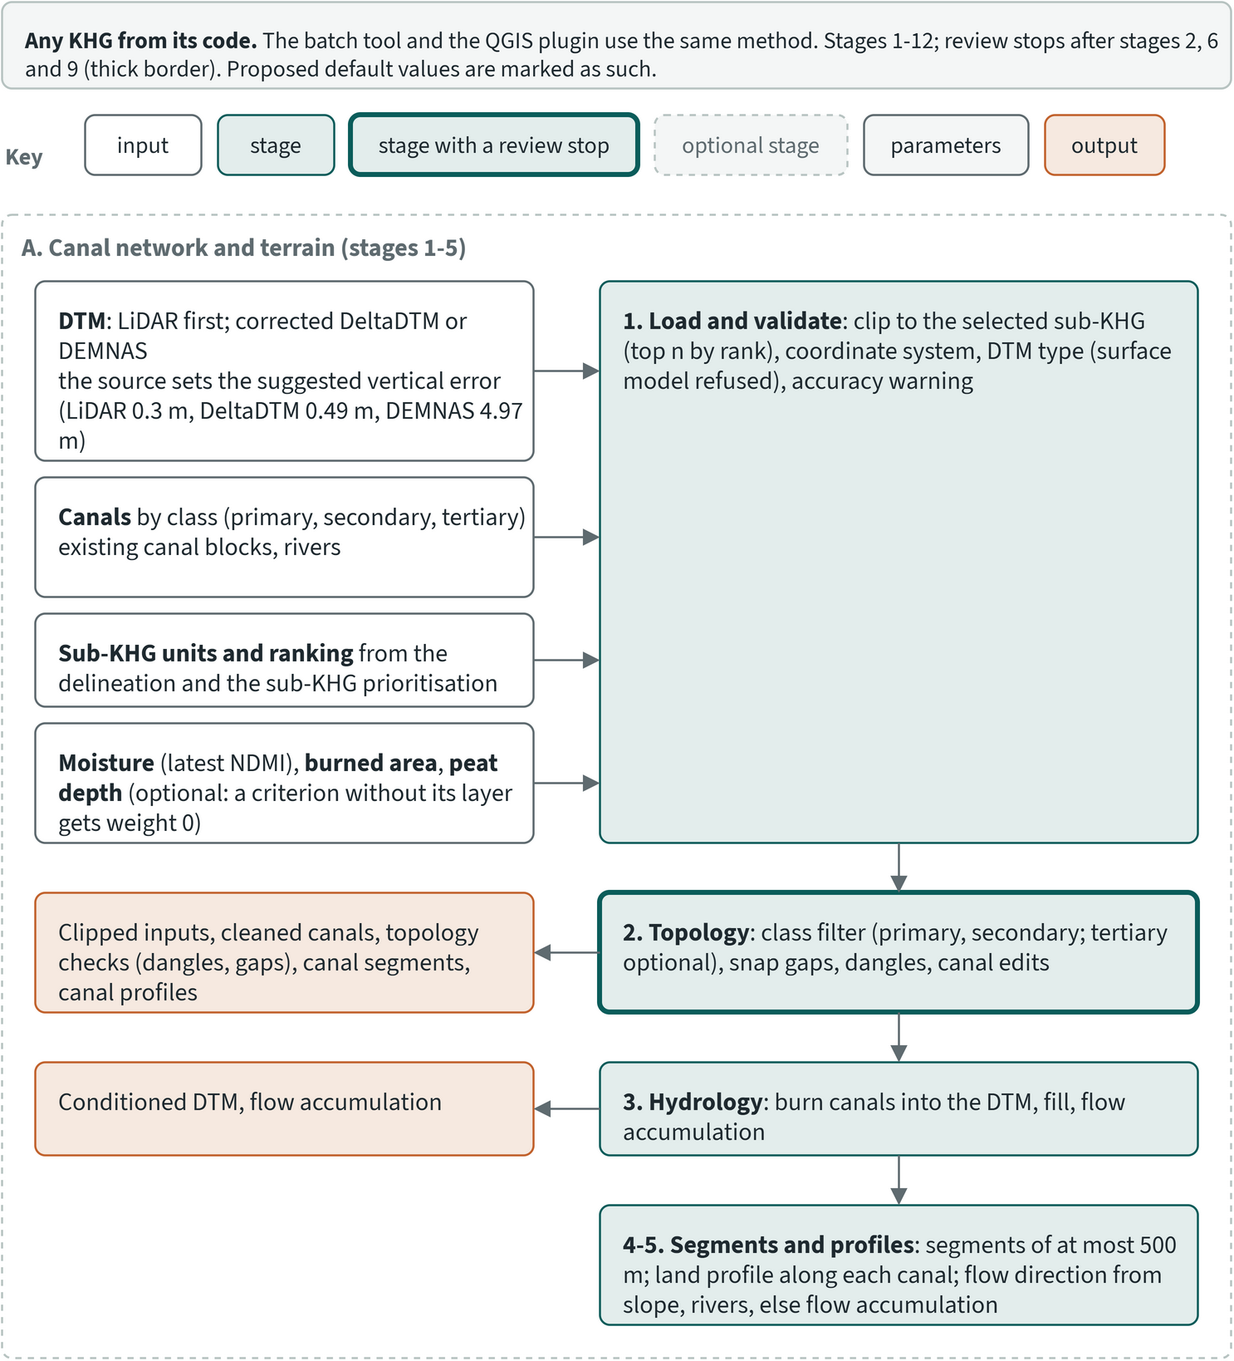
Figure 9.1. Method of RE-PEAT Interventions, part 1: inputs and stages 1 to 5
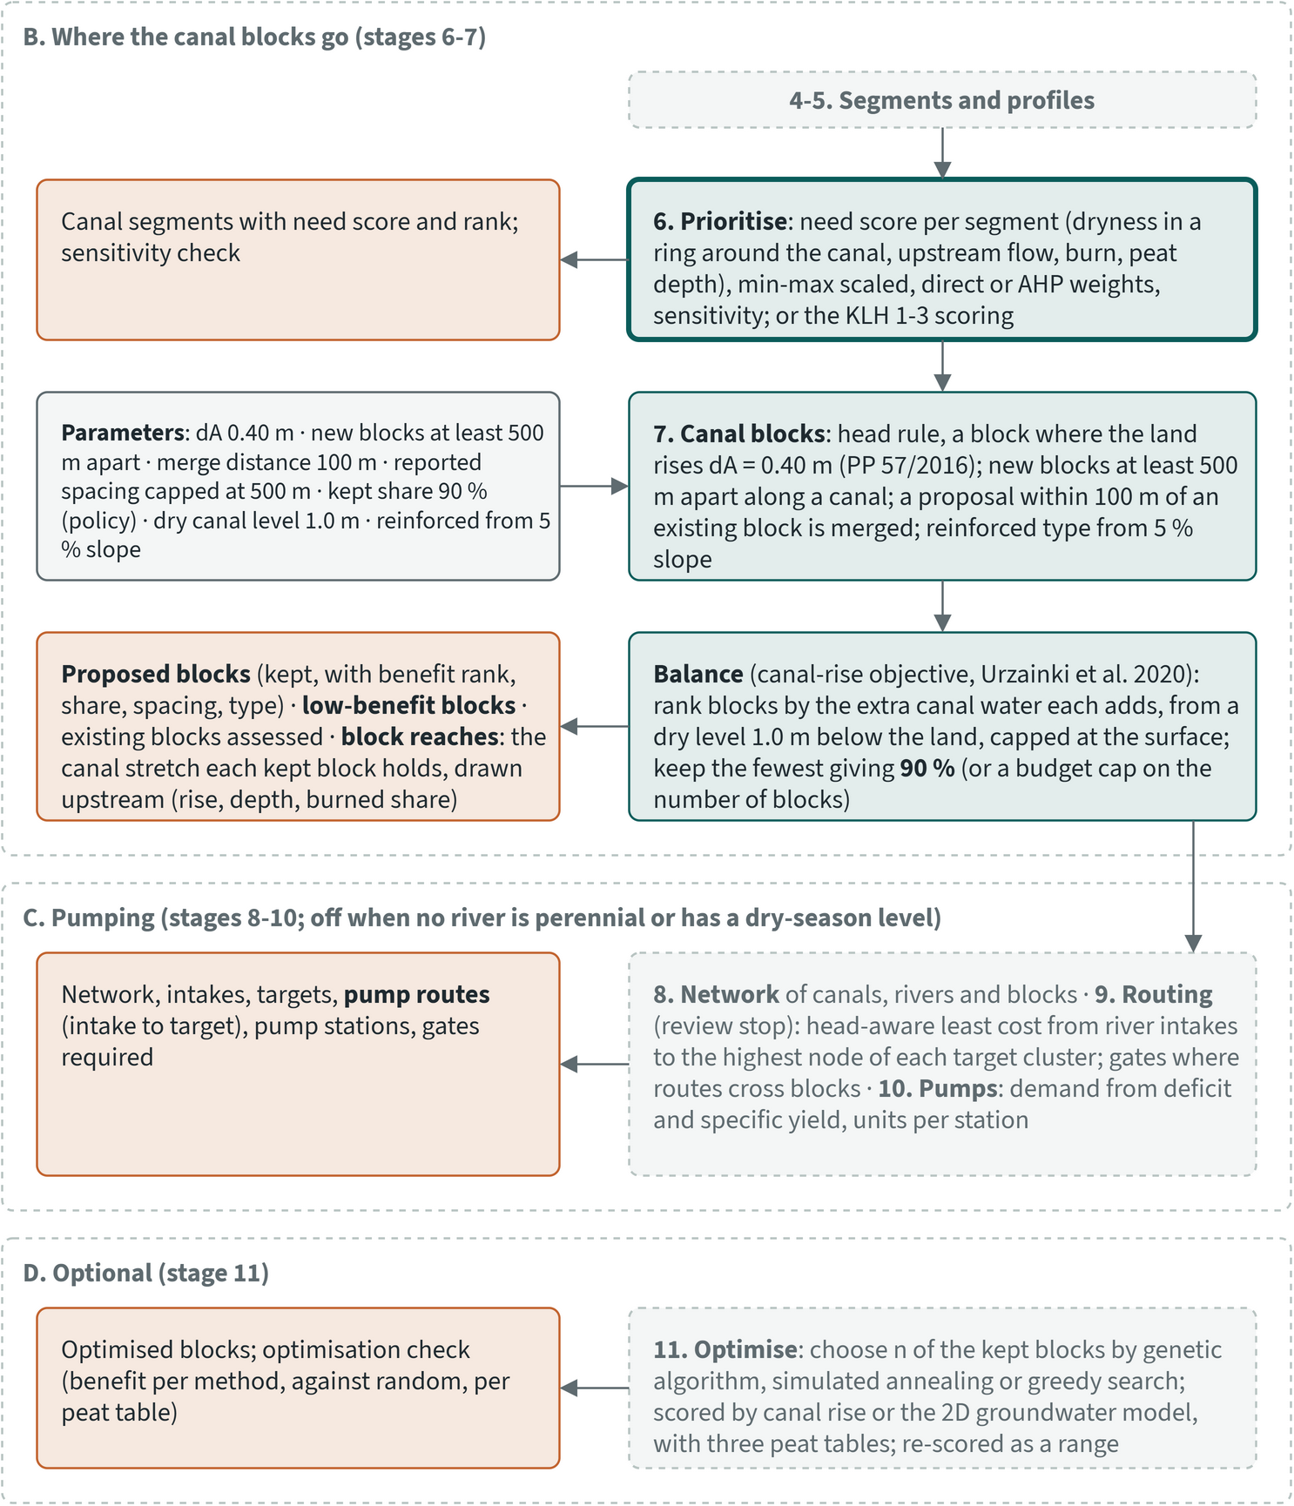
Figure 9.2. Method of RE-PEAT Interventions, part 2: stages 6 to 11 (blocks, pumping, optimisation); review points after stages 6 and 9
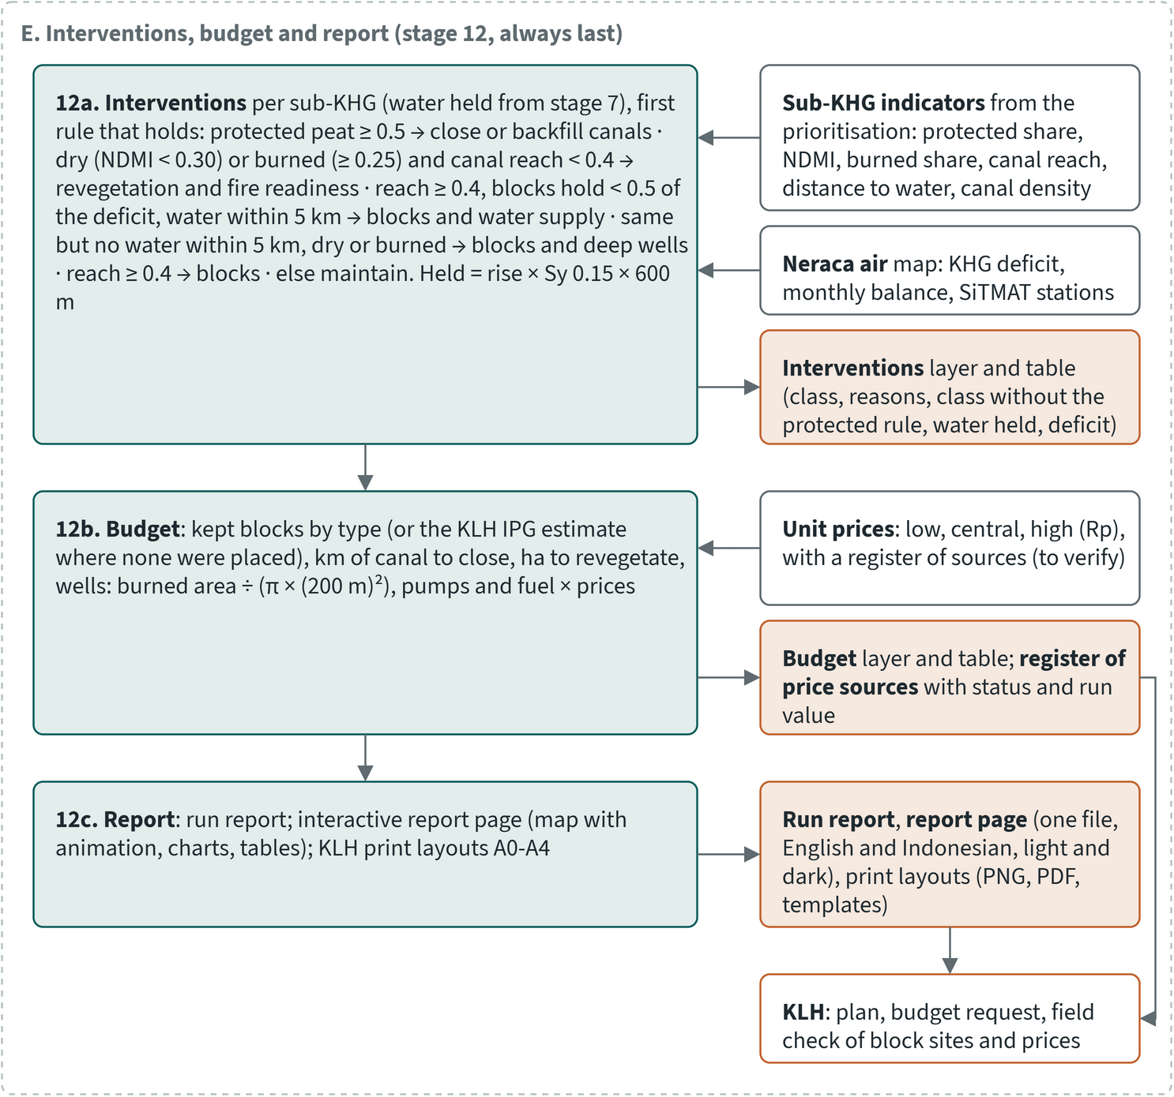
Figure 9.3. Method of RE-PEAT Interventions, part 3: stage 12 (interventions, budget, report)
1. Load and validate. Clips every input to the selected sub-KHG plus a 600 m margin, checks the coordinate system and the DTM type, and warns when the DTM's vertical error is too large for head-based placement (when 0.40 m is less than twice the vertical RMSE).
2. Topology (review point). Keeps the chosen canal classes, snaps end points within 1 m, and marks dangles, gaps and canals with no connection to a river for checking. Nothing is deleted without review.
3. Hydrology. Burns the canals 2 m into the DTM (where a canal has no depth) and computes flow accumulation.
4. Segments. Cuts canals into segments of at most 500 m and flags pieces shorter than 25 m, which stay in the network but are not scored.
5. Profiles. Samples the land along each canal every 5 m from the unburned DTM and sets each canal's flow direction from its slope, else its river connection, else flow accumulation (downstream is the end where clearly more water collects).
6. Need score per segment (review point). Scores dryness (moisture in a ring 15 to 100 m from the canal, outside the canal water), upstream contribution, burn frequency and peat depth. Each criterion is min-max normalised and weighted; the top 20 % of segments are selected. A one-at-a-time sensitivity test moves each weight by ±10 % and ±20 %.
7. Canal blocks. Places blocks by the head rule, merges them with existing blocks and keeps the fewest that give 90 % of the canal rewetting (sections 9.3 and 9.4).
8. Network. Builds a directed graph of canals, rivers and blocks (only when pumping is planned).
9. Routing (review point). Finds head-aware least-cost routes from river intakes to the highest pool of each cluster of selected segments.
10. Pumps. Computes water demand, places pump stations along each route and sizes them.
11. Block optimisation (optional, off by default). Chooses a set number of the kept blocks by genetic algorithm, simulated annealing or greedy search, scored by canal rise or by the groundwater model, which is in development.
12. Interventions, budget and report. Assigns a treatment to every sub-KHG, prices the quantities and writes the report.
When no river in the analysis extent is perennial or has a dry-season level, stages 8 to 10 are skipped and the plan covers blocks only. All plans reported in this chapter are block-only for that reason.

9.3 Block placement: the head rule and the KLH minimum distance
Blocks are placed where the land along a canal has risen enough to need one, so their number follows the slope of the land and the quality of the DTM. Starting at the downstream end, the method walks up each canal along the land profile and puts a new block where the land has risen dA = 0.40 m above the previous block, the water-table limit of PP 57/2016. This is the guide's idea of equal-head points, computed from the profile instead of from vector contours. An existing block resets the baseline.
For each canal the module also reports the required number of blocks (the land rise between the canal ends divided by dA, rounded up) and the KLH adequacy index IPG (existing blocks ÷ required blocks). It gives the required spacing dA ÷ slope, capped at 500 m, and the block height from the canal depth, spacing and slope. Blocks on a slope of 5 % or more are marked as reinforced; the slope sets the block type and never removes a block.
Two spacing values were taken from the KLH technical guide at the request of KLH users:
- A minimum distance of 500 m between new blocks along a canal (the guide's minimum distance between blocks). After a new block is placed, the next new block on that canal is at least 500 m further upstream. On land steeper than 0.40 m in 500 m (0.08 %) this overrides the head rule and gives fewer blocks.
- A merge distance of 100 m. A proposed block within 100 m of an existing block, or of a block proposed on another canal, is dropped. The guide's script used 50 m.
A new block also never lies within 100 m of an existing block on the same canal. Existing blocks count as built when they lie within 30 m of an analysed canal.
The 500 m maximum caps only the reported required spacing. Flat land does not receive a block every 500 m: on a canal where the land rises less than 0.40 m, the head rule places no block.

9.4 Merging with existing blocks and the 90 % balance
The balance step roughly halves the number of blocks while keeping 90 % of the rewetting, which keeps the plan to blocks that each hold a useful amount of water. At Sugihan-Lumpur on LiDAR it kept 43 of 86 head-rule blocks for 90.2 % of the rise.
Existing blocks enter the placement in three ways. They reset the head baseline, they suppress new blocks within 100 m, and in the balance they are held as already in place.
The head rule can propose many blocks that each add little. The balance step ranks the proposed blocks by the canal rewetting each adds, measured as the change in canal water level. Urzainki et al. (2020) used that measure as the simpler of their two block-placement schemes; their main scheme minimises the mean water-table depth, which needs a groundwater model. Each block holds water at its land level minus dA. It raises every canal station upstream that lies lower, starting from an unblocked dry-season canal level 1.0 m below the land, and never above the land surface. Blocks are added in order of extra rise, and the fewest that give 90 % of the rise of all head-rule blocks are kept. The rest are reported as low-benefit blocks with their rank and gain. A cap on the number of blocks, set from the budget, can override the share.
The 90 % share was chosen from test layouts at Sugihan-Lumpur made before the 500 m and 100 m spacing values were adopted. On the LiDAR network, past 90 % the water each extra block holds fell by 2.4 to 5 times, and balanced layouts held 1.9 to 2.5 times more water per block than the full head-rule layout. Including tertiary canals gave balanced layouts 2.8 to 3.3 times the water. The KLH guide analyses primary and secondary canals, so tertiary canals stay optional. The order of the blocks barely changed when the unblocked level was set anywhere between 0.8 and 1.2 m. The groundwater model of the neraca air work (chapter 8) uses the same 1.0 m unblocked canal level when it simulates block scenarios, so the two methods start from the same canal state.
For every kept block the plan shows its reach: the canal stretch whose final level that block sets, with the rise, the depth of the water below the land and the share inside burnt area.

9.5 Prioritisation of sub-KHG and canal segments
Blocks are planned first in the sub-KHG with the highest need. By default these are the three highest-ranked units of the sub-KHG prioritisation. That ranking uses default weights proposed for agreement with KLH and the World Bank and adjustable in the dashboard, so the selected units may change once the weights are agreed.
Inside the selected units, stage 6 ranks canal segments by need, with equal weights of 0.25 for burn frequency, peat depth, dryness and upstream contribution (the equal weighting of the KLH scoring). These segment weights are also proposed values for agreement. Weights can instead be set by pairwise comparison (AHP, consistency ratio at most 0.10), and the guide's own 1-to-3 scoring with a threshold of 10 out of 12 is available as an option. Concession areas are flagged after scoring and never dropped silently.
At Sugihan-Lumpur the need ranking was stable under weight changes. The lowest Spearman correlation under ±20 % weight changes was 0.988 on LiDAR, 0.983 on DeltaDTM and 0.977 on DEMNAS. The share of top segments retained was at least 0.93, 0.92 and 0.82.

9.6 Routing water and sizing pumps
Pumping is designed for KHG where a river can supply water in the dry season. It has not yet been applied to a real KHG, and its values are engineering proposals with low or medium confidence, to be replaced by the procurement specification.
Sources are points where a river meets a canal, found with a 30 m canal buffer as in the guide. Targets are the highest node of each connected cluster of selected segments, where the guide uses segment centroids. The cost of moving along a canal is its length plus a penalty for each metre of uphill lift (by default 1 m of lift costs as much as 1 km of canal). By default one Steiner tree serves all targets, so several targets share trunk canals; one shortest route per target, as in the guide's script, is the alternative. Existing blocks without a gate are dead ends. Proposed blocks on a route are designed with a gate.
Demand for each target is the KHG deficit times the peat area within 600 m of the served segments, delivered over the design period. Without a deficit it is a 0.40 m water-table rise times a specific yield of 0.30 times the same area. The flow is the volume divided by the period (120 days by default, July to October; Ritzema et al. 2014). Stations are placed at the intake and wherever the lift plus canal friction (Manning n 0.035; Chow 1959) would exceed 5 m. A station moves back to the nearest block in that stretch, so a lift station sits at a block. Power is ρgQH divided by the pump efficiency (Karassik et al. 2008), with an efficiency of 0.65 at the low end of the normal range (Haman 2017). Units of 0.10 m³/s each are counted. Shortfalls are reported, never capped silently.

9.7 Interventions per sub-KHG and the link to the water balance
Blocks keep water that would otherwise drain away. They do not supply water in the dry season, and they act only on land near the canals. Most sub-KHG therefore need another treatment as well as, or instead of, blocks. Stage 12 gives every sub-KHG the first treatment whose rule holds.
Table 9.2. Treatment rules per sub-KHG (proposed policy thresholds, for agreement). Source: interventions module code and proposed defaults
Treatment | Rule
Close or backfill canals | protected peat function on at least 0.5 of the unit
Revegetation and fire readiness | dry (NDMI below 0.30) or burnt (at least 0.25 ever burnt), and canals reach less than 0.4 of the unit
Blocks and water supply | canals reach at least 0.4, blocks hold less than 0.5 of the deficit, permanent water within 5,000 m on average
Blocks and deep wells | as above, but no water within 5,000 m, and dry or burnt
Blocks | canals reach at least 0.4
Maintain and monitor | none of the above

For units under the protected-peat rule, the plan also reports the treatment they would get without it.
The water the kept blocks hold in a unit is the canal rise times a specific yield of 0.15 (the neraca air value) times a lateral reach of 600 m (Urzainki et al. 2023). This is compared with the unit's deficit: the KHG deficit in mm from the neraca air times the unit area. Units outside the analysed sub-KHG have no block layout, so blocks count as falling short there when the KHG deficit is at least 50 mm.

9.8 Budget and its sources
The budget prices the quantities of each sub-KHG at low, central and high unit prices. All prices are proposed unit prices, to be verified, and should be replaced by the KLH cost standard for rewetting infrastructure once KLH provides it.
Table 9.3. Budget items, quantities and proposed unit prices. Source: interventions module code, proposed defaults and price register
Item | Quantity | Unit price, low / central / high (Rp)
Standard block | kept blocks of stage 7 in the analysed sub-KHG; elsewhere, for a block treatment, the KLH IPG estimate of missing blocks from the sub-KHG prioritisation | 12 / 18 / 18 million per block
Reinforced block | kept blocks on a slope of 5 % or more | 70 million per block
Canal closure | canal density (primary and secondary) × peat area, for close-canal units | not priced
Revegetation | area ever burnt, revegetation units | 8 / 12.1 / 15 million per ha
Deep wells | area ever burnt ÷ area of one well (π × (200 m)², about 12.6 ha), revegetation and block-with-wells units | 3 / 8.5 / 9 million per well
Pumps and fuel | pump units of stage 10; power × 12 h/day × design period × 0.3 L/kWh | 15.5 million per pump; diesel 23,554 to 24,886 per L

The prices come from news reports, a journal article, a marketplace listing and the October 2026 industrial diesel reference, found by web search on 27 October 2026. They are not adjusted for inflation. Each price is recorded in a price register with its source, link, date accessed and status. Of its 19 entries, 15 are marked to verify, 2 unconfirmed, 1 an assumption and 1 to obtain from KLH; none has yet been checked against its source page. No published price per km of canal backfilling was found, so canal closure is reported as length only.

9.9 Outputs
Each plan, one per DEM, delivers:
- map layers for every stage: cleaned canals, segments with need score, proposed and low-benefit blocks, block reaches, assessed existing blocks, interventions, budget, and (with pumping) routes and stations;
- tables of interventions per sub-KHG, budget per sub-KHG and item, and the price register with the prices used;
- a report with counts, warnings, the balance, interventions, budget and every value taken from the proposed defaults;
- an interactive report page in English and Bahasa Indonesia, with light and dark themes. It has a map of interventions or the dry-season balance, blocks, animated reaches, burnt area and SiTMAT stations, plus the rewetting curve against blocks or rupiah, the budget with its sources, and a sortable sub-KHG table;
- print layouts in the style of the KLH peat maps, A0 to A4, landscape or portrait. They carry a lat/long border, north arrow, scale bar, legend in columns, data sources, a locator inset and a budget table. Planned blocks are dark green squares and existing blocks magenta squares, following the KLH sheets.
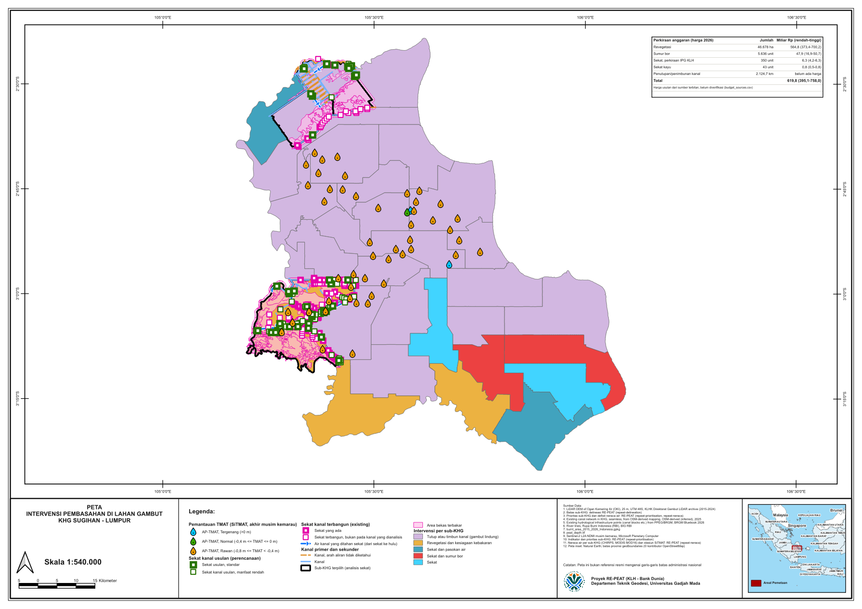
Figure 9.4. Print layout (A3 landscape) of the LiDAR plan at Sugihan-Lumpur, 28 October 2026: interventions per sub-KHG, planned and existing blocks, burnt area and SiTMAT stations. Source: RE-PEAT Interventions, Sugihan-Lumpur LiDAR run
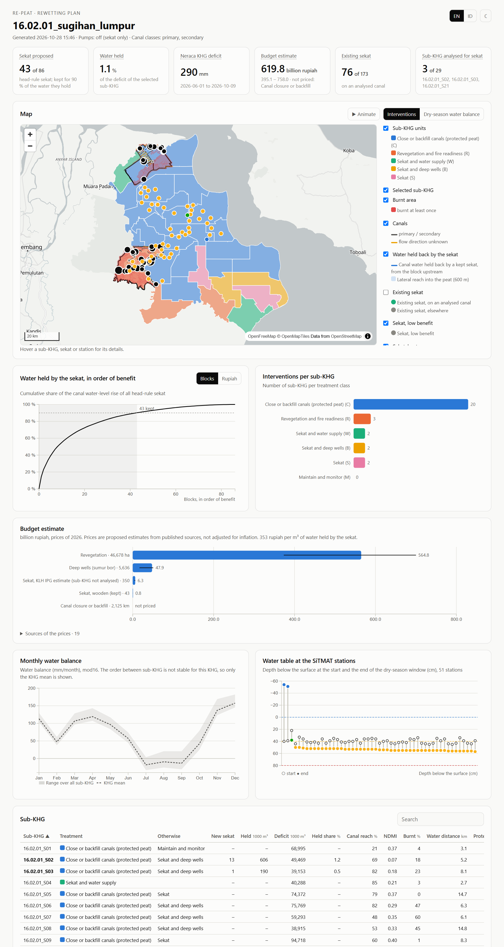
Figure 9.5. The interventions report for Sugihan-Lumpur on the LiDAR DEM: headline numbers, map of interventions, water held by the blocks in order of benefit, interventions per sub-KHG, budget, monthly water balance and the SiTMAT water table. Source: RE-PEAT Interventions run of 28 October 2026

9.10 The QGIS plugin for KLH staff
KLH staff receive the module as a QGIS plugin, so a plan can be prepared, reviewed and printed in the GIS software they already use. The plugin runs the same method as the batch version and carries the KLH layout templates, logo and locator map. It is installed once, with an internet connection, and then works in English and Bahasa Indonesia.
A guided wizard takes staff through a plan and is also meant for training:
- Staff choose a KHG, and the wizard fills in the inputs held for it and lists anything missing. It proposes how the canal classes in the data map to primary, secondary and tertiary, for the user to confirm. Pump planning is offered only when a river has a dry-season level or is marked perennial; tertiary canals are off by default.
- Policy values can be filled from the proposed defaults, each marked as such, and a value entered by the user always takes precedence. Datums, DTM error and the moisture direction must always be entered by the user.
- Each stage explains what it does and which decisions it needs, with an optional learning mode that adds the reasoning and references.
- At the three review points (stages 2, 6 and 9) the wizard pauses so staff can inspect the layers on the map and accept or repeat the stage.
- The last step exports the report page and the print layout, which staff can edit further in QGIS.
The plugin has been tested in an automated session in QGIS 4.2.2. It has not yet been used by KLH staff.

9.11 How the module follows and departs from the KLH guide
The KLH technical guide (Panduan Teknis GIS Rewetting KLH), prepared by the Department of Geodetic Engineering, UGM, with a method developed jointly with KLH, sets out ten manual steps in QGIS, from data preparation to block placement with a Python script. The module follows its order and most of its values. It departs from the guide where the guide's method loses information or depends on manual tuning.
Table 9.4. Comparison with the KLH technical guide. Source: KLH technical guide (Appendix A and D) and interventions module code and proposed defaults
Topic | KLH guide | RE-PEAT Interventions
Canal classes | primary and secondary | same by default; tertiary optional
Segments | at most 500 m; under 25 m not scored | same
Stream burning | fixed 2 m | canal depth where known, else 2 m
Moisture and flow extraction | 50 m buffer including the canal | ring 15 to 100 m outside the canal water; the 50 m buffer is used in the guide's scoring mode
Scoring | four criteria scored 1 to 3, summed (maximum 12), class breaks fitted by hand to each KHG | min-max normalised criteria, direct or AHP weights, sensitivity test; the guide's scoring available as an option
Priority threshold | score of 10 or more (marked temporary) | top 20 % of segments
Route targets | centroids of priority segments | highest pool of each cluster of selected segments
Routing | shortest path from each start | head-aware least cost; Steiner tree by default, per-target routes as an option
Block placement | 0.5 m contours on smoothed DEMNAS crossing the route | land profile, a block at each 0.40 m rise (PP 57/2016), no vector contours
Minimum distance between new blocks | 500 m | 500 m (from the guide)
Merge distance | 50 m | 100 m
Slope 5 % | marks the block type | same
Concessions | left out of scoring | flagged after scoring
Number of blocks | all placed | fewest giving 90 % of the canal rewetting

The guide places blocks only along the routes from river mouths to priority segments. The module places them on every analysed canal in the selected sub-KHG, so a block-only plan is possible where no river qualifies as a source.

9.12 Results at Sugihan-Lumpur by DEM
At Sugihan-Lumpur (KHG 16.02.01) the plan keeps 39 to 62 blocks in the three selected sub-KHG, depending on the DTM, at a cost below 1.2 billion rupiah. These blocks hold under 7 % of the dry-season deficit, so most of the budget goes to other treatments, chiefly revegetation of burnt land.
Plans were made with each of the three DTM variants, using primary and secondary canals and the proposed defaults, including the 500 m minimum distance and the 100 m merge distance. All three are block-only because no river feature lies inside the analysis extent. The LiDAR variant at this KHG is the KLHK 25 m LiDAR DEM. DeltaDTM (30 m) and DEMNAS (8 m) are the smoothed, corrected surfaces from the DEM correction.
The three highest-ranked sub-KHG differ by DEM, because each DEM has its own sub-KHG delineation and ranking, and unit codes are numbered per variant. The numbers in the next table therefore compare different areas as well as different surfaces.
Table 9.5. Canal blocks at Sugihan-Lumpur by DTM, three highest-ranked sub-KHG, 28 October 2026. Source: run reports and map layers of the three plans
 | LiDAR (25 m) | DeltaDTM (30 m) | DEMNAS (8 m)
Sub-KHG analysed | S21, S03, S02 | S23, S03, S08 | S20, S06, S04
Vertical error assumed (m) | 0.3 | 0.49 | 4.97
Primary and secondary canals after cleaning | 596 | 408 | 476
Canals oriented by flow accumulation | 191 | 165 | 294
Canals with unresolved direction | 302 | 182 | 178
Existing blocks in extent / on an analysed canal | 173 / 76 | 273 / 127 | 380 / 131
Proposals dropped within 100 m of another block | 3 | 4 | 12
Head-rule blocks | 86 | 117 | 226
Blocks kept at 90 % | 43 | 39 | 62
Canal held back by kept blocks (km) | 68.7 | 110.1 | 128.9
of which inside burnt area (km) | 26.9 | 65.0 | 58.9
Water held / deficit, selected sub-KHG (million m³) | 2.19 / 196.9 | 5.06 / 175.9 | 5.02 / 227.1
Share of deficit held per sub-KHG (%) | 0.5 to 1.3 | 0.5 to 6.9 | 1.4 to 3.2

The DTM changed the head-rule count 2.6-fold: DEMNAS gives 226 head-rule blocks against 86 on LiDAR. (Adding tertiary canals changes it more, 3 to 4 times at this KHG.) The DEMNAS plan assumed the vertical error of raw DEMNAS, 4.97 m, and the DeltaDTM plan its benchmark error against LiDAR, 0.49 m. Against a step of 0.40 m, much of the rise DEMNAS shows along a canal is likely noise. The method flags every DTM whose assumed error exceeds 0.2 m, which here is all three. After the 90 % balance the gap narrows to 62 against 43 blocks, because many noise-driven blocks add little rise. DeltaDTM gives fewer kept blocks than LiDAR (39 against 43) but more held canal length, on a different set of sub-KHG. These differences are within one KHG and one set of defaults. They show that block counts from DEMNAS should not be taken as a design.
The kept blocks hold under 7 % of the dry-season deficit in every selected sub-KHG (KHG deficit 290 mm). Blocking keeps water in place but cannot cover a deficit of this size, and most sub-KHG get another treatment.
Table 9.6. Treatments per sub-KHG at Sugihan-Lumpur by DTM (proposed thresholds). Source: run reports of the three plans
Treatment | LiDAR | DeltaDTM | DEMNAS
Close or backfill canals (protected peat) | 20 | 18 | 16
Revegetation and fire readiness | 3 | 2 | 1
Blocks and water supply | 2 | 2 | 4
Blocks and deep wells | 2 | 4 | 5
Blocks | 2 | 3 | 0
Maintain and monitor | 0 | 0 | 1
Total sub-KHG | 29 | 29 | 27

Table 9.7. Budget estimate at Sugihan-Lumpur by DTM, billion rupiah at proposed 2026 prices (low / central / high). Source: run reports and budget tables of the three plans
Item | LiDAR | DeltaDTM | DEMNAS
Kept blocks (number; cost) | 43; 0.52 / 0.77 / 0.77 | 39; 0.47 / 0.70 / 0.70 | 62; 0.74 / 1.12 / 1.12
KLH IPG estimate of blocks elsewhere (number; cost) | 350; 4.20 / 6.30 / 6.30 | 1,615; 19.38 / 29.07 / 29.07 | 7,327; 87.92 / 131.89 / 131.89
Revegetation (ha; cost) | 46,678; 373.4 / 564.8 / 700.2 | 27,641; 221.1 / 334.5 / 414.6 | 8,173; 65.4 / 98.9 / 122.6
Deep wells (number; cost) | 5,636; 16.9 / 47.9 / 50.7 | 5,089; 15.3 / 43.3 / 45.8 | 4,627; 13.9 / 39.3 / 41.6
Canal closure (km, not priced) | 2,124.7 | 1,607.9 | 1,595.9
Total | 395.1 / 619.8 / 758.0 | 256.2 / 407.5 / 490.2 | 167.9 / 271.2 / 297.2
Kept-block cost per m³ held (Rp) | 353 | 139 | 223

The total depends mostly on which treatment the sub-KHG receive, and that in turn follows the DEM through the delineation. On LiDAR, revegetation of burnt land is 91 % of the central total. On DEMNAS the KLH IPG estimate of missing blocks outside the analysed sub-KHG is the largest item, at 131.89 billion rupiah for 7,327 blocks. Kept blocks themselves cost under 1.2 billion rupiah on every variant. The budget leaves out canal closure, which has no price, and every price is still to be verified.

9.13 Results across the first four KHG
The table covers the four KHG on which the method was developed; chapter 10 gives the results for all 14 analysed KHG.
Table 9.8. Canal blocks, pumps, water and budget by KHG and DTM, three highest-ranked sub-KHG, proposed defaults (default weights)
KHG | DTM | Blocks, head rule / kept (n) | Existing blocks on analysed canals (n) | Pump units (n) | Water held (million m³) | Deficit (million m³) | Budget low / central / high (billion Rp) | Run date
Sugihan-Lumpur | LiDAR | 86 / 43 | 76 | 0 | 2.19 | 196.9 | 395 / 620 / 758 | 28 Oct 2026
Sugihan-Lumpur | DeltaDTM | 117 / 39 | 127 | 0 | 5.06 | 175.9 | 256 / 407 / 490 | 28 Oct 2026
Sugihan-Lumpur | DEMNAS | 226 / 62 | 131 | 0 | 5.02 | 227.1 | 168 / 271 / 297 | 28 Oct 2026
Kampar-Gaung | LiDAR | 51 / 24 | 105 | 0 | 2.33 | 5.1 | 1 / 1 / 1 | 28 Oct 2026
Kampar-Gaung | DeltaDTM | 117 / 57 | 105 | 0 | 4.71 | 5.0 | 4 / 7 / 7 | 28 Oct 2026
Kampar-Gaung | DEMNAS | 194 / 33 | 99 | 0 | 10.02 | 7.5 | 25 / 38 / 38 | 28 Oct 2026
Mendahara-Batanghari | LiDAR | 112 / 64 | 35 | 0 | 4.47 | 38.2 | 9 / 14 / 14 | 28 Oct 2026
Mendahara-Batanghari | DeltaDTM | 114 / 54 | 30 | 0 | 3.45 | 26.2 | 50 / 77 / 90 | 28 Oct 2026
Mendahara-Batanghari | DEMNAS | 216 / 73 | 48 | 0 | 4.98 | 28.8 | 85 / 130 / 146 | 28 Oct 2026
Saleh-Sugihan | LiDAR (62% of KHG) | 59 / 22 | 0 | 0 | 1.24 | - | 15 / 23 / 26 | 28 Oct 2026
Saleh-Sugihan | DeltaDTM | 21 / 11 | 0 | 0 | 0.48 | - | 16 / 25 / 30 | 28 Oct 2026
Saleh-Sugihan | DEMNAS | 68 / 30 | 0 | 0 | 1.56 | - | 20 / 31 / 38 | 28 Oct 2026
Three highest-ranked sub-KHG per run, proposed defaults. Existing blocks: existing structures minus those not snapped to an analysed canal. Run date: date the run report was written. Default weights, proposed for agreement with KLH and the World Bank.
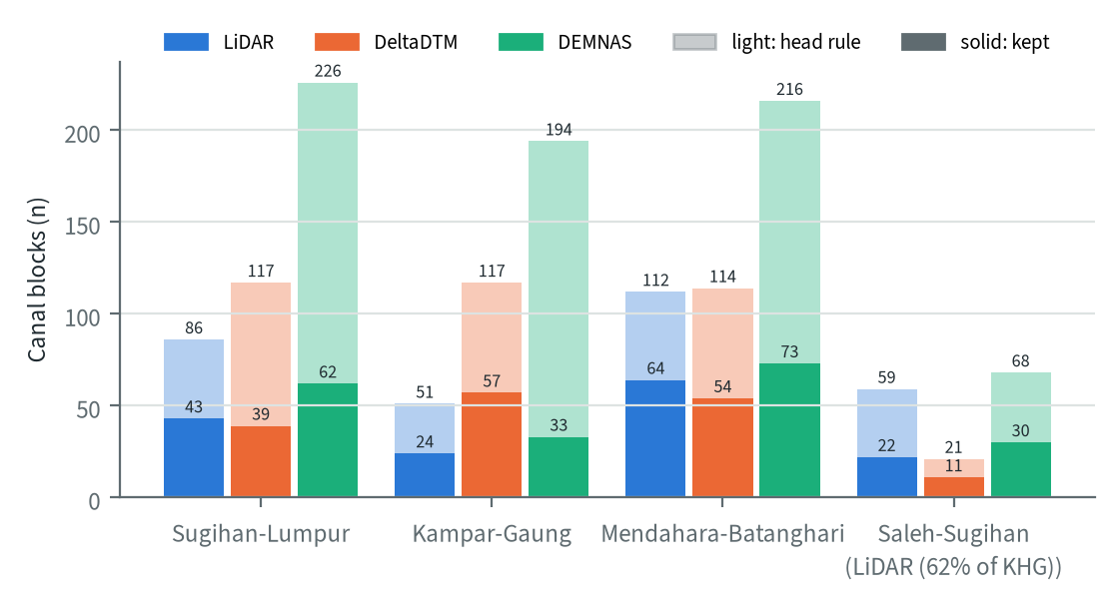
Figure 9.6. Head-rule and kept canal blocks by KHG and DTM

9.14 Limits
- Block placement depends on the DTM. A vertical error above 0.2 m makes the 0.40 m head rule noisy. The 0.3 m LiDAR error is an assumed value; the LiDAR delivery states none. The 4.97 m DEMNAS figure comes from a field comparison of DEMNAS itself, while these plans used the corrected surface, whose error at this KHG has not yet been measured.
- The canal-rise measure ignores flow and seepage. On flat, connected networks a few blocks take most of the rise.
- Specific yield 0.15, reach 600 m and the 1.0 m unblocked canal level set the volumes held, not the order of the blocks. The spread of held water toward burnt land is a fixed 600 m band, not modelled.
- Many canals at Sugihan-Lumpur have no clear slope and no river connection (302 unresolved on LiDAR). Their flow direction is estimated by the fallback rule and may be wrong.
- Pumping has not been applied to a real KHG. The pump values are engineering proposals.
- Budget prices are proposed unit prices from web sources, to be verified. Canal closure has no price, and the KLH cost standard was not available.
- The selected sub-KHG come from a ranking with default weights proposed for agreement with KLH and the World Bank. The treatment thresholds are proposed policy values.
- Block optimisation and the groundwater model (in development) depend on peat properties not measured at these KHG and were not used in the reported plans.

10 Results per KHG
This chapter follows each analysed KHG (Kesatuan Hidrologis Gambut, peat hydrological unit) through the whole analysis: terrain, sub-KHG units, water balance, priority and canal blocks. Fourteen KHG are covered: eleven of the 12 main KHG chosen with KLH, two reserve KHG (Pulau Tebing Tinggi and Sugihan-Lumpur) and the earlier test site Kampar-Gaung. Each is analysed once per elevation model that covers it: LiDAR where the analysis uses it, corrected DeltaDTM and corrected DEMNAS. Five KHG have all three models and nine have the two corrected open models, which makes 33 analyses. Every section shows the results side by side and closes with how far the choice of elevation model changes them. Chapters 4 to 9 describe the methods and the first four KHG; here the results are read KHG by KHG.
Ranks use default weights proposed for agreement with KLH and the World Bank and adjustable in the dashboard.

10.1 Data readiness and national rank
The KHG that rank highest nationally are not the ones with the best data. Deciding where to work first and judging where the toolkit's results are most reliable are therefore separate questions.
Table 10.1 brings together, for the 14 KHG, the national rank, the data each KHG has, and the elevation models on which the analysis is complete. Ranks are from the national profile, using default weights proposed for agreement with KLH and the World Bank and adjustable in the dashboard.
Table 10.1. The 14 analysed KHG (11 main, 2 reserve, 1 earlier test site): national rank and class (of 476 ranked KHG; default weights), peat area, LiDAR and modelled peat-depth coverage of the KHG, mapped canals, existing hydrological structures (BRGM), SiTMAT stations and the elevation models for which the full analysis is complete. Source: national profile, per-KHG data summary, DEM input register and analysis status of 30 October 2026
KHG | Province | National rank (class) | Peat (km²) | LiDAR cover (%) | Peat depth model cover (%) | Canals (km) | Existing structures | SiTMAT stations | Full chain
Pungurbesar - Kapuas | Kalimantan Barat | 1 (high) | 744 | none | 54 | 4,786 | 521 | 5 | DeltaDTM, DEMNAS
Kahayan - Sebangau | Kalimantan Tengah | 3 (high) | 3,955 | none | none | 9,573 | 1,333 | 1 | DeltaDTM, DEMNAS
Balangan - Batangalai | Kalimantan Selatan | 5 (high) | 137 | none | 53 | 1,379 | 112 | 0 | DeltaDTM, DEMNAS
Mempawah - Peniti | Kalimantan Barat | 22 (high) | 376 | none | 54 | 4,915 | 264 | 0 | DeltaDTM, DEMNAS
Saleh - Sugihan | Sumatera Selatan | 27 (high) | 1,607 | 62 | 69 | 3,648 | 192 | 0 | LiDAR, DeltaDTM, DEMNAS
Sugihan - Lumpur | Sumatera Selatan | 32 (high) | 5,424 | 100 | 75 | 14,231 | 2,972 | 54 | LiDAR, DeltaDTM, DEMNAS
Mendahara - Batanghari | Jambi | 71 (high) | 1,731 | 100 | 63 | 4,586 | 700 | 14 | LiDAR, DeltaDTM, DEMNAS
Pulau Bengkalis | Riau | 78 (high) | 893 | none | 73 | 1,865 | 205 | 2 | DeltaDTM, DEMNAS
Air Hitam Laut - Buntu Kecil | Jambi, Sumatera Selatan | 84 (high) | 1,432 | 100 | 96 | 873 | 238 | 9 | LiDAR, DeltaDTM, DEMNAS
Kapuas - Barito | Kalimantan Tengah | 92 (high) | 4,407 | none | none | 5,818 | 254 | 6 | DeltaDTM, DEMNAS
Buru Mappi - Buru Obaa | Papua | 143 (high) | 1,699 | none | none | 31 | 0 | 0 | DeltaDTM, DEMNAS
Kampar - Gaung | Riau | 179 (medium) | 6,863 | 100 | not in recap | 12,839 | 2,799 | 92 | LiDAR, DeltaDTM, DEMNAS
Pulau Padang | Riau | 192 (medium) | 1,102 | 100 | 81 | 1,168 | 292 | 3 | DeltaDTM, DEMNAS
Pulau Tebing Tinggi | Riau | 205 (medium) | 1,364 | none | 79 | 1,340 | 382 | 6 | DeltaDTM, DEMNAS

The KHG fall into two groups.
- Five KHG have the analysis on all three elevation models: Saleh-Sugihan, Sugihan-Lumpur, Mendahara-Batanghari, Air Hitam Laut-Buntu Kecil and the earlier test site Kampar-Gaung. All are in Sumatra and all have LiDAR, Saleh-Sugihan only for about 62 % of its area.
- Nine KHG are analysed on corrected DeltaDTM and DEMNAS only: Pungurbesar-Kapuas, Balangan-Batangalai, Kahayan-Sebangau, Mempawah-Peniti, Kapuas-Barito and Buru Mappi-Buru Obaa (Kalimantan and Papua, no LiDAR), and Pulau Bengkalis, Pulau Tebing Tinggi and Pulau Padang in Riau. Pulau Padang has a 2 m LiDAR over the whole KHG, which the analysis leaves out (chapter 3, section 3.7); Bengkalis and Tebing Tinggi have none.
The Kalimantan and Papua KHG rank high nationally (Pungurbesar-Kapuas first, Balangan-Batangalai fourth, Kahayan-Sebangau seventh), yet none has LiDAR, and Kahayan-Sebangau, Kapuas-Barito and Buru Mappi-Buru Obaa have no modelled peat depth. Their results rest on the corrected open elevation models, with the uncertainty that chapter 4 describes. Buru Mappi-Buru Obaa has 31 km of mapped canals, no structures and no stations; its national rank comes from hotspots. The KHG with the most data, Kampar-Gaung, with 92 stations and 2,799 structures, ranks 178th, while the top-ranked KHG have little terrain or water-table data.
The twelfth main KHG, Cawang-Lalang, is not yet analysed: its name does not match the official boundary file and is to be confirmed with KLH (chapter 2).

10.2 Pulau Padang (KHG 14.10.01)
Table 10.2. Pulau Padang: key facts. Source: national KHG profile, national canal and structures layers, RE-PEAT results for this KHG
Item | Value
Province | Riau
Area of the KHG polygon (km²) | 1,112
Peat area (km²) | 1,102
National rank (class) | 192 of 476 (medium priority)
Canals, primary / secondary / tertiary (km) | 121 / 188 / 859
Existing water-management structures, all types (n) | 292
SiTMAT water-table stations (n) | 3
Realised canal blocks inside the KHG (n) | 156
LiDAR cover of the KHG (%) | not used for this KHG
Elevation model ready, by elevation model | DeltaDTM, DEMNAS
Sub-KHG units, by elevation model | DeltaDTM, DEMNAS
Water balance, by elevation model | DeltaDTM, DEMNAS
Priority of sub-KHG, by elevation model | DeltaDTM, DEMNAS
Canal blocks and costs, by elevation model | DeltaDTM, DEMNAS
Dry-season deficit from stations | computed
Rank among ranked KHG with default weights, proposed for agreement with KLH and the World Bank. Canals: mapped canal network. Structures and realised canal blocks: national layer of existing water-management structures (all types, and the canal blocks recorded as realised).
Pulau Padang is a KHG (Kesatuan Hidrologis Gambut, peat hydrological unit) in Riau. It covers 1,112 km², of which 1,102 km² is peat, and ranks 194 of 476 ranked KHG nationally (medium priority) with the default weights proposed for agreement with KLH and the World Bank. Its burned share of peat is below 0.4 % a year and it stays between rank 171 and 269 under every weight preset (chapter 6). The mapped network has 121 km of primary, 188 km of secondary and 859 km of tertiary canals, and the national layer records 292 water-management structures, 156 of them realised canal blocks. Only 3 SiTMAT water-table stations lie inside the KHG. The 2 m LiDAR flown in 2016 is left out of the chain (chapter 4), so the KHG was analysed on corrected DeltaDTM and corrected DEMNAS, with no reference against which to measure their error. Every step has run on both models.

Terrain and the three elevation models
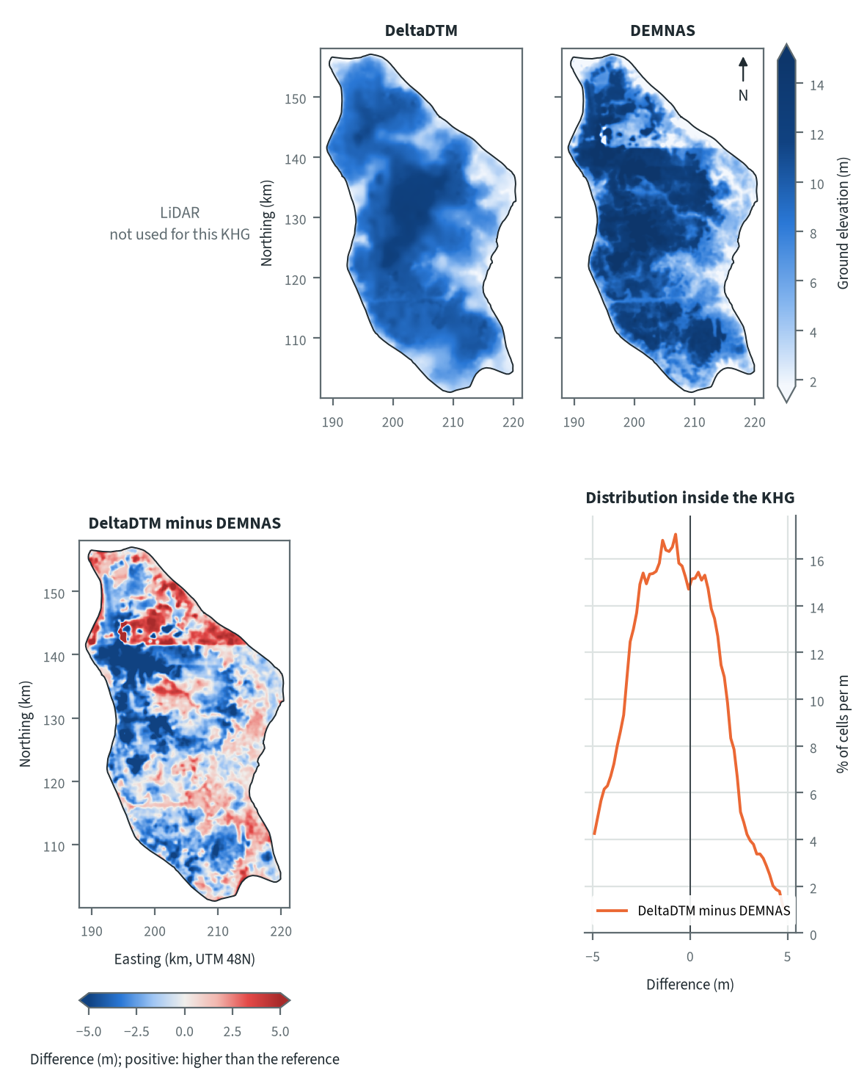
Figure 10.1. Pulau Padang: ground elevation from each elevation model on one colour scale, and their differences. Source: LiDAR terrain model, DeltaDTM and DEMNAS after the DEM correction
Both models show a raised centre with lower ground towards the eastern margin and the coast, and DeltaDTM draws it as a smooth surface. DEMNAS follows the same pattern but sits higher over most of the centre, west and south-east, and lower in a north-eastern strip; it is more than 2 m above DeltaDTM over 33 % of the KHG and more than 2 m below it over 11 %. A straight edge across the northern third, with a patchy block above it, looks like a tile boundary in DEMNAS rather than terrain. The likely causes are canopy and plantation cover left in the DEMNAS surface after the correction and its finer 8 m grid, which carries local noise that the 30 m DeltaDTM averages out.
Table 10.3. Pulau Padang: resolution, cover and relief of each elevation model, and its difference to LiDAR. Source: LiDAR terrain model, DeltaDTM and DEMNAS after the DEM correction
Elevation model | Source | Resolution (m) | Cover of the KHG (%) | Relief, 5th-95th percentile (m)
LiDAR | not used for this KHG
DeltaDTM | DeltaDTM v1.1 (global coastal terrain model), after the DEM correction | 30 | 99 | 2.7 to 11.7
DEMNAS | DEMNAS (BIG national surface model), after the DEM correction | 8 | 100 | 2.0 to 14.6
Statistics over the KHG polygon on a common 30 m grid (the DeltaDTM grid; finer models averaged onto it). NMAD: normalised median absolute deviation, a spread measure robust to outliers. Where LiDAR covers only part of the KHG, differences are over that part.
Relief between the 5th and 95th percentiles is 2.7 to 11.7 m on DeltaDTM (9.0 m) and 2.0 to 14.6 m on DEMNAS (12.6 m); both cover at least 99 % of the KHG. Without LiDAR no difference to a reference can be given, and the distribution of DeltaDTM minus DEMNAS has a 5th to 95th percentile of -5.0 to +3.1 m and a histogram peak at -0.75 m. A spread of that size is local error rather than a constant offset, so the slopes along canals will differ between the models. On the 2016 LiDAR of this KHG, smoothed DEMNAS had a height-difference error of 1.67 m over 1 km (chapter 4), well above the 0.3 m head drop between blocks.

Sub-KHG units
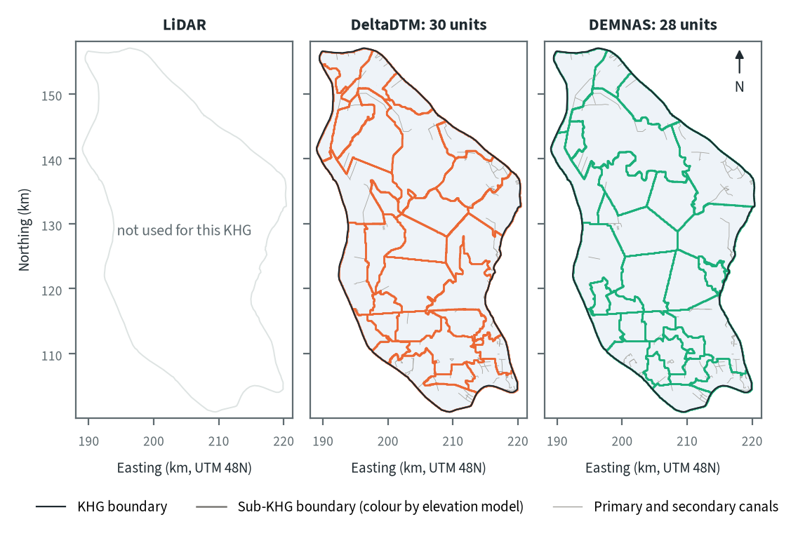
Figure 10.2. Pulau Padang: sub-KHG units delineated on each elevation model. Source: sub-KHG delineation on each elevation model, mapped canals
DeltaDTM gives 30 sub-KHG units and DEMNAS 28, with median areas of 31 and 27 km² and ranges of 12 to 100 and 12 to 144 km². Boundaries follow the mapped primary and secondary canals, which are sparse in the centre and north-east, so the large units there are set by terrain divides. Both models draw many small units in the canal-dense south and in the north-west, and DEMNAS produces the largest unit (144 km²), where its raised surface shifts the divides.
Table 10.4. Pulau Padang: number and size of sub-KHG units, and agreement between elevation models (area in the best-matching unit, adjusted Rand index). Source: sub-KHG delineation on each elevation model
Elevation model or pair | Units (n) | Unit area, median (km²) | Unit area, range (km²) | Units total (km²) | Overlap (km²) | Area in best-matching unit (%) | Adjusted Rand index
LiDAR | not used for this KHG
DeltaDTM | 30 | 31 | 12 to 100 | 1,112
DEMNAS | 28 | 27 | 12 to 144 | 1,112
DeltaDTM and DEMNAS |  |  |  |  | 1,112 | 66 | 0.46
Pairs are compared over the area both cover. Best-matching unit: share of the overlap that lies in the unit of the other model it overlaps most, averaged over both directions. Adjusted Rand index: 1 for identical partitions, about 0 for chance agreement; computed on 1 ha cells.
DeltaDTM and DEMNAS share 66 % of the area in best-matching units, with an adjusted Rand index of 0.46. This is lower than the 0.60 of the flat-surface test of chapter 5, which uses only the mapped canals, so at this KHG the terrain model changes the unit layout more than the canal network alone does. Only one pair of models exists here, so this is the pair that differs most.

Water balance and deficit
Table 10.5. Pulau Padang: dry-season deficit from water-table stations and climatic balance per sub-KHG. Source: SiTMAT water-table stations, CHIRPS rain, MOD16 and WaPOR evapotranspiration
Quantity | All models | LiDAR | DeltaDTM | DEMNAS
Dry-season deficit from 3 stations, 01 Jun to 15 Oct 2026 (mm) | 0 (0 to 0)
Deficit volume over the KHG (million m³) | 0
Months in deficit in that window (n) | 1
Sub-KHG units (n) |  | not used for this KHG | 30 | 28
Climatic balance, MOD16, area mean (mm/month) |  | not used for this KHG | 39.1 | 39.1
Climatic balance, unit range (mm/month) |  | not used for this KHG | 34.4 to 50.7 | 34.8 to 47.0
Climatic balance, WaPOR, area mean (mm/month) |  | not used for this KHG | 48.1 | 48.1
Deficit months per year, area mean |  | not used for this KHG | 3.17 | 3.15
Order of units usable (ET products agree) |  | not used for this KHG | no | no
The station deficit uses water-table stations and reanalysis rain and evaporation (band: specific yield 0.10 to 0.20) and does not depend on the elevation model. The climatic balance is CHIRPS rain minus evapotranspiration, 2018-2025, per sub-KHG of each model.
From 1 June to 15 October 2026, the 3 stations give a dry-season deficit of 0 mm (0 to 0 mm for a specific yield of 0.10 to 0.20), or 0 million m³ over the KHG, with 1 month in deficit in that window. Rain exceeded evapotranspiration over the period, so no supply from outside the rain balance shows in these stations, although 3 stations are a thin base. The order of units by climatic balance is not usable with either model: the two evapotranspiration products do not order the units alike, so the unit balances are left out of the ranking (chapter 8). The unit means run from 34.4 to 50.7 mm/month on DeltaDTM and 34.8 to 47.0 mm/month on DEMNAS, a narrow range that gives the test little to separate.
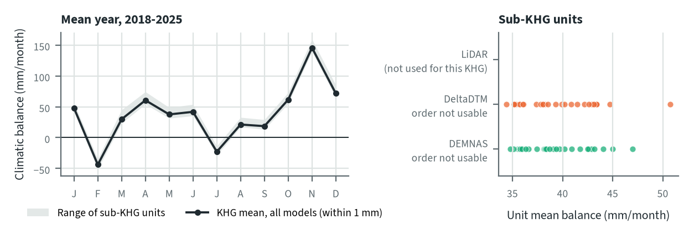
Figure 10.3. Pulau Padang: climatic balance through the mean year, and the balance of each sub-KHG, by elevation model. Source: CHIRPS rain and MOD16 evapotranspiration, 2018-2025
The mean climatic balance is negative in February (-44 mm/month) and July (-23 mm/month) and positive in every other month, with the largest surplus in November. February and July are the months with most deficit years in 2018-2025 at Pulau Padang (chapter 8). The KHG mean with MOD16 is 39.1 mm/month on both models (48.1 mm/month with WaPOR) and deficit months per year are 3.17 and 3.15, so the elevation model leaves the balance of the KHG unchanged and moves only the spread between units.

Priority of sub-KHG
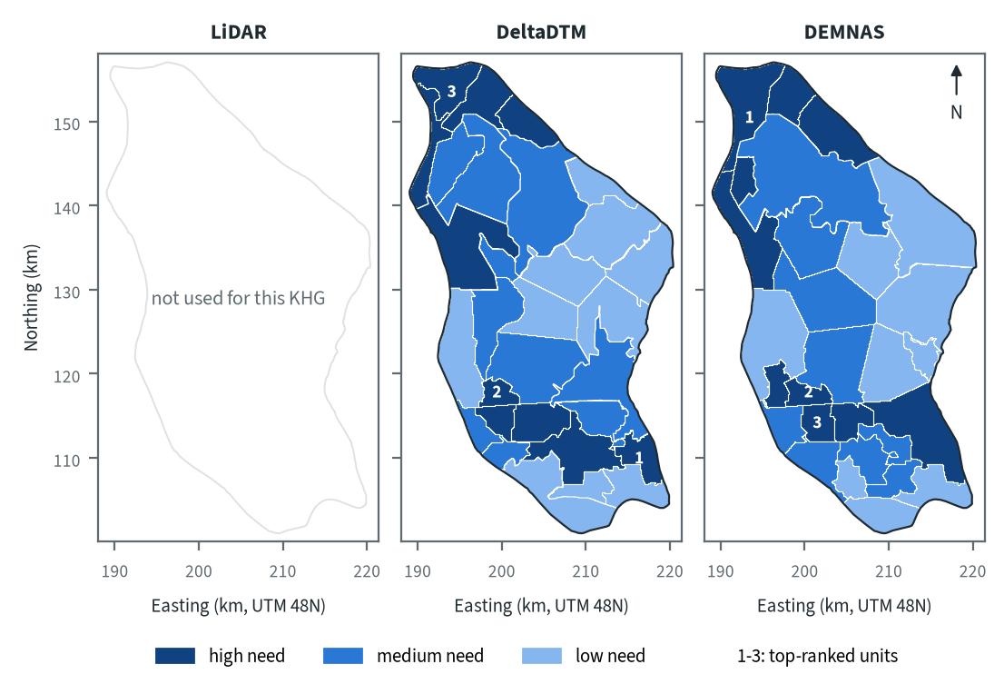
Figure 10.4. Pulau Padang: need for intervention per sub-KHG, by elevation model. Source: sub-KHG prioritisation with default weights
With the default weights proposed for agreement with KLH and the World Bank, high-need units lie in the north-west, the west and the south on both models, and the north-east and centre are low or medium need. The top-ranked unit differs: DeltaDTM puts it in the south-east and DEMNAS in the north-west, where DeltaDTM ranks a unit third. The need score combines vegetation dryness, fire, peat depth and, where usable, the water balance (chapter 7). Fire is limited on this KHG and the balance order is not usable, so the ranking rests on the remaining components.
Table 10.6. Pulau Padang: high-need area and agreement of the priority classes between elevation models. Source: sub-KHG prioritisation with default weights
Elevation model or pair | High need (units, km²) | Overlap (km²) | Same need class (% of overlap) | High need in first also high in second (%) | Spearman of scores, area-weighted
LiDAR | not used for this KHG
DeltaDTM | 10, 287
DEMNAS | 10, 291
DeltaDTM and DEMNAS |  | 1,112 | 71 | 72 | 0.72
Units are matched by location, since each model has its own units. Shares are of the area both models cover. Default weights, proposed for agreement with KLH and the World Bank.
High-need area is 287 km² (10 units) on DeltaDTM and 291 km² (10 units) on DEMNAS. 71 % of the area keeps its need class between the two models, 72 % of the high-need area in one is also high need in the other, and the area-weighted Spearman correlation of the scores is 0.72. The total hardly moves, but the units differ in shape, so the high-need area is similar while the unit that ranks first is not.

Canal blocks and pumping
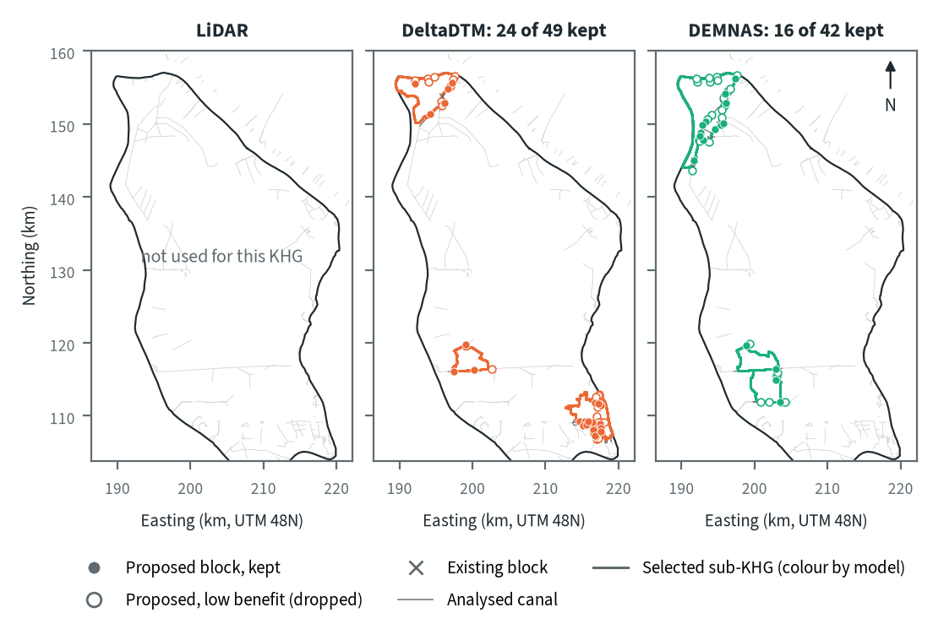
Figure 10.5. Pulau Padang: proposed canal blocks in the three highest-ranked sub-KHG, by elevation model. Source: RE-PEAT Interventions on each elevation model, mapped canals and existing blocks
In the three highest-ranked sub-KHG the sekat kanal (canal block) step proposes 49 blocks on DeltaDTM and 42 on DEMNAS, and keeps 24 and 16 for 90 % of the water-level rise; the other 25 and 26 add little and are dropped. Blocks go on canals in the north-west and in the south, where the surface falls along the canal. The selected units differ (S27, S20 and S01 on DeltaDTM; S02, S17 and S18 on DEMNAS), so the two plans cover the same general areas but not the same canals. Existing blocks on the analysed canals number 3 on DeltaDTM and 11 on DEMNAS, out of 156 in the KHG.
Table 10.7. Pulau Padang: canal blocks, water held and budget, by elevation model. Source: RE-PEAT Interventions and sub-KHG prioritisation on each elevation model
Quantity | LiDAR | DeltaDTM | DEMNAS
Selected sub-KHG (top 3 by priority) | not used for this KHG | S27, S20, S01 | S02, S17, S18
Blocks needed by the slope rule of the ranking, whole KHG (n) | not used for this KHG | 992 | 2,355
Existing blocks counted by the ranking, whole KHG (n) | not used for this KHG | 156 | 156
Existing blocks on analysed canals (n) | not used for this KHG | 3 | 11
Blocks proposed by the head rule (n) | not used for this KHG | 49 | 42
Blocks kept, 90% of the water-level rise (n) | not used for this KHG | 24 | 16
Pump units (n) | not used for this KHG | pumping not assessed | pumping not assessed
Water held by kept blocks (million m³) | not used for this KHG | 0.43 | 0.64
Deficit of the selected units (million m³) | not used for this KHG | 0.0 | 0.0
Budget, low / central / high (billion Rp) | not used for this KHG | 2 / 3 / 3 | 7 / 11 / 11
of which revegetation of burned land, central (billion Rp) | not used for this KHG | - | -
Blocks, water and budget are for the three highest-ranked sub-KHG of each model, which can differ between models. Kept: the fewest proposed blocks giving 90% of the water-level rise of all proposed blocks. Pumping is not assessed in these results. Default weights, proposed for agreement with KLH and the World Bank.
The kept blocks hold 0.43 million m³ on DeltaDTM and 0.64 on DEMNAS. The deficit of the selected units is 0 million m³ on both, so the water held cannot be set against a deficit. The central budget is 3 billion Rp on DeltaDTM (low 2, high 3) and 11 billion Rp on DEMNAS (low 7, high 11), and neither plan includes revegetation of burned land. The budget is 3.8 times higher on DEMNAS while it keeps fewer blocks (16 against 24), so the cost follows the canals and units selected and hardly the block count. Pumping was not assessed in this analysis.

How the elevation model changes the result
Table 10.8. Pulau Padang: headline outputs by elevation model and their spread. Source: RE-PEAT results on each elevation model
Output | LiDAR | DeltaDTM | DEMNAS | Spread
Sub-KHG units (n) | not used for this KHG | 30 | 28 | ×1.1
Median unit area (km²) | not used for this KHG | 31 | 27 | ×1.2
Area covered by units (km²) | not used for this KHG | 1,114 | 1,114 | ×1.0
Climatic balance, area mean (mm/month) | not used for this KHG | 39.1 | 39.1 | range 0.0
High-need area (km²) | not used for this KHG | 287 | 291 | ×1.0
High-need units (n) | not used for this KHG | 10 | 10 | ×1.0
Blocks needed, slope rule of the ranking, whole KHG (n) | not used for this KHG | 992 | 2,355 | ×2.4
Blocks proposed, head rule (n) | not used for this KHG | 49 | 42 | ×1.2
Blocks kept (n) | not used for this KHG | 24 | 16 | ×1.5
Water held by kept blocks (million m³) | not used for this KHG | 0.43 | 0.64 | ×1.5
Budget, central (billion Rp) | not used for this KHG | 3 | 11 | ×3.8
Spread: largest value over smallest across the models (range for the balance). Blocks kept, water and budget refer to the three highest-ranked sub-KHG of each model, so they move with the choice of units as well as with the terrain. Default weights, proposed for agreement with KLH and the World Bank.
The balance does not move (39.1 mm/month on both models), and the number of units, the high-need area and the number of high-need units change by a factor of 1.1 or less. Outputs that depend on canal slopes move more: blocks needed by the slope rule of the ranking over the whole KHG are 992 on DeltaDTM and 2,355 on DEMNAS (x2.4), blocks kept and water held x1.5, and the central budget x3.8, partly because the selected units change. There is no LiDAR to check either model. Chapter 4 measured the processed DeltaDTM error at 0.47 to 0.64 m over 1 km at two KHG and processed DEMNAS at 1.66 m over 1 km at Mendahara, so block counts here should be read as a range between the two models, the DeltaDTM count being the nearer to a measured error.
For decisions at Pulau Padang DeltaDTM is the model to use, with canal levels and block crests set by levelling in the field before any design.

Summary for this KHG
Pulau Padang is a medium-priority KHG with little fire history. The 3 stations show no dry-season deficit from 1 June to 15 October 2026, although the climatic balance is negative in February and July. On DeltaDTM, the model to use, the plan keeps 24 canal blocks in the three highest-ranked sub-KHG, holding 0.43 million m³ at a central budget of 3 billion Rp, while DEMNAS gives 16 kept blocks and 11 billion Rp. The choice of model changes the selected sub-KHG, so blocks, water and budget move with the units as well as the terrain, while the KHG balance stays the same. Missing are a LiDAR reference for the two models, enough stations to test the order of units, and any pumping assessment.

10.3 Pulau Bengkalis (KHG 14.03.02)
Table 10.9. Pulau Bengkalis: key facts. Source: national KHG profile, national canal and structures layers, RE-PEAT results for this KHG
Item | Value
Province | Riau
Area of the KHG polygon (km²) | 906
Peat area (km²) | 893
National rank (class) | 78 of 476 (high priority)
Canals, primary / secondary / tertiary (km) | 242 / 342 / 1,281
Existing water-management structures, all types (n) | 205
SiTMAT water-table stations (n) | 2
Realised canal blocks inside the KHG (n) | 46
LiDAR cover of the KHG (%) | no LiDAR covers this KHG
Elevation model ready, by elevation model | DeltaDTM, DEMNAS
Sub-KHG units, by elevation model | DeltaDTM, DEMNAS
Water balance, by elevation model | DeltaDTM, DEMNAS
Priority of sub-KHG, by elevation model | DeltaDTM, DEMNAS
Canal blocks and costs, by elevation model | DeltaDTM, DEMNAS
Dry-season deficit from stations | computed
Rank among ranked KHG with default weights, proposed for agreement with KLH and the World Bank. Canals: mapped canal network. Structures and realised canal blocks: national layer of existing water-management structures (all types, and the canal blocks recorded as realised).
Pulau Bengkalis is a KHG (Kesatuan Hidrologis Gambut, peat hydrological unit) in Riau that covers the island of Bengkalis. It covers 906 km², of which 893 km² is peat, and ranks 69 of 476 ranked KHG nationally (high priority) with the default weights proposed for agreement with KLH and the World Bank. This year's fire record stands out: 6.0 % of its peat has burned in the part of 2026 covered so far, more than in any full year since 2015, and 389 of its 674 hotspots on peat fell in February (chapter 6). The mapped network has 242 km of primary, 342 km of secondary and 1,281 km of tertiary canals, about 2.1 km of canal per km² (the three classes added and divided by the area), and the national layer records 205 water-management structures, 46 of them realised canal blocks. No LiDAR covers this KHG and only 2 SiTMAT water-table stations lie inside it. The chain therefore ran on corrected DeltaDTM and corrected DEMNAS only, with no reference to measure their error against. Chapter 4 gives that error at the two LiDAR KHG, 0.47 to 0.64 m over 1 km for DeltaDTM and 1.66 to 2.49 m for processed DEMNAS, so block counts below should be read as a range between the two models.

Terrain and the three elevation models
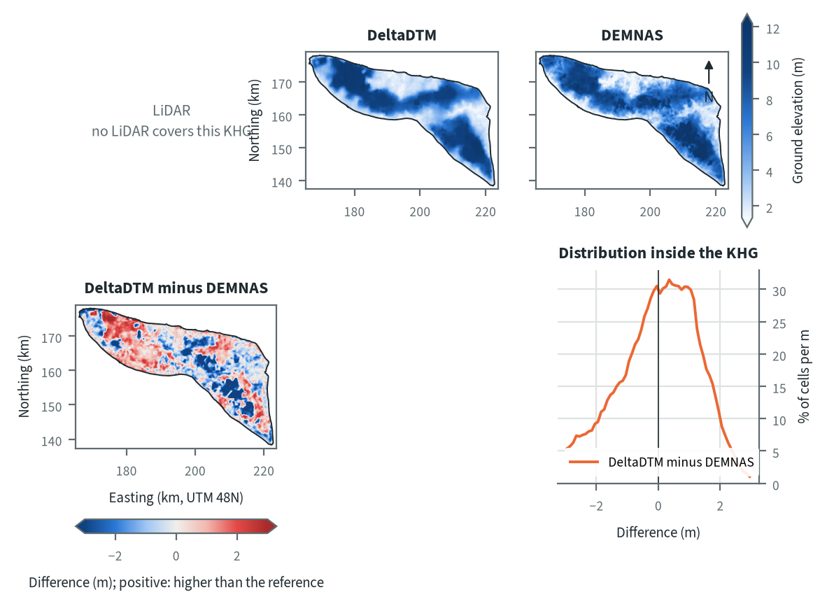
Figure 10.6. Pulau Bengkalis: ground elevation from each elevation model on one colour scale, and their differences. Source: LiDAR terrain model, DeltaDTM and DEMNAS after the DEM correction
Both models show an elongated island running north-west to south-east, with a low band of ground across the centre and higher ground in the north-west and in the south-eastern lobe. These higher areas are the peat domes. The two models agree on this pattern and differ in detail. The difference map shows blocky patches several metres deep in the centre and the south-east, with the opposite sign in much of the north-west, and such patches follow land cover more than terrain. The ICESat-2 test of chapter 4 found DEMNAS 2.16 m above the ground at Bengkalis, with 0.21 of the canopy height left in the surface under tree cover, so canopy left in DEMNAS is the likely cause of the largest patches.
Table 10.10. Pulau Bengkalis: resolution, cover and relief of each elevation model, and its difference to LiDAR. Source: LiDAR terrain model, DeltaDTM and DEMNAS after the DEM correction
Elevation model | Source | Resolution (m) | Cover of the KHG (%) | Relief, 5th-95th percentile (m)
LiDAR | no LiDAR covers this KHG
DeltaDTM | DeltaDTM v1.1 (global coastal terrain model), after the DEM correction | 30 | 99 | 1.8 to 11.0
DEMNAS | DEMNAS (BIG national surface model), after the DEM correction | 8 | 100 | 1.5 to 11.6
Statistics over the KHG polygon on a common 30 m grid (the DeltaDTM grid; finer models averaged onto it). NMAD: normalised median absolute deviation, a spread measure robust to outliers. Where LiDAR covers only part of the KHG, differences are over that part.
Relief between the 5th and 95th percentiles is 1.8 to 11.0 m on DeltaDTM (30 m cells, 99 % cover) and 1.5 to 11.6 m on DEMNAS (8 m cells, 100 % cover), so the two agree on the overall range. Without LiDAR the table has no difference to a reference. The difference between the two models in the figure has a median of 0.05 m (DeltaDTM minus DEMNAS), with 83 % of the cells within 2 m, so it is local error more than a single datum offset. DeltaDTM is defined only for land below 10 m above mean sea level and its 95th percentile of 11.0 m lies above that, so part of the highest dome ground falls outside its scope (chapter 4). The slopes used by the later steps therefore carry the local error of each model, which chapter 4 measured at 0.47 to 0.64 m over 1 km for DeltaDTM and 1.66 to 2.49 m for processed DEMNAS.

Sub-KHG units
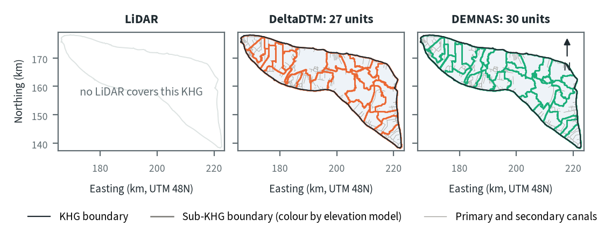
Figure 10.7. Pulau Bengkalis: sub-KHG units delineated on each elevation model. Source: sub-KHG delineation on each elevation model, mapped canals
DeltaDTM gives 27 sub-KHG units and DEMNAS 30, with median areas of 29 and 26 km². Both sets cover the whole 906 km², and the maps show boundaries running along the primary and secondary canals, which are dense across the island. The largest DeltaDTM unit is 105 km² and the largest DEMNAS unit 64 km². The two sets differ most in the north-west and in the central band, where the DEMNAS surface gives more divides and so more and smaller units.
Table 10.11. Pulau Bengkalis: number and size of sub-KHG units, and agreement between elevation models (area in the best-matching unit, adjusted Rand index). Source: sub-KHG delineation on each elevation model
Elevation model or pair | Units (n) | Unit area, median (km²) | Unit area, range (km²) | Units total (km²) | Overlap (km²) | Area in best-matching unit (%) | Adjusted Rand index
LiDAR | no LiDAR covers this KHG
DeltaDTM | 27 | 29 | 16 to 105 | 906
DEMNAS | 30 | 26 | 16 to 64 | 906
DeltaDTM and DEMNAS |  |  |  |  | 906 | 77 | 0.61
Pairs are compared over the area both cover. Best-matching unit: share of the overlap that lies in the unit of the other model it overlaps most, averaged over both directions. Adjusted Rand index: 1 for identical partitions, about 0 for chance agreement; computed on 1 ha cells.
DeltaDTM and DEMNAS share 77 % of the area in best-matching units, with an adjusted Rand index of 0.61. This is close to the 0.601 that the stability test of chapter 5 found for a flat surface with only the mapped canals, so at this KHG the canal network sets most of the unit layout. Only this one pair can be compared, because no LiDAR units exist.

Water balance and deficit
Table 10.12. Pulau Bengkalis: dry-season deficit from water-table stations and climatic balance per sub-KHG. Source: SiTMAT water-table stations, CHIRPS rain, MOD16 and WaPOR evapotranspiration
Quantity | All models | LiDAR | DeltaDTM | DEMNAS
Dry-season deficit from 2 stations, 01 Jun to 15 Oct 2026 (mm) | 0 (0 to 0)
Deficit volume over the KHG (million m³) | 0
Months in deficit in that window (n) | 1
Sub-KHG units (n) |  | no LiDAR covers this KHG | 27 | 30
Climatic balance, MOD16, area mean (mm/month) |  | no LiDAR covers this KHG | 27.8 | 27.9
Climatic balance, unit range (mm/month) |  | no LiDAR covers this KHG | 17.0 to 45.4 | 19.7 to 47.5
Climatic balance, WaPOR, area mean (mm/month) |  | no LiDAR covers this KHG | 54.5 | 54.5
Deficit months per year, area mean |  | no LiDAR covers this KHG | 3.50 | 3.52
Order of units usable (ET products agree) |  | no LiDAR covers this KHG | no | no
The station deficit uses water-table stations and reanalysis rain and evaporation (band: specific yield 0.10 to 0.20) and does not depend on the elevation model. The climatic balance is CHIRPS rain minus evapotranspiration, 2018-2025, per sub-KHG of each model.
From 1 June to 15 October 2026, 2 stations give a dry-season deficit of 0 mm (0 to 0 mm for a specific yield of 0.10 to 0.20), or 0 million m³ over the KHG, with 1 month in deficit in that window. Rain exceeded evapotranspiration over the window as a whole, so the stations show no water supplied from outside the rain balance, although two stations are few for a KHG of 906 km². The order of units by climatic balance is not usable on either model, because the two evapotranspiration products do not order the units alike, so the balance of single units cannot be used for ranking. The mean balance is 27.8 mm/month on DeltaDTM units and 27.9 mm/month on DEMNAS units, with unit means from 17.0 to 45.4 and from 19.7 to 47.5 mm/month. The WaPOR balance is 54.5 mm/month on both.
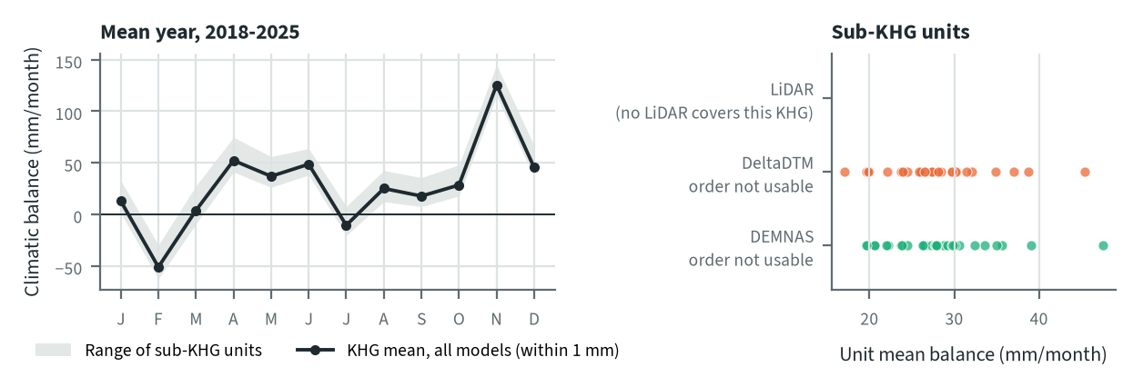
Figure 10.8. Pulau Bengkalis: climatic balance through the mean year, and the balance of each sub-KHG, by elevation model. Source: CHIRPS rain and MOD16 evapotranspiration, 2018-2025
In the mean year of 2018 to 2025 the balance is negative in February (-51 mm/month) and slightly negative in July (-11 mm/month), and highest in November (125 mm/month). Individual years have 3.50 to 3.52 deficit months on average, so the mean year understates how often a month falls short. The elevation model does not change the KHG balance (27.8 against 27.9 mm/month, a range of 0.1). It changes only the spread between units, because each unit set averages the same rain and evapotranspiration grids over different areas.

Priority of sub-KHG
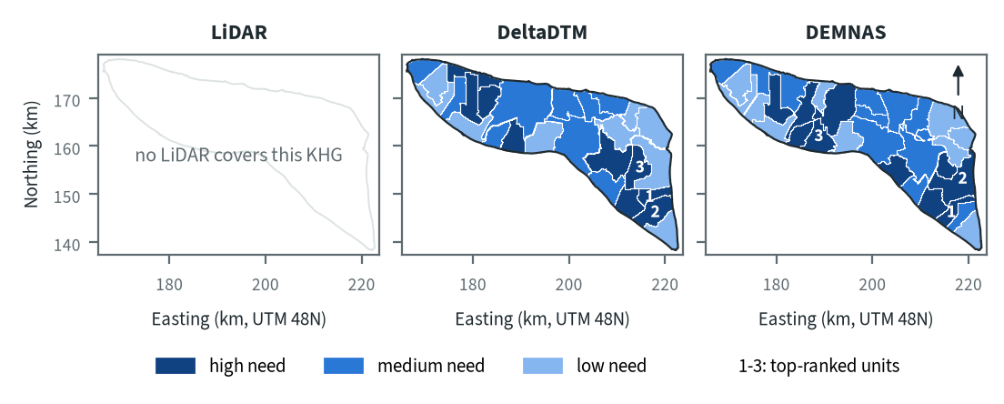
Figure 10.9. Pulau Bengkalis: need for intervention per sub-KHG, by elevation model. Source: sub-KHG prioritisation with default weights
With the default weights proposed for agreement with KLH and the World Bank, the top-ranked unit lies in the south-east on both models, and so does the second. The third is in the south-east on DeltaDTM and in the north-west on DEMNAS, and high-need units also appear in the north-west on both. The balance of units could not enter the need score because its order failed the test on both models, so the scores rest on the other indicators of chapter 7, among them fire, vegetation dryness and canals.
Table 10.13. Pulau Bengkalis: high-need area and agreement of the priority classes between elevation models. Source: sub-KHG prioritisation with default weights
Elevation model or pair | High need (units, km²) | Overlap (km²) | Same need class (% of overlap) | High need in first also high in second (%) | Spearman of scores, area-weighted
LiDAR | no LiDAR covers this KHG
DeltaDTM | 9, 260
DEMNAS | 10, 308
DeltaDTM and DEMNAS |  | 906 | 63 | 58 | 0.71
Units are matched by location, since each model has its own units. Shares are of the area both models cover. Default weights, proposed for agreement with KLH and the World Bank.
High-need area is 260 km² (9 units) on DeltaDTM and 308 km² (10 units) on DEMNAS. Between the two models 63 % of the area keeps its need class, 58 % of the high-need area on DeltaDTM is also high need on DEMNAS, and the area-weighted Spearman correlation of the scores is 0.71. The difference comes from the units: DEMNAS draws three more and smaller units, and a unit that straddles burned and unburned land can change class when its boundary moves.

Canal blocks and pumping
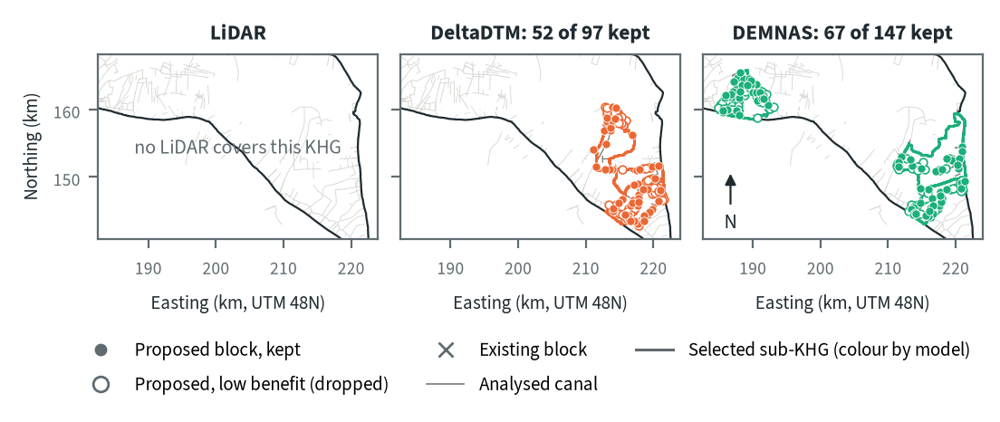
Figure 10.10. Pulau Bengkalis: proposed canal blocks in the three highest-ranked sub-KHG, by elevation model. Source: RE-PEAT Interventions on each elevation model, mapped canals and existing blocks
In the three highest-ranked sub-KHG the sekat kanal (canal block) step proposes 97 blocks on DeltaDTM and 147 on DEMNAS, and keeps 52 and 67 for 90 % of the water-level rise; the other 45 and 80 add little and are dropped. The selected units are S24, S26 and S22 on DeltaDTM and S28, S25 and S17 on DEMNAS. On DeltaDTM the blocks lie only in the south-east, while DEMNAS puts a north-west unit in its selection as well, so block positions change with the units selected as well as with the terrain. None of the 46 existing blocks lies on the analysed canals, so every proposed block is new.
Table 10.14. Pulau Bengkalis: canal blocks, water held and budget, by elevation model. Source: RE-PEAT Interventions and sub-KHG prioritisation on each elevation model
Quantity | LiDAR | DeltaDTM | DEMNAS
Selected sub-KHG (top 3 by priority) | no LiDAR covers this KHG | S24, S26, S22 | S28, S25, S17
Blocks needed by the slope rule of the ranking, whole KHG (n) | no LiDAR covers this KHG | 2,291 | 3,732
Existing blocks counted by the ranking, whole KHG (n) | no LiDAR covers this KHG | 46 | 46
Existing blocks on analysed canals (n) | no LiDAR covers this KHG | 0 | 0
Blocks proposed by the head rule (n) | no LiDAR covers this KHG | 97 | 147
Blocks kept, 90% of the water-level rise (n) | no LiDAR covers this KHG | 52 | 67
Pump units (n) | no LiDAR covers this KHG | pumping not assessed | pumping not assessed
Water held by kept blocks (million m³) | no LiDAR covers this KHG | 1.17 | 2.32
Deficit of the selected units (million m³) | no LiDAR covers this KHG | 0.0 | 0.0
Budget, low / central / high (billion Rp) | no LiDAR covers this KHG | 14 / 21 / 21 | 20 / 30 / 30
of which revegetation of burned land, central (billion Rp) | no LiDAR covers this KHG | 0 | 0
Blocks, water and budget are for the three highest-ranked sub-KHG of each model, which can differ between models. Kept: the fewest proposed blocks giving 90% of the water-level rise of all proposed blocks. Pumping is not assessed in these results. Default weights, proposed for agreement with KLH and the World Bank.
The kept blocks hold 1.17 million m³ on DeltaDTM and 2.32 million m³ on DEMNAS. The deficit of the selected units is 0 million m³ on both, so the held water cannot be set against a deficit; this follows from the station deficit of 0 mm. The central budget is 21 billion Rp on DeltaDTM (14 low) and 30 billion Rp on DEMNAS (20 low). Revegetation of burned land contributes 0 to both, so the budget is made of the other items of the cost model (chapter 9) and follows the number of blocks kept, 52 against 67. Pumping was not assessed in this analysis.

How the elevation model changes the result
Table 10.15. Pulau Bengkalis: headline outputs by elevation model and their spread. Source: RE-PEAT results on each elevation model
Output | LiDAR | DeltaDTM | DEMNAS | Spread
Sub-KHG units (n) | no LiDAR covers this KHG | 27 | 30 | ×1.1
Median unit area (km²) | no LiDAR covers this KHG | 29 | 26 | ×1.1
Area covered by units (km²) | no LiDAR covers this KHG | 908 | 908 | ×1.0
Climatic balance, area mean (mm/month) | no LiDAR covers this KHG | 27.8 | 27.9 | range 0.1
High-need area (km²) | no LiDAR covers this KHG | 260 | 308 | ×1.2
High-need units (n) | no LiDAR covers this KHG | 9 | 10 | ×1.1
Blocks needed, slope rule of the ranking, whole KHG (n) | no LiDAR covers this KHG | 2,291 | 3,732 | ×1.6
Blocks proposed, head rule (n) | no LiDAR covers this KHG | 97 | 147 | ×1.5
Blocks kept (n) | no LiDAR covers this KHG | 52 | 67 | ×1.3
Water held by kept blocks (million m³) | no LiDAR covers this KHG | 1.17 | 2.32 | ×2.0
Budget, central (billion Rp) | no LiDAR covers this KHG | 21 | 30 | ×1.4
Spread: largest value over smallest across the models (range for the balance). Blocks kept, water and budget refer to the three highest-ranked sub-KHG of each model, so they move with the choice of units as well as with the terrain. Default weights, proposed for agreement with KLH and the World Bank.
The KHG balance barely moves (27.8 against 27.9 mm/month), and the number of units, the median unit area and the high-need area change by a factor of 1.2 or less. Block outputs move more. Blocks needed by the slope rule of the ranking over the whole KHG are 2,291 on DeltaDTM and 3,732 on DEMNAS (×1.6), blocks proposed by the head rule move by ×1.5, blocks kept by ×1.3, the central budget by ×1.4 and water held by ×2.0. Water held and budget refer to the three selected units, which differ between the models, so they move with the choice of units as well as with the terrain.
With no LiDAR, neither model can be called correct here. DeltaDTM is the one to use for decisions, because the benchmark measured the smaller error for it (chapter 4) and its counts form the lower end of the range, with DEMNAS giving the upper end. Chapter 9 concludes that DEMNAS block counts should not be taken as a design.

Summary for this KHG
Pulau Bengkalis is a densely drained KHG with a high burned share of peat in 2026, yet its two stations show no dry-season deficit from 1 June to 15 October, so the data do not show water being supplied from outside the rain balance. On DeltaDTM, the model to use here, the plan keeps 52 canal blocks in the three highest-ranked sub-KHG, holding 1.17 million m³, for a central budget of 21 billion Rp. DEMNAS gives 67 blocks, 2.32 million m³ and 30 billion Rp, so with no LiDAR reference the result is a range of 52 to 67 blocks and 21 to 30 billion Rp. The KHG balance and the high-need area change little with the model, while the selected units and the blocks change with it. Pumping was not assessed, the order of units by balance is not usable on either model, and only 2 water-table stations exist, so heights of canals and blocks need to be surveyed before any design.

10.4 Saleh-Sugihan (KHG 16.02-07.01)
Table 10.16. Saleh-Sugihan: key facts. Source: national KHG profile, national canal and structures layers, RE-PEAT results for this KHG
Item | Value
Province | Sumatera Selatan
Area of the KHG polygon (km²) | 1,898
Peat area (km²) | 1,607
National rank (class) | 27 of 476 (high priority)
Canals, primary / secondary / tertiary (km) | 321 / 1,156 / 2,171
Existing water-management structures, all types (n) | 192
SiTMAT water-table stations (n) | 0
Realised canal blocks inside the KHG (n) | 25
LiDAR cover of the KHG (%) | 62
Elevation model ready, by elevation model | LiDAR, DeltaDTM, DEMNAS
Sub-KHG units, by elevation model | LiDAR, DeltaDTM, DEMNAS
Water balance, by elevation model | LiDAR, DeltaDTM, DEMNAS
Priority of sub-KHG, by elevation model | LiDAR, DeltaDTM, DEMNAS
Canal blocks and costs, by elevation model | LiDAR, DeltaDTM, DEMNAS
Dry-season deficit from stations | not computed
Rank among ranked KHG with default weights, proposed for agreement with KLH and the World Bank. Canals: mapped canal network. Structures and realised canal blocks: national layer of existing water-management structures (all types, and the canal blocks recorded as realised).
Saleh-Sugihan is a KHG (Kesatuan Hidrologis Gambut, peat hydrological unit) of 1,898 km² in Sumatera Selatan, of which 1,607 km² is peat. It ranks 30th of 476 KHG nationally, in the high-priority class, with default weights proposed for agreement with KLH and the World Bank. The rank comes from fire history: the 2015 fires burned 42.6 % of its peat, and it burned again in 2019 (28.3 %) and 2023 (11.9 %), which puts it at the 99th percentile for burned share and repeat burns (chapter 6). On fire history alone it would rise to 23rd; on this year's hotspots alone it falls to 151st.
The KHG is heavily drained, with 321 km of primary, 1,156 km of secondary and 2,171 km of tertiary canals. The national layer records 192 water-management structures, 25 of them realised canal blocks. No SiTMAT water-table station lies inside the KHG. LiDAR covers about 62 % of the area, the southern part, so the LiDAR results describe only that part. The full chain has run on all three elevation models: LiDAR, DeltaDTM and DEMNAS.

Terrain and the three elevation models
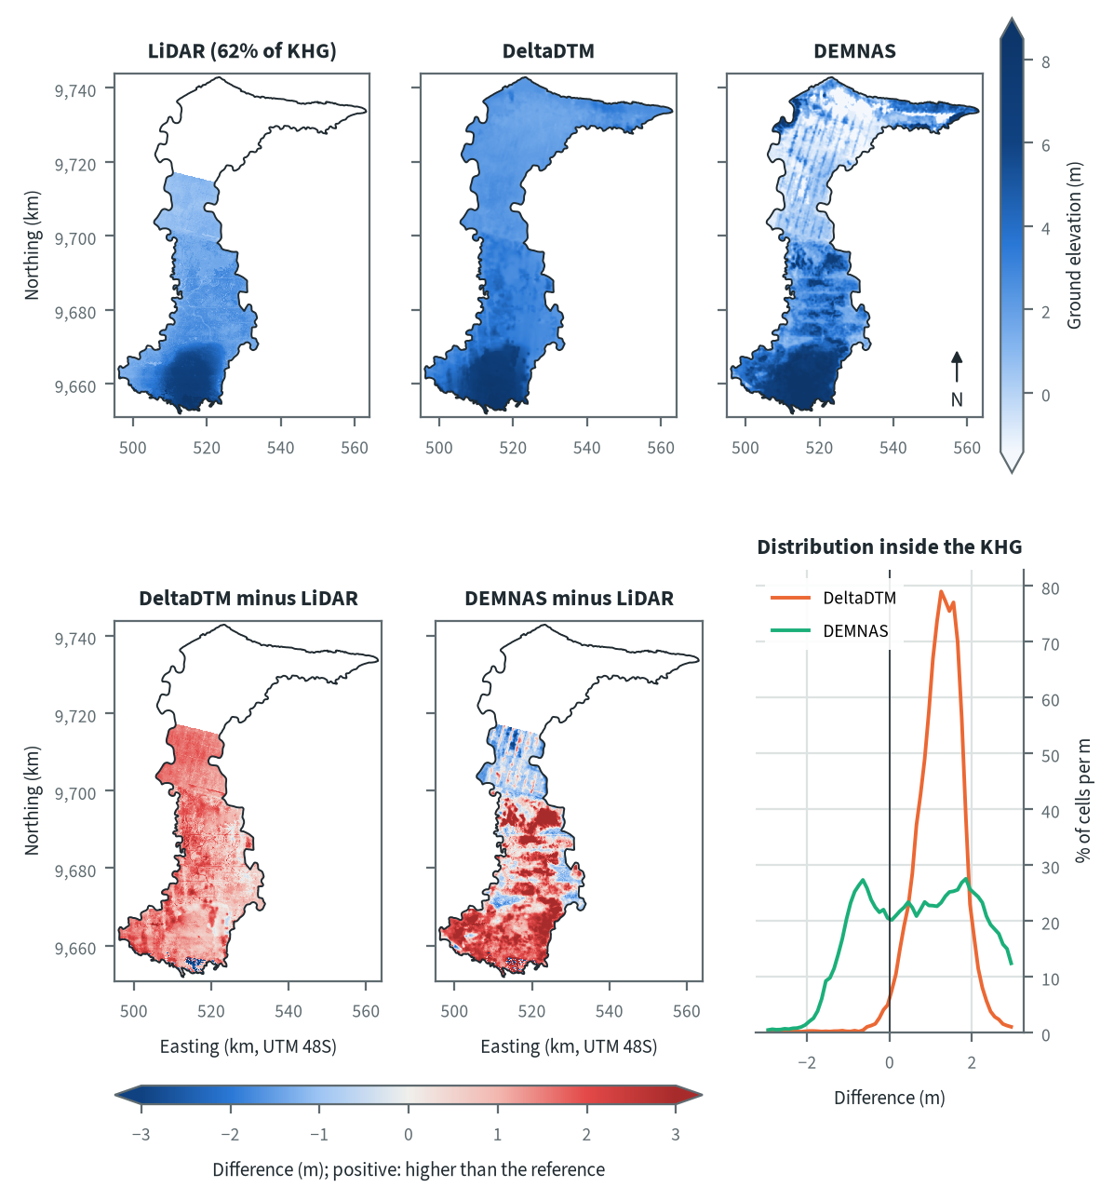
Figure 10.11. Saleh-Sugihan: ground elevation from each elevation model on one colour scale, and their differences. Source: LiDAR terrain model, DeltaDTM and DEMNAS after the DEM correction
The land rises from the low coastal plain in the north to a peat dome in the south, where all three models show the highest ground. DeltaDTM sits above LiDAR almost everywhere, by a fairly even amount. DEMNAS behaves differently in the two halves of the LiDAR area. In the northern part, where the canal grid is dense, DEMNAS lies below LiDAR and shows diagonal stripes that do not follow the land, which points to an artefact of the national surface model. Over the southern dome it lies above LiDAR in patches, and over the LiDAR area as a whole it is more than 2 m above LiDAR in 27 % of the cells and more than 2 m below in 1 %, the pattern expected where tree canopy is left in a surface model.
Table 10.17. Saleh-Sugihan: resolution, cover and relief of each elevation model, and its difference to LiDAR. Source: LiDAR terrain model, DeltaDTM and DEMNAS after the DEM correction
Elevation model | Source | Resolution (m) | Cover of the KHG (%) | Relief, 5th-95th percentile (m) | Difference to LiDAR, median (m) | Difference to LiDAR, NMAD (m)
LiDAR | Airborne LiDAR terrain model (KLHK), as delivered | 20 | 62 | 0.6 to 6.7
DeltaDTM | DeltaDTM v1.1 (global coastal terrain model), after the DEM correction | 30 | 99 | 2.2 to 7.7 | 1.26 | 0.56
DEMNAS | DEMNAS (BIG national surface model), after the DEM correction | 8 | 100 | -0.3 to 8.6 | 0.96 | 1.77
Statistics over the KHG polygon on a common 20 m grid (the LiDAR grid; finer models averaged onto it). NMAD: normalised median absolute deviation, a spread measure robust to outliers. Where LiDAR covers only part of the KHG, differences are over that part.
Within the 5th to 95th percentiles, LiDAR spans 0.6 to 6.7 m over its 62 % of the KHG, DeltaDTM 2.2 to 7.7 m and DEMNAS -0.3 to 8.6 m over the whole KHG. DeltaDTM lies a median 1.26 m above LiDAR with a spread (NMAD) of 0.56 m. This is mostly an offset, as at the other four KHG with LiDAR, and an offset does not change slopes. DEMNAS has a smaller median difference, 0.96 m, but a spread of 1.77 m, about three times that of DeltaDTM, and its differences fall into two groups, one below and one above LiDAR. This local error goes straight into the canal slopes that set block spacing, so DEMNAS slopes at this KHG are the least reliable of the three.

Sub-KHG units
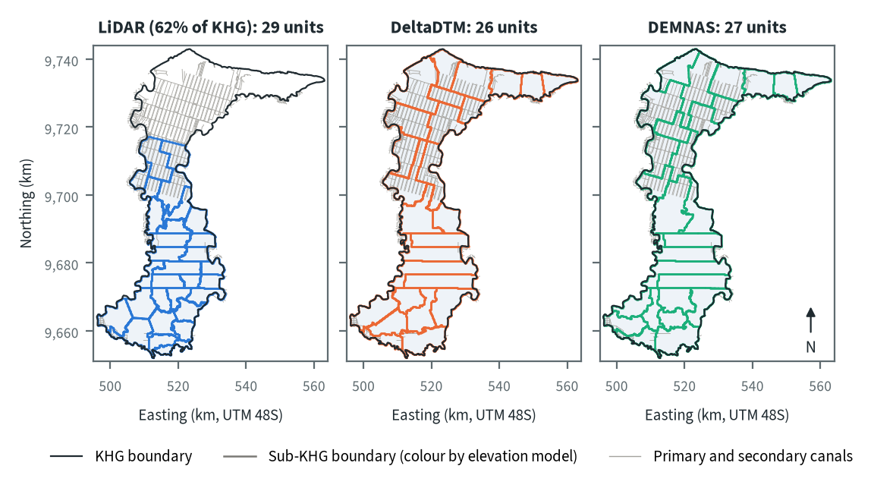
Figure 10.12. Saleh-Sugihan: sub-KHG units delineated on each elevation model. Source: sub-KHG delineation on each elevation model, mapped canals
LiDAR gives 29 sub-KHG units, DeltaDTM 26 and DEMNAS 27, all close to the cap of 30. The KHG has 3,080 primary and secondary canal segments (chapter 5), so unit boundaries mostly follow canals: in the north they trace the plantation grid, and in the middle all three models draw the same east-west boundaries along long straight canals. The models part ways on the southern dome, where canals are sparse and the drainage divides come from the terrain itself. The LiDAR units cover only 1,174 km², so they are smaller (median 39 km² against 75 km² on DeltaDTM and 67 km² on DEMNAS) and leave the northern part of the KHG without units.
Table 10.18. Saleh-Sugihan: number and size of sub-KHG units, and agreement between elevation models (area in the best-matching unit, adjusted Rand index). Source: sub-KHG delineation on each elevation model
Elevation model or pair | Units (n) | Unit area, median (km²) | Unit area, range (km²) | Units total (km²) | Overlap (km²) | Area in best-matching unit (%) | Adjusted Rand index
LiDAR (62% of KHG) | 29 | 39 | 20 to 77 | 1,174
DeltaDTM | 26 | 75 | 32 to 137 | 1,898
DEMNAS | 27 | 67 | 37 to 138 | 1,898
LiDAR and DeltaDTM |  |  |  |  | 1,174 | 65 | 0.47
LiDAR and DEMNAS |  |  |  |  | 1,174 | 68 | 0.49
DeltaDTM and DEMNAS |  |  |  |  | 1,898 | 79 | 0.68
Pairs are compared over the area both cover. Best-matching unit: share of the overlap that lies in the unit of the other model it overlaps most, averaged over both directions. Adjusted Rand index: 1 for identical partitions, about 0 for chance agreement; computed on 1 ha cells.
DeltaDTM and DEMNAS agree most closely: 79 % of the area lies in the best-matching unit, with an adjusted Rand index of 0.68. Each agrees less with LiDAR over the LiDAR area, with 65 % and 0.47 for DeltaDTM and 68 % and 0.49 for DEMNAS. LiDAR against DeltaDTM is the pair that differs most. Part of that difference comes from the LiDAR delineation stopping at the edge of the LiDAR, which cuts units that the other two models extend northwards.

Water balance and deficit
Table 10.19. Saleh-Sugihan: dry-season deficit from water-table stations and climatic balance per sub-KHG. Source: SiTMAT water-table stations, CHIRPS rain, MOD16 and WaPOR evapotranspiration
Quantity | All models | LiDAR (62% of KHG) | DeltaDTM | DEMNAS
Dry-season deficit from stations | not computed: no water-table station inside the KHG
Sub-KHG units (n) |  | 29 | 26 | 27
Climatic balance, MOD16, area mean (mm/month) |  | 75.5 | 84.2 | 84.2
Climatic balance, unit range (mm/month) |  | 65.9 to 105.3 | 68.0 to 113.1 | 68.0 to 113.0
Climatic balance, WaPOR, area mean (mm/month) |  | 100.8 | 101.8 | 101.8
Deficit months per year, area mean |  | 2.46 | 2.17 | 2.17
Order of units usable (ET products agree) |  | yes | no | no
The station deficit uses water-table stations and reanalysis rain and evaporation (band: specific yield 0.10 to 0.20) and does not depend on the elevation model. The climatic balance is CHIRPS rain minus evapotranspiration, 2018-2025, per sub-KHG of each model.
No water-table station lies inside Saleh-Sugihan, so no dry-season deficit from stations can be computed for this KHG, and no water need can be set against the blocks. The climatic balance from the neraca air (water balance), CHIRPS rain minus MOD16 evapotranspiration for 2018-2025, averages 84.2 mm/month over the whole KHG with DeltaDTM or DEMNAS units, with about 2.2 months in deficit a year. The LiDAR units give 75.5 mm/month and 2.46 deficit months because they cover only the drier southern part. The order of units by balance is usable only with the LiDAR units, where MOD16 and WaPOR rank the units alike (Spearman 0.56 against 0.43 needed, chapter 8). With the DeltaDTM and DEMNAS units their agreement, 0.38 and 0.30, stays below the 0.46 and 0.44 needed, so for the whole KHG the order of units by balance should not be used.
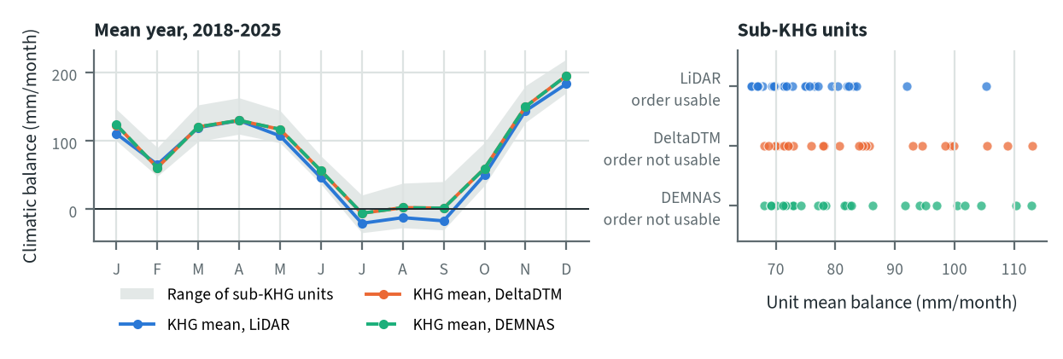
Figure 10.13. Saleh-Sugihan: climatic balance through the mean year, and the balance of each sub-KHG, by elevation model. Source: CHIRPS rain and MOD16 evapotranspiration, 2018-2025
The dry months are July, August and September, when the mean balance falls to about zero over the whole KHG and below zero over the LiDAR part. As in the rest of South Sumatra, the dry season can run from July to October; 2019 was the worst year and 2022 had no deficit month here (chapter 8). The elevation model enters the balance only through the units: DeltaDTM and DEMNAS give the same KHG mean, and their unit means span almost the same range, 68.0 to 113.1 and 68.0 to 113.0 mm/month.

Priority of sub-KHG
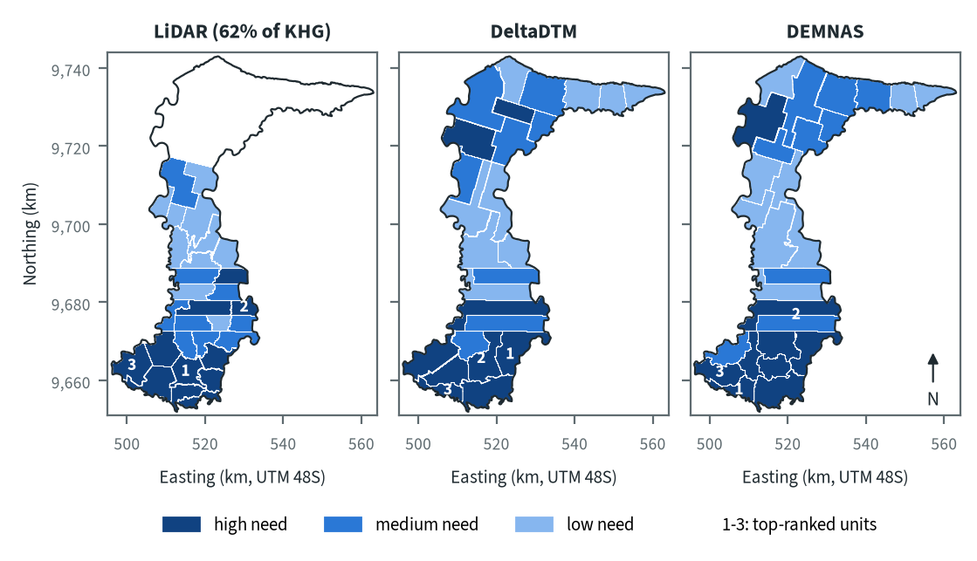
Figure 10.14. Saleh-Sugihan: need for intervention per sub-KHG, by elevation model. Source: sub-KHG prioritisation with default weights
With the default weights proposed for agreement with KLH and the World Bank, every model puts the high-need units on the southern dome and along the band of long east-west canals in the middle of the KHG. Burned land makes up most of the treatment cost in the selected units (see below), which fits the KHG's fire history. DeltaDTM and DEMNAS also mark a high-need unit in the north-west, which lies outside the LiDAR. All three models place one of their top three units on the south-western edge. LiDAR and DEMNAS also select a unit in the middle band, while DeltaDTM takes its other two from the dome further south and east.
Table 10.20. Saleh-Sugihan: high-need area and agreement of the priority classes between elevation models. Source: sub-KHG prioritisation with default weights
Elevation model or pair | High need (units, km²) | Overlap (km²) | Same need class (% of overlap) | High need in first also high in second (%) | Spearman of scores, area-weighted
LiDAR (62% of KHG) | 10, 460
DeltaDTM | 9, 638
DEMNAS | 9, 618
LiDAR and DeltaDTM |  | 1,174 | 79 | 88 | 0.85
LiDAR and DEMNAS |  | 1,174 | 71 | 82 | 0.86
DeltaDTM and DEMNAS |  | 1,898 | 74 | 79 | 0.86
Units are matched by location, since each model has its own units. Shares are of the area both models cover. Default weights, proposed for agreement with KLH and the World Bank.
The need scores agree well across models, with an area-weighted rank correlation of 0.85 to 0.86 for every pair. Between 71 % and 79 % of the shared area keeps its need class, and 79 % to 88 % of the area that is high need on one model is high need on the other. LiDAR and DEMNAS differ most in class (71 % the same). The high-need area is 460 km² on LiDAR, which covers only part of the KHG, against 638 km² on DeltaDTM and 618 km² on DEMNAS.

Canal blocks and pumping
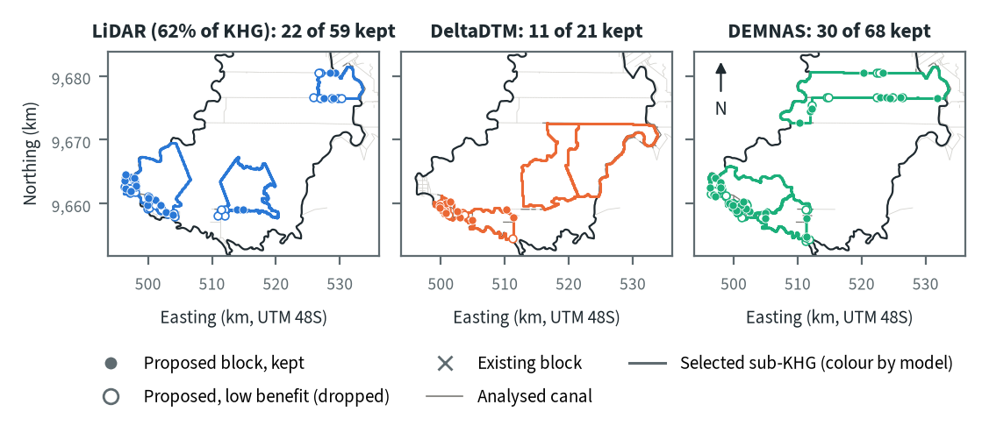
Figure 10.15. Saleh-Sugihan: proposed canal blocks in the three highest-ranked sub-KHG, by elevation model. Source: RE-PEAT Interventions on each elevation model, mapped canals and existing blocks
On every model most proposed sekat kanal (canal blocks) sit on the canal along the south-western edge of the KHG, where the land rises enough along the canal for the head rule to place blocks. LiDAR keeps 22 of 59 proposed blocks, DeltaDTM 11 of 21 and DEMNAS 30 of 68; the rest add little to the canal rewetting and are dropped. The other selected units change with the model. On LiDAR the second cluster lies on a canal in the east of the middle band; on DEMNAS blocks follow two east-west canals in the middle band; on DeltaDTM the two other selected units, larger and further east, receive no blocks. None of the 25 existing blocks lies on the analysed canals. Pumping was not assessed in this analysis.
Table 10.21. Saleh-Sugihan: canal blocks, water held and budget, by elevation model. Source: RE-PEAT Interventions and sub-KHG prioritisation on each elevation model
Quantity | LiDAR (62% of KHG) | DeltaDTM | DEMNAS
Selected sub-KHG (top 3 by priority) | S26, S14, S25 | S21, S23, S25 | S26, S18, S25
Blocks needed by the slope rule of the ranking, whole KHG (n) | 7,752 | 1,165 | 6,768
Existing blocks counted by the ranking, whole KHG (n) | 0 | 25 | 25
Existing blocks on analysed canals (n) | 0 | 0 | 0
Blocks proposed by the head rule (n) | 59 | 21 | 68
Blocks kept, 90% of the water-level rise (n) | 22 | 11 | 30
Pump units (n) | pumping not assessed | pumping not assessed | pumping not assessed
Water held by kept blocks (million m³) | 1.24 | 0.48 | 1.56
Deficit of the selected units (million m³) | - | - | -
Budget, low / central / high (billion Rp) | 15 / 23 / 26 | 16 / 25 / 30 | 20 / 31 / 38
of which revegetation of burned land, central (billion Rp) | 14 | 25 | 31
Blocks, water and budget are for the three highest-ranked sub-KHG of each model, which can differ between models. Kept: the fewest proposed blocks giving 90% of the water-level rise of all proposed blocks. Pumping is not assessed in these results. Default weights, proposed for agreement with KLH and the World Bank.
The kept blocks hold 1.24 million m³ on LiDAR, 0.48 million m³ on DeltaDTM and 1.56 million m³ on DEMNAS. Without a station deficit, this water cannot be compared with the need of the selected units. The central budget is 23 billion Rp on LiDAR, 25 billion Rp on DeltaDTM and 31 billion Rp on DEMNAS. Revegetation of burned land is the main item: 25 and 31 billion Rp, nearly all the budget, on DeltaDTM and DEMNAS, and 14 billion Rp on LiDAR, where most of the remaining 9 billion Rp (the difference of the two) is the KLH estimate of missing blocks in a unit given block treatment (chapter 9). The budget therefore follows how much burned land the selected units contain rather than the number of blocks.
The ranking's slope rule, applied to all primary and secondary canals of the KHG, gives a very different picture: 7,752 blocks needed on LiDAR (62 % of the KHG), 6,768 on DEMNAS and only 1,165 on DeltaDTM. The smooth 30 m DeltaDTM gives gentle canal slopes and wide spacing, while the local error in DEMNAS and the fine detail of the 20 m LiDAR give steeper slopes and close spacing. Chapter 7 treats this count as a first, rough figure.

How the elevation model changes the result
Table 10.22. Saleh-Sugihan: headline outputs by elevation model and their spread. Source: RE-PEAT results on each elevation model
Output | LiDAR (62% of KHG) | DeltaDTM | DEMNAS | Spread
Sub-KHG units (n) | 29 | 26 | 27 | ×1.0
Median unit area (km²) | 39 | 74 | 67 | ×1.1
Area covered by units (km²) | 1,173 | 1,897 | 1,897 | ×1.0
Climatic balance, area mean (mm/month) | 75.5 | 84.2 | 84.2 | range 0.1
High-need area (km²) | 460 | 638 | 618 | ×1.0
High-need units (n) | 10 | 9 | 9 | ×1.0
Blocks needed, slope rule of the ranking, whole KHG (n) | 7,752 | 1,165 | 6,768 | ×5.8
Blocks proposed, head rule (n) | 59 | 21 | 68 | ×3.2
Blocks kept (n) | 22 | 11 | 30 | ×2.7
Water held by kept blocks (million m³) | 1.24 | 0.48 | 1.56 | ×3.3
Budget, central (billion Rp) | 23 | 25 | 31 | ×1.3
Spread: largest value over smallest across the models (range for the balance). Blocks kept, water and budget refer to the three highest-ranked sub-KHG of each model, so they move with the choice of units as well as with the terrain. The spread leaves out the LiDAR column, which covers 62% of the KHG. Default weights, proposed for agreement with KLH and the World Bank.
Between DeltaDTM and DEMNAS, which both cover the whole KHG, the block counts move most: 5.8 times for the slope-rule count, 3.2 times for proposed blocks, 2.7 times for kept blocks and 3.3 times for the water they hold. The unit count, the climatic balance, the high-need area and the central budget (1.3 times) barely move. Some of the block spread comes from the choice of units, since each model selects different top-three units, and some from terrain: DEMNAS carries a local error of 1.77 m (NMAD) against LiDAR, larger than the 0.40 m step of the head rule.
For decisions, LiDAR is the model to use in the southern 62 % of the KHG, which holds the dome and most of the high-need area. For the northern part, DeltaDTM is the better of the two open models here: its difference to LiDAR is mostly an offset, while DEMNAS shows stripes and a wide spread. Its low block counts should still be read as the lower end of a range, with DEMNAS as the upper end, until the north is surveyed.

Summary for this KHG
Saleh-Sugihan needs rewetting chiefly on its southern dome, where repeated fires since 2015 have left the most burned peat, and every elevation model ranks that area high. On LiDAR, which covers that part, the plan keeps 22 canal blocks in the three selected units, holding 1.24 million m³, for a central budget of 23 billion Rp, most of it revegetation of burned land. LiDAR is the recommended model for the south and DeltaDTM for the north. The units and priorities hold up across models, but block counts vary up to 5.8 times. With no water-table station in the KHG, the water held by blocks cannot be compared with a dry-season deficit, the northern 38 % has no LiDAR, and pumping was not assessed in this analysis.

10.5 Mendahara-Batanghari (KHG 15.05-07-10.01)
Table 10.23. Mendahara-Batanghari: key facts. Source: national KHG profile, national canal and structures layers, RE-PEAT results for this KHG
Item | Value
Province | Jambi
Area of the KHG polygon (km²) | 2,013
Peat area (km²) | 1,731
National rank (class) | 71 of 476 (high priority)
Canals, primary / secondary / tertiary (km) | 860 / 1,338 / 2,388
Existing water-management structures, all types (n) | 700
SiTMAT water-table stations (n) | 14
Realised canal blocks inside the KHG (n) | 417
LiDAR cover of the KHG (%) | 100
Elevation model ready, by elevation model | LiDAR, DeltaDTM, DEMNAS
Sub-KHG units, by elevation model | LiDAR, DeltaDTM, DEMNAS
Water balance, by elevation model | LiDAR, DeltaDTM, DEMNAS
Priority of sub-KHG, by elevation model | LiDAR, DeltaDTM, DEMNAS
Canal blocks and costs, by elevation model | LiDAR, DeltaDTM, DEMNAS
Dry-season deficit from stations | computed
Rank among ranked KHG with default weights, proposed for agreement with KLH and the World Bank. Canals: mapped canal network. Structures and realised canal blocks: national layer of existing water-management structures (all types, and the canal blocks recorded as realised).
Mendahara-Batanghari is a KHG (Kesatuan Hidrologis Gambut, peat hydrological unit) in Jambi province. Of its 2,013 km², 1,731 km² is peat, about 86 % of the polygon. With the default weights proposed for agreement with KLH and the World Bank it ranks 71 of 476 ranked KHG, in the high-priority class. The land is heavily drained: the mapped network has 860 km of primary, 1,338 km of secondary and 2,388 km of tertiary canals, about 2.3 km of canal per km² of KHG (4,586 km over 2,013 km²). The national layer records 700 water-management structures, 417 of them realised canal blocks. Airborne LiDAR covers the whole KHG, so this is one of the sites where DeltaDTM and DEMNAS can be judged against LiDAR everywhere, and every step from terrain to canal blocks has run on all three elevation models. Of the 14 SiTMAT water-table stations in the KHG, 12 have records for the dry-season deficit.

Terrain and the three elevation models
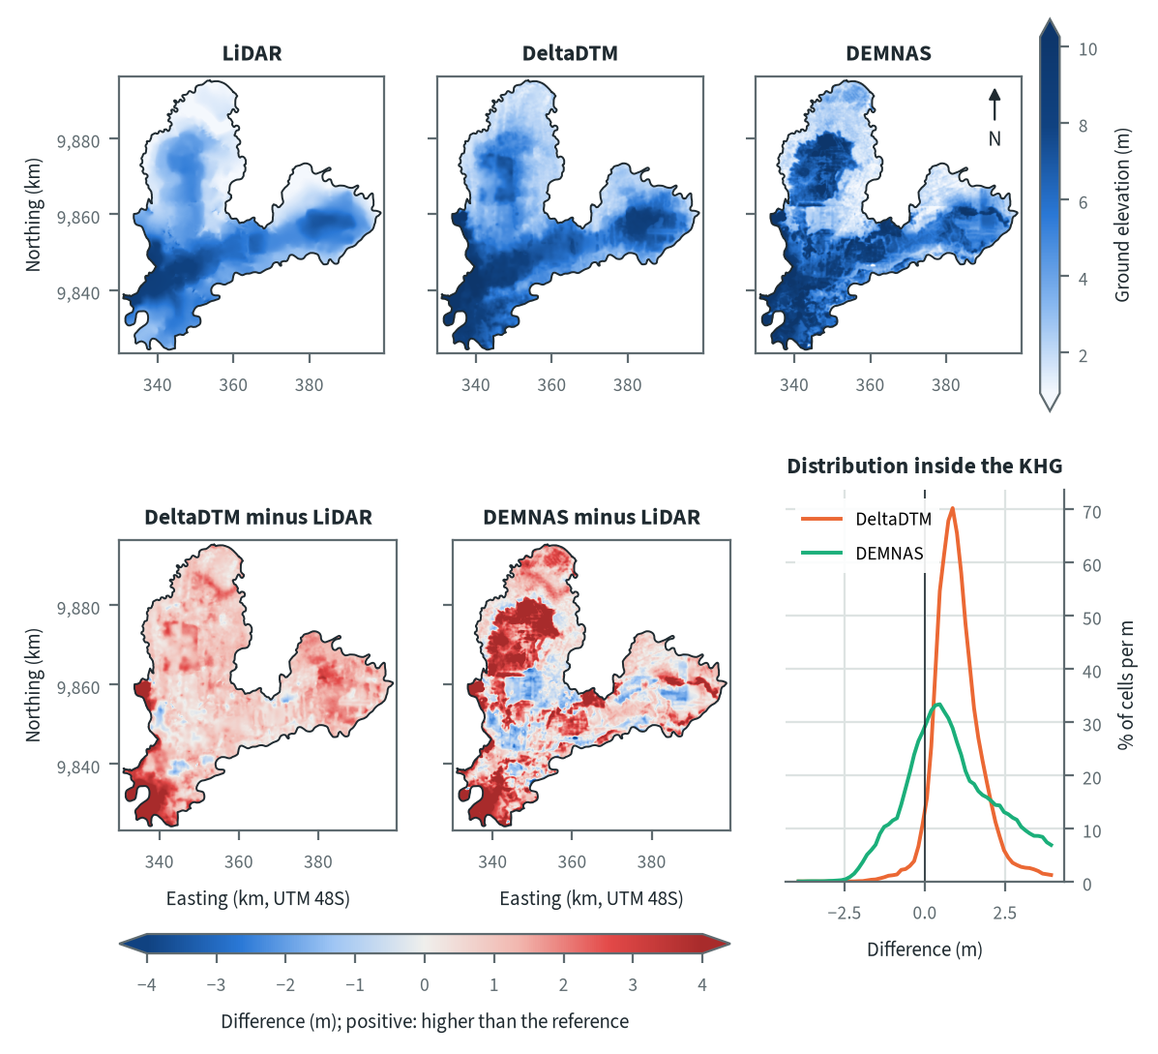
Figure 10.16. Mendahara-Batanghari: ground elevation from each elevation model on one colour scale, and their differences. Source: LiDAR terrain model, DeltaDTM and DEMNAS after the DEM correction
On LiDAR the highest ground forms a band across the south-west and centre of the KHG, with a second raised area in the eastern lobe and a lower dome in the northern lobe. The outer margins of the northern and eastern lobes are the lowest ground. DeltaDTM draws the same shape higher almost everywhere (median difference 0.97 m, more than 2 m above LiDAR over 12 % of the KHG), and departs from that offset mainly along the south-western and western edge, where it lies well above LiDAR. DEMNAS disagrees in large patches with straight edges: much of the interior of the northern lobe and parts of the south-west sit above LiDAR, while blocks in the centre sit below it. DEMNAS is more than 2 m above LiDAR over 29 % of the KHG and more than 2 m below it over 0.7 %. Patches that follow land-cover boundaries in this way point to canopy left in the surface. Tree cover is 82 % of the benchmark area here, and the correction fitted a canopy share of only 0.087 for tree cover in DEMNAS (chapter 4).
Table 10.24. Mendahara-Batanghari: resolution, cover and relief of each elevation model, and its difference to LiDAR. Source: LiDAR terrain model, DeltaDTM and DEMNAS after the DEM correction
Elevation model | Source | Resolution (m) | Cover of the KHG (%) | Relief, 5th-95th percentile (m) | Difference to LiDAR, median (m) | Difference to LiDAR, NMAD (m)
LiDAR | Airborne LiDAR terrain model (KLHK), as delivered | 25 | 100 | 0.9 to 7.8
DeltaDTM | DeltaDTM v1.1 (global coastal terrain model), after the DEM correction | 30 | 100 | 1.9 to 9.0 | 0.97 | 0.64
DEMNAS | DEMNAS (BIG national surface model), after the DEM correction | 8 | 100 | 1.4 to 9.8 | 0.86 | 1.60
Statistics over the KHG polygon on a common 25 m grid (the LiDAR grid; finer models averaged onto it). NMAD: normalised median absolute deviation, a spread measure robust to outliers. Where LiDAR covers only part of the KHG, differences are over that part.
Relief (5th to 95th percentile) is 0.9 to 7.8 m on LiDAR, 1.9 to 9.0 m on DeltaDTM and 1.4 to 9.8 m on DEMNAS, so DEMNAS stretches the range by about 1.5 m. Both corrected models sit above LiDAR by a similar median, 0.97 m for DeltaDTM and 0.86 m for DEMNAS. The spread around that median differs far more: the NMAD is 0.64 m for DeltaDTM and 1.60 m for DEMNAS. The DeltaDTM difference is mostly a constant offset, as at the other four KHG with LiDAR, and a constant offset leaves slopes unchanged. The DEMNAS difference is local error four times the 0.40 m head step used to place canal blocks, and that error enters every slope the later steps compute.

Sub-KHG units
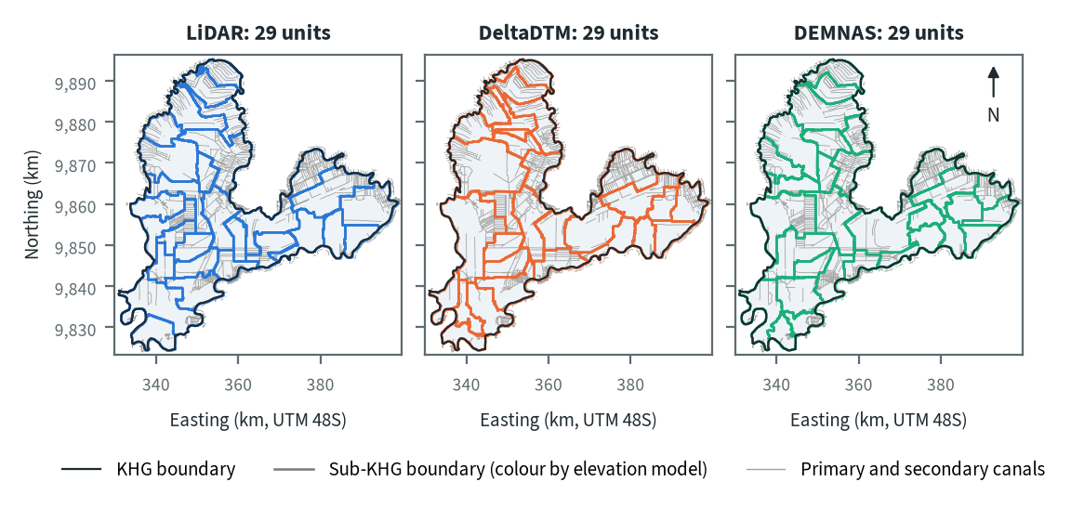
Figure 10.17. Mendahara-Batanghari: sub-KHG units delineated on each elevation model. Source: sub-KHG delineation on each elevation model, mapped canals
Each model gives 29 sub-KHG units, close to the cap of 30. The KHG has 2,190 primary and secondary canal segments, so the catchment pieces are small and the cap is reached at a minimum unit area of about 30 km² (chapter 5). Many boundaries run straight along primary and secondary canals, especially in the canal grids of the north and east, and these are drawn alike on all three models. The models diverge where boundaries cross open land between canal blocks, in the centre and the west, because there the divide follows the terrain itself. DeltaDTM merges more of that ground into one large unit (203 km² at most, against 140 km² on LiDAR), and DEMNAS cuts the eastern lobe into smaller units than LiDAR.
Table 10.25. Mendahara-Batanghari: number and size of sub-KHG units, and agreement between elevation models (area in the best-matching unit, adjusted Rand index). Source: sub-KHG delineation on each elevation model
Elevation model or pair | Units (n) | Unit area, median (km²) | Unit area, range (km²) | Units total (km²) | Overlap (km²) | Area in best-matching unit (%) | Adjusted Rand index
LiDAR | 29 | 64 | 36 to 140 | 2,012
DeltaDTM | 29 | 55 | 39 to 203 | 2,013
DEMNAS | 29 | 56 | 35 to 151 | 2,013
LiDAR and DeltaDTM |  |  |  |  | 2,012 | 76 | 0.59
LiDAR and DEMNAS |  |  |  |  | 2,012 | 71 | 0.55
DeltaDTM and DEMNAS |  |  |  |  | 2,013 | 70 | 0.54
Pairs are compared over the area both cover. Best-matching unit: share of the overlap that lies in the unit of the other model it overlaps most, averaged over both directions. Adjusted Rand index: 1 for identical partitions, about 0 for chance agreement; computed on 1 ha cells.
Agreement is moderate. LiDAR and DeltaDTM agree best, with 76 % of the area in the best-matching unit and an adjusted Rand index of 0.59. LiDAR and DEMNAS reach 71 % and 0.55, and DeltaDTM and DEMNAS differ most, at 70 % and 0.54. Median unit area is 64 km² on LiDAR, 55 km² on DeltaDTM and 56 km² on DEMNAS.

Water balance and deficit
Table 10.26. Mendahara-Batanghari: dry-season deficit from water-table stations and climatic balance per sub-KHG. Source: SiTMAT water-table stations, CHIRPS rain, MOD16 and WaPOR evapotranspiration
Quantity | All models | LiDAR | DeltaDTM | DEMNAS
Dry-season deficit from 12 stations, 01 Jun to 13 Oct 2026 (mm) | 119 (108 to 130)
Deficit volume over the KHG (million m³) | 240
Months in deficit in that window (n) | 4
Sub-KHG units (n) |  | 29 | 29 | 29
Climatic balance, MOD16, area mean (mm/month) |  | 62.0 | 62.0 | 62.0
Climatic balance, unit range (mm/month) |  | 53.4 to 74.8 | 51.5 to 78.9 | 48.3 to 73.6
Climatic balance, WaPOR, area mean (mm/month) |  | 90.1 | 90.1 | 90.1
Deficit months per year, area mean |  | 2.48 | 2.46 | 2.48
Order of units usable (ET products agree) |  | no | no | no
The station deficit uses water-table stations and reanalysis rain and evaporation (band: specific yield 0.10 to 0.20) and does not depend on the elevation model. The climatic balance is CHIRPS rain minus evapotranspiration, 2018-2025, per sub-KHG of each model.
From 1 June to 13 October 2026 the neraca air (water balance) at the 12 stations gives a dry-season deficit of 119 mm (108 to 130 mm for specific yield 0.10 to 0.20), or 240 million m³ over the KHG, with 4 months in deficit. The climate removed 152 mm in that window; the stations fell 22 cm, which supplied 33 mm, and the rest had to come from outside the rain balance (chapter 8). Seven of the 12 stations belong to one concession, so the figure leans towards managed land. The order of units by climatic balance is not usable on any model: MOD16 and WaPOR rank the units in unrelated ways (Spearman -0.10 to 0.08), and the MOD16 balance follows forest share almost entirely, so interception sets the order rather than water (chapter 8).
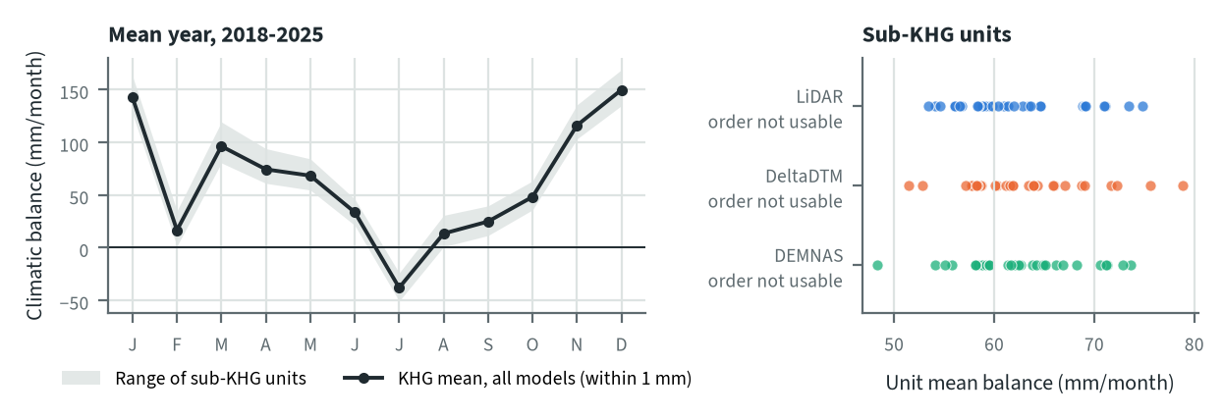
Figure 10.18. Mendahara-Batanghari: climatic balance through the mean year, and the balance of each sub-KHG, by elevation model. Source: CHIRPS rain and MOD16 evapotranspiration, 2018-2025
In the mean year 2018-2025 July is the only month with a negative climatic balance, about -38 mm. February and August stay low but positive (16 and 13 mm). The KHG mean is 62.0 mm/month with MOD16 on every model, because the elevation model enters only through the unit boundaries. Those boundaries widen or narrow the spread between units: 53.4 to 74.8 mm/month on LiDAR, 51.5 to 78.9 mm/month on DeltaDTM and 48.3 to 73.6 mm/month on DEMNAS. Deficit months per year average 2.46 to 2.48 on all three.

Priority of sub-KHG
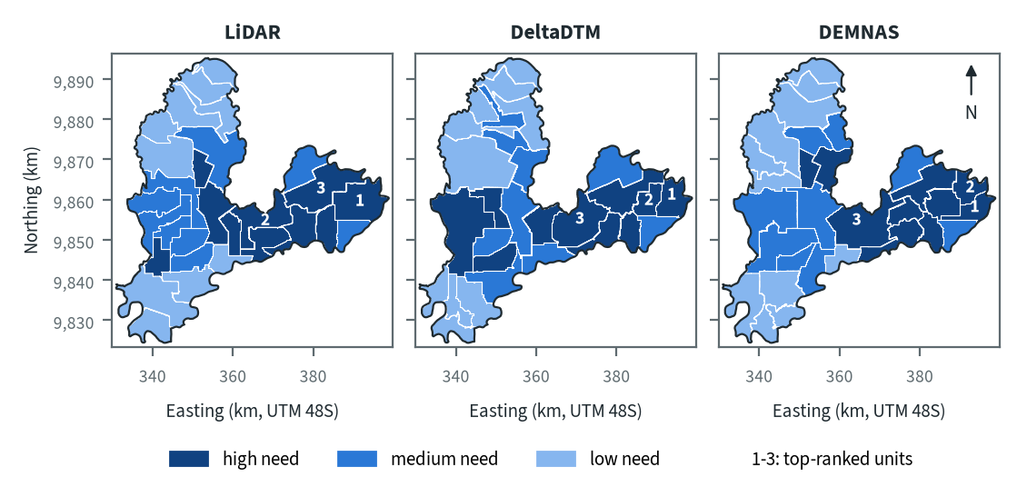
Figure 10.19. Mendahara-Batanghari: need for intervention per sub-KHG, by elevation model. Source: sub-KHG prioritisation with default weights
With the default weights proposed for agreement with KLH and the World Bank, the high-need units lie in the eastern lobe and the centre, and most of the northern lobe and the south-west are low need on every model. All three models put the top-ranked units in the eastern lobe. These units have the highest hotspot density and burned share of the KHG; high-need units further down the list get there mostly through dense canals and wide canal reach. Each model selects a different set of three: LiDAR spreads its top three from the centre to the far east, while DeltaDTM and DEMNAS each pair two units in the far east with one unit further west.
Table 10.27. Mendahara-Batanghari: high-need area and agreement of the priority classes between elevation models. Source: sub-KHG prioritisation with default weights
Elevation model or pair | High need (units, km²) | Overlap (km²) | Same need class (% of overlap) | High need in first also high in second (%) | Spearman of scores, area-weighted
LiDAR | 10, 695
DeltaDTM | 10, 754
DEMNAS | 10, 616
LiDAR and DeltaDTM |  | 2,012 | 67 | 73 | 0.87
LiDAR and DEMNAS |  | 2,012 | 84 | 80 | 0.91
DeltaDTM and DEMNAS |  | 2,013 | 69 | 62 | 0.88
Units are matched by location, since each model has its own units. Shares are of the area both models cover. Default weights, proposed for agreement with KLH and the World Bank.
Every model rates 10 units as high need, covering 695 km² on LiDAR, 754 km² on DeltaDTM and 616 km² on DEMNAS. LiDAR and DEMNAS agree best: 84 % of the area keeps its class, 80 % of the LiDAR high-need area is also high need on DEMNAS, and the area-weighted Spearman correlation of scores is 0.91. DeltaDTM is the outlier, with 67 % of the area in the same class as LiDAR and 69 % as DEMNAS. Its largest difference is a large high-need unit in the west-central part that LiDAR and DEMNAS split into smaller medium-need units, so a single boundary choice moves the class of a large area.

Canal blocks and pumping
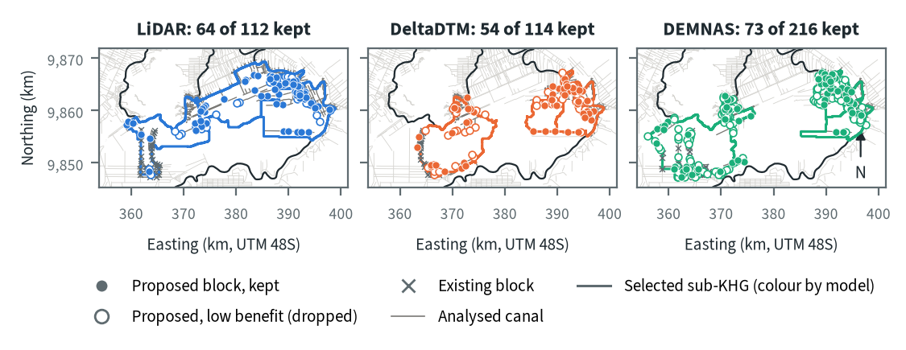
Figure 10.20. Mendahara-Batanghari: proposed canal blocks in the three highest-ranked sub-KHG, by elevation model. Source: RE-PEAT Interventions on each elevation model, mapped canals and existing blocks
RE-PEAT Interventions places sekat kanal (canal blocks) by the 0.40 m head rule along the analysed canals of the three selected units, then keeps the fewest that give 90 % of the canal rewetting. On LiDAR it proposes 112 blocks and keeps 64, most of them on the canal grid of the far east. DeltaDTM proposes 114 and keeps 54, and DEMNAS proposes 216 and keeps 73, so 48, 60 and 143 blocks are dropped as low benefit. Because DeltaDTM and DEMNAS select a unit in the west, their blocks fall in two separate clusters, and the western cluster sits next to existing blocks (35, 30 and 48 existing blocks lie on the analysed canals). DEMNAS proposes almost twice as many blocks as LiDAR, partly because its local error steepens canal slopes and partly because its selected units differ.
Table 10.28. Mendahara-Batanghari: canal blocks, water held and budget, by elevation model. Source: RE-PEAT Interventions and sub-KHG prioritisation on each elevation model
Quantity | LiDAR | DeltaDTM | DEMNAS
Selected sub-KHG (top 3 by priority) | S12, S15, S10 | S12, S13, S15 | S15, S12, S18
Blocks needed by the slope rule of the ranking, whole KHG (n) | 1,995 | 3,908 | 8,763
Existing blocks counted by the ranking, whole KHG (n) | 417 | 417 | 417
Existing blocks on analysed canals (n) | 35 | 30 | 48
Blocks proposed by the head rule (n) | 112 | 114 | 216
Blocks kept, 90% of the water-level rise (n) | 64 | 54 | 73
Pump units (n) | pumping not assessed | pumping not assessed | pumping not assessed
Water held by kept blocks (million m³) | 4.47 | 3.45 | 4.98
Deficit of the selected units (million m³) | 38.2 | 26.2 | 28.8
Budget, low / central / high (billion Rp) | 9 / 14 / 14 | 50 / 77 / 90 | 85 / 130 / 146
of which revegetation of burned land, central (billion Rp) | 0 | 57 | 70
Blocks, water and budget are for the three highest-ranked sub-KHG of each model, which can differ between models. Kept: the fewest proposed blocks giving 90% of the water-level rise of all proposed blocks. Pumping is not assessed in these results. Default weights, proposed for agreement with KLH and the World Bank.
The kept blocks hold 4.47 million m³ on LiDAR, 3.45 million m³ on DeltaDTM and 4.98 million m³ on DEMNAS, against a deficit of the selected units of 38.2, 26.2 and 28.8 million m³. That is about 12 %, 13 % and 17 % of the deficit. The central budget is 14 billion Rp on LiDAR, 77 billion Rp on DeltaDTM and 130 billion Rp on DEMNAS. On DeltaDTM and DEMNAS, revegetation of burned land is the largest item (57 and 70 billion Rp), because their selected units include burned land assigned that treatment; on LiDAR revegetation costs nothing, and most of the budget is the KLH estimate of blocks missing outside the analysed canals of the selected units, an item that also grows with the noisier slopes of DEMNAS. Pumping was not assessed in this analysis, so no pump design exists for this KHG.

How the elevation model changes the result
Table 10.29. Mendahara-Batanghari: headline outputs by elevation model and their spread. Source: RE-PEAT results on each elevation model
Output | LiDAR | DeltaDTM | DEMNAS | Spread
Sub-KHG units (n) | 29 | 29 | 29 | ×1.0
Median unit area (km²) | 64 | 55 | 56 | ×1.2
Area covered by units (km²) | 2,011 | 2,012 | 2,012 | ×1.0
Climatic balance, area mean (mm/month) | 62.0 | 62.0 | 62.0 | range 0.1
High-need area (km²) | 695 | 754 | 616 | ×1.2
High-need units (n) | 10 | 10 | 10 | ×1.0
Blocks needed, slope rule of the ranking, whole KHG (n) | 1,995 | 3,908 | 8,763 | ×4.4
Blocks proposed, head rule (n) | 112 | 114 | 216 | ×1.9
Blocks kept (n) | 64 | 54 | 73 | ×1.4
Water held by kept blocks (million m³) | 4.47 | 3.45 | 4.98 | ×1.4
Budget, central (billion Rp) | 14 | 77 | 130 | ×9.3
Spread: largest value over smallest across the models (range for the balance). Blocks kept, water and budget refer to the three highest-ranked sub-KHG of each model, so they move with the choice of units as well as with the terrain. Default weights, proposed for agreement with KLH and the World Bank.
The number of units (29), the KHG mean climatic balance (range 0.1 mm/month), the station deficit and the number of high-need units (10) do not move with the elevation model. The high-need area moves by a factor of 1.2 and the water held by 1.4. The outputs that depend on slope move most. Blocks needed by the slope rule of the ranking range from 1,995 on LiDAR to 8,763 on DEMNAS (a factor of 4.4), blocks proposed by a factor of 1.9, and the central budget by 9.3, from 14 to 130 billion Rp. The budget spread comes from two effects together: the noisier DEMNAS slopes, and the different selected units, which bring burned land into the DeltaDTM and DEMNAS plans.
LiDAR covers the whole KHG and is the model to use for decisions here. DeltaDTM is the closest substitute: its 0.97 m offset leaves slopes intact, its NMAD of 0.64 m is the lowest of the corrected models, and its priority ranking still correlates with LiDAR at 0.87, although its units and selected units differ. DEMNAS ranks the units much like LiDAR (Spearman 0.91), but its 1.60 m local error is four times the 0.40 m head step between blocks and should not be used to place blocks or count them.

Summary for this KHG
Mendahara-Batanghari is a densely drained KHG that needed 119 mm of water from outside the rain balance in the 2026 dry season, 240 million m³ over 2,013 km², and its highest-need units lie in the burned eastern lobe on every elevation model. On the recommended LiDAR model the plan keeps 64 canal blocks in the three selected units, for a central budget of 14 billion Rp, and these blocks hold about 12 % of those units' deficit, so blocking alone cannot close it. The ranking is fairly stable across models, but block counts and the budget are not: DEMNAS raises the budget to 130 billion Rp through noisier slopes and a different choice of units. Pumping was not assessed in this analysis. The station deficit rests on 12 stations, 7 of them in one concession, so the need of the land outside licences is the least certain part of the estimate.

10.6 Air Hitam Laut-Buntu Kecil (KHG 15-16.01)
Table 10.30. Air Hitam Laut-Buntu Kecil: key facts. Source: national KHG profile, national canal and structures layers, RE-PEAT results for this KHG
Item | Value
Province | Jambi, Sumatera Selatan
Area of the KHG polygon (km²) | 1,837
Peat area (km²) | 1,432
National rank (class) | 84 of 476 (high priority)
Canals, primary / secondary / tertiary (km) | 57 / 344 / 472
Existing water-management structures, all types (n) | 238
SiTMAT water-table stations (n) | 9
Realised canal blocks inside the KHG (n) | 201
LiDAR cover of the KHG (%) | 100
Elevation model ready, by elevation model | LiDAR, DeltaDTM, DEMNAS
Sub-KHG units, by elevation model | LiDAR, DeltaDTM, DEMNAS
Water balance, by elevation model | LiDAR, DeltaDTM, DEMNAS
Priority of sub-KHG, by elevation model | LiDAR, DeltaDTM, DEMNAS
Canal blocks and costs, by elevation model | LiDAR, DeltaDTM, DEMNAS
Dry-season deficit from stations | computed
Rank among ranked KHG with default weights, proposed for agreement with KLH and the World Bank. Canals: mapped canal network. Structures and realised canal blocks: national layer of existing water-management structures (all types, and the canal blocks recorded as realised).
Air Hitam Laut-Buntu Kecil is a coastal KHG (Kesatuan Hidrologis Gambut, peat hydrological unit) on the border of Jambi and Sumatera Selatan. Of its 1,837 km², 1,432 km² is peat, about 78 % of the area. It ranks 90th of 476 KHG at the default weights proposed for agreement with KLH and the World Bank, in the high class, and stays in that class in 98 % of the random weight draws (chapter 6). Fire history decides the top of the national ranking (chapter 6), and this KHG sits in the lower half of the high class: it is one of four main KHG that leave the top 158 under at least one of the dashboard's weight presets.
The KHG has 873 km of mapped canals (57 km primary, 344 km secondary, 472 km tertiary), 238 existing water-management structures and 201 canal blocks recorded as built. It has 9 SiTMAT water-table stations and a 25 m LiDAR terrain model that covers the whole KHG, and modelled peat depth covers 96 % of it (chapter 3). The full chain has run on all three elevation models: LiDAR, corrected DeltaDTM and corrected DEMNAS.

Terrain and the three elevation models
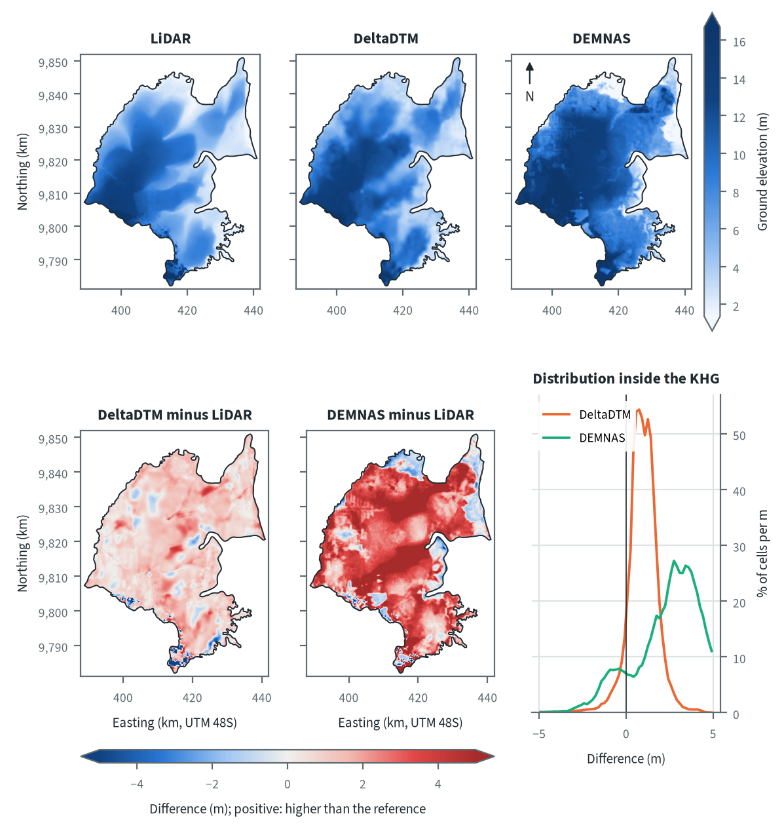
Figure 10.21. Air Hitam Laut-Buntu Kecil: ground elevation from each elevation model on one colour scale, and their differences. Source: LiDAR terrain model, DeltaDTM and DEMNAS after the DEM correction
On LiDAR the peat rises from the north-eastern coast to a broad dome in the west and south-west (elevation 2.0 to 13.0 m between the 5th and 95th percentiles), with lower ground along the estuary that cuts into the KHG from the east and a small high tip in the far south. DeltaDTM draws the same dome and sits a little higher almost everywhere, with a few local patches of larger difference. DEMNAS is higher than LiDAR over most of the dome and the north-east, shows rectangular patches in the west, and falls below LiDAR along the northern and eastern coastal edge. The difference histogram of DEMNAS peaks at +2.75 m and DEMNAS is more than 2 m above LiDAR over 69 % of the KHG, which fits a surface model that keeps part of the canopy over forest and is pieced together from several radar sources (chapter 4).
Table 10.31. Air Hitam Laut-Buntu Kecil: resolution, cover and relief of each elevation model, and its difference to LiDAR. Source: LiDAR terrain model, DeltaDTM and DEMNAS after the DEM correction
Elevation model | Source | Resolution (m) | Cover of the KHG (%) | Relief, 5th-95th percentile (m) | Difference to LiDAR, median (m) | Difference to LiDAR, NMAD (m)
LiDAR | Airborne LiDAR terrain model (KLHK), as delivered | 25 | 100 | 2.0 to 13.0
DeltaDTM | DeltaDTM v1.1 (global coastal terrain model), after the DEM correction | 30 | 100 | 2.8 to 13.7 | 0.95 | 0.71
DEMNAS | DEMNAS (BIG national surface model), after the DEM correction | 8 | 100 | 1.4 to 16.6 | 2.96 | 1.86
Statistics over the KHG polygon on a common 25 m grid (the LiDAR grid; finer models averaged onto it). NMAD: normalised median absolute deviation, a spread measure robust to outliers. Where LiDAR covers only part of the KHG, differences are over that part.
The 5th to 95th percentile range of height is 2.0 to 13.0 m on LiDAR, 2.8 to 13.7 m on DeltaDTM and 1.4 to 16.6 m on DEMNAS, so DEMNAS stretches the relief by about 4 m. DeltaDTM sits a median 0.95 m above LiDAR with a spread (NMAD) of 0.71 m: most of its difference is a near-constant offset, which leaves slopes and divides largely intact. DEMNAS sits 2.96 m above LiDAR with an NMAD of 1.86 m, so much of its difference is local error, and that error goes straight into the canal slopes and head drops the later steps use.

Sub-KHG units
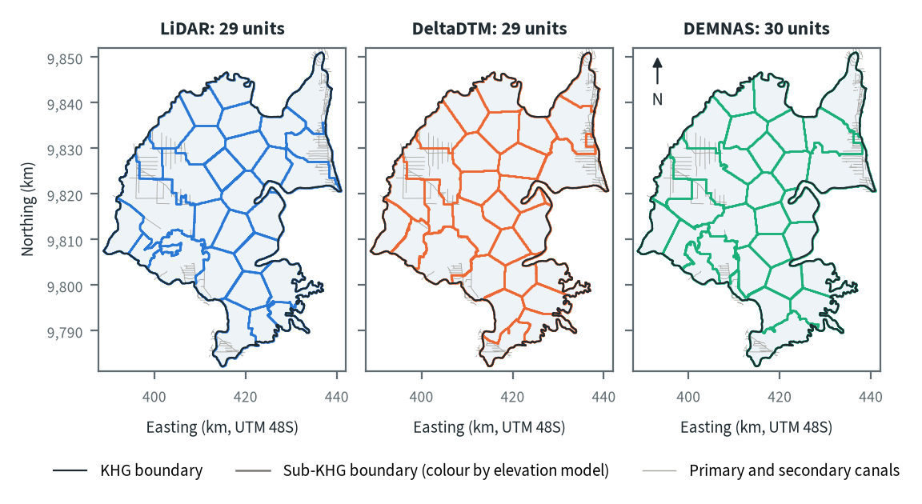
Figure 10.22. Air Hitam Laut-Buntu Kecil: sub-KHG units delineated on each elevation model. Source: sub-KHG delineation on each elevation model, mapped canals
LiDAR and DeltaDTM each give 29 sub-KHG units and DEMNAS 30, all with a median area of 56 to 57 km². Where canals are dense, in the west and the north-east, unit boundaries follow the canal grid in steps; in the canal-free centre they follow the terrain and come out as rounder cells. Mapped rivers are missing for this KHG (chapter 3), so no river line fixes a boundary and the units rest on the elevation model and the canals alone. The LiDAR set has the widest size range, 33 to 164 km², including a unit in the south-west with a ragged outline wrapped around a neighbour, likely where the flat dome top lets small height differences decide the flow paths.
Table 10.32. Air Hitam Laut-Buntu Kecil: number and size of sub-KHG units, and agreement between elevation models (area in the best-matching unit, adjusted Rand index). Source: sub-KHG delineation on each elevation model
Elevation model or pair | Units (n) | Unit area, median (km²) | Unit area, range (km²) | Units total (km²) | Overlap (km²) | Area in best-matching unit (%) | Adjusted Rand index
LiDAR | 29 | 56 | 33 to 164 | 1,836
DeltaDTM | 29 | 57 | 43 to 124 | 1,837
DEMNAS | 30 | 56 | 39 to 127 | 1,837
LiDAR and DeltaDTM |  |  |  |  | 1,836 | 67 | 0.54
LiDAR and DEMNAS |  |  |  |  | 1,836 | 67 | 0.54
DeltaDTM and DEMNAS |  |  |  |  | 1,837 | 72 | 0.61
Pairs are compared over the area both cover. Best-matching unit: share of the overlap that lies in the unit of the other model it overlaps most, averaged over both directions. Adjusted Rand index: 1 for identical partitions, about 0 for chance agreement; computed on 1 ha cells.
LiDAR shares 67 % of the area with its best-matching unit in either open model, with an adjusted Rand index of 0.54 for both pairs. The two open models agree more with each other (72 %, 0.61) than either does with LiDAR. The units therefore differ most between LiDAR and the open models, and DeltaDTM's smaller error relative to LiDAR does not translate into closer units here.

Water balance and deficit
Table 10.33. Air Hitam Laut-Buntu Kecil: dry-season deficit from water-table stations and climatic balance per sub-KHG. Source: SiTMAT water-table stations, CHIRPS rain, MOD16 and WaPOR evapotranspiration
Quantity | All models | LiDAR | DeltaDTM | DEMNAS
Dry-season deficit from 8 stations, 01 Jun to 15 Oct 2026 (mm) | 211 (209 to 212)
Deficit volume over the KHG (million m³) | 386
Months in deficit in that window (n) | 4
Sub-KHG units (n) |  | 29 | 29 | 30
Climatic balance, MOD16, area mean (mm/month) |  | 66.8 | 66.9 | 66.8
Climatic balance, unit range (mm/month) |  | 58.8 to 76.6 | 59.1 to 82.0 | 59.1 to 81.3
Climatic balance, WaPOR, area mean (mm/month) |  | 81.4 | 81.4 | 81.4
Deficit months per year, area mean |  | 2.36 | 2.35 | 2.35
Order of units usable (ET products agree) |  | no | no | no
The station deficit uses water-table stations and reanalysis rain and evaporation (band: specific yield 0.10 to 0.20) and does not depend on the elevation model. The climatic balance is CHIRPS rain minus evapotranspiration, 2018-2025, per sub-KHG of each model.
The neraca air (water balance) from 8 water-table stations gives a supply deficit of 211 mm from 1 June to 15 October 2026 (209 to 212 mm for a specific yield of 0.10 to 0.20), or 386 million m³ over the KHG, with 4 months in deficit in that window. This deficit does not depend on the elevation model. The climatic balance of 2018-2025 averages 66.8 to 66.9 mm/month with MOD16 and 81.4 mm/month with WaPOR, with 2.35 to 2.36 deficit months a year. The order of units by balance is not usable on any of the three models, because MOD16 and WaPOR do not order the units' evapotranspiration alike (chapter 8); the balance values are therefore left out of the sub-KHG ranking.
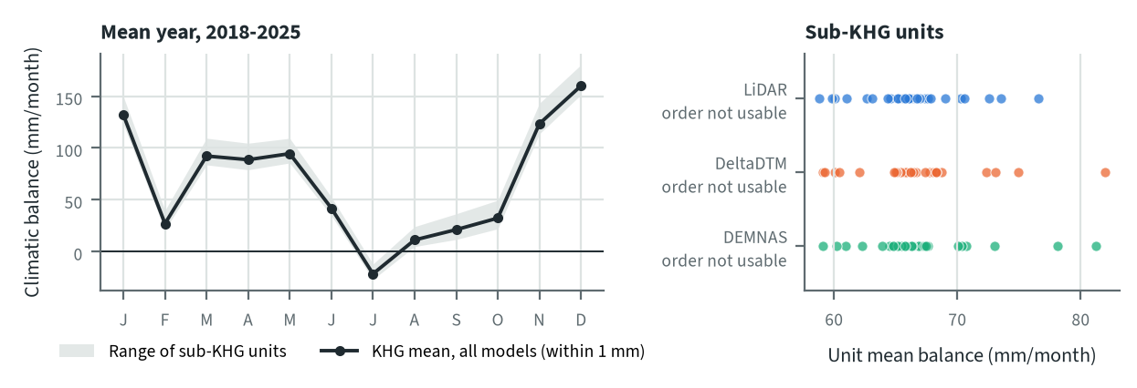
Figure 10.23. Air Hitam Laut-Buntu Kecil: climatic balance through the mean year, and the balance of each sub-KHG, by elevation model. Source: CHIRPS rain and MOD16 evapotranspiration, 2018-2025
In the mean year July is the only month with a negative balance, and February and August to October stay low but positive; the 2026 dry season was drier than this mean, with 4 months in deficit. The KHG mean is the same on all three models to within 1 mm/month. The models change only the spread between units, 58.8 to 76.6 mm/month on LiDAR against 59.1 to 82.0 mm/month on DeltaDTM and 59.1 to 81.3 mm/month on DEMNAS, where single units reach higher values.

Priority of sub-KHG
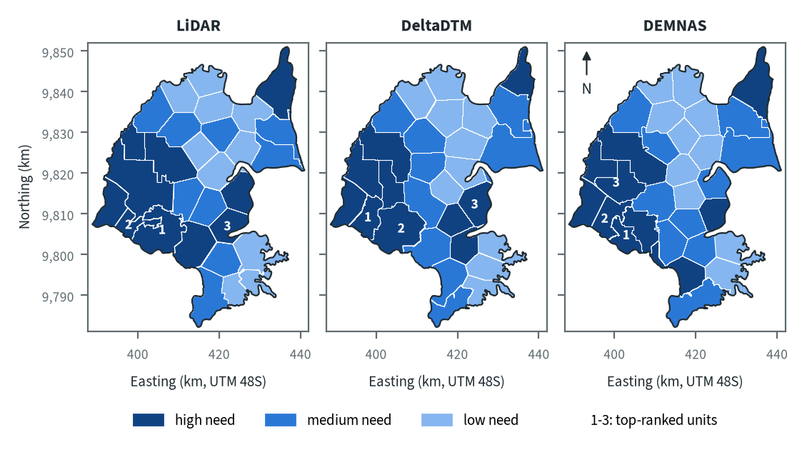
Figure 10.24. Air Hitam Laut-Buntu Kecil: need for intervention per sub-KHG, by elevation model. Source: sub-KHG prioritisation with default weights
With the default weights proposed for agreement with KLH and the World Bank, the high-need units lie in the west and south-west, where the canal grid is densest, and at the north-eastern tip, which also has canals; the central north, where few canals are mapped, is low need on every model. The same broad pattern appears on all three models. On LiDAR and DeltaDTM two of the three top-ranked units lie in the south-west and the third in the centre south, while DEMNAS places all three in the west, one of them further north.
Table 10.34. Air Hitam Laut-Buntu Kecil: high-need area and agreement of the priority classes between elevation models. Source: sub-KHG prioritisation with default weights
Elevation model or pair | High need (units, km²) | Overlap (km²) | Same need class (% of overlap) | High need in first also high in second (%) | Spearman of scores, area-weighted
LiDAR | 10, 777
DeltaDTM | 10, 645
DEMNAS | 10, 653
LiDAR and DeltaDTM |  | 1,836 | 76 | 76 | 0.85
LiDAR and DEMNAS |  | 1,836 | 73 | 77 | 0.84
DeltaDTM and DEMNAS |  | 1,837 | 78 | 80 | 0.84
Units are matched by location, since each model has its own units. Shares are of the area both models cover. Default weights, proposed for agreement with KLH and the World Bank.
Every model gives 10 high-need units, covering 777 km² on LiDAR against 645 km² on DeltaDTM and 653 km² on DEMNAS. Between models 73 to 78 % of the area keeps its need class and the area-weighted Spearman correlation of scores is 0.84 to 0.85. The largest difference is the extra 124 to 132 km² of high need on LiDAR, with the same number of units: the class goes to whole units, and LiDAR's high-need units are larger on average (77.7 km² against 64.5 and 65.3 km²).

Canal blocks and pumping
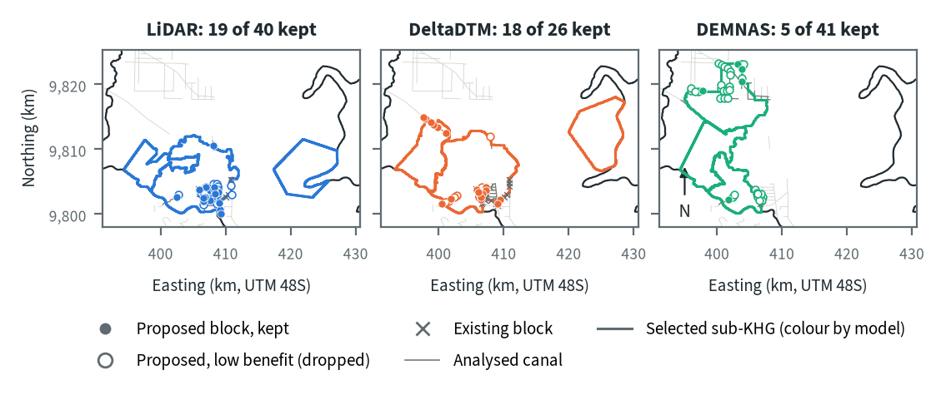
Figure 10.25. Air Hitam Laut-Buntu Kecil: proposed canal blocks in the three highest-ranked sub-KHG, by elevation model. Source: RE-PEAT Interventions on each elevation model, mapped canals and existing blocks
New sekat kanal (canal blocks) can only go on analysed canals, and in the selected units these lie in the south-west, so the unit in the centre south that LiDAR and DeltaDTM select receives none. On LiDAR the proposed blocks cluster on the canal grid in the southern part of the western unit, beside existing blocks, and 19 of 40 are kept. DeltaDTM places blocks on the same grid and on canals further north-west, keeping 18 of 26. DEMNAS selects different units and puts most of its 41 proposed blocks on a canal grid in the northern part of those units, of which only 5 are kept; the rest are dropped as low benefit.
Table 10.35. Air Hitam Laut-Buntu Kecil: canal blocks, water held and budget, by elevation model. Source: RE-PEAT Interventions and sub-KHG prioritisation on each elevation model
Quantity | LiDAR | DeltaDTM | DEMNAS
Selected sub-KHG (top 3 by priority) | S23, S21, S22 | S20, S22, S19 | S24, S21, S15
Blocks needed by the slope rule of the ranking, whole KHG (n) | 1,543 | 1,012 | 2,616
Existing blocks counted by the ranking, whole KHG (n) | 201 | 201 | 201
Existing blocks on analysed canals (n) | 18 | 18 | 6
Blocks proposed by the head rule (n) | 40 | 26 | 41
Blocks kept, 90% of the water-level rise (n) | 19 | 18 | 5
Pump units (n) | pumping not assessed | pumping not assessed | pumping not assessed
Water held by kept blocks (million m³) | 0.74 | 0.30 | 1.39
Deficit of the selected units (million m³) | 38.9 | 46.7 | 33.9
Budget, low / central / high (billion Rp) | 7 / 11 / 14 | 12 / 18 / 22 | 17 / 26 / 31
of which revegetation of burned land, central (billion Rp) | 11 | 18 | 22
Blocks, water and budget are for the three highest-ranked sub-KHG of each model, which can differ between models. Kept: the fewest proposed blocks giving 90% of the water-level rise of all proposed blocks. Pumping is not assessed in these results. Default weights, proposed for agreement with KLH and the World Bank.
The kept blocks hold 0.74 million m³ on LiDAR, 0.30 million m³ on DeltaDTM and 1.39 million m³ on DEMNAS, against a deficit of the selected units of 38.9, 46.7 and 33.9 million m³: about 1.9 %, 0.6 % and 4.1 % of it. The 5 DEMNAS blocks hold the most water, which matches chapter 9's finding that much of the rise DEMNAS shows along a canal is likely noise. The central budget is 11 billion Rp on LiDAR, 18 billion Rp on DeltaDTM and 26 billion Rp on DEMNAS. Revegetation of burned land makes up 11, 18 and 22 billion Rp of these, so the budget follows how much burned land the selected units hold rather than the number of blocks. Pumping was not assessed in this analysis.

How the elevation model changes the result
Table 10.36. Air Hitam Laut-Buntu Kecil: headline outputs by elevation model and their spread. Source: RE-PEAT results on each elevation model
Output | LiDAR | DeltaDTM | DEMNAS | Spread
Sub-KHG units (n) | 29 | 29 | 30 | ×1.0
Median unit area (km²) | 56 | 57 | 56 | ×1.0
Area covered by units (km²) | 1,835 | 1,836 | 1,836 | ×1.0
Climatic balance, area mean (mm/month) | 66.8 | 66.9 | 66.8 | range 0.0
High-need area (km²) | 777 | 645 | 653 | ×1.2
High-need units (n) | 10 | 10 | 10 | ×1.0
Blocks needed, slope rule of the ranking, whole KHG (n) | 1,543 | 1,012 | 2,616 | ×2.6
Blocks proposed, head rule (n) | 40 | 26 | 41 | ×1.6
Blocks kept (n) | 19 | 18 | 5 | ×3.8
Water held by kept blocks (million m³) | 0.74 | 0.30 | 1.39 | ×4.6
Budget, central (billion Rp) | 11 | 18 | 26 | ×2.3
Spread: largest value over smallest across the models (range for the balance). Blocks kept, water and budget refer to the three highest-ranked sub-KHG of each model, so they move with the choice of units as well as with the terrain. Default weights, proposed for agreement with KLH and the World Bank.
The number and size of units, the area they cover, the climatic balance and the number of high-need units barely move with the elevation model, and the station deficit does not depend on it. The outputs that rest on canal slopes move most. Blocks needed by the slope rule of the ranking over the whole KHG range from 1,012 on DeltaDTM to 2,616 on DEMNAS (a factor of 2.6), with LiDAR at 1,543; this is the one KHG of the five where DeltaDTM gives fewer than LiDAR (chapter 10), probably because its 30 m grid smooths canal-scale slopes. Blocks kept differ by a factor of 3.8, water held by 4.6 and the central budget by 2.3, and these also move because each model selects different sub-KHG.
LiDAR covers the whole KHG, so decisions here should rest on the LiDAR results. DeltaDTM is the closer of the two open models in height (an offset of 0.95 m with an NMAD of 0.71 m), but its units agree with LiDAR no better than DEMNAS's do, and DEMNAS's local error of 1.86 m is several times the 0.40 m head step used to place blocks.

Summary for this KHG
Air Hitam Laut-Buntu Kecil lost 211 mm of water, 386 million m³, in the 2026 dry season, and the high-need units sit on the dense canal grid of the west and south-west and at the north-eastern tip. On the recommended LiDAR model, RE-PEAT Interventions keeps 19 of 40 proposed blocks in the three top-ranked units; they hold 0.74 million m³, about 1.9 % of those units' deficit, so blocking alone will not close the deficit. The central budget is 11 billion Rp, almost all of it for revegetation of burned land. The choice of elevation model changes the blocks, the water held and the budget by factors of 2.3 to 4.6, partly through different selected units, while the deficit, the balance and the broad pattern of need hardly change. Pumping was not assessed, the order of units by climatic balance could not be used, and mapped rivers are missing for this KHG.

10.7 Mempawah-Peniti (KHG 61.02-08.01)
Table 10.37. Mempawah-Peniti: key facts. Source: national KHG profile, national canal and structures layers, RE-PEAT results for this KHG
Item | Value
Province | Kalimantan Barat
Area of the KHG polygon (km²) | 510
Peat area (km²) | 376
National rank (class) | 22 of 476 (high priority)
Canals, primary / secondary / tertiary (km) | 212 / 1,282 / 3,422
Existing water-management structures, all types (n) | 264
SiTMAT water-table stations (n) | 0
Realised canal blocks inside the KHG (n) | 0
LiDAR cover of the KHG (%) | no LiDAR covers this KHG
Elevation model ready, by elevation model | DeltaDTM, DEMNAS
Sub-KHG units, by elevation model | DeltaDTM, DEMNAS
Water balance, by elevation model | DeltaDTM, DEMNAS
Priority of sub-KHG, by elevation model | DeltaDTM, DEMNAS
Canal blocks and costs, by elevation model | DeltaDTM, DEMNAS
Dry-season deficit from stations | not computed
Rank among ranked KHG with default weights, proposed for agreement with KLH and the World Bank. Canals: mapped canal network. Structures and realised canal blocks: national layer of existing water-management structures (all types, and the canal blocks recorded as realised).
Mempawah-Peniti is a KHG (Kesatuan Hidrologis Gambut, peat hydrological unit) in Kalimantan Barat. It covers 510 km², of which 376 km² is peat. It ranks 21 of 476 ranked KHG nationally (high priority) with the default weights proposed for agreement with KLH and the World Bank, and rises to 10 when this year's hotspots are weighed more, to 6 when canals are weighed more and to 3 with equal weights (chapter 6). It is at the 98th percentile for this year's hotspots and for secondary and tertiary canal density, and 6.0 % of its peat has burned in the part of 2026 covered so far, more than in any full year since 2015. None of its 691 hotspots on peat this year fell inside a licence area. The mapped network has 212 km of primary, 1,282 km of secondary and 3,422 km of tertiary canals, and the national layer records 264 water-management structures but no canal block recorded as realised. No LiDAR covers the KHG and no SiTMAT water-table station lies inside it, so the chain ran on corrected DeltaDTM and corrected DEMNAS only and no station deficit could be computed.

Terrain and the three elevation models
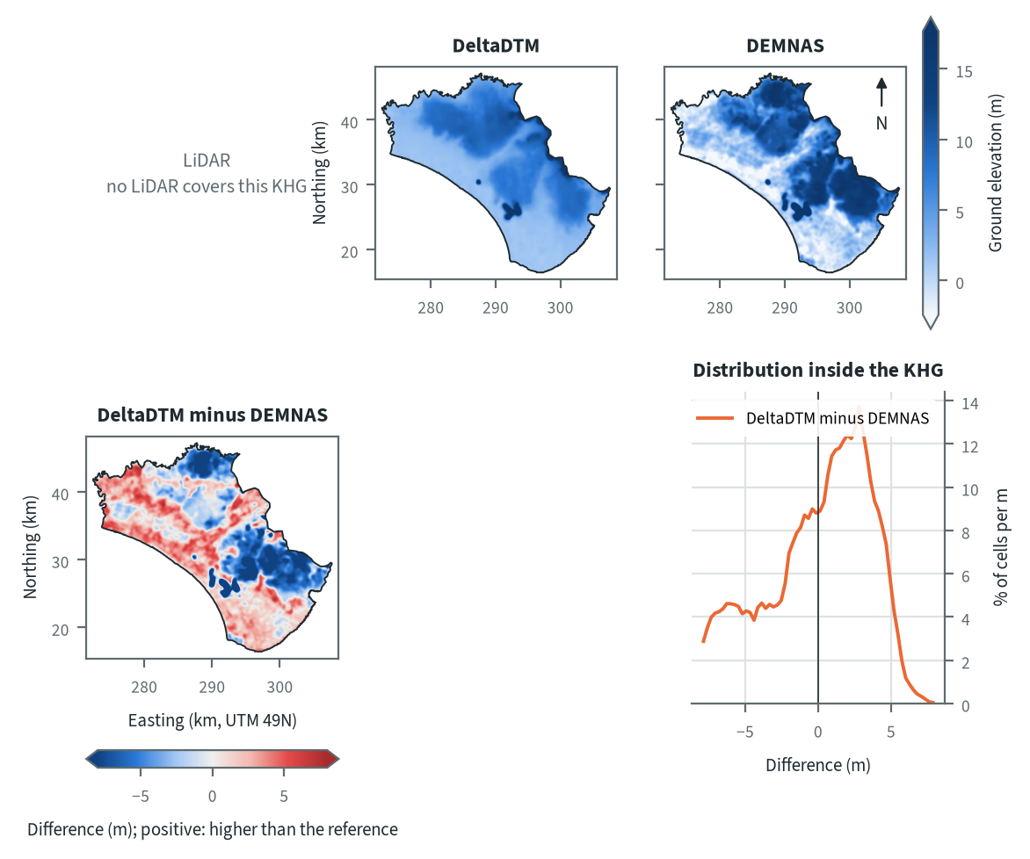
Figure 10.26. Mempawah-Peniti: ground elevation from each elevation model on one colour scale, and their differences. Source: LiDAR terrain model, DeltaDTM and DEMNAS after the DEM correction
Both models show a low coastal plain in the south-west that rises towards the north and east, but they disagree on how high. DeltaDTM shows a gentle high in the north and a broad rise in the east, while DEMNAS shows the north and the east-centre as large dark blocks and low values along the south-west coast. The difference map has two large areas, one in the north and one in the east, where DEMNAS stands well above DeltaDTM, and a band across the west and centre where DeltaDTM is higher. DEMNAS is more than 2 m above DeltaDTM over 31 % of the KHG and more than 2 m below it over 33 %. The blocky outlines of the northern and eastern patches suggest surface cover left in DEMNAS after the correction (chapter 4 found its errors largest under tree cover and cropland at Sugihan-Lumpur), but with no LiDAR here this cannot be confirmed. DeltaDTM is defined only for land below 10 m above mean sea level (chapter 4), so the highest ground of this KHG lies at the edge of its range.
Table 10.38. Mempawah-Peniti: resolution, cover and relief of each elevation model, and its difference to LiDAR. Source: LiDAR terrain model, DeltaDTM and DEMNAS after the DEM correction
Elevation model | Source | Resolution (m) | Cover of the KHG (%) | Relief, 5th-95th percentile (m)
LiDAR | no LiDAR covers this KHG
DeltaDTM | DeltaDTM v1.1 (global coastal terrain model), after the DEM correction | 30 | 100 | 1.5 to 10.4
DEMNAS | DEMNAS (BIG national surface model), after the DEM correction | 8 | 100 | -2.2 to 16.6
Statistics over the KHG polygon on a common 30 m grid (the DeltaDTM grid; finer models averaged onto it). NMAD: normalised median absolute deviation, a spread measure robust to outliers. Where LiDAR covers only part of the KHG, differences are over that part.
Relief between the 5th and 95th percentiles is 1.5 to 10.4 m on DeltaDTM (30 m cells) and -2.2 to 16.6 m on DEMNAS (8 m cells), a span of 8.9 m against 18.8 m. With no LiDAR the difference to LiDAR cannot be given. The histogram of DeltaDTM minus DEMNAS peaks at +2.80 m and is broad, with a 5th percentile of -8.8 m. A constant datum offset would give a narrow peak, so much of the difference is local and changes the slopes along canals, which the canal-block step uses. Over 1 km, the error against LiDAR was 0.47 to 0.64 m for DeltaDTM and between 1.66 and 2.49 m for DEMNAS, FABDEM and GLO-30 at the two LiDAR KHG (chapter 4), so block counts here should be read as a range between the two models.

Sub-KHG units
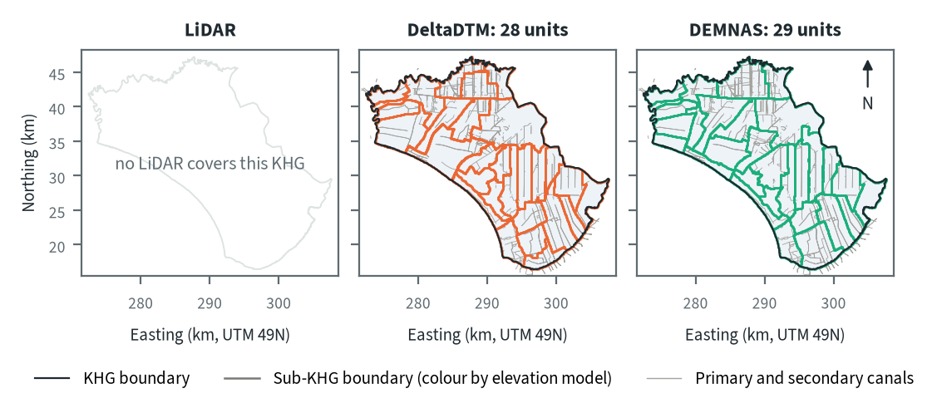
Figure 10.27. Mempawah-Peniti: sub-KHG units delineated on each elevation model. Source: sub-KHG delineation on each elevation model, mapped canals
DeltaDTM gives 28 sub-KHG units and DEMNAS 29. The dense canal grid, with long straight canals running north to south in the east, sets many boundaries in both maps (chapter 5). The models draw the units differently in the north and the west, where the boundaries between canals follow terrain divides, and where the difference between the two surfaces moves the divides.
Table 10.39. Mempawah-Peniti: number and size of sub-KHG units, and agreement between elevation models (area in the best-matching unit, adjusted Rand index). Source: sub-KHG delineation on each elevation model
Elevation model or pair | Units (n) | Unit area, median (km²) | Unit area, range (km²) | Units total (km²) | Overlap (km²) | Area in best-matching unit (%) | Adjusted Rand index
LiDAR | no LiDAR covers this KHG
DeltaDTM | 28 | 15 | 10 to 56 | 510
DEMNAS | 29 | 17 | 8 to 47 | 510
DeltaDTM and DEMNAS |  |  |  |  | 510 | 82 | 0.68
Pairs are compared over the area both cover. Best-matching unit: share of the overlap that lies in the unit of the other model it overlaps most, averaged over both directions. Adjusted Rand index: 1 for identical partitions, about 0 for chance agreement; computed on 1 ha cells.
DeltaDTM and DEMNAS share 82 % of the area in best-matching units, with an adjusted Rand index of 0.68. At Sugihan-Lumpur the three pairs scored 0.60 to 0.66 (a flat surface with the mapped canals gave 0.601, chapter 5), so the layout here is held together by the canals and the two models agree a little more than there. Median unit area is 15 km² on DeltaDTM and 17 km² on DEMNAS, with ranges of 10 to 56 and 8 to 47 km². Only one pair exists, so no pair stands out.

Water balance and deficit
Table 10.40. Mempawah-Peniti: dry-season deficit from water-table stations and climatic balance per sub-KHG. Source: SiTMAT water-table stations, CHIRPS rain, MOD16 and WaPOR evapotranspiration
Quantity | All models | LiDAR | DeltaDTM | DEMNAS
Dry-season deficit from stations | not computed: no water-table station inside the KHG
Sub-KHG units (n) |  | no LiDAR covers this KHG | 28 | 29
Climatic balance, MOD16, area mean (mm/month) |  | no LiDAR covers this KHG | 62.9 | 63.0
Climatic balance, unit range (mm/month) |  | no LiDAR covers this KHG | 55.2 to 77.4 | 55.9 to 74.6
Climatic balance, WaPOR, area mean (mm/month) |  | no LiDAR covers this KHG | 101.4 | 101.4
Deficit months per year, area mean |  | no LiDAR covers this KHG | 2.40 | 2.40
Order of units usable (ET products agree) |  | no LiDAR covers this KHG | no | no
The station deficit uses water-table stations and reanalysis rain and evaporation (band: specific yield 0.10 to 0.20) and does not depend on the elevation model. The climatic balance is CHIRPS rain minus evapotranspiration, 2018-2025, per sub-KHG of each model.
No dry-season deficit from stations is given, because no water-table station lies inside the KHG. The climatic balance (CHIRPS rain minus evapotranspiration, 2018 to 2025) averages 62.9 mm/month over the DeltaDTM units and 63.0 mm/month over the DEMNAS units, with 2.40 deficit months per year on both. The order of units by balance is not usable with either model, because the two evapotranspiration products do not agree on the order of the units (chapter 8); they also differ in level, with WaPOR at 101.4 mm/month on both unit sets against 62.9 and 63.0 with MOD16. The unit balances (55.2 to 77.4 mm/month on DeltaDTM, 55.9 to 74.6 on DEMNAS) are therefore shown as a range and not used as a ranking.
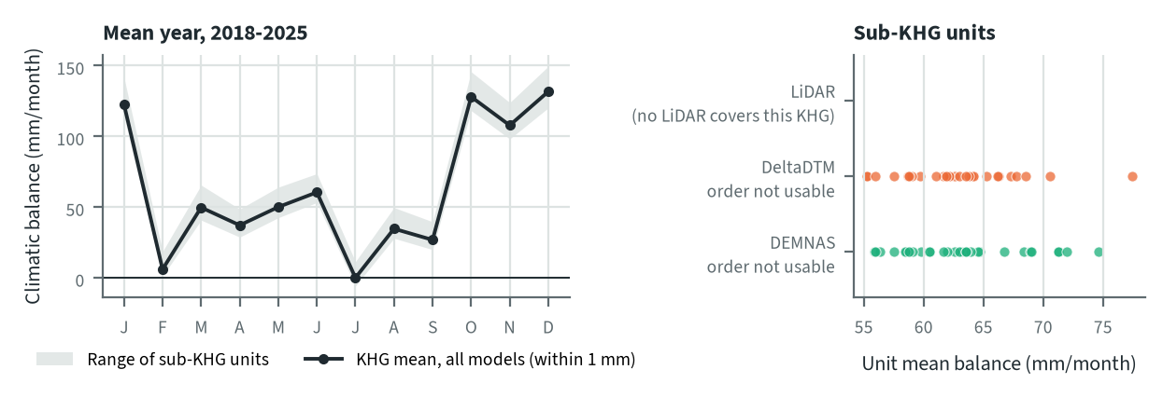
Figure 10.28. Mempawah-Peniti: climatic balance through the mean year, and the balance of each sub-KHG, by elevation model. Source: CHIRPS rain and MOD16 evapotranspiration, 2018-2025
In the mean year the balance falls to 0 mm/month in July and 6 mm/month in February, and stays low in August and September (35 and 27 mm/month). October to January are the wet months, at 108 to 132 mm/month. The elevation model changes the KHG balance by only 0.1 mm/month, because it enters only through the unit boundaries, which average the same rain and evapotranspiration grids over different areas.

Priority of sub-KHG
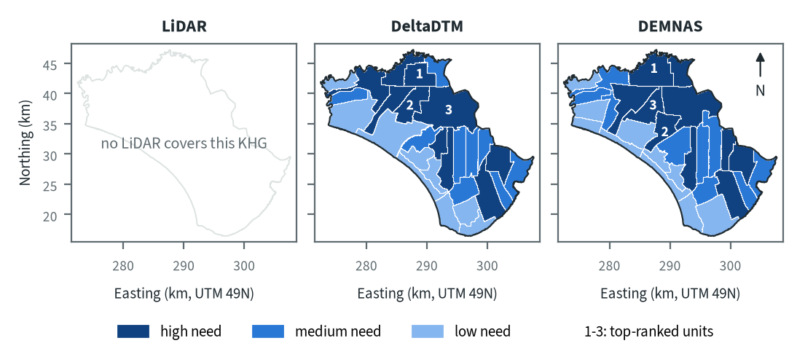
Figure 10.29. Mempawah-Peniti: need for intervention per sub-KHG, by elevation model. Source: sub-KHG prioritisation with default weights
With the default weights proposed for agreement with KLH and the World Bank, high-need units form a block in the north and centre-north, a row of long narrow units east of the centre and a group near the south-east coast, while the south-west coast is low need on both models. The first-ranked unit lies in the north on both models. The second and third lie in the west-centre and the centre-north on DeltaDTM, and in the centre and the centre-north on DEMNAS. The rank of the KHG rises when this year's hotspots or canals weigh more (chapter 6), which fits the dense network and the 2026 burn.
Table 10.41. Mempawah-Peniti: high-need area and agreement of the priority classes between elevation models. Source: sub-KHG prioritisation with default weights
Elevation model or pair | High need (units, km²) | Overlap (km²) | Same need class (% of overlap) | High need in first also high in second (%) | Spearman of scores, area-weighted
LiDAR | no LiDAR covers this KHG
DeltaDTM | 10, 229
DEMNAS | 10, 232
DeltaDTM and DEMNAS |  | 510 | 82 | 83 | 0.83
Units are matched by location, since each model has its own units. Shares are of the area both models cover. Default weights, proposed for agreement with KLH and the World Bank.
High-need area is 229 km² (10 units) on DeltaDTM and 232 km² (10 units) on DEMNAS. 82 % of the overlap keeps its need class, 83 % of the high-need area in DeltaDTM is also high need in DEMNAS, and the area-weighted Spearman of the scores is 0.83. This is higher than the 57 to 65 % at Sugihan-Lumpur. The differences come from the units, since each model groups the same fire, canal and dryness data into different shapes, and the top three units are not the same units on the two models.

Canal blocks and pumping
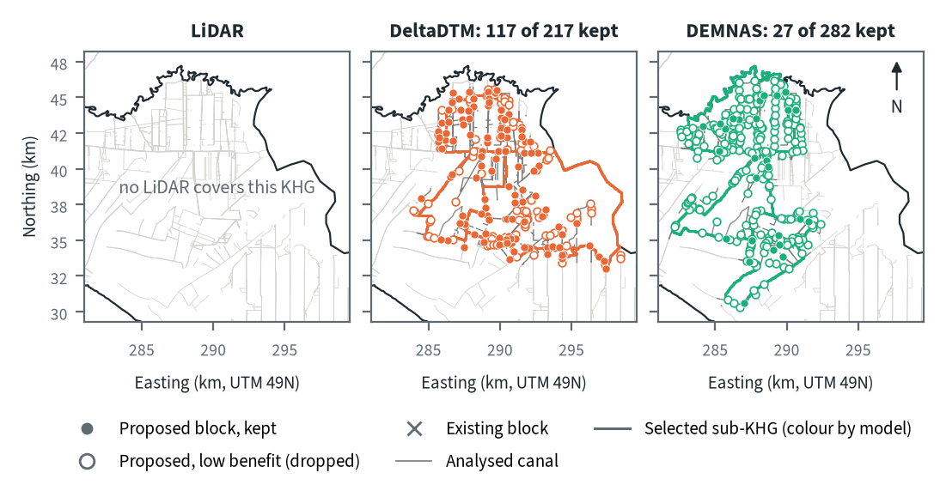
Figure 10.30. Mempawah-Peniti: proposed canal blocks in the three highest-ranked sub-KHG, by elevation model. Source: RE-PEAT Interventions on each elevation model, mapped canals and existing blocks
The three selected sub-KHG differ between the models: S03, S07 and S08 on DeltaDTM, S01, S12 and S06 on DEMNAS. DeltaDTM puts its blocks in the north and the west-centre, while the DEMNAS blocks follow a long strip from the north towards the south. The head rule proposes 217 blocks on DeltaDTM and 282 on DEMNAS (×1.3), and the 90 % balance then keeps 117 of the 217 (54 %) on DeltaDTM but only 27 of the 282 (10 %) on DEMNAS. The larger height steps along DEMNAS canals probably put most of the water-level rise into a few blocks, so the other 255 add little and are dropped. On DeltaDTM the rise is spread over more blocks. No existing block is counted on any analysed canal, so every kept block is new.
Table 10.42. Mempawah-Peniti: canal blocks, water held and budget, by elevation model. Source: RE-PEAT Interventions and sub-KHG prioritisation on each elevation model
Quantity | LiDAR | DeltaDTM | DEMNAS
Selected sub-KHG (top 3 by priority) | no LiDAR covers this KHG | S03, S07, S08 | S01, S12, S06
Blocks needed by the slope rule of the ranking, whole KHG (n) | no LiDAR covers this KHG | 4,586 | 18,544
Existing blocks counted by the ranking, whole KHG (n) | no LiDAR covers this KHG | 0 | 0
Existing blocks on analysed canals (n) | no LiDAR covers this KHG | 0 | 0
Blocks proposed by the head rule (n) | no LiDAR covers this KHG | 217 | 282
Blocks kept, 90% of the water-level rise (n) | no LiDAR covers this KHG | 117 | 27
Pump units (n) | no LiDAR covers this KHG | pumping not assessed | pumping not assessed
Water held by kept blocks (million m³) | no LiDAR covers this KHG | 2.18 | 6.97
Deficit of the selected units (million m³) | no LiDAR covers this KHG | - | -
Budget, low / central / high (billion Rp) | no LiDAR covers this KHG | 30 / 44 / 44 | 105 / 158 / 158
of which revegetation of burned land, central (billion Rp) | no LiDAR covers this KHG | - | 1
Blocks, water and budget are for the three highest-ranked sub-KHG of each model, which can differ between models. Kept: the fewest proposed blocks giving 90% of the water-level rise of all proposed blocks. Pumping is not assessed in these results. Default weights, proposed for agreement with KLH and the World Bank.
Kept blocks hold 2.18 million m³ on DeltaDTM and 6.97 million m³ on DEMNAS (×3.2), or 0.019 and 0.26 million m³ per kept block, a ratio of about 14. The deficit of the selected units is not available without a station deficit, so the water held is not compared with it. The central budget is 44 billion Rp on DeltaDTM (30 low) and 158 billion Rp on DEMNAS (105 low). Revegetation of burned land is 1 billion Rp of the DEMNAS total and is not shown for DeltaDTM, so it is not the main item, and the table does not itemise the rest (chapter 9 lists the budget items; blocks outside the selected units are priced from an estimate of missing blocks). The budget ratio of ×3.6 is close to the ×4.0 ratio in blocks needed by the slope rule over the whole KHG (4,586 on DeltaDTM, 18,544 on DEMNAS) and moves opposite to the blocks kept. Pumping was not assessed.

How the elevation model changes the result
Table 10.43. Mempawah-Peniti: headline outputs by elevation model and their spread. Source: RE-PEAT results on each elevation model
Output | LiDAR | DeltaDTM | DEMNAS | Spread
Sub-KHG units (n) | no LiDAR covers this KHG | 28 | 29 | ×1.0
Median unit area (km²) | no LiDAR covers this KHG | 16 | 17 | ×1.1
Area covered by units (km²) | no LiDAR covers this KHG | 511 | 511 | ×1.0
Climatic balance, area mean (mm/month) | no LiDAR covers this KHG | 62.9 | 63.0 | range 0.1
High-need area (km²) | no LiDAR covers this KHG | 229 | 232 | ×1.0
High-need units (n) | no LiDAR covers this KHG | 10 | 10 | ×1.0
Blocks needed, slope rule of the ranking, whole KHG (n) | no LiDAR covers this KHG | 4,586 | 18,544 | ×4.0
Blocks proposed, head rule (n) | no LiDAR covers this KHG | 217 | 282 | ×1.3
Blocks kept (n) | no LiDAR covers this KHG | 117 | 27 | ×4.3
Water held by kept blocks (million m³) | no LiDAR covers this KHG | 2.18 | 6.97 | ×3.2
Budget, central (billion Rp) | no LiDAR covers this KHG | 44 | 158 | ×3.6
Spread: largest value over smallest across the models (range for the balance). Blocks kept, water and budget refer to the three highest-ranked sub-KHG of each model, so they move with the choice of units as well as with the terrain. Default weights, proposed for agreement with KLH and the World Bank.
The KHG balance (62.9 and 63.0 mm/month), the number of units (28 and 29) and the high-need area (229 and 232 km², 10 units on both) barely move. Outputs that depend on canal slopes move most: blocks needed by the slope rule over the whole KHG by ×4.0, blocks kept by ×4.3 (more on DeltaDTM), water held by ×3.2 and the central budget by ×3.6. Blocks, water and budget refer to the three selected sub-KHG, which differ between models, so they move with the choice of units as well as with the terrain.
With no LiDAR there is no measured error for either model here. Chapter 4 recommends processed DeltaDTM as the closer model for a KHG without LiDAR, with a measured error of 0.47 to 0.64 m over 1 km, so DeltaDTM is the model to use for decisions, with DEMNAS read as the upper end of the range for water held and cost. DEMNAS plans a few high-benefit blocks on a surface that probably carries canopy and cropland in the north and east, and chapter 9 concludes that DEMNAS block counts should not be taken as a design.

Summary for this KHG
Mempawah-Peniti is a high-priority KHG (rank 21 of 476) with a dense canal network and a large share of its peat burned this year. The two models agree on the climatic balance (about 63 mm/month, 2.40 deficit months a year), on the high-need area (229 to 232 km², 10 units) and broadly on where the high-need units lie (82 % of the area keeps its class). They disagree on the plan: DeltaDTM keeps 117 blocks holding 2.18 million m³ for a central budget of 44 billion Rp, and DEMNAS keeps 27 blocks holding 6.97 million m³ for 158 billion Rp, in different sub-KHG, so block counts should be read as a range between the two and DeltaDTM used for decisions. Still missing are LiDAR or a levelled reference to measure the error here, a water-table station to give the station deficit, a usable order of units by balance, and pumping, which was not assessed.

10.8 Pungurbesar-Kapuas (KHG 61.12-71.01)
Table 10.44. Pungurbesar-Kapuas: key facts. Source: national KHG profile, national canal and structures layers, RE-PEAT results for this KHG
Item | Value
Province | Kalimantan Barat
Area of the KHG polygon (km²) | 1,013
Peat area (km²) | 744
National rank (class) | 1 of 476 (high priority)
Canals, primary / secondary / tertiary (km) | 379 / 1,537 / 2,871
Existing water-management structures, all types (n) | 521
SiTMAT water-table stations (n) | 5
Realised canal blocks inside the KHG (n) | 395
LiDAR cover of the KHG (%) | no LiDAR covers this KHG
Elevation model ready, by elevation model | DeltaDTM, DEMNAS
Sub-KHG units, by elevation model | DeltaDTM, DEMNAS
Water balance, by elevation model | DeltaDTM, DEMNAS
Priority of sub-KHG, by elevation model | DeltaDTM, DEMNAS
Canal blocks and costs, by elevation model | DeltaDTM, DEMNAS
Dry-season deficit from stations | computed
Rank among ranked KHG with default weights, proposed for agreement with KLH and the World Bank. Canals: mapped canal network. Structures and realised canal blocks: national layer of existing water-management structures (all types, and the canal blocks recorded as realised).
Pungurbesar-Kapuas is a KHG (Kesatuan Hidrologis Gambut, peat hydrological unit) in Kalimantan Barat. It covers 1,013 km², of which 744 km² is peat. It ranks 1 of 476 ranked KHG nationally (high priority) with the default weights proposed for agreement with KLH and the World Bank, and stays in the top 7 when only fire history is weighed (chapter 6). Peat here burns in most years: 16.6 % of it in 2018, 11.0 % in 2023 and 8.0 % in the part of 2026 covered so far, and 1,825 hotspots fell on peat this year, 710 of them in March (chapter 6). The mapped network is dense, with 379 km of primary, 1,537 km of secondary and 2,871 km of tertiary canals, and the national layer records 521 water-management structures, 395 of them realised canal blocks. No LiDAR covers this KHG, so the chain ran on DeltaDTM and DEMNAS only, both after the DEM correction. Five SiTMAT water-table stations lie inside the KHG, and three of them give the station deficit.

Terrain and the three elevation models
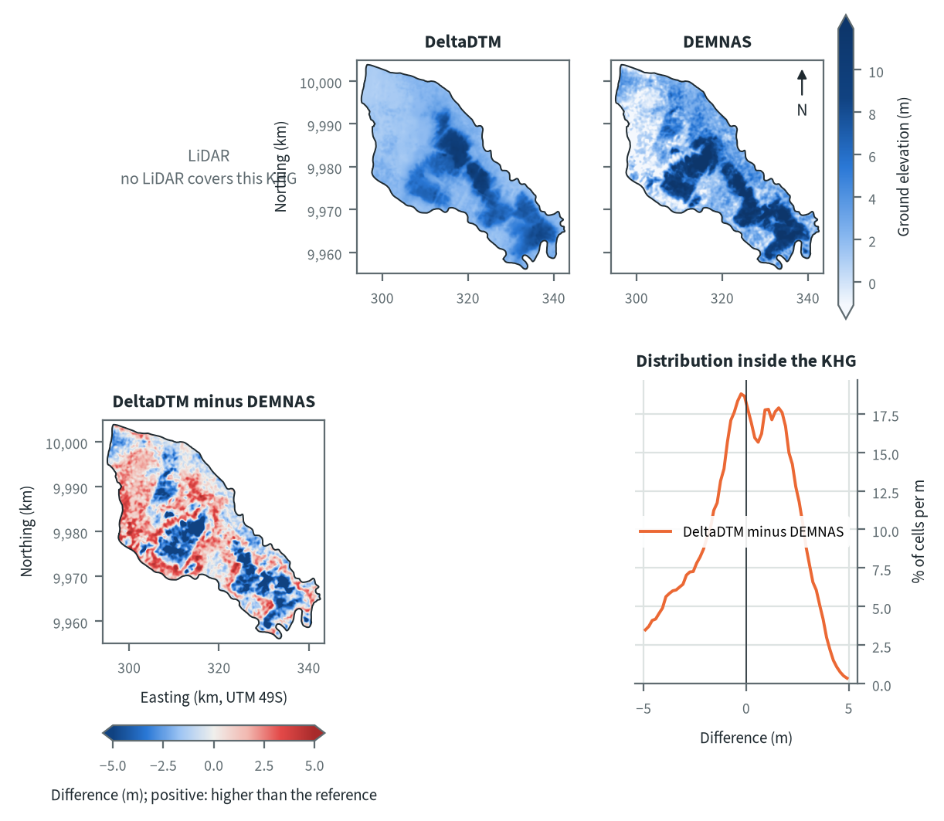
Figure 10.31. Pungurbesar-Kapuas: ground elevation from each elevation model on one colour scale, and their differences. Source: LiDAR terrain model, DeltaDTM and DEMNAS after the DEM correction
On DeltaDTM the KHG is a peat plain with a raised area in the centre and a second one towards the south-east along the long axis of the KHG, and the lowest ground lies in the north-west and at the south-eastern tip. DEMNAS shows the same pattern with more contrast: its elevation runs from -0.9 to 11.5 m between the 5th and 95th percentiles, against 1.2 to 8.4 m on DeltaDTM. The difference map shows blocky patches where DEMNAS stands above DeltaDTM, and the opposite sign along the western and south-western margin and in the north. DEMNAS is more than 2 m above DeltaDTM over 22 % of the KHG and more than 2 m below it over 18 %. Patches of this shape follow canopy and land cover more than terrain; at the two LiDAR KHG the correction removed only part of the canopy from DEMNAS, which stayed worst under tree cover and cropland (chapter 4). The same cause is the likely one here, but with no LiDAR it cannot be tested.
Table 10.45. Pungurbesar-Kapuas: resolution, cover and relief of each elevation model, and its difference to LiDAR. Source: LiDAR terrain model, DeltaDTM and DEMNAS after the DEM correction
Elevation model | Source | Resolution (m) | Cover of the KHG (%) | Relief, 5th-95th percentile (m)
LiDAR | no LiDAR covers this KHG
DeltaDTM | DeltaDTM v1.1 (global coastal terrain model), after the DEM correction | 30 | 100 | 1.2 to 8.4
DEMNAS | DEMNAS (BIG national surface model), after the DEM correction | 8 | 100 | -0.9 to 11.5
Statistics over the KHG polygon on a common 30 m grid (the DeltaDTM grid; finer models averaged onto it). NMAD: normalised median absolute deviation, a spread measure robust to outliers. Where LiDAR covers only part of the KHG, differences are over that part.
Relief between the 5th and 95th percentiles is 1.2 to 8.4 m on DeltaDTM (7.2 m) and -0.9 to 11.5 m on DEMNAS (12.4 m, 1.7 times wider). With no LiDAR there is no difference to LiDAR to report, so the error of each model cannot be measured here. At the two KHG that do have LiDAR, the processed models sat 0.6 to 1.0 m above the LiDAR as a constant offset that does not change slopes, and the error of DeltaDTM over 1 km was 0.64 and 0.47 m, against 1.66 and 2.19 m for DEMNAS (chapter 4). If the same holds here, DEMNAS slopes are the less reliable input to the delineation and the canal-block step, and block counts from the two models should be read as a range.

Sub-KHG units
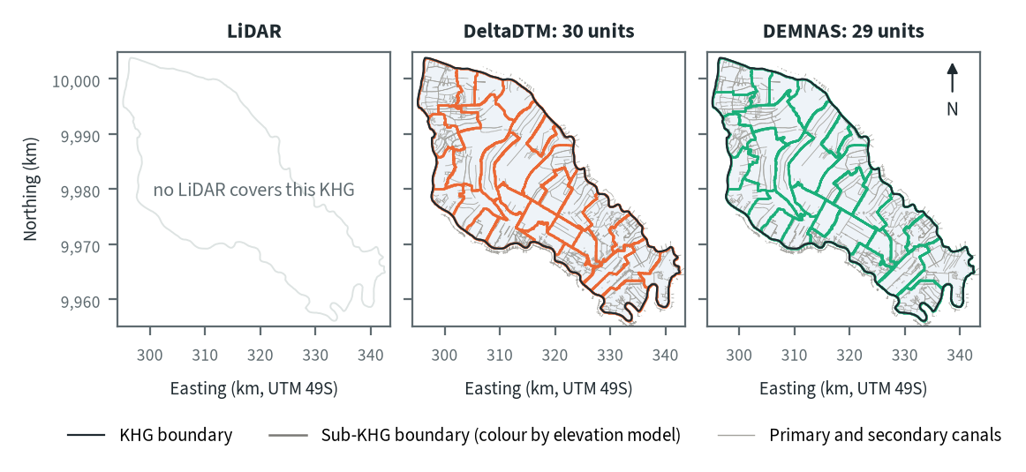
Figure 10.32. Pungurbesar-Kapuas: sub-KHG units delineated on each elevation model. Source: sub-KHG delineation on each elevation model, mapped canals
DeltaDTM gives 30 sub-KHG units and DEMNAS 29, with median areas of 28 and 31 km² and ranges of 18 to 93 and 19 to 92 km². The units are far smaller than at Sugihan-Lumpur because the canal network is dense (4,787 km of canals in 1,013 km², about 4.7 km per km², a ratio of the figures shown), and most unit boundaries follow the canal lines that run across the KHG. The two models draw the larger units in the north-west and around the central dome differently, where canals are further apart and terrain divides decide the boundary.
Table 10.46. Pungurbesar-Kapuas: number and size of sub-KHG units, and agreement between elevation models (area in the best-matching unit, adjusted Rand index). Source: sub-KHG delineation on each elevation model
Elevation model or pair | Units (n) | Unit area, median (km²) | Unit area, range (km²) | Units total (km²) | Overlap (km²) | Area in best-matching unit (%) | Adjusted Rand index
LiDAR | no LiDAR covers this KHG
DeltaDTM | 30 | 28 | 18 to 93 | 1,013
DEMNAS | 29 | 31 | 19 to 92 | 1,013
DeltaDTM and DEMNAS |  |  |  |  | 1,013 | 88 | 0.79
Pairs are compared over the area both cover. Best-matching unit: share of the overlap that lies in the unit of the other model it overlaps most, averaged over both directions. Adjusted Rand index: 1 for identical partitions, about 0 for chance agreement; computed on 1 ha cells.
DeltaDTM and DEMNAS share 88 % of the area in best-matching units, with an adjusted Rand index of 0.79. This is higher than the 0.60 to 0.66 found between the three models at Sugihan-Lumpur (chapter 5), which fits the denser canal network here: the canals fix most of the layout and the terrain moves only some divides. There is no LiDAR layout to compare with, so the agreement shows that the choice of model matters little for the units, and does not show that either is correct.

Water balance and deficit
Table 10.47. Pungurbesar-Kapuas: dry-season deficit from water-table stations and climatic balance per sub-KHG. Source: SiTMAT water-table stations, CHIRPS rain, MOD16 and WaPOR evapotranspiration
Quantity | All models | LiDAR | DeltaDTM | DEMNAS
Dry-season deficit from 3 stations, 01 Jun to 15 Oct 2026 (mm) | 132 (122 to 143)
Deficit volume over the KHG (million m³) | 134
Months in deficit in that window (n) | 3
Sub-KHG units (n) |  | no LiDAR covers this KHG | 30 | 29
Climatic balance, MOD16, area mean (mm/month) |  | no LiDAR covers this KHG | 91.3 | 91.3
Climatic balance, unit range (mm/month) |  | no LiDAR covers this KHG | 78.3 to 132.0 | 76.2 to 129.0
Climatic balance, WaPOR, area mean (mm/month) |  | no LiDAR covers this KHG | 123.3 | 123.3
Deficit months per year, area mean |  | no LiDAR covers this KHG | 1.42 | 1.45
Order of units usable (ET products agree) |  | no LiDAR covers this KHG | yes | yes
The station deficit uses water-table stations and reanalysis rain and evaporation (band: specific yield 0.10 to 0.20) and does not depend on the elevation model. The climatic balance is CHIRPS rain minus evapotranspiration, 2018-2025, per sub-KHG of each model.
From 1 June to 15 October 2026, three stations give a dry-season deficit of 132 mm (122 to 143 mm for a specific yield of 0.10 to 0.20), or 134 million m³ over the KHG, with 3 months in deficit in that window. The deficit does not depend on the elevation model. With only three stations it describes the managed land around them and cannot show differences between sub-KHG. The order of units by climatic balance is usable on both unit sets, because the two evapotranspiration products agree, so no model fails the test here.
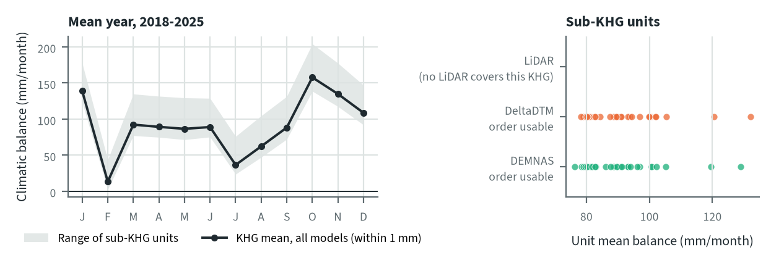
Figure 10.33. Pungurbesar-Kapuas: climatic balance through the mean year, and the balance of each sub-KHG, by elevation model. Source: CHIRPS rain and MOD16 evapotranspiration, 2018-2025
In the mean year the KHG balance is lowest in February (13 mm/month) and July (36 mm/month), and stays above zero in every month. In single years it is negative in 1.42 months (DeltaDTM units) to 1.45 months (DEMNAS units) on average. The KHG mean is 91.3 mm/month with MOD16 and 123.3 mm/month with WaPOR on both unit sets, so the elevation model does not change the balance of the KHG. It changes the spread between units slightly, from 78.3 to 132.0 mm/month on DeltaDTM units to 76.2 to 129.0 mm/month on DEMNAS units.

Priority of sub-KHG
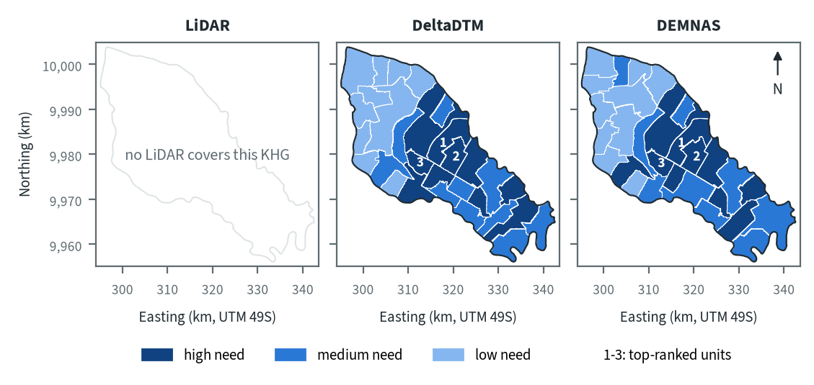
Figure 10.34. Pungurbesar-Kapuas: need for intervention per sub-KHG, by elevation model. Source: sub-KHG prioritisation with default weights
With the default weights proposed for agreement with KLH and the World Bank, high-need units form a band through the centre and the south-east on both models, and the north-west is mostly low need. The three top-ranked units lie next to each other in the centre, at the same places on both models. This pattern is consistent with the fire history of the KHG (chapter 6) and with the need score of chapter 7, which combines vegetation dryness, fire, peat depth and, where it is usable, the water balance.
Table 10.48. Pungurbesar-Kapuas: high-need area and agreement of the priority classes between elevation models. Source: sub-KHG prioritisation with default weights
Elevation model or pair | High need (units, km²) | Overlap (km²) | Same need class (% of overlap) | High need in first also high in second (%) | Spearman of scores, area-weighted
LiDAR | no LiDAR covers this KHG
DeltaDTM | 10, 379
DEMNAS | 10, 363
DeltaDTM and DEMNAS |  | 1,013 | 84 | 80 | 0.94
Units are matched by location, since each model has its own units. Shares are of the area both models cover. Default weights, proposed for agreement with KLH and the World Bank.
High-need area is 379 km² (10 units) on DeltaDTM and 363 km² (10 units) on DEMNAS. Of the area both models cover, 84 % keeps its need class, 80 % of the high-need area in one model is also high need in the other, and the area-weighted Spearman correlation of the scores is 0.94. The few units that change class lie at the edges of the high-need band and in the north-west, where the two models draw the unit boundaries differently.

Canal blocks and pumping
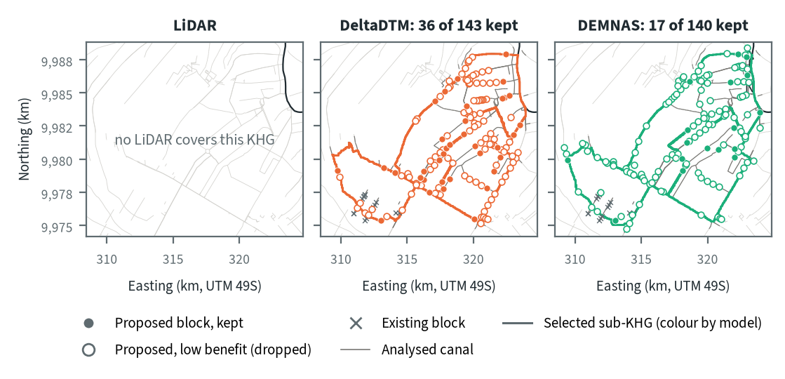
Figure 10.35. Pungurbesar-Kapuas: proposed canal blocks in the three highest-ranked sub-KHG, by elevation model. Source: RE-PEAT Interventions on each elevation model, mapped canals and existing blocks
The three selected sub-KHG lie in the centre-north of the KHG: S12, S13 and S14 on DeltaDTM, and S12, S14 and S17 on DEMNAS, so two of the three are shared. The sekat kanal (canal block) step proposes 143 blocks on DeltaDTM and 140 on DEMNAS along the primary and secondary canals where the canal falls, and keeps 36 and 17 of them for 90 % of the water-level rise; the other 107 and 123 add little and are dropped. The proposed blocks sit mostly along the outer canals of the units and on a few cross canals, and 15 existing blocks lie on the analysed canals (of 395 realised blocks in the KHG). The head-rule count is almost the same on both models, but DEMNAS keeps half as many blocks, so more of its proposed blocks add little rise.
Table 10.49. Pungurbesar-Kapuas: canal blocks, water held and budget, by elevation model. Source: RE-PEAT Interventions and sub-KHG prioritisation on each elevation model
Quantity | LiDAR | DeltaDTM | DEMNAS
Selected sub-KHG (top 3 by priority) | no LiDAR covers this KHG | S12, S13, S14 | S12, S14, S17
Blocks needed by the slope rule of the ranking, whole KHG (n) | no LiDAR covers this KHG | 4,896 | 17,432
Existing blocks counted by the ranking, whole KHG (n) | no LiDAR covers this KHG | 395 | 395
Existing blocks on analysed canals (n) | no LiDAR covers this KHG | 15 | 15
Blocks proposed by the head rule (n) | no LiDAR covers this KHG | 143 | 140
Blocks kept, 90% of the water-level rise (n) | no LiDAR covers this KHG | 36 | 17
Pump units (n) | no LiDAR covers this KHG | pumping not assessed | pumping not assessed
Water held by kept blocks (million m³) | no LiDAR covers this KHG | 4.25 | 7.41
Deficit of the selected units (million m³) | no LiDAR covers this KHG | 12.5 | 12.7
Budget, low / central / high (billion Rp) | no LiDAR covers this KHG | 23 / 34 / 34 | 129 / 193 / 193
of which revegetation of burned land, central (billion Rp) | no LiDAR covers this KHG | 0 | 0
Blocks, water and budget are for the three highest-ranked sub-KHG of each model, which can differ between models. Kept: the fewest proposed blocks giving 90% of the water-level rise of all proposed blocks. Pumping is not assessed in these results. Default weights, proposed for agreement with KLH and the World Bank.
The kept blocks hold 4.25 million m³ on DeltaDTM and 7.41 million m³ on DEMNAS, against a deficit of the selected units of 12.5 and 12.7 million m³, or 34 % and 58 % of it (ratios of the figures shown). The central budget is 34 billion Rp on DeltaDTM and 193 billion Rp on DEMNAS (low estimates 23 and 129 billion Rp). In both plans the main item is the KLH estimate of missing blocks in the sub-KHG outside the analysed units: 1,866 blocks for 33.6 billion Rp on DeltaDTM and 10,687 blocks for 192.4 billion Rp on DEMNAS. The kept blocks cost 0.65 and 0.31 billion Rp, and no revegetation of burned land is priced on either model. The budget therefore follows the slope-based block count of the ranking over the whole KHG, 4,896 on DeltaDTM against 17,432 on DEMNAS, more than the blocks the plan keeps. Pumping was not assessed in this analysis.

How the elevation model changes the result
Table 10.50. Pungurbesar-Kapuas: headline outputs by elevation model and their spread. Source: RE-PEAT results on each elevation model
Output | LiDAR | DeltaDTM | DEMNAS | Spread
Sub-KHG units (n) | no LiDAR covers this KHG | 30 | 29 | ×1.0
Median unit area (km²) | no LiDAR covers this KHG | 28 | 31 | ×1.1
Area covered by units (km²) | no LiDAR covers this KHG | 1,013 | 1,013 | ×1.0
Climatic balance, area mean (mm/month) | no LiDAR covers this KHG | 91.3 | 91.3 | range 0.0
High-need area (km²) | no LiDAR covers this KHG | 379 | 363 | ×1.0
High-need units (n) | no LiDAR covers this KHG | 10 | 10 | ×1.0
Blocks needed, slope rule of the ranking, whole KHG (n) | no LiDAR covers this KHG | 4,896 | 17,432 | ×3.6
Blocks proposed, head rule (n) | no LiDAR covers this KHG | 143 | 140 | ×1.0
Blocks kept (n) | no LiDAR covers this KHG | 36 | 17 | ×2.1
Water held by kept blocks (million m³) | no LiDAR covers this KHG | 4.25 | 7.41 | ×1.7
Budget, central (billion Rp) | no LiDAR covers this KHG | 34 | 193 | ×5.6
Spread: largest value over smallest across the models (range for the balance). Blocks kept, water and budget refer to the three highest-ranked sub-KHG of each model, so they move with the choice of units as well as with the terrain. Default weights, proposed for agreement with KLH and the World Bank.
The balance does not move (91.3 mm/month on both), and the number of units, their median area, the high-need area and the number of high-need units change by a factor of 1.1 or less. The outputs that depend on canal slope move most: blocks needed by the slope rule over the whole KHG differ by ×3.6 (4,896 against 17,432), blocks kept by ×2.1 and the central budget by ×5.6 (34 against 193 billion Rp). Blocks proposed by the head rule barely move (143 and 140), and water held differs by ×1.7. Blocks, water and budget refer to the three top-ranked units, which differ by one unit between the models, so they move with the choice of units as well as with the terrain.
For decisions at Pungurbesar-Kapuas the DeltaDTM plan is the safer base. At the two KHG with LiDAR its error over 1 km was 0.47 to 0.64 m against 1.66 to 2.19 m for DEMNAS (chapter 4), and chapter 9 concludes that DEMNAS block counts should not be taken as a design. This KHG has no LiDAR, so that error is not measured here, and the block counts should be read as a range between the two plans: 17 to 36 blocks kept and 4.25 to 7.41 million m³ held in the selected units.

Summary for this KHG
Pungurbesar-Kapuas ranks first nationally and is a densely drained peat KHG that burns in most years; in the 2026 dry season the managed land around three stations needed about 132 mm, or 134 million m³ over the KHG, of supplied water to hold its level. On DeltaDTM, the model to prefer, the plan keeps 36 canal blocks in the three highest-ranked sub-KHG; they hold 4.25 million m³, about a third of the deficit of those units, and the central budget is 34 billion Rp, mostly the estimated cost of blocks in the other sub-KHG. The choice of elevation model changes the units selected and with them the blocks (17 to 36), water held (4.25 to 7.41 million m³) and budget (34 to 193 billion Rp), while the unit layout (88 % agreement), the need class (84 % agreement) and the water balance barely change. Still missing are a LiDAR reference to measure the error of both models, more than three stations for the deficit, and an assessment of pumping.

10.9 Kahayan-Sebangau (KHG 62.11-14.02)
Table 10.51. Kahayan-Sebangau: key facts. Source: national KHG profile, national canal and structures layers, RE-PEAT results for this KHG
Item | Value
Province | Kalimantan Tengah
Area of the KHG polygon (km²) | 4,503
Peat area (km²) | 3,955
National rank (class) | 3 of 476 (high priority)
Canals, primary / secondary / tertiary (km) | 1,333 / 259 / 7,980
Existing water-management structures, all types (n) | 1,333
SiTMAT water-table stations (n) | 1
Realised canal blocks inside the KHG (n) | 0
LiDAR cover of the KHG (%) | no LiDAR covers this KHG
Elevation model ready, by elevation model | DeltaDTM, DEMNAS
Sub-KHG units, by elevation model | DeltaDTM, DEMNAS
Water balance, by elevation model | DeltaDTM, DEMNAS
Priority of sub-KHG, by elevation model | DeltaDTM, DEMNAS
Canal blocks and costs, by elevation model | DeltaDTM, DEMNAS
Dry-season deficit from stations | computed
Rank among ranked KHG with default weights, proposed for agreement with KLH and the World Bank. Canals: mapped canal network. Structures and realised canal blocks: national layer of existing water-management structures (all types, and the canal blocks recorded as realised).
Kahayan-Sebangau is a KHG (Kesatuan Hidrologis Gambut, peat hydrological unit) in Kalimantan Tengah and the site of the team's 2021 study. It covers 4,503 km², of which 3,955 km² is peat. It ranks 7 of 476 ranked KHG nationally (high priority) with the default weights proposed for agreement with KLH and the World Bank, and stays in the top 7 when only fire history is weighed, but falls to 75 when only canal indicators count (chapter 6). The 2015 fires burned 38.9 % of its peat and 2019 another 17.6 %; this year 2,538 hotspots fell on peat, and licence areas hold only 3.5 % of the peat, so most of the burning is in open land (chapter 6). The mapped network has 1,333 km of primary, 259 km of secondary and 7,980 km of tertiary canals, the national layer lists 1,333 water-management structures, and none of them is recorded as a realised canal block. No LiDAR covers this KHG and only one SiTMAT water-table station lies inside it, so the chain ran on two elevation models, corrected DeltaDTM and corrected DEMNAS. Every step ran on both except pumping, which was not assessed; the station deficit could be computed, but from one station.

Terrain and the three elevation models
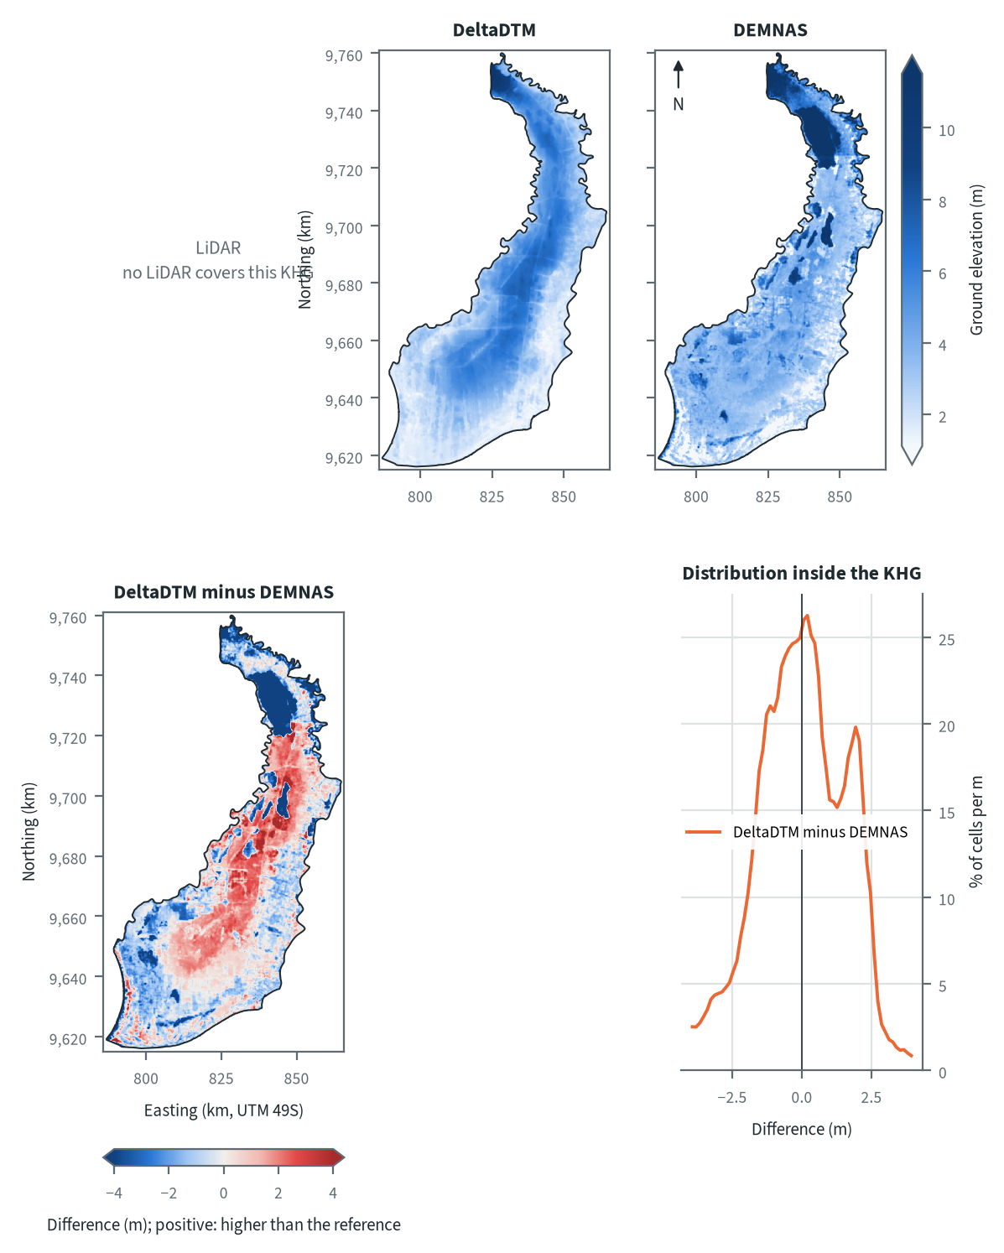
Figure 10.36. Kahayan-Sebangau: ground elevation from each elevation model on one colour scale, and their differences. Source: LiDAR terrain model, DeltaDTM and DEMNAS after the DEM correction
With no LiDAR, the terrain can only be read from the two open models. The KHG is long and narrow, running from a northern tip down to a wide southern part. DeltaDTM shows low ground along the southern coast and the eastern margin, a broad ridge along the centre and a high at the northern tip. DEMNAS agrees on the broad pattern but is rougher and has dark patches in the north and along the centre that DeltaDTM does not show. DeltaDTM is higher than DEMNAS over the central ridge and lower in the west, the south-west and a large patch in the north, so the difference between them is not one offset: DeltaDTM is more than 2 m above DEMNAS over 11 % of the KHG and more than 2 m below it over 15 %. The likely causes are canopy and other surface features left in DEMNAS after correction (chapter 4 found its errors largest under tree cover), its 8 m cells against 30 m for DeltaDTM, and a datum offset that changes from place to place, since the raw DEMNAS offset to the ground was -3.4 m at Sebangau, -0.03 m at Mendahara and +2.16 m at Bengkalis (chapter 4).
Table 10.52. Kahayan-Sebangau: resolution, cover and relief of each elevation model, and its difference to LiDAR. Source: LiDAR terrain model, DeltaDTM and DEMNAS after the DEM correction
Elevation model | Source | Resolution (m) | Cover of the KHG (%) | Relief, 5th-95th percentile (m)
LiDAR | no LiDAR covers this KHG
DeltaDTM | DeltaDTM v1.1 (global coastal terrain model), after the DEM correction | 30 | 100 | 1.5 to 6.8
DEMNAS | DEMNAS (BIG national surface model), after the DEM correction | 8 | 100 | 1.3 to 10.6
Statistics over the KHG polygon on a common 30 m grid (the DeltaDTM grid; finer models averaged onto it). NMAD: normalised median absolute deviation, a spread measure robust to outliers. Where LiDAR covers only part of the KHG, differences are over that part.
Relief between the 5th and 95th percentiles is 1.5 to 6.8 m on DeltaDTM and 1.3 to 10.6 m on DEMNAS, so DEMNAS spans about 1.8 times the range (9.3 m against 5.3 m, a ratio of the two spans). Without LiDAR there is no difference to a reference, and the table cannot say which model is closer to the ground. The only measured error is from the two LiDAR KHG: over 1 km DeltaDTM is off by 0.47 to 0.64 m and corrected DEMNAS by 1.66 to 2.19 m (chapter 4), and an earlier ICESat-2 test over this KHG gave 2.14 m for calibrated DEMNAS over 1 to 2 km. A head drop between blocks is about 0.3 m, so on both models the slopes along canals carry error of the same size as the signal, and DEMNAS more than DeltaDTM.

Sub-KHG units
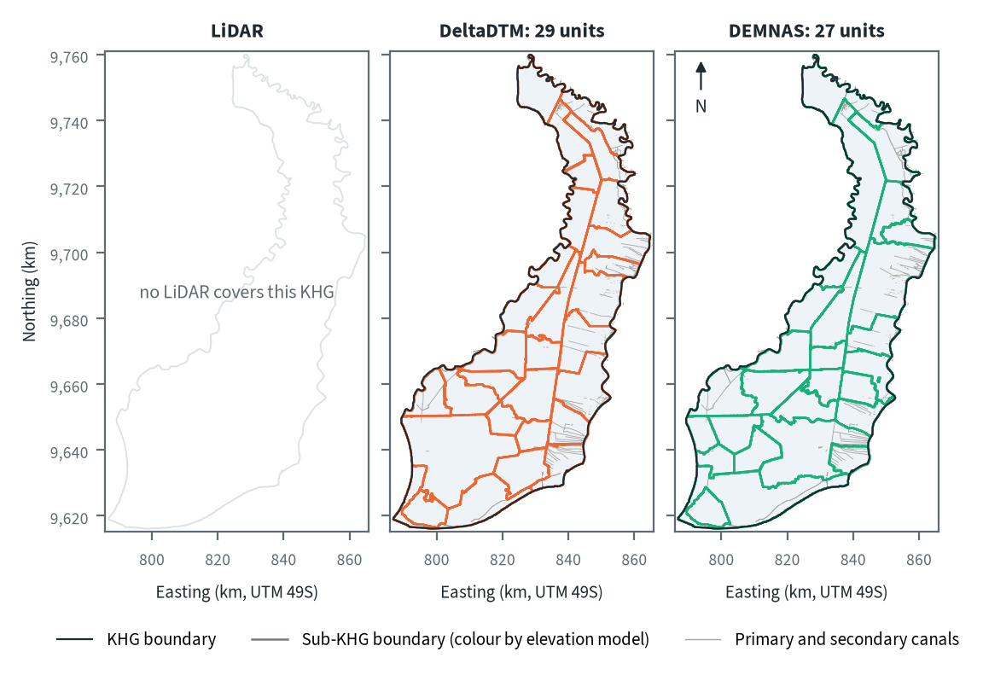
Figure 10.37. Kahayan-Sebangau: sub-KHG units delineated on each elevation model. Source: sub-KHG delineation on each elevation model, mapped canals
DeltaDTM gives 29 sub-KHG units and DEMNAS 27, both with a median area of 131 km² (ranges 75 to 617 km² and 73 to 445 km²). A long boundary on the east side runs the length of the KHG on both maps, and the units east of it are narrow strips. The models differ mostly in the west and south-west and in the north, where DeltaDTM draws small units and one very large one (617 km²) and DEMNAS draws fewer, more even units. The 2021 study used 16 units (4,523 km² in total, smallest 35 km²); the smallest unit now is 75 km² on DeltaDTM and 73 km² on DEMNAS, and chapter 5 notes that the comparison with the 2021 layout has still to be made.
Table 10.53. Kahayan-Sebangau: number and size of sub-KHG units, and agreement between elevation models (area in the best-matching unit, adjusted Rand index). Source: sub-KHG delineation on each elevation model
Elevation model or pair | Units (n) | Unit area, median (km²) | Unit area, range (km²) | Units total (km²) | Overlap (km²) | Area in best-matching unit (%) | Adjusted Rand index
LiDAR | no LiDAR covers this KHG
DeltaDTM | 29 | 131 | 75 to 617 | 4,503
DEMNAS | 27 | 131 | 73 to 445 | 4,503
DeltaDTM and DEMNAS |  |  |  |  | 4,503 | 70 | 0.46
Pairs are compared over the area both cover. Best-matching unit: share of the overlap that lies in the unit of the other model it overlaps most, averaged over both directions. Adjusted Rand index: 1 for identical partitions, about 0 for chance agreement; computed on 1 ha cells.
DeltaDTM and DEMNAS share 70 % of the area in best-matching units, with an adjusted Rand index of 0.46. This is lower than the 0.60 that a flat surface gives at Sugihan-Lumpur with the mapped canals alone (chapter 5), so here the terrain moves the divides more than it does at that KHG. With two models there is one pair only, and a third set, LiDAR, does not exist at this KHG.

Water balance and deficit
Table 10.54. Kahayan-Sebangau: dry-season deficit from water-table stations and climatic balance per sub-KHG. Source: SiTMAT water-table stations, CHIRPS rain, MOD16 and WaPOR evapotranspiration
Quantity | All models | LiDAR | DeltaDTM | DEMNAS
Dry-season deficit from 1 stations, 01 Jun to 15 Oct 2026 (mm) | 348 (344 to 352)
Deficit volume over the KHG (million m³) | 1,571
Months in deficit in that window (n) | 5
Sub-KHG units (n) |  | no LiDAR covers this KHG | 29 | 27
Climatic balance, MOD16, area mean (mm/month) |  | no LiDAR covers this KHG | 64.9 | 64.8
Climatic balance, unit range (mm/month) |  | no LiDAR covers this KHG | 54.9 to 83.8 | 50.4 to 82.7
Climatic balance, WaPOR, area mean (mm/month) |  | no LiDAR covers this KHG | 87.6 | 87.6
Deficit months per year, area mean |  | no LiDAR covers this KHG | 2.88 | 2.89
Order of units usable (ET products agree) |  | no LiDAR covers this KHG | no | no
The station deficit uses water-table stations and reanalysis rain and evaporation (band: specific yield 0.10 to 0.20) and does not depend on the elevation model. The climatic balance is CHIRPS rain minus evapotranspiration, 2018-2025, per sub-KHG of each model.
From 1 June to 15 October 2026 the station deficit is 348 mm (344 to 352 mm for a specific yield of 0.10 to 0.20), or 1,571 million m³ over the KHG, with 5 months in deficit in that window. It rests on one station, so it is low confidence and should be read as indicative; it does not depend on the elevation model. The order of units by climatic balance fails the test on both models: the two evapotranspiration products do not agree on the order of units, so the balance is shown but not used to rank units. In the 2021 units the mean balance followed forest share (correlation -0.82) while rain minus evapotranspiration did not (0.11, chapter 8), and the same interception effect probably sets the order here.
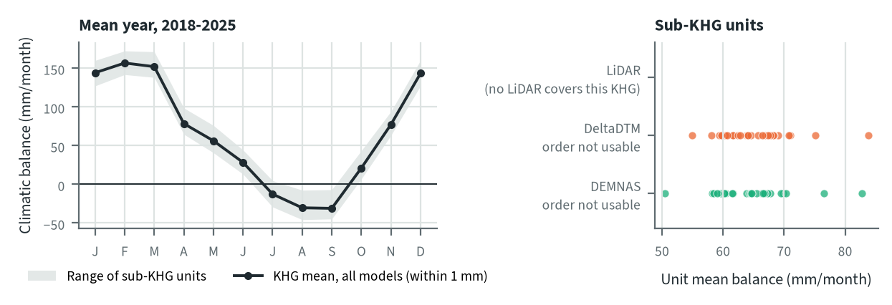
Figure 10.38. Kahayan-Sebangau: climatic balance through the mean year, and the balance of each sub-KHG, by elevation model. Source: CHIRPS rain and MOD16 evapotranspiration, 2018-2025
The mean climatic balance is negative in July, August and September and positive again in October; the wettest months are December to March. The KHG mean is 64.9 mm/month on DeltaDTM units and 64.8 on DEMNAS units (87.6 mm/month with WaPOR on both), and the deficit months per year are 2.88 and 2.89, so the elevation model does not change the balance of the KHG. It changes only the spread between units, 54.9 to 83.8 mm/month on DeltaDTM and 50.4 to 82.7 on DEMNAS, because each unit set averages the same rain and evapotranspiration grids over different areas.

Priority of sub-KHG
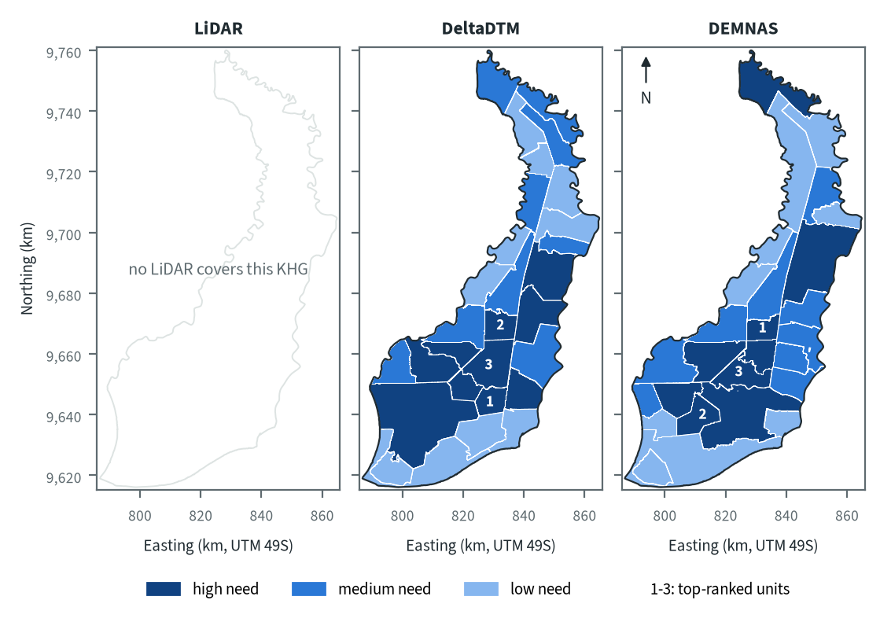
Figure 10.39. Kahayan-Sebangau: need for intervention per sub-KHG, by elevation model. Source: sub-KHG prioritisation with default weights
With the default weights proposed for agreement with KLH and the World Bank, high-need units form a block across the south-west and centre on both models, and a strip along the east. The three top-ranked units of both models lie in the south-centre, but they are different units. DEMNAS also puts the northern tip in high need, which DeltaDTM rates medium. The need score rests on fire history, dryness, canal and forest indicators (chapter 7); peat depth has no weight because there is no modelled depth layer for this KHG (chapter 3), and the water balance is left out because its order test fails. The burned share of 38.9 % in 2015 and 17.6 % in 2019 is the main reason for the high national rank.
Table 10.55. Kahayan-Sebangau: high-need area and agreement of the priority classes between elevation models. Source: sub-KHG prioritisation with default weights
Elevation model or pair | High need (units, km²) | Overlap (km²) | Same need class (% of overlap) | High need in first also high in second (%) | Spearman of scores, area-weighted
LiDAR | no LiDAR covers this KHG
DeltaDTM | 10, 1,843
DEMNAS | 9, 1,778
DeltaDTM and DEMNAS |  | 4,503 | 64 | 66 | 0.66
Units are matched by location, since each model has its own units. Shares are of the area both models cover. Default weights, proposed for agreement with KLH and the World Bank.
High-need area is 1,843 km² (10 units) on DeltaDTM and 1,778 km² (9 units) on DEMNAS, about 41 % and 39 % of the KHG (ratios to 4,503 km²). 64 % of the area keeps its need class between the two models, 66 % of the high-need area in one is also high need in the other, and the area-weighted Spearman correlation of the scores is 0.66. The largest differences are at the northern tip and in the west, where each model draws units of different shape around the same fire and canal data, so a large unit that straddles burned and unburned land can change class when its boundary moves.

Canal blocks and pumping
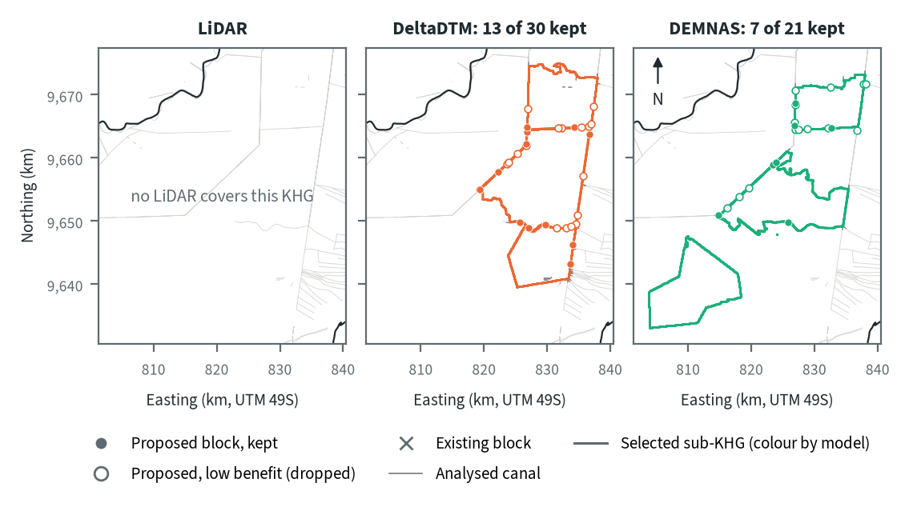
Figure 10.40. Kahayan-Sebangau: proposed canal blocks in the three highest-ranked sub-KHG, by elevation model. Source: RE-PEAT Interventions on each elevation model, mapped canals and existing blocks
In the three highest-ranked sub-KHG the sekat kanal (canal block) step proposes 30 blocks on DeltaDTM and 21 on DEMNAS, keeps 13 and 7 for 90 % of the water-level rise, and drops the other 17 and 14 as low benefit. Blocks lie on the canals that form or cross the unit edges, in rows along the east-west canals on DeltaDTM and along the western and northern canals on DEMNAS. The selected units differ (S24, S15 and S21 on DeltaDTM; S12, S22 and S18 on DEMNAS), and the south-western unit chosen on DEMNAS has no block on any analysed canal. There is no existing block in the KHG to build on, and the slope rule of the ranking asks for 3,276 blocks on DeltaDTM and 7,466 on DEMNAS over the whole KHG, far more than the plan keeps.
Table 10.56. Kahayan-Sebangau: canal blocks, water held and budget, by elevation model. Source: RE-PEAT Interventions and sub-KHG prioritisation on each elevation model
Quantity | LiDAR | DeltaDTM | DEMNAS
Selected sub-KHG (top 3 by priority) | no LiDAR covers this KHG | S24, S15, S21 | S12, S22, S18
Blocks needed by the slope rule of the ranking, whole KHG (n) | no LiDAR covers this KHG | 3,276 | 7,466
Existing blocks counted by the ranking, whole KHG (n) | no LiDAR covers this KHG | 0 | 0
Existing blocks on analysed canals (n) | no LiDAR covers this KHG | 0 | 0
Blocks proposed by the head rule (n) | no LiDAR covers this KHG | 30 | 21
Blocks kept, 90% of the water-level rise (n) | no LiDAR covers this KHG | 13 | 7
Pump units (n) | no LiDAR covers this KHG | pumping not assessed | pumping not assessed
Water held by kept blocks (million m³) | no LiDAR covers this KHG | 2.69 | 1.51
Deficit of the selected units (million m³) | no LiDAR covers this KHG | 127.1 | 111.7
Budget, low / central / high (billion Rp) | no LiDAR covers this KHG | 56 / 95 / 111 | 152 / 241 / 283
of which revegetation of burned land, central (billion Rp) | no LiDAR covers this KHG | 66 | 182
Blocks, water and budget are for the three highest-ranked sub-KHG of each model, which can differ between models. Kept: the fewest proposed blocks giving 90% of the water-level rise of all proposed blocks. Pumping is not assessed in these results. Default weights, proposed for agreement with KLH and the World Bank.
The kept blocks hold 2.69 million m³ on DeltaDTM and 1.51 million m³ on DEMNAS, against a deficit of the selected units of 127.1 and 111.7 million m³, or 2.1 % and 1.4 % of it. The central budget is 95 billion Rp on DeltaDTM (56 low, 111 high) and 241 billion Rp on DEMNAS (152 low, 283 high). Revegetation of burned land is the main item, 66 of 95 and 182 of 241 billion Rp. The 2.5-fold difference in budget therefore comes mostly from the units each model selects and the burned land in them, and little from the number of blocks. Pumping was not assessed.

How the elevation model changes the result
Table 10.57. Kahayan-Sebangau: headline outputs by elevation model and their spread. Source: RE-PEAT results on each elevation model
Output | LiDAR | DeltaDTM | DEMNAS | Spread
Sub-KHG units (n) | no LiDAR covers this KHG | 29 | 27 | ×1.1
Median unit area (km²) | no LiDAR covers this KHG | 132 | 131 | ×1.0
Area covered by units (km²) | no LiDAR covers this KHG | 4,512 | 4,512 | ×1.0
Climatic balance, area mean (mm/month) | no LiDAR covers this KHG | 64.9 | 64.8 | range 0.0
High-need area (km²) | no LiDAR covers this KHG | 1,843 | 1,778 | ×1.0
High-need units (n) | no LiDAR covers this KHG | 10 | 9 | ×1.1
Blocks needed, slope rule of the ranking, whole KHG (n) | no LiDAR covers this KHG | 3,276 | 7,466 | ×2.3
Blocks proposed, head rule (n) | no LiDAR covers this KHG | 30 | 21 | ×1.4
Blocks kept (n) | no LiDAR covers this KHG | 13 | 7 | ×1.9
Water held by kept blocks (million m³) | no LiDAR covers this KHG | 2.69 | 1.51 | ×1.8
Budget, central (billion Rp) | no LiDAR covers this KHG | 95 | 241 | ×2.5
Spread: largest value over smallest across the models (range for the balance). Blocks kept, water and budget refer to the three highest-ranked sub-KHG of each model, so they move with the choice of units as well as with the terrain. Default weights, proposed for agreement with KLH and the World Bank.
The balance of the KHG does not move (64.9 and 64.8 mm/month), and the number of units, the median unit area and the high-need area change by a factor of 1.1 or less. The outputs that depend on canal slopes and on the choice of units move most: blocks needed by the slope rule by ×2.3, blocks proposed by ×1.4, blocks kept by ×1.9, water held by ×1.8 and the central budget by ×2.5. The three selected units differ between the models, so the spread is not terrain alone.
Neither model can be checked here, because no LiDAR exists. DeltaDTM is the better choice for decisions: at the two LiDAR KHG its error over 1 km was 0.47 to 0.64 m against 1.66 to 2.19 m for DEMNAS (chapter 4), and its relief of 1.5 to 6.8 m at the 5th to 95th percentile sits inside the 10 m limit of the product. The block counts should be read as a range between the two models, 7 to 13 kept blocks, and the DEMNAS count should not be taken as a design (chapter 9).

Summary for this KHG
Kahayan-Sebangau is a heavily burned KHG, mostly outside licence areas, with a dry season from July to September and a station deficit of 348 mm (1,571 million m³) that rests on one station and is indicative only. On DeltaDTM, the model to prefer without a LiDAR check, the plan keeps 13 canal blocks in the three highest-ranked sub-KHG; they hold 2.69 million m³, about 2 % of the deficit of those units, so blocking cannot rewet this KHG alone, and the central budget is 95 billion Rp, mostly revegetation of burned land. The choice of model changes which sub-KHG are selected, so kept blocks (13 and 7) and budget (95 and 241 billion Rp) move by ×1.9 and ×2.5, while the KHG balance and the high-need area stay almost the same. Still missing are LiDAR or levelling to measure the terrain error, a peat depth layer, more water-table stations, the pumping step, and a comparison with the 16 units of the 2021 study.

10.10 Kapuas-Barito (KHG 62.03-04.01)
Table 10.58. Kapuas-Barito: key facts. Source: national KHG profile, national canal and structures layers, RE-PEAT results for this KHG
Item | Value
Province | Kalimantan Tengah
Area of the KHG polygon (km²) | 5,574
Peat area (km²) | 4,407
National rank (class) | 92 of 476 (high priority)
Canals, primary / secondary / tertiary (km) | 1,501 / 184 / 4,133
Existing water-management structures, all types (n) | 254
SiTMAT water-table stations (n) | 6
Realised canal blocks inside the KHG (n) | 53
LiDAR cover of the KHG (%) | no LiDAR covers this KHG
Elevation model ready, by elevation model | DeltaDTM, DEMNAS
Sub-KHG units, by elevation model | DeltaDTM, DEMNAS
Water balance, by elevation model | DeltaDTM, DEMNAS
Priority of sub-KHG, by elevation model | DeltaDTM, DEMNAS
Canal blocks and costs, by elevation model | DeltaDTM, DEMNAS
Dry-season deficit from stations | computed
Rank among ranked KHG with default weights, proposed for agreement with KLH and the World Bank. Canals: mapped canal network. Structures and realised canal blocks: national layer of existing water-management structures (all types, and the canal blocks recorded as realised).
Kapuas-Barito is a KHG (Kesatuan Hidrologis Gambut, peat hydrological unit) in Kalimantan Tengah. It covers 5,574 km², of which 4,407 km² is peat. It ranks 96 of 476 ranked KHG nationally (high priority) with the default weights proposed for agreement with KLH and the World Bank, and falls in the high class in 0.99 of the weight draws (chapter 6). The mapped network has 1,501 km of primary, 184 km of secondary and 4,133 km of tertiary canals, and the national layer records 254 water-management structures, 53 of them realised canal blocks. No LiDAR covers this KHG, and 6 SiTMAT water-table stations lie inside it. The chain therefore ran on corrected DeltaDTM and corrected DEMNAS only, with no reference against which to measure the error of either, and a station deficit could be computed. There is no modelled peat-depth layer for this KHG (chapter 3), so the ranking gives peat depth no weight.

Terrain and the three elevation models
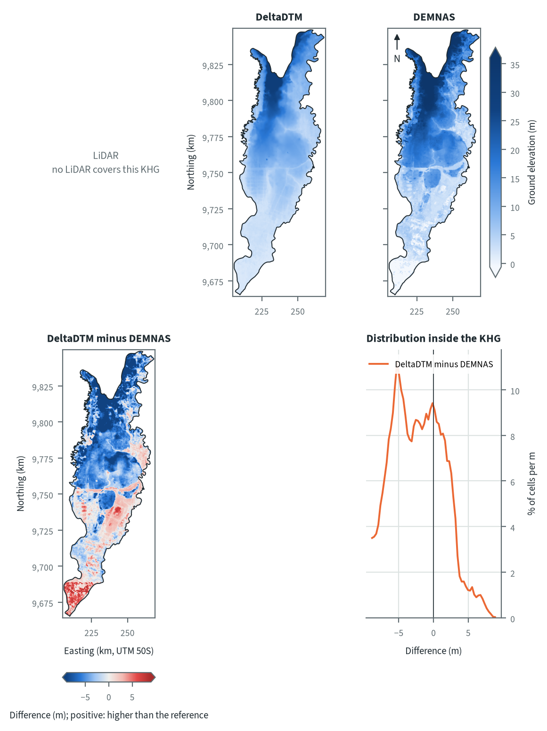
Figure 10.41. Kapuas-Barito: ground elevation from each elevation model on one colour scale, and their differences. Source: LiDAR terrain model, DeltaDTM and DEMNAS after the DEM correction
Both models show a peat landscape that rises from the south to a high northern arm. Elevation between the 5th and 95th percentiles is 2.0 to 24.8 m on DeltaDTM and 0.1 to 34.5 m on DEMNAS, highest in the north, so the relief is much larger than at the two LiDAR KHG. DeltaDTM minus DEMNAS has a 5th to 95th percentile of -10.9 to +3.4 m and its histogram peaks at -5.25 m: DEMNAS is more than 2 m above DeltaDTM over 57 % of the KHG, and stands higher than DeltaDTM across the northern high ground, while DeltaDTM is higher in a patch at the south-western tip. DeltaDTM is defined only for land below 10 m above mean sea level (chapter 4), and much of the northern part lies above that, so the difference there says more about the limit of DeltaDTM than about DEMNAS. The blocky patches in the central and southern DEMNAS are consistent with canopy and cropland left in a surface model, but with no LiDAR here this cannot be tested.
Table 10.59. Kapuas-Barito: resolution, cover and relief of each elevation model, and its difference to LiDAR. Source: LiDAR terrain model, DeltaDTM and DEMNAS after the DEM correction
Elevation model | Source | Resolution (m) | Cover of the KHG (%) | Relief, 5th-95th percentile (m)
LiDAR | no LiDAR covers this KHG
DeltaDTM | DeltaDTM v1.1 (global coastal terrain model), after the DEM correction | 30 | 100 | 2.0 to 24.8
DEMNAS | DEMNAS (BIG national surface model), after the DEM correction | 8 | 100 | 0.1 to 34.5
Statistics over the KHG polygon on a common 30 m grid (the DeltaDTM grid; finer models averaged onto it). NMAD: normalised median absolute deviation, a spread measure robust to outliers. Where LiDAR covers only part of the KHG, differences are over that part.
Relief between the 5th and 95th percentiles is 2.0 to 24.8 m on DeltaDTM and 0.1 to 34.5 m on DEMNAS, both covering the whole KHG (DeltaDTM resolution 30 m, DEMNAS 8 m). No difference to LiDAR can be given, so it is unknown whether the gap between the models is a constant offset or local error. The two LiDAR KHG suggest local error for DEMNAS: after correction its error over 1 km was 1.66 m at Mendahara-Batanghari against 0.64 m for DeltaDTM (chapter 4). Even the 1 km error of DeltaDTM there (0.47 to 0.64 m across the two benchmark KHG) is above the real 1 km LiDAR relief of 0.38 to 0.46 m, so slopes from either model should be read as a range, not as measured values.

Sub-KHG units
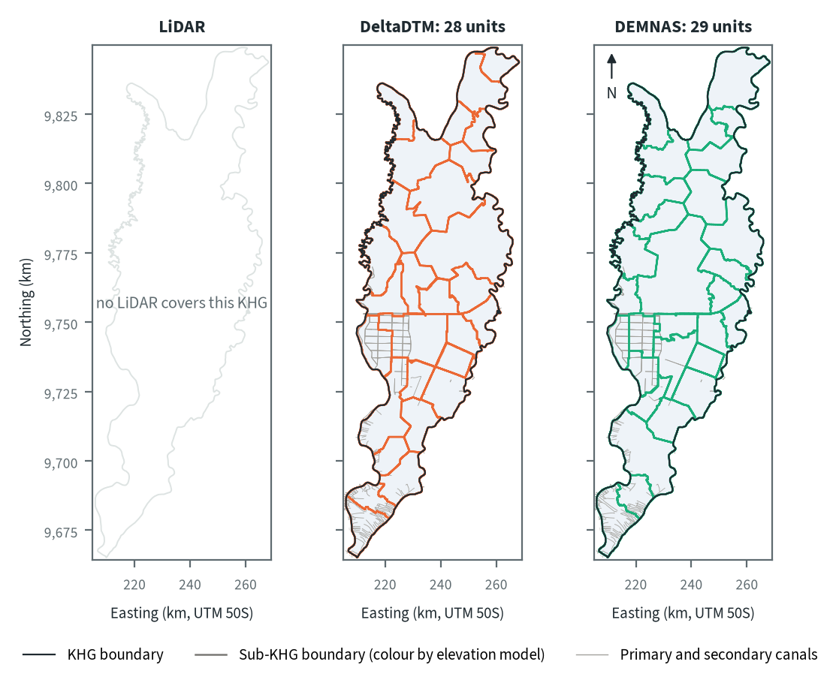
Figure 10.42. Kapuas-Barito: sub-KHG units delineated on each elevation model. Source: sub-KHG delineation on each elevation model, mapped canals
DeltaDTM gives 28 sub-KHG units and DEMNAS 29. The boundaries follow the dense grid of canals in the west-centre and the canal fans at the southern tip, and a long east-west boundary line appears on both models. In the north, where the maps show no mapped primary or secondary canals, the boundaries follow terrain divides and are drawn differently by the two models.
Table 10.60. Kapuas-Barito: number and size of sub-KHG units, and agreement between elevation models (area in the best-matching unit, adjusted Rand index). Source: sub-KHG delineation on each elevation model
Elevation model or pair | Units (n) | Unit area, median (km²) | Unit area, range (km²) | Units total (km²) | Overlap (km²) | Area in best-matching unit (%) | Adjusted Rand index
LiDAR | no LiDAR covers this KHG
DeltaDTM | 28 | 163 | 102 to 653 | 5,574
DEMNAS | 29 | 156 | 77 to 702 | 5,574
DeltaDTM and DEMNAS |  |  |  |  | 5,574 | 68 | 0.46
Pairs are compared over the area both cover. Best-matching unit: share of the overlap that lies in the unit of the other model it overlaps most, averaged over both directions. Adjusted Rand index: 1 for identical partitions, about 0 for chance agreement; computed on 1 ha cells.
DeltaDTM and DEMNAS share 68 % of the area in best-matching units, with an adjusted Rand index of 0.46. This is lower than the 0.60 to 0.66 at Sugihan-Lumpur, where the canal network sets most of the layout (chapter 5). Here much of the KHG has few mapped canals and strong relief, so the terrain model has more influence on where units are drawn. Median unit area is 163 km² on DeltaDTM and 156 km² on DEMNAS, with ranges of 102 to 653 km² and 77 to 702 km².

Water balance and deficit
Table 10.61. Kapuas-Barito: dry-season deficit from water-table stations and climatic balance per sub-KHG. Source: SiTMAT water-table stations, CHIRPS rain, MOD16 and WaPOR evapotranspiration
Quantity | All models | LiDAR | DeltaDTM | DEMNAS
Dry-season deficit from 6 stations, 01 Jun to 15 Oct 2026 (mm) | 299 (297 to 301)
Deficit volume over the KHG (million m³) | 1,666
Months in deficit in that window (n) | 4
Sub-KHG units (n) |  | no LiDAR covers this KHG | 28 | 29
Climatic balance, MOD16, area mean (mm/month) |  | no LiDAR covers this KHG | 72.2 | 72.2
Climatic balance, unit range (mm/month) |  | no LiDAR covers this KHG | 64.0 to 81.5 | 65.4 to 80.3
Climatic balance, WaPOR, area mean (mm/month) |  | no LiDAR covers this KHG | 93.5 | 93.5
Deficit months per year, area mean |  | no LiDAR covers this KHG | 2.34 | 2.35
Order of units usable (ET products agree) |  | no LiDAR covers this KHG | no | no
The station deficit uses water-table stations and reanalysis rain and evaporation (band: specific yield 0.10 to 0.20) and does not depend on the elevation model. The climatic balance is CHIRPS rain minus evapotranspiration, 2018-2025, per sub-KHG of each model.
From 1 June to 15 October 2026, 6 stations give a dry-season deficit of 299 mm (297 to 301 mm for a specific yield of 0.10 to 0.20), or 1,666 million m³ over the KHG, with 4 months in deficit in that window. The deficit does not depend on the elevation model. The order of units by climatic balance is not usable on either model. The two evapotranspiration products agree at 0.33 against a threshold of 0.45 on DeltaDTM units, and at 0.42 against 0.43 on DEMNAS units, a near miss. The mean balance of the units follows forest share (correlation -0.78 on both models) while rain minus evapotranspiration barely does (0.11 and 0.25), so the order reflects land cover more than water. The balance values are therefore left out of the sub-KHG ranking.
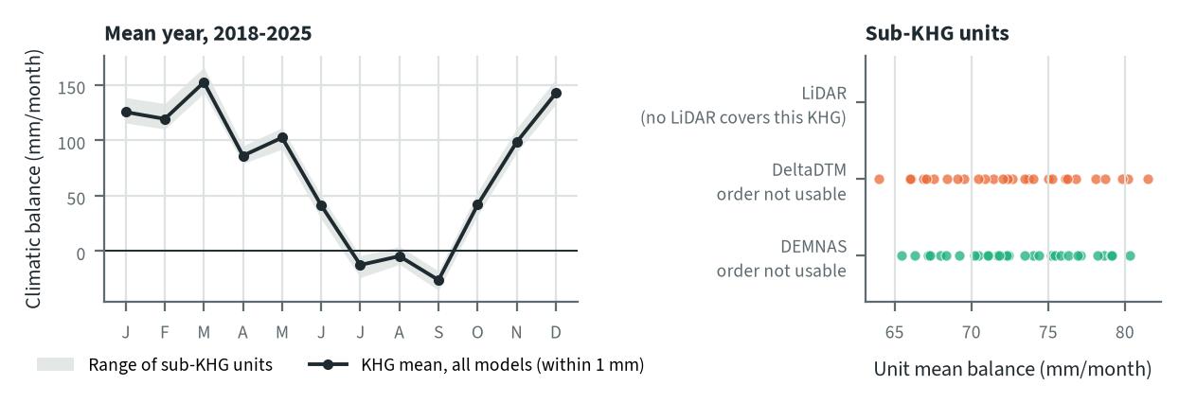
Figure 10.43. Kapuas-Barito: climatic balance through the mean year, and the balance of each sub-KHG, by elevation model. Source: CHIRPS rain and MOD16 evapotranspiration, 2018-2025
The mean climatic balance is negative in July, August and September and positive in the other months, with a peak of 152 mm/month in March. The KHG mean is 72.2 mm/month (MOD16) and 93.5 mm/month (WaPOR) on both models, with 2.34 and 2.35 deficit months a year, so the elevation model does not change the balance of the KHG. It changes only the spread between units, 64.0 to 81.5 mm/month on DeltaDTM and 65.4 to 80.3 mm/month on DEMNAS.

Priority of sub-KHG
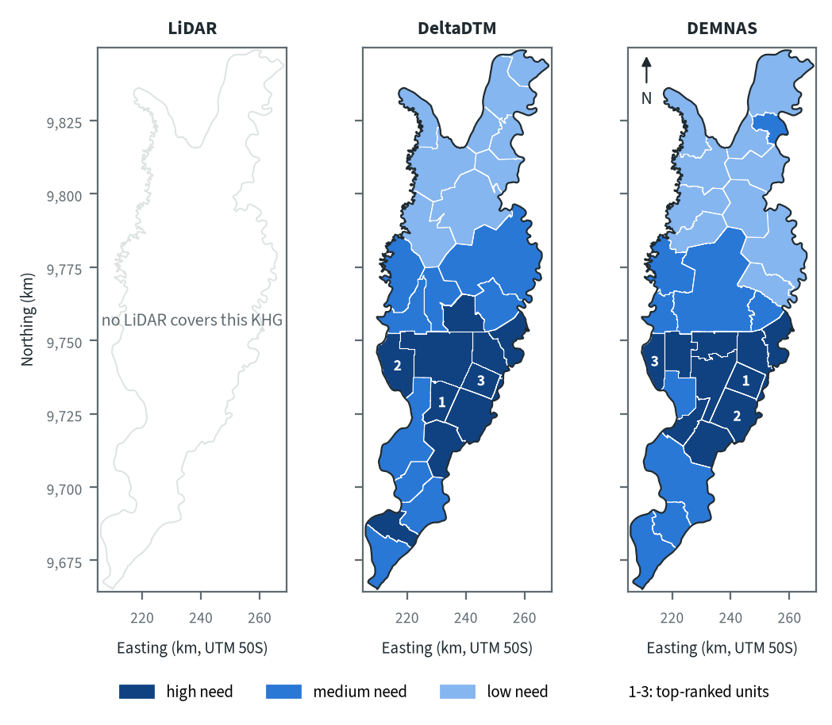
Figure 10.44. Kapuas-Barito: need for intervention per sub-KHG, by elevation model. Source: sub-KHG prioritisation with default weights
With the default weights proposed for agreement with KLH and the World Bank, high-need units lie in the southern half on both models, in the western canal grid and the south-east, and the north is mostly low need. The score uses 13 indicators, mainly fire history, hotspots, vegetation dryness, canal density by class and the gap in canal blocks; it uses neither peat depth nor the water balance. The three top-ranked units have burned in 12 to 31 % of their area on DeltaDTM and 12 to 48 % on DEMNAS, against 4 to 6 % in the median unit. The rank 1 unit differs: DeltaDTM puts it in the central south, DEMNAS in the east. Both put the western canal grid among the top three.
Table 10.62. Kapuas-Barito: high-need area and agreement of the priority classes between elevation models. Source: sub-KHG prioritisation with default weights
Elevation model or pair | High need (units, km²) | Overlap (km²) | Same need class (% of overlap) | High need in first also high in second (%) | Spearman of scores, area-weighted
LiDAR | no LiDAR covers this KHG
DeltaDTM | 10, 1,632
DEMNAS | 10, 1,391
DeltaDTM and DEMNAS |  | 5,574 | 81 | 81 | 0.93
Units are matched by location, since each model has its own units. Shares are of the area both models cover. Default weights, proposed for agreement with KLH and the World Bank.
High-need area is 1,632 km² (10 units) on DeltaDTM and 1,391 km² (10 units) on DEMNAS. 81 % of the area keeps its need class between the two models, 81 % of the high-need area of one is also high need in the other, and the area-weighted Spearman correlation of the scores is 0.93. That is higher than the 57 to 65 % at Sugihan-Lumpur, probably because the north-south gradient in fire and canals sets the pattern on both models. The 241 km² difference in high-need area comes from units whose boundaries move, for example the single medium-need unit that DEMNAS draws in the north-east.

Canal blocks and pumping
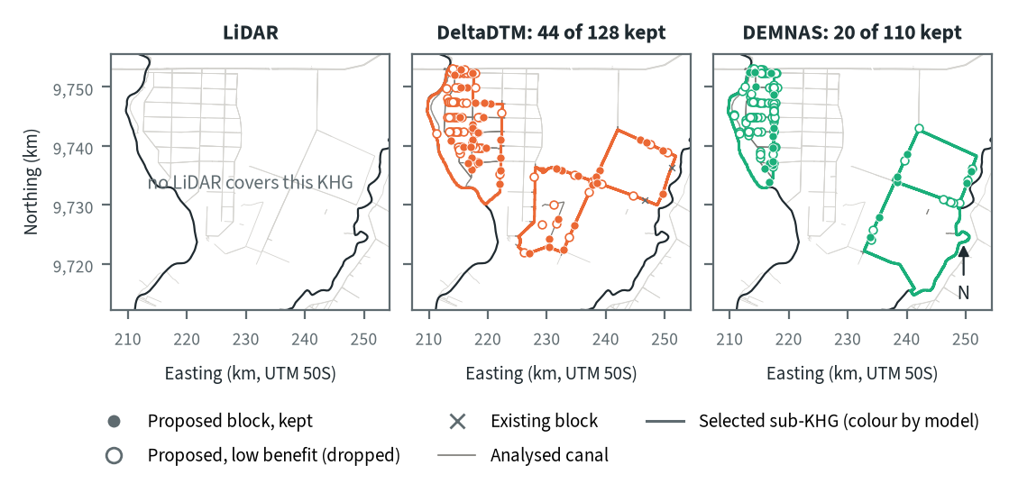
Figure 10.45. Kapuas-Barito: proposed canal blocks in the three highest-ranked sub-KHG, by elevation model. Source: RE-PEAT Interventions on each elevation model, mapped canals and existing blocks
In the three highest-ranked sub-KHG the sekat kanal (canal block) step proposes 128 blocks on DeltaDTM and 110 on DEMNAS, and keeps 44 and 20 for 90 % of the water-level rise; the other 84 and 90 add little and are dropped. The blocks sit close together on the canals of the western grid and along the straight canals of the eastern units. The selected units differ (S21, S19 and S20 on DeltaDTM; S21, S24 and S19 on DEMNAS, where labels belong to each model), but the western canal grid is chosen on both. Of the 53 existing blocks in the KHG, only 2 lie on the analysed canals. With no LiDAR to check either model, block counts here should be read as a range between the two.
Table 10.63. Kapuas-Barito: canal blocks, water held and budget, by elevation model. Source: RE-PEAT Interventions and sub-KHG prioritisation on each elevation model
Quantity | LiDAR | DeltaDTM | DEMNAS
Selected sub-KHG (top 3 by priority) | no LiDAR covers this KHG | S21, S19, S20 | S21, S24, S19
Blocks needed by the slope rule of the ranking, whole KHG (n) | no LiDAR covers this KHG | 3,810 | 12,184
Existing blocks counted by the ranking, whole KHG (n) | no LiDAR covers this KHG | 53 | 53
Existing blocks on analysed canals (n) | no LiDAR covers this KHG | 2 | 2
Blocks proposed by the head rule (n) | no LiDAR covers this KHG | 128 | 110
Blocks kept, 90% of the water-level rise (n) | no LiDAR covers this KHG | 44 | 20
Pump units (n) | no LiDAR covers this KHG | pumping not assessed | pumping not assessed
Water held by kept blocks (million m³) | no LiDAR covers this KHG | 6.93 | 7.03
Deficit of the selected units (million m³) | no LiDAR covers this KHG | 119.7 | 119.9
Budget, low / central / high (billion Rp) | no LiDAR covers this KHG | 13 / 24 / 25 | 54 / 86 / 90
of which revegetation of burned land, central (billion Rp) | no LiDAR covers this KHG | 4 | 18
Blocks, water and budget are for the three highest-ranked sub-KHG of each model, which can differ between models. Kept: the fewest proposed blocks giving 90% of the water-level rise of all proposed blocks. Pumping is not assessed in these results. Default weights, proposed for agreement with KLH and the World Bank.
The kept blocks hold 6.93 million m³ on DeltaDTM and 7.03 million m³ on DEMNAS, against a deficit of the selected units of 119.7 and 119.9 million m³, or 5.8 % and 5.9 % of it. The central budget is 24 billion Rp on DeltaDTM (low to high 13 to 25) and 86 billion Rp on DEMNAS (54 to 90). On DEMNAS the largest item is the estimate of missing blocks in units outside the three analysed, 60.1 billion Rp for 3,337 blocks against 9.8 billion Rp for 542 blocks on DeltaDTM; it follows the slope rule and so the terrain model. Revegetation of burned land is 3.6 billion Rp (300 ha) on DeltaDTM and 17.1 billion Rp (1,409 ha) on DEMNAS, and the new blocks cost under 0.8 billion Rp on both. Pumping was not assessed in this analysis.

How the elevation model changes the result
Table 10.64. Kapuas-Barito: headline outputs by elevation model and their spread. Source: RE-PEAT results on each elevation model
Output | LiDAR | DeltaDTM | DEMNAS | Spread
Sub-KHG units (n) | no LiDAR covers this KHG | 28 | 29 | ×1.0
Median unit area (km²) | no LiDAR covers this KHG | 163 | 156 | ×1.0
Area covered by units (km²) | no LiDAR covers this KHG | 5,579 | 5,579 | ×1.0
Climatic balance, area mean (mm/month) | no LiDAR covers this KHG | 72.2 | 72.2 | range 0.0
High-need area (km²) | no LiDAR covers this KHG | 1,632 | 1,391 | ×1.2
High-need units (n) | no LiDAR covers this KHG | 10 | 10 | ×1.0
Blocks needed, slope rule of the ranking, whole KHG (n) | no LiDAR covers this KHG | 3,810 | 12,184 | ×3.2
Blocks proposed, head rule (n) | no LiDAR covers this KHG | 128 | 110 | ×1.2
Blocks kept (n) | no LiDAR covers this KHG | 44 | 20 | ×2.2
Water held by kept blocks (million m³) | no LiDAR covers this KHG | 6.93 | 7.03 | ×1.0
Budget, central (billion Rp) | no LiDAR covers this KHG | 24 | 86 | ×3.6
Spread: largest value over smallest across the models (range for the balance). Blocks kept, water and budget refer to the three highest-ranked sub-KHG of each model, so they move with the choice of units as well as with the terrain. Default weights, proposed for agreement with KLH and the World Bank.
The KHG balance does not move (72.2 mm/month on both), and the number of units, the high-need area and the number of high-need units change by a factor of 1.2 or less. The outputs that depend on canal slope move most. Blocks needed by the slope rule of the ranking over the whole KHG rise from 3,810 on DeltaDTM to 12,184 on DEMNAS (×3.2). Over the 1,685 km of primary and secondary canals that is one block every 442 m against one every 138 m. The median slope along canals in the top three units is 0.055 to 0.085 % on DeltaDTM and 0.12 to 0.25 % on DEMNAS, which fits a rougher DEMNAS surface. The central budget moves ×3.6 and blocks kept ×2.2, while blocks proposed (×1.2) and water held (×1.0) barely change.
For decisions at Kapuas-Barito DeltaDTM is the better choice, since it came closer to LiDAR at both benchmark KHG (chapter 4) and DEMNAS block counts should not be taken as a design (chapter 9). Its limits here are the 10 m ceiling of its definition over the northern high ground and the lack of any local reference, so the three selected units, which lie in the lower southern half, are the part to trust. Block counts and costs should be quoted as a range between the two models.

Summary for this KHG
Kapuas-Barito has a station deficit of 299 mm, or 1,666 million m³, in the 2026 dry season, and the order of its sub-KHG by climatic balance is not usable on either model. The ranking points to the western canal grid and the south-east, and the two models agree on the need class of 81 % of the area. On DeltaDTM, the model to use here, the plan keeps 44 canal blocks in the three highest-ranked sub-KHG; they hold 6.93 million m³, about 6 % of the deficit of those units, at a central budget of 24 billion Rp, against 20 blocks and 86 billion Rp on DEMNAS. Most of the spread between models comes from canal slope, which sets the blocks needed (3,810 against 12,184) and the cost of missing blocks. Still missing are LiDAR to check the models, any peat-depth layer, a usable water-balance order and an assessment of pumping.

10.11 Balangan-Batangalai (KHG 63.07-08-11.01)
Table 10.65. Balangan-Batangalai: key facts. Source: national KHG profile, national canal and structures layers, RE-PEAT results for this KHG
Item | Value
Province | Kalimantan Selatan
Area of the KHG polygon (km²) | 308
Peat area (km²) | 137
National rank (class) | 5 of 476 (high priority)
Canals, primary / secondary / tertiary (km) | 157 / 395 / 827
Existing water-management structures, all types (n) | 112
SiTMAT water-table stations (n) | 0
Realised canal blocks inside the KHG (n) | 0
LiDAR cover of the KHG (%) | no LiDAR covers this KHG
Elevation model ready, by elevation model | DeltaDTM, DEMNAS
Sub-KHG units, by elevation model | DeltaDTM, DEMNAS
Water balance, by elevation model | DeltaDTM, DEMNAS
Priority of sub-KHG, by elevation model | DeltaDTM, DEMNAS
Canal blocks and costs, by elevation model | DeltaDTM, DEMNAS
Dry-season deficit from stations | not computed
Rank among ranked KHG with default weights, proposed for agreement with KLH and the World Bank. Canals: mapped canal network. Structures and realised canal blocks: national layer of existing water-management structures (all types, and the canal blocks recorded as realised).
Balangan-Batangalai is a KHG (Kesatuan Hidrologis Gambut, peat hydrological unit) in Kalimantan Selatan and one of the smallest of the selected KHG, with 308 km², of which 137 km² is peat. It ranks 4 of 476 ranked KHG nationally (high priority) with the default weights proposed for agreement with KLH and the World Bank. It is in the top 7 at default weights and when only fire history is weighed, but falls to 54 when only this year's hotspots count (chapter 6). The mapped network has 157 km of primary, 395 km of secondary and 827 km of tertiary canals, and the national layer records 112 water-management structures, none of them a realised canal block. No LiDAR covers the KHG, so the chain ran on corrected DeltaDTM and corrected DEMNAS only. No SiTMAT water-table station lies inside the KHG, so no station-based deficit can be computed, and pumping was not assessed.

Terrain and the three elevation models
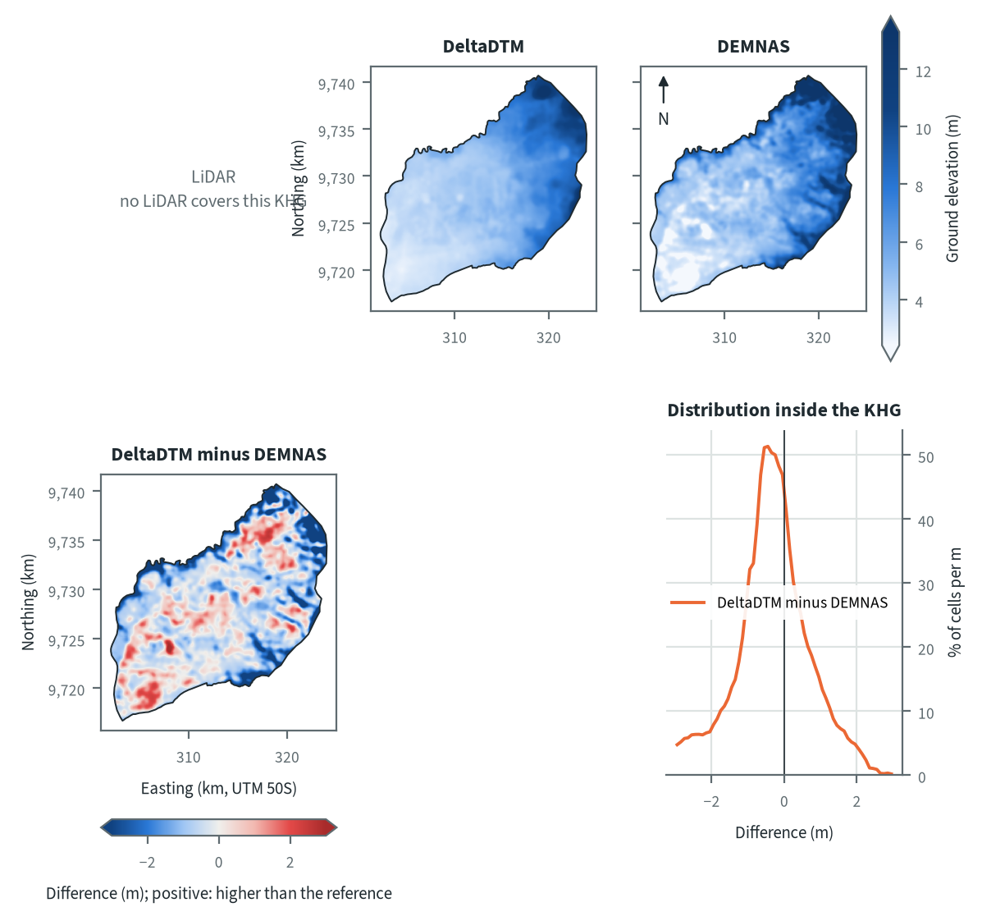
Figure 10.46. Balangan-Batangalai: ground elevation from each elevation model on one colour scale, and their differences. Source: LiDAR terrain model, DeltaDTM and DEMNAS after the DEM correction
Both models show the same terrain: the ground is lowest in the south-west and rises along the north-east and east edges; elevation between the 5th and 95th percentiles is 3.1 to 10.0 m on DeltaDTM and 2.6 to 12.1 m on DEMNAS. DeltaDTM is smooth. DEMNAS has the same trend with a blotchy texture at the scale of a few hundred metres. In the difference map DEMNAS stands higher than DeltaDTM along the northern and eastern edges and in strips in the south-east, and lower in patches in the south-west. 87 % of the cells differ by less than 2 m and the histogram peaks at -0.45 m (DeltaDTM minus DEMNAS). Patches of this kind are what a surface model gives where vegetation or buildings remain in the heights after correction (chapter 4).
Table 10.66. Balangan-Batangalai: resolution, cover and relief of each elevation model, and its difference to LiDAR. Source: LiDAR terrain model, DeltaDTM and DEMNAS after the DEM correction
Elevation model | Source | Resolution (m) | Cover of the KHG (%) | Relief, 5th-95th percentile (m)
LiDAR | no LiDAR covers this KHG
DeltaDTM | DeltaDTM v1.1 (global coastal terrain model), after the DEM correction | 30 | 98 | 3.1 to 10.0
DEMNAS | DEMNAS (BIG national surface model), after the DEM correction | 8 | 100 | 2.6 to 12.1
Statistics over the KHG polygon on a common 30 m grid (the DeltaDTM grid; finer models averaged onto it). NMAD: normalised median absolute deviation, a spread measure robust to outliers. Where LiDAR covers only part of the KHG, differences are over that part.
Relief between the 5th and 95th percentiles is 3.1 to 10.0 m (6.9 m) on DeltaDTM and 2.6 to 12.1 m (9.5 m) on DEMNAS, so DEMNAS shows 2.6 m more relief over the same ground. DeltaDTM covers 98 % of the KHG at 30 m and DEMNAS 100 % at 8 m. With no LiDAR here, neither model can be measured against a reference. At the two KHG that have LiDAR, corrected DeltaDTM had a height-difference error of 0.47 and 0.64 m over 1 km and DEMNAS 1.66 to 2.49 m, while the real 1 km relief of the LiDAR was 0.38 and 0.46 m (chapter 4). If the same holds here, part of the extra DEMNAS relief is error, so DEMNAS slopes and block counts should be read as the upper end of a range with DeltaDTM at the lower end.

Sub-KHG units
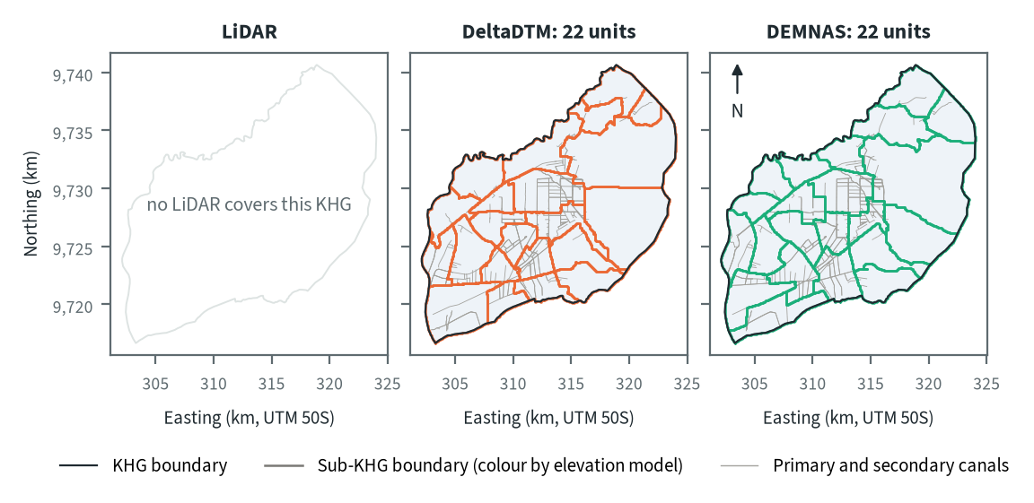
Figure 10.47. Balangan-Batangalai: sub-KHG units delineated on each elevation model. Source: sub-KHG delineation on each elevation model, mapped canals
DeltaDTM and DEMNAS each give 22 sub-KHG units, with median areas of 11 and 12 km². The count is below the cap of about 30 because the automatic minimum area (chapter 5) did not need to rise: it started at 5 km², and merging the 2,077 pieces on DeltaDTM and 2,264 on DEMNAS at that size already gave 22 units. Units range from 6 to 48 km² on DeltaDTM and from 7 to 56 km² on DEMNAS. Boundaries follow the dense canal network in the centre and south-west, with 5,862 mapped canal segments in 308 km², and no river layer is mapped for this KHG (chapter 3). The north-east and east have few canals and hold the largest units.
Table 10.67. Balangan-Batangalai: number and size of sub-KHG units, and agreement between elevation models (area in the best-matching unit, adjusted Rand index). Source: sub-KHG delineation on each elevation model
Elevation model or pair | Units (n) | Unit area, median (km²) | Unit area, range (km²) | Units total (km²) | Overlap (km²) | Area in best-matching unit (%) | Adjusted Rand index
LiDAR | no LiDAR covers this KHG
DeltaDTM | 22 | 11 | 6 to 48 | 308
DEMNAS | 22 | 12 | 7 to 56 | 308
DeltaDTM and DEMNAS |  |  |  |  | 308 | 71 | 0.54
Pairs are compared over the area both cover. Best-matching unit: share of the overlap that lies in the unit of the other model it overlaps most, averaged over both directions. Adjusted Rand index: 1 for identical partitions, about 0 for chance agreement; computed on 1 ha cells.
The two unit sets share 71 % of the area in best-matching units, with an adjusted Rand index of 0.54. At Sugihan-Lumpur the three pairs scored 0.60 to 0.66, close to the value for a flat surface with canals only (0.601, chapter 5). The lower value here suggests the terrain model has more influence on the layout than at that KHG, probably where canals are sparse. With two models, DeltaDTM against DEMNAS is the only pair.

Water balance and deficit
Table 10.68. Balangan-Batangalai: dry-season deficit from water-table stations and climatic balance per sub-KHG. Source: SiTMAT water-table stations, CHIRPS rain, MOD16 and WaPOR evapotranspiration
Quantity | All models | LiDAR | DeltaDTM | DEMNAS
Dry-season deficit from stations | not computed: no water-table station inside the KHG
Sub-KHG units (n) |  | no LiDAR covers this KHG | 22 | 22
Climatic balance, MOD16, area mean (mm/month) |  | no LiDAR covers this KHG | 64.8 | 64.9
Climatic balance, unit range (mm/month) |  | no LiDAR covers this KHG | 41.5 to 80.9 | 40.2 to 83.1
Climatic balance, WaPOR, area mean (mm/month) |  | no LiDAR covers this KHG | 91.1 | 91.1
Deficit months per year, area mean |  | no LiDAR covers this KHG | 2.47 | 2.48
Order of units usable (ET products agree) |  | no LiDAR covers this KHG | no | no
The station deficit uses water-table stations and reanalysis rain and evaporation (band: specific yield 0.10 to 0.20) and does not depend on the elevation model. The climatic balance is CHIRPS rain minus evapotranspiration, 2018-2025, per sub-KHG of each model.
No water-table station lies inside the KHG, so no dry-season deficit from stations is computed and no deficit period can be stated from observations. The climatic balance per sub-KHG (chapter 8) has a mean of 64.8 mm/month on DeltaDTM units and 64.9 mm/month on DEMNAS units, with 2.47 and 2.48 deficit months a year; this is within the 58 to 84 mm/month and 2.2 to 2.7 months found at the selected KHG. The order of units by balance is not usable on either model, because the two evapotranspiration products do not agree on that order. Unit values range from 41.5 to 80.9 mm/month on DeltaDTM and from 40.2 to 83.1 mm/month on DEMNAS, but that spread should not be used to rank units.
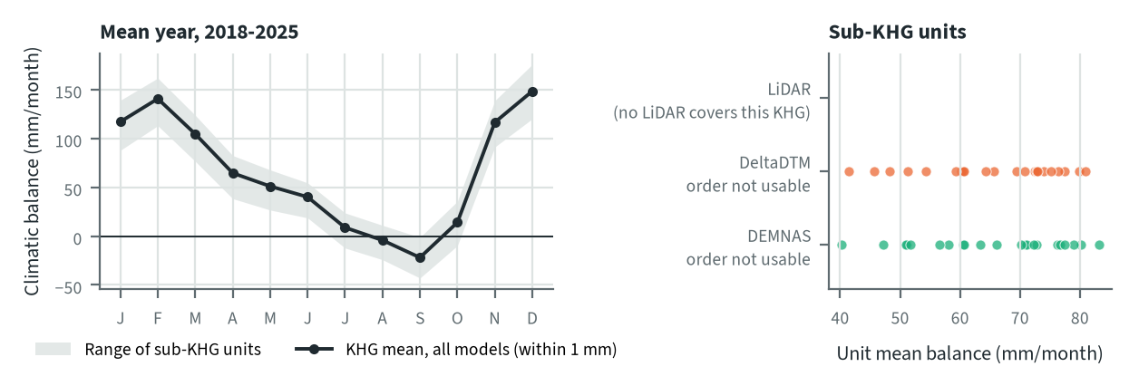
Figure 10.48. Balangan-Batangalai: climatic balance through the mean year, and the balance of each sub-KHG, by elevation model. Source: CHIRPS rain and MOD16 evapotranspiration, 2018-2025
The mean-year balance is negative in August and September, lowest in September at -22 mm/month, and positive again in October. The WaPOR balance is 91.1 mm/month on both unit sets, against 64.8 and 64.9 mm/month with MOD16. The elevation model does not change the KHG balance (a difference of 0.1 mm/month); it changes only which cells fall in which unit, and so the spread between units.

Priority of sub-KHG
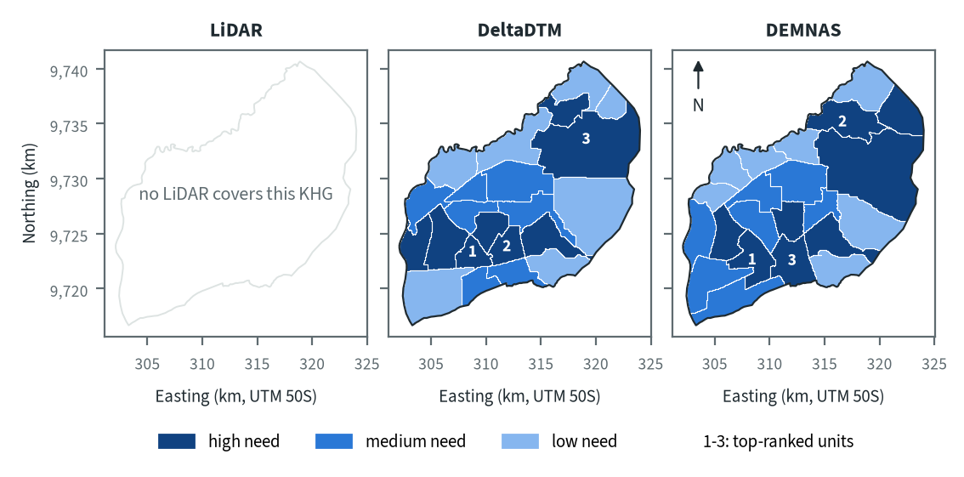
Figure 10.49. Balangan-Batangalai: need for intervention per sub-KHG, by elevation model. Source: sub-KHG prioritisation with default weights
With the default weights proposed for agreement with KLH and the World Bank, 8 units (116 km²) are high need on DeltaDTM and 8 units (143 km²) on DEMNAS. On both models the top-ranked unit lies in the south-west centre, where the canals are densest. The second and third differ: DeltaDTM places them in the south-west centre and in a large unit in the north-east, and DEMNAS in the north and in the south centre. The need score combines fire, vegetation dryness, canals and peat depth (chapter 7). The water balance cannot enter because its order test failed, and modelled peat depth covers only 53 % of this KHG, the lowest of the selected KHG that have it (chapter 3), so its weight still needs a decision.
Table 10.69. Balangan-Batangalai: high-need area and agreement of the priority classes between elevation models. Source: sub-KHG prioritisation with default weights
Elevation model or pair | High need (units, km²) | Overlap (km²) | Same need class (% of overlap) | High need in first also high in second (%) | Spearman of scores, area-weighted
LiDAR | no LiDAR covers this KHG
DeltaDTM | 8, 116
DEMNAS | 8, 143
DeltaDTM and DEMNAS |  | 308 | 68 | 83 | 0.64
Units are matched by location, since each model has its own units. Shares are of the area both models cover. Default weights, proposed for agreement with KLH and the World Bank.
Of the area both models cover, 68 % keeps its need class, and 83 % of the high-need area in DeltaDTM is also high need in DEMNAS. The area-weighted Spearman correlation of the scores is 0.64. DEMNAS marks 27 km² more as high need (143 against 116 km²); the maps show that its high-need units in the north-east and east are drawn larger than those of DeltaDTM. Class agreement is a little higher than the 57 to 65 % at Sugihan-Lumpur.

Canal blocks and pumping
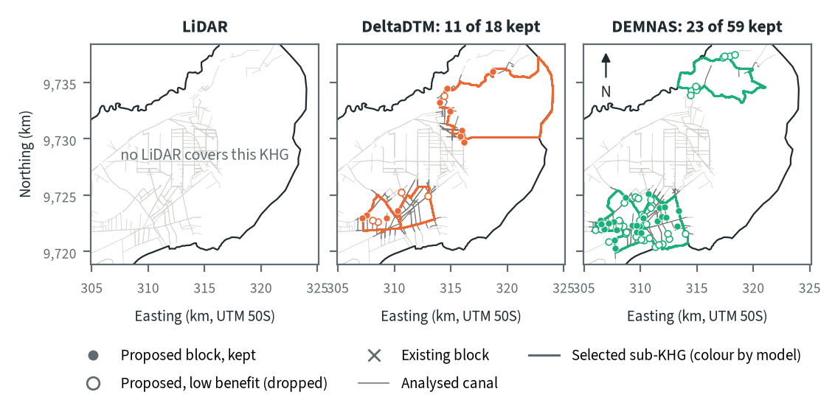
Figure 10.50. Balangan-Batangalai: proposed canal blocks in the three highest-ranked sub-KHG, by elevation model. Source: RE-PEAT Interventions on each elevation model, mapped canals and existing blocks
In the three highest-ranked sub-KHG the sekat kanal (canal block) step proposes 18 blocks on DeltaDTM and keeps 11, and proposes 59 on DEMNAS and keeps 23; 7 and 36 are dropped as adding little. Blocks sit along canals in the south-west and, on DeltaDTM, in the north-centre. The selected units differ: S18, S17 and S04 on DeltaDTM and S18, S03 and S19 on DEMNAS, and only S18 is shared. DEMNAS puts most of its blocks in a dense cluster in the south-west, which follows local noise in its surface as at Sugihan-Lumpur (chapter 9). With no LiDAR to measure against, the block counts should be read as a range between the two models.
Table 10.70. Balangan-Batangalai: canal blocks, water held and budget, by elevation model. Source: RE-PEAT Interventions and sub-KHG prioritisation on each elevation model
Quantity | LiDAR | DeltaDTM | DEMNAS
Selected sub-KHG (top 3 by priority) | no LiDAR covers this KHG | S18, S17, S04 | S18, S03, S19
Blocks needed by the slope rule of the ranking, whole KHG (n) | no LiDAR covers this KHG | 723 | 2,277
Existing blocks counted by the ranking, whole KHG (n) | no LiDAR covers this KHG | 0 | 0
Existing blocks on analysed canals (n) | no LiDAR covers this KHG | 0 | 0
Blocks proposed by the head rule (n) | no LiDAR covers this KHG | 18 | 59
Blocks kept, 90% of the water-level rise (n) | no LiDAR covers this KHG | 11 | 23
Pump units (n) | no LiDAR covers this KHG | pumping not assessed | pumping not assessed
Water held by kept blocks (million m³) | no LiDAR covers this KHG | 0.15 | 0.96
Deficit of the selected units (million m³) | no LiDAR covers this KHG | - | -
Budget, low / central / high (billion Rp) | no LiDAR covers this KHG | 5 / 8 / 8 | 15 / 23 / 23
of which revegetation of burned land, central (billion Rp) | no LiDAR covers this KHG | 1 | 0
Blocks, water and budget are for the three highest-ranked sub-KHG of each model, which can differ between models. Kept: the fewest proposed blocks giving 90% of the water-level rise of all proposed blocks. Pumping is not assessed in these results. Default weights, proposed for agreement with KLH and the World Bank.
The kept blocks hold 0.15 million m³ on DeltaDTM and 0.96 million m³ on DEMNAS. They cannot be set against a deficit, because no station-based deficit exists for these units. The central budget is 8 billion Rp on DeltaDTM (5 to 8 billion Rp from low to high) and 23 billion Rp on DEMNAS (15 to 23), and revegetation of burned land accounts for 1 and 0 billion Rp of these. The budget is larger on DEMNAS because it keeps more blocks (23 against 11) in different units. Pumping was not assessed in this analysis.

How the elevation model changes the result
Table 10.71. Balangan-Batangalai: headline outputs by elevation model and their spread. Source: RE-PEAT results on each elevation model
Output | LiDAR | DeltaDTM | DEMNAS | Spread
Sub-KHG units (n) | no LiDAR covers this KHG | 22 | 22 | ×1.0
Median unit area (km²) | no LiDAR covers this KHG | 11 | 12 | ×1.1
Area covered by units (km²) | no LiDAR covers this KHG | 308 | 308 | ×1.0
Climatic balance, area mean (mm/month) | no LiDAR covers this KHG | 64.8 | 64.9 | range 0.1
High-need area (km²) | no LiDAR covers this KHG | 116 | 143 | ×1.2
High-need units (n) | no LiDAR covers this KHG | 8 | 8 | ×1.0
Blocks needed, slope rule of the ranking, whole KHG (n) | no LiDAR covers this KHG | 723 | 2,277 | ×3.1
Blocks proposed, head rule (n) | no LiDAR covers this KHG | 18 | 59 | ×3.3
Blocks kept (n) | no LiDAR covers this KHG | 11 | 23 | ×2.1
Water held by kept blocks (million m³) | no LiDAR covers this KHG | 0.15 | 0.96 | ×6.6
Budget, central (billion Rp) | no LiDAR covers this KHG | 8 | 23 | ×3.0
Spread: largest value over smallest across the models (range for the balance). Blocks kept, water and budget refer to the three highest-ranked sub-KHG of each model, so they move with the choice of units as well as with the terrain. Default weights, proposed for agreement with KLH and the World Bank.
The KHG balance barely moves (0.1 mm/month), and the number of units, the median unit area, the area covered and the number of high-need units move by a factor of 1.1 or less. The high-need area moves by ×1.2. The outputs that depend on canal slopes and on which units are selected move most: blocks needed by the slope rule over the whole KHG range from 723 on DeltaDTM to 2,277 on DEMNAS (×3.1), blocks proposed by the head rule by ×3.3, blocks kept by ×2.1, the central budget by ×3.0 and water held by ×6.6. The last three also move because the selected units change.
No LiDAR exists here, and the benchmark of chapter 4 found corrected DeltaDTM closer to LiDAR at the two sites that have it. DeltaDTM is therefore the model to use for decisions, with DEMNAS as the upper end of the range of block counts, and its error is not measured at this KHG.

Summary for this KHG
Balangan-Batangalai is a small, high-ranked KHG with a dense canal network in the south-west and no realised canal blocks. On DeltaDTM, the model recommended here, the plan keeps 11 canal blocks in the three highest-ranked sub-KHG, holding 0.15 million m³, for a central budget of 8 billion Rp; DEMNAS gives 23 blocks, 0.96 million m³ and 23 billion Rp. The KHG balance does not change with the model, but the selected units do, and with them blocks, water and budget; the two unit sets agree on 71 % of the area. Neither model can be checked against LiDAR here. No water-table station lies inside the KHG, so no deficit can be computed, the order of units by climatic balance is not usable, pumping was not assessed, and modelled peat depth covers only 53 % of the KHG.

10.12 Buru Mappi-Buru Obaa (KHG 91.18-17.01)
Table 10.72. Buru Mappi-Buru Obaa: key facts. Source: national KHG profile, national canal and structures layers, RE-PEAT results for this KHG
Item | Value
Province | Papua
Area of the KHG polygon (km²) | 3,979
Peat area (km²) | 1,699
National rank (class) | 143 of 476 (high priority)
Canals, primary / secondary / tertiary (km) | 5 / 11 / 15
Existing water-management structures, all types (n) | 0
SiTMAT water-table stations (n) | 0
Realised canal blocks inside the KHG (n) | 0
LiDAR cover of the KHG (%) | no LiDAR covers this KHG
Elevation model ready, by elevation model | DeltaDTM, DEMNAS
Sub-KHG units, by elevation model | DeltaDTM, DEMNAS
Water balance, by elevation model | DeltaDTM, DEMNAS
Priority of sub-KHG, by elevation model | DeltaDTM, DEMNAS
Canal blocks and costs, by elevation model | DeltaDTM, DEMNAS
Dry-season deficit from stations | not computed
Rank among ranked KHG with default weights, proposed for agreement with KLH and the World Bank. Canals: mapped canal network. Structures and realised canal blocks: national layer of existing water-management structures (all types, and the canal blocks recorded as realised).
Buru Mappi-Buru Obaa is a KHG (Kesatuan Hidrologis Gambut, peat hydrological unit) in Papua (Papua Selatan, chapter 3). It covers 3,979 km², of which 1,699 km² is peat. It ranks 138 of 476 ranked KHG nationally (high priority) with the default weights proposed for agreement with KLH and the World Bank, and 49 when only this year's hotspots are counted. Its burned share is low (0.7 % of peat a year), but 920 hotspots fell on its peat in 2026, 703 of them in July, which puts it 12th by this year's count (chapter 6). It has the least data of the main KHG: 5 km of primary, 11 km of secondary and 15 km of tertiary canal are mapped, and there are no water-management structures, no canal blocks, no water-table station, no modelled peat depth and no LiDAR. The chain therefore ran on corrected DeltaDTM and corrected DEMNAS only.

Terrain and the three elevation models
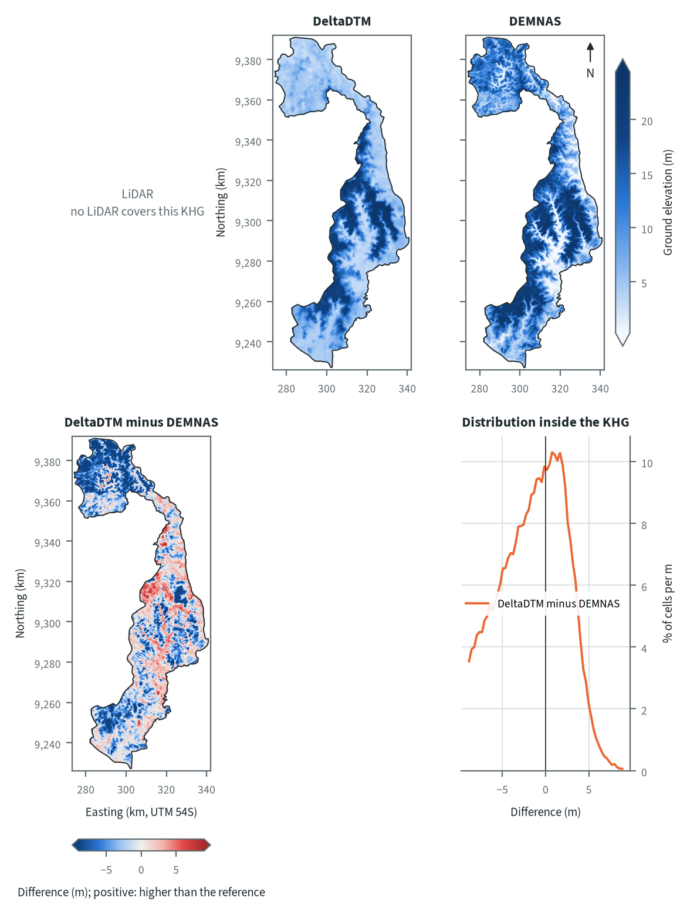
Figure 10.51. Buru Mappi-Buru Obaa: ground elevation from each elevation model on one colour scale, and their differences. Source: LiDAR terrain model, DeltaDTM and DEMNAS after the DEM correction
The KHG is a long, narrow strip running north to south, with a wider lobe in the north. Both models show higher ground along a central band, and lower ground in the northern lobe and at the southern tip. DEMNAS resolves a branching pattern of stream valleys inside the higher ground, while DeltaDTM, at 30 m, shows the same band as a smooth surface. The difference map has DEMNAS higher than DeltaDTM over much of the northern lobe and the south-west, and DeltaDTM higher in patches of the central band. DEMNAS is more than 2 m above DeltaDTM over 46 % of the KHG and more than 2 m below it over 18 %, and the 5th to 95th percentile of the difference is -10.1 to +4.0 m. The pattern follows forest cover and valleys more than a regular offset, which points to canopy left in DEMNAS in places and to smoothing of valleys in DeltaDTM. There is no LiDAR here, so neither model can be measured against a reference.
Table 10.73. Buru Mappi-Buru Obaa: resolution, cover and relief of each elevation model, and its difference to LiDAR. Source: LiDAR terrain model, DeltaDTM and DEMNAS after the DEM correction
Elevation model | Source | Resolution (m) | Cover of the KHG (%) | Relief, 5th-95th percentile (m)
LiDAR | no LiDAR covers this KHG
DeltaDTM | DeltaDTM v1.1 (global coastal terrain model), after the DEM correction | 30 | 99 | 3.1 to 21.2
DEMNAS | DEMNAS (BIG national surface model), after the DEM correction | 8 | 99 | 0.5 to 22.7
Statistics over the KHG polygon on a common 30 m grid (the DeltaDTM grid; finer models averaged onto it). NMAD: normalised median absolute deviation, a spread measure robust to outliers. Where LiDAR covers only part of the KHG, differences are over that part.
Relief between the 5th and 95th percentiles is 3.1 to 21.2 m on DeltaDTM and 0.5 to 22.7 m on DEMNAS, which is 18.1 and 22.2 m. Both cover 99 % of the KHG. Without LiDAR no difference to a reference can be given. At the two KHG that have LiDAR, the corrected DEMNAS differed from it by an NMAD of 1.60 and 2.28 m and DeltaDTM by 0.64 and 0.46 m (chapter 4), so DEMNAS has the larger local error at both. Those sites are flat Sumatran peat plains and the same errors may not hold on this terrain, but they are the only guide. Slopes taken from DEMNAS should be treated as less certain than slopes from DeltaDTM.

Sub-KHG units
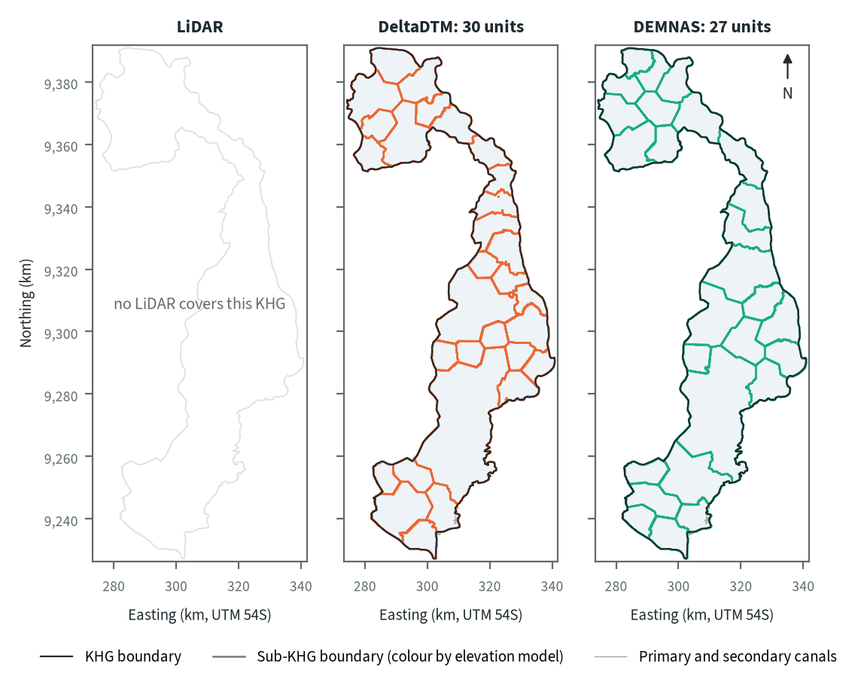
Figure 10.52. Buru Mappi-Buru Obaa: sub-KHG units delineated on each elevation model. Source: sub-KHG delineation on each elevation model, mapped canals
DeltaDTM gives 30 sub-KHG units and DEMNAS 27. Only 16 km of primary and secondary canal is mapped, so the unit boundaries have few canals to follow. The maps show compact polygons that are smaller in the northern lobe and at the southern tip and larger in the central strip. The two sets differ mainly in the central strip, where DeltaDTM draws one unit of 845 km², and in the northern lobe, where the boundaries fall in different places.
Table 10.74. Buru Mappi-Buru Obaa: number and size of sub-KHG units, and agreement between elevation models (area in the best-matching unit, adjusted Rand index). Source: sub-KHG delineation on each elevation model
Elevation model or pair | Units (n) | Unit area, median (km²) | Unit area, range (km²) | Units total (km²) | Overlap (km²) | Area in best-matching unit (%) | Adjusted Rand index
LiDAR | no LiDAR covers this KHG
DeltaDTM | 30 | 88 | 60 to 845 | 3,979
DEMNAS | 27 | 126 | 70 to 666 | 3,979
DeltaDTM and DEMNAS |  |  |  |  | 3,979 | 70 | 0.60
Pairs are compared over the area both cover. Best-matching unit: share of the overlap that lies in the unit of the other model it overlaps most, averaged over both directions. Adjusted Rand index: 1 for identical partitions, about 0 for chance agreement; computed on 1 ha cells.
The two unit sets share 70 % of the area in best-matching units, with an adjusted Rand index of 0.60. Median unit area is 88 km² on DeltaDTM (range 60 to 845 km²) and 126 km² on DEMNAS (range 70 to 666 km²). The index is close to the 0.601 that a flat surface gave at Sugihan-Lumpur in the stability test of chapter 5, although that test used a dense canal network. Here the elevation model changes where the units fall, and no LiDAR unit set exists to show which one is closer.

Water balance and deficit
Table 10.75. Buru Mappi-Buru Obaa: dry-season deficit from water-table stations and climatic balance per sub-KHG. Source: SiTMAT water-table stations, CHIRPS rain, MOD16 and WaPOR evapotranspiration
Quantity | All models | LiDAR | DeltaDTM | DEMNAS
Dry-season deficit from stations | not computed: no water-table station inside the KHG
Sub-KHG units (n) |  | no LiDAR covers this KHG | 30 | 27
Climatic balance, MOD16, area mean (mm/month) |  | no LiDAR covers this KHG | 164.8 | 164.8
Climatic balance, unit range (mm/month) |  | no LiDAR covers this KHG | 154.8 to 172.1 | 156.5 to 174.0
Climatic balance, WaPOR, area mean (mm/month) |  | no LiDAR covers this KHG | 184.0 | 184.0
Deficit months per year, area mean |  | no LiDAR covers this KHG | 0.59 | 0.60
Order of units usable (ET products agree) |  | no LiDAR covers this KHG | no | no
The station deficit uses water-table stations and reanalysis rain and evaporation (band: specific yield 0.10 to 0.20) and does not depend on the elevation model. The climatic balance is CHIRPS rain minus evapotranspiration, 2018-2025, per sub-KHG of each model.
No water-table station lies inside the KHG, so no station-based dry-season deficit can be computed. The climatic balance per sub-KHG averages 164.8 mm/month with MOD16 evapotranspiration and 184.0 mm/month with WaPOR on both unit sets, and the deficit months average 0.59 a year on DeltaDTM units and 0.60 on DEMNAS units. The order of units by balance is not usable with either model, because the two evapotranspiration products do not agree on that order, so the balance values are left out of the unit ranking (chapter 8).
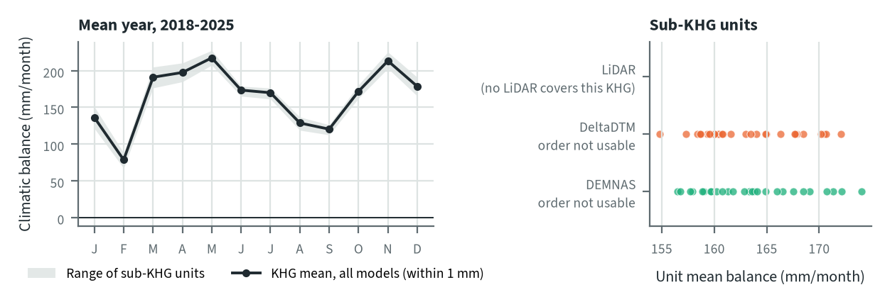
Figure 10.53. Buru Mappi-Buru Obaa: climatic balance through the mean year, and the balance of each sub-KHG, by elevation model. Source: CHIRPS rain and MOD16 evapotranspiration, 2018-2025
The mean balance stays positive in every month. It is lowest in February and again in August and September, and highest in May and November. The KHG mean is the same on both unit sets (164.8 mm/month), so the elevation model does not change it. It changes only the spread between units, from 154.8 to 172.1 mm/month on DeltaDTM units and 156.5 to 174.0 mm/month on DEMNAS units. This is far above the 58 to 84 mm/month of the Sumatran KHG in chapter 8, so the climatic balance here shows little seasonal shortage of water.

Priority of sub-KHG
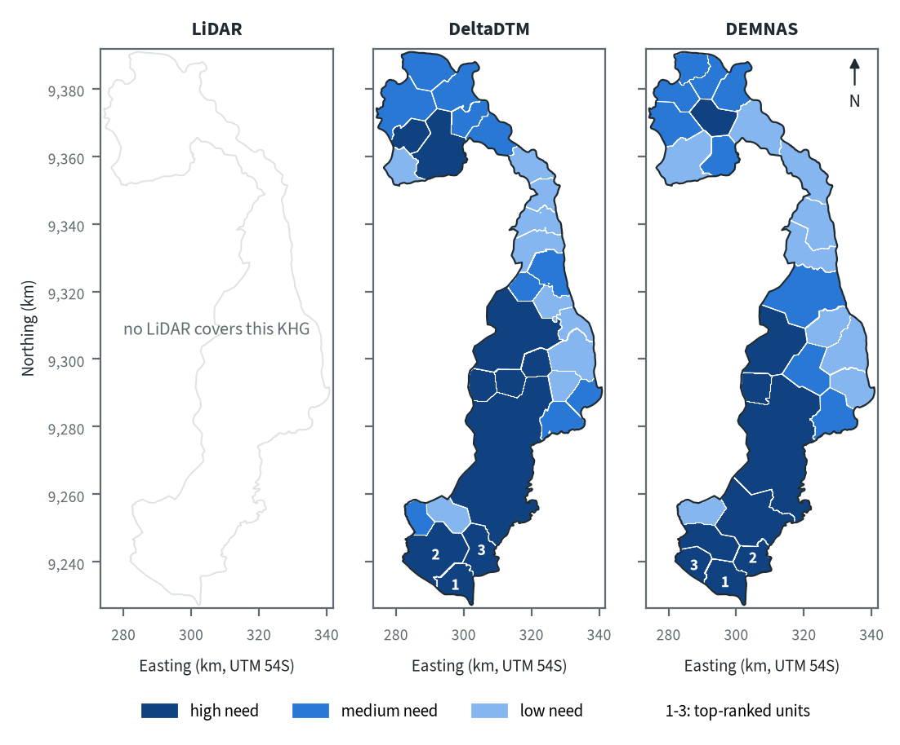
Figure 10.54. Buru Mappi-Buru Obaa: need for intervention per sub-KHG, by elevation model. Source: sub-KHG prioritisation with default weights
With the default weights proposed for agreement with KLH and the World Bank, high-need units cover the central and southern strip on both models, and the north-western lobe has medium or high need depending on the model. The three top-ranked units lie at the southern tip on both. Peat depth has weight 0 because no depth layer exists (chapter 3), and the balance is left out because its order is not usable, so the score rests on the fire, vegetation dryness, canal and other indicators of chapter 7. This KHG has little burned area but many hotspots this year, so the ranking reflects current fire activity more than past burning.
Table 10.76. Buru Mappi-Buru Obaa: high-need area and agreement of the priority classes between elevation models. Source: sub-KHG prioritisation with default weights
Elevation model or pair | High need (units, km²) | Overlap (km²) | Same need class (% of overlap) | High need in first also high in second (%) | Spearman of scores, area-weighted
LiDAR | no LiDAR covers this KHG
DeltaDTM | 10, 2,124
DEMNAS | 9, 1,725
DeltaDTM and DEMNAS |  | 3,979 | 74 | 76 | 0.81
Units are matched by location, since each model has its own units. Shares are of the area both models cover. Default weights, proposed for agreement with KLH and the World Bank.
High-need area is 2,124 km² (10 units) on DeltaDTM and 1,725 km² (9 units) on DEMNAS. 74 % of the area keeps its need class between the two models, 76 % of the high-need area in one is also high need in the other, and the area-weighted Spearman correlation of the scores is 0.81. The largest difference is in the north-western lobe, where DeltaDTM marks two units as high need and DEMNAS marks one.

Canal blocks and pumping
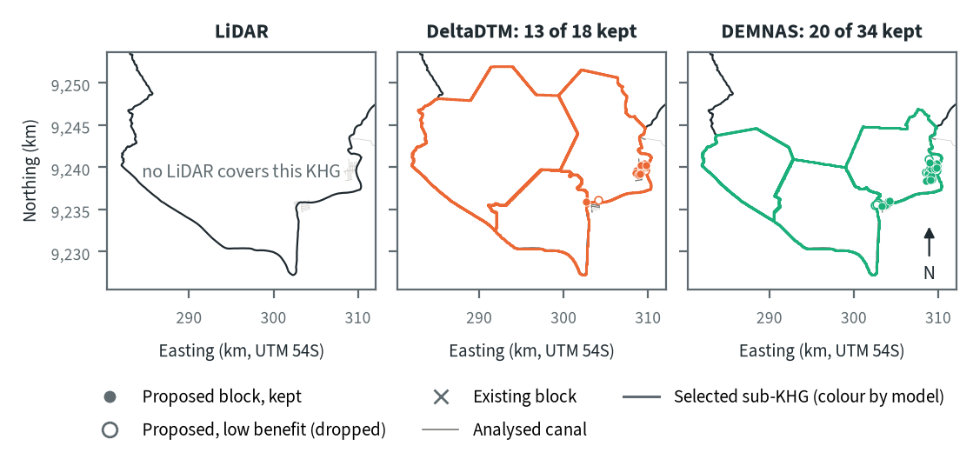
Figure 10.55. Buru Mappi-Buru Obaa: proposed canal blocks in the three highest-ranked sub-KHG, by elevation model. Source: RE-PEAT Interventions on each elevation model, mapped canals and existing blocks
The three selected sub-KHG are S30, S29 and S28 on DeltaDTM and S27, S25 and S26 on DEMNAS. The labels differ because each model has its own unit set, but the units lie at the same southern tip of the KHG. The sekat kanal (canal block) step proposes 18 blocks on DeltaDTM and 34 on DEMNAS, and keeps 13 and 20 for 90 % of the water-level rise; the other 5 and 14 add little and are dropped. The blocks cluster along the few mapped canals at the eastern edge of the selected units, since the rest of the selected area has no mapped canal to block. No existing blocks are counted.
Table 10.77. Buru Mappi-Buru Obaa: canal blocks, water held and budget, by elevation model. Source: RE-PEAT Interventions and sub-KHG prioritisation on each elevation model
Quantity | LiDAR | DeltaDTM | DEMNAS
Selected sub-KHG (top 3 by priority) | no LiDAR covers this KHG | S30, S29, S28 | S27, S25, S26
Blocks needed by the slope rule of the ranking, whole KHG (n) | no LiDAR covers this KHG | 73 | 303
Existing blocks counted by the ranking, whole KHG (n) | no LiDAR covers this KHG | 0 | 0
Existing blocks on analysed canals (n) | no LiDAR covers this KHG | 0 | 0
Blocks proposed by the head rule (n) | no LiDAR covers this KHG | 18 | 34
Blocks kept, 90% of the water-level rise (n) | no LiDAR covers this KHG | 13 | 20
Pump units (n) | no LiDAR covers this KHG | pumping not assessed | pumping not assessed
Water held by kept blocks (million m³) | no LiDAR covers this KHG | 0.13 | 0.21
Deficit of the selected units (million m³) | no LiDAR covers this KHG | - | -
Budget, low / central / high (billion Rp) | no LiDAR covers this KHG | 48 / 75 / 92 | 10 / 15 / 18
of which revegetation of burned land, central (billion Rp) | no LiDAR covers this KHG | 74 | 14
Blocks, water and budget are for the three highest-ranked sub-KHG of each model, which can differ between models. Kept: the fewest proposed blocks giving 90% of the water-level rise of all proposed blocks. Pumping is not assessed in these results. Default weights, proposed for agreement with KLH and the World Bank.
The kept blocks hold 0.13 million m³ on DeltaDTM and 0.21 million m³ on DEMNAS. No deficit can be given for the selected units, since there is no station deficit, so the water held cannot be set against one. The central budget is 75 billion Rp on DeltaDTM (48 to 92 from low to high) and 15 billion Rp on DEMNAS (10 to 18), of which revegetation of burned land is 74 and 14 billion Rp. Both budgets follow the burned land inside the selected units, and the blocks themselves are a small part. Pumping was not assessed.

How the elevation model changes the result
Table 10.78. Buru Mappi-Buru Obaa: headline outputs by elevation model and their spread. Source: RE-PEAT results on each elevation model
Output | LiDAR | DeltaDTM | DEMNAS | Spread
Sub-KHG units (n) | no LiDAR covers this KHG | 30 | 27 | ×1.1
Median unit area (km²) | no LiDAR covers this KHG | 88 | 126 | ×1.4
Area covered by units (km²) | no LiDAR covers this KHG | 3,979 | 3,979 | ×1.0
Climatic balance, area mean (mm/month) | no LiDAR covers this KHG | 164.8 | 164.8 | range 0.0
High-need area (km²) | no LiDAR covers this KHG | 2,124 | 1,725 | ×1.2
High-need units (n) | no LiDAR covers this KHG | 10 | 9 | ×1.1
Blocks needed, slope rule of the ranking, whole KHG (n) | no LiDAR covers this KHG | 73 | 303 | ×4.2
Blocks proposed, head rule (n) | no LiDAR covers this KHG | 18 | 34 | ×1.9
Blocks kept (n) | no LiDAR covers this KHG | 13 | 20 | ×1.5
Water held by kept blocks (million m³) | no LiDAR covers this KHG | 0.13 | 0.21 | ×1.6
Budget, central (billion Rp) | no LiDAR covers this KHG | 75 | 15 | ×5.0
Spread: largest value over smallest across the models (range for the balance). Blocks kept, water and budget refer to the three highest-ranked sub-KHG of each model, so they move with the choice of units as well as with the terrain. Default weights, proposed for agreement with KLH and the World Bank.
The KHG balance does not move (164.8 mm/month on both), and the number of units, the high-need area and the number of high-need units change by a factor of 1.2 or less. Blocks needed by the slope rule of the ranking over the whole KHG move most: 73 on DeltaDTM and 303 on DEMNAS (×4.2). The head rule gives ×1.9, kept blocks ×1.5, water held ×1.6 and the central budget ×5.0, the last mostly through the choice of units. The totals are small because the mapped network is short, 31 km in all. Per kilometre of mapped canal the slope rule gives 2.4 blocks on DeltaDTM and 9.8 on DEMNAS, against 0.26 and 1.8 at Sugihan-Lumpur (3,634 and 25,580 blocks over 14,231 km), so canal length explains the small totals while the density is not low. The relief here is also larger than at Sugihan-Lumpur, where it is 0.8 to 7.0 m on LiDAR.
With no LiDAR, block counts should be read as a range between the two models. DEMNAS counts are likely inflated by local error (chapter 9 advises against taking them as a design), and DeltaDTM had the smaller error at both LiDAR KHG. For decisions here DeltaDTM is the better choice, with the DEMNAS result as an upper bound, until a reference such as LiDAR or surveyed canal levels is available.

Summary for this KHG
Buru Mappi-Buru Obaa ranks 138 of 476 nationally, and the ranking rests on its 920 hotspots on peat in 2026 more than on past burning. The analysis has no LiDAR, water-table station or peat depth and only 31 km of mapped canal, so no station deficit can be computed and neither elevation model can be checked against a reference. On DeltaDTM, the model to use, the plan keeps 13 canal blocks in the three highest-ranked sub-KHG at the southern tip. They hold 0.13 million m³, and the central budget is 75 billion Rp, mostly revegetation of burned land. DEMNAS gives 20 blocks and 15 billion Rp for a different set of units, so the block counts should be read as a range between the two models. Pumping was not assessed.

10.13 Pulau Tebing Tinggi (KHG 14.10.03)
Table 10.79. Pulau Tebing Tinggi: key facts. Source: national KHG profile, national canal and structures layers, RE-PEAT results for this KHG
Item | Value
Province | Riau
Area of the KHG polygon (km²) | 1,380
Peat area (km²) | 1,364
National rank (class) | 205 of 476 (medium priority)
Canals, primary / secondary / tertiary (km) | 96 / 408 / 836
Existing water-management structures, all types (n) | 382
SiTMAT water-table stations (n) | 6
Realised canal blocks inside the KHG (n) | 168
LiDAR cover of the KHG (%) | no LiDAR covers this KHG
Elevation model ready, by elevation model | DeltaDTM, DEMNAS
Sub-KHG units, by elevation model | DeltaDTM, DEMNAS
Water balance, by elevation model | DeltaDTM, DEMNAS
Priority of sub-KHG, by elevation model | DeltaDTM, DEMNAS
Canal blocks and costs, by elevation model | DeltaDTM, DEMNAS
Dry-season deficit from stations | computed
Rank among ranked KHG with default weights, proposed for agreement with KLH and the World Bank. Canals: mapped canal network. Structures and realised canal blocks: national layer of existing water-management structures (all types, and the canal blocks recorded as realised).
Pulau Tebing Tinggi is a KHG (Kesatuan Hidrologis Gambut, peat hydrological unit) in Riau. It covers 1,380 km², of which 1,364 km² is peat. It ranks 204 of 476 ranked KHG nationally (medium priority) with the default weights proposed for agreement with KLH and the World Bank, because little of its peat has burned: the burned share is below 0.4 % of peat per year, which still places it at the 68th percentile because 217 of the 476 ranked KHG have no burned peat at all (chapter 6). The mapped network has 96 km of primary, 408 km of secondary and 836 km of tertiary canals, and the national layer records 382 water-management structures, 168 of them realised canal blocks, none with a build year (chapter 3). No LiDAR covers this KHG, so the chain ran on corrected DeltaDTM and corrected DEMNAS only. Six SiTMAT water-table stations lie inside the KHG, and a station deficit was computed from five of them.

Terrain and the three elevation models
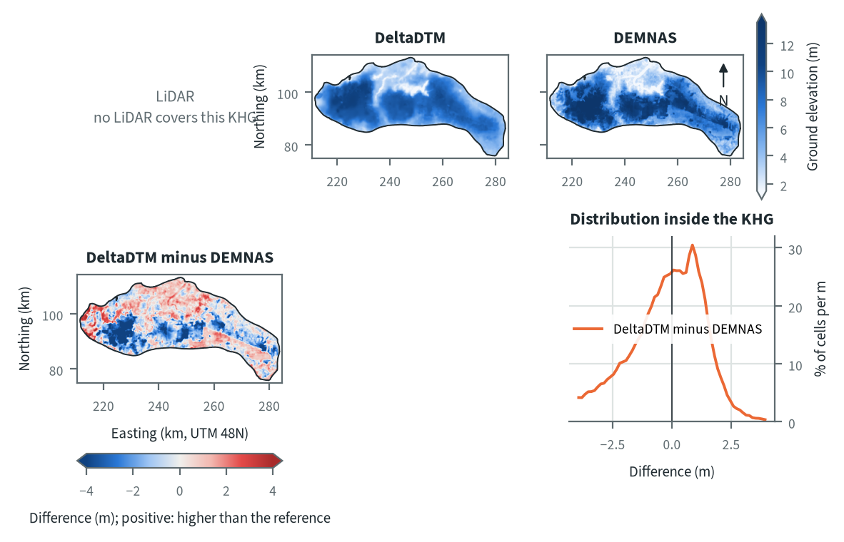
Figure 10.56. Pulau Tebing Tinggi: ground elevation from each elevation model on one colour scale, and their differences. Source: LiDAR terrain model, DeltaDTM and DEMNAS after the DEM correction
Both models show higher ground in the west and centre and a low corridor through the north-centre of the KHG, with the land falling towards the narrow south-eastern tail. They disagree over large blocks in the west and centre, where DEMNAS stands above DeltaDTM, and along strips in the north and south-east, where DeltaDTM is higher. DEMNAS is more than 2 m above DeltaDTM over 17 % of the KHG and more than 2 m below it over 5 %; the histogram of the difference (DeltaDTM minus DEMNAS) peaks at +0.87 m and its 5th to 95th percentile is -3.9 to +1.9 m. The blocky patches have the shape of canopy or land cover left in a surface model, and DEMNAS errors are largest under tree cover at the benchmark KHG (chapter 4), so canopy is the likely cause. Against the 2015 field survey elevations, DeltaDTM sits a median 0.37 m lower and DEMNAS 1.86 m higher (chapter 8).
Table 10.80. Pulau Tebing Tinggi: resolution, cover and relief of each elevation model, and its difference to LiDAR. Source: LiDAR terrain model, DeltaDTM and DEMNAS after the DEM correction
Elevation model | Source | Resolution (m) | Cover of the KHG (%) | Relief, 5th-95th percentile (m)
LiDAR | no LiDAR covers this KHG
DeltaDTM | DeltaDTM v1.1 (global coastal terrain model), after the DEM correction | 30 | 98 | 2.4 to 10.2
DEMNAS | DEMNAS (BIG national surface model), after the DEM correction | 8 | 100 | 1.8 to 13.1
Statistics over the KHG polygon on a common 30 m grid (the DeltaDTM grid; finer models averaged onto it). NMAD: normalised median absolute deviation, a spread measure robust to outliers. Where LiDAR covers only part of the KHG, differences are over that part.
DeltaDTM has 30 m cells and covers 98 % of the KHG; DEMNAS has 8 m cells and covers all of it. Relief between the 5th and 95th percentiles is 2.4 to 10.2 m on DeltaDTM and 1.8 to 13.1 m on DEMNAS, so DEMNAS shows 11.3 m of relief against 7.8 m. The upper end of DeltaDTM lies at the 10 m limit of the land that product describes, so the highest ground is outside its scope (chapter 4). There is no LiDAR here, so the offset and local error of each model cannot be measured. At the two benchmark KHG, DeltaDTM differed from LiDAR mostly by a constant offset and DEMNAS by a larger local error (chapter 4), so the slopes used later are likely to be better on DeltaDTM, and block counts should be read as a range between the two models.

Sub-KHG units
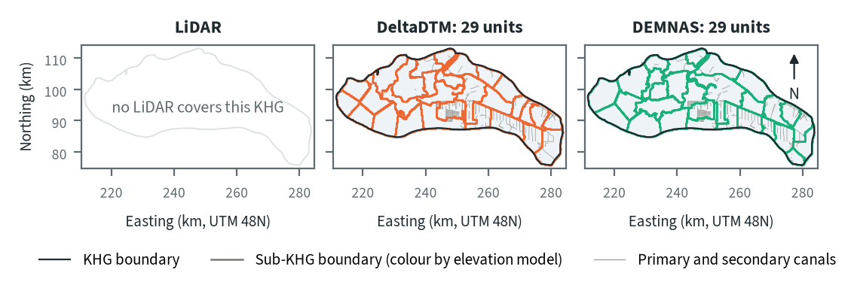
Figure 10.57. Pulau Tebing Tinggi: sub-KHG units delineated on each elevation model. Source: sub-KHG delineation on each elevation model, mapped canals
DeltaDTM and DEMNAS each give 29 sub-KHG units, with a median area of 45 km². The boundaries follow the mapped primary and secondary canals, which form a dense grid in the south-east and centre. DEMNAS draws a wider range of unit sizes, 21 to 126 km² against 24 to 90 km² on DeltaDTM, mainly in the west and north where few canals are mapped and terrain divides decide the lines.
Table 10.81. Pulau Tebing Tinggi: number and size of sub-KHG units, and agreement between elevation models (area in the best-matching unit, adjusted Rand index). Source: sub-KHG delineation on each elevation model
Elevation model or pair | Units (n) | Unit area, median (km²) | Unit area, range (km²) | Units total (km²) | Overlap (km²) | Area in best-matching unit (%) | Adjusted Rand index
LiDAR | no LiDAR covers this KHG
DeltaDTM | 29 | 45 | 24 to 90 | 1,380
DEMNAS | 29 | 45 | 21 to 126 | 1,380
DeltaDTM and DEMNAS |  |  |  |  | 1,380 | 73 | 0.57
Pairs are compared over the area both cover. Best-matching unit: share of the overlap that lies in the unit of the other model it overlaps most, averaged over both directions. Adjusted Rand index: 1 for identical partitions, about 0 for chance agreement; computed on 1 ha cells.
The two unit sets share 73 % of the area in best-matching units, with an adjusted Rand index of 0.57. This is close to the value of 0.601 that the stability test of chapter 5 found for a flat surface with only the mapped canals, so the canal network sets most of the layout here and the terrain adds little. With two models there is one pair to compare.

Water balance and deficit
Table 10.82. Pulau Tebing Tinggi: dry-season deficit from water-table stations and climatic balance per sub-KHG. Source: SiTMAT water-table stations, CHIRPS rain, MOD16 and WaPOR evapotranspiration
Quantity | All models | LiDAR | DeltaDTM | DEMNAS
Dry-season deficit from 5 stations, 01 Jun to 15 Oct 2026 (mm) | 0 (0 to 0)
Deficit volume over the KHG (million m³) | 0
Months in deficit in that window (n) | 1
Sub-KHG units (n) |  | no LiDAR covers this KHG | 29 | 29
Climatic balance, MOD16, area mean (mm/month) |  | no LiDAR covers this KHG | 40.3 | 40.2
Climatic balance, unit range (mm/month) |  | no LiDAR covers this KHG | 36.9 to 52.7 | 34.9 to 52.7
Climatic balance, WaPOR, area mean (mm/month) |  | no LiDAR covers this KHG | 52.5 | 52.5
Deficit months per year, area mean |  | no LiDAR covers this KHG | 3.87 | 3.88
Order of units usable (ET products agree) |  | no LiDAR covers this KHG | no | no
The station deficit uses water-table stations and reanalysis rain and evaporation (band: specific yield 0.10 to 0.20) and does not depend on the elevation model. The climatic balance is CHIRPS rain minus evapotranspiration, 2018-2025, per sub-KHG of each model.
From 1 June to 15 October 2026, five stations give a dry-season deficit of 0 mm (0 to 0 mm for a specific yield of 0.10 to 0.20), or 0 million m³ over the KHG, with 1 month in deficit in that window. In this window the stations record no net water loss, so there is no deficit for blocks to offset. The deficit does not depend on the elevation model. The order of units by climatic balance is not usable on either model, as at the other KHG tested in chapter 8: the two evapotranspiration products do not agree on the order of the 29 units. Unit balances are therefore context only.
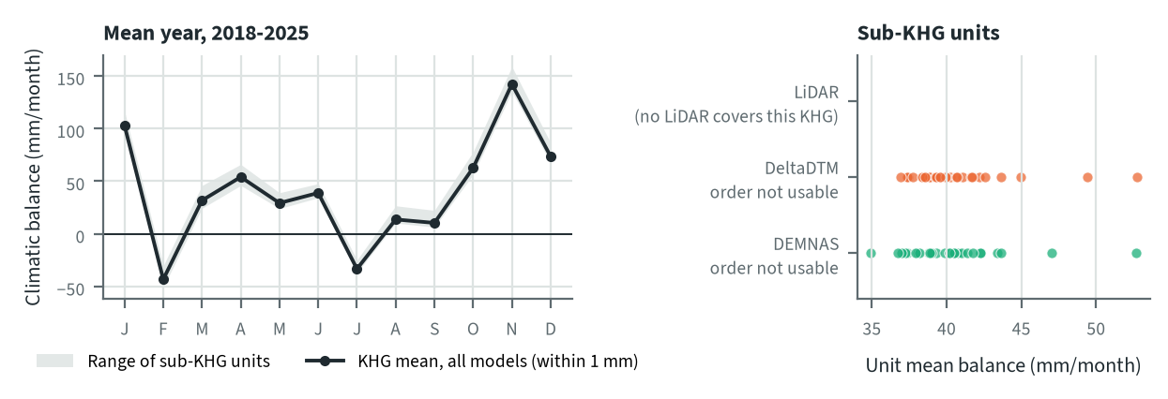
Figure 10.58. Pulau Tebing Tinggi: climatic balance through the mean year, and the balance of each sub-KHG, by elevation model. Source: CHIRPS rain and MOD16 evapotranspiration, 2018-2025
The mean climatic balance is negative in February and July, low in August and September (14 and 10 mm/month), and highest in November. The KHG mean is 40.3 mm/month with DeltaDTM units and 40.2 mm/month with DEMNAS units (52.5 mm/month with WaPOR on both), and the deficit months per year are 3.87 and 3.88, so the elevation model does not change the balance of the KHG. It changes only the spread between units, 36.9 to 52.7 mm/month on DeltaDTM and 34.9 to 52.7 mm/month on DEMNAS.

Priority of sub-KHG
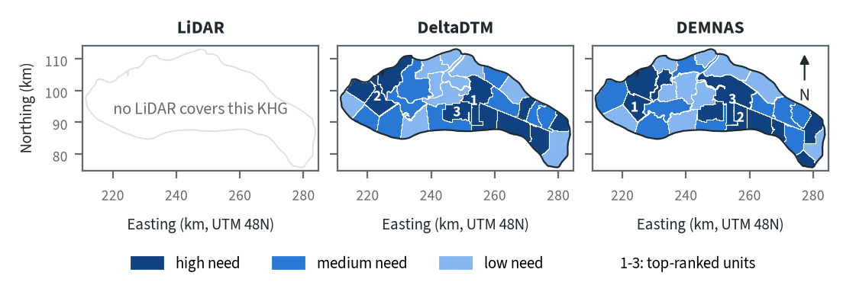
Figure 10.59. Pulau Tebing Tinggi: need for intervention per sub-KHG, by elevation model. Source: sub-KHG prioritisation with default weights
With the default weights proposed for agreement with KLH and the World Bank, high-need units lie in the centre, the south-east and the north-west on both models, and low-need units in the west and centre-north. The top-ranked unit is in the centre on DeltaDTM and in the west on DEMNAS. Because this KHG has little fire, the score here rests mainly on the canal network and vegetation dryness (chapter 7), and the weights are provisional.
Table 10.83. Pulau Tebing Tinggi: high-need area and agreement of the priority classes between elevation models. Source: sub-KHG prioritisation with default weights
Elevation model or pair | High need (units, km²) | Overlap (km²) | Same need class (% of overlap) | High need in first also high in second (%) | Spearman of scores, area-weighted
LiDAR | no LiDAR covers this KHG
DeltaDTM | 10, 488
DEMNAS | 10, 485
DeltaDTM and DEMNAS |  | 1,380 | 59 | 71 | 0.67
Units are matched by location, since each model has its own units. Shares are of the area both models cover. Default weights, proposed for agreement with KLH and the World Bank.
High-need area is 488 km² (10 units) on DeltaDTM and 485 km² (10 units) on DEMNAS, a difference under 1 %. Even so, only 59 % of the area keeps its need class, 71 % of the high-need area in one model is also high need in the other, and the area-weighted Spearman correlation of the scores is 0.67. The total is stable and the places move, because each model groups the same canal, fire and vegetation data into differently shaped units, and a large unit that straddles two conditions can change class when its boundary shifts.

Canal blocks and pumping
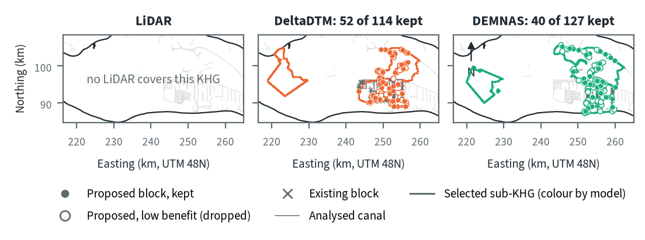
Figure 10.60. Pulau Tebing Tinggi: proposed canal blocks in the three highest-ranked sub-KHG, by elevation model. Source: RE-PEAT Interventions on each elevation model, mapped canals and existing blocks
In the three highest-ranked sub-KHG the sekat kanal (canal block) step proposes 114 blocks on DeltaDTM and 127 on DEMNAS, and keeps 52 and 40 of them for 90 % of the water-level rise; the other 62 and 87 add little and are dropped. Blocks go on the analysed canals of the central units, where the surface falls along the canal, with one separate unit in the west on each model. The selected units are S13, S12 and S18 on DeltaDTM and S14, S19 and S12 on DEMNAS, so only S12 is shared. The analysed canals hold 48 existing blocks on DeltaDTM and 29 on DEMNAS, which shows that the two plans work on different canals.
Table 10.84. Pulau Tebing Tinggi: canal blocks, water held and budget, by elevation model. Source: RE-PEAT Interventions and sub-KHG prioritisation on each elevation model
Quantity | LiDAR | DeltaDTM | DEMNAS
Selected sub-KHG (top 3 by priority) | no LiDAR covers this KHG | S13, S12, S18 | S14, S19, S12
Blocks needed by the slope rule of the ranking, whole KHG (n) | no LiDAR covers this KHG | 1,088 | 2,845
Existing blocks counted by the ranking, whole KHG (n) | no LiDAR covers this KHG | 168 | 168
Existing blocks on analysed canals (n) | no LiDAR covers this KHG | 48 | 29
Blocks proposed by the head rule (n) | no LiDAR covers this KHG | 114 | 127
Blocks kept, 90% of the water-level rise (n) | no LiDAR covers this KHG | 52 | 40
Pump units (n) | no LiDAR covers this KHG | pumping not assessed | pumping not assessed
Water held by kept blocks (million m³) | no LiDAR covers this KHG | 2.43 | 3.39
Deficit of the selected units (million m³) | no LiDAR covers this KHG | 0.0 | 0.0
Budget, low / central / high (billion Rp) | no LiDAR covers this KHG | 3 / 4 / 4 | 3 / 4 / 4
of which revegetation of burned land, central (billion Rp) | no LiDAR covers this KHG | 0 | 0
Blocks, water and budget are for the three highest-ranked sub-KHG of each model, which can differ between models. Kept: the fewest proposed blocks giving 90% of the water-level rise of all proposed blocks. Pumping is not assessed in these results. Default weights, proposed for agreement with KLH and the World Bank.
The kept blocks hold 2.43 million m³ on DeltaDTM and 3.39 million m³ on DEMNAS. The deficit of the selected units is 0 million m³ on both, so water held cannot be set against a deficit here. The central budget is 4 billion Rp on both models (3 to 4 billion Rp from low to high), and revegetation of burned land is 0 billion Rp, since little of this KHG has burned. The budget therefore changes little with the model. Pumping was not assessed in this analysis.

How the elevation model changes the result
Table 10.85. Pulau Tebing Tinggi: headline outputs by elevation model and their spread. Source: RE-PEAT results on each elevation model
Output | LiDAR | DeltaDTM | DEMNAS | Spread
Sub-KHG units (n) | no LiDAR covers this KHG | 29 | 29 | ×1.0
Median unit area (km²) | no LiDAR covers this KHG | 45 | 45 | ×1.0
Area covered by units (km²) | no LiDAR covers this KHG | 1,381 | 1,381 | ×1.0
Climatic balance, area mean (mm/month) | no LiDAR covers this KHG | 40.3 | 40.2 | range 0.0
High-need area (km²) | no LiDAR covers this KHG | 488 | 485 | ×1.0
High-need units (n) | no LiDAR covers this KHG | 10 | 10 | ×1.0
Blocks needed, slope rule of the ranking, whole KHG (n) | no LiDAR covers this KHG | 1,088 | 2,845 | ×2.6
Blocks proposed, head rule (n) | no LiDAR covers this KHG | 114 | 127 | ×1.1
Blocks kept (n) | no LiDAR covers this KHG | 52 | 40 | ×1.3
Water held by kept blocks (million m³) | no LiDAR covers this KHG | 2.43 | 3.39 | ×1.4
Budget, central (billion Rp) | no LiDAR covers this KHG | 4 | 4 | ×1.0
Spread: largest value over smallest across the models (range for the balance). Blocks kept, water and budget refer to the three highest-ranked sub-KHG of each model, so they move with the choice of units as well as with the terrain. Default weights, proposed for agreement with KLH and the World Bank.
The balance of the KHG (40.3 and 40.2 mm/month), the number of units (29), the high-need area (488 and 485 km²) and the central budget (4 billion Rp) barely move. The outputs that depend on canal slopes move most: blocks needed by the slope rule of the ranking over the whole KHG are 1,088 on DeltaDTM and 2,845 on DEMNAS (×2.6), blocks kept differ by ×1.3 and water held by ×1.4, partly because the selected units differ. DeltaDTM is the model to use for decisions here, because at the benchmark KHG its error over 1 km was 0.47 to 0.64 m against 1.66 to 2.49 m for DEMNAS (chapter 4), and DEMNAS block counts should not be taken as a design (chapter 9). With no LiDAR, block counts should be read as a range between the two models.

Summary for this KHG
Pulau Tebing Tinggi is a densely canalled KHG with little burned peat, and in the 2026 dry season its five stations show no deficit, so the case for rewetting here rests on its canals and existing blocks and not on fire or water loss. On DeltaDTM, the model to use, the plan keeps 52 canal blocks in the three highest-ranked sub-KHG, holding 2.43 million m³, for a central budget of 4 billion Rp. The choice of elevation model changes which sub-KHG are selected and with them the blocks and water held, while the balance of the KHG, the high-need area and the budget stay close. Pumping was not assessed, no LiDAR exists to measure the error of either model, the order of units by climatic balance is not usable, and the 2015 field survey could not test the water-table pattern (chapter 8).

10.14 Sugihan-Lumpur (KHG 16.02.01)
Table 10.86. Sugihan-Lumpur: key facts. Source: national KHG profile, national canal and structures layers, RE-PEAT results for this KHG
Item | Value
Province | Sumatera Selatan
Area of the KHG polygon (km²) | 6,351
Peat area (km²) | 5,424
National rank (class) | 32 of 476 (high priority)
Canals, primary / secondary / tertiary (km) | 782 / 3,012 / 10,437
Existing water-management structures, all types (n) | 2,972
SiTMAT water-table stations (n) | 54
Realised canal blocks inside the KHG (n) | 2,847
LiDAR cover of the KHG (%) | 100
Elevation model ready, by elevation model | LiDAR, DeltaDTM, DEMNAS
Sub-KHG units, by elevation model | LiDAR, DeltaDTM, DEMNAS
Water balance, by elevation model | LiDAR, DeltaDTM, DEMNAS
Priority of sub-KHG, by elevation model | LiDAR, DeltaDTM, DEMNAS
Canal blocks and costs, by elevation model | LiDAR, DeltaDTM, DEMNAS
Dry-season deficit from stations | computed
Rank among ranked KHG with default weights, proposed for agreement with KLH and the World Bank. Canals: mapped canal network. Structures and realised canal blocks: national layer of existing water-management structures (all types, and the canal blocks recorded as realised).
Sugihan-Lumpur is a KHG (Kesatuan Hidrologis Gambut, peat hydrological unit) in Sumatera Selatan. It covers 6,351 km², of which 5,424 km² is peat. It ranks 31 of 476 ranked KHG nationally (high priority) with the default weights proposed for agreement with KLH and the World Bank, and rises to 24 when only fire history is weighed. The KHG is at the 96th percentile for burned share and the 2015 fires burned 37.0 % of its peat, while it is low on this year's hotspots (59th percentile) and has burned at most 5.5 % a year since 2015 (chapter 6). The mapped network is dense, with 782 km of primary, 3,012 km of secondary and 10,437 km of tertiary canals, and the national layer records 2,972 water-management structures, 2,847 of them realised canal blocks. LiDAR covers the whole KHG and 54 SiTMAT water-table stations lie inside it, so every step of the chain has run on all three elevation models (LiDAR, DeltaDTM and DEMNAS) and a station deficit could be computed.

Terrain and the three elevation models
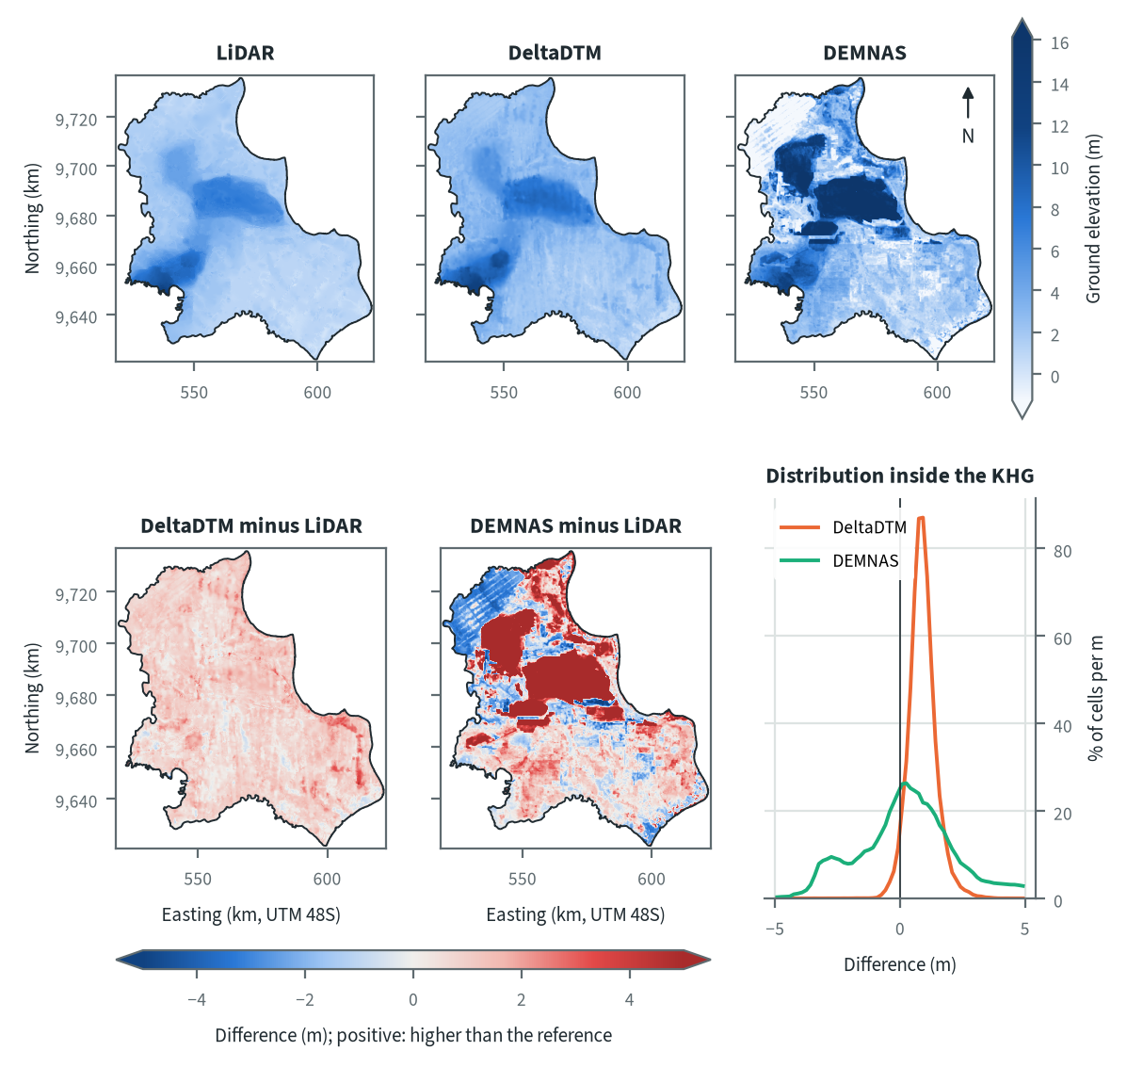
Figure 10.61. Sugihan-Lumpur: ground elevation from each elevation model on one colour scale, and their differences. Source: LiDAR terrain model, DeltaDTM and DEMNAS after the DEM correction
On the LiDAR the KHG is a low peat plain with two raised areas: a dome in the centre-north and a smaller high in the south-west, both several metres above the eastern and coastal margins. DeltaDTM reproduces this pattern almost everywhere and sits slightly higher across the whole KHG, the regular offset of about 0.9 to 1.3 m that DeltaDTM shows against LiDAR in all five KHG. DEMNAS departs strongly from both. Large blocky areas in the centre and north stand well above the LiDAR, and a striped area in the north-west lies below it. DEMNAS is more than 2 m above LiDAR over 30 % of the KHG and more than 2 m below it over 12 %. These patches follow tiles and land cover more than terrain; the benchmark found DEMNAS errors largest under tree cover and cropland at this KHG (NMAD 2.65 and 3.05 m, chapter 4), which points to canopy and crops left in the surface model after the correction.
Table 10.87. Sugihan-Lumpur: resolution, cover and relief of each elevation model, and its difference to LiDAR. Source: LiDAR terrain model, DeltaDTM and DEMNAS after the DEM correction
Elevation model | Source | Resolution (m) | Cover of the KHG (%) | Relief, 5th-95th percentile (m) | Difference to LiDAR, median (m) | Difference to LiDAR, NMAD (m)
LiDAR | Airborne LiDAR terrain model (KLHK), as delivered | 25 | 100 | 0.8 to 7.0
DeltaDTM | DeltaDTM v1.1 (global coastal terrain model), after the DEM correction | 30 | 98 | 1.4 to 8.2 | 0.87 | 0.46
DEMNAS | DEMNAS (BIG national surface model), after the DEM correction | 8 | 100 | -1.4 to 16.7 | 0.73 | 2.28
Statistics over the KHG polygon on a common 25 m grid (the LiDAR grid; finer models averaged onto it). NMAD: normalised median absolute deviation, a spread measure robust to outliers. Where LiDAR covers only part of the KHG, differences are over that part.
Relief between the 5th and 95th percentiles is 0.8 to 7.0 m on LiDAR, 1.4 to 8.2 m on DeltaDTM and -1.4 to 16.7 m on DEMNAS. DeltaDTM differs from LiDAR by a median of 0.87 m with an NMAD of 0.46 m, so most of its difference is a constant offset that leaves slopes largely intact. DEMNAS has a similar median difference (0.73 m) but an NMAD of 2.28 m, about five times that of DeltaDTM, so its error is local and changes the slopes that the delineation and the canal-block step depend on. Even the error of DeltaDTM over 1 km (0.47 m) is larger than the real 1 km relief of the LiDAR here (0.38 m, chapter 4), so on this flat ground both open models carry more noise than relief at the scale of a sub-KHG.

Sub-KHG units
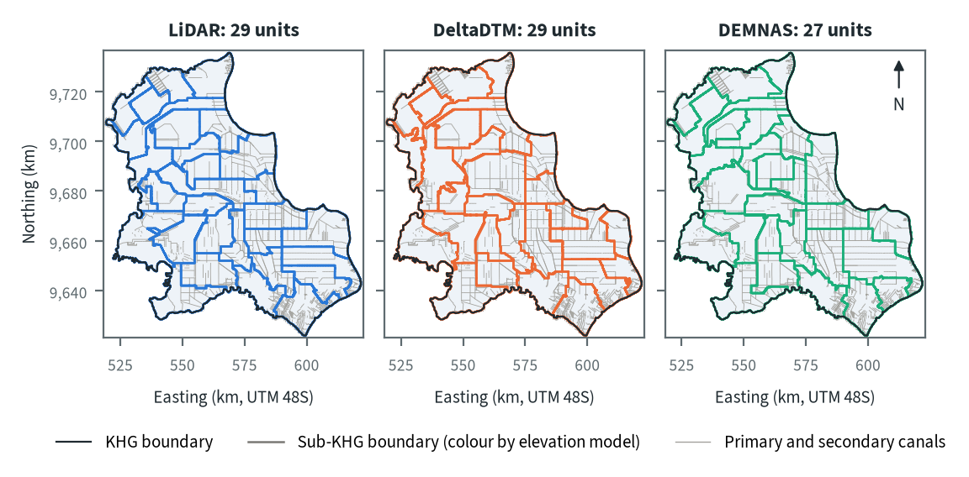
Figure 10.62. Sugihan-Lumpur: sub-KHG units delineated on each elevation model. Source: sub-KHG delineation on each elevation model, mapped canals
LiDAR and DeltaDTM each give 29 sub-KHG units and DEMNAS 27, with median areas of 221, 189 and 223 km². Most boundaries follow the primary and secondary canals, which make up nearly all of the outlet network here (chapter 5), so the grid of straight canal lines in the east and centre appears in all three maps. The models differ mainly in the north-west and around the central dome, where boundaries follow terrain divides between canals. DEMNAS, whose raised patches shift the divides, draws fewer and larger units (up to 481 km² against 373 km² on LiDAR).
Table 10.88. Sugihan-Lumpur: number and size of sub-KHG units, and agreement between elevation models (area in the best-matching unit, adjusted Rand index). Source: sub-KHG delineation on each elevation model
Elevation model or pair | Units (n) | Unit area, median (km²) | Unit area, range (km²) | Units total (km²) | Overlap (km²) | Area in best-matching unit (%) | Adjusted Rand index
LiDAR | 29 | 221 | 126 to 373 | 6,350
DeltaDTM | 29 | 189 | 118 to 413 | 6,351
DEMNAS | 27 | 223 | 121 to 481 | 6,351
LiDAR and DeltaDTM |  |  |  |  | 6,350 | 75 | 0.60
LiDAR and DEMNAS |  |  |  |  | 6,350 | 73 | 0.60
DeltaDTM and DEMNAS |  |  |  |  | 6,351 | 78 | 0.66
Pairs are compared over the area both cover. Best-matching unit: share of the overlap that lies in the unit of the other model it overlaps most, averaged over both directions. Adjusted Rand index: 1 for identical partitions, about 0 for chance agreement; computed on 1 ha cells.
LiDAR and DeltaDTM share 75 % of the area in best-matching units (adjusted Rand index 0.60), LiDAR and DEMNAS 73 % (0.60), and DeltaDTM and DEMNAS 78 % (0.66). The pair that differs most is LiDAR and DEMNAS. These values are close to what the stability test of chapter 5 found for a flat surface with only the mapped canals (adjusted Rand index 0.601), so at this KHG the canal network sets most of the unit layout and the terrain adds little.

Water balance and deficit
Table 10.89. Sugihan-Lumpur: dry-season deficit from water-table stations and climatic balance per sub-KHG. Source: SiTMAT water-table stations, CHIRPS rain, MOD16 and WaPOR evapotranspiration
Quantity | All models | LiDAR | DeltaDTM | DEMNAS
Dry-season deficit from 51 stations, 01 Jun to 09 Oct 2026 (mm) | 290 (285 to 296)
Deficit volume over the KHG (million m³) | 1,842
Months in deficit in that window (n) | 5
Sub-KHG units (n) |  | 29 | 29 | 27
Climatic balance, MOD16, area mean (mm/month) |  | 69.3 | 69.3 | 69.3
Climatic balance, unit range (mm/month) |  | 56.5 to 94.1 | 57.6 to 88.0 | 60.5 to 88.0
Climatic balance, WaPOR, area mean (mm/month) |  | 91.1 | 91.0 | 91.1
Deficit months per year, area mean |  | 2.44 | 2.45 | 2.42
Order of units usable (ET products agree) |  | no | no | yes
The station deficit uses water-table stations and reanalysis rain and evaporation (band: specific yield 0.10 to 0.20) and does not depend on the elevation model. The climatic balance is CHIRPS rain minus evapotranspiration, 2018-2025, per sub-KHG of each model.
From 1 June to 9 October 2026, 51 stations give a dry-season deficit of 290 mm (285 to 296 mm for a specific yield of 0.10 to 0.20), or 1,842 million m³ over the KHG, with 5 months in deficit in that window. The station water table fell only about 11 cm while the climate removed about 307 mm, so most of the water came from outside the rain balance, through canal inflow, gates and pumping in the managed concessions (chapter 8). The deficit does not depend on the elevation model. The order of units by climatic balance is usable only with DEMNAS units, where the two evapotranspiration products agree at 0.53 against a threshold of 0.44; with LiDAR and DeltaDTM units they agree at 0.41 against 0.43. The test sits on its threshold, so the pass with DEMNAS reflects how the units are drawn and says nothing about the quality of its terrain.
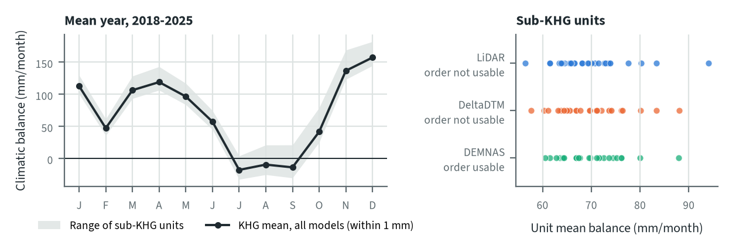
Figure 10.63. Sugihan-Lumpur: climatic balance through the mean year, and the balance of each sub-KHG, by elevation model. Source: CHIRPS rain and MOD16 evapotranspiration, 2018-2025
The mean climatic balance is negative in July, August and September and recovers in October; February dips but stays positive. The KHG mean is 69.3 mm/month on all three unit sets and the deficit months per year are 2.42 to 2.45, so the elevation model does not change the balance of the KHG. It changes only the spread between units, from 56.5 to 94.1 mm/month on LiDAR units to 60.5 to 88.0 mm/month on DEMNAS units, because each unit set averages the same rain and evapotranspiration grids over different areas.

Priority of sub-KHG
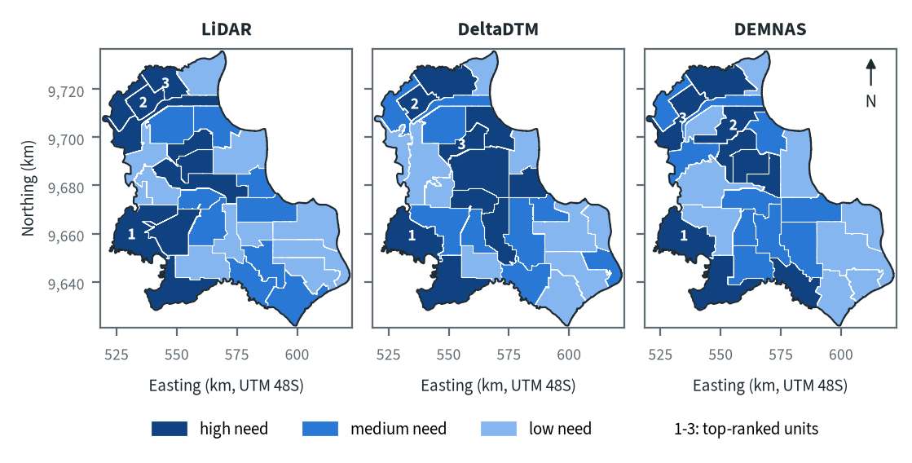
Figure 10.64. Sugihan-Lumpur: need for intervention per sub-KHG, by elevation model. Source: sub-KHG prioritisation with default weights
With the default weights proposed for agreement with KLH and the World Bank, high-need units lie in the west and south-west on every model, and the east is mostly low or medium need. The top-ranked unit is in the south-west on all three models. The second and third lie in the north-west on LiDAR, while DeltaDTM places its third unit in the centre and DEMNAS its second in the centre-north. The need score combines vegetation dryness, fire, peat depth and, where it is usable, the water balance (chapter 7); the peat depth model covers only 74.7 % of this KHG, so its weight in the score still needs a decision.
Table 10.90. Sugihan-Lumpur: high-need area and agreement of the priority classes between elevation models. Source: sub-KHG prioritisation with default weights
Elevation model or pair | High need (units, km²) | Overlap (km²) | Same need class (% of overlap) | High need in first also high in second (%) | Spearman of scores, area-weighted
LiDAR | 10, 2,175
DeltaDTM | 10, 2,379
DEMNAS | 9, 2,057
LiDAR and DeltaDTM |  | 6,350 | 62 | 63 | 0.68
LiDAR and DEMNAS |  | 6,350 | 57 | 64 | 0.55
DeltaDTM and DEMNAS |  | 6,351 | 65 | 66 | 0.72
Units are matched by location, since each model has its own units. Shares are of the area both models cover. Default weights, proposed for agreement with KLH and the World Bank.
High-need area is 2,175 km² (10 units) on LiDAR, 2,379 km² (10 units) on DeltaDTM and 2,057 km² (9 units) on DEMNAS. Between pairs, 57 to 65 % of the area keeps its need class, and 63 to 66 % of the high-need area in one model is also high need in the other. LiDAR and DEMNAS agree least (57 %, area-weighted Spearman 0.55), and DeltaDTM and DEMNAS most (65 %, 0.72). The differences come from the units: each model groups the same fire, vegetation and depth data into differently shaped units, and a large unit that straddles burned and unburned land can change class when its boundary moves.

Canal blocks and pumping
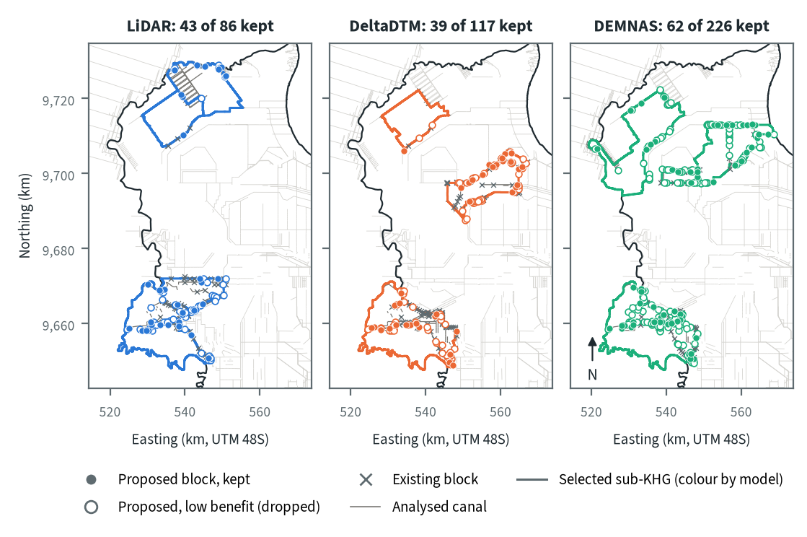
Figure 10.65. Sugihan-Lumpur: proposed canal blocks in the three highest-ranked sub-KHG, by elevation model. Source: RE-PEAT Interventions on each elevation model, mapped canals and existing blocks
In the three highest-ranked sub-KHG the sekat kanal (canal block) step proposes 86 blocks on LiDAR, 117 on DeltaDTM and 226 on DEMNAS, and keeps 43, 39 and 62 of them for 90 % of the water-level rise; the other 43, 78 and 164 add little and are dropped. Blocks go on primary and secondary canals where the surface falls along the canal, and much of the canal length they hold back lies in burned land (26.9 of 68.7 km on LiDAR, 65.0 of 110.1 km on DeltaDTM, chapter 9). The selected units differ between models (S21, S03 and S02 on LiDAR; S23, S03 and S08 on DeltaDTM; S20, S06 and S04 on DEMNAS), and only the south-western unit is shared by all three plans. The dense DEMNAS layout follows local noise in its surface; chapter 9 concludes that DEMNAS block counts should not be taken as a design.
Table 10.91. Sugihan-Lumpur: canal blocks, water held and budget, by elevation model. Source: RE-PEAT Interventions and sub-KHG prioritisation on each elevation model
Quantity | LiDAR | DeltaDTM | DEMNAS
Selected sub-KHG (top 3 by priority) | S21, S03, S02 | S23, S03, S08 | S20, S06, S04
Blocks needed by the slope rule of the ranking, whole KHG (n) | 3,634 | 6,237 | 25,580
Existing blocks counted by the ranking, whole KHG (n) | 2,847 | 2,847 | 2,847
Existing blocks on analysed canals (n) | 76 | 127 | 131
Blocks proposed by the head rule (n) | 86 | 117 | 226
Blocks kept, 90% of the water-level rise (n) | 43 | 39 | 62
Pump units (n) | pumping not assessed | pumping not assessed | pumping not assessed
Water held by kept blocks (million m³) | 2.19 | 5.06 | 5.02
Deficit of the selected units (million m³) | 196.9 | 175.9 | 227.1
Budget, low / central / high (billion Rp) | 395 / 620 / 758 | 256 / 407 / 490 | 168 / 271 / 297
of which revegetation of burned land, central (billion Rp) | 597 | 353 | 104
Blocks, water and budget are for the three highest-ranked sub-KHG of each model, which can differ between models. Kept: the fewest proposed blocks giving 90% of the water-level rise of all proposed blocks. Pumping is not assessed in these results. Default weights, proposed for agreement with KLH and the World Bank.
The kept blocks hold 2.19 million m³ on LiDAR, 5.06 on DeltaDTM and 5.02 on DEMNAS, against a deficit of the selected units of 196.9, 175.9 and 227.1 million m³, or 1.1 %, 2.9 % and 2.2 % of it. The central budget is 620 billion Rp on LiDAR, 407 on DeltaDTM and 271 on DEMNAS, and the blocks themselves cost under 1.2 billion Rp on every model. Revegetation of burned land is the main item on LiDAR and DeltaDTM (91 % of the central total on LiDAR, chapter 9); on DEMNAS the largest item is the estimate of missing blocks outside the analysed units. The budget therefore follows which units are selected and how much burned land they contain, and hardly depends on the number of blocks. Pumping was not assessed in this analysis.

How the elevation model changes the result
Table 10.92. Sugihan-Lumpur: headline outputs by elevation model and their spread. Source: RE-PEAT results on each elevation model
Output | LiDAR | DeltaDTM | DEMNAS | Spread
Sub-KHG units (n) | 29 | 29 | 27 | ×1.1
Median unit area (km²) | 221 | 189 | 223 | ×1.2
Area covered by units (km²) | 6,346 | 6,347 | 6,347 | ×1.0
Climatic balance, area mean (mm/month) | 69.3 | 69.3 | 69.3 | range 0.0
High-need area (km²) | 2,175 | 2,379 | 2,057 | ×1.2
High-need units (n) | 10 | 10 | 9 | ×1.1
Blocks needed, slope rule of the ranking, whole KHG (n) | 3,634 | 6,237 | 25,580 | ×7.0
Blocks proposed, head rule (n) | 86 | 117 | 226 | ×2.6
Blocks kept (n) | 43 | 39 | 62 | ×1.6
Water held by kept blocks (million m³) | 2.19 | 5.06 | 5.02 | ×2.3
Budget, central (billion Rp) | 620 | 407 | 271 | ×2.3
Spread: largest value over smallest across the models (range for the balance). Blocks kept, water and budget refer to the three highest-ranked sub-KHG of each model, so they move with the choice of units as well as with the terrain. Default weights, proposed for agreement with KLH and the World Bank.
The KHG balance does not move (69.3 mm/month on every model), and the number of units, the high-need area and the number of high-need units change by a factor of 1.2 or less. The outputs that depend on canal slopes move most: blocks needed by the slope rule of the ranking over the whole KHG range from 3,634 on LiDAR to 25,580 on DEMNAS (×7.0), and blocks proposed by the head rule by ×2.6. Water held and the central budget each move by ×2.3, mostly because the selected units change.
For decisions at Sugihan-Lumpur the LiDAR model should be used. It covers the whole KHG, and both open models have errors over 1 km larger than the relief here. DeltaDTM is the better fallback, since its difference to LiDAR is mostly an offset (NMAD 0.46 m), while the 2.28 m local spread of DEMNAS makes its block layout unusable as a design.

Summary for this KHG
Sugihan-Lumpur is a heavily drained and widely burned KHG whose concessions held the water table through the 2026 dry season with about 290 mm, or 1.8 billion m³, of water from outside the rain balance. On the LiDAR model, the one to use here, the plan keeps 43 canal blocks in the three highest-ranked sub-KHG; they hold 2.19 million m³, about 1 % of the deficit of those units, so blocking keeps water in place but cannot rewet this KHG on its own. The central budget of 620 billion Rp is mostly revegetation of burned land. The choice of elevation model changes which sub-KHG are selected and with them the blocks, water and budget, while the deficit and the KHG balance stay the same. Pumping was not assessed in this analysis, no community water-table station lies in the open land outside licences, and the peat depth layer covers only 74.7 % of the KHG.

10.15 Kampar-Gaung (KHG 14.02-04-05.01)
Table 10.93. Kampar-Gaung: key facts. Source: national KHG profile, national canal and structures layers, RE-PEAT results for this KHG
Item | Value
Province | Riau
Area of the KHG polygon (km²) | 7,108
Peat area (km²) | 6,863
National rank (class) | 179 of 476 (medium priority)
Canals, primary / secondary / tertiary (km) | 260 / 1,585 / 10,994
Existing water-management structures, all types (n) | 2,799
SiTMAT water-table stations (n) | 92
Realised canal blocks inside the KHG (n) | 2,754
LiDAR cover of the KHG (%) | 100
Elevation model ready, by elevation model | LiDAR, DeltaDTM, DEMNAS
Sub-KHG units, by elevation model | LiDAR, DeltaDTM, DEMNAS
Water balance, by elevation model | LiDAR, DeltaDTM, DEMNAS
Priority of sub-KHG, by elevation model | LiDAR, DeltaDTM, DEMNAS
Canal blocks and costs, by elevation model | LiDAR, DeltaDTM, DEMNAS
Dry-season deficit from stations | computed
Rank among ranked KHG with default weights, proposed for agreement with KLH and the World Bank. Canals: mapped canal network. Structures and realised canal blocks: national layer of existing water-management structures (all types, and the canal blocks recorded as realised).
Kampar-Gaung is the largest KHG (Kesatuan Hidrologis Gambut, peat hydrological unit) analysed in this report: 7,108 km² in Riau, of which 6,863 km² is peat. With the default weights proposed for agreement with KLH and the World Bank it ranks 178 of 476 ranked KHG nationally, in the medium priority class. It is one of the most heavily drained and most heavily managed KHG in the set. The mapped network has 260 km of primary, 1,585 km of secondary and 10,994 km of tertiary canals, the national layer records 2,799 water-management structures, 2,754 of them realised canal blocks, and 92 SiTMAT water-table stations lie inside it. LiDAR covers the whole KHG, so the full chain has run on all three elevation models (LiDAR, DeltaDTM and DEMNAS), from the terrain to the canal blocks, and a station-based deficit exists.

Terrain and the three elevation models
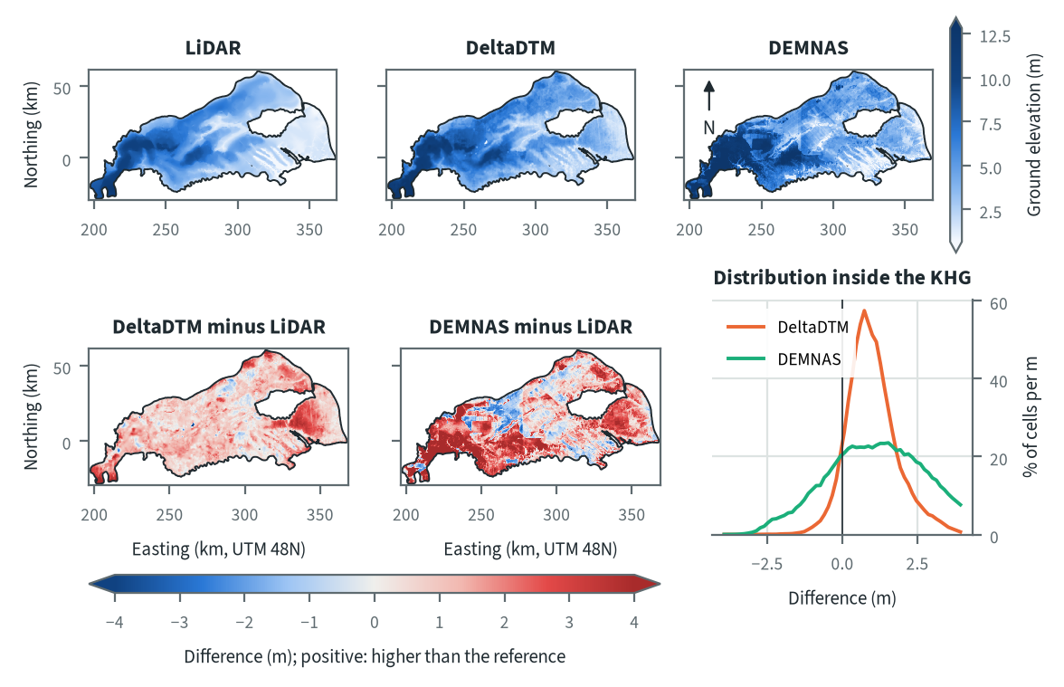
Figure 10.66. Kampar-Gaung: ground elevation from each elevation model on one colour scale, and their differences. Source: LiDAR terrain model, DeltaDTM and DEMNAS after the DEM correction
On LiDAR the ground is highest in the west and south-west of the KHG and falls gently towards the low eastern end, with lower, linear corridors running north-west to south-east across the centre. DeltaDTM reproduces this pattern almost everywhere and sits slightly above LiDAR over most of the KHG, with a stronger positive patch in the east. DEMNAS disagrees in large rectangular patches: it is more than 2 m above LiDAR over 36 % of the KHG, over much of the south and west, and more than 2 m below LiDAR over 3 %, in parts of the north-centre. Straight-edged patches of this kind follow land-use blocks or source tiles rather than terrain, and the likely causes are canopy or plantation stands left in the surface model, which the correction removes only in part (chapter 4), and joins between the radar sources from which DEMNAS is built.
Table 10.94. Kampar-Gaung: resolution, cover and relief of each elevation model, and its difference to LiDAR. Source: LiDAR terrain model, DeltaDTM and DEMNAS after the DEM correction
Elevation model | Source | Resolution (m) | Cover of the KHG (%) | Relief, 5th-95th percentile (m) | Difference to LiDAR, median (m) | Difference to LiDAR, NMAD (m)
LiDAR | Airborne LiDAR terrain model (KLHK), as delivered | 25 | 100 | 0.9 to 9.4
DeltaDTM | DeltaDTM v1.1 (global coastal terrain model), after the DEM correction | 30 | 99 | 1.7 to 10.7 | 0.91 | 0.74
DEMNAS | DEMNAS (BIG national surface model), after the DEM correction | 8 | 100 | 1.2 to 12.7 | 1.31 | 1.87
Statistics over the KHG polygon on a common 25 m grid (the LiDAR grid; finer models averaged onto it). NMAD: normalised median absolute deviation, a spread measure robust to outliers. Where LiDAR covers only part of the KHG, differences are over that part.
The 5th to 95th percentile of elevation spans 8.5 m on LiDAR (0.9 to 9.4 m), 9.0 m on DeltaDTM and 11.5 m on DEMNAS (differences of the values in the table). DeltaDTM lies a median 0.91 m above LiDAR with a spread (NMAD) of 0.74 m, so most of its difference is an offset; the LiDAR datum was never recorded, so the offset cannot be assigned to either side (chapter 4), and it does not change slopes. DEMNAS lies a median 1.31 m above LiDAR but with a spread of 1.87 m, larger than the median itself. Its difference is mainly local error, and local error is what changes the canal slopes and head drops that the block design reads from the terrain.

Sub-KHG units
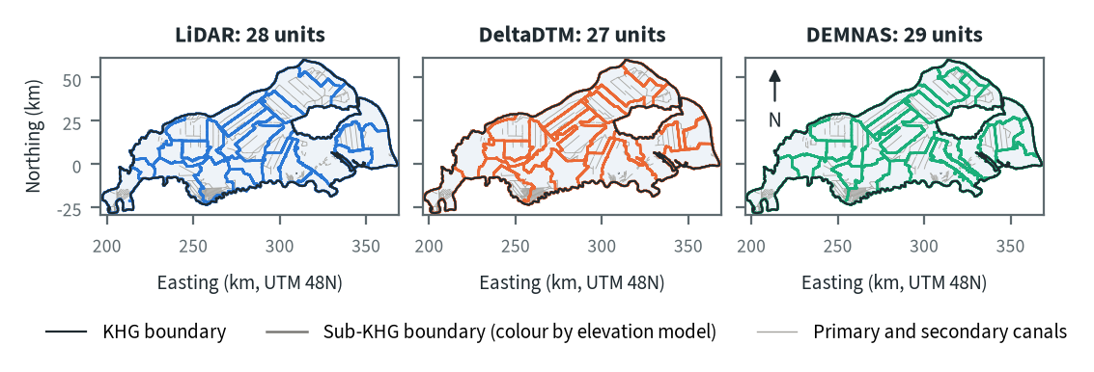
Figure 10.67. Kampar-Gaung: sub-KHG units delineated on each elevation model. Source: sub-KHG delineation on each elevation model, mapped canals
The delineation gives 28 sub-KHG units on LiDAR, 27 on DeltaDTM and 29 on DEMNAS, with median sizes of 215 to 225 km². The units are large because the KHG has 977 primary and secondary canal segments over its whole area (chapter 5), far fewer per km² than the South Sumatra and Jambi KHG. In the canal-dense north and centre the unit boundaries follow the primary and secondary canals and look alike on all three models. Where the canals are sparse, in the south and east, the boundaries follow terrain divides, and that is where the models draw them differently.
Table 10.95. Kampar-Gaung: number and size of sub-KHG units, and agreement between elevation models (area in the best-matching unit, adjusted Rand index). Source: sub-KHG delineation on each elevation model
Elevation model or pair | Units (n) | Unit area, median (km²) | Unit area, range (km²) | Units total (km²) | Overlap (km²) | Area in best-matching unit (%) | Adjusted Rand index
LiDAR | 28 | 216 | 109 to 621 | 7,094
DeltaDTM | 27 | 225 | 128 to 539 | 7,108
DEMNAS | 29 | 215 | 127 to 511 | 7,108
LiDAR and DeltaDTM |  |  |  |  | 7,094 | 80 | 0.66
LiDAR and DEMNAS |  |  |  |  | 7,094 | 72 | 0.57
DeltaDTM and DEMNAS |  |  |  |  | 7,108 | 76 | 0.60
Pairs are compared over the area both cover. Best-matching unit: share of the overlap that lies in the unit of the other model it overlaps most, averaged over both directions. Adjusted Rand index: 1 for identical partitions, about 0 for chance agreement; computed on 1 ha cells.
LiDAR and DeltaDTM agree best: 80 % of the area lies in the best-matching unit, with an adjusted Rand index of 0.66. LiDAR and DEMNAS differ most, at 72 % and 0.57, and DeltaDTM and DEMNAS fall between, at 76 % and 0.60. The ordering follows the local error of the elevation models in the previous table.

Water balance and deficit
Table 10.96. Kampar-Gaung: dry-season deficit from water-table stations and climatic balance per sub-KHG. Source: SiTMAT water-table stations, CHIRPS rain, MOD16 and WaPOR evapotranspiration
Quantity | All models | LiDAR | DeltaDTM | DEMNAS
Dry-season deficit from 78 stations, 01 Jun to 09 Oct 2026 (mm) | 7 (2 to 12)
Deficit volume over the KHG (million m³) | 50
Months in deficit in that window (n) | 2
Sub-KHG units (n) |  | 28 | 27 | 29
Climatic balance, MOD16, area mean (mm/month) |  | 58.6 | 58.6 | 58.6
Climatic balance, unit range (mm/month) |  | 50.9 to 64.5 | 50.9 to 67.2 | 50.5 to 63.8
Climatic balance, WaPOR, area mean (mm/month) |  | 82.3 | 82.3 | 82.3
Deficit months per year, area mean |  | 2.65 | 2.66 | 2.66
Order of units usable (ET products agree) |  | no | no | no
The station deficit uses water-table stations and reanalysis rain and evaporation (band: specific yield 0.10 to 0.20) and does not depend on the elevation model. The climatic balance is CHIRPS rain minus evapotranspiration, 2018-2025, per sub-KHG of each model.
From 1 June to 9 October 2026, 78 stations give a neraca air (water balance) deficit of 7 mm (2 to 12 mm over the range of specific yield), about 50 million m³ over the KHG, with 2 months in deficit. The deficit is small because the climate was close to neutral in that season and the station mean water table rose by 10.9 cm while the stations were held at about 40 cm (chapter 8). The deficit does not depend on the elevation model. The order of sub-KHG by climatic balance is not usable with any of the three unit sets, because MOD16 and WaPOR evapotranspiration rank the units in opposite directions (Spearman -0.48 to -0.59, chapter 8).
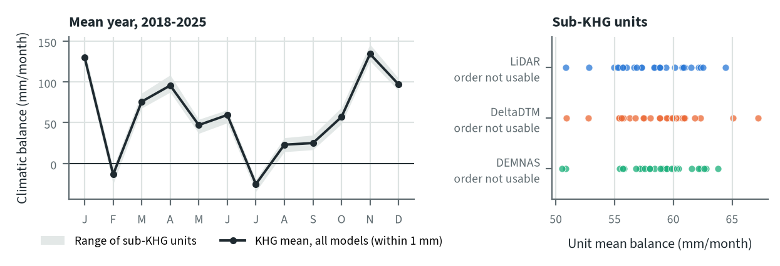
Figure 10.68. Kampar-Gaung: climatic balance through the mean year, and the balance of each sub-KHG, by elevation model. Source: CHIRPS rain and MOD16 evapotranspiration, 2018-2025
Over 2018-2025 the KHG has two dry months a year on average: July is the driest (a mean of -25 mm) and February has a second, smaller deficit (-13 mm, chapter 8). The KHG mean is 58.6 mm/month on all three models, and the deficit months per year differ only between 2.65 and 2.66. The elevation model enters only through the unit boundaries, so it changes the spread of unit means (50.9 to 64.5 mm/month on LiDAR, 50.9 to 67.2 on DeltaDTM, 50.5 to 63.8 on DEMNAS), and that spread is small next to the disagreement between the two evapotranspiration products.

Priority of sub-KHG
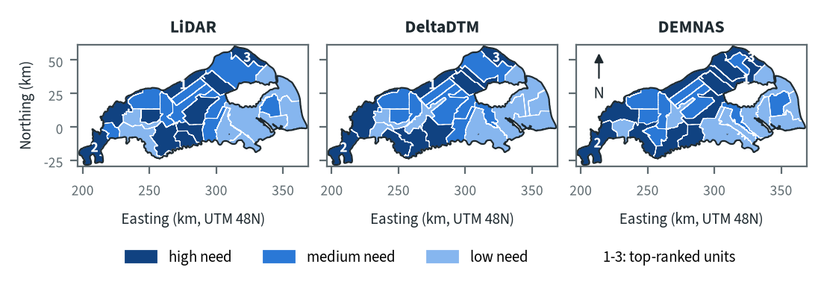
Figure 10.69. Kampar-Gaung: need for intervention per sub-KHG, by elevation model. Source: sub-KHG prioritisation with default weights
With the default weights proposed for agreement with KLH and the World Bank, the high-need units lie in the west, the south-west lobe and the south-centre of the KHG, and the eastern end is mostly low need. The three top-ranked units are in the same three places on every model: a long strip in the north-centre, the south-west corner and the north-east. All three lie outside concession areas, and each has burned more than most units, has few existing blocks for the blocks its canals need, or has deep peat. DEMNAS draws the north-central and north-eastern top units larger and adds more high-need area in the north.
Table 10.97. Kampar-Gaung: high-need area and agreement of the priority classes between elevation models. Source: sub-KHG prioritisation with default weights
Elevation model or pair | High need (units, km²) | Overlap (km²) | Same need class (% of overlap) | High need in first also high in second (%) | Spearman of scores, area-weighted
LiDAR | 10, 2,398
DeltaDTM | 9, 2,384
DEMNAS | 10, 3,003
LiDAR and DeltaDTM |  | 7,094 | 77 | 76 | 0.81
LiDAR and DEMNAS |  | 7,094 | 63 | 74 | 0.75
DeltaDTM and DEMNAS |  | 7,108 | 75 | 87 | 0.83
Units are matched by location, since each model has its own units. Shares are of the area both models cover. Default weights, proposed for agreement with KLH and the World Bank.
LiDAR and DeltaDTM give almost the same high-need area (2,398 and 2,384 km², 10 and 9 units), and 77 % of the area keeps its class between them (area-weighted Spearman 0.81). DEMNAS gives 3,003 km² of high need. The largest difference is between LiDAR and DEMNAS: only 63 % of the area keeps its class (Spearman 0.75), although 74 % of the LiDAR high-need area is also high need on DEMNAS. Most of the disagreement is therefore in the medium and low classes. The extra DEMNAS high-need area follows its larger units, and its noisier terrain raises the number of blocks the canals appear to need, which feeds the missing-block indicator.

Canal blocks and pumping
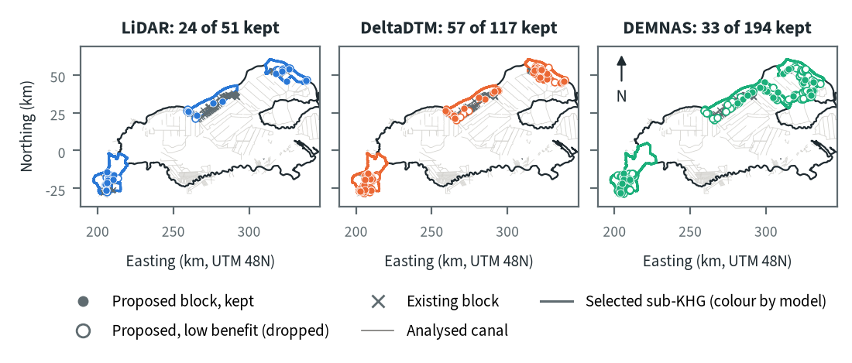
Figure 10.70. Kampar-Gaung: proposed canal blocks in the three highest-ranked sub-KHG, by elevation model. Source: RE-PEAT Interventions on each elevation model, mapped canals and existing blocks
The selected sub-KHG are in the same three places on every model, but their outlines differ, and DEMNAS draws the north-central and north-eastern units larger. On LiDAR the head rule proposes 51 sekat kanal (canal blocks) and keeps 24. DeltaDTM proposes 117 and keeps 57, and DEMNAS proposes 194 and keeps 33. The kept blocks sit on the canals of the south-west corner and the north-east, where the land rises along the canal. The north-central strip already holds a line of existing blocks, and several new blocks proposed there are dropped as low benefit. DEMNAS spreads proposals over many more canals, and its balance step keeps only 17 % of them (33 of 194, a ratio of the table values), because much of the rise it reads along a canal is likely terrain noise (chapter 9). Pumping was not assessed in this analysis.
Table 10.98. Kampar-Gaung: canal blocks, water held and budget, by elevation model. Source: RE-PEAT Interventions and sub-KHG prioritisation on each elevation model
Quantity | LiDAR | DeltaDTM | DEMNAS
Selected sub-KHG (top 3 by priority) | S05, S28, S01 | S06, S27, S01 | S05, S29, S01
Blocks needed by the slope rule of the ranking, whole KHG (n) | 1,675 | 3,394 | 9,518
Existing blocks counted by the ranking, whole KHG (n) | 2,754 | 2,754 | 2,754
Existing blocks on analysed canals (n) | 105 | 105 | 99
Blocks proposed by the head rule (n) | 51 | 117 | 194
Blocks kept, 90% of the water-level rise (n) | 24 | 57 | 33
Pump units (n) | pumping not assessed | pumping not assessed | pumping not assessed
Water held by kept blocks (million m³) | 2.33 | 4.71 | 10.02
Deficit of the selected units (million m³) | 5.1 | 5.0 | 7.5
Budget, low / central / high (billion Rp) | 1 / 1 / 1 | 4 / 7 / 7 | 25 / 38 / 38
of which revegetation of burned land, central (billion Rp) | - | - | -
Blocks, water and budget are for the three highest-ranked sub-KHG of each model, which can differ between models. Kept: the fewest proposed blocks giving 90% of the water-level rise of all proposed blocks. Pumping is not assessed in these results. Default weights, proposed for agreement with KLH and the World Bank.
The kept blocks hold 2.33 million m³ on LiDAR, 4.71 on DeltaDTM and 10.02 on DEMNAS, against a 2026 deficit of the selected units of 5.1, 5.0 and 7.5 million m³. That is about 46 %, 94 % and 134 % of the deficit (ratios of the table values). The DEMNAS figure exceeds the deficit, which shows how much head its noise adds. The central budget is 1 billion rupiah on LiDAR, 7 on DeltaDTM and 38 on DEMNAS. On every model the largest item is the estimate, from the KLH adequacy index (IPG), of blocks missing in the sub-KHG outside the three analysed in detail, and no revegetation of burned land enters. That estimate grows with the number of blocks the slope rule of the ranking requires, which is 1,675 for the whole KHG on LiDAR, 3,394 on DeltaDTM and 9,518 on DEMNAS. On LiDAR the requirement is below the 2,754 blocks already built, which is why so little new spending is proposed there.

How the elevation model changes the result
Table 10.99. Kampar-Gaung: headline outputs by elevation model and their spread. Source: RE-PEAT results on each elevation model
Output | LiDAR | DeltaDTM | DEMNAS | Spread
Sub-KHG units (n) | 28 | 27 | 29 | ×1.1
Median unit area (km²) | 216 | 225 | 215 | ×1.0
Area covered by units (km²) | 7,096 | 7,110 | 7,110 | ×1.0
Climatic balance, area mean (mm/month) | 58.6 | 58.6 | 58.6 | range 0.0
High-need area (km²) | 2,398 | 2,384 | 3,003 | ×1.3
High-need units (n) | 10 | 9 | 10 | ×1.1
Blocks needed, slope rule of the ranking, whole KHG (n) | 1,675 | 3,394 | 9,518 | ×5.7
Blocks proposed, head rule (n) | 51 | 117 | 194 | ×3.8
Blocks kept (n) | 24 | 57 | 33 | ×2.4
Water held by kept blocks (million m³) | 2.33 | 4.71 | 10.02 | ×4.3
Budget, central (billion Rp) | 1 | 7 | 38 | ×27.2
Spread: largest value over smallest across the models (range for the balance). Blocks kept, water and budget refer to the three highest-ranked sub-KHG of each model, so they move with the choice of units as well as with the terrain. Default weights, proposed for agreement with KLH and the World Bank.
The number and size of units, the area covered and the climatic balance barely move with the elevation model (spread ×1.1 or less, balance range 0.0 mm/month), and the high-need area moves by ×1.3. Everything that reads canal slopes moves a great deal. The blocks required by the slope rule of the ranking spread ×5.7, proposed blocks ×3.8, kept blocks ×2.4, water held ×4.3 and the central budget ×27.2. Part of the block, water and budget spread comes from DEMNAS selecting larger units (their deficit is 7.5 against 5.0 to 5.1 million m³), and the rest comes from the terrain itself: DEMNAS's local error of 1.87 m NMAD is several times the 0.40 m head step a block is designed to hold. Kampar-Gaung is fully covered by LiDAR, so LiDAR should be used for decisions here. DeltaDTM is the closest substitute (an offset of 0.91 m, spread 0.74 m, unit agreement 80 %), but it still doubles the kept blocks and water held and raises the central budget from 1 to 7 billion rupiah. DEMNAS should not be used for block design at this KHG.

Summary for this KHG
Kampar-Gaung is densely canalised and already has 2,754 realised blocks, which on LiDAR is more than the 1,675 the slope rule of the ranking requires. In 2026 its stations were held near 40 cm with a dry-season deficit of only 7 mm, so the case for new blocks rests on the highest-ranked units, which lie outside concessions in the south-west, the north-centre and the north-east. On LiDAR, the recommended model here, the plan for the three highest-ranked sub-KHG keeps 24 new blocks that hold 2.33 million m³, about half the deficit of those units, for a central budget of about 1 billion rupiah. DeltaDTM and especially DEMNAS inflate blocks, water held and cost (the central budget on DEMNAS is 27.2 times that on LiDAR), while the units, the balance and the location of the top-priority units hold steady. Pumping was not assessed in this analysis, the order of units by climatic balance cannot be used because the evapotranspiration products disagree, and the station deficit covers a single dry season (chapter 8).

10.16 Across the KHG
Across the 14 KHG, the elevation model changes the number of canal blocks far more than any other choice. It changes the sub-KHG layout and the high-need area little, and it does not change the KHG water balance. The budget follows the treatments that the selected sub-KHG receive, and through them the elevation model. The two tables below set the main result of each step side by side, for the five KHG with LiDAR and for the nine without.
Table 10.100. Results of the analysis at the five KHG with LiDAR, per elevation model: sub-KHG units, KHG supply deficit of the 2026 dry season, high-need sub-KHG (number and area; default weights), canal blocks needed by the slope rule of the ranking and blocks existing, blocks proposed by RE-PEAT Interventions and blocks kept at 90 % of the canal rewetting, and the central budget estimate. Saleh-Sugihan's LiDAR covers about 62 % of the KHG, so its LiDAR row describes that part only. Source: delineation, neraca air, prioritisation and interventions outputs
KHG | DEM | Sub-KHG | Deficit 2026 (mm) | Deficit (million m³) | High-need units (n, km²) | Blocks needed (ranking) | Blocks existing | Blocks proposed, kept | Budget, central (billion Rp)
Kampar - Gaung | LiDAR | 28 | 7 | 50 | 10, 2,398 | 1,675 | 2,754 | 51, 24 | 1
Kampar - Gaung | DeltaDTM | 27 | 7 | 50 | 9, 2,384 | 3,394 | 2,754 | 117, 57 | 7
Kampar - Gaung | DEMNAS | 29 | 7 | 50 | 10, 3,003 | 9,518 | 2,754 | 194, 33 | 38
Air Hitam Laut - Buntu Kecil | LiDAR | 29 | 211 | 386 | 10, 777 | 1,543 | 201 | 40, 19 | 11
Air Hitam Laut - Buntu Kecil | DeltaDTM | 29 | 211 | 386 | 10, 645 | 1,012 | 201 | 26, 18 | 18
Air Hitam Laut - Buntu Kecil | DEMNAS | 30 | 211 | 386 | 10, 653 | 2,616 | 201 | 41, 5 | 26
Mendahara - Batanghari | LiDAR | 29 | 119 | 240 | 10, 695 | 1,995 | 417 | 112, 64 | 14
Mendahara - Batanghari | DeltaDTM | 29 | 119 | 240 | 10, 754 | 3,908 | 417 | 114, 54 | 77
Mendahara - Batanghari | DEMNAS | 29 | 119 | 240 | 10, 616 | 8,763 | 417 | 216, 73 | 130
Saleh - Sugihan | LiDAR | 29 | no stations | - | 10, 460 | 7,752 | 0 | 59, 22 | 23
Saleh - Sugihan | DeltaDTM | 26 | no stations | - | 9, 638 | 1,165 | 25 | 21, 11 | 25
Saleh - Sugihan | DEMNAS | 27 | no stations | - | 9, 618 | 6,768 | 25 | 68, 30 | 31
Sugihan - Lumpur | LiDAR | 29 | 290 | 1,842 | 10, 2,175 | 3,634 | 2,847 | 86, 43 | 620
Sugihan - Lumpur | DeltaDTM | 29 | 290 | 1,842 | 10, 2,379 | 6,237 | 2,847 | 117, 39 | 407
Sugihan - Lumpur | DEMNAS | 27 | 290 | 1,842 | 9, 2,057 | 25,580 | 2,847 | 226, 62 | 271

Table 10.101. Results of the analysis at the nine KHG without LiDAR, on corrected DeltaDTM and DEMNAS (same columns as the table above). A deficit of 0 mm means that rain exceeded evapotranspiration over the period of the station record. Source: delineation, neraca air, prioritisation and interventions outputs
KHG | DEM | Sub-KHG | Deficit 2026 (mm) | Deficit (million m³) | High-need units (n, km²) | Blocks needed (ranking) | Blocks existing | Blocks proposed, kept | Budget, central (billion Rp)
Pulau Bengkalis | DeltaDTM | 27 | 0 | 0 | 9, 260 | 2,291 | 46 | 97, 52 | 21
Pulau Bengkalis | DEMNAS | 30 | 0 | 0 | 10, 308 | 3,732 | 46 | 147, 67 | 30
Pulau Padang | DeltaDTM | 30 | 0 | 0 | 10, 287 | 992 | 156 | 49, 24 | 3
Pulau Padang | DEMNAS | 28 | 0 | 0 | 10, 291 | 2,355 | 156 | 42, 16 | 11
Pulau Tebing Tinggi | DeltaDTM | 29 | 0 | 0 | 10, 488 | 1,088 | 168 | 114, 52 | 4
Pulau Tebing Tinggi | DEMNAS | 29 | 0 | 0 | 10, 485 | 2,845 | 168 | 127, 40 | 4
Mempawah - Peniti | DeltaDTM | 28 | no stations | - | 10, 229 | 4,586 | 0 | 217, 117 | 44
Mempawah - Peniti | DEMNAS | 29 | no stations | - | 10, 232 | 18,544 | 0 | 282, 27 | 158
Pungurbesar - Kapuas | DeltaDTM | 30 | 132 | 134 | 10, 379 | 4,896 | 395 | 143, 36 | 34
Pungurbesar - Kapuas | DEMNAS | 29 | 132 | 134 | 10, 363 | 17,432 | 395 | 140, 17 | 193
Kapuas - Barito | DeltaDTM | 28 | 299 | 1,666 | 10, 1,632 | 3,810 | 53 | 128, 44 | 24
Kapuas - Barito | DEMNAS | 29 | 299 | 1,666 | 10, 1,391 | 12,184 | 53 | 110, 20 | 86
Kahayan - Sebangau | DeltaDTM | 29 | 348 | 1,571 | 10, 1,843 | 3,276 | 0 | 30, 13 | 95
Kahayan - Sebangau | DEMNAS | 27 | 348 | 1,571 | 9, 1,778 | 7,466 | 0 | 21, 7 | 241
Balangan - Batangalai | DeltaDTM | 22 | no stations | - | 8, 116 | 723 | 0 | 18, 11 | 8
Balangan - Batangalai | DEMNAS | 22 | no stations | - | 8, 143 | 2,277 | 0 | 59, 23 | 23
Buru Mappi - Buru Obaa | DeltaDTM | 30 | no stations | - | 10, 2,124 | 73 | 0 | 18, 13 | 75
Buru Mappi - Buru Obaa | DEMNAS | 27 | no stations | - | 9, 1,725 | 303 | 0 | 34, 20 | 15

All 33 analyses use the same settings, including the KLH block spacing (at least 500 m between new blocks, 100 m merge distance). Pumping was not enabled in any of them. Five patterns stand out.
- The sub-KHG count is 22 to 30 per analysis, and 26 to 30 everywhere except Balangan-Batangalai (22 units on 137 km² of peat). The tertile classes give 8 to 10 high-need units; their area runs from 116 km² at Balangan-Batangalai (DeltaDTM) to 3,003 km² at Kampar-Gaung (DEMNAS). Within one KHG the elevation model changes the unit count by 0 to 3 and the high-need area by 1 to 39 %: 16 to 39 % across the three models at the five LiDAR KHG (the 39 % at Saleh-Sugihan, where LiDAR covers part of the KHG) and 1 to 23 % between DeltaDTM and DEMNAS at the nine others.
- The supply deficit from the neraca air (water balance) is a property of the KHG and does not depend on the elevation model. It is 348 mm at Kahayan-Sebangau (one station, so low confidence), 299 mm at Kapuas-Barito (6 stations), 290 mm at Sugihan-Lumpur (51), 211 mm at Air Hitam Laut-Buntu Kecil (8), 132 mm at Pungurbesar-Kapuas (3), 119 mm at Mendahara-Batanghari (12) and 7 mm at Kampar-Gaung (78). It is 0 mm at Pulau Padang, Pulau Bengkalis and Pulau Tebing Tinggi, where rain exceeded evapotranspiration by 153, 220 and 105 mm from 1 June to 15 October. Four KHG have no station inside them (Saleh-Sugihan, Mempawah-Peniti, Balangan-Batangalai, Buru Mappi-Buru Obaa), so no deficit can be computed there. The deficit rests on the stations that enter the calculation, which can be fewer than the stations in Table 10.1 (3 of 5 at Pungurbesar-Kapuas, 78 of 92 at Kampar-Gaung).
- The canal blocks needed by the slope rule of the ranking depend most on the elevation model. At the five LiDAR KHG the highest count is 2.6 to 7.0 times the lowest: 1,012 to 2,616 at Air Hitam Laut-Buntu Kecil (2.6), 1,675 to 9,518 at Kampar-Gaung (5.7), 1,995 to 8,763 at Mendahara-Batanghari (4.4), 1,165 to 7,752 at Saleh-Sugihan (6.7) and 3,634 to 25,580 at Sugihan-Lumpur (7.0). At the nine others DEMNAS gives 1.6 to 4.2 times the DeltaDTM count: 2,291 to 3,732 at Pulau Bengkalis (1.6), 3,276 to 7,466 at Kahayan-Sebangau (2.3), 4,586 to 18,544 at Mempawah-Peniti (4.0) and 73 to 303 at Buru Mappi-Buru Obaa (4.2). DEMNAS gives more than DeltaDTM at all 14 KHG. LiDAR gives the fewest at Kampar-Gaung, Mendahara-Batanghari and Sugihan-Lumpur; DeltaDTM gives the fewest at Air Hitam Laut-Buntu Kecil and Saleh-Sugihan, where LiDAR gives the most.
- RE-PEAT Interventions proposes far fewer blocks, because it follows the 0.40 m head rule only along the analysed canals of the selected sub-KHG and keeps the blocks that give 90 % of the canal rewetting. It proposes 18 to 282 blocks per analysis and keeps 5 to 117. The 90 % balance narrows the differences between elevation models, and their direction is not constant. Between DeltaDTM and DEMNAS the kept count differs by 1.3 to 4.3 times at the nine KHG without LiDAR, and DEMNAS keeps fewer than DeltaDTM at six of them (Kahayan-Sebangau, Kapuas-Barito, Mempawah-Peniti, Pulau Padang, Pulau Tebing Tinggi, Pungurbesar-Kapuas). At the five LiDAR KHG the kept count differs by 1.4 to 3.8 times across models.
- The central budget estimate runs from 1 billion Rp (Kampar-Gaung, LiDAR) to 620 billion Rp (Sugihan-Lumpur, LiDAR). The kept blocks themselves cost 0.09 to 2.11 billion Rp per analysis. The largest budget item is the revegetation of burned land in 14 analyses and the KLH IPG estimate of missing blocks outside the analysed sub-KHG in 19. The IPG estimate is large where the ranking counts many blocks: on DEMNAS it is 192 of 193 billion Rp at Pungurbesar-Kapuas and 157 of 158 at Mempawah-Peniti. At the nine KHG without LiDAR the budget on DEMNAS is higher than on DeltaDTM at seven, equal at one and lower at one (Buru Mappi-Buru Obaa, 15 against 75 billion Rp), by a factor of 1.0 to 5.7.
The size of the elevation-model effect differs between KHG. It is largest at Sugihan-Lumpur (7.0), Saleh-Sugihan (6.7) and Kampar-Gaung (5.7), and smallest at Pulau Bengkalis (1.6) and Kahayan-Sebangau (2.3). The mechanism shown at Sugihan-Lumpur (chapter 7, section 7.5) is that block spacing is 0.4 m divided by the canal slope, and the slope is larger on a noisier elevation model; the tables here do not separate it from the canal layout. The absolute counts follow the mapped canal network: Mempawah-Peniti has 13 km of canal per km² of peat and 4,586 to 18,544 blocks needed on 229 to 232 km² of high-need area, while Buru Mappi-Buru Obaa has 31 km of canals on 1,699 km² of peat and needs 73 to 303. At Saleh-Sugihan the LiDAR count describes the covered 62 % only and the high-need units differ between models, so its factor mixes the effect of the elevation model with a different selection.
Existing blocks matter for the comparison. Kampar-Gaung (2,754) and Sugihan-Lumpur (2,847) already have many built sekat kanal (canal blocks), Mendahara-Batanghari has 417, Pungurbesar-Kapuas 395, Air Hitam Laut-Buntu Kecil 201, Pulau Tebing Tinggi 168, Pulau Padang 156, Kapuas-Barito 53, Pulau Bengkalis 46 and Saleh-Sugihan 25 (none inside the area its LiDAR covers). The block layer used by the ranking holds none at Mempawah-Peniti, Kahayan-Sebangau, Balangan-Batangalai and Buru Mappi-Buru Obaa, although the national structure layer in Table 10.1 lists 264, 1,333 and 112 structures at the first three. At these KHG the blocks needed by the ranking are not set against existing blocks. Elsewhere they are, and the interventions module adds blocks only where its head rule finds a gap.
The spread across elevation models is the main uncertainty in these numbers. At the five KHG with LiDAR, read the LiDAR result first, keeping in mind that it covers 62 % of Saleh-Sugihan. At the nine KHG without LiDAR, read the block counts and the sub-KHG selected for them as a range between the corrected DeltaDTM and DEMNAS results, and check them in the field before design. The KHG water balance and the station deficit can be read without that range.

11 Findings, limits and decisions needed

11.1 What the toolkit can deliver now
For any KHG, RE-PEAT produces a set of outputs per elevation model: sub-KHG units, a water balance and dry-season supply deficit, a ranked list of sub-KHG, and a plan of canal blocks with its water need, budget and print layouts. The full chain has been applied to 14 KHG: five on three elevation models each and nine on corrected DeltaDTM and DEMNAS, 33 analyses in all (chapter 10). The 14 are eleven of the 12 main KHG, two reserve KHG and the earlier test site; the twelfth main KHG, Cawang-Lalang, awaits confirmation with KLH.
The main findings are:
- Terrain is the weakest input. No open elevation model met the accuracy needed on flat peat domes; the best, corrected DeltaDTM, still errs by 0.47 to 0.64 m over 1 km, which is more than the real relief (chapter 4). Results that depend on slope, above all the number of canal blocks, change several-fold between elevation models (chapters 7 and 9): 2.6 to 7.0 times at the five KHG with LiDAR, and DEMNAS gives 1.6 to 4.2 times the DeltaDTM count at the nine without (chapter 10). The chain therefore runs once per elevation model, and the spread between runs is part of the result.
- Sub-KHG boundaries are set mainly by the mapped canals and rivers. With secondary canals as outlets, units agree about as well across terrain sources as across noisy copies of the LiDAR (chapter 5).
- The national ranking follows later fire well (AUC 0.956 to 0.973 on 2023-2025), and 10 of the 11 resolved main KHG are in its top third. It uses default weights proposed by the project for agreement with KLH and the World Bank, which can be adjusted in the dashboard (chapter 6).
- In managed concessions, water management holds the water table up where rain alone would not. At Sugihan-Lumpur the stations fell 11 cm while the climate removed 307 mm in the 2026 dry season, which implies about 290 mm, 1.8 billion m³, supplied from outside the rain balance (chapter 8).
- The 2026 dry-season supply deficit differs widely between KHG: 7 mm at Kampar-Gaung, 119 mm at Mendahara-Batanghari, 132 mm at Pungurbesar-Kapuas, 211 mm at Air Hitam Laut-Buntu Kecil, 290 mm at Sugihan-Lumpur, 299 mm at Kapuas-Barito and 348 mm at Kahayan-Sebangau, the last from one station. It is 0 mm at Pulau Padang, Pulau Bengkalis and Pulau Tebing Tinggi, where rain exceeded evapotranspiration (chapter 10).
- Open climate data give a reliable calendar of dry months per KHG, but separate sub-KHG reliably in only 2 of 12 runs at the four KHG where this was tested (chapter 8).
- The groundwater model, which is in development, reproduces the supply in managed land when that land is held at 0.4 m, and shows canal blocks acting within about 350 m of a blocked reach. For land outside licences the only test is 6 community stations in one KHG: on their screened record and the 100 m grid, canals at the levels measured in LiDAR reproduce the stations' level and fall (chapter 8).

11.2 How the outputs serve the KLH focus group discussion
The KLH/BPLH discussion of 2 November 2026 on fire prevention through KHG water governance asks for four things (KLH/BPLH 2026). Table 11.1 shows what the toolkit offers for each and where it stops.
Table 11.1. Questions of the KLH/BPLH focus group discussion and the toolkit outputs that address them. Source: terms of reference of the discussion (KLH/BPLH 2026) and chapters 3 to 9 of this report
Question of the discussion | What the toolkit provides | Not covered
Current condition and fire risk of the priority KHG | National ranking of 865 KHG on burned peat, hotspots 2012-2025, this year's KLH hotspots and canals by class; profile and map per KHG; SiTMAT water-table summary per KHG (chapters 3 and 6) | Climate projections; the list of 337 priority KHG, which was not available to the project
Factors that make peat vulnerable | Canal density by class, missing canal blocks, distance to water, water balance and dry months, station water tables, land status overlays (licences, peat function, forest area) per KHG and sub-KHG (chapters 6 to 8) | Institutional and governance factors
Roles of ministries and agencies | Blocks are placed on primary and secondary canals, the canals the discussion links to the Ministry of Public Works; overlays separate forest area, licence areas and land outside them (chapters 6 and 9) | Assignment of roles itself
A KHG-based action plan: locations, interventions, timing, funding | Ranked sub-KHG, proposed canal blocks per sub-KHG with the water they hold, water need from the deficit, budget range with price sources, dry-season months per KHG, print layouts in the KLH style (chapters 7 to 9) | Prices are unverified; canal closure has no price; pumping has not yet been applied to a real KHG

Water sharing between licence holders and the communities around them, which the discussion names, needs two kinds of data the project does not have: canal water levels in concessions and water-table records in land outside licences. Section 11.5 lists them.

11.3 Limits that apply across the report
- The rankings rest on default weights. The order of KHG and sub-KHG may change once KLH and the World Bank agree the weights.
- The burned-area polygons carry the largest weight in both rankings and are the validation target, but their provider and method are not documented, so their accuracy cannot be stated.
- SiTMAT covers one season, April to October 2026, mostly in concessions. Four of the 14 KHG (Saleh-Sugihan, Mempawah-Peniti, Balangan-Batangalai, Buru Mappi-Buru Obaa) have no station inside them, so no station-based deficit can be computed for them. The deficit of Kahayan-Sebangau rests on one station, that of Pungurbesar-Kapuas on three and that of Kapuas-Barito on six.
- Peat depth covers part of most KHG, and where it can be checked it agrees poorly with field cores (correlation 0.10 at Pulau Tebing Tinggi). Kahayan-Sebangau, Kapuas-Barito and Buru Mappi-Buru Obaa have no modelled peat-depth layer, so peat depth is not scored in their sub-KHG ranking.
- LiDAR is used at five KHG, all in Sumatra. At Saleh-Sugihan it covers about 62 % of the KHG, and the LiDAR results there describe only that part. The other nine KHG rest on corrected DeltaDTM and DEMNAS, so their block counts are ranges between the two results, not design figures. Pulau Padang has a 2 m LiDAR that the analysis leaves out.
- Interventions budgets use proposed unit prices that are still to be verified; the KLH cost standard for rewetting works was not available to the project.
- Pumping was not assessed in any of the 33 analyses.
- The groundwater model is in development; its scenario maps are indicative.

11.4 Decisions needed from KLH and the World Bank
1. The weights of the national and sub-KHG rankings, for example set in a pairwise-comparison session with the project team, with the held-out validation as a check.
2. Whether peat depth keeps its weight in the sub-KHG ranking where it covers only part of the KHG (chapter 7).
3. Confirmation of the twelfth KHG, Cawang-Lalang, whose name does not match the official boundary file (nearest match KHG Air Banyuasin - Air Lalang).
4. Whether FABDEM, under its non-commercial licence, may be used in a KLH deliverable (chapter 4).
5. How the groundwater model represents water management in concessions (a target water table, or a supply sized from the station deficit), and what field evidence it is checked against (chapter 8).
6. Whether the KLH cost standard can replace the price register and treatment thresholds of RE-PEAT Interventions (chapter 9).

11.5 Data needed
- Water-table stations in land outside licences, recording through a full dry season, in several KHG.
- Canal water levels in concessions and community land, by season.
- LiDAR, or an equally accurate terrain model, for the KHG where block design and scenarios are wanted; GNSS heights for canal levels and block crests.
- The source and method of the burned-area layer.
- A river layer that records which rivers keep water in the dry season, so that pumping can be planned.
- The KLH list of 337 priority KHG and the official DMPG village list, to compare with the national ranking and the overlays.

11.6 Next steps
- Confirm Cawang-Lalang with KLH and apply the chain to it.
- Obtain LiDAR, or an equally accurate terrain model, and water-table stations for the KHG outside Sumatra, starting with those that rank highest (Pungurbesar-Kapuas, Balangan-Batangalai, Kahayan-Sebangau), so that block counts there stop depending on a range between DeltaDTM and DEMNAS.
- Add stations at Saleh-Sugihan, Mempawah-Peniti, Balangan-Batangalai and Buru Mappi-Buru Obaa, and more than one at Kahayan-Sebangau, so that a deficit can be computed or confirmed.
- Compare the delineation of Kahayan-Sebangau with the 16 sub-KHG of the 2021 study.
- Check the block counts in the field at the KHG where a design is planned, at least one KHG per elevation-model group.
- Assess pumping with RE-PEAT Interventions at the KHG with a deficit, starting with those that have stations.
- Run the groundwater model at further KHG beyond those of chapter 8, on a baseline that matches the canal level of RE-PEAT Interventions, and test it against stations outside licences as soon as they exist.
- Test a trend correction of DeltaDTM with ICESat-2, and the KLHK modelled DTM away from the LiDAR footprints.
- Measure LiDAR coverage against the whole KHG, so that a LiDAR covering only part of a KHG is flagged before its results are used.

References
Amal, N. (2022). Dampak perubahan iklim terhadap kondisi neraca air pada lahan gambut tropis: Studi kasus di Kesatuan Hidrologis Gambut Pulau Padang Provinsi Riau [Doctoral dissertation, Universitas Gadjah Mada]. UGM ETD repository. https://etd.repository.ugm.ac.id/penelitian/detail/208041
Amal, N., Sujono, J., Jayadi, R., & Ohgushi, K. (2021). Variability of water table elevation and flow response of tropical peatland case study at Pulau Padang, Riau Province of Indonesia. Lowland Technology International, 22(4). https://cot.unhas.ac.id/journals/index.php/ialt_lti/article/view/674
Apers, S., Cobb, A. R., De Lannoy, G. J. M., & Bechtold, M. (2025). Characterising tropical peatland hydrological response with satellite-based rainfall: A case study in Brunei. Hydrological Processes, 39(8), e70209. https://doi.org/10.1002/hyp.70209
Apers, S., De Lannoy, G. J. M., Baird, A. J., Cobb, A. R., Dargie, G. C., del Aguila Pasquel, J., Gruber, A., Hastie, A., Hidayat, H., Hirano, T., Hoyt, A. M., Jovani-Sancho, A. J., Katimon, A., Kurnain, A., Koster, R. D., Lampela, M., Mahanama, S. P. P., Melling, L., Page, S. E., . . . Bechtold, M. (2022). Tropical peatland hydrology simulated with a global land surface model. Journal of Advances in Modeling Earth Systems, 14(3), e2021MS002784. https://doi.org/10.1029/2021MS002784
Bastiaanssen, W. G. M., Cheema, M. J. M., Immerzeel, W. W., Miltenburg, I. J., & Pelgrum, H. (2012). Surface energy balance and actual evapotranspiration of the transboundary Indus Basin estimated from satellite measurements and the ETLook model. Water Resources Research, 48, 2011WR010482. https://doi.org/10.1029/2011WR010482
Cahyono, B. K., Aditya, T., & Istarno. (2022). The determination of priority areas for the restoration of degraded tropical peatland using hydrological, topographical, and remote sensing approaches. Land, 11(7), 1094. https://doi.org/10.3390/land11071094
Chen, H., Gnanamoorthy, P., Chen, Y., Mansaray, L. R., Song, Q., Liao, K., Shi, A., Feng, G., & Sun, C. (2022). Assessment and inter-comparison of multi-source high spatial resolution evapotranspiration products over Lancang-Mekong River Basin, Southeast Asia. Remote Sensing, 14(3), 479. https://doi.org/10.3390/rs14030479
Chow, V. T. (1959). Open-channel hydraulics. McGraw-Hill.
Cobb, A. R., & Harvey, C. F. (2019). Scalar simulation and parameterization of water table dynamics in tropical peatlands. Water Resources Research, 55(11), 9351-9377. https://doi.org/10.1029/2019WR025411
Cobb, A. R., Hoyt, A. M., Gandois, L., Eri, J., Dommain, R., Abu Salim, K., Kai, F. M., Haji Su'ut, N. S., & Harvey, C. F. (2017). How temporal patterns in rainfall determine the geomorphology and carbon fluxes of tropical peatlands. Proceedings of the National Academy of Sciences, 114(26), E5187-E5196. https://doi.org/10.1073/pnas.1701090114
Evans, C. D., Williamson, J. M., Kacaribu, F., Irawan, D., Suardiwerianto, Y., Hidayat, M. F., Laurén, A., & Page, S. E. (2019). Rates and spatial variability of peat subsidence in Acacia plantation and forest landscapes in Sumatra, Indonesia. Geoderma, 338, 410-421. https://doi.org/10.1016/j.geoderma.2018.12.028
Faisol, A., Indarto, Novita, E., & Budiyono. (2020). An evaluation of MODIS global evapotranspiration product (MOD16A2) as terrestrial evapotranspiration in East Java - Indonesia. IOP Conference Series: Earth and Environmental Science, 485(1), 012002. https://doi.org/10.1088/1755-1315/485/1/012002
Funk, C., Peterson, P., Landsfeld, M., Pedreros, D., Verdin, J., Shukla, S., Husak, G., Rowland, J., Harrison, L., Hoell, A., & Michaelsen, J. (2015). The climate hazards infrared precipitation with stations: a new environmental record for monitoring extremes. Scientific Data, 2, 150066. https://doi.org/10.1038/sdata.2015.66
Gumbricht, T., Roman-Cuesta, R. M., Verchot, L., Herold, M., Wittmann, F., Householder, E., Herold, N., & Murdiyarso, D. (2017). An expert system model for mapping tropical wetlands and peatlands reveals South America as the largest contributor. Global Change Biology, 23(9), 3581-3599. https://doi.org/10.1111/gcb.13689
Haman, D. Z. (2017). Pumps for Florida irrigation and drainage systems (Circular CIR832). UF/IFAS Extension. https://edis.ifas.ufl.edu/publication/WI001/pdf (Original work published 1989)
Hawker, L., Uhe, P., Paulo, L., Sosa, J., Savage, J., Sampson, C., & Neal, J. (2022). A 30 m global map of elevation with forests and buildings removed. Environmental Research Letters, 17(2), 024016. https://doi.org/10.1088/1748-9326/ac4d4f
Hirano, T., Kusin, K., Limin, S., & Osaki, M. (2015). Evapotranspiration of tropical peat swamp forests. Global Change Biology, 21(5), 1914-1927. https://doi.org/10.1111/gcb.12653
Hooijer, A., & Vernimmen, R. (2026). Modelling water table depth variation in Southeast Asia forested peatlands using satellite rainfall data. Scientific Reports, 16(1), 26515. https://doi.org/10.1038/s41598-026-64641-2
Hoyt, A. M., Chaussard, E., Seppalainen, S. S., & Harvey, C. F. (2020). Widespread subsidence and carbon emissions across Southeast Asian peatlands. Nature Geoscience, 13(6), 435-440. https://doi.org/10.1038/s41561-020-0575-4
Imanudin, M. S., Wildayana, E., & Armanto, M. E. (2018). Option for land and water management to prevent fire in peat land areas of Sumatera, Indonesia. Journal of Wetlands Environmental Management, 6(1), 12-26. https://www.tropicalpeatlands.org/knowledge/publication/11463-19717
Ingram, H. A. P. (1982). Size and shape in raised mire ecosystems: a geophysical model. Nature, 297(5864), 300-303. https://doi.org/10.1038/297300a0
Ismail, I., Haghighi, A. T., Marttila, H., Kurniawan, U., Karyanto, O., & Kløve, B. (2021). Water table variations on different land use units in a drained tropical peatland island of Indonesia. Hydrology Research, 52(6), 1372-1388. https://doi.org/10.2166/nh.2021.062
Jaenicke, J., Wösten, H., Budiman, A., & Siegert, F. (2010). Planning hydrological restoration of peatlands in Indonesia to mitigate carbon dioxide emissions. Mitigation and Adaptation Strategies for Global Change, 15(3), 223-239. https://doi.org/10.1007/s11027-010-9214-5
Julzarika, A., & Harintaka. (2019). Indonesian DEMNAS: DSM or DTM? In 2019 IEEE Asia-Pacific Conference on Geoscience, Electronics and Remote Sensing Technology (AGERS) (pp. 31-36). IEEE. https://doi.org/10.1109/AGERS48446.2019.9034351
Karassik, I. J., Messina, J. P., Cooper, P., & Heald, C. C. (2008). Pump handbook (4th ed.). McGraw-Hill.
Katimon, A., Shahid, S., Abd Wahab, A. K., & Ali, M. H. (2013). Hydrological behaviour of a drained agricultural peat catchment in the tropics. 1: Rainfall, runoff and water table relationships. Hydrological Sciences Journal, 58(6), 1297-1309. https://doi.org/10.1080/02626667.2013.815759
Konecny, K., Ballhorn, U., Navratil, P., Jubanski, J., Page, S. E., Tansey, K., Hooijer, A., Vernimmen, R., & Siegert, F. (2016). Variable carbon losses from recurrent fires in drained tropical peatlands. Global Change Biology, 22(4), 1469-1480. https://doi.org/10.1111/gcb.13186
Kurnianto, S., Jabbar, A., Fitriyah, N. A., Asyhari, A., Balamurugan, M., Ghimire, C. P., Pertiwi, N., Susanto, A. P., Nurwanda, A., Gunawan, S., Nurholis, Nardi, Suardiwerianto, Y., Simamora, N., Salam, Y. W., Haldar, A. K., Evans, C. D., Page, S. E., Agus, F., . . . Deshmukh, C. S. (2026). Hydrological dynamics in a tropical peatland mosaic at Pulau Padang, Indonesia: Influence of land-cover changes and rainfall variability. Journal of Hydrology: Regional Studies, 64, 103185. https://doi.org/10.1016/j.ejrh.2026.103185
Mahdiyasa, A. W., Large, D. J., Icardi, M., & Muljadi, B. P. (2024). MPeat2D - a fully coupled mechanical-ecohydrological model of peatland development in two dimensions. Earth Surface Dynamics, 12(4), 929-952. https://doi.org/10.5194/esurf-12-929-2024
Mezbahuddin, S., Nikonovas, T., Spessa, A., Grant, R. F., Imron, M. A., Doerr, S. H., & Clay, G. D. (2023). Accuracy of tropical peat and non-peat fire forecasts enhanced by simulating hydrology. Scientific Reports, 13, 619. https://doi.org/10.1038/s41598-022-27075-0
Miettinen, J., Shi, C., & Liew, S. C. (2016). Land cover distribution in the peatlands of Peninsular Malaysia, Sumatra and Borneo in 2015 with changes since 1990. Global Ecology and Conservation, 6, 67-78. https://doi.org/10.1016/j.gecco.2016.02.004
Mu, Q., Zhao, M., & Running, S. W. (2011). Improvements to a MODIS global terrestrial evapotranspiration algorithm. Remote Sensing of Environment, 115(8), 1781-1800. https://doi.org/10.1016/j.rse.2011.02.019
Pronk, M., Hooijer, A., Eilander, D., Haag, A., de Jong, T., Vousdoukas, M., Vernimmen, R., Ledoux, H., & Eleveld, M. (2024). DeltaDTM: A global coastal digital terrain model. Scientific Data, 11, 273. https://doi.org/10.1038/s41597-024-03091-9
Putra, S. S., Baird, A. J., & Holden, J. (2022). Modelling the performance of bunds and ditch dams in the hydrological restoration of tropical peatlands. Hydrological Processes, 36(1), e14470. https://doi.org/10.1002/hyp.14470
Ritzema, H. P., Limin, S., Kusin, K., Jauhiainen, J., & Wösten, H. (2014). Canal blocking strategies for hydrological restoration of degraded tropical peatlands in Central Kalimantan, Indonesia. Catena, 114, 11-20. https://doi.org/10.1016/j.catena.2013.10.009
Setiawan, B. I., Rudiyanto, & Minasny, B. (2020). Peat physical and hydraulic properties due to peatland fires. IOP Conference Series: Earth and Environmental Science, 504, 012020. https://doi.org/10.1088/1755-1315/504/1/012020
Suryadi, Y., Soekarno, I., & Humam, I. A. (2021). Effectiveness analysis of canal blocking in sub-peatland hydrological unit 5 and 6 Kahayan Sebangau, Central Kalimantan, Indonesia. Journal of Engineering and Technological Sciences, 53(2), 210205. https://doi.org/10.5614/j.eng.technol.sci.2021.53.2.5
Susetyo, D. B. (2023). Vertical accuracy assessment of various open-source DEM data: DEMNAS, SRTM-1, and ASTER GDEM. Geodesy and Cartography, 49(4), 209-215. https://doi.org/10.3846/gac.2023.18168
Susetyo, D. B., Lumban-Gaol, Y. A., & Sofian, I. (2018). Prototype of national digital elevation model in Indonesia. The International Archives of the Photogrammetry, Remote Sensing and Spatial Information Sciences, XLII-4, 609-613. https://doi.org/10.5194/isprs-archives-XLII-4-609-2018
Sutikno, S., Rinaldi, Yusa, M., Nasrul, B., Yesi, Chairul, Prayitno, A., Putra, A., & Ardi, M. G. (2023). Water management for integrated peatland restoration in Pulau Tebing Tinggi PHU, Riau. In K. Mizuno, O. Kozan, & H. Gunawan (Eds.), Vulnerability and transformation of Indonesian peatlands (pp. 161-183). Springer Nature Singapore. https://doi.org/10.1007/978-981-99-0906-3_9
Taufik, M., Setiawan, B. I., & Van Lanen, H. A. J. (2019). Increased fire hazard in human-modified wetlands in Southeast Asia. Ambio, 48(4), 363-373. https://doi.org/10.1007/s13280-018-1082-3
Taufik, M., Veldhuizen, A. A., Wösten, J. H. M., & van Lanen, H. A. J. (2019). Exploration of the importance of physical properties of Indonesian peatlands to assess critical groundwater table depths, associated drought and fire hazard. Geoderma, 347, 160-169. https://doi.org/10.1016/j.geoderma.2019.04.001
Taufik, M., Widyastuti, M. T., Santikayasa, I. P., Arif, C., & Minasny, B. (2023). Peat moisture dataset of Sumatra peatlands. Data in Brief, 46, 108889. https://doi.org/10.1016/j.dib.2023.108889
Taufik, M., Widyastuti, M. T., Sulaiman, A., Murdiyarso, D., Santikayasa, I. P., & Minasny, B. (2022). An improved drought-fire assessment for managing fire risks in tropical peatlands. Agricultural and Forest Meteorology, 312, 108738. https://doi.org/10.1016/j.agrformet.2021.108738
Umarhadi, D. A., Widyatmanti, W., Kumar, P., Yunus, A. P., Khedher, K. M., Kharrazi, A., & Avtar, R. (2022). Tropical peat subsidence rates are related to decadal LULC changes: Insights from InSAR analysis. Science of the Total Environment, 816, 151561. https://doi.org/10.1016/j.scitotenv.2021.151561
Urzainki, I., Laurén, A., Palviainen, M., Haahti, K., Budiman, A., Basuki, I., Netzer, M., & Hökkä, H. (2020). Canal blocking optimization in restoration of drained peatlands. Biogeosciences, 17(19), 4769-4784. https://doi.org/10.5194/bg-17-4769-2020
Urzainki, I., Palviainen, M., Hökkä, H., Persch, S., Chatellier, J., Wang, O., Mahardhitama, P., Yudhista, R., & Laurén, A. (2023). A process-based model for quantifying the effects of canal blocking on water table and CO2 emissions in tropical peatlands. Biogeosciences, 20(11), 2099-2116. https://doi.org/10.5194/bg-20-2099-2023
Wang, Y., Li, R., Hu, J., Wang, X., Kabeja, C., Min, Q., & Wang, Y. (2021). Evaluations of MODIS and microwave based satellite evapotranspiration products under varied cloud conditions over East Asia forests. Remote Sensing of Environment, 264, 112606. https://doi.org/10.1016/j.rse.2021.112606
Widodo, J., Sulaiman, A., Awaluddin, A., Riyadi, A., Nasucha, M., Perissin, D., & Sri Sumantyo, J. T. (2019). Application of SAR interferometry using ALOS-2 PALSAR-2 data as precise method to identify degraded peatland areas related to forest fire. Geosciences, 9(11), 484. https://doi.org/10.3390/geosciences9110484
Yananto, A., Sartohadi, J., Marhaento, H., & Awaluddin. (2021). Groundwater level estimation model on peatlands using SAR Sentinel-1 data in part of Riau, Indonesia. International Journal of Remote Sensing and Earth Sciences, 18(2), 203-216. https://ejournal.brin.go.id/ijreses/article/view/13780
Yondriadi, & Sutikno, S. (2026). Evaluation of Global Precipitation Measurement (GPM) satellite rainfall accuracy in tropical peatlands of Riau Province. IOP Conference Series: Earth and Environmental Science, 1632(1), 012013. https://doi.org/10.1088/1755-1315/1632/1/012013

Regulations and official documents
FAO. (2025). WaPOR version 3 now available in GEE [News item, 6 June 2025]. WaPOR, remote sensing for water productivity. Food and Agriculture Organization of the United Nations. https://www.fao.org/in-action/remote-sensing-for-water-productivity/news-and-events/news/news-detail/wapor-v3-data-now-available-on-the-google-earth-engine-data-catalogue/en
FAO. (n.d.). WaPOR data. WaPOR, remote sensing for water productivity. Food and Agriculture Organization of the United Nations. https://www.fao.org/in-action/remote-sensing-for-water-productivity/wapor-data/en
Keputusan Menteri Lingkungan Hidup dan Kehutanan Nomor SK.129/MENLHK/SETJEN/PKL.0/2/2017 tentang Penetapan Peta Kesatuan Hidrologis Gambut Nasional. (2017).
Klaasse, A., Pelgrum, H., Wonink, S., & Zalite, K. (2023). WaPOR v3: ETLook evapotranspiration from field to global scale [Conference presentation]. International Workshop on High-Resolution Thermal EO, European Space Agency. https://thermal2023.esa.int/iframe-agenda/files/presentation-163.pdf
KLH/BPLH (Kementerian Lingkungan Hidup/Badan Pengendalian Lingkungan Hidup). (2026). TOR - Focus Group Discussion (FGD): Penguatan kolaborasi para pihak dalam pencegahan kebakaran hutan dan lahan gambut berbasis tata kelola air dalam Kesatuan Hidrologis Gambut (KHG), attached to invitation letter B.70/E/PKL.4.5/10/2026 of 26 October 2026, Deputi Tata Lingkungan dan Sumber Daya Alam Berkelanjutan. Document held by the team.
Laporan Akhir KHG Kahayan-Sebangau. (2021). Laporan akhir: Penyusunan neraca air di KHG Sungai Kahayan - Sungai Sebangau (Kontrak SPK.168/PPK-2/REN/9/2021). Lembaga Kajian LKFT, Fakultas Teknik, Universitas Gadjah Mada.
NASA LP DAAC. (2021). MOD16 user guide, collection 6.1 (version 1.0, 11 March 2021) [User guide]. NASA Land Processes Distributed Active Archive Center. https://lpdaac.usgs.gov/documents/931/MOD16_User_Guide_V61.pdf
NASA LP DAAC. (n.d.). MOD16A2GF.061: Terra net evapotranspiration gap-filled 8-day global 500 m [Data set]. Earth Engine Data Catalog, Google. Dataset DOI 10.5067/MODIS/MOD16A2GF.061. https://developers.google.com/earth-engine/datasets/catalog/MODIS_061_MOD16A2GF
Panduan Teknis GIS Rewetting KLH. (n.d.). Panduan teknis analisis GIS: Pemilihan kanal dan penempatan sekat kanal untuk rewetting lahan gambut bekas terbakar. Departemen Teknik Geodesi, Universitas Gadjah Mada, with Kementerian Lingkungan Hidup. Training document held by the team.
Peraturan Menteri Lingkungan Hidup dan Kehutanan Republik Indonesia Nomor P.15/MENLHK/SETJEN/KUM.1/2/2017 tentang Tata Cara Pengukuran Muka Air Tanah di Titik Penaatan Ekosistem Gambut. (2017). Berita Negara Republik Indonesia Tahun 2017 Nomor 337. https://peraturan.go.id/files/bn337-2017.pdf
Peraturan Pemerintah Republik Indonesia Nomor 57 Tahun 2016 tentang Perubahan atas Peraturan Pemerintah Nomor 71 Tahun 2014 tentang Perlindungan dan Pengelolaan Ekosistem Gambut. (2016). Lembaran Negara Republik Indonesia Tahun 2016 Nomor 260. https://peraturan.go.id/files/pp57-2016bt.pdf
Peraturan Pemerintah Republik Indonesia Nomor 71 Tahun 2014 tentang Perlindungan dan Pengelolaan Ekosistem Gambut. (2014). Lembaran Negara Republik Indonesia Tahun 2014 Nomor 209. https://peraturan.bpk.go.id/Details/5513/pp-no-71-tahun-2014
UN FAO. (n.d.). Actual evapotranspiration and interception [WaPOR data components and methodology]. WaPOR ETLook wiki, un-fao/wapor-et-look. https://github.com/un-fao/wapor-et-look/wiki/Actual%20Evapotranspiration%20and%20Interception

Annex A Glossary
Table A.1. Terms and abbreviations used in this report. Source: RE-PEAT background documentation and the chapters of this report
Term | Meaning
AUC | Area under the receiver operating curve: how well a score separates units with a later event from units without (0.5 is chance, 1 is perfect)
Boussinesq equation | The groundwater equation for the water table of a layer much wider than it is deep: the water table changes with rain, evapotranspiration and sideways flow, divided by the specific yield
BRG, BRGM | Badan Restorasi Gambut (dan Mangrove), the peat (and mangrove) restoration agency; its mandate ended on 31 December 2024
CHIRPS | Climate Hazards Group InfraRed Precipitation with Stations: daily rain at 0.05° from satellite estimates and station records
DEM, DSM, DTM | Digital elevation model; digital surface model, which includes trees and buildings; digital terrain model, the bare ground
DEMNAS | Indonesia's national elevation model from BIG, a radar surface model blended with stereo mass points
Dekad | Ten-day period: days 1-10, 11-20 and 21 to the end of a month
DPG, DMPG | Desa Peduli Gambut, peat-care village; renamed Desa Mandiri Peduli Gambut in 2020
ET, evapotranspiration | Water that returns to the air from soil, open water and plants, including transpiration and evaporation of rain held on leaves
Gambut | Peat
Interception | Rain held on leaves and stems that evaporates without reaching the ground
IoU | Intersection over union: the overlap of two areas divided by their union
KHG | Kesatuan Hidrologis Gambut, peat hydrological unit: a peat area bounded by rivers or the sea that behaves as one water system; 865 in SK.129/MENLHK/2017
KLH, BPLH | Kementerian Lingkungan Hidup, Ministry of Environment; Badan Pengendalian Lingkungan Hidup, Environmental Control Agency
Kubah gambut | Peat dome, the high central part of a KHG from which water flows outward
LiDAR | Airborne laser scanning; here the bare-earth terrain models derived from it
MOD16 | NASA evapotranspiration product from the MODIS sensor: 500 m pixels, 8-day totals
NMAD | Normalised median absolute deviation, a robust measure of spread
Neraca air | Water balance: rain minus evapotranspiration, runoff and drainage
Pintu air | Water gate: a canal block whose opening can be adjusted
RMSE | Root mean square error
Sekat kanal | Canal block: a small dam that holds water in a canal and stops it draining the peat
SiTMAT | Online portal of daily peat water-table readings at concession and community stations
Specific yield (Sy) | The share of peat volume that drains when the water table falls; about 0.3 near the surface of drained peat
Sub-KHG | Part of a KHG that drains to one stretch of outlet channel; the analysis unit inside a KHG
TMA, TMAT | Tinggi muka air (tanah): the water table in the peat, reported here as depth below the surface
Titik penaatan | Compliance point where the water table is measured against the 0.4 m standard
Transmissivity (T) | How much water the saturated peat carries sideways for a given slope of the water table, in m²/day; it falls with depth
WaPOR | FAO water productivity portal; its AETI layer is actual evapotranspiration and interception, 300 m, dekadal
Water sharing | Moving water held in one part of a KHG to parts in deficit, through gates or pumps

