|  |  |  |  |  |  |
| --- | --- | --- | --- | --- | --- |
| |  |  | | --- | --- | |  | **Greek Statistical Institute**  Proceedings of the 36th Panhellenic & 2nd International Stat Conf (2024), pp.000-000 | | |  |  | | --- | --- | |  |  | |

**OPTIONS PriCing USING THE MARTINGALE METHOD:** **IMplementation and calibration of the Heston stochastic volatility model**

***Themistoklis Dimitriadis, Georgios Tsaklidis***

Aristotle University of Thessaloniki

dimthedim@math.auth.gr, tsaklidi@math.auth.gr

**Abstract**

The present text uses the martingale method to derive a general formula for pricing vanilla options, shows the performance and provides a complete calibration of the Heston stochastic volatility model (1993). The model proposed by Heston extends the Black- Scholes model (1973) and includes it as a special case. We applied a weighted least squared error fit, choosing the deterministic trust region reflective optimization method in combination with the stochastic simulated annealing algorithm to calibrate the model. Then, we compared the efficiency of the Heston and Black-Scholes models on real data.

*Keywords:* Options pricing, Martingale method, Heston model, Black-Scholes model, Trust Region Reflective, Simulated Annealing, Least-Squares Monte Carlo method (LSM)

**1. Introduction**

In this paper we provide an adequate method for pricing options utilizing Monte Carlo simulations, using the Heston stochastic volatility model. In the field of option pricing, Monte Carlo simulations refer to a range of techniques used to generate financial values, such as stock prices. To model the fluctuations of these values, financial theories employ mainly continuous-time stochastic processes; consequently, the first stage in the development of any simulation scheme is to convert a continuous-time process into a discrete-time process. For discretizing both the geometric Brownian motion and the Heston model, we opt for the Euler discretization approach due to its simplicity, effectiveness, and low computational cost. Alternatively, the more advanced Milstein scheme could be utilized for the same purpose, though the results are generally similar to those produced by the Euler scheme [Rouah, (2013)]. The respective codes are constructed in Python.

Pricing financial derivatives is an established problem in the field of financial mathematics. The most basic model, introduced by Black and Scholes [Black & Scholes (1973)], assumes that the underlying price () follows the stochastic differential equation known as geometric Brownian motion with constant drift and volatility ,

where is the Brownian motion.

Then, the price of a vanilla option is given mainly as a function of a single parameter, the volatility. Although simple, this consideration provides a solid theoretical framework for pricing options.

Heston’s setting takes into account essential characteristics of market behavior such as skewness of the distribution of log returns and the correlation between the underlying price and its volatility. Assuming that the volatility follows an Ornstein-Uhlenbeck process, he introduced a second Brownian motion to describe its fluctuations. He also managed to derive a closed-form solution for the price of a European call option on an asset with stochastic volatility.

**2. martingale method**

We state the following important theorem [Shreve (2004)]:

**Theorem 1** (Martingale Representation, one dimension). Let , be a Brownian motion on a probability space ( and let , be a filtration generated by this Brownian motion. Let be a martingale with respect to this filtration. Then there is an adapted process such that

Let , be a Brownian motion on a probability space ( and let , be a filtration generated by this Brownian motion. Consider an underlying price process, whose stochastic differential equation (SDE) is

where the mean rate of return and the volatility are allowed to be adapted processes. Assume constant risk-free rate, . Define the discounted stock price

Then, Itô’s formula for the process , leads to

Since the drift in this SDE is , the process is not a martingale with respect to Denote , the value at time of a replicating portfolio which invests in a money market account, paying a constant rate of interest , and in shares of the underlying title

The position can be random but must be adapted to the filtration , while . The rate of return of is specified by the ordinary differential equation

The above portfolio must be self-financing, so the differential is due to two factors, the capital gain on the stock position and the interest earnings on the cash position. This condition is represented by

Next, define the discounted value of the portfolio as

Then, Itô’s formula leads (via substitution) to

This shows that the change in the discounted portfolio value is solely due to change in the discounted stock price.

Provided that a probability measure can be found under which is a martingale then, from Theorem 1, is also a martingale. This can be shown, by noting that

and defining the process

Then

Using Girsanov’s theorem [Pironneau (2019)] we get that the process is a Brownian motion under the risk-neutral measure

Substituting into the stochastic differential equation for and gives

This implies that under the risk-neutral measure , the discounted price is a martingale and so is the random process . Consequently, its expected value at time T equals its value at time :

Thus, the value of the replicating portfolio at time , is

The value of a European type of derivative security at time , is derived by calculating the capital an agent would need in order to hedge a short position in this derivative security (i.e. in order to have V(T) equal to the derivative’s payoff almost surely). If that was not the case, then there would be an arbitrage opportunity in the market and the price would not be stable. Let be an -measurable random variable (i.e. to depend on anything that occurs between ) which represents the payoff at time of a derivative security. The fact that the discounted portfolio process is a martingale under implies that the value of the derivative at time , is

For American options, which can be exercised at any time before the expiration date, the value is given by

where is a stopping time. This is because of the no arbitrage assumption in the market, which dictates that the option’s price must be equal to the maximum expected reward from it. So, pricing an American option involves determining the optimal stopping time and then estimating the expected value. For that purpose, we make use of the LSM method developed by Longstaff and Schwartz [Longstaff & Schwartz (2001)], [Gustafsson (2015)].

Typically, an American option carries a higher premium than an otherwise identical European option, due to the early exercise feature. However, there exist circumstances in which their values are equal. We will expand on that in the final chapter.

**3. Heston’s stochastic volatility Model**

In what follows we make use of the following notations:

* underlying spot price, financial index, etc.,
* variance,
* strike price,
* interest rate,
* dividend rate,
* expiration date,
* standard Brownian motions,
* mean reversion rate,
* long run variance,
* volatility of volatility (this is unlike the in the BS model),
* correlation between the Brownian motions,
* initial variance,
* current date,
* market price of volatility risk,

The Heston’s stochastic volatility model is described by the following stochastic differential equations when the spot asset is correlated with volatility [Heston (1993)]

while

with

The variance process is related to the square-root process of Cox, Ingersoll and Ross, and hence is strictly positive if .

Using Girsanov’s theorem, it is proven that the above stochastic differential equations can be written, under the risk-neutral measure [Heston (1993)], as

where

and

The simulation of underlying spot prices should be done under the risk-neutral measure for the risk-neutralised process because it exclusively determines prices. This occurs for the same reason that the Black-Scholes formula does not depend on the mean rate of return of the underlying asset price. We then can apply the formula derived from the martingale method and conduct sufficient simulations (10.000 seems to be a sufficient number to get a balance between time and accuracy) to price an option.

**3.1 Pricing formula for European call**

Heston’s model provides a closed-form solution for the price of a European call option, on a dividend paying stock, using a solution technique based on characteristic functions [Heston (1993)]. The closed-form solution should be verified via Monte Carlo simulations.

Heston derives the solution in the form of the corresponding Black-Scholes formula for a vanilla European call which is derived from

Where the probabilities are solutions to certain pricing PDEs and are given by

where is the imaginary unit and is the characteristic function of the logarithm of the underlying price process and is of the form

where

and

This formula can be evaluated in Python. The only part that poses a problem is the integrals which can be approximated with reasonable accuracy by using numerical integration techniques, such as the adaptive quadrature method implemented by the quad function from SciPy’s integrate module, or the faster Fast Fourier Transform method [Carr & Madan (1999)]. We make use of the latter.

**4. Heston’s model implementation to market data**

To implement Heston’s model, we first calibrate the parameters under the risk-neutral measure based on observed market prices for vanilla options, using Monte-Carlo simulations and the closed-form solution. One can then apply the calibrated model, to calculate the value of exotic/complex options (where typically there is no closed-form solution) for the same underlying asset. Another, less common, use of the model’s parameters is to give us an indication of the market expectations in the options market, similar to how traders interpret implied volatility. That way we know if a derivative is being priced differently by the market from what we would expect.

We calibrate the model to some traded plain vanilla call options of SPDR S&P 500 ETF Trust (SPY). The dataset we acquired contains data for American options which can be exercised on or before the expiration date. This is unlike European options contracts, which can only be exercised on the expiration date. We intend to price the call options available in the market on a specific date. MORE ABOUT DATASET

**4.1 Calibration scheme**

When estimating the parameters of the Heston model, one must consider the fact that there are options with many different expiration dates (T) and different strike prices (K). The parameters , , , , and should represent the entire set of options or at least the most significant ones. For example, these parameters should adequately represent options whose strike prices frequently appear in the database. Additionally, in the case of the introduction of new data, the parameters should not be significantly affected.

Next, we examine a least squared error fit as described below.

Let be the vector of model parameters, be a set of some expiration dates, be a set of strikes and the corresponding market implied volatility. The aim of the calibration is to minimize the least squared error function

Where denotes the market price for a call with maturity and strike price and is the price calculated with the Heston model. The parameter represents the risk-free rate. The penalty function gives the calibration additional stability and may be e.g. the distance to the initial parameter vector, .

For the weights, we can define ​. This means that when the spread between the bid and ask prices for an option is small, a greater weight is assigned, while a larger spread results in a smaller weight and therefore, the model is allowed to imply a wider range of prices around the mid-price. Alternatively, the implied volatility of each option can also be used as a weight, as it reflects the market's expectations of future price fluctuations.

**4.2 Methods of optimization**

Minimizing the objective function is a nonlinear programming problem with the nonlinear constrain . Further testing indicates that the objective function is far from being convex and there exist many local extrema [Cui, Rollin, & Germano (2017)]. Thus, we decide to try both local and global methods of optimization. In particular, we apply the dual simulated annealing (stochastic) [Tsallis & Stariolo (1996)], [Xiang & Gong (2000)] and the trust region reflective (deterministic) algorithms [Branch, Coleman, & Li (1999)]. To estimate the parameters of the Heston model, we start by applying the simulated annealing method, thus obtaining a list of candidate global minima. Then, at each of these points, we apply the trust region reflective method. In this way, we (hopefully) find the global minimum of the objective function.

* Local (deterministic) algorithms:

The performance of these types of optimization methods largely depends on the quality of the initial guess for the parameter vector . The algorithm then determines the optimal direction and the stepsize towards the minimum of the objective function. The majority of these algorithms work relatively fast, but there is always the risk of ending up in a local minimum. Thus, they should be used when we have a “good” initial guess for the parameter vector i.e. when there is a need for recalibration of the model every day and the prices have not changed much.

* Stochastic algorithms:

The initial guess is irrelevant to the performance of stochastic optimization methods such as dual simulated annealing, an extension of the basic simulated annealing algorithm, designed to improve the convergence rate and effectiveness. In general, stochastic algorithms tend to be more computationally demanding compared to deterministic optimizers. The dual simulated annealing algorithm chooses the direction and stepsize randomly, moving always downhill. It may allow occasional uphill moves to escape local minima, with a certain probability which depends on the, gradually reduced, annealing parameter . It combines the generalizations of Classical Simulated Annealing (CSA) [Tsallis & Stariolo (1996)] and Fast Simulated Annealing (FSA), coupled to a strategy for applying a local search on accepted locations [Xiang & Gong (2000)]. There exist some convergence theorems, which prove that the algorithm always ends up in the global minimum provided that the annealing process is sufficiently slow.

We adopt the SciPy package which contains a robust and stable implementations of these methods in Python.

**4.3 Results**

Applying the local and global optimizers mentioned above, we were able to calibrate the Heston model to the SPY ETF for frequently traded American call options, with the following results (see Table 1). Since our data consists of American options, the closed-form solution cannot be applied to tune the parameters of the model. Once the model's parameters are optimized, we utilize the LSM method to estimate the price of options and the Fast Fourier Transform method for approximating the closed-form solution.

***Table 1.*** *Results from calibrating the Heston model*

Table

|  |  |  |
| --- | --- | --- |
|  | Monte-Carlo simulation | Closed-form solution |
| Average absolute error ( | 0.422 | 0.508 |
| Mean squared error | 0.163 | 0.238 |
| Total squared error | 97.945 | 132.732 |

Although the closed-form solution for the Heston model cannot be used for pricing American call options, it provides valuable insight since the price of an American call is the same as that of a European call for non-dividend paying stocks. This is because the early exercise of an American call option does not provide any additional value over waiting until expiration (dividend payments might incentivize early exercise, given that they tend to lower the stock price prior to the dividend payout). As expected, the results from the Monte-Carlo simulation approximate the real market values more accurately. However, we first calibrate the model using the simulated annealing (SA) algorithm and the much faster closed-form solution, and then use the resulting parameters as an initial guess for the trust region reflective (TRF) algorithm combined with the LSM method for pricing American options.

***Figure 1.*** *Errors after the calibration of the Heston model to the SPY ETF*

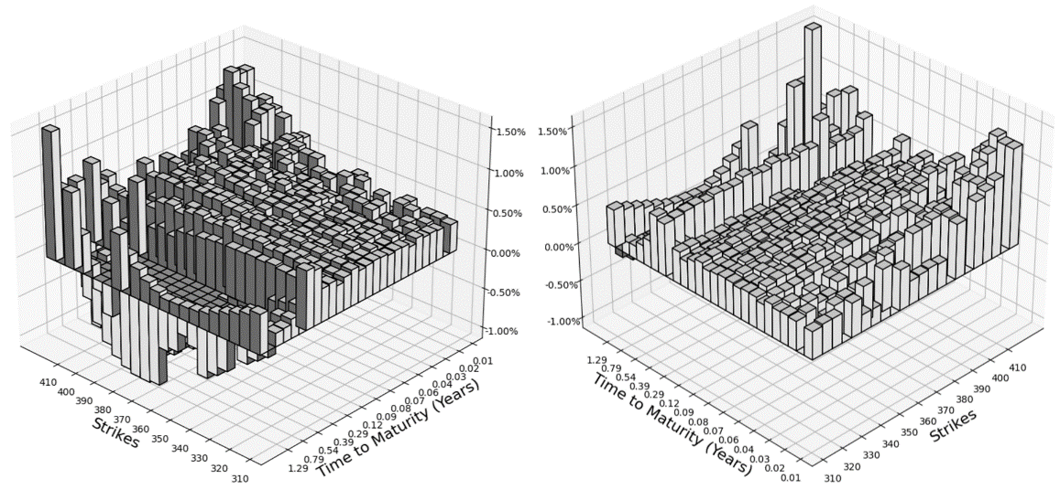

***Figure 2.*** *Market price surface for the SPY ETF*

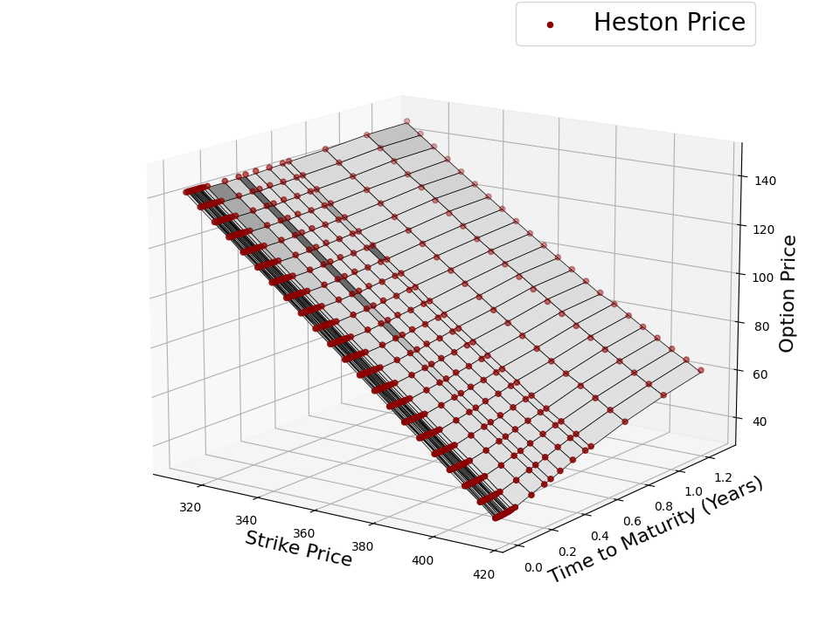

It can be concluded by Figures 1 and 2 that the vast majority of the options have an absolute relative error under , with a maximum of .

We simulated the underlying price times to obtain these results. The TRF method tends to be very robust and reliable when a “good” initial guess is available, otherwise we apply the dual simulated annealing algorithm.

We can also price the same American options under the assumption that the underlying asset is modelled as a geometric Brownian motion with constant parameters, as described at the beginning of this paper (the same assumption the Black-Scholes model makes). The Longstaff-Schwartz method (LSM) is originally based on the same framework and uses Monte Carlo simulation to estimate the value of the option. A detailed representation of the algorithm can be found in the reference [Gustafsson (2015)].

***Figure 3.*** *Errors after the implementation of the original LSM method*

We managed to estimate all the options with a mean absolute relative error of using this method with a maximum error of a little over . Comparing Figures 1 and 3 it is evident that employing the pricing method (LSM), yields more satisfying results when we assume that the underlying asset price follows the diffusion proposed by Heston. The added complexity of the Heston model compared to the geometric Brownian motion, does increase computation time, but the improvement in accuracy more than compensates for this slight increase.

**περιληψη**

Το παρόν κείμενο χρησιμοποιεί τη μέθοδο martingale για την παραγωγή ενός γενικού τύπου τιμολόγησης vanilla options, παρουσιάζει την απόδοση και προσαρμόζει το μοντέλου στοχαστικής διακύμανσης του Heston (1993). Το μοντέλο που πρότεινε ο Heston επεκτείνει το μοντέλο των Black-Scholes (1973) και το περιλαμβάνει ως ειδική περίπτωση. Εφαρμόσαμε τη μέθοδο ελάχιστου τετραγωνικού σφάλματος με βάρη, επιλέγοντας τον ντετερμινιστικό αλγόριθμο trust region reflective σε συνδυασμό με τον στοχαστικό αλγόριθμο simulated annealing για την προσαρμογή του μοντέλου. Στη συνέχεια, συγκρίναμε την αποδοτικότητα των μοντέλων Heston και Black-Scholes σε πραγματικά δεδομένα.

*Acknowledgments:*I would like to thank my supervisor Georgios Tsaklidis for all his help and support during this project, and for introducing me to the area of financial mathematics.

**References**

Black, F., & Scholes, M. (1973). The Pricing of Options and Corporate Liabilities. *Journal of Political Economy, University of Chicago Press*, vol. 81(3), pages 637-654, May-June.

Branch, M. A., Coleman, T. F., & Li, Y. (1999). A Subspace, Interior, and Conjugate Gradient Method for Large-Scale Bound-Constrained Minimization Problems. *SIAM Journal on Scientific Computing*, Vol. 21, Number 1, pp 1-23.

Carr, P., & Madan, D. (1999). Option Valuation Using the Fast Fourier Transform. *Journal of Computational Finance*, 2, 61-73.

Cui, Y., Rollin, S. d., & Germano, G. (2017). Full and fast calibration of the Heston stochastic volatility model. *European Journal of Operational Research*, Volume 263, Issue 2, Pages 625-638.

Gustafsson, W. (2015). Evaluating the Longstaff-Schwartz method for pricing of American options.

Heston, S. L. (1993). A closed-form solution for options with stochastic volatility, with applications to bond and currency options. *Review of Financial Studies 6*, 327-343.

Longstaff, F. A., & Schwartz, E. S. (2001). Valuing American Options by Simulation: A Simple Least-Squares Approach. *The Review of Financial Studies*, vol. 14, no. 1, pp. 113–47.

Mikhailov, S., & Nögel, U. (2003). Heston's Stochastic Volatility Model Implementation, Calibration and Some.

Pironneau, O. (2019). Calibration of Heston Model with Keras.

Rouah, F. (2013). Euler and Milstein discretization.

Shreve, S. E. (2004). *Stochastic Calculus for Finance II Continuous Time Models.* Springer.

Tsallis, C., & Stariolo, D. A. (1996). Generalized Simulated Annealing. *Physica A: Statistical Mechanics and its Applications*, vol. 233, 395-406.

Xiang, Y., & Gong, X. G. (2000). Efficiency of Generalized Simulated Annealing. *Physical Review E*, vol 62, 4473.