import plotElnod as pE
import plotAzscan as pA
import BK_analysis as BK_an
May are the GitHub files:
https://github.com/sofiaf-pixel/WVR-pipeline/blob/main/plotAzscan.py
https://github.com/sofiaf-pixel/WVR-pipeline/blob/main/BK_analysis.py
https://github.com/sofiaf-pixel/WVR-pipeline/blob/main/plotElnod.py

The class and functions show by GitHub
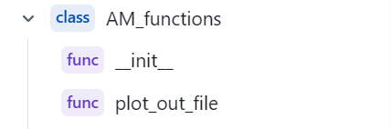
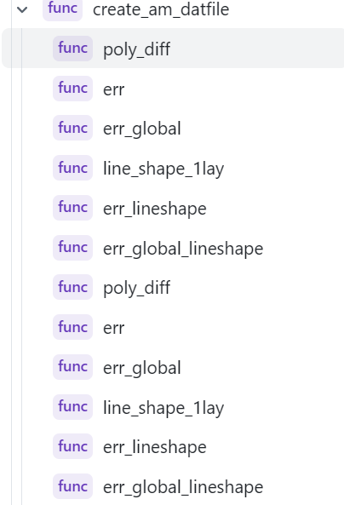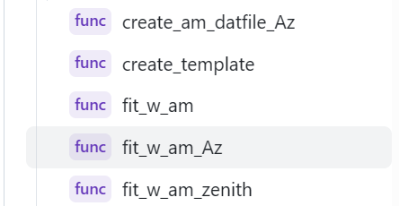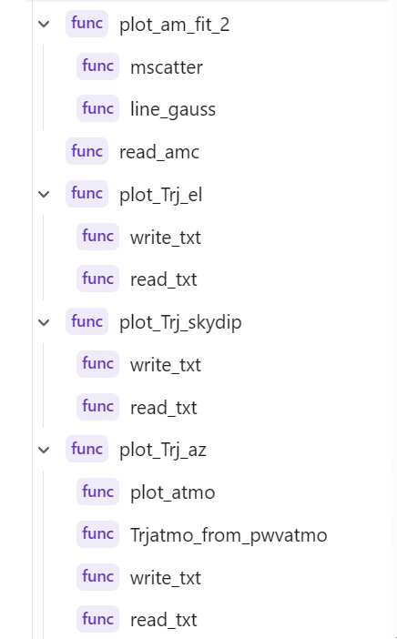

class AM_functions
func _init_
LO
IF
ch
freqs
path_to_all

func plot_out_file(filename)
#read the file at specifical folder, and plot the figure from the file

func create_am_datfile

