# Recombination

Wiens Law

Max wavelength for beginning universe 150nm (which is uv

Cosmic redshift uv into microwave

# CMB maps

## background: Gravitation redshift

redshift of photon

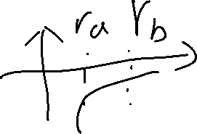

same for photon

delta Energy = 0 🡪 E_photon down 🡪 wavelength increasing

## First detection

Max wavelength(1.06*10^-3 m) same all sky 🡪 same temperature 🡪 thermal equilibrium

## Improved instruments

Detect different wavelength

MCB map

2.725 + .000300 K --- 2.725 - .000300 K

Planck map # diff map by Planck

(24:24)