# Final project

## Project brief

Contoso Medical wants to open a SARS-Cov2 test center. They have comissioned you with creating the necessary APIs.

## Requirements

### Booking API

* Everyone can book an appointment
* Appointments should be stored using a GUID (Globally unique identifier)
* Appointments should request some parameters
  + First name, last name, street, post code, city, email address
* User can use their GUID to cancel their appointment
* There should be a way to list all open appointments
* Booked appointments may only be received when the GUID is used

### Test results API

* Admins publish test results using an API key or similar query-string or header-based authentication
* Admins can remove results using an API key or similar query-string or header-based authentication
* Users use their GUID to get their result

### Bonus features

* Advanced: Appointment storage persistent in a database
* Highly advanced: Authorization and authentication: Admins should be able to view and remove all appointments and tests after authenticating. This can be a database with users and hashed passwords, but ideally would use OAuth2 to allow Google and Microsoft accounts to be used

## Technical details

* You can use any REST framework. Flask is easy to use, Django has more features.
* You can test the API locally, but we have also prepared WebApps for you
* For the project to be successful it is enough to use an in-memory database (i.e. an array or a hashtable)
* Your API can use the query string or a body to accept data
  + If you use a query string, take care to encode the parameter values!
  + Hint: from urllib.parse import urlencode, quote_plus
* For the full integration with automatic publishing to your very own web service:
  + Sign in to dev.azure.com with your ReDI address
  + Fork the repository: [Final Project REST API - Repos (azure.com)](https://dev.azure.com/Spring2021Python/_git/Final%20Project%20REST%20API)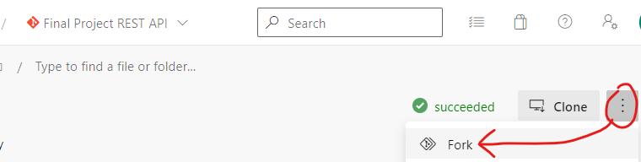
  + Develop your code in your subfolder, push it to your fork, and create a Pull Request in the main repository
  + When the pull request is merged, you can access your app at <https://YOURFOLDERNAME-redi-spring-2021.azurewebsites.net>

Sample code to get you started:

from flask import Flask

from flask import request

import json

app = Flask(__name__)

# Routes define your API endpoints, if you will

# @app.route() is called a Decorator - it "decorates" a function

# This route is a dynamic route that can contain the ISBN of a book

@app.route("/bookings", methods=['GET'])

def get_things(guid=None):

return response

@app.route("/bookings", methods=['POST'])

def get_things():

return response

@app.route("/bookings", methods=['DELETE'])

def get_things(guid):

return response