Financial Risk Assessment System Documentation
Project: ReLIFE Financial Service
Date: January 6, 2026
Document Version: 1.0

Table of Contents
1. Executive Summary
2. Overview of risk_assessment_v3.py
3. Detailed Component Analysis
4. Reorganization into Three Modules
5. Comparison: Current vs. Advanced Implementation
6. API Integration Recommendations

Executive Summary
This document describes the financial risk assessment system contained in risk_assessment_v3.py and how it has been reorganized into three modular files (simulation_engine.py, indicator_outputs.py, and visualizations.py) for production API deployment.

Key Points:
• risk_assessment_v3.py: Monolithic 708-line file containing complete Monte Carlo simulation system
• Current API: Simple placeholder calculations (not true financial metrics)
• Advanced System: Sophisticated Monte Carlo simulation with 10,000+ scenarios
• Reorganized Structure: Separated into three modules for better maintainability and API integration

Overview of risk_assessment_v3.py

Purpose
risk_assessment_v3.py is a comprehensive financial risk assessment tool that uses Monte Carlo simulation to evaluate energy retrofit projects under uncertainty. It generates probability distributions for five key performance indicators (KPIs) by simulating thousands of future scenarios.

File Structure (708 lines)
1. Financial Calculation Functions (Lines 1-267)
2. Statistical Distribution Functions (Lines 268-374)
3. Monte Carlo Simulation Engine (Lines 375-708)

Main Function
get_kpi_results() - Performs Monte Carlo simulation and returns KPI distributions with visualizations

Detailed Component Analysis

1. Financial Calculation Functions

1.1 Cash Flow Generators

cash_flows_with_loan(capex, annual_energy_savings, annual_maintenace_cost, project_lifetime, electricity_prices, inflation_rate, loan_amount, loan_interest_rate, loan_term)
Purpose: Generates annual cash flow projections when a project is financed with a loan.
Logic:
• t=0 (Initial): Equity outflow = -(capex - loan_amount)
• The loan reduces upfront cash needed
• Years 1 to T:
• Operating cash flow = (annual_energy_savings × electricity_price[year]) - (maintenance_cost × cumulative_inflation)
• Debt service = constant_principal_payment + interest_on_remaining_balance
• Annual cash flow = operating_cf - debt_service
Debt Service Calculation:
• Principal payment: loan_amount / loan_term (constant amortization)
• Interest payment: outstanding_balance × interest_rate[year]
• Outstanding balance decreases each year by principal payment
Output: List of cash flows [CF₀, CF₁, CF₂, ..., CFₜ]
Example:
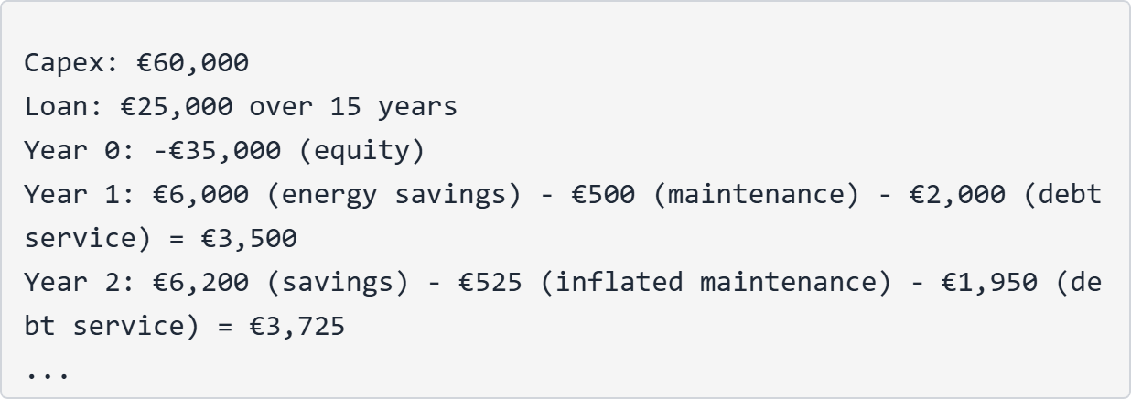

cash_flows(capex, annual_energy_savings, annual_maintenace_cost, project_lifetime, electricity_prices, inflation_rate)
Purpose: Simplified version for equity-only projects (no loan).
Logic:
• t=0: -capex (full upfront payment)
• Years 1 to T: (energy_savings × price) - (maintenance × cumulative_inflation)
Output: List of cash flows [CF₀, CF₁, CF₂, ..., CFₜ]

1.2 Financial Indicator Functions

IRR(flows) - Internal Rate of Return
What it calculates: The discount rate that makes NPV = 0
Method: Uses numpy_financial.irr() - iterative root-finding algorithm
Output: Fraction (0.15 = 15% annual return)
Interpretation:
• IRR > cost of capital → Project is profitable
• IRR < 0 → Project loses money
• NaN → No solution exists (multiple sign changes in cash flows)
Example:
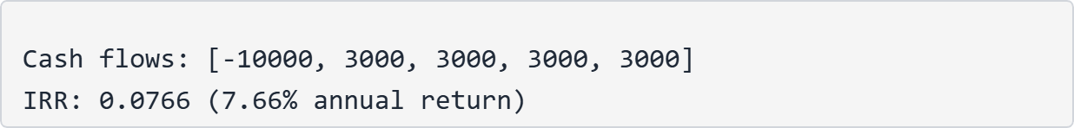

NPV(discount_rate, flows) - Net Present Value
What it calculates: Present value of all future cash flows minus initial investment
Formula:
Method: Uses numpy_financial.npv()
Output: Currency value (e.g., €5,432)
Interpretation:
• NPV > 0 → Project adds value
• NPV < 0 → Project destroys value
• NPV = 0 → Break-even
Example:


PBP(flows) - Simple Payback Period
What it calculates: Years until cumulative cash inflows equal initial investment (undiscounted)
Logic:
1. Track cumulative cash flows year by year
2. Find year when cumulative > initial investment
3. Use linear interpolation for fractional year
Output: Years (e.g., 7.3 years)
Special Cases:
• Returns NaN if project never breaks even
• Uses linear interpolation: Year + (remaining/next_cash_flow)
Interpretation:
• Lower is better
• PBP > project_lifetime → Infeasible
• Commonly used decision rule: PBP < 5-7 years
Example:
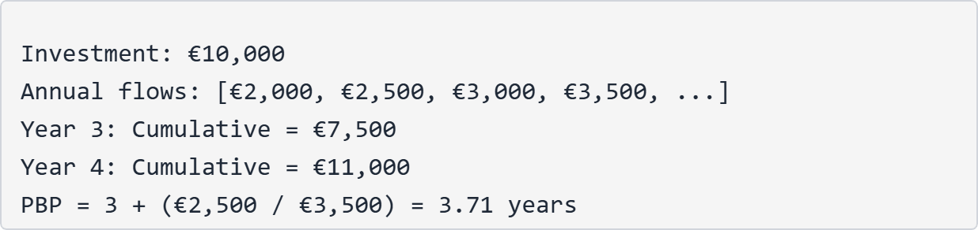

DPP(discount_rate, n, flows) - Discounted Payback Period
What it calculates: Same as PBP but with discounted cash flows
Logic:
1. Discount each cash flow to present value
2. Apply PBP logic to discounted flows
Output: Years (e.g., 9.2 years)
Interpretation:
• More conservative than PBP (always longer)
• Accounts for time value of money
• DPP > project_lifetime → Infeasible

ROI(flows) - Return on Investment
What it calculates: Simple profitability ratio
Formula:
where net_profit = sum of all future cash flows
Output: Fraction (0.45 = 45% total return)
Interpretation:
• ROI > 0 → Profitable
• ROI = 0 → Break-even
• ROI < 0 → Loss
• Does NOT account for time value of money
• Does NOT annualize returns
Example:
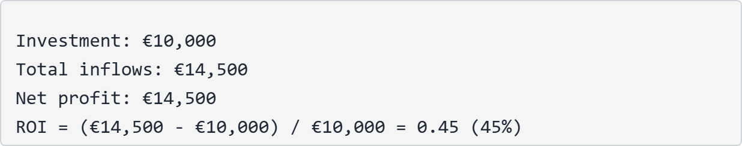

2. Statistical Distribution Functions

2.1 Core Concept
The system uses three scenarios (optimistic, moderate, pessimistic) to define uncertainty for each market variable. These scenarios are interpreted as:
• Pessimistic ≈ P10 (10th percentile)
• Moderate ≈ P50 (50th percentile, median)
• Optimistic ≈ P90 (90th percentile)
From these three points, the system derives full probability distributions.

2.2 Helper Functions

Z90 = 1.2815515655446004
Purpose: Z-score for 90th percentile of standard normal distribution
Usage: Converting P10-P90 spread to standard deviation

pad_to_length(lst, length)
Purpose: Extends forecast lists to match project lifetime
Method: Repeats the last value if list is shorter than needed
Example:


2.3 Distribution Parameter Calculators

_mu_sigma_from_p10_p50_p90(p10, p50, p90)
Purpose: Derives Normal distribution parameters from percentiles
Assumptions:
• Variable follows Normal distribution
• P50 (median) = mean (μ)
• Spread between P10 and P90 defines standard deviation (σ)
Formula:
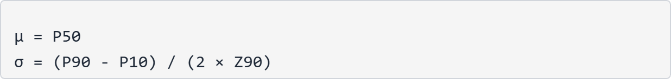
Used for: Inflation rates, interest rates, discount rates
Example:
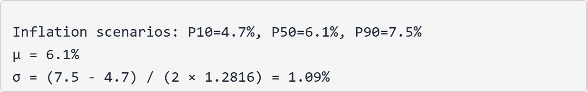

_log_mu_sigma_from_p10_p50_p90_prices(p10, p50, p90)
Purpose: Derives Lognormal distribution parameters for electricity prices
Why Lognormal?
• Ensures prices always stay positive
• Allows for skewed distributions (common in commodity prices)
• Better represents multiplicative growth processes
Method:
• Work in log-space: ln(prices)
• Apply normal distribution logic
• Exponentiate when sampling
Formula:

Example:
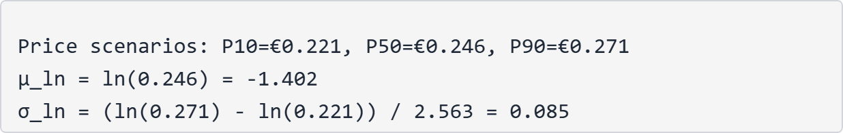

2.4 Market Distribution Builder

build_market_distributions(inflation_rate_data, electricity_prices_data, interest_rate_data, discount_rate_data, project_lifetime)
Purpose: Main function that processes all scenario forecasts into distribution parameters
Input Structure:
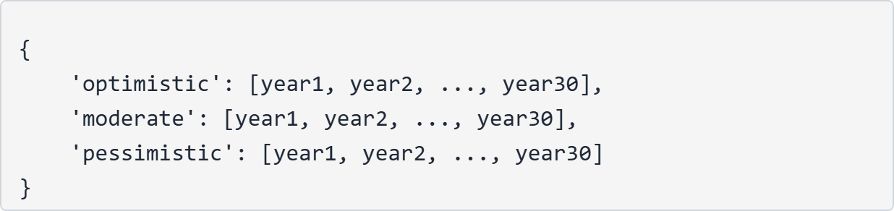
Processing Steps:
1. Pad all lists to project_lifetime (max 30 years)
2. Convert three scenarios into P10/P50/P90 arrays
3. Calculate μ and σ for each year
4. Package into structured dict
Output Structure:
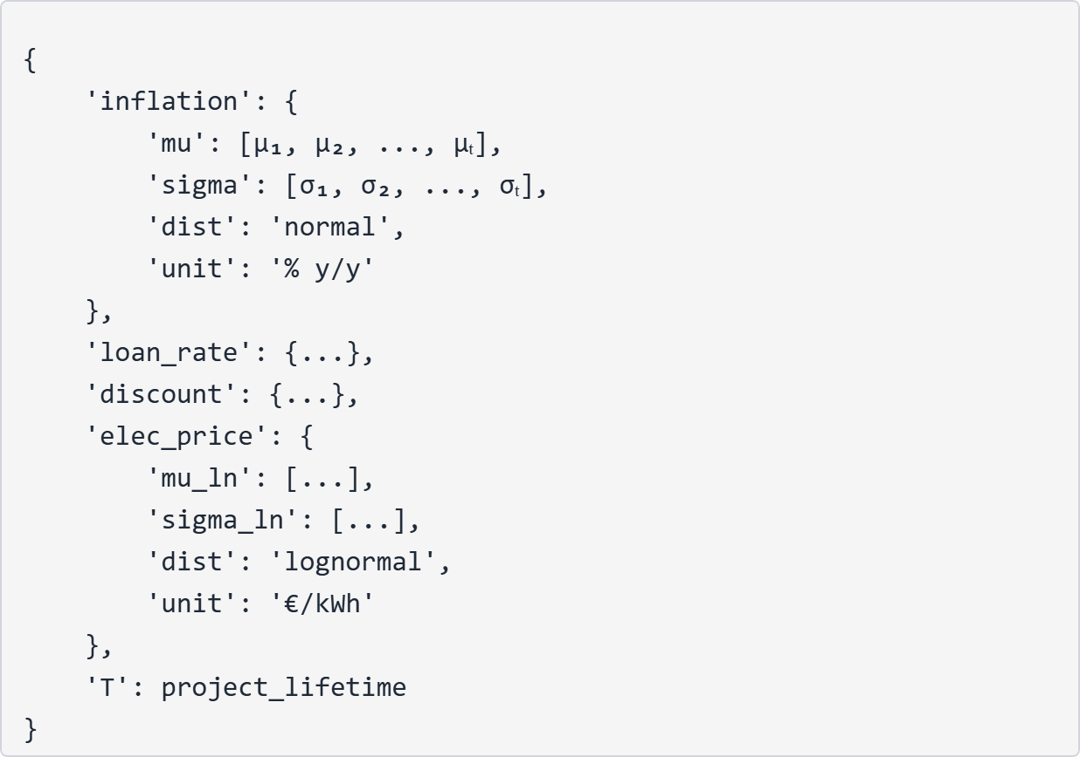
Special Handling:
• Discount rate: Expanded from single value to T years (assumes constant)
• Electricity prices: Uses Lognormal (mu_ln, sigma_ln instead of mu, sigma)

3. Monte Carlo Simulation Engine

3.1 Main Function: get_kpi_results()
Signature:
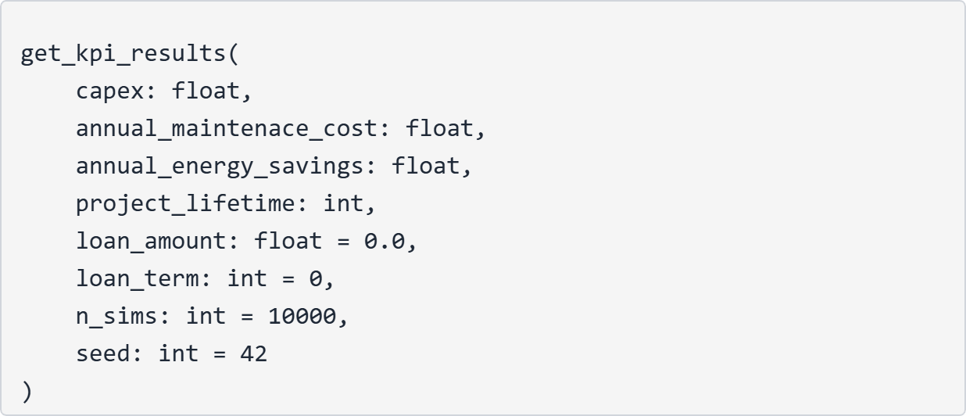

3.2 Input Validation (Comprehensive)
Validated Parameters:
1. capex ≥ 0
2. annual_maintenace_cost ≥ 0
3. annual_energy_savings ≥ 0
4. project_lifetime > 0 and ≤ 30 years
5. loan_amount ≥ 0 and ≤ capex
6. loan_term > 0 if loan_amount > 0, and ≤ project_lifetime
7. n_sims > 0 and ≤ 1,000,000
8. seed must be integer
Error Handling: Raises ValueError with descriptive messages

3.3 Embedded Market Forecasts
The system includes hard-coded 30-year forecasts from machine learning models:

Inflation Rates (%):
• Optimistic: 4.70 → 0.62 (declining trend)
• Moderate: 6.11 → 8.71 (rising trend)
• Pessimistic: 7.52 → 16.80 (high inflation scenario)

Electricity Prices (€/kWh):
• Optimistic: 0.221 → 0.358 (62% increase)
• Moderate: 0.246 → 0.383 (56% increase)
• Pessimistic: 0.271 → 0.408 (51% increase)

Interest Rates (%):
• Optimistic: 1.47 → -2.29 (negative rates)
• Moderate: 3.27 → -0.49 (declining)
• Pessimistic: 5.08 → 1.00 (positive)

Discount Rates:
• Optimistic: 2%
• Moderate: 6%
• Pessimistic: 8%
Note: These are static forecasts generated externally and embedded in the code.

3.4 Monte Carlo Simulation Process

Step 1: Distribution Parameter Generation
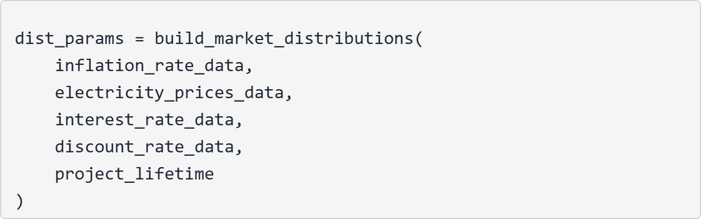

Step 2: Random Sampling
Create n_sims × T matrix for each variable:
• Inflation: Normal(μ, σ) for each year
• Interest rates: Normal(μ, σ) for each year
• Discount rates: Normal(μ, σ) (constant across years)
• Electricity prices: Lognormal(μ_ln, σ_ln) for each year
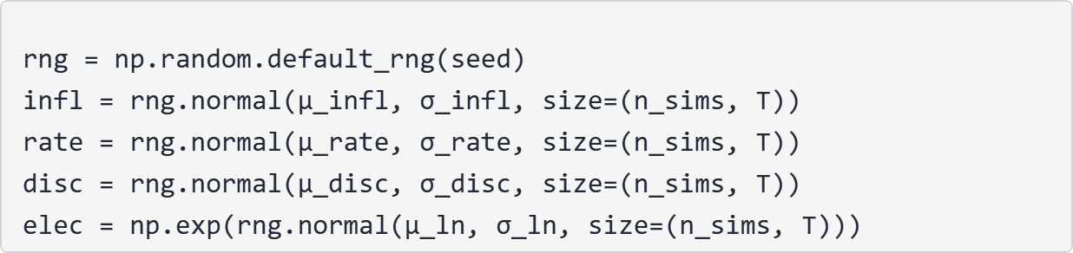

Step 3: Safety Guards
Prevent extreme values that could break calculations:
• Inflation: ≥ -50%
• Interest rates: ≥ -50%
• Discount rates: ≥ -0.99 (prevents division errors)
• Electricity prices: ≥ 1e-9 (prevents zero/negative)

Step 4: Simulation Loop
For each of n_sims scenarios:
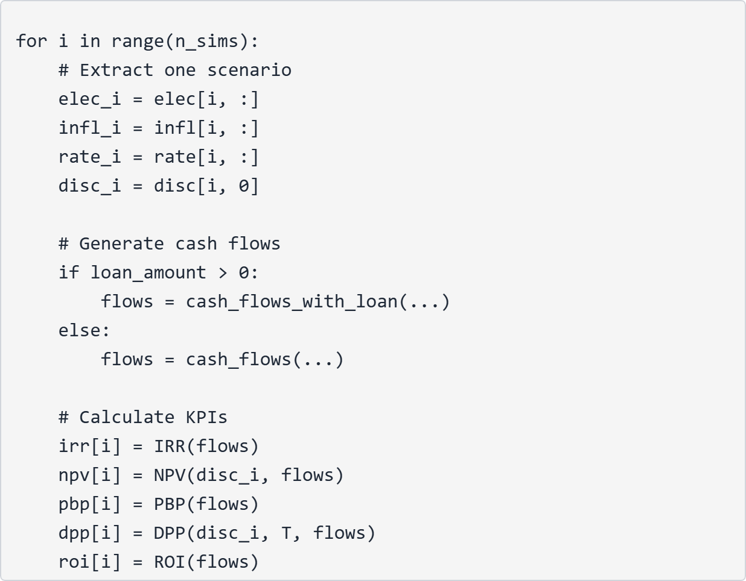
Result: Five arrays, each with n_sims values

3.5 Statistical Summary Generation

Percentiles Calculation
For each indicator, compute: P5, P10, P25, P50, P75, P90, P95
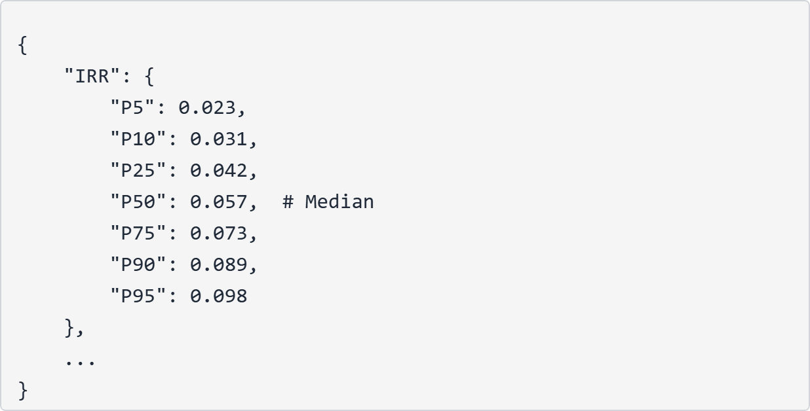

Success Probabilities
• Pr(NPV > 0): Fraction of simulations with positive NPV
• Pr(PBP ≤ Ty): Fraction with payback within project life
• Pr(DPP ≤ Ty): Fraction with discounted payback within project life
Example:
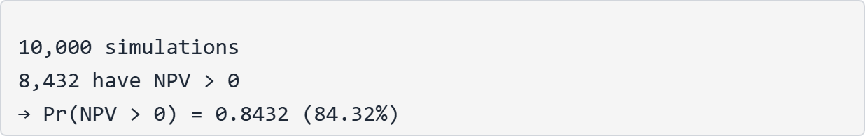

3.6 Visualization Generation
Creates 2×3 subplot grid:

Plots 1-5: KPI Distributions
For each indicator (IRR, NPV, PBP, DPP, ROI):
• Histogram with separate colors:
• Green/Blue: Feasible outcomes
• Red: Infeasible outcomes
• Confidence bands:
• Shaded area: P10 to P90 (80% confidence interval)
• Dashed lines: P10 and P90 markers
• Solid line: P50 (median)
• Special markers:
• PBP/DPP: Vertical line at project lifetime
• NPV: Vertical line at zero (break-even)

Plot 6: Success Probabilities
Bar chart showing three probabilities with values labeled

3.7 Output Structure
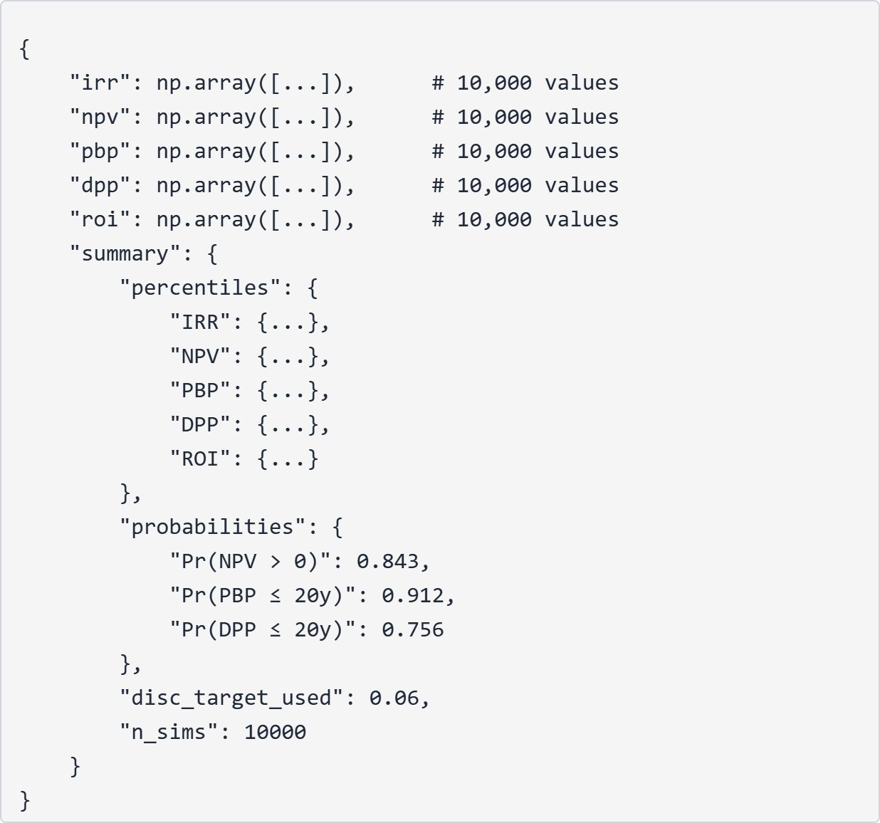

Reorganization into Three Modules

Module 1: simulation_engine.py (598 lines)
Purpose: Core financial calculations and Monte Carlo simulation
Contents:
1. Cash flow functions
• cash_flows_with_loan()
• cash_flows()
2. KPI calculation functions
• IRR()
• NPV()
• PBP()
• DPP()
• ROI()
3. Distribution helpers
• pad_to_length()
• _mu_sigma_from_p10_p50_p90()
• _log_mu_sigma_from_p10_p50_p90_prices()
• build_market_distributions()
4. Main simulation function
• run_simulation() - Enhanced version of get_kpi_results()
Key Improvement: Enhanced Output Structure
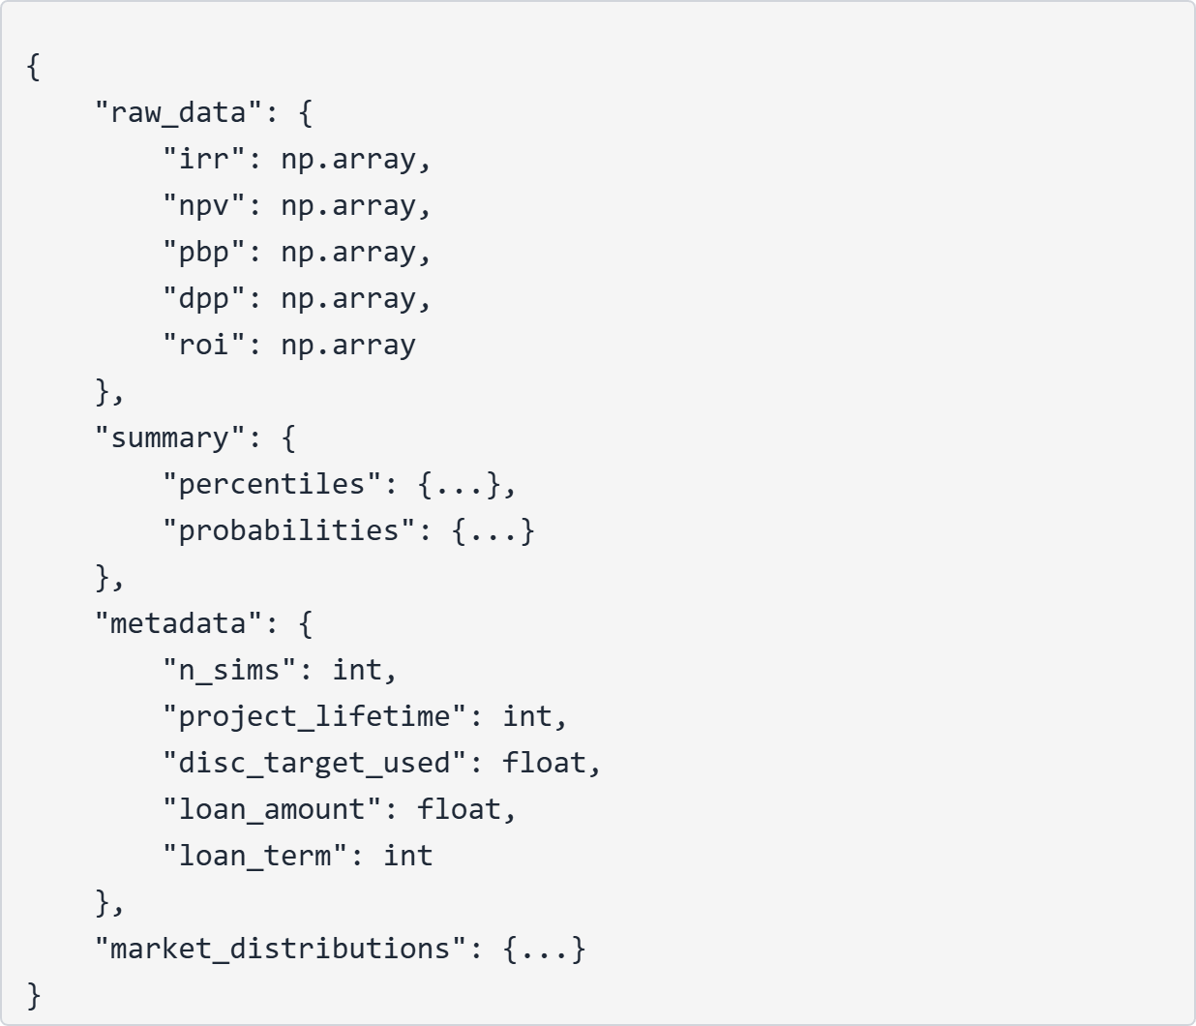
What's Removed: Visualization code (moved to visualizations.py)

Module 2: indicator_outputs.py (360 lines)
Purpose: Extract and format specific information from simulation results
Functions:

1. get_point_forecast(simulation_results, indicator, statistic='median')
Returns: Single float value
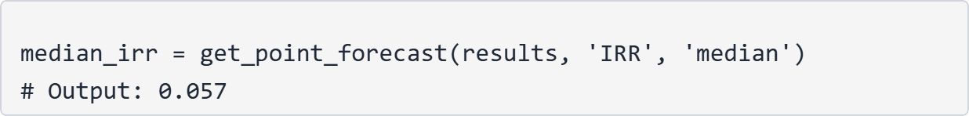

2. get_distribution_summary(simulation_results, indicator, percentiles=None)
Returns: Dict with percentiles and statistics
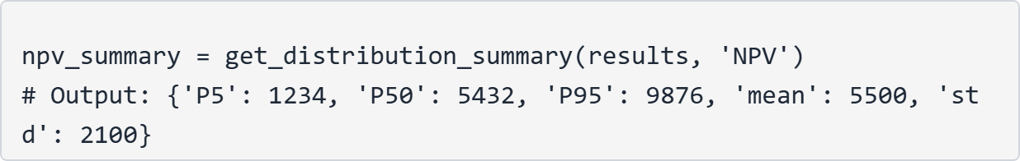

3. get_full_distribution(simulation_results, indicator, remove_nan=True)
Returns: Numpy array with all simulation values
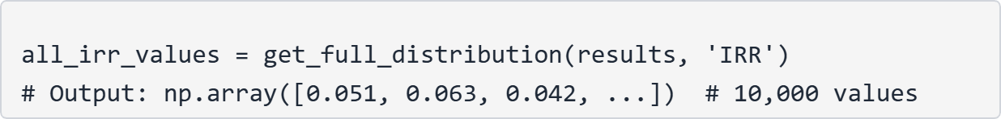

4. get_success_probabilities(simulation_results)
Returns: Dict with all probability metrics
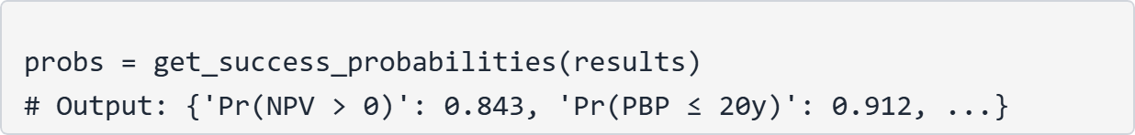

5. get_indicator_probability(simulation_results, indicator, threshold, operator='>')
Returns: Custom probability calculation
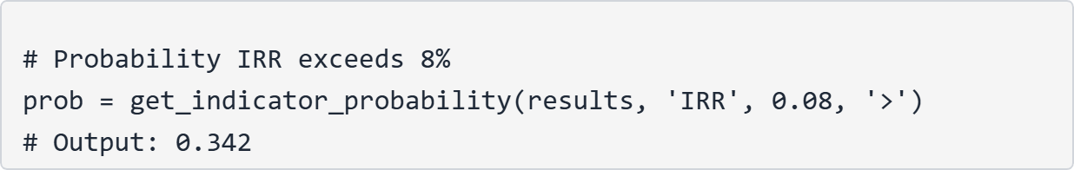

6. get_all_indicators_summary(simulation_results)
Returns: Summary for all indicators at once
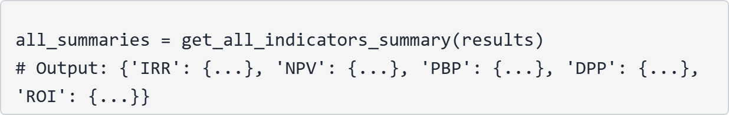

7. format_indicator_output(simulation_results, indicator, format_type='summary')
Returns: API-ready formatted output
Format Types:
• 'point': Single value + metadata
• 'summary': Percentiles + statistics
• 'full': Complete distribution array
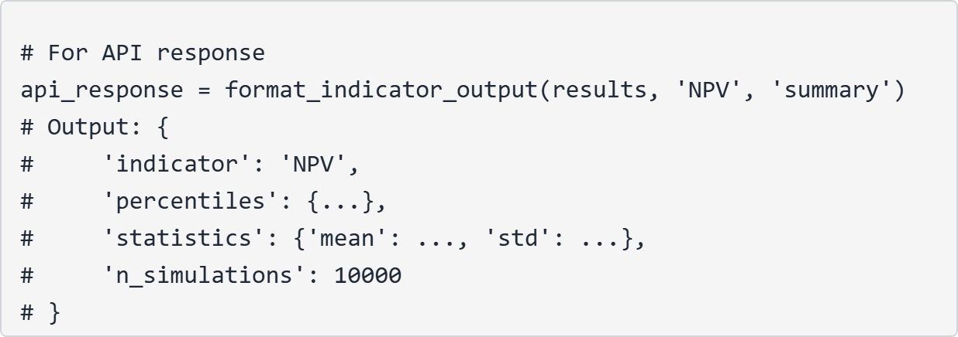

8. get_metadata(simulation_results)
Returns: Simulation parameters used
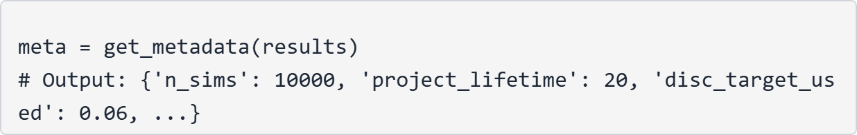
Benefits:
• API flexibility: Get exactly what you need
• Performance: Don't serialize 50,000+ values when only need median
• Clean interfaces: Pre-built formatters for JSON responses

Module 3: visualizations.py (443 lines)
Purpose: Generate charts for analysis and API responses
Functions:

1. plot_indicator_distribution(simulation_results, indicator, save_path=None, return_base64=False, figsize=(10,6), color='steelblue', show_plot=True)
Purpose: Single indicator histogram with statistical markers
Features:
• Separate colors for feasible/infeasible outcomes
• P10, P50, P90 markers and confidence band
• Special markers (project lifetime for payback, zero for NPV)
Output Options:
• show_plot=True: Display in matplotlib window
• save_path='path/to/file.png': Save to disk
• return_base64=True: Return base64 string for API responses
Usage Example:
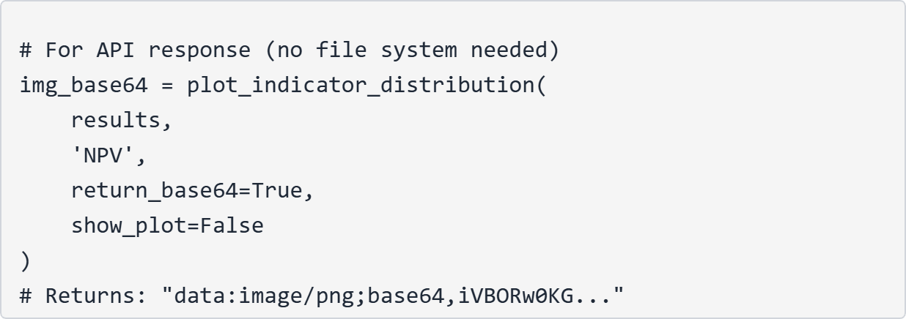

2. plot_success_probabilities(simulation_results, save_path=None, return_base64=False, figsize=(8,5), show_plot=True)
Purpose: Bar chart of success probabilities
Features:
• Three bars with distinct colors
• Percentage labels above each bar
• Formatted for professional presentation

3. plot_all_indicators(simulation_results, save_path=None, return_base64=False, figsize=(16,10), show_plot=True)
Purpose: Comprehensive 6-panel view (replicates original visualization)
Layout: 2×3 grid
• Top row: IRR, NPV, PBP distributions
• Bottom row: DPP, ROI distributions, Success probabilities bar chart
Benefits:
• Single call creates complete analysis
• Consistent styling across all panels
• Suitable for reports and presentations

4. Additional Utility Functions
(Implied in remaining code)
• Data preparation helpers
• Styling and formatting utilities
• Export format handlers
Key Features Across All Visualization Functions:
1. Base64 encoding for API responses (no file system required)
2. Flexible output formats (display, save, return object)
3. Professional styling with feasibility color coding
4. Consistent design language across all plots

Comparison: Current vs. Advanced Implementation

Current Simple APIs (Placeholder Versions)
Located in: src/relife_financial/services/

1. calculate_ii() - Initial Investment
✅ Status: Adequate - simple arithmetic calculation

2. calculate_opex() - Operating Expenses
✅ Status: Adequate - straightforward sum

3. calculate_irr() - Internal Rate of Return (SIMPLE)
❌ Problem: This is NOT true IRR!
• Ignores time value of money
• Ignores cash flow timing
• Single-period profitability ratio
• Missing loan amortization
True IRR: Iterative solution where NPV = 0

4. calculate_roi() - Return on Investment (SIMPLE)
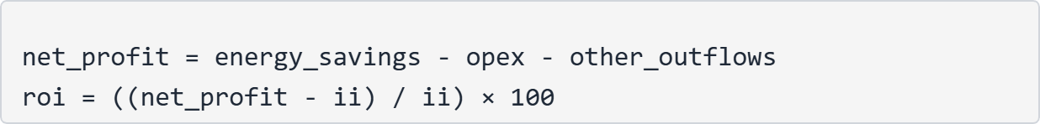
❌ Problem: Overly simplified
• Single period calculation
• Doesn't model multi-year cash flows
• No discounting

5. calculate_npv() - Net Present Value
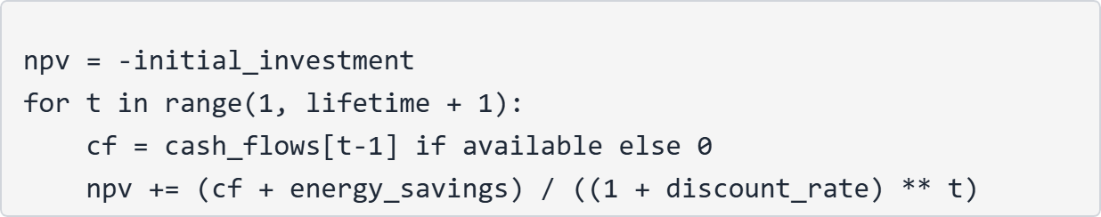
⚠️ Status: Partially correct but limited
• Basic NPV logic is correct
• Doesn't handle inflation properly
• No debt service modeling
• Single deterministic scenario

Advanced Implementation (risk_assessment_v3.py / reorganized modules)

Financial Indicators ✅
Indicator | Current API | Advanced System
IRR | Simple ratio | True iterative IRR (numpy_financial.irr)
NPV | Basic discounting | Full cash flow model with inflation
ROI | Single period | Multi-year cumulative
PBP | Not implemented | Undiscounted payback with interpolation
DPP | Not implemented | Discounted payback period

Uncertainty Quantification ✅
Feature | Current API | Advanced System
Output type | Single value | Probability distribution
Scenarios | Deterministic | 10,000 Monte Carlo simulations
Market variables | Fixed | Stochastic (inflation, prices, rates)
Confidence intervals | None | P5, P10, P25, P50, P75, P90, P95
Risk metrics | None | Success probabilities

Cash Flow Modeling ✅
Feature | Current API | Advanced System
Loan handling | Simplified | Full amortization schedule
Inflation | Not modeled | Cumulative inflation on maintenance
Energy prices | Fixed | Year-by-year forecast with uncertainty
Interest rates | Single value | Variable rates per scenario

Output Richness ✅
Current API Output:
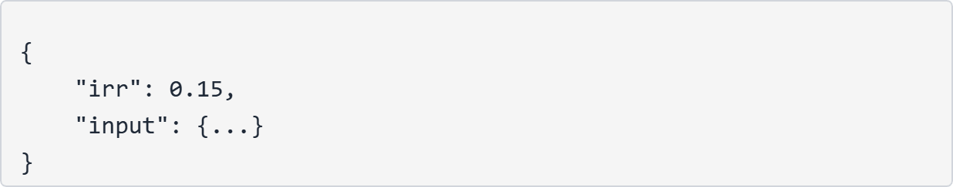
Advanced System Output:
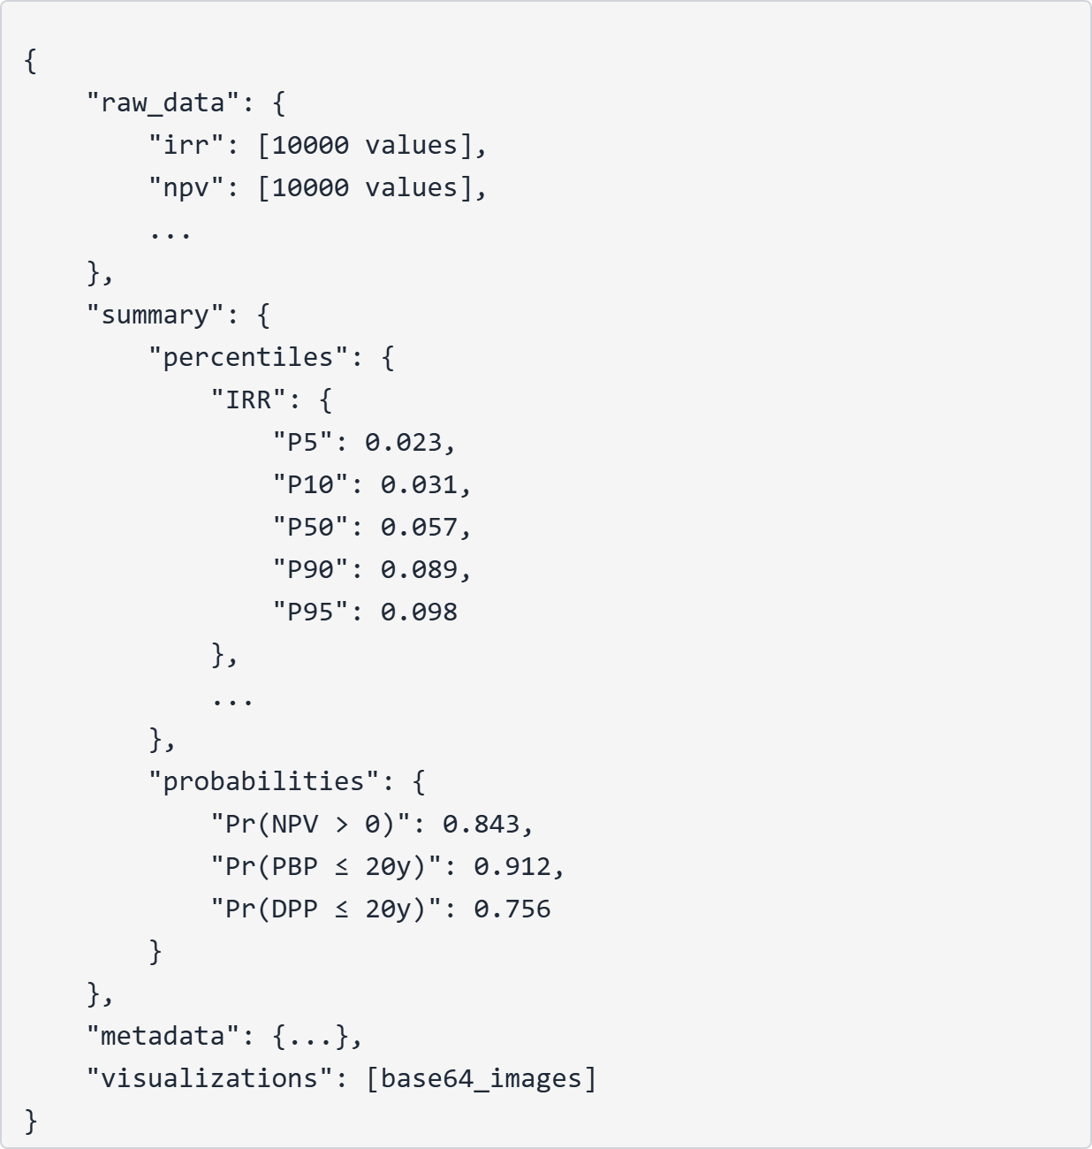

API Integration Recommendations

Recommended New Endpoints

1. POST /financial/risk-assessment (Comprehensive)
Purpose: Full Monte Carlo simulation with all outputs
Input:
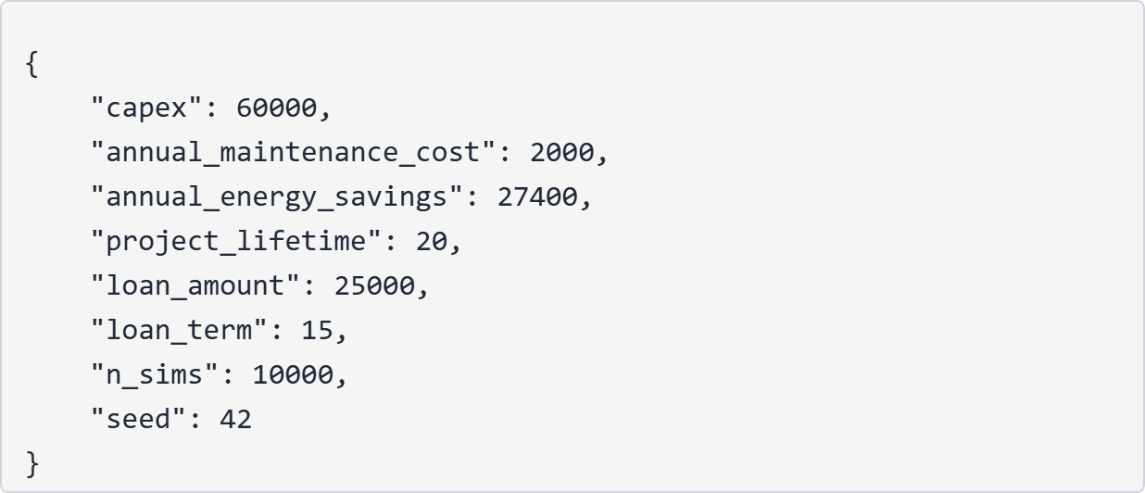
Output:
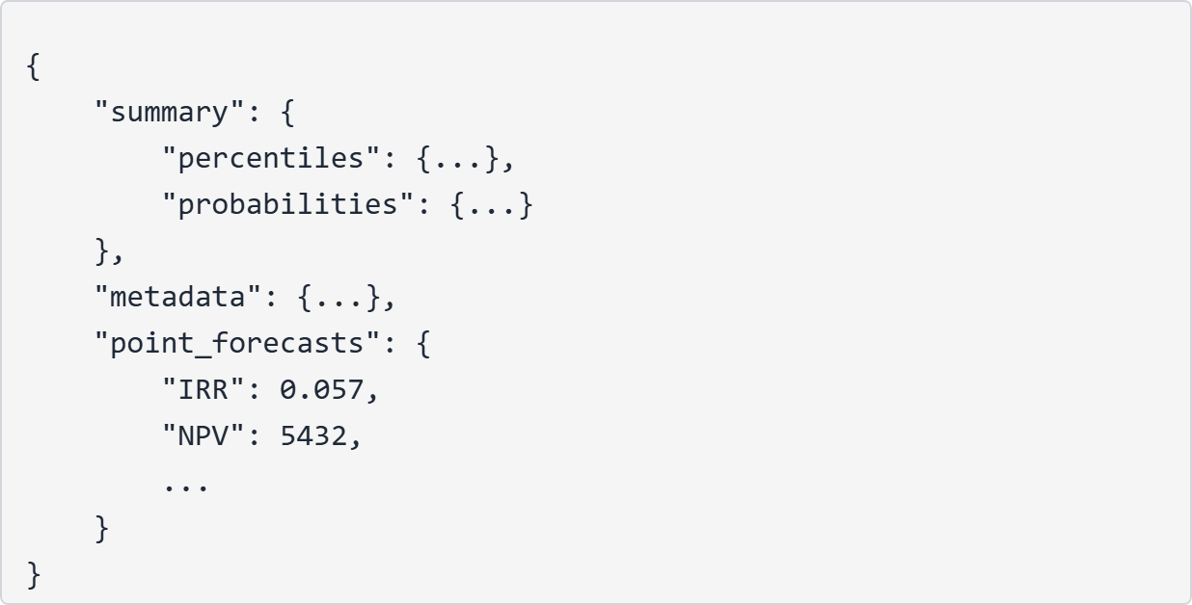
Implementation:
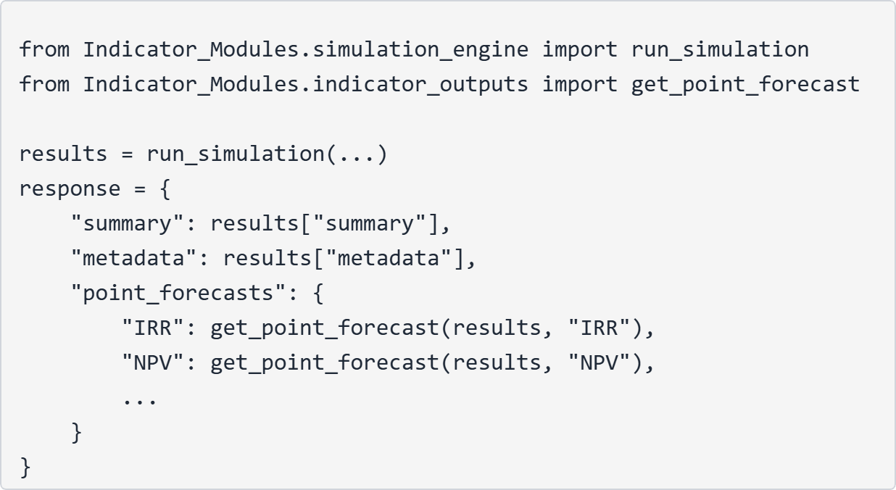

2. POST /financial/indicator-detail (Single Indicator Deep Dive)
Purpose: Get complete distribution for one indicator
Input:
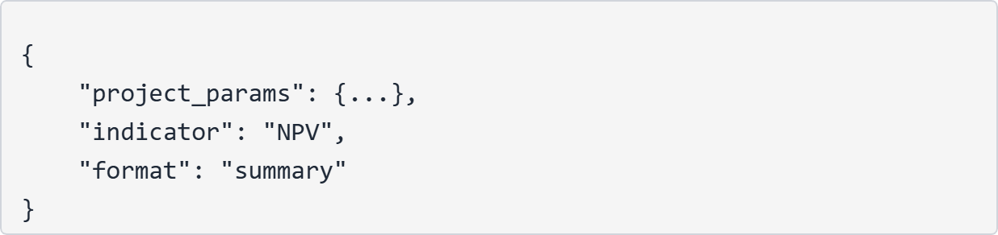
Output:
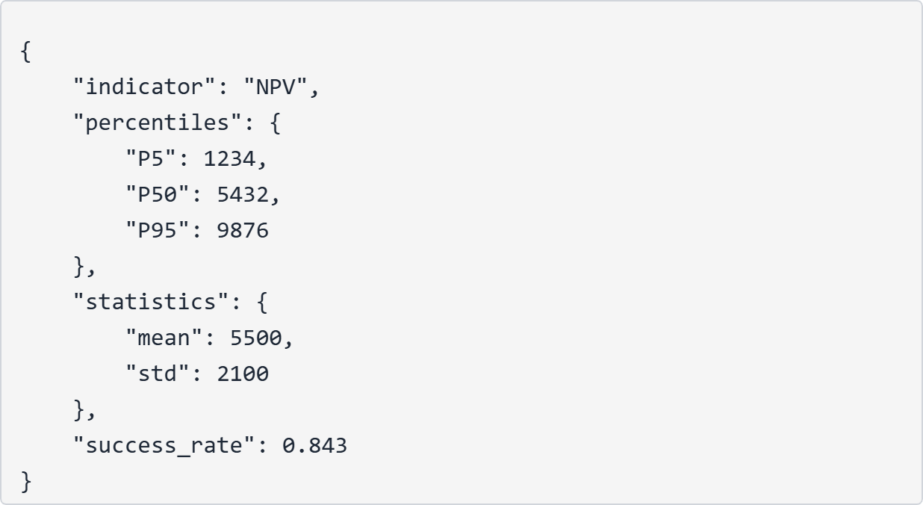

3. POST /financial/quick-forecast (Fast Median Estimates)
Purpose: Get P50 values for all indicators quickly
Input:
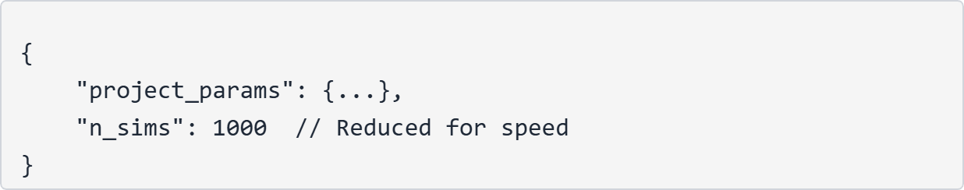
Output:
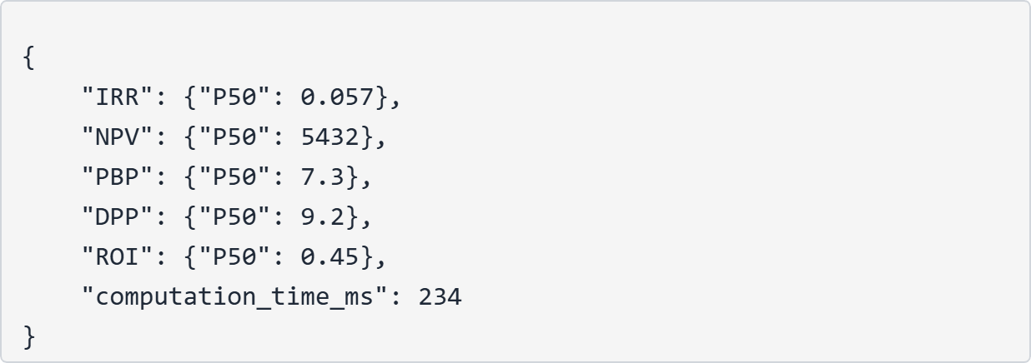

4. POST /financial/visualization (Chart Generation)
Purpose: Generate charts for reports
Input:
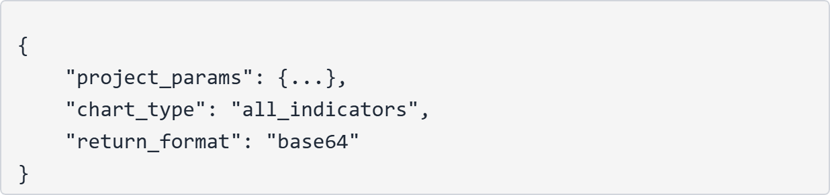
Output:
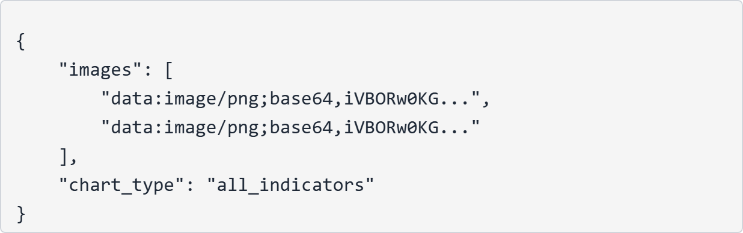

5. POST /financial/success-probability (Decision Support)
Purpose: Get probability of meeting specific thresholds
Input:
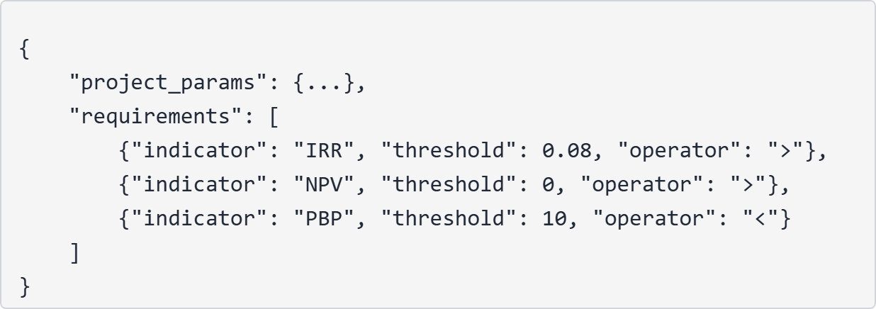
Output:
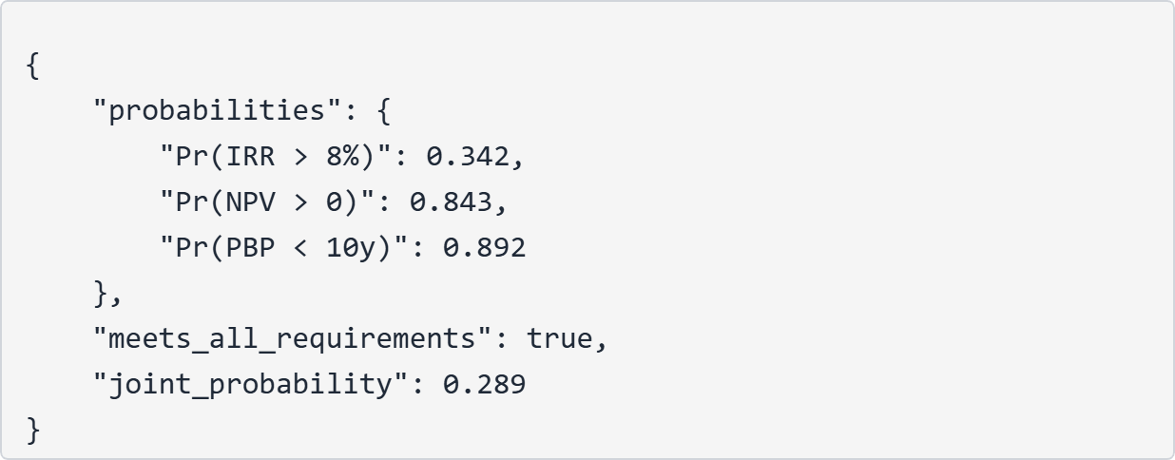

Migration Strategy

Phase 1: Parallel Deployment
• Keep existing simple endpoints
• Deploy new advanced endpoints alongside
• Allow users to choose based on needs

Phase 2: Gradual Transition
• Mark simple endpoints as deprecated
• Provide migration documentation
• Monitor usage patterns

Phase 3: Full Replacement
• Remove simple endpoints
• Use advanced system as primary API

Performance Considerations

Computation Time
n_sims | Approximate Time | Use Case
1,000 | ~0.2 seconds | Quick estimates
10,000 | ~2 seconds | Standard analysis
100,000 | ~20 seconds | High-precision research
Recommendations:
• Default: 10,000 simulations
• Quick API: 1,000 simulations
• Add timeout handling for large requests

Caching Strategy
• Cache results by input hash
• TTL: 1 hour (market data is relatively stable)
• Redis or in-memory cache

Async Processing
For visualization endpoints:
• Generate images in background tasks
• Return job ID immediately
• Poll or webhook for completion

Architectural Benefits

Code Organization
Aspect | Original File | Reorganized Modules
Lines per file | 708 (monolithic) | 360 + 443 + 598
Single Responsibility | ❌ | ✅
Unit testability | Difficult | Easy
Import flexibility | All-or-nothing | Import only what needed
Maintenance | Changes affect entire file | Isolated changes

API Integration Benefits
1. Selective imports: Import only simulation_engine for headless API
2. Optional visualization: Only load matplotlib when needed
3. Flexible output formats: Choose level of detail per endpoint
4. Performance optimization: Skip visualization generation for pure data APIs
5. Better error handling: Structured returns allow graceful degradation

Testing Benefits
simulation_engine.py:
• Unit test each financial function independently
• Test distribution builders with known inputs
• Validate Monte Carlo convergence
indicator_outputs.py:
• Test each extraction function with mock data
• Validate formatters produce correct JSON
• Test edge cases (NaN handling, empty results)
visualizations.py:
• Test chart generation without display
• Validate base64 encoding
• Test all output formats (show/save/return)

Technical Specifications

Dependencies
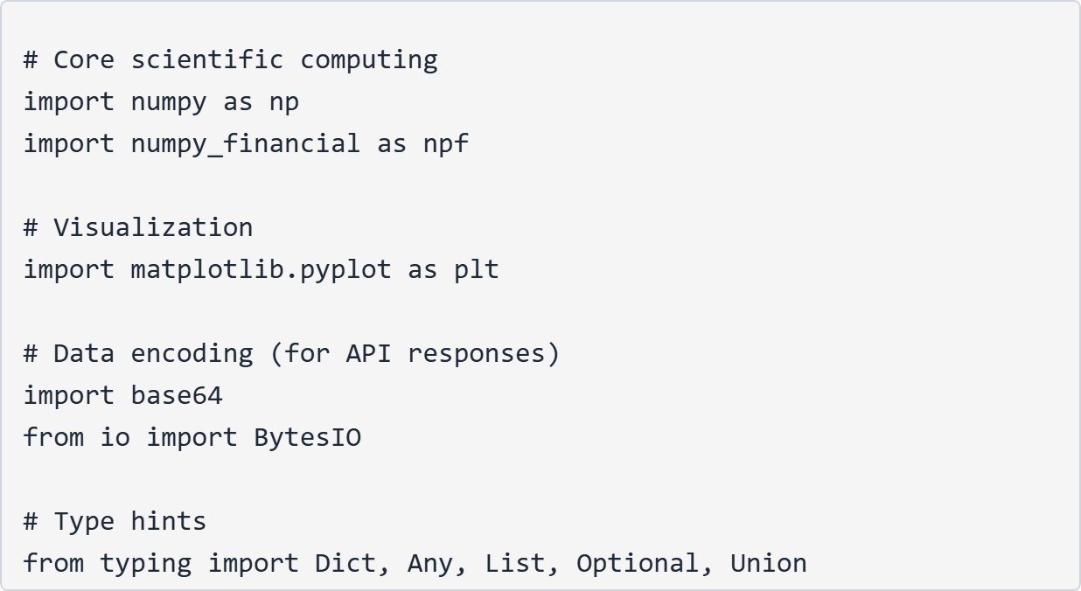

Data Structures

Simulation Results Dictionary
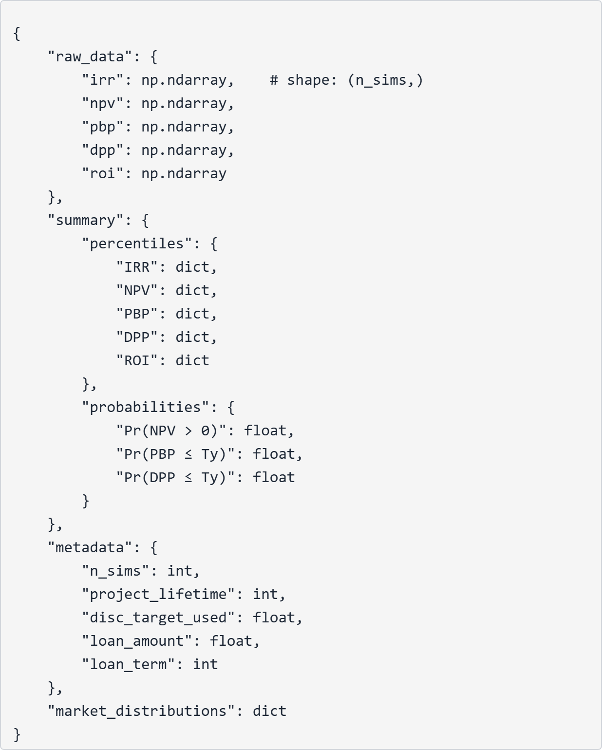

Error Handling
All functions include try-except blocks:
• Financial calculations return np.nan on error
• Prevents single failure from crashing entire simulation
• Allows analysis of partial results

Conclusion
The reorganization of risk_assessment_v3.py into three modular files represents a significant improvement in code architecture while maintaining 100% functional equivalence. The advanced Monte Carlo simulation system provides:
1. True financial calculations (not simplified placeholders)
2. Comprehensive risk quantification with probability distributions
3. Production-ready API integration capabilities
4. Flexible output formats for different use cases
5. Professional visualization options
The system is ready for API deployment and offers substantial improvements over the current simple placeholder implementations.

Appendix: Quick Reference

Five Key Performance Indicators
1. IRR - Internal Rate of Return (%)
• Discount rate where NPV = 0
• Higher is better
• Interpretation: Expected annual return
2. NPV - Net Present Value (€)
• Present value of all cash flows
• Positive is good
• Interpretation: Value created by project
3. PBP - Simple Payback Period (years)
• Time to recover investment (undiscounted)
• Lower is better
• Interpretation: Years to break even
4. DPP - Discounted Payback Period (years)
• Time to recover investment (discounted)
• Lower is better
• Interpretation: Conservative breakeven time
5. ROI - Return on Investment (%)
• Total return as percentage of investment
• Higher is better
• Interpretation: Total profitability

Success Criteria Interpretation
Probability | Interpretation
< 50% | High risk, likely to fail
50-70% | Moderate risk, uncertain
70-85% | Good prospects
85-95% | Very good prospects
> 95% | Excellent prospects

Document End

