The nature of reconceptualising in REMSTEP

## Project name: Reconceptualising Chemistry

## Who was involved: Gail Chittleborough, Leissa Kelly

## Overview of the project

Dr Gail Chittleborough (Unit Chair, Chemistry Curriculum Studies) has been collaborating with Dr Jenny Pringle to develop an innovative project for pre-service teachers enrolled in chemistry curriculum units over the last two years. Under the guidance of Dr Gail Chittleborough, undergraduate pre-service teaching students training to be chemistry teachers, have been working closely with postgraduate research science students from the Institute of Frontier Materials at Deakin University. From these one-on-one discussions, the pre-service teachers have developed teaching resources that address key criteria, including identifying the practices used by the scientists’ to develop new knowledge and techniques, and identifying links to the chemistry in Victorian and National curriculums.

The pre-service teachers involved in this project were either undergraduate students completing a Bachelor of Science / Bachelor of Teaching or Masters students completing a Master of Teaching. In 2014, 19 pre-service teachers and 8 research chemists participated and in 2015, 13 pre-service teachers and 7 research chemists participated. The research chemists involved in 2014 were not involved in 2014.

Assignment tasks that the pre-service chemistry teachers completed are aligned to the objectives of the ReMSTEP project <http://remstep.org.au/> that is **“**dedicated to developing new teacher education practices that align contemporary practices in the sciences with innovative and engaging approaches to teaching and learning**.”**

### What was the nature of engagement of PSTs or teachers with contemporary STEM practice?

On-campus students of the Chemistry Curriculum Unit visited the IFM Research Facility in Week 2 of the 2nd trimester to listen to the Research Fellows and Research Doctoral students from the Institute for Frontier Materials (IFM) give presentations on their research projects. The PSTs were then given the opportunity to talk to the research chemist about their projects with a view to developing a teaching module that could be used to teach the ‘cutting edge chemistry’ and represent the work of the scientists. The research chemists were available to collaborate with the students by answering their questions throughout the trimester.

### What aspects of STEM practice were represented to the PSTs or teachers? In what sense do you regard this as innovative or significant?

Through their collaborations with the research Chemists, PSTs were presented with cutting edge research into new and improved applications of chemistry, and given insight into the experiences and practices of the individual scientists.

The Research chemists presented the problem or issue that that the research were tackling and explained the chemistry of their project in everyday terms, they used diagrams and animations. The value of the data became apparent as some scientists asked for the data was confidential While the chemist explained the nature of their research m they were also demonstrating the inquiry process that they were following- -asking questions, modeling interpreting data and refining ideas, These points are significant because the chemistry related to everyday issues- such as exploring chemicals that will provide longer life and safer batteries, reducing the corrosion on coronary artery stents

### What changed curriculum / classroom practices are envisaged, flowing from the project? By what means are these changes supported, and is there evidence they have occurred?

As part of the Unit, PSTs produced a teaching module that represented the work and scientific practices of the scientist. The teaching module produced included teaching activities, teacher notes and student activities, and contextual video or posters. Some PSTs were able to trial their modules within schools when on practicum.

The experience of the PST – talking to research chemists, gaining an understanding of their projects and relating this to teaching chemistry – has the potential to inform their future teaching.

The evidence from a former student in 2014 cohort- who in 2015 – related to me via email:

Also on teaching rounds this week I used some of the stuff we did on Ionic liquids to teach Yr 10 on ionic bonds and the kids were really interested and my supervising teacher was also interested to know where the research is headed. So thank you.

### What ongoing links are there or will there be between PSTs and STEM practitioners?

Throughout the course of the Trimester, the research Chemists were available to the PSTs to answer any questions. It is envisaged that future Chemistry Curriculum Methods Units will continue to work with IFM Research Chemists on this project.

I don’t know of any ongoing links

### What opportunities were there for science or maths students (undergrad or HDR) to reconceptualise their perceptions of school science or mathematics learning and teaching?

PSTs were given the opportunity to reflect on their chemistry pedagogical practices and encouraged to incorporate the contemporary scientific innovations and science practices that they learnt through their collaborations with the research scientists.

The nature of the task – creating a teaching resource required the PST to reflect and design an appropriate teaching resource with interactivity, the three levels of chemical representation, links to the curriculum- etc- refer to the criteria in the rubric.

### What evidence is there on successful recruitment of science or maths students into a teaching pathway?

None

### What evidence is there of improved learning and engagement of PSTs, or school students, in science or mathematics, as a result of the project?

Not yet

### Is there evidence of a cultural shift in the way education and science faculty staff inter-relate as a result of this project?

Yes there are increasing links and understandings between education and IFM researchers.

Ongoing project with staff willing to be involved again in the third iteration

Highlights the importance of communication skills, by both PST and Research chemists

### What has been learnt about processes for incorporating contemporary STEM practices in teacher education?

The timetable and curriculum constraints on VCE Chemistry teachers inhibit incorporating contemporary research practices into the classroom.

Recognizing that the benefits of providing PST with rich experiences are varied and sometimes difficult to identify specifically. The PST experience may not be linked to a specific project or topic but rather the experiences will subliminally be incorporated into their conversations with students, teaching moments – at times where it is relevant and appropriate.

### What has been learnt about the efficacy of incorporating contemporary STEM practices in the school curriculum?

Not yet.

Appendix

Details of the Assignment tasks 2015

|  |  |
| --- | --- |
| **Assessment 1** | **Emerging Science** |
| **Brief description of assessment task** | This can be a group assignment. The aim of this assignment is to:   * Examine the chemistry in a particular “cutting edge science “ area. * Identify ways new ideas and research and development practices in chemistry can be integrated in the secondary chemistry curriculum. * Discuss:   + the work of research chemists and its relation to technological advances and societal applications   + the importance of teaching emerging sciences (biotechnology, green chemistry, nanotechnology, neuroscience, organic chemistry and synchrotron) and cutting edge sciences |
| **Detail of student output** | *Presentation - 1500 words or equivalent - shared* |
| **Weight** | *30%* |
| **Due date** | *Assessment 1 –presentation due August 6th 2015 – in seminar or online* |
| **Assessment Criteria** | * *Identify the key chemical concepts and practices* * *identify and explain the key chemical concepts using multiple representations* * *identify the practices used by the scientists to develop new knowledge and techniques* * *explore the ideas associated with the a “cutting edge science” through three level of representation of matter – micro, micro and sub-microscopic* * *explain the cutting edge science in everyday language* * *Identify the links to the chemistry Victorian and National curriculums;* |

Assignment 1 and 2 are designed in conjunction with the ReMSTEP project <http://remstep.org.au/> that is **“dedicated to developing new teacher education practices that align contemporary practices in the sciences with innovative and engaging approaches to teaching and learning.”**

Please visit the website for Institute of Frontiers Material (IFM) at Deakin University and look at the various characteristics of the research. The details of the research are at: <http://www.deakin.edu.au/research/ifm/electromaterials/index.php>

Please watch the Tour of Institute for Frontier Materials located at Burwood (<https://www.youtube.com/watch?v=KOrOOpd70IA>). Please read about the projects on the website. There are links to other universities and more projects through the Australian Research Council (ARC) Centre of Excellence for Electromaterials Science (ACES) <http://www.electromaterials.edu.au/about/index.html>

On-campus students of ESJ460/ESS768 will visit the IFM Research facility in Week 2, on Thursday 23rd July, 2015. The Research Fellows and Research Doctoral students from IFM will give brief presentations on their projects, and then you will have the opportunity to talk to the research chemist working on the projects. Please come prepared to ask them questions – you need to gather the information to complete Part 1 of the assignment. The Research chemists will also be able to answer questions for you during the trimester as you work on Part 2, 3 and 4 of the assignment.

Off campus students are welcome to join the meeting at uni on July 24th, otherwise they will be able to work in a group through *collaborate* and they will make contact with the research chemists through email and collaborate. This is a unique opportunity!

|  |  |
| --- | --- |
| **Assignment 2 Teaching a Difficult Chemical Concept 40% individual** | |
| **Detail of student output** | A written submission (1500 words) plus a presentation (5 minutes) detailing the pedagogical strategy, informed by research literature, explaining and justifying how best to teach the difficult chemical concept. |
| **Weight** | 40% Equivalent to 1600 words |
| **Due date and form of submission** | Wednesday October 1st 2015- online submission  Presentation by on campus students in seminar on 2nd October 2015 |
| **Assessment Criteria** | * *Pedagogical justification for the content of the lesson - informed by constructivist learning theories* * *Consideration of how common misconceptions are addressed (Educational literature research can provide information about common misconceptions)* * *Tailoring the design to students needs* * *Evidence of pedagogical content knowledge in the design of the strategy* * *Explanations of the choice and purpose of the teaching resources e.g Appropriate use of digital technologies* |
|  |  |

Some aspects to consider:

* How will students be engaged? Is the authenticity and applicability of the project communicated??
* The resources can use a variety of multimedia format e.g. powerpoint with audio, digital flashcards, video, digital stories, podcasts, vodcasts, IWB, slowmation, animations.
* Consider the most appropriate way to present the chemical ideas – experimental activities, simulations, manipulation of data, video, visual representations, animations.
* Is there an inquiry component to the lesson?, if so, do the inquiry aspects reflect the way the scientists research and develop?
* Is there an opportunity for the students to re-represent chemical ideas?
* What knowledge is assumed?
* What vocabulary do students need?
* What makes this a quality-teaching lesson?
* Does the teaching resource encourage students to think, reason, talk and do chemistry? How?

Appendix

Rubrics for the two tasks – presentation plus teaching resource

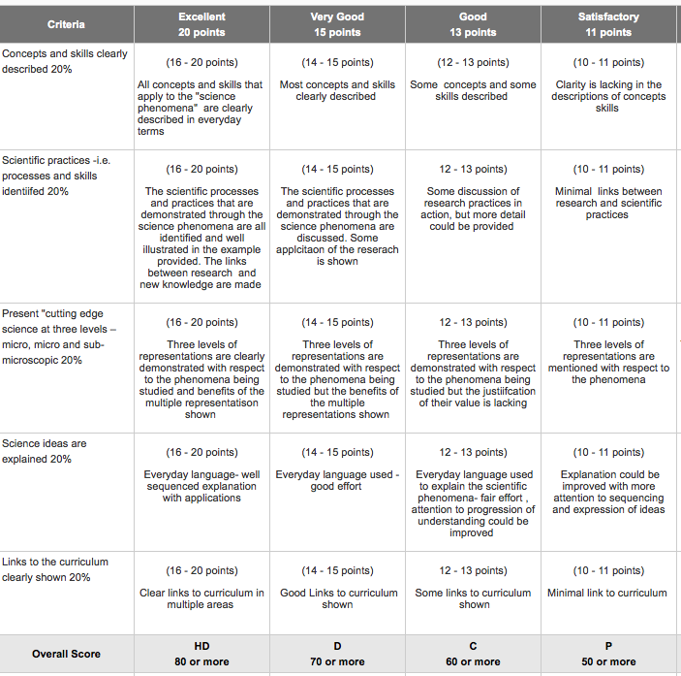

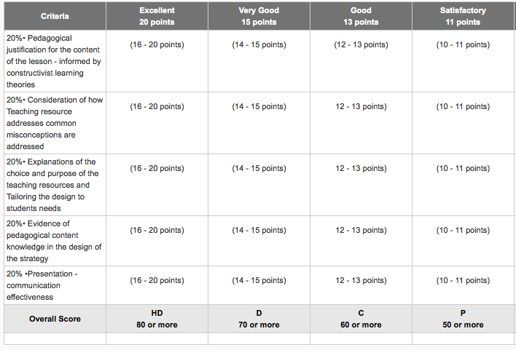

## Results

The number of participants that took part in the Chemistry Curriculum project throughout the ReMSTEP funded period is outlined in the following table:

|  |  |  |  |  |  |  |
| --- | --- | --- | --- | --- | --- | --- |
| **Activity** | **Participant Number** | | | | | |
| **2014** | | **2015** | | **2016** | |
| **Students** | **Scientists** | **Students** | **Scientists** | **Students** | **Scientists** |
| Chemistry pre service teachers interacting with research scientists | 19 | 8 | 13 | 7 | 24 | 7 |

The number of these participants that have taken part in the evaluatory process, whether it be via responding to surveys or joining in interviews or focus group sessions, are outlined in the table below:

|  |  |  |  |
| --- | --- | --- | --- |
| **Participant** | **Number** | **Year** | **Type** |
| Students & Scientists | 15 | 2014/2015 | Survey |
| Students | 9 | 2015 | Focus group interviews |
| Students | 5 | 2016 | Survey |
| Lecturer | 1 | 2016 | Interviews |
| Scientists | 7 | 2016 | Survey |

The data from these surveys, focus group interviews and informal interviews provide the evidence and comprise the basis of this section of this project report.

### Experience of participants

* What was the experience of PSTs or science and mathematics students, school students, teachers, scientists, teacher educators?

Undergraduate pre-service teachers (PSTs) training to become Chemistry teachers have been working closely with postgraduate research science students from the Institute of Frontier Materials at Deakin University. During this collaborative process, the research scientists initially presented their work to the PSTs, who then liaised with the scientists with the view to developing a teaching module. This module was to incorporate the ‘cutting-edge’ science that had been presented to the PSTs, as well as representing the work of the scientists. After the initial presentation and contact, the research scientists were available to collaborate with the PSTs and answer their questions throughout the trimester.

This ReMSTEP experience was perceived to be a positive one across all program stakeholders. This was especially so for the pre-service teachers (PSTs) who all felt that the ReMSTEP activity was worthwhile (see table below). Comments indicated that the program allowed the PSTs to gain insights into the daily work of a research scientist and of their scientific activities on the University campuses. This broadened their perspective of the type of science that is undertaken in the real world and its possible application:

*“It was really interesting to see the lab and equipment the researchers use and to discuss the concepts behind their work in person.” (PST, 2015, survey comment)*

*“This project expanded my knowledge and understanding of different chemistry methods and the way in which they interact. It was interesting and thought provoking to consider the research involved and provided an opportunity to think about teaching the ways in which chemistry is applied in the real world.” (PST, 2015, survey comment)*

The program allowed undergraduate science students to understand future learning and development pathways through connecting with existing research. This differed with the experience of secondary school where in year 12 the basics are taught.

*“When teaching students about the function of electrolytes in batteries, I can now relate it to research that is currently being done to improve the electrolytes and what the implications for future technologies would be in regards to OIPC’s”. (PST, 2015 survey comment)*

Scientists’ comments indicated that the program had led them to better understand how to make their research more engaging for the public and students.

The teacher educator associated with the program indicated that PSTs undertaking a Masters level program, and who had been in industry previously, appeared more confident conversing with the scientists, suggesting that they had a bit more maturity.

* What evidence is available to identify the experience? (surveys, notes, video, etc?)

The evidence used here was obtained from multiple sources:

* one survey in 2014/15 completed by scientists and pre-service teachers;
* two surveys conducted in 2016, one completed by scientists, the other by university students;
* two focus groups, both made up of pre-service teachers and;
* a semi-structured interview with a university lecturer.

In addition, other evidence is available upon request (although this has not been used here for evaluation purposes), including:

* Videos of Scientists’ presentations;
* Videos of students’ presentations.

2016 Student Survey results (written responses are quoted from the table below)

|  |  |  |  |  |  |  |
| --- | --- | --- | --- | --- | --- | --- |
| From the activity… | Strongly Agree | Agree | Neither agree nor disagree | Disagree | Strongly Disagree | Not applicable |
| ..has improved my understanding of contemporary chemistry concepts | 66.7% | 33.3% | 0.0% | 0.0% | 0.0% | 0.0% |
| ... has improved my understandings of the practices of the scientific research community | 33.3% | 66.7% | 0.0% | 0.0% | 0.0% | 0.0% |
| ... has convinced me that chemistry is really important for quality of our lives and that of society | 50.0% | 50.0% | 0.0% | 0.0% | 0.0% | 0.0% |
| ... given me skills in translating contemporary science research into educational activities | 83.3% | 16.7% | 0.0% | 0.0% | 0.0% | 0.0% |
| ... will be fruitful in my future work as a teacher in making my teaching relevant and interesting for students | 66.7% | 33.3% | 0.0% | 0.0% | 0.0% | 0.0% |
| ... has alerted me to the importance and possibilities of representing contemporary topics in the science curriculum | 66.7% | 33.3% | 0.0% | 0.0% | 0.0% | 0.0% |
| ... was a positive experience | 66.7% | 16.67% | 16.67% | 0.0% | 0.0% | 0.0% |
| ... resulted in a quality resource | 66.7% | 33.3% | 0.0% | 0.0% | 0.0% | 0.0% |
| ...taught me how to bring cutting edge science into my classroom in the future | 50.0% | 50.0% | 0.0% | 0.0% | 0.0% | 0.0% |
| ...was a unique and valuable experience | 66.7% | 33.3% | 0.0% | 0.0% | 0.0% | 0.0% |
| ...provided an opportunity to collaborate with research scientists on an authentic science project | 3333% | 66.7% | 0.0% | 0.0% | 0.0% | 0.0% |
| ...provided an opportunity to work on an authentic chemistry project and relate it to the chemistry curriculum | 33.3% | 66.7% | 0.0% | 0.0% | 0.0% | 0.0% |
| ..provided insights into the practices of research scientists | 33.3% | 50.0% | 16.7% | 0.0% | 0.0% | 0.0% |
| ...provided experience in translating the practices of research scientists into the chemistry curriculum | 80.0% | 20.0% | 0.0% | 0.0% | 0.0% | 0.0% |
|  |  |  |  |  |  |  |

### Project outputs

* What resources were produced and what is their quality (and where can they be found)?

There were several examples of resources that were produced. Some of these resources may be available on the ReMSTEP website (dependent on student consent).

• Experiments: In conjunction with the scientists, the PSTs conducted an experiment on galvanic cells. It was identified that this was a resource that was applicable to ‘a classroom but then, you couldn’t use all of it.’ (i.e using the actual galvanic cells)

• Powerpoints/Quizzes

• Cardboard cutouts (It was indicated that these took some time to produce, at least one day to undertaking the process of ‘cutting out’.)

• Activity booklet: A year 12 activity booklet that could be used as a whole or by selecting activities. This booklet included information about how batteries work and they had to investigate how they would increase the voltage in a battery. The booklet was ‘mainly based around activities of everything that they have to do in the curriculum.’

* What understandings or models have resulted, concerning how to engage PSTs with contemporary science and mathematics practice?

The model for PST/Research scientist interaction that we have adopted here has worked extremely well and will be employed in the future, with a couple of modifications (ie ensuring a set time is allocated for the PSTs to contact the scientists throughout the semester, etc.)

### Project outcomes: What were the outcomes for the different players?

* Is there evidence of a cultural shift in the way education and science faculty staff inter-relate as a result of this project?

PSTs obtained a stronger understanding of current areas of chemistry research through interacting with scientists. They could view latest research facilities across different laboratory sites and gain insight into how current research is applicable to consumer and industrial applications. PSTs were able to provide context to the principles that they will teach to their school students when they enter the classroom. Some PSTs could better understand how some fundamental theories of science were applied in current research projects.

PSTs became aware of how scientists are focused and take ownership of their research. It was viewed that the scientists are ‘very focused in on the specifics of everything.’ (PST, 2015, focus group) By engaging with the scientist and ‘trying to get them to talk about the overall picture of the applications,’ (PST, 2015, focus group) PSTs could then ‘fit it back to creating a science resource, because it’s very hard to make a science resource for high school when they’re so focused in on like the specific aspects of it all.’ (PST, 2015 focus group)

PSTs understood that they shared the scientists’ point of view and found ‘it really interesting to sit and just listen all about what they’re doing.’ (PST, 2015) PSTs absorbed the scientist’s work and the overall picture, ‘because we can’t use all those tiny, tiny finer details in a classroom when we’re trying to teach it as an application kind of overview of the whole thing.’ (PST, 2015)

* What have research scientists or mathematicians gained by participating in the REMSTEP project? Have their views about teaching and learning science and mathematics changed as a result of the project?

Scientists gained a better understanding of tailoring the delivery of their results to different audiences. They felt that the broader aspects of the research methodology, their own motivation for the research and how research can be used to address different problems should be the focus of their presentations to the PSTs. Scientists felt that by understanding the chemistry curriculum, they could have better targeted ‘the presentation/ content towards the audience and overall intention of the program.’ (Scientist, 2016, survey) Through interacting with science teachers, the scientist learnt to highlight the importance of communicating their research in a simpler way, it was a ‘unique chance to push through some of my ideas that I think are important for chemistry students to understand, and the things that I would've wanted to know. Hopefully these will travel to their destination!’ (Scientist, 2015)

* What have science or mathematics undergraduate or HDR students gained by participating in the project? Is there evidence of a shift in science or mathematics students’ perception of teaching as a worthwhile career path?

For students, this was a rare opportunity to work with scientists in laboratories. Academic staff highlighted the importance of undertaking such activities, noting that the real world could be brought into the chemistry curriculum, creating a move away from ‘the dot points and the textbooks’ and offering another approach to teaching chemistry, ‘this sort of assignment and the RemSTEP project sort of opened their horizons in terms of how can they actually bring different teaching methods into chemistry.’ (Lecturer, 2016)

One student reminisced about their own high school experience having found chemistry ‘a very hard and confusing topic’ and had questioned the importance of what was being taught in secondary schools, ‘why are we learning this, what’s the point, am I ever going to use it in the future?’(PST, 2015). This student’s perception changed through taking part in this ReMSTEP project as they were presented with ways that scientists had applied their chemistry learnings and understandings to research problems. Through this activity the student gained the insight that ‘it was good to be able to see that, see many ideas, we got to see all the presentations not just the one we were working with, so having a whole lot of applications and being able to use it was really good.’ (PST, 2015)

When asked during a focus group if their attitudes to science changed as a result of the project and working with the scientists, several PSTs indicated that they were glad to be a teacher and not a scientist, mentioning that the interactions they had had with scientists through this program had reinforced their own identity as a teacher - and highlighted their lack of desire to be a scientist.

* What evidence is there of improved learning and engagement of PSTs, or of teachers, as a result of the project? What did PSTs learn about the nature of science, or how to incorporate science/mathematics practices into the curriculum?

PST survey participants indicated that they had learned and consolidated their understandings of science concepts through taking part in this project. (This activity) “Gave me a greater understanding of ions and solvents. In all honesty I didn’t really understand ions until (this) course and I completed 8 units of Chem with the lowest mark a D.” (PST, 2015, survey). This proved to be a positive learning experience, as one PST indicated: ‘If you look at the purpose of this whole experience is to show students what is out there you find that we do use chemistry to improve our life - and then that purpose has been achieved.’ (PST, 2015)

The PSTs developed new approaches to science teaching that they could use in their future teaching, including how to embed contemporary science and science teaching practices into the curriculum. They designed resources to support their students’ learning and to provide insight into how scientists think and operate (it is anticipated that some of these resources will be made available on the ReMSTEP website). PST survey responses indicated that they had also gained an appreciation of the high volume of planning (and conducting) of experiments that research scientists must undertake as part of their work, and the difficulties these scientists face in developing new concepts and ideas for research.

* What has been learnt about the efficacy of incorporating contemporary science/mathematics practices in the school curriculum? What evidence is there of improved learning and engagement of school students, as a result of the project?

For the PSTs, the project provided ‘new ideas to talk about in class and meant that working on lesson planning and documents of work is always useful. Having to justify the pedagogical value of teaching techniques and comparing the research to the curriculum was thought provoking and valuable.’ (PST, 2015) In doing so, the curriculum attribute of *Science as a Human Endeavour* was highlighted and allowed for real world connections to chemistry to be made. PSTs indicated that the activities they developed would enable their future students to understand what a ‘real’ scientist was doing, the topics being explored and the current research. (PST, 2016 survey)

## Concluding discussion

### Challenges

* What was the nature of challenges to successful implementation?

Challenges impacting successful implementation were:

* reticence of scientists to give specifics of their unpublished research work;
* difficulties in establishing appropriate contact times between the scientists and PSTs;
* some of the PSTs (mainly undergraduate students) lacked confidence in approaching and working with the scientist;
* time constraints.
* What changes were made, from which we can learn?

Flexible timeframes or, alternately, set contact times, are necessary to accommodate collaboration between the research scientists and the PSTs. In addition, clear communication and clarity of purpose will assist with more effective collaborations.

### Impact

* What is the short/medium term impact of the project (ongoing processes, commitments, existence of resources, over a 1-3 year projection)?

PST participants shared their resources with their class colleagues and with their schools, and some of these resources were taken up and adopted into the class curriculum by the supervising teacher. Some of these resources will be available on the ReMSTEP website for other teachers to access (dependent on the PSTs consent).

In addition, PSTs trained in chemistry are pedagogically and scientifically engaged with contemporary scientific practices and are keen to take their resources and understandings into their future classrooms.

* What are the longer-term implications?

This project has been considered a very valuable exercise for both IFM research science students and for the Chemistry Curriculum PSTs. It is planned to continue this relationship (and activity) as part of this Unit into the future.

### Sustainability

* What has been learnt about processes for incorporating contemporary science and mathematics practices in teacher education?

One of the key processes is the identification of appropriate education and science research faculties, institutions or organisations and cultivating relationships between these partners. In this project, a strong partnership developed between the School of Education and the Institute for Frontier Materials with a view to the design and development of a science communication and educational activity that was of mutual benefit to all stakeholders.

* In what sense is the project sustainable?

As this project has been successful for both PSTs and research scientists, (with the scientists surveyed indicating a willingness to participate in a future program of a similar nature), it is envisaged that this activity will continue into the future.

### Scalability

* What is the possibility of the project processes and outcomes being reproduced at scale?

This project is reproducible at scale where a similar context exists, that is, where there are science research institutions (or faculties) and schools of education interested in developing a mutually beneficial partnership to incorporate contemporary science processes into the PST curriculum.