REPAPER AI
Giving Every Sheet
a Second Life
AI-powered paper reuse for schools
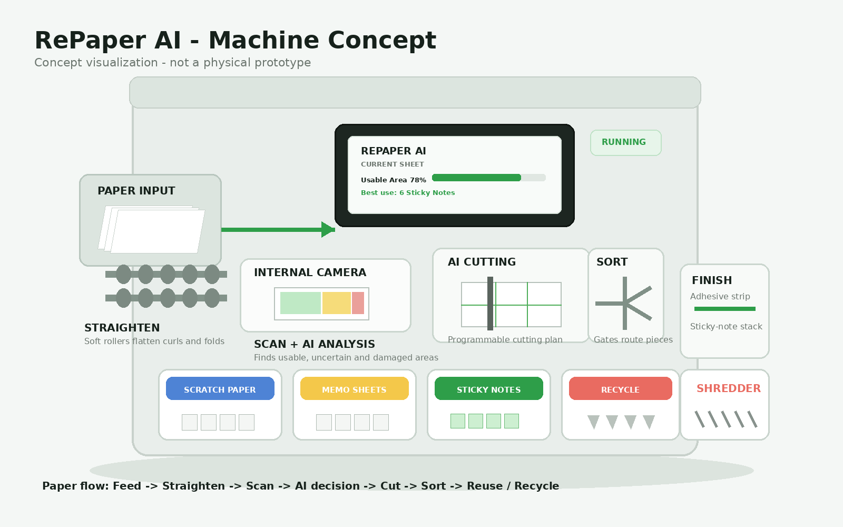
Figure 1. RePaper AI machine concept. The visual shows the proposed paper path and output modules; it is a concept illustration, not a finished prototype.
THE IDEA IN ONE SENTENCE
RePaper AI takes discarded school paper, straightens and scans it, uses AI to decide the best second use, automatically cuts and sorts it into useful products such as sticky notes, and recycles the material that cannot be reused.

Chosen theme: Environmental Sustainability
Supporting document for Samsung Solve for Tomorrow 2026

1. THE PROBLEM
Schools use paper every day. Some of it is thrown away even though part of the sheet is still useful. A worksheet may have printing on one side and a large blank area on the other. A folded or partly damaged sheet may still contain good paper. The difficulty is that schools do not have a simple way to inspect every discarded sheet, decide what can be reused, and turn the usable part into something the school actually needs.
WHY THIS MATTERS
Recycling is valuable, but it is a later-stage process. RePaper AI adds a step before recycling: recover direct-use value from suitable paper first, then recycle what remains. This is not a replacement for recycling; it is a way to reduce the amount of material that needs to enter the recycling stream when direct reuse is practical.

Environmental context
The U.S. Environmental Protection Agency has cited an estimate that recycling one ton of paper saves about 17 trees and about 4,077 kWh of energy compared with making paper from virgin material. These figures are broad reference values, not a prediction for one school or for RePaper AI. They show why paper recovery matters at scale. RePaper focuses on an additional opportunity: keeping suitable paper in use for longer before it reaches recycling.
WHAT IS MISSING TODAY
A practical, school-focused system that can look at mixed discarded sheets one by one and answer four questions: What part is usable? What should it become? How should it be cut? Should the remainder be recycled?

100-word opportunity / problem write-up
Schools discard paper every day, including worksheets, drafts and handouts that still contain usable areas. A folded sheet may still have good paper, and a worksheet printed on one side may have a large usable section. Today, schools mainly throw this paper away or send it for recycling. Recycling is important, but it still requires collection, transport and processing. The problem is that schools have no simple way to find the best use for paper before recycling it. RePaper AI fills this gap by giving suitable discarded paper a practical second life while recycling material that cannot be reused effectively.
Source note: Competition requirements and judging framework are from the Samsung Solve for Tomorrow 2026 Information Pack, which asks teams to explain the issue, who is affected, what is missing, and how technology creates impact. EPA reference: “Resource Conservation Challenge: Making the Connection with Solid Waste Facts and Figures.”

2. THE SOLUTION
RePaper AI is designed as one compact machine with several linked stages. The physical mechanisms do the movement, cutting and sorting. The AI acts as the decision-maker: it examines the paper, estimates what is usable, considers what the school needs, and creates the cutting plan.
# | STAGE | HOW IT WORKS
1 | Feed | Rollers pull in one sheet at a time.
2 | Straighten | Soft rollers flatten curls and folds enough for reliable scanning and cutting.
3 | Scan | An internal camera captures the whole sheet.
4 | Understand | Computer vision marks reusable, uncertain and damaged areas.
5 | Decide | AI chooses the best product based on paper condition, usable area, school demand and cutting waste.
6 | Cut | A programmable cutter follows the AI-generated cutting map.
7 | Sort | Rollers and diverter gates send different pieces to the correct output.
8 | Finish | Suitable pieces can receive a repositionable adhesive strip for sticky notes or simply be stacked as memo/scratch paper.
9 | Recycle | Unusable pieces are shredded for the recycling stream.


Figure 2. Proposed internal layout: the machine is intentionally vertical and enclosed so the paper follows a controlled path from input to outputs.

200-word idea / solution write-up
RePaper AI is an intelligent paper reuse system for schools. Paper is fed into the machine one sheet at a time. Rollers straighten curled or folded sheets, and an internal camera scans each sheet. Computer vision identifies printed, handwritten, blank and damaged areas and estimates how much paper can still be used. The AI then considers the school’s current demand - for example, whether it needs more sticky notes, memo sheets or scratch paper - and chooses the most useful second life for that sheet. It creates a cutting plan, and an automatic cutter follows the plan. The cut pieces are sorted into output sections. Suitable pieces can be stacked as scratch or memo paper, or sent through a finishing module that applies a repositionable adhesive strip to create sticky notes. Any material that is too damaged or left over is shredded for recycling. A dashboard records sheets processed, paper reused, products created, recycling output and reuse rate. This makes the system measurable as well as practical overall. The project is at the concept stage; next steps are to validate the computer-vision model, test paper handling with real school waste, refine the mechanical design, and build a small physical prototype.

3. HOW THE MACHINE MAKES A DECISION
The key technology is not the blade or the rollers. It is the link between the camera, the AI decision and the physical machine. The software produces a plan that mechanical parts can execute.
A. PAPER CONDITION  The AI checks for blank space, printing, handwriting, stains, folds, tears and other areas that may affect reuse. | B. USABLE AREA  The system estimates how much of the sheet is suitable for cutting and which shapes can fit inside that area.
C. SCHOOL NEED  The school dashboard gives the AI a demand profile. High-demand products are prioritised. | D. BEST CUT  The AI compares possible cutting patterns and selects one that aims to increase useful output while reducing offcuts.

Example: one discarded worksheet
Input | A folded A4 maths worksheet.
After straightening | Sheet is flat enough for scanning and cutting.
AI result | 78% estimated usable area; damaged region excluded.
School demand | Sticky notes = high demand; scratch paper = high demand.
Output decision | Cut plan produces a set of sticky notes and smaller memo/scratch pieces; leftovers go to recycling.
IMPORTANT FEASIBILITY PRINCIPLE
RePaper AI should never force reuse. If the usable area is too small, the paper is too damaged, or the cutting waste is too high, the system should choose recycling instead. The machine is designed to make a better decision, not simply to reuse everything.

Concept-stage safety and engineering
Cutters and the shredder should remain inside enclosed compartments with interlocks or other protective controls. The feed system should detect jams and multiple-sheet feeds. Adhesive would be supplied through a replaceable cartridge rather than requiring the machine to manufacture adhesive chemistry.
These are proposed engineering choices for future development, not claims that the finished machine has already been built or tested.

4. THE REPAPER AI DASHBOARD
The dashboard is the control centre for the system. It gives the operator a clear view of the current sheet, the AI recommendation, school demand and the machine’s overall impact.
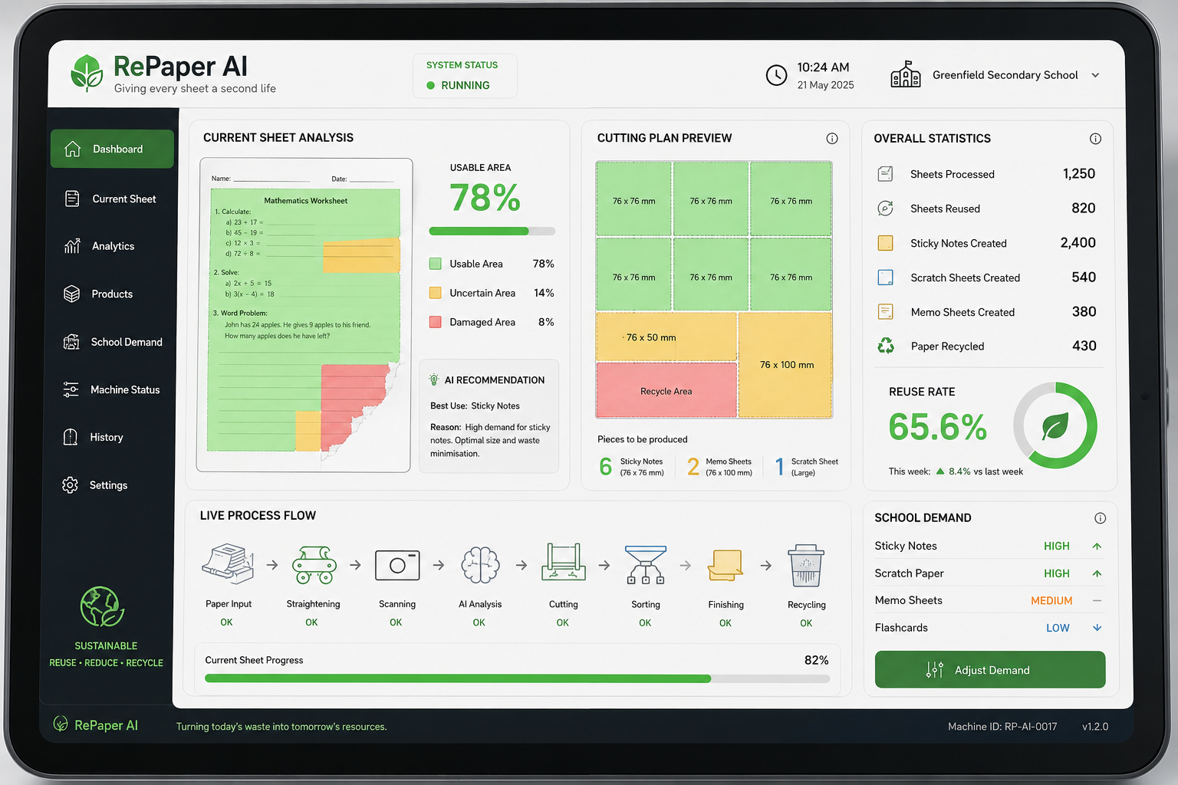
Figure 3. Dashboard concept. Values shown are illustrative demo data, not measured results from a physical machine.
DASHBOARD FEATURE | PURPOSE
Current sheet | Shows estimated usable area, condition and the AI recommendation for that sheet.
Cutting plan | Shows the proposed sizes and the estimated mix of products before the machine cuts.
School demand | Lets the school set priorities such as high demand for sticky notes or scratch paper.
Impact tracking | Counts sheets processed, reused, recycled, and products created.
Machine status | Shows whether feeding, scanning, cutting, sorting, finishing and recycling stages are ready or need attention.
WHY THE DASHBOARD MATTERS
The dashboard makes reuse measurable and helps the school adjust what the machine produces.

5. IMPACT, FEASIBILITY AND NEXT STEPS

Potential impact
ENVIRONMENT | SCHOOL | TECHNOLOGY
Extend paper use before recycling | Create useful school supplies from suitable discarded sheets | Use computer vision + AI optimisation to make decisions
Reduce avoidable paper waste | Reduce the need to buy some small paper products | Connect software decisions to physical mechanisms
Measure reuse and recycling | Create a visible sustainability metric for the school | Build a platform that can improve from usage data

Development plan
PHASE | WHAT WE WILL TEST
Phase 1 - Software validation | Test paper-image analysis and cutting-plan logic on a controlled dataset.
Phase 2 - Material testing | Collect real discarded school paper and measure how well the system handles folds, handwriting, printing and damage.
Phase 3 - Mechanical prototype | Build the feeder, straightener, scanner, cutter and basic sorting path; validate safety and reliability.
Phase 4 - Product modules | Add sticky-note finishing and refine memo/scratch-paper outputs.
Phase 5 - School pilot | Run a controlled trial, measure reuse rate, product quality, energy use and operating cost, then improve the design.

Why it fits Samsung Solve for Tomorrow 2026
Relevance - 20% | Targets a clear school waste problem and provides a direct reuse pathway.
Creativity - 25% | Combines adaptive paper reuse, product creation and a school-demand model in one system.
Feasibility - 30% | Uses familiar mechanisms - rollers, cameras, cutters, conveyors and sorting gates - connected by a defined workflow.
Technology - 25% | Uses computer vision and AI to understand paper and choose an efficient second use.

References and notes
1. Samsung Solve for Tomorrow 2026 Information Pack, Competition Overview, Theme, Submission Requirements, Judging Criteria and FAQ (pages 2-11). The pack identifies Environmental Sustainability as a theme and weights Relevance 20%, Creativity 25%, Feasibility 30% and Technology 25%.
2. U.S. Environmental Protection Agency, “Resource Conservation Challenge: Making the Connection with Solid Waste Facts and Figures.” The source gives broad historical reference figures of about 17 trees and 4,077 kWh saved per ton of recycled paper compared with virgin paper. These figures are context only and are not used as a measured RePaper AI performance claim.
3. Existing sticky-note production uses adhesive application, drying/setting, cutting and stacking. RePaper AI proposes using a replaceable repositionable-adhesive module for recovered paper; this is a future engineering implementation, not a demonstrated prototype result.
4. All machine dimensions, performance values, recovery rates and dashboard numbers shown in this document are concept-stage illustrations unless explicitly identified as external reference data.

Final message
REPAPER AI
Reuse what still has value. Recycle what does not. Give every sheet a second life.

